Information Retrieval – Assignment 2 (Group 32)
Building a Search, Ranking, and
Recommendation System
Group: [Group 32]
Student Registration Number | Name | Percentage of contribution out of 100%
2025aa05005 | PRAVEEN YADAV | 100%
2025aa05011 | RONGALI BHAVYA TEJA | 100%
2025aa05012 | P VAMSI KRISHNA | 100%

Streamlit App Url:
https://bits-wilp-sem2-ir-grp-32-assignment-2-csmclagpjovo3yzjsj9lkr.streamlit.app/

[ Add a screenshot here — a screenshot of the app running in your BITS Virtual Lab session ]

What this project is
This project is a small, complete information retrieval system, built end to end and wrapped in a Streamlit app so every step — collecting documents, cleaning and understanding them, indexing, searching, ranking, recommending, and evaluating
The dataset is a corpus of about 60 Wikipedia articles, crawled starting from seven AI/ML/robotics-related topics, with the option to mix in an extra CSV of unrelated tech articles to show the system can absorb documents from more than one source.
The app has eight pages: a Dashboard, Search, Crawler, Index Management, Ranking, Recommendations, Evaluation, and Performance Analytics. Each one drives a real piece of the pipeline.

Collecting the data
The crawler (crawler/wiki_crawler.py) starts from seven seed topics — Artificial intelligence, Machine learning, Deep learning, Neural network, Natural language processing, Computer vision, and Robotics — and works outward one link at a time, breadth-first. Rather than exhausting one topic before moving to the next, it round-robins across the seven queues so a topic with lots of outgoing links can't eat the whole crawl budget by itself. How far it wanders from each seed, and how many pages it fetches in total, are both configurable from the Crawler page.
Two kinds of duplicates are caught before a page is ever saved: an exact duplicate is caught by hashing the page text, and a near-duplicate (a slightly reworded copy, or a redirect that lands on essentially the same content) is caught by comparing word overlap between the new page and everything already stored, using a similarity cutoff of 0.85. Anything that clears either bar is logged but never written to disk, so it never reaches the index. The crawler is also polite about it — a small delay between requests, and automatic retries with backoff if a request gets rate-limited.
Everything the crawler learns about a page — its title, URL, which seed it came from, how deep it was found, whether it turned out to be a duplicate — is kept in a metadata table (data/metadata/metadata.csv), completely separate from the article text itself (data/raw/*.txt). That separation is what lets later stages filter and group documents by topic or depth without having to re-read and re-parse the raw text every time.
On the run this report is based on, the crawler processed 62 pages, stored 61 after dropping one exact duplicate, and an extra 12 articles were added from an uploaded CSV covering unrelated tech topics (cloud, blockchain, IoT, and so on) — giving 73 documents in the corpus overall.
[ Add a screenshot here — the Crawler page — the crawl form, live progress log, and completion summary ]

Cleaning and understanding the text
Raw Wikipedia text is noisy for modelling purposes, so before anything is indexed it goes through a cleaning pass: lowercase, keep only alphabetic tokens of two or more letters, drop common English stopwords, and then normalize what's left — either by lemmatizing (WordNetLemmatizer), stemming (PorterStemmer), or leaving it as-is, depending on which configuration is being tested. From the cleaned text, both a bag-of-words representation and a TF-IDF representation are built, with configurable n-gram range and vocabulary size.
Because there's more than one reasonable way to do that cleaning, the Performance Analytics page runs a small experiment rather than just picking one: it tries three normalization modes × two n-gram settings × two feature types (twelve combinations total), and scores each one by how well a Naive Bayes classifier can predict a document's topic from it, using 4-fold cross-validation. The results were reasonably clear-cut:
Normalization | N-grams | Features | Vocabulary | Sparsity | Macro-F1
lemmatize | unigram | TF-IDF | 13,558 | 93.4% | 0.515
stem | unigram | TF-IDF | 10,058 | 92.4% | 0.507
none | unigram | TF-IDF | 15,284 | 93.7% | 0.506
stem | unigram | bag-of-words | 10,058 | 92.4% | 0.478
none | unigram | bag-of-words | 15,284 | 93.7% | 0.475
none | unigram+bigram | bag-of-words | 109,363 | 97.2% | 0.464
lemmatize | unigram | bag-of-words | 13,558 | 93.4% | 0.457
none | unigram+bigram | TF-IDF | 109,363 | 97.2% | 0.418

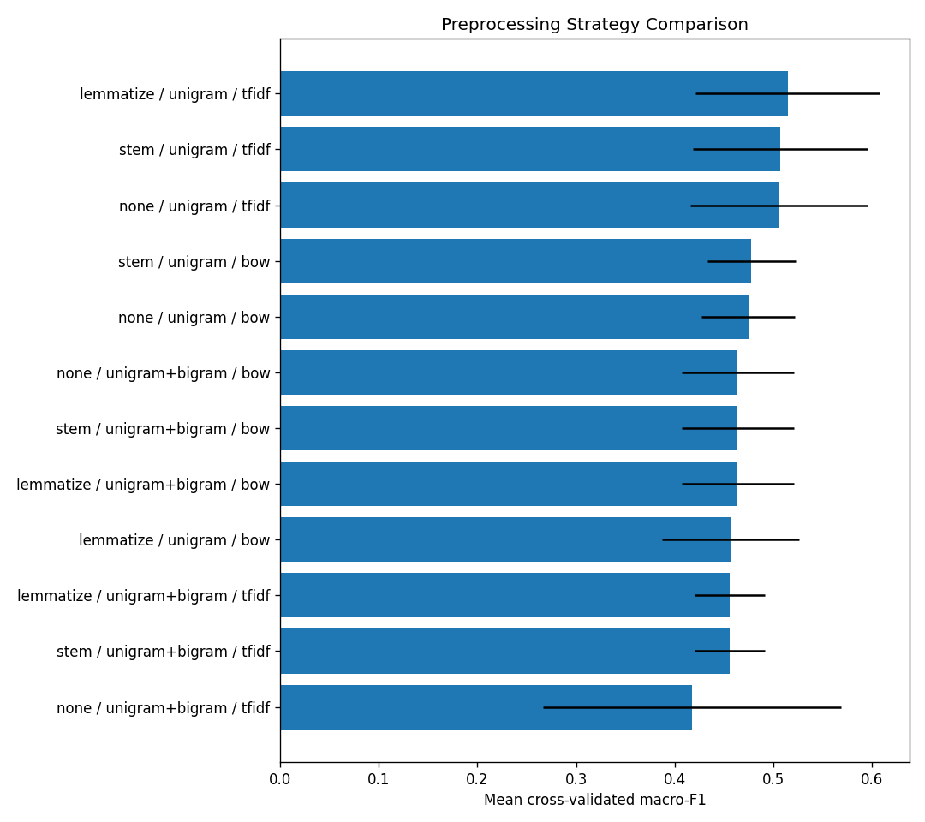
Classifier score by preprocessing configuration
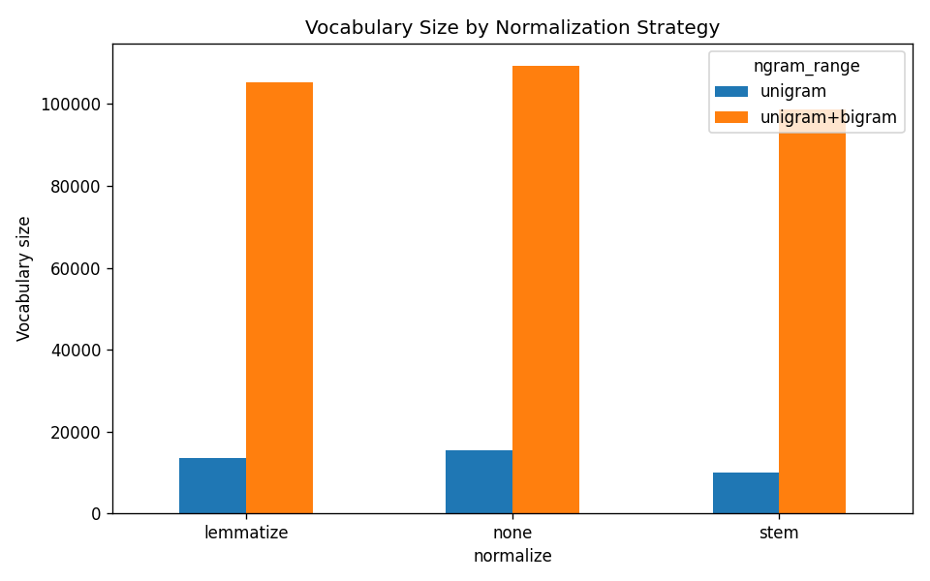
Vocabulary size by preprocessing configuration
Lemmatized unigram TF-IDF came out on top. Adding bigrams multiplies the vocabulary by about eight times without any real gain in classification quality — on a corpus this small, bigrams mostly add sparsity, not signal. That's the configuration used everywhere else in the system.
The same TF-IDF vectors are reused to pull out keywords, both per document and per topic (by averaging TF-IDF weight within a topic), which then feed the word clouds shown on the Corpus Statistics tab. A separate set of plots — Zipf's law, Heaps' law, document-length distribution, and vocabulary richness by topic — gives a sense of the corpus's basic shape.
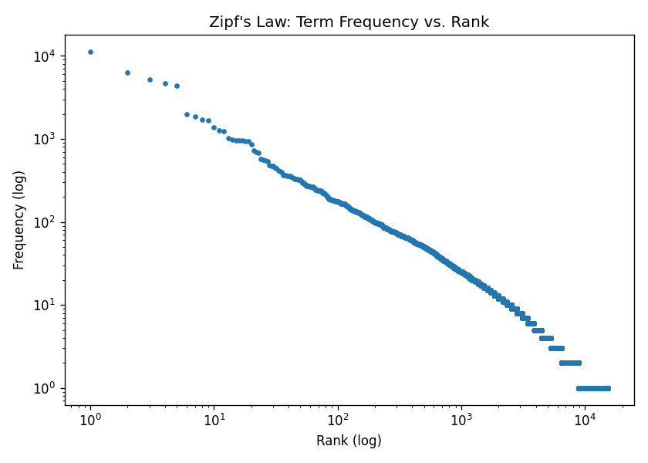
Zipf's law: term frequency vs. rank
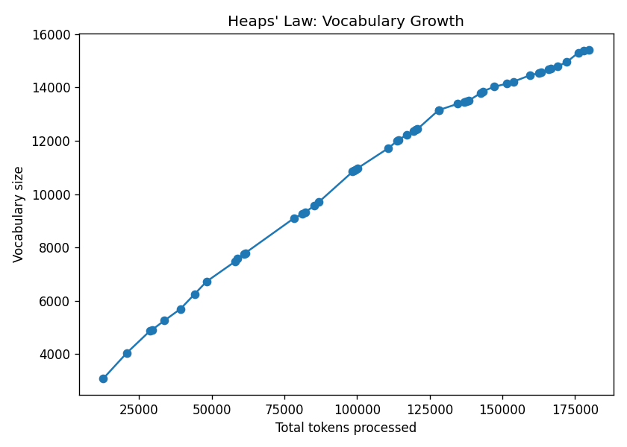
Heaps' law: vocabulary growth
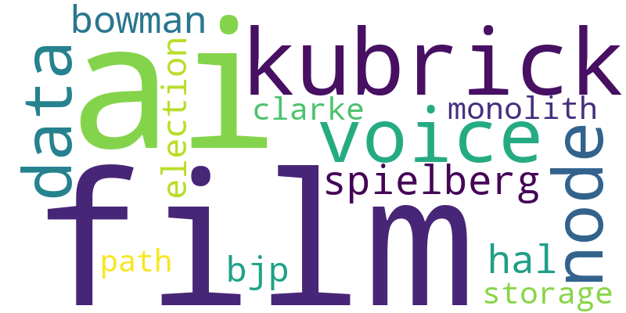
Word cloud for the AI topic

Classifying documents by topic
Using the best-performing TF-IDF setup, two classifiers were compared on the topic-prediction task — Naive Bayes and Logistic Regression — again with 4-fold cross-validation:
Model | Accuracy | Macro-F1
Naive Bayes | 63.3% | 0.515
Logistic Regression | 59.1% | 0.477

Naive Bayes won on both measures. On a held-out 25% split (13 documents), it got about half right overall, but the per-topic breakdown is uneven — several topics show 0.00 precision and recall simply because there were only one or two test examples for that topic, and a single mistake wipes the score out completely. That's a data-size problem more than a modelling problem, and it's worth keeping in mind when reading the confusion matrix below.
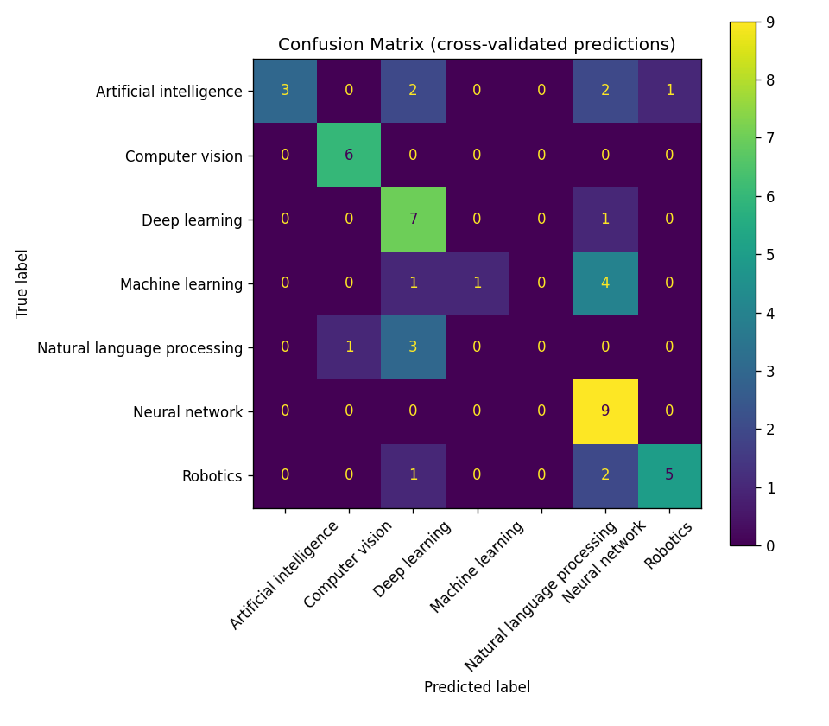
Confusion matrix, Naive Bayes, out-of-fold predictions

Searching and ranking results
Two indexes back the search page: an inverted index mapping each term to the documents it appears in (used to quickly narrow down candidates before doing anything expensive), and a TF-IDF vector index used for cosine-similarity scoring. A third structure, a directed graph of which articles link to which, is used purely for ranking and recommendation — it only keeps links between documents that are actually in the corpus, since a link out to the rest of Wikipedia carries no useful ranking signal here.
A query first gets cleaned the same way documents were (lowercased, stopwords removed, lemmatized) so it lands in the same vector space, and optionally expanded with a couple of WordNet synonyms per word. The inverted index then filters candidates — either “must contain any query term” or “must contain all of them” — before cosine similarity is computed only against that shortlist, rather than the whole collection.
On top of plain content similarity, the link graph feeds PageRank and HITS (via networkx), and the two are combined with a simple weighted average:
final score = alpha × content score + (1 − alpha) × link score
with alpha defaulting to 0.7, and both content and link scores normalized to a 0–1 range first. The Search and Ranking pages let you flip between pure content, pure link-based, and hybrid ranking, and compare them side by side — which is genuinely useful for seeing how much link authority can move things around. For the query “neural networks for computer vision”, for instance:
Rank | Content-only | score | Hybrid | score
1 | Neural network | 0.448 | Computer vision | 0.511
2 | Computer vision | 0.445 | Artificial intelligence | 0.362
3 | Neural network (biology) | 0.438 | Neural network | 0.335
4 | Deep learning | 0.299 | Neural network (biology) | 0.316
5 | Artificial neuron | 0.139 | Deep learning | 0.312

“Artificial intelligence” barely shows up on content similarity alone (0.088), but it's the single most-linked page in the whole corpus, so once link authority is blended in it jumps to second place. That's a nice concrete illustration of both what hybrid ranking buys you and where it can go wrong — more on that in the discussion section.
[ Add a screenshot here — the Search page — a query, its ranked results, and the content-vs-hybrid comparison ]
[ Add a screenshot here — the Ranking page — the link-graph visualization and the top-10 PageRank/HITS chart ]

Recommending related articles
Given a document, the app can suggest related ones in three ways: purely by content (TF-IDF cosine similarity to every other document), purely by graph structure (a personalized PageRank seeded at that document, over the undirected link graph), or a blend of the two, weighted the same way ranking is — alpha times content, (1 − alpha) times graph proximity, both normalized first. Collaborative filtering — recommending based on what other users liked — isn't implemented, for a simple reason: a Wikipedia crawl has no users and no click or rating history, so there's nothing to build it from. That trade-off, and how content-based and collaborative approaches compare in general, is discussed in the section below.
As an example, recommending for the “Neural network” article:
Content-based | score | Graph-based | score
Neural network (biology) | 0.744 | Artificial intelligence | 0.073
Artificial neuron | 0.508 | Machine learning | 0.057
Deep learning | 0.502 | Activation function | 0.052
Machine learning | 0.298 | Backpropagation | 0.043
Artificial intelligence | 0.258 | AI alignment | 0.040

The two methods clearly answer different questions. Content-based recommends articles that read like this one; graph-based recommends articles this one is structurally close to in the web of links — which tends to surface big hub topics rather than close cousins. The hybrid recommender blends both rather than forcing a choice.
[ Add a screenshot here — the Recommendations page — picking a document and viewing its top-K recommendations ]

Measuring how well it works
There's no real query log or hand-labeled relevance data for a freshly crawled corpus, so relevance here is approximated: eight test queries were written up front (things like “artificial intelligence overview” or “deep learning neural networks”), each tagged with the topic(s) it should be relevant to, and a document counts as relevant to a query if it came from a matching seed topic. It's a proxy, not ground truth, but it's reproducible and cheap to recompute every time the corpus changes — which matters more than perfect accuracy for a student project like this.
Against that relevance set, five ways of ranking results were compared — content-only, PageRank-only, HITS-only, and two hybrids (one with each link algorithm) — scored with precision, recall, F1, precision/recall at 5, MAP, MRR, and NDCG:
Method | MAP | MRR | P@5 | R@5 | F1 | NDCG@5 | NDCG@10
Content only | 0.359 | 0.938 | 0.475 | 0.322 | 0.390 | 0.578 | 0.563
Hybrid + PageRank | 0.232 | 0.792 | 0.375 | 0.227 | 0.345 | 0.416 | 0.438
Hybrid + HITS | 0.166 | 0.833 | 0.250 | 0.146 | 0.242 | 0.340 | 0.357
PageRank only | 0.078 | 0.423 | 0.200 | 0.112 | 0.180 | 0.205 | 0.214
HITS only | 0.081 | 0.400 | 0.150 | 0.066 | 0.174 | 0.167 | 0.205

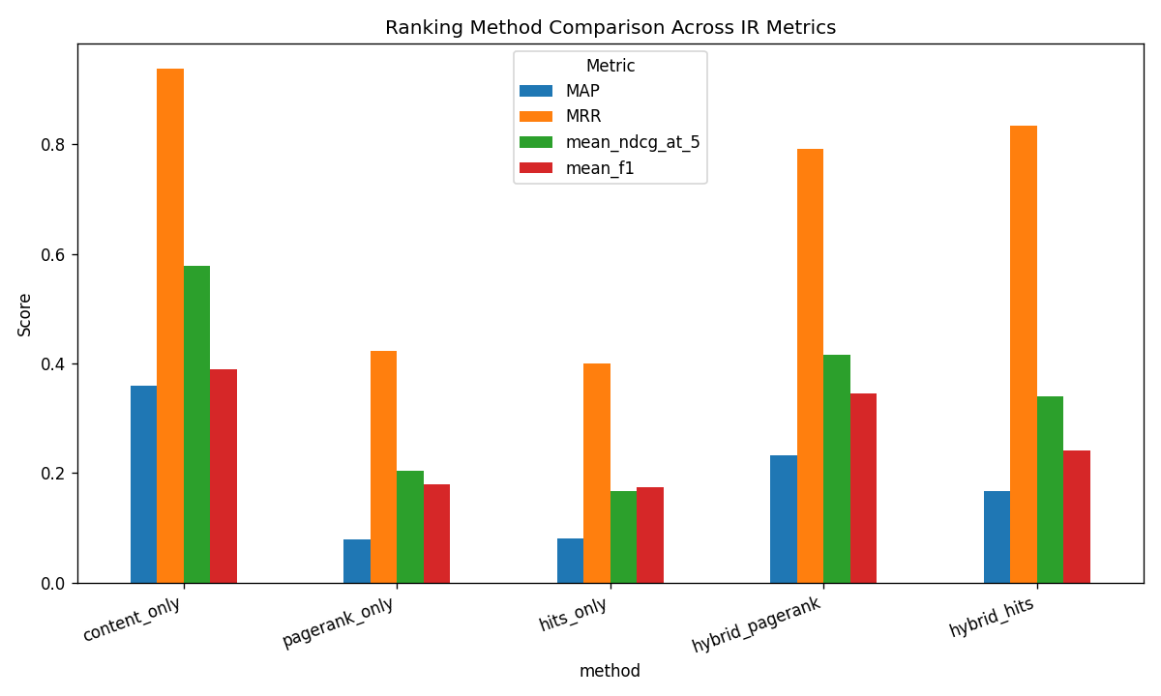
MAP, MRR, NDCG@5 and F1 across the five ranking methods
Content-only ranking wins on almost every measure. Ranking by link authority alone is clearly the weakest option here — not surprising, since PageRank and HITS describe how the corpus is linked together, not whether a page answers a particular query, and with only 61 pages and 300 links, a handful of hub topics end up dominating the authority scores regardless of what was actually asked. The hybrids land in between, closer to content-only than to link-only, but don't beat content-only at the default blend of 70% content / 30% link — which says the default blend is probably tilted too far toward link authority for a corpus this small.
This evaluation covers search ranking. The recommender is exercised and timed (see the Performance Analytics page for how long each pipeline stage takes on a full rebuild), but it isn't scored against a relevance set the way search results are — doing that properly would need its own notion of “what's actually related to what”, which felt out of scope here.
[ Add a screenshot here — the Evaluation page — the method comparison table, chart, and per-query breakdown ]
[ Add a screenshot here — the Performance Analytics page — preprocessing/classification results and the runtime benchmark ]

Discussion
A few things stood out while building and testing this, worth calling out explicitly rather than leaving implicit in the numbers above.

Why relevant documents can rank poorly
The clearest example of this in the system is the “Artificial intelligence” case from the ranking section above: a document with weak content similarity to a query can still outrank much more relevant ones, purely because it's heavily linked. That happens because the link graph here is small — 61 pages, 300 edges — so authority concentrates in a few hub pages rather than spreading out proportionally to actual relevance. A related but opposite problem is that plain TF-IDF matching misses documents that are relevant but phrased differently — query expansion exists to help with that but isn't switched on by default. And because there's no phrase or proximity scoring, a document where the query words happen to appear far apart scores exactly the same as one where they appear together meaningfully. The fixes that seem most worth trying are: tuning the alpha blend against the evaluation numbers instead of leaving it at a fixed default (the evaluation above already shows 0.7 isn't ideal for this corpus), using a topic-aware version of PageRank instead of a single global one, turning query expansion on by default, and eventually growing the corpus so link authority has more to work with.

What duplicate documents would break
If duplicate or near-duplicate pages made it into the index, the effects would show up everywhere: term statistics get skewed (a term that's actually common looks rarer than it is, because it's only “concentrated” in one duplicated article), search results get cluttered with near-identical hits instead of genuinely distinct ones, the content-based recommender would recommend a document its own near-copy almost every time (a technically correct but useless suggestion), and evaluation numbers would look better than they should, since the relevance check used here is topic-based and would happily count both copies as separate hits for the same underlying need.
This is exactly why the crawler checks for exact duplicates (by hashing page text) and near-duplicates (by comparing word overlap, at a similarity cutoff of 0.85) before saving anything — one exact duplicate was in fact caught and dropped during the actual crawl this report is based on. The one gap worth flagging: the second way of adding documents, uploading a CSV, skips that check entirely, so anything added that way is trusted as unique without verification. A reasonable next step would be running the same duplicate check on that path too, and adding some diversity-aware re-ranking as a backstop for near-duplicates that slip through either way.

Content-based vs. collaborative recommendations
This system only implements content-based and graph-based recommendation (plus a hybrid of the two) — not collaborative filtering, which recommends based on what other users with similar taste have liked. The reason is simple: collaborative filtering needs a history of user interactions to work from, and a freshly crawled Wikipedia corpus has none. So the comparison here is more conceptual than measured.
Content-based recommendation works from day one, even for a brand-new document, because it only needs the document's own text — no waiting for anyone to interact with it. Collaborative filtering, by contrast, can't say anything useful about a new item until enough people have engaged with it, and can't personalize for a new user until they've interacted with enough items themselves. In exchange, collaborative filtering can surface genuinely surprising connections — two articles that share no vocabulary at all but that the same readers keep coming back to — which content similarity can never find, by definition, since it only ever looks at the document's own text. Content-based recommendation tends to feel a little narrow over time for the same reason: it keeps suggesting near-variations of what you already looked at. In short, content-based fits a system like this one, where there's text but no user history; collaborative filtering becomes worth the extra effort once a real, active user base exists to learn from.

Why the pieces need to work together
None of these stages are useful in isolation. A crawler without duplicate detection poisons everything downstream of it. The choice of how text is cleaned and vectorized doesn't just affect search — the same TF-IDF representation is what the content-based recommender and the topic classifier both run on too, so the ~24% swing in classification score between preprocessing configurations shown earlier is really a statement about search and recommendation quality as well, not just classification. Search and recommendation turned out to share more machinery than expected — both use the exact same alpha-weighted blend of content similarity and link/graph authority, just applied to a query on one side and a seed document on the other. And evaluation is what actually closes the loop: without it, there'd be no way to know that content-only ranking beats the hybrid on this particular corpus, or that the default alpha is probably too link-heavy — that's not something you'd guess by eye.

What the results actually taught us
Pulling together everything above, a few takeaways feel worth stating plainly. Content-based ranking beat pure link-based ranking by a wide margin on this corpus, which says more about corpus size than about PageRank/HITS being bad algorithms — they just need a denser link graph than 300 edges to be a reliable relevance signal. Blending two signals isn't automatically better than the stronger one alone; the hybrid sits between content-only and link-only here, not above content-only, so the blend ratio needs to be tuned against real evaluation numbers rather than assumed. How the text is preprocessed matters roughly as much as which ranking formula is used — a ~24% swing in classification score from normalization and n-gram choices alone is not a small effect. Naive Bayes beat Logistic Regression for topic classification here, most likely because the simpler model handles the very small per-class sample sizes better. Those same small sample sizes are the real bottleneck in the classification results — a topic with only two test documents can't score well no matter which model is used, so more data would help more than a better algorithm would. The duplicate-detection gap in the CSV upload path is a reminder that a safeguard built once for one entry point doesn't automatically cover every entry point. And the two recommendation methods genuinely disagree with each other in useful ways — content-based and graph-based each surfaced a different, reasonable notion of “related” for the same document — which is the actual argument for offering a hybrid instead of picking one and calling it done.

Wrapping up
The code, the crawled dataset, and this report together cover the full pipeline described above. A few things are still worth doing before calling this finished:
- Fill in the names/IDs and date on the cover page.
[ Add a screenshot here — the remaining screenshots above, plus a short recording of the app running end to end ]
- Double-check the README's install and run steps still match what's in requirements.txt.

