SUBMISSION DELIVERABLE
SEML Assignment 1
Objective 1 – GR4ML Business View
Business View

Purpose
The purpose of the Early Diabetes Risk Prediction System is to support healthcare organizations and healthcare professionals in identifying individuals who may be at risk of diabetes at an early stage. Early identification enables timely intervention, improves patient outcomes, and reduces long-term treatment costs.
The system acts as a decision-support tool and assists healthcare professionals in evaluating diabetes risk using patient health information and Machine Learning techniques.

Business Objectives
The primary business objective is to improve preventive healthcare through early identification of diabetes risk.
The proposed system aims to:
- Improve early detection of diabetes risk.
- Support preventive healthcare initiatives.
- Improve patient outcomes.
- Reduce long-term healthcare costs.
- Enhance decision support for healthcare professionals.
- Improve resource utilization within healthcare organizations.

Stakeholders

Primary Stakeholders
- Patients
Patients benefit from early awareness of diabetes risk and can seek medical intervention before complications arise.
- Healthcare Professionals (Doctors): Decision Support
Doctors, nurses, and clinicians use prediction results to support patient assessment and decision-making.
- Hospitals and Clinics (Resource Optimization)
Healthcare institutions benefit through improved patient care, improved resource utilization, and reduced treatment costs.

Secondary Stakeholders
- Healthcare Administrators (Planning)
Healthcare administrators can use aggregated prediction information to support planning and preventive healthcare programs.
- Insurance Providers (Cost Reduction)
Insurance organizations may benefit through reduced healthcare costs resulting from early intervention and improved disease management.

Business Process
The proposed business process is as follows:
- Patient information is collected.
- Patient health parameters are entered into the system.
- The Machine Learning model evaluates diabetes risk.
- Prediction results are generated.
- Healthcare professionals review the prediction.
- Appropriate preventive actions or further investigations may be initiated.
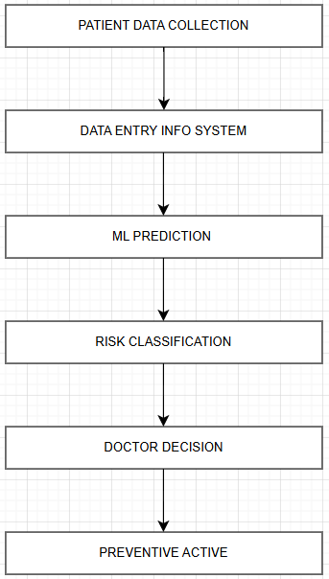
Figure 1Business Process

5. Business Benefits
Business Benefit | Expected Outcome
Early Risk Identification | Increased preventive care opportunities
Improved Decision Support | Faster assessment of patient risk
Better Patient Outcomes | Reduced diabetes-related complications
Reduced Healthcare Costs | Lower treatment and hospitalization expenses
Improved Resource Utilization | Better allocation of healthcare resources
Improved Preventive Care | Earlier intervention and treatment planning
Table 1Business Benefits

6. Business Risks
Risk | Mitigation Strategy
Incorrect Prediction | Use validated Machine Learning models and testing procedures
Poor Data Quality | Input validation and data quality checks
User Misinterpretation | Clear presentation of prediction results
Over-Reliance on System | Position system as a decision-support tool only
Model Performance Degradation | Periodic model review and retraining
Table 2Business Risks

7. GR4ML Business Mapping
The following table maps business goals to stakeholders and supporting business requirements.
Business Goal | Stakeholder | Business Requirement
Early identification of diabetes risk | Patients | Accurate diabetes risk prediction
Improved patient outcomes | Healthcare Professionals | Reliable prediction results
Better preventive healthcare | Hospitals and Clinics | Early intervention support
Reduced healthcare costs | Healthcare Administrators | Improved resource utilization
Enhanced decision support | Healthcare Professionals | Fast and understandable prediction output
Table 3 GR4ML Business Mapping

8. Business Success Measures
The success of the proposed system will be evaluated using the following measures:
- Accurate identification of diabetes risk.
- Timely generation of prediction results.
- Ease of use for healthcare professionals.
- Reliable system operation.
- Ability to support preventive healthcare decisions.

9. Summary
The Business View establishes the business context for the Early Diabetes Risk Prediction System by identifying stakeholders, business objectives, expected benefits, business risks, and success measures. It provides the foundation for developing the Analytics Design View and Data Preparation View in subsequent phases of the project.

