- GitHub Repository Link containing
- Complete source code
- requirements.txt
- README.md

https://github.com/2025aa05376-himanshu/ml-assignment-2.git

- Live Streamlit App Link
- Deployed using Streamlit Community Cloud
- Must open an interactive frontend when clicked
https://ml-assignment-2-n7je8bvqjgh7nevqr9f9yp.streamlit.app/

- Screenshot
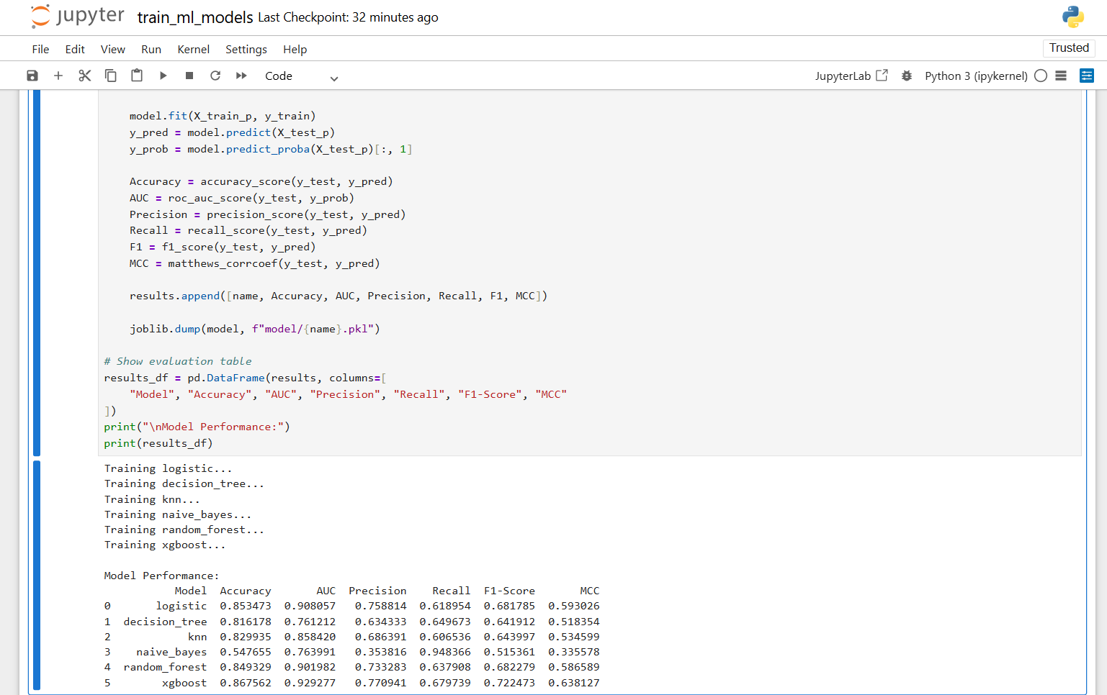



- The Github README content
- Problem Statement:
The objective of this project is to develop and compare multiple machine learning classification models to determine whether an individual's annual income exceeds $50,000 using demographic and employment- related features from the U.S. Census dataset.
- Dataset Description
- Dataset Name: Adult Income Dataset
- Source: UCI Machine Learning Repository
- Number of Instances: 48,842
- Number of Features: 14 input attributes
- Target Variable: Income (<=50K, >50K)
- Type of Problem: Binary Classification
The dataset contains both numerical and categorical attributes describing an individual's education level, occupation, working hours, marital status, and other socio-economic characteristics.
- Data Preprocessing Steps
- Removed rows containing missing values
- Converted target variable into binary format (0 and 1)
- Applied One-Hot Encoding to categorical features
- Standardized numerical features
- Split dataset into 80% training and 20% testing sets
- The following six classification Machine Learning Models are Implemented.
- Logistic Regression
- Decision Tree Classifier
- K-Nearest Neighbours
- Gaussian Naive Bayes
- Random Forest (Ensemble)
- XGBoost (Ensemble Boosting)
- Evaluation Metrics
- Accuracy
- AUC Score
- Precision
- Recall
- F1 Score
- Matthews Correlation Coefficient (MCC)
- Model Comparison Table
Model | Accuracy | AUC | Precision | Recall | F1 | MCC
Logistic Regression | 0.853473 | 0.908057 | 0.758814 | 0.618954 | 0.681785 | 0.593026
Decision Tree | 0.816178 | 0.761212 | 0.634333 | 0.649673 | 0.641912 | 0.518354
K-Nearest Neighbours | 0.829935 | 0.858420 | 0.686391 | 0.606536 | 0.643997 | 0.534599
Gaussian Naive Bayes | 0.547655 | 0.763991 | 0.353816 | 0.948366 | 0.515361 | 0.335578
Random Forest (Ensemble) | 0.849329 | 0.901982 | 0.733283 | 0.637908 | 0.682279 | 0.586589
XGBoost (Ensemble Boosting) | 0.867562 | 0.929277 | 0.770941 | 0.679739 | 0.722473 | 0.638127

- Observations
- Logistic Regression provided a strong baseline performance.
- Decision Tree showed moderate accuracy but potential overfitting.
- KNN performed well after feature scaling.
- Naive Bayes was computationally efficient but slightly lower in predictive power.
- Random Forest improved overall stability and generalization.
- XGBoost achieved the best performance across most evaluation metrics.

- Streamlit Application Features
The application has been deployed using Streamlit Community Cloud. The deployed web application includes:

- CSV test dataset upload
- Model selection dropdown
- Display of evaluation metrics
- Confusion matrix visualization
- Classification report


