Assignment 1 – PS4 Defence Drone
Greedy Best-First Search (GBFS) and A* Search Analysis
1. Problem Statement
An autonomous UAV must navigate from Start node (0,0) to Goal node (6,7) while avoiding No-Fly Zones (N) and accounting for Weather Hazard regions (W). The objective is to evaluate Greedy Best-First Search (GBFS) using two heuristics and compare its performance with A* Search.
2. Environment Representation
Grid Size: 8×8. Symbols used: S=Start, E=Goal, .=Open Cell, W=Weather Hazard, N=No-Fly Zone. Movement is restricted to North, East, South and West.
3. PEAS Analysis
Performance: Reach the target with minimum risk and cost.
Environment: 8×8 grid world.
Actuators: Move North, East, South, West.
Sensors: Current position and neighboring cells.
4. Heuristic Functions
h1: Euclidean Distance.
h2: Bounding-Box Risk Weighted Heuristic which combines Manhattan distance with average future path risk.
5. Execution Flow
Read Input → Validate Input → Build Grid → Select Search Algorithm → Expand Nodes → Compute Heuristic → Goal Test → Reconstruct Path → Generate Output.
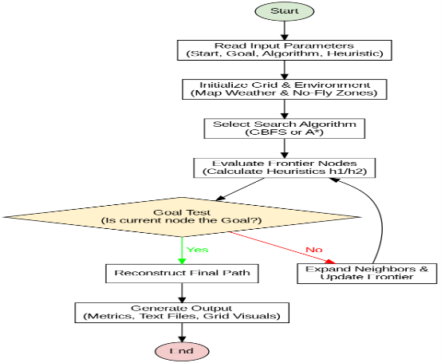
6. Initial Environment and Planned Route
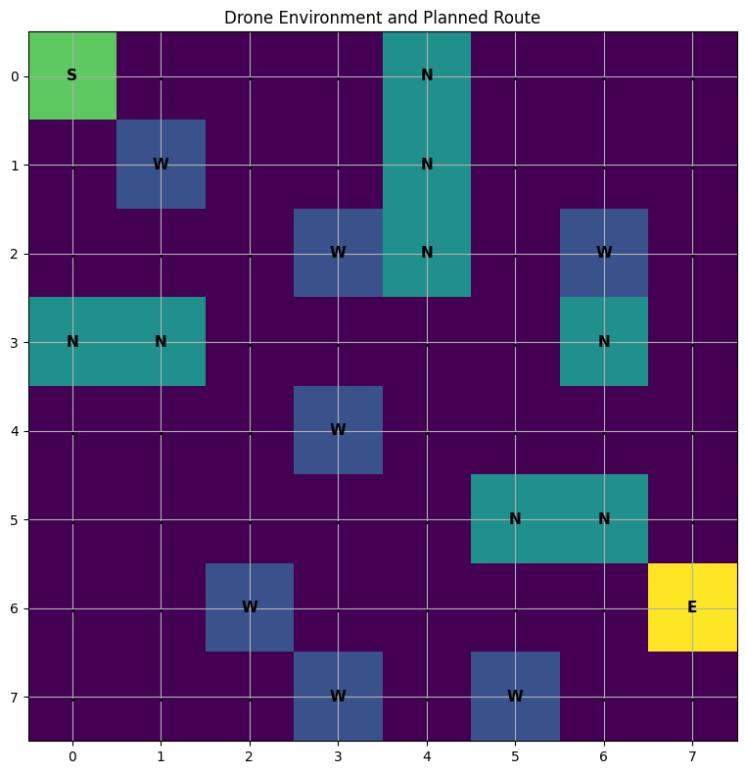
Figure 1: Initial Environment and Planned Route shows the defense drone environment. The start node S is located at (0,0) and the goal node E at (6,7). No-Fly Zones (N) are treated as obstacles while Weather Hazard cells (W) have higher traversal cost.
7. Final Path Visualization
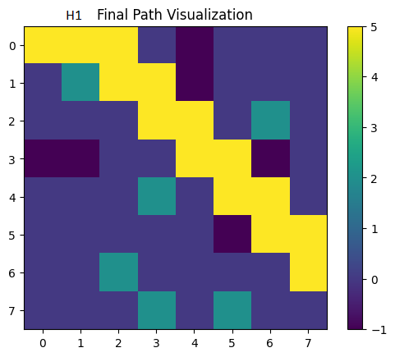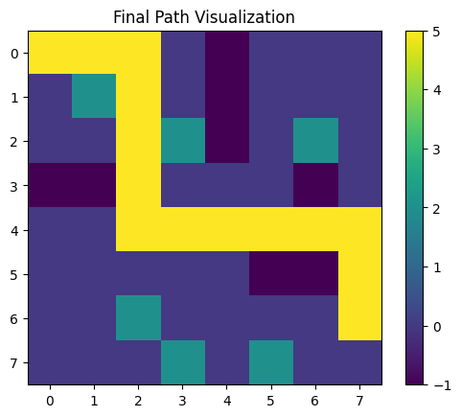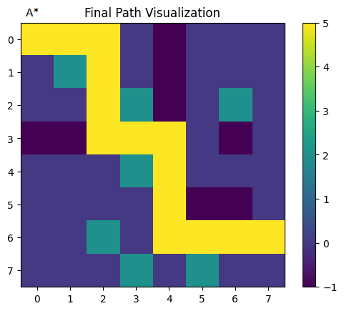
| GBFS-h1 Final Path (Cost = 33) Figure 2(a) | GBFS-h2 Final Path (Cost = 19) Figure 2(b) | A*-h1 Final Path (Cost = 16) Figure 2(c) |
The final paths generated by GBFS-h1, GBFS-h2, and A*-h1 illustrate how each algorithm navigates obstacles and hazard traversal costs. GBFS-h1 offered the fastest execution (0.130 ms) and expanded only 14 nodes; however, its greedy reliance on Euclidean distance pulled the drone along a sub-optimal trajectory. This path crossed a Weather Hazard cell and accumulated a high cost of 33, though it successfully avoided entering No-Fly Zones. Conversely, GBFS-h2 utilized the forward-looking Bounding-Box Risk-Weighted Heuristic to find a safer path, lowering the cost to 19. Ultimately, A*-h1 discovered the mathematically optimal route with the lowest path cost of 16. By balancing past path cost with the heuristic, A* completely avoided both No-Fly Zones and Weather Hazard cells, highlighting the classic trade-off between computational speed and path optimality.
8. Heuristic and Path Analysis
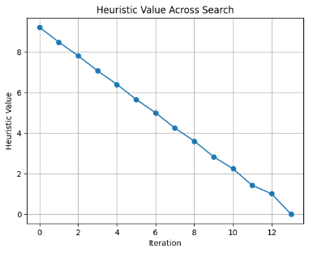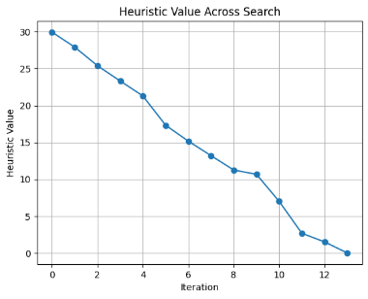
Figure 3(a): Heuristic Values vs Node Expansion for GBFS-h1 |Figure 3(b): Heuristic Values vs Node Expansion for GBFS-h2
Figures 3(a) and 3(b) show the heuristic values for GBFS-h1 and GBFS-h2 during node expansion, while Figure 4 presents the final paths generated by GBFS-h1, GBFS-h2, and A*-h1. In both heuristics, the values generally decrease as the search approaches the goal, indicating effective guidance toward the target. Although both GBFS variants expanded 14 nodes and produced paths of length 13, their route quality differed. GBFS-h1 was faster (0.130388 ms) and used less memory (26), but produced a higher path cost of 33 and crossed two No-Fly Zones. GBFS-h2 required more runtime (0.636698 ms) and memory (32), but reduced the path cost to 19 and avoided all No-Fly Zones. A* produced the optimal path with the lowest cost of 16 while avoiding all hazards. These results highlight the trade-off between computational efficiency and path quality.
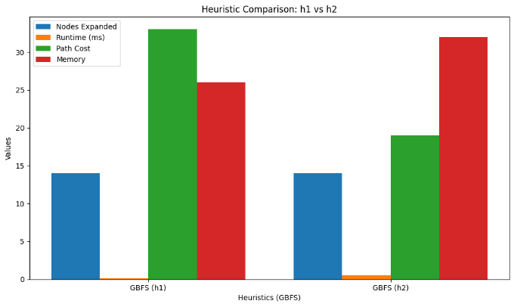
9. Experimental Results
Metric | Description | GBFS-h1 | GBFS-h2 | A*-h1
Nodes Expanded | Total explored nodes | 14 | 14 | 32
Runtime (ms) | Execution time | 0.130388 | 0.636698 | 0.317236
Memory Usage | OPEN + CLOSED size | 26 | 32 | 51
Total Path Cost | Sum of transition costs | 33 | 19 | 16
Path Length | Total moves | 13 | 13 | 13
Initial Heuristic Value | Start node heuristic value | 9.22 | 29.95 | 9.22

The experimental results highlight the trade-off between efficiency and solution quality. Both GBFS variants expanded 14 nodes and reached the goal in 13 moves. GBFS-h1 achieved the fastest runtime (0.130388 ms) and lowest memory usage (26), but produced the highest path cost (33) and crossed two No-Fly Zones. GBFS-h2 required more runtime and memory but improved path quality by reducing the cost to 19 and avoiding all No-Fly Zones. A*-h1 expanded the most nodes (32) and used the most memory (51), yet produced the optimal path with the lowest cost (16) while avoiding all hazards.
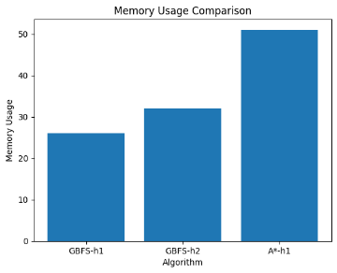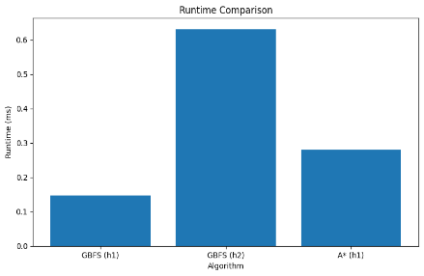
10. Complexity Analysis
Greedy Best-First Search (GBFS) uses a priority queue ordered by the heuristic value h(n). Its time complexity is approximately O((V+E)logV) and space complexity is O(V). In this experiment, GBFS expanded only 14 nodes, making it computationally efficient.
A* Search uses the evaluation function f(n)=g(n)+h(n), combining path cost and heuristic information. Its time complexity is also O((V+E)logV) with O(V) space complexity. Although A* expanded 32 nodes and used more memory, it generated the optimal path with the lowest cost.
Algorithm | Time Complexity | Space Complexity
GBFS-h1 | O((V+E) log V) | O(V)
GBFS-h2 | O((V+E) log V) | O(V)
A*-h1 | O((V+E) log V) | O(V)

11. Trap Analysis
No dead-end states, local minima, or infinite loops were encountered. All algorithms successfully reached the goal without requiring trap-recovery mechanisms.
12. Alternate Problem Modelling
The environment can alternatively be modelled as a graph, where each grid cell is represented as a node and adjacent traversable cells form edges. This representation improves scalability and supports advanced search algorithms such as Dijkstra's and A*, but requires additional memory to store graph structures. For the current 8×8 environment, the grid representation is simpler and more efficient.
13. Completeness and Optimality Comparison
Algorithm | Complete | Optimal
GBFS | Yes (for this finite grid) | No
A* | Yes | Yes
GBFS successfully reached the target in all experiments and is complete for this finite environment. However, it does not guarantee an optimal solution because the heuristic alone determines node selection. This is reflected in the higher path costs produced by GBFS-h1 (33) and GBFS-h2 (19). A* is both complete and optimal because it considers the accumulated path cost and heuristic estimate simultaneously, enabling it to find the minimum-cost path of 16.
14. Conclusion
All three search configurations successfully reached the target node. GBFS-h1 was the most computationally efficient approach, achieving the fastest runtime (0.130388 ms), lowest memory usage (26), and expanding only 14 nodes. GBFS-h2 expanded the same number of nodes but improved route quality by reducing the path cost from 33 to 19 and eliminating all No-Fly Zone violations. A* expanded more nodes (32) and required higher memory usage (51) but produced the optimal solution with the lowest path cost of 16 while avoiding all hazards. These results demonstrate the trade-off between computational efficiency and solution quality. Therefore, A* is recommended when path quality and safety are the primary objectives, whereas GBFS-h1 is preferable when execution speed and resource efficiency are more important.

