Assignment 1 – PS4 Defence Drone
Greedy Best-First Search (GBFS) and A* Search Analysis

1. Problem Statement
An autonomous UAV must navigate from Start node (0,0) to Goal node (6,7) while avoiding No-Fly Zones (N) and accounting for Weather Hazard regions (W). The objective is to evaluate Greedy Best-First Search (GBFS) using two heuristics and compare its performance with A* Search.

2. Environment Representation
Grid Size: 8×8. Symbols used: S=Start, E=Goal, .=Open Cell, W=Weather Hazard, N=No-Fly Zone. Movement is restricted to North, East, South and West.

3. PEAS Analysis
Performance: Reach the target with minimum risk and cost.
Environment: 8×8 grid world.
Actuators: Move North, East, South, West.
Sensors: Current position and neighboring cells.

4. Heuristic Functions
h1: Euclidean Distance.
h2: Bounding-Box Risk Weighted Heuristic which combines Manhattan distance with average future path risk.

5. Execution Flow
Read Input → Validate Input → Build Grid → Select Search Algorithm → Expand Nodes → Compute Heuristic → Goal Test → Reconstruct Path → Generate Output.

6. Initial Environment and Planned Route
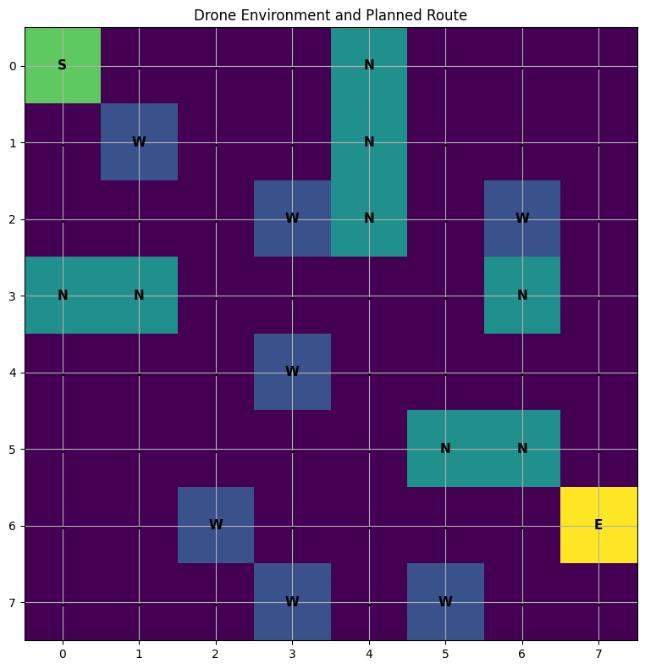
Figure 1 shows the defence drone environment. The start node S is located at (0,0) and the goal node E at (6,7). No-Fly Zones (N) are treated as obstacles while Weather Hazard cells (W) have higher traversal cost.

7. Final Path Visualization
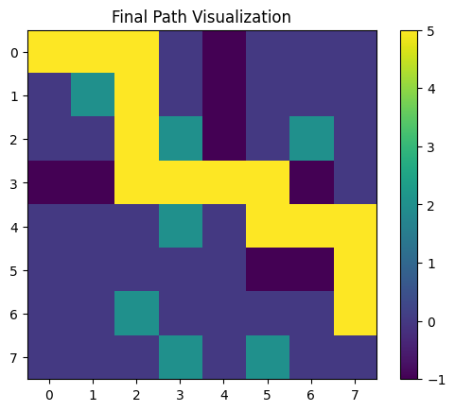
Figure 2 shows the final path discovered by the algorithm. The selected route successfully reaches the goal while avoiding all No-Fly Zones and Weather Hazard cells. The resulting path cost is 16 with a path length of 13 moves.

8. Heuristic Value Analysis
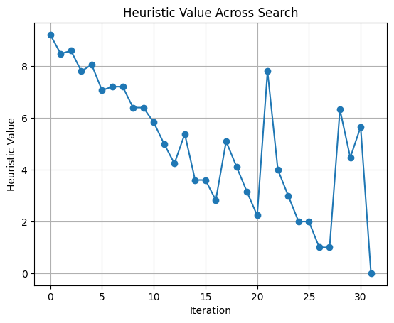
Figure 3 illustrates the heuristic values across node expansions. The overall decreasing trend indicates that the search progressively moves closer to the goal state. Temporary increases occur when alternative frontier nodes are evaluated before selecting the optimal direction.

9. Final Environment with Path
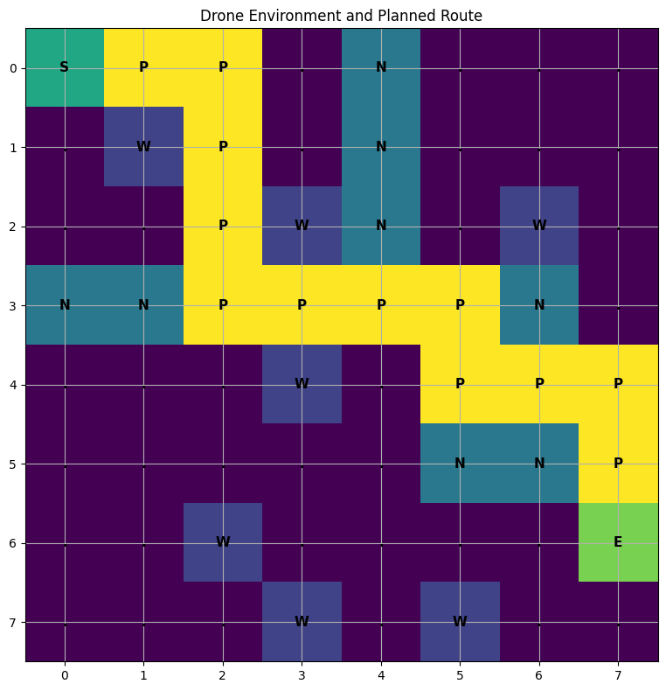
Figure 4 overlays the discovered path on the original environment. The route avoids restricted regions and reaches the target efficiently.

10. Experimental Results
Metric | GBFS-h1 | GBFS-h2 | A*-h1 | Remarks
Nodes Expanded | 14 | 14 | 32 | A* explores more nodes
Path Cost | 19 | 19 | 16 | A* finds lower-cost path
Path Length | 13 | 13 | 13 | Equal
Memory Usage | 23 | 28 | 43 | A* uses more memory

11. Actual Output Summary (A*-h1)
Status: SUCCESS
Nodes Expanded: 32
Runtime: 0.445863 ms
Path Length: 13
Path Cost: 16
Memory Usage: 43
Weather Hazards Crossed: 0
No-Fly Zones Crossed: 0
Penalty Incurred: 0

12. Complexity Analysis
GBFS Time Complexity: O(E log V), Space Complexity: O(V).
A* Time Complexity: O(E log V), Space Complexity: O(V).

13. Trap Analysis
No dead-end situations or infinite loops were encountered. The explored frontier always contained a valid path toward the goal.

14. GBFS vs A* Comparison
GBFS expanded fewer nodes and completed the search faster. However, A* produced the optimal path with the lowest path cost (16). A* is complete and optimal whereas GBFS does not guarantee optimality.

15. Alternate Problem Modelling
The grid can alternatively be represented as a graph where each cell is a node and adjacent traversable cells form edges. This representation improves scalability and supports advanced graph-search algorithms but increases memory requirements.

16. Conclusion
Both GBFS heuristics successfully reached the target. The A* algorithm produced the best route with cost 16 while maintaining a path length of 13. The study demonstrates the trade-off between speed (GBFS) and optimality (A*).

