1. Project Title

BITS Pilani – Work Integrated Learning Programmes
RecoMart Recommendation System
End-to-End Data Engineering and MLOps Pipeline
DM4DL Assignment
Report Version: v7
Generated: 2026-07-21

2. Team Member Details
S. No. | Name | BITS ID / Email ID
1 | RAMAMURTHY S | 2025ab05099@wilp.bits-pilani.ac.in
2 | MEGHA ASHWIN KANU | 2025ab05130@wilp.bits-pilani.ac.in
3 | RANJITA PATEL | 2025ab05117@wilp.bits-pilani.ac.in
4 | KIRAN KUMAR DEVARA | 2025ab05105@wilp.bits-pilani.ac.in
5 | VIVEK RANJAN UPADHYAY | 2025ab05127@wilp.bits-pilani.ac.in

Table of Contents
Update field in Word to refresh.

3. Problem Statement
Modern digital platforms such as e-commerce, OTT, and music streaming services rely on recommendation systems to deliver personalized user experiences, improve customer engagement, and increase business value. These systems continuously generate large volumes of data from multiple heterogeneous sources, including clickstream logs, transactional purchase history, product catalogs, and external services. Managing this diverse and continuously growing data while maintaining data quality, consistency, scalability, and reliability presents a significant engineering challenge.
RecoMart, an e-commerce startup, aims to build a scalable recommendation platform capable of ingesting, validating, transforming, and managing data from multiple sources to generate reliable features for machine learning models. The platform requires an automated, modular, and maintainable data management pipeline that ensures data freshness, quality, traceability, and reproducibility while enabling continuous model training and updates.
As part of the RecoMart Data Platform Team, this project focuses on designing and implementing an end-to-end data management pipeline that supports both batch and near-real-time data processing. The proposed solution integrates data ingestion, validation, preparation, feature engineering, feature management, model training, experiment tracking, and workflow orchestration to ensure that recommendation models are consistently trained using validated, well-structured, and up-to-date data. The overall objective is to establish a scalable, maintainable, and production-oriented data pipeline aligned with modern data engineering and MLOps best practices.

4. Objectives
- The central motivation is to demonstrate how disciplined data engineering and MLOps practices improve the reliability of recommendation work.
- Source datasets may contain missing values, duplicate events, inconsistent identifiers, invalid ranges, or broken relationships.
- Without explicit validation and quarantine, these defects can silently influence prepared data, engineered features, model training, and reported results.
- RecoMart represents an online retail setting in which users interact with products through views, clicks, ratings, and purchases.
- The business objective is to use these signals to identify relevant items while maintaining trustworthy data, consistent recommendation features, and comparable model results.
- A project team receives MovieLens seed data and produces controlled synthetic retail datasets representing users, products, clickstream activity, purchase history, and popularity information.
- These sources enter a layered pipeline that preserves raw inputs, validates quality, prepares analytical datasets, engineers recommendation features, trains collaborative and content-based models, and records the evidence required to reproduce results.
- Retail recommendation systems must convert fragmented behavioral and catalogue data into relevant product suggestions.
- RecoMart addresses this challenge by building an end-to-end recommendation pipeline that combines user activity, product information, clickstream events, purchase history, ratings, and popularity signals.
- The academic problem is broader than training a model: the project must ensure that heterogeneous inputs can be collected, checked, transformed, and used consistently throughout the recommendation lifecycle.

5. Methodology / Pipeline
Architecture applies across all stages; stage-specific details live under RecoMart uses a layered batch architecture with ports and adapters. MLflow is not the source of truth for pipeline batch status. Airflow creates a pipeline run_id and locks or claims the batch. MLflow failure prevents model-stage completion but does not erase trained Feature-store registration, lineage, and MLflow tracking occur at their relevant A stage idempotency key is derived from the stage name, input checksums, Captures stage-level execution attempts, including task name, attempt number,
Airflow metadata database is not a substitute for this domain record. Tracks registered versions, model-run source, stage or alias, approval status, Asset registration and successful stage status are committed together after Destructive changes require staged migration and explicit approval. RecoMart is an enterprise-style data management and machine-learning pipeline for Use Apache Airflow solely to schedule and orchestrate processing. Track parameters, metrics, artifacts, and model versions in MLflow. Portability: local MinIO/PostgreSQL/MLflow and cloud equivalents use the same
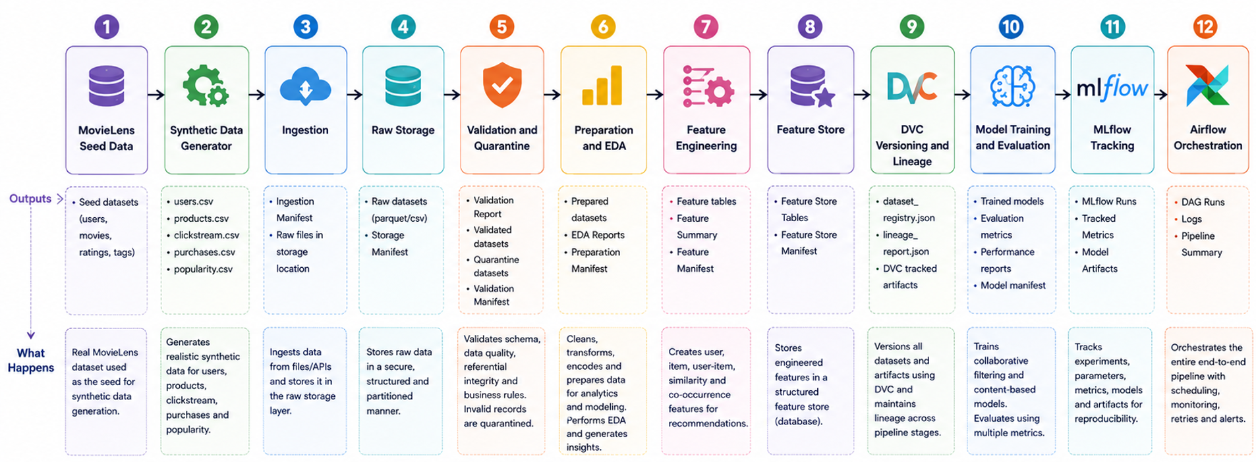
Figure: RecoMart End-to-End Data Management and MLOps Pipeline

MovieLens Seed Data
Provides the base user, product, rating, and interaction data used by the synthetic data generator.

Synthetic Data Generation
Generates users, products, clickstream events, purchase history, and popularity data for repeatable pipeline execution.

Data Ingestion
Collects CSV, JSON, and REST API data and publishes immutable source records with ingestion manifests.

Raw Storage
Preserves ingested source data in its original format using partitioned local or S3-compatible storage.

Validation and Quarantine
Profiles datasets, applies schema and business rules, and separates valid records from rejected records.

Data Preparation and EDA
Cleans and standardizes validated data, creates analytical datasets, and produces exploratory data-analysis outputs.

Feature Engineering
Creates reproducible user, item, user-item, co-occurrence, and similarity features.

Feature Store
Persists versioned feature definitions and materializations for consistent training and retrieval.

DVC Versioning and Lineage
Versions datasets and artifacts while maintaining traceability across pipeline stages.

Model Training and Evaluation
Trains collaborative-filtering and content-based recommendation models and evaluates their performance.

MLflow Experiment Tracking
Records model parameters, metrics, run identifiers, and generated model artifacts.

Apache Airflow Orchestration
Coordinates the complete pipeline while keeping business logic inside reusable application modules.

6. Implementation Details

6.1 Synthetic Data Generation
Purpose: do not quarantine; dependent rules are SKIPPED when required inputs are absent.
Implementation Summary: outputs exist, but ERROR failures or invalid rows were found. destination raises a conflict; outputs are never silently overwritten.
Technology Used: DVC
Input: do not quarantine; dependent rules are SKIPPED when required inputs are absent.
Output: outputs exist, but ERROR failures or invalid rows were found.

6.2 Data Ingestion
Purpose: Supports data ingestion in the RecoMart lifecycle.
Implementation Summary: Implemented as a modular pipeline component using repository-defined contracts.
Technology Used: Python
Input: Validated upstream project data and configuration.
Output: Versioned downstream artifacts for the next pipeline stage.

6.3 Raw Storage
Purpose: feature and prepared checksum to its output table.
Implementation Summary: SHA-256 proves content identity between source/response and raw output.
Output: feature and prepared checksum to its output table.

6.4 Data Validation and Quarantine
Purpose: outputs exist, but ERROR failures or invalid rows were found.
Implementation Summary: destination raises a conflict; outputs are never silently overwritten. validated outputs and may decide how to correct or impute data.

6.5 Data Preparation and EDA
Purpose: Supports data preparation and eda in the RecoMart lifecycle.

6.6 Feature Engineering
Purpose: Feature engineering converts prepared MovieLens entities into reproducible,
Implementation Summary: Changing meaning, inputs, or calculation requires a new definition version. versions, as-of time, configuration version, and code version.
Input: Changing meaning, inputs, or calculation requires a new definition version.

6.7 Feature Store
Purpose: Supports feature store in the RecoMart lifecycle.

6.8 DVC Versioning and Lineage
Purpose: Reproducibility requires the exact input bytes, transformation configuration,
Implementation Summary: registry DVC output is persistent so version history survives dvc repro.
Input: Reproducibility requires the exact input bytes, transformation configuration,
Output: registry DVC output is persistent so version history survives dvc repro.

6.9 Model Training and Evaluation
Purpose: A model package includes the estimator, fitted preprocessing, input/output
Implementation Summary: similar_items(product_id, top_k) with the same output schema and also The implementation is deterministic biased Funk SVD, a matrix-factorization
Input: A model package includes the estimator, fitted preprocessing, input/output
Output: A model package includes the estimator, fitted preprocessing, input/output

6.10 Apache Airflow Orchestration
Purpose: Supports apache airflow orchestration in the RecoMart lifecycle.

7. Results and Output Screenshots

7.1 Problem Formulation
- A short report outlining the problem definition, objectives, data sources, and expected pipeline outcomes.
Evidence not available at report-generation time.
This document defines how data advances through RecoMart. The layer order is mandatory:
Incoming → Raw → Validated → Prepared → Features → Models → Reports

7.2 Data Collection and Ingestion
- Python scripts for ingestion.
- Logs showing ingestion success or failure.
- Folder or bucket structure for raw data.

src/ingestion/__init__.py
﻿"""Incoming-source ingestion and immutable raw-storage publication."""

logs/modeling/model_training.log
{"timestamp": "2026-07-18T23:00:53.909Z", "log_level": "INFO", "module": "src.modeling.runner", "message": "Training started", "model_run_id": "MODEL_20260718_230052_63cb86", "feature_batch_id": "FEAT_20260718_224621_d4f3c8", "operation": "training_run", "status": "STARTED"}
{"timestamp": "2026-07-18T23:01:24.010Z", "log_level": "INFO", "module": "src.modeling.runner", "message": "Training started", "model_run_id": "MODEL_20260718_230123_b4e2ba", "feature_batch_id": "FEAT_20260718_224621_d4f3c8", "operation": "training_run", "status": "STARTED"}
{"timestamp": "2026-07-18T23:01:53.266Z", "log_level": "INFO", "module": "src.modeling.runner", "message": "Training started", "model_run_id": "MODEL_20260718_230152_ffa5c0", "feature_batch_id": "FEAT_20260718_224621_d4f3c8", "operation": "training_run", "status": "STARTED"}
{"timestamp": "2026-07-18T23:02:18.672Z", "log_level": "INFO", "module": "src.modeling.runner", "message": "Training started", "model_run_id": "MODEL_20260718_230218_21cb49", "feature_batch_id": "FEAT_20260718_224621_d4f3c8", "operation": "training_run", "status": "STARTED"}
{"timestamp": "2026-07-18T23:02:24.018Z", "log_level": "INFO", "module": "src.modeling.runner", "message": "Collaborative training finished", "model_run_id": "MODEL_20260718_230218_21cb49", "feature_batch_id": "FEAT_20260718_224621_d4f3c8", "model_name": "FunkSVD", "operation": "train_model", "status": "SUCCESS", "duration_ms": 1592.4740000627935}
{"timestamp": "2026-07-18T23:02:25.069Z", "log_level": "INFO", "module": "src.modeling.runner", "message": "Content training finished", "model_run_id": "MODEL_20260718_230218_21cb49", "feature_batch_id": "FEAT_20260718_224621_d4f3c8", "model_name": "cosine_content", "operation": "train_model", "status": "SUCCESS", "duration_ms": 18.510299967601895}
{"timestamp": "2026-07-18T23:02:25.118Z", "log_level": "INFO", "module": "src.modeling.runner", "message": "Training completed", "model_run_id": "MODEL_20260718_230218_21cb49", "feature_batch_id": "FEAT_20260718_224621_d4f3c8", "operation": "training_run", "status": "SUCCESS", "duration_ms": 6883.15}
{"timestamp": "2026-07-18T23:12:47.258Z", "log_level": "INFO", "module": "src.modeling.runner", "message": "Training started", "model_run_id": "MODEL_20260718_231246_7a56d5", "feature_batch_id": "FEAT_20260718_224621_d4f3c8", "operation": "training_run", "status": "STARTED"}
{"timestamp": "2026-07-18T23:12:52.448Z", "log_level": "INFO", "module": "src.modeling.runner", "message": "Collaborative training finished", "model_run_id": "MODEL_20260718_231246_7a56d5", "feature_batch_id": "FEAT_20260718_224621_d4f3c8", "model_name": "FunkSVD", "operation": "train_model", "status": "SUCCESS", "duration_ms": 1510.754100047052}
{"timestamp": "2026-07-18T23:12:53.495Z", "log_level": "INFO", "module": "src.modeling.runner", "message": "Content training finished", "model_run_id": "MODEL_20260718_231246_7a56d5", "feature_batch_id": "FEAT_20260718_224621_d4f3c8", "model_name": "cosine_content", "operation": "train_model", "status": "SUCCESS", "duration_ms": 17.667900072410703}
{"timestamp": "2026-07-18T23:12:53.550Z", "log_level": "INFO", "module": "src.modeling.runner", "message": "Training completed", "model_run_id": "MODEL_20260718_231246_7a56d5", "feature_batch_id": "FEAT_20260718_224621_d4f3c8", "operation": "training_run", "status": "SUCCESS", "duration_ms": 6724.64}
{"timestamp": "2026-07-19T00:18:41.920Z", "log_level": "INFO", "module": "src.modeling.runner", "message": "Training started", "model_run_id": "MODEL_20260719_001840_f296c8", "feature_batch_id": "FEAT_20260719_001600_ff752a", "operation": "training_run", "status": "STARTED"}
{"timestamp": "2026-07-19T00:18:50.028Z", "log_level": "INFO", "module": "src.modeling.runner", "message": "Collaborative training finished", "model_run_id": "MODEL_20260719_001840_f296c8", "feature_batch_id": "FEAT_20260719_001600_ff752a", "model_name": "FunkSVD", "operation": "train_model", "status": "SUCCESS", "duration_ms": 1943.0364840081893}
{"timestamp": "2026-07-19T00:18:52.873Z", "log_level": "INFO", "module": "src.modeling.runner", "message": "Content training finished", "model_run_id": "MODEL_20260719_001840_f296c8", "feature_batch_id": "FEAT_20260719_001600_ff752a", "model_name": "cosine_content", "operation": "train_model", "status": "SUCCESS", "duration_ms": 5.672899016644806}
{"timestamp": "2026-07-19T00:18:52.897Z", "log_level": "INFO", "module": "src.modeling.runner", "message": "Training completed", "model_run_id": "MODEL_20260719_001840_f296c8", "feature_batch_id": "FEAT_20260719_001600_ff752a", "operation": "training_run", "status": "SUCCESS", "duration_ms": 12834.48}
data/incoming/
- .gitkeep
- clickstream.csv
- popularity.json
- products.json
- purchasehistory.csv
- users.csv
data/raw/
- .gitkeep
+ api
+ popularity
+ ingestion_date=2026-07-18
+ ingestion_date=2026-07-19
+ ingestion_date=2026-07-20
+ file
+ clickstream
+ ingestion_date=2026-07-18
+ ingestion_date=2026-07-19
+ ingestion_date=2026-07-20
+ products
+ ingestion_date=2026-07-18
+ ingestion_date=2026-07-19
+ ingestion_date=2026-07-20
+ purchasehistory
+ ingestion_date=2026-07-18
+ ingestion_date=2026-07-19
+ ingestion_date=2026-07-20
+ users
+ ingestion_date=2026-07-18
+ ingestion_date=2026-07-19
+ ingestion_date=2026-07-20
+ manifests
+ ingestion_date=2026-07-18
+ ingestion_hour=21
+ ingestion_date=2026-07-19
+ ingestion_hour=00
+ ingestion_date=2026-07-20
+ ingestion_hour=11
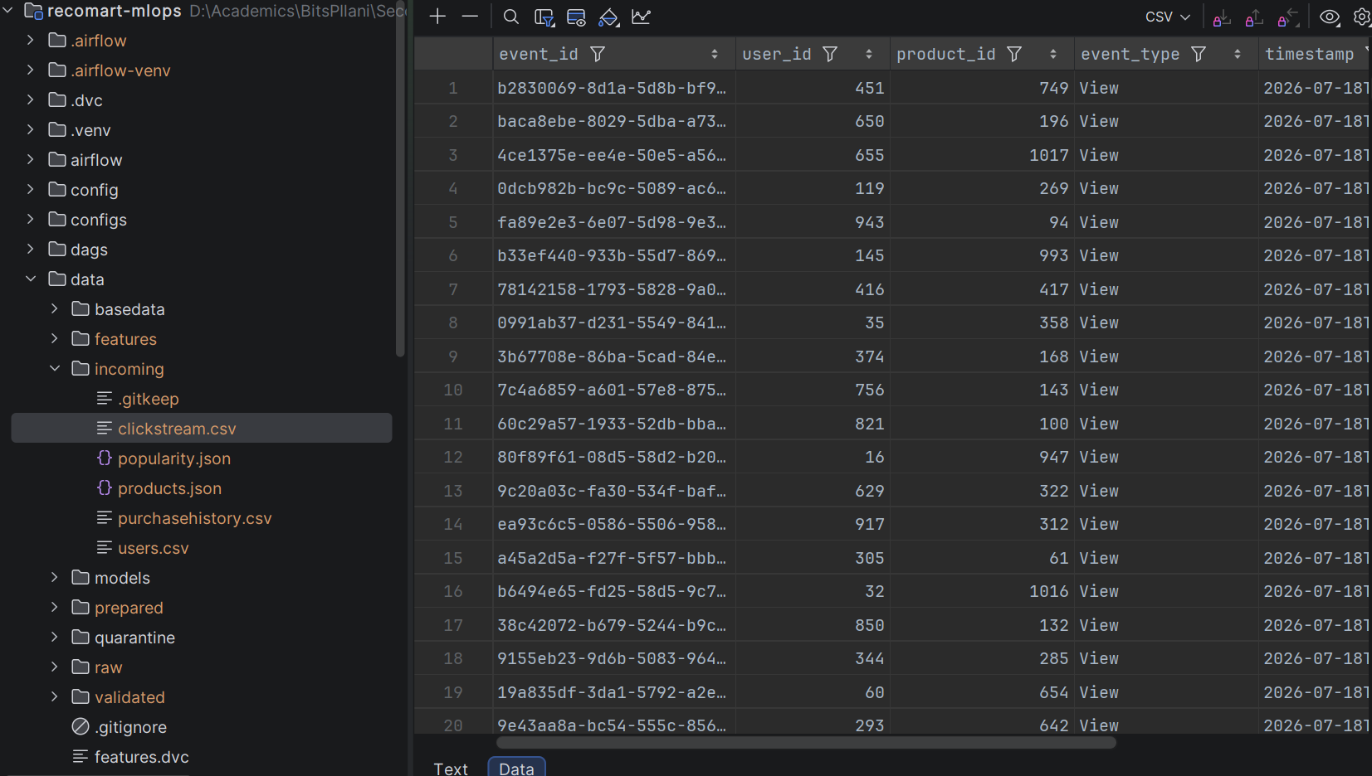
02 Datasets Clickstream
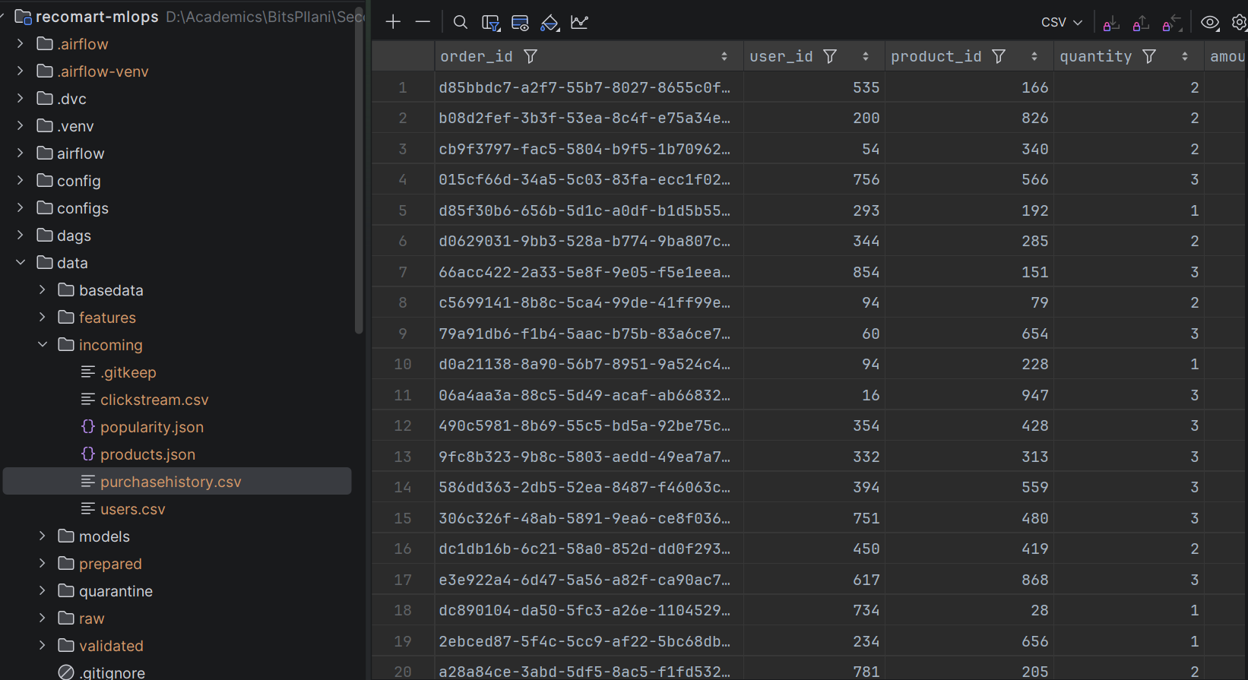
02 Datasets Purchase
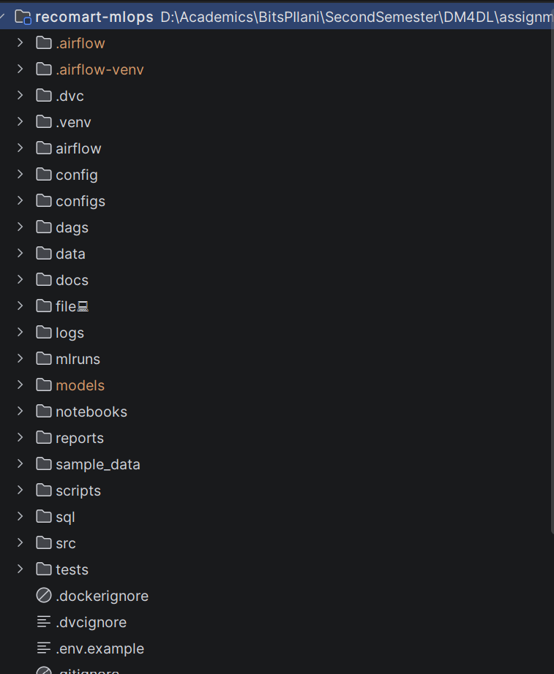
91 Repository Structure

7.3 Raw Storage
- Storage structure documentation.
- Upload scripts or configuration files.
PostgreSQL uses schema recomart_features; SQLite omits qualification. Tables are feature_batch, feature_definition, feature_lineage, user_features, item_features, user_item_features, item_cooccurrence_features, and item_similarity_features.
Primary keys pair feature batch with entity key(s). Pair tables enforce canonical/no-self uniqueness. Index scripts cover user/product lookup, co-occurrence endpoints, ranked similarity, and lineage batch lookup. Views provide latest user/item/user-item features, top similar items, popular items, and active users. PostgreSQL uses JSONB/TIMESTAMPTZ/UUID in versioned SQL; SQLite application tables use compatible TEXT/timestamp values.
SQL assets are under sql/feature_store/.
SELECT user_id, total_interactions, interaction_frequency_per_day
FROM recomart_features.latest_user_features
ORDER BY total_interactions DESC LIMIT 20;

src/feature_engineering/storage.py
﻿"""Transactional PostgreSQL/SQLite feature warehouse persistence."""
from __future__ import annotations
import json
from typing import Any
import pandas as pd
from sqlalchemy import create_engine, inspect, text
from sqlalchemy.engine import Engine, make_url
from src.feature_engineering.config import FeatureConfig
from src.feature_engineering.errors import (
DatabaseInitializationError,
FeatureConflictError,
FeaturePersistenceError,
)
from src.feature_engineering.features import FeatureFrames
data/
- .gitignore
+ basedata
+ ml-100k
+ ml-100k
+ features
- features.dvc
- .gitkeep
+ feature_date=2026-07-18
+ feature_hour=22
+ feature_date=2026-07-19
+ feature_hour=00
+ feature_date=2026-07-20
+ feature_hour=11
+ incoming
- incoming.dvc
- .gitkeep
- clickstream.csv
- popularity.json
- products.json
- purchasehistory.csv
- users.csv
+ models
- .gitkeep
+ prepared
- prepared.dvc
- .gitkeep
+ processing_date=2026-07-18
+ processing_hour=22
+ processing_date=2026-07-19
+ processing_hour=00
+ processing_date=2026-07-20
+ processing_hour=11
+ quarantine
+ clickstream
+ validation_date=2026-07-18
+ validation_date=2026-07-19
+ validation_date=2026-07-20
+ popularity
+ validation_date=2026-07-18
+ validation_date=2026-07-19
+ validation_date=2026-07-20
+ products
+ validation_date=2026-07-18
+ validation_date=2026-07-19
+ validation_date=2026-07-20
+ purchasehistory
+ validation_date=2026-07-18
+ validation_date=2026-07-19
+ validation_date=2026-07-20
+ users
+ validation_date=2026-07-18
+ validation_date=2026-07-19
+ validation_date=2026-07-20
+ raw
- raw.dvc
- .gitkeep
+ api
+ popularity
+ file
+ clickstream
+ products
+ purchasehistory
+ users
+ manifests
+ ingestion_date=2026-07-18
+ ingestion_date=2026-07-19
+ ingestion_date=2026-07-20
- recomart_features.db
+ validated
- validated.dvc
- .gitkeep
+ clickstream
+ validation_date=2026-07-18
+ validation_date=2026-07-19
+ validation_date=2026-07-20
+ popularity
+ validation_date=2026-07-18
+ validation_date=2026-07-19
+ validation_date=2026-07-20
+ products
+ validation_date=2026-07-18
+ validation_date=2026-07-19
+ validation_date=2026-07-20
+ purchasehistory
+ validation_date=2026-07-18
+ validation_date=2026-07-19
+ validation_date=2026-07-20
+ users
+ validation_date=2026-07-18
+ validation_date=2026-07-19
+ validation_date=2026-07-20
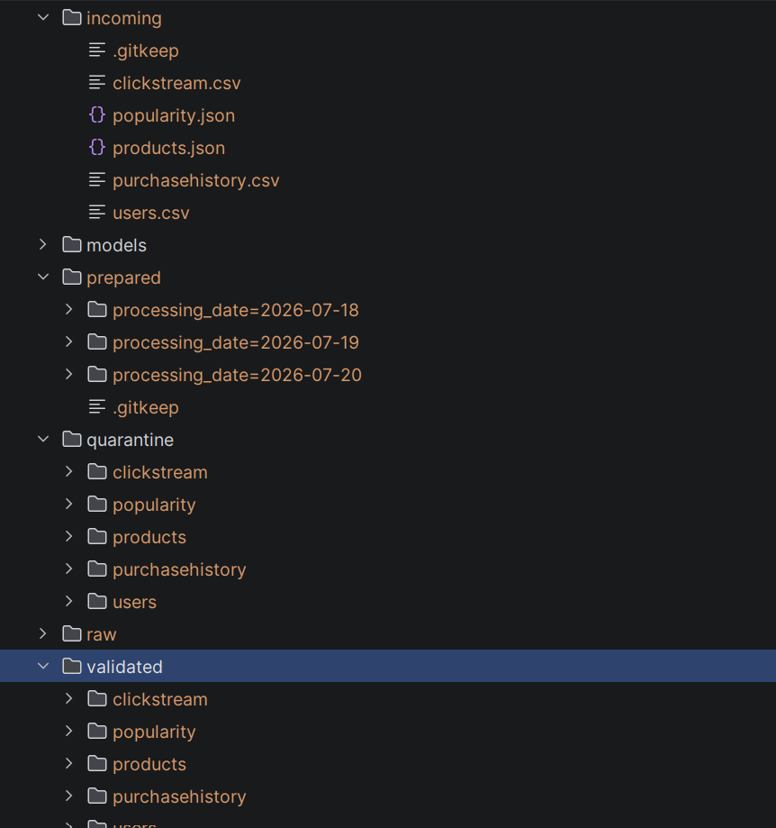
03 Raw Storage Structure

7.4 Data Profiling and Validation
- Python code for automated validation.
- Data profiling and validation summary.
- Data Quality Report.

src/validation/__init__.py
﻿"""Manifest-driven data profiling, validation, and quality reporting."""
Data Quality Report (reports/data_quality/validation_date=2026-07-20/validation_hour=11/batch_id=RECO_20260720_114419_07a4ea/data_quality_report.pdf)
Measure | Value
report_version | 1.0
batch_id | RECO_20260720_114419_07a4ea
validation_run_id | 783f6b75-cc0c-44e8-b506-41e2cc56f51f
correlation_id | 7c49b49a-9628-4df5-a6ff-c9a249e176ac
started_at | 2026-07-20T11:44:23Z
completed_at | 2026-07-20T11:44:34Z
status | SUCCESS
raw_manifest_path | /opt/airflow/project/data/raw/manifests/ingestion_date=2026-07-20/ingestion_hour=11/batch_id=RECO_20260720_114419_07a4ea/ingestion_manifest.json
configuration_version | 1.0
configuration_sha256 | cc80a1504db439745d7b9c525d1624bba948a217f7a94eb0bb673ec6f1c0dba4
quality_score_formula.completeness_weight | 0.3
quality_score_formula.uniqueness_weight | 0.2
quality_score_formula.validity_weight | 0.3
quality_score_formula.consistency_weight | 0.2
executive_summary.datasets_checked | 5
executive_summary.total_records | 236258
executive_summary.valid_records | 236258
executive_summary.invalid_records | 0
executive_summary.failed_rules | 0
executive_summary.warnings | 0
executive_summary.skipped_rules | 0
executive_summary.overall_quality_score | 100.0
datasets | [{"dataset_type": "users", "source_path": "/opt/airflow/project/data/raw/file/users/ingestion_date=2026-07-20/ingestion_hour=11/batch_id=RECO_20260720_114419_07a4ea/users.csv", "source_sha256": "ee69449c77829ab864d2139a593b9ea726938be59ae7494ab676260e2f6e76f9", "file_type": "csv", "total_records": 943, "valid_records": 943, "invalid_records": 0, "quality_score": 100.0, "component_scores": {"completeness_score": 100.0, "uniqueness_score": 100.0, "validity_score": 100.0, "consistency_score": 100.0
cross_dataset_rules | [{"rule_id": "CLICKSTREAM_USER_REFERENCE", "rule_name": "Foreign key exists in parent dataset", "dataset_type": "clickstream", "column_name": "user_id", "category": "Referential Integrity", "severity": "ERROR", "status": "PASSED", "records_checked": 176576, "failed_record_count": 0, "failure_percentage": 0.0, "message": "user_id must exist in users.user_id.", "sample_failed_values": []}, {"rule_id": "CLICKSTREAM_PRODUCT_REFERENCE", "rule_name": "Foreign key exists in parent dataset", "dataset_ty
recommendations | []
technical_errors | []
validation_configuration.validation.config_version | 1.0
validation_configuration.validation.fail_fast | False
validation_configuration.validation.strict_quality | False
validation_configuration.validation.sample_error_count | 5
validation_configuration.validation.future_timestamp_tolerance_minutes | 5
validation_configuration.validation.popularity_max_age_hours | 168
validation_configuration.paths.raw | data/raw
validation_configuration.paths.validated | data/validated
validation_configuration.paths.quarantine | data/quarantine
validation_configuration.paths.reports | reports/data_quality
validation_configuration.quality_score.completeness_weight | 0.3
validation_configuration.quality_score.uniqueness_weight | 0.2
validation_configuration.quality_score.validity_weight | 0.3
validation_configuration.quality_score.consistency_weight | 0.2
validation_configuration.users.required_columns | ["user_id", "age", "gender", "occupation", "zipcode", "registration_date", "customer_segment"]
validation_configuration.users.age.minimum | 1
validation_configuration.users.age.maximum | 120
validation_configuration.users.allowed_genders | ["M", "F"]
validation_configuration.users.allowed_segments | ["Premium", "Gold", "Silver", "Standard"]
validation_configuration.products.required_columns | ["product_id", "product_name", "category", "release_date", "price", "brand", "average_rating", "total_ratings"]
validation_configuration.products.minimum_price | 0.01
validation_configuration.products.rating.minimum | 1
validation_configuration.products.rating.maximum | 5
validation_configuration.products.rating.unrated_value | 0
validation_configuration.clickstream.required_columns | ["event_id", "user_id", "product_id", "event_type", "timestamp", "session_id"]
validation_configuration.clickstream.allowed_event_types | ["View", "Wishlist", "AddToCart"]
validation_configuration.purchasehistory.required_columns | ["order_id", "user_id", "product_id", "quantity", "amount", "rating", "purchase_timestamp"]
validation_configuration.purchasehistory.quantity.minimum | 1
validation_configuration.purchasehistory.quantity.maximum | 100
validation_configuration.purchasehistory.rating.minimum | 1
validation_configuration.purchasehistory.rating.maximum | 5
validation_configuration.purchasehistory.rating.purchase_minimum_rating | 4
validation_configuration.purchasehistory.amount_tolerance | 0.01
validation_configuration.popularity.required_columns | ["product_id", "average_rating", "total_ratings", "popularity_score", "trend", "updated_at"]
validation_configuration.popularity.score.minimum | 0
validation_configuration.popularity.score.maximum | 100
validation_configuration.popularity.rating.minimum | 1
validation_configuration.popularity.rating.maximum | 5
validation_configuration.popularity.rating.unrated_value | 0
validation_configuration.popularity.allowed_trends | ["UP", "DOWN"]
validation_configuration.popularity.rating_tolerance | 0.01
validation_configuration.popularity.total_ratings_tolerance | 0
validation_configuration.logging.level | INFO
validation_configuration.logging.directory | logs/validation
validation_configuration.logging.filename | validation.log
validation_configuration.logging.max_bytes | 5242880
validation_configuration.logging.backup_count | 5
artifacts.pdf_report | /opt/airflow/project/reports/data_quality/validation_date=2026-07-20/validation_hour=11/batch_id=RECO_20260720_114419_07a4ea/data_quality_report.pdf
artifacts.json_summary | /opt/airflow/project/reports/data_quality/validation_date=2026-07-20/validation_hour=11/batch_id=RECO_20260720_114419_07a4ea/data_quality_summary.json

7.5 Data Preparation
- Jupyter notebook or script demonstrating cleaning and EDA.
- Summary plots such as histograms and heatmaps.
- Prepared dataset ready for transformation.

notebooks/data_preparation_and_eda.ipynb
{
"cells": [
{
"cell_type": "markdown",
"metadata": {},
"source": [
"# RecoMart Data Preparation and EDA\n",
"\n",
"This notebook demonstrates the production preparation pipeline over the latest validated batch. Explicit ratings (1–5) remain separate from implicit weighted feedback. A zero implicit matrix cell or `NaN` explicit rating means no observed interaction—not bad data and not a fabricated rating."
]
},
{
"cell_type": "markdown",
"metadata": {},
"source": ["## Environment and Configuration"]
},
{
"cell_type": "code",
Selected latest partitioned EDA batch: RECO_20260720_114419_07a4ea.
Measure | Value
batch_id | RECO_20260720_114419_07a4ea
preparation_run_id | 7d9cac41-69a4-4d96-9922-e12666b44536
generated_at | 2026-07-20T11:44:39Z
users | 943
products | 1682
interactions | 231951
unique_user_product_pairs | 100000
possible_user_product_pairs | 1586126
density | 0.06304669364224531
sparsity | 0.9369533063577546
interaction_type_counts.View | 100000
interaction_type_counts.AddToCart | 55375
interaction_type_counts.Purchase | 55375
interaction_type_counts.Wishlist | 21201
rating_distribution.4 | 34174
rating_distribution.5 | 21201
top_products | [{"product_id": 50, "interaction_count": 1910}, {"product_id": 100, "interaction_count": 1547}, {"product_id": 181, "interaction_count": 1436}, {"product_id": 127, "interaction_count": 1329}, {"product_id": 258, "interaction_count": 1329}, {"product_id": 174, "interaction_count": 1318}, {"product_id": 98, "interaction_count": 1259}, {"product_id": 1, "interaction_count": 1213}, {"product_id": 286, "interaction_count": 1208}, {"product_id": 56, "interaction_count": 1170}, {"product_id": 172, "int
top_users | [{"user_id": 450, "interaction_count": 1422}, {"user_id": 13, "interaction_count": 1310}, {"user_id": 416, "interaction_count": 1309}, {"user_id": 276, "interaction_count": 1139}, {"user_id": 7, "interaction_count": 1112}, {"user_id": 303, "interaction_count": 1081}, {"user_id": 59, "interaction_count": 1076}, {"user_id": 405, "interaction_count": 1037}, {"user_id": 846, "interaction_count": 1031}, {"user_id": 592, "interaction_count": 1019}, {"user_id": 130, "interaction_count": 993}, {"user_id
train_records | 162367
validation_records | 34792
test_records | 34792
price_statistics.minimum | 101.82
price_statistics.maximum | 2999.21
price_statistics.mean | 1564.7544827586207
price_statistics.median | 1604.77
price_statistics.p25 | 834.1
price_statistics.p75 | 2312.2875000000004
price_statistics.p95 | 2862.812
interactions_per_user.minimum | 20.0
interactions_per_user.maximum | 1422.0
interactions_per_user.mean | 245.9713679745493
interactions_per_user.median | 159.0
interactions_per_user.p25 | 80.5
interactions_per_user.p75 | 339.0
interactions_per_user.p95 | 701.9
cold_start.cold_start_validation_users | 0
cold_start.cold_start_validation_products | 27
cold_start.cold_start_test_users | 0
cold_start.cold_start_test_products | 25

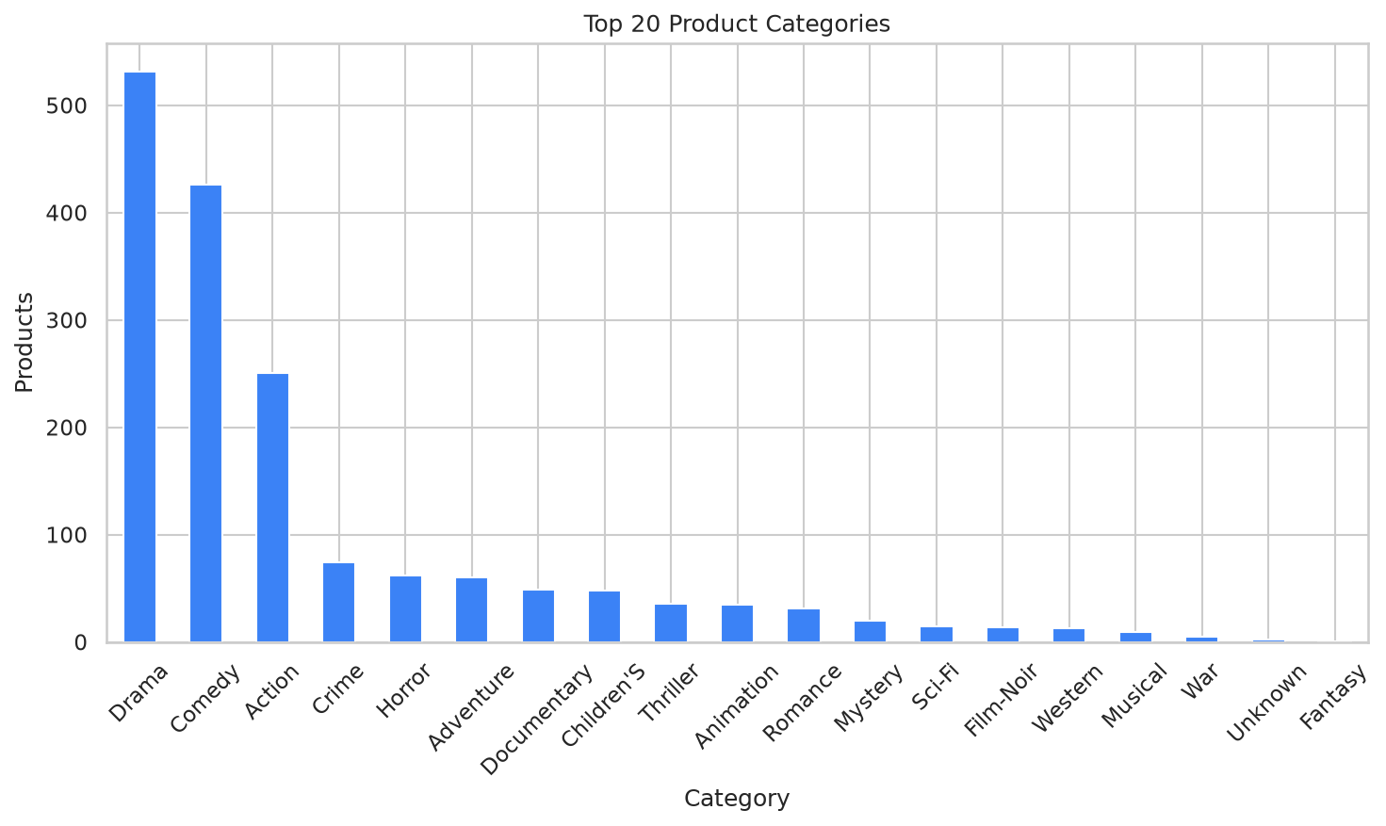
Category Distribution - EDA batch RECO_20260720_114419_07a4ea
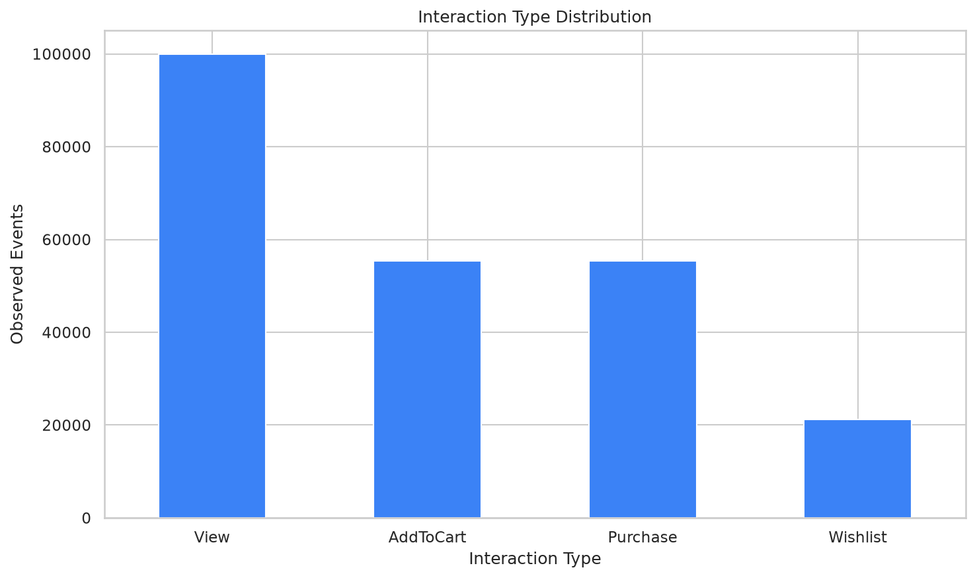
Interaction Type Distribution - EDA batch RECO_20260720_114419_07a4ea
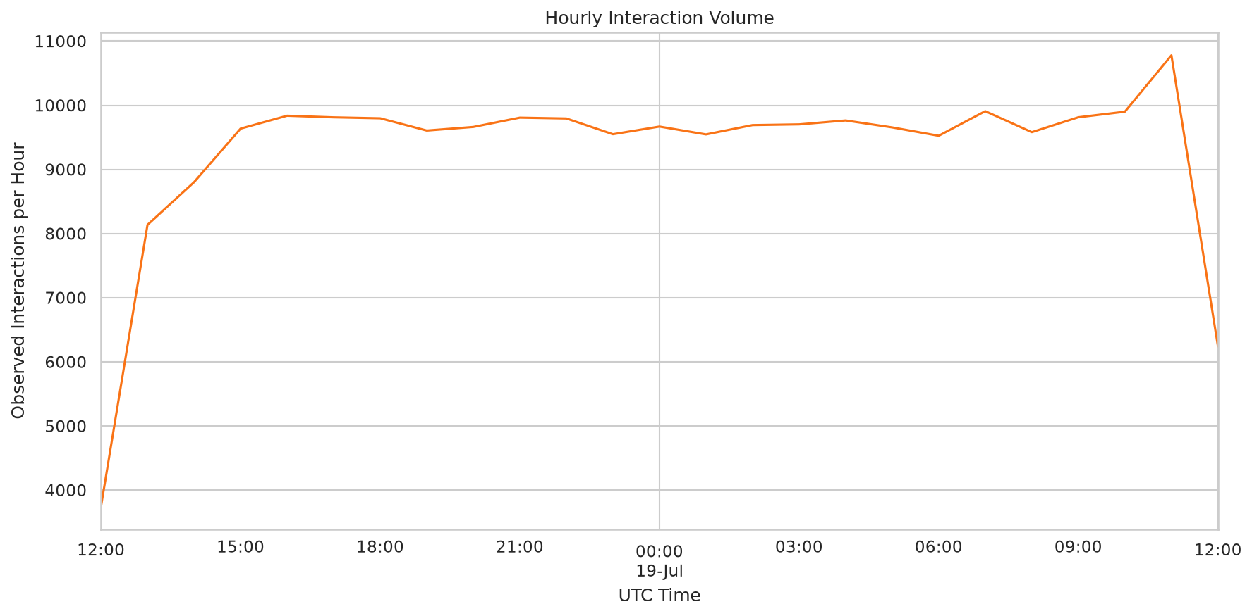
Interactions Over Time - EDA batch RECO_20260720_114419_07a4ea
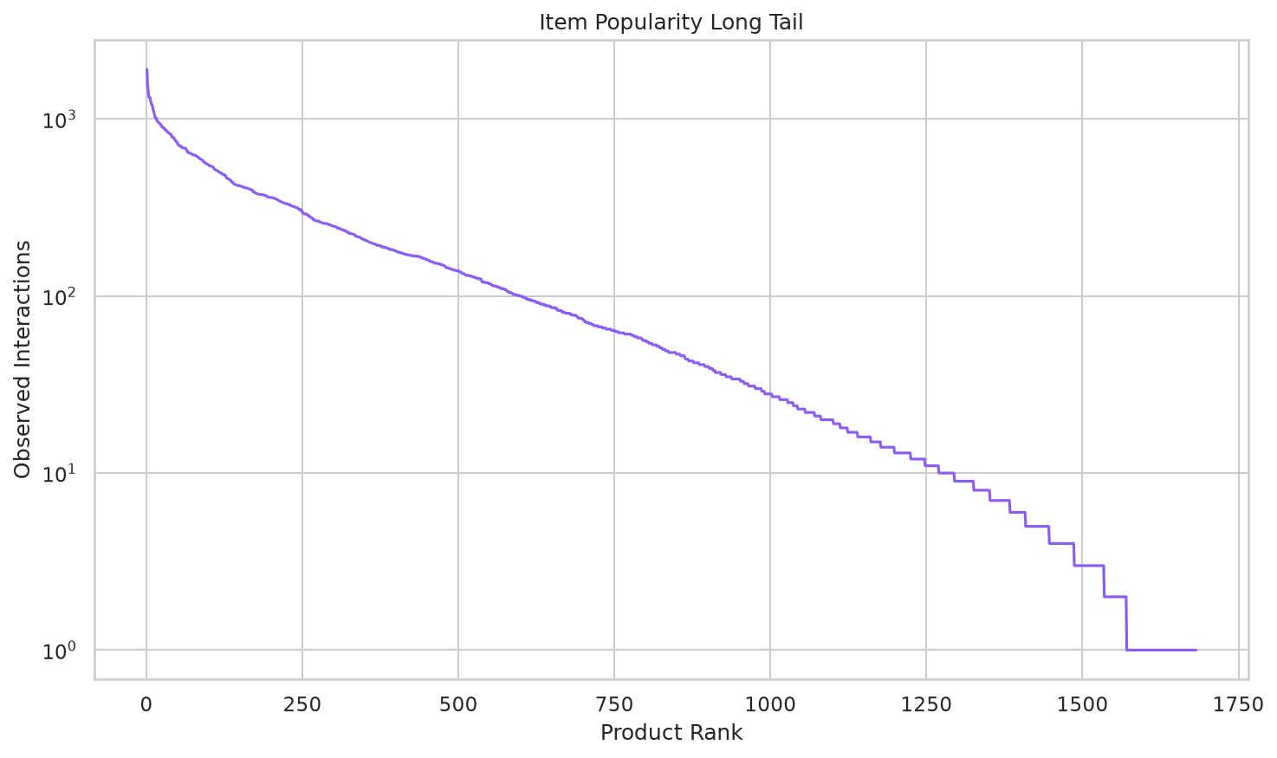
Item Popularity Distribution - EDA batch RECO_20260720_114419_07a4ea
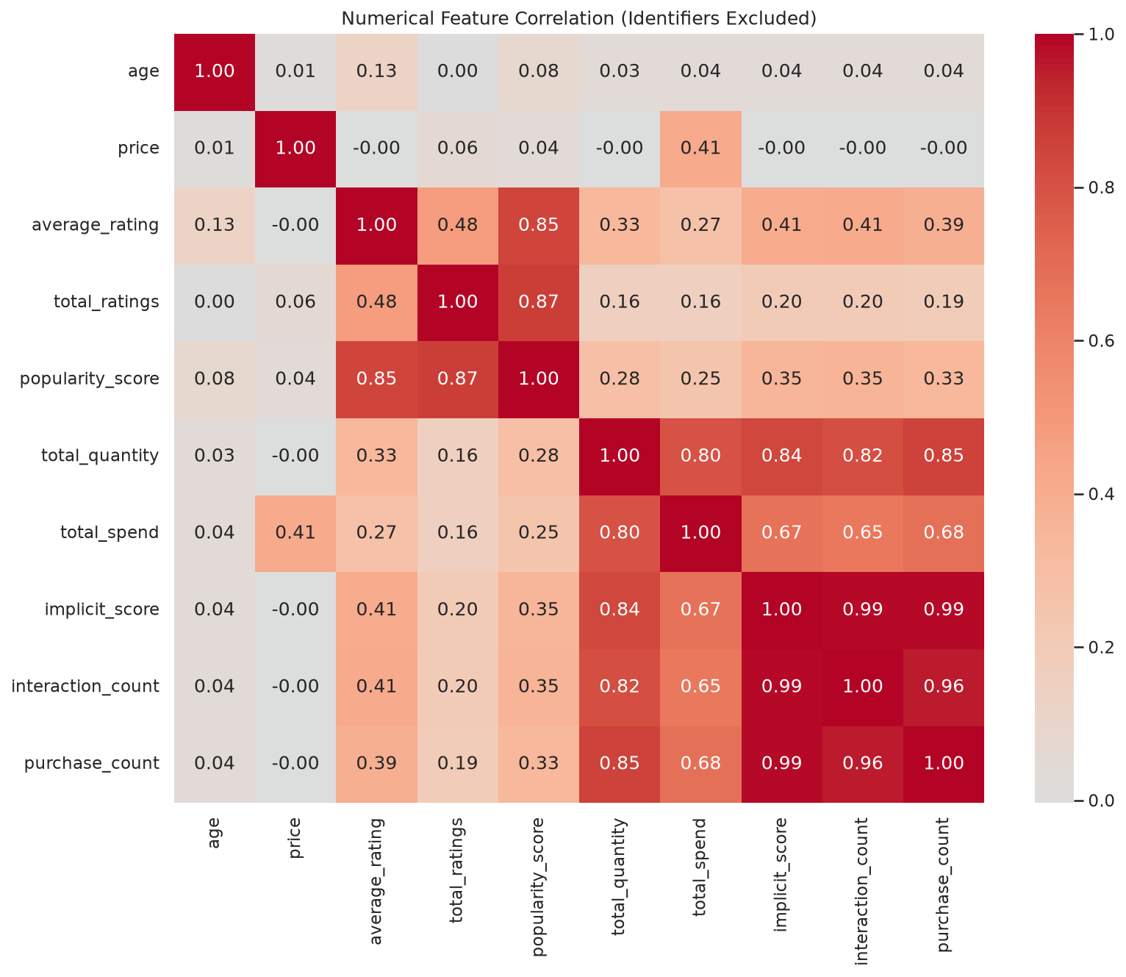
Numerical Correlation Heatmap - EDA batch RECO_20260720_114419_07a4ea
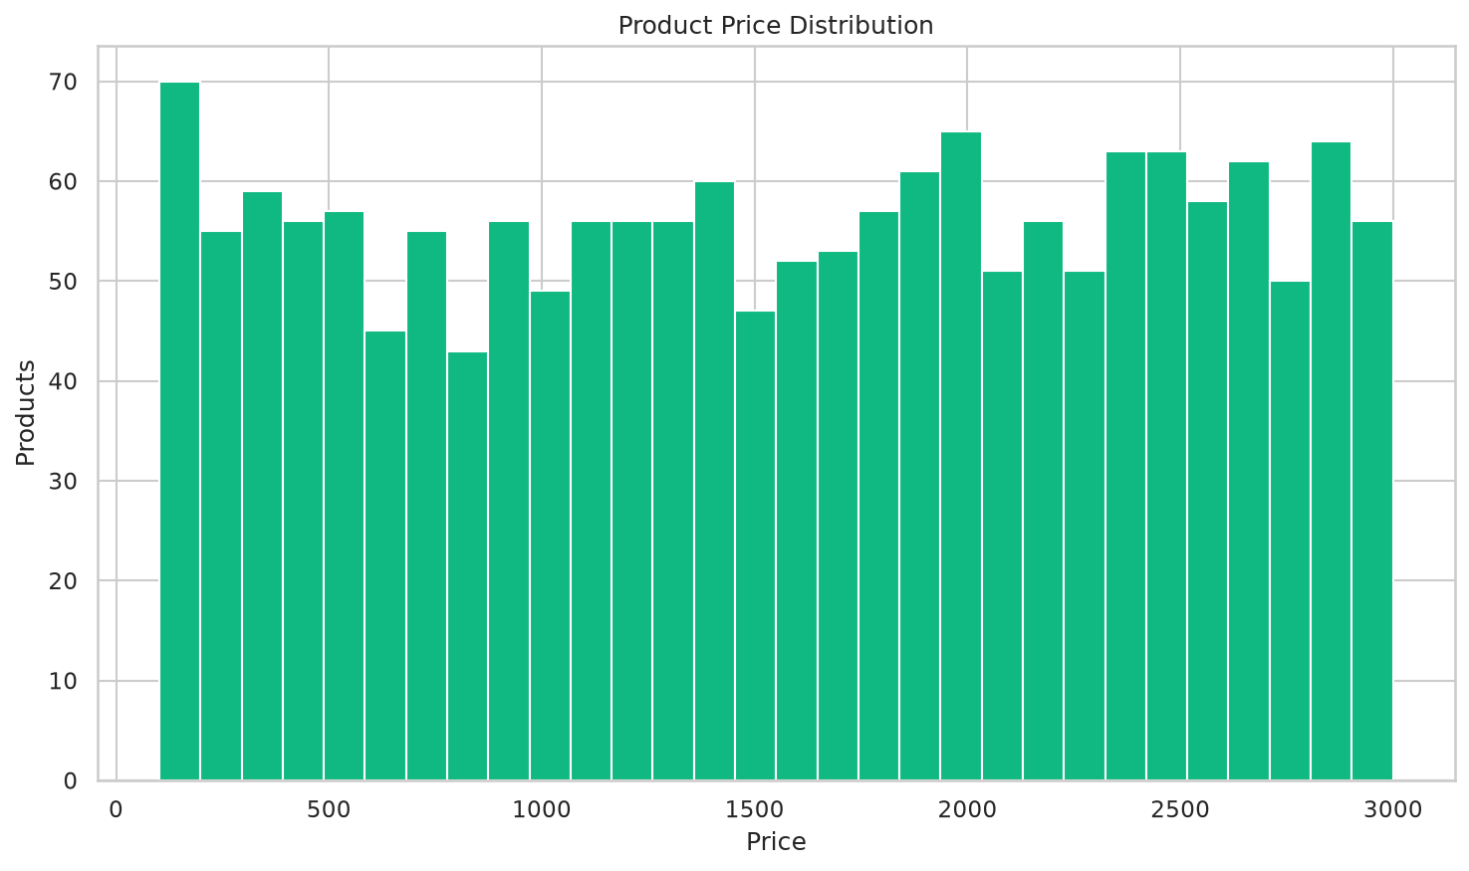
Price Distribution - EDA batch RECO_20260720_114419_07a4ea
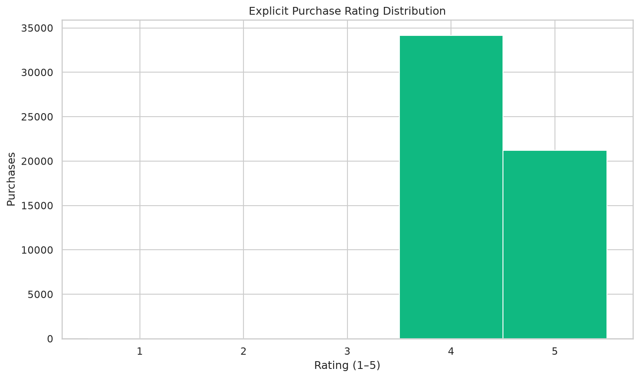
Rating Distribution - EDA batch RECO_20260720_114419_07a4ea
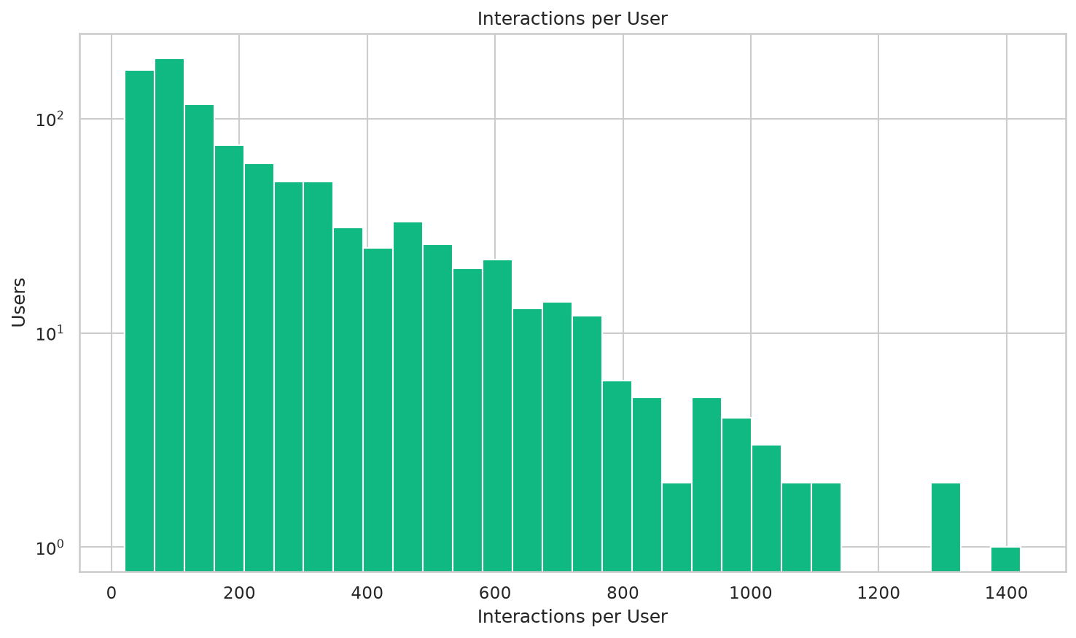
User Interaction Distribution - EDA batch RECO_20260720_114419_07a4ea
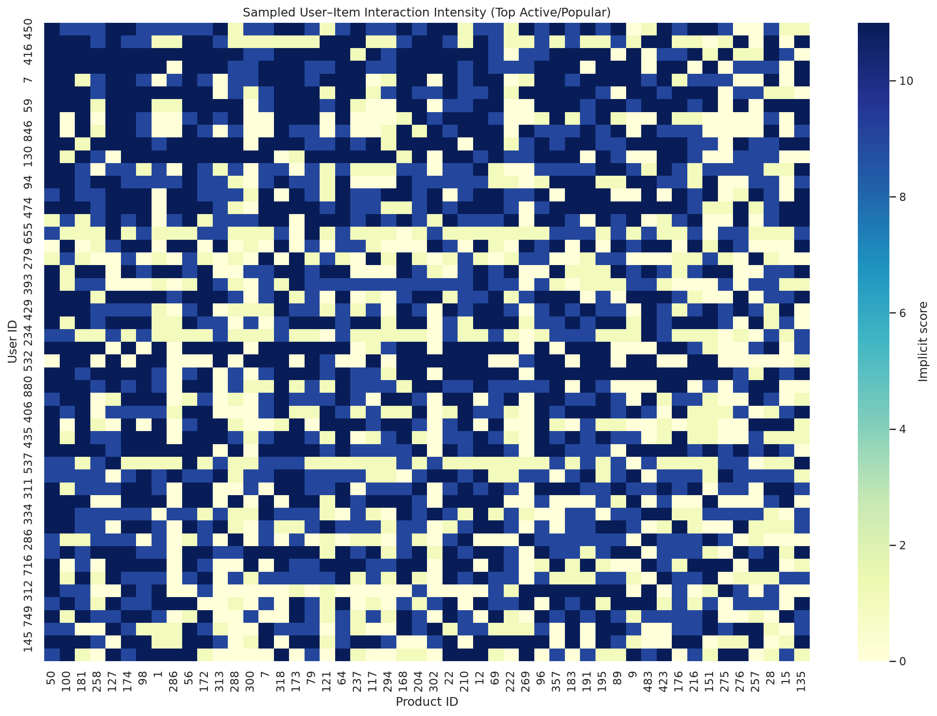
User Item Sparsity Heatmap - EDA batch RECO_20260720_114419_07a4ea
Dataset | Rows | Columns / Type
data\prepared\processing_date=2026-07-18\processing_hour=22\batch_id=RECO_20260718_211004_2ec353\interactions_prepared.parquet | Available | Parquet
data\prepared\processing_date=2026-07-18\processing_hour=22\batch_id=RECO_20260718_211004_2ec353\products_prepared.parquet | Available | Parquet
data\prepared\processing_date=2026-07-18\processing_hour=22\batch_id=RECO_20260718_211004_2ec353\test.parquet | Available | Parquet
data\prepared\processing_date=2026-07-18\processing_hour=22\batch_id=RECO_20260718_211004_2ec353\train.parquet | Available | Parquet
data\prepared\processing_date=2026-07-18\processing_hour=22\batch_id=RECO_20260718_211004_2ec353\user_item_implicit.parquet | Available | Parquet
data\prepared\processing_date=2026-07-18\processing_hour=22\batch_id=RECO_20260718_211004_2ec353\user_item_ratings.parquet | Available | Parquet

7.6 Feature Engineering
- SQL schema.
- Transformation scripts.
- Summary of feature logic.

sql/feature_store/001_create_feature_schema.sql
CREATE SCHEMA IF NOT EXISTS recomart_features;
Features | Type | Logic / source | Null/default
total_interactions, unique_products_interacted | integer | Count events/distinct products | 0
view_count, wishlist_count, add_to_cart_count, purchase_count | integer | Event-type counts | 0
interaction_frequency_per_day | float | total / max(1, observation days) | 0
interaction_frequency_last_7d, interaction_frequency_last_30d | float | Window count / window days | 0
active_days, session_count, average_events_per_session | numeric | Distinct UTC dates/sessions and safe ratio | Ratio null if no sessions
average_rating_given, rating_count, rating_stddev, minimum_rating_given, maximum_rating_given | numeric | Valid non-null explicit ratings only | Statistics null without ratings; count 0
total_quantity_purchased, total_spend | float | Purchase sums | 0
average_order_value, maximum_order_value | float | Purchase amounts | Null without purchase
days_since_last_interaction, days_since_last_purchase | float | Reference minus latest UTC event | Purchase recency null without purchase
user_tenure_days | float | Reference minus registration | Null if registration unavailable
preferred_category, preferred_brand | string | Highest implicit-weight total | Null without events
preferred_interaction_type | string | Highest event count | Null without events
view_to_cart_ratio, cart_to_purchase_ratio, purchase_conversion_rate | float | Safe directional ratios | Null on zero denominator
user_activity_level | string | LOW < q33; HIGH > q66; else MEDIUM | Thresholds persisted
cold_start_user_flag | boolean | total interactions < configured 5 | False/true

Activity/type/unique-user counts, rating statistics, quantity/revenue/order amount, three separate popularity scores, conversion ratios, 7/30-day counts, growth rate, category/brand/price/scaled price/product age, overall/category rank, long-tail flag, and cold-start flag are materialized. Ratings remain null without explicit feedback. Long tail means interaction count below the 80th percentile boundary. Cold start means unique users below 3 or interactions below 5.
Observed-pair interaction/type counts, implicit score, explicit/latest/average rating, quantity/spend, first/last interaction and purchase timestamps, reference-time recencies, average interval, sessions, safe conversion ratios, category affinity, brand affinity, price preference distance, and 1/(1+distance) similarity are materialized. Affinity is category/brand implicit weight divided by the user's total implicit weight.
Source | Type | Location
FEATURE_CATALOG.md | MD | docs\pipeline\feature_engineering\FEATURE_CATALOG.md
FEATURE_ENGINEERING_DESIGN.md | MD | docs\pipeline\feature_engineering\FEATURE_ENGINEERING_DESIGN.md
FEATURE_ENGINEERING_GUIDELINES.md | MD | docs\pipeline\feature_engineering\FEATURE_ENGINEERING_GUIDELINES.md
FEATURE_EXECUTION_GUIDE.md | MD | docs\pipeline\feature_engineering\FEATURE_EXECUTION_GUIDE.md
FEATURE_STORAGE_SCHEMA.md | MD | docs\pipeline\feature_engineering\FEATURE_STORAGE_SCHEMA.md
__init__.py | PY | src\feature_engineering\__init__.py
catalog.py | PY | src\feature_engineering\catalog.py
cli.py | PY | src\feature_engineering\cli.py
config.py | PY | src\feature_engineering\config.py
errors.py | PY | src\feature_engineering\errors.py

7.7 Feature Store
- Feature-store configuration or code.
- Feature metadata documentation.
- Sample feature retrieval demonstration.
Table | Rows | Columns and Datatypes | Primary Key
feature_batch | 3 | feature_batch_id (VARCHAR(80)), source_batch_id (VARCHAR(100)), preparation_run_id (VARCHAR(80)), feature_reference_timestamp (TIMESTAMP), feature_source_split (VARCHAR(10)), started_at (TIMESTAMP), completed_at (TIMESTAMP), status (VARCHAR(30)), user_feature_count (BIGINT), item_feature_count (BIGINT), user_item_feature_count (BIGINT), cooccurrence_feature_count (BIGINT), similarity_feature_count (BIGINT), configuration_hash (VARCHAR(64)), source_checksum (VARCHAR(64)), identity_hash (VARCHAR(64)), error_message (TEXT), created_at (TIMESTAMP) | feature_batch_id
feature_definition | 94 | feature_name (VARCHAR(150)), feature_group (VARCHAR(50)), entity_type (VARCHAR(50)), data_type (VARCHAR(50)), description (TEXT), calculation_logic (TEXT), source_columns (TEXT), default_value (TEXT), null_handling (TEXT), feature_version (VARCHAR(30)), owner (VARCHAR(80)), is_active (BOOLEAN), created_at (TIMESTAMP), updated_at (TIMESTAMP) | feature_name, feature_version
feature_lineage | 282 | lineage_id (VARCHAR(80)), feature_batch_id (VARCHAR(80)), feature_name (VARCHAR(150)), source_dataset (VARCHAR(150)), source_columns (TEXT), transformation_name (VARCHAR(150)), transformation_version (VARCHAR(30)), transformation_parameters (TEXT), source_checksum (VARCHAR(64)), output_table (VARCHAR(100)), generated_at (TIMESTAMP) | lineage_id
item_cooccurrence_features | 469638 | feature_batch_id (TEXT), source_batch_id (TEXT), feature_reference_timestamp (TEXT), item_id_a (BIGINT), item_id_b (BIGINT), cooccurrence_count (BIGINT), cooccurring_user_count (BIGINT), item_a_user_count (BIGINT), item_b_user_count (BIGINT), cooccurring_session_count (BIGINT), co_purchase_count (BIGINT), support (FLOAT), confidence_a_to_b (FLOAT), confidence_b_to_a (FLOAT), lift (FLOAT), created_at (TEXT) | None
item_features | 5046 | feature_batch_id (TEXT), source_batch_id (TEXT), feature_reference_timestamp (TEXT), product_id (BIGINT), category (TEXT), brand (TEXT), price (FLOAT), price_scaled (FLOAT), product_age_days (FLOAT), total_interactions (FLOAT), unique_users (FLOAT), average_rating (FLOAT), rating_count (FLOAT), rating_stddev (FLOAT), minimum_rating (FLOAT), maximum_rating (FLOAT), total_quantity_sold (FLOAT), total_revenue (FLOAT), average_selling_amount (FLOAT), view_count (FLOAT), wishlist_count (FLOAT), add_to_cart_count (FLOAT), purchase_count (FLOAT), interaction_popularity_score (FLOAT), purchase_popularity_score (FLOAT), external_popularity_score (FLOAT), view_to_cart_ratio (FLOAT), cart_to_purchase_ratio (FLOAT), purchase_conversion_rate (FLOAT), interaction_count_last_7d (FLOAT), interaction_count_last_30d (FLOAT), popularity_growth_rate (FLOAT), item_popularity_rank (BIGINT), category_popularity_rank (BIGINT), long_tail_flag (BOOLEAN), cold_start_item_flag (BOOLEAN), created_at (TEXT) | None
item_similarity_features | 231250 | feature_batch_id (TEXT), source_batch_id (TEXT), feature_reference_timestamp (TEXT), product_id (BIGINT), similar_product_id (BIGINT), cosine_similarity (FLOAT), jaccard_similarity (FLOAT), category_similarity (FLOAT), brand_similarity (FLOAT), price_similarity (FLOAT), rating_similarity (FLOAT), combined_similarity_score (FLOAT), similarity_rank (BIGINT), created_at (TEXT) | None
user_features | 2828 | feature_batch_id (TEXT), source_batch_id (TEXT), feature_reference_timestamp (TEXT), user_id (BIGINT), total_interactions (BIGINT), unique_products_interacted (BIGINT), active_days (BIGINT), session_count (BIGINT), average_rating_given (FLOAT), rating_count (BIGINT), rating_stddev (FLOAT), minimum_rating_given (FLOAT), maximum_rating_given (FLOAT), total_quantity_purchased (FLOAT), total_spend (FLOAT), average_order_value (FLOAT), maximum_order_value (FLOAT), view_count (BIGINT), wishlist_count (BIGINT), add_to_cart_count (BIGINT), purchase_count (BIGINT), interaction_frequency_per_day (FLOAT), interaction_frequency_last_7d (FLOAT), interaction_frequency_last_30d (FLOAT), average_events_per_session (FLOAT), days_since_last_interaction (FLOAT), days_since_last_purchase (FLOAT), user_tenure_days (FLOAT), preferred_category (TEXT), preferred_brand (TEXT), preferred_interaction_type (TEXT), view_to_cart_ratio (FLOAT), cart_to_purchase_ratio (FLOAT), purchase_conversion_rate (FLOAT), user_activity_level (TEXT), cold_start_user_flag (BOOLEAN), created_at (TEXT) | None
user_item_features | 134785 | feature_batch_id (TEXT), source_batch_id (TEXT), feature_reference_timestamp (TEXT), user_id (BIGINT), product_id (BIGINT), interaction_count (BIGINT), implicit_score (FLOAT), average_explicit_rating (FLOAT), latest_explicit_rating (FLOAT), total_quantity (FLOAT), total_spend (FLOAT), first_interaction_timestamp (TIMESTAMP), last_interaction_timestamp (TIMESTAMP), session_count (BIGINT), view_count (BIGINT), wishlist_count (BIGINT), add_to_cart_count (BIGINT), purchase_count (BIGINT), first_purchase_timestamp (TIMESTAMP), last_purchase_timestamp (TIMESTAMP), explicit_rating (FLOAT), days_since_last_interaction (FLOAT), days_since_last_purchase (FLOAT), average_time_between_interactions_hours (FLOAT), user_item_view_to_cart_ratio (FLOAT), user_item_cart_to_purchase_ratio (FLOAT), user_category_affinity (FLOAT), user_brand_affinity (FLOAT), price_preference_distance (FLOAT), price_preference_similarity (FLOAT), created_at (TEXT) | None

Sample: item_cooccurrence_features
feature_batch_id | source_batch_id | feature_reference_timestamp | item_id_a | item_id_b
FEAT_20260718_224621_d4f3c8 | RECO_20260718_211004_2ec353 | 2026-07-18T19:12:24+00:00 | 1 | 151
FEAT_20260718_224621_d4f3c8 | RECO_20260718_211004_2ec353 | 2026-07-18T19:12:24+00:00 | 1 | 50
FEAT_20260718_224621_d4f3c8 | RECO_20260718_211004_2ec353 | 2026-07-18T19:12:24+00:00 | 1 | 121
FEAT_20260718_224621_d4f3c8 | RECO_20260718_211004_2ec353 | 2026-07-18T19:12:24+00:00 | 1 | 100
FEAT_20260718_224621_d4f3c8 | RECO_20260718_211004_2ec353 | 2026-07-18T19:12:24+00:00 | 1 | 405

Sample: item_similarity_features
feature_batch_id | source_batch_id | feature_reference_timestamp | product_id | similar_product_id
FEAT_20260718_224621_d4f3c8 | RECO_20260718_211004_2ec353 | 2026-07-18T19:12:24+00:00 | 1 | 588
FEAT_20260718_224621_d4f3c8 | RECO_20260718_211004_2ec353 | 2026-07-18T19:12:24+00:00 | 1 | 501
FEAT_20260718_224621_d4f3c8 | RECO_20260718_211004_2ec353 | 2026-07-18T19:12:24+00:00 | 1 | 946
FEAT_20260718_224621_d4f3c8 | RECO_20260718_211004_2ec353 | 2026-07-18T19:12:24+00:00 | 1 | 969
FEAT_20260718_224621_d4f3c8 | RECO_20260718_211004_2ec353 | 2026-07-18T19:12:24+00:00 | 1 | 240

Sample: user_item_features
feature_batch_id | source_batch_id | feature_reference_timestamp | user_id | product_id
FEAT_20260718_224621_d4f3c8 | RECO_20260718_211004_2ec353 | 2026-07-18T19:12:24+00:00 | 1 | 11
FEAT_20260718_224621_d4f3c8 | RECO_20260718_211004_2ec353 | 2026-07-18T19:12:24+00:00 | 1 | 13
FEAT_20260718_224621_d4f3c8 | RECO_20260718_211004_2ec353 | 2026-07-18T19:12:24+00:00 | 1 | 15
FEAT_20260718_224621_d4f3c8 | RECO_20260718_211004_2ec353 | 2026-07-18T19:12:24+00:00 | 1 | 21
FEAT_20260718_224621_d4f3c8 | RECO_20260718_211004_2ec353 | 2026-07-18T19:12:24+00:00 | 1 | 23

7.8 Data Versioning and Lineage
- Repository structure showing dataset versions.
- Documentation of the versioning workflow.
Stage | Command | Dependencies | Outputs
generator | python -m src.versioning.dvc_stage --stage incoming --output reports/versioning/stages/incoming.json | src/generator  src/versioning  data/incoming  configs/versioning.yaml | reports/versioning/stages/incoming.json
ingestion | python -m src.versioning.dvc_stage --stage raw --output reports/versioning/stages/raw.json | reports/versioning/stages/incoming.json  src/ingestion  data/raw  configs/versioning.yaml | reports/versioning/stages/raw.json
validation | python -m src.versioning.dvc_stage --stage validated --output reports/versioning/stages/validated.json | reports/versioning/stages/raw.json  src/validation  data/validated  reports/data_quality  configs/versioning.yaml | reports/versioning/stages/validated.json
preparation | python -m src.versioning.dvc_stage --stage prepared --output reports/versioning/stages/prepared.json | reports/versioning/stages/validated.json  src/preparation  data/prepared  configs/versioning.yaml | reports/versioning/stages/prepared.json
feature_engineering | python -m src.versioning.dvc_stage --stage features --output reports/versioning/stages/features.json | reports/versioning/stages/prepared.json  src/feature_engineering  data/features  configs/versioning.yaml | reports/versioning/stages/features.json
training | python -m src.versioning.dvc_stage --stage models --output reports/versioning/stages/models.json | reports/versioning/stages/features.json  src/modeling  models  reports/model_training  configs/versioning.yaml | reports/versioning/stages/models.json
registry_and_lineage | python -m src.versioning.cli | src/versioning  reports/versioning/stages/incoming.json  reports/versioning/stages/raw.json  reports/versioning/stages/validated.json  reports/versioning/stages/prepared.json  reports/versioning/stages/features.json  reports/versioning/stages/models.json  reports/eda  configs/versioning.yaml | {'reports/versioning/dataset_registry.json': {'persist': True}}  reports/versioning/lineage_report.json  reports/versioning/version_summary.json  reports/versioning/pipeline_lineage.png

Locked Stage | Dependencies | Outputs
generator | 4 | 1
ingestion | 4 | 1
validation | 5 | 1
preparation | 4 | 1
feature_engineering | 4 | 1
training | 5 | 1
registry_and_lineage | 9 | 5

RecoMart versions data because source code alone cannot reproduce a model. Reproducibility requires the exact input bytes, transformation configuration, manifests, feature materialization, model artifacts, and reports. Git versions source code, YAML, SQL, DVC metadata, and documentation. DVC versions generated and large artifacts. Git LFS is not used.
The registered lifecycle is:
Incoming → Raw → Validated → Prepared → Features → Models

91 Repository Structure

7.9 Model Training and Evaluation
- Training and evaluation script.
- Model performance report.
- Tracked model metadata including run IDs, parameters, and metrics.

src/modeling/__init__.py
﻿"""Recommendation model training, evaluation, persistence, and tracking."""

recomart-recommendation-models - MODEL_20260718_231246_7a56d5-content
Field | Value
Run ID | 448b5f7fa1b94b578ceb8172f4f7aab3
Status | FINISHED
Parameters | algorithm=cosine_content, catalog_size=1682, features=category,brand,price,average_rating, feature_batch_id=FEAT_20260718_224621_d4f3c8, top_k=20
Metrics | catalog_coverage=0.637337, coverage=0.637337, diversity=0.982065, evaluated_users=751, hit_rate_at_10=0.0359521, inference_time_seconds=0.864124, intra_list_diversity=0.982065, map_at_10=0.00239797, ndcg_at_10=0.00566519, novelty=6.65694, precision_at_10=0.00359521, recall_at_10=0.00735406, similarity_quality=0.242878, training_time_seconds=0.0176679

recomart-recommendation-models - MODEL_20260718_231246_7a56d5-collaborative
Field | Value
Run ID | 4153587f54d04076b67dd0d3867f9c41
Status | FINISHED
Parameters | algorithm=FunkSVD, epochs=20, factors=40, feature_batch_id=FEAT_20260718_224621_d4f3c8, learning_rate=0.005, random_seed=42, regularization=0.02, train_rows=61778
Metrics | catalog_coverage=0.0576694, coverage=0.0576694, diversity=0.959831, evaluated_users=751, hit_rate_at_10=0.133156, inference_time_seconds=2.99705, intra_list_diversity=0.959831, mae=0.416871, map_at_10=0.0099611, ndcg_at_10=0.0227928, novelty=4.02133, precision_at_10=0.014514, recall_at_10=0.0326255, rmse=0.461959, training_time_seconds=1.51075

Model Performance Report (reports/model_training/model_run_id=MODEL_20260720_114606_6e383a/model_performance_report.pdf)
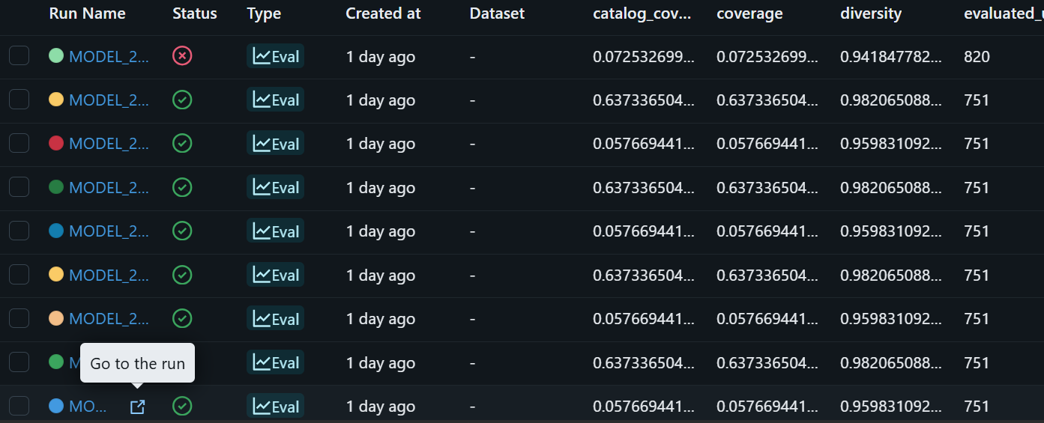
11 Mlruns

7.10 Pipeline Orchestration
- Orchestration DAG or code.
- Screenshots or logs showing successful execution.

airflow/scripts/export_execution_evidence.py
"""Enrich a completed run's evidence with authoritative Airflow task states."""
from __future__ import annotations
import argparse
import csv
import json
import os
import subprocess
from datetime import datetime
from pathlib import Path
from typing import Any
from src.orchestration.monitoring import safe_identifier
def _parser() -> argparse.ArgumentParser:
parser = argparse.ArgumentParser(
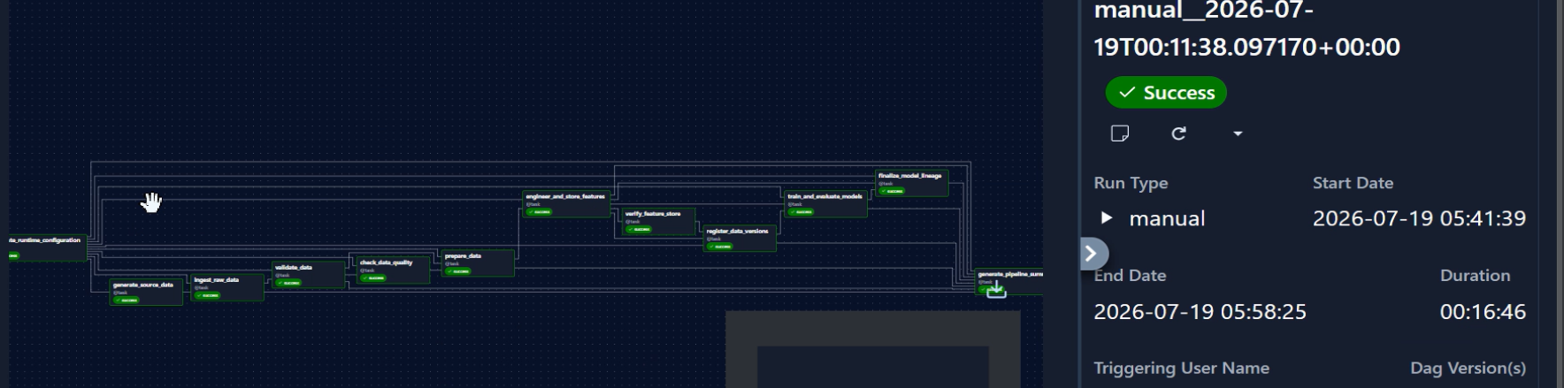
Airflow

8. Conclusion and Future Scope

Project Achievements
A change is complete when its behavior is documented, typed, logged, tested, documented and must not contain credentials, personal information, or complete To add a member, append one complete mapping to team and assign the next To remove a member, delete that member's complete list

Limitations

Future Work
Secrets are provided through environment variables or a deployment secret A future PDF report generator will load this YAML, validate the required keys,

