MLOps ASSIGNMENT REPORT
Heart Disease Classification: End-to-End MLOps Workflow
Course: MLOps
Assignment: Heart Disease Prediction API
Student Name: Prabin Kumar muduli
Student ID: 2025AE05171
Semester: 3rd Sem

1. Abstract
This project demonstrates an end-to-end MLOps workflow for a binary heart-disease classification task. It covers data acquisition, exploratory data analysis (EDA), preprocessing, model comparison, MLflow experiment tracking, model packaging, API serving, Docker containerization, and basic request monitoring. This is an educational demonstration, not a medical diagnostic tool.

2. Objective and Dataset
The objective is to train and serve a model that predicts a binary target from 13 input features. The dataset was retrieved in Google Colab using the UCI Machine Learning Repository interface (dataset ID 45). Target values were converted to a binary label: 0 for original target value 0 and 1 for original target values greater than 0. The notebook reported 303 records and 13 input features.
The data inspection reported missing values in ca (4) and thal (2). These should be handled in the preprocessing pipeline. The binary class distribution was 164 records for class 0 and 139 for class 1.

OUTPUT
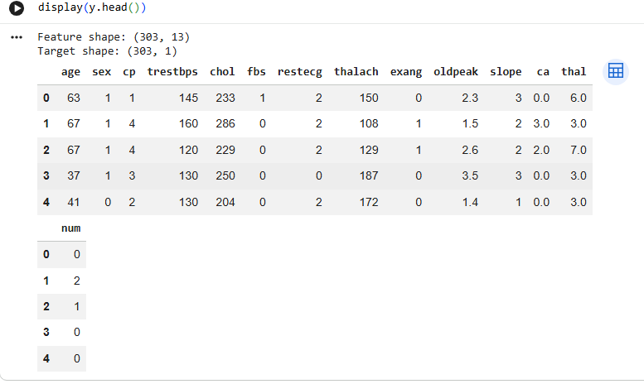

3. Exploratory Data Analysis (EDA)
Histograms were used to inspect feature distributions. A correlation heatmap was created to examine pairwise linear relationships, including correlations with the target. The class-count plot showed a moderately balanced distribution (164 class-0 and 139 class-1 records). Correlation does not establish causation.
[SCREENSHOT PLACEHOLDER: Feature histograms]
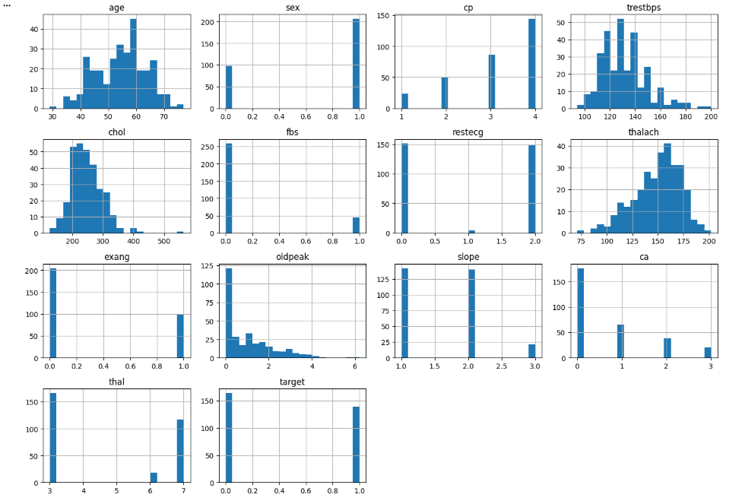
Paste your genuine screenshot in the box above. Remove this instruction after inserting it.

Feature correlation heatmap
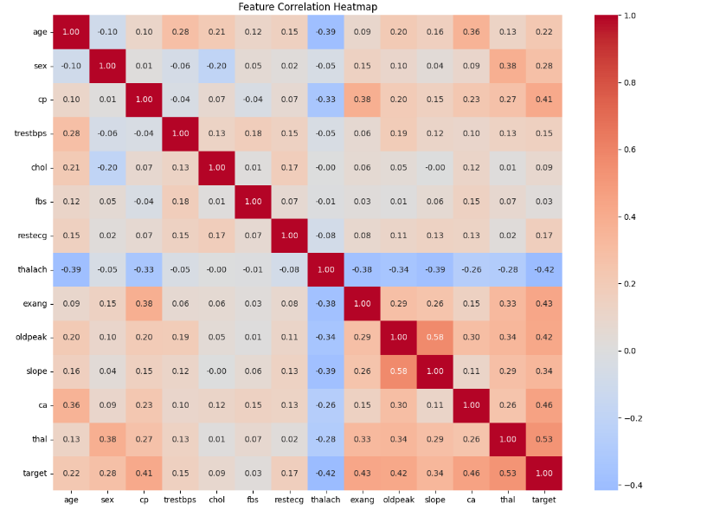

Target class distribution plot
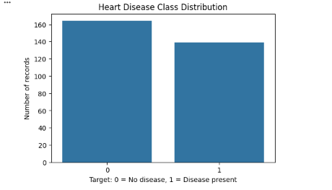

4. Feature Engineering and Model Development
The data was split into 242 training records and 61 testing records. The training set contained 131 class-0 and 111 class-1 records. A preprocessing pipeline handled missing values and applied scaling/encoding as configured. Logistic Regression and Random Forest were evaluated using five-fold cross-validation.
Recorded evaluation results:
Model | CV accuracy mean | CV accuracy std | Test accuracy | Precision | Recall / ROC-AUC
Logistic Regression | 0.843 | 0.053 | 0.885 | 0.839 | 0.929 / 0.966
Random Forest | 0.806 | 0.059 | 0.852 | 0.806 | 0.893 / 0.943
Logistic Regression was selected because it had higher recorded cross-validation accuracy, test accuracy, precision, recall, and ROC-AUC than Random Forest in this run. These results describe this evaluation setup and do not establish clinical suitability.
Model comparison / evaluation output
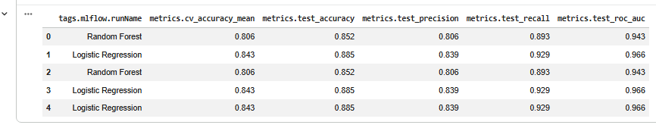

5. Experiment Tracking with MLflow
MLflow was used to organize experiments and record evaluation results and artifacts. Earlier runs showed model serialization errors with newer scikit-learn types; later notebook output showed finished runs with artifacts including heart_disease_model.joblib and model_comparison.csv. Insert evidence from the successful run(s) in the MLflow UI.
MLflow was used to track model experiments, evaluation metrics, and output artifacts. The successful run recorded the trained model (heart_disease_model.joblib) and model comparison results (model_comparison.csv). This supports experiment traceability and helps reproduce the model development process.

MLflow experiment / runs and metrics

MLflow artifact listing
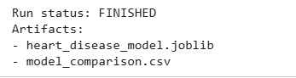

6. Model Packaging and Reproducibility
The selected model was saved as heart_disease_model.joblib. A requirements.txt file was generated with pinned dependency versions. The API loads the saved model at startup. Keep the dataset acquisition steps, preprocessing pipeline, training code, model artifact, and dependency list together in the project repository.
Versions recorded in the notebook: pandas 2.2.3; numpy 2.1.3; scikit-learn 1.6.1; joblib 1.4.0; mlflow 3.17.1; fastapi 0.141.1; uvicorn 0.54.0. Verify these against the final requirements.txt before submission.
Saved model and requirements.txt in project folder
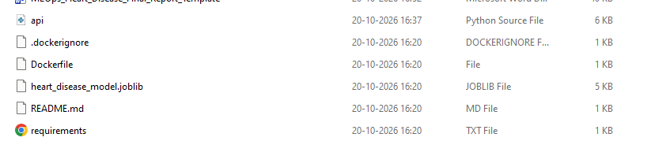

7. API and Docker Containerization
A FastAPI service exposes POST /predict to accept JSON containing 13 model features and return a predicted class and the model-estimated probability for class 1. It also exposes GET /health for health checks and GET /metrics for basic in-memory counters. The Docker image built successfully and the container started with port 8000 mapped to the host.
Example response observed: {"prediction": 0, "probability_class_1": 0.1655}. This is a model output for the supplied example, not a medical diagnosis or clinically validated risk estimate.

[SCREENSHOT PLACEHOLDER: Successful Docker image build in Command Prompt]
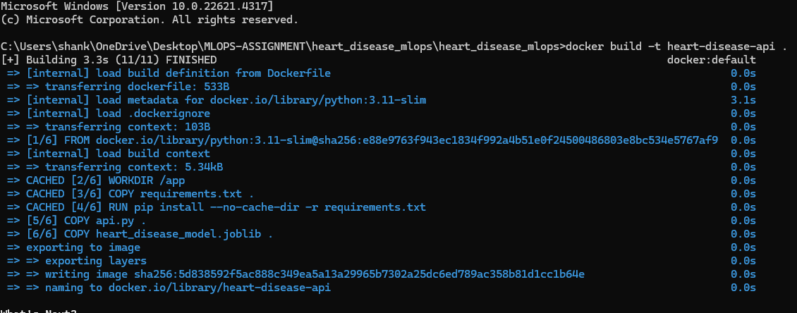
Paste your genuine screenshot in the box above. Remove this instruction after inserting it.
[SCREENSHOT PLACEHOLDER: Running Docker container / Uvicorn startup]
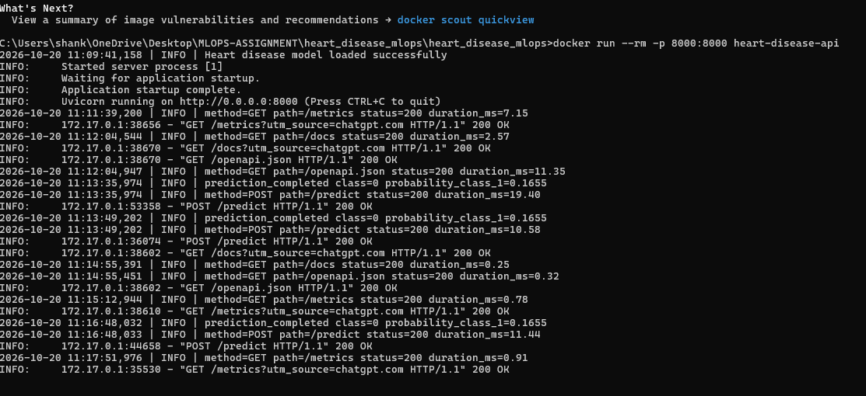
Paste your genuine screenshot in the box above. Remove this instruction after inserting it.

[SCREENSHOT PLACEHOLDER: Swagger POST /predict response (HTTP 200)]
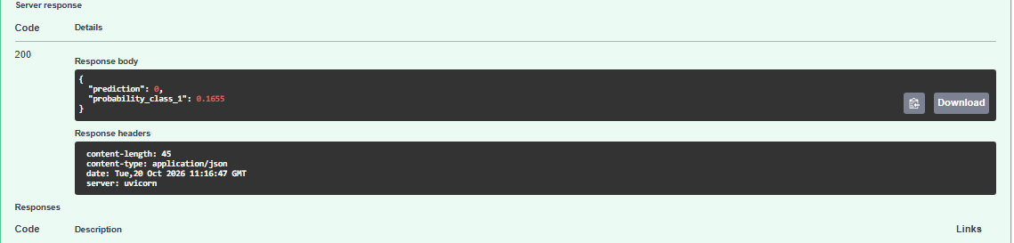
Paste your genuine screenshot in the box above. Remove this instruction after inserting it.
[SCREENSHOT PLACEHOLDER: GET /health response]
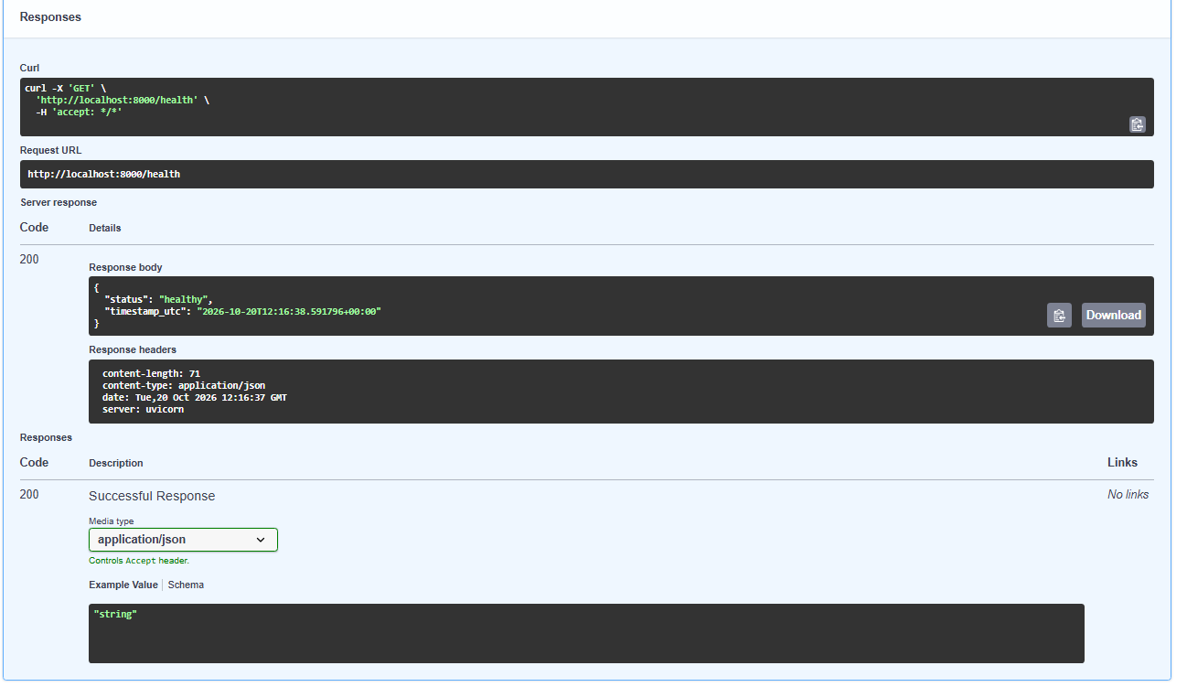
Paste your genuine screenshot in the box above. Remove this instruction after inserting it.

8. Basic Monitoring and Logging
The API logs request method, endpoint, HTTP status code, and request duration. The /metrics endpoint exposes in-memory counters for total requests, successful predictions, failed requests, and prediction classes. One captured test showed 10 total requests, 3 successful predictions, 0 failed requests, 3 class-0 predictions, and 0 class-1 predictions.
These counters reset when the container restarts and are not persistent production telemetry. This is basic application monitoring, not a Prometheus/Grafana deployment.
[SCREENSHOT PLACEHOLDER: GET /metrics response after prediction tests]
Paste your genuine screenshot in the box above. Remove this instruction after inserting it.

9. CI/CD, Testing, and Deployment Status
The project scaffold includes a GitHub Actions workflow and test files. Before claiming CI/CD or Kubernetes/cloud deployment as complete, run the tests and workflow and verify their results. A successful local Docker run alone does not prove that CI/CD or public-cloud/Kubernetes deployment is complete.
[SCREENSHOT PLACEHOLDER: GitHub repository URL / repository structure]
Paste your genuine screenshot in the box above. Remove this instruction after inserting it.
[SCREENSHOT PLACEHOLDER: GitHub Actions successful workflow run (only after it passes)]
Paste your genuine screenshot in the box above. Remove this instruction after inserting it.
[SCREENSHOT PLACEHOLDER: Unit test results (only after running tests)]
Paste your genuine screenshot in the box above. Remove this instruction after inserting it.
[SCREENSHOT PLACEHOLDER: Kubernetes/cloud deployment evidence (if completed)]
Paste your genuine screenshot in the box above. Remove this instruction after inserting it.

10. Conclusion
The project demonstrates key stages of a small MLOps workflow: data analysis, model evaluation, experiment tracking, packaging, API serving, Docker containerization, and basic monitoring. Logistic Regression outperformed Random Forest on the recorded metrics and was selected for the API. Before submission, verify the final repository, tests, CI/CD status, and any required deployment evidence.

Submission Checklist
☐ Add student details and submission date.
☐ Insert genuine screenshots and remove unused placeholders.
☐ Add the final GitHub repository URL.
☐ Verify requirements.txt and the saved model are included.
☐ Run tests and report actual results only.
☐ If deployment is required, include genuine deployment evidence or state that only local Docker deployment was completed.
☐ Check formatting and export to PDF if required.

