BITS Pilani · Work Integrated Learning Programmes
Machine Learning Operations (AIMLCZG523) — Assignment 01
Heart Disease Risk Prediction:
an End-to-End MLOps Pipeline from Data to a Monitored Kubernetes API
Item | Details
Student | Premkumar Jaywardhan
BITS ID | ________________
Code repository | https://github.com/<your-username>/heart-disease-mlops
Deployed API | Docker Desktop Kubernetes — http://localhost:8080 (access steps in §9)
Demo video | <link to recording>
Date | October 2026
Contents
1. Overview | 7. CI/CD Pipeline and Automated Testing
2. Setup and Reproduction | 8. Model Containerisation
3. Data Acquisition and Exploratory Analysis | 9. Production Deployment on Kubernetes
4. Feature Engineering and Model Development | 10. Monitoring and Logging
5. Experiment Tracking with MLflow | 11. Architecture
6. Model Packaging and Reproducibility | 12. Limitations and Next Steps

1. Overview
The goal is to predict whether a patient has heart disease from 13 routinely collected clinical attributes, and to run that model the way a production team would: reproducible data and training, tracked experiments, automated tests and builds, a containerised API on Kubernetes, and live monitoring.
Outcome. A regularised Logistic Regression was selected over a tuned Random Forest on cross-validated ROC-AUC (0.912 ± 0.017 vs 0.898 ± 0.029). On the untouched 20 % hold-out it reaches ROC-AUC 0.962, accuracy 0.885 and recall 0.929. It is served by a FastAPI service in a non-root Docker image, deployed as a 2-replica Kubernetes Deployment behind a LoadBalancer, and observed through structured JSON logs and a Prometheus + Grafana dashboard. A GitHub Actions pipeline lints, tests (34 tests, 94 % coverage), retrains with a quality gate, builds and smoke-tests the image on every push.
Table 1. How each assignment task maps to the deliverables
Task (marks) | Implementation | Section
1 Data & EDA (5) | download_data.py, heartml.data, notebook 01, 7 figures | §3
2 Features & models (8) | ColumnTransformer; LogReg + RF grid search, 5-fold CV | §4
3 Experiment tracking (5) | MLflow: 68 runs, nested trials, plots, registry | §5
4 Packaging (7) | joblib pipeline + MLflow model + metadata; pinned requirements | §6
5 CI/CD & tests (8) | pytest suite; GitHub Actions lint→test→train→docker | §7
6 Containerisation (5) | FastAPI /predict, multi-stage Dockerfile | §8
7 Deployment (7) | Kustomize manifests, LoadBalancer + Ingress, probes | §9
8 Monitoring (3) | JSON logs, Prometheus metrics + alerts, Grafana | §10
9 Documentation (2) | This report, README, architecture diagram | §2, §11

2. Setup and Reproduction
Everything runs from a clean clone with one requirements file. A second, minimal file (requirements-serve.txt, 8 packages) is used for the container so the image carries no training or tracking libraries. All versions are pinned and were checked to resolve on Python 3.12.
git clone https://github.com/<your-username>/heart-disease-mlops && cd heart-disease-mlops
python -m venv .venv && source .venv/bin/activate
pip install -r requirements.txt && pip install -e .
python scripts/download_data.py # raw + cleaned CSV
python scripts/run_eda.py # EDA figures
python scripts/train.py # tuning, MLflow tracking, models/
pytest -v && flake8 src app tests scripts
mlflow ui --backend-store-uri sqlite:///mlflow.db # http://localhost:5000
The same steps are available as make data eda train test lint (or make all). The three notebooks (01_eda, 02_model_training, 03_inference) call the same package code, so notebook, script and CI results cannot drift apart. A from-scratch run in a fresh virtual environment reproduced identical metrics (fixed random_state=42 for the split, CV folds and Random Forest).

3. Data Acquisition and Exploratory Analysis

3.1 Acquisition
The dataset is the processed Cleveland subset of the UCI Heart Disease collection: 303 patients, 13 attributes and a diagnosis num from 0 (no disease) to 4. scripts/download_data.py fetches the official UCI file and, if that host is unreachable, falls back to a GitHub mirror of the same 303 records, converting its text codes (e.g. asymptomatic → cp=4) to the UCI encoding. The raw table is cached in data/raw/; the cleaned table in data/processed/heart_clean.csv is committed to the repository.

3.2 Cleaning
- Every column is coerced to numeric; UCI ? markers and stray text become missing values.
- Values outside plausible clinical ranges (e.g. cholesterol outside 100–600 mg/dl) and unknown category codes are set to missing rather than silently kept.
- Duplicate and unlabelled rows are dropped; the target is binarised as num > 0.
- Only 6 cells are missing (ca: 4, thal: 2). They are imputed inside the model pipeline (median / most frequent), not in the CSV, so the statistics are learned on each training fold only and the API applies the identical rule to requests that omit those fields.

3.3 Findings
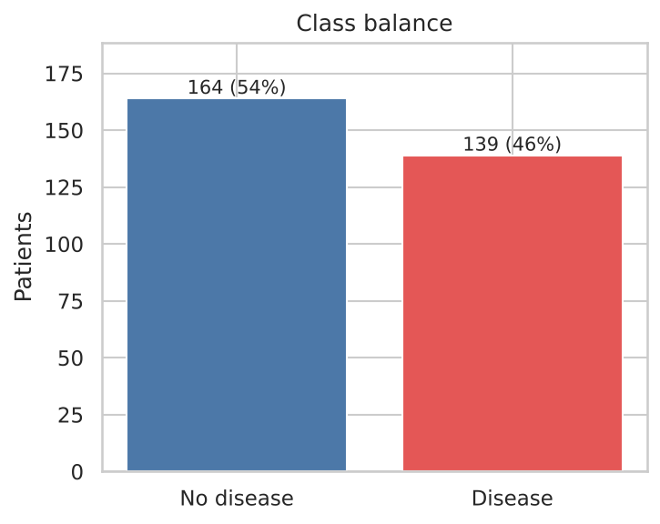 | 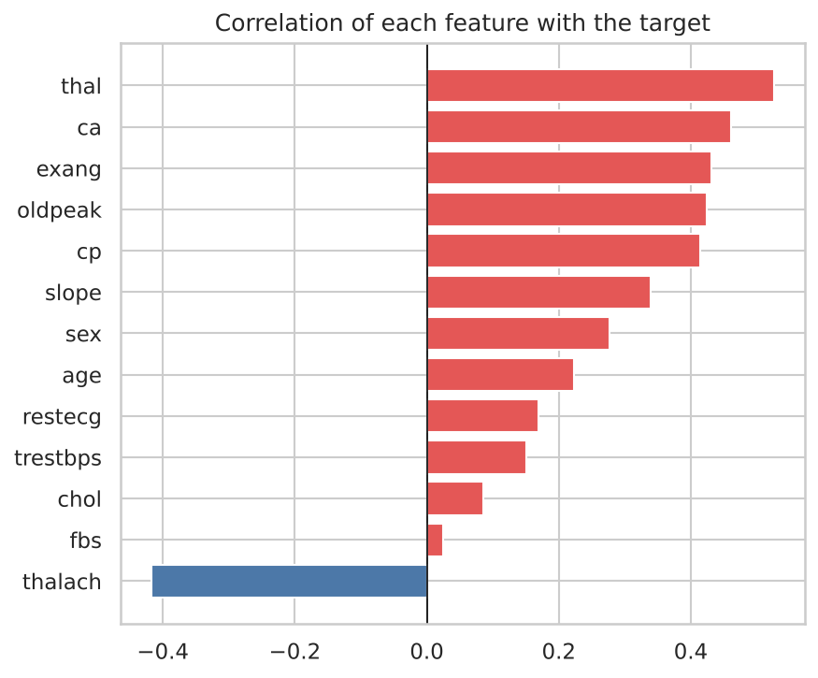
Figure 1. Class balance (left) and correlation of each feature with the diagnosis (right).
Classes are close to balanced (164 without / 139 with disease), so no resampling is needed and ROC-AUC is a fair selection metric. The strongest single signals are thallium defect (thal, r = 0.526), number of affected vessels (ca, 0.46), exercise angina (0.432), ST depression (0.425) and, negatively, maximum heart rate.
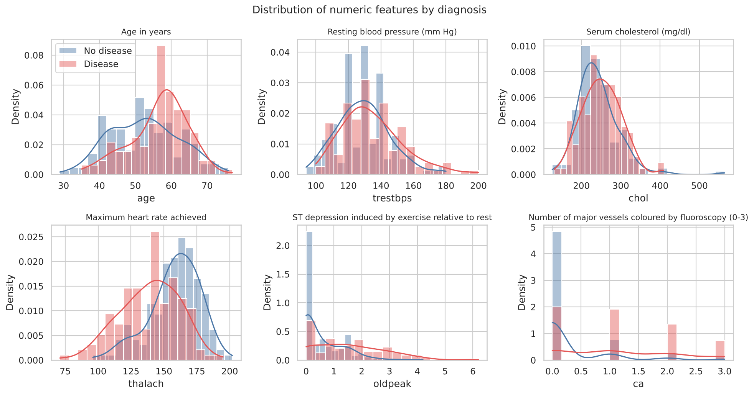
Figure 2. Numeric features by diagnosis. Patients with disease are older, reach lower peak heart rates and show more ST depression; cholesterol and resting blood pressure separate the classes only weakly.
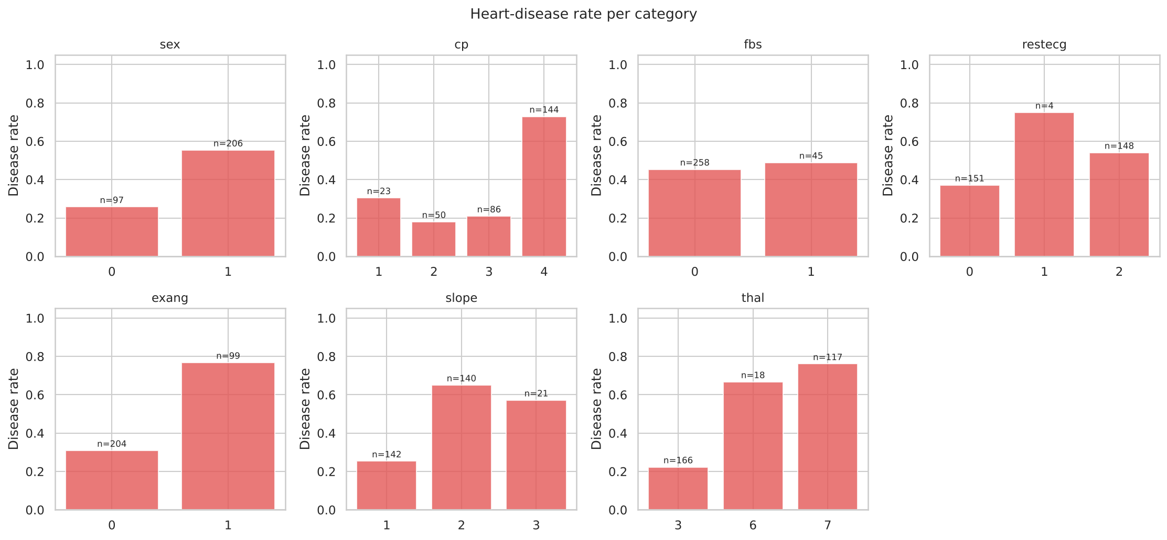
Figure 3. Disease rate per category. Asymptomatic chest pain (cp = 4) carries a 73 % disease rate; reversible thallium defect (thal = 7) 76 %.
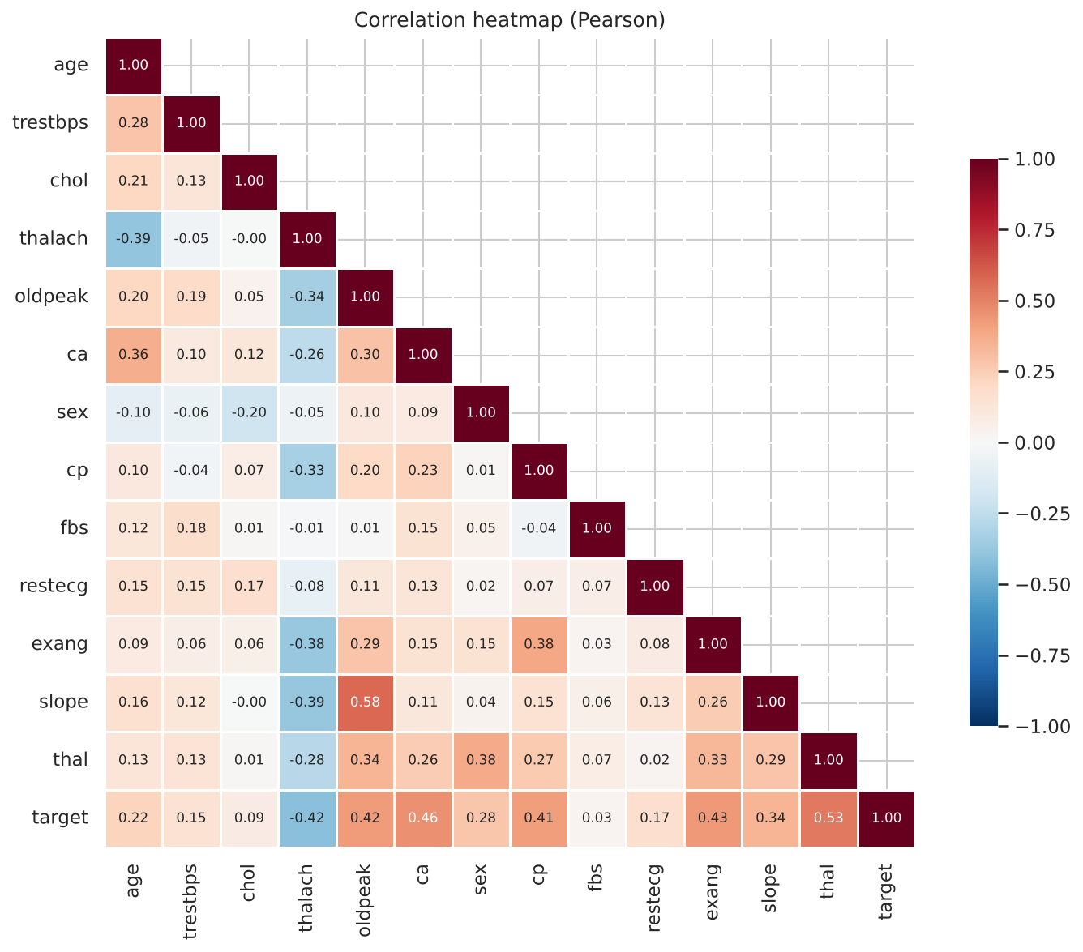
Figure 4. Pearson correlation heatmap. No feature pair exceeds |r| = 0.6, so collinearity is mild (slope vs oldpeak, 0.58, is the largest).
Decisions carried into modelling. cp, thal, restecg and slope are nominal codes, so they are one-hot encoded rather than treated as numbers. Numeric features differ in scale by two orders of magnitude, so they are standardised (needed for a regularised linear model). Weak features such as fbs and chol are kept and left to L1/L2 regularisation rather than pruned by hand on 303 rows. restecg = 1 occurs only 4 times, so the encoder ignores unseen codes instead of failing.

4. Feature Engineering and Model Development

4.1 Preprocessing pipeline
One scikit-learn ColumnTransformer handles all feature preparation and is saved together with the classifier as a single Pipeline, so raw patient fields go in and probabilities come out — there is no separate preprocessing step to forget at serving time.
Table 2. Preprocessing
Columns | Steps | Output
age, trestbps, chol, thalach, oldpeak, ca | median imputation → standard scaling | 6 columns
sex, cp, fbs, restecg, exang, slope, thal | most-frequent imputation → one-hot (unknown → all-zero) | 19 columns

4.2 Models and tuning
Two model families with different inductive biases were compared, plus a majority-class baseline as a floor:
- Logistic Regression — interpretable (coefficients are log-odds), strong on small tabular data. Grid: C ∈ {0.01 … 10} (7 values) × L2/L1 penalty × class weighting = 28 configurations.
- Random Forest — captures non-linear effects and interactions without scaling. Grid: trees ∈ {200, 500} × max depth ∈ {3, 5, none} × min leaf ∈ {1, 3, 5} × max features ∈ {√p, 0.5} = 36 configurations.
Protocol: a stratified 80/20 split (242 / 61 patients); GridSearchCV with stratified 5-fold CV on the 80 % scoring accuracy, precision, recall, F1 and ROC-AUC, refitting on ROC-AUC. The family with the best mean CV ROC-AUC is selected. The hold-out set is never used for any choice — only for the final report numbers.
Table 3. Cross-validated (5-fold, mean) and hold-out results of the best configuration per family
Model | CV ROC-AUC | CV Acc. | CV Prec. | CV Recall | CV F1 | Test ROC-AUC | Test Acc.
Logistic Regression (L2, C = 0.1) | 0.912 ± 0.017 | 0.847 | 0.869 | 0.792 | 0.826 | 0.962 | 0.885
Random Forest (500 trees, leaf ≥ 3) | 0.898 ± 0.029 | 0.810 | 0.808 | 0.774 | 0.787 | 0.953 | 0.885
Majority-class baseline | 0.500 | 0.541 | – | 0.000 | – | 0.500 | 0.541

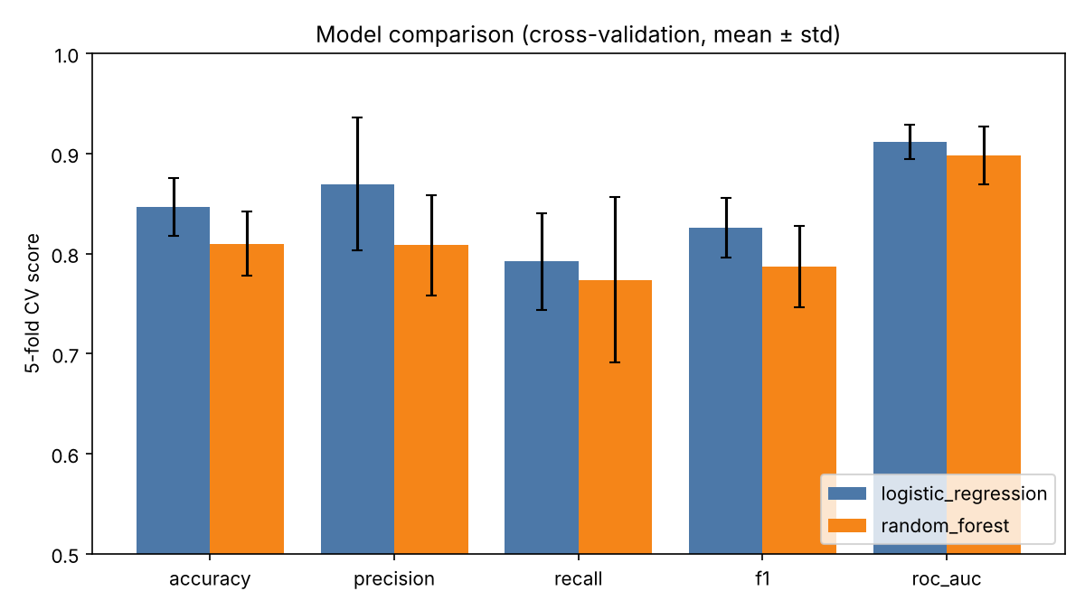
Figure 5. Cross-validation comparison. Logistic Regression is ahead on every metric and has a lower spread across folds.

4.3 Why Logistic Regression
- It wins on the selection metric and on every other CV metric, with lower fold-to-fold variance (ROC-AUC std 0.017 vs 0.029).
- It generalises more honestly: the gap between training and CV ROC-AUC is 0.014 versus 0.089 for the forest, which memorises much of a 242-row training set.
- Its coefficients can be read by a clinician (Figure 7), the artefact is tiny (a few KB) and inference takes microseconds.
Tuning detail: the top LR configurations are tightly grouped (C = 0.1 with L2 at 0.912, with class balancing at 0.911, C = 1 with L1 at 0.910), so the choice is stable rather than a lucky grid point. Strong regularisation (C = 0.01) and weak regularisation (C = 10) both score lower, confirming a genuine optimum. All 64 configurations are stored as MLflow child runs and as CSV tables.
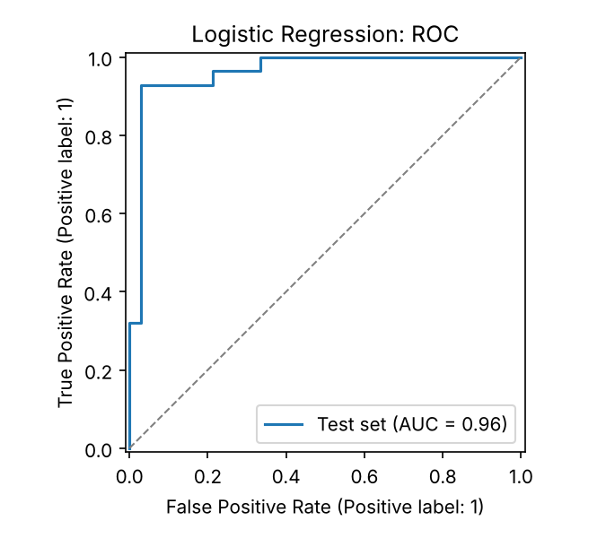 | 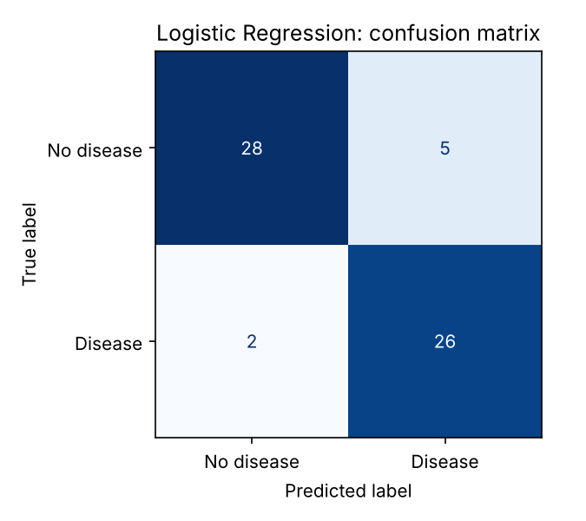
Figure 6. Selected model on the hold-out set: ROC curve (AUC 0.962) and confusion matrix at threshold 0.5.
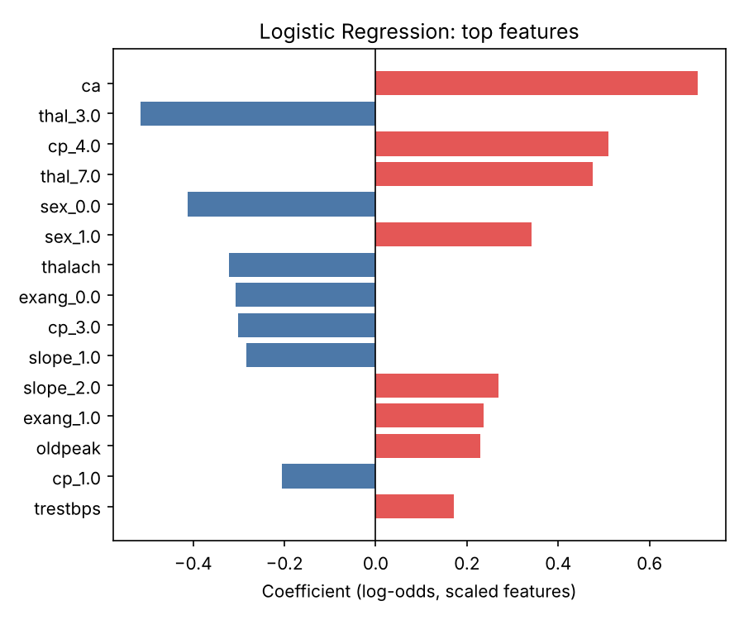
Figure 7. Largest Logistic Regression coefficients. Affected vessels, asymptomatic chest pain and reversible thallium defect raise risk; a normal thallium scan and high peak heart rate lower it — consistent with the EDA and clinical expectation.

5. Experiment Tracking with MLflow
MLflow uses a SQLite backend (mlflow.db, which enables the model registry) with artefacts in ./mlruns. The experiment heart-disease-classification is organised so that every trained configuration is inspectable and comparable:
Table 4. MLflow run structure (68 runs per training execution)
Run | Logged parameters | Logged metrics | Artefacts
baseline_majority_class | strategy | CV + test accuracy, precision, recall, F1, ROC-AUC | –
logistic_regression / random_forest (parents) | best hyper-parameters, grid size, folds, selection metric | CV mean ± std of 5 metrics, 5 test metrics, train–CV gap, tuning time | ROC, PR, confusion matrix, feature importance, full CV table, MLflow model with signature + input example
lr_trial_00 … 27, rf_trial_00 … 35 (nested) | that grid point's hyper-parameters | CV mean and std of 5 metrics, train ROC-AUC, rank | –
model_selection | selected model, source run id | CV and test ROC-AUC of each family, baseline accuracy | comparison chart, model card JSON
The winning run's model is registered as heart-disease-classifier and tagged with the alias champion, so a deployment can refer to "the current champion" instead of a hard-coded run id. In CI the whole mlruns/ folder and mlflow.db are uploaded as a build artefact, giving a tracked history for every pipeline execution.
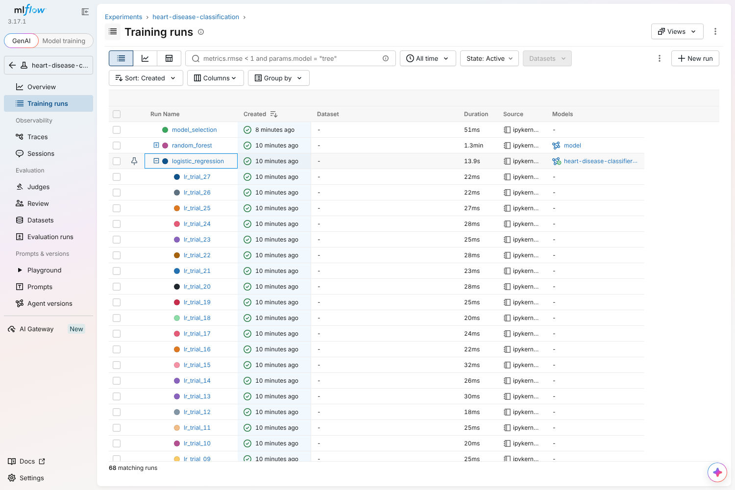
Figure 8. MLflow UI: 68 runs; the logistic_regression parent expanded to show its nested lr_trial_* runs (one per grid point).
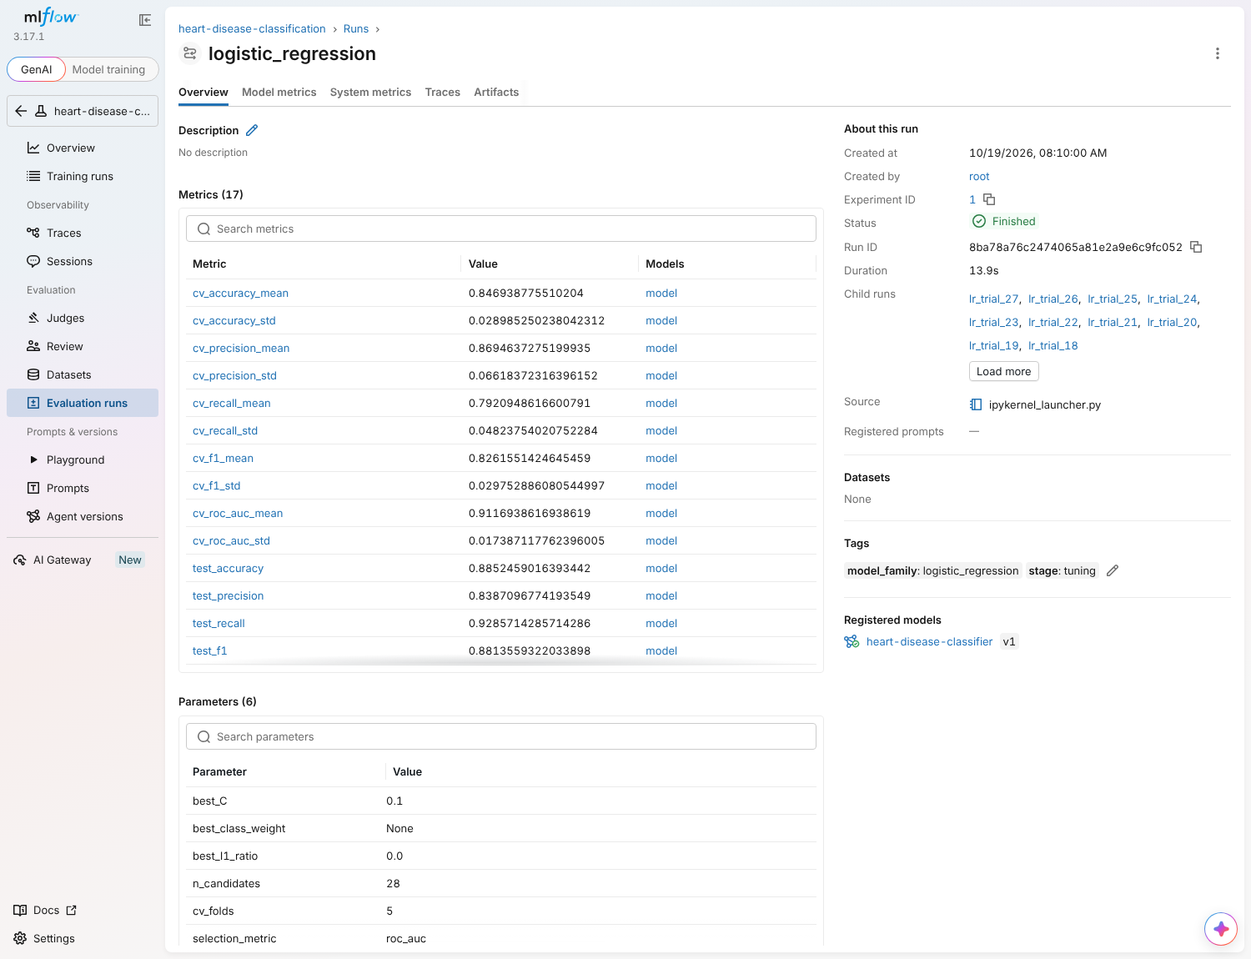
Figure 9. Selected run: CV and test metrics, best hyper-parameters, child runs, tags and the linked registered model.
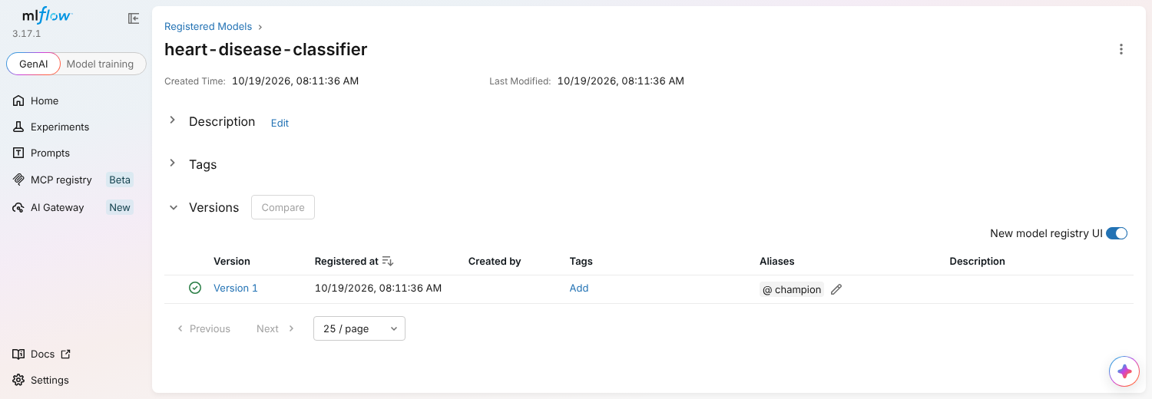
Figure 10. Model registry: heart-disease-classifier version 1 carries the champion alias.

6. Model Packaging and Reproducibility
Table 5. Packaged artefacts in models/
File | Purpose
model.joblib | Complete fitted pipeline (imputers, scaler, encoder, classifier). Loaded by the API; needs only scikit-learn.
mlflow_model/ | Same pipeline in MLflow format with input/output signature, input example, conda.yaml, python_env.yaml — servable with mlflow models serve.
model_metadata.json | Model card: family, version (20261019024132), hyper-parameters, CV and test metrics, threshold, feature order, training rows, MLflow run id, registry version, Python and scikit-learn versions.
Reproducibility is enforced at several levels: pinned versions in requirements.txt; fixed random seeds; data cleaning and feature preparation implemented once in the heartml package and imported by scripts, notebooks, tests and CI; the training environment recorded in the model card; and the cleaned dataset committed alongside the code. Notebook 03 shows the joblib pipeline, the MLflow pyfunc model and the REST API all return the same predictions for the same patients — including one with ca and thal missing.

7. CI/CD Pipeline and Automated Testing

7.1 Test suite
34 pytest tests (94 % line coverage) run without network access on synthetic UCI-shaped data, so they can run before any training:
Table 6. Test coverage by area
File | What is verified
test_data.py (8) | UCI ? parsing, mirror code mapping, target binarisation, column order, out-of-range → missing, duplicate/unlabelled removal, junk strings, schema errors
test_features.py (5) | no NaNs after transform, one-hot width, standardisation, unseen category tolerated, determinism
test_model.py (7) | both families fit and emit valid probabilities, beat a dummy model by > 0.1 AUC, handle missing inputs, joblib round-trip, metric helper
test_pipeline.py (2) | EDA writes all figures; full training run (fast grids) logs the expected 7 MLflow runs, registers the model and writes all artefacts
test_api.py (12) | health/ready, prediction schema and confidence maths, optional fields, 422 on invalid / unknown / missing fields, batch, Prometheus counters, model card, 503 when no model
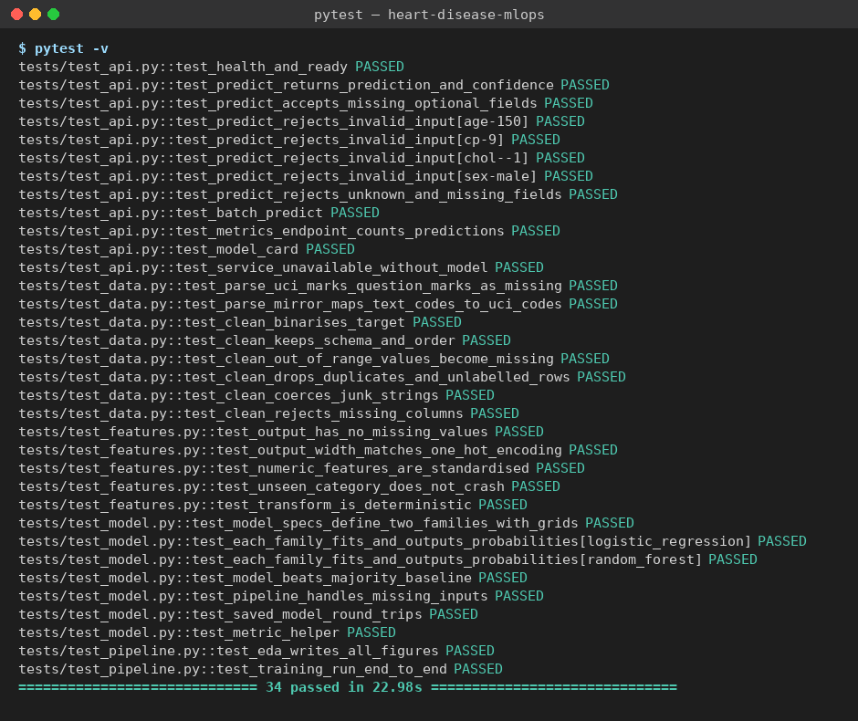
Figure 11. Local test run: all 34 tests pass (the same suite gates the CI pipeline).

7.2 GitHub Actions workflow
.github/workflows/ci.yml runs on every push and pull request. Each job depends on the previous one, so any lint error, failing test, coverage drop, weak model or broken container stops the pipeline with that step's log.
Table 7. Pipeline jobs
Job | Steps | Fails when | Artefacts
lint | flake8 on src, app, tests, scripts | any style or error violation | flake8 report
test | clean install from requirements.txt; pytest with JUnit + coverage; summary table | any test fails or coverage < 80 % | junit.xml, coverage.xml
train | download → EDA → train → quality gate → summary table | download/training error or CV ROC-AUC < 0.85 | model, MLflow runs, figures, training log
docker | build with the model just trained; run; check /ready, /predict output, 422 on bad input, /metrics; push to GHCR on main | build fails or any smoke check fails | image tarball, container log
[Insert screenshot: GitHub Actions — successful run (lint → test → train → docker)]
Actions tab → latest run (screenshots/05_github_actions_run.png)

[Insert screenshot: GitHub Actions — run summary with test and model tables, artefacts]
run → Summary (screenshots/06_github_actions_summary.png)

8. Model Containerisation
The API (app/main.py) is built with FastAPI. Requests are validated by a Pydantic schema that mirrors the training ranges and rejects unknown fields, so bad input fails fast with a field-level 422 rather than producing a silent wrong prediction.
Table 8. API endpoints
Endpoint | Behaviour
POST /predict | One patient → prediction (0/1), label, confidence (probability of the predicted class), P(disease), risk band, model version, request id
POST /predict/batch | Up to 256 patients in one call
GET /health, /ready | Liveness (process up) and readiness (model loaded) — used by Docker and Kubernetes probes
GET /model | Model card from model_metadata.json
GET /metrics, /docs | Prometheus exposition; Swagger UI
$ curl -X POST localhost:8000/predict -H 'Content-Type: application/json' \
-d '{"age":63,"sex":1,"cp":4,"trestbps":145,"chol":233,"fbs":1,"restecg":2,
"thalach":150,"exang":0,"oldpeak":2.3,"slope":3,"ca":0,"thal":6}'
{"prediction":1,"label":"heart_disease","confidence":0.5757,"probability_disease":0.5757,
"risk_band":"moderate","model_version":"20261019024132","request_id":"b8d56736f7e2"}
The Dockerfile is multi-stage: wheels are built in a builder stage and only installed into a clean python:3.12-slim runtime with the 8 serving packages, the app/ code and the two model files. It runs as a fixed non-root UID (10001), defines a HEALTHCHECK against /ready, and disables Uvicorn's own access log because the application writes structured logs. The serving environment was verified in isolation — a virtual environment with only requirements-serve.txt and only the files the image copies — and returned the same prediction.
docker build -t heart-disease-api:1.0.0 .
docker run -d --name heart-api -p 8000:8000 heart-disease-api:1.0.0
curl -X POST localhost:8000/predict -H 'Content-Type: application/json' -d @scripts/sample_request.json
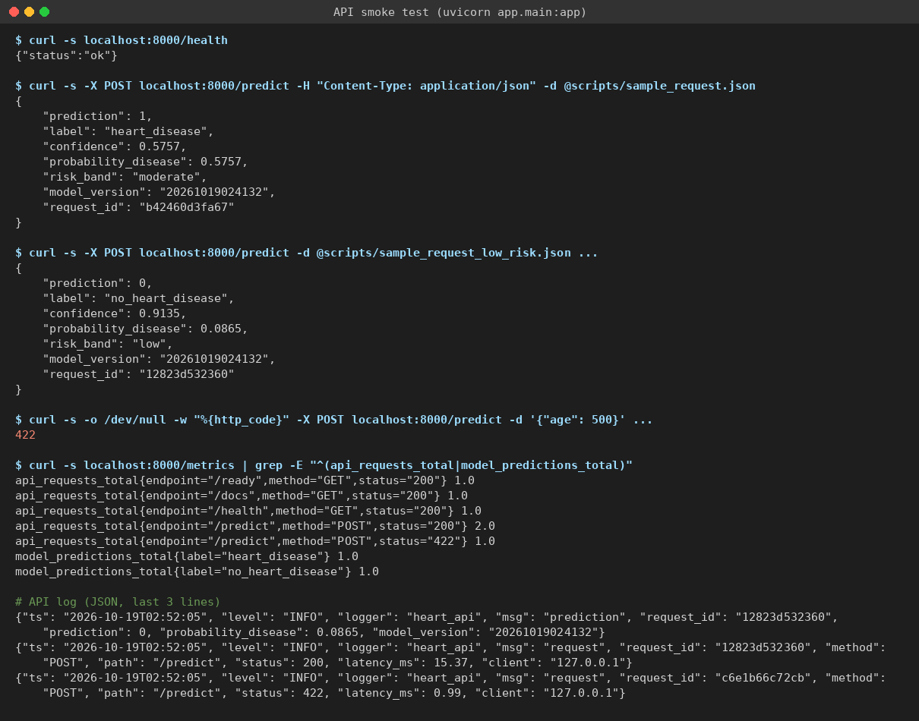
Figure 12. Smoke test of the serving app: high- and low-risk patients, a rejected invalid request (422), Prometheus counters and the JSON log lines.
[Insert screenshot: docker build + docker run + /predict response]
terminal (screenshots/08_docker_build_run.png)

9. Production Deployment on Kubernetes
The target is the Kubernetes cluster built into Docker Desktop. Because that cluster shares the local Docker image store, the locally built image is used directly (imagePullPolicy: IfNotPresent). The manifests are plain YAML combined with Kustomize and were validated against the Kubernetes schemas in strict mode (15/15 resources valid).
Table 9. Kubernetes resources (k8s/)
Resource | Configuration
Namespace heart-api | Isolates the application
Deployment heart-api | 2 replicas; rolling update with maxUnavailable 0 (zero-downtime); readiness probe /ready, liveness probe /health; CPU/memory requests and limits; non-root, read-only root filesystem, no privilege escalation; Prometheus scrape annotations
Service heart-api | type LoadBalancer, port 8080 → container 8000 (Docker Desktop publishes it on localhost:8080; on GKE/EKS/AKS it receives a public IP)
Ingress (optional) | NGINX ingress, host heart-api.localhost
kubectl config use-context docker-desktop
docker build -t heart-disease-api:1.0.0 .
kubectl apply -k k8s/
kubectl -n heart-api rollout status deploy/heart-api
kubectl -n heart-api get deploy,pods,svc
curl -X POST http://localhost:8080/predict -H 'Content-Type: application/json' -d @scripts/sample_request.json
[Insert screenshot: kubectl get deploy,pods,svc — 2/2 pods Running, LoadBalancer on localhost:8080]
screenshots/09_k8s_resources.png

[Insert screenshot: curl /predict through the LoadBalancer + Swagger UI at localhost:8080/docs]
screenshots/10_k8s_predict.png, 11_swagger.png

10. Monitoring and Logging
Logging. A middleware writes one JSON line per request (request id, method, path, status, latency, client) and the prediction path writes one line per prediction (request id, class, P(disease), model version). The request id is returned in the x-request-id header so a user report can be traced to its log line. In Kubernetes the logs are read with kubectl logs or shipped by any log collector.
{"ts": "2026-10-19T02:52:05", "level": "INFO", "logger": "heart_api",
"msg": "request", "request_id": "12823d532360", "method": "POST",
"path": "/predict", "status": 200, "latency_ms": 15.37, "client": "127.0.0.1"}
Metrics. The API exports Prometheus metrics; Prometheus (deployed in a monitoring namespace) discovers each API pod through Kubernetes service discovery and evaluates three alert rules. Grafana is provisioned with the Prometheus datasource and a ready-made dashboard.
Table 10. Exported metrics and how they are used
Metric | Dashboard panel / alert
api_requests_total{endpoint, method, status} | Requests/s, rate by endpoint and status, error rate; alert if 5xx > 5 %
api_request_latency_seconds (histogram) | p50 / p95 / p99 latency of /predict; alert if p95 > 500 ms
model_predictions_total{label} | Predictions by class — a shift in the disease share is an early model-drift signal
model_prediction_probability (histogram) | Distribution of P(disease) — confidence drift
api_requests_in_progress, up | In-flight requests, healthy targets; alert if no healthy pod
kubectl apply -k monitoring/ # Prometheus :9090, Grafana :3000 (admin/admin)
python scripts/load_test.py --url http://localhost:8080 --n 300 # generate traffic
For a quick local demo without Kubernetes, docker compose up --build starts the same API, Prometheus and Grafana stack.
[Insert screenshot: Grafana dashboard after the load test]
http://localhost:3000 → Heart Disease API dashboard (screenshots/12_grafana_dashboard.png)

[Insert screenshot: Prometheus targets (2 pods UP) and API logs]
screenshots/13_prometheus_targets.png, 14_api_logs.png

11. Architecture
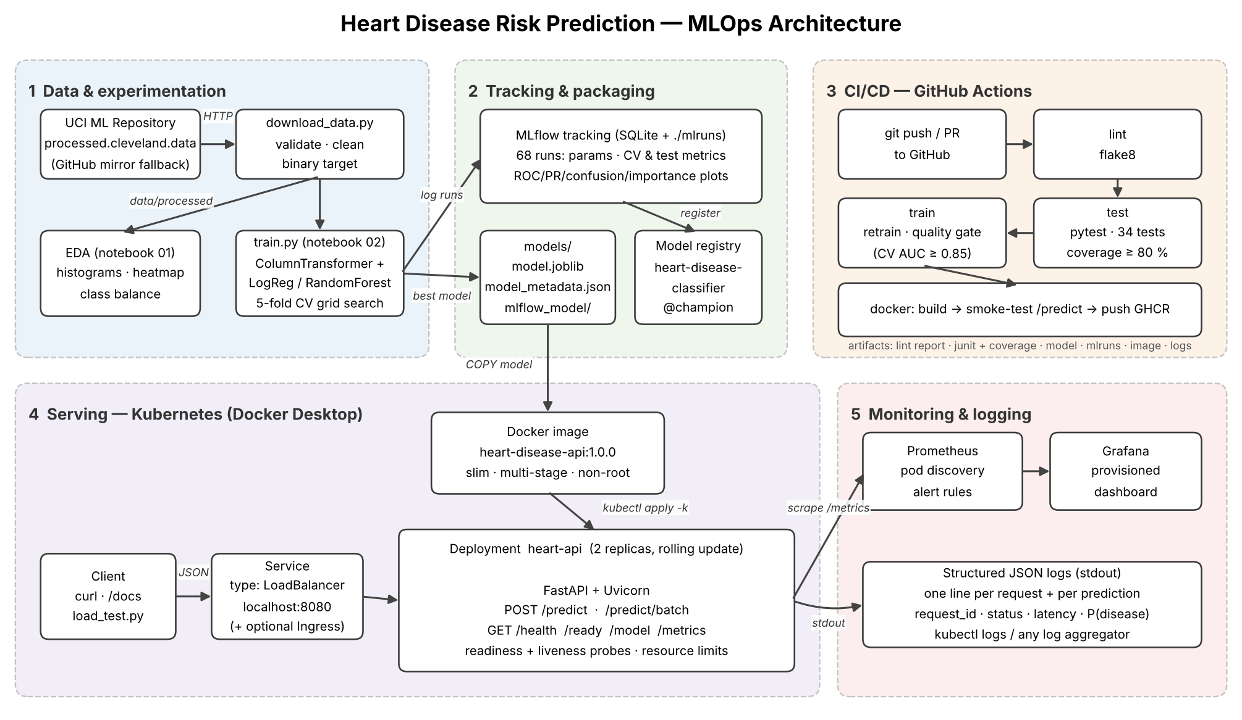
Figure 13. End-to-end architecture: data and experimentation, tracking and packaging, CI/CD, Kubernetes serving, and monitoring.
Data flows left to right through the experimentation stage into MLflow and the packaged model; GitHub Actions re-runs that path on every change and produces the image; the image runs as a Kubernetes Deployment behind a LoadBalancer; Prometheus, Grafana and structured logs close the loop by showing how the live service and its predictions behave.

12. Limitations and Next Steps
- Small dataset. 303 patients from one hospital; hold-out estimates carry wide uncertainty (61 test patients), which is why selection relies on cross-validation. Pooling the Hungarian, Swiss and Long Beach subsets would test generalisation across sites.
- Decision threshold. 0.5 is used for now. In screening, missing a sick patient is costlier than a false alarm; the threshold is stored in the model card so it can be tuned for higher recall without retraining or code changes.
- Drift monitoring. Prediction mix and confidence are tracked; adding input-feature drift checks (e.g. population stability index against the training data) and delayed-label performance tracking would complete the picture.
- Delivery. The next step is continuous deployment: have CI update the image tag in the manifests and let a GitOps controller (Argo CD) roll it out, using the registry's champion alias for promotion.

Links
Code repository: https://github.com/<your-username>/heart-disease-mlops
Dataset: UCI Machine Learning Repository, Heart Disease (Detrano et al., 1988), https://archive.ics.uci.edu/dataset/45/heart+disease

