End-to-End MLOps for Heart Disease Risk Classification
Assignment 01 | AIMLCZG523 Machine Learning Operations

Student | Pawan Sharma
Student ID | 2025AE05327
Dataset | UCI Cleveland Heart Disease
Repository | https://github.com/2025ae05327-code/mlops-assignment-1-heart-disease
Report date | 2026-10-07

This report documents a reproducible learning project. The API is an educational risk classifier and must not be used as a clinical diagnosis system.

1. Executive Summary and Objectives
This project implements the complete lifecycle of a binary heart disease risk model: versioned acquisition, data-quality checks, exploratory analysis, leakage-safe feature engineering, comparative model tuning, experiment tracking, package creation, automated testing, container delivery, Kubernetes deployment, and operational monitoring.
- Business objective: estimate the probability of heart disease from 13 clinical attributes.
- Engineering objective: make every material artifact reproducible from a clean checkout.
- Selection objective: compare Logistic Regression and Random Forest by mean CV ROC-AUC.
- Serving objective: return a validated prediction and confidence through FastAPI.
- Operations objective: expose health, logs, Prometheus metrics, and a Grafana dashboard.

Scope and responsible use
The solution is designed for coursework and technical demonstration. It does not establish clinical validity, calibrated treatment thresholds, fairness across protected groups, or regulatory compliance. A production healthcare use would require all of these controls.

2. Data Acquisition and Quality
The acquisition script downloads the processed Cleveland cohort from the UCI Machine Learning Repository. It retries transient failures, writes atomically, maps '?' tokens to missing values, validates domains, binarizes the original 0-4 diagnosis field, removes exact duplicates, and records a SHA-256 checksum and source URL.
Quality measure | Observed value
Rows | 303
Predictors | 13
Duplicate rows after cleaning | 0
Class counts | {'0': 164, '1': 139}
Raw SHA-256 | a74b7efa387bc9d108d7d0115d831fe9b414b29ae7124f331b622b4efa0427c8
Missing predictors are intentionally not imputed in the persisted CSV. Imputers are fitted inside each cross-validation training fold, preventing information leakage.

3. Exploratory Data Analysis
The EDA job produces deterministic, high-resolution plots for class balance, missingness, numeric distributions by outcome, and the full Pearson correlation matrix. These views test whether imbalance, implausible values, or strongly redundant variables need intervention.
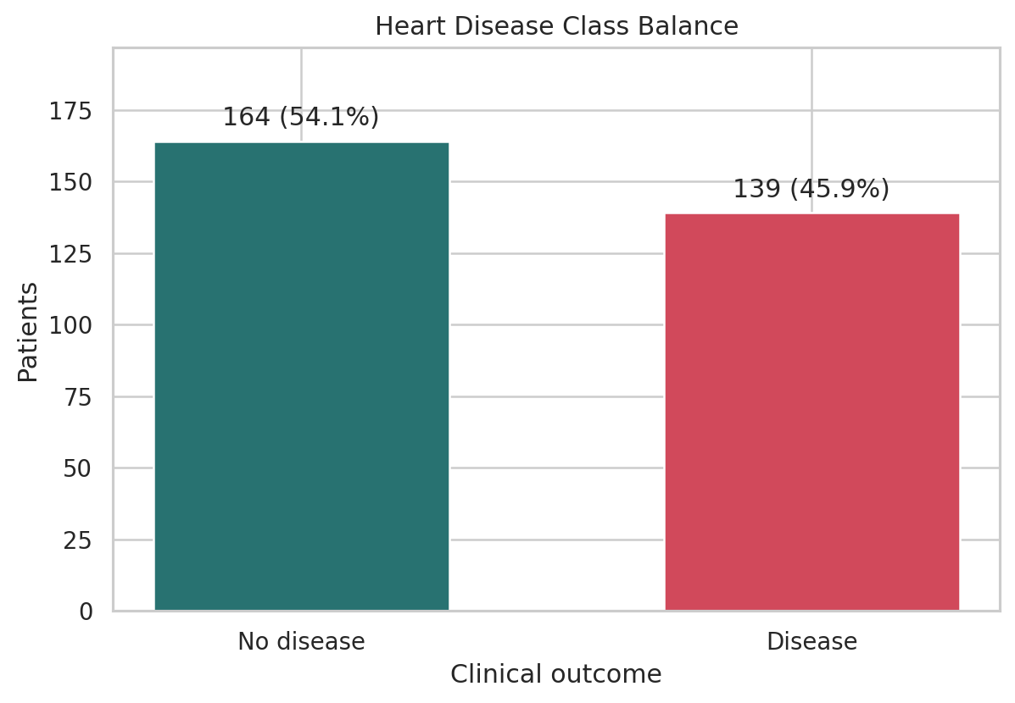
Figure 1. Binary target balance after cleaning.
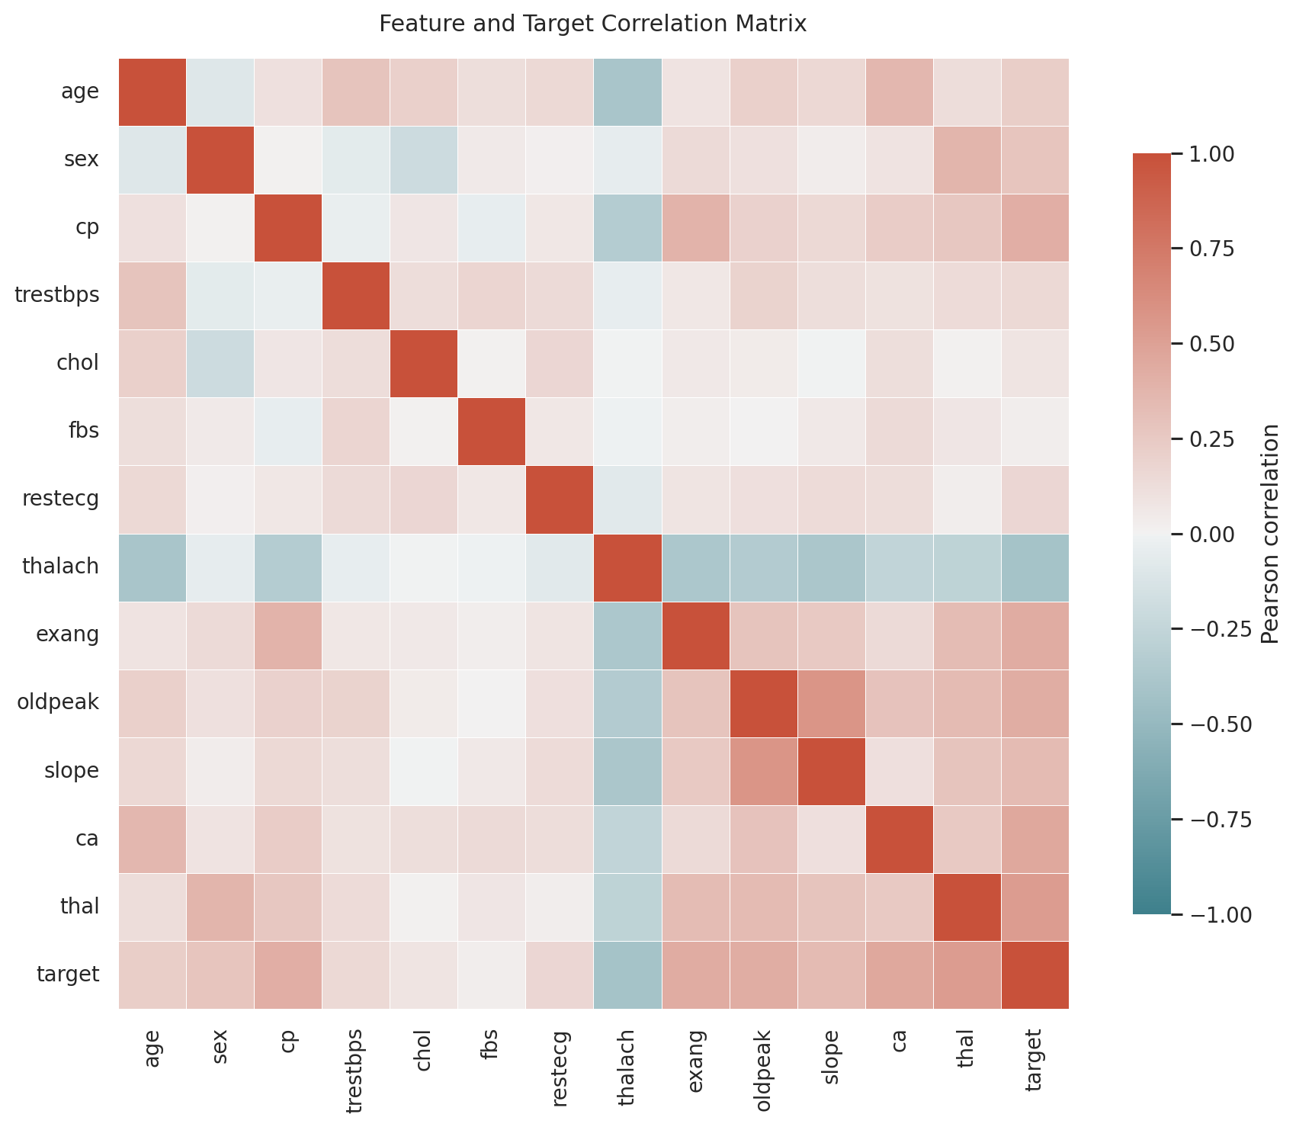
Figure 2. Correlation matrix for features and target.

4. Feature Engineering and Validation Design
Five continuous variables use median imputation followed by standard scaling. Eight coded categorical variables use most-frequent imputation and one-hot encoding with unknown-category tolerance. A scikit-learn ColumnTransformer and classifier are saved as one pipeline, ensuring that training and inference execute identical transformations.
- Train/test split: stratified 80/20 with random state 42.
- Tuning: shuffled stratified five-fold cross-validation on the training split only.
- Primary selection metric: mean validation ROC-AUC.
- Secondary metrics: accuracy, precision, recall, standard deviation, and fit time.
- Final test set: evaluated once for an unbiased estimate after candidate tuning.
The linear model provides a lower-variance, interpretable baseline. The forest tests whether non-linear interactions and threshold effects improve ranking performance. Balanced class weights reduce sensitivity to moderate outcome imbalance.

5. Experiments, Tuning, and Results
Every candidate has a separate MLflow run containing the grid choice, cross-validation metrics and variability, held-out metrics, fit duration, ROC curve, confusion matrix, input example, model signature, and serialized pipeline.
Model | Split | Accuracy | Precision | Recall | ROC-AUC
Logistic Regression | CV mean | 0.851 | 0.848 | 0.837 | 0.907
Logistic Regression | Test | 0.852 | 0.806 | 0.893 | 0.959
Random Forest | CV mean | 0.818 | 0.806 | 0.801 | 0.899
Random Forest | Test | 0.885 | 0.818 | 0.964 | 0.951
Selected model: logistic_regression. Selection is based exclusively on mean cross-validated ROC-AUC, not on the test score. This rule is stored in model_metadata.json.
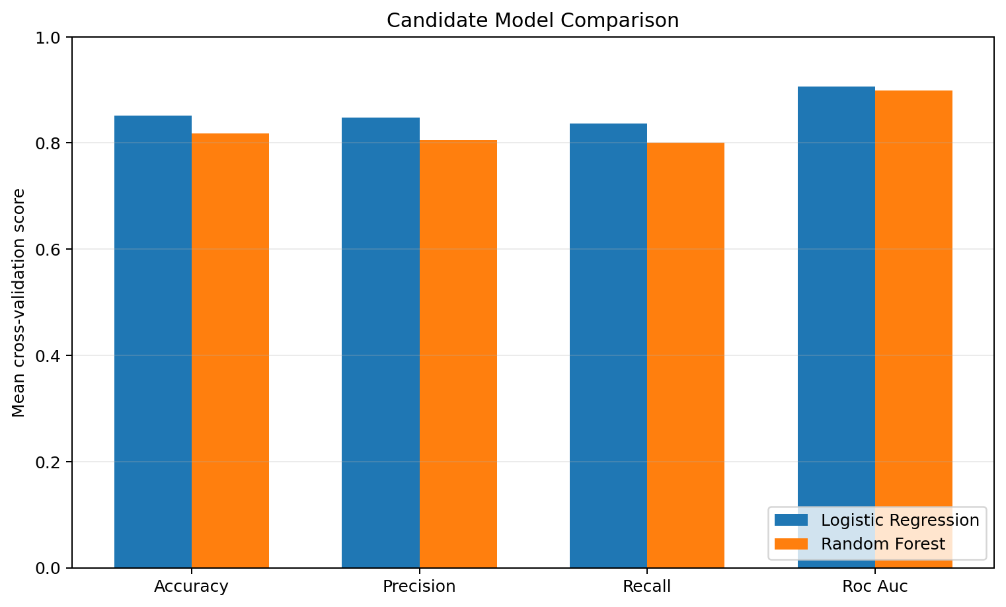
Figure 3. Cross-validation comparison used for model selection.
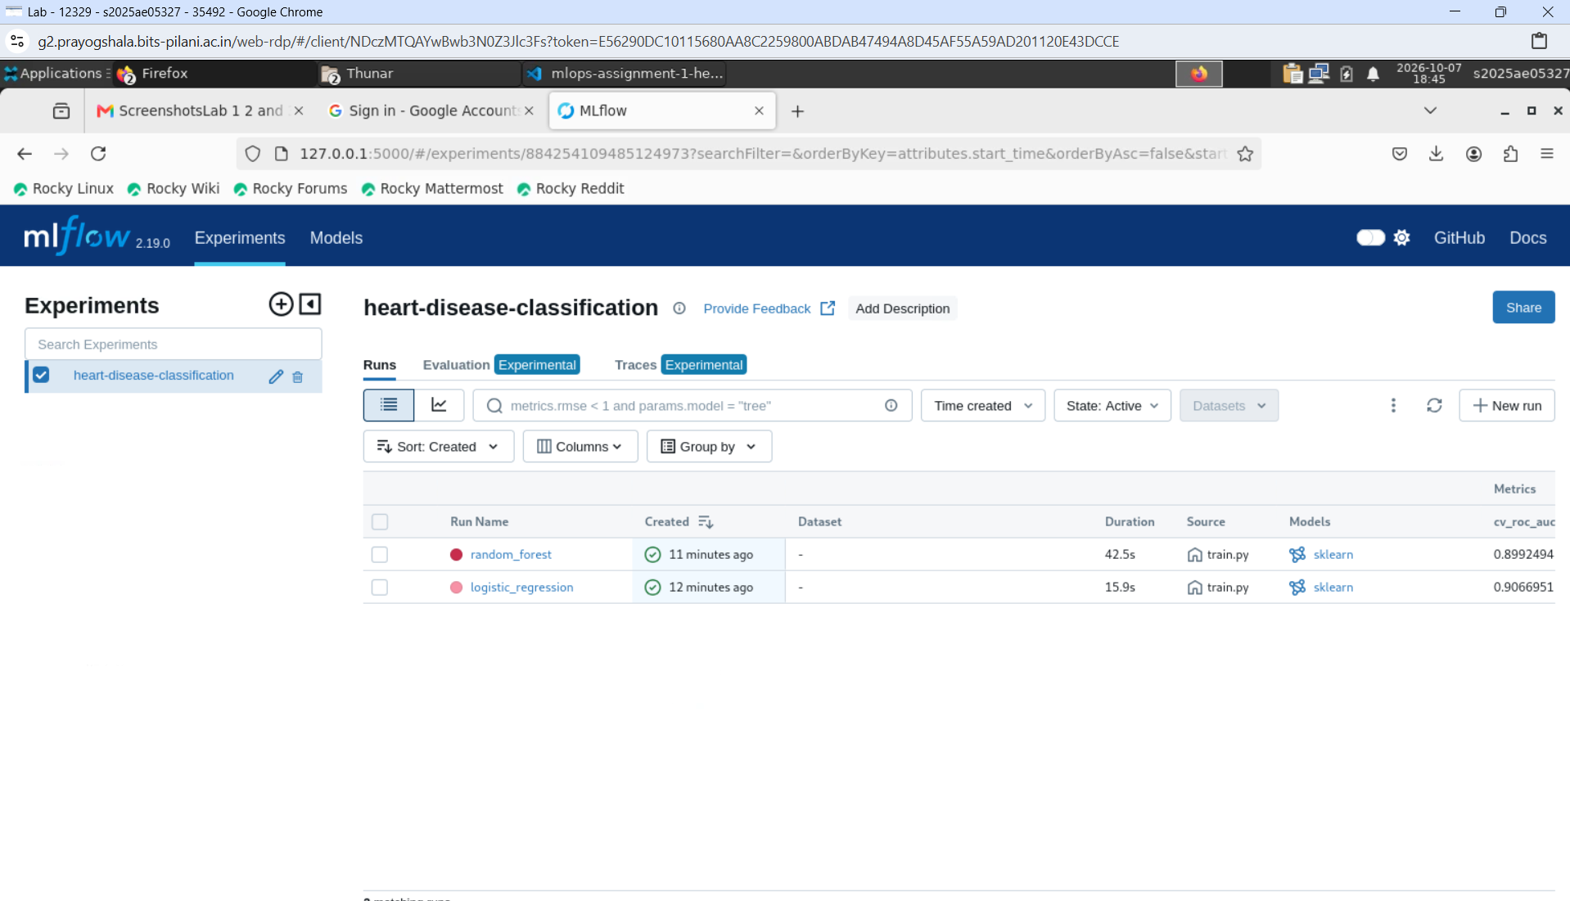
Figure 4. MLflow experiment comparison for both candidate models.
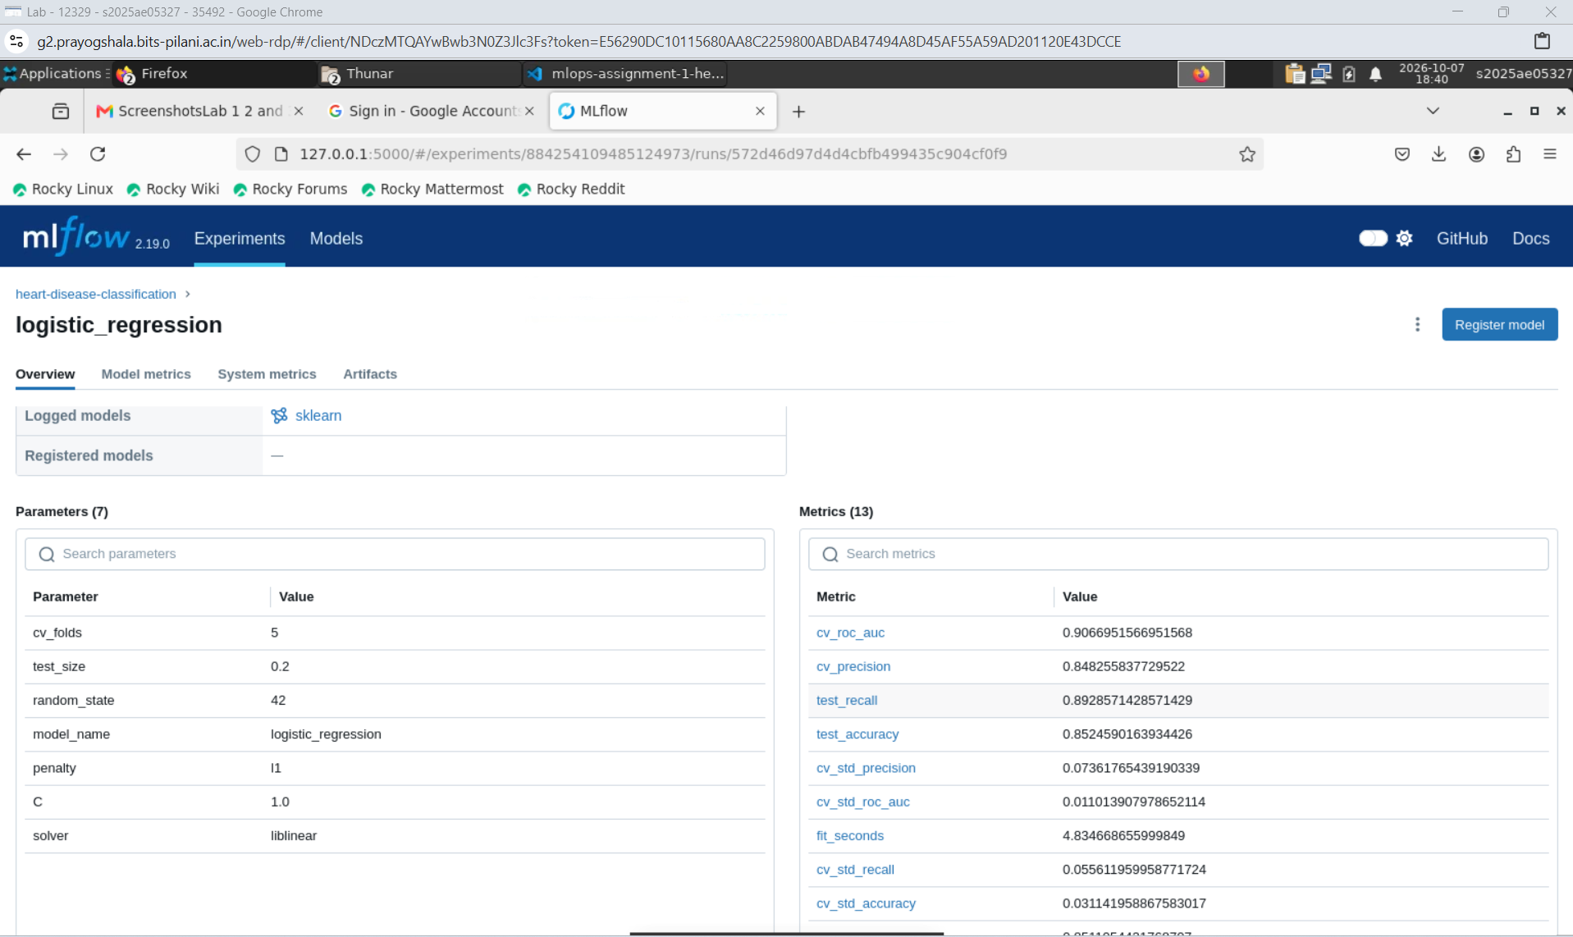
Figure 5. Selected Logistic Regression run details in MLflow.

6. Packaging and Inference API
The winning preprocessing-classifier pipeline is stored with Joblib and accompanied by JSON metadata that contains feature order, package version, candidate results, run identifier, and selection rationale. FastAPI validates all 13 fields and rejects missing, extra, or out-of-range values before invoking the model.
Endpoint | Purpose | Evidence
GET /health | Readiness and model loading | 200 only when model is usable
POST /predict | Prediction and confidence | Strict JSON schema
GET /metrics | Prometheus exposition | Counts and latency histogram
GET /docs | OpenAPI user interface | Interactive contract
Structured logs include request ID, route, status, latency, and output class. Raw patient features are deliberately excluded from logs to reduce exposure of sensitive information.
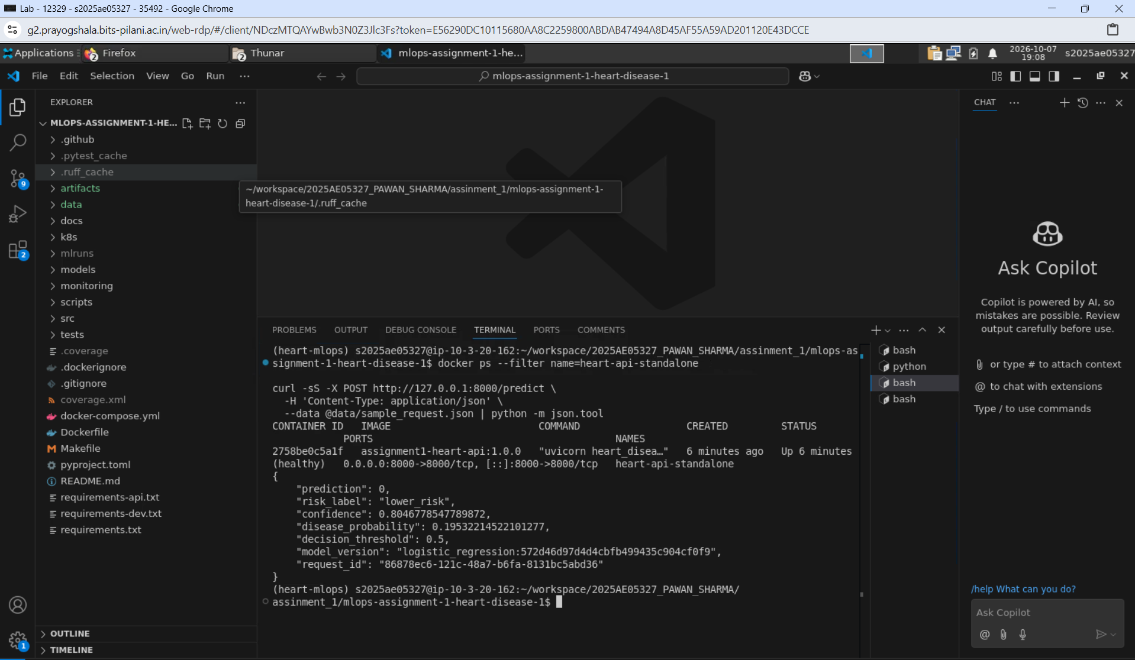
Figure 6. Healthy isolated Docker container and successful prediction response.

7. Automated Testing and CI/CD
Tests use deterministic synthetic data and cover schema failures, missing-value treatment, both model families, EDA generation, end-to-end MLflow packaging, API validation, model unavailability, and Prometheus output. The GitHub Actions workflow fails immediately on lint or test errors before running later stages.
- Ruff enforces errors, imports, bugbear checks, and Python modernization rules.
- Pytest publishes JUnit and XML coverage evidence.
- Training uses a reduced but representative grid in CI to control execution time.
- The final model, MLflow store, plots, cleaned data, report, and logs are uploaded.
- Docker build proves that the serving environment is independently reproducible.
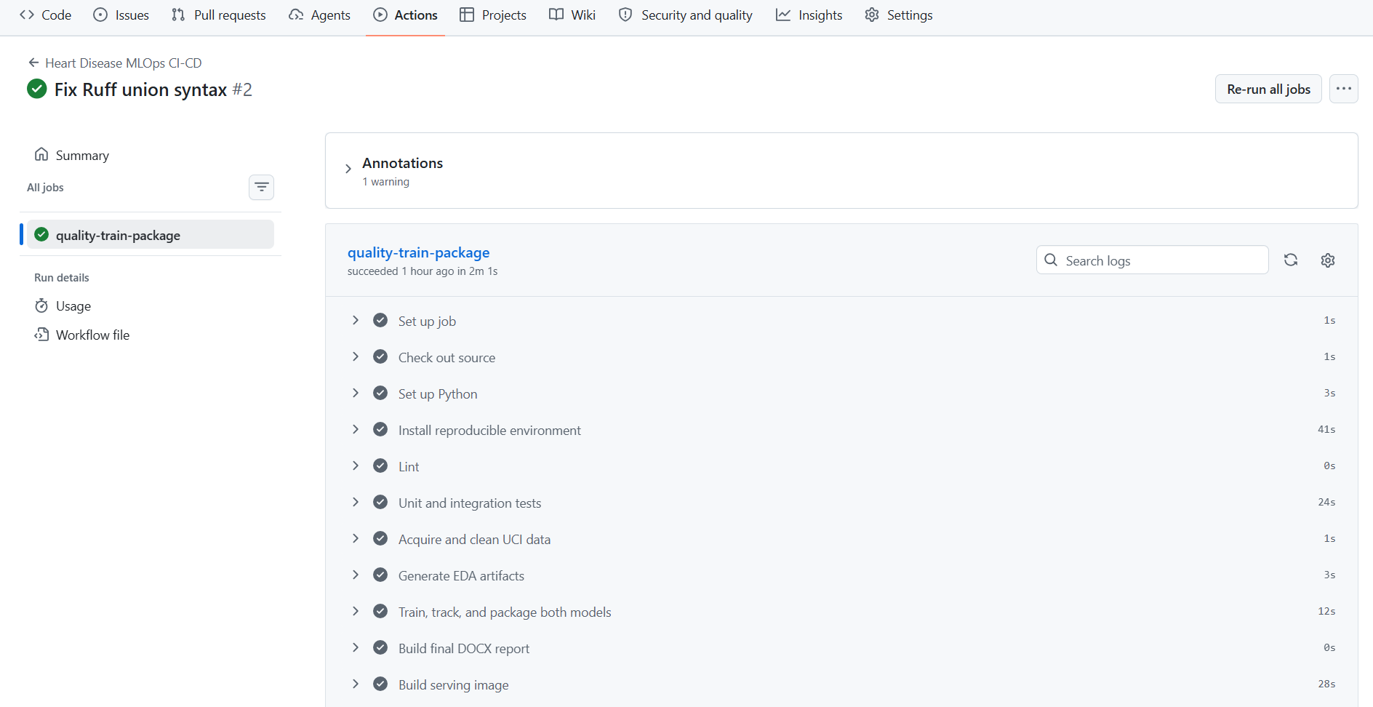
Figure 7. Successful CI/CD pipeline from lint through image packaging.

8. Containerization and Kubernetes Deployment
The image uses a pinned Python 3.11 slim base, a serving-only dependency set, a non-root user, a model-aware health check, unbuffered logs, and one worker per container. Docker Compose adds read-only model mounting and a read-only API filesystem.
Kubernetes deploys two API replicas with readiness/liveness probes, CPU and memory requests and limits, dropped Linux capabilities, a read-only root filesystem, and a LoadBalancer service. Prometheus and Grafana share the namespace through Kustomize.
UCI | -> | Data/EDA | -> | MLflow + Model
GitHub | -> | Actions | -> | Docker Image
Client | -> | FastAPI/K8s | -> | Prometheus/Grafana
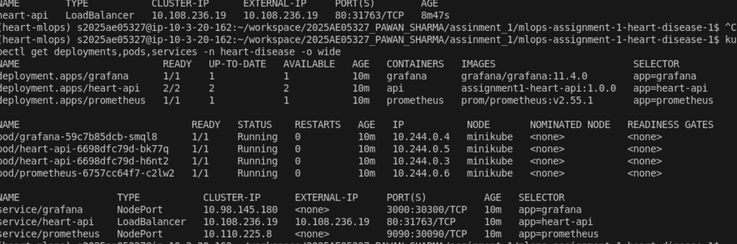
Figure 8. Healthy Kubernetes deployments, pods, and exposed services.
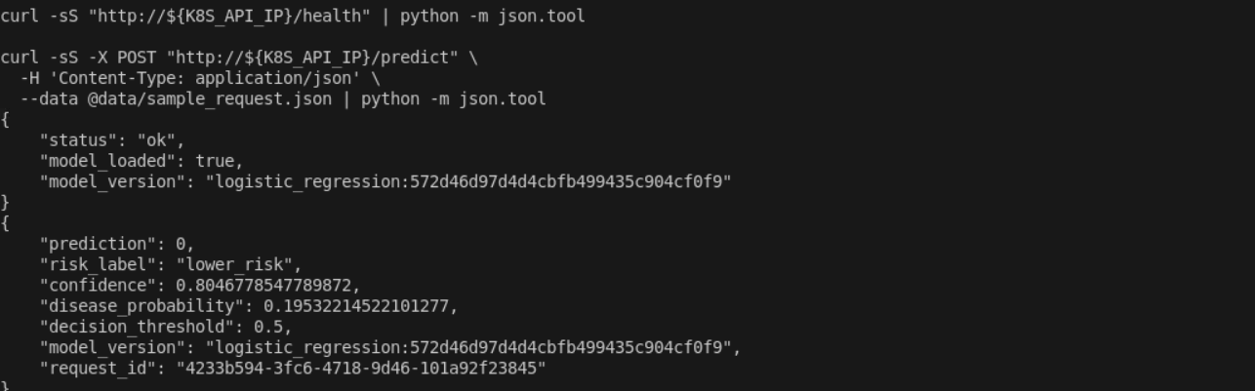
Figure 9. Prediction served through the Kubernetes LoadBalancer service.

9. Monitoring, Logging, and Operations
Prometheus scrapes the service every five seconds. The provisioned Grafana dashboard reports request rate by route, p95 latency, HTTP status trends, and output distribution. Health probes prevent traffic reaching a pod that cannot load its model. Request IDs support correlation from a client response to a JSON log line.
- Availability signal: health probe and request status series.
- Latency signal: histogram-derived p95 by endpoint.
- Traffic signal: per-route request rate.
- Behavior signal: prediction class distribution for drift triage.
- Recommended extension: validated feature drift, calibration drift, and outcome feedback.
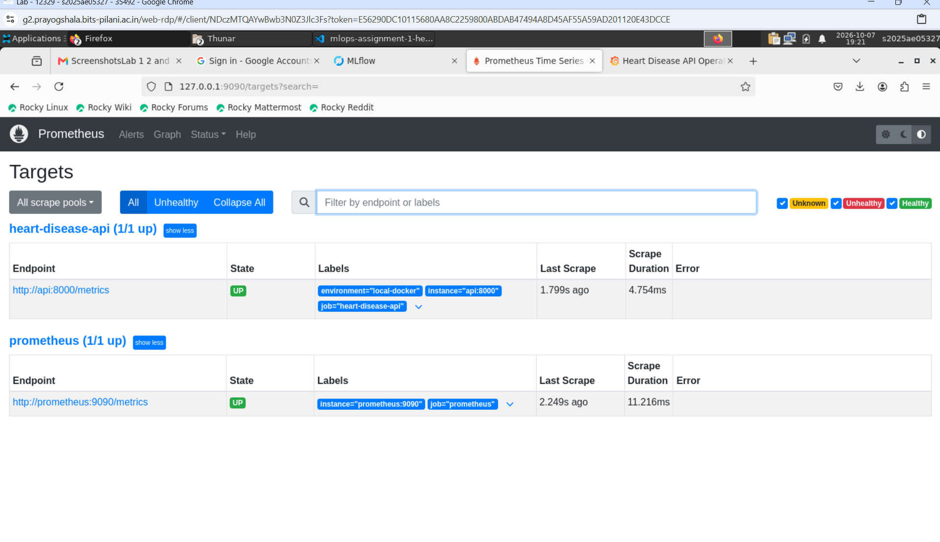
Figure 10. Prometheus API target in the UP state.
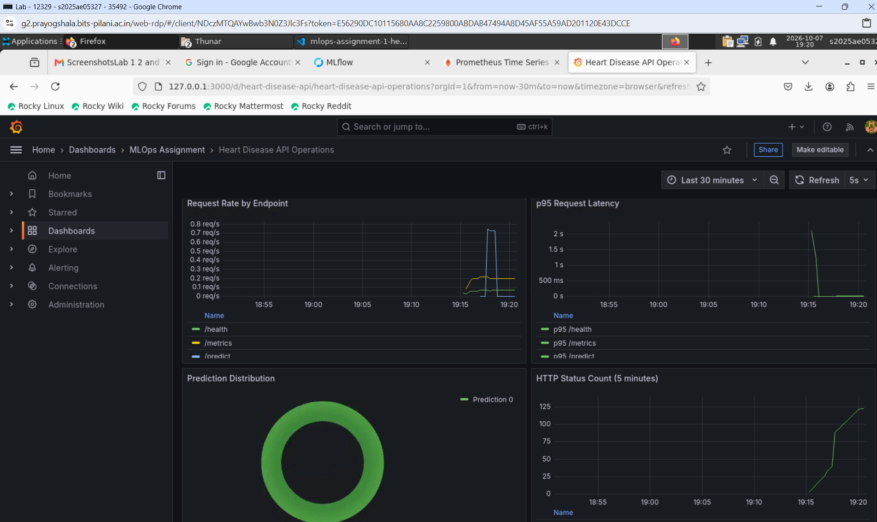
Figure 11. Provisioned Grafana operations dashboard with live metrics.
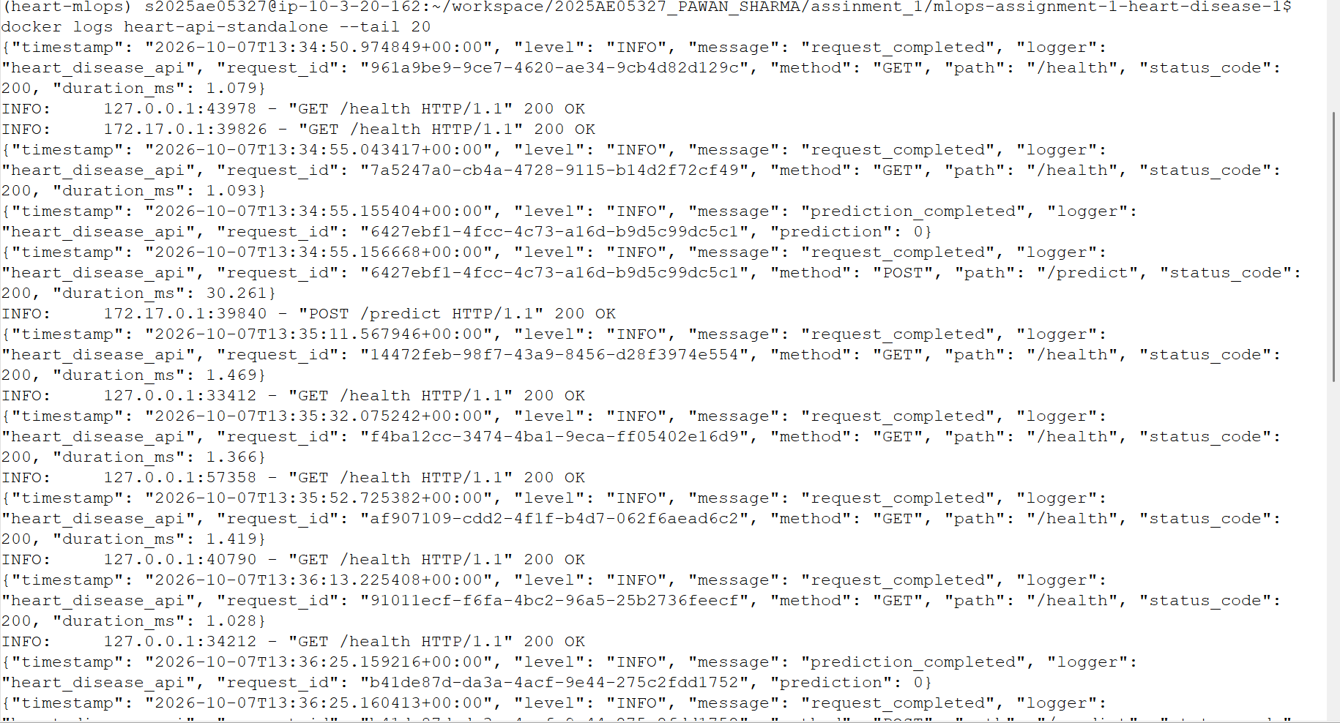
Figure 12. Structured request logs with status, latency, and request IDs.

10. Reproducibility, Limitations, and Conclusion
Reproduction starts from pinned dependencies and a single documented command sequence. Source checksum, fixed random states, fold strategy, feature order, best hyperparameters, package version, MLflow run ID, and image tag make major transitions auditable.

Limitations and next steps
- The Cleveland cohort is small and may not represent current or global populations.
- No causal or clinical claim follows from predictive association.
- Confidence is model probability, not a guarantee of calibrated individual risk.
- External validation, fairness analysis, threshold governance, and clinician review are required.
- Production should use a registry, signed images, secrets management, TLS, and durable metrics.

Conclusion
The assignment demonstrates an integrated MLOps system rather than an isolated notebook. The same preprocessing artifact moves from cross-validation to API inference; CI recreates data, evidence, model, report, and image; Kubernetes supplies scalable delivery; and metrics close the operational feedback loop.

Reproduction commands
python -m heart_disease_mlops.data
python -m heart_disease_mlops.eda
python -m heart_disease_mlops.train
pytest -q && ruff check src tests scripts
docker compose up --build -d
kubectl apply -k k8s

Appendix: Submission Evidence
The repository screenshots directory contains execution evidence for MLflow, CI/CD, Docker, Kubernetes, Prometheus, Grafana, and structured API logs. The repository URL, local API access instructions, and demonstration video link complete the submission.

