Machine Learning Operations (MLOps) - AIMLCZG523
Assignment 01
Heart Disease Risk Prediction: End-to-End ML Pipeline with CI/CD, Docker, Kubernetes and Monitoring
Submitted by
Name: Daddekar Rohit Tukaram Vaishali
BITS ID: 2025AE05519
Repository: https://github.com/2025ae05519/mlops_assignment_01
Video: [add link after recording]

Contents
1. Introduction
2. Setup and Installation
3. Data Acquisition, Cleaning and EDA
3.1 Acquisition and cleaning
3.2 Exploratory data analysis
4. Feature Engineering and Model Development
4.1 Preprocessing pipeline
4.2 Models, cross-validation and tuning
4.3 Model selection
5. Experiment Tracking with MLflow
6. Model Packaging and Reproducibility
7. Testing and CI/CD Pipeline
7.1 Unit tests
7.2 GitHub Actions workflow
8. API and Containerisation
9. Production Deployment on Kubernetes
10. Monitoring and Logging
11. Architecture
12. Conclusion

1. Introduction
The goal of this assignment is to build a classifier that predicts whether a patient has heart disease from routine clinical measurements, and to take it all the way to a monitored API running on Kubernetes using MLOps practices: experiment tracking, automated testing, CI/CD, containerisation and monitoring.
Dataset: UCI Heart Disease (Cleveland), repository id 45. It has 303 patient records and 13 input features (age, sex, chest pain type, resting blood pressure, cholesterol, fasting blood sugar, resting ECG, maximum heart rate, exercise-induced angina, ST depression, ST slope, number of major vessels, thalassemia). The original target num takes values 0 to 4; I mapped 0 to "no disease" and 1 to 4 to "disease present", which gives 164 negative and 139 positive cases.
Heart disease is one of the leading causes of death, and simple measurements such as blood pressure, cholesterol and an exercise ECG are collected for almost every patient. A model that flags high-risk patients from these values can help prioritise further tests. My aim in this assignment was not only to train a good classifier, but to make the whole lifecycle reproducible and automated: one command to retrain, every experiment recorded, every change tested by CI, and the model served as a monitored API on Kubernetes.

2. Setup and Installation
The project uses Python 3.12 (the same version as the Dockerfile and the CI workflow). All dependencies are listed in requirements.txt with pinned or bounded versions.
git clone https://github.com/2025ae05519/mlops_assignment_01.git
cd mlops_assignment_01
python -m venv .venv && source .venv/bin/activate
pip install -r requirements.txt
python -m src.train # download data, train, log to MLflow, save model
python -m pytest -v # unit tests
python -m uvicorn src.api:app --port 8000 # run the API locally
Repository layout:
Folder / file | Purpose
src/train.py | data download and cleaning, preprocessing, model training, CV, tuning, MLflow logging
src/predict.py, src/api.py | inference helper and FastAPI service (/health, /predict, /metrics)
tests/ | unit tests for data cleaning, model code and API (16 tests)
notebooks/ | EDA and experiment notebook
data/raw, data/processed | raw download and cleaned dataset
artifacts/ | saved pipeline, feature list, metrics, plots
Dockerfile, docker-compose.yml | API image; local API + Prometheus + Grafana stack
deployment/ | Kubernetes Deployment, LoadBalancer Service and Ingress
.github/workflows/ci.yml | GitHub Actions pipeline
monitoring/ | Prometheus scrape config and Grafana dashboard
Table 1: Repository structure
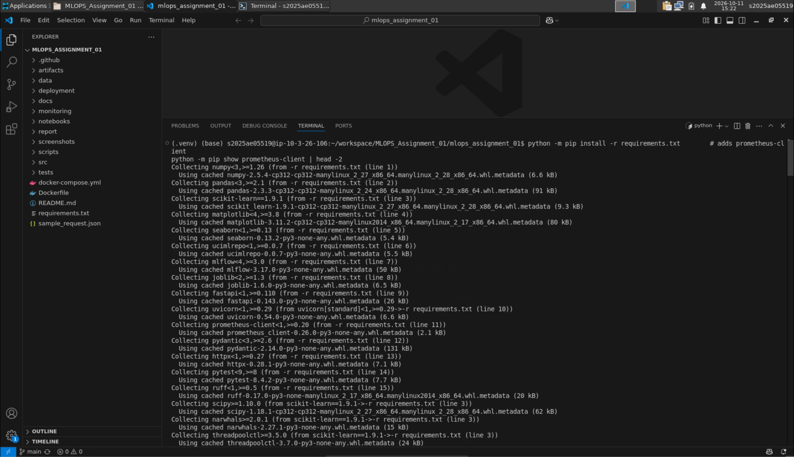Figure 1: Project environment and dependency installation

3. Data Acquisition, Cleaning and EDA

3.1 Acquisition and cleaning
The data is downloaded with the ucimlrepo package (fetch_ucirepo(id=45)) and cached as data/raw/heart_disease_uci_raw.csv, so later runs do not depend on the UCI server. Cleaning steps in clean_dataframe():
- missing value markers ("?", "NA", empty strings) are converted to NaN and all columns are coerced to numeric;
- rows without a target are dropped and the target is mapped to binary (0 vs 1 to 4);
- ca has 4 missing values and thal has 2. These are not dropped; they are imputed inside the model pipeline so that imputation statistics come only from the training data.
The cleaned data is saved to data/processed/heart_disease_clean.csv.
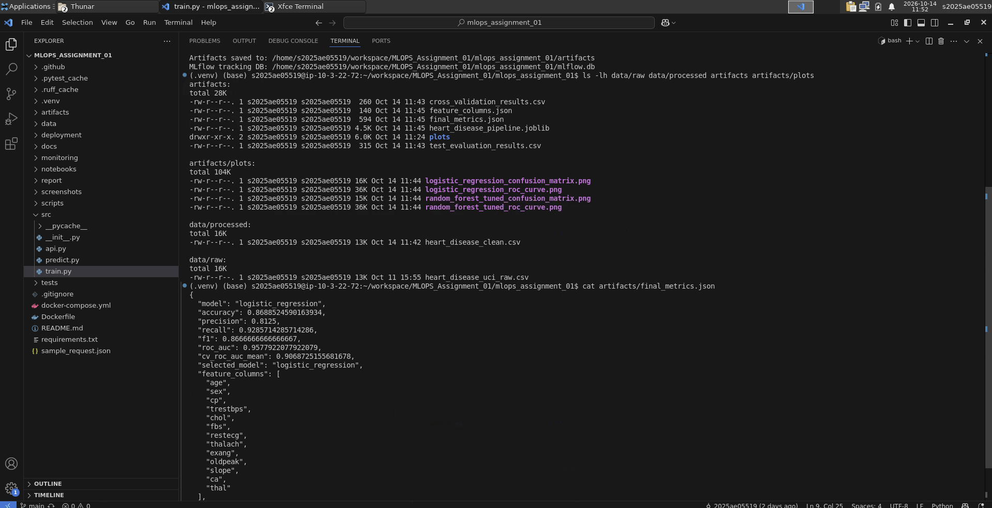
Figure 2: Raw and processed dataset files and generated artifacts

3.2 Exploratory data analysis
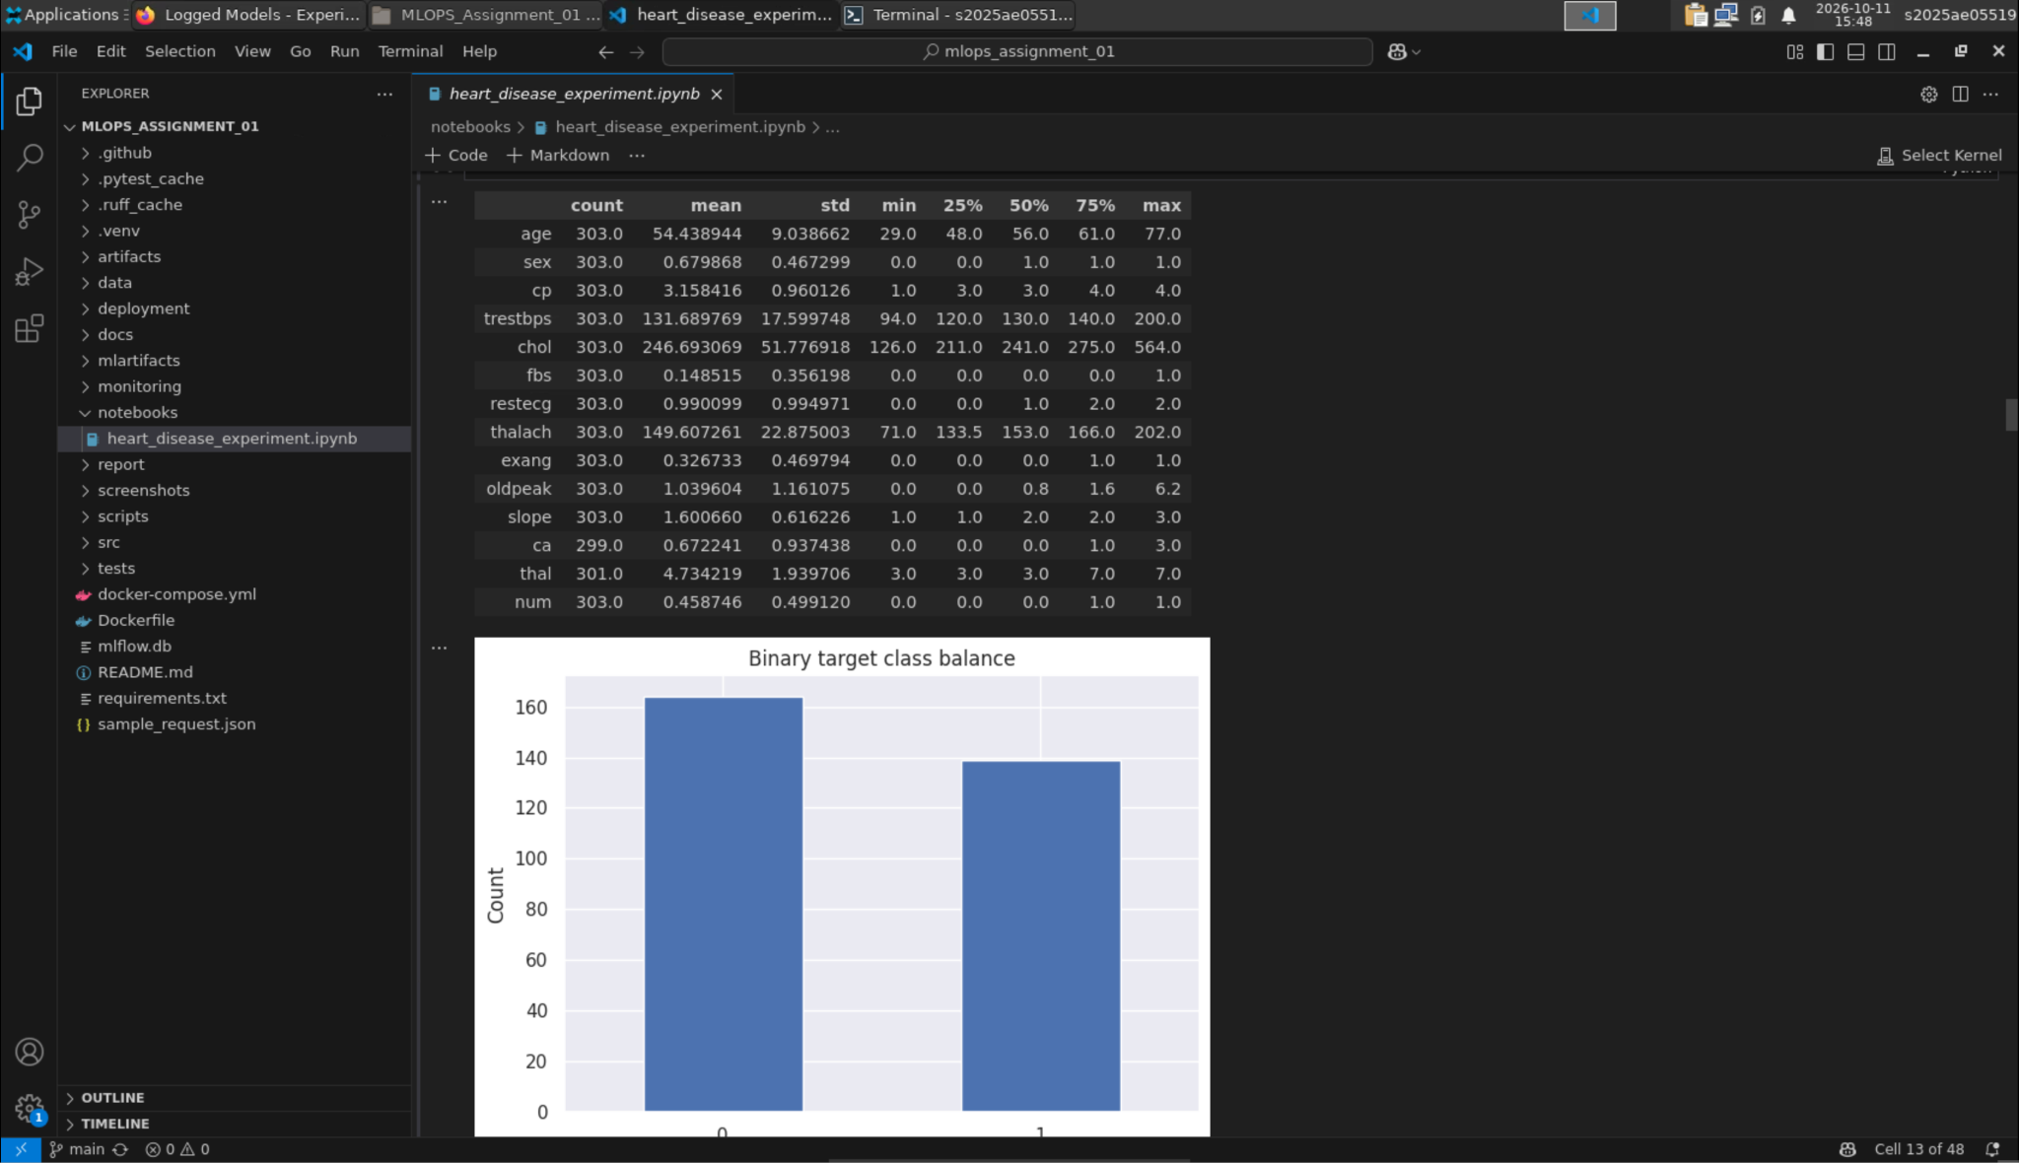
Figure 3: Class balance of the binary target
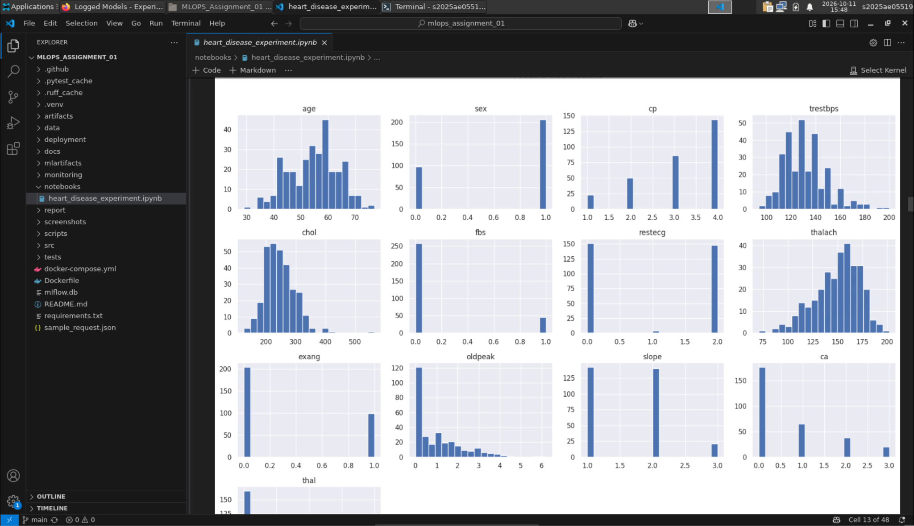
Figure 4: Feature distributions
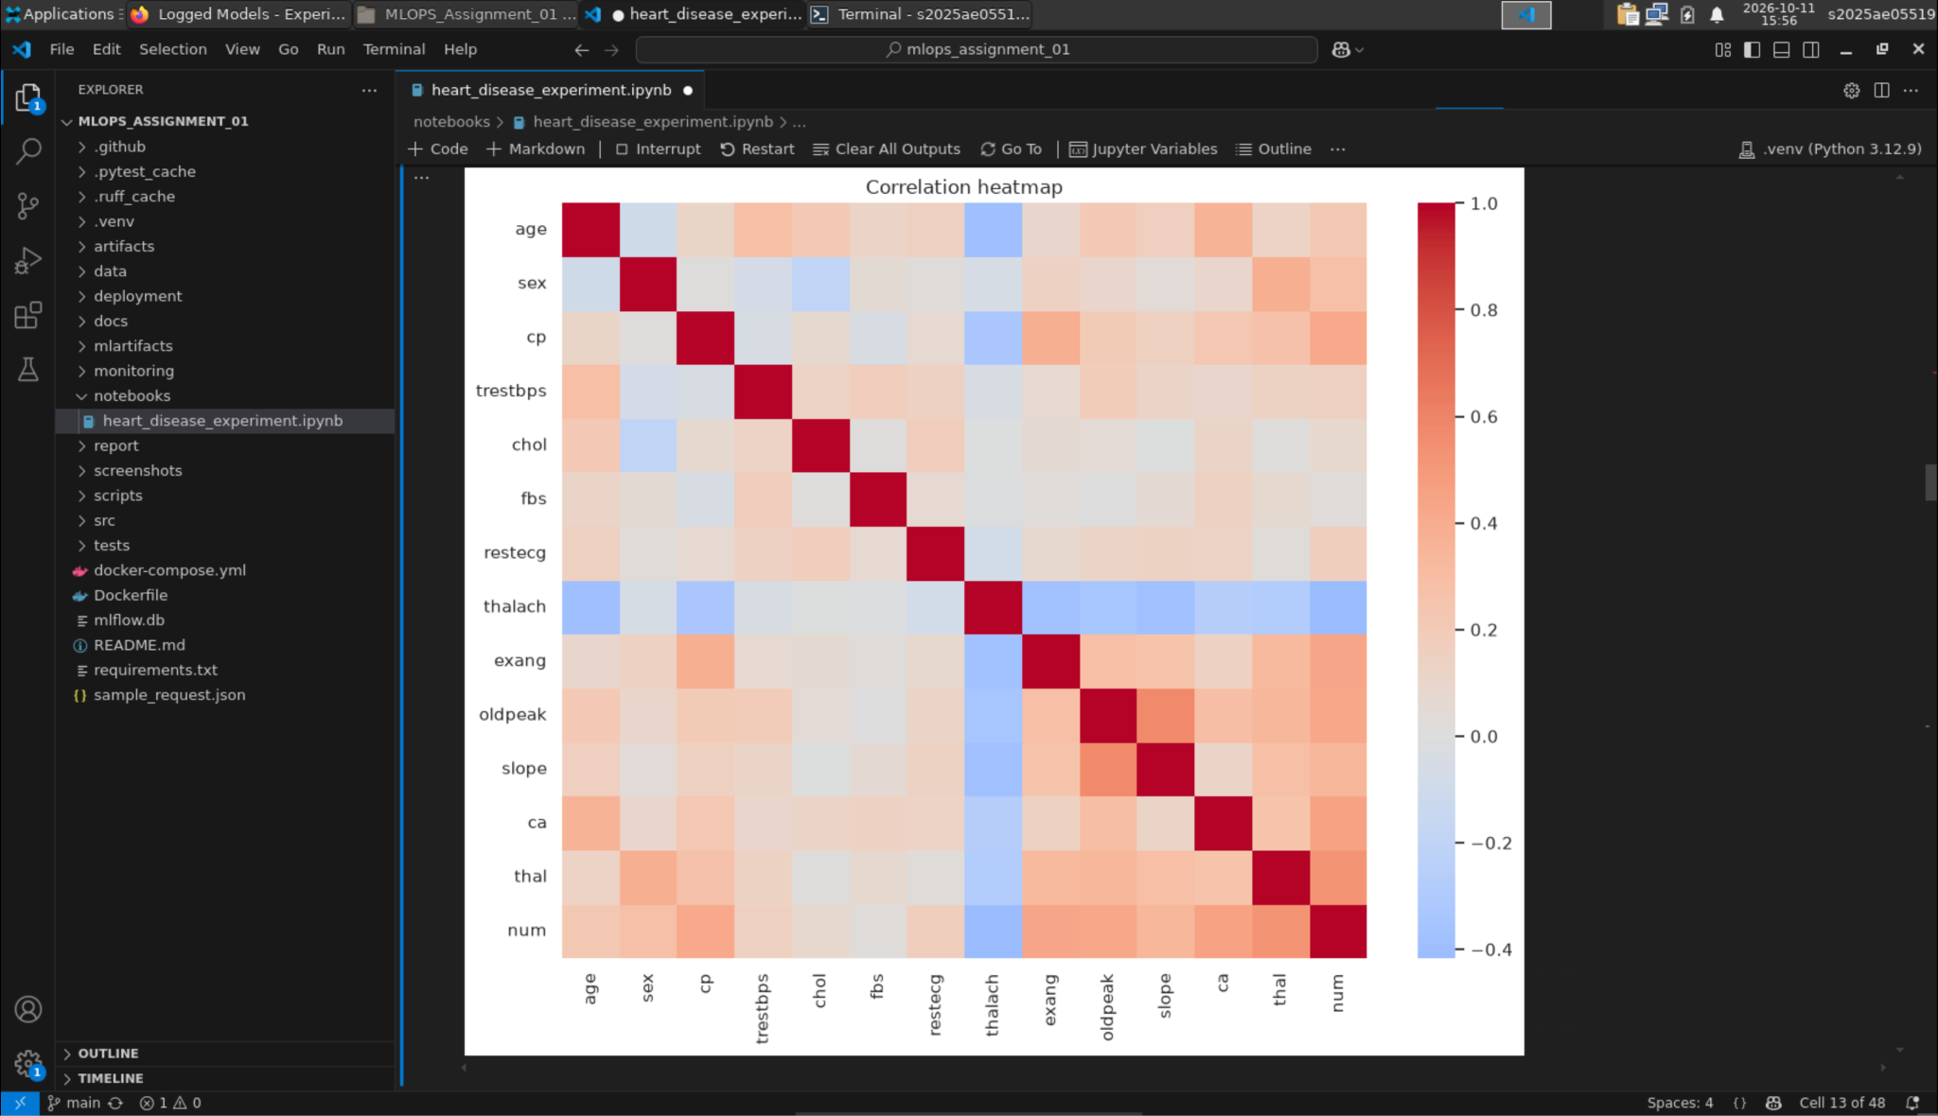
Figure 5: Correlation heatmap
Class balance: the target is reasonably balanced, with 164 patients without disease and 139 with disease (54% vs 46%). Because of this I did not need resampling, but I still used class_weight="balanced" and stratified splits, and I report recall and ROC-AUC alongside accuracy, since missing a sick patient is worse than a false alarm.
Distributions: age ranges from 29 to 77 (mean 54) and is roughly normal. Cholesterol (skew 1.14, maximum 564) and ST depression oldpeak (skew 1.27, many zeros) are right-skewed with a few outliers, and maximum heart rate thalach is slightly left-skewed. sex, fbs and exang are binary, and the dataset is about two-thirds male (206 vs 97). cp, restecg, slope and thal take only a few integer values; they are category codes rather than measurements, which is why I one-hot encode them.
Correlations with the target: the strongest positive correlations are thal (0.53), ca (0.46), exang (0.43), oldpeak (0.42) and cp (0.41). Maximum heart rate has the strongest negative correlation (-0.42), meaning patients who reach a lower peak heart rate are more likely to have disease. Cholesterol (0.09) and fasting blood sugar (0.03) are only weakly related to the target on their own. No pair of input features is so strongly correlated that a feature had to be removed.

4. Feature Engineering and Model Development

4.1 Preprocessing pipeline
All preprocessing lives inside a scikit-learn Pipeline (ColumnTransformer + model), so exactly the same transformations are applied during training, cross-validation and serving:
Feature group | Columns | Steps
Numeric | age, sex, trestbps, chol, fbs, thalach, exang, oldpeak, ca | median imputation; StandardScaler (Logistic Regression only)
Nominal (categorical) | cp, restecg, slope, thal | most-frequent imputation; OneHotEncoder(handle_unknown="ignore")
Table 2: Preprocessing per feature group
Chest pain type is coded 1 to 4, but type 4 is not "twice" type 2; the numbers are just labels. If they are fed in as one numeric column, a linear model is forced to assume an ordered, evenly spaced effect, which is not meaningful. One-hot encoding gives each category its own binary column so the model can learn a separate weight for each. handle_unknown="ignore" makes the API robust if an unexpected code is sent. Scaling is applied only for Logistic Regression, because its regularised coefficients depend on feature scale, while Random Forest splits on thresholds and is not affected by scaling. Adding the one-hot encoding raised Logistic Regression's cross-validation ROC-AUC from 0.896 to 0.907.

4.2 Models, cross-validation and tuning
Two models were compared: Logistic Regression (class_weight="balanced", max_iter=2000) and Random Forest (class_weight="balanced"). The data was split 80/20 with stratification (random_state=42). On the training set I used stratified 5-fold cross-validation with accuracy, precision, recall, F1 and ROC-AUC. Random Forest was tuned with GridSearchCV over n_estimators {200, 400}, max_depth {None, 5, 10} and min_samples_leaf {1, 2, 4}, optimising ROC-AUC. Best parameters: n_estimators=200, max_depth=None, min_samples_leaf=4.
Model (5-fold CV on training set) | Accuracy | Precision | Recall | F1 | ROC-AUC
Logistic Regression | 0.847 | 0.848 | 0.819 | 0.831 | 0.907
Random Forest (default) | 0.801 | 0.788 | 0.783 | 0.781 | 0.898
Table 3: Cross-validation results (artifacts/cross_validation_results.csv)
Model (held-out test set, 61 rows) | Accuracy | Precision | Recall | F1 | ROC-AUC | CV ROC-AUC
Logistic Regression (selected) | 0.869 | 0.813 | 0.929 | 0.867 | 0.958 | 0.907
Random Forest (tuned) | 0.885 | 0.839 | 0.929 | 0.881 | 0.947 | 0.902
Table 4: Test set results (artifacts/test_evaluation_results.csv)

4.3 Model selection
The final model is chosen by mean cross-validation ROC-AUC, not by the test score, so the test set stays an unbiased estimate. Logistic Regression had the higher CV ROC-AUC (0.907 vs 0.902) and was selected. Its test results are accuracy 0.869, recall 0.929 and ROC-AUC 0.958.
On the test set the tuned Random Forest had slightly higher accuracy (0.885 vs 0.869) and F1 (0.881 vs 0.867), while Logistic Regression had the higher ROC-AUC (0.958 vs 0.947) and the same recall (0.929). I kept the rule decided before looking at the test set: choose by cross-validation. The test set has only 61 patients, so a difference of one patient changes accuracy by 1.6 percentage points; picking whichever model looks best on it would be a form of overfitting to the test set and would make the reported test score optimistic. Logistic Regression is also simpler, faster and easier to explain to clinicians through its coefficients.
For a screening tool, recall matters most: a false negative sends a sick patient home. The selected model detects 26 of the 28 positive test patients (recall 0.929), at the cost of some false positives (precision 0.813), which is an acceptable trade-off because a false positive only leads to further tests.
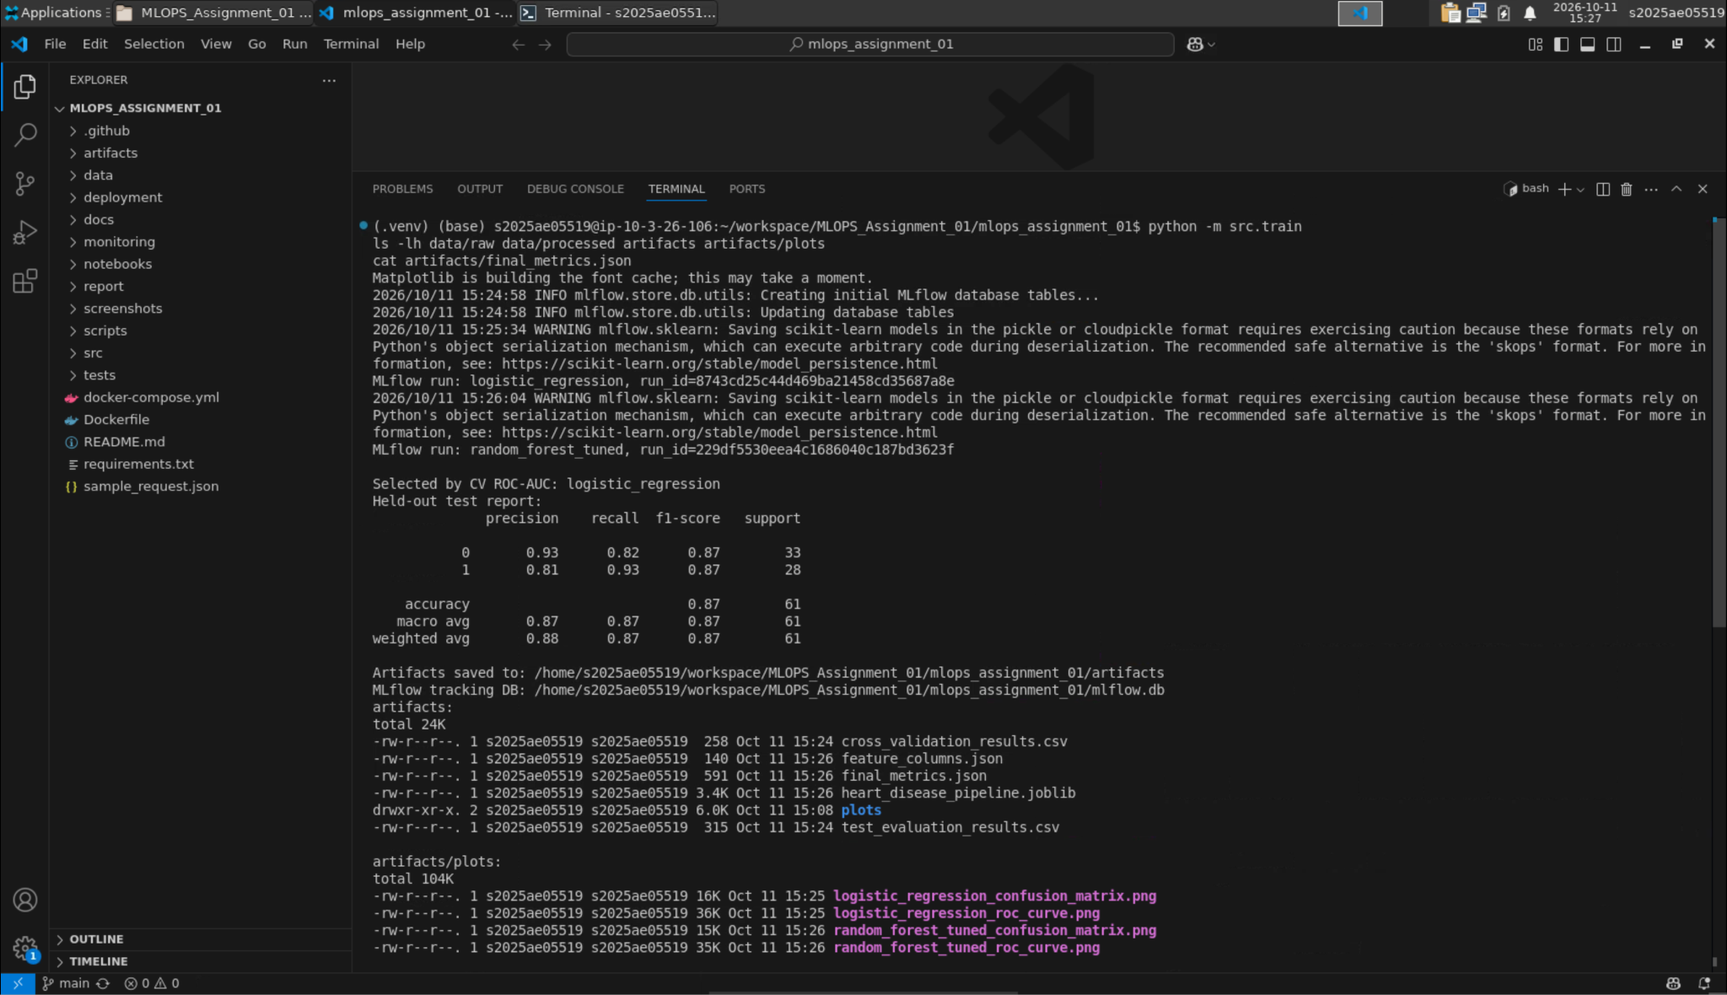
Figure 6: Training run output with the selected model and classification report

5. Experiment Tracking with MLflow
MLflow is configured with a local SQLite backend (mlflow.db) and an artifact folder (mlartifacts/), under the experiment heart-disease-classification. Every training run logs one MLflow run per candidate model containing:
- parameters: model name, dataset id, target mapping, random state, test size, number of CV folds, and the best grid-search parameters for Random Forest;
- metrics: cv_roc_auc_mean and test accuracy, precision, recall, F1 and ROC-AUC;
- artifacts: the CV and test result CSVs, ROC curve and confusion matrix plots;
- the model itself (mlflow.sklearn.log_model) with an input example and signature; tags mark which run was selected.
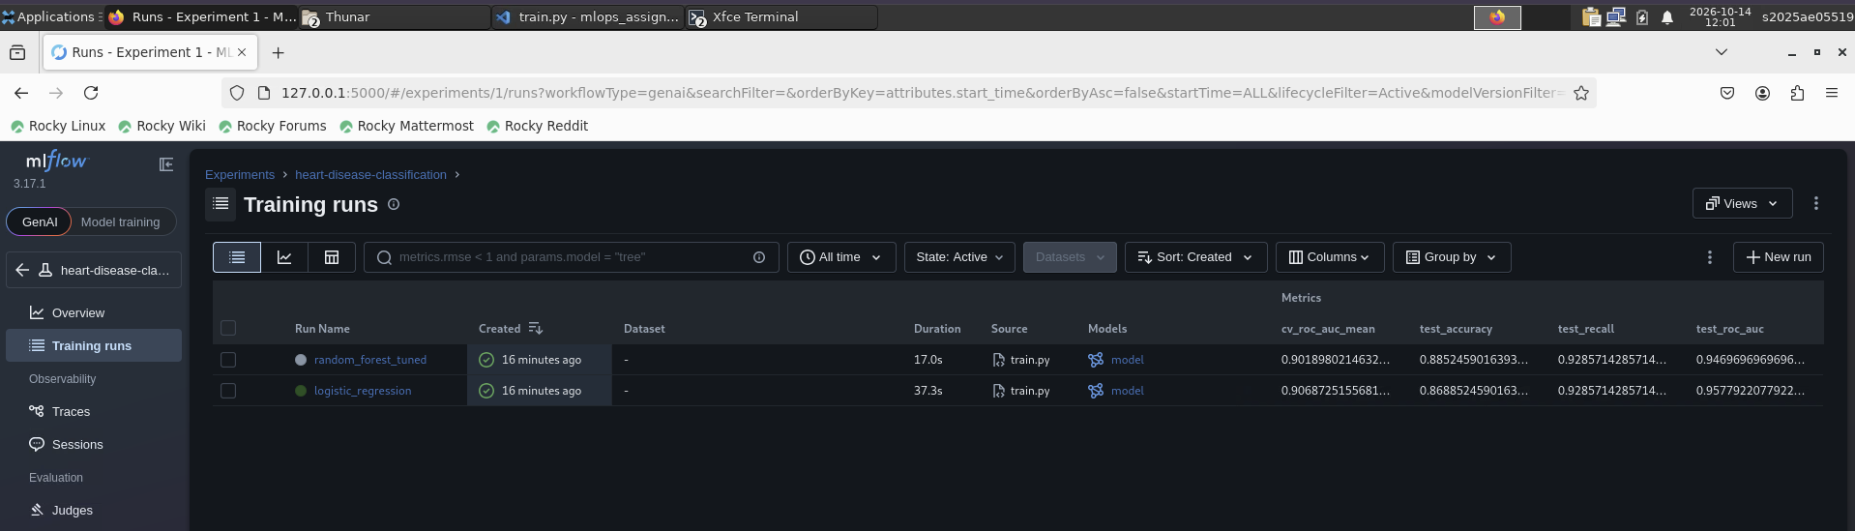
Figure 7: MLflow runs list for the experiment
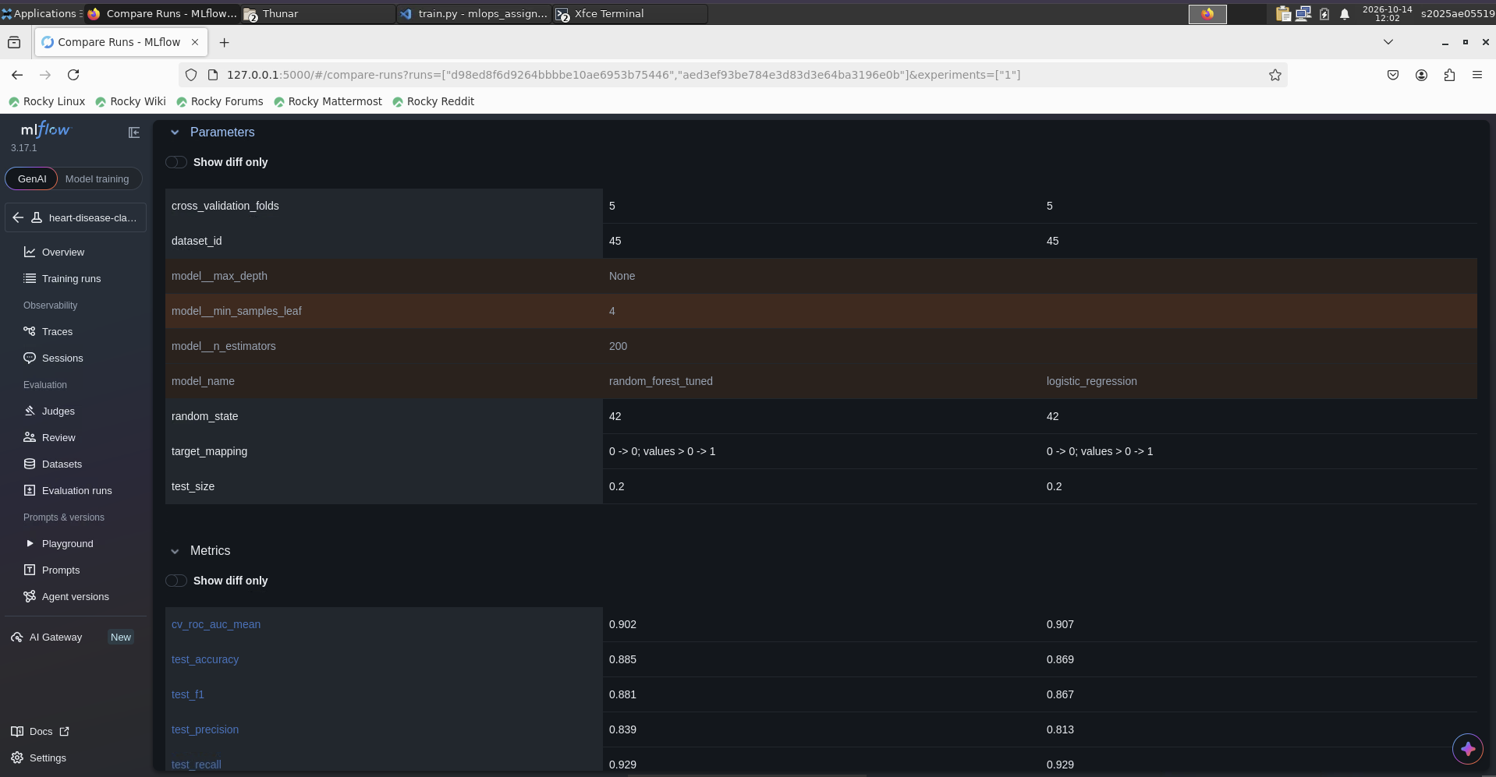
Figure 8: Comparing the two runs side by side
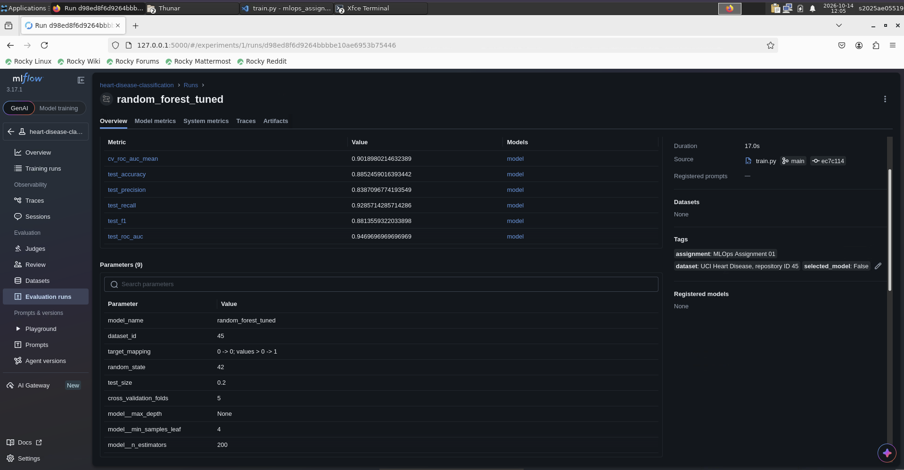
Figure 9: Parameters and metrics of one run
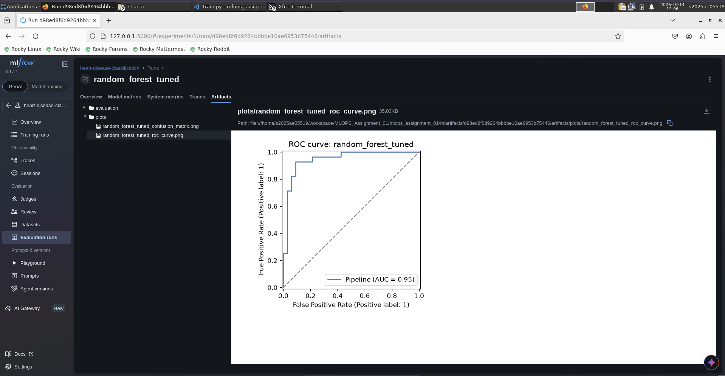
Figure 10: Logged plots (ROC curve, confusion matrix)
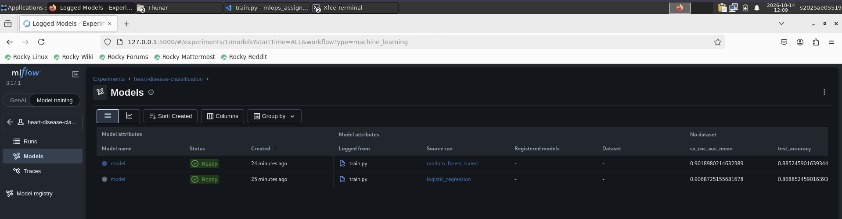
Figure 11: Logged models
MLflow made the comparison concrete instead of relying on terminal output. The runs table shows the CV and test metrics of both models side by side, the compare view highlights which parameters differ, and the logged plots let me check the ROC curves and confusion matrices of every run later. When I added one-hot encoding, I could compare the new runs with the earlier ones and confirm that the CV ROC-AUC improved before keeping the change.

6. Model Packaging and Reproducibility
- The whole fitted pipeline (preprocessing + model) is saved with joblib to artifacts/heart_disease_pipeline.joblib, and the ordered input columns to artifacts/feature_columns.json. The API rejects requests whose feature names do not match this list.
- The same model is also stored in MLflow format in every run.
- requirements.txt pins scikit-learn to the exact version used for training, so the pickled pipeline loads correctly in Docker and CI.
- A fixed random_state (42) is used for the split, CV folds and models; re-running training reproduces the same metrics.

7. Testing and CI/CD Pipeline

7.1 Unit tests
Test file | What it checks
tests/test_data.py (5) | missing markers become NaN, rows without target dropped, binary target mapping, column renaming, empty columns removed
tests/test_model.py (6) | both pipelines fit and output probabilities, scaling only for LR, one-hot encoding of nominal features and unseen categories, plots written, feature validation, confidence value
tests/test_api.py (5) | /health returns 200 (and 503 if the model is missing), /predict validation and response, /metrics counters
Table 5: Unit tests (16 in total)
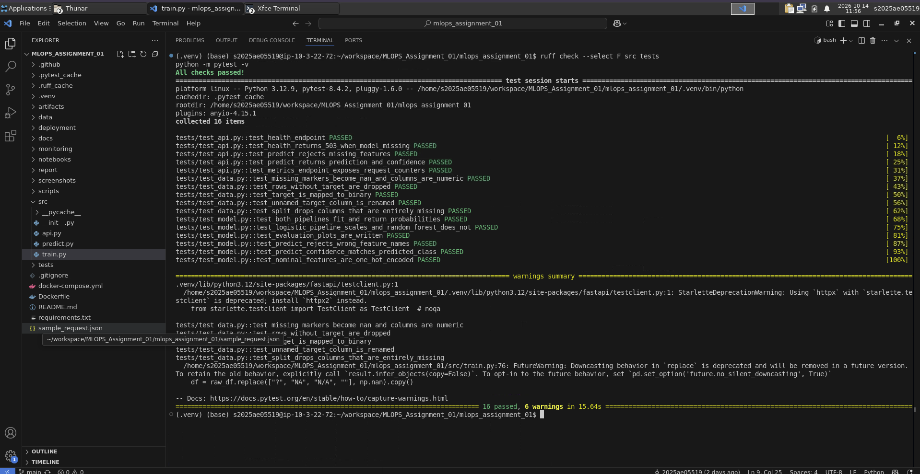
Figure 12: Local lint and test run (16 passed)

7.2 GitHub Actions workflow
The workflow .github/workflows/ci.yml runs on every push, pull request and manual dispatch, with two jobs:
- Lint, train and test: install dependencies, ruff lint, python -m src.train (output saved to training.log), pytest with a JUnit XML report, then upload artifacts/, the datasets, the training log and the test report as a downloadable run artifact.
- Build and smoke-test Docker image: runs only if the first job passes; builds the image, starts the container, waits for /health, calls /predict with sample_request.json, checks /metrics and prints the container logs.
Any lint error, training error, failing test or unhealthy container makes the run fail. The training step runs with bash pipefail so an error is not hidden by the tee command.
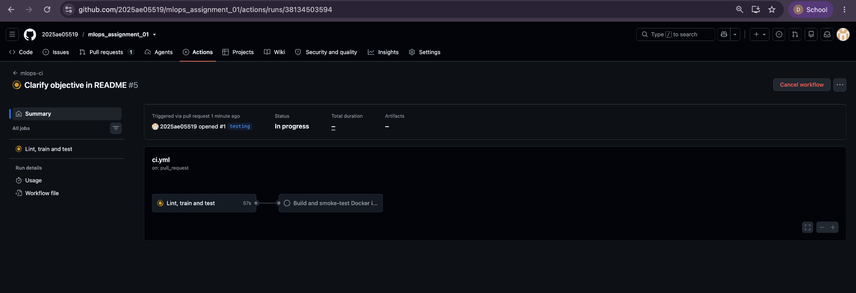
Figure 13: Workflow graph: the Docker job starts only after Lint, train and test
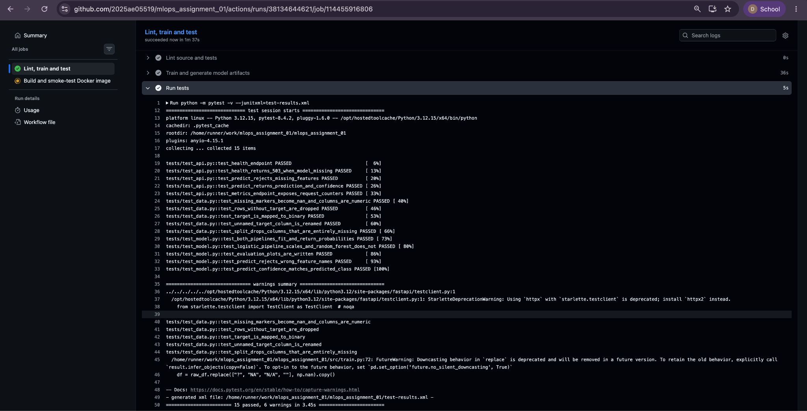
Figure 14: Lint, train and test job log from an earlier CI run (15 tests passed; the one-hot encoding test was added later, giving the 16 tests in Figure 12)
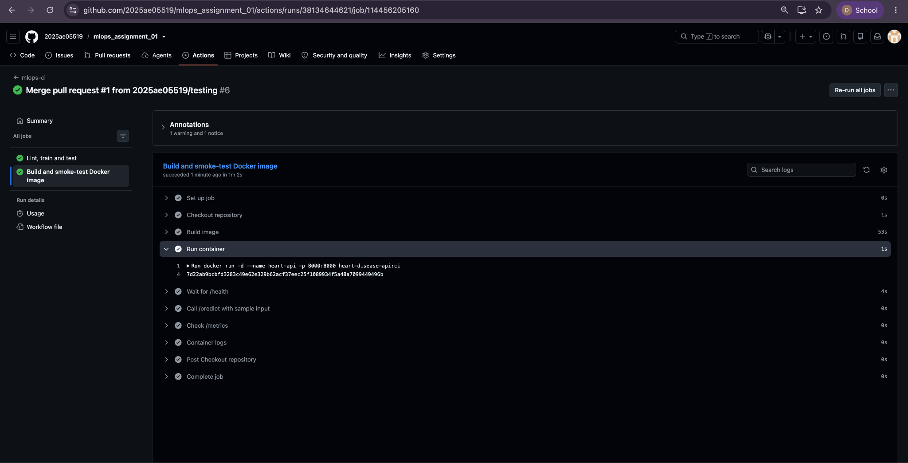
Figure 15: Docker build and smoke-test job: container started, /health, /predict and /metrics checked
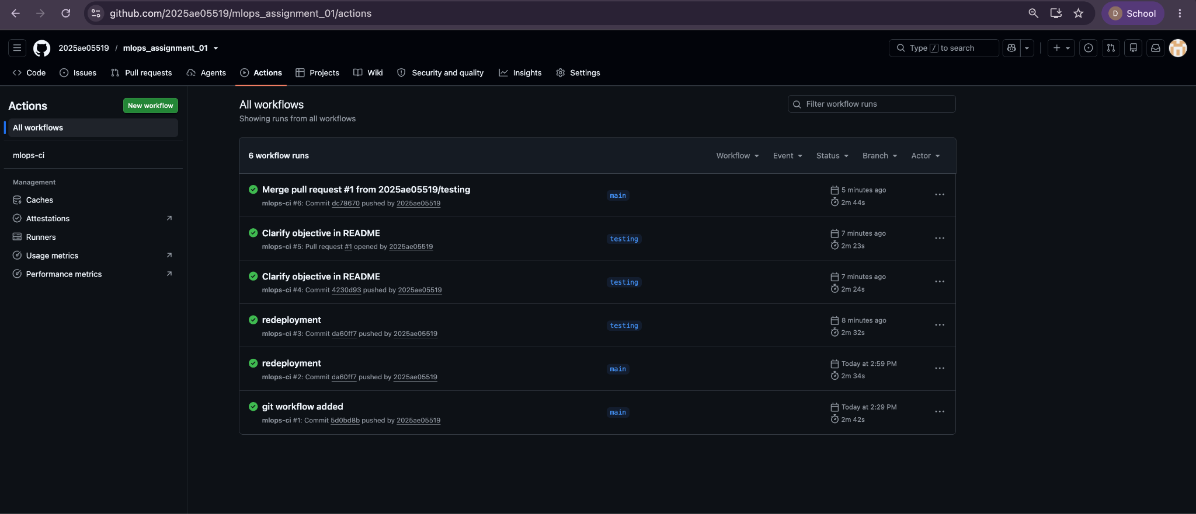
Figure 16: GitHub Actions run history: all six mlops-ci runs passed, including the pull request run

8. API and Containerisation
The model is served with FastAPI (src/api.py) and uvicorn:
Endpoint | Description
GET /health | returns 200 and model_loaded=true only if the model can be loaded, otherwise 503 (used by Kubernetes probes)
POST /predict | accepts JSON {"features": {...13 values...}}, returns prediction, label, confidence and positive-class probability
GET /metrics | Prometheus metrics: request count, latency histogram, predictions by label
Table 6: API endpoints
Example response for sample_request.json:
{"prediction": 0, "label": "disease_not_detected", "confidence": 0.82, "positive_class_probability": 0.18}
The Dockerfile uses python:3.12-slim, installs requirements.txt, copies src/ and artifacts/, exposes port 8000 and defines a HEALTHCHECK on /health.
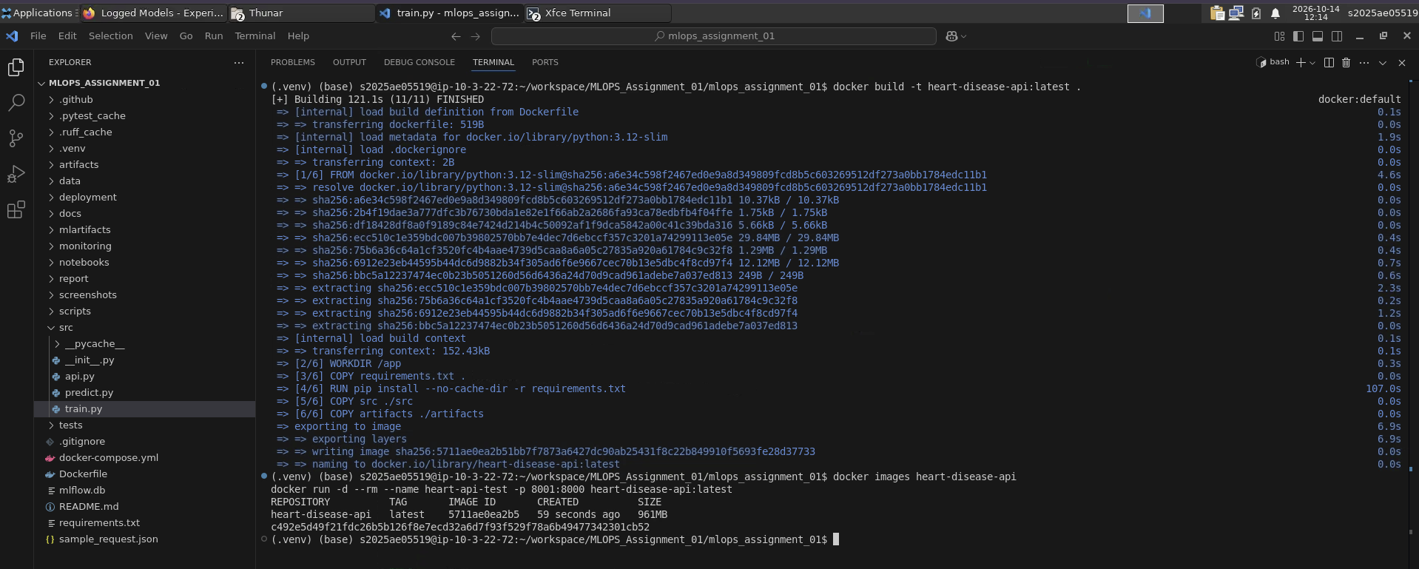
Figure 17: Docker image build
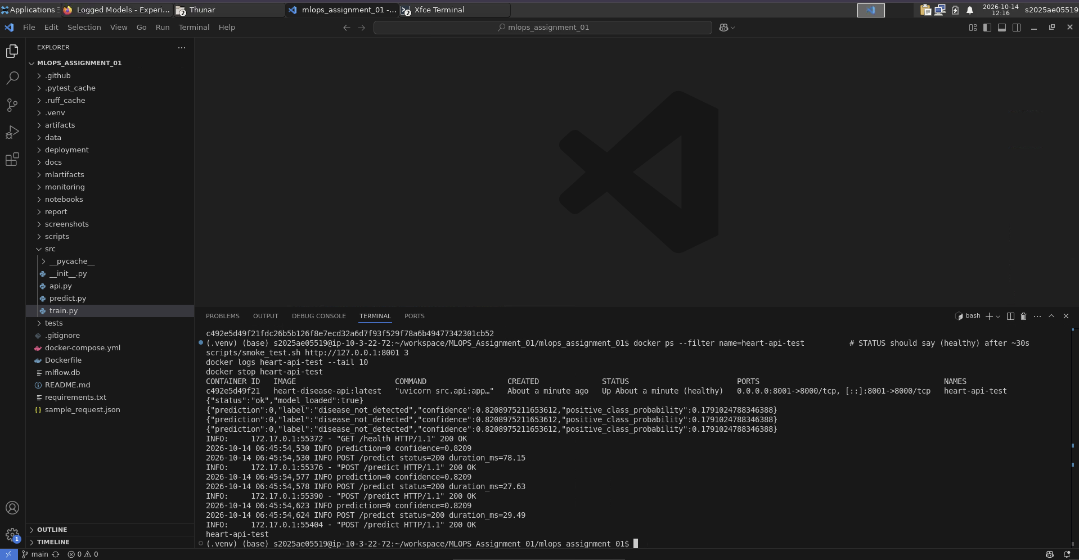
Figure 18: Container healthy on port 8001 and answering the smoke test (confidence 0.8209)
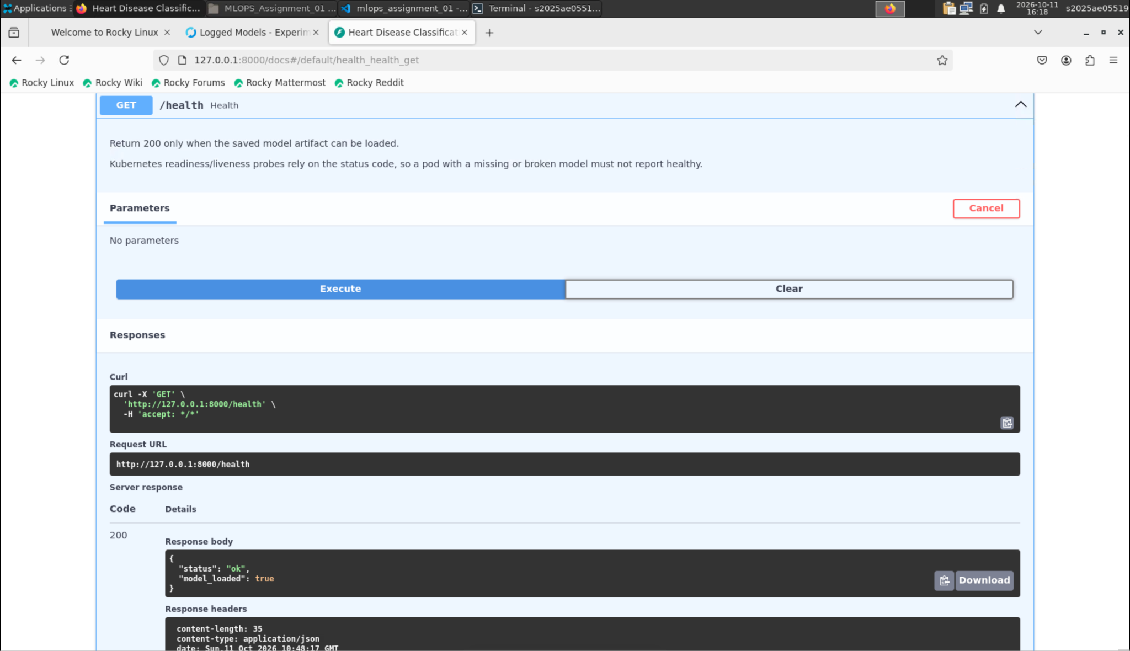
Figure 19: /health response
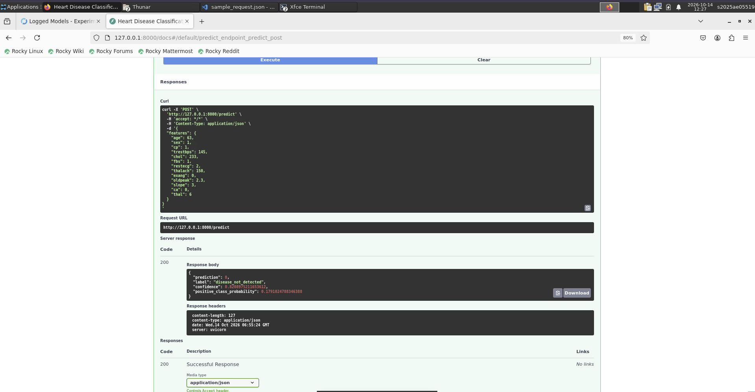
Figure 20: /predict request and response with confidence

9. Production Deployment on Kubernetes
The API is deployed to a local Minikube cluster with deployment/kubernetes.yaml:
- Deployment with 2 replicas, CPU/memory requests and limits, readiness and liveness probes on /health, and Prometheus scrape annotations;
- Service of type LoadBalancer (port 80 to container port 8000), reachable through minikube tunnel;
- optional nginx Ingress (deployment/ingress.yaml) with host heart-api.local.
minikube image load heart-disease-api:latest
kubectl apply -f deployment/kubernetes.yaml
minikube tunnel # separate terminal
scripts/smoke_test.sh http://<EXTERNAL-IP> 5
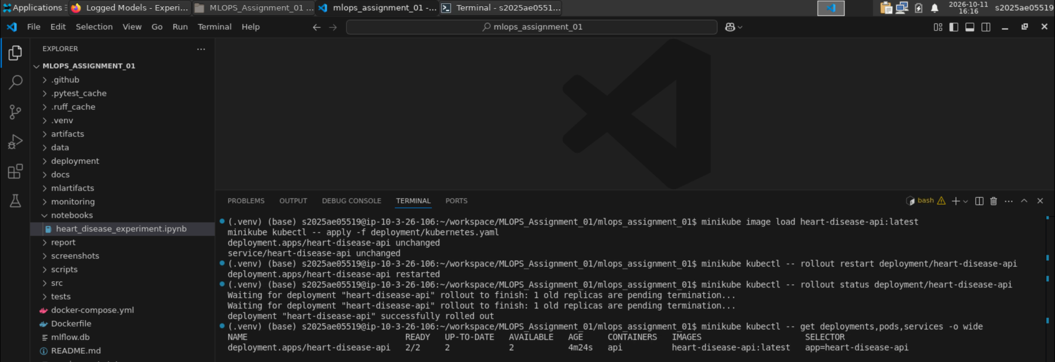
Figure 21: Image load, apply, rollout restart and rollout status (successfully rolled out, deployment 2/2 ready)
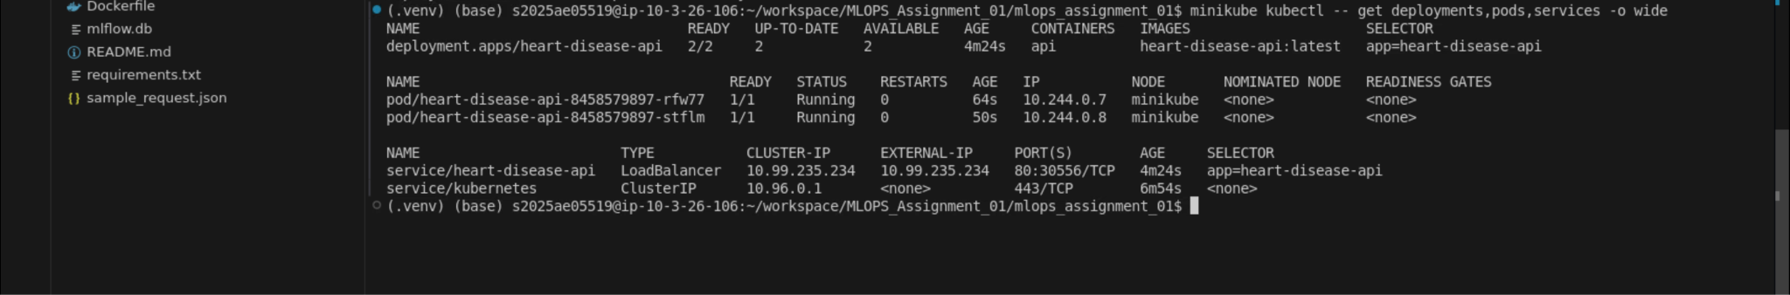
Figure 22: Two running pods and the LoadBalancer service (port 80:30556)
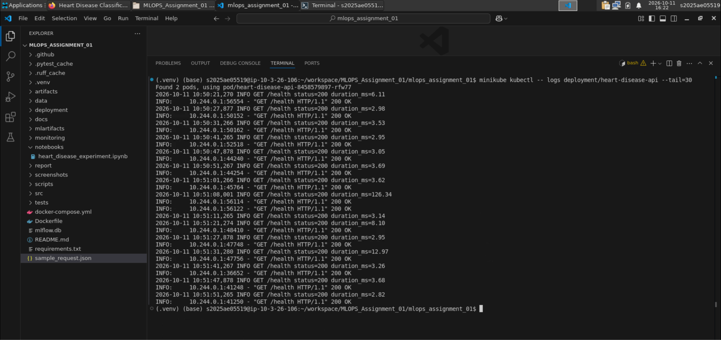
Figure 23: Pod logs: the request-logging middleware records every readiness and liveness probe on /health
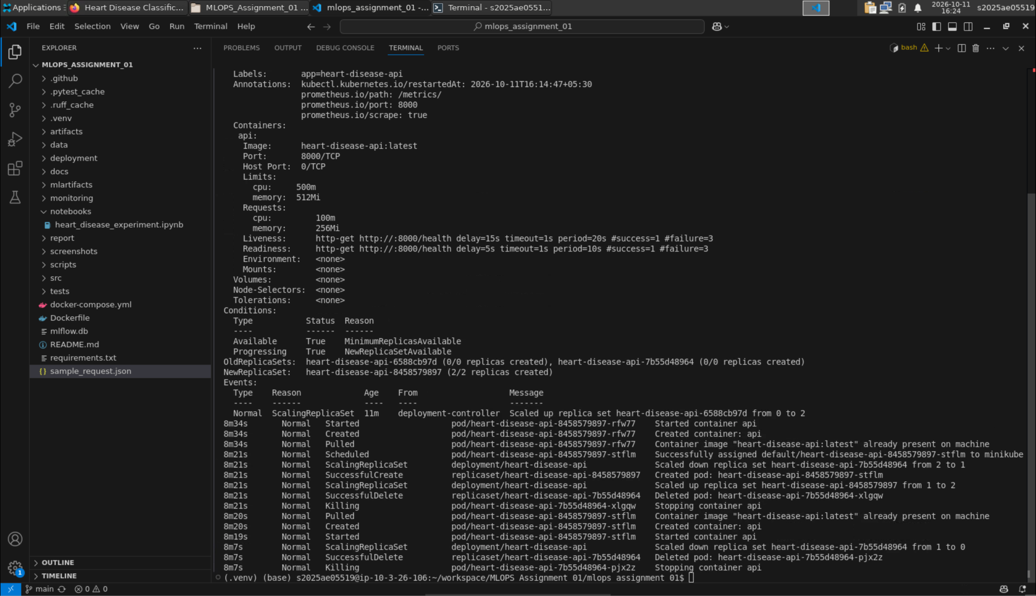
Figure 24: Probes and resource limits (kubectl describe)
Access instructions: the API is not publicly hosted; follow the commands above (or README.md) to run it locally.

10. Monitoring and Logging
Every request is logged by a FastAPI middleware (method, path, status, duration), and the same middleware updates Prometheus counters and a latency histogram; predictions are counted per label. docker compose up starts the API, Prometheus (scraping /metrics every 5 s) and Grafana with a provisioned dashboard (requests per second, p95 latency, predictions by label).
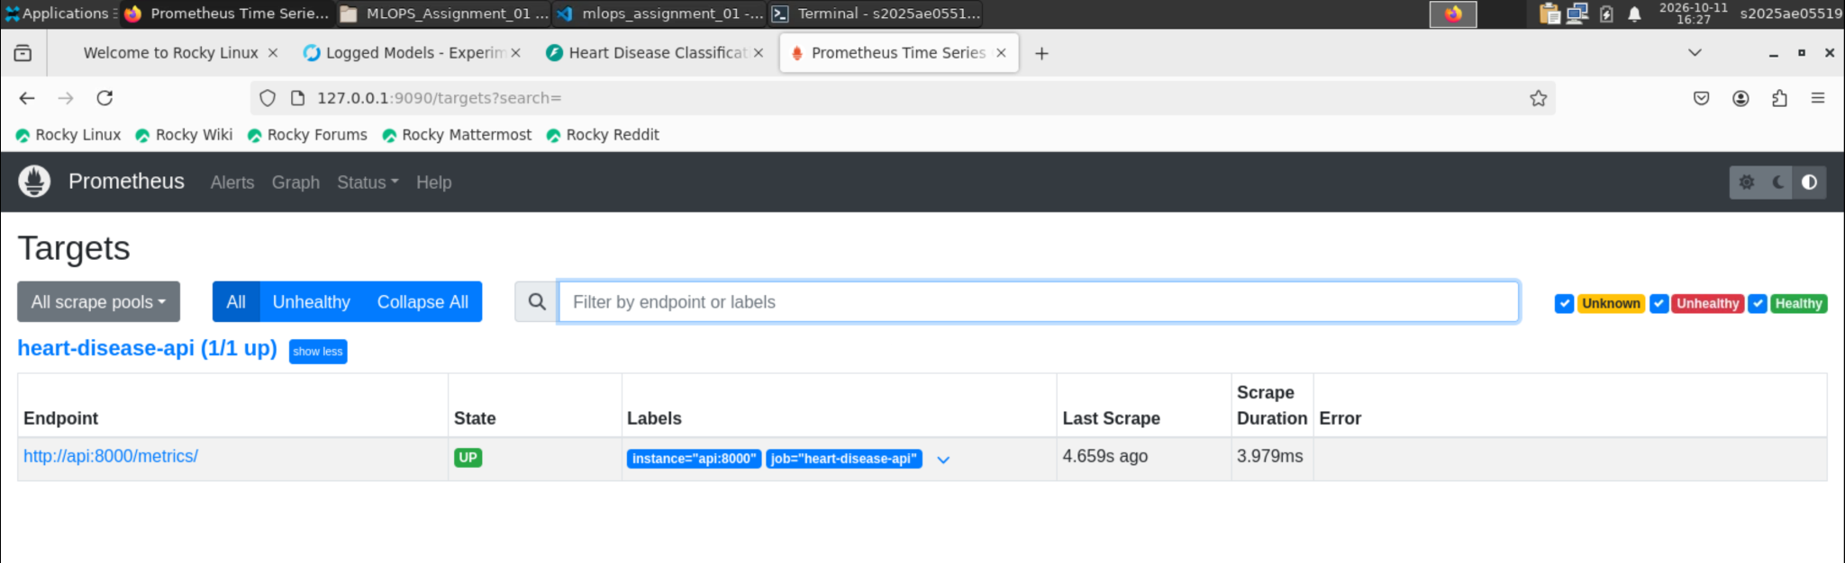
Figure 25: Prometheus target is up
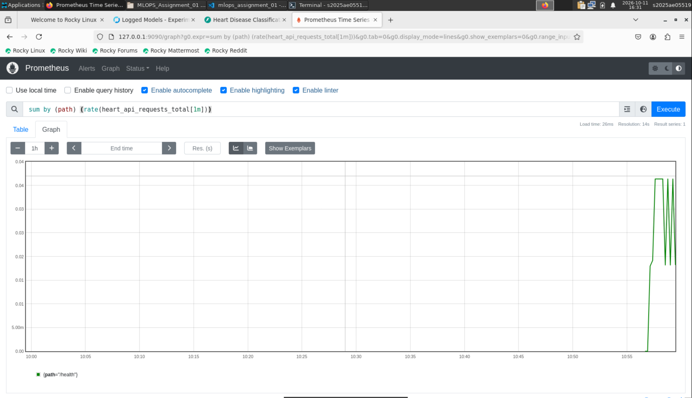
Figure 26: Prometheus query sum by (path) (rate(heart_api_requests_total[1m]))
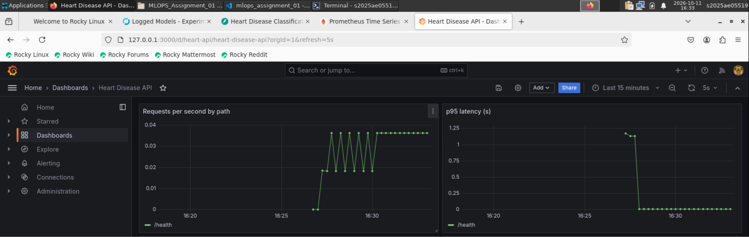
Figure 27: Grafana dashboard: requests per second and p95 latency by path
For a real production system I would add Prometheus alerting rules (for example on error rate and p95 latency), log the distribution of incoming feature values to detect data drift, and track the share of positive predictions over time as an early warning that the input population has changed.

11. Architecture
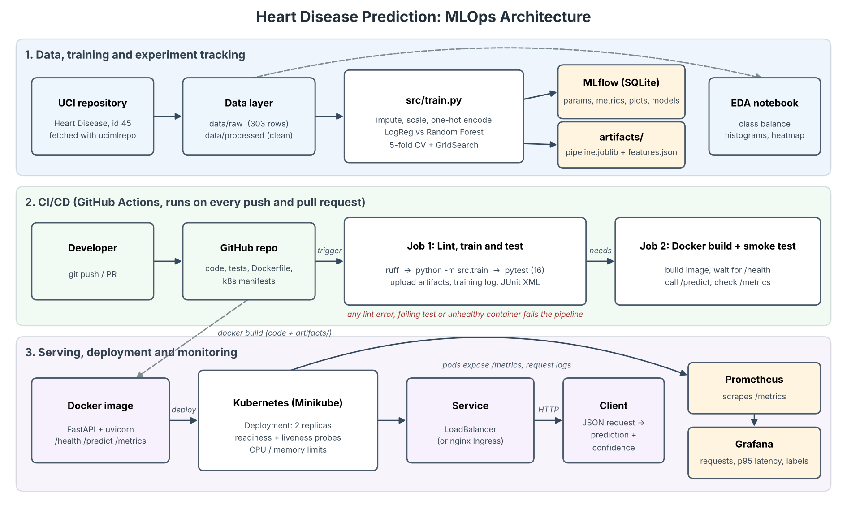
Figure 28: End-to-end architecture
The diagram shows three layers. In the data and training layer, the UCI data is downloaded and cleaned, src/train.py builds the preprocessing pipelines, compares the models with cross-validation and grid search, logs every run to MLflow and saves the selected pipeline to artifacts/. In the CI/CD layer, every push or pull request to GitHub triggers GitHub Actions: the first job lints, retrains and tests the code and uploads the artifacts, and the second job builds the Docker image and smoke-tests the running container. In the serving layer, the image is deployed to Minikube as a two-replica Deployment behind a LoadBalancer Service or Ingress; clients call /predict, and Prometheus scrapes /metrics from the API so Grafana can show request rate, latency and prediction counts.

12. Conclusion
In this assignment I built a complete, reproducible pipeline for heart disease prediction. The final model is a Logistic Regression pipeline with median imputation, scaling and one-hot encoding of the nominal features, selected by 5-fold cross-validation ROC-AUC (0.907). On the held-out test set it reaches ROC-AUC 0.958, accuracy 0.869 and recall 0.929. Experiments are tracked in MLflow, 16 unit tests run in GitHub Actions on every push, and the model is served by a FastAPI container on Kubernetes with Prometheus and Grafana monitoring.
A few things needed fixing along the way. The notebook and the training script originally built their pipelines separately; I changed the notebook to import build_models from src/train.py so both always use the same preprocessing. I found that the CI training step piped its output through tee, which hid a failing exit code, and fixed it by running that step with bash pipefail. On Minikube the cluster could not see my locally built image until I loaded it with minikube image load and restarted the rollout. Finally, the categorical codes were first treated as numbers; one-hot encoding them improved the cross-validation score.

