MLOps (Semester 3)
Assignment 1
Heart Disease Prediction: End-to-End MLOps Pipeline

Name: ____________________
Student ID: 2025ae05519
Repository: https://github.com/2025ae05519/mlops_assignment_01
Video: ____________________
Date: ____________________

1. Introduction
[Write this section in your own words, then delete this note. Points to cover:]
- The problem: predict presence of heart disease from clinical measurements.
- Dataset: UCI Heart Disease (repository id 45), 303 patients, 13 input features.
- Target: original values 0-4 mapped to 0 (no disease) and 1 (disease, values 1-4).
- Goal of the assignment: not only a model, but a reproducible pipeline (tracking, tests, CI, Docker, Kubernetes, monitoring).
Table 1: Input features
Feature | Meaning | Type used
age | Age in years | numeric
sex | 1 = male, 0 = female | numeric (binary)
cp | Chest pain type (1-4) | categorical, one-hot
trestbps | Resting blood pressure (mm Hg) | numeric
chol | Serum cholesterol (mg/dl) | numeric
fbs | Fasting blood sugar > 120 mg/dl | numeric (binary)
restecg | Resting ECG result (0-2) | categorical, one-hot
thalach | Maximum heart rate achieved | numeric
exang | Exercise induced angina | numeric (binary)
oldpeak | ST depression induced by exercise | numeric
slope | Slope of peak exercise ST segment (1-3) | categorical, one-hot
ca | Number of major vessels (0-3) | numeric
thal | Thalassemia (3, 6, 7) | categorical, one-hot

2. Setup and Installation
[Write this section in your own words, then delete this note. Points to cover:]
- Environment you used (Prayogshala VM, Python version, virtual environment).
- Steps: clone repo, create venv, pip install -r requirements.txt, python -m src.train, pytest.
- Where the README and docs/RUNBOOK.md describe the full steps.
[Insert screenshots/01_project_environment.png here]
Figure 1: Project structure and Python environment

3. Data Acquisition, Cleaning and EDA
[Write this section in your own words, then delete this note. Points to cover:]
- How the data is downloaded (ucimlrepo) and saved to data/raw and data/processed.
- Missing values: '?' markers converted to NaN; ca and thal have missing values.
- Imputation happens inside the pipeline (median for numeric, most frequent for categorical), so no leakage from the test set.
- What you observed in each plot: class balance, feature distributions, correlations with the target.
[Insert screenshots/03_artifacts_and_dataset.png here]
Figure 2: Downloaded dataset and generated artifacts
[Insert screenshots/10_eda_class_balance.png here]
Figure 3: Class balance of the binary target
[Insert screenshots/11_eda_histograms.png here]
Figure 4: Distributions of the numeric features
[Insert screenshots/12_eda_correlation.png here]
Figure 5: Correlation heatmap

4. Feature Engineering and Model Development
[Write this section in your own words, then delete this note. Points to cover:]
- Why cp, restecg, slope and thal are one-hot encoded (codes have no numeric order).
- Scaling is applied for Logistic Regression only; Random Forest does not need it.
- Two models: Logistic Regression (class_weight balanced) and Random Forest tuned with GridSearchCV.
- Stratified 80/20 train/test split, stratified 5-fold cross-validation, random seed 42.
- Selection rule: the model with the best mean CV ROC-AUC is selected, not the best test score, to avoid choosing on the test set.
- Discuss: RF had slightly higher test accuracy and F1, LR had higher CV and test ROC-AUC. Why you kept the rule.
Table 2: 5-fold cross-validation results on the training set (untuned models)
Model | Accuracy | Precision | Recall | F1 | ROC-AUC
Logistic Regression | 0.847 | 0.848 | 0.819 | 0.831 | 0.907
Random Forest | 0.801 | 0.789 | 0.783 | 0.782 | 0.898

Table 3: Held-out test set results (61 patients)
Model | Accuracy | Precision | Recall | F1 | ROC-AUC | CV ROC-AUC
Logistic Regression (selected) | 0.869 | 0.813 | 0.929 | 0.867 | 0.958 | 0.907
Random Forest (tuned) | 0.885 | 0.839 | 0.929 | 0.881 | 0.947 | 0.903

Best Random Forest parameters: n_estimators = 200, max_depth = None, min_samples_leaf = 4.
[Insert screenshots/02_training_output.png here]
Figure 6: Output of python -m src.train

5. Experiment Tracking with MLflow
[Write this section in your own words, then delete this note. Points to cover:]
- MLflow with a SQLite backend (mlflow.db); how you start the UI (mlflow ui).
- What is logged per run: parameters, CV and test metrics, ROC curve and confusion matrix plots, CSV results, the model.
- How you compared the two runs in the UI.
[Insert screenshots/05_mlflow_runs.png here]
Figure 7: MLflow runs in the heart-disease-classification experiment
[Insert screenshots/06_mlflow_compare.png here]
Figure 8: Comparison of the two runs
[Insert screenshots/07_mlflow_params_metrics.png here]
Figure 9: Parameters and metrics of one run
[Insert screenshots/08_mlflow_plots.png here]
Figure 10: ROC curve and confusion matrix logged as artifacts
[Insert screenshots/09_mlflow_model.png here]
Figure 11: Logged models

6. Model Packaging, Reproducibility and Testing
[Write this section in your own words, then delete this note. Points to cover:]
- The whole sklearn pipeline (preprocessing + model) is saved as artifacts/heart_disease_pipeline.joblib.
- feature_columns.json fixes the input contract used by the API.
- Pinned requirements.txt and fixed random seed make runs repeatable.
- Unit tests: test_data.py (cleaning), test_model.py (pipelines, one-hot encoding, plots, prediction), test_api.py (endpoints). 16 tests in total; ruff for linting.
[Insert screenshots/04_lint_and_tests.png here]
Figure 12: ruff and pytest results

7. API and Containerisation
Table 4: API endpoints
Endpoint | Method | Purpose
/health | GET | Readiness check; returns 503 if the model file is missing
/predict | POST | Returns prediction, label and confidence for one patient
/metrics | GET | Prometheus metrics (request count, latency, predictions)

[Write this section in your own words, then delete this note. Points to cover:]
- FastAPI app served by uvicorn; input validated against feature_columns.json.
- Dockerfile: python:3.12-slim base, copies src/ and artifacts/, HEALTHCHECK on /health.
- Example request (sample_request.json) and the response you received.
[Insert screenshots/13_docker_build.png here]
Figure 13: Docker image build
[Insert screenshots/14_docker_run_test.png here]
Figure 14: Running the container and the smoke test
[Insert screenshots/17_api_health.png here]
Figure 15: Health endpoint
[Insert screenshots/18_api_predict.png here]
Figure 16: Prediction through the Swagger UI

8. CI/CD Pipeline
[Write this section in your own words, then delete this note. Points to cover:]
- GitHub Actions workflow .github/workflows/ci.yml runs on every push and pull request.
- Job 1: install, ruff lint, train, pytest, upload artifacts (model, metrics, plots, logs).
- Job 2 (needs Job 1): docker build, run the container, check /health, /predict and /metrics.
- What happens when a step fails (the run turns red and later steps are skipped).
[Insert screenshots/24_ci_pipeline.png here]
Figure 17: Successful GitHub Actions run
[Insert screenshots/25_ci_test_steps.png here]
Figure 18: Lint, train and test job
[Insert screenshots/26_ci_docker_steps.png here]
Figure 19: Docker build and smoke-test job
[Insert screenshots/27_pr_checks.png here]
Figure 20: Checks on a pull request

9. Deployment on Kubernetes
Table 5: Kubernetes settings (deployment/kubernetes.yaml)
Setting | Value
Cluster | minikube (image loaded with minikube image load)
Replicas | 2
Probes | readiness and liveness on /health, port 8000
Resources | requests 100m CPU / 256Mi, limits 500m CPU / 512Mi
Service | LoadBalancer, port 80 -> 8000; optional Ingress (deployment/ingress.yaml)

[Write this section in your own words, then delete this note. Points to cover:]
- Commands you used to deploy and how you accessed the service.
- Why two replicas and probes (availability, automatic restart).
[Insert screenshots/15_k8s_resources.png here]
Figure 21: Pods and service
[Insert screenshots/16_k8s_rollout.png here]
Figure 22: Deployment rollout
[Insert screenshots/20_probes_and_resources.png here]
Figure 23: Probes and resource limits

10. Monitoring and Logging
[Write this section in your own words, then delete this note. Points to cover:]
- Each request is logged with method, path, status and duration.
- Prometheus scrapes /metrics; which query you ran.
- Grafana dashboard panels and what they show.
[Insert screenshots/19_app_logs.png here]
Figure 24: Application logs from the pods
[Insert screenshots/21_prometheus_targets.png here]
Figure 25: Prometheus target
[Insert screenshots/22_prometheus_query.png here]
Figure 26: Prometheus query
[Insert screenshots/23_grafana_dashboard.png here]
Figure 27: Grafana dashboard

11. Architecture
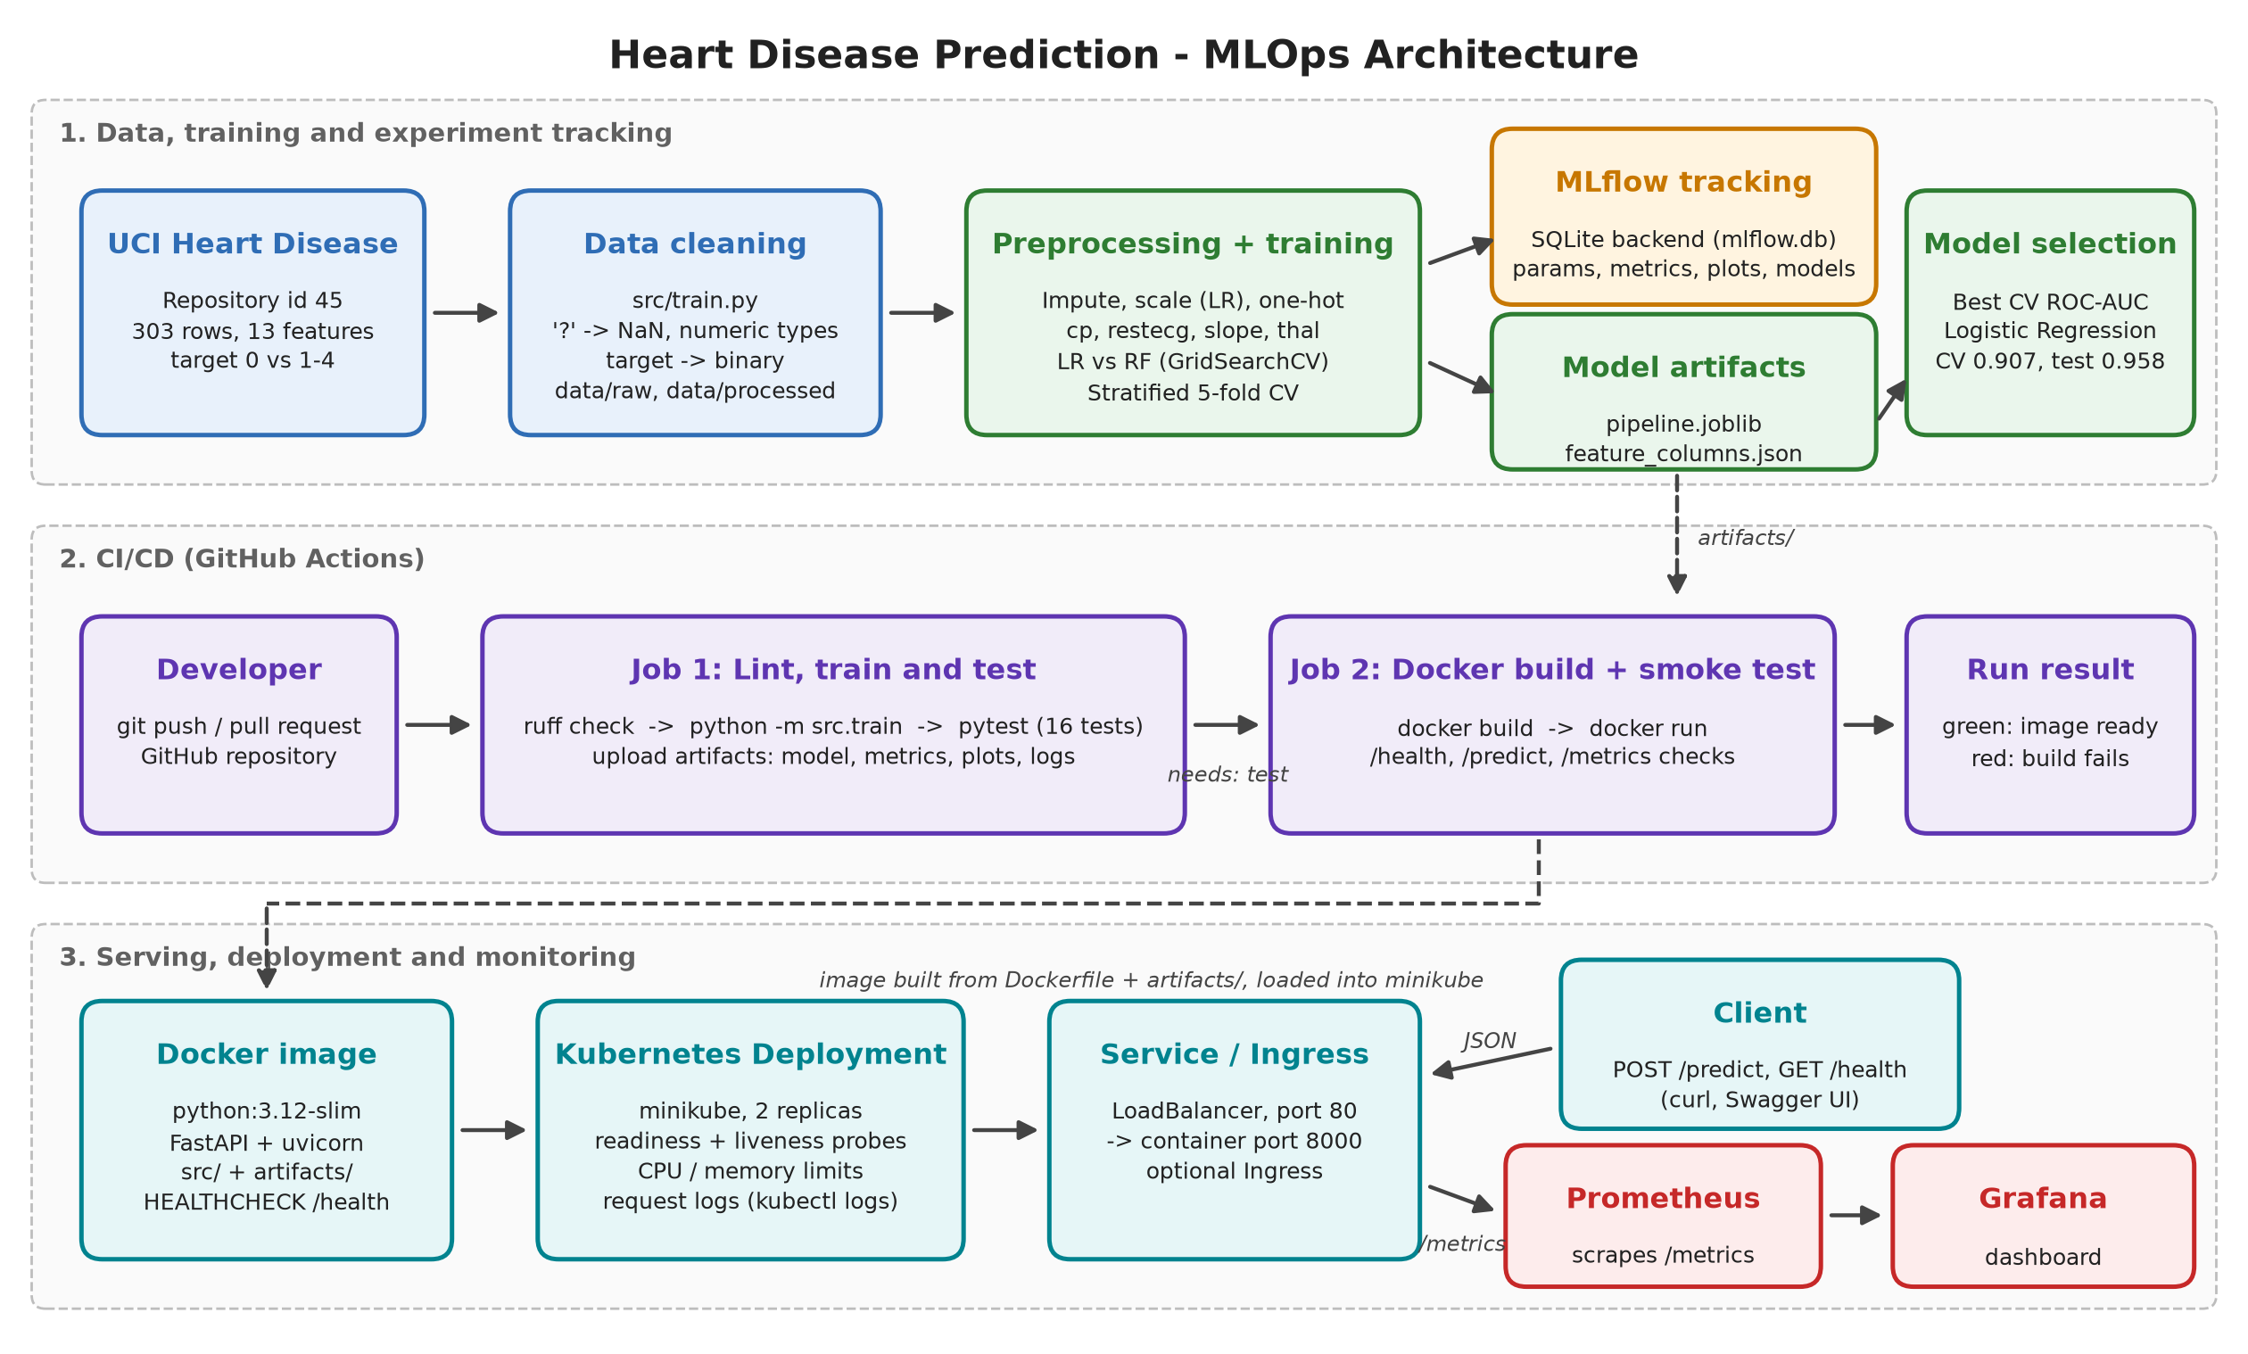
Figure 28: Overall architecture
[Write this section in your own words, then delete this note. Points to cover:]
- Walk through the diagram from data to monitoring in a short paragraph.

12. Conclusion and Future Work
[Write this section in your own words, then delete this note. Points to cover:]
- What was achieved and the final model performance.
- What you learned / what was difficult.
- Future work: model registry, data drift monitoring, pushing the image to a container registry, cloud deployment, alerting.

References
- Janosi, A., Steinbrunn, W., Pfisterer, M., Detrano, R. Heart Disease [Dataset]. UCI Machine Learning Repository, 1988.
- scikit-learn, MLflow, FastAPI, Docker, Kubernetes and Prometheus documentation.

