END-TO-END MLOps PROJECT
Heart Disease Classification | Experiment Tracking | CI/CD | Docker | Minikube

Student name: Shruti Bhasin
Course / module: AIMLCZG523 - Machine Learning Operations (MLOps)
Institution: BITS Pilani, Work Integrated Learning Program
BITS ID: 2025AE05570
Submission date: 20 October 2026

Project report prepared against the supplied MLOps assignment brief.

1. Executive Summary
This project implements a reproducible machine-learning workflow to classify the binary target derived from the Cleveland subset of the UCI Heart Disease dataset. The workflow covers data acquisition, exploratory data analysis, preprocessing, model comparison, experiment tracking, packaging, automated testing, containerization, local Kubernetes deployment with Minikube, and basic observability.
Two supervised classifiers are compared: Logistic Regression and Random Forest. Both are trained through scikit-learn Pipelines so imputation, scaling and categorical encoding are fitted only on the training folds. Stratified cross-validation is used for model selection; a held-out test set is used for final comparison. MLflow records parameters, metrics, model artifacts and diagnostic plots.
The final model is serialized with joblib and served by a FastAPI application. Docker packages the service and model, while Kubernetes Deployment and Service manifests run it in Minikube. The API exposes health, prediction and Prometheus-compatible metrics endpoints and logs requests.
Status as of 20 October 2026: the dataset analysis, model training, local API, standalone Docker container, Minikube deployment, tests, and a GitHub Actions run have been verified using the project artifacts and captured evidence. The Rocky Linux 9 bootstrap/deployment script has been added, but has not yet been executed on the target VM. Minikube is a local cluster; no public API endpoint is claimed.

Project objectives
- Build and evaluate at least two binary classification models.
- Make preprocessing and training repeatable from a clean environment.
- Track experiments and persist evaluation artifacts.
- Test the code and automate quality checks with GitHub Actions.
- Serve predictions through a containerized API deployed locally to Minikube.
- Demonstrate request logging and metrics exposure.

2. Problem Definition and Dataset

2.1 Problem statement
The assignment asks for a cloud-ready, monitored API that predicts the binary heart-disease label from patient-related measurements. This project treats the task as a supervised binary classification problem. The output is a model prediction and estimated class probability, not a medically validated risk score.

2.2 Dataset source and target
The data acquisition script downloads the Heart Disease archive from the UCI Machine Learning Repository and extracts processed.cleveland.data. The Cleveland file contains 13 input attributes and one target column. The original target uses values 0 through 4; the project maps 0 to class 0 and values greater than 0 to class 1.
Table 2.1. Feature groups and preprocessing treatments.
Feature group | Fields (source names) | Treatment
Continuous measurements | age, trestbps, chol, thalach, oldpeak | Median imputation and standard scaling
Categorical / coded values | sex, cp, fbs, restecg, exang, slope, ca, thal | Most-frequent imputation and one-hot encoding
Target | target / original num | Binary mapping: 0 versus >0

2.3 Data quality
The raw source represents some missing values with a question mark. The loader converts these markers to missing numeric values. Duplicate rows are removed before splitting. The pipeline imputes remaining missing feature values within each cross-validation training fold, preventing information leakage from validation or test rows.
The dataset is small and historically collected. Its labels and measurement conventions reflect the original data collection context. It is suitable for an educational MLOps exercise, but not sufficient to establish clinical validity, fairness, calibration or generalization to present-day populations.

3. Data Acquisition and Exploratory Data Analysis

3.1 Reproducible acquisition
Run `python scripts/download_data.py` from the repository root. The script fetches the official UCI archive over HTTPS and writes `data/raw/heart.csv`. Network access is required for the initial download. The downloaded file is not fabricated or manually re-created by the training pipeline.

3.2 EDA procedure
Run `python scripts/make_eda.py`. The script produces a cleaned CSV, a text summary, feature histograms, a target-class bar chart and a correlation heatmap. It also records missing-value counts and descriptive statistics. These artifacts are saved under `data/processed/` and `reports/`.
- Histograms help identify ranges, skew and unusual values for individual features.
- The class-balance plot shows the number of examples in each binary class and informs the use of stratified splitting.
- The correlation heatmap summarizes pairwise linear relationships; correlation alone does not establish causality.
- The summary file records dataset dimensions, missingness and descriptive statistics for the actual downloaded file.

3.3 Observed EDA findings
The generated summary contains 303 rows after duplicate removal. The `ca` feature has 4 missing values and `thal` has 2; the remaining columns have no missing values. The binary classes contain 164 class-0 records (54.1%) and 139 class-1 records (45.9%), a modest imbalance that supports the use of stratified splits and class weighting. The histogram, class-balance chart, and correlation heatmap below are the generated project figures.
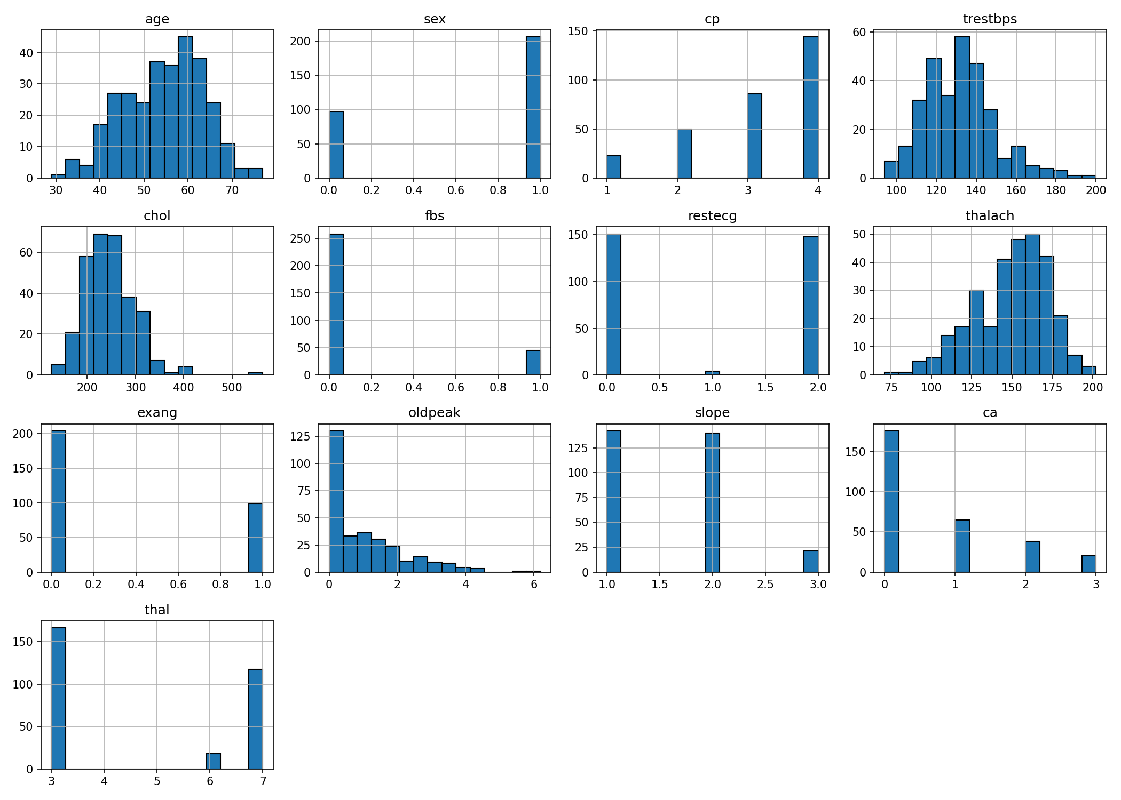  Figure 3.1. Feature distributions. | 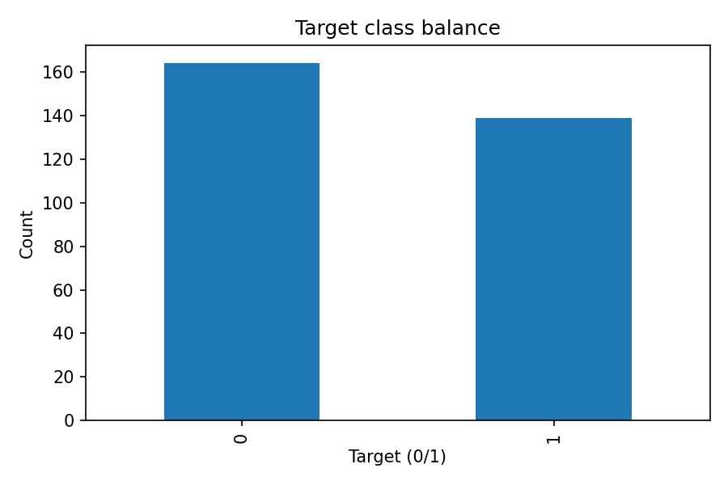  Figure 3.2. Binary target class counts.
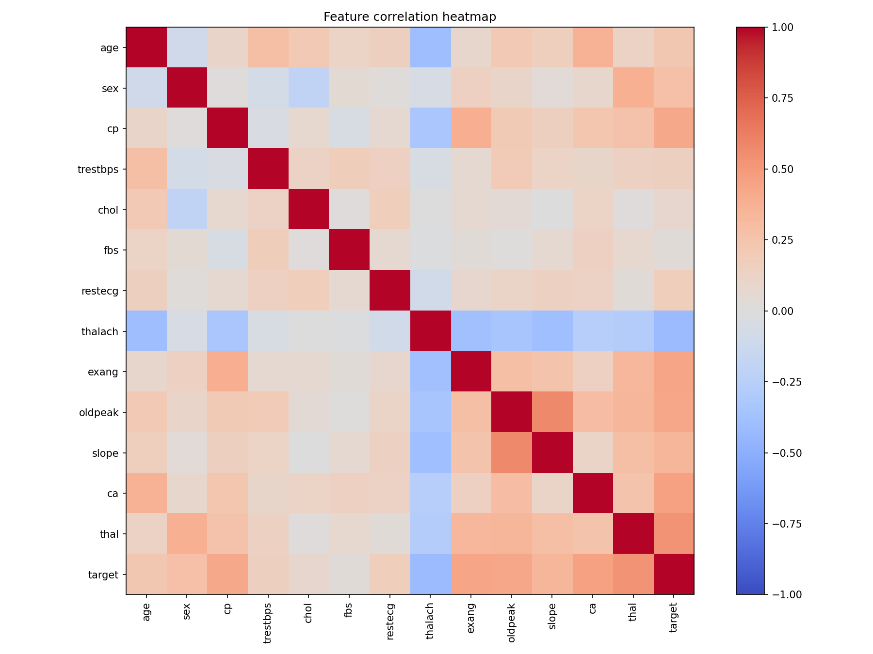
Figure 3.3. Feature correlation heatmap.

4. Feature Engineering and Model Development

4.1 Preprocessing design
A ColumnTransformer applies separate preprocessing to numeric and coded categorical fields. Numeric fields are median-imputed and standardized. Categorical fields are imputed with the most frequent value and one-hot encoded with unknown categories ignored at inference time. The preprocessing transformer is part of each estimator Pipeline, so the complete pipeline can be serialized and reused by the API.

4.2 Models and tuning
Table 4.1. Hyperparameter search spaces and rationale.
Model | Search space | Rationale
Logistic Regression | C = 0.1, 1, 10 | Interpretable linear baseline; class weighting helps address class imbalance.
Random Forest | n_estimators = 150 or 300; max_depth = None, 6 or 12 | Non-linear ensemble that can capture feature interactions; class weighting is enabled.
A fixed random seed is used for reproducibility. Data are split into training and held-out test partitions using stratification. GridSearchCV performs stratified five-fold cross-validation on the training partition, optimizing ROC-AUC. The final candidate is selected by held-out test ROC-AUC, and the full fitted preprocessing-plus-model pipeline is saved.

4.3 Metrics
- Accuracy: fraction of correct predictions at the chosen threshold.
- Precision: fraction of predicted positives that are positive in the reference labels.
- Recall: fraction of reference positives recovered by the classifier.
- F1: harmonic mean of precision and recall.
- ROC-AUC: ranking discrimination across thresholds; it is not a measure of clinical utility or calibration.
- Confusion matrix and ROC curve: diagnostic plots logged for each model.
The measured held-out test results and five-fold cross-validation ROC-AUC values are shown in Table 4.2. Logistic Regression had the highest held-out ROC-AUC (0.9654) and is the selected model; Random Forest had higher recall (0.9643) on this split. The close accuracy and F1 values should be interpreted cautiously given the small dataset and single held-out split.
Table 4.2. Held-out test metrics and mean cross-validation ROC-AUC.
Model | Accuracy | Precision | Recall | F1 | Test ROC-AUC | CV ROC-AUC
Logistic Regression | 0.8852 | 0.8387 | 0.9286 | 0.8814 | 0.9654 | 0.9028
Random Forest | 0.8852 | 0.8182 | 0.9643 | 0.8852 | 0.9453 | 0.8987

5. Experiment Tracking and Reproducibility

5.1 MLflow
The training script configures an SQLite tracking database at `mlflow.db` and creates the `heart-disease-classification` experiment. MLflow records one run for each candidate model family, including tuned parameters, accuracy, precision, recall, F1, test ROC-AUC, mean cross-validation ROC-AUC, the fitted pipeline, and diagnostic plots. Local artifact files are retained under `mlruns/`.

5.2 Inspecting experiments
- Run the download and EDA steps first.
- Run `python -m src.train` and confirm that model and report files are created.
- Start the UI with `mlflow ui --backend-store-uri sqlite:///mlflow.db --host 127.0.0.1 --port 5000` and open `http://127.0.0.1:5000`.
- Open `http://127.0.0.1:5000` and inspect the experiment, two runs, metrics, parameters and artifacts.
- Figure 5.1 shows the captured experiment run list and metric columns from the MLflow UI.
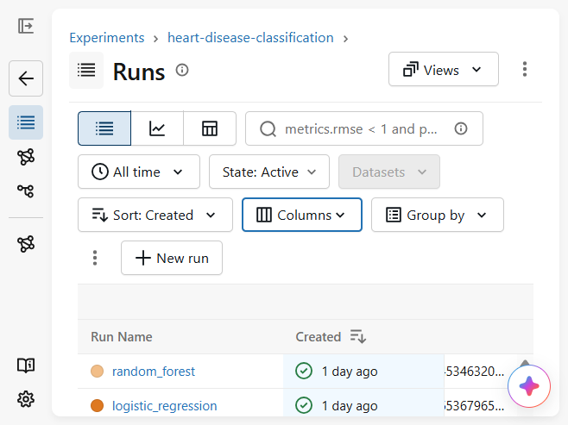
Figure 5.1. MLflow run list with logged model metrics.

5.3 Persisted artifacts
- `models/heart_model.joblib`: complete fitted preprocessing and prediction pipeline.
- `models/metadata.json`: selected model name, feature list and selected-run metrics.
- `reports/training_summary.json`: both models' tuned parameters and evaluation metrics.
- `reports/figures/`: confusion matrices, ROC curves and EDA plots.
- `mlruns/`: local experiment tracking metadata and artifacts.
The random seed, dependency file, source scripts and fixed split settings improve reproducibility. Exact numerical results can still vary across dependency versions and platforms, so the environment and run outputs should be retained with the submission.

6. API, Packaging and Automated Testing

6.1 FastAPI service
The service in `src/api.py` loads the saved joblib pipeline and exposes `/`, `/health`, `/predict` and `/metrics`. The prediction request schema validates all 13 expected features and basic plausible numeric ranges. The prediction response includes the binary class, estimated probability of the positive class, a confidence value and an educational-use disclaimer.

6.2 Error handling and logging
The API returns a validation error for malformed requests, a service-unavailable response if the model file is absent, and a generic server error if prediction fails. Application logs include request completion status, duration and client address when available. Avoid logging sensitive patient data; the current application logs do not print submitted feature values.

6.3 Testing and linting
The verified CI-equivalent local checks were `ruff check --select F src scripts tests` and `pytest -q`; the selected Ruff checks passed and all 5 tests passed. This report does not claim that the broader default Ruff rules are clean: import-order findings remain outside the CI-selected `F` checks.

6.4 CI workflow
The GitHub Actions workflow installs Python 3.11 dependencies, runs linting and tests, then downloads the dataset, generates EDA and trains the model. Training artifacts are uploaded from the workflow. The training job depends on the quality-check job, so a lint or test failure prevents model training in that workflow.
GitHub Actions run 39155719569 completed successfully for the quality-check and training jobs and uploaded the model-and-reports artifact. The run is available at https://github.com/2025ae05570-shruti/2025ae05570-mlops/actions/runs/39155719569; an evidence capture is included below.
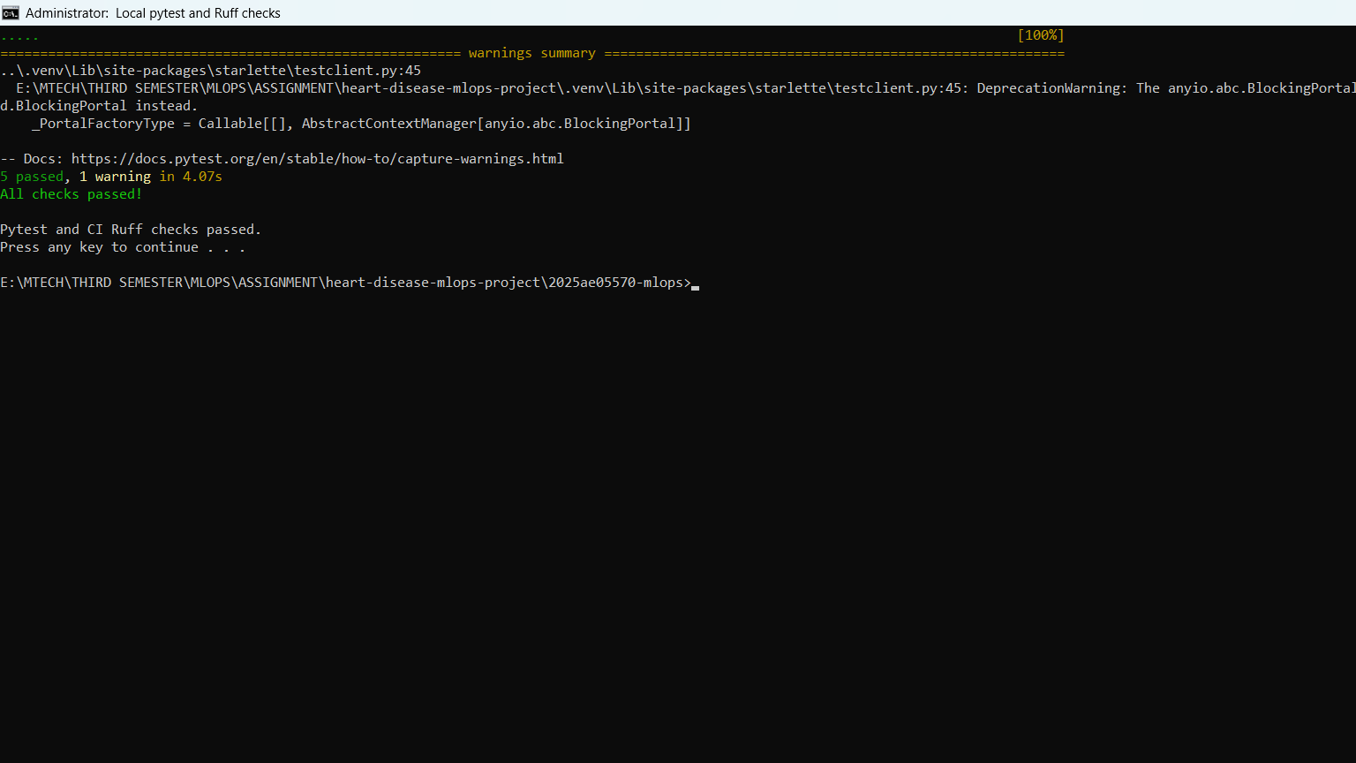  Figure 6.1. Pytest and CI-selected Ruff checks. | 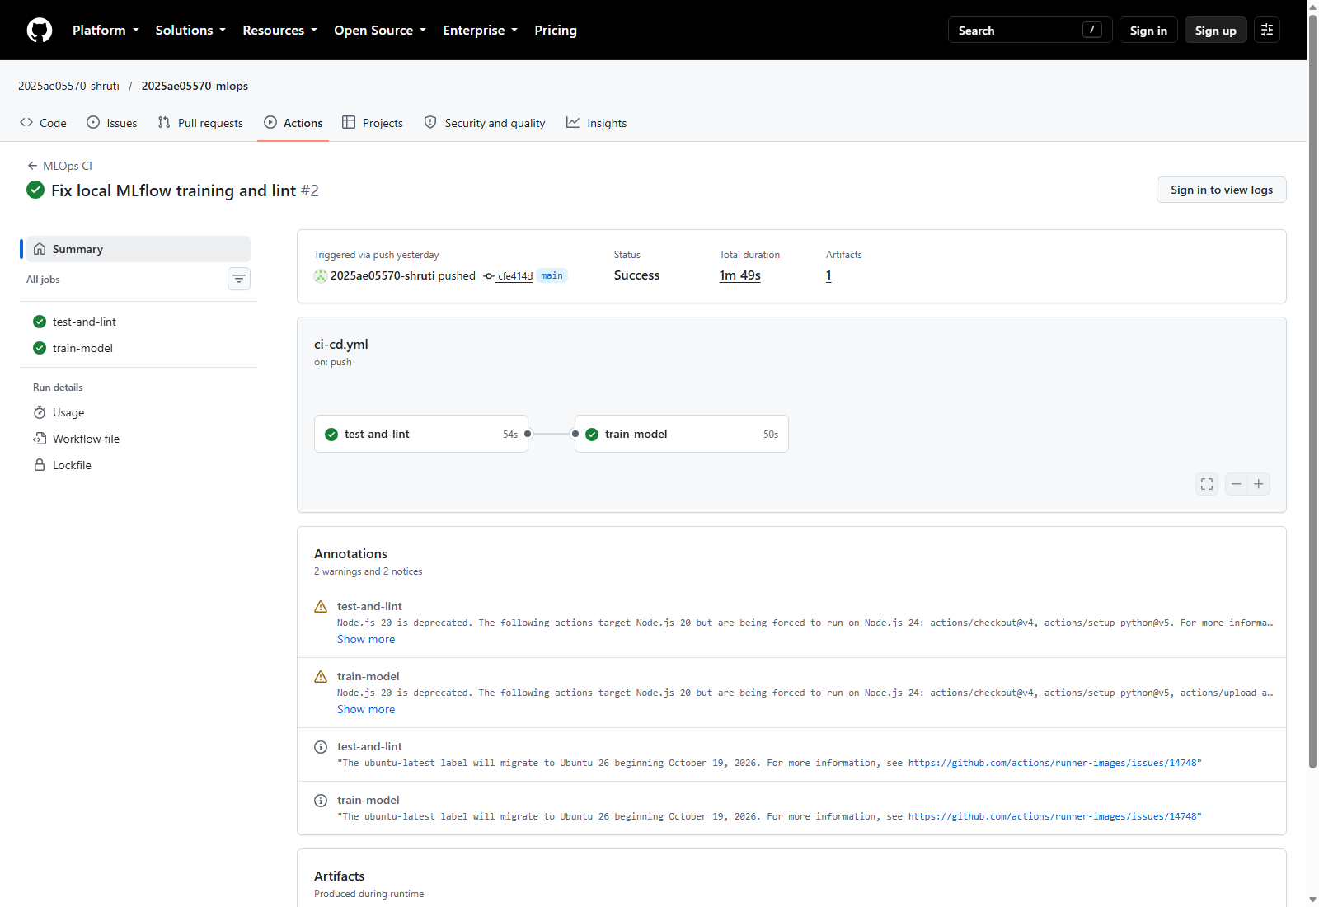  Figure 6.2. Successful GitHub Actions workflow run.

7. Docker Containerization

7.1 Image contents
The Dockerfile uses a slim Python 3.11 base image, installs pinned-major-version dependency ranges, copies the application and trained model, and starts Uvicorn on port 8000. The process runs as an unprivileged user. The image is built after local training has created `models/heart_model.joblib`.

7.2 Build and local validation
- Run `docker build -t heart-disease-api:1.0 .` from the repository root.
- Run `docker run --rm -p 8000:8000 heart-disease-api:1.0`.
- Open `/health` and `/docs`, send a synthetic sample to `/predict`, and inspect `/metrics`.
- The standalone container `heart-disease-standalone` was running on host port 8002; `http://127.0.0.1:8002/health` returned `status=ok` and `model_loaded=true`. A screenshot of the running container and health response is included below.
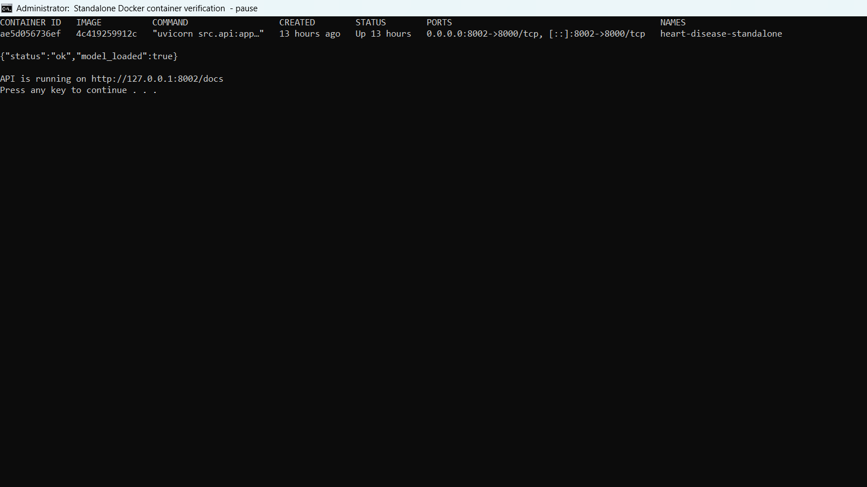
Figure 7.1. Standalone Docker container and health check.

7.3 Operational considerations
The model is packaged in the image for a self-contained local demonstration. Production systems should use image scanning, dependency pinning, a registry, signed artifacts, secret management, resource limits, authentication, HTTPS and a formal model promotion process. The current image is a coursework prototype rather than a hardened clinical service.

8. Minikube Deployment

8.1 Architecture
The verified Windows Minikube deployment used one API replica and a NodePort Service on port 30080. Readiness and liveness probes call `/health`; resource requests and limits are configured. The Pod reached 1/1 Ready. On Windows with the Docker driver, direct Node-IP access timed out, so `minikube service heart-api --url` supplied a working localhost tunnel URL (`http://127.0.0.1:60245`); its terminal had to remain open.
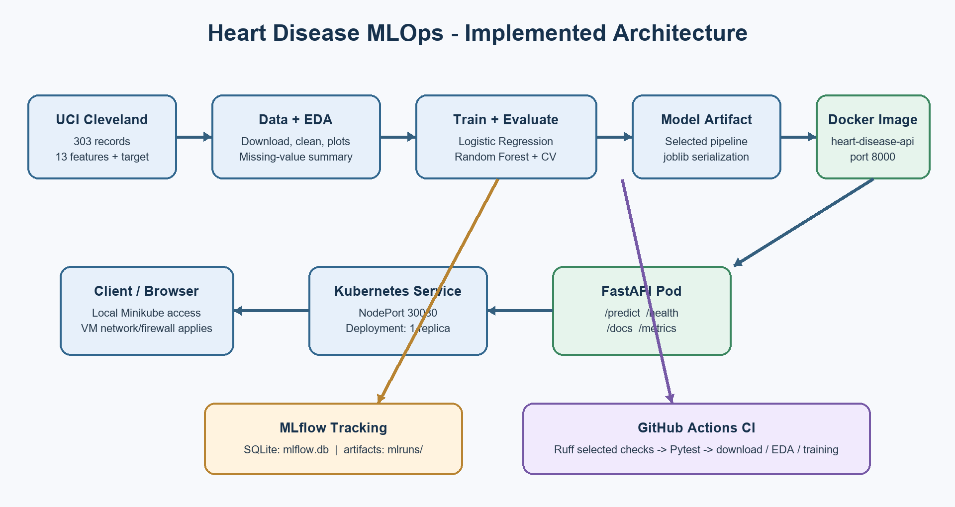
Figure 8.1. Data, training, experiment tracking, serving, and CI workflow architecture.
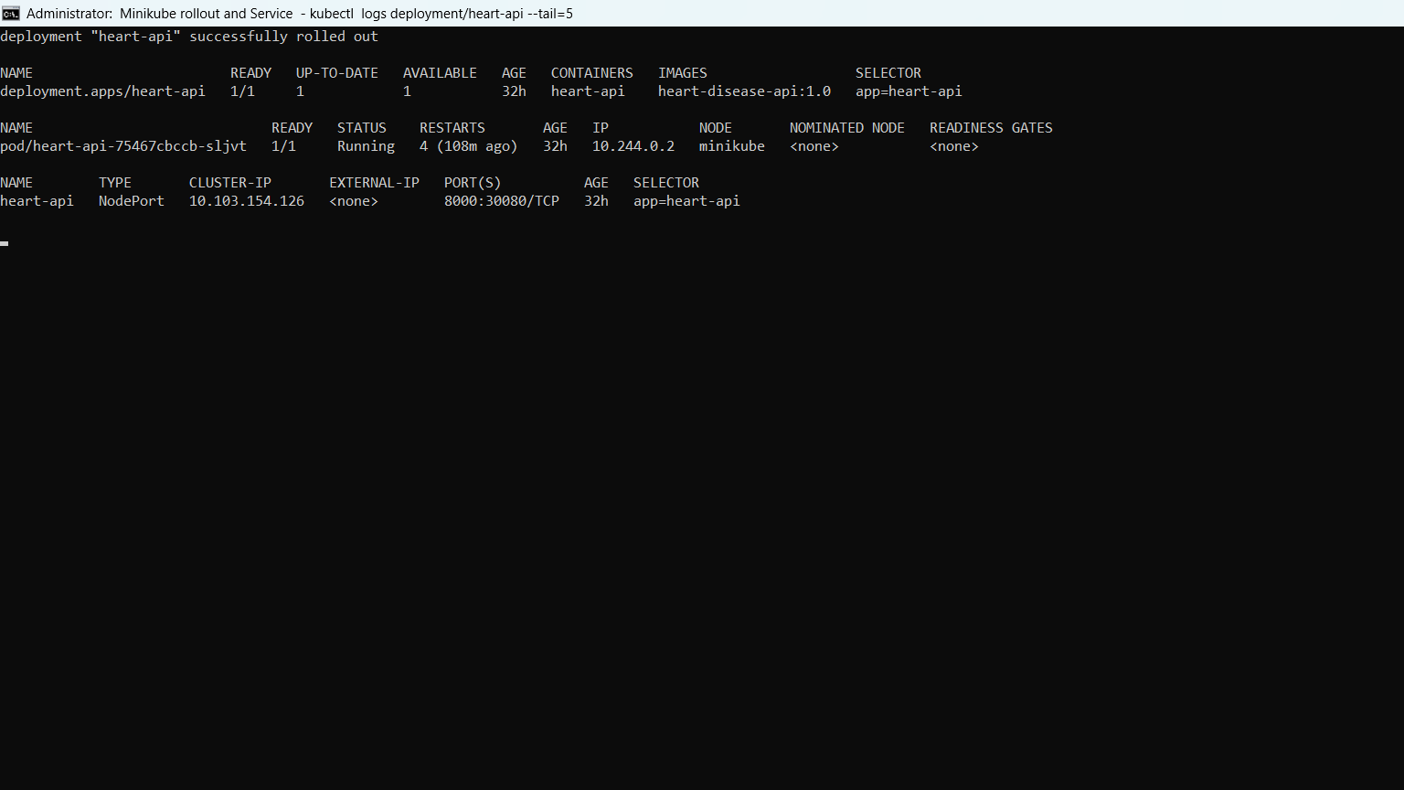
Figure 8.2. Minikube rollout, ready Pod, and NodePort Service.
Table 8.1. Kubernetes components and service configuration.
Component | Purpose
Deployment: heart-api | Maintains one API replica and defines probes/resources.
Pod container | Runs the Docker image `heart-disease-api:1.0` on port 8000.
Service: heart-api | Routes local cluster traffic to the Pod via NodePort 30080.
Minikube | Provides a local Kubernetes environment for demonstration.

8.2 Deployment commands
The verified deployment flow was `minikube start --driver=docker`, `minikube image build -t heart-disease-api:1.0 .`, `kubectl apply -f deployment/kubernetes.yaml`, and `kubectl rollout status deployment/heart-api`. The Windows host accessed the service through `minikube service heart-api --url`, then checked the API endpoints. For the Rocky Linux 9 VM, `scripts/install_rocky9_minikube.sh` automates setup, build, deployment, and a health check; this VM-specific path is documented but not yet executed. The script reports a NodePort URL, and VM firewall/network rules may need adjustment for remote clients.

8.3 Validation and troubleshooting
- Use `kubectl get pods,svc` to inspect status and service mapping.
- Use `kubectl rollout status deployment/heart-api` to confirm rollout.
- Use `kubectl logs deployment/heart-api` for application logs.
- Use `kubectl describe pod -l app=heart-api` for scheduling, image and probe errors.
- A missing model artifact typically indicates training was not completed before the Docker image was built.
Minikube is a local development cluster and does not automatically create a public internet endpoint. The submitted evidence should state that local access is required unless a separate, secured public deployment is configured.

9. Monitoring, Results and Discussion

9.1 Monitoring
Prometheus FastAPI Instrumentator exposes request counts, latency and other HTTP metrics at `/metrics`. Structured application logging records completed requests and failures. The supplied Prometheus YAML is a starter configuration; its target must be adapted to the actual network topology when Prometheus is installed inside Minikube. Opening `/metrics` and reviewing API logs is sufficient for the basic monitoring demonstration, while a full Prometheus/Grafana dashboard is an optional extension.

9.2 Results interpretation
On the held-out split, Logistic Regression achieved the highest ROC-AUC (0.9654) and precision (0.8387); Random Forest achieved the highest recall (0.9643) and F1 (0.8852). Both achieved accuracy of 0.8852. The recall advantage of Random Forest may come with a false-positive trade-off. The difference in ROC-AUC does not establish general superiority: the dataset is small, and the evaluation uses one held-out split.

9.3 Limitations and responsible use
- The dataset is small, historical and not representative of all populations or modern clinical practice.
- The output probability is not established as a calibrated medical risk.
- No prospective validation, external validation, fairness audit or clinical review is included.
- Held-out test ROC-AUC informed model-family selection, so the reported test metrics are not fully independent and may be optimistic. Future evaluation should use nested cross-validation or a separate untouched test set.
- Feature definitions and category codes must match the source dataset.
- This system is a learning artifact only and must not be used for patient care.

9.4 Evidence summary
Figures 3.1-3.3 show generated EDA outputs; Figures 5.1-8.2 show captured experiment, quality-check, container, and cluster evidence. The associated status and file references are summarized in Table 9.1. The Rocky Linux 9 automation is included in the code repository, but its target-VM execution remains unverified.
Table 9.1. Deliverable evidence and current verification status.
Evidence | File or location | Status
EDA visualizations | reports/figures/ and Figures 3.1-3.3 | Generated and embedded
Measured metrics | reports/training_summary.json; Table 4.2 | Recorded for both models
MLflow runs | SQLite mlflow.db; mlruns/; Figure 5.1 | Two runs captured
Test and lint output | Figure 6.1 | 5 tests passed; CI-selected Ruff checks passed
Docker validation | Figure 7.1 | Standalone health check passed on port 8002
Minikube deployment | Figure 8.1 | Windows cluster 1/1 Ready; NodePort 30080
GitHub Actions | Run 39155719569; Figure 6.1 | Successful quality and training jobs
Rocky Linux 9 automation | scripts/install_rocky9_minikube.sh | Script added; target VM run pending
Repository URL | https://github.com/2025ae05570-shruti/2025ae05570-mlops | Available

10. Setup Guide, Conclusion and References

10.1 Reproducible run order
- On Rocky Linux 9, run `bash scripts/install_rocky9_minikube.sh` as a regular user; it detects existing tools and installs missing prerequisites.
- The script creates/reuses the Python 3.11 `.venv` and installs `requirements.txt`.
- If the raw dataset is absent, the script downloads it; it generates EDA and trains the model when the saved model is absent.
- The script runs `ruff check --select F src scripts tests` and `pytest -q` before deployment.
- The script starts Minikube with the Docker driver and builds `heart-disease-api:1.0` in Minikube.
- It applies `deployment/kubernetes.yaml`, waits for the Deployment rollout, and checks `/health`.
- The cluster remains running after the script exits; the report prints the API access URLs and writes a timestamped log under the user home directory.
- To change Minikube capacity, set `MINIKUBE_CPUS` and `MINIKUBE_MEMORY` before running the script.
- The target VM deployment has not yet been run, so its health check and remote firewall reachability still require verification on that VM.
- Repository: https://github.com/2025ae05570-shruti/2025ae05570-mlops. The verified Actions run and project screenshots are referenced in this report.

10.2 Conclusion
This project demonstrates the end-to-end path from UCI data acquisition to a monitored FastAPI prediction service: leakage-aware preprocessing, model selection, MLflow tracking, tests and CI, Docker packaging, and a local Minikube deployment. The recorded evidence confirms the Windows local deployment and successful GitHub workflow. A Rocky Linux 9 bootstrap/deployment script is included, but the target-VM rollout remains a follow-up validation item. The API is an educational prototype and is not suitable for clinical decisions.

