MLOps Assignment Report
Heart Disease Prediction
Local Kubernetes Deployment • API • Monitoring • Grafana
SUBMISSION DETAIL | VALUE
Student name | KOUSHIKAA K C
Roll number | 2025AE05628
Project | Heart Disease Prediction MLOps
GitHub repository | https://github.com/2025ae05628-koushi/2025ae05628_mlos
Verification date | 20 October 2026
Deployment | Docker Desktop local Kubernetes

EDUCATIONAL DEMONSTRATION — NOT A MEDICAL DEVICE
Repository status: this is the configured Git remote. The local report recorded work as uncommitted/unpushed; confirm final files are on GitHub before using the link as evidence of uploaded work.

1. Executive Summary and Architecture
This educational MLOps workflow uses the processed Cleveland subset of the UCI Heart Disease dataset. It validates and explores data, compares Logistic Regression and Random Forest with leakage-safe preprocessing, logs experiments in local MLflow, packages a fitted model pipeline, and serves predictions using FastAPI. Docker Desktop Kubernetes runs the API, while Prometheus scrapes metrics and Grafana displays a dashboard.
Recorded project verification: 15 pytest tests passed; Ruff and dependency checks passed; Docker/API and Kubernetes checks succeeded; the Prometheus scrape was up and Grafana was provisioned. During this session Docker Desktop restarted briefly; the cluster recovered, all three pods became 1/1 Ready, and live API/Grafana/Prometheus checks returned HTTP 200. A live valid prediction was checked. Remote CI and cloud deployment are not claimed.
Stage | Implementation evidence
Dataset | UCI Cleveland data; acquisition, validation, EDA.
Modeling | Stratified split; fold-fitted preprocessors; two candidates.
Tracking | SQLite mlflow.db; artifacts in mlartifacts/.
Packaging | Existing fitted model and metadata under artifacts/.
Serving | FastAPI: /health, /predict, /metrics, /docs.
Operations | Docker; Kubernetes; Prometheus; Grafana.
Quality | pytest, Ruff; CI workflow exists, remote run unverified.

System flow
UCI data → validate/clean → split → fold-fitted preprocessing → CV/model selection → MLflow → fitted pipeline → Docker/FastAPI → Kubernetes Service → Prometheus → Grafana.

2. Dataset Source, Data Quality and Raw EDA
Source: UCI Machine Learning Repository, processed Cleveland Heart Disease subset. processed.cleveland.data has 303 records and 14 fields (13 inputs plus num). Each row is a record from this historical dataset.
Observed fact | Evidence
Shape | 303 rows; 13 input fields plus target num.
Missing values | 4 in ca and 2 in thal; preserved.
Duplicates | No exact duplicate rows found.
Raw target counts | num 0:164; 1:55; 2:36; 3:35; 4:13.
Binary target for modeling | 0→absence; original 1–4→presence (164/139).
Category codes | Observed values checked against documented categories.

The acquisition step preserves the source. Cleaning creates a separate typed file and retains missing values for later training-fold imputation. Categorical codes are not treated as continuous measurements.
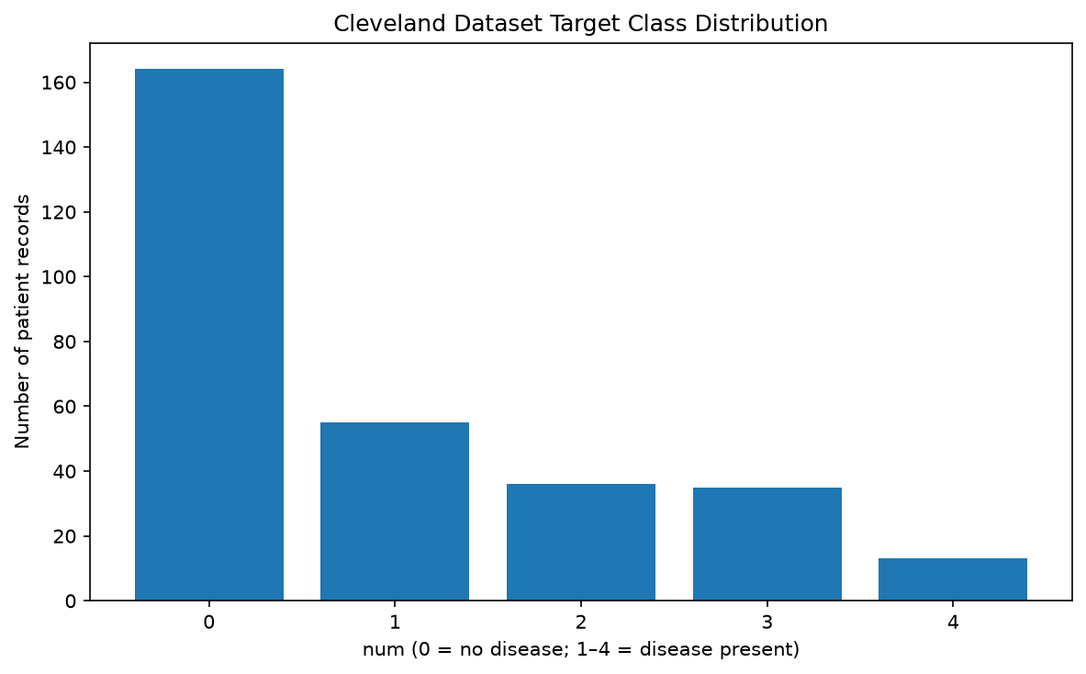
Figure 1. Raw dataset target distribution.
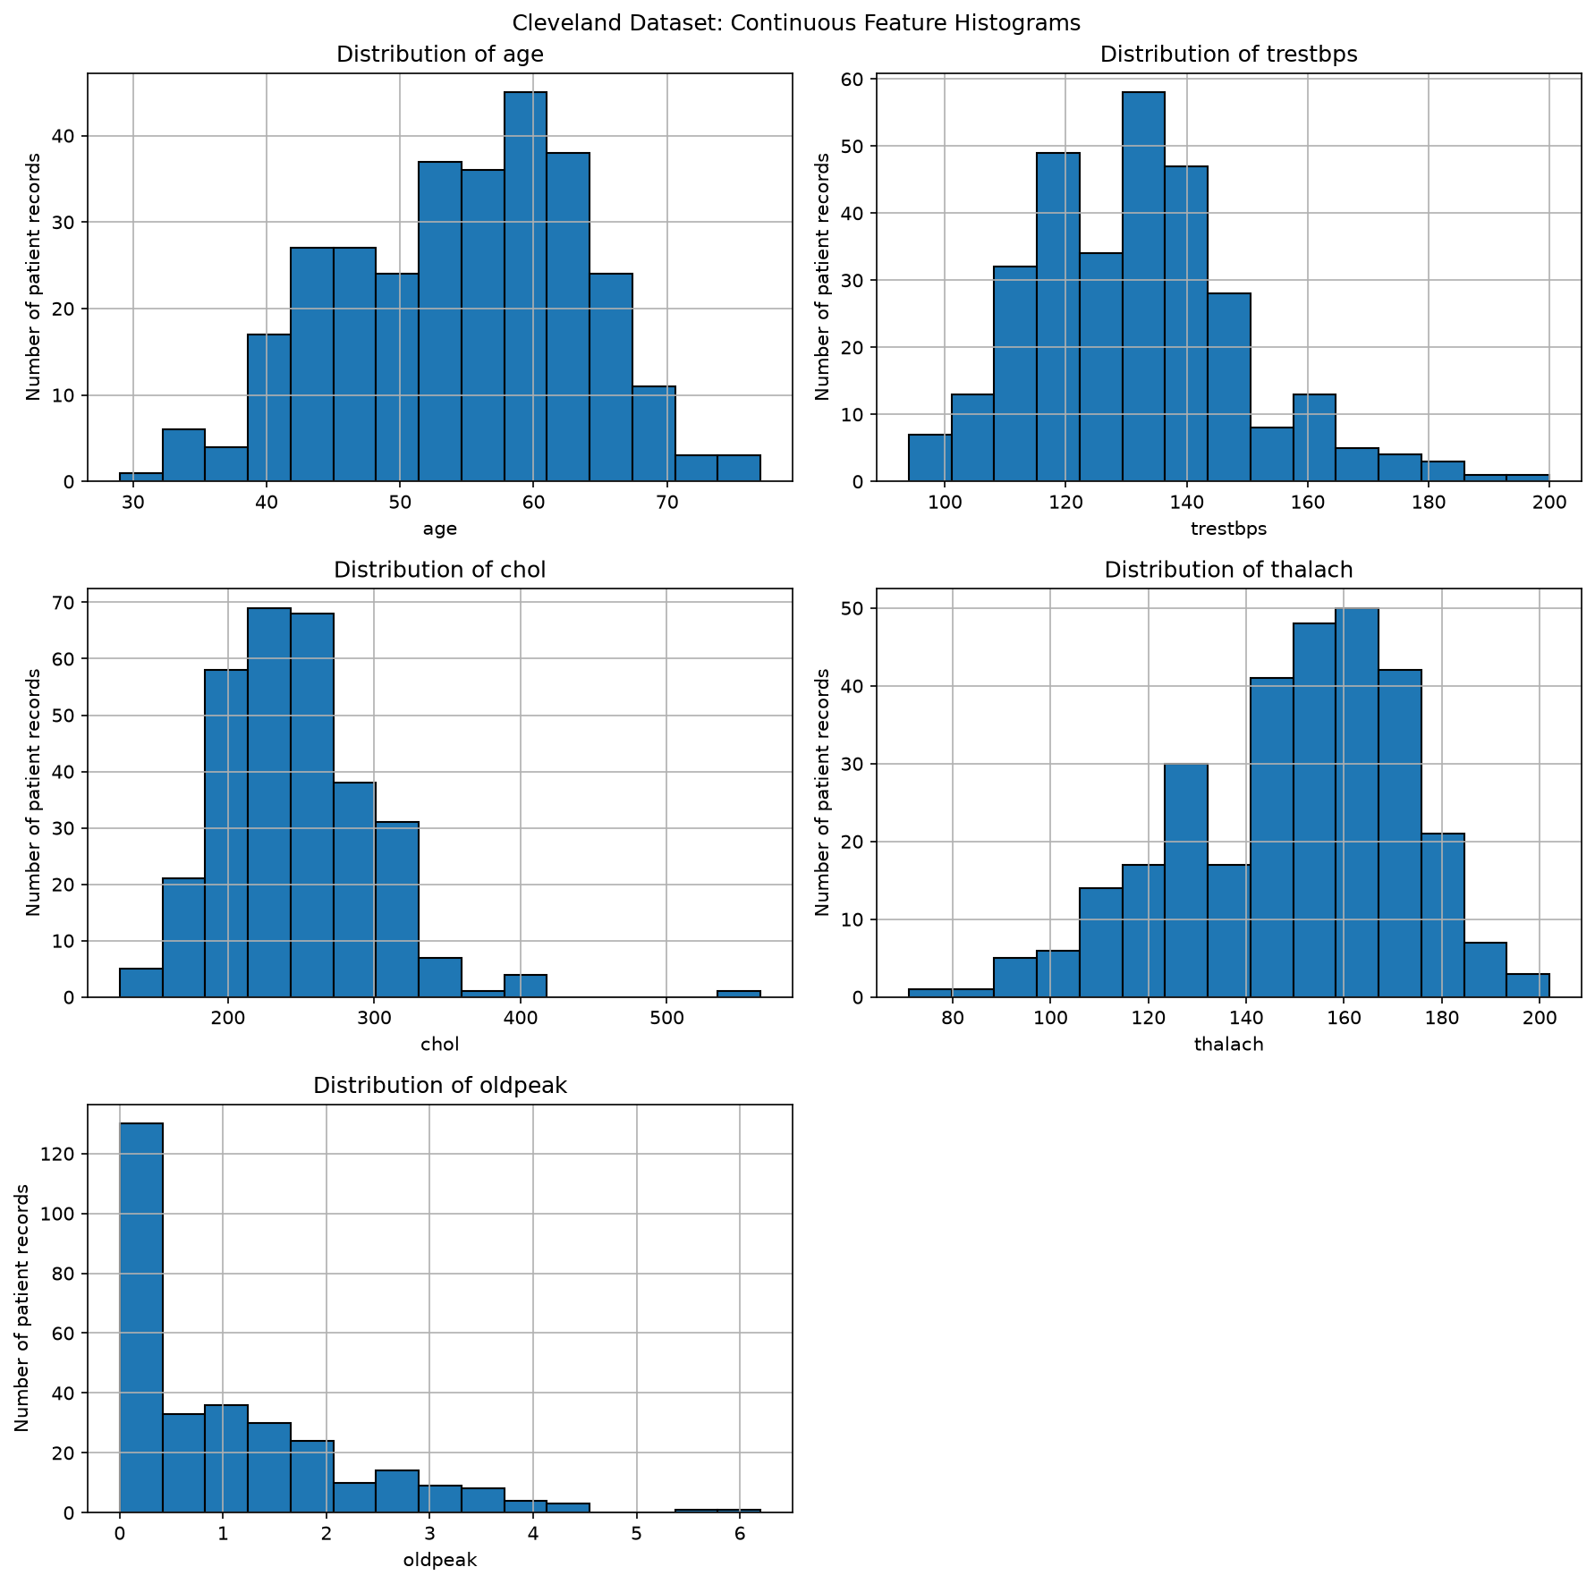
Figure 2. Raw continuous-feature histograms.

3. Exploratory Analysis: Raw and Cleaned Data
The saved EDA outputs summarize target distribution, continuous-feature ranges and distribution shapes, and pairwise linear associations. These plots describe this dataset only; they do not establish medical thresholds, causality, or model validity.
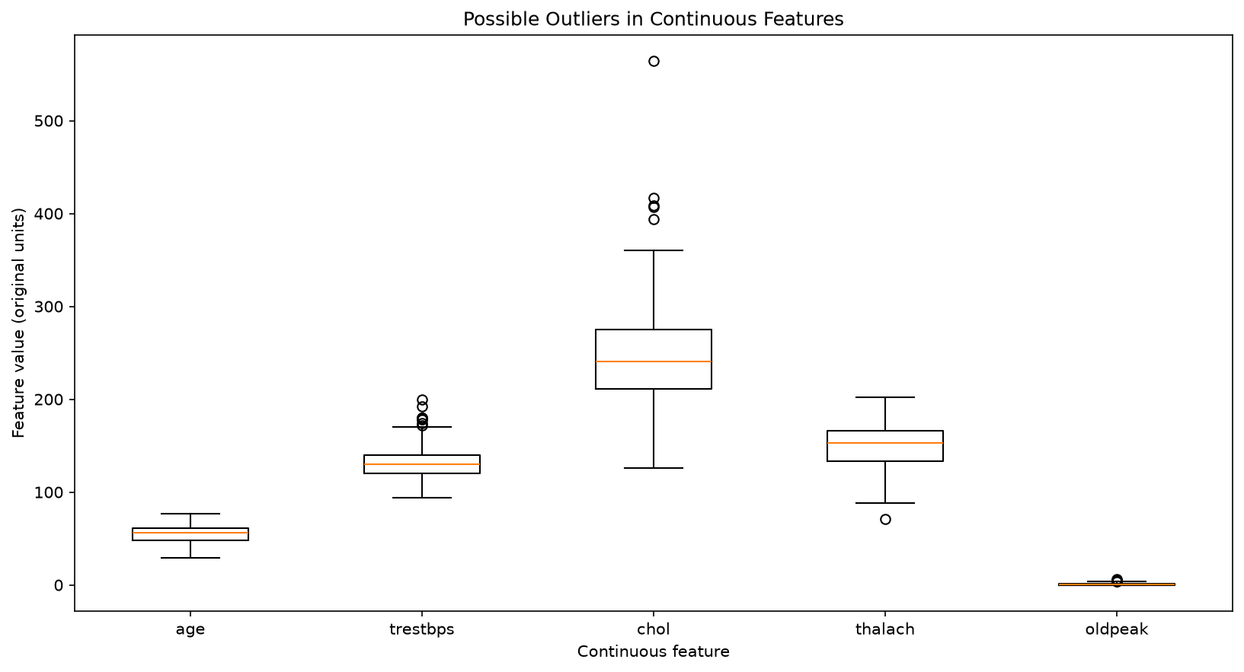
Figure 3. Raw continuous-feature boxplots.
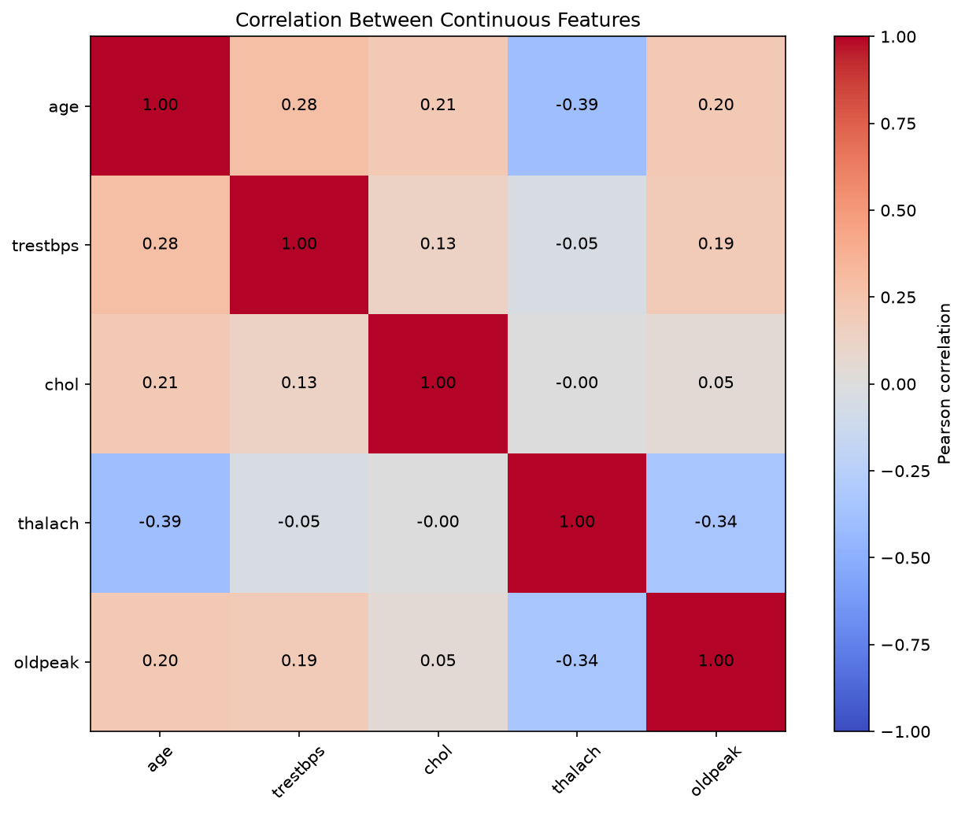
Figure 4. Raw continuous-feature correlation heatmap.
Figure 5. Target distribution after typed cleaning; still source-coded 0–4.

3.1 Processed Dataset Visual Evidence
The processed dataset retains the original num target coding at this stage. Training later applies the explicitly documented binary mapping. Missing features remain for imputation inside the model pipeline.
Figure 6. Processed continuous-feature histograms.
Figure 7. Processed continuous-feature boxplots.
Figure 8. Processed continuous-feature correlation heatmap.

4. Feature Schema, Preprocessing and Leakage Prevention
The training target maps num==0 to absence (class 0) and num>0 to presence (class 1). All 13 source inputs are retained. A stratified 80/20 split with random_state=42 yields 242 training and 61 test rows. Five-fold stratified cross-validation is performed only on training data.
Field | Meaning / group | API JSON type
age | Age; numeric, impute + scale | number
sex | Coded category 0/1 | integer
cp | Chest-pain category 1–4 | integer
trestbps | Resting blood pressure; numeric | number
chol | Cholesterol; numeric | number
fbs | Fasting blood sugar category | integer
restecg | Resting ECG category 0–2 | integer
thalach | Maximum heart rate; numeric | number
exang | Exercise-induced angina code | integer
oldpeak | ST depression; numeric | number
slope | Peak exercise ST slope code | integer
ca | Major-vessel category/count code | integer
thal | Thalassemia test category | integer

Numeric features: median imputation then standard scaling. Coded categorical features: most-frequent imputation then one-hot encoding. Both transformations live inside the scikit-learn pipeline and are fitted separately within each CV fold. The held-out test partition is not used to estimate preprocessing statistics. The packaged model contains the fitted transforms; inference does not refit them.

5. Training Method and Cross-Validation Results
Candidates share the same data split. The selection rule is highest mean ROC-AUC across five stratified folds on training data. Test scores are calculated only after selection and do not tune the models.
Candidate | CV accuracy\nmean ± SD | CV precision\nmean ± SD | CV recall\nmean ± SD | CV ROC-AUC\nmean ± SD
Logistic Regression | 0.8471 ± 0.0112 | 0.8768 ± 0.0606 | 0.7834 ± 0.0513 | 0.9025 ± 0.0161
Random Forest | 0.8139 ± 0.0259 | 0.7967 ± 0.0298 | 0.8008 ± 0.0898 | 0.8936 ± 0.0372

Selection and reproducibility
Logistic Regression was selected: its training-only CV mean ROC-AUC 0.902493 exceeded Random Forest’s 0.893573. The standard deviations are the recorded sample standard deviations across folds. Split seed, fold count and selection rule are in the saved evaluation report.

Interpretation
This is a small, single-subset educational baseline, not independent external validation or evidence of clinical performance. Results may not generalize to other populations or settings.

5.1 Held-Out Test Results
The final 61-row test split was held aside for evaluation. Precision, recall and F1 below refer to the presence class (binary label 1).
Model | Accuracy | Precision | Recall | F1 | ROC-AUC
Logistic Regression (selected) | 0.8852 | 0.8387 | 0.9286 | 0.8814 | 0.9665
Random Forest | 0.8689 | 0.8125 | 0.9286 | 0.8667 | 0.9443

Confusion matrix label order for rows and columns is [absence, presence]. Logistic Regression: [[28,5],[2,26]]. Random Forest: [[27,6],[2,26]].
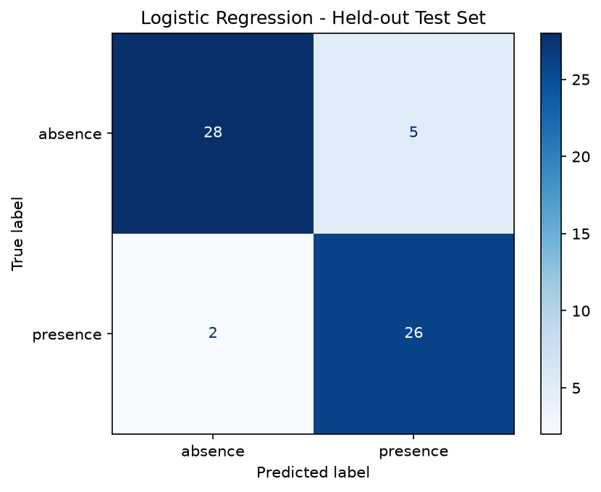
Figure 9. Logistic Regression held-out confusion matrix.
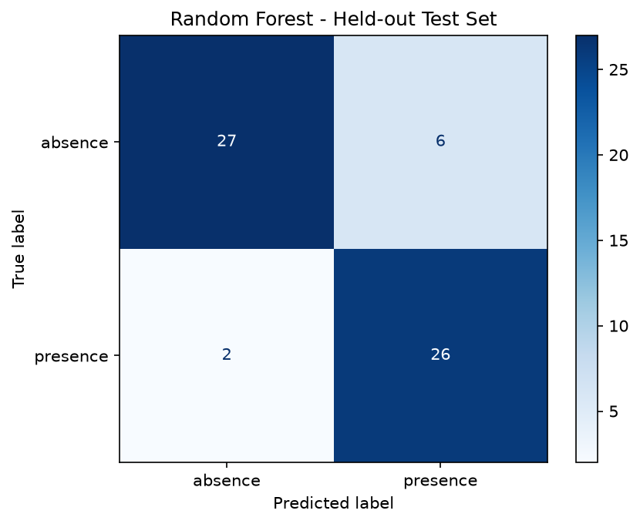
Figure 10. Random Forest held-out confusion matrix.
Selected fitted artifact: artifacts/final_heart_disease_pipeline.joblib. Metadata: artifacts/final_heart_disease_metadata.json. Recorded SHA-256: 3432bdf59ce436280d5084d20d97f2254c5515163712c64ef096a66f454f370c.

6. MLflow Experiment Tracking and Run Evidence
Local tracking uses SQLite metadata in mlflow.db and run artifacts in mlartifacts/. Experiment heart-disease-classification has ID 1. The experiment script and UI must use this same tracking store to show the existing parameters, metrics, and runs.
Run ID | Model | Status | CV ROC-AUC | Test accuracy | Test ROC-AUC
dd5b5052f3f549c3a8e46d3cf392ae19 | Logistic Reg. | FAILED | 0.9025 | 0.8852 | 0.9665
860c5a6bda3b4d81abdc954cb6deea41 | Logistic Reg. | FINISHED | 0.9025 | 0.8852 | 0.9665
fb6bfb53d35343bfad4d638619facf8e | Random Forest | FINISHED | 0.8936 | 0.8689 | 0.9443
b0d81c076d1f4aa0b803b3c7e4b0df34 | Logistic Reg. | FINISHED | 0.9025 | 0.8852 | 0.9665
d81ef620515240d7b0c686d9a3abb2c4 | Random Forest | FINISHED | 0.8936 | 0.8689 | 0.9443

Recorded: four FINISHED runs and one FAILED run. Finished runs logged parameters and metrics. Values logged before the failed run stopped do not make it a completed run. The selected-run reference is b0d81c076d1f4aa0b803b3c7e4b0df34. Existing experiment records were preserved.

Open the existing MLflow UI without retraining
$trackingDb = (Join-Path $PWD 'mlflow.db') -replace '\\', '/'
.\.venv\Scripts\python.exe -m mlflow ui --backend-store-uri "sqlite:///$trackingDb" --host 127.0.0.1 --port 5000
Open http://127.0.0.1:5000 and select heart-disease-classification. Do not rerun the tracker just to view old runs.

7. Packaged Model and FastAPI Contract
The inference artifact contains the already fitted preprocessing pipeline and Logistic Regression classifier. Metadata records selected model, input schema, target mapping, package information, evaluation results, artifact digest and a successful MLflow run reference. Packaging copied/reused the selected model; it did not retrain it.
Route | Purpose
/health — GET | Process health; returns {"status":"ok"}.
/predict — POST | Validate the feature row and use the fitted model.
/metrics — GET | Prometheus-compatible metrics; not shown in Swagger.
/docs — GET | Interactive Swagger UI.
/openapi.json — GET | Machine-readable API description.

Feature names/order: age, sex, cp, trestbps, chol, fbs, restecg, thalach, exang, oldpeak, slope, ca, thal. Numeric inputs use JSON numbers; coded categories use strict integers. Null is permitted for missing fields that can be imputed. Extra fields, including target num, are forbidden; category codes are checked.

Example valid request
{ "age":63, "sex":1, "cp":1, "trestbps":145, "chol":233, "fbs":1, "restecg":2, "thalach":150, "exang":0, "oldpeak":2.3, "slope":3, "ca":0, "thal":6 }
A live verified response used the saved model and returned selected_model=logistic_regression, predicted_class=0 and predicted_label=absence for this example. It is not a diagnosis; probabilities are not necessarily calibrated.

8. Input Validation, Errors and Docker Verification
Pydantic/FastAPI validates required fields and strict JSON types. Missing values, extra fields, invalid feature types and unsupported category codes are rejected with HTTP 422 and an explanatory response. Model unavailable is HTTP 503; inference failure is HTTP 500. Request failures are monitored without logging raw input values.
Verification | Actual evidence
/health | HTTP 200; status ok.
/docs | HTTP 200; Swagger page loads.
/metrics | HTTP 200; Prometheus exposition.
Valid /predict | Live prediction returned from existing saved model.
Invalid category | Recorded Docker smoke test returned HTTP 422.
Model lifecycle | Loaded saved artifact; no training on API request.

Docker image and runtime
Existing Dockerfile builds heart-disease-mlops:step11 and runs Uvicorn on container port 8000. Recorded container smoke testing used available host port 18001 and verified health, docs, metrics, prediction and invalid-input handling. Kubernetes reuses the existing model image.
kubectl port-forward -n heart-disease service/heart-disease-api 18002:8000
Invoke-RestMethod 'http://127.0.0.1:18002/health'
Invoke-WebRequest -UseBasicParsing 'http://127.0.0.1:18002/docs'
Invoke-WebRequest -UseBasicParsing 'http://127.0.0.1:18002/metrics'
At final verification the API routes /health, /docs, /metrics returned HTTP 200; valid /predict produced a live response.

9. Monitoring, Privacy-Safe Logs and Data Quality
Request middleware measures end-to-end latency, counts requests and errors, and emits structured JSON to the container output. Prometheus labels use bounded method/route/status/reason values to avoid high cardinality.
Metric | Definition
heart_disease_api_requests_total | Request counter by method, route, status.
heart_disease_api_request_failures_total | Errors by route, status, reason.
heart_disease_api_request_duration_seconds | Latency histogram; used for p95.
heart_disease_predictions_succeeded_total | Successful prediction count.
heart_disease_input_feature_issues_total | Quality issues by feature and issue.

What is included in logs
- UTC timestamp, request ID, method, bounded route, status, latency and failure reason when applicable.
- Successful response class/label can be logged.
- Raw patient feature values and the entire request body are not logged.
- Validation errors count issue types without exposing submitted values.
kubectl logs -n heart-disease deployment/heart-disease-api --tail=50

Empirical range monitoring
Numeric feature | Training minimum | Training maximum
age | 29 | 77
trestbps | 94 | 200
chol | 126 | 564
thalach | 71 | 202
oldpeak | 0.0 | 6.2

Ranges are measured from the actual 242-row training split. Out-of-range values are counted, not automatically rejected. These boundaries are not medical limits, a drift threshold, or proof of invalidity. Nulls and invalid categories/values are also monitored.

10. Prometheus Scrape and Grafana Dashboard
The Kubernetes monitoring manifest configures a 15-second Prometheus scrape of heart-disease-api:8000/metrics. Grafana uses the provisioned Prometheus datasource and dashboard JSON.
Grafana panel | Measurement
API requests per second | Request-counter rate.
HTTP failure ratio | Error requests relative to current-process requests.
Request latency p95 | 95th percentile from the request histogram.
Successful predictions | Successful prediction counter.

Live post-recovery evidence: API, Prometheus and Grafana pods were each 1/1 Ready; Prometheus target health=up with no scrape error; Grafana /api/health and Prometheus /-/ready returned HTTP 200. A real valid prediction was sent before checking the success counter.

Dashboard: http://127.0.0.1:13000/d/heart-disease-api/heart-disease-api
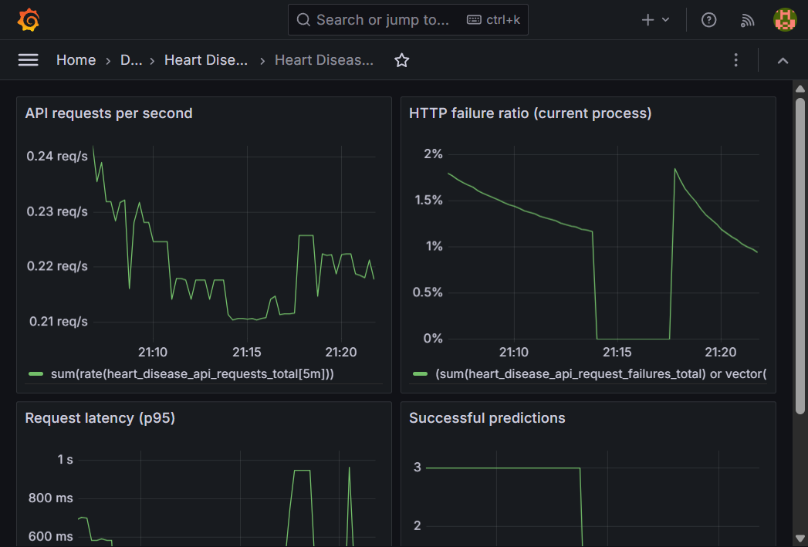
Figure 11. Saved Grafana Heart Disease API dashboard screenshot.
The Grafana and Prometheus browser interfaces are Kubernetes services, not necessarily ordinary Docker Desktop container-list entries. Their local port-forwards must remain open; automatic startup after Windows restart is not configured.
Prometheus UI: http://127.0.0.1:19090

11. Kubernetes Deployment, Tests and Assignment Checklist
k8s/deployment.yaml defines the API Deployment, health probes and resource settings. k8s/service.yaml preserves the rubric-required LoadBalancer type; its address is private to the local cluster. k8s/monitoring.yaml provisions Prometheus and Grafana. Windows host access is via port-forward. Use kubectl, not docker ps, to inspect Kubernetes pods.
Requirement | Status / evidence
Local Kubernetes API deployment | PASS reported; existing step11 image.
Deployment manifest applied | PASS reported; k8s/deployment.yaml.
LoadBalancer Service | PASS reported; private local address.
health/docs/prediction | PASS reported; live API checks passed.
Request logs and metrics | PASS; JSON logs and /metrics.
Prometheus and Grafana | PASS; target up; live dashboard health.
Screenshots | All available PNGs included in this report.
Remote GitHub Actions | NOT VERIFIED; no successful remote run evidence.
Live accuracy/drift | NOT MEASURED; no production ground truth.
Public cloud/video | Not implemented/not found.

Quality checks and limitations
Existing verification records 15 pytest tests passed; Ruff and pip check passed. The GitHub Actions workflow is configured to run Ruff and pytest on pushes and pull requests, but a remote success is not verified. Ground-truth production labels are absent; live accuracy, drift and degradation are not measured. Prometheus/Grafana local storage is ephemeral. The model is not clinically validated. The serialized scikit-learn version differs from the local runtime version, as noted in the existing report.

Recovery and diagnostic commands
kubectl config current-context; kubectl get nodes
kubectl get pods,svc -n heart-disease -o wide
kubectl get events -n heart-disease --sort-by=.lastTimestamp
kubectl logs -n heart-disease deployment/heart-disease-api --tail=100

12. Screenshot Appendix and PowerShell Access Guide
All 13 PNG files present in screenshots/ and reports/figures/ are embedded in this Word report: three genuine saved UI screenshots and ten actual project-generated EDA/evaluation figures. No images were fabricated.
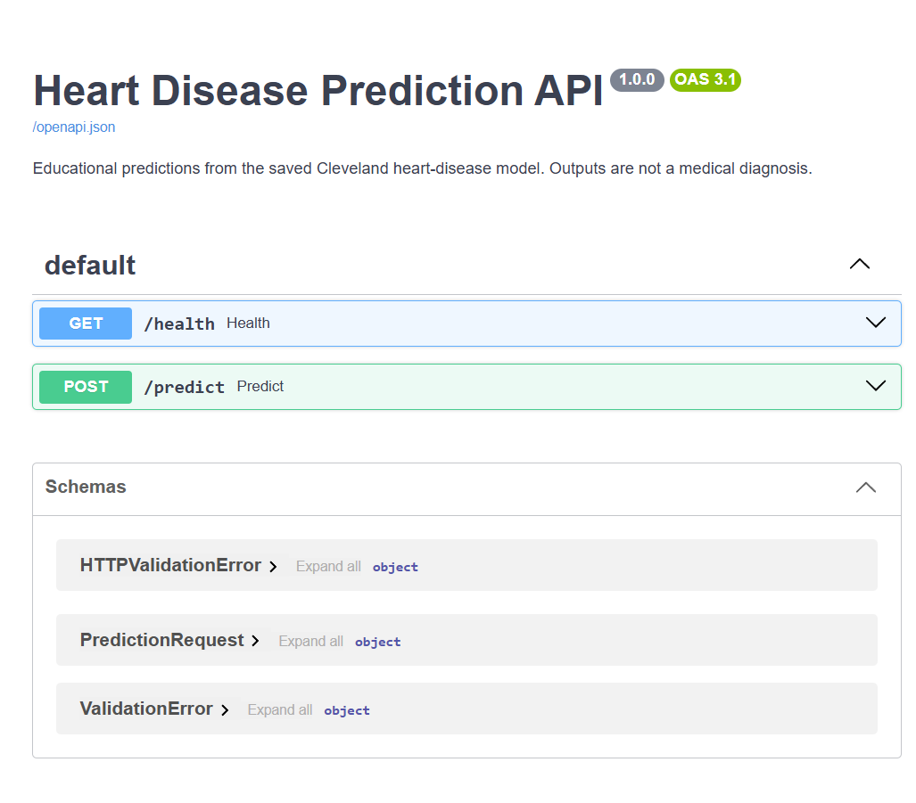
Figure 12. Existing screenshot of the FastAPI Swagger UI.
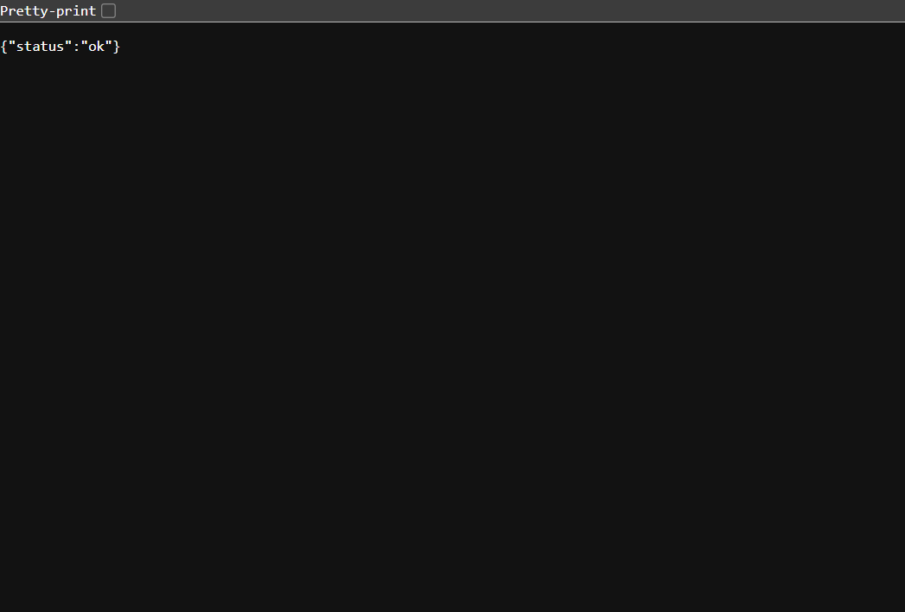
Figure 13. Existing screenshot of the API health endpoint.

Exact PowerShell project location
Set-Location 'C:\Users\hemak\Documents\koushikaa-2025ae05628\2025ae05628_mlos\heart-disease-mlops'

Start local forwards in separate terminals
kubectl port-forward -n heart-disease service/heart-disease-api 18002:8000
kubectl port-forward -n heart-disease service/grafana 13000:3000
kubectl port-forward -n heart-disease service/prometheus 19090:9090
If a port is already in use, the forward may already be running; test the URL before starting a second copy. A Docker Desktop restart requires Kubernetes to become Ready again and port-forwards to be restarted.
GitHub repository: https://github.com/2025ae05628-koushi/2025ae05628_mlos
If the instructor requires separate Kubernetes node/Pods/Service screenshots or a successful prediction screenshot, capture them from the live deployment and append them. Those additional views were not among the saved image files available for this report.

