Machine Learning Operations (AIMLCZG523)
Assignment 1
CardioRisk
End-to-end MLOps pipeline for heart-disease risk prediction:
experiment tracking, CI/CD, containerisation, Kubernetes deployment and monitoring
Submission details
Student name | Gaurisha Mathur
BITS ID | 2025ae05642
Code repository | https://github.com/2025ae05642/heart-disease-mlops
Dataset | UCI Heart Disease (Cleveland subset, 303 patients, 13 features)
Date of submission | October 2026

1. Introduction and objectives
Heart disease is the leading cause of death worldwide, and an early, cheap risk estimate from routine measurements helps clinicians decide who needs further testing. The goal of this assignment is not only a good classifier but a production-shaped system around it: reproducible data preparation, tracked experiments, automated testing, a containerised API, a Kubernetes deployment and live monitoring.
The final system, CardioRisk, takes 13 clinical measurements as JSON and returns a binary prediction, the probability of disease, a confidence score and a risk band. Every stage from the raw UCI file to the running pods is automated and verified in a GitHub Actions pipeline.
Assignment task | Where it is addressed | Key evidence
1. Data acquisition & EDA | Section 4 | download script, 6 EDA figures
2. Feature engineering & models | Section 5 | 3 model families, 5-fold CV, 5 metrics
3. Experiment tracking | Section 6 | MLflow runs, nested grid runs, registry
4. Packaging & reproducibility | Section 7 | sklearn Pipeline, joblib + MLflow model, pinned deps
5. CI/CD & testing | Section 8 | 26 pytest tests, 5-job GitHub Actions workflow
6. Containerisation | Section 9 | Dockerfile, /predict smoke test
7. Production deployment | Section 10 | Minikube + kind, LoadBalancer, Ingress, HPA
8. Monitoring & logging | Section 11 | JSON logs, Prometheus, Grafana dashboard
9. Documentation | This report, README | architecture diagram, screenshots

2. System architecture
The system is organised in three layers (Figure 1). Experimentation turns the raw UCI file into a validated dataset, explores it and trains candidate models, with every run recorded in MLflow. CI/CD re-executes the whole chain on every push: lint, tests, training with a quality gate, image build with a container smoke test, and a throw-away Kubernetes deployment that is verified end to end. Serving runs the image as a replicated Deployment behind a LoadBalancer Service and an NGINX Ingress, with Prometheus discovering every pod and Grafana visualising service and model health.
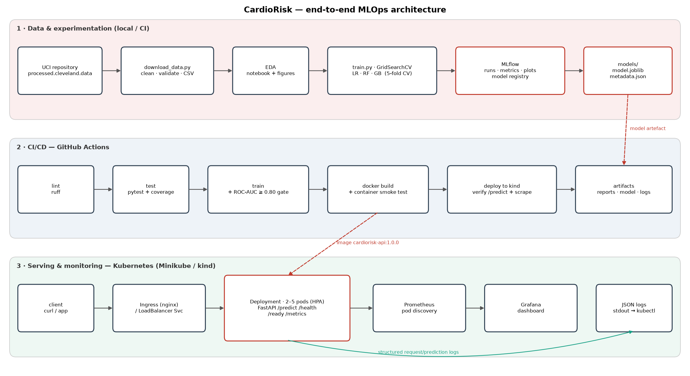
Figure 1. End-to-end architecture of CardioRisk.

Key design decisions
- One sklearn Pipeline from raw features to prediction. Feature engineering, imputation, scaling and encoding live inside the saved artefact, so training, notebooks, tests and the API can never apply different transformations (no training/serving skew).
- The model is baked into the image. An image tag therefore identifies exactly one model version, and rollbacks are a plain kubectl rollout undo.
- Runtime-only serving image. The container installs requirements-serve.txt (no MLflow, Jupyter or plotting libraries), which keeps it small and reduces the attack surface. Versions of numpy, pandas and scikit-learn are pinned identically in both files so the pickled pipeline always loads.
- Scale with replicas, not workers. Prometheus counters live in process memory, so each container runs a single Uvicorn worker and Kubernetes scales pods (HPA 2–5). Prometheus scrapes each pod individually through Kubernetes pod discovery instead of scraping the Service, which would sample a random pod.

3. Setup and installation
Requirements: Python 3.11+ (3.12 is used in CI and in the image), Docker, and for deployment kubectl with Minikube or Docker Desktop Kubernetes. All commands run from a clean clone:
git clone https://github.com/2025ae05642/heart-disease-mlops.git && cd heart-disease-mlops
python -m venv .venv && source .venv/bin/activate
pip install -r requirements-dev.txt && pip install -e . --no-deps
python scripts/download_data.py # raw + cleaned data
python scripts/run_eda.py # EDA figures -> reports/figures/
python -m cardiorisk.train # tune, compare, track, package
pytest -v && ruff check . # tests + lint
mlflow ui --backend-store-uri sqlite:///mlflow.db # browse experiments
The repository layout follows the deliverables list: src/cardiorisk/ (package), scripts/, notebooks/ (EDA, training, inference — committed with outputs), tests/, data/raw and data/processed, models/, deploy/k8s/ and deploy/monitoring/ (manifests), .github/workflows/ci.yml, screenshots/ and docs/.

4. Data acquisition and exploratory analysis

4.1 Acquisition and cleaning
scripts/download_data.py fetches processed.cleveland.data from the UCI repository and falls back to the zipped bundle on UCI's newer static host if the classic URL fails. The file's SHA-256 fingerprint is logged with every training run, so each model can be traced back to the exact bytes it was trained on. Cleaning (cardiorisk/data.py) performs four steps:
- Parse ? markers as missing values (4 rows in ca, 2 rows in thal).
- Collapse the diagnosis num (0–4) into a binary target: 0 = no disease, 1–4 = disease.
- Validate physiological ranges and category codes; impossible values become missing rather than being silently kept.
- Drop exact duplicate rows (none in this file, but the check protects future data refreshes).
Missing values are deliberately not imputed during cleaning. Imputation is part of the model pipeline, so its statistics are learned on training folds only and cross-validation scores are not inflated by leakage.

4.2 Findings
The cleaned dataset has 303 patients: 164 without disease (54 %) and 139 with disease (46 %). The classes are close to balanced, so accuracy is meaningful, but precision, recall and ROC-AUC are reported alongside it because a missed diagnosis (false negative) costs more than a false alarm.
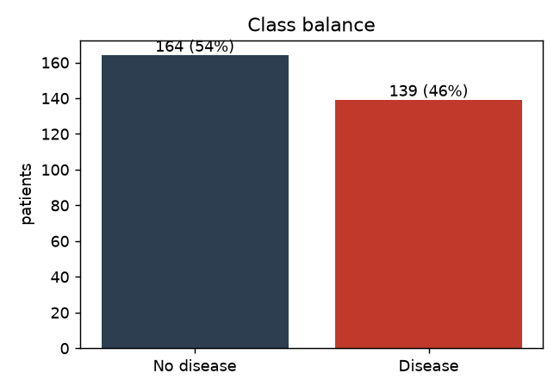
Figure 2. Class balance of the binary target.
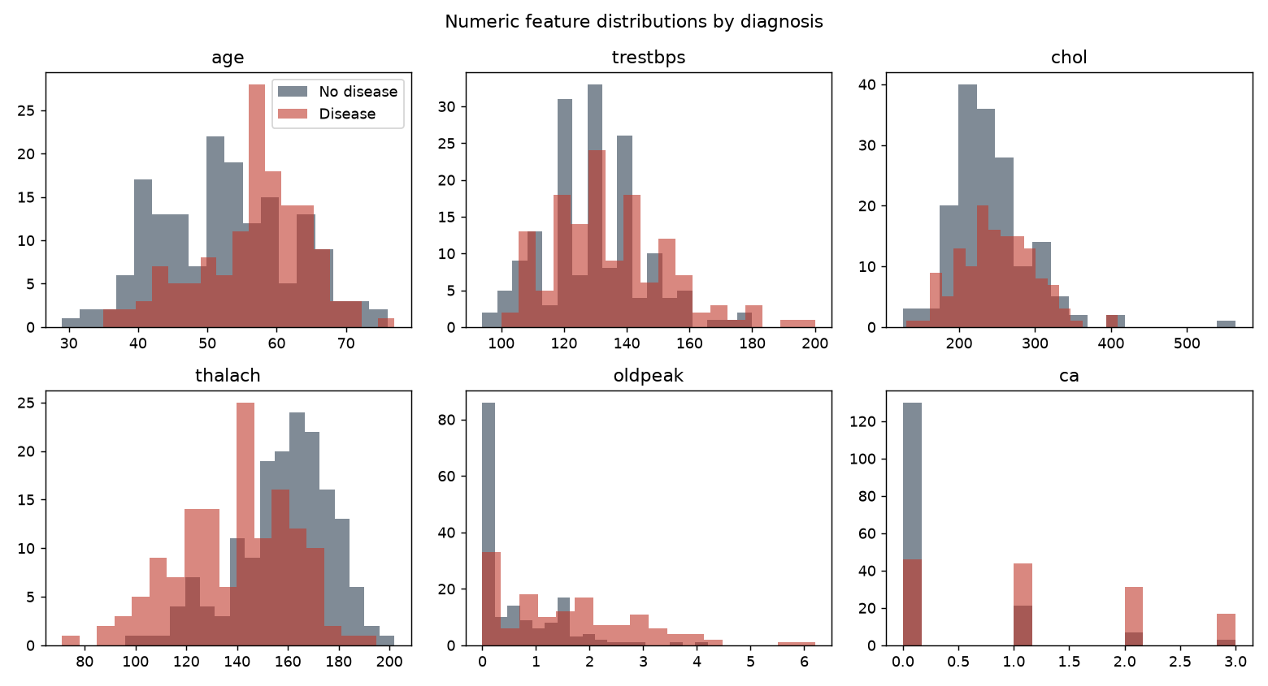
Figure 3. Distributions of numeric features by diagnosis.
Patients with disease reach a lower maximum heart rate (thalach), show more exercise-induced ST depression (oldpeak) and have more vessels coloured by fluoroscopy (ca). Cholesterol and resting blood pressure overlap heavily between classes.
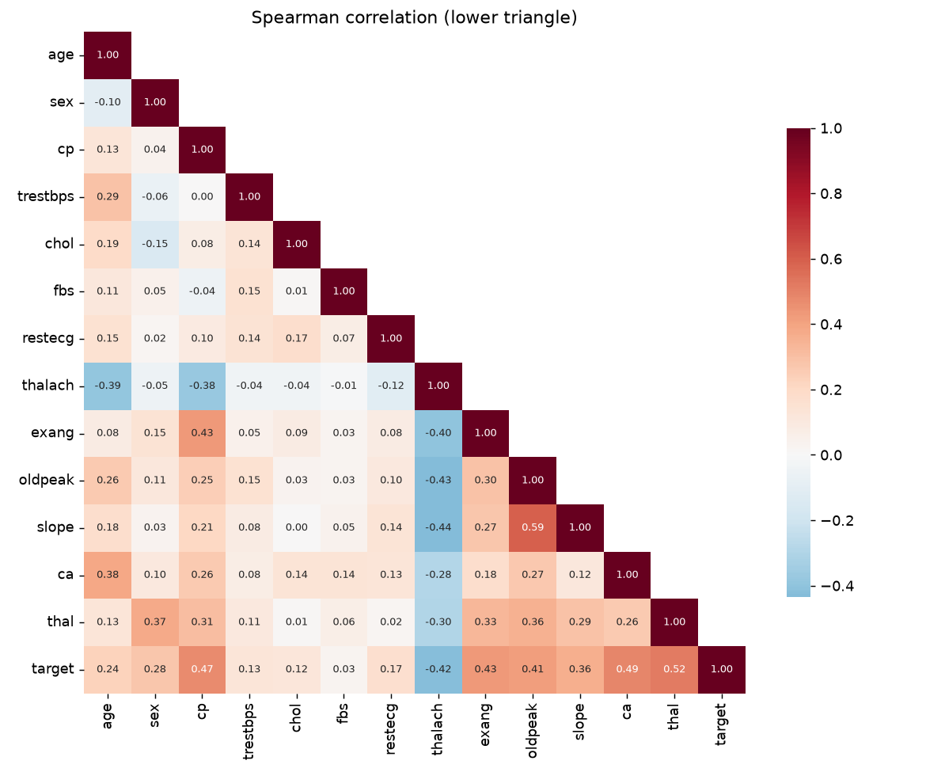
Figure 4. Spearman correlation matrix (rank-based, robust to the ordinal codes).
Spearman correlation with the target ranks the signals as: thal 0.52, ca 0.49, cp 0.47, exang 0.43, thalach −0.42, oldpeak 0.41, slope 0.36, then much weaker sex, age, restecg, trestbps, chol and fbs (0.03).
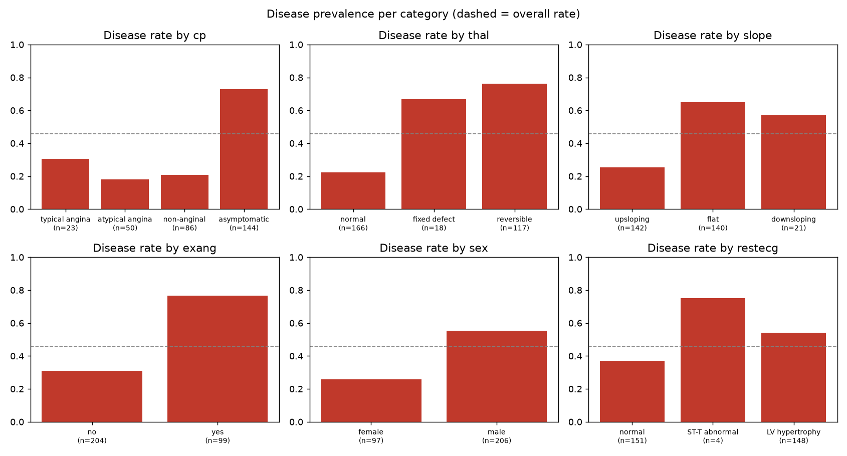
Figure 5. Disease prevalence per category; the dashed line is the overall rate.
Asymptomatic chest pain (cp = 4), a reversible thallium defect and a flat ST slope roughly double the disease rate relative to baseline. These are nominal codes: the numbers 1–4 carry no order, so they must be one-hot encoded rather than treated as numeric.

4.3 Decisions driven by EDA
Observation | Decision
cp, thal, slope, restecg are nominal codes | One-hot encode with a fixed category list (stable width even if a CV fold misses a level)
Max heart rate falls with age, confounding thalach | Engineer hr_reserve_pct = thalach / (220 − age)
Cholesterol and BP are individually weak | Engineer interaction bp_chol_load = z(BP) × z(chol)
Feature scales differ by two orders of magnitude | StandardScaler on numeric features (needed for the linear model)
Only 6 missing cells, all in categorical-like fields | Median / most-frequent imputation inside the pipeline
Outliers in chol / trestbps are physiologically plausible | Kept; tree models are robust and scaling limits their effect on LR

5. Feature engineering and model development

5.1 Pipeline
The model is a single sklearn Pipeline: ClinicalFeatureBuilder → ColumnTransformer → estimator. The custom transformer adds the two engineered features and learns the BP and cholesterol reference statistics in fit(), so they come from training data only. The column transformer applies median imputation and scaling to the 8 numeric features (6 raw + 2 engineered), most-frequent imputation to the 3 binary flags, and imputation plus one-hot encoding (13 columns) to the 4 nominal features, giving 24 model inputs.

5.2 Candidate models and tuning
Three model families were compared, each tuned with GridSearchCV over a deliberately small grid. With about 240 training rows, wide grids mostly fit noise in the CV estimate.
Model | Search space | Candidates | Selected hyper-parameters
Logistic Regression | C ∈ {0.01, 0.1, 0.3, 1, 3}; L1 vs L2 (l1_ratio ∈ {0, 1}); class_weight ∈ {None, balanced} | 20 | C = 1.0, L2, balanced
Random Forest | n_estimators ∈ {200, 400}; max_depth ∈ {4, 6, None}; min_samples_leaf ∈ {2, 5}; max_features ∈ {sqrt, 0.5} | 24 | 400 trees, depth 6, leaf 5, sqrt
Gradient Boosting | n_estimators ∈ {100, 200}; learning_rate ∈ {0.03, 0.1}; max_depth ∈ {2, 3}; subsample 0.8 | 8 | 100 trees, lr 0.03, depth 2

Protocol. A stratified 80/20 split (seed 42) sets aside 61 patients as a hold-out test set. Model selection uses stratified 5-fold cross-validation on the 242 training patients only, scoring accuracy, precision, recall, F1 and ROC-AUC. Each grid is refit on ROC-AUC because it is threshold-independent and measures how well the model ranks patients by risk. The winner is chosen by mean CV ROC-AUC; the hold-out set is used only for reporting, so its numbers remain an unbiased estimate.

5.3 Results
Model | CV ROC-AUC | CV accuracy | CV recall | Test ROC-AUC | Test accuracy | Test precision | Test recall
Logistic Regression | 0.907 ± 0.015 | 0.831 | 0.793 | 0.958 | 0.869 | 0.813 | 0.929
Random Forest | 0.896 ± 0.025 | 0.814 | 0.765 | 0.954 | 0.885 | 0.839 | 0.929
Gradient Boosting | 0.881 ± 0.021 | 0.818 | 0.765 | 0.957 | 0.902 | 0.867 | 0.929

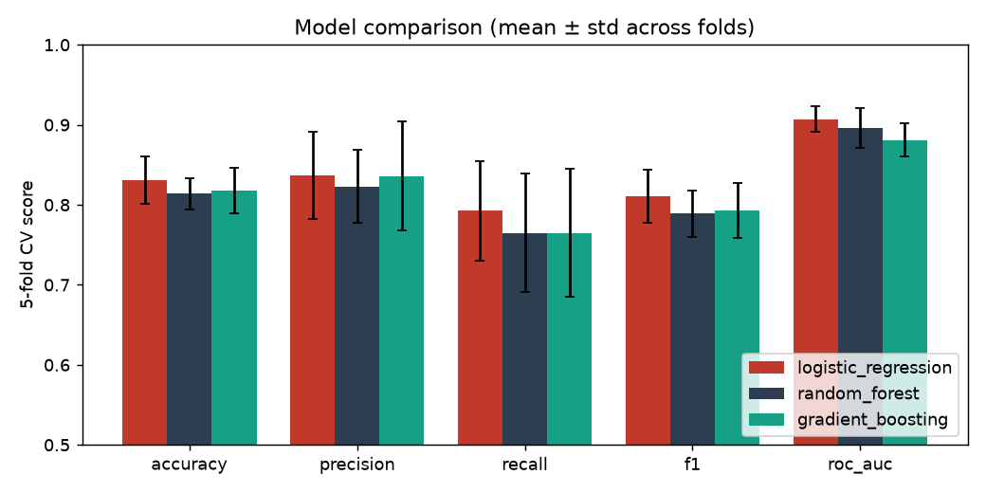
Figure 6. Five-fold CV comparison (error bars = standard deviation across folds).
Why Logistic Regression. It has the highest mean CV ROC-AUC and the lowest fold-to-fold variance. The tree ensembles score slightly higher accuracy on the 61-patient hold-out, but a difference of one or two patients is within noise at that size, and the CV estimate (five times as many evaluations) favours LR. LR is also the easiest to explain to clinicians: its largest coefficients are male sex, number of coloured vessels, asymptomatic chest pain and reversible thallium defect (risk ↑), and normal thallium, typical angina and upsloping ST (risk ↓). This matches the clinical literature and the EDA. The balanced class weight also gives the model the best recall on the hold-out set (26 of 28 diseased patients detected; 6 false alarms among 33 healthy patients).

6. Experiment tracking with MLflow
Every training run logs to MLflow (SQLite backend locally; the database is uploaded as a CI artefact). Runs are nested so a single training produces 56 runs: one parent selection run, one family run per model type, and one candidate run per grid point.
Run level | Parameters | Metrics | Artefacts
Parent (model-selection-<ts>) | row counts, CV folds, seed, data SHA-256, positive rate | winner CV / test ROC-AUC | cleaned CSV, comparison chart + CSV, metadata.json, registered final model
Family (e.g. logistic_regression) | best hyper-parameters | CV mean & std of 5 metrics, hold-out metrics | ROC, PR, confusion matrix, feature importance (PNG + CSV), cv_results.csv, MLflow model with signature + input example
Candidate (…-cand-NN) | that grid point | CV mean & std of 5 metrics, rank | —

The final model is registered as cardiorisk-classifier in the MLflow Model Registry; two versions exist, one from the CLI run and one from the training notebook. MLflow 3.x serialises sklearn models with skops by default, which refuses unknown classes. Instead of falling back to pickle, the code passes an explicit allow-list of trusted types: the project's own transformer and sklearn's tree structure.
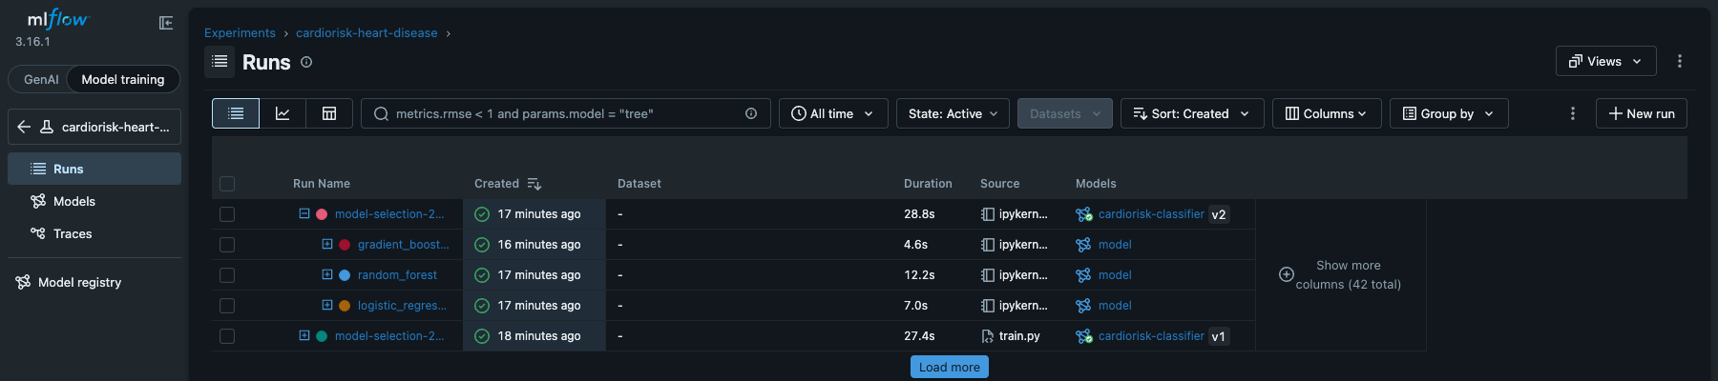
Figure 7. MLflow runs: parent selection runs with nested family runs and registered model versions.
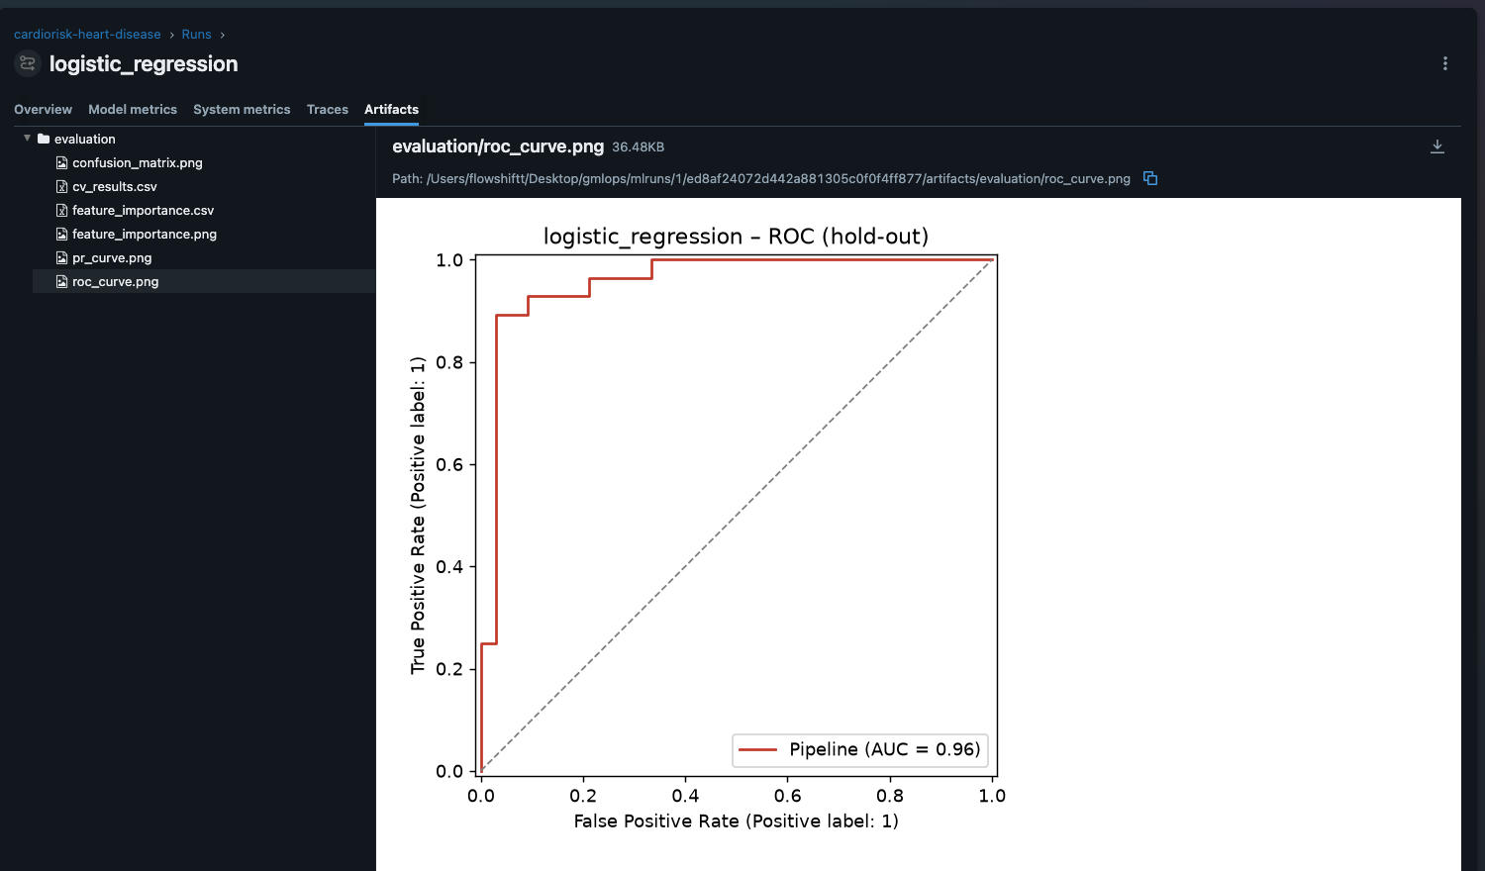
Figure 8. Artefacts logged for the winning run: evaluation plots and CSVs.

7. Model packaging and reproducibility
- Artefacts. models/model.joblib (the full pipeline, loaded by the API), models/mlflow_model/ (MLflow sklearn/pyfunc flavour with signature and input example), and models/metadata.json (model name, version, training timestamp, MLflow run id, data hash, features, threshold, best parameters, CV and test metrics, Python and sklearn versions).
- Dependencies. requirements.txt (pinned runtime + training), requirements-dev.txt (adds pytest, ruff, nbconvert) and requirements-serve.txt (the container's minimal subset, same pins for the numeric stack).
- Determinism. Fixed seeds for the split, CV folds and every estimator. Re-running training reproduces identical metrics. The notebook re-run produced exactly the same hold-out ROC-AUC of 0.9578 as the CLI run.
- Inference parity. notebooks/03_inference.ipynb loads both the joblib pipeline and the MLflow pyfunc model and scores the same patients, including one with unknown ca/thal, which the pipeline imputes.

8. CI/CD pipeline and automated testing

8.1 Unit tests
26 pytest tests run offline in about 2 seconds on synthetic data with a planted signal, so CI does not depend on the UCI server.
File | What is verified
test_data.py (7) | binary target, NaNs preserved for imputation, out-of-range and invalid codes nulled, duplicates dropped, '?' parsing, X/y shapes and dtypes
test_features.py (5) | heart-rate-reserve formula, no leakage of transform-time statistics, no NaNs after preprocessing and correct width, unknown categories tolerated, standardisation
test_model.py (7) | both LR and RF learn the signal (CV AUC > 0.7), valid probabilities, metric dictionary, importances aligned with names, required model families present, save/load round-trip, missing optional fields
test_api.py (7) | health/readiness, /predict returns prediction + confidence, 422 on out-of-range and unknown fields, batch endpoint, Prometheus metrics exposed, JSON request logs carry the request id

8.2 GitHub Actions workflow
.github/workflows/ci.yml runs on every push and pull request (and on demand, with an optional quick-grid mode). Jobs are chained with needs:, and every step runs under bash -euo pipefail. Any failing command therefore stops the pipeline with a clear log and skips everything downstream.
Job | Steps | Artefacts / logging
1. Lint | ruff check (pyflakes, pycodestyle, isort, bugbear, pyupgrade) | inline GitHub annotations
2. Test | pip install pinned deps, record pip freeze, pytest + coverage | JUnit XML, coverage XML, pip-freeze.txt
3. Train | download data, EDA, full training, quality gate: hold-out ROC-AUC ≥ 0.80 | model, MLflow DB + runs, figures; metrics in job summary
4. Docker | build image, run container, smoke test, save image | container logs, image tarball
5. Deploy | kind cluster, load image, apply manifests + monitoring, rollout, smoke test via Service, assert Prometheus sees ≥ 2 healthy replicas | cluster state (get/describe/logs)

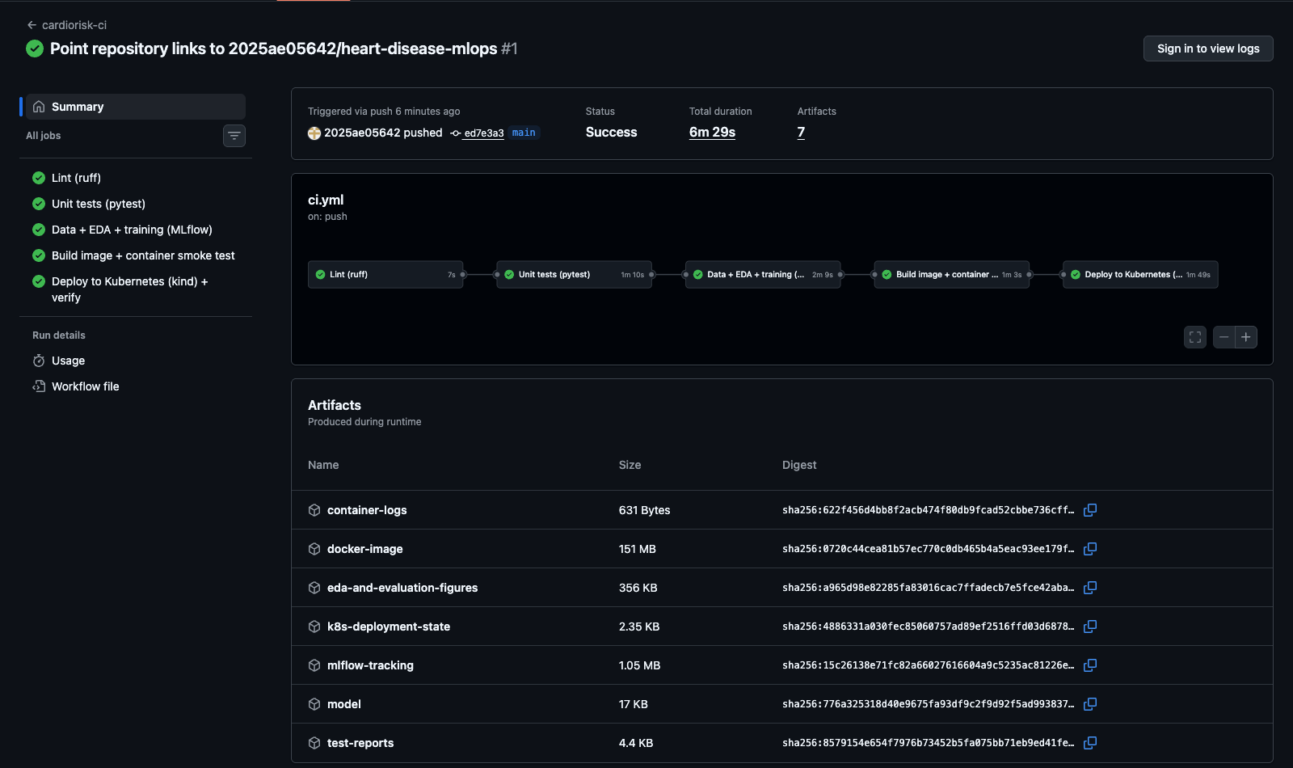
Figure 9. Successful pipeline run: all five jobs green, with the seven uploaded artefacts (model, MLflow store, figures, test reports, image, logs, cluster state).
To verify the fail-fast requirement, a pull request with a deliberate lint error (a redundant import) was opened. CI stopped at the lint stage and test, train, build and deploy were all skipped (Figure 10); the PR was then closed without merging. During development, a deploy-job failure was also traced to curl treating {} in a Prometheus query as a URL glob; it was fixed by URL-encoding the query and adding a retry loop.
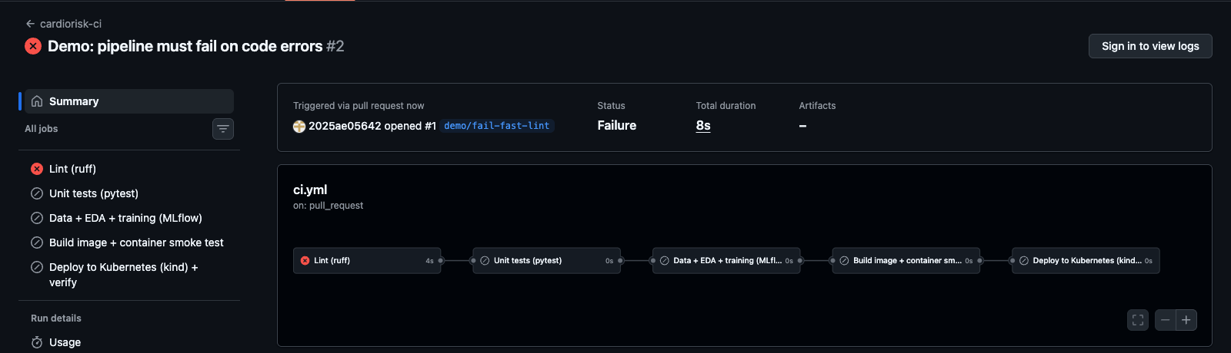
Figure 10. Pipeline stops at the first failing stage (lint); downstream jobs are skipped.

9. Model containerisation
The image is built from python:3.12-slim and installs only the serving dependencies. It copies the package and the model artefact, runs as a non-root user (UID 10001), and declares a Docker HEALTHCHECK against /health. The API is FastAPI with Pydantic validation: each field has a physiological range or an allowed set of codes, unknown fields are rejected, and ca/thal may be null (imputed by the pipeline).
Endpoint | Purpose
POST /predict | One patient → prediction (0/1), label, confidence (probability of the predicted class), probability_disease, risk_band, model_name, model_version, request_id
POST /predict/batch | Up to 500 patients in one call
GET /health, /ready | Liveness (process up) and readiness (model loaded), used by Kubernetes probes
GET /model-info | Contents of metadata.json for the loaded model
GET /metrics | Prometheus exposition format

docker build -t cardiorisk-api:1.0.0 .
docker run -d -p 8000:8000 --name cardiorisk-api cardiorisk-api:1.0.0
curl -X POST localhost:8000/predict -H 'content-type: application/json' -d @sample_request.json
{"prediction":1,"label":"disease","confidence":0.9969,"probability_disease":0.9969,
"risk_band":"high","model_name":"logistic_regression","model_version":"1.0.0+202610030813",...}
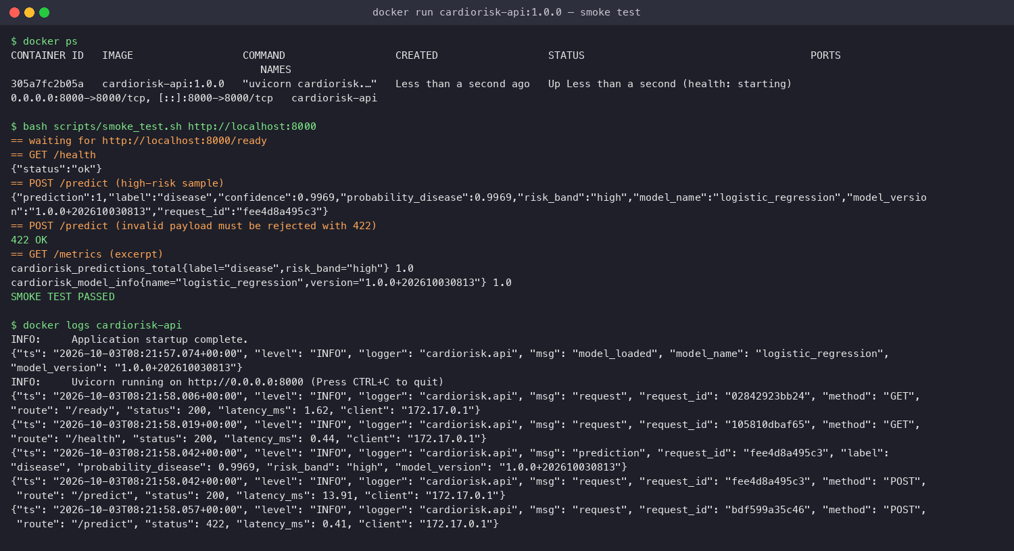
Figure 11. Local container: build, run and automated smoke test (health, prediction, 422 on invalid input, metrics) with structured logs.

10. Production deployment on Kubernetes
The image was deployed to a local Minikube cluster (Docker driver on Colima). CI also deploys it to an ephemeral kind cluster on every push. Manifests in deploy/k8s/ are applied together with kubectl apply -k:
- Deployment: 2 replicas, rolling update with maxUnavailable: 0 (no capacity drop during a model rollout), readiness probe on /ready and liveness probe on /health, CPU/memory requests and limits, and a hardened security context (non-root, read-only root filesystem, all capabilities dropped, seccomp RuntimeDefault).
- Service of type LoadBalancer (port 80 → 8000). Minikube assigns it an external IP via minikube tunnel; on GKE, EKS or AKS the same manifest provisions a cloud load balancer.
- Ingress (NGINX class) routing host cardiorisk.local to the Service.
- HorizontalPodAutoscaler: 2–5 replicas at 70 % CPU.
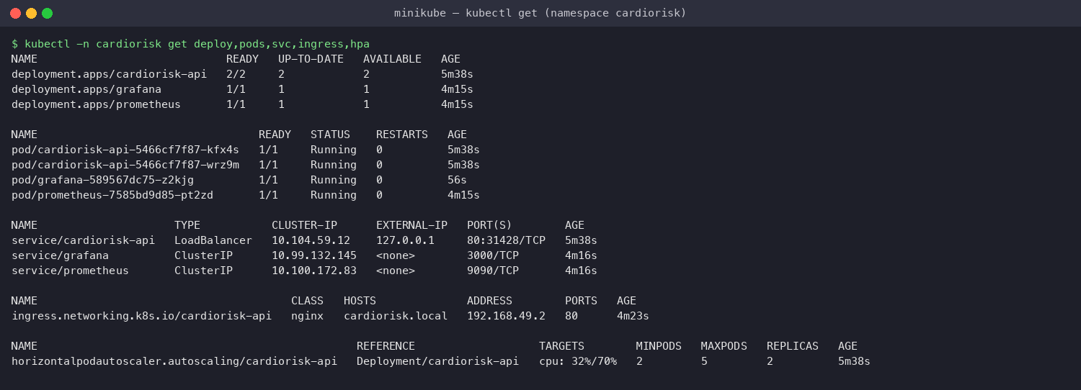
Figure 12. All resources in the cardiorisk namespace: API pods, monitoring, LoadBalancer service with external IP, ingress and HPA.
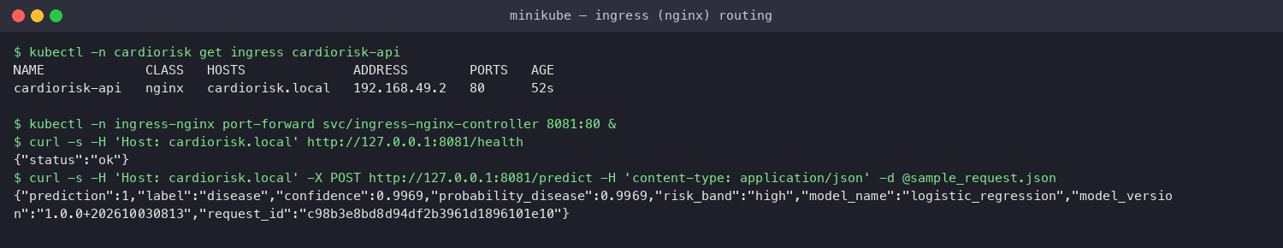
Figure 13. API reached through the NGINX Ingress (Host: cardiorisk.local). The full LoadBalancer smoke-test log is in docs/logs/k8s_deploy_verify.log.

Access instructions (local testing)
minikube start --driver=docker && minikube addons enable ingress
minikube image load cardiorisk-api:1.0.0
kubectl apply -k deploy/k8s && kubectl apply -k deploy/monitoring
minikube tunnel # LoadBalancer gets EXTERNAL-IP (asks for sudo for port 80)
curl http://<EXTERNAL-IP>/health
# without sudo: minikube service cardiorisk-api -n cardiorisk --url

11. Monitoring and logging
Logging. A middleware assigns every request an id (or reuses an incoming x-request-id, which the NGINX ingress supplies), times it, and writes one JSON object per line to stdout. The object holds the timestamp, route, status, latency and client; prediction events additionally carry the label, probability, risk band and model version. Raw patient features are deliberately not logged. JSON lines can be read with kubectl logs and are ready for a log stack such as Loki or ELK.
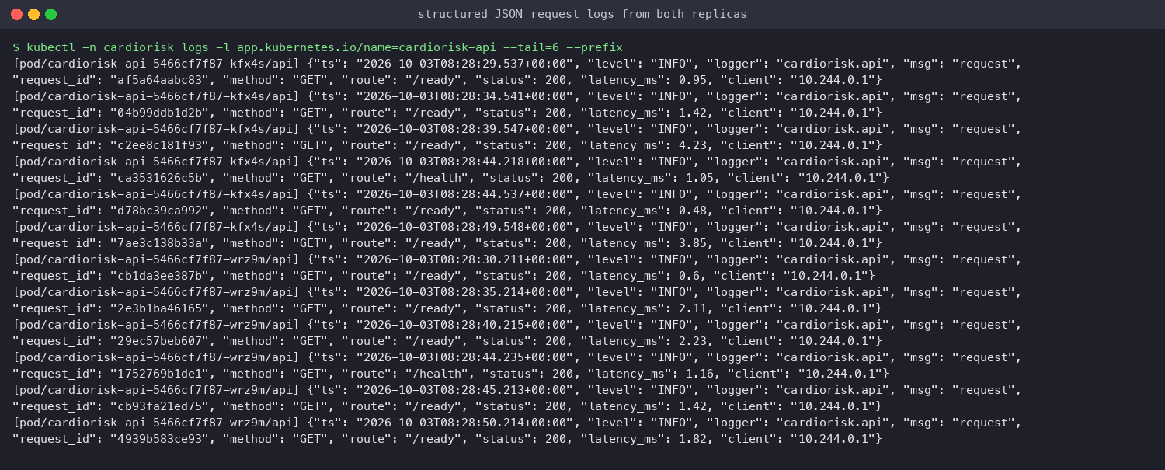
Figure 14. Structured request and prediction logs from both replicas (kubectl logs --prefix).
Metrics. The API exposes the following on /metrics:
- request count by route and status, and request latency histograms;
- predictions by label and risk band;
- a histogram of predicted probabilities, used as a simple input-drift signal;
- validation errors by offending field;
- a model-info gauge carrying the loaded model's name and version.
In the cluster, Prometheus uses Kubernetes pod discovery (namespaced RBAC) to scrape every API replica, and Grafana is provisioned automatically with a datasource and an 11-panel dashboard. To produce realistic traffic, scripts/load_test.py replays real patients from the dataset, about 5 % of them deliberately invalid.
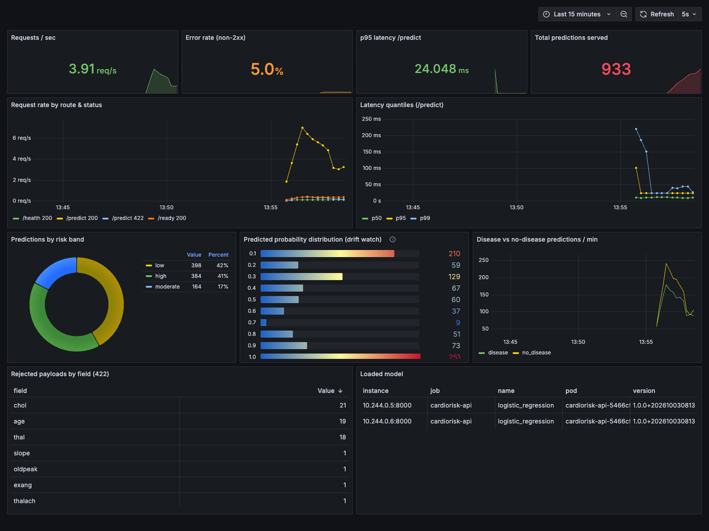
Figure 15. Grafana dashboard under replayed traffic: throughput, error rate, latency quantiles, prediction mix, probability distribution, rejected fields and loaded model per pod.
The dashboard showed p95 latency of about 24 ms for /predict, an error rate of about 5 %, consistent with the deliberately injected invalid payloads, and the most frequently rejected fields (chol, age, thal), which tells a client team which inputs they get wrong most often.

12. Limitations and next steps
- Small dataset. 303 patients from one hospital; hold-out metrics carry wide confidence intervals (±1 patient ≈ ±1.6 % accuracy). External validation on the Hungarian, Swiss and VA subsets is the next step before any clinical claim.
- Threshold. A fixed 0.5 cut-off. A screening use case would lower it to trade precision for recall, chosen on CV predictions.
- Drift. Drift is only watched (probability histogram). Alerting rules and a scheduled retraining job are not yet implemented.
- Registry-driven deploys. Images are currently tagged by version. Promoting models via MLflow registry aliases and pushing images to a registry (GHCR) would complete continuous delivery to a cloud cluster.

13. Deliverables and links
Deliverable | Location
Code repository | https://github.com/2025ae05642/heart-disease-mlops
Dockerfile, requirements files | Dockerfile, requirements.txt, requirements-dev.txt, requirements-serve.txt
Cleaned dataset + download script | data/processed/heart_clean.csv, data/raw/, scripts/download_data.py
Notebooks | notebooks/01_eda.ipynb, 02_training.ipynb, 03_inference.ipynb
Unit tests | tests/ (26 tests)
CI workflow | .github/workflows/ci.yml
Deployment manifests | deploy/k8s/, deploy/monitoring/, docker-compose.yml
Screenshots | screenshots/ (MLflow, API, Docker, Kubernetes, Prometheus, Grafana, GitHub Actions)
API access | Local: section 10 access instructions (no public cloud endpoint)
Pipeline video | [link to your recording]

