MLOps Assignment 1 -Heart Disease Prediction Using MLOps

Course: MLOps
Institution: BITS Pilani
Project: Heart Disease Prediction
Student ID: 2025AE05691 – SANTOSH SRINIVAS G
Submission Evidence
GitHub repository URL: 2025ae05691-rgb/MLOpsAssignment1 at feature/MLOps1
Video link(Click on RAW format) : MLOpsAssignment1/Assignmnet-Submission-Files/MLOps_Assignment01_2025ae05691.mp4 at feature/MLOps1 · 2025ae05691-rgb/MLOpsAssignment1
Google drive link: https://drive.google.com/drive/folders/1RaCKZNE0TRbhDlrK_05mgK_8a8wk9kK0

1. Executive Summary
This project implements an end-to-end MLOps pipeline for heart disease classification.
The pipeline includes data acquisition, exploratory data analysis, preprocessing, model training, experiment tracking, automated testing, model packaging, API development, containerization, Kubernetes deployment, monitoring and documentation. The objective is to make the machine learning solution reproducible, testable, deployable and observable.
2. Problem Statement
The objective is to develop a machine learning classification system using the heart disease dataset and apply MLOps practices throughout its development and deployment lifecycle.
The trained model is exposed through an API that accepts structured feature inputs and returns a model prediction.
3. Dataset and Data Preparation
3.1 Dataset
Dataset name: Heart Disease UCI dataset.
Dataset source: UCI Machine Learning Repository
Number of records: 303 Patients
Number of input features: 13 features (excluding target variable)
Target variable: The target column is target, encoded as:
- 0 = no heart disease
- 1 = heart disease present
3.2 Data Acquisition
src/download_data.py downloads the Cleveland Heart Disease dataset from the UCI repository.
Dataset source: Downloads the Cleveland Heart Disease dataset from the UCI Machine Learning Repository.
Download and loading: Uses requests.get() with a 30-second timeout and checks for HTTP errors. Pandas reads the downloaded CSV text, assigns 14 column names, and treats ? as missing data.
File storage: Creates data/raw/ and saves the dataset as data/raw/heart_disease.csv.
Validation: Checks that the dataset has exactly 303 rows and 14 columns. If the shape differs, it raises an error instead of saving the data. It also prints the first five rows and missing-value counts.
3.3 Exploratory Data Analysis
src/eda.py analyses the 303-row, 14-column heart-disease dataset:
- Data quality: Reports column types, missing values, and duplicates; removes duplicate rows but keeps missing values for the training pipeline to handle.
- Target: Converts num to binary target (0 = no disease, 1 = disease).
- Features: Prints summary statistics and plots distributions for age, blood pressure, cholesterol, maximum heart rate, and oldpeak.
- Correlations: Saves a heatmap for those numeric features and the target. oldpeak correlates positively with target (~0.42); thalach correlates negatively (~−0.42). Correlation does not imply causation.
- Outputs: Saves processed data to data/processed/heart_disease_cleaned.csv and plots to reports/.
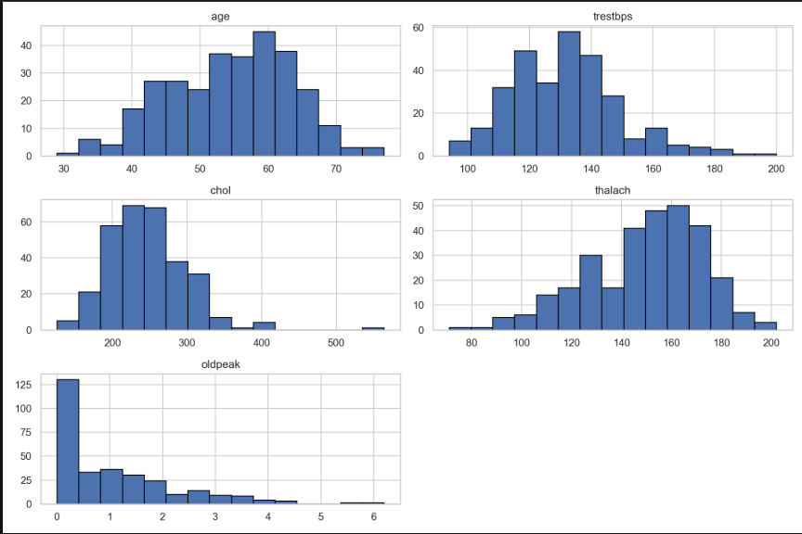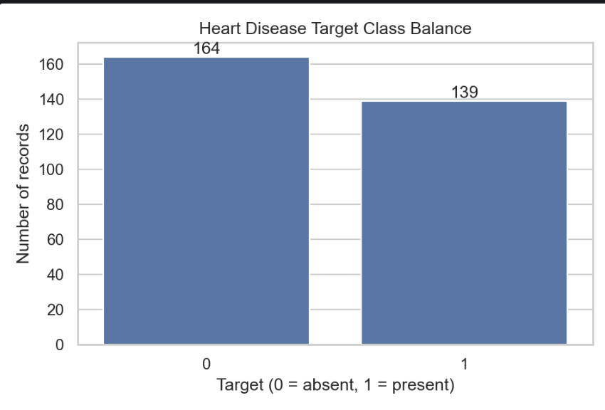

4. Feature Engineering and Model Development
Preprocessing and model selection in src/train.py
- Features: Uses 13 inputs: 5 numeric and 8 categorical. The binary target is what the models predict.
- Preprocessing pipeline: Numeric values are median-imputed, then standardized. Categorical values are filled with the most frequent value, then one-hot encoded; unknown categories are ignored. Preprocessing and classifier are combined in one pipeline to avoid data leakage.
- Models evaluated: Logistic Regression and Random Forest, both configured with balanced class weights.
- Selection: Splits data into an 80% training set and 20% held-out test set, preserving target proportions. Compares and tunes both models using 5-fold stratified cross-validation; grid search selects parameters by ROC-AUC. Chooses the model with the highest cross-validation ROC-AUC, then evaluates it once on the held-out test set.
- Current result: Random Forest was selected. Its held-out test ROC-AUC was 0.945.
4.1 Model Evaluation
- Split: 80% training / 20% test; stratified, random_state=42.
- Cross-validation: 5-fold stratified CV; models tuned using ROC-AUC.
- Selected model: Random Forest.
- Test accuracy: 0.8689
- Test precision: 0.8333
- Test recall: 0.8929
- Test F1-score: 0.86
- Test ROC-AUC: 0.9448
The test metrics are from final_metrics.json; the F1-score is reported by the code-generated classification report.
Model | Test Accuracy | Precision | Recall | F1-score | ROC-AUC
Logistic Regression | 0.8852 | 0.8387 | 0.9286 | 0.88 | 0.9654
Random Forest | 0.8689 | 0.8333 | 0.8929 | 0.86 | 0.9448

5. Experiment Tracking with MLflow
Experiment name: heart-disease-classification
Tracking implementation: src/train_with_mlflow.py
- Runs: Two completed runs: logistic_regression and random_forest.
- Parameters logged: Random seed, test split, CV folds, selection metric, class weight, model family, and best tuning parameters.
- Metrics logged: Baseline 5-fold CV mean and standard deviation for accuracy, precision, recall, and ROC-AUC; best CV ROC-AUC; and held-out test accuracy, precision, recall, and ROC-AUC.
- Artifacts: Per-model metrics JSON, classification report, confusion matrix, ROC curve, and the fitted preprocessing/model pipeline.
- Final selection: Random Forest, selected by the higher 5-fold training CV ROC-AUC (0.90299 vs Logistic Regression’s 0.90279). The test set was kept separate for final evaluation.
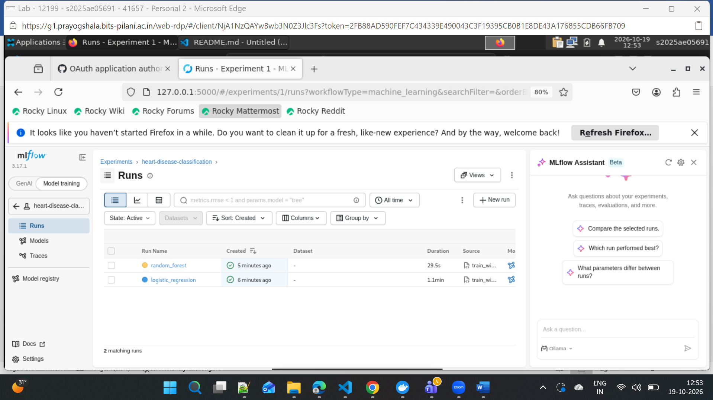
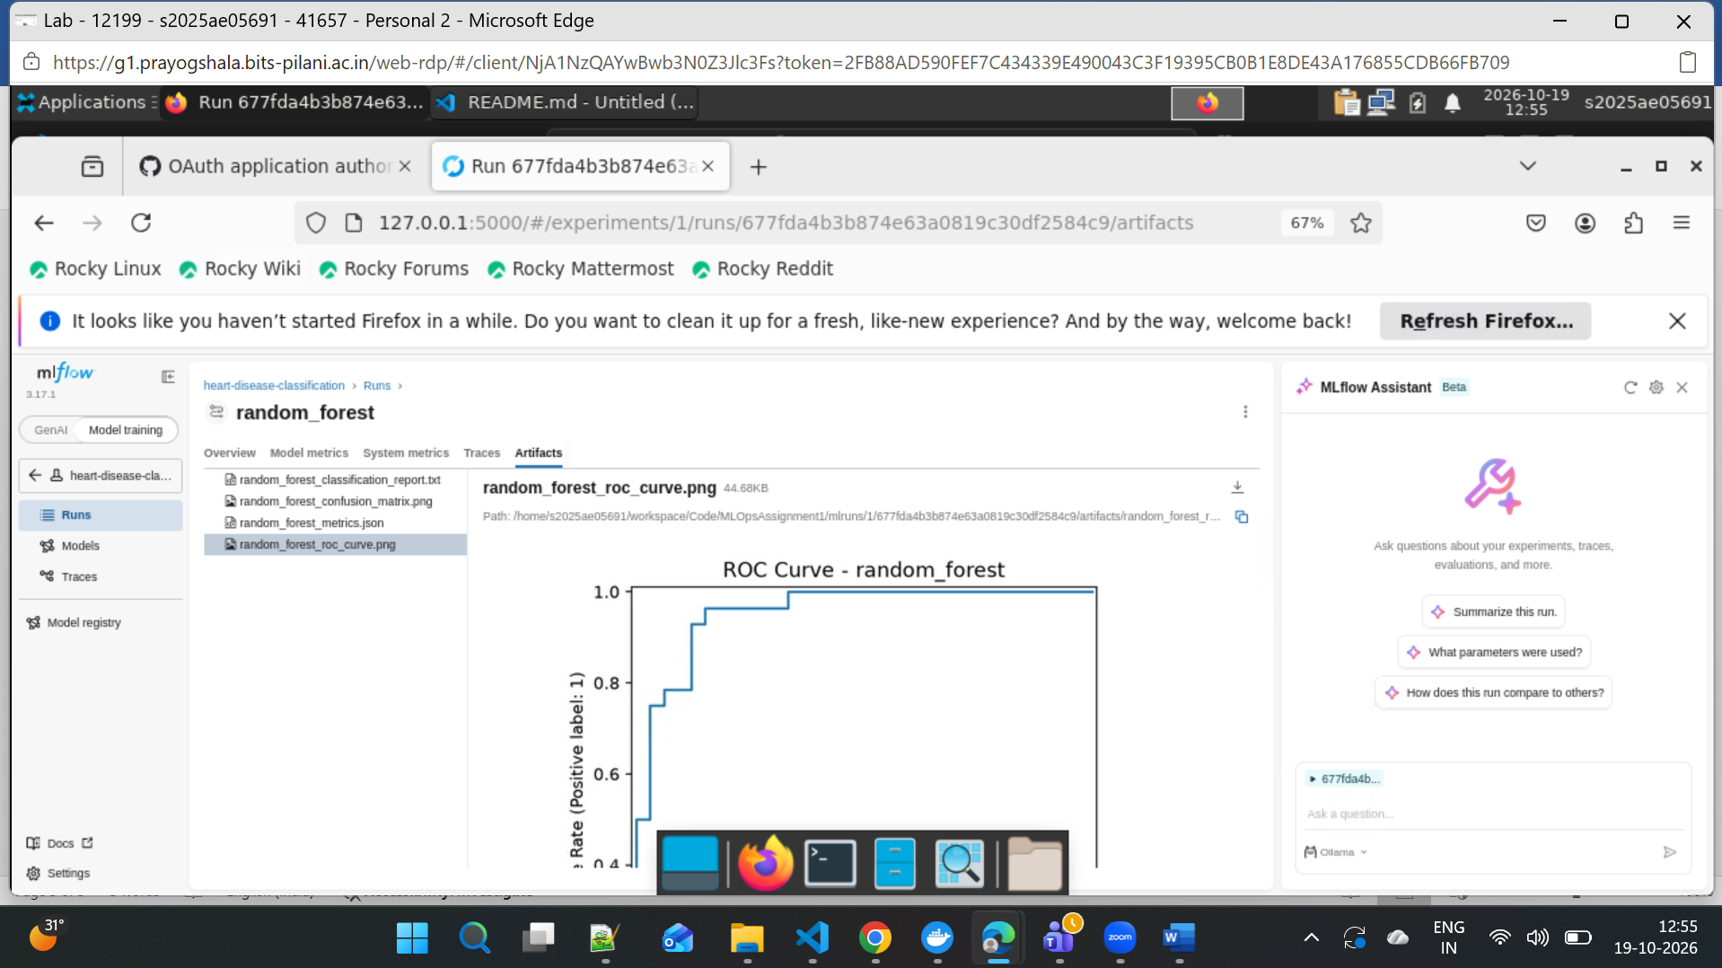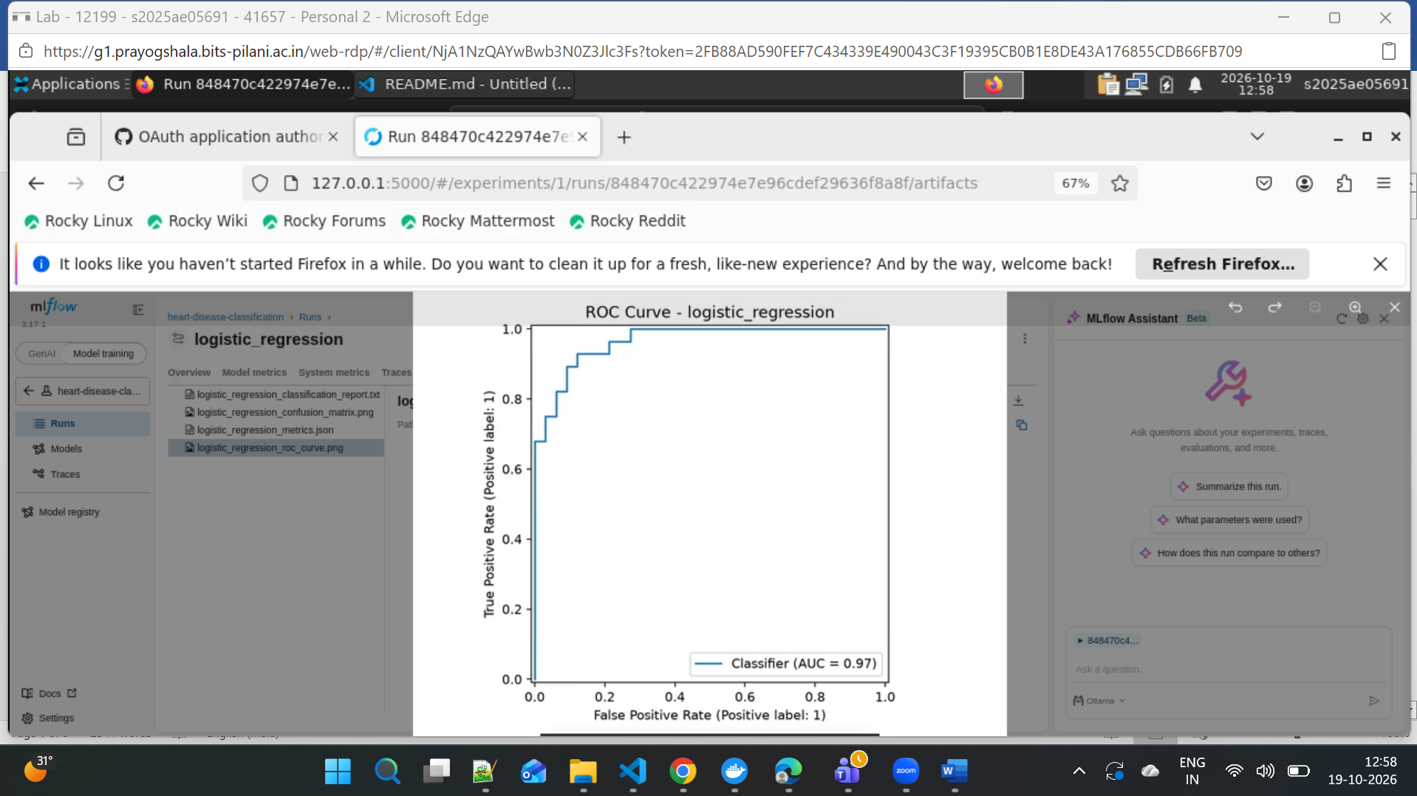
6. Testing and Continuous Integration
- Framework: pytest. test_pipeline.py tests pipeline predictions, probabilities, missing-value handling, and expected features. test_monitoring.py tests API health, metrics, model info, batch predictions, and empty-batch validation.
- Static analysis: Ruff checks src and tests for selected E and F rules, ignoring E402.
- Latest local results: 11 tests passed and Ruff reported “All checks passed!” Pytest also emitted one Starlette deprecation warning.
- CI: GitHub Actions workflow runs on pushes and pull requests targeting main, master, or feature/MLOps1. It installs dependencies, runs Ruff and pytest, then downloads data, runs EDA and MLflow training, verifies the model, and uploads artifacts.
- Failure and resolution: The workflow run you shared failed because tests imported the API, which tried to load a model artifact not yet generated in CI. The test now mocks model loading; local tests pass. A successful GitHub Actions run has not yet been verified—push the fix and check the Actions tab for a green run before reporting CI success.
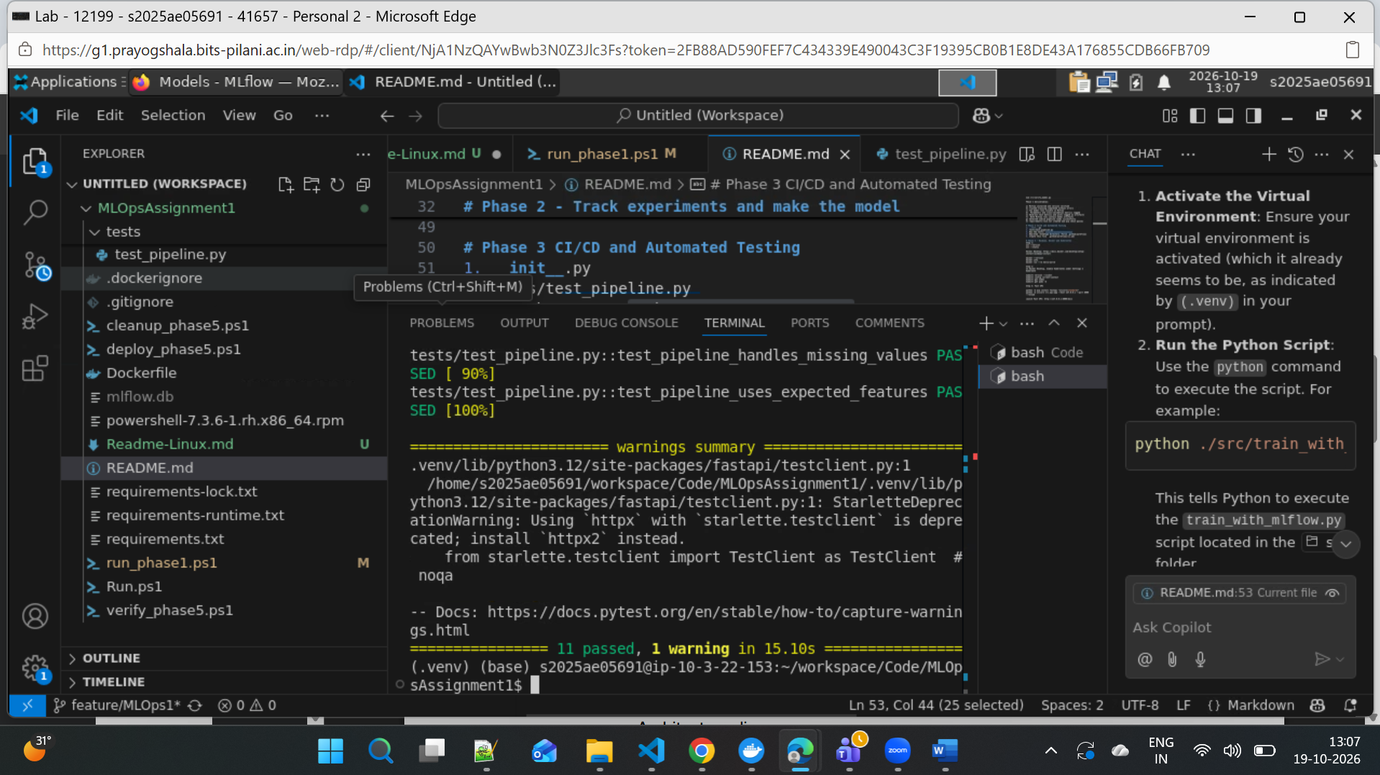
Evidences: Linting, unit test, and model training steps for each workflow run
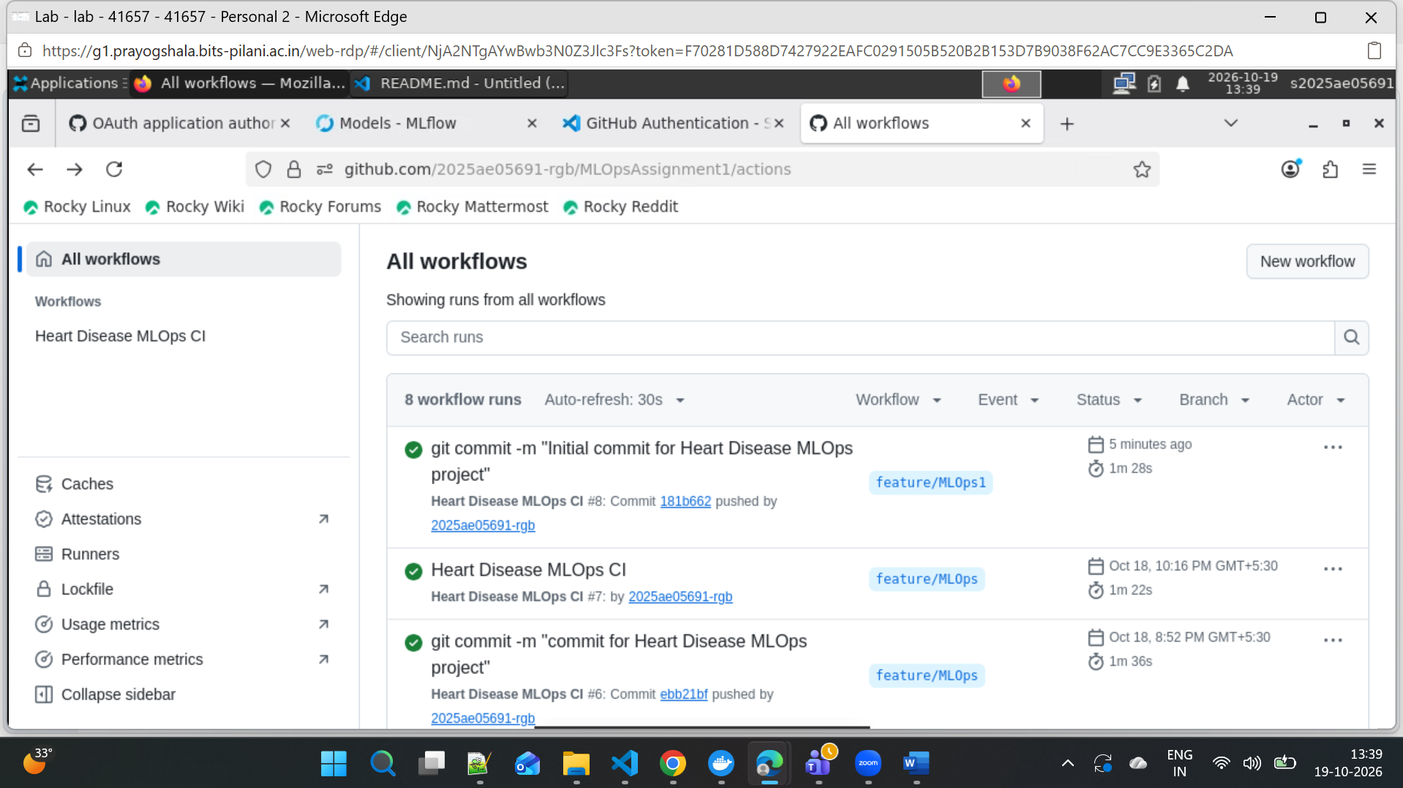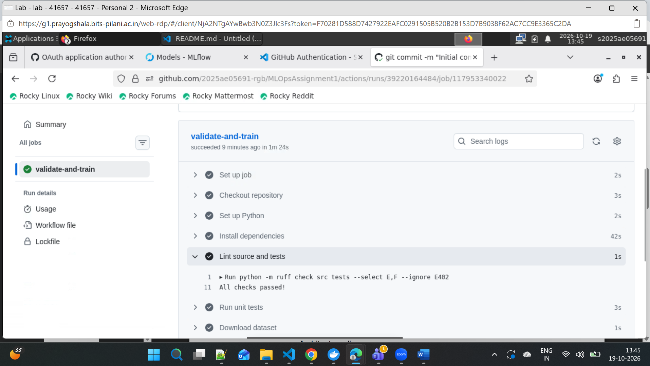

7. Model Packaging and API
- Model artifact: models/heart_disease_model.joblib stores the trained preprocessing-and-classifier pipeline. The API loads it at startup using joblib.
- API: src/api.py implements a FastAPI service.
- Endpoints: GET /health checks API/model status; POST /predict predicts for one patient; POST /predict/batch predicts for a non-empty list; GET /metrics exposes Prometheus metrics. The API also provides GET /model-info and GET /metrics/summary.
- Prediction flow: Pydantic validates patient fields and limits; inputs are arranged in the model’s expected feature order, then passed to the loaded pipeline. Responses contain predicted class and, when supported, class probabilities.
- Errors: Invalid field values are rejected by FastAPI validation. Prediction ValueError or TypeError exceptions return HTTP 400.
A valid request to POST /predict returned HTTP 200:
{
"age": 55,
"sex": 1,
"cp": 2,
"trestbps": 130,
"chol": 220,
"fbs": 0,
"restecg": 1,
"thalach": 150,
"exang": 0,
"oldpeak": 1.0,
"slope": 2,
"ca": 0,
"thal": 3
}
Response from the trained model:
{
"prediction": 0,
"probabilities": {
"0": 0.7654,
"1": 0.2346
}
}
Here, 0 means the model predicted no heart disease. Probabilities are model estimates, not a medical diagnosis.
8. Docker Containerization
Docker image: heart-disease-api:2.0
- Base image: python:3.10-slim.
- Dependencies: Installed from requirements-runtime.txt (FastAPI, Uvicorn, joblib, pandas, scikit-learn, and Prometheus client).
- Model: models/ and src/ are copied into the image.
- Startup: Runs python -m uvicorn src.api:app --host 0.0.0.0 --port 8000.
- Container port: 8000.
Include Docker build and image verification evidence.
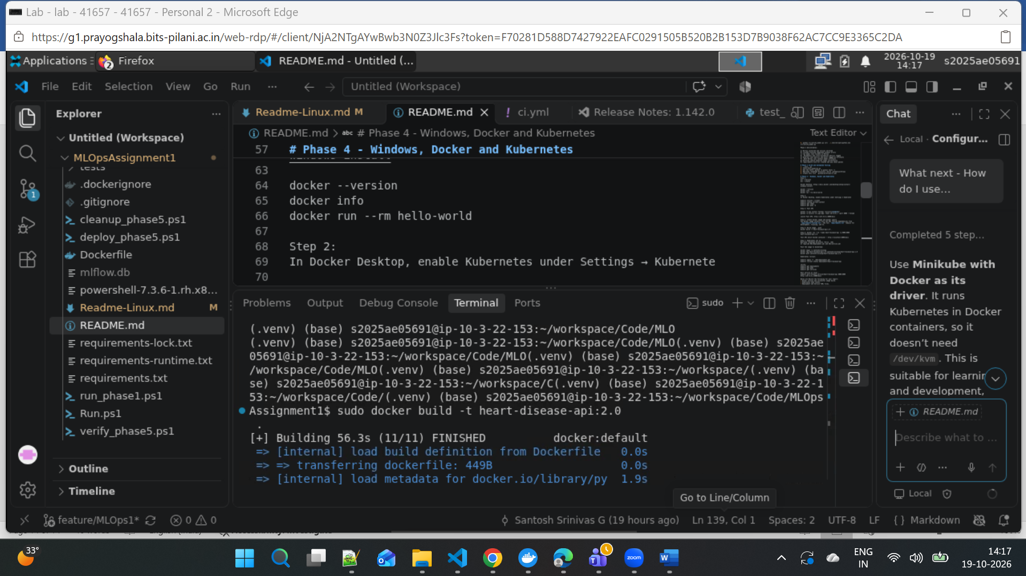
Host image in Docker Engine:
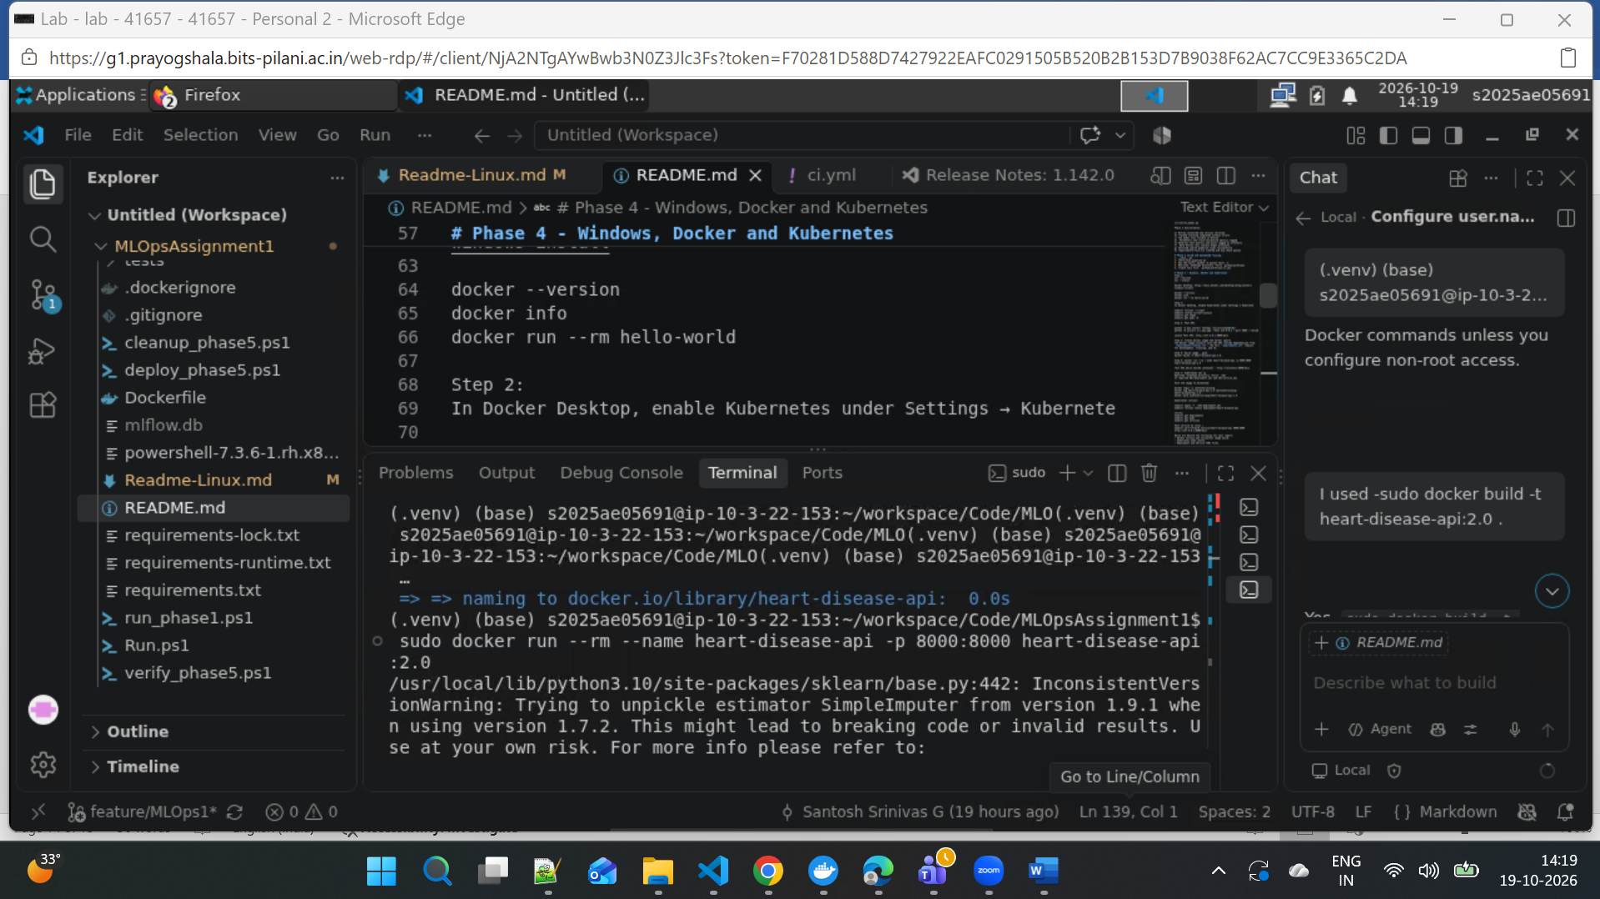

Run docker container image through local host:
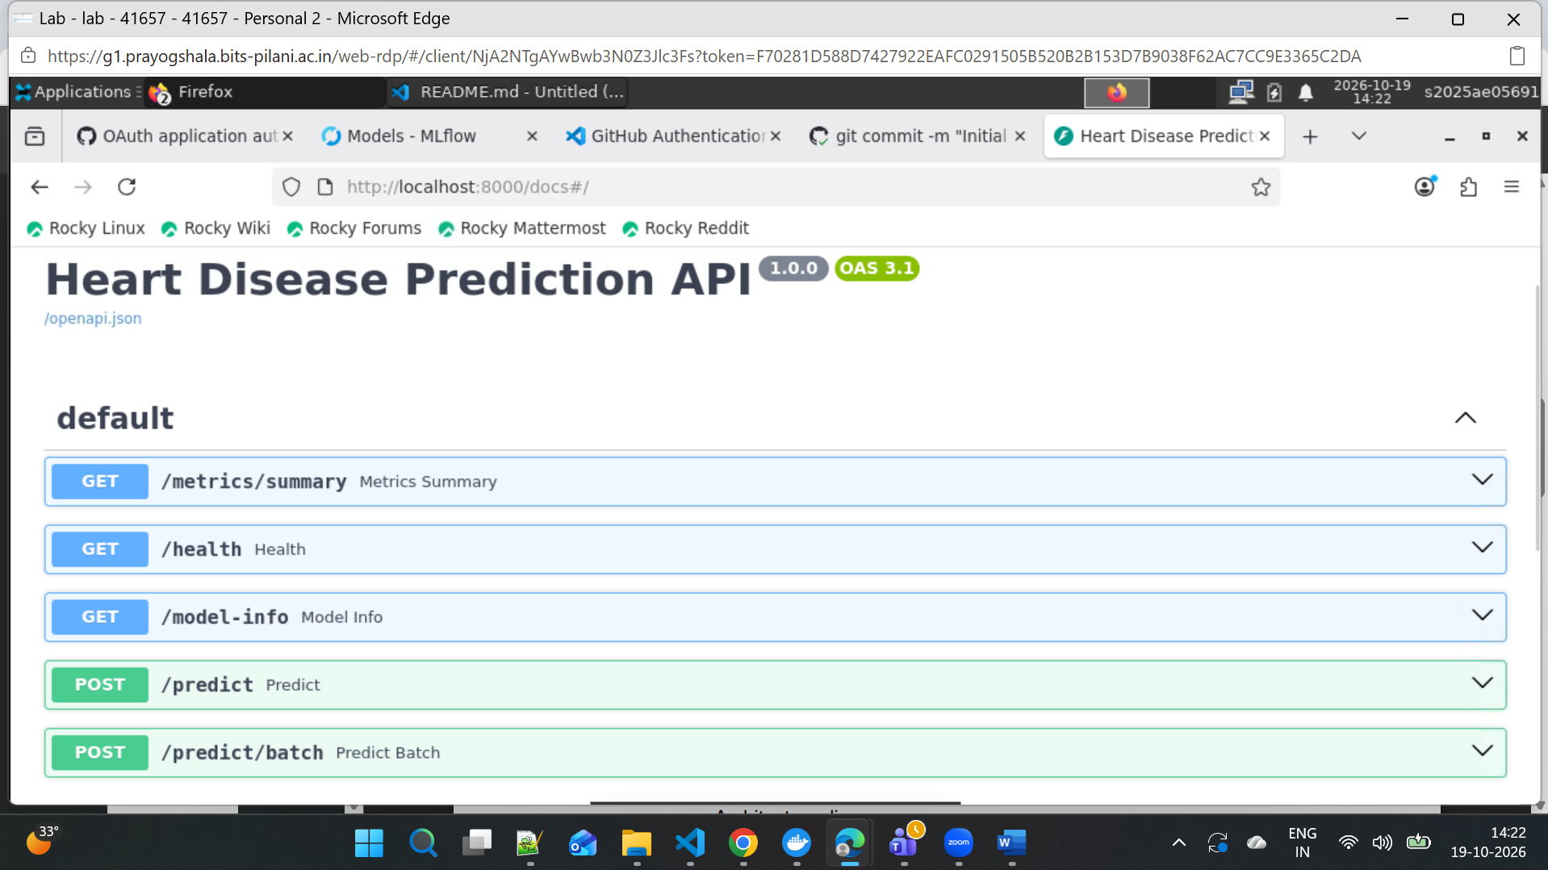

9. Kubernetes Deployment
Platform: MiniKube,Kubectl
Deployment manifest: k8s/deployment.yaml
Service manifest: k8s/service.yaml
Document:
- Replicas: 1 API Pod.
- Image: santoshsrinivasg/heart-disease-api:2.0, pulled if not already on the node.
- Health probes: Readiness and liveness checks call GET /health on port 8000.
- Resources: Requests: 100m CPU and 128Mi memory. Limits: 500m CPU and 512Mi memory.
- Service: ClusterIP on port 8001, routing to container port 8000. It’s accessible only inside the cluster.
- Local access: Forward a local port to the Service, then access the API:
kubectl port-forward service/heart-disease-api 8001:8000
Access URL: http://127.0.0.1:8001/docs

Mini Kube installation and push image to minikube:
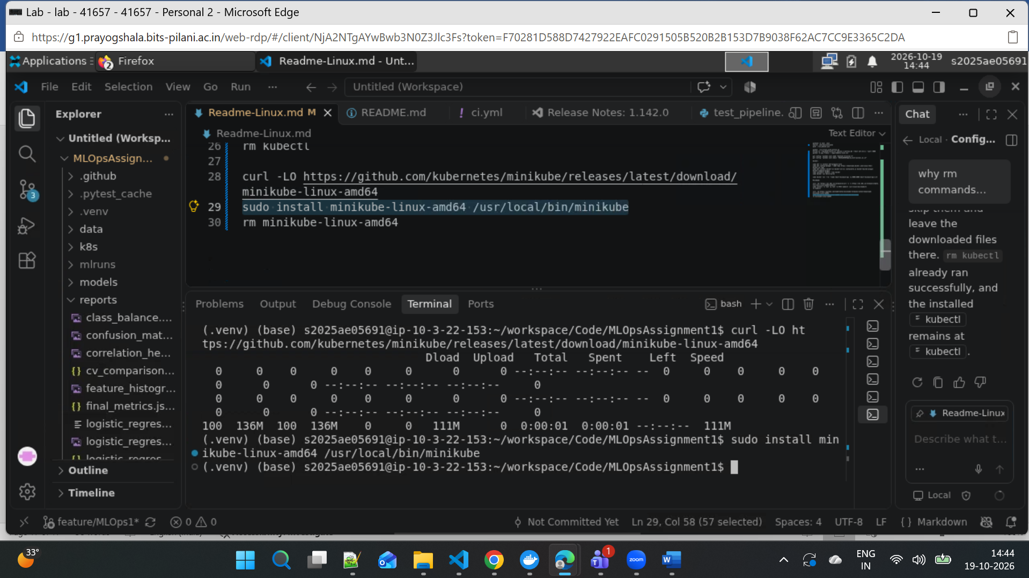

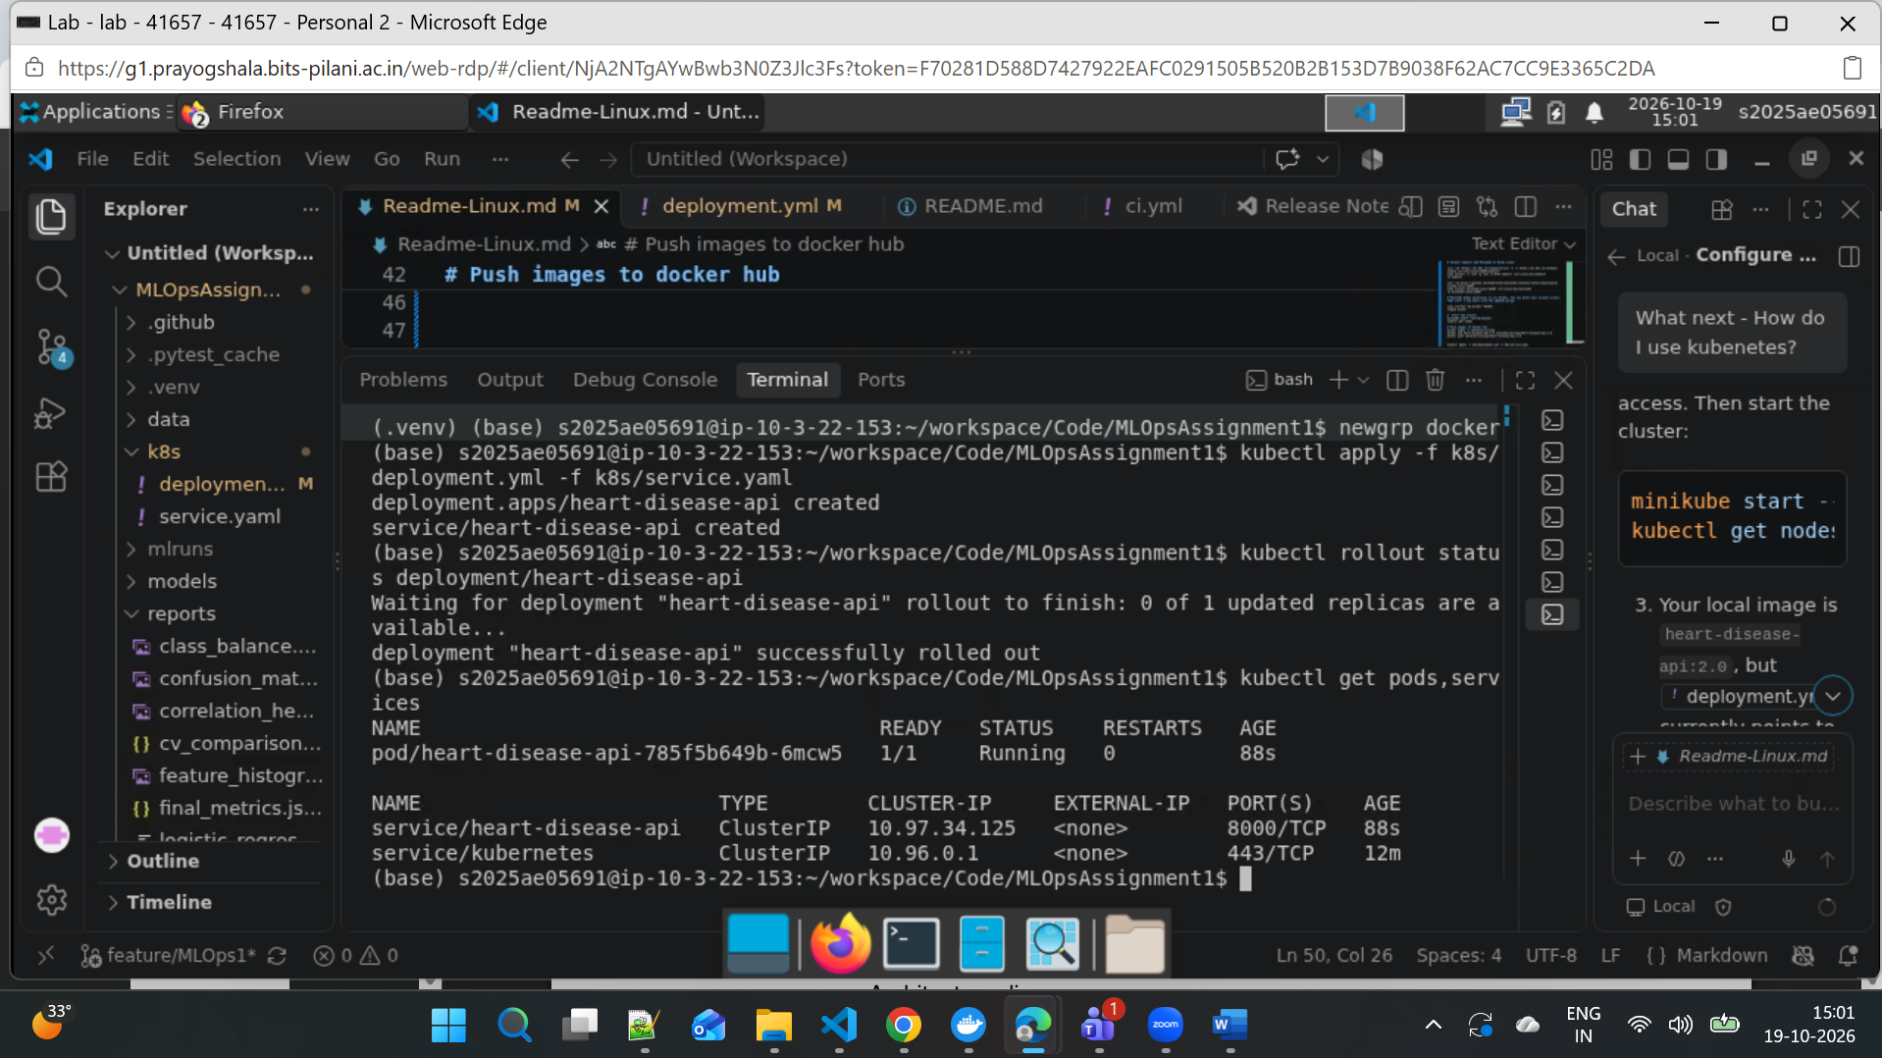

After deployed to Kubernetes, access through port 8001
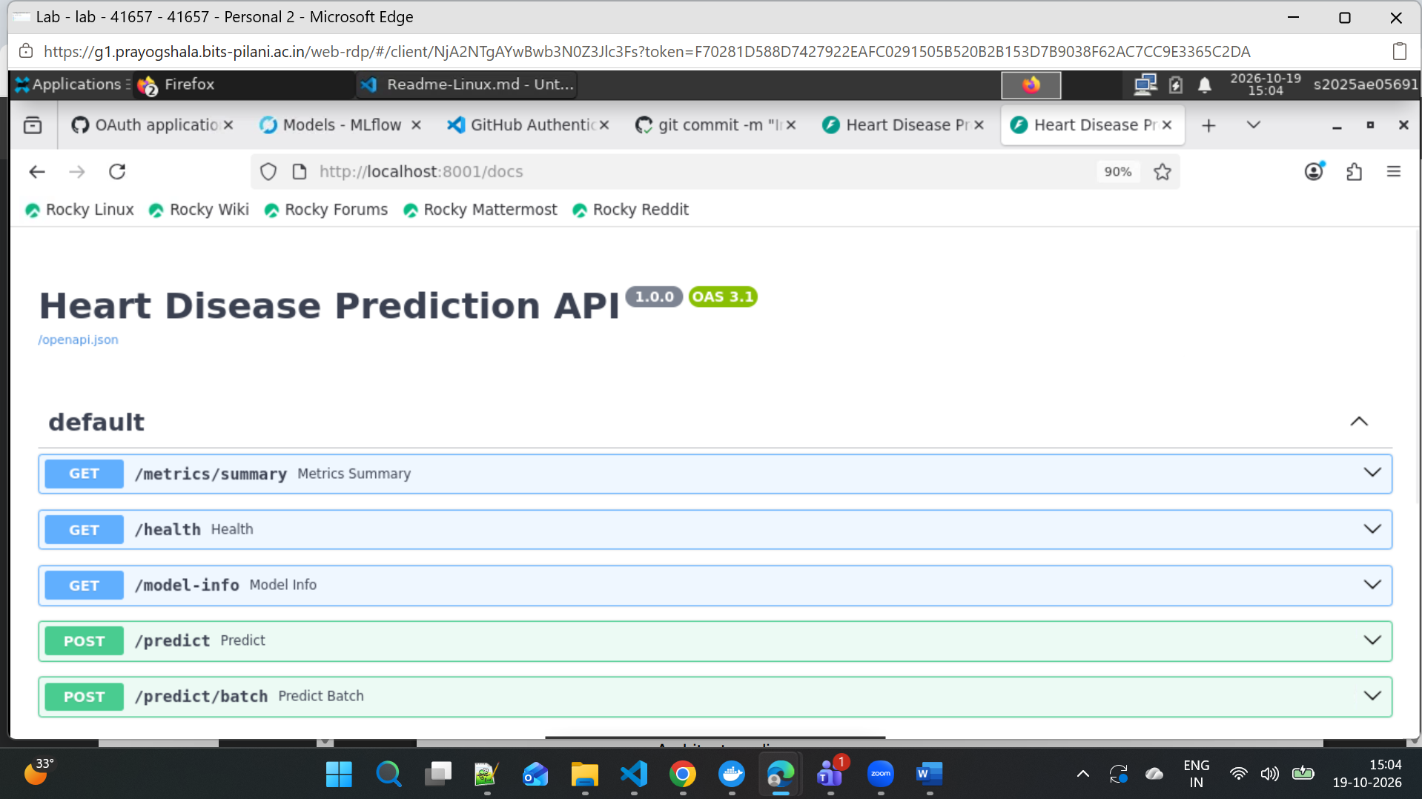

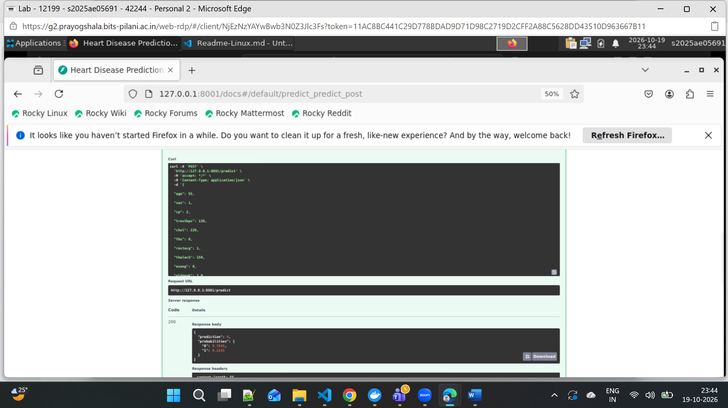
10. Monitoring and Logging
- Application logs: Records each HTTP request’s method, path, status code, and duration. Patient payloads are not logged.
- Metrics: Tracks request counts, latency histograms, and HTTP errors (status codes 400+).
- Health: GET /health reports API and model status; Kubernetes readiness and liveness probes use it.
- Prometheus: Metrics are exposed at GET /metrics in Prometheus format. GET /metrics/summary provides a JSON summary. A separate Prometheus server/scraper is not configured.
API metrics/logs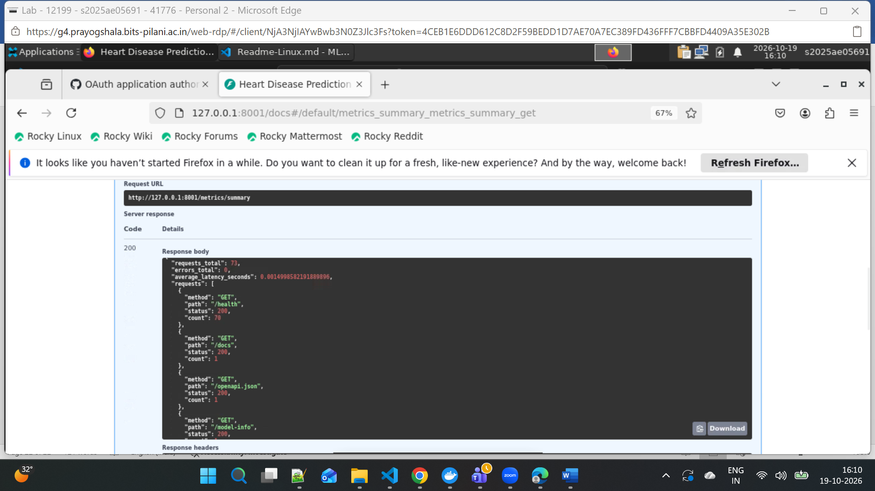

- Application Kubernetes logs:
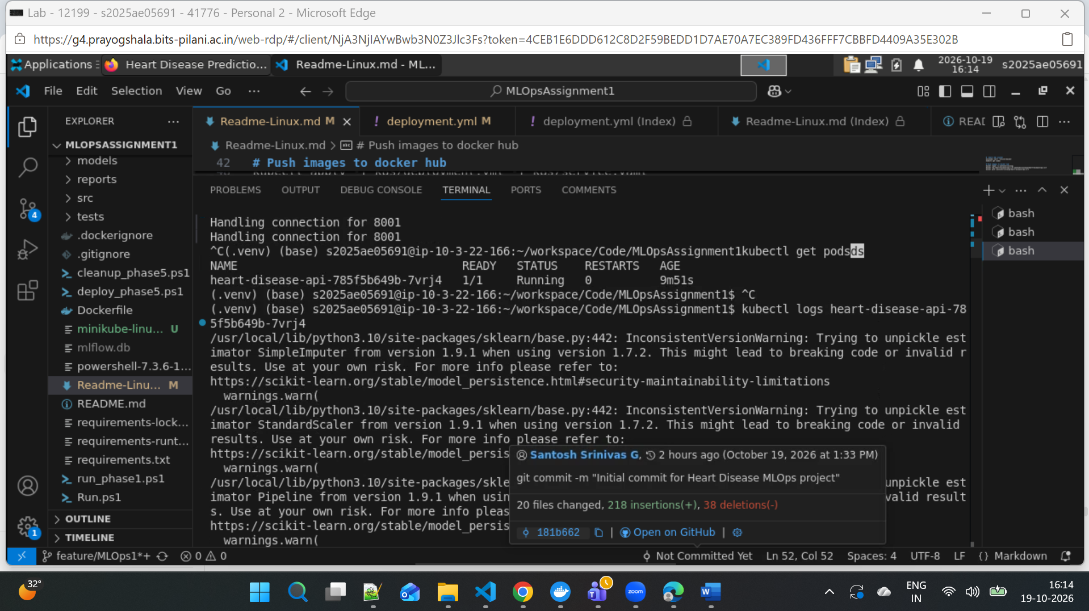

14. Conclusion
This project implements an end-to-end MLOps workflow: data preparation, model training and comparison, MLflow experiment tracking, automated tests and linting, Docker packaging, Kubernetes deployment, and API monitoring. Together, these practices improve reproducibility, catch issues earlier, simplify deployment, and make API health and performance observable.

