Text to Video Retrieval
Concise Architecture, Evaluation, Research Summary and Modality screenshots

1. Objective
Build a natural-language video retrieval system that accepts a text query and ranks the most relevant videos from a 100-video MSR-VTT subset. The system uses pretrained CLIP embeddings to connect text and visual content and compares two video representations: mean pooling and a temporal GRU.

2. Dataset and Experimental Setup
Item | Configuration
Categories | 20
Videos per category | 5
Total videos | 100
Caption records per video | 2
Total captions | 200
Frames per video | 8, uniformly sampled
CLIP model | ViT-B/32; laion2b_s34b_b79b
Embedding dimension | 512
GRU hidden dimension | 512
GRU learning rate / epochs | 0.0002 / 100
Weight decay / temperature | 0.0001 / 0.07
Batch size / seed | 16 / 42

3. System Architecture
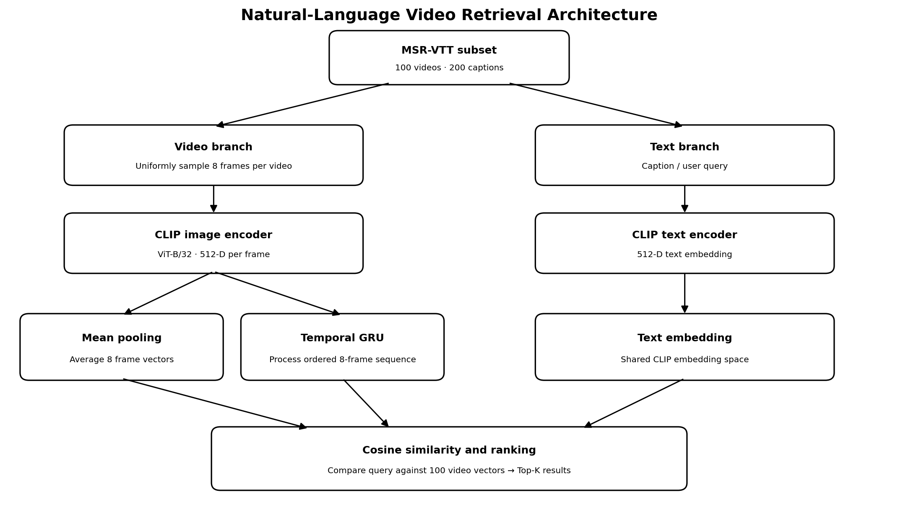
Figure 1. End-to-end architecture for text-to-video retrieval.
The video branch samples eight frames from each clip and extracts 512-dimensional frame embeddings using CLIP ViT-B/32. The mean-pooling branch averages the frame vectors; the temporal branch feeds their ordered sequence into a GRU. The text branch encodes a caption or query with the CLIP text encoder. Normalized text and video vectors are compared using cosine similarity, and videos are ranked to return the Top-K results.

4. Representation Methods

4.1 Mean pooling baseline
For frame embeddings F₁,…,F₈, mean pooling computes the element-wise average and L2-normalizes the result: v_mean = Normalize((1/8) Σᵢ₌₁⁸ Fᵢ). This produces one 512-dimensional vector per video. It is simple and computationally inexpensive, but does not explicitly preserve frame order.

4.2 Temporal GRU and contrastive alignment
The GRU receives the ordered frame tensor with shape N × 8 × 512, processes the sequence, and projects its final hidden representation to a normalized 512-dimensional video vector. It is trained to align video representations with paired CLIP text embeddings using symmetric contrastive loss: L = ½(L_video→text + L_text→video). Similarity logits are temperature-scaled using τ = 0.07.

5. Retrieval and Evaluation
A text query is encoded with the CLIP text encoder. Its normalized embedding is compared with each stored video embedding. Because both vectors are L2-normalized, their dot product equals cosine similarity. For 200 caption queries and 100 candidate videos, the evaluation similarity matrix is 200 × 100.

Metric | Mean pooling | Temporal GRU
Recall@1 | 0.60 | 0.10
Precision@1 | 0.60 | 0.10
Recall@5 | 0.95 | 0.75
Precision@5 | 0.190 | 0.150
Recall@10 | 1.00 | 0.85
Precision@10 | 0.100 | 0.085
MRR | 0.7671 | 0.3668
Mean rank | 1.80 | 5.55
Median rank | 1.0 | 3.0
Interpretation: higher Recall, Precision and MRR are better; lower mean and median rank are better. Mean pooling outperforms Temporal GRU on all nine reported retrieval metrics in the latest evaluation.

6. Experimental Evaluation and Research Conclusions
The experiments provide an empirical comparison of mean-pooled frame representations and a temporal GRU representation for text-to-video retrieval. The results address whether simple aggregation of pretrained CLIP frame features is sufficient for the current dataset and experimental configuration.

6.1 Do Mean-Pooled Frame Representations Suffice Compared with Temporal Modelling?
In the latest evaluation, Mean Pooling outperforms Temporal GRU across all nine reported retrieval metrics. Mean Pooling achieves Recall@1 of 0.60, Recall@5 of 0.95, and Recall@10 of 1.00, compared with 0.10, 0.75, and 0.85 respectively for GRU. Precision is also higher for Mean Pooling at K=1 (0.60 vs 0.10), K=5 (0.190 vs 0.150), and K=10 (0.100 vs 0.085). Mean Pooling records a higher MRR (0.7671 vs 0.3668) and lower mean rank (1.80 vs 5.55) and median rank (1.0 vs 3.0), indicating that the relevant video is generally ranked closer to the top. These results are specific to the latest experimental configuration and do not establish that temporal modelling is generally unnecessary.

6.2 Concrete Conclusions and Insights Supported by the Experimental Data
The latest measurements support four conclusions. First, Mean Pooling is the stronger method because it leads on all nine reported metrics. Its Recall@1 advantage is 0.50, its Recall@5 advantage is 0.20, and its Recall@10 advantage is 0.15. The MRR advantage (0.7671 vs 0.3668), together with lower mean rank (1.80 vs 5.55) and median rank (1.0 vs 3.0), indicates that Mean Pooling tends to place the relevant video earlier in the ranked list. These findings are specific to the dataset and experimental setup; they do not prove that temporal modelling is inherently inferior.
Overall conclusion: under the latest experimental conditions, averaging pretrained CLIP frame embeddings is more effective than the tested GRU-based temporal representation and is computationally simpler. Further experiments with larger datasets, denser frame sampling, and carefully controlled video-level evaluation would help assess when temporal modelling provides an advantage.

7. Limitations and Conclusion
The experiment is limited by the 100-video MSR-VTT subset and the use of eight uniformly sampled frames per video. Uniform sampling can miss short events, while a small training set can make robust temporal learning difficult. Runtime and hardware costs should be reported using measurements from the actual environment.
In conclusion, the project demonstrates a CLIP-based text-to-video retrieval pipeline and compares mean-pooled visual representations with GRU-based temporal representations. In the latest evaluation, Mean Pooling achieves better results across all reported retrieval metrics. Future work should test larger subsets, more informative frame sampling, and controlled video-level train/test separation to assess generalization.

streamlit application run through command:

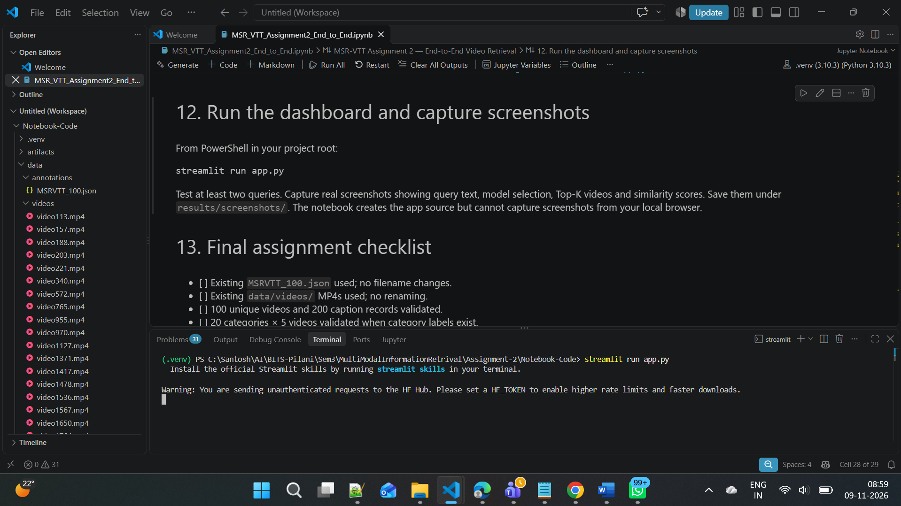

Query: crowd with club’s marches children

Modality1- Mean pooling (CLIP Baseline)

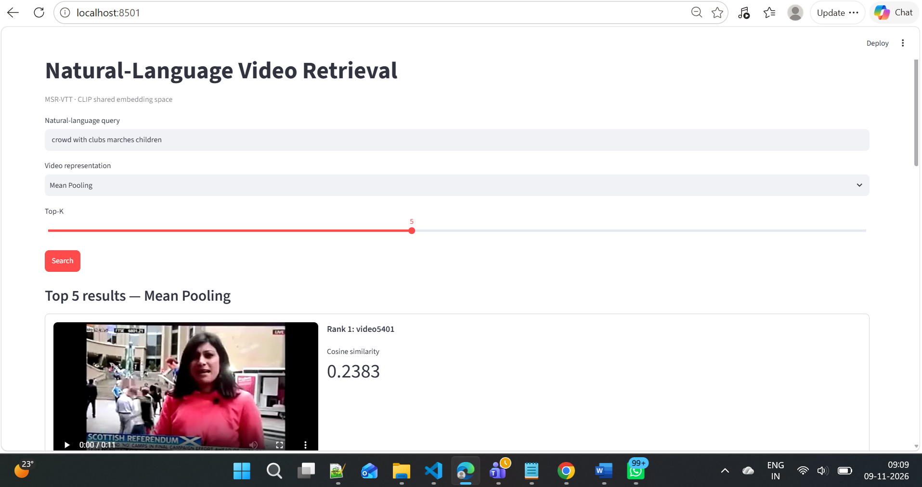

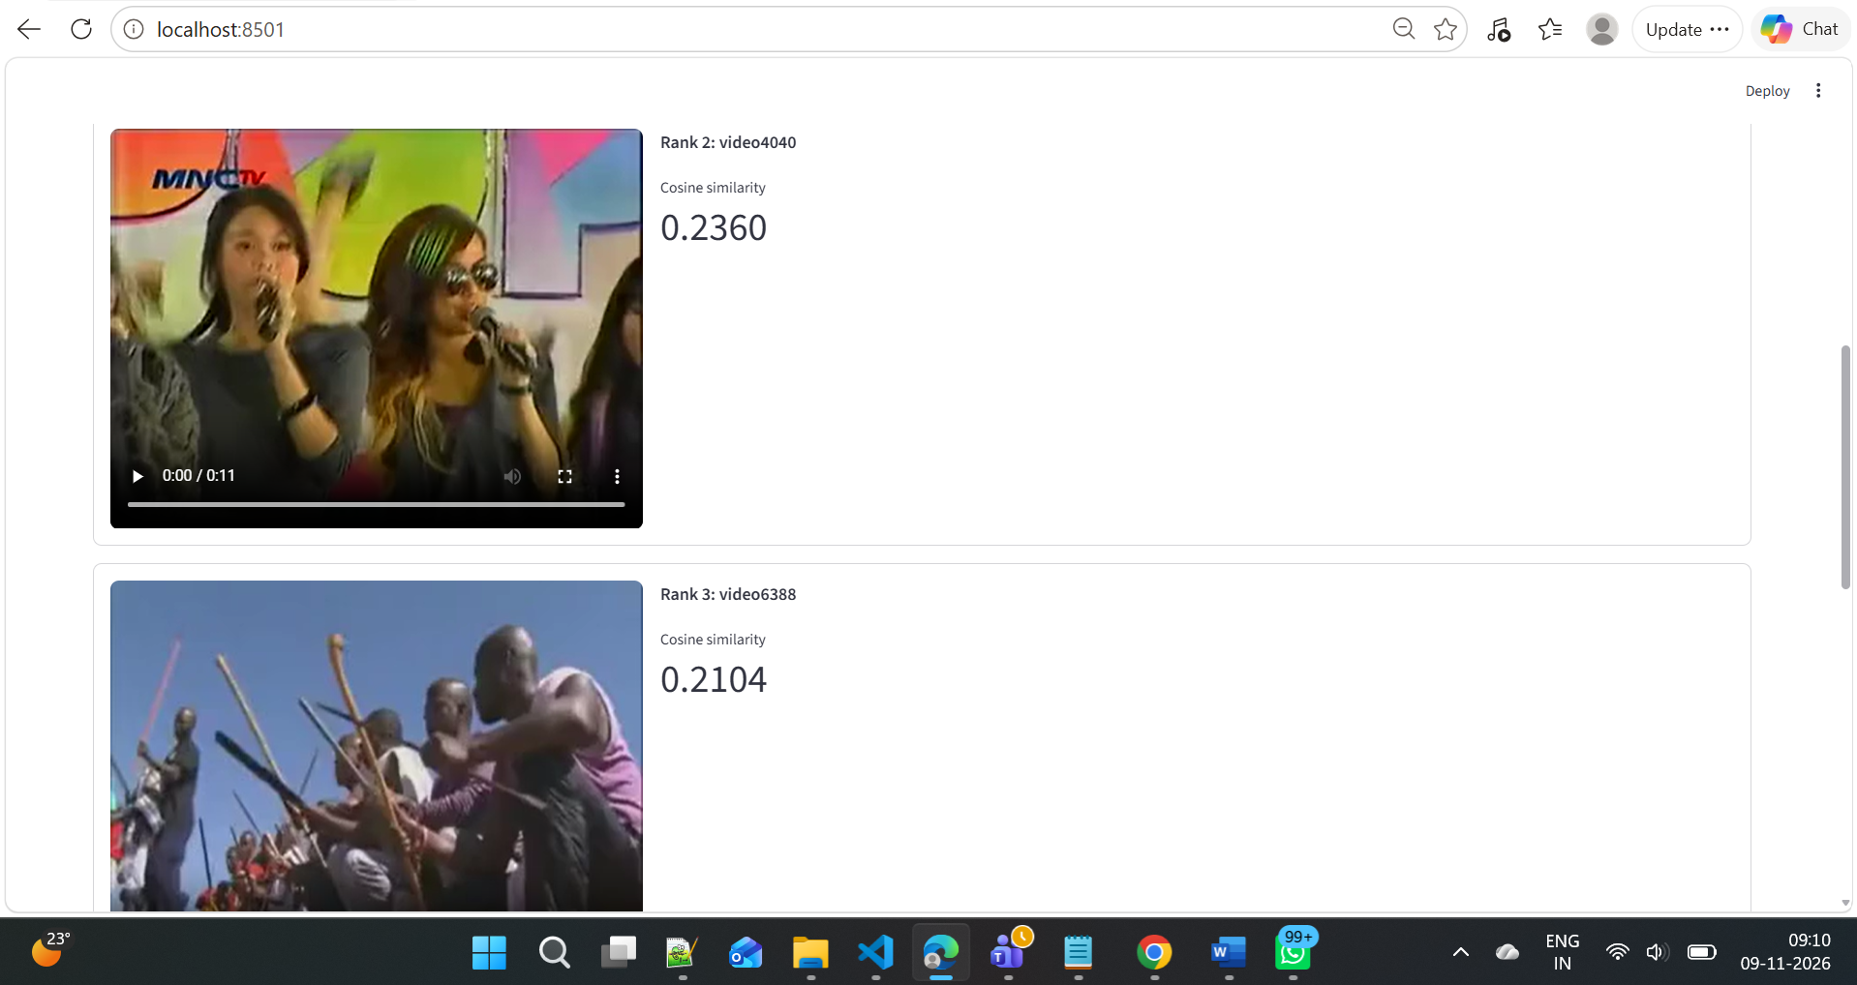

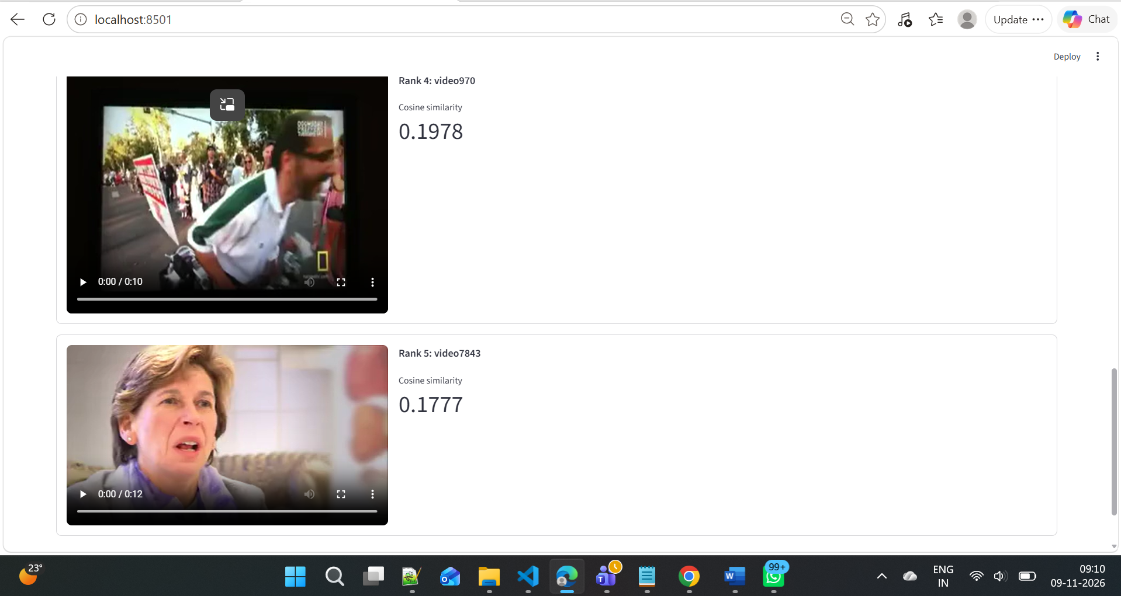

Modality2 - Temporal GRU:

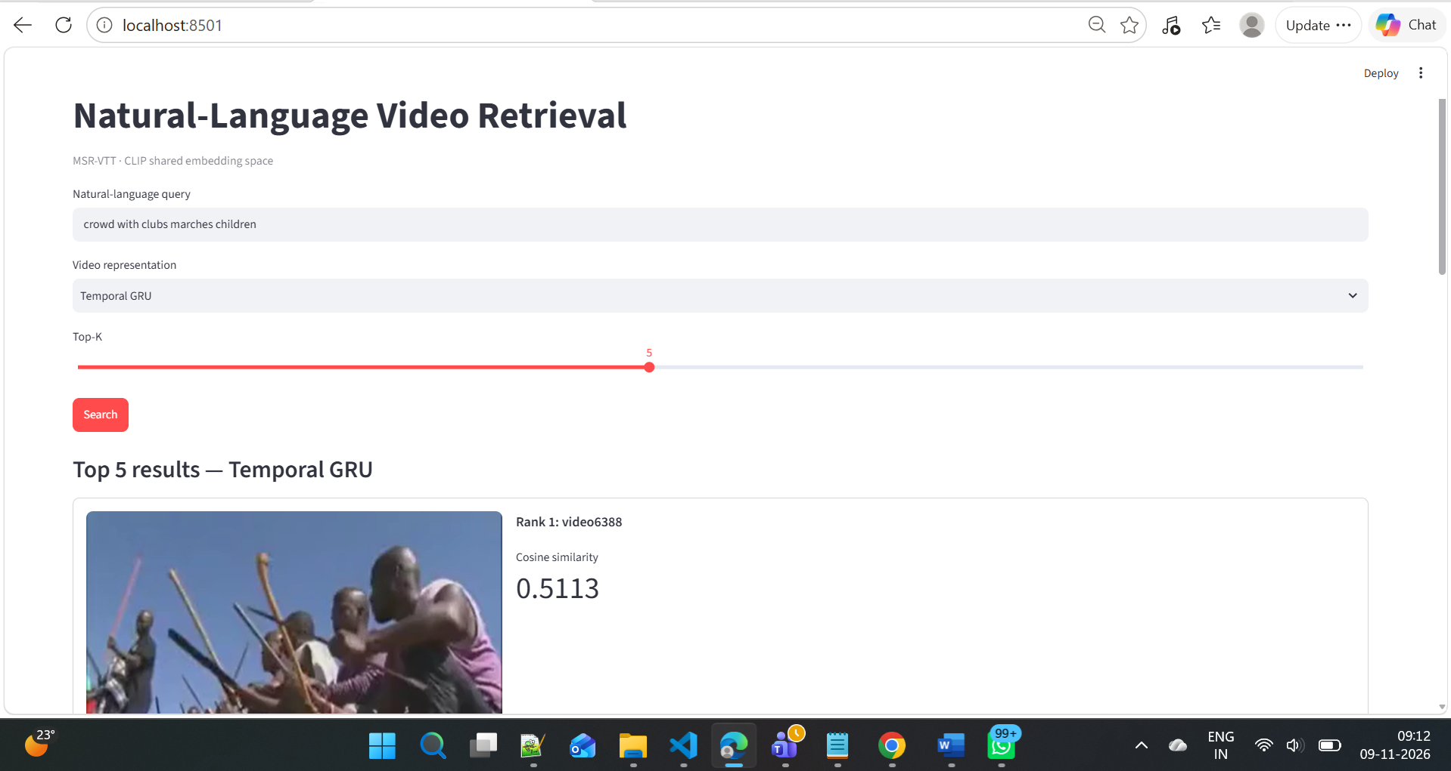

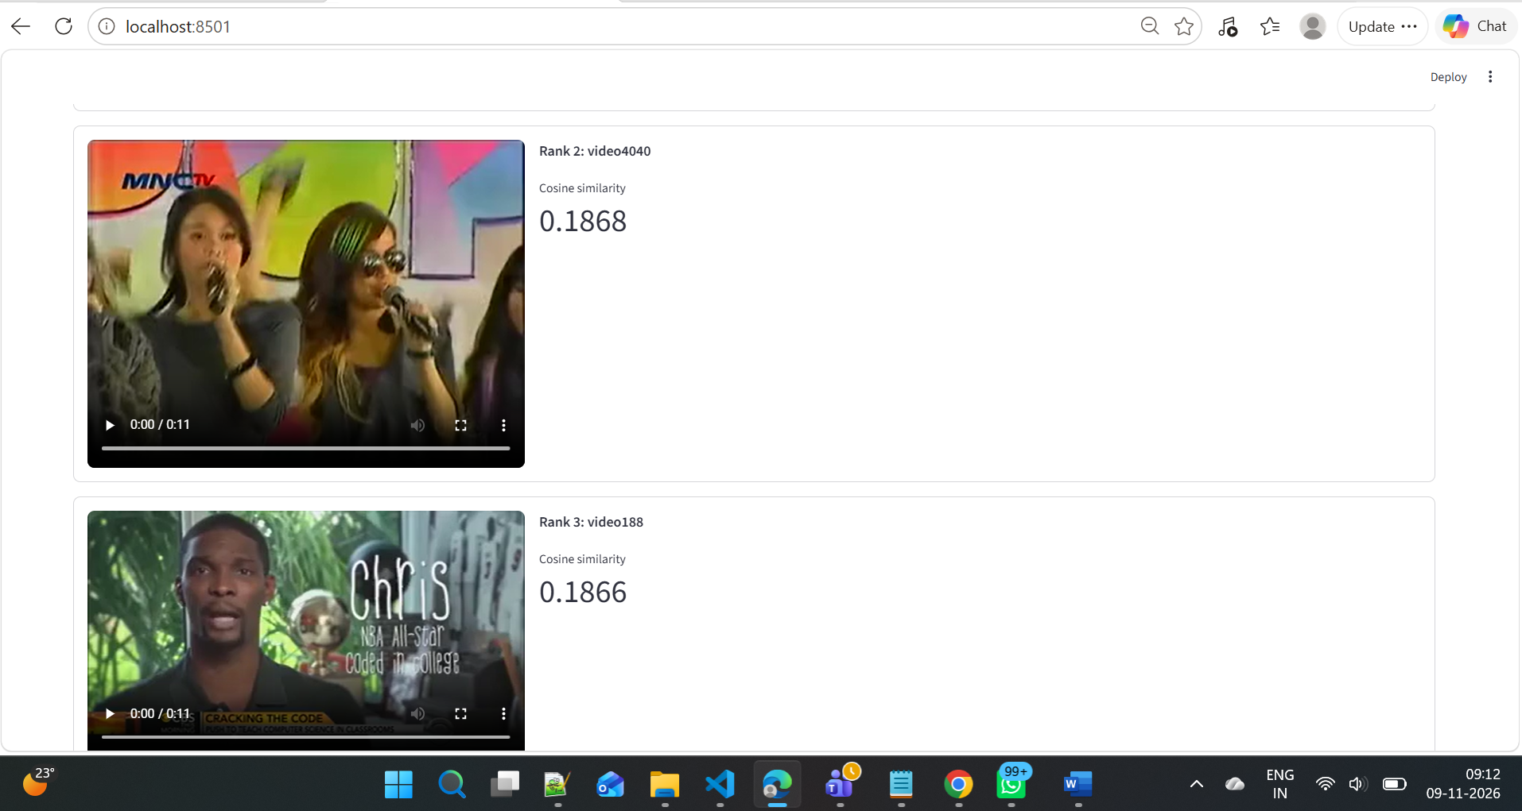

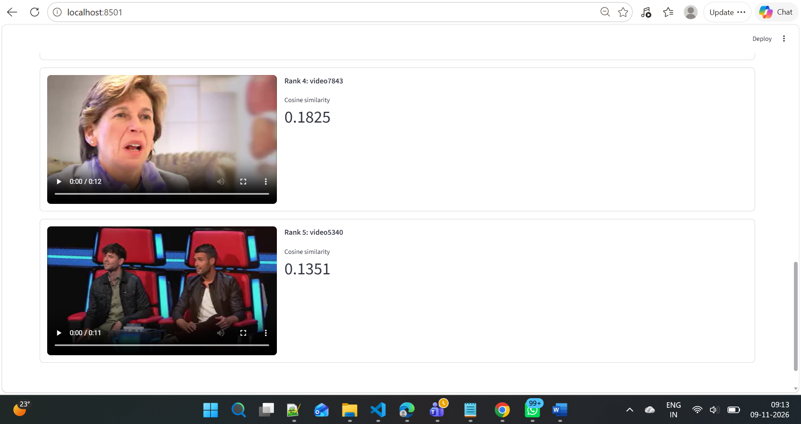

Quey 2: Gun shooter

Modality1- Mean pooling (CLIP Baseline)
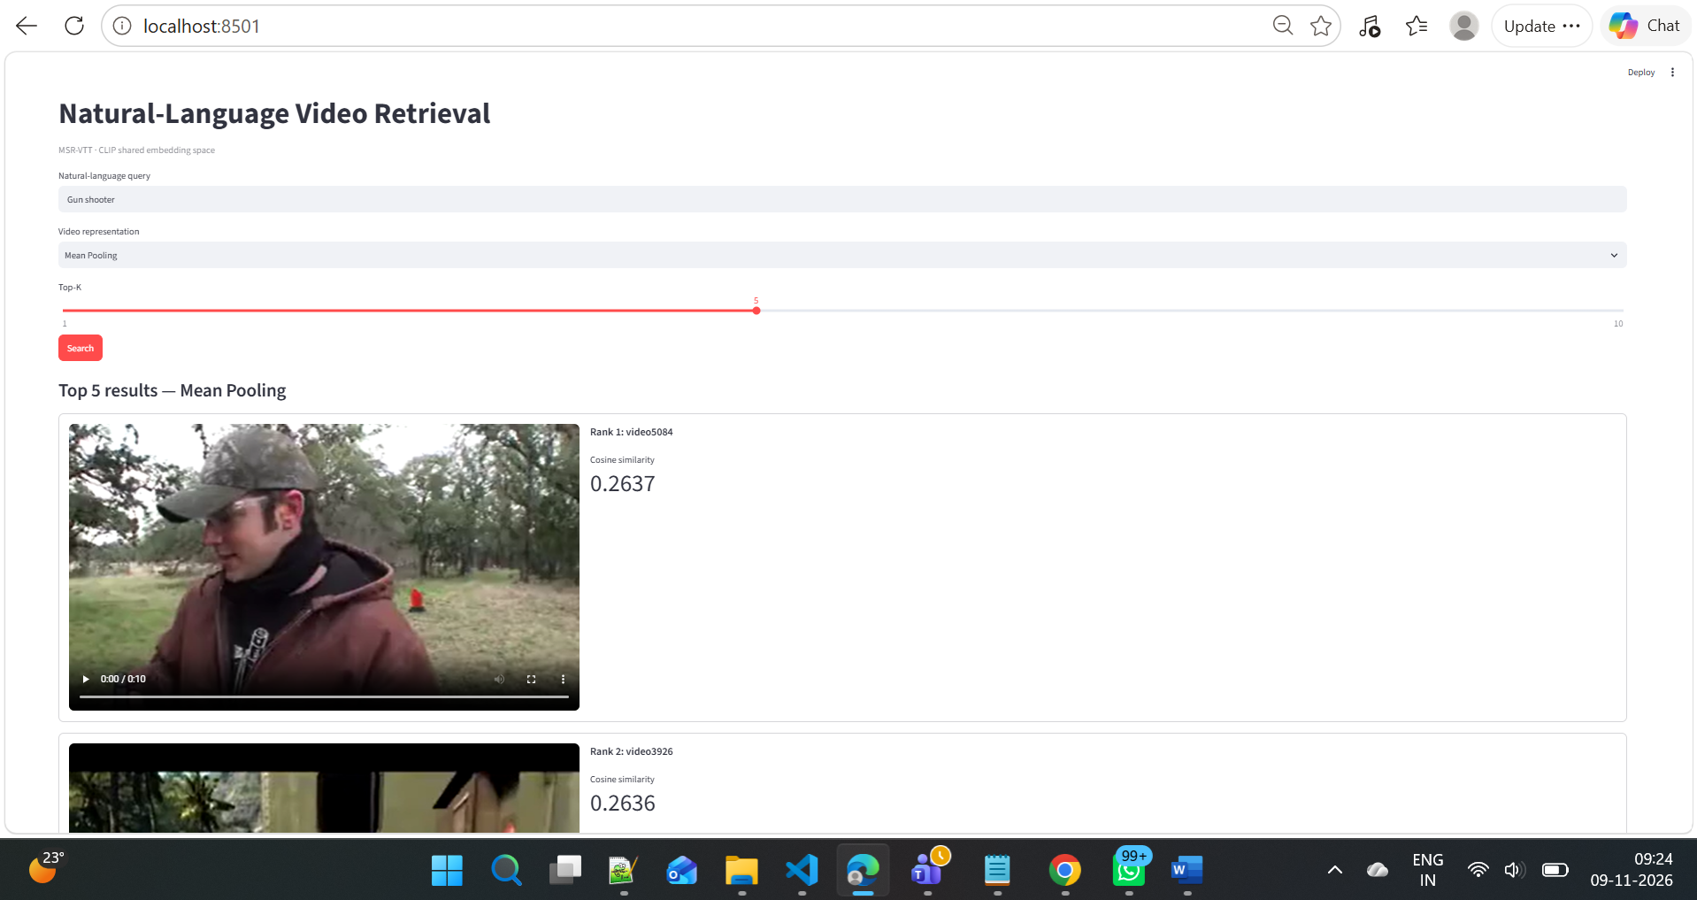
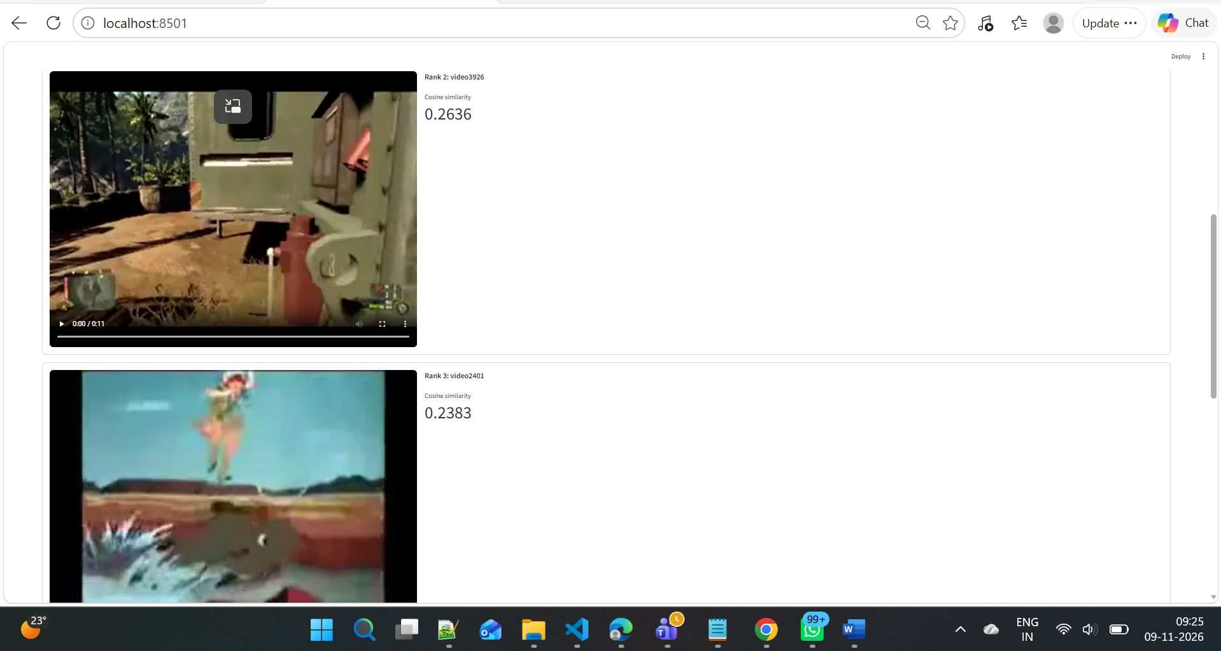

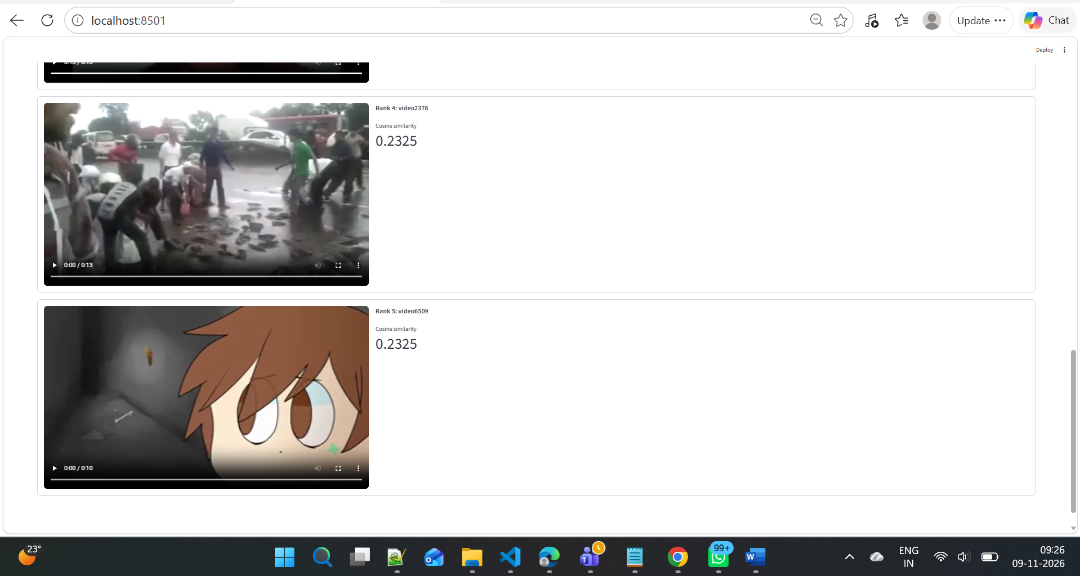

Modality2 - Temporal GRU:


