Heart Disease Risk Prediction: End-to-End MLOps Pipeline
UCI Heart Disease | MLflow | FastAPI | Docker | Kubernetes | Prometheus/Grafana
Course: Machine Learning Operations (AIMLCZG523), Assignment 1
Student: Puneet Chawla (2025AE05770)
Code repository: https://github.com/2025ae05770-cpu/heart-disease-mlops
Code repository:
Deployed API / access: local Kubernetes (Minikube)

1. Executive Summary
This project builds a heart-disease risk classifier from the UCI Heart Disease (Cleveland) dataset and runs it as a reproducible, tested, containerised and monitored REST API. The workflow has four parts:
- Experimentation: a download script, schema validation, cleaning, EDA, a single scikit-learn pipeline (domain feature, imputation, scaling and one-hot encoding), three tuned model families, and 5-fold cross-validation scored on five metrics.
- Tracking and packaging: every grid candidate is logged to MLflow, and the champion is registered with the champion alias. The model is exported as a joblib pipeline and in MLflow format, alongside pinned requirements.
- Automation: GitHub Actions runs lint, unit tests (44 tests, 87% coverage), training and a Docker build with a smoke test. The pipeline stops on the first failure.
- Operations: a FastAPI service runs in a non-root container, deployed to Kubernetes with probes, an HPA, a LoadBalancer and an Ingress. It writes JSON request logs and exposes Prometheus metrics, which feed a provisioned Grafana dashboard.
The champion is Logistic Regression (C = 0.5, balanced class weights). It scored CV ROC-AUC 0.909 ± 0.018 and hold-out ROC-AUC 0.958, with recall 0.929 on the hold-out set.

2. Architecture
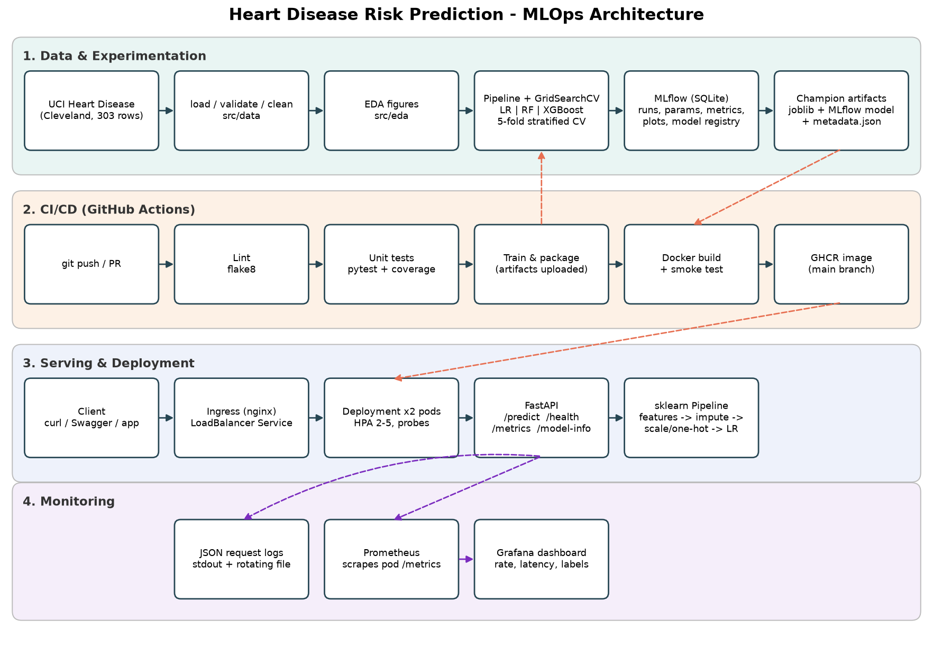
Figure 1 - System architecture: data and experimentation, CI/CD, serving and monitoring
Layer | Tools | Key files
Data & EDA | pandas, requests, seaborn | src/data/*, src/eda/run_eda.py, scripts/download_data.py
Features & models | scikit-learn, XGBoost | src/features/*, src/models/*
Tracking & registry | MLflow 3 (SQLite backend) | src/tracking/*, mlflow.db, mlruns/
Serving | FastAPI, uvicorn, pydantic | src/api/*, src/inference/predict.py
Packaging | joblib, MLflow model, Docker | models/, Dockerfile, requirements*.txt
CI/CD | GitHub Actions, GHCR | .github/workflows/ci.yml
Deployment | Kubernetes, Kustomize | k8s/*.yaml, scripts/deploy_k8s.*
Monitoring | prometheus_client, Prometheus, Grafana | src/monitoring/*, monitoring/, k8s/monitoring/
Orchestration | Airflow (optional) | dags/heart_disease_pipeline.py

The design follows the Webinar 1 pattern. The notebooks only orchestrate, and all logic lives in importable src/ modules. As a result, the notebooks, the training command-line tool, the Airflow DAG, the CI pipeline and the API all run the same code.

3. Setup and Installation
- Clone the repository and create an environment: python -m venv .venv, then activate it.
- Install the pinned dependencies with pip install -r requirements.txt (Python 3.13; 3.12 also works).
- Reproduce everything with ./scripts/run_pipeline.ps1 on Windows or ./scripts/run_pipeline.sh on Linux/WSL. The script runs lint, tests, download, EDA, training and batch inference.
- Open the MLflow UI with mlflow ui --backend-store-uri sqlite:///mlflow.db --port 5000.
- Start the API with uvicorn src.api.main:app --port 8000, or with docker compose up --build to include Prometheus and Grafana.
requirements.txt pins every direct dependency. requirements-serve.txt pins the minimal runtime with identical versions, so the pickled pipeline loads the same way inside the container. I confirmed this by installing only requirements-serve.txt into a fresh virtual environment and passing all 7 smoke-test checks against it.

4. Data Acquisition and EDA
Source: processed.cleveland.data from the UCI Machine Learning Repository: 303 patients, 13 features and a diagnosis num from 0 to 4. scripts/download_data.py (equivalently, python -m src.data.load_data) downloads the file only if it is missing, then cleans and validates it.
Cleaning decisions (src/data/clean_data.py):
- The file is headerless, so column names are supplied; ? placeholders are converted to NaN and all columns are coerced to numeric.
- The diagnosis num (0 to 4) is collapsed into a binary target: 0 = absent, 1 = present (any of num 1 to 4).
- Duplicates are dropped (none found). Clinical range checks report out-of-range values (none found) and write them to data_quality_report.json.
- Six missing values remain (ca 4, thal 2). They are kept in the cleaned CSV on purpose and imputed inside the model pipeline. This keeps imputation statistics fold-local during CV, which avoids leakage, and makes serving apply exactly the same step.
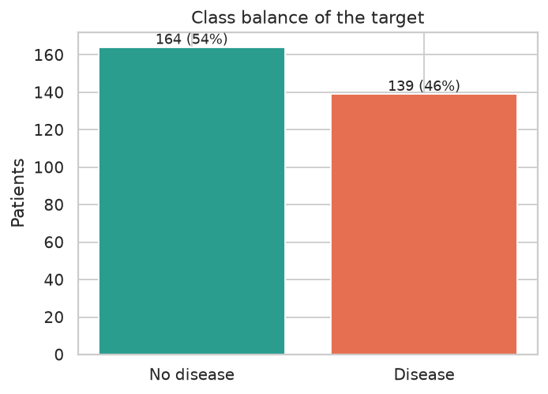  Figure 2 - Class balance: 164 without disease (54%) vs 139 with disease (46%) | 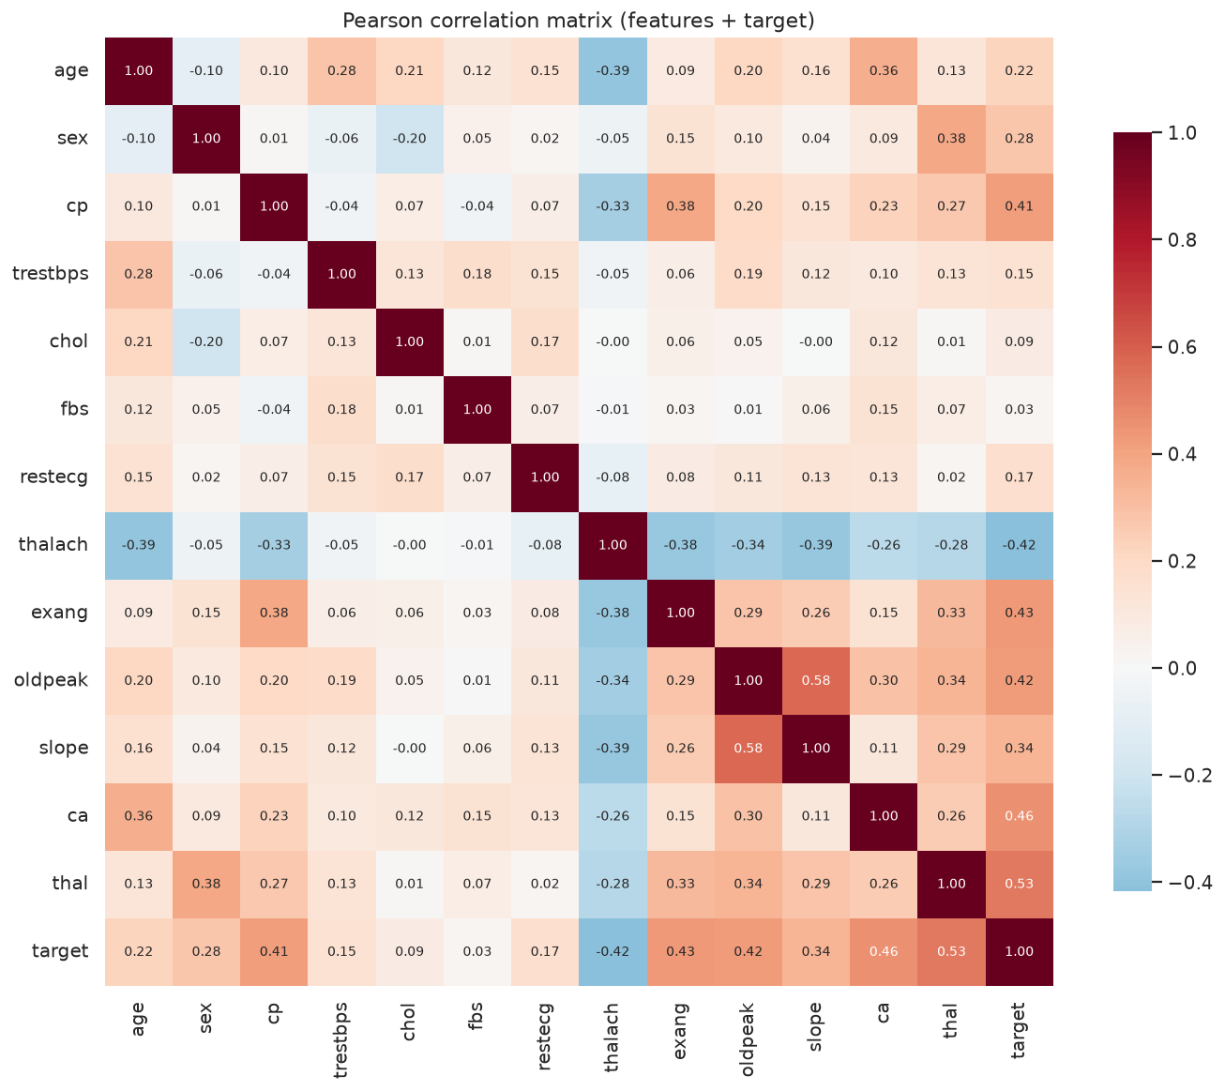  Figure 3 - Correlation heatmap of features and target

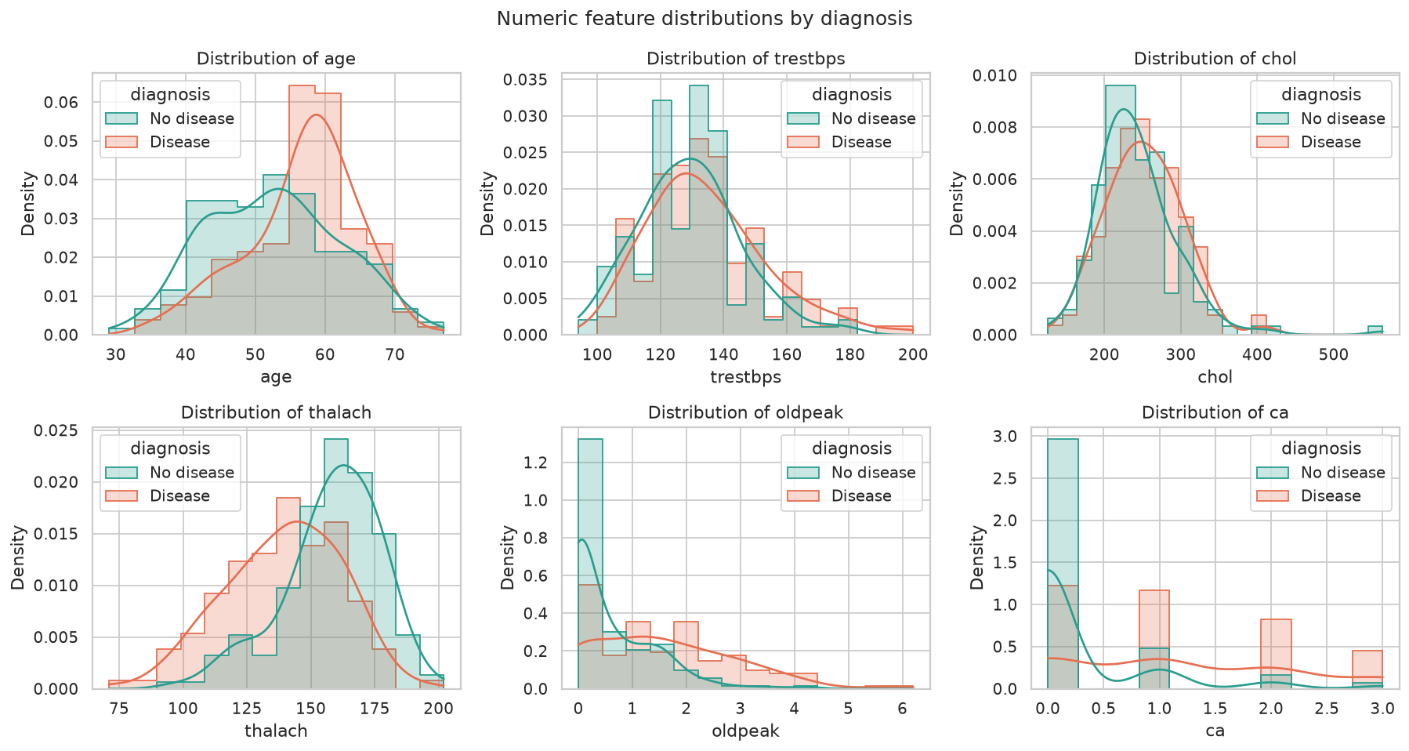
Figure 4 - Numeric feature distributions by diagnosis
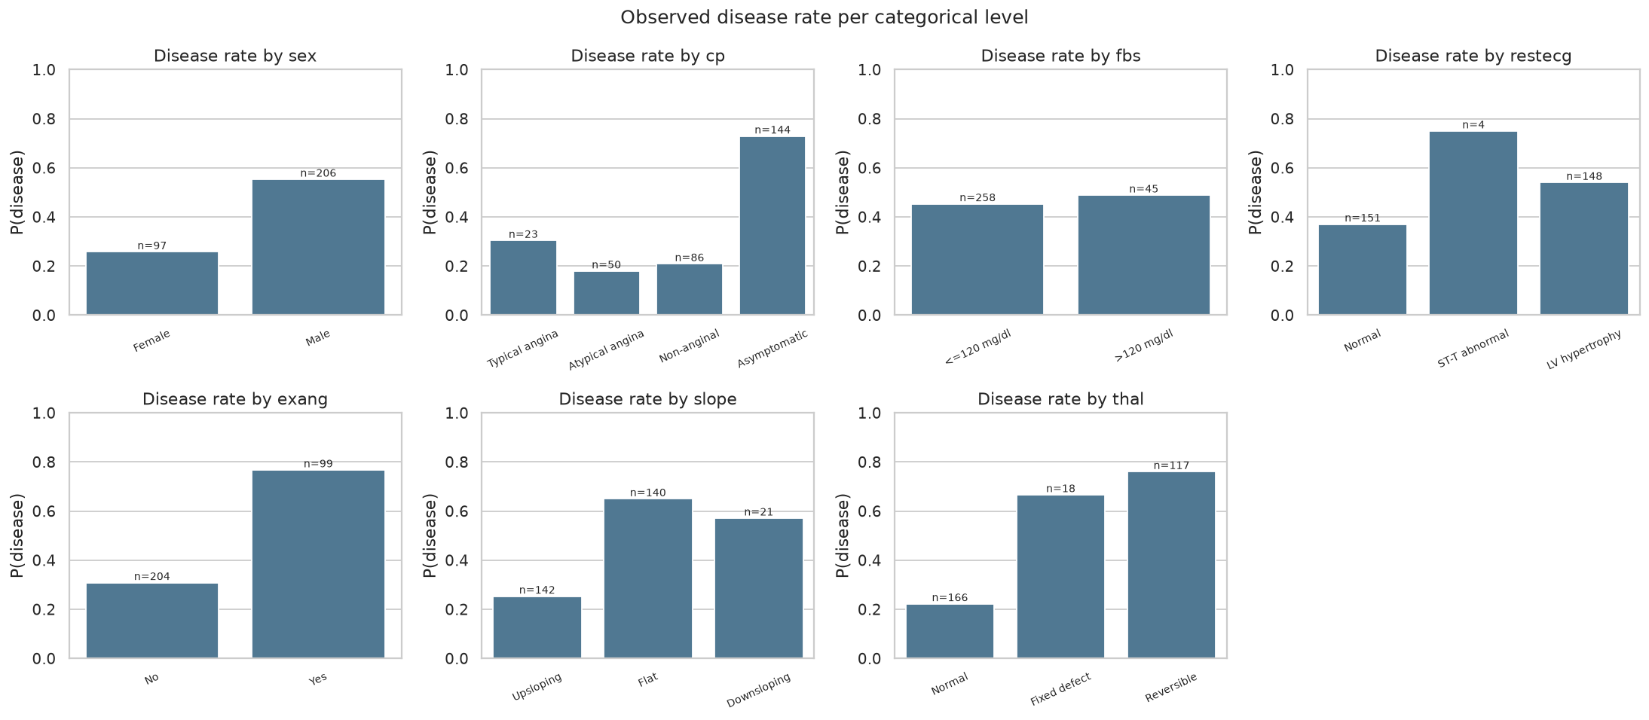
Figure 5 - Observed disease rate per categorical level (n shown on bars)
Key findings and their impact on modelling:
Finding | Modelling decision
Mild imbalance (54/46) | Stratified split and CV; tune class_weight; report recall and ROC-AUC, not only accuracy
Strongest target correlations: thal 0.53, ca 0.46, exang 0.43, oldpeak 0.43, thalach -0.42, cp 0.41 | All features kept; the regularisation strength C is tuned
cp, restecg, slope, thal are nominal codes (for example, asymptomatic chest pain has a 73% disease rate) | One-hot encode instead of treating codes as numbers
thalach falls with age | Engineered hr_pct_of_max = thalach / (220 - age)
Scales differ by about 100x and chol has outliers (up to 564) | Standardise numeric features, which matters for the linear model
chol and fbs correlate weakly with the target | Kept, with the effect left to regularisation and the trees to judge

5. Feature Engineering and Model Development
Preprocessing pipeline (src/features/prepare_data.py). One sklearn Pipeline holds every transformation, so the same object runs in CV, on the test set and inside the API:
- ClinicalFeatureEngineer, a custom transformer, adds hr_pct_of_max, the share of the age-predicted maximum heart rate reached during exercise. A low value (chronotropic incompetence) is a known cardiac risk marker.
- Numeric columns (age, trestbps, chol, thalach, oldpeak, ca, hr_pct_of_max) get a median imputer, then a StandardScaler.
- Categorical columns (sex, cp, fbs, restecg, exang, slope, thal) get a most-frequent imputer, then a OneHotEncoder with drop="if_binary" and handle_unknown="ignore".
The output is 23 model features.
Models and tuning (src/models/model_pipelines.py, src/models/train_models.py). The data is split 80/20 with stratification (242 training rows, 61 test rows). Each family is tuned with GridSearchCV using StratifiedKFold(5, shuffle=True, random_state=42). Every candidate is scored on accuracy, precision, recall, F1 and ROC-AUC, and the best candidate is refit on ROC-AUC.
Model | Grid searched | Candidates | Best parameters
Logistic Regression | C ∈ {0.01, 0.1, 0.5, 1, 5} × class_weight ∈ {None, balanced} | 10 | C = 0.5, class_weight = balanced
Random Forest | n_estimators ∈ {200, 500} × max_depth ∈ {None, 4, 8} × min_samples_leaf ∈ {1, 4} | 12 | 500 trees, max_depth None, min_samples_leaf 4
XGBoost | n_estimators ∈ {100, 300} × max_depth ∈ {2, 3} × learning_rate ∈ {0.03, 0.1}; subsample and colsample = 0.8 | 8 | 100 trees, depth 2, learning rate 0.03

Results (CV columns are the mean of 5 folds on the training split; test columns are the 61-row hold-out set):
Model | CV acc | CV prec | CV recall | CV F1 | CV ROC-AUC | Test acc | Test prec | Test recall | Test F1 | Test ROC-AUC
Logistic Regression | 0.855 | 0.875 | 0.810 | 0.837 | 0.909 ± 0.018 | 0.869 | 0.812 | 0.929 | 0.867 | 0.958
Random Forest | 0.818 | 0.839 | 0.764 | 0.792 | 0.898 ± 0.028 | 0.885 | 0.839 | 0.929 | 0.881 | 0.950
XGBoost | 0.826 | 0.838 | 0.783 | 0.803 | 0.894 ± 0.024 | 0.902 | 0.867 | 0.929 | 0.897 | 0.957

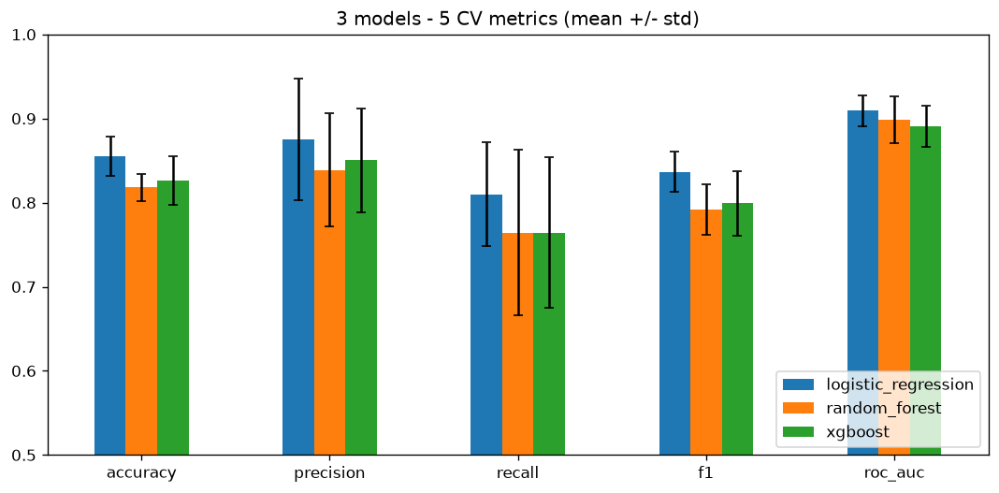  Figure 6 - Cross-validated metrics per model (mean ± std over 5 folds) | 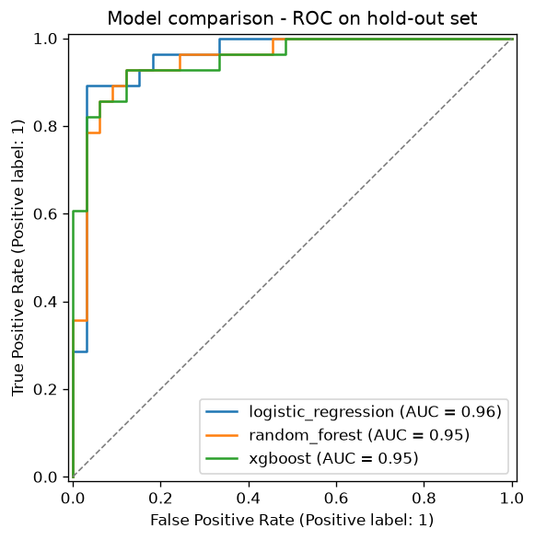  Figure 7 - ROC curves of all candidates on the hold-out set

Model selection rationale (src/tracking/select_champion.py):
- The primary criterion is mean CV ROC-AUC. It does not depend on a decision threshold, and it averages 5 folds of about 48 rows each, so it is far more stable than a single 61-row hold-out set, where one patient moves accuracy by 1.6 points. Ties are broken by test recall, because missing a sick patient is the costlier error.
- Logistic Regression has the best CV score on every metric and the lowest variance. The tree ensembles have slightly higher hold-out accuracy but lower CV scores, which points to hold-out noise rather than genuinely better performance. The small dataset (303 rows) also favours a well-regularised linear model over high-variance ensembles.
- Logistic Regression is also interpretable, and it is small and fast to serve. Its largest coefficients are sex, ca, cp = 4 (asymptomatic) and thal = 7 (reversible defect), which is clinically plausible.
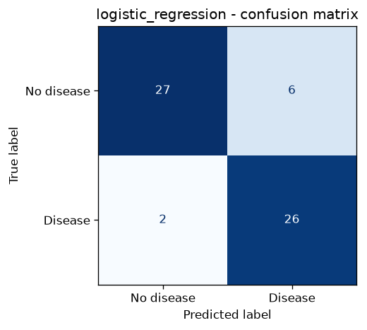  Figure 8 - Champion confusion matrix (hold-out): 26 of 28 diseased patients detected | 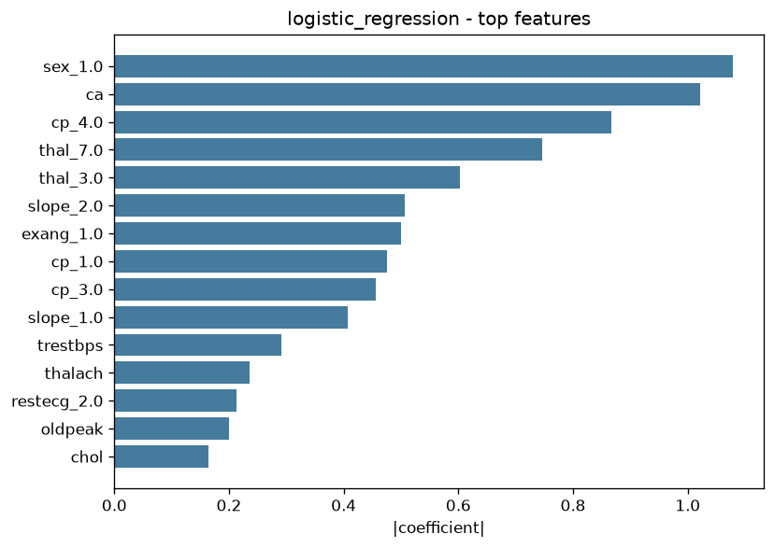  Figure 9 - Champion feature importance (absolute standardised coefficients)

6. Experiment Tracking (MLflow)
src/tracking/mlflow_tracking.py uses a SQLite backend (mlflow.db) with file artifacts (mlruns/), following the class convention. Each training run produces:
- One parent run per model family, which logs:
  - the best hyperparameters, plus data and CV settings (rows, folds, grid size, refit metric, random state);
  - the mean and standard deviation of all five CV metrics, and the five test metrics;
  - plots (confusion matrix, ROC/PR curves, feature importance) and the full cv_results_ CSV;
  - the training dataset as an MLflow dataset input;
  - the model with an inferred signature, an input example and the bundled src/ code, so the custom transformer loads anywhere.
- One nested child run per grid candidate (30 in total), with its parameters, the CV mean of each metric and its rank. Every configuration tried can be compared in the UI.
- A `model-comparison` run, which stores the comparison table and plots and tags the champion.
- A registry entry: the champion is registered as HeartDiseaseRiskChampion, a new version per training run, with the alias @champion and tags for model family and CV ROC-AUC.
Three training runs (CLI, notebook and re-run) produced identical metrics and registry versions 1 to 3, which confirms that training is reproducible end to end.
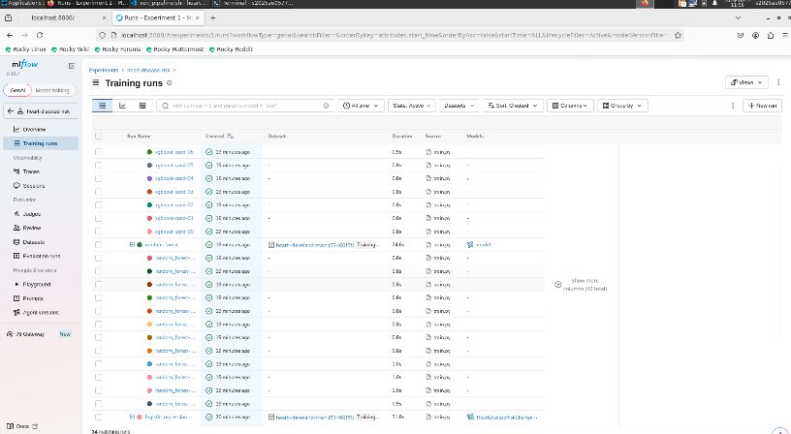  Figure 10 - MLflow experiment: parent runs per model family with the dataset input | 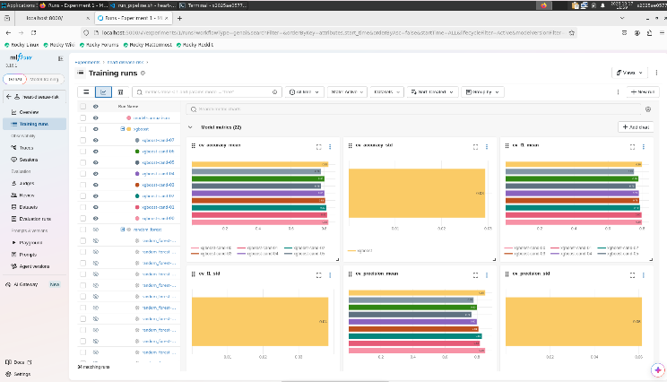  Figure 11 - MLflow chart view comparing CV metrics across runs

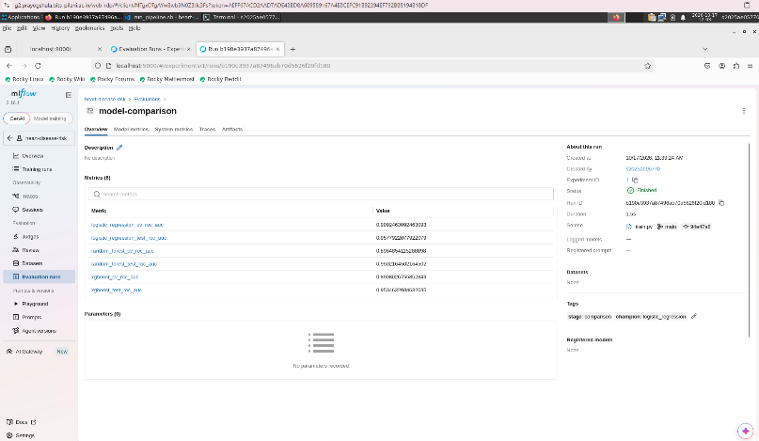  Figure 12 - Champion run with its nested grid-candidate child runs | 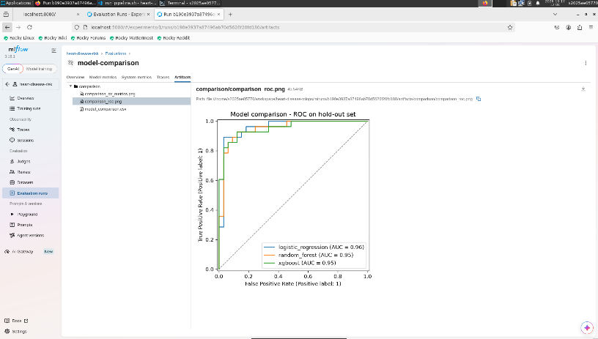  Figure 13 - Logged plot artifacts (ROC/PR curves) for the champion run

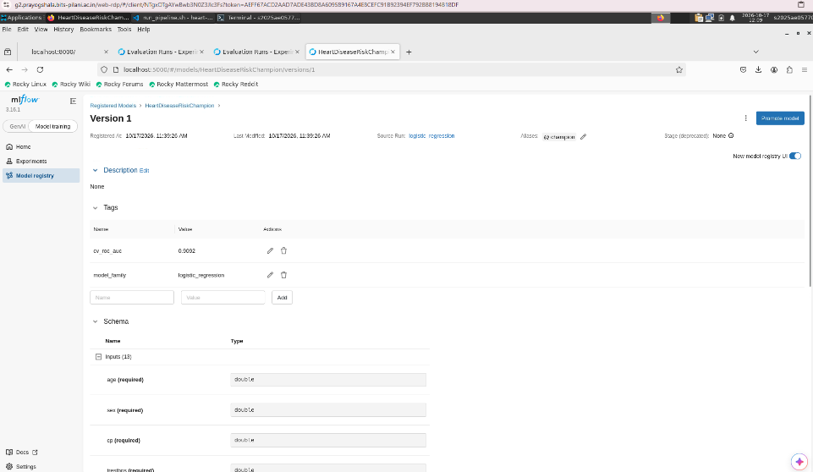
Figure 14 - Model Registry: HeartDiseaseRiskChampion versions with the @champion alias

7. Model Packaging and Reproducibility
Artifact | Purpose
models/heart_disease_model.joblib | The full sklearn pipeline (feature engineering, preprocessing and classifier); loaded by the API
models/model_metadata.json | Version, training time, parameters, CV and test metrics, feature list, threshold, Python and sklearn versions, MLflow run ID
models/mlflow_model/ | MLflow format (MLmodel, model.pkl, conda.yaml, python_env.yaml, requirements.txt, signature, input example, bundled code), servable with mlflow models serve
requirements.txt / requirements-serve.txt | Pinned full environment and pinned minimal runtime

Reproducibility comes from fixed seeds (random_state = 42) for the split, CV folds and every model; configuration in one place (src/config.py); preprocessing fitted inside the pipeline, so there is no training/serving skew; and pinned dependency versions.
Loading models/mlflow_model with mlflow.pyfunc and loading models:/HeartDiseaseRiskChampion@champion both return the same prediction as the joblib model. Batch scoring (python -m src.inference.predict) writes data/processed/batch_predictions.csv.

8. CI/CD Pipeline and Automated Testing
Unit tests (tests/, pytest, 44 tests, 87% line coverage) run on synthetic patients and temporary MLflow stores, so they need neither network access nor a pre-trained model:
File | What it covers
test_data.py | Headerless parsing, ? to NaN, target binarisation, duplicate removal, validation errors (missing columns, bad target, empty data), mocked download
test_features.py | The engineered feature formula, stratified split, no NaN after preprocessing, scaling to zero mean and unit variance, one-hot names, unseen categories
test_models.py | Model specs, CV summary keys, metrics, champion selection and tie-break, risk bands, the prediction output contract, batch inference, end-to-end run_training
test_tracking.py | MLflow parent run parameters, metrics and artifacts, nested child runs, registry alias, reloading the logged model
test_api.py | /health, /predict response contract, optional fields, 422 on invalid or unknown input, batch, /metrics, request log file, 503 when the model is missing

GitHub Actions (.github/workflows/ci.yml) runs on every push and pull request. Its four jobs are chained with needs, so a failure stops all later jobs, and every step runs under bash -eo pipefail:
- Lint: flake8 over src, tests, scripts and dags; the report is uploaded as an artifact.
- Unit tests: pytest with JUnit XML and a coverage XML report, plus a coverage gate of at least 75%. Results are uploaded and summarised on the run page.
- Train: download, EDA, training with MLflow tracking and registration, then batch inference. The model, reports, mlflow.db, mlruns/, logs and processed data are uploaded, and the model comparison table is written to the job summary.
- Docker: builds the image from the model trained in step 3, runs the container, and smoke-tests /health, three /predict cases, the 422 path, /predict/batch and /metrics. Container logs are uploaded. On main, the image is pushed to ghcr.io/<owner>/heart-disease-api.
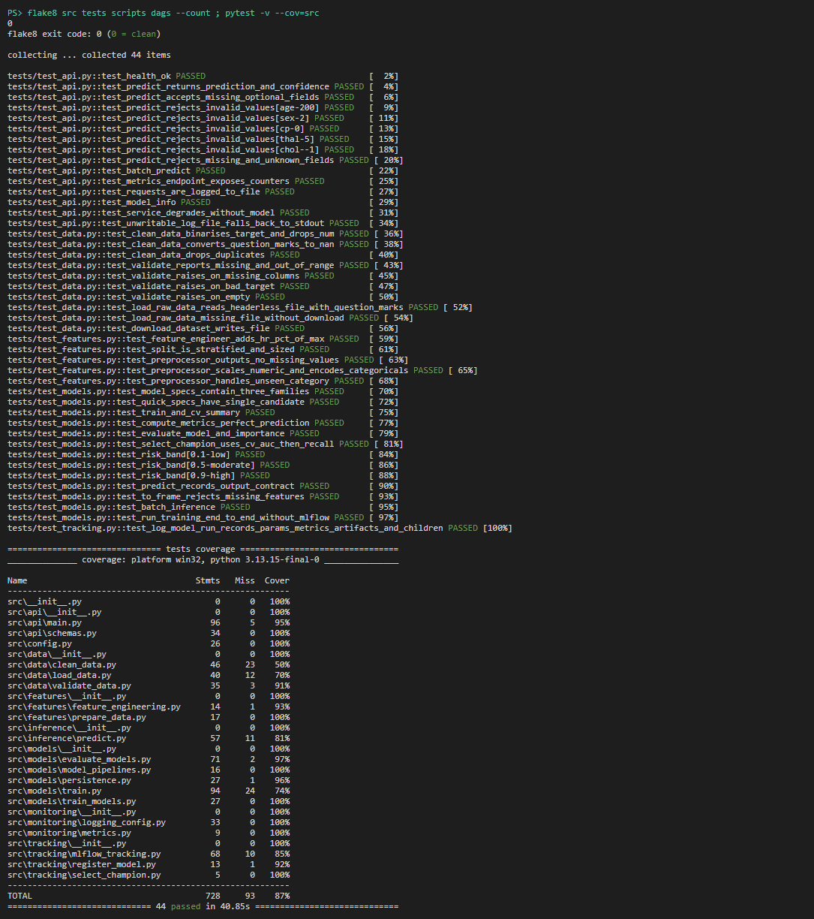  Figure 15 - Run of lint and the unit-test suite with coverage | 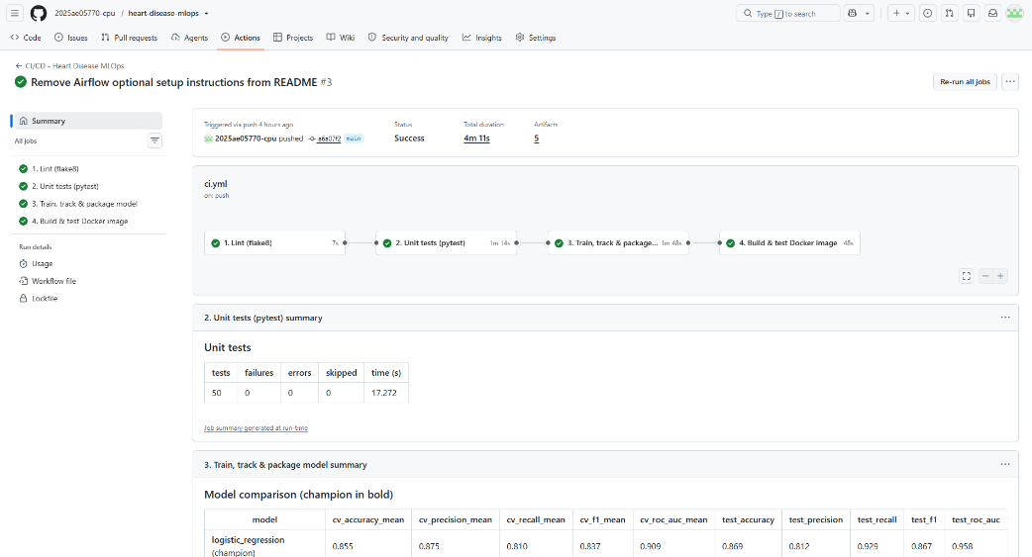Figure 16 - GitHub Actions run showing the lint, test, train and docker jobs and their artifacts

9. Containerisation, Deployment and API
API (src/api/main.py, FastAPI):
- Endpoints: POST /predict (one patient), POST /predict/batch (up to 500 patients), GET /health, GET /model-info, GET /metrics, and an interactive Swagger UI at /docs.
- Input validation: a pydantic schema enforces clinical ranges and allowed codes (for example cp ∈ {1, 2, 3, 4} and thal ∈ {3, 6, 7}) and rejects unknown fields with HTTP 422. ca and thal are optional and are imputed.
- Response: prediction (0 or 1), label, confidence (the probability of the predicted class), probability_heart_disease, risk_level (low below 0.35, moderate below 0.65, high otherwise), model_version and request_id. The request ID is also returned in the X-Request-ID header.
POST /predict {"age":63,"sex":1,"cp":1,"trestbps":145,"chol":233,"fbs":1,"restecg":2,
"thalach":150,"exang":0,"oldpeak":2.3,"slope":3,"ca":0,"thal":6}
200 OK {"prediction":0,"label":"no_heart_disease","confidence":0.7385,
"probability_heart_disease":0.2615,"risk_level":"low","model_version":"3",
"request_id":"3965b220b029"}
Docker (Dockerfile):
- Single stage on python:3.13-slim, installing only requirements-serve.txt (with the CPU-only XGBoost wheel), src/ and the model files.
- Runs as a non-root user (UID 10001), with a HEALTHCHECK on /health. uvicorn listens on port 8000.
- .dockerignore keeps data, notebooks, tests and MLflow stores out of the image.
Build and run with docker build -t heart-disease-api:1.0.0 . and docker run -p 8000:8000 heart-disease-api:1.0.0, then check with python scripts/smoke_test.py.
Kubernetes (k8s/, applied with kubectl apply -k k8s/ or scripts/deploy_k8s.ps1):
- Namespace heart-disease, plus a ConfigMap for the model path and log settings.
- Deployment:
  - 2 replicas, with a rolling update that keeps 0 pods unavailable;
  - startup, readiness and liveness probes on /health;
  - CPU and memory requests and limits;
  - a security context with non-root user, read-only root filesystem and all capabilities dropped (emptyDir volumes for logs and /tmp);
  - Prometheus scrape annotations.
- Service of type LoadBalancer (port 80 to 8000), an nginx Ingress for host heart-disease.local, and an HPA that scales from 2 to 5 replicas at 70% CPU.
Cluster | Access
Docker Desktop | http://localhost/docs, python scripts/smoke_test.py --url http://localhost
Minikube | minikube tunnel, then the EXTERNAL-IP, or minikube service heart-disease-api -n heart-disease --url
Ingress | Hosts entry <ingress-ip> heart-disease.local, then http://heart-disease.local/docs

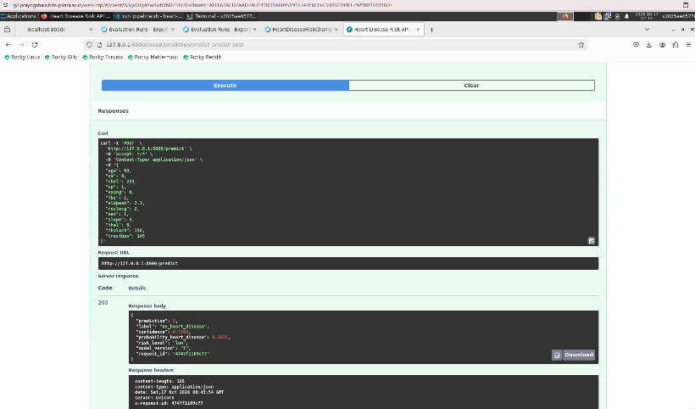  Figure 17 - Swagger UI: live /predict call returning prediction and confidence | 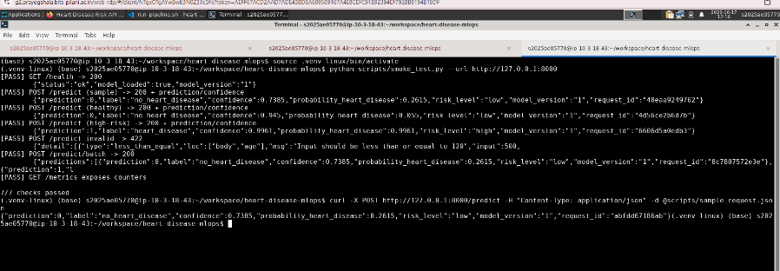  Figure 18 - Smoke test against the running API (7/7 checks)

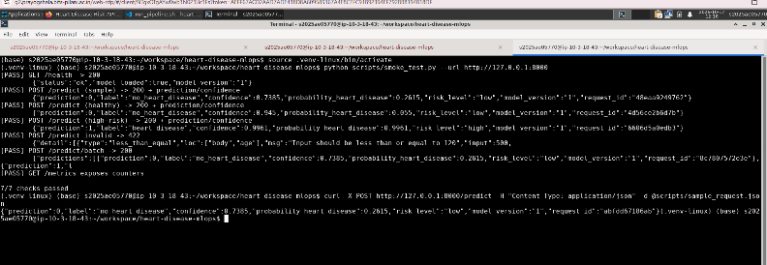  Figure 19 - docker build and docker run with a sample request | 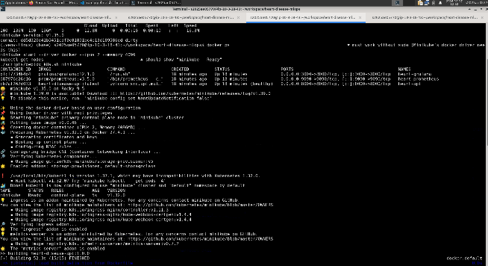Figure 20 - kubectl get pods,svc,ingress,hpa -n heart-disease

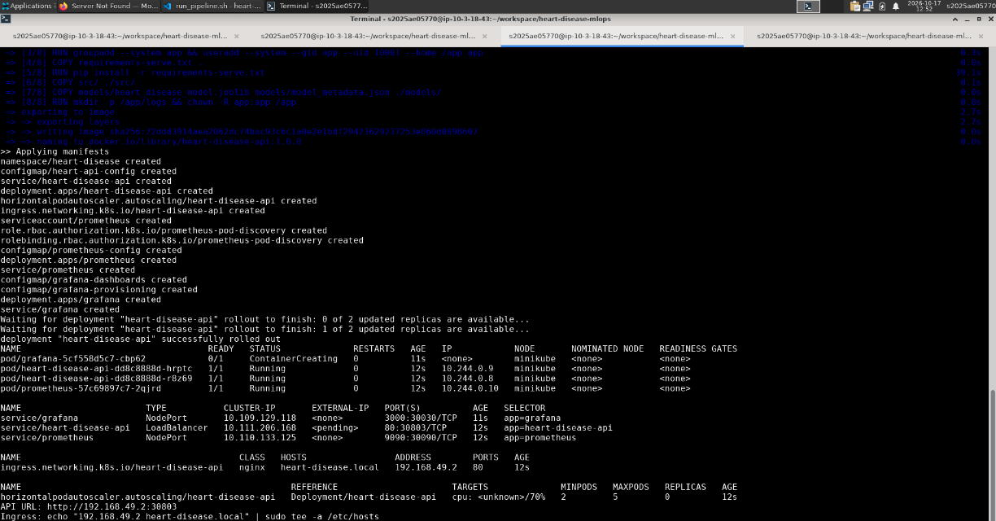
Figure 21 - Endpoint verification through the LoadBalancer / Ingress

10. Monitoring and Logging
Logging: each request writes a JSON line with timestamp, request ID, method, path, status, latency and client. Each prediction writes a second JSON line with the validated input, the prediction, the probability and the risk band. Logs go to stdout, where kubectl logs and docker logs can read them, and to a rotating file at /app/logs/api.log. A shared request ID links the request line to its prediction line.
Metrics (src/monitoring/metrics.py, exposed at /metrics):
Metric | Type
heart_api_requests_total{method,endpoint,status_code} | Counter
heart_api_request_latency_seconds | Histogram
heart_api_requests_in_progress | Gauge
heart_model_predictions_total{label} | Counter
heart_model_probability | Histogram
heart_model_prediction_errors_total, heart_model_loaded, heart_model_info | Counter, Gauge, Info

Endpoint labels use the route template rather than the raw path, which keeps label cardinality bounded.
Dashboard:
- Prometheus scrapes the pods. Under docker compose it uses a static target; in Kubernetes it uses pod service discovery with namespace-scoped RBAC and the prometheus.io/* annotations.
- Grafana is provisioned automatically with a datasource and the Heart Disease API dashboard. Its panels show: model loaded, total predictions, request rate, p95 latency, 5xx error ratio, count of validation rejects, requests by endpoint and status, p50/p95/p99 latency, predictions by label, and the share of high-risk predictions over 15 minutes as a simple prediction-drift signal.
- scripts/generate_traffic.py replays rows from the cleaned dataset (about 5% deliberately invalid) to populate the dashboard.
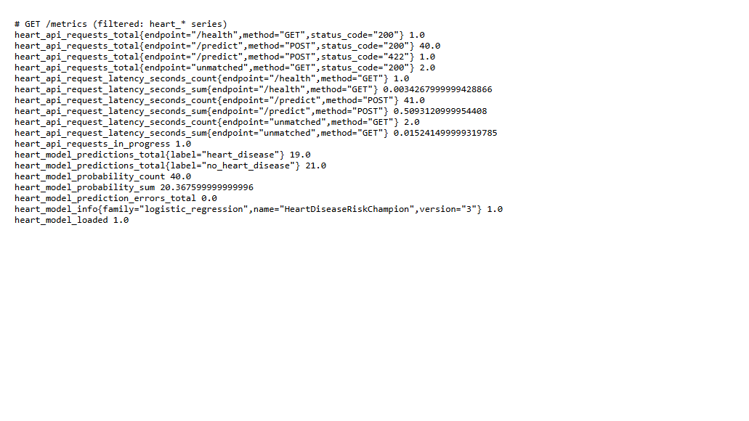  Figure 22 - Prometheus metrics exposed by the API after generated traffic | 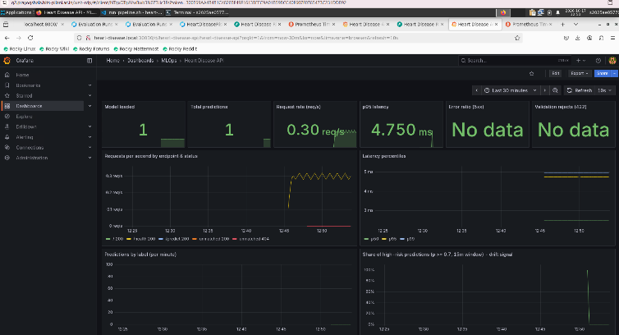  Figure 23 - Grafana "Heart Disease API" dashboard
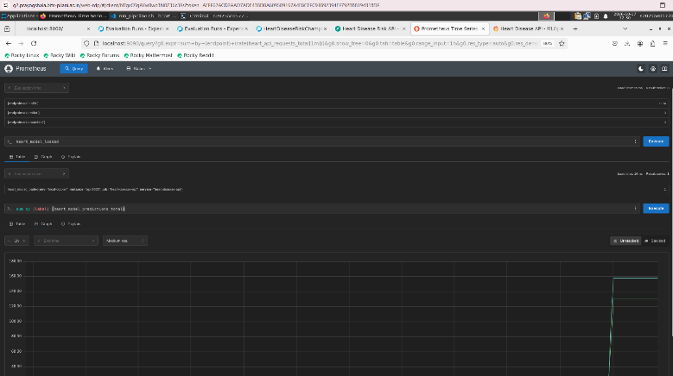  Figure 25 – Different Prometheus metrics exposed | 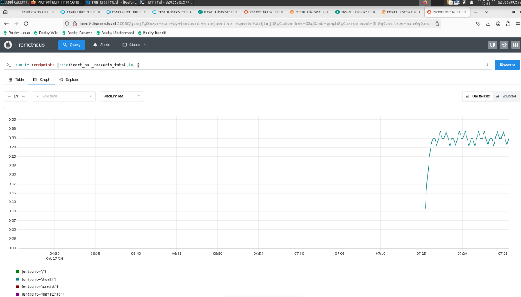  Figure 26 - Prometheus metrics exposed by the API after generated traffic in kubectl container

11. Conclusions and Future Work
The pipeline is reproducible: the same commands work locally, in Airflow and in CI. It is tested and automated, with every stage gated in GitHub Actions, and the deployment is observable through logs, metrics and a dashboard.
Possible next steps:
- Calibrate the probabilities and choose the decision threshold from a clinical cost of false negatives.
- Add data-drift tests (for example, PSI on the input features) using the logged inputs.
- Add the other three UCI sites (Hungary, Switzerland, VA) as an external validation set.
- Promote models through MLflow aliases (challenger to champion) with an automated quality gate before deployment.
- Add a Helm chart and a GitOps deployment, such as Argo CD.

Appendix A: Deliverables Checklist
Requirement | Location
Code, Dockerfile, requirements | src/, Dockerfile, docker-compose.yml, requirements.txt, requirements-serve.txt
Cleaned dataset and download script | data/processed/heart_disease_clean.csv, scripts/download_data.py
Notebooks (EDA, training, inference) | notebooks/01_eda.ipynb, 02_model_training.ipynb, 03_inference.ipynb
Unit tests | tests/ (44 tests)
CI/CD workflow | .github/workflows/ci.yml
Deployment manifests | k8s/, k8s/monitoring/
Monitoring configuration | monitoring/ (Prometheus and Grafana provisioning, dashboard JSON)
Screenshots | screenshots/
Report | reports/REPORT.md, reports/Heart_Disease_MLOps_Report.docx
Orchestration (as in class) | dags/heart_disease_pipeline.py

