End-to-End Machine Learning Model Development, CI/CD, and Production Deployment
Course: Machine Learning Operations (AIMLCZG523) — Assignment 01
Name & Bits ID: Prashant V Panchal (2025ae05830)
Submission date: 20th October 2026

Abstract
This project delivers a complete, production-grade MLOps pipeline for predicting the presence of heart disease from patient health data. It spans the full lifecycle: automated data acquisition, exploratory data analysis, model development with cross-validated hyperparameter tuning, experiment tracking with MLflow, reproducible model packaging, unit-tested and linted code with a GitHub Actions CI/CD pipeline, containerized serving via FastAPI and Docker, deployment on a local Kubernetes cluster (Minikube) with Deployment, Service and Ingress resources, and live monitoring through Prometheus and Grafana. The final model (Logistic Regression, tuned) achieves a test ROC-AUC of 0.966 and is served as a JSON API returning both a prediction and its confidence.

1. Setup and Installation
Repository link: https://github.com/2025ae05830/MLOpsAssignment1
git clone <YOUR_GITHUB_REPO_URL>
cd MLOps
python3 -m venv .venv
source .venv/bin/activate
pip install -r requirements.txt
Running the full pipeline from a clean setup (all commands run from the project root):
python -m src.data.download_data # fetch raw data from UCI -> data/raw/
python -m src.data.preprocess # clean -> data/processed/heart_clean.csv
python -m src.data.eda # figures -> reports/figures/
python -m src.models.train # train + tune, log everything to MLflow
python -m src.models.export_model # export best run -> models/best_model/
python -m src.models.predict # sample inference
ruff check src tests # linting
pytest tests/ -v # unit tests
mlflow ui --backend-store-uri sqlite:///mlflow.db # experiment tracking UI
Serving the model:
# Local development
uvicorn src.api.main:app --host 0.0.0.0 --port 8000
# Docker
docker build -t heart-api .
docker run -p 8000:8000 heart-api
# Kubernetes (Minikube)
minikube image load heart-api
kubectl apply -f deployment/deployment.yaml -f deployment/service.yaml -f deployment/ingress.yaml
minikube service heart-api --url # accessible API URL
# Monitoring stack
docker compose up -d # Prometheus :9090, Grafana :3000
API access instructions (for local testing):
curl http://localhost:8000/health
curl -X POST http://localhost:8000/predict -H "Content-Type: application/json" \
-d '{"age":63,"sex":1,"cp":1,"trestbps":145,"chol":233,"fbs":1,"restecg":2,"thalach":150,"exang":0,"oldpeak":2.3,"slope":3,"ca":0,"thal":6}'
Example response: {"prediction": 0, "confidence": 0.16553481726226757}

2. Introduction and Objective
The objective of this assignment is to design, develop, and deploy a scalable, reproducible machine learning solution following modern MLOps best practices, mirroring real-world production scenarios. The problem statement is to build a classifier that predicts the risk of heart disease from patient health data, and to deploy it as a cloud-ready, monitored API. The emphasis is not only on model quality, but on automation, traceability, testing, containerization, deployment, and monitoring.

3. Project Architecture

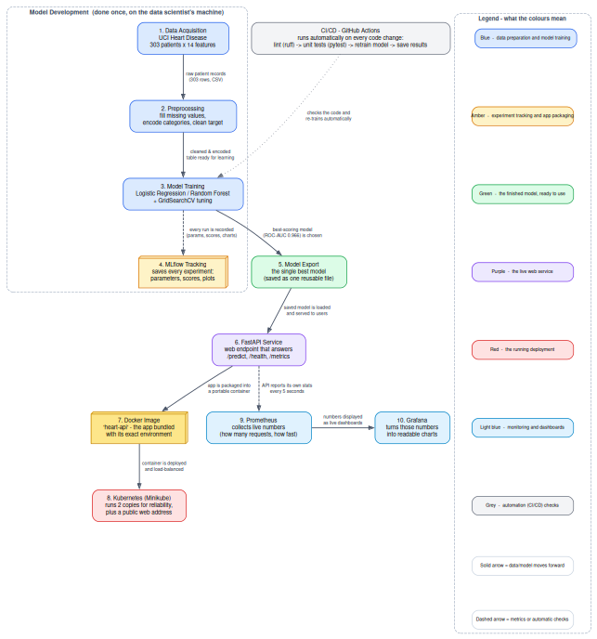
End-to-End MLOps Architecture

Repository layout:
|-- data/ raw/ and processed/ datasets
|-- notebooks/ 01_EDA.ipynb
|-- src/
| |-- data/ download_data.py, preprocess.py, eda.py
| |-- models/ t rain.py, export_model.py, predict.py
| |-- api/ main.py (FastAPI serving app)
|-- tests/ pytest unit tests (test_preprocess.py, test_train.py)
|-- deployment/ deployment.yaml, service.yaml, ingress.yaml
|-- reports/ FINAL_REPORT.md/pdf + figures/
|-- screenshots/ screenshots
|-- .github/workflows/ci.yml
|-- Dockerfile, docker-compose.yml, prometheus.yml
|-- requirements.txt

4. Task 1 — Data Acquisition and EDA
Acquisition. The dataset is fetched by python -m src.data.download_data, which pulls processed.cleveland.data from the official UCI Machine Learning Repository, assigns the 14 standard column names, converts ? placeholders to NaN, and saves data/raw/heart_cleveland.csv (303 rows x 14 columns). This makes data acquisition fully reproducible rather than a manual download.
Cleaning and preprocessing (src/data/preprocess.py): - The original target column (grades 0–4) is binarized: 0 = no disease, 1–4 = disease present. - Missing numeric values are imputed with the column median; missing categorical values with the column mode. - The cleaned dataset is saved to data/processed/heart_clean.csv. Final class balance: 164 negative / 139 positive — nearly balanced, so accuracy is a usable metric alongside ROC-AUC.
EDA (src/data/eda.py, figures in reports/figures/):
Figure | Insight
class_balance.png | Classes are nearly balanced (54%/46%); no resampling needed
numeric_histograms.png | Age ~30–77 (mean ~54); trestbps and chol show right skew (outlier patients)
correlation_heatmap.png | cp and thalach correlate positively with target; oldpeak and exang correlate negatively. chol/fbs show weak correlation — candidates for future feature pruning
age_by_target.png | Disease-positive cases spread across age groups, not only older patients
A Jupyter notebook (notebooks/01_EDA.ipynb) reproduces the same exploration interactively.
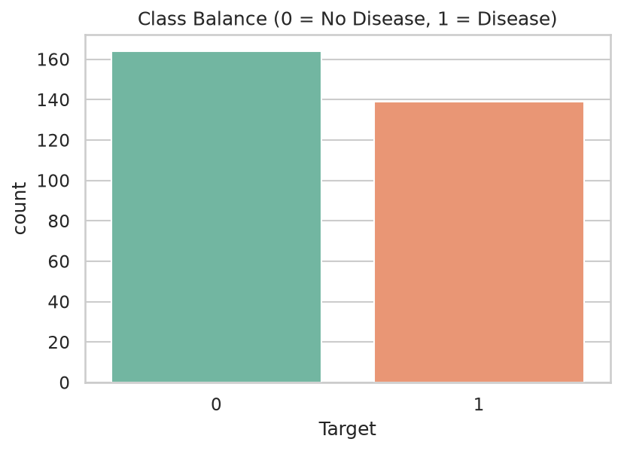
Class balance
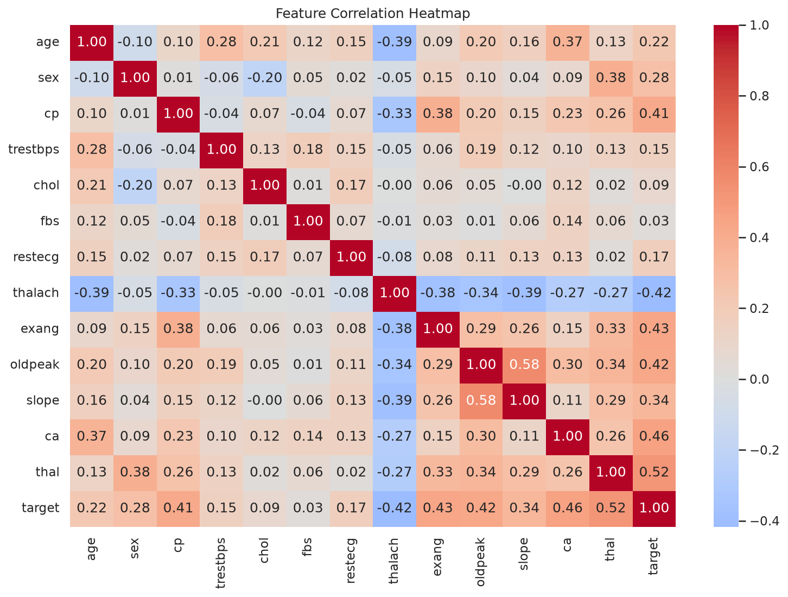
Correlation heatmap
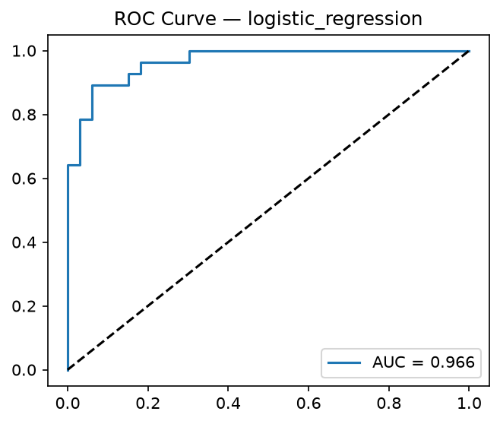
ROC curves

5. Task 2 — Feature Engineering and Model Development
Feature pipeline (src/models/train.py::build_preprocessor): - Numeric features (age, trestbps, chol, thalach, oldpeak): median imputation, then StandardScaler. - Categorical features (sex, cp, fbs, restecg, exang, slope, ca, thal): mode imputation, then OneHotEncoder(handle_unknown="ignore"). - The preprocessor is a ColumnTransformer embedded inside the model Pipeline, so the same transformation is applied at training and serving time.
Models. Two classifiers were trained and compared with 5-fold stratified cross-validation and a held-out 20% test set (stratified split, fixed seed for reproducibility).
Tuning. GridSearchCV (scoring = ROC-AUC, same CV scheme) was run per model: - Logistic Regression: C in {0.1, 1.0, 10.0} — best C = 1.0 (the default is already optimal on this dataset). - Random Forest: n_estimators in {100, 300} x max_depth in {None, 6} — best n_estimators = 300, max_depth = 6, which improved test ROC-AUC from 0.943 (baseline) to 0.950 and accuracy from 0.852 to 0.869.
Results (tuned models):
Model | Accuracy | Precision | Recall | ROC-AUC | CV ROC-AUC (5-fold)
Logistic Regression (C=1.0) | 0.885 | 0.839 | 0.929 | 0.966 | 0.902 +/- 0.014
Random Forest (300 trees, depth 6) | 0.869 | 0.833 | 0.893 | 0.950 | 0.897 +/- 0.031
Model selection. Logistic Regression is selected as the final model: it leads on every reported metric and shows lower cross-validation variance (0.014 vs 0.031), indicating more stable generalization. The high recall (0.929) is especially valuable in a medical screening context, where missing a positive case is costlier than a false alarm. Confusion matrices and ROC curves for both models are logged as MLflow artifacts.

6. Task 3 — Experiment Tracking
MLflow is integrated directly into the training script (src/models/train.py): - Tracking backend: SQLite (mlflow.db), which is fully versionable and avoids the deprecated file-store backend. - Experiment name: heart_disease. Each training session produces four runs: {model}_baseline (default hyperparameters) and {model}_tuned (grid-search result), making the effect of tuning directly comparable in the UI. - Logged per run: - Parameters: model_type, tuning, and the selected hyperparameters (e.g. clf__C, clf__max_depth). - Metrics: accuracy, precision, recall, ROC-AUC, CV ROC-AUC mean/std, and baseline_roc_auc. - Artifacts: confusion-matrix and ROC-curve plots, plus the complete sklearn pipeline via mlflow.sklearn.log_model. - The export_model script queries MLflow for the best run by ROC-AUC and materializes it to models/best_model/, so model selection is data-driven and repeatable.
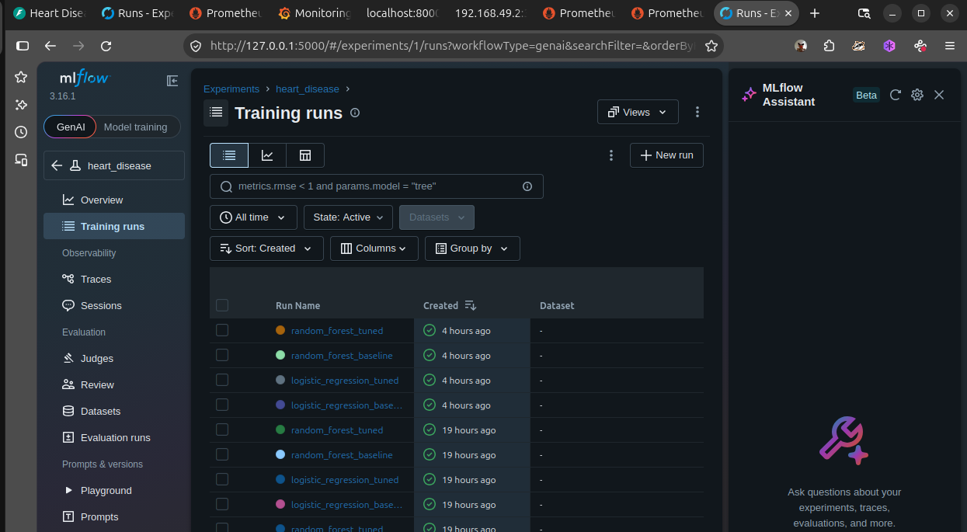
MLflow experiment tracking UI

7. Task 4 — Model Packaging and Reproducibility
- Reusable format: the final model is saved in MLflow’s sklearn flavor (including the embedded preprocessing pipeline) and exported locally by python -m src.models.export_model to models/best_model/. Because preprocessing travels inside the pipeline, training/serving skew is structurally impossible.
- Inference helper: src/models/predict.py exposes load_model() and predict(features_dict); it returns {"prediction": 0|1, "confidence": <probability>}. Running it locally produced {"prediction": 0, "confidence": 0.1655} for the sample patient — identical to the response produced inside the Docker container, confirming the packaged artifact reproduces training behavior.
- Environment reproducibility: requirements.txt pins all runtime dependencies (pandas, scikit-learn, mlflow, fastapi, prometheus-client, pytest, ruff, …). A fresh virtualenv plus pip install -r requirements.txt is sufficient to run every script in this report.

8. Task 5 — CI/CD Pipeline and Automated Testing
Unit tests (tests/, pytest — 8 tests, all passing): - test_preprocess.py: dataset loads with expected shape/columns; target is binarized to {0,1}; cleaned data has zero missing values; cleaning preserves the usable rows. - test_train.py: preprocessor expands categorical features correctly; build_model returns the expected pipeline structure; an invalid model name raises ValueError; evaluate returns all metrics within [0, 1].
Linting. ruff check src tests runs clean; import hygiene issues were auto-fixed during development.
CI/CD workflow (.github/workflows/ci.yml, GitHub Actions) triggers on pushes and pull requests and executes, in order: 1. Checkout and Python 3.12 environment setup. 2. pip install -r requirements.txt. 3. Lint (ruff check src tests) — fails the build on violations. 4. Unit tests (pytest tests/ -v) — fails the build on any test failure. 5. Model training (python -m src.models.train) — reproduces the full training run in CI, with MLFLOW_TRACKING_URI pointed at a CI-local SQLite database. 6. Artifact upload: reports/figures/ and configs/model_results.json are archived for every workflow run, providing a traceable record of what each run produced.
Any lint, test, or training error stops the pipeline with explicit logs, satisfying the production-readiness requirement.
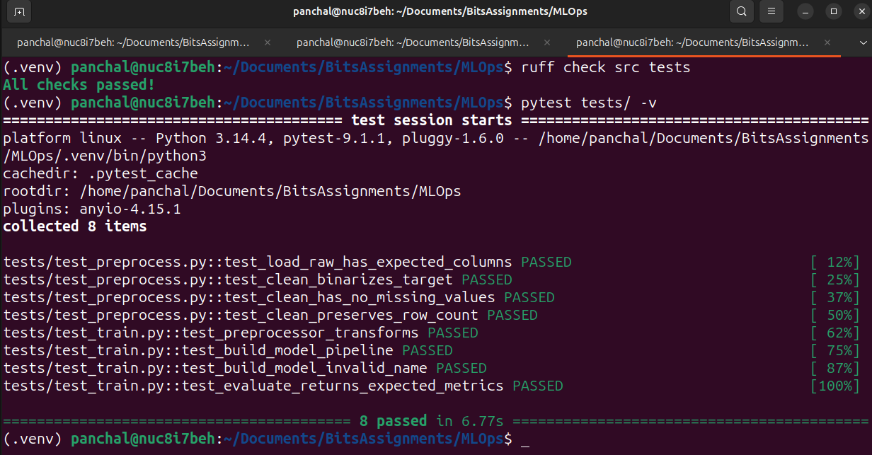
Lint and unit test results

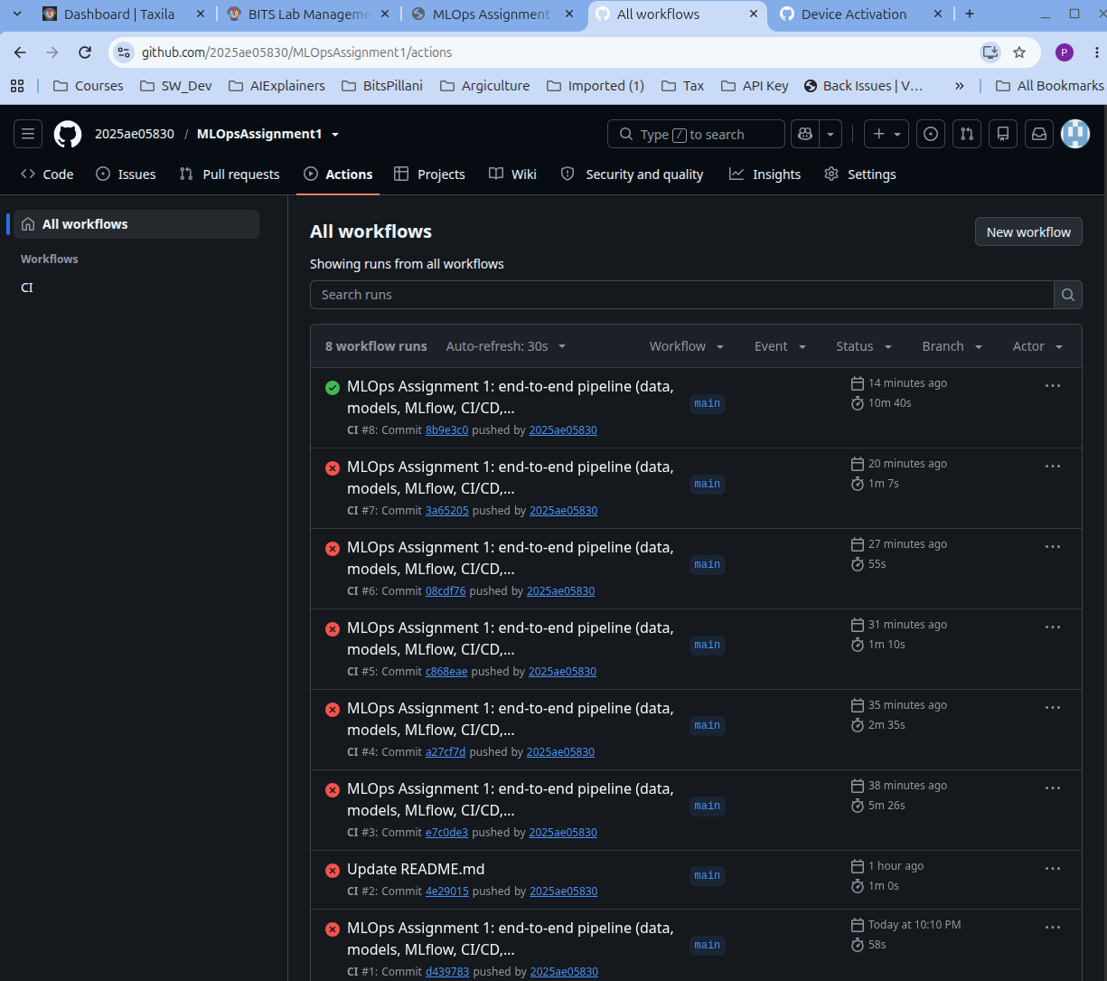
GitHub CI Actions

9. Task 6 — Containerization
The serving API (src/api/main.py) is built with FastAPI: - GET /health — liveness probe endpoint. - POST /predict — accepts a JSON object with the 13 patient features, returns {prediction, confidence}. - An HTTP middleware logs every request (method, path, status code, latency) and feeds Prometheus metrics (see Task 8).
A Dockerfile (base python:3.12-slim) installs requirements.txt, copies the exported model and source, and launches Uvicorn on port 8000. A .dockerignore keeps virtualenvs, MLflow data, and git metadata out of the image.
Verified locally (Prayogshala not working):
docker build -t heart-api . -> image built (938 MB)
docker run -p 8000:8000 heart-api -> server starts, model loads on first request
curl POST /predict -> {"prediction":0,"confidence":0.16553481726226757}
The image is built and the server started manually; the screenshots below show the build completing, the container running Uvicorn, and the running container listed by Docker.
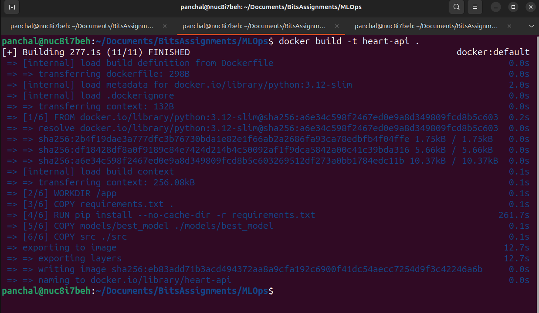
Docker build
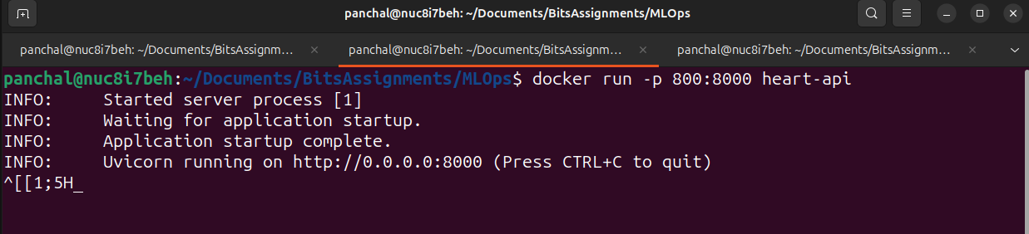
Docker container running
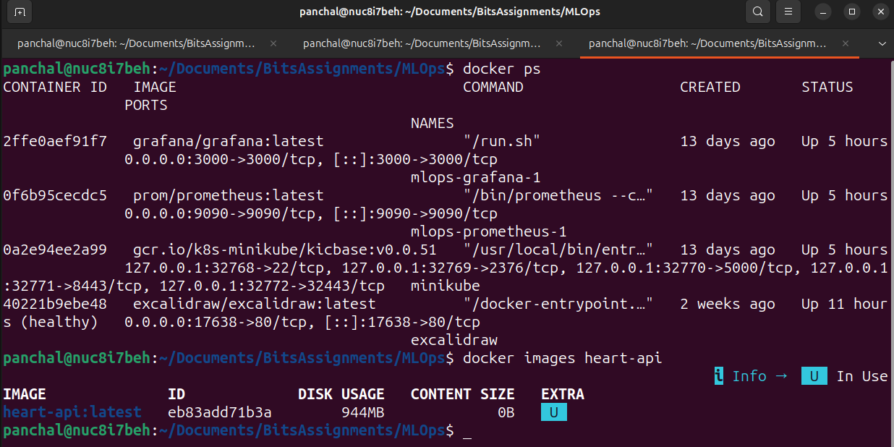
Docker container status
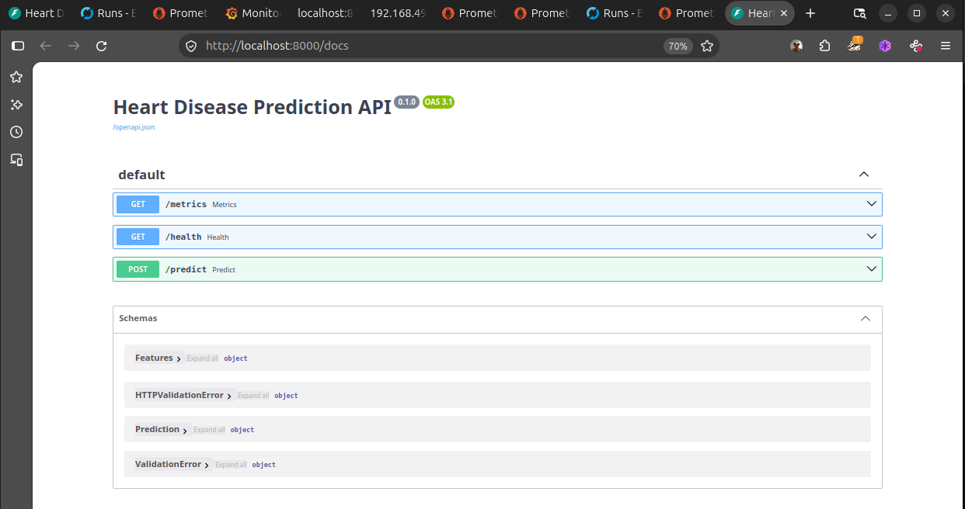
FastAPI interactive documentation

10. Task 7 — Production Deployment
The Dockerized API is deployed to a local Kubernetes cluster (Minikube, Kubernetes v1.37) using declarative manifests in deployment/:
- deployment.yaml — a Deployment with 2 replicas for availability, labels/selectors for service routing, a readiness probe against /health, and imagePullPolicy: Never so the locally built heart-api image is used.
- service.yaml — a LoadBalancer Service mapping port 80 to container port 8000.
- ingress.yaml — an Ingress exposing the service through the cluster’s nginx ingress controller (addon enabled), giving a single HTTP entry point.
Deployment steps and verification:
minikube image load heart-api
kubectl apply -f deployment/deployment.yaml -f deployment/service.yaml -f deployment/ingress.yaml
kubectl get pods # 2/2 pods Running
minikube service heart-api --url # http://192.168.49.2:30175
The endpoint returns the same prediction as local execution, confirming the deployed artifact is identical to the one validated in development. The same manifests apply unchanged to a cloud cluster (GKE/EKS/AKS) by pointing kubectl at that context.
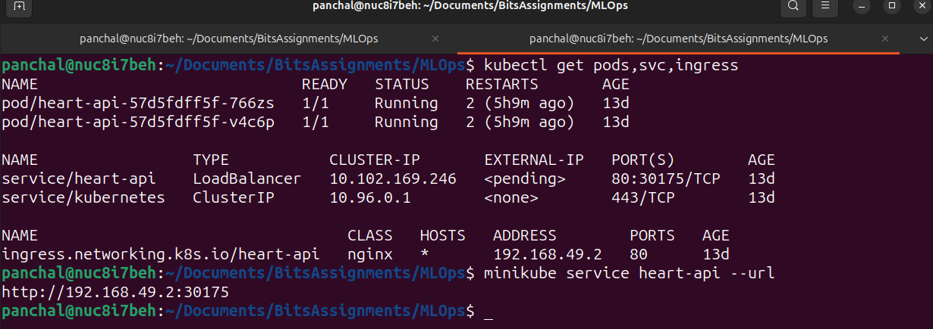
Kubernetes deployment and verified endpoint

11. Task 8 — Monitoring and Logging
Logging. The FastAPI middleware logs each request with method, path, status code, and duration via Python’s logging module, visible in the container/pod logs (docker logs heart-api, kubectl logs deploy/heart-api).
Metrics. The same middleware instruments a Prometheus registry exposed at GET /metrics: - api_requests_total{method,endpoint,status} — request counter per route and status. - api_request_latency_seconds{endpoint} — latency histogram per route.
Monitoring stack. docker-compose.yml provisions Prometheus (localhost:9090) and Grafana (localhost:3000). prometheus.yml scrapes the API’s /metrics endpoint every 5 seconds, and the target health is verified as up. In Grafana, the Prometheus datasource can be wired to dashboards plotting request rate (rate(api_requests_total[1m])) and average latency (rate(..._sum)/rate(..._count)), giving a live view of API health and traffic.
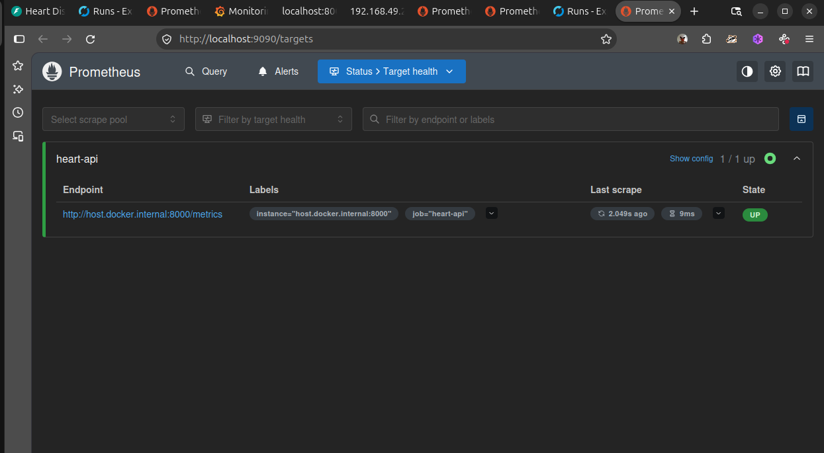
Prometheus scrape target
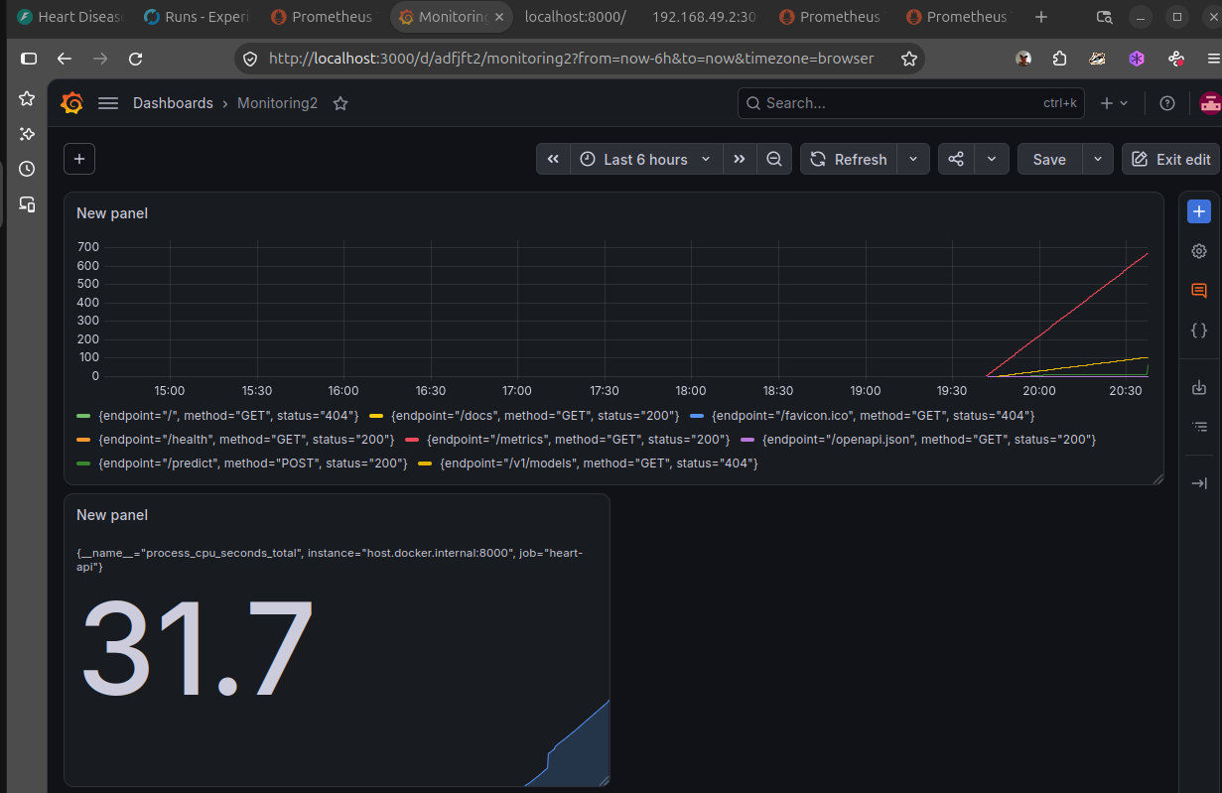
Grafana dashboard

12. Screenshots Summary
All evidence screenshots referenced above are stored in screenshots/:
File | Content
mlflow_ui.png | MLflow experiment UI with baseline/tuned runs
tests_lint.png | Ruff clean + 8/8 pytest passing
DockerBuild.png | docker build -t heart-api . completing successfully
DockerRun.png | Container running with Uvicorn serving on port 8000
DockerStatus.png | docker ps output showing the heart-api container
api_docs.png | FastAPI interactive /docs page
deployment_k8s.png | Pods 2/2 Running, Service/Ingress, verified endpoint
prometheus.png | Prometheus targets (API target up)
grafana.png | Grafana datasource / dashboard configured against Prometheus
architecture.png | End-to-end MLOps architecture diagram
GitHubCI.png | Git Hub Actions in works.
Prayogshala (Not taken) | Not working due the authentication issues and VM getting dropped within 30 seconds.

13. Conclusion and Future Work
This project delivers a complete MLOps loop: reproducible data acquisition and cleaning, documented EDA, cross-validated and grid-searched model development, tracked experiments, packaged and exportable artifacts, automated quality gates in CI, containerized serving, declarative Kubernetes deployment with redundancy, and live request logging and metrics. The final Logistic Regression pipeline reaches ROC-AUC 0.966 with strong recall, and the identical artifact is exercised at every stage — from notebook to container to cluster.
Future work: - Feature selection guided by the correlation analysis (e.g., dropping weak predictors such as chol/fbs) and testing additional classifiers. - Broader hyperparameter searches and MLflow model-registry promotion (staging -> production) for governed releases. - Alerting rules and richer dashboards in Grafana (latency SLOs, error-rate alarms), plus request-level payload logging for drift monitoring. - Automated image build/push and GitOps-style deployment from the CI pipeline once a cloud cluster is available.

