Machine Learning Operations (AIMLCZG523)
Assignment 01
Heart Disease Risk Prediction
End-to-end MLOps: experiment tracking, CI/CD, containerisation, Kubernetes deployment and monitoring
Shrilekha Sivakumar
BITS ID: 2025AF05024
Repository: https://github.com/2025af05024-Shrilekha/MLOps-Assignment
Video: <link to demo recording>

Contents
Contents 2
1. Introduction and problem statement 3
2. Data acquisition and exploratory analysis 3
2.1 Source and acquisition 3
2.2 Cleaning 3
2.3 Findings 4
3. Feature engineering and model development 5
3.1 Preprocessing pipeline 5
3.2 Candidate models and tuning 6
3.3 Results 6
4. Experiment tracking with MLflow 8
5. Model packaging and reproducibility 9
6. CI/CD pipeline and automated testing 9
6.1 Unit tests 9
6.2 GitHub Actions workflow (ci-cd.yml) 9
7. Model containerisation 10
8. Production deployment 10
9. Monitoring and logging 11
10. Architecture 12
11. Setup and run instructions 12
12. Limitations and future work 13
References 13

(Right-click → Update Field in Word to refresh page numbers.)

1. Introduction and problem statement
Coronary heart disease is often diagnosed only after symptoms escalate. The goal of this project is a binary classifier that estimates the probability that a patient has heart disease from 13 routine clinical measurements, and to deliver it as a reproducible, tested, containerised and monitored API, the way a production ML service would be run.
The emphasis of the assignment is the operational lifecycle, not only model accuracy: every step from data download to a scaled Kubernetes deployment is scripted, versioned in Git, executed automatically in GitHub Actions, and observable through Prometheus and Grafana.
Requirement | Where it is implemented
Data acquisition & EDA | src/data_preprocessing.py, src/eda.py, notebooks/
Feature engineering & two models | build_preprocessor(), src/train.py (LogReg, RandomForest)
Experiment tracking | MLflow file store mlruns/ (params, metrics, plots, models)
Packaging & reproducibility | artifacts/model/model.joblib, pinned requirements, seeds
CI/CD & testing | .github/workflows/ci-cd.yml, tests/ (pytest), flake8 + black
Containerisation | Dockerfile (multi-stage), FastAPI src/app.py
Deployment | k8s/ on Minikube, docker-compose.yml
Monitoring & logging | /metrics, JSON logs, Prometheus + Grafana

2. Data acquisition and exploratory analysis

2.1 Source and acquisition
The Cleveland subset of the UCI Heart Disease dataset (processed.cleveland.data; 303 patients, 13 features, diagnosis column num 0-4) is downloaded by `python -m src.data_preprocessing`. The script is idempotent (skips the download if the file exists, --force re-downloads) and falls back to a GitHub re-publication of the same 303 records only if the UCI server is unreachable, converting its text labels back to UCI codes. The log records which source was used.

2.2 Cleaning
- Target: num > 0 → 1 (disease), num = 0 → 0. 139 positive / 164 negative (45.9 %), so the classes are close to balanced.
- Missing values: `?` parsed as NaN: ca 4 rows, thal 2 rows. Physiologically impossible zero blood pressure or cholesterol would also be set to NaN (none occur in this file).
- Duplicates dropped; all columns coerced to numeric.
- Imputation is deliberately not done during cleaning. It is part of the model pipeline so that the API applies exactly the same rule at prediction time.

2.3 Findings
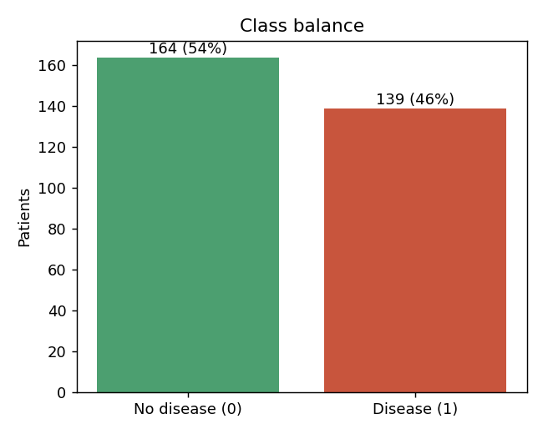
Figure 1 - Class balance
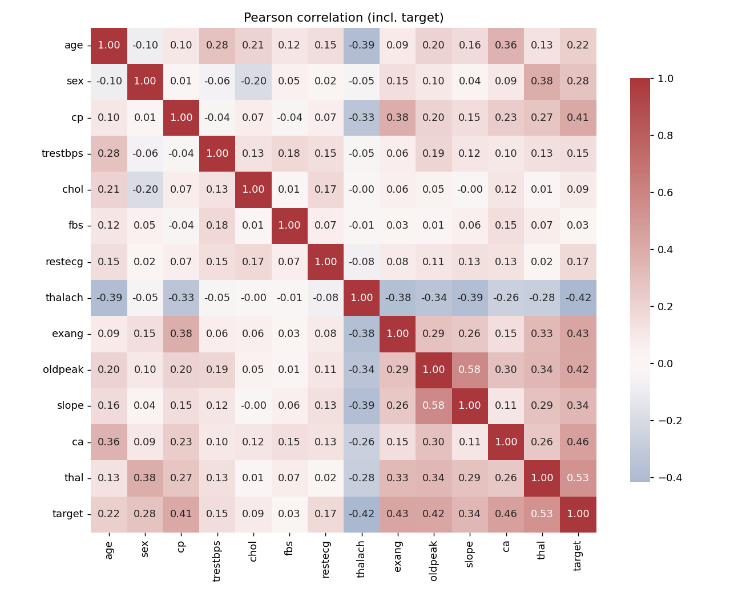
Figure 2 - Correlation heatmap including the target
The strongest linear associations with the target are thal (|r| = 0.53), ca (0.46), exang (0.43), oldpeak (0.43), thalach (0.42, negative) and cp (0.41). Cholesterol, resting blood pressure and fasting blood sugar carry very little signal. thal and cp are nominal codes, so their correlation is only indicative; this is why they are one-hot encoded rather than treated as numbers.
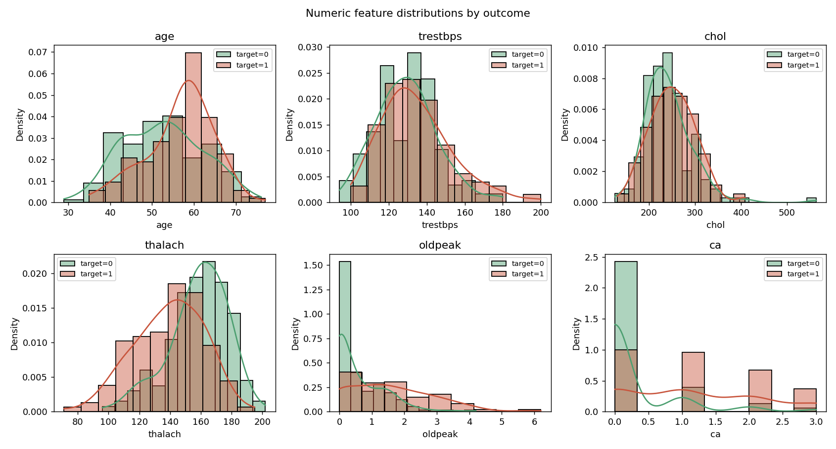
Figure 3 - Numeric distributions by outcome
Patients with disease are older on average, reach a lower maximum heart rate during exercise and show larger ST depression (oldpeak). Most healthy patients have ca = 0. Distributions are moderately skewed (oldpeak, chol) but without extreme outliers, so standard scaling is adequate. [Add your own interpretation here.]
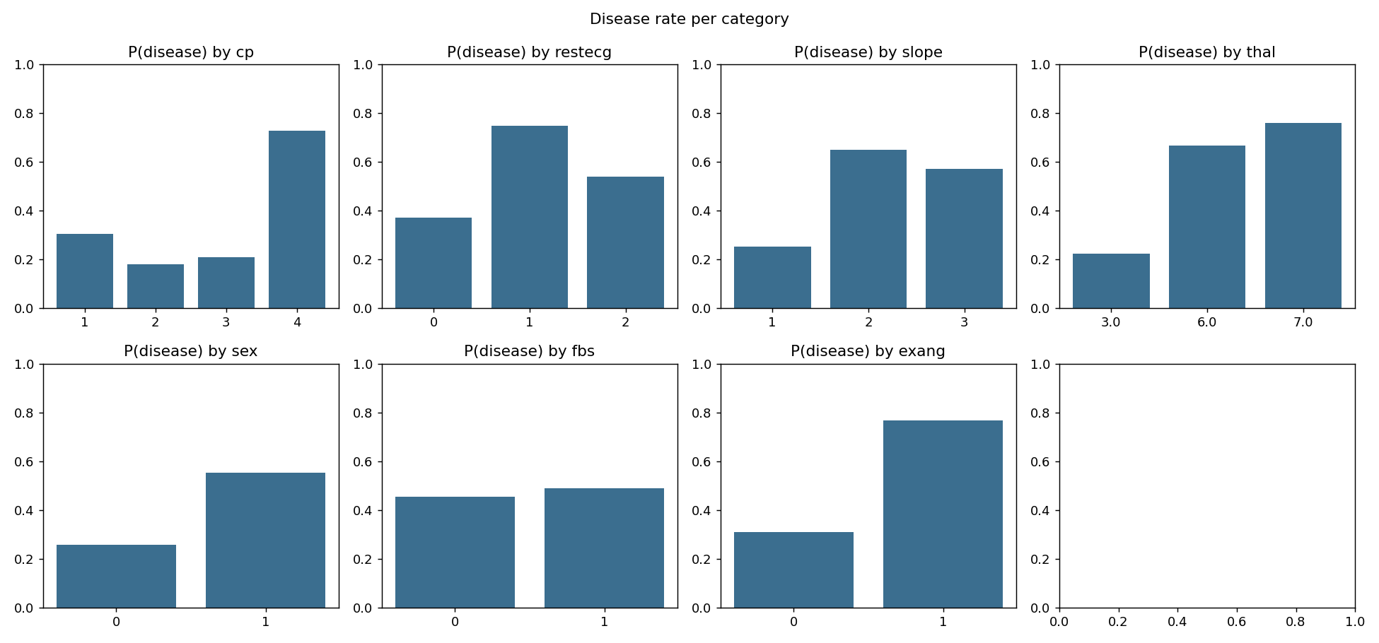
Figure 4 - Disease rate per category

3. Feature engineering and model development

3.1 Preprocessing pipeline
Group | Columns | Transformations
Numeric | age, trestbps, chol, thalach, oldpeak, ca | median imputation → StandardScaler
Binary | sex, fbs, exang | most-frequent imputation (already 0/1)
Nominal | cp, restecg, slope, thal | most-frequent imputation → OneHotEncoder(handle_unknown='ignore')

This produces 22 model features. The ColumnTransformer is fitted on the training split only (no leakage), saved as data/processed/preprocessor.joblib, and embedded in the final model Pipeline. A stratified 80/20 split (242 / 61 rows, seed 42) is persisted to split_indices.json so that training, evaluation and the notebook all use identical rows.

3.2 Candidate models and tuning
Model | Why | Search grid (GridSearchCV, 5-fold, ROC-AUC)
Logistic Regression | Interpretable linear baseline; coefficients explain risk factors | C ∈ {0.01, 0.1, 0.3, 1, 3}; penalty ∈ {l1, l2}; class_weight ∈ {None, balanced} (20 combos)
Random Forest | Captures non-linearities and interactions; robust to scaling | n_estimators ∈ {200, 400}; max_depth ∈ {None, 4, 6}; min_samples_leaf ∈ {1, 3, 5}; max_features ∈ {sqrt, 0.5} (36 combos)

ROC-AUC is the tuning and selection metric because it is threshold-independent and the classes are balanced. The model is chosen on mean cross-validated AUC on the training split; the test split is only a final, untouched check.

3.3 Results
Metric | Logistic Regression | Random Forest
Best params | C=0.3, L2, class_weight=balanced | 400 trees, depth 6, leaf 5, sqrt
CV ROC-AUC | 0.907 ± 0.019 | 0.901 ± 0.024
CV accuracy | 0.855 ± 0.027 | 0.826 ± 0.029
CV precision | 0.882 ± 0.070 | 0.841 ± 0.049
CV recall | 0.801 ± 0.075 | 0.773 ± 0.087
Test ROC-AUC | 0.961 | 0.957
Test accuracy | 0.869 | 0.885
Test precision | 0.813 | 0.839
Test recall | 0.929 | 0.929

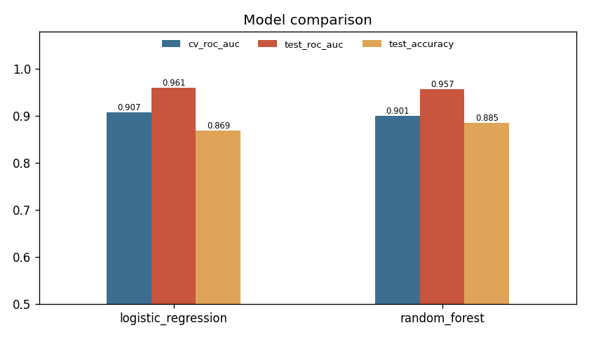
Figure 5 - Model comparison
Selected model: Logistic Regression. It has the higher CV ROC-AUC (0.907 vs 0.901) with lower variance across folds, and higher CV recall, which matters most in screening because a missed diagnosis costs more than a false alarm. Random Forest scores slightly higher accuracy on the 61-row test split, but a difference of one patient is within noise. Logistic Regression is also simpler, faster and explainable through its coefficients.
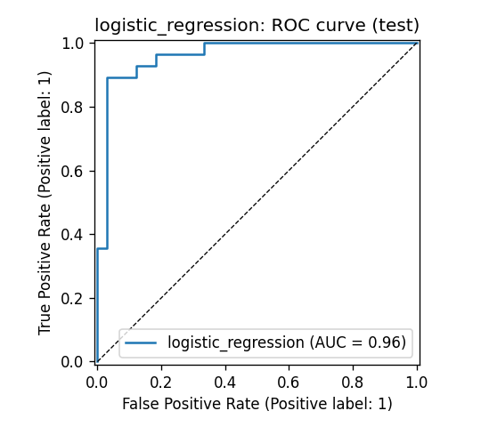
Figure 6 - ROC curve, selected model (test)
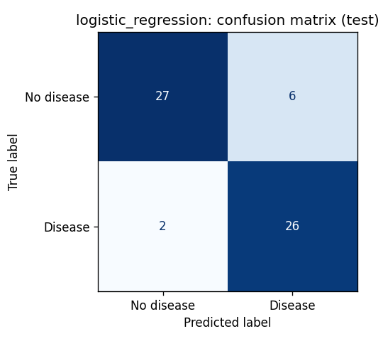
Figure 7 - Confusion matrix, selected model (test): 2 false negatives, 6 false positives
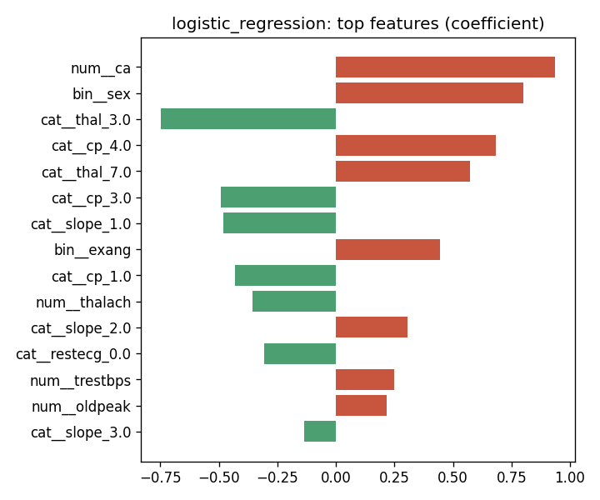
Figure 8 - Largest Logistic Regression coefficients (red = raises risk)

4. Experiment tracking with MLflow
Every training execution creates one MLflow run per model family in the experiment heart-disease-classifier (local file store mlruns/, committed to the repository and uploaded as a CI artifact).
Logged item | Content
Parameters | best hyper-parameters, cv_folds, test_size, grid_size, n_train, n_test
Metrics | CV mean and std for accuracy, precision, recall, F1, ROC-AUC; test metrics; best grid-search score
Artifacts | plots/ (confusion matrix, ROC, feature weights), tuning/grid_search_results.csv, classification_report.json
Model | mlflow.sklearn model with input signature and input example
Tags | model_family, sklearn and python versions, selected_as_best=true on the winning run (plus joblib/model.joblib)

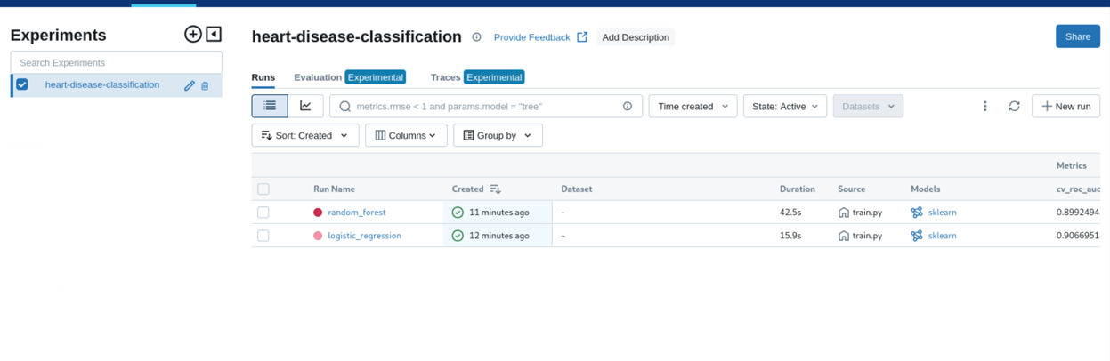

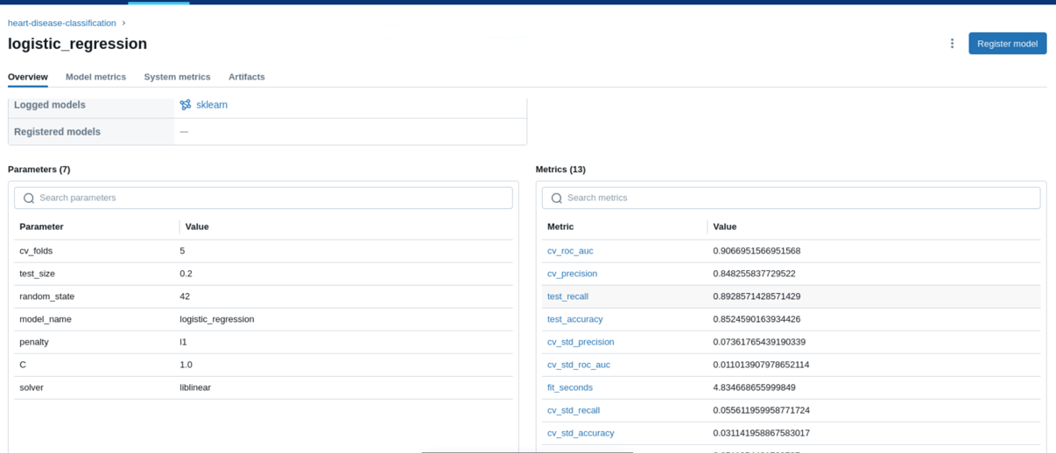

[ INSERT SCREENSHOT: screenshots/03_mlflow_artifacts.png ]
Artifacts of the selected run: plots, model, joblib

5. Model packaging and reproducibility
- Final model: artifacts/model/model.joblib, a single sklearn Pipeline (preprocessor + classifier), so raw patient values go in and no separate scaler is needed at serving time. model_meta.json stores params, metrics, sklearn version, training time and the MLflow run id.
- Transformers: data/processed/preprocessor.joblib (fitted on train) and the transformed matrix heart_features.csv.
- Environment: requirements.txt pins every library (numpy 1.26.4, pandas 2.2.3, scikit-learn 1.5.2, mlflow 2.17.2, fastapi 0.115.4 …). requirements-serve.txt is the minimal subset for the image, with the same numpy and scikit-learn versions so the pickle loads identically.
- Determinism: seed 42 for the split, CV folds and models; persisted split indices; re-running the pipeline reproduces the metrics above exactly.
- One code path: the notebook, the CLI (make pipeline), CI and the API all import src/.

6. CI/CD pipeline and automated testing

6.1 Unit tests
26 pytest tests run offline against a synthetic, UCI-shaped dataset (fast and deterministic):
File | What is verified
tests/test_data.py | '?' parsing; target binarisation; missing values preserved for the pipeline; de-duplication; impossible zeros flagged; mirror→UCI conversion; preprocessor output width, no NaNs, unit variance; deterministic stratified split; saved artefacts reload; both model families configured; models beat chance; metric arithmetic; unseen category handled; joblib round-trip identical
tests/test_api.py | /health 200 and 503 without a model; /predict returns prediction + confidence + request id; null ca/thal accepted; invalid age/cp/sex/chol → 422; batch endpoint; /metrics and /metrics/summary count predictions

6.2 GitHub Actions workflow (ci-cd.yml)
Triggered on push and pull_request to main (and manually). Four chained jobs: a failure in any job stops all later jobs and the run is marked red with the failing step's log.
Job | Steps | Evidence uploaded
1 Lint & test | checkout → Python 3.11 + pip cache → install → flake8 → black --check → pytest + coverage | junit.xml, coverage.xml
2 Train | download → EDA → MLflow training → held-out evaluation → quality gate (CV AUC ≥ 0.85) → summary table | model, artifacts/, mlruns/, train.log
3 Docker | build → run → smoke test → docker compose up → Prometheus scrape + Grafana dashboard check → push to GHCR (latest, v1, sha) | image tar, container logs
4 Minikube | start cluster → image load → apply manifests → scale to 3 → smoke test through Service → deploy Prometheus/Grafana → assert 3 targets UP | kubectl get all, describe, pod logs, events

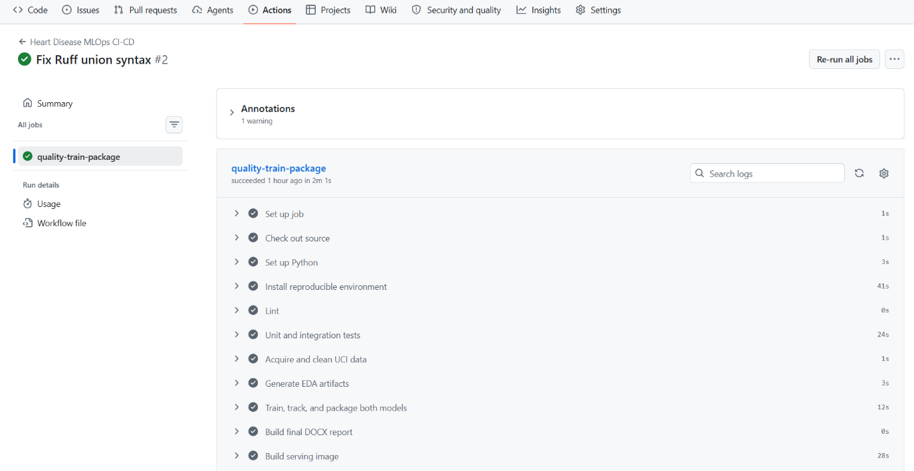

7. Model containerisation
The FastAPI service (src/app.py) loads the joblib pipeline at start-up and exposes:
Endpoint | Behaviour
GET /health | 200 {status: ok} once the model is loaded, 503 otherwise (used by Docker HEALTHCHECK and k8s probes)
POST /predict | JSON patient record → prediction (0/1), label, risk_probability, confidence, model_name
POST /predict/batch | 1-500 records
GET /model | served model metadata and MLflow run id
GET /metrics | Prometheus metrics
GET /docs | Swagger UI

Input is validated with Pydantic: value ranges (e.g. age 1-120, chol 80-700) and allowed codes (cp ∈ {1,2,3,4}, thal ∈ {3,6,7}). ca and thal may be null and are imputed. Confidence is the probability of the predicted class.
curl -X POST localhost:8000/predict -H "Content-Type: application/json" \
-d '{"age":58,"sex":1,"cp":4,"trestbps":140,"chol":260,"fbs":0,"restecg":2,
"thalach":130,"exang":1,"oldpeak":2.4,"slope":2,"ca":2,"thal":7}'
→ {"prediction":1,"label":"heart_disease","risk_probability":0.9913,"confidence":0.9913,...}

Dockerfile: two stages. The builder installs only requirements-serve.txt into /install. The runtime python:3.11-slim image copies that prefix plus three source files and the model, runs as non-root UID 10001, and defines a HEALTHCHECK against /health. Tests, notebooks, data and MLflow runs are excluded via .dockerignore, keeping the image small.
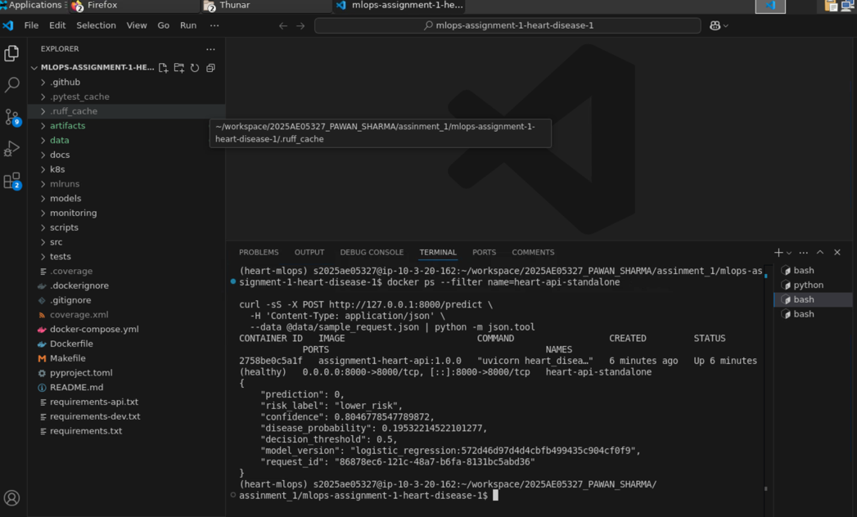

8. Production deployment
Registry: the image is pushed to GitHub Container Registry as ghcr.io/<you>/heart-disease-api (manually with a PAT, and automatically by CI with GITHUB_TOKEN).
Kubernetes (Minikube): the image is loaded onto the node with minikube image load and deployed from the manifests in k8s/:
- Namespace heart-risk.
- Deployment heart-api: 2 replicas (scaled to 3-5), RollingUpdate with maxUnavailable 0, readiness and liveness probes on /health, CPU/memory requests and limits, non-root security context, prometheus.io/scrape annotations.
- Service type LoadBalancer on port 80 (external IP via minikube tunnel; NodePort 30080 also usable) and an nginx Ingress for host heart-api.local.
minikube image load heart-disease-api:v1
kubectl apply -f k8s/namespace.yaml -f k8s/deployment.yaml -f k8s/service.yaml
kubectl -n heart-risk scale deployment/heart-api --replicas=3
kubectl -n heart-risk port-forward svc/heart-api 8080:80

docker compose offers the same stack without Kubernetes: API, Prometheus and Grafana with one command.
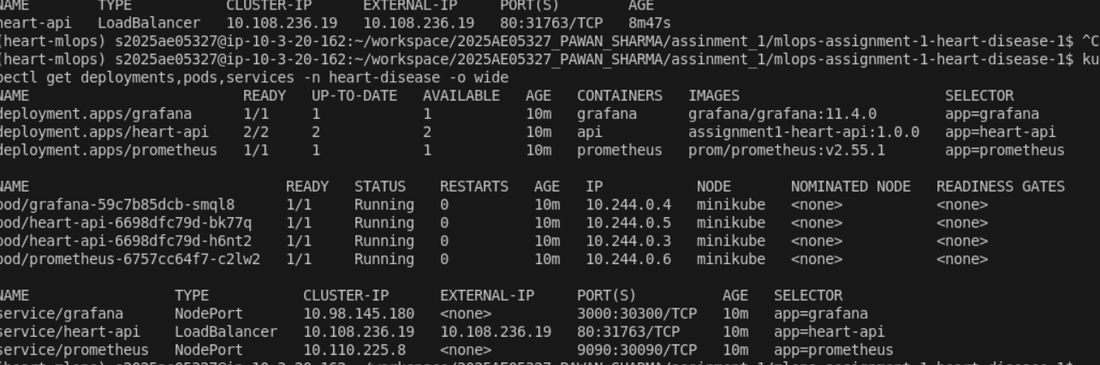

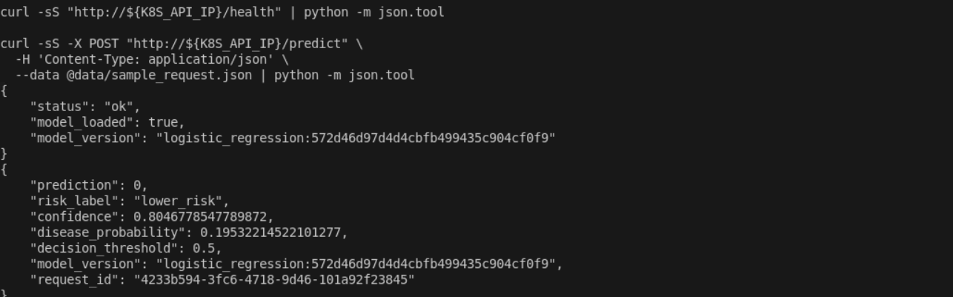

9. Monitoring and logging
Logging: middleware writes one JSON line per request (timestamp, request id, method, path, status, latency in ms, client, pod) to stdout, where `kubectl logs` and `docker logs` collect it. Each response carries an x-request-id header for tracing.
Metrics exposed on /metrics:
Metric | Type | Purpose
heart_api_requests_total{method,endpoint,status} | counter | throughput, 4xx/5xx rate
heart_api_request_latency_seconds{endpoint} | histogram | p50/p95/p99 latency
heart_api_predictions_total{label} | counter | predicted class mix (a simple drift signal)
heart_api_risk_probability | histogram | distribution of predicted risk
heart_api_prediction_errors_total | counter | inference failures
heart_api_model_info / _model_loaded | gauge | which model is live / readiness

Prometheus (prom/prometheus:v2.54.1, loaded into Minikube) discovers API pods through the Kubernetes API using a ServiceAccount with read-only RBAC, so every replica is scraped individually and scaling is visible immediately. Three alert rules are defined: API down, error rate > 5 %, and p95 /predict latency > 500 ms.
Grafana (grafana/grafana:11.2.0) is provisioned with the Prometheus datasource and a 12-panel dashboard: pods up, requests/s, error %, p95 latency, high-risk share, request rate by endpoint/status, latency percentiles, predictions by class, requests per pod, risk distribution, and served model.
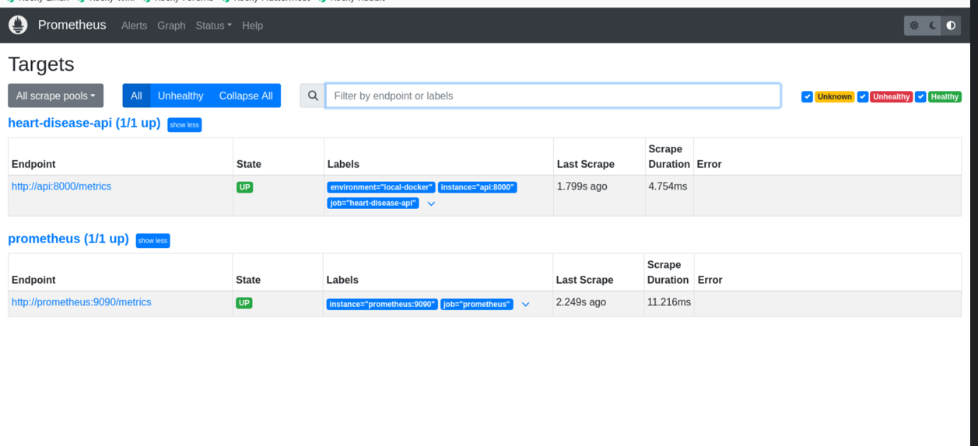

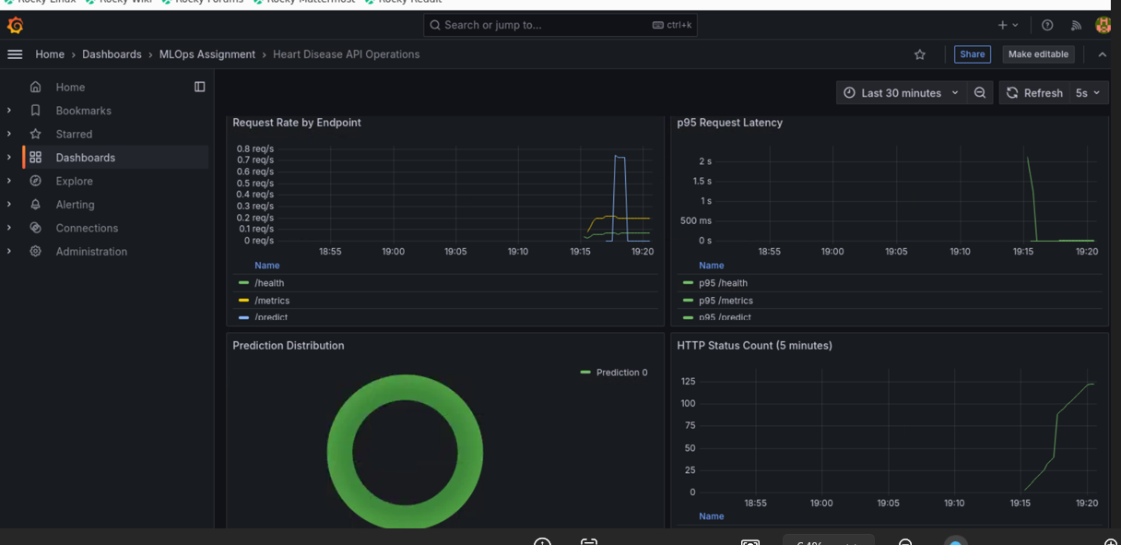

[ INSERT SCREENSHOT: screenshots/09_scale_grafana.png ]
Requests-per-pod panel after kubectl scale --replicas=5

10. Architecture
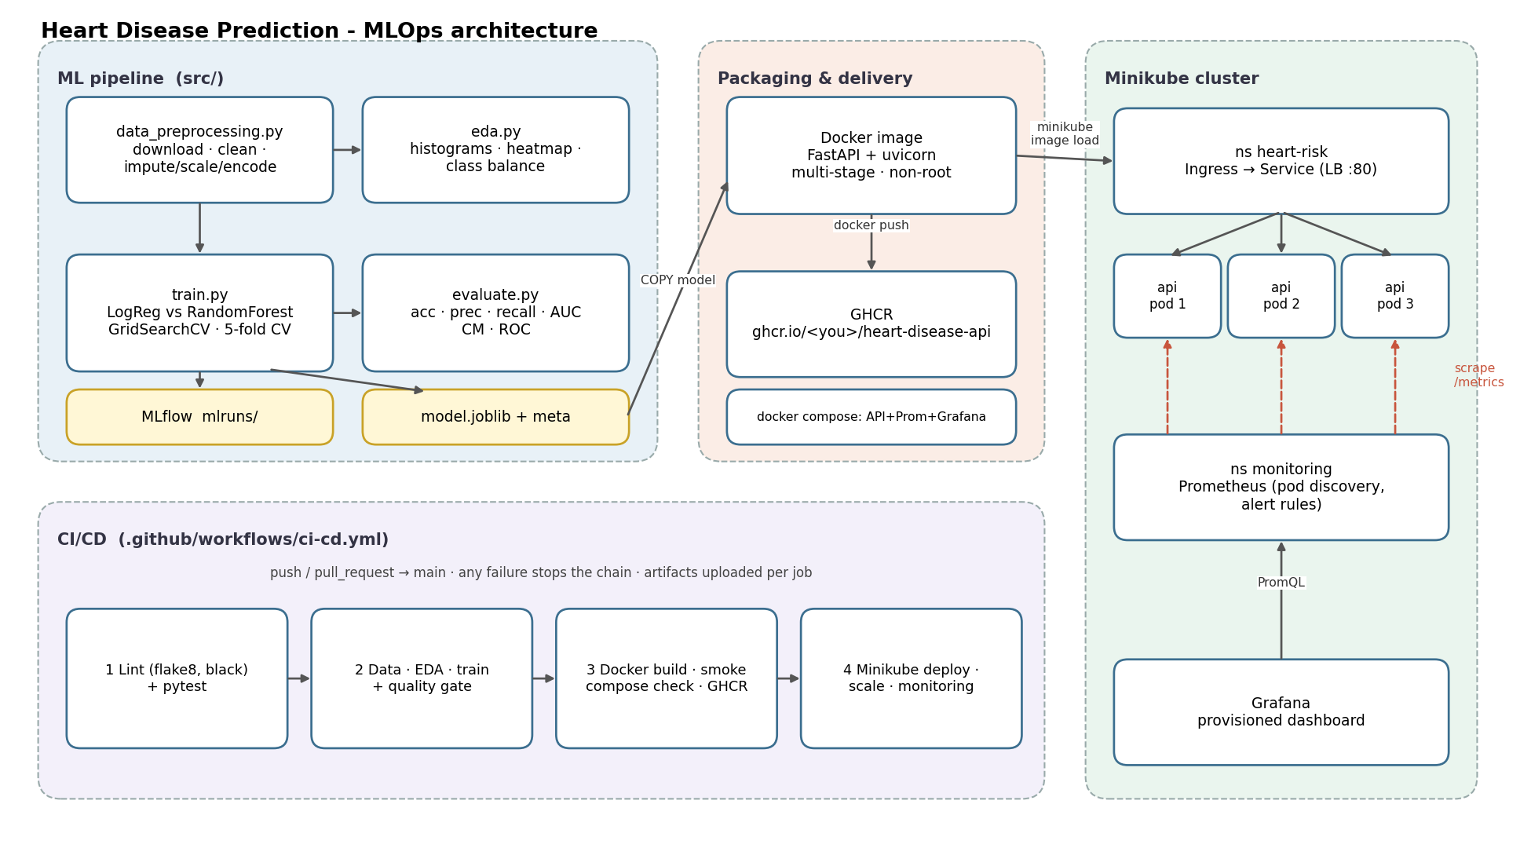
Figure 9 - System architecture
The ML pipeline produces a single versioned artefact (the joblib Pipeline) that flows unchanged through Docker, GHCR and Kubernetes. GitHub Actions automates every stage, and Prometheus/Grafana close the loop by observing the running service.

11. Setup and run instructions
git clone https://github.com/<you>/mlops-assignment-1-heart-disease && cd mlops-assignment-1-heart-disease
python -m venv .venv && source .venv/bin/activate && pip install -r requirements.txt
make pipeline # data → EDA → train (MLflow) → evaluate
make lint test # flake8, black, pytest
make docker-build docker-test
docker compose up -d --build # API :8000, Prometheus :9090, Grafana :3000
scripts/deploy_minikube.sh 3 && scripts/deploy_monitoring.sh

A stage-by-stage walkthrough for GitHub Codespaces with one commit per stage is in docs/RUNBOOK.md.

12. Limitations and future work
- 303 patients from a single hospital: the confidence intervals on test metrics are wide, and the model may not transfer to other populations without recalibration.
- The 0.5 threshold is a default; a clinical deployment would tune it for recall at an agreed precision.
- Monitoring covers service health and the prediction mix; true model-performance monitoring would need delayed ground-truth labels and feature-drift tests (e.g. PSI/KS on inputs).
- Next steps: MLflow Model Registry with a remote tracking server, Helm chart, HPA on CPU/RPS, and automated retraining triggered by drift alerts.

References
Janosi, A., Steinbrunn, W., Pfisterer, M., & Detrano, R. (1988). Heart Disease [Dataset]. UCI Machine Learning Repository. https://doi.org/10.24432/C52P4X
Documentation: scikit-learn, MLflow, FastAPI, Docker, Kubernetes, Prometheus and Grafana official docs.

