Machine Learning Operations (AIMLCZG523)
Assignment 01
Heart Disease Risk Prediction:
An End-to-End MLOps Pipeline from Data to Monitored Kubernetes API
Student: [Your Name]
BITS ID: [Your ID]
Code repository: https://github.com/<your-username>/heart-risk-mlops
Pipeline video: [link]
October 2026

Contents

1. Overview
The goal is to predict whether a patient has heart disease from 13 routinely collected clinical attributes, and to deliver that model as a reproducible, tested, containerised and monitored web service. The project covers the full lifecycle: data acquisition, exploratory analysis, feature engineering, model selection with experiment tracking, packaging, CI/CD, Docker, Kubernetes deployment and monitoring.
Headline result: an L2-regularised Logistic Regression reaches a 5-fold cross-validated ROC-AUC of 0.908 (± 0.037) and, on a held-out 20% test set, ROC-AUC 0.922, accuracy 0.852, precision 0.880 and recall 0.786. It is served by a FastAPI application exposing /predict, deployed to Minikube behind a LoadBalancer and an Ingress, and scraped by Prometheus with a Grafana dashboard.

1.1 Architecture
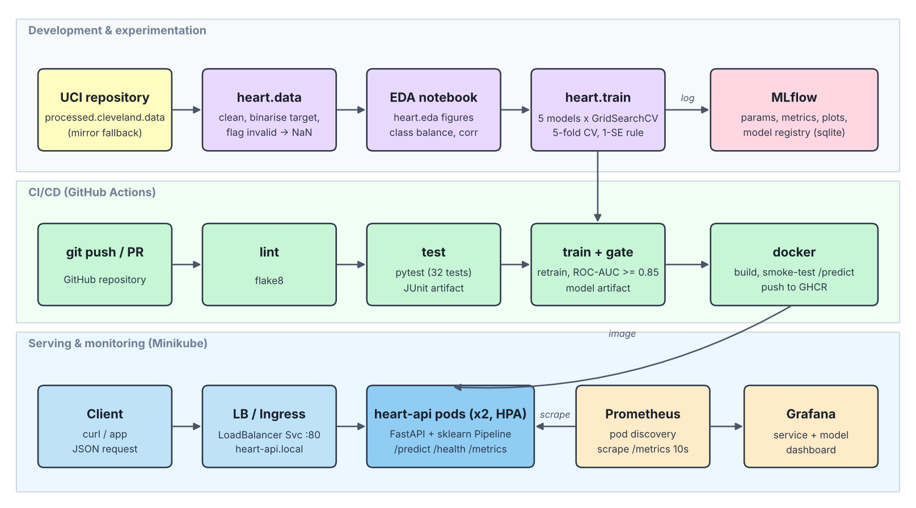
Figure 1. System architecture: experimentation, CI/CD and serving/monitoring layers.
Three layers share one code base (src/heart). The experimentation layer produces a cleaned dataset, EDA figures and an MLflow-tracked model. The CI/CD layer re-runs lint, tests and training on every push, applies a quality gate and builds a Docker image. The serving layer runs that image on Kubernetes, with Prometheus discovering every API pod and Grafana visualising service and model metrics.

2. Setup and Installation
All steps run from a clean Python 3.13 environment; the same version is used locally, in CI and in the Docker image.
git clone https://github.com/<your-username>/heart-risk-mlops && cd heart-risk-mlops
python -m venv .venv && source .venv/bin/activate
pip install -r requirements.txt && pip install -e .

python -m heart.data # download + clean -> data/processed/heart_clean.csv
python -m heart.eda # EDA figures -> reports/figures/
python -m heart.train # tune 5 models, log to MLflow -> models/model.joblib
pytest -v && flake8 src api tests
mlflow ui --backend-store-uri sqlite:///mlflow.db --port 5000
uvicorn api.app:app --port 8000 # http://localhost:8000/docs
A Makefile wraps the same commands (make setup data train test serve), and environment.yml provides a Conda alternative. Two requirement files are kept: requirements.txt (everything, pinned) and requirements-serve.txt (runtime only, used by the Docker image), with identical pins for scikit-learn and XGBoost so the pickled pipeline loads exactly as trained.

3. Data Acquisition and Exploratory Analysis

3.1 Acquisition
The Cleveland subset of the UCI Heart Disease dataset (303 patients) is downloaded by heart.data.download(). It requests processed.cleveland.data from the UCI repository; if that fails (UCI outages are common, and some networks block it), it falls back to a widely used GitHub copy of the same records. That copy uses a different coding (0-based categories, inverted target), so the script maps it back to the original UCI coding. A unit test pins the mapping against the first record of the original file so both sources yield an identical schema.

3.2 Cleaning
- The 0-4 diagnosis num is binarised: 0 = no disease, 1-4 = disease (164 vs 138 patients).
- One exact duplicate row is removed (302 rows remain).
- Out-of-range category codes and impossible values (cholesterol or blood pressure of 0) are set to missing rather than dropped.
- Missing values (ca: 4, thal: 2) are left as NaN and imputed inside the model pipeline, so the same logic is applied at training and serving time and nothing leaks from the test split. The API therefore also accepts requests without ca or thal.

3.3 Exploratory findings
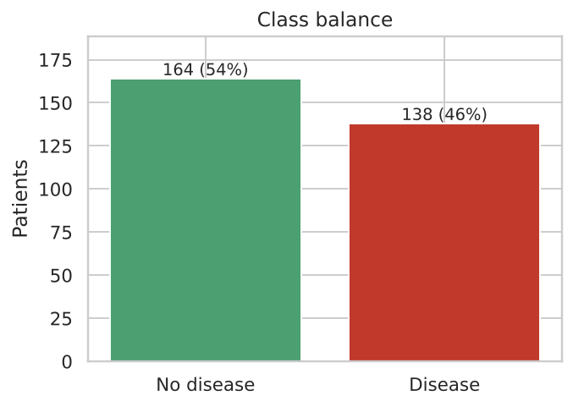
Figure 2. Class balance after binarisation.
Classes are close to balanced (54% / 46%), so accuracy is informative; precision, recall and ROC-AUC are still reported and all splits are stratified.
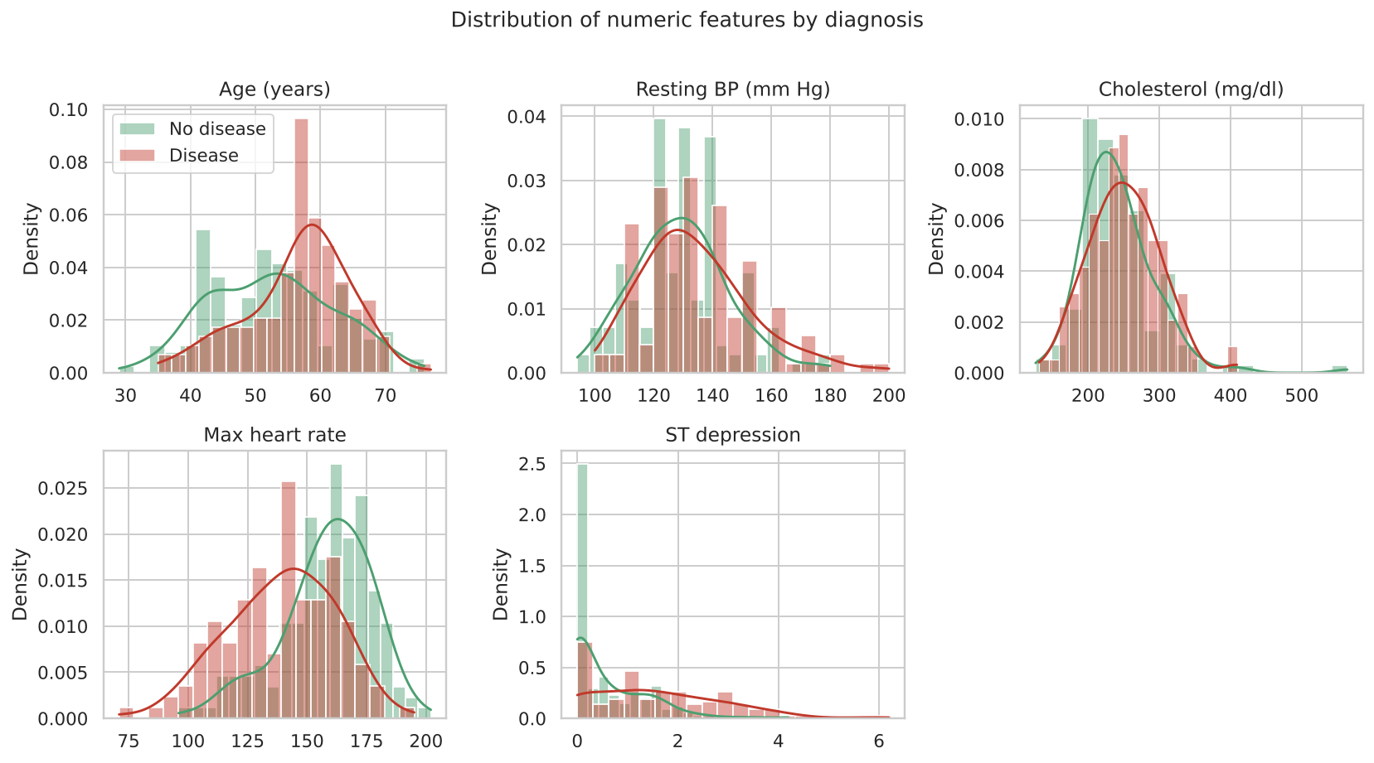
Figure 3. Numeric features by diagnosis.
Patients with disease reach a lower maximum heart rate (thalach) and show more exercise-induced ST depression (oldpeak); age is shifted upward. Cholesterol and resting blood pressure overlap almost completely and carry little standalone signal.
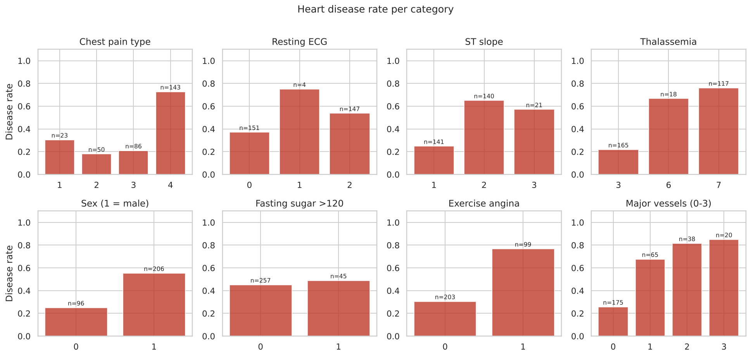
Figure 4. Disease rate per category (n = patients in each category).
The strongest categorical markers are asymptomatic chest pain (cp = 4, 73% disease rate), a reversible thalassemia defect (thal = 7, 76%), exercise-induced angina (77%) and the number of fluoroscopy-coloured vessels, which rises monotonically from 25% to 85%. restecg = 1 has only 4 patients, so its rate is not reliable. Fasting blood sugar shows almost no difference.
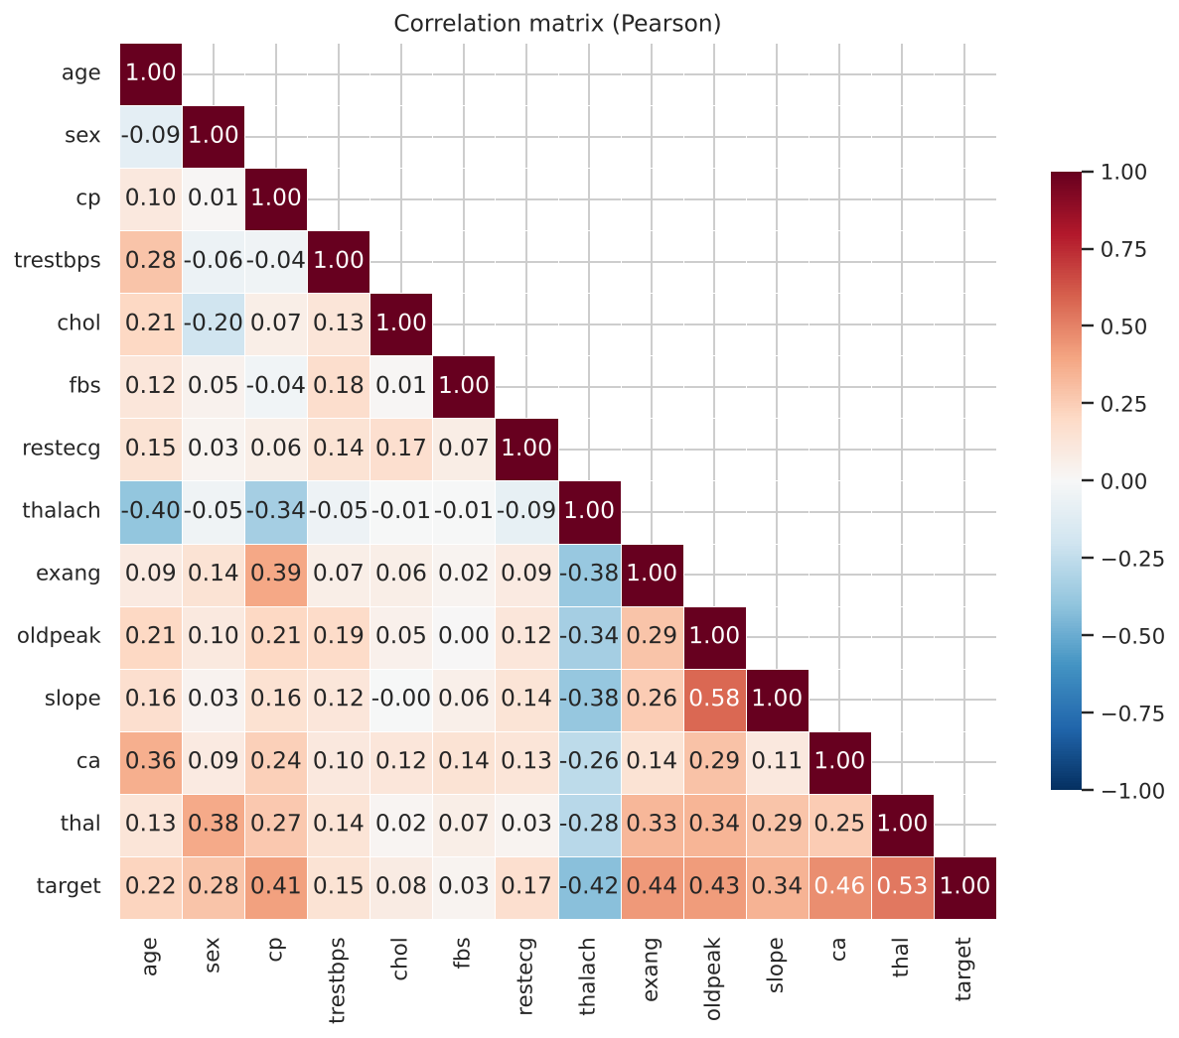
Figure 5. Pearson correlation matrix.
No feature pair is strongly collinear (|r| < 0.6), so all 13 features are kept. The largest absolute correlations with the target are thal (0.53), ca (0.46), exang (0.44), oldpeak (0.43), thalach (-0.42) and cp (0.41). Box plots, a missing-value chart and a target-correlation chart are in the repository and in notebooks/01_eda.ipynb.

4. Feature Engineering and Model Development

4.1 Preprocessing pipeline
Preprocessing is a single scikit-learn ColumnTransformer stored inside the model Pipeline:
Group | Features | Transform
Numeric (6) | age, trestbps, chol, thalach, oldpeak, ca | median imputation, then StandardScaler
Binary (3) | sex, fbs, exang | most-frequent imputation, passed through
Nominal (4) | cp, restecg, slope, thal | most-frequent imputation, then one-hot (unknown codes ignored)

This yields 22 model inputs. ca is ordinal (0-3) and its disease rate rises monotonically, so it is scaled rather than one-hot encoded. The nominal codes have no natural order (e.g. thal 3 / 6 / 7), which is why they are one-hot encoded. Scaling matters for the distance- and margin-based models (KNN, SVM) and for regularised Logistic Regression.

4.2 Models and tuning
The data are split 80/20 (stratified, seed 42). On the 241-row training split, each model family is tuned with GridSearchCV using 5-fold stratified cross-validation, scored on accuracy, precision, recall, F1 and ROC-AUC, and refit on ROC-AUC. The 61-row test split is used only for final reporting.
Model | Grid searched | Best parameters
Logistic Regression | C ∈ {0.01 … 5}, l1_ratio ∈ {0, 0.5, 1} (15) | C = 0.1, l1_ratio = 0 (L2)
Random Forest | trees {200, 400}, depth {3, 5, None}, min leaf {1, 3, 5} (18) | 200 trees, depth 3, leaf 3
XGBoost | trees, depth, learning rate, subsample (24) | 100 trees, depth 3, lr 0.03, subsample 0.8
SVM (RBF, calibrated) | C {0.1 … 5}, gamma {scale, 0.01, 0.05} (12) | C = 1, gamma = 0.01
KNN | k {5, 9, 15, 21}, weights {uniform, distance} (8) | k = 21, distance-weighted

Every family prefers strong regularisation or shallow trees, which is expected with about 240 training rows. The SVM is wrapped in CalibratedClassifierCV so that it returns a calibrated probability, needed for the API's confidence output.

4.3 Results and model selection
Model | CV ROC-AUC (± SD) | CV acc. | Test ROC-AUC | Test acc. | Test prec. | Test recall
Random Forest | 0.916 ± 0.029 | 0.822 | 0.893 | 0.787 | 0.826 | 0.679
SVM (RBF) | 0.913 ± 0.039 | 0.847 | 0.911 | 0.852 | 0.880 | 0.786
Logistic Regression ★ | 0.908 ± 0.037 | 0.850 | 0.922 | 0.852 | 0.880 | 0.786
XGBoost | 0.903 ± 0.037 | 0.813 | 0.895 | 0.787 | 0.826 | 0.679
KNN | 0.894 ± 0.040 | 0.838 | 0.905 | 0.787 | 0.800 | 0.714

Selection rule. Random Forest has the highest mean CV ROC-AUC, but the spread between all five families (0.894-0.916) is smaller than the fold-to-fold standard deviation (about 0.03-0.04). Picking the top mean would mostly be picking noise. The training script therefore applies the one-standard-error rule: among the families whose CV ROC-AUC lies within one SD of the best (here, all five), it chooses the simplest. Logistic Regression is selected. It also generalises best to the untouched test split, trains in milliseconds, and its coefficients are directly interpretable. The rule is implemented in select_champion() and covered by a unit test, so the choice is automated and reproducible rather than made by hand.
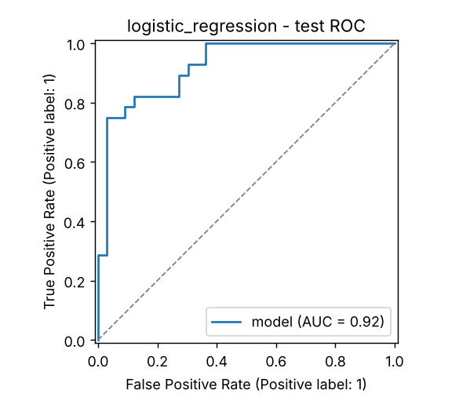
Figure 6. Champion ROC curve on the test split (AUC 0.922).
On the test split the champion produces 22 true positives, 30 true negatives, 3 false positives and 6 false negatives. In a screening context false negatives are the costlier error, so the decision threshold is exposed as a configuration value (DECISION_THRESHOLD) rather than hard-coded.
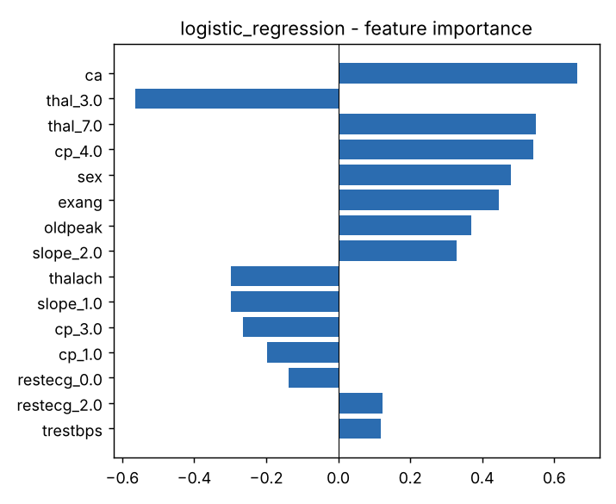
Figure 7. Logistic Regression coefficients (standardised inputs).
The largest coefficients (number of coloured vessels, thalassemia type, asymptomatic chest pain, male sex, exercise angina, ST depression) match the EDA findings and established clinical risk factors, which supports the model's validity.

5. Experiment Tracking with MLflow
MLflow (SQLite backend, mlflow.db) is integrated directly into heart.train. One training execution creates 83 runs in the experiment heart-disease-classification:
- 5 parent runs (one per model family): best hyper-parameters; grid size; CV mean and SD for all five metrics; test metrics; training time; artifacts (confusion matrix, ROC curve, feature-importance plot, full CV results CSV); and the fitted pipeline logged as an MLflow model with input signature and example.
- 77 nested child runs, one per grid candidate, with its parameters, mean CV metrics and rank. This makes the whole search comparable in the MLflow UI, not just the winners.
- 1 champion-selection run recording the selection rule, the chosen family, the comparison table and the model metadata. The champion is also registered as heart-disease-classifier in the MLflow Model Registry.
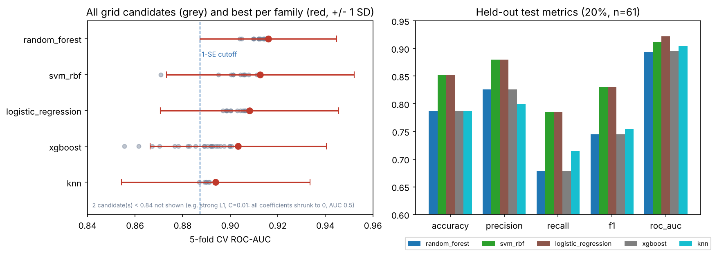
Figure 8. All 77 tracked candidates and per-family best (left); held-out test metrics (right).
Figure 8 is generated from the MLflow database itself. It shows that the tuning grids span a wide range (one heavily regularised L1 candidate collapses to AUC 0.5), while the best configurations of all families overlap within their error bars.
[ INSERT SCREENSHOT ] MLflow UI: experiment run list comparing the 5 parent runs (metrics columns visible)

[ INSERT SCREENSHOT ] MLflow UI: one parent run showing parameters, metrics and the evaluation/ artifacts folder

6. Model Packaging and Reproducibility
- Single artefact. The champion is saved as models/model.joblib, a complete Pipeline (imputers, scaler, one-hot encoder, classifier). Raw patient values go in and probabilities come out; there is no separate preprocessing code to drift out of sync between notebook, training and serving.
- MLflow format. Each family's pipeline is also logged as an MLflow model with signature and input example, and the champion is in the registry, so it can be served with mlflow models serve as an alternative.
- Metadata. models/model_meta.json records the model family, MLflow run ID, parameters, feature order, threshold, selection rule, scores and training timestamp. The API reports the run ID as its model version.
- Determinism. A fixed seed is used for splits, CV folds and all estimators; retraining reproduces identical metrics. Dependencies are pinned to exact versions.
- Notebooks. Three executed notebooks (EDA, training and tracking, inference) call the same package functions as the scripts, so they cannot diverge from the production code.

7. CI/CD Pipeline and Automated Testing

7.1 Unit tests
The tests/ folder contains 32 pytest tests:
File | What is tested
test_data.py (7) | target binarisation, duplicate removal, invalid values become NaN, valid category codes, input not mutated, mirror re-coding, cleaned-data schema
test_features.py (5) | no NaNs after preprocessing, output width (22), numeric scaling, missing and unseen category handling, column-order independence
test_model.py (11) | required models present, every family trains and beats AUC 0.75, metrics function, feature importance, one-SE selection rule, saved model quality
test_api.py (9) | health/ready, single and batch prediction, optional fields, four invalid payloads return 422, Prometheus metrics exposed

The API tests train a tiny model into a temporary directory, so they do not depend on a pre-built artefact.

7.2 GitHub Actions workflow
.github/workflows/ci.yml runs on every push, pull request and manual dispatch. Jobs are chained, so any failure stops the pipeline with the failing step's log:
Job | Steps | Artifacts
1. lint | flake8 over src, api, tests (fails on any violation) | console log
2. test | install pinned requirements, prepare data, pytest -v | JUnit XML report
3. train | full training with MLflow; quality gate: champion CV ROC-AUC must be ≥ 0.85 | model, mlflow.db, plots, training log
4. docker | build image with this run's model, start container, call /predict and assert the response; push to GHCR on main | prediction JSON, container logs

The workflow was validated with actionlint. Fail-fast behaviour was exercised during development: flake8 flagged three over-long lines, and a test caught a tuning grid whose first candidate was too heavily regularised to learn. Both were fixed before the code was finalised.
[ INSERT SCREENSHOT ] GitHub Actions: successful workflow run showing lint → test → train → docker

[ INSERT SCREENSHOT ] GitHub Actions: artifacts list for the run (test-report, model-and-experiments, container-smoke-test)

8. Model Containerisation
The service is a FastAPI application (api/app.py) with Pydantic validation (api/schemas.py):
Endpoint | Purpose
POST /predict | one patient object, or {"instances": [...]} for up to 500; returns prediction, label, confidence and P(disease)
GET /health | liveness probe
GET /ready | readiness probe; returns 503 until the model is loaded
GET /model-info | model family, version (MLflow run ID), threshold, metadata
GET /metrics | Prometheus exposition format

Inputs are range-checked (for example age 1-120, cp ∈ {1,2,3,4}) and unknown fields are rejected, so malformed requests get a clear 422 response instead of a silent wrong prediction.
$ curl -X POST localhost:8000/predict -H 'Content-Type: application/json' \
-d '{"age":67,"sex":1,"cp":4,"trestbps":160,"chol":286,"fbs":0,"restecg":2,
"thalach":108,"exang":1,"oldpeak":1.5,"slope":2,"ca":3,"thal":3}'
{"model_name":"logistic_regression","model_version":"fc709b7b",
"predictions":[{"prediction":1,"label":"disease","confidence":0.9652,
"probability_disease":0.9652}]}
The Dockerfile is a two-stage build on python:3.13-slim. The first stage installs only the serving requirements into a virtualenv; the runtime stage copies that virtualenv, the source and the model, runs as a non-root user (uid 1001), and defines a HEALTHCHECK on /health. A single uvicorn worker runs per container because Prometheus counters live in process memory; horizontal scaling is done with Kubernetes replicas instead.
docker build -t heart-risk-api:1.0.0 .
docker run --rm -p 8000:8000 heart-risk-api:1.0.0
./scripts/smoke_test.sh http://localhost:8000
[ INSERT SCREENSHOT ] Terminal: docker build output and docker ps showing the container (healthy)

[ INSERT SCREENSHOT ] Terminal: ./scripts/smoke_test.sh output against the container

9. Production Deployment on Kubernetes (Minikube)
The manifests in k8s/ are applied together with Kustomize (kubectl apply -k k8s/) and were schema-validated against Kubernetes 1.33:
Resource | Configuration
Namespace | heart-mlops
Deployment heart-api | 2 replicas, rolling update (maxUnavailable 0), CPU/memory requests and limits, readiness probe on /ready, liveness probe on /health, non-root, Prometheus scrape annotations
Service (LoadBalancer) | port 80 → 8000; external IP via minikube tunnel
Ingress (nginx) | host heart-api.local → service
HorizontalPodAutoscaler | 2-5 replicas at 70% CPU
Prometheus | ServiceAccount + Role for pod discovery, ConfigMap, Deployment, NodePort 30090
Grafana | provisioned datasource and dashboard from ConfigMaps, NodePort 30300

The script scripts/deploy_minikube.sh starts Minikube, enables the ingress and metrics-server add-ons, builds the image directly inside Minikube's Docker daemon (so no registry is needed), applies the manifests and waits for the rollout.
./scripts/deploy_minikube.sh
minikube tunnel # second terminal
kubectl -n heart-mlops get pods,svc,ingress,hpa
./scripts/smoke_test.sh http://<EXTERNAL-IP>
curl http://heart-api.local/health # after adding minikube ip to /etc/hosts
[ INSERT SCREENSHOT ] kubectl -n heart-mlops get pods,svc,ingress,hpa (pods Running, LoadBalancer EXTERNAL-IP)

[ INSERT SCREENSHOT ] curl /predict through the LoadBalancer IP and through heart-api.local (Ingress)

10. Monitoring and Logging
Logging. A middleware writes one structured JSON log line per request (request ID, method, path, status, latency, client) and the endpoint writes one line per prediction (labels and probabilities). The request ID is returned in the x-request-id header so a client report can be traced to its log line. In Kubernetes these logs are read with kubectl logs.
{"ts": "2026-10-18T13:04:54", "level": "INFO", "msg": "request", "request_id": "31a70b3fd99a",
"method": "POST", "path": "/predict", "status": 200, "latency_ms": 23.77}
Metrics. Prometheus scrapes every pod every 10 seconds:
Metric | Type | Used for
api_requests_total{endpoint,status} | counter | traffic and error ratio
api_request_latency_seconds | histogram | p50 / p95 / p99 latency
model_predictions_total{label} | counter | prediction mix over time
model_prediction_confidence | histogram | mean confidence
model_probability_disease | histogram | score distribution (drift signal)
model_loaded{model_name,version} | gauge | which model version is live

The Grafana dashboard (provisioned automatically from monitoring/grafana/dashboards/heart-api.json) has stat panels for total predictions, request rate, p95 latency and error ratio, plus time series for requests by endpoint and status, latency percentiles, predictions by label, and mean confidence / mean P(disease). A sudden shift in the share of "disease" predictions or in mean confidence is a cheap early indicator of input drift. scripts/load_test.py replays dataset rows (5% deliberately invalid) to populate the dashboard.
[ INSERT SCREENSHOT ] Grafana: Heart Disease API dashboard after running load_test.py

[ INSERT SCREENSHOT ] Prometheus: Status → Targets showing both heart-api pods UP

11. Limitations and Future Work
- The Cleveland dataset is small (302 patients) and from a single centre in the 1980s; the CV spread of ±0.04 AUC shows how uncertain any single number is. Validation on the Hungarian, Swiss and VA subsets would test generalisation.
- The 0.5 threshold optimises accuracy; for screening, a lower threshold chosen on CV to reach a target recall would be more appropriate and only requires changing DECISION_THRESHOLD.
- Monitoring tracks output distributions; adding per-feature input drift statistics (for example a population stability index) and alerting rules in Prometheus would complete the loop.
- The model is baked into the image for reproducibility; pulling the registered model from an MLflow server at start-up would allow model updates without rebuilding the image.

12. Deliverables and Links
Deliverable | Location
Code repository | https://github.com/<your-username>/heart-risk-mlops
Download script / instructions | src/heart/data.py, scripts/download_data.sh, README §2
Cleaned dataset | data/processed/heart_clean.csv
Notebooks | notebooks/01_eda, 02_training_and_tracking, 03_inference
Unit tests | tests/ (32 tests)
CI/CD workflow | .github/workflows/ci.yml
Dockerfile and requirements | Dockerfile, requirements.txt, requirements-serve.txt, environment.yml
Deployment manifests | k8s/ (Kustomize), docker-compose.yml
Monitoring | monitoring/, k8s/monitoring/
Screenshots | screenshots/
API access | Local: http://<EXTERNAL-IP> via minikube tunnel, or http://heart-api.local (Ingress)
Pipeline video | [link]

