MLOps Assignment 1: Heart Disease Prediction
Student: Hussain Badri
ID: 2025AF05063
Repository: https://github.com/2025af05063-a11y/MlopsAssignment1
Report date: 20 October 2026
Submission note: the evidence screenshots, student name, and repository URL are included. Verify the Prometheus target and final CI status, then export and review the PDF and video before submission.

1. Project Overview
This project implements an end-to-end machine-learning workflow for the UCI Cleveland Heart Disease dataset. It downloads and explores the data, cleans and transforms it, compares two classifiers, logs experiments with MLflow, serves predictions through FastAPI, packages the service as a Docker image, and deploys it to Kubernetes on Minikube. Prometheus and Grafana are running in the cluster for monitoring.
The API returns a model-estimated probability and a binary prediction. It is an educational demonstration, not a clinical diagnostic tool.

2. Architecture
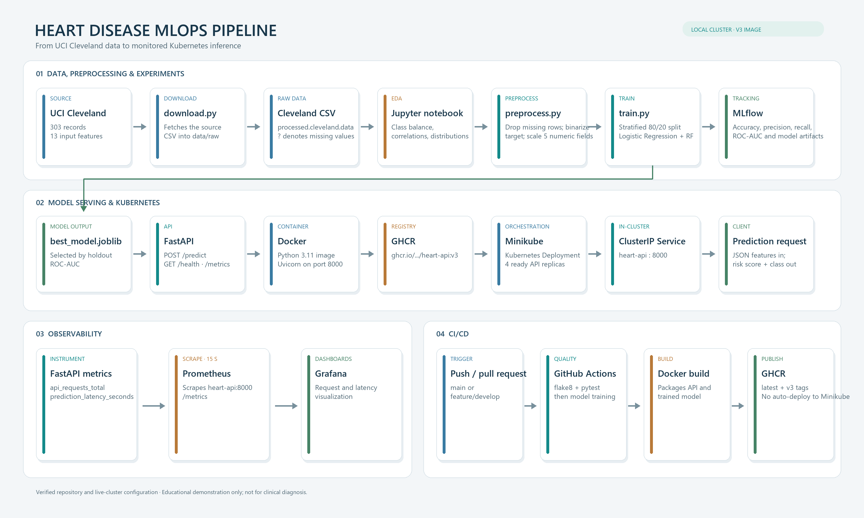
Heart Disease MLOps architecture
The checked-in workflow publishes both latest and v3, matching the image tag used by the live Minikube deployment. The workflow builds and publishes images; it does not deploy them to Minikube.

3. Reproduction and Setup
The commands below assume Windows PowerShell, Docker Desktop, Minikube, and a GitHub Container Registry account. Run commands from the repository root.
# Create and install into a project virtual environment
py -m venv .venv
.\.venv\Scripts\python.exe -m pip install -r requirements.txt
# Download the data and train the models
.\.venv\Scripts\python.exe data/download.py
$env:MLFLOW_TRACKING_URI = "sqlite:///mlflow.db"
.\.venv\Scripts\python.exe -m src.train
# View the experiment database created by training
.\.venv\Scripts\mlflow.exe ui --backend-store-uri sqlite:///mlflow.db --port 5000
Open http://localhost:5000 to compare runs. To run the API locally after training, use a separate terminal from the repository root:
.\.venv\Scripts\python.exe -m uvicorn src.api:app --host 127.0.0.1 --port 8000
Check the health endpoint at http://localhost:8000/health. For a local prediction request in PowerShell:
$body = @{
age = 63; sex = 1; cp = 3; trestbps = 145; chol = 233
fbs = 1; restecg = 0; thalach = 150; exang = 0
oldpeak = 2.3; slope = 0; ca = 0; thal = 1
} | ConvertTo-Json -Compress
Invoke-RestMethod -Uri "http://localhost:8000/predict" -Method Post -ContentType "application/json" -Body $body

4. Data and Modeling
The source file contains 303 records and 13 input features. Six records with missing values are removed, leaving 297 rows: 160 negative and 137 positive target values. The original target values 1 through 4 are grouped as positive; 0 remains negative.
Five numeric features (age, trestbps, chol, thalach, and oldpeak) are standardized. The eight integer-coded categorical features are passed through unchanged. The split is stratified, with 80% used for training and 20% held out for evaluation (random_state=42). The code imports cross_val_score but does not use it; the results below are from one holdout split, not five-fold cross-validation.
Model | Accuracy | Precision | Recall | ROC-AUC
Logistic Regression | 0.8333 | 0.8462 | 0.7857 | 0.9487
Random Forest | 0.8667 | 0.8846 | 0.8214 | 0.9386

These are the latest successful runs recorded in the local MLflow database. Training selects the model with the higher ROC-AUC, so Logistic Regression is saved as best_model.joblib, despite Random Forest having higher accuracy, precision, and recall on this split. Earlier failed/repeated runs remain in the MLflow history; use the latest finished run for each model when reviewing results.

5. Experiment Tracking and API
The experiment is named heart-disease-classification. MLflow records the model type, accuracy, precision, recall, ROC-AUC, and serialized model for each run. The notebook also creates class-balance, correlation, and numeric-feature distribution plots for logging as artifacts.
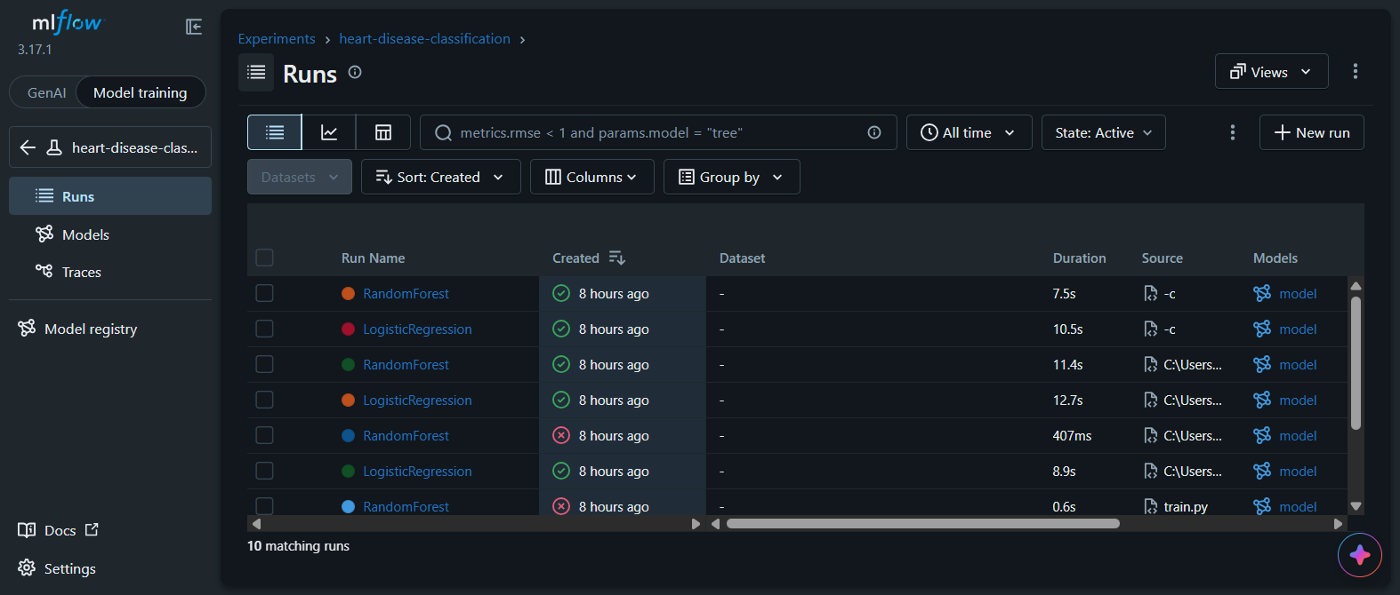
MLflow experiment runs
src/api.py loads best_model.joblib and provides:
- POST /predict for a patient feature set
- GET /health for readiness checks
- GET /metrics for Prometheus-format request and latency metrics
The prediction endpoint constructs a named-column DataFrame to match the preprocessing pipeline. A verified sample returned a heart-disease risk of approximately 0.0336 and prediction 0. This example is for software testing only.

6. CI/CD and Containerization
The GitHub Actions workflow in .github/workflows/ci-cd.yml runs on pushes and pull requests. Its first job installs flake8 and pytest, lints src/, and runs tests/. After that job succeeds, a second job installs project requirements, trains the model, logs in to GHCR using the workflow token, and builds and pushes the Docker image.
The Dockerfile uses Python 3.11, installs pinned dependencies, copies the source and trained model, and starts Uvicorn on port 8000. The workflow publishes ghcr.io/<owner>/heart-api:latest and ghcr.io/<owner>/heart-api:v3; the live Kubernetes deployment is pinned to ghcr.io/2025af05063-a11y/heart-api:v3. The evidence folder includes a successful GitHub Actions run; rerun the workflow after any further code or workflow changes.

7. Kubernetes and Monitoring
The Kubernetes resources are in k8s/deployment.yaml and k8s/service.yaml. The deployment uses a readiness probe on /health and the ghcr-secret image-pull secret. The service is ClusterIP on port 8000; for local testing, forward it with:
minikube kubectl -- port-forward service/heart-api 8080:8000
The live cluster was inspected on 20 October 2026: the deployment used the v3 image and had four ready API replicas. Grafana and Prometheus components were also running. The checked-in deployment manifest requests two replicas, so a fresh apply will not reproduce the live count of four unless it is changed or scaled:
minikube kubectl -- scale deployment/heart-api --replicas=4
The workspace-level Prometheus configuration defines a heart-api scrape job for heart-api:8000/metrics every 15 seconds. Confirm the target is UP in Prometheus and that the Grafana dashboard displays the custom API metrics before describing monitoring as fully verified. The Prometheus configuration file is currently outside the project directory; include it in the repository if a clean clone must reproduce that setup.

8. Submission Evidence and Recording
The screenshots/ directory contains the architecture, MLflow, CI, Grafana, and prediction evidence. Capture kubectl_pods.png before exporting the final PDF.
File | Evidence to capture | Status
screenshots/architecture_diagram.png | Architecture diagram included in this repository | Ready
screenshots/mlflow.png | MLflow UI with the latest finished run for both models | Ready
screenshots/github_actions.png | Successful GitHub Actions run | Ready
screenshots/kubectl get pods.png | minikube kubectl -- get pods showing the API and monitoring pods | Ready
screenshots/grafana.png | Grafana dashboard with API request and latency panels | Ready
screenshots/curl_output.png | Successful prediction response | Ready

Record a 3–5 minute walkthrough showing the architecture and repository, MLflow comparison, successful CI run, API response, four Kubernetes replicas, and Grafana metrics. Export this Markdown report to PDF or DOCX and confirm it is no more than 10 pages. Fill in the student name and repository URL, add the evidence files, and verify the Prometheus target before final submission.

Appendix A. Deployment and Monitoring Evidence
Screenshots captured from the project workflow and local Minikube environment.
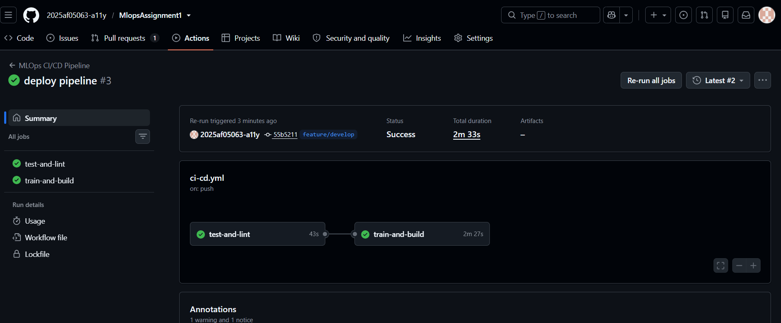
GitHub Actions: test-and-lint and train-and-build succeeded.
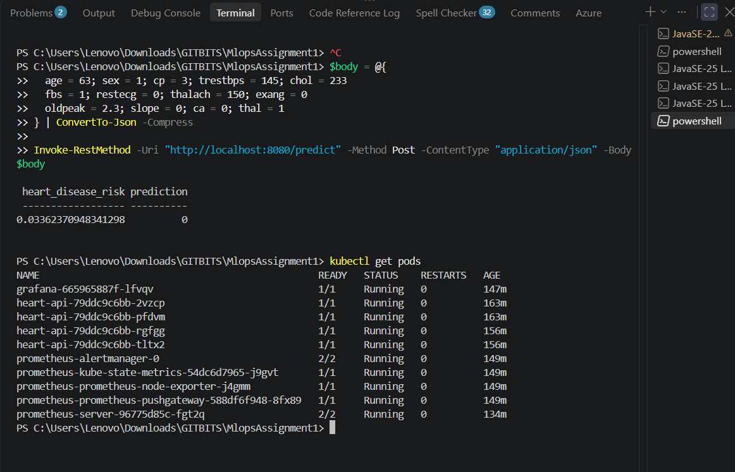
Minikube: four API replicas and monitoring pods are ready.

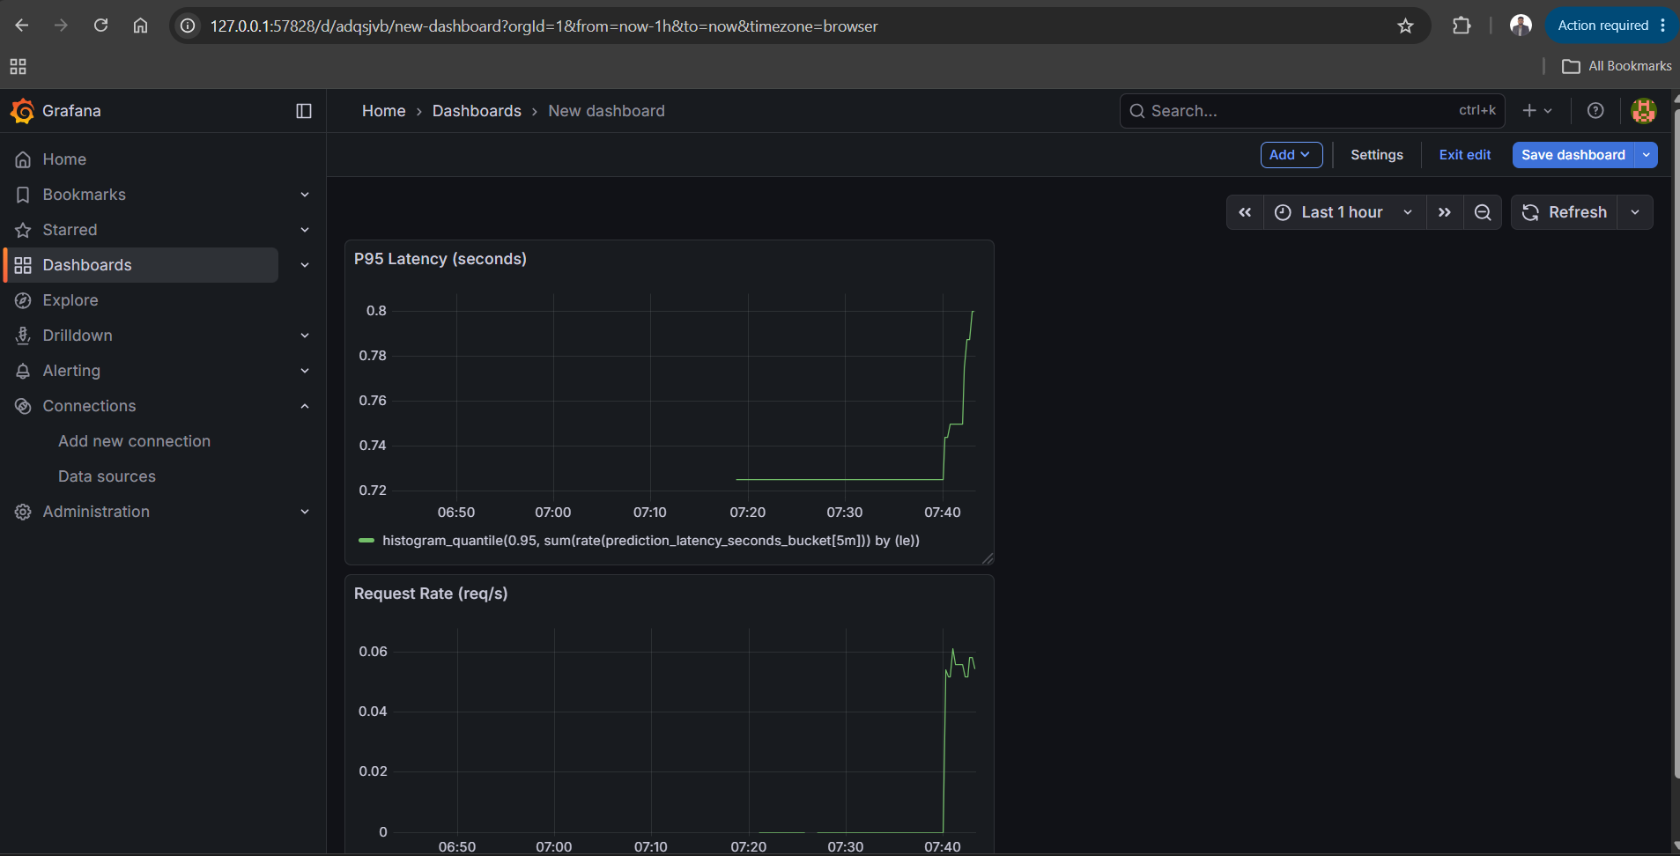
Grafana: request-rate and P95-latency panels.
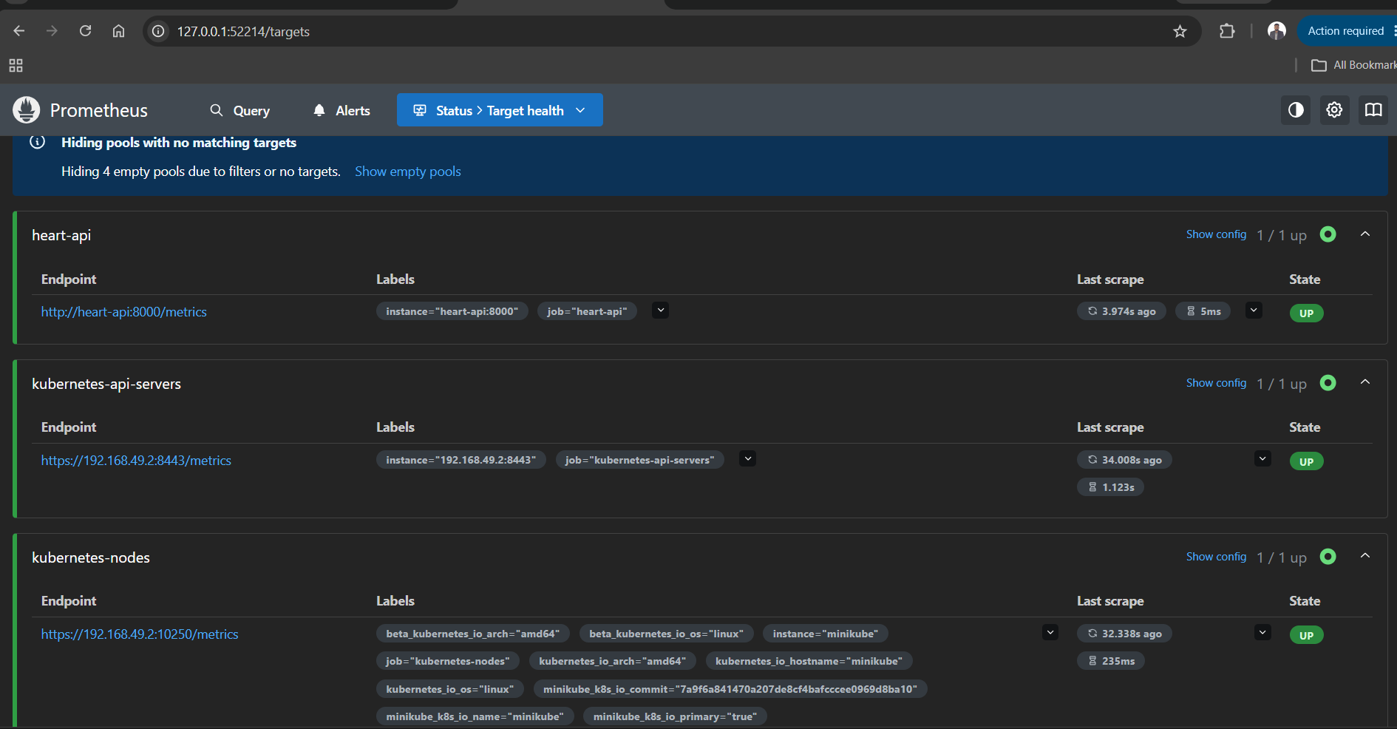
Prometheus: heart-api scrape target is UP.

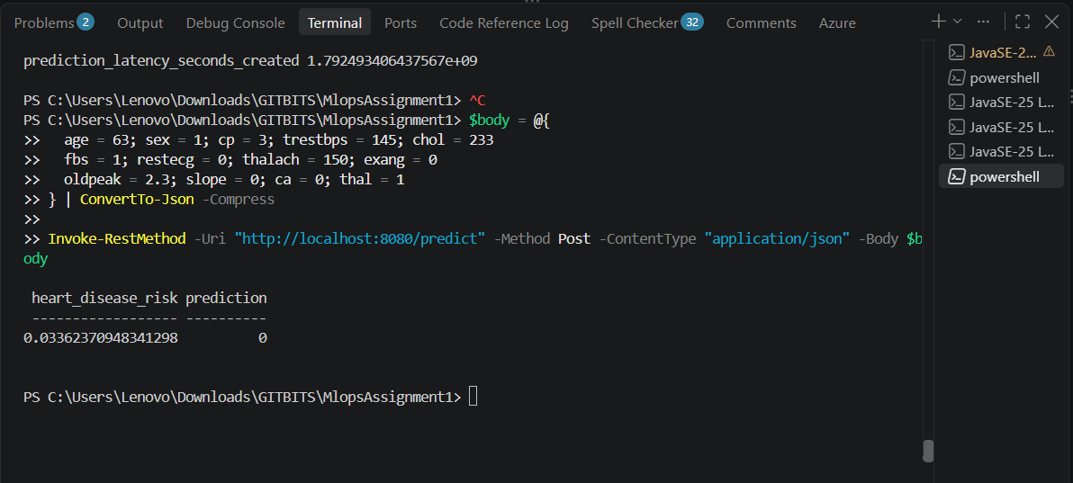
API prediction response for the sample request.
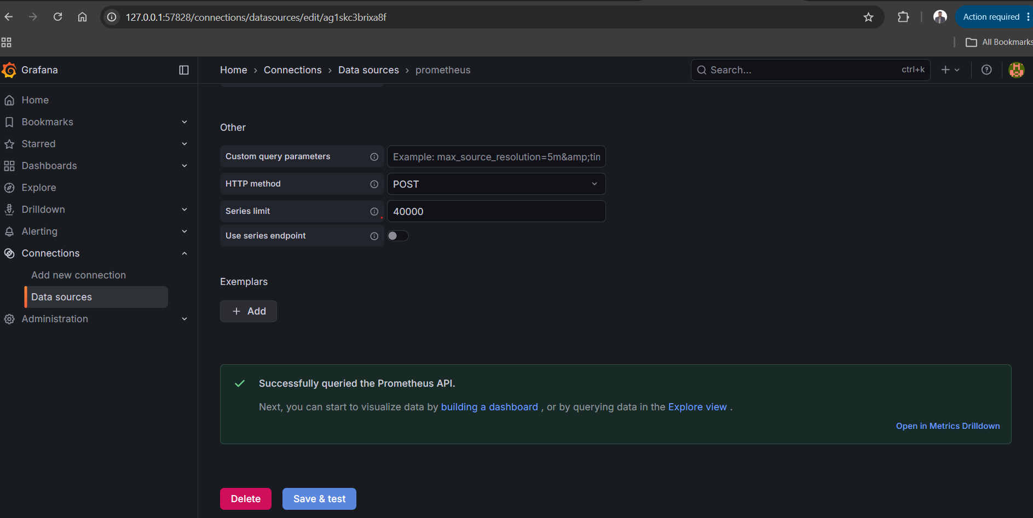
Grafana data-source connectivity verification.

