DEEPFAKE VIDEO DETECTION ON CELEB-DF V2
Seven-Model Comparison with Low-Resolution and 64-Frame Evaluation
CAPSTONE PROJECT
Submitted in partial fulfillment of the requirements of the
Post Graduate Certification Program
in
Artificial Intelligence and Machine Learning

By
Varahagiri Venkata Sri Swati
(2025AIML002)
Aishwary Agrawal
(2025AIML017)
Devesh Srivastava
(2025AIML055)

Under the supervision of
(Tapas Chakraborty)
Project work carried out at
BIRLA INSTITUTE OF TECHNOLOGY AND SCIENCE
Pilani (Rajasthan) INDIA

October, 2026

PCAM ZC321 CAPSTONE PROJECT
DEEPFAKE VIDEO DETECTION ON CELEB-DF V2
Seven-Model Comparison with Low-Resolution and 64-Frame Evaluation
Submitted in partial fulfillment of the requirements of the
PGP - Artificial Intelligence and Machine Learning

By
Varahagiri Venkata Sri Swati
(2025AIML002)
Aishwary Agrawal
(2025AIML017)
Devesh Srivastava
(2025AIML055)

Under the supervision of
(Tapas Chakraborty)
Project work carried out at
BIRLA INSTITUTE OF TECHNOLOGY AND SCIENCE
PILANI (RAJASTHAN)

October, 2026

Acknowledgements
We would like to express our sincere gratitude to our mentor, Tapas Chakraborty, for the guidance, critical feedback and encouragement provided throughout this capstone project. The feedback received during the project reviews, in particular the suggestion to evaluate the final model on more frames and on low-resolution videos, directly shaped the last phase of this work.
We thank the faculty and the Work Integrated Learning Programmes Division of the Birla Institute of Technology and Science, Pilani, for designing the Post Graduate Program in Artificial Intelligence and Machine Learning and for the structured capstone framework within which this project was carried out.
We acknowledge the authors of the Celeb-DF v2 dataset for making their benchmark available for research, and the maintainers of the open-source libraries used in this work, including PyTorch, timm, InsightFace, ONNX Runtime, OpenCV and scikit-learn. GPU time was provided by Kaggle Notebooks and Google Colab, without which training and comparing seven deep-learning models would not have been possible.
Finally, we thank our families, colleagues and employers for their patience and support while we balanced this project with our professional responsibilities.

Varahagiri Venkata Sri Swati
Aishwary Agrawal
Devesh Srivastava
BIRLA INSTITUTE OF TECHNOLOGY AND SCIENCE, PILANI
CERTIFICATE
This is to certify that the Capstone Project entitled Deepfake Video Detection on Celeb-DF v2: Seven-Model Comparison with Low-Resolution and 64-Frame Evaluation and submitted by Varahagiri Venkata Sri Swati (ID No. 2025AIML002) in partial fulfillment of the requirements of PCAM ZC321 Capstone Project, embodies the work done by the candidate under my supervision.

Place : Hyderabad | Signature of the Mentor
Date : 4/10/2026 | Name : Tapas Chakraborty
BIRLA INSTITUTE OF TECHNOLOGY AND SCIENCE, PILANI
CERTIFICATE
This is to certify that the Capstone Project entitled Deepfake Video Detection on Celeb-DF v2: Seven-Model Comparison with Low-Resolution and 64-Frame Evaluation and submitted by Aishwary Agrawal (ID No. 2025AIML017) in partial fulfillment of the requirements of PCAM ZC321 Capstone Project, embodies the work done by the candidate under my supervision.

Place : Hyderabad | Signature of the Mentor
Date : 4/10/2026 | Name : Tapas Chakraborty
BIRLA INSTITUTE OF TECHNOLOGY AND SCIENCE, PILANI
CERTIFICATE
This is to certify that the Capstone Project entitled Deepfake Video Detection on Celeb-DF v2: Seven-Model Comparison with Low-Resolution and 64-Frame Evaluation and submitted by Devesh Srivastava (ID No. 2025AIML055) in partial fulfillment of the requirements of PCAM ZC321 Capstone Project, embodies the work done by the candidate under my supervision.

Place : Hyderabad | Signature of the Mentor
Date : 4/10/2026 | Name : Tapas Chakraborty
BIRLA INSTITUTE OF TECHNOLOGY & SCIENCE, PILANI
SECOND SEMESTER 2025-26
PCAM ZC321 CAPSTONE PROJECT
Project Title | : Deepfake Video Detection on Celeb-DF v2: Seven-Model Comparison with Low-Resolution and 64-Frame Evaluation
Name of Mentor | : Tapas Chakraborty
Name of Students | : Varahagiri Venkata Sri Swati, Aishwary Agrawal, Devesh Srivastava
ID No. of Students | : 2025AIML002, 2025AIML017, 2025AIML055
Abstract
Deepfake videos, in which one person’s face is replaced by another’s using deep generative models, are now realistic enough to deceive casual viewers and are increasingly misused for misinformation, fraud and impersonation. This capstone project builds and evaluates an end-to-end pipeline that takes a video file as input and returns one REAL or FAKE decision with a fake-probability score. It uses the Celeb-DF v2 benchmark (590 real celebrity videos, 300 real YouTube videos and 5,639 face-swapped videos; 6,529 in total), downloaded from Kaggle.
In the data-preparation step, videos were divided into training (4,385), validation (817) and holdout (809) sets with an identity-graph split, so that no person appears in more than one of these sets; the 518-video official test list was kept separate. Four face detectors were benchmarked, and RetinaFace was selected because it found every face at 50.2 FPS, about three times faster than MTCNN, and its five landmarks allow eye-aligned crops. Evenly spaced frames were sampled from every video, giving 73,429 aligned face images (99.95% yield, no video without a face).
In the team’s final Kaggle notebook, seven ImageNet-pretrained architectures (EfficientNet-B0, ResNet-50, Xception, ConvNeXt-Tiny, Swin-Tiny, EfficientNet-B4 and CLIP ViT-B/16) were fine-tuned under identical conditions on an NVIDIA T4 GPU. A video score is the mean of its face scores, and each model’s threshold was chosen on validation videos with Youden’s J statistic.
ConvNeXt-Tiny ranked first, with holdout AUC 0.9998 (bootstrap 95% CI 0.9993–1.0000), EER 0.0076, 98.27% accuracy (795 of 809 videos, no fake video missed) and an official-test AUC of 0.9990. The intervals of the six CNN and Swin models overlap, so these models are statistically close. Xception made the fewest holdout errors at its own threshold (8 of 809). ConvNeXt-Tiny was also the most robust model under JPEG compression, downscaling and blur (worst AUC drop 0.0010). The final Kaggle run measured about 643 classifier face images per second for ConvNeXt-Tiny. Grad-CAM shows attention on facial regions including the eyes, nose and mouth. CLIP ViT-B/16 remained the weakest model in the seven-model comparison (holdout AUC 0.9905).
Two resolution studies complete the work. An independent ConvNeXt-Tiny rebuild (Run B; holdout accuracy 97.28% and AUC 0.9998 at validation-selected threshold 0.4825) scored the three lowest-resolution real official-test videos on 64 frames before and after enhancement (CLAHE contrast enhancement and sharpening, with upscaling below 360 pixels): all 64 faces were detected for every condition and all three videos were classified REAL with a fake score of 0.0000 before and after enhancement. In Run A, a four-video check of high-resolution (974 × 500) and low-resolution (286 × 300) real and fake videos classified all four correctly. The report closes with recommendations and future work, including cross-dataset testing, video-level calibration and temporal models.
Key Words: Deepfake detection; Celeb-DF v2; ConvNeXt-Tiny; RetinaFace; transfer learning; video-level classification; identity-disjoint split; Grad-CAM; robustness; calibration; low-resolution video.
List of Symbols & Abbreviations Used
Symbol / Abbreviation | Meaning
AMP | Automatic Mixed Precision (FP16 training/inference)
AP | Average Precision (area under the precision-recall curve)
AUC | Area Under the ROC Curve
BCE | Binary Cross-Entropy loss
BGR / RGB | Blue-Green-Red (OpenCV) / Red-Green-Blue colour channel order
CI | Confidence Interval (95%, stratified bootstrap unless stated)
CLAHE | Contrast Limited Adaptive Histogram Equalisation
CLIP | Contrastive Language-Image Pre-training
CNN | Convolutional Neural Network
CUDA | Compute Unified Device Architecture (NVIDIA GPU platform)
ECE | Expected Calibration Error (15 bins)
EER | Equal Error Rate (point where FPR = FNR)
FF++ | FaceForensics++ dataset
FN / FP | False Negative (fake predicted real) / False Positive (real predicted fake)
FNR / FPR | False Negative Rate / False Positive Rate
FPS | Frames Per Second
GAN | Generative Adversarial Network
GPU | Graphics Processing Unit
Grad-CAM | Gradient-weighted Class Activation Mapping
ID | Identity (a person appearing in the dataset)
MTCNN | Multi-Task Cascaded Convolutional Network (face detector)
ONNX / ORT | Open Neural Network Exchange / ONNX Runtime
ROC | Receiver Operating Characteristic
Run A | Seven-model comparison in the team’s final Kaggle notebook
Run B | Independent ConvNeXt-Tiny rebuild with the 64-frame low-resolution enhancement test
TN / TP | True Negative (real predicted real) / True Positive (fake predicted fake)
TPR / TNR | True Positive Rate (recall) / True Negative Rate (specificity)
ViT | Vision Transformer
p, P(fake) | Probability that a face (or video) is FAKE, output of the sigmoid
s(v) | Video-level fake score: mean of P(fake) over the faces of video v
t, τ | Decision threshold: a video is FAKE if s(v) ≥ t
T | Temperature used to rescale logits in temperature scaling
J | Youden’s J statistic, J = TPR – FPR
w+ | Positive-class weight in the BCE loss (pos_weight = N_real / N_fake)
σ(·) | Sigmoid function
N | Number of frames sampled from a video

List of Tables
Table 2.1: Summary of the reviewed literature 5
Table 3.1: Project team 7
Table 3.2: Hardware resources 8
Table 3.3: Software resources 8
Table 3.4: Data challenges, risks and mitigations 9
Table 3.5: Plan of work 10
Table 4.1: Composition of Celeb-DF v2 11
Table 4.2: Video-level split 12
Table 4.3: Frame sampling policy 13
Table 4.4: Face detector comparison 13
Table 4.5: Aligned face crops per split (Run A) 15
Table 4.6: Training augmentation 15
Table 5.1: Seven candidate architectures 17
Table 5.2: Shared training settings 18
Table 5.3: Model-specific settings and training outcome (Run A, Kaggle T4) 18
Table 5.4: Input options of the final Kaggle notebook 20
Table 5.5: Run B training history (ConvNeXt-Tiny, Kaggle T4) 20
Table 5.6: Frame enhancement steps 22
Table 7.1: Measures used and their justification 40
Table 7.2: Seven-model comparison (Run A, final notebook) 41
Table 7.3: Holdout confusion counts per model (105 real, 704 fake videos) 44
Table 7.4: Holdout video AUC under degradation (up to 8 faces per video) 45
Table 7.5: Calibration of the holdout video scores before and after temperature scaling 47
Table 7.6: Full-video demo results (Run A) 48
Table 7.7: Speed measurements (Kaggle T4 GPU, Python timers) 48
Table 7.8: Run B video-level metrics at threshold 0.4825 49
Table 7.9: Comparison of the two ConvNeXt-Tiny runs 51
Table 7.10: Videos selected for the enhancement test 53
Table 7.11: Original versus enhanced results (64 frames, threshold 0.4825) 54
Table 7.12: High- versus low-resolution results (32 frames, threshold 0.0079) 54
Table 7.13: Results against project objectives 57
Table A.1: Configuration values of the final notebook (Run A) 64
Table B.1: Sections of the final notebook (Run A) 65
Table B.2: Cells of the final Kaggle notebook (Run B) 66
Table C.1: Output files (under the retinaface_models working folder) 67
List of Figures
Figure 3.1: Consolidated machine-learning process flow (solution architecture) 6
Figure 3.2: Video inference flow from input file to REAL / FAKE decision 7
Figure 4.1: Speed of the four face detectors on the same frames 13
Figure 4.2: Randomly sampled eye-aligned training crops: real (top) and fake (bottom) 15
Figure 4.3: Videos (a) and aligned face crops (b) per split, by class 15
Figure 5.1: Run B training loss (a) and validation AUC (b); epoch 5 was selected 21
Figure 6.1: Kaggle screenshot of the final Kaggle notebook: environment preflight showing Tesla T4 and ONNX Runtime providers (5 October 2026) 30
Figure 6.2: Kaggle screenshot of the final Kaggle notebook: manifest and leakage audit 31
Figure 6.3: Kaggle screenshot of the final Kaggle notebook: RetinaFace model download and the first face-cache shard 32
Figure 6.4: Kaggle screenshot of the final Kaggle notebook: remaining face-cache shards and crop counts 33
Figure 7.1: Holdout AUC with bootstrap 95% confidence intervals (a) and accuracy versus speed (b) 42
Figure 7.2: Video-level ROC curves of the seven models on the holdout (left) and official test (right) videos, zoomed to FPR ≤ 0.3 43
Figure 7.3: Holdout confusion matrices of the seven models, each at its own validation threshold 44
Figure 7.4: Training loss (a) and validation frame AUC (b) of the seven models in Run A 44
Figure 7.5: Worst holdout AUC drop per model under the four degradations (lower is better) 46
Figure 7.6: Grad-CAM attention for one real (top) and one fake (bottom) holdout face, with each model’s P(fake) 48
Figure 7.7: Run B confusion matrices on the validation and holdout videos 50
Figure 7.8: Run A and Run B threshold-dependent error comparison; Run B metrics and confusion matrices 52
Figure 7.9: Extracted faces of the three low-resolution REAL videos, original (left) and enhanced (right) 53
Figure 7.10: Aligned RetinaFace crops of the four videos of the resolution check (6 of 32 shown per video) 56
Table of Contents
Chapter 1: Introduction 1
1.1 Background 1
1.2 Problem Statement 1
1.3 Objectives of the Project 1
1.4 Scope and Assumptions 2
1.5 Organisation of the Report 2
Chapter 2: Literature Review 3
2.1 Deepfake Datasets and Benchmarks 3
2.2 Frame-Level CNN Detectors 3
2.3 Artefact-Focused Methods 3
2.4 Temporal Methods 4
2.5 Vision Transformers and Foundation Models 4
2.6 Face Detection and Alignment 4
2.7 Explainability, Evaluation and Calibration 4
2.8 Summary and Research Gap 4
Chapter 3: Solution Architecture and Project Planning 6
3.1 Machine Learning Process Flow 6
3.2 Resources Needed for the Project 7
3.2.1 People 7
3.2.2 Hardware 8
3.2.3 Software 8
3.3 Potential Data Challenges and Risks 8
3.4 Detailed Plan of Work 9
Chapter 4: Data Pre-Processing 11
4.1 Dataset Description 11
4.2 Label Convention and Manifest Validation 11
4.3 Leak-Resistant Identity Split 11
4.4 Frame Sampling 12
4.5 Face Detector Selection 13
4.6 Face Detection, Alignment and Caching 14
4.7 Summary of the Prepared Data 15
4.8 Data Augmentation and Normalisation 15
4.9 Outlier Handling, Data Quality and Visualisation 16
Chapter 5: Machine Learning Modelling and Techniques 17
5.1 Problem Formulation 17
5.2 Candidate Architectures 17
5.3 Training Configuration 17
5.4 Training Procedure 18
5.5 Video-Level Aggregation and Threshold Selection 19
5.6 Evaluation Protocol of the Final Comparison 19
5.7 ConvNeXt-Tiny Rebuild (Run B, Run B) 20
5.8 Low-Resolution 64-Frame Enhancement Test (Run B) 21
5.9 High- versus Low-Resolution Check (Run A) 22
Chapter 6: Code and Screenshots 23
6.1 Final Team Notebook (Run A) 23
6.1.1 Environment, Data and Model Registry 23
6.1.2 Training and Evaluation of the Seven Models 24
6.1.3 Comparison, Robustness and Calibration 26
6.1.4 Demo, Export and High / Low Resolution Check 27
6.2 Low-Resolution Run B (Run B) 29
6.2.1 Environment and GPU Check 29
6.2.2 Manifest and Leakage Audit 30
6.2.3 RetinaFace Detection and Eye Alignment 31
6.2.4 Model Construction and Training Loop 34
6.2.5 Threshold Selection and Evaluation 36
6.2.6 Enhancement and 64-Frame Video Inference 38
Chapter 7: Results and Interpretation 40
7.1 Justification of Measures and Metrics 40
7.2 Seven-Model Comparison (Run A) 40
7.3 Official Test Benchmark 45
7.4 Robustness to Compression, Downscaling and Blur 45
7.5 Probability Calibration 46
7.6 Explainability with Grad-CAM 48
7.7 End-to-End Demo, Speed and Export 48
7.8 ConvNeXt-Tiny Rebuild (Run B) and Comparison of the Two Runs 49
7.9 Low-Resolution 64-Frame Enhancement Results (Run B) 53
7.10 High- versus Low-Resolution Check (Run A) 54
7.11 Summary of Results Against Objectives 57
Chapter 8: Conclusions and Recommendations 58
8.1 Conclusions 58
8.2 Recommendations 58
Chapter 9: Directions for Future Work 60
References 69
Appendices 69
Appendix A: Configuration of the Final Notebook 64
Appendix B: Notebook Maps 65
Appendix C: Files Produced by the Pipeline 67
List of Publications / Conference Presentations 55
Checklist of Items for the Final Report 56

Chapter 1: Introduction

1.1 Background
A deepfake is a synthetic video in which the face of one person is replaced by, or re-animated to look like, the face of another person using deep generative models such as autoencoders and generative adversarial networks [1]. Face-swap tools are now freely available, and the quality of their output has improved to the point where many fake videos can no longer be recognised by a casual viewer [2, 3]. Such videos can be misused for political misinformation, financial fraud, impersonation and non-consensual content, and their existence also makes it easier to dismiss genuine recordings as fake.
Automatic detection is therefore an important applied machine-learning problem. Public benchmarks such as FaceForensics++ [4], Celeb-DF [5] and the DeepFake Detection Challenge (DFDC) dataset [6] have made it possible to train and compare detectors. Celeb-DF v2 was designed to be harder than earlier datasets: its fake videos were produced with an improved synthesis process that reduces visible artefacts such as colour mismatch and blending boundaries [5]. This project uses Celeb-DF v2 as its benchmark.
Most practical detectors work on faces rather than on complete frames. The face is located, cropped and passed to an image classifier, and the per-face scores are combined into one decision for the video. This project follows that design and concentrates on practical questions: which face detector and which classifier backbone work best, how reliable and well calibrated the result is on people never seen during training and on degraded video, how fast the complete pipeline is, and how the detector behaves on low-resolution input.

1.2 Problem Statement
Given a video that contains a human face, automatically decide whether the video is REAL or FAKE (face-swapped) and report a fake-probability score for the whole video. To be useful in practice, the detector should:
- generalise to people who were not seen during training, which requires an evaluation split with no identity overlap between training and test data;
- remain reliable when the video is compressed, downscaled, blurred or of low resolution, as happens when videos are re-uploaded to social media;
- process a complete video within a few seconds on a single GPU;
- show which face regions influenced its decision, so that a human reviewer can check the result.

1.3 Objectives of the Project
O1 Build a reproducible data pipeline that turns the raw Celeb-DF v2 videos into aligned face images, using an identity-disjoint train / validation / holdout split.
O2 Select a face detector by benchmarking OpenCV Haar, MTCNN, RetinaFace and YOLOv8 on the same frames.
O3 Fine-tune and compare seven ImageNet-pretrained architectures under identical conditions and select the best one by holdout video-level AUC.
O4 Convert face scores into video decisions with a threshold chosen on validation data, and evaluate on the holdout split and the official Celeb-DF test list using AUC with bootstrap confidence intervals, accuracy, precision, recall, F1, EER and confusion matrices.
O5 Test robustness to JPEG compression, downscaling and blur; check probability calibration; explain predictions with Grad-CAM; measure speed; and demonstrate and export the complete video-to-decision pipeline.
O6 Evaluate the final model on low-resolution input: 64 frames per video with and without frame enhancement, and a comparison of high- and low-resolution real and fake videos.

1.4 Scope and Assumptions
- Data: Celeb-DF v2 only (6,529 videos), obtained from a Kaggle mirror [7]; the manipulation type is face swapping.
- Faces: one dominant face per frame is assumed; when several faces are detected, the largest one is used.
- Models: frame-level image classifiers; the video score is the mean of the face scores. Temporal models and audio are outside the scope of this project.
- Hardware: a single NVIDIA Tesla T4 GPU in Kaggle Notebooks.
- Experiments reported. Run A is the seven-model comparison in the team’s final Kaggle notebook (deepfake-detection-final.ipynb), which also contains the robustness, calibration, Grad-CAM, demo and export steps and the four-video high- versus low-resolution check. Run B is a separate rebuild of the selected ConvNeXt-Tiny pipeline (Run B workflow) that adds the 64-frame low-resolution enhancement test. An earlier version of the comparison, run on Google Colab and shown in the project presentation, is superseded by Run A.

1.5 Organisation of the Report
Chapter 2 reviews previous work on deepfake datasets, detectors, face detection, explainability and calibration. Chapter 3 presents the machine-learning process flow, the resources used, the data challenges and risks, and the plan of work. Chapter 4 describes the data pre-processing steps, and Chapter 5 the modelling and evaluation techniques, including the two resolution studies. Chapter 6 contains the key code and notebook outputs. Chapter 7 justifies the metrics used and interprets all results. Chapters 8 and 9 give the conclusions, recommendations and directions for future work, followed by the references, appendices and the completed checklist.

Chapter 2: Literature Review
This chapter summarises the previous work that informed the design choices of the project. It is organised by topic: datasets, frame-level detectors, artefact-focused methods, temporal methods, transformers and foundation models, face detection, and explainability and evaluation.

2.1 Deepfake Datasets and Benchmarks
FaceForensics++ [4] contains 1,000 original YouTube videos manipulated with four methods (DeepFakes, Face2Face, FaceSwap and NeuralTextures) at several compression levels. Its benchmark showed that an Xception network fine-tuned on face crops is a strong detector, and that accuracy falls noticeably on heavily compressed video. Celeb-DF v2 [5] contains 590 real interview videos of 59 celebrities, 300 additional real YouTube videos and 5,639 face-swapped videos produced with an improved synthesis method; it also defines an official test list of 518 videos. Its authors showed that many detectors that performed well on earlier datasets performed much worse on Celeb-DF. The DFDC dataset [6] is larger still, with more than 100,000 clips recorded with paid actors, and its public competition showed that strong ImageNet-pretrained CNN backbones applied to face crops were a common basis of the best entries.

2.2 Frame-Level CNN Detectors
Early work such as MesoNet [8] used compact CNNs that focus on mid-level (mesoscopic) image detail. Later work relied on transfer learning from large ImageNet-pretrained backbones [9]. Xception [10], built from depthwise separable convolutions, became the standard deepfake baseline after FaceForensics++ [4]. ResNet [11] introduced residual connections and is a common reference backbone. EfficientNet [12] scales depth, width and resolution together and gives good accuracy per parameter; EfficientNet-B0 served as this project’s mid-term baseline, and the EfficientNet-B4 weights used here come from Noisy Student self-training [13]. ConvNeXt [14] modernises the ResNet design with ideas taken from vision transformers (larger depthwise kernels, LayerNorm, GELU activations and inverted bottlenecks) and matches transformer accuracy while remaining a pure CNN.

2.3 Artefact-Focused Methods
Several methods target the traces left by the face-swap process. Li and Lyu [15] showed that the warping needed to fit a synthesised face to the target leaves resolution inconsistencies that a CNN can detect. Face X-ray [16] predicts the blending boundary between the inserted face and the background, which makes the detector less dependent on a particular generator. Multi-attentional detection [17] uses several attention maps to focus on local texture differences. A common message of these works is that the strongest evidence lies around the blended regions of the face, such as the eyes, nose, mouth and face boundary; the Grad-CAM results in Chapter 7 are consistent with this.

2.4 Temporal Methods
Video adds a time dimension that single-frame models ignore. Güera and Delp [18] combined a CNN feature extractor with an LSTM to detect frame-to-frame inconsistencies, and LipForensics [19] used mouth-movement features to obtain detectors that generalise better and are more robust to compression. Temporal models need more compute and more complex data loading, so this project uses frame-level classification with score averaging and lists temporal modelling as future work.

2.5 Vision Transformers and Foundation Models
The Vision Transformer (ViT) [20] treats an image as a sequence of patches processed by self-attention. Swin Transformer [21] restricts attention to shifted local windows, which makes it efficient for dense image detail. CLIP [22] learns image and text encoders jointly from a very large set of image-text pairs; Ojha et al. [23] showed that CLIP image features generalise well for detecting images from unseen generators. These results motivated the inclusion of Swin-Tiny and CLIP ViT-B/16 in the comparison, to test whether attention-based and foundation models outperform CNNs on face-swap detection.

2.6 Face Detection and Alignment
The quality of face crops directly affects any face-based detector. The Viola-Jones Haar cascade [24] is fast on a CPU but less reliable for rotated or partly occluded faces. MTCNN [25] uses a three-stage CNN cascade and returns five facial landmarks. RetinaFace [26] is a single-stage detector that predicts boxes and five landmarks at several scales and is widely available through the InsightFace project [27]. YOLOv8 [28] is a fast general-purpose detector that, as used here, returns boxes without landmarks. Landmarks matter because they allow every face to be rotated and scaled so that the eyes are at fixed positions, which gives the classifier consistent input.

2.7 Explainability, Evaluation and Calibration
Grad-CAM [29] produces a heat map of the image regions that most influenced a CNN’s output by weighting the last convolutional feature maps with the gradients of the class score. For evaluation, the ROC curve and its area (AUC) [30] measure ranking quality independently of any threshold and are the standard metrics on imbalanced deepfake benchmarks; bootstrap resampling [31] gives confidence intervals for such metrics. Youden’s J statistic [32], J = TPR – FPR, gives a simple rule for choosing a threshold on a validation set. Guo et al. [33] showed that modern neural networks are often over-confident and proposed temperature scaling, which divides the logits by a single fitted temperature to improve calibration without changing the ranking.

2.8 Summary and Research Gap
Table 2.1 summarises the reviewed work and its relevance to this project.
Table 2.1: Summary of the reviewed literature
Work | Approach / key idea | Use in this project
Rössler et al. [4] | FF++ benchmark; Xception on face crops | Xception baseline; effect of compression
Li et al. [5] | Celeb-DF v2 with improved synthesis | Dataset and official test list used here
Afchar et al. [8] | Compact CNN (MesoNet) | Early frame-level detector
Tan and Le [12]; Xie et al. [13] | Compound-scaled CNN; Noisy Student weights | EfficientNet-B0 (baseline) and B4 compared
Liu et al. [14] | Modernised CNN (ConvNeXt) | Selected final model
Liu et al. [21]; Radford et al. [22] | Window attention; image-text pre-training | Swin-Tiny and CLIP ViT-B/16 compared
Li et al. [16]; Zhao et al. [17] | Blending boundary; multi-attention | Explains why face-region cues matter
Güera and Delp [18]; Haliassos et al. [19] | Temporal CNN-LSTM; lip movements | Future work
Deng et al. [26]; Zhang et al. [25] | Landmark-based face detectors | RetinaFace selected
Selvaraju et al. [29] | Gradient-based class activation maps | Model explanation
Guo et al. [33] | Temperature scaling for calibration | Calibration check of all seven models

The review shows four gaps that this project addresses. First, published comparisons often use different pre-processing for different models, so differences in results may come from the data pipeline rather than the architecture; here all seven models share the same face images, split, augmentation and training budget. Second, random video-level splits can place the same person in training and test data and inflate results; here train, validation and holdout sets are identity-disjoint. Third, robustness, calibration and low-resolution behaviour are often not reported; here they are tested explicitly. Fourth, end-to-end speed from video file to decision is rarely measured; here it is.

Chapter 3: Solution Architecture and Project Planning

3.1 Machine Learning Process Flow
The consolidated approach is shown in Figure 3.1. It consists of three steps, each producing a saved output that the next step reuses, so that expensive work (face extraction and training) is done once.
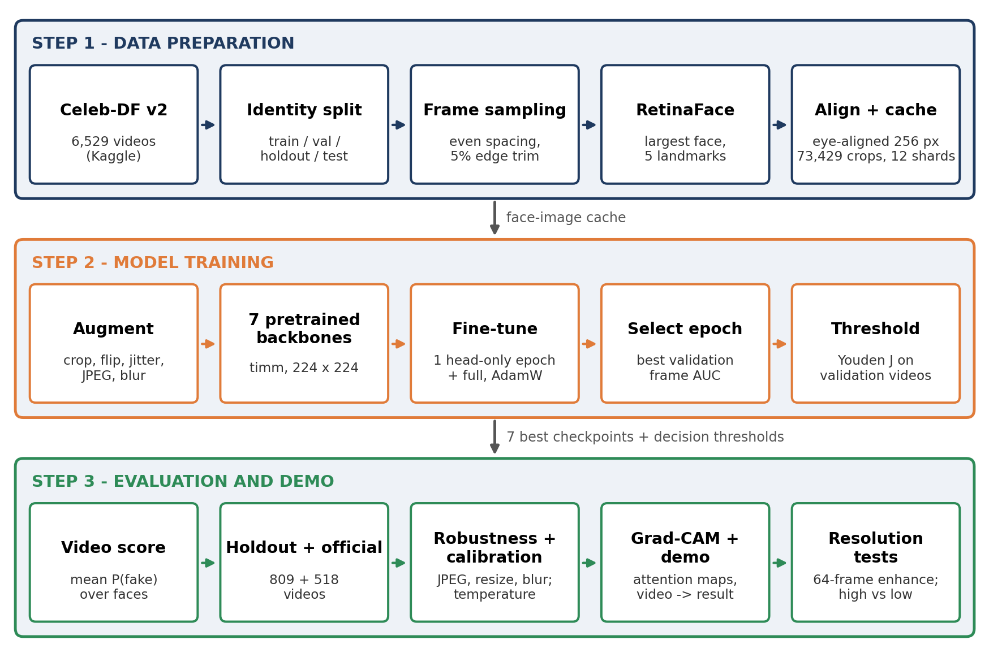
Figure 3.1: Consolidated machine-learning process flow (solution architecture)
1. Data acquisition: the Celeb-DF v2 dataset attached in Kaggle is located automatically, and the folder counts (590 / 300 / 5,639) are verified.
2. Manifest and split: every video is parsed into identities and labels, the official test list is separated, and the remaining videos are split into identity-disjoint train, validation and holdout sets.
3. Frame sampling: evenly spaced frames are taken from each video, skipping the first and last 5%.
4. Face detection and alignment: RetinaFace finds the largest face and its five landmarks; the face is rotated and scaled so that the eyes are horizontal and at fixed positions in a 256 × 256 crop.
5. Caching: crops are saved as JPEG (quality 95) and packed into 12 shards, so that every model trains on the same stored faces instead of decoding videos again.
6. Training: each pretrained backbone is fine-tuned on the cached faces with the same augmentation and epoch budget.
7. Model selection and threshold: the epoch with the best validation frame AUC is kept, and the video threshold is chosen on validation video scores with Youden’s J.
8. Evaluation: holdout and official test videos are scored and compared with their labels; bootstrap intervals, robustness, calibration, Grad-CAM and speed are measured.
9. Inference and export: a new video passes through the same steps and receives a REAL / FAKE decision; the best model, its threshold and its pre-processing settings are saved as one inference bundle.
10. Resolution tests: the selected model is tested on 64 frames per video before and after enhancement (Run B) and on high- and low-resolution real and fake videos (Run A).
Figure 3.2 shows the inference path used for any single video, including the demo and both resolution tests.
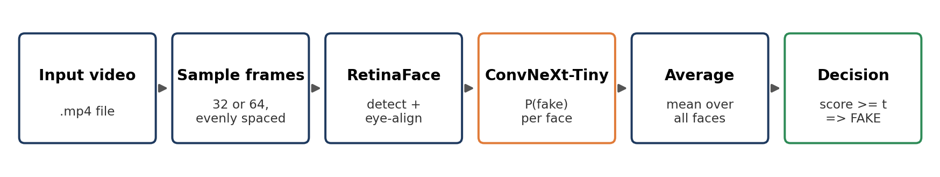
Figure 3.2: Video inference flow from input file to REAL / FAKE decision

3.2 Resources Needed for the Project

3.2.1 People
Table 3.1: Project team
Role | Name | BITS ID No.
Student | Varahagiri Venkata Sri Swati | 2025AIML002
Student | Aishwary Agrawal | 2025AIML017
Student | Devesh Srivastava | 2025AIML055
Mentor | Tapas Chakraborty | -

The team carried out the data preparation, model training, evaluation and documentation, with guidance and review from the mentor. The final notebook is organised in four parts: data and face extraction; training components and training; comparison, robustness, calibration, explainability and demo; and the high- versus low-resolution check.

3.2.2 Hardware
Table 3.2: Hardware resources
Resource | Specification | Used for
Kaggle GPU notebook | 2 × NVIDIA Tesla T4 (15,360 MiB each; the pipeline uses one), driver 580.178.04 | Run A: face cache, training of the seven models (21-48 min each), evaluation, robustness, calibration, Grad-CAM, demo, export, resolution check. Run B: ConvNeXt-Tiny rebuild and 64-frame test
Google Colab GPU runtime | NVIDIA Tesla T4, 16 GB | Earlier version of the seven-model comparison shown in the project presentation (superseded by Run A)
Cloud storage | /kaggle/working (Kaggle notebooks) | Manifest, face-cache shards, checkpoints, predictions, metrics, demo videos, inference bundle
Personal laptops | Standard office laptops | Development, analysis, presentation and report writing

3.2.3 Software
Table 3.3: Software resources
Package / tool | Version | Purpose
Python | 3.12 (Kaggle image) | Programming language
PyTorch [34] / torchvision | 2.11.0 (Run A), 2.10.0 (Run B); CUDA 12.8 | Model training, inference, transforms
timm [35] | 1.0.11 | Pretrained backbones (e.g. convnext_tiny.fb_in22k_ft_in1k)
InsightFace [27] | 0.7.3 (buffalo_l pack) | RetinaFace detector (det_10g.onnx)
ONNX Runtime GPU | 1.26.0 | Runs RetinaFace on the GPU (CUDA execution provider)
OpenCV | Kaggle default | Video decoding, alignment, enhancement (CLAHE)
scikit-learn [36] | Kaggle default | AUC, ROC, confusion matrix, precision / recall / F1, log loss
SciPy | Kaggle default | Logit / sigmoid functions for temperature scaling
pandas, NumPy, Matplotlib | Kaggle default | Manifests, metrics tables, plots
Kagglehub | Latest | Dataset download fallback (Run B, Option 1)
Kaggle Notebooks / Google Colab | - | GPU notebook environments

3.3 Potential Data Challenges and Risks
Table 3.4 lists the main data challenges and project risks identified at the start of the work, and how each was handled.
Table 3.4: Data challenges, risks and mitigations
# | Challenge / risk | Impact | Mitigation used
1 | Class imbalance: 890 real vs 5,639 fake videos | Model biased towards FAKE; accuracy misleading | More frames from real videos (32 vs 8); loss weight w+ = 0.508; AUC as main metric; threshold tuned on validation
2 | Identity leakage between splits | Over-optimistic results | Identity-graph split with automatic leakage audit
3 | Official test list uses 1 = real, 0 = fake | Silently inverted labels | Labels flipped and cross-checked against folders; run stops on any mismatch
4 | Missed faces, several faces in a frame | Missing or wrong crops | RetinaFace (score ≥ 0.5), largest face kept, frames without a face skipped (99.95% yield)
5 | Train / inference pre-processing mismatch | Lower accuracy in deployment | Same detector, alignment and BGR→RGB conversion in training and inference; settings saved in the bundle
6 | Compression, blur and low resolution | Accuracy drop on re-uploaded videos | JPEG and blur augmentation; robustness test; two low-resolution tests
7 | GPU session limits and disconnects | Lost training progress | 12 cache shards; last.pt saved after every epoch with automatic resume; finished runs skipped
8 | Large raw video volume | Slow repeated decoding | Faces extracted once and cached
9 | Unseen manipulation methods | Possible drop on other generators | Stated as a limitation; cross-dataset testing proposed as future work
10 | Ethical use of face data | Misuse or over-trust of predictions | Research dataset only; outputs reported as probabilities; human review recommended

3.4 Detailed Plan of Work
The work was carried out in nine phases (Table 3.5). Each phase produced a saved output used by the next phase, which made it possible to resume after interruptions and to repeat parts of the work on a different platform.
Table 3.5: Plan of work
Phase | Activity | Main tasks | Output
1 | Problem definition and literature review | Scope, success metrics, candidate methods | Problem statement, approach
2 | Data acquisition and validation | Obtain Celeb-DF v2 from Kaggle; verify folder counts; parse official test list | Validated video manifest
3 | Leak-resistant split | Identity graph, greedy split, leakage audit | videos.csv with split column
4 | Face-detector benchmark | Haar, MTCNN, RetinaFace, YOLOv8 on 10 videos × 15 frames | RetinaFace selected
5 | Face extraction and caching | Sampling, detection, eye alignment, JPEG cache in 12 shards | 73,429 aligned face images
6 | Baseline and seven-model training | EfficientNet-B0 baseline (mid-term), first comparison on Colab, final comparison on Kaggle (Run A) | 7 best checkpoints and thresholds
7 | Evaluation (Run A) | Holdout and official test, bootstrap intervals, confusion matrices, ROC, robustness, calibration, Grad-CAM, demo, speed, export | Model comparison; ConvNeXt-Tiny selected
8 | Resolution studies | Run B: ConvNeXt-Tiny rebuild with 64-frame enhancement test; Run A: four-video high vs low resolution check | Low-resolution results
9 | Documentation | Presentation and project report | Final deliverables

All nine phases have been completed.

Chapter 4: Data Pre-Processing
This chapter describes how the raw videos were turned into a clean, labelled and leak-free set of aligned face images. All steps are implemented in the project notebooks and are deterministic for a given seed (42).

4.1 Dataset Description
Celeb-DF v2 [5] was obtained from Kaggle [7]. Its composition, as counted by the notebook, is shown in Table 4.1.
Table 4.1: Composition of Celeb-DF v2
Folder / file | Content | Label | Videos
Celeb-real | Real interview videos of celebrities (file name id<a>_<n>) | REAL (0) | 590
YouTube-real | Additional real YouTube videos (numeric file name) | REAL (0) | 300
Celeb-synthesis | Face-swapped videos combining identities a and b (id<a>_id<b>_<n>) | FAKE (1) | 5,639
Total |  |  | 6,529
List_of_testing_videos.txt | Official test list (178 real, 340 fake), kept separate | both | 518

The dataset is strongly imbalanced at video level: real videos are only 13.6% of the total (890 of 6,529). This imbalance shapes several later choices, including frame sampling, the loss weight and the choice of AUC as the main metric.

4.2 Label Convention and Manifest Validation
A manifest (videos.csv) with one row per video is built before any image processing. The following checks are applied automatically, and the notebook stops if any of them fails:
- The label convention REAL = 0, FAKE = 1 is used throughout. The official test file uses the opposite convention (1 = real, 0 = fake), so its flags are inverted when read.
- Every video named in the official test list must exist in the dataset folders, and its inverted label must agree with the label implied by its folder.
- Every file name must match one of three patterns (Celeb-real, YouTube-real or fake); any unrecognised name raises an error, so no video is silently dropped.
- The folder counts must match the expected values (590 / 300 / 5,639).

4.3 Leak-Resistant Identity Split
If the same person appeared in both training and test data, the model could learn to recognise the person instead of the manipulation, and test results would be too optimistic. The split therefore works on identities rather than on videos:
1. Each video is parsed into one identity (real video) or two identities (fake video, id<a>_id<b>).
2. A union-find structure joins the two identities of every fake video, so that people who appear together in any fake video form one connected component.
3. The official test videos are set aside. The remaining components are sorted by size and assigned greedily to the split that is furthest below its target share (75% train, 15% validation, 10% holdout); components with fake videos and real-only components are assigned separately.
4. A leakage audit checks that train, validation and holdout share no identity.
The audit passed. Because whole components are assigned, the final shares differ from the targets: 73.0% train, 13.6% validation and 13.5% holdout of the 6,011 non-test videos (Table 4.2). The audit also reports that the official test list shares 36 identities with the training set, which is expected by the design of Celeb-DF.
Table 4.2: Video-level split
Split | Real | of which YouTube | Fake | Total | Fake per real | Purpose
Train | 495 | 171 | 3,890 | 4,385 | 7.86 | Model fitting
Validation | 112 | 35 | 705 | 817 | 6.29 | Epoch selection and threshold
Holdout | 105 | 24 | 704 | 809 | 6.70 | Main unseen-identity result
Official test | 178 | 70 | 340 | 518 | 1.91 | Celeb-DF benchmark result
Total | 890 | 300 | 5,639 | 6,529 | 6.34

Because the official test list shares identities with training, the holdout split is treated as the main measure of generalisation to unseen people, and the official test list as the published benchmark.

4.4 Frame Sampling
For a video with N frames, the sampler skips the first and last 5% (to avoid fades and titles) and takes n evenly spaced frame indices between first = ⌊0.05N⌋ and last = ⌊0.95N⌋ − 1. If fewer than half of the requested frames can be read by seeking, the video is decoded sequentially instead. Different numbers of frames are taken from real and fake videos to reduce the class imbalance at face level (Table 4.3).
Table 4.3: Frame sampling policy
Video type | Frames | Reason
Real video (train / val / holdout) | 32 | Real videos are rare, so more faces are taken from each
Fake video (train / val / holdout) | 8 | Fake videos are plentiful; fewer faces per video suffice
Official test video | 16 | Same number for both classes, no rebalancing
Demo and high / low resolution check (Run A) | 32 | End-to-end prediction on full videos
Low-resolution enhancement test (Run B) | 64 | More coverage of each video

With this policy the training set has 15,805 real and 31,120 fake faces, a ratio of about 1 : 2, compared with 1 : 7.9 at video level.

4.5 Face Detector Selection
Four detectors were compared on the same 15 frames from each of 10 videos on a T4 GPU (Table 4.4 and Figure 4.1). Only detection was compared; the classifier was not involved.
Table 4.4: Face detector comparison
Detector | Speed (FPS) | Face yield | Landmarks | Decision
OpenCV Haar cascade [24] | 4.5 | 99.3% | No
MTCNN [25] | 15.4 | 100% | Yes (5)
RetinaFace, buffalo_l [26] | 50.2 | 100% | Yes (5) | Selected
YOLOv8n [28] | 76.3 | 100% | No (boxes only)

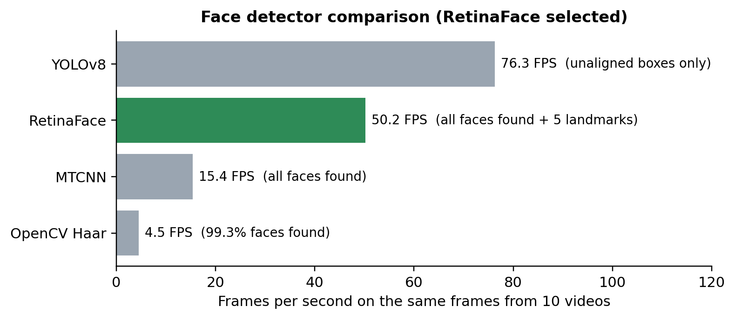
Figure 4.1: Speed of the four face detectors on the same frames
RetinaFace was selected: it found every face, it was about three times faster than MTCNN with the same face yield, and its five landmarks allow eye-aligned crops. YOLOv8 was faster but returns unaligned boxes. RetinaFace is also used at inference time, because changing the detector would create a mismatch between training and inference crops.

4.6 Face Detection, Alignment and Caching
Each sampled frame is processed as follows:
1. RetinaFace (InsightFace buffalo_l, det_10g model, input size 640 × 640, minimum score 0.50) is run through ONNX Runtime on the GPU; the notebook stops if the CUDA provider is not active.
2. If several faces are found, the one with the largest bounding box is kept; frames without a face are skipped.
3. The two eye landmarks define the rotation angle (atan2 of the eye vector) and the scale, so that the eye distance becomes (1 − 2 × 0.35) × 256 ≈ 77 pixels and the eye line lies at 35% of the crop height.
4. An affine warp (bicubic interpolation, replicated borders) produces a 256 × 256 crop; a crop is rejected if the eye distance is almost zero.
5. Crops are saved as JPEG (quality 95) in split / class folders and packed into 12 tar shards; on a restart the shards are restored instead of being recomputed.
Figure 4.2 shows randomly sampled aligned training crops. The alignment places the eyes at the same position in every crop, so that the classifier can compare like with like.
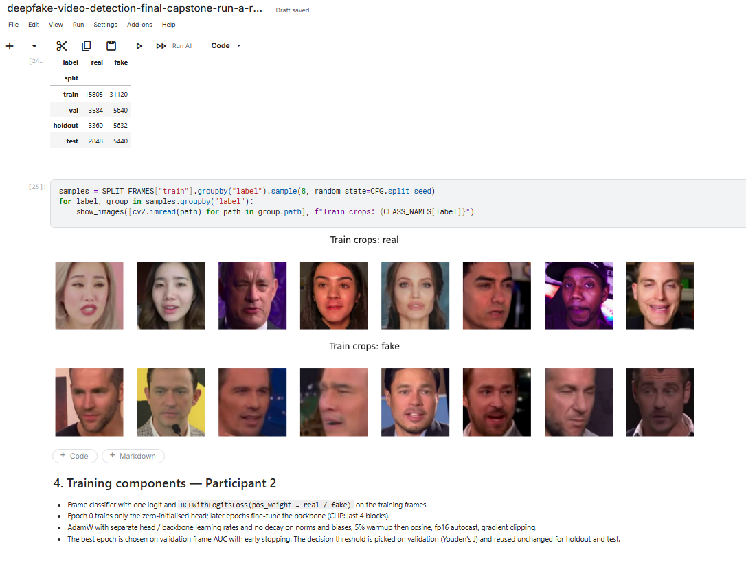
Figure 4.2: Randomly sampled eye-aligned training crops: real (top) and fake (bottom)

4.7 Summary of the Prepared Data
The preprocessing completed for all 6,529 videos with no video left without a face. The final notebook produced 73,429 indexed aligned face images. Table 4.5 gives the Run A counts, and Figure 4.3 visualises the video and face counts per split.
Table 4.5: Aligned face crops per split (Run A)
Split | Real faces | Fake faces | Total
Train | 15,805 | 31,120 | 46,925
Validation | 3,584 | 5,640 | 9,224
Holdout | 3,360 | 5,632 | 8,992
Official test | 2,848 | 5,440 | 8,288
Total | 25,597 | 47,832 | 73,429

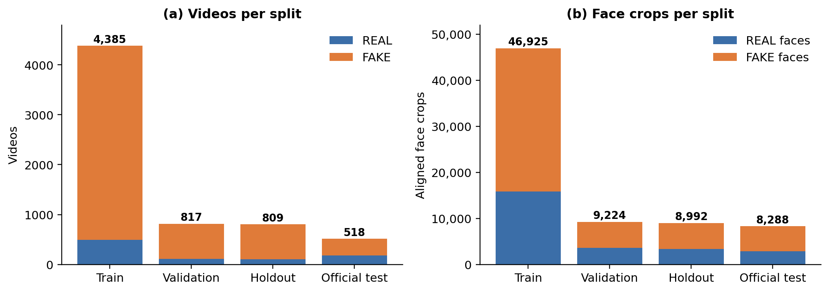
Figure 4.3: Videos (a) and aligned face crops (b) per split, by class

4.8 Data Augmentation and Normalisation
Training images are augmented on the fly to make the model less sensitive to framing, colour and compression (Table 4.6). Validation, holdout and test images are only resized to 224 × 224. Every model is normalised with the mean and standard deviation of its own pretrained weights.
Table 4.6: Training augmentation
Transform | Setting | Purpose
RandomResizedCrop | 224 × 224, scale 0.8-1.0, aspect 0.95-1.05 | Small shifts and zoom
RandomHorizontalFlip | p = 0.5 | Left / right symmetry
ColorJitter | brightness 0.2, contrast 0.2, saturation 0.15 | Lighting and camera differences
RandomJPEG | quality 40-95, p = 0.5 | Compression as in re-uploaded videos
GaussianBlur | kernel 3, σ 0.1-1.2, p = 0.1 | Slight defocus or motion
Normalize | per-model mean / std (timm data config) | Match pretraining statistics

4.9 Outlier Handling, Data Quality and Visualisation
- Detection outliers: low-confidence detections (score < 0.5) are ignored; background faces are removed by keeping the largest face; crops with degenerate eye landmarks are rejected.
- Unreadable frames: frames that cannot be decoded are skipped, with a sequential-decoding fallback; videos that cannot be opened are excluded from the resolution tests.
- Consistency checks: every cached crop must map to exactly one manifest row, and its folder split must match the manifest split; otherwise the run stops.
- Safe cache restore: archive members are extracted with a safety filter so that no file can be written outside the cache folder.
- Visual summaries: sample crops for one real and one fake video, random training crops (Figure 4.2), the split counts (Figure 4.3) and the crops of the resolution tests (Chapter 7) were inspected to confirm that alignment and labelling were correct.

Chapter 5: Machine Learning Modelling and Techniques

5.1 Problem Formulation
Each aligned face x is classified by a network f that outputs one logit z = f(x). The probability that the face is fake is p = σ(z). Training minimises the class-weighted binary cross-entropy
L = − [ w+ · y · log σ(z) + (1 − y) · log(1 − σ(z)) ],
where y = 1 for FAKE and w+ = N_real / N_fake = 15,805 / 31,120 = 0.508 (PyTorch BCEWithLogitsLoss with pos_weight). Because fake faces are still about twice as common as real ones in training, w+ < 1 down-weights them so that both classes contribute equally to the loss.

5.2 Candidate Architectures
Seven ImageNet-pretrained [9] backbones from the timm library [35] were compared (Table 5.1). They cover classic CNNs, modern CNNs, a window-attention transformer and a foundation model.
Table 5.1: Seven candidate architectures
Model | timm checkpoint | Reason for inclusion
EfficientNet-B0 [12] | efficientnet_b0.ra_in1k | Lightweight CNN; mid-term baseline
ResNet-50 [11] | resnet50.a1_in1k | Plain residual CNN reference
Xception [10] | legacy_xception.tf_in1k | Standard FaceForensics++ deepfake baseline
ConvNeXt-Tiny [14] | convnext_tiny.fb_in22k_ft_in1k | Modern CNN with ImageNet-22k pretraining
Swin-Tiny [21] | swin_tiny_patch4_window7_224.ms_in22k_ft_in1k | Window-attention transformer that keeps local detail
EfficientNet-B4 [12, 13] | tf_efficientnet_b4.ns_jft_in1k | Larger EfficientNet (Noisy Student), common in DFDC solutions
CLIP ViT-B/16 [22] | vit_base_patch16_clip_224.openai | Foundation model; only the last 4 of 12 blocks fine-tuned

5.3 Training Configuration
Every model used the same face images, split, augmentation, 224 × 224 input and epoch budget. The shared settings are listed in Table 5.2; the settings that differ by model family are listed in Table 5.3.
Table 5.2: Shared training settings
Setting | Value
Input size / batch size | 224 × 224 / 64
Epoch budget / early-stopping patience | 8 / 3
Optimiser | AdamW [37]
Learning rate of the head | 1e-3
Weight decay on biases and normalisation parameters | 0
Schedule | Linear warm-up for 5% of steps, then cosine decay [38]
Warm-up phase | Epoch 1: zero-initialised head only; later epochs: backbone too
Dropout before the head | 0.3
Gradient clipping | Global norm 1.0
Precision | Automatic mixed precision (FP16) [39]
Loss | BCEWithLogitsLoss, pos_weight = 0.508
Head initialization | Zero weights and bias (starts from a neutral logit)
Checkpoint criterion | Best validation frame-level AUC
Random seed | 42 (Python, NumPy, PyTorch)

Table 5.3: Model-specific settings and training outcome (Run A, Kaggle T4)
Model | Backbone LR | Weight decay | Drop path | Fine-tuned params | Train time (min) | Best epoch
EfficientNet-B0 | 2e-4 | 1e-4 | 0.1 | 4.0 M | 21.3 | 7
ResNet-50 | 2e-4 | 1e-4 | 0.1 | 23.5 M | 31.1 | 7
Xception | 2e-4 | 1e-4 | - | 20.8 M | 47.6 | 8
ConvNeXt-Tiny | 1e-4 | 0.05 | 0.1 | 27.8 M | 33.3 | 8
Swin-Tiny | 1e-4 | 0.05 | 0.1 | 27.5 M | 40.9 | 5
EfficientNet-B4 | 2e-4 | 1e-4 | 0.2 | 17.6 M | 35.0 | 3*
CLIP ViT-B/16 | 2e-5 | 0.05 | 0.1 | 28.4 of 85.8 M | 39.3 | 8

* EfficientNet-B4 stopped early after six epochs, because the validation AUC did not improve for three epochs after epoch 3. BatchNorm CNNs keep the EfficientNet-B0 recipe; ConvNeXt, Swin and CLIP use lower learning rates and a weight decay of 0.05.

5.4 Training Procedure
1. Build the pretrained backbone with a single-output head and set the head weights to zero.
2. Epoch 1 (warm-up): freeze the backbone and train only the head, so that the random head does not disturb the pretrained features.
3. Later epochs: unfreeze the backbone (for CLIP only the last four blocks); the head and backbone use different learning rates.
4. After each epoch, score the validation faces, compute frame-level and video-level validation AUC and EER, and save best.pt if the frame-level AUC improved.
5. Save the full training state (model, optimiser, scheduler, scaler) to last.pt after every epoch, so that an interrupted Kaggle session resumes where it stopped.
6. Stop early if the AUC does not improve for three epochs; write the epoch history to history.csv.
7. Reload best.pt, score the validation, holdout and test faces, choose the threshold and save the predictions and metrics; no retraining is done during evaluation.

5.5 Video-Level Aggregation and Threshold Selection
A video v with detected faces F(v) receives the score
s(v) = (1 / |F(v)|) · Σ p_i , i ∈ F(v),
that is, the mean fake probability over its faces. The video is predicted FAKE if s(v) ≥ t. The threshold t is chosen on the validation videos as the point on the ROC curve that maximises Youden’s J = TPR – FPR [32], and is reused unchanged for the holdout and test splits. The holdout and test splits are never used for choosing weights or thresholds, so their results remain independent.

5.6 Evaluation Protocol of the Final Comparison
- Confidence intervals: a stratified bootstrap [31] with 1,000 resamples of the holdout real and fake videos gives a 95% interval for each holdout AUC; gaps smaller than the interval are treated as noise.
- Speed: GPU throughput is measured on batches of 64 images of size 224 × 224 in FP16 (3 warm-up batches, then 20 timed batches), so it excludes decoding and face detection.
- Robustness: up to 8 holdout faces per video are scored again after JPEG re-compression at quality 50 and 30, downscaling to half size and back, and Gaussian blur (radius 1.5); the worst AUC drop against the clean score is reported.
- Calibration: one temperature T per model is fitted on the validation frames by minimising log loss over 300 values between 0.1 and 100, and the holdout video log loss and expected calibration error (ECE, 15 bins) are compared before and after scaling [33].
- Explainability: Grad-CAM [29] is computed for one real and one fake holdout face for every model, from each model’s last spatial layer (for CLIP, the patch tokens of the last block reshaped to 14 × 14).
- Demo and export: the best model scores the first holdout video of each class end to end (32 frames), and the weights, threshold and pre-processing settings are saved as one inference bundle.

5.7 ConvNeXt-Tiny Rebuild (Run B, Run B)
To test more frames and low-resolution input, ConvNeXt-Tiny was rebuilt independently as Run B within the final Kaggle workflow. It keeps the same data pipeline and ConvNeXt-Tiny settings used for the comparison. The executed run trained for eight epochs (0–7); the best validation frame AUC occurred at epoch 5 and that checkpoint was selected for evaluation.
Table 5.4: Input options of the final Kaggle notebook
Option | Input | Enhancement test
1 | Celeb-DF v2 attached in Kaggle, or downloaded with kagglehub | 1 low-resolution FAKE video
2 | Celeb-DF v2 attached through Kaggle ‘Add Input’ | 3 different low-resolution REAL videos
3 | One personal video uploaded to Kaggle (needs an attached best.pt) | 1 personal video

Table 5.5 and Figure 5.1 show the Run B training history. The warm-up epoch started near 0.59 validation frame AUC; after the backbone was unfrozen, validation performance rose rapidly above 0.98. The best validation frame AUC was 0.9976 at epoch 5.
Table 5.5: Run B training history (ConvNeXt-Tiny, Kaggle T4)
Epoch | Phase | Train loss | Val. frame AUC | Val. video AUC | Minutes
1 | head-only | 0.3890 | 0.5826 | 0.5976 | 3.37
2 | full | 0.1169 | 0.9895 | 0.9981 | 5.00
3 | full | 0.0372 | 0.9913 | 0.9986 | 4.55
4 | full | 0.0208 | 0.9938 | 0.9979 | 4.52
5 | full | 0.0138 | 0.9957 | 0.9993 | 4.44
6 | full | 0.0089 | 0.9973 | 0.9998 | 4.44
7 | full | 0.0046 | 0.9973 | 0.9997 | 4.41
8 | full | 0.0035 | 0.9971 | 0.9997 | 4.40

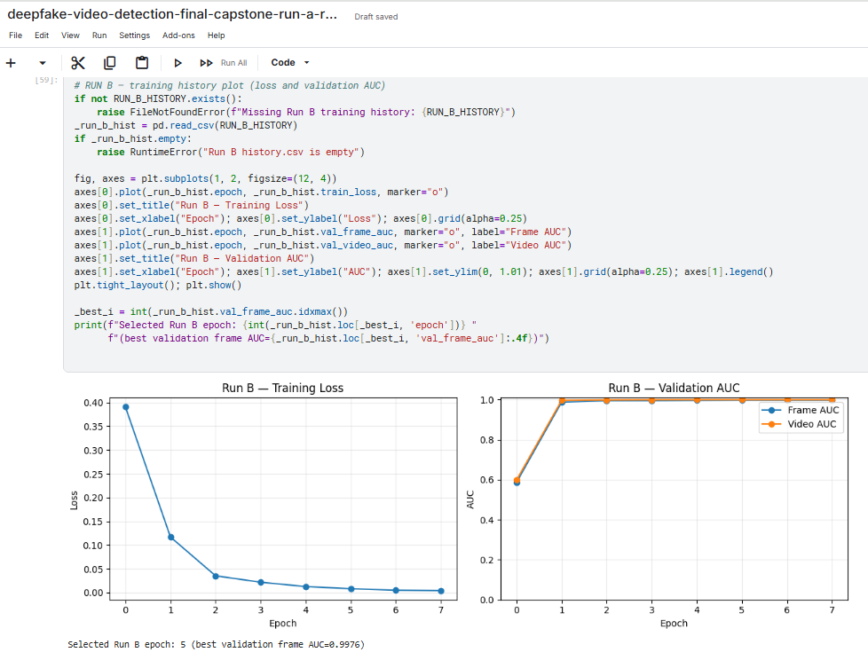
Figure 5.1: Run B training loss (a) and validation AUC (b); epoch 5 was selected
Total Run B training time was approximately 30.2 minutes (733 batches per epoch). The decision threshold chosen only on the validation videos with Youden’s J was t = 0.4825.

5.8 Low-Resolution 64-Frame Enhancement Test (Run B)
This test asks whether enhancing low-resolution frames improves the result. It was designed so that the only difference between the two conditions is the enhancement step:
- Selection: official-test videos of the chosen class are read, sorted by pixel area (width × height), and the smallest ones are taken. With Option 2 these are the three lowest-resolution REAL videos.
- Frames: 64 evenly spaced frame positions per video, identical for both conditions.
- Model and threshold: the same independently trained Run B ConvNeXt-Tiny checkpoint and the same validation-selected threshold (0.4825) were used for Original and Enhanced conditions.
- Enhancement: applied to each frame before RetinaFace in the Enhanced condition only (Table 5.6).
- Output: frames read, faces found, face-detection rate, fake score, confidence, prediction and, when the label is known, whether the prediction is correct.
Table 5.6: Frame enhancement steps
Step | Operation | Details
1 | Upscaling | If the frame is less than 360 pixels high, resize it with bicubic interpolation so that its height is 360 pixels
2 | Contrast (CLAHE [40]) | Convert to YCrCb and apply CLAHE (clip limit 1.5, 8 × 8 tiles) to the luminance channel only, so that colours are not changed
3 | Sharpening | Unsharp mask: 1.15 × image − 0.15 × Gaussian-blurred image (σ = 1.0)

The confidence reported for a video is the probability of the predicted class: the fake score s(v) when the prediction is FAKE and 1 − s(v) when it is REAL.

5.9 High- versus Low-Resolution Check (Run A)
The final notebook adds a short check of how the selected model behaves on videos of very different native resolution. It does not change any earlier training or results:
- Selection: all readable Celeb-DF videos are sorted by pixel area within each class; the smallest and the largest REAL and FAKE videos are taken, giving exactly four videos (manual overrides are possible).
- Model and threshold: the best Run A model (ConvNeXt-Tiny) with its validation-selected threshold (0.0079).
- Frames: 32 evenly spaced frames per video, processed with the same RetinaFace detection and alignment; no enhancement is applied.
- Output: faces detected, mean P(fake), prediction, correctness and time, together with six of the aligned crops for each video.

Chapter 6: Code and Screenshots
This chapter shows the key parts of the two notebooks used in the project, together with the outputs they produced: the team’s final notebook (deepfake-detection-final.ipynb, Run A) and the low-resolution notebook (deepfake-detection-low-resolution-64-frame-final.ipynb, Run B). Code is abridged for space. Maps of all notebook cells are given in Appendix B.

6.1 Final Team Notebook (Run A)

6.1.1 Environment, Data and Model Registry
Output 6.1: Environment, dataset, split and face-cache checks (Sections 1-4)
torch 2.11.0+cu128 | timm 1.0.11 | onnxruntime 1.26.0 | Tesla T4
Dataset: /kaggle/input/datasets/reubensuju/celeb-df-v2
Dataset ready: {'Celeb-real': 590, 'YouTube-real': 300, 'Celeb-synthesis': 5639}
train / val / holdout are identity-disjoint. The official test shares 36 identities with
train (expected for Celeb-DF).
real fake youtube_real fake_per_real
train 495 3890 171 7.8586
val 112 705 35 6.2946
holdout 105 704 24 6.7048
test 178 340 70 1.9101
73,429 face crops | 0 videos without a detected face
pos_weight = 0.508

Listing 6.1: Model registry of the seven architectures (Section 1)
@dataclass(frozen=True)
class ModelSpec:
timm_name: str
lr_backbone: float
weight_decay: float
cam_layer: str
drop_path_rate: float | None = 0.1
trainable_blocks: int | None = None
model_kwargs: dict = field(default_factory=dict)

MODELS = {
"efficientnet_b0": ModelSpec("efficientnet_b0.ra_in1k", 2e-4, 1e-4, "bn2"),
"resnet50": ModelSpec("resnet50.a1_in1k", 2e-4, 1e-4, "layer4"),
"xception": ModelSpec("legacy_xception.tf_in1k", 2e-4, 1e-4, "act4", drop_path_rate=None),
"convnext_tiny": ModelSpec("convnext_tiny.fb_in22k_ft_in1k", 1e-4, 0.05, "stages.3"),
"swin_tiny": ModelSpec("swin_tiny_patch4_window7_224.ms_in22k_ft_in1k", 1e-4, 0.05,
"layers.3"),
"efficientnet_b4": ModelSpec("tf_efficientnet_b4.ns_jft_in1k", 2e-4, 1e-4, "bn2",
drop_path_rate=0.2),
"clip_vit_b16": ModelSpec("vit_base_patch16_clip_224.openai", 2e-5, 0.05, "blocks.11.norm1",
trainable_blocks=4, model_kwargs={"act_layer": "quick_gelu"}),
}

6.1.2 Training and Evaluation of the Seven Models
Listing 6.2: Training epoch and evaluation of one run (Sections 4-5, abridged)
def _run_epoch(self) -> None:
start, warmup = time.time(), self.state.epoch < CFG.freeze_epochs
set_phase(self.model, self.spec, warmup) # head only in epoch 0
train_loss = train_one_epoch(self.model, self.train_loader, self.optimizer,
self.scheduler, self.scaler, self.criterion)
val = score_predictions(SPLIT_FRAMES["val"].assign(
prob=predict(self.model, self.val_loader)), threshold=0.5)
improved = val["frame_auc"] > self.state.best_auc
if improved: # keep the best epoch
self.state.best_auc = val["frame_auc"]
atomic_save(self.model.state_dict(), self.out / "best.pt")
self.state.bad_epochs = 0 if improved else self.state.bad_epochs + 1

def evaluate_run(key, seed):
model, eval_tf = load_best(key, seed)
predictions = {split: SPLIT_FRAMES[split].assign(
prob=predict(model, make_loader(SPLIT_FRAMES[split], eval_tf)))
for split in ("val", "holdout", "test")}
threshold = youden_threshold(predictions["val"].label, predictions["val"].prob)
... # video-level metrics per split, GPU throughput, best epoch -> metrics.json

Output 6.2: ConvNeXt-Tiny training log and final AUC of every model (Section 5, abridged)
convnext_tiny: 27.82M params | 733 steps/epoch
epoch 0 warmup | loss 0.3909 | val frame AUC 0.5867 (video 0.5990, EER 0.4233) | 2.9 min
epoch 1 full | loss 0.1171 | val frame AUC 0.9873 (video 0.9967, EER 0.0370) | 4.3 min
epoch 2 full | loss 0.0355 | val frame AUC 0.9944 (video 0.9986, EER 0.0167) | 4.0 min
epoch 3 full | loss 0.0219 | val frame AUC 0.9946 (video 0.9995, EER 0.0174) | 3.9 min
epoch 4 full | loss 0.0128 | val frame AUC 0.9963 (video 0.9997, EER 0.0073) | 3.9 min
epoch 5 full | loss 0.0083 | val frame AUC 0.9976 (video 0.9998, EER 0.0073) | 3.9 min
epoch 6 full | loss 0.0051 | val frame AUC 0.9973 (video 0.9996, EER 0.0059) | 3.9 min
epoch 7 full | loss 0.0043 | val frame AUC 0.9974 (video 0.9997, EER 0.0094) | 3.9 min
Best checkpoint: epoch 5.

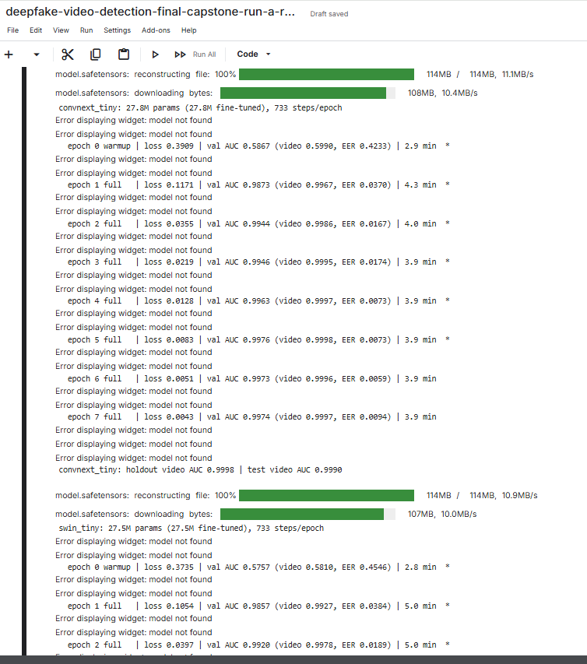

6.1.3 Comparison, Robustness and Calibration
Listing 6.3: Bootstrap interval, robustness conditions and temperature scaling (Sections 6-8)
def bootstrap_auc_ci(videos, n_boot=1000, seed=0):
rng = np.random.default_rng(seed)
real = videos.prob[videos.label == 0].to_numpy()
fake = videos.prob[videos.label == 1].to_numpy()
targets = np.r_[np.zeros(len(real)), np.ones(len(fake))]
aucs = [roc_auc_score(targets, np.r_[rng.choice(real, len(real)),
rng.choice(fake, len(fake))]) for _ in range(n_boot)]
return tuple(np.percentile(aucs, [2.5, 97.5])) # stratified 95% interval

PERTURBATIONS = {"clean": identity,
"jpeg_q50": functools.partial(jpeg_compress, quality=50),
"jpeg_q30": functools.partial(jpeg_compress, quality=30),
"downscale_x0.5": downscale, "blur_r1.5": blur}

def fit_temperature(labels, probs): # one T per model
logits, grid = to_logits(probs), np.logspace(-1, 2, 300)
losses = [log_loss(labels, expit(logits / t), labels=[0, 1]) for t in grid]
return float(grid[int(np.argmin(losses))])

Output 6.3: Model comparison and robustness tables (Sections 6-7, abridged columns)
model Params(M) GPU img/s Train min Holdout frame AUC Holdout video AUC CI low CI high EER Holdout F1 Test AUC Test F1
convnext_tiny 27.8209 643.2474 30.8771 0.9963 0.9998 0.9993 1.0000 0.0076 0.9902 0.9990 0.9497
efficientnet_b4 17.5504 521.3066 31.2077 0.9919 0.9994 0.9986 0.9999 0.0119 0.9922 0.9992 0.9869
xception 20.8090 568.9492 29.8581 0.9902 0.9991 0.9981 0.9998 0.0188 0.9943 0.9991 0.9700
swin_tiny 27.5201 457.4665 37.2300 0.9928 0.9984 0.9964 0.9997 0.0188 0.9901 0.9989 0.9471
efficientnet_b0 4.0088 1479.6056 22.1450 0.9891 0.9981 0.9963 0.9994 0.0133 0.9880 0.9978 0.9524
resnet50 23.5101 780.3894 27.7604 0.9896 0.9976 0.9956 0.9991 0.0188 0.9901 0.9981 0.9671
clip_vit_b16 85.8002 350.3646 33.7194 0.9777 0.9905 0.9839 0.9959 0.0389 0.9772 0.9959 0.9354

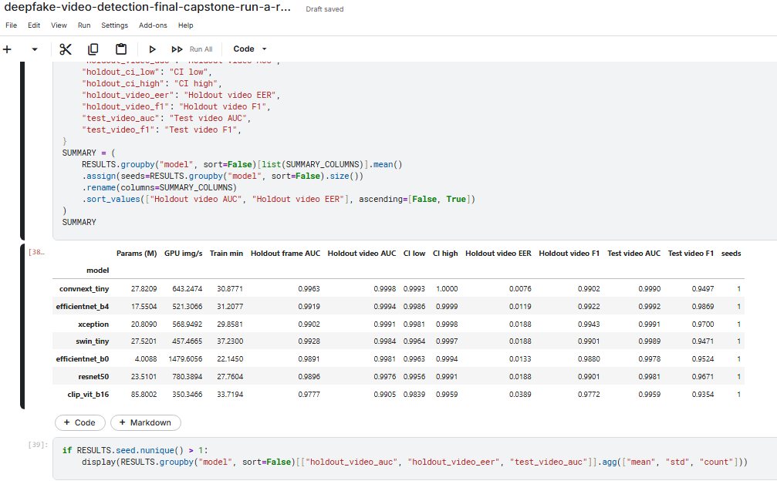

6.1.4 Demo, Export and High / Low Resolution Check
Output 6.4: End-to-end demo, export and resolution check (Sections 10-11)
Best model: convnext_tiny | threshold 0.0079
video truth faces p_fake prediction seconds
id49_0000.mp4 REAL 32 3.6828e-05 REAL 6.0812
id49_id50_0000.mp4 FAKE 32 7.4542e-01 FAKE 10.5001
Participant 4 — High vs Low Resolution Comparison
REAL_HIGH id16_0012.mp4 974x500 32 faces P(fake)=0.0000 REAL correct
FAKE_HIGH id16_id9_0012.mp4 974x500 32 faces P(fake)=1.0000 FAKE correct
REAL_LOW id24_0003.mp4 286x300 32 faces P(fake)=0.0019 REAL correct
FAKE_LOW id24_id19_0003.mp4 286x300 32 faces P(fake)=0.9999 FAKE correct
Accuracy: 100.0% (4/4)

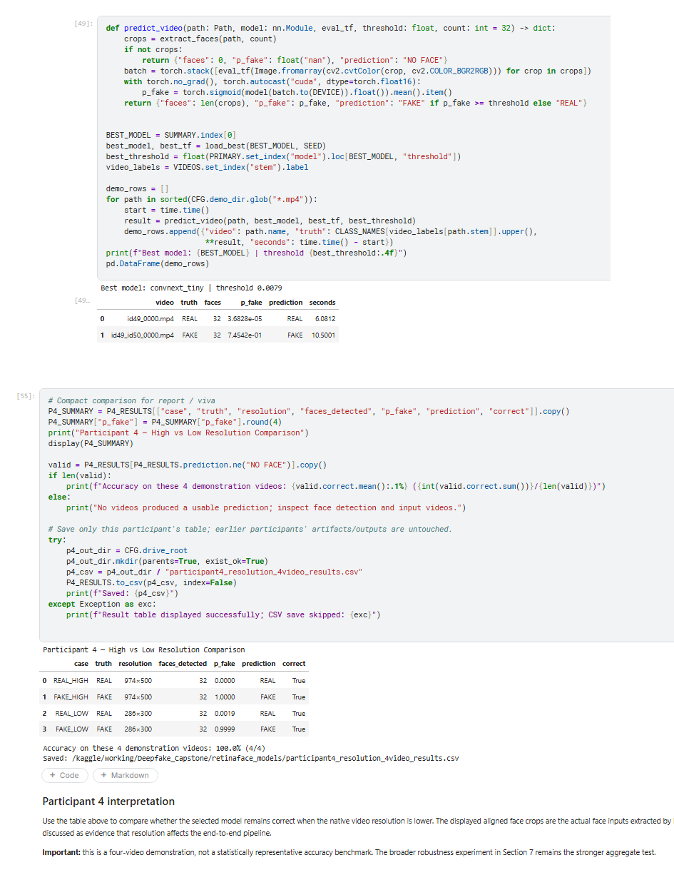

6.2 Low-Resolution Run B (Run B)

6.2.1 Environment and GPU Check
Listing 6.4: PyTorch, GPU and ONNX Runtime pre-flight check (Cells 0 and 2)
import torch
import onnxruntime as ort
import timm
assert torch.cuda.is_available(), "Switch Kaggle runtime to a GPU accelerator."
DEVICE = torch.device("cuda")
ORT_PROVIDERS = ort.get_available_providers()
print(f"torch {torch.__version__} | timm {timm.__version__} | onnxruntime {ort.__version__} | {torch.cuda.get_device_name(0)}")
print("ONNX Runtime providers:", ORT_PROVIDERS)
print("Environment preflight: PASS")

Output 6.5
torch 2.11.0+cu128 | timm 1.0.29 | onnxruntime 1.30.0 | Tesla T4
ONNX Runtime providers: ['AzureExecutionProvider', 'CPUExecutionProvider']
Environment preflight: PASS
PyTorch training used the Tesla T4. RetinaFace used ONNX Runtime CPUExecutionProvider in this final Kaggle execution.

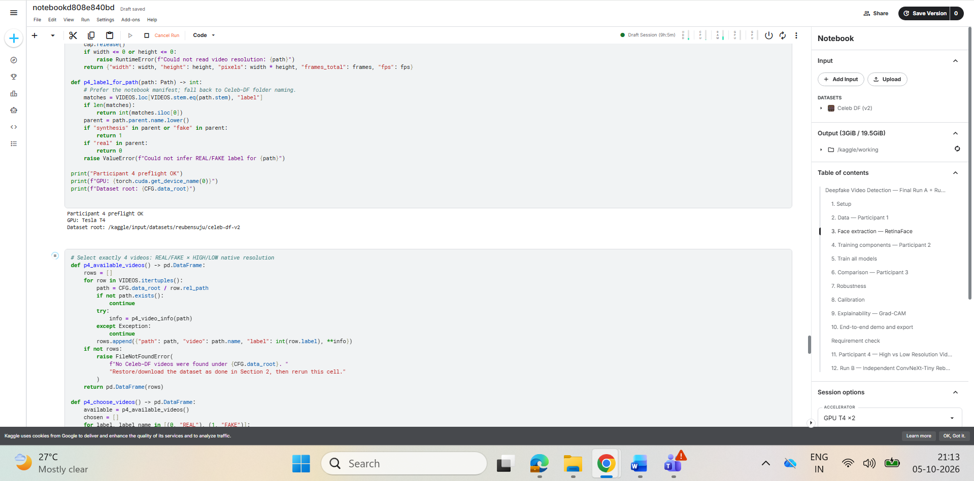
Figure 6.1: Kaggle screenshot of the final Kaggle notebook: environment preflight showing Tesla T4 and ONNX Runtime providers (5 October 2026)

6.2.2 Manifest and Leakage Audit
Listing 6.5: Identity components (union-find) and leakage audit (Cell 5)
def identity_components(videos):
parent = {}
def find(i):
parent.setdefault(i, i)
while parent[i] != i:
parent[i] = parent[parent[i]]; i = parent[i]
return i
def union(a, b):
ra, rb = find(a), find(b)
if ra != rb: parent[rb] = ra
for id_a, id_b in zip(videos.id_a, videos.id_b):
find(id_a)
if isinstance(id_b, str): union(id_a, id_b)
return videos.id_a.map(find)

def audit_leakage(videos):
for a, b in [("train", "val"), ("train", "holdout"), ("val", "holdout")]:
shared = split_identities(videos, a) & split_identities(videos, b)
if shared:
raise RuntimeError(f"Identity leakage between {a} and {b}")
print("Leakage audit passed: train / val / holdout are identity-disjoint.")

Output 6.6
Celeb-real: 590 MP4 videos
YouTube-real: 300 MP4 videos
Celeb-synthesis: 5639 MP4 videos
Leakage audit passed: train / val / holdout are identity-disjoint.

real fake
split
train 495 3890
val 112 705
holdout 105 704
test 178 340

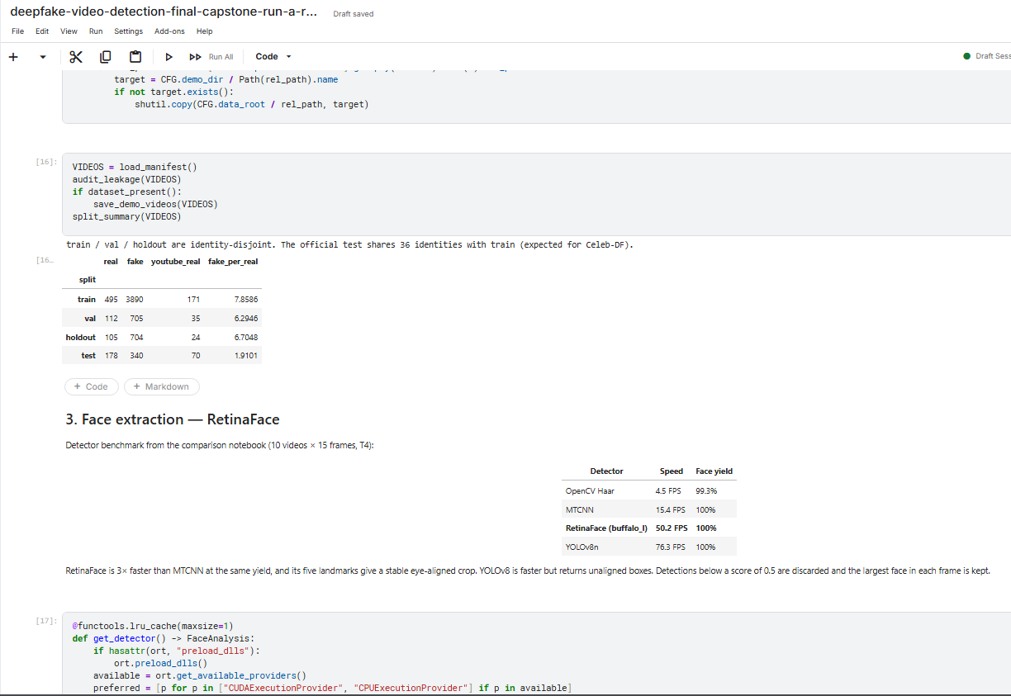
Figure 6.2: Kaggle screenshot of the final Kaggle notebook: manifest and leakage audit

6.2.3 RetinaFace Detection and Eye Alignment
Listing 6.6: Eye alignment and face extraction (Cell 6)
def align_face(image, landmarks, size): # size = 256
left_eye, right_eye = landmarks[0], landmarks[1]
dx, dy = (right_eye - left_eye).tolist()
distance = math.hypot(dx, dy)
if distance < 1e-3:
return None
center = tuple(((left_eye + right_eye) / 2).tolist())
scale = (1 - 2 * EYE_MARGIN_X) * size / distance # EYE_MARGIN_X = 0.35
M = cv2.getRotationMatrix2D(center, math.degrees(math.atan2(dy, dx)), scale)
M[0, 2] += size * 0.5 - center[0]
M[1, 2] += size * EYE_LINE_Y - center[1] # EYE_LINE_Y = 0.35
return cv2.warpAffine(image, M, (size, size), flags=cv2.INTER_CUBIC,
borderMode=cv2.BORDER_REPLICATE)

def extract_face_from_frame(frame):
face = largest_face(get_detector().get(frame)) # RetinaFace, det_thresh 0.5
return None if face is None else align_face(frame, face.kps, CFG.align_size)

Output 6.7
RetinaFace providers: ['CPUExecutionProvider']
Face-cache shard 1/12: 545/545 [24:57]
Face-cache shard 2/12: 544/544 [25:11]
Face-cache shard 3/12: 544/544 [23:00]
Face-cache shard 4/12: 544/544 [24:15]
Face-cache shard 5/12: 544/544 [42:37]
Face-cache shard 6/12: 544/544 [24:10]
Face-cache shard 7/12: 544/544 [22:38]
Face-cache shard 8/12: 544/544 [23:04]
Face-cache shard 9/12: 544/544 [24:30]
Face-cache shard 10/12: 544/544 [24:19]
Face-cache shard 11/12: 544/544 [24:03]
Face-cache shard 12/12: 544/544 [23:55]
73,429 aligned face crops indexed.
label real fake
train 15805 31120
val 3584 5640
holdout 3360 5632
test 2848 5440

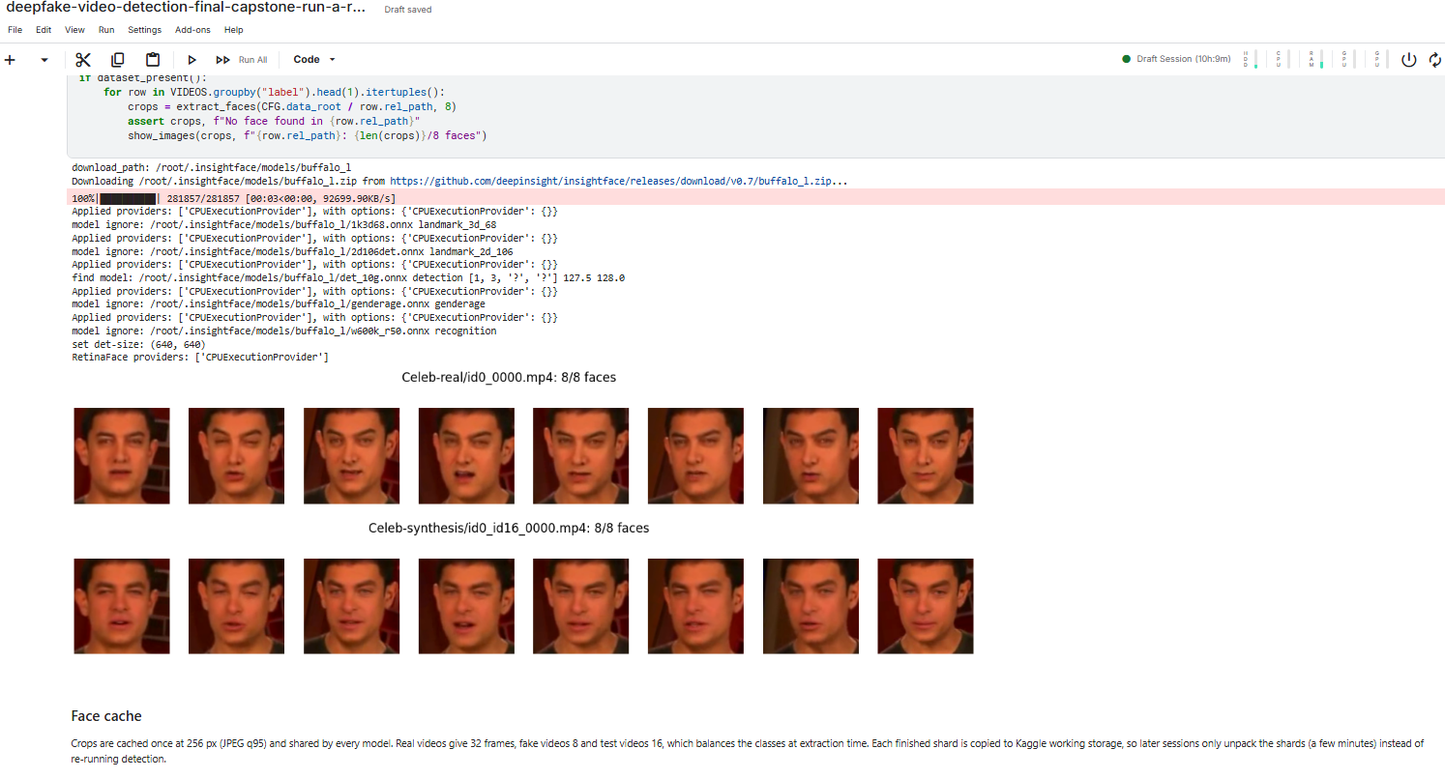
Figure 6.3: Kaggle screenshot of the final Kaggle notebook: RetinaFace model download and the first face-cache shard
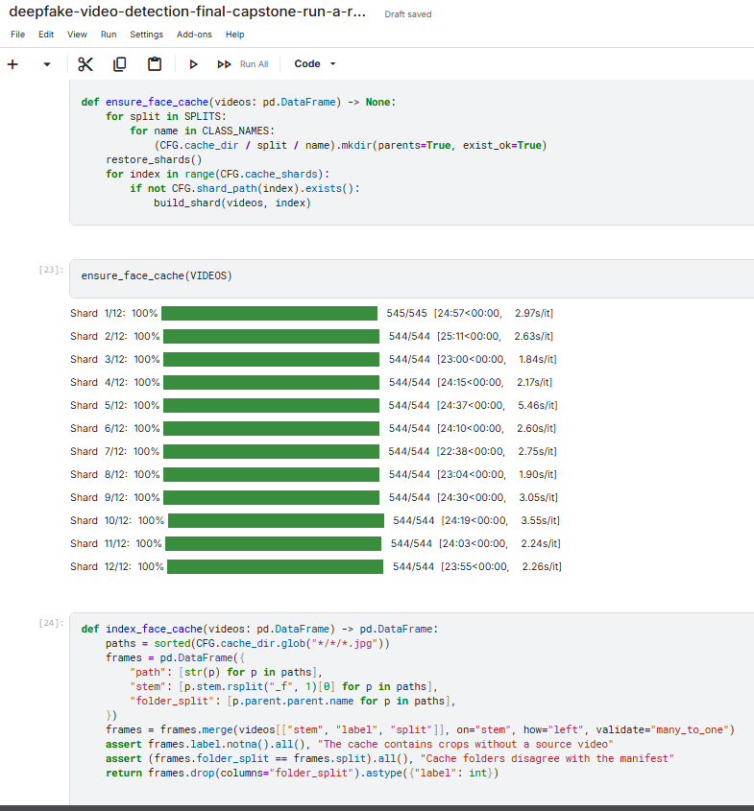
Figure 6.4: Kaggle screenshot of the final Kaggle notebook: remaining face-cache shards and crop counts

6.2.4 Model Construction and Training Loop
Listing 6.7: ConvNeXt-Tiny construction and training loop (Cells 8 and 10, abridged)
def build_model(pretrained=True):
model = timm.create_model("convnext_tiny.fb_in22k_ft_in1k", pretrained=pretrained,
num_classes=1, drop_rate=0.3, drop_path_rate=0.1)
if pretrained: # neutral starting logit
head = model.get_classifier()
nn.init.zeros_(head.weight); nn.init.zeros_(head.bias)
return model.to(DEVICE)

criterion = nn.BCEWithLogitsLoss(pos_weight=torch.tensor([POS_WEIGHT], device=DEVICE))
for epoch in range(CFG.epochs):
set_phase(model, warmup=epoch < CFG.freeze_epochs) # head-only in epoch 1
train_loss = train_one_epoch(model, train_loader, optimizer, scheduler,
scaler, criterion) # AMP + grad clipping
val_frames["prob"] = predict_loader(model, val_loader)
val_videos = video_scores(val_frames) # mean P(fake) per video
val_frame_auc = roc_auc_score(val_frames.label, val_frames.prob)
if val_frame_auc > best_val_auc: # keep best checkpoint
best_val_auc, bad_epochs = val_frame_auc, 0
torch.save(model.state_dict(), BEST_MODEL_PATH)
else:
bad_epochs += 1
if bad_epochs >= CFG.patience:
break

Output 6.8 (values rounded to four decimals)
Run B ConvNeXt-Tiny: 27.82M params | 733 steps/epoch
epoch 0 warmup | loss 0.3909 | val frame AUC 0.5867 | video 0.5990 | EER 0.4233 | 2.6 min
epoch 1 full | loss 0.1171 | val frame AUC 0.9873 | video 0.9967 | EER 0.0370 | 4.0 min
epoch 2 full | loss 0.0355 | val frame AUC 0.9944 | video 0.9986 | EER 0.0167 | 4.0 min
epoch 3 full | loss 0.0219 | val frame AUC 0.9946 | video 0.9995 | EER 0.0174 | 4.0 min
epoch 4 full | loss 0.0128 | val frame AUC 0.9963 | video 0.9997 | EER 0.0073 | 3.9 min
epoch 5 full | loss 0.0083 | val frame AUC 0.9976 | video 0.9998 | EER 0.0073 | 3.9 min
epoch 6 full | loss 0.0051 | val frame AUC 0.9973 | video 0.9996 | EER 0.0059 | 3.9 min
epoch 7 full | loss 0.0043 | val frame AUC 0.9974 | video 0.9997 | EER 0.0094 | 3.9 min
Selected Run B epoch: 5 (best validation frame AUC = 0.9976)

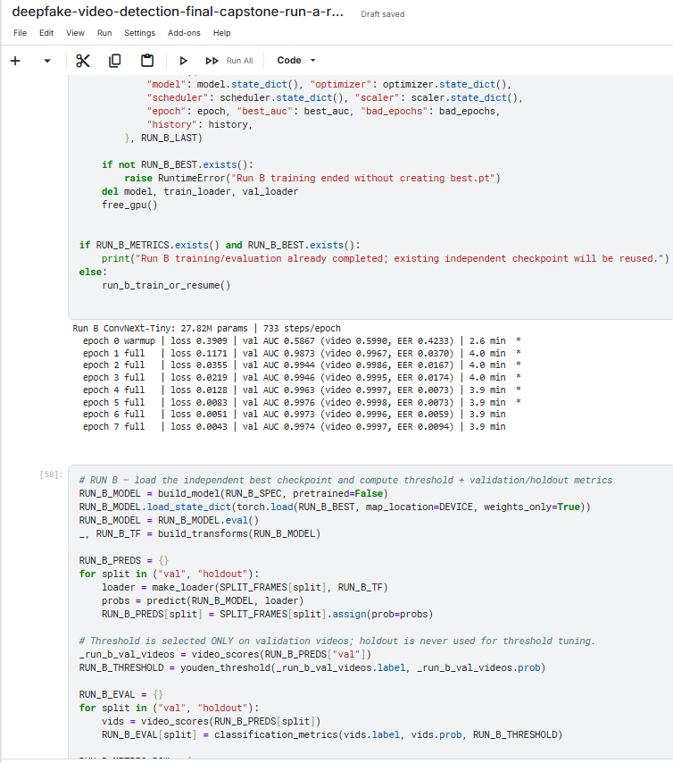

6.2.5 Threshold Selection and Evaluation
Listing 6.8: Validation threshold (Youden J) and video-level metrics (Cells 9 and 11)
def youden_threshold(y_true, y_prob):
fpr, tpr, thresholds = roc_curve(y_true, y_prob)
finite = np.isfinite(thresholds)
fpr, tpr, thresholds = fpr[finite], tpr[finite], thresholds[finite]
return float(thresholds[np.argmax(tpr - fpr)])

FINAL_THRESHOLD = youden_threshold(val_videos.label, val_videos.prob)
val_metrics = classification_metrics(val_videos.label, val_videos.prob, FINAL_THRESHOLD)
holdout_metrics = classification_metrics(holdout_videos.label, holdout_videos.prob,
FINAL_THRESHOLD)

Output 6.9
Run B threshold (validation Youden J): 0.4825
Split AUC Accuracy Precision Recall Specificity F1 EER
Validation 0.9998 0.9878 1.0000 0.9858 1.0000 0.9929 0.0073
Holdout 0.9998 0.9728 1.0000 0.9688 1.0000 0.9841 0.0076
Confusion counts (TN / FP / FN / TP)
Validation: 112 / 0 / 10 / 695
Holdout: 105 / 0 / 22 / 682

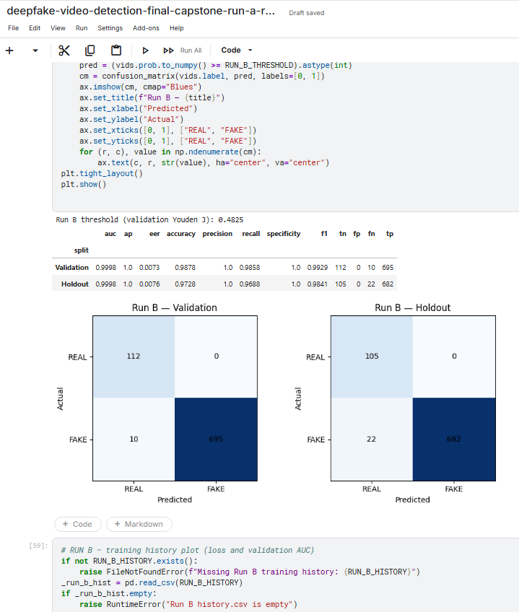

6.2.6 Enhancement and 64-Frame Video Inference
Listing 6.9: Frame enhancement and per-video inference (Cells 12 and 15, abridged)
def enhance_low_res_frame(frame_bgr, target_min_height=360):
h, w = frame_bgr.shape[:2]
if h < target_min_height: # bicubic upscaling
s = target_min_height / h
frame_bgr = cv2.resize(frame_bgr, (round(w * s), round(h * s)),
interpolation=cv2.INTER_CUBIC)
y, cr, cb = cv2.split(cv2.cvtColor(frame_bgr, cv2.COLOR_BGR2YCrCb))
y = cv2.createCLAHE(clipLimit=1.5, tileGridSize=(8, 8)).apply(y) # luminance only
out = cv2.cvtColor(cv2.merge([y, cr, cb]), cv2.COLOR_YCrCb2BGR)
blurred = cv2.GaussianBlur(out, (0, 0), 1.0)
return cv2.addWeighted(out, 1.15, blurred, -0.15, 0) # mild sharpening

def predict_video(path, known_label, n_frames=64, enhance=False):
crops, _, frames_read = extract_faces_from_video(path, n_frames, enhance)
probs = score_faces(crops) # BGR -> RGB -> eval transform -> sigmoid
fake_score = float(np.mean(probs))
predicted = int(fake_score >= FINAL_THRESHOLD)
confidence = 100 * (fake_score if predicted == 1 else 1 - fake_score)
...

Output 6.10
Selected 3 low-resolution video(s) for enhancement testing.

Test video Video Resolution Frames available
0 REAL Low 1 id27_0008.mp4 348x500 331
1 REAL Low 2 id16_0011.mp4 456x500 272
2 REAL Low 3 id29_0009.mp4 476x482 474

Video Condition Frames read Faces found Fake score Confidence % Prediction Correct
REAL Low 1 Original 64 64 0.0000 100.00 REAL YES
REAL Low 1 Enhanced 64 64 0.0000 100.00 REAL YES
REAL Low 2 Original 64 64 0.0000 100.00 REAL YES
REAL Low 2 Enhanced 64 64 0.0000 100.00 REAL YES
REAL Low 3 Original 64 64 0.0000 100.00 REAL YES
REAL Low 3 Enhanced 64 64 0.0000 100.00 REAL YES

Across 3 videos: improved=0, worse=0, already-correct/no need=3, not fixed=0.

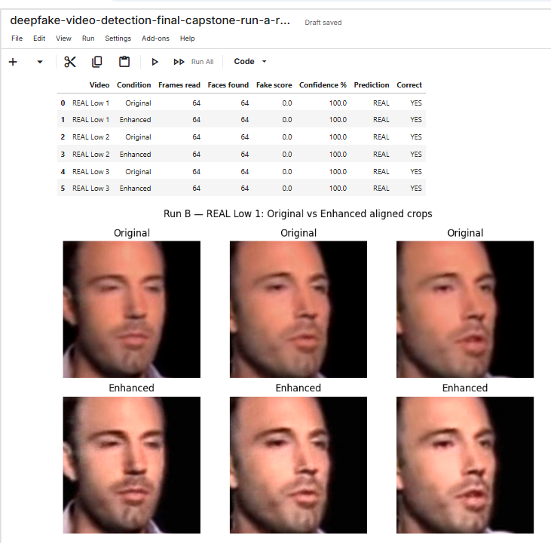

Chapter 7: Results and Interpretation
This chapter first justifies the measures used, then reports the seven-model comparison, robustness, calibration, explainability, speed and demo of the final notebook (Run A), followed by the ConvNeXt-Tiny rebuild (Run B) and the two low-resolution studies.

7.1 Justification of Measures and Metrics
The task is a binary decision per video, and the data are imbalanced: in the holdout split 704 of 809 videos (87.0%) are fake. A model that always answers FAKE would therefore reach 87.0% accuracy while being useless. All headline metrics are computed at video level, because the decision is made per video and faces from the same video are strongly correlated. Table 7.1 explains each measure.
Table 7.1: Measures used and their justification
Measure | Definition | Why it is used
ROC-AUC | Probability that a random fake video scores higher than a random real video | Threshold-free and insensitive to class imbalance; main metric for model selection [30]
95% CI of AUC | Stratified bootstrap interval of the holdout AUC (1,000 resamples) | Only 105 real holdout videos, so small AUC differences must be checked for overlap [31]
Accuracy | (TP + TN) / N | Easy to communicate; reported with the number of correct videos
Precision | TP / (TP + FP) | How trustworthy a FAKE alarm is
Recall (TPR) | TP / (TP + FN) | Share of fake videos caught
Specificity (TNR) | TN / (TN + FP) | Share of real videos correctly passed; false accusations of real videos are costly
F1 score | 2 · Precision · Recall / (Precision + Recall) | Single summary of the FAKE-class trade-off
EER | Error rate where FPR = FNR | Threshold-free error figure common in forensics and biometrics
Confusion matrix | Counts of TN, FP, FN, TP | Shows which kind of error a model makes
Log loss, ECE | Penalty for confident wrong probabilities; gap between confidence and accuracy | Whether the scores can be read as probabilities [33]
Speed | Face images / s (GPU) and seconds / video | Feasibility of practical use
Confidence | s(v) if FAKE, 1 − s(v) if REAL | Used to compare Original and Enhanced runs

7.2 Seven-Model Comparison (Run A)
All seven models were evaluated on the 809 holdout videos (main result) and the 518 official test videos. Table 7.2 gives the results, ordered by holdout AUC; accuracy and F1 use each model’s own validation threshold, and speed is the GPU throughput on prepared faces (T4, FP16).
Table 7.2: Seven-model comparison (Run A, final notebook)
Model | Holdout AUC (95% CI) | Holdout accuracy (correct) | Holdout EER | Holdout F1 | Official AUC | Official F1 | GPU img/s
ConvNeXt-Tiny | 0.9998 (0.9993-1.0000) | 98.27% (795) | 0.0076 | 0.9902 | 0.9990 | 0.9497 | 643
EfficientNet-B4 | 0.9994 (0.9986-0.9999) | 98.64% (798) | 0.0119 | 0.9922 | 0.9992 | 0.9869 | 521
Xception | 0.9991 (0.9981-0.9998) | 99.01% (801) | 0.0188 | 0.9943 | 0.9991 | 0.9700 | 569
Swin-Tiny | 0.9984 (0.9964-0.9997) | 98.27% (795) | 0.0188 | 0.9901 | 0.9989 | 0.9471 | 457
EfficientNet-B0 | 0.9981 (0.9963-0.9994) | 97.90% (792) | 0.0133 | 0.9880 | 0.9978 | 0.9524 | 1,480
ResNet-50 | 0.9976 (0.9956-0.9991) | 98.27% (795) | 0.0188 | 0.9901 | 0.9981 | 0.9671 | 780
CLIP ViT-B/16 | 0.9905 (0.9839-0.9959) | 96.04% (777) | 0.0389 | 0.9772 | 0.9959 | 0.9354 | 350

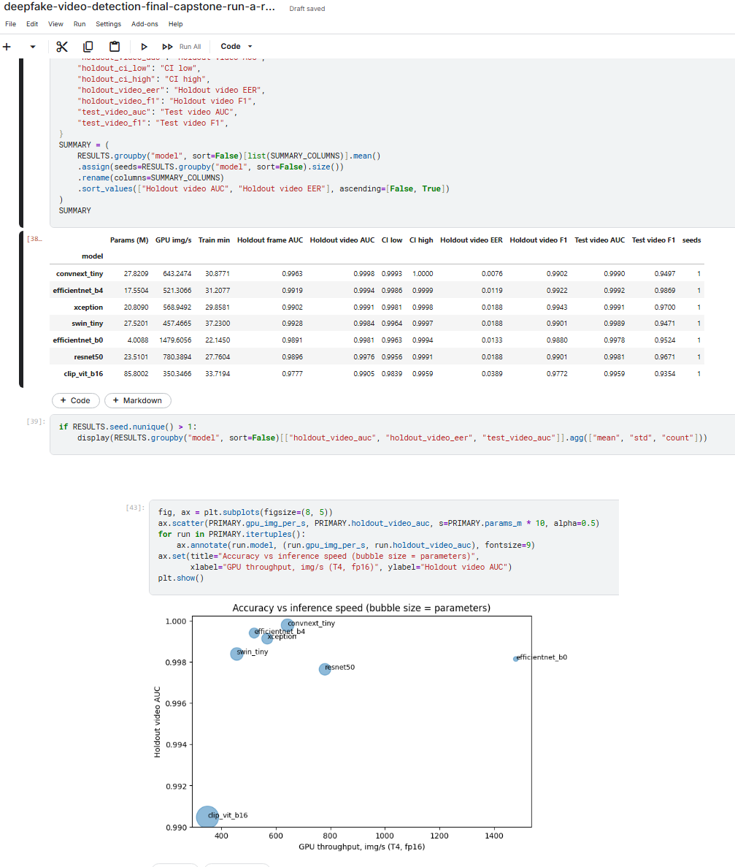
Figure 7.1: Holdout AUC with bootstrap 95% confidence intervals (a) and accuracy versus speed (b)
The ROC curves (Figure 7.2), the confusion matrices (Figure 7.3, Table 7.3) and the training curves (Figure 7.4) show the same picture in more detail.
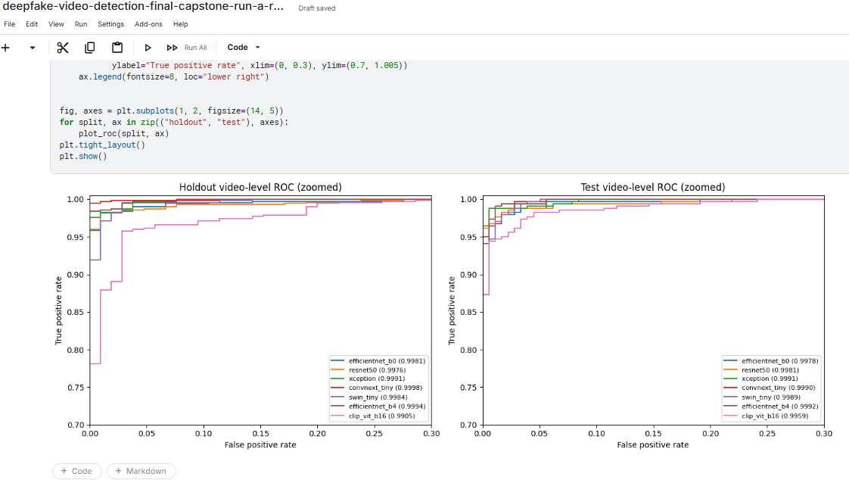
Figure 7.2: Video-level ROC curves of the seven models on the holdout (left) and official test (right) videos, zoomed to FPR ≤ 0.3
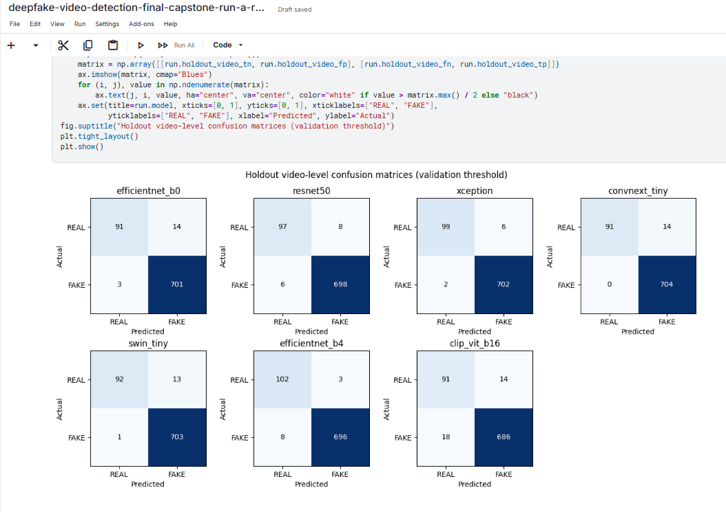
Figure 7.3: Holdout confusion matrices of the seven models, each at its own validation threshold
Table 7.3: Holdout confusion counts per model (105 real, 704 fake videos)
Model | TN | FP | FN | TP | Errors | Specificity | Recall
EfficientNet-B0 | 91 | 14 | 3 | 701 | 17 | 86.7% | 99.6%
ResNet-50 | 97 | 8 | 6 | 698 | 14 | 92.4% | 99.1%
Xception | 99 | 6 | 2 | 702 | 8 | 94.3% | 99.7%
ConvNeXt-Tiny | 91 | 14 | 0 | 704 | 14 | 86.7% | 100.0%
Swin-Tiny | 92 | 13 | 1 | 703 | 14 | 87.6% | 99.9%
EfficientNet-B4 | 102 | 3 | 8 | 696 | 11 | 97.1% | 98.9%
CLIP ViT-B/16 | 91 | 14 | 18 | 686 | 32 | 86.7% | 97.4%

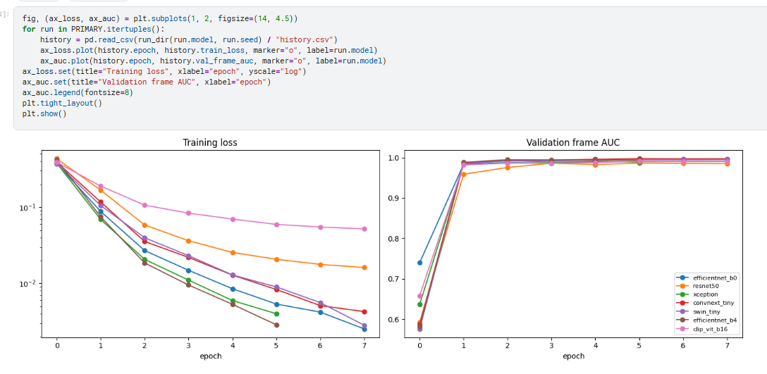
Figure 7.4: Training loss (a) and validation frame AUC (b) of the seven models in Run A
Interpretation.
- ConvNeXt-Tiny ranks the videos best by holdout AUC (0.9998) and missed no fake video at its validation-selected threshold (recall 100%). Its holdout EER in this final execution is 0.0076.
- The top six models are statistically close. ConvNeXt-Tiny’s interval (0.9993-1.0000) overlaps the intervals of EfficientNet-B4, ResNet-50, Swin-Tiny, EfficientNet-B0 and Xception, so their AUC differences are within bootstrap noise. Only CLIP ViT-B/16 is clearly worse, with an interval (0.9843-0.9949) below all the others.
- At each model’s own validation-selected threshold, Xception made the fewest holdout errors (8 of 809, 99.01% accuracy). ConvNeXt-Tiny made 14 errors, all real videos flagged as fake; its threshold (0.0079) favours catching every fake.
- Most errors are real videos flagged as fake. Real videos are the minority class, so each false alarm costs about one percentage point of specificity (1 / 105), and specificity ranges from 79.0% (EfficientNet-B0) to 97.1% (ResNet-50) while recall stays at or above 99.3% for the six strongest models.
- CLIP ViT-B/16 was the weakest model in the final seven-model comparison by holdout AUC (0.9905). Its holdout accuracy was 96.04% (777/809), with 18 missed fake videos. Only its last four transformer blocks were fine-tuned, so this result should be interpreted as the performance of the configured transfer-learning setup rather than a general limitation of CLIP.
- Training was fast and stable: all models passed 0.96 validation AUC after the first full epoch; EfficientNet-B4 reached its best epoch early and stopped after six epochs.
- Selection: ConvNeXt-Tiny was selected as the final Run A model because it had the highest holdout video AUC (0.9998), missed no fake video at its validation-selected threshold, and had the smallest robustness drop (0.0010). It is moderate in size (27.8 M parameters) and achieved about 643 face images/s for classifier inference on the T4 GPU.

7.3 Official Test Benchmark
On the 518-video official Celeb-DF test list, all seven models reached AUCs between 0.9963 (CLIP) and 0.9995 (Swin-Tiny); ConvNeXt-Tiny reached AUC 0.9990 and F1 0.958. The F1 scores vary more (0.943-0.990, highest for EfficientNet-B4) than the AUCs, because each threshold was chosen on the validation split and transfers differently to a test list with a different class balance (178 real, 340 fake). ConvNeXt-Tiny’s very low threshold most likely produces extra false FAKE alarms on the real test videos. The official list also shares 36 identities with training, so the holdout split remains the main measure of generalisation.

7.4 Robustness to Compression, Downscaling and Blur
Table 7.4 gives the holdout video AUC of every model under each degradation, and Figure 7.5 the worst AUC drop.
Table 7.4: Holdout video AUC under degradation (up to 8 faces per video)
Model | Clean | JPEG q50 | JPEG q30 | Downscale ×0.5 | Blur r1.5 | Worst drop
ConvNeXt-Tiny | 0.9998 | 0.9998 | 0.9991 | 0.9990 | 0.9988 | 0.0010
Swin-Tiny | 0.9991 | 0.9982 | 0.9973 | 0.9966 | 0.9961 | 0.0031
ResNet-50 | 0.9980 | 0.9965 | 0.9966 | 0.9948 | 0.9946 | 0.0034
Xception | 0.9987 | 0.9977 | 0.9960 | 0.9951 | 0.9945 | 0.0042
EfficientNet-B0 | 0.9982 | 0.9961 | 0.9954 | 0.9955 | 0.9932 | 0.0049
EfficientNet-B4 | 0.9990 | 0.9968 | 0.9934 | 0.9950 | 0.9943 | 0.0056
CLIP ViT-B/16 | 0.9928 | 0.9911 | 0.9912 | 0.9795 | 0.9744 | 0.0184

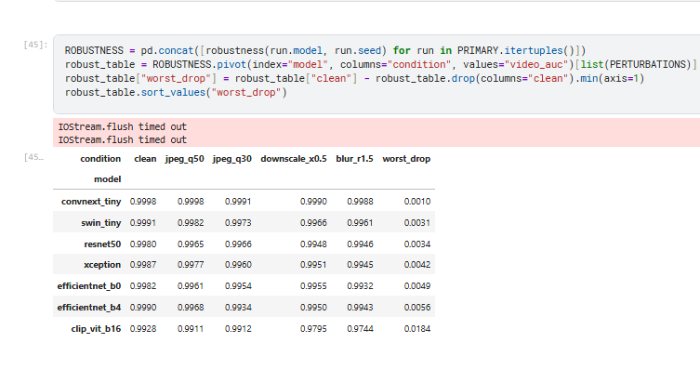
Figure 7.5: Worst holdout AUC drop per model under the four degradations (lower is better)
ConvNeXt-Tiny was the most robust model in this execution: clean holdout AUC was 0.9998 and the worst degradation AUC was 0.9988, a worst drop of 0.0010. Swin-Tiny, ResNet-50, Xception, EfficientNet-B0 and EfficientNet-B4 had worst drops of 0.0031, 0.0034, 0.0042, 0.0049 and 0.0056 respectively. CLIP ViT-B/16 was least robust, falling to 0.9744 AUC under blur (drop 0.0184).

7.5 Probability Calibration
Table 7.5 compares the holdout video-level log loss and expected calibration error (ECE) before and after temperature scaling.
Table 7.5: Calibration of the holdout video scores before and after temperature scaling
Model | Temperature T | Log loss before | Log loss after | ECE before | ECE after
EfficientNet-B0 | 2.6592 | 0.1676 | 0.1957 | 0.1084 | 0.1393
ResNet-50 | 2.1106 | 0.2462 | 0.2686 | 0.1577 | 0.1931
Xception | 1.5274 | 0.1998 | 0.2223 | 0.1451 | 0.1668
ConvNeXt-Tiny | 2.4245 | 0.1100 | 0.1240 | 0.0783 | 0.0943
Swin-Tiny | 3.1260 | 0.1543 | 0.1658 | 0.0964 | 0.1178
EfficientNet-B4 | 1.3926 | 0.1192 | 0.1316 | 0.0871 | 0.0993
CLIP ViT-B/16 | 2.5391 | 0.3659 | 0.3276 | 0.1719 | 0.1954

Interpretation.
- ConvNeXt-Tiny and EfficientNet-B4 are the best calibrated models without any correction (log loss 0.089 and 0.090, ECE 0.064 and 0.067); CLIP is the worst (0.534 and 0.222).
- All fitted temperatures are above 1 (1.46-2.72), which confirms that the raw frame-level probabilities are over-confident on the validation frames.
- Temperature scaling did not improve the video-level calibration. Log loss and ECE increased for six of the seven models; only CLIP’s log loss decreased (0.534 to 0.429), while its ECE still rose. The temperature is fitted on single frames but evaluated on video scores, which are already averages over 8-32 faces and therefore less extreme; softening them further moves correct video scores away from 0 and 1.
- Practical consequence: the raw video scores together with the validation threshold are the better choice for the final model. A temperature fitted on validation video scores, rather than frames, is proposed as future work. Temperature scaling does not change the ranking, so all AUC results are unaffected.

7.6 Explainability with Grad-CAM
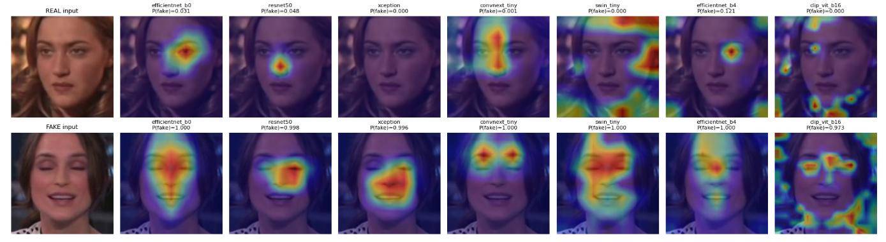
Figure 7.6: Grad-CAM attention for one real (top) and one fake (bottom) holdout face, with each model’s P(fake)
On the fake face, most models concentrate on the eyes, nose and mouth, the regions where the swapped face is blended into the target, which agrees with the artefact-focused literature [16, 17]; ConvNeXt-Tiny focuses on both eyes. All models give the fake face a score of at least 0.986 (CLIP) and 1.000 for five models, while the real face receives low scores (0.000-0.088, highest for ResNet-50). Swin-Tiny and EfficientNet-B4 spread attention to the background on the real face, and CLIP’s maps are scattered across the face and background, matching its weaker results. The Grad-CAM scores refer to single frames; the final decision uses the average over the whole video, which smooths out individual uncertain frames.

7.7 End-to-End Demo, Speed and Export
The best Run A model (ConvNeXt-Tiny, threshold 0.0079) was run end to end on the first holdout video of each class, using 32 evenly spaced frames and one face per frame (Table 7.6). Both were classified correctly.
Table 7.6: Full-video demo results (Run A)
Video | Truth | Faces | P(fake) | Prediction | Time
id49_0000.mp4 | REAL | 32 | 0.00004 | REAL ✓ | 6.08 s
id49_id50_0000.mp4 | FAKE | 32 | 0.7454 | FAKE ✓ | 10.50 s

Table 7.7: Speed measurements (Kaggle T4 GPU, Python timers)
Measurement | Result
Classifier only (ConvNeXt-Tiny, FP16, batches of 64 faces) | 643 face images / s
Classifier range across the seven models | 350 (CLIP) to 1,480 (EfficientNet-B0) images / s
Complete pipeline (decode + RetinaFace + ConvNeXt-Tiny, 32 frames) | 6.08-10.50 s per demo video in final Kaggle run
Face detection | RetinaFace executed with CPUExecutionProvider in the final Kaggle run

In the final Kaggle execution, complete end-to-end inference took 6.08 s for the REAL demo and 10.50 s for the FAKE demo. The classifier itself remains much faster than the full pipeline; video decoding and CPU-based RetinaFace detection dominate the end-to-end time in this environment. The notebook saves the trained artifacts and result tables under the Kaggle working directory.

7.8 ConvNeXt-Tiny Rebuild (Run B) and Comparison of the Two Runs
The independently rebuilt ConvNeXt-Tiny pipeline (Run B) was evaluated on validation and holdout videos with its own validation-selected threshold t = 0.4825 (Table 7.8 and Figure 7.7).
Table 7.8: Run B video-level metrics at threshold 0.4825
Metric | Validation (817 videos) | Holdout (809 videos)
AUC | 0.9998 | 0.9998
Accuracy | 98.78% (807 / 817) | 97.28% (787 / 809)
Precision | 1.0000 | 1.0000
Recall (TPR) | 0.9858 | 0.9688
Specificity (TNR) | 1.0000 | 1.0000
F1 score | 0.9929 | 0.9841
EER | 0.0073 | 0.0076
TN / FP / FN / TP | 112 / 0 / 10 / 695 | 105 / 0 / 22 / 682

Figure 7.7: Run B confusion matrices on the validation and holdout videos
Run B reproduced the strong ranking quality of Run A: both achieved holdout AUC 0.9998. The main difference is the validation-selected threshold and therefore the distribution of classification errors (Table 7.9).
Table 7.9: Comparison of the two ConvNeXt-Tiny runs
Item | Run A | Run B
Notebook | Final team notebook | Independent ConvNeXt-Tiny rebuild
Platform | Kaggle, Tesla T4 | Kaggle, Tesla T4
Face images | 73,429 | same shared face cache
Selected epoch | Epoch 5 (of 8) | Epoch 5 (of 8)
Training time | 30.88 min | 30.2 min
Validation threshold | 0.0079 | 0.4825
Holdout AUC | 0.9998 | 0.9998
Holdout accuracy | 98.27% (795 / 809) | 97.28% (787 / 809)
Holdout EER | 0.0076 | 0.0076
False alarms on real videos (FP) | 14 | 0
Missed fake videos (FN) | 0 | 22

Figure 7.8: Run A and Run B threshold-dependent error comparison; Run B metrics and confusion matrices are shown above
Interpretation. Run A and Run B both rank the holdout videos extremely well, but their independently selected thresholds differ (0.0079 versus 0.4825). Run A produced 14 false positives and no false negatives; Run B produced no false positives but 22 false negatives. This demonstrates why threshold-dependent accuracy must be interpreted together with AUC and the confusion matrix.

7.9 Low-Resolution 64-Frame Enhancement Results (Run B)
Run B selected the three lowest-resolution REAL videos from the official test list that had at least 64 readable frames (Table 7.10).
Table 7.10: Videos selected for the enhancement test
Test video | File | Resolution (W × H) | Frames available
REAL Low 1 | id27_0008.mp4 | 348 × 500 | 331
REAL Low 2 | id16_0011.mp4 | 456 × 500 | 272
REAL Low 3 | id29_0009.mp4 | 476 × 482 | 474

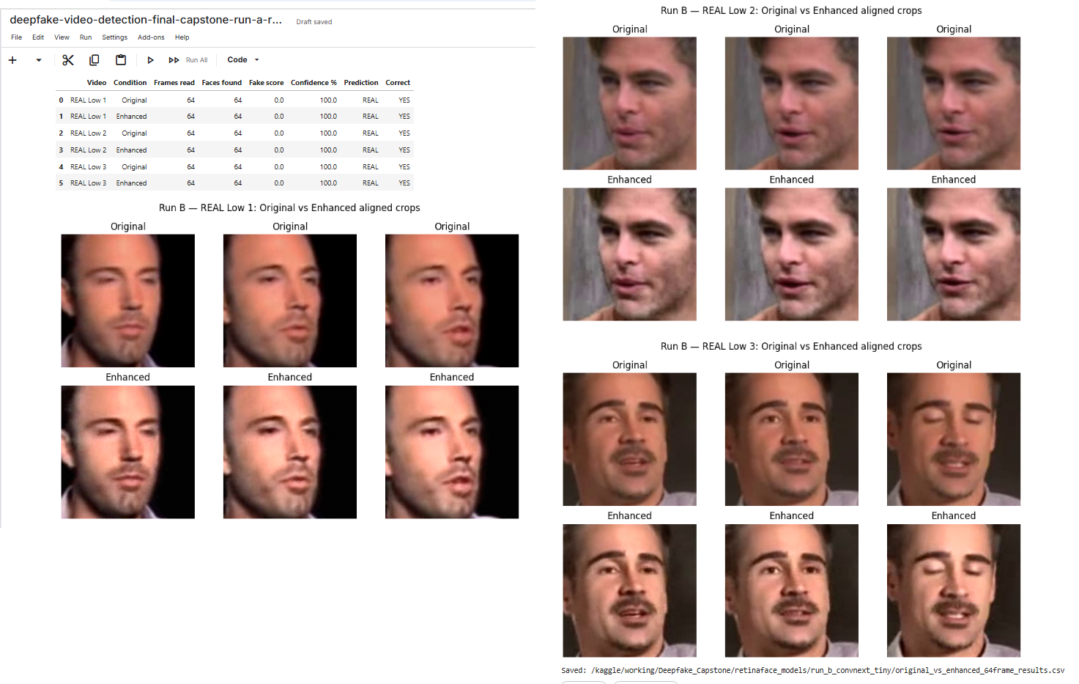
Figure 7.9: Extracted faces of the three low-resolution REAL videos, original (left) and enhanced (right)
Enhancement visibly increased the contrast and sharpness of the extracted faces (Figure 7.9). The scores are given in Table 7.11.
Table 7.11: Original versus enhanced results (64 frames, threshold 0.4825)
Video | Condition | Faces found | Fake score | Confidence | Prediction | Correct
REAL Low 1 | Original | 64 / 64 | 0.0000 | 100% | REAL | Yes
REAL Low 1 | Enhanced | 64 / 64 | 0.0000 | 100% | REAL | Yes
REAL Low 2 | Original | 64 / 64 | 0.0000 | 100% | REAL | Yes
REAL Low 2 | Enhanced | 64 / 64 | 0.0000 | 100% | REAL | Yes
REAL Low 3 | Original | 64 / 64 | 0.0000 | 100% | REAL | Yes
REAL Low 3 | Enhanced | 64 / 64 | 0.0000 | 100% | REAL | Yes

Interpretation.
- Face detection was already complete before enhancement: RetinaFace found 64 of 64 faces in every video and condition, so enhancement could not improve detection.
- The prediction and confidence did not change: all six outputs were REAL with a fake score of 0.0000 (100% confidence). The notebook’s automatic summary was “improved = 0, worse = 0, already correct / no need = 3, not fixed = 0”.
- Enhancement did no harm: it did not create a false FAKE alarm on any real video, which shows that the classifier is not sensitive to the contrast and sharpening changes.
- The upscaling branch was not triggered: all three videos are at least 482 pixels high, above the 360-pixel limit, so the enhancement consisted of CLAHE and sharpening only. In addition, every face is aligned to 256 × 256 and resized to 224 × 224 before classification, which already normalises size.
- Limitation: the three selected low-resolution videos are all REAL and their scores saturated at 0.0000 in both conditions, leaving no room to demonstrate an improvement from enhancement. A stronger follow-up should include low-resolution FAKE videos and controlled degradations that move scores closer to the decision threshold.
Conclusion of the test: for these low-resolution real videos the original input was already sufficient; enhancement was not needed for correctness, and it neither improved nor harmed the result.

7.10 High- versus Low-Resolution Check (Run A)
Run A selected high- and low-resolution REAL and FAKE videos and scored them with ConvNeXt-Tiny at threshold 0.0079 (Table 7.12 and Figure 7.10).
Table 7.12: High- versus low-resolution results (32 frames, threshold 0.0079)
Case | Video | Resolution | Faces | P(fake) | Prediction | Time
REAL, high | id16_0012.mp4 | 974 × 500 | 32 / 32 | 0.0000 | REAL ✓ | 6.12 s
FAKE, high | id16_id9_0012.mp4 | 974 × 500 | 32 / 32 | 1.0000 | FAKE ✓ | 6.08 s
REAL, low | id24_0003.mp4 | 286 × 300 | 32 / 32 | 0.0019 | REAL ✓ | 5.86 s
FAKE, low | id24_id19_0003.mp4 | 286 × 300 | 32 / 32 | 0.9999 | FAKE ✓ | 5.89 s

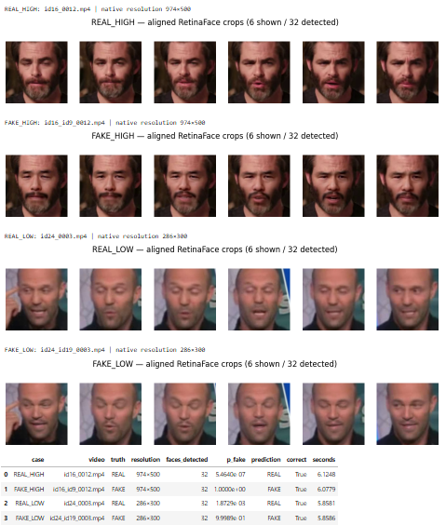
Figure 7.10: Aligned RetinaFace crops of the four videos of the resolution check (6 of 32 shown per video)
Interpretation.
- Detection was not affected by resolution: RetinaFace found a face in all 32 frames even at 286 × 300, the lowest resolution in the dataset, although the low-resolution crops are visibly softer.
- All four videos were classified correctly (4 / 4), with scores far from the threshold: below 10⁻⁵ for the real videos and at least 0.9998 for the fake videos. The low-resolution fake scored 0.9998 against 1.0000 for the high-resolution fake, a negligible change in confidence.
- Each real / fake pair shares the same source scene: the pairs have identical resolution and frame count and show the same background and pose, so the comparison isolates the face swap itself.
- Low-resolution videos were processed faster (0.69 s against about 1 s), because smaller frames are quicker to decode and to search for faces.
- Limitations: this is a four-video demonstration, not a benchmark. The selection draws on all splits, so the chosen videos may include training videos; restricting it to holdout videos would make it a true unseen-data test. The robustness experiment in Section 7.4 remains the stronger aggregate evidence.
Together with the Run B test, this check shows that the final pipeline remains reliable on the lowest-resolution videos available in Celeb-DF v2, both real and fake.

7.11 Summary of Results Against Objectives
Table 7.13: Results against project objectives
# | Objective | Result | Status
O1 | Identity-disjoint data pipeline | 6,529 videos; leakage audit passed; 73,429 indexed aligned faces | Met
O2 | Face detector selection | RetinaFace selected; aligned face extraction completed | Met
O3 | Seven-model comparison | ConvNeXt-Tiny best by holdout AUC: 0.9998 | Met
O4 | Video-level evaluation | Holdout 98.27% (Run A) / 97.28% (Run B); Run A official AUC 0.9990 | Met
O5 | Robustness, calibration, explanation, speed, demo | Worst AUC drop 0.0010; Grad-CAM generated; 2 / 2 demo videos correct | Met
O6 | Low-resolution evaluation | 64-frame test: 3 / 3 REAL correct before/after enhancement; high vs low check: 4 / 4 correct | Met

Chapter 8: Conclusions and Recommendations

8.1 Conclusions
1. A complete video-to-decision deepfake detector was built, evaluated and exported. The pipeline samples frames, detects and aligns faces with RetinaFace, scores each face with a fine-tuned ConvNeXt-Tiny and averages the scores into one REAL / FAKE decision per video; the model and its settings are saved as one inference bundle.
2. Careful data preparation was essential. The identity-disjoint split removed the risk of the model recognising people instead of manipulations, and the automatic checks (label inversion, folder counts, leakage audit, cache consistency) prevented silent data errors. Face preparation reached a 99.95% yield.
3. ConvNeXt-Tiny was the best of seven architectures by holdout AUC (0.9998), with no missed fake video at its validation-selected threshold and an official-test AUC of 0.9990. The six CNN and Swin models remain very close in ranking quality; CLIP ViT-B/16 was weaker in this face-swap setting.
4. The independent Run B rebuild reached the same holdout ranking quality (AUC 0.9998), with 97.28% holdout accuracy at its own validation-selected threshold.
5. The threshold controls the type of error, not only ranking quality. Run A used threshold 0.0079 and produced 14 false positives / 0 false negatives; Run B used threshold 0.4825 and produced 0 false positives / 22 false negatives.
6. The model is robust and explainable. ConvNeXt-Tiny lost at most 0.0010 AUC under JPEG compression, downscaling and blur. Grad-CAM visualisations show attention on facial regions including the eyes, nose and mouth. Frame-level temperature scaling did not improve the reported video-level calibration measures.
7. In the final Kaggle environment, ConvNeXt-Tiny classifier throughput was about 643 face images/s, while complete 32-frame demo inference took about 6–10.5 s per video because decoding and CPU-based RetinaFace detection dominated the pipeline time.
8. Low resolution did not break the detector. All faces were detected in the lowest-resolution videos (down to 286 × 300); the three lowest-resolution real test videos were classified REAL with a fake score of 0.0000 with and without enhancement, and the high- versus low-resolution check classified all four videos correctly. Enhancement was not needed for these inputs.

8.2 Recommendations
- Use ConvNeXt-Tiny with RetinaFace alignment as the default detector for face-swap screening, and keep the same detector, alignment and normalisation at training and inference time (as stored in the bundle). ResNet-50 and EfficientNet-B4 are good alternatives where fewer errors at a fixed threshold matter more than the AUC.
- Choose the operating threshold from the cost of errors, not only from Youden’s J. For human-reviewed moderation, a low threshold that misses no fake (as in Run A) is preferable; for automatic action, a higher threshold with few false alarms (as in Run B) is safer. Report the operating point with every result.
- Use the raw video scores rather than frame-level temperature scaling, which made the video-level calibration worse; if calibrated probabilities are needed, fit the temperature on validation video scores.
- Treat the output as a risk score with human review, especially for real videos, where a false accusation is costly.
- Do not add enhancement by default. It did not change any result on the tested videos and adds processing time; it should only be enabled if future tests on degraded fake videos show a benefit.
- Validate on other data before deployment, because all results come from one dataset and one family of face-swap methods.

Chapter 9: Directions for Future Work
The following extensions would strengthen the evidence and widen the scope of the detector:
1. Cross-dataset generalisation: train on Celeb-DF v2 and test on FaceForensics++ [4], DFDC [6] and newer face swaps, and add data from several generators to training.
2. Multiple seeds: repeat the top models with several random seeds (the final notebook already supports this) and report mean ± standard deviation, since Run A and Run B showed that the threshold in particular varies between runs.
3. Harder low-resolution tests: extend Run B to include low-resolution FAKE videos (low-resolution FAKE video), restrict the high / low check to holdout videos, build a degraded test set (for example 240p frames, JPEG quality 30 and low-bit-rate re-encoding), and measure whether enhancement or learned super-resolution helps when scores are close to the threshold.
4. Video-level calibration: fit the temperature (or a Platt / isotonic mapping) on validation video scores, and report recall at fixed false-positive rates.
5. Temporal modelling: replace simple averaging with a sequence model over face embeddings, or with mouth-movement features [19], to use inconsistencies between frames.
6. Ensembles: combine ConvNeXt-Tiny with ResNet-50 or EfficientNet-B4, whose errors differ (Table 7.3), to reduce both false alarms and missed fakes.
7. Multiple faces and tracking: track every face through the video and score each person separately, instead of keeping only the largest face per frame.
8. Quantitative explainability: measure how often Grad-CAM attention falls inside the blended region and provide region-level explanations to reviewers.
9. Deployment: export the bundle to ONNX / TensorRT, speed up decoding and face detection (which dominate the end-to-end time) and provide a simple web or API service for uploaded videos.
10. Audio-visual detection: add audio and lip-sync consistency checks for videos with manipulated speech.

References
[1] I. Goodfellow, J. Pouget-Abadie, M. Mirza, B. Xu, D. Warde-Farley, S. Ozair, A. Courville and Y. Bengio, ‘Generative adversarial nets’, in Advances in Neural Information Processing Systems 27 (NIPS), Montreal, Canada, Dec. 2014, pp. 2672-2680.
[2] R. Tolosana, R. Vera-Rodriguez, J. Fierrez, A. Morales and J. Ortega-Garcia, ‘Deepfakes and beyond: A survey of face manipulation and fake detection’, Information Fusion, Vol. 64, pp. 131-148, Dec. 2020.
[3] Y. Mirsky and W. Lee, ‘The creation and detection of deepfakes: A survey’, ACM Computing Surveys, Vol. 54, No. 1, Article 7, Jan. 2021.
[4] A. Rössler, D. Cozzolino, L. Verdoliva, C. Riess, J. Thies and M. Nießner, ‘FaceForensics++: Learning to detect manipulated facial images’, in Proc. IEEE/CVF Int. Conf. Computer Vision (ICCV), Seoul, Korea, Oct. 2019, pp. 1-11.
[5] Y. Li, X. Yang, P. Sun, H. Qi and S. Lyu, ‘Celeb-DF: A large-scale challenging dataset for DeepFake forensics’, in Proc. IEEE/CVF Conf. Computer Vision and Pattern Recognition (CVPR), Seattle, WA, USA, Jun. 2020, pp. 3207-3216.
[6] B. Dolhansky, J. Bitton, B. Pflaum, J. Lu, R. Howes, M. Wang and C. C. Ferrer, ‘The DeepFake Detection Challenge (DFDC) dataset’, arXiv preprint arXiv:2006.07397, 2020.
[7] Celeb-DF v2 dataset mirror on Kaggle, ‘reubensuju/celeb-df-v2’. Available: https://www.kaggle.com/datasets/reubensuju/celeb-df-v2
[8] D. Afchar, V. Nozick, J. Yamagishi and I. Echizen, ‘MesoNet: A compact facial video forgery detection network’, in Proc. IEEE Int. Workshop on Information Forensics and Security (WIFS), Hong Kong, Dec. 2018, pp. 1-7.
[9] J. Deng, W. Dong, R. Socher, L.-J. Li, K. Li and L. Fei-Fei, ‘ImageNet: A large-scale hierarchical image database’, in Proc. IEEE Conf. Computer Vision and Pattern Recognition (CVPR), Miami, FL, USA, Jun. 2009, pp. 248-255.
[10] F. Chollet, ‘Xception: Deep learning with depthwise separable convolutions’, in Proc. IEEE Conf. Computer Vision and Pattern Recognition (CVPR), Honolulu, HI, USA, Jul. 2017, pp. 1251-1258.
[11] K. He, X. Zhang, S. Ren and J. Sun, ‘Deep residual learning for image recognition’, in Proc. IEEE Conf. Computer Vision and Pattern Recognition (CVPR), Las Vegas, NV, USA, Jun. 2016, pp. 770-778.
[12] M. Tan and Q. V. Le, ‘EfficientNet: Rethinking model scaling for convolutional neural networks’, in Proc. 36th Int. Conf. Machine Learning (ICML), Long Beach, CA, USA, Jun. 2019, pp. 6105-6114.
[13] Q. Xie, M.-T. Luong, E. Hovy and Q. V. Le, ‘Self-training with Noisy Student improves ImageNet classification’, in Proc. IEEE/CVF Conf. Computer Vision and Pattern Recognition (CVPR), Seattle, WA, USA, Jun. 2020, pp. 10687-10698.
[14] Z. Liu, H. Mao, C.-Y. Wu, C. Feichtenhofer, T. Darrell and S. Xie, ‘A ConvNet for the 2020s’, in Proc. IEEE/CVF Conf. Computer Vision and Pattern Recognition (CVPR), New Orleans, LA, USA, Jun. 2022, pp. 11976-11986.
[15] Y. Li and S. Lyu, ‘Exposing DeepFake videos by detecting face warping artifacts’, in Proc. IEEE/CVF Conf. Computer Vision and Pattern Recognition Workshops (CVPRW), Long Beach, CA, USA, Jun. 2019, pp. 46-52.
[16] L. Li, J. Bao, T. Zhang, H. Yang, D. Chen, F. Wen and B. Guo, ‘Face X-ray for more general face forgery detection’, in Proc. IEEE/CVF Conf. Computer Vision and Pattern Recognition (CVPR), Seattle, WA, USA, Jun. 2020, pp. 5001-5010.
[17] H. Zhao, W. Zhou, D. Chen, T. Wei, W. Zhang and N. Yu, ‘Multi-attentional deepfake detection’, in Proc. IEEE/CVF Conf. Computer Vision and Pattern Recognition (CVPR), Jun. 2021, pp. 2185-2194.
[18] D. Güera and E. J. Delp, ‘Deepfake video detection using recurrent neural networks’, in Proc. 15th IEEE Int. Conf. Advanced Video and Signal Based Surveillance (AVSS), Auckland, New Zealand, Nov. 2018, pp. 1-6.
[19] A. Haliassos, K. Vougioukas, S. Petridis and M. Pantic, ‘Lips don’t lie: A generalisable and robust approach to face forgery detection’, in Proc. IEEE/CVF Conf. Computer Vision and Pattern Recognition (CVPR), Jun. 2021, pp. 5039-5049.
[20] A. Dosovitskiy, L. Beyer, A. Kolesnikov, D. Weissenborn, X. Zhai, T. Unterthiner, M. Dehghani, M. Minderer, G. Heigold, S. Gelly, J. Uszkoreit and N. Houlsby, ‘An image is worth 16x16 words: Transformers for image recognition at scale’, in Proc. Int. Conf. Learning Representations (ICLR), May 2021.
[21] Z. Liu, Y. Lin, Y. Cao, H. Hu, Y. Wei, Z. Zhang, S. Lin and B. Guo, ‘Swin Transformer: Hierarchical vision transformer using shifted windows’, in Proc. IEEE/CVF Int. Conf. Computer Vision (ICCV), Montreal, QC, Canada, Oct. 2021, pp. 10012-10022.
[22] A. Radford, J. W. Kim, C. Hallacy, A. Ramesh, G. Goh, S. Agarwal, G. Sastry, A. Askell, P. Mishkin, J. Clark, G. Krueger and I. Sutskever, ‘Learning transferable visual models from natural language supervision’, in Proc. 38th Int. Conf. Machine Learning (ICML), Jul. 2021, pp. 8748-8763.
[23] U. Ojha, Y. Li and Y. J. Lee, ‘Towards universal fake image detectors that generalize across generative models’, in Proc. IEEE/CVF Conf. Computer Vision and Pattern Recognition (CVPR), Vancouver, BC, Canada, Jun. 2023, pp. 24480-24489.
[24] P. Viola and M. Jones, ‘Rapid object detection using a boosted cascade of simple features’, in Proc. IEEE Conf. Computer Vision and Pattern Recognition (CVPR), Kauai, HI, USA, Dec. 2001, pp. I-511-I-518.
[25] K. Zhang, Z. Zhang, Z. Li and Y. Qiao, ‘Joint face detection and alignment using multitask cascaded convolutional networks’, IEEE Signal Processing Letters, Vol. 23, No. 10, pp. 1499-1503, Oct. 2016.
[26] J. Deng, J. Guo, E. Ververas, I. Kotsia and S. Zafeiriou, ‘RetinaFace: Single-shot multi-level face localisation in the wild’, in Proc. IEEE/CVF Conf. Computer Vision and Pattern Recognition (CVPR), Seattle, WA, USA, Jun. 2020, pp. 5203-5212.
[27] J. Guo, J. Deng et al., ‘InsightFace: 2D and 3D face analysis project’, GitHub repository. Available: https://github.com/deepinsight/insightface
[28] G. Jocher, A. Chaurasia and J. Qiu, ‘Ultralytics YOLOv8’, software, version 8.0.0, 2023. Available: https://github.com/ultralytics/ultralytics
[29] R. R. Selvaraju, M. Cogswell, A. Das, R. Vedantam, D. Parikh and D. Batra, ‘Grad-CAM: Visual explanations from deep networks via gradient-based localization’, in Proc. IEEE Int. Conf. Computer Vision (ICCV), Venice, Italy, Oct. 2017, pp. 618-626.
[30] T. Fawcett, ‘An introduction to ROC analysis’, Pattern Recognition Letters, Vol. 27, No. 8, pp. 861-874, Jun. 2006.
[31] B. Efron and R. J. Tibshirani, An Introduction to the Bootstrap. New York; Chapman & Hall, 1993.
[32] W. J. Youden, ‘Index for rating diagnostic tests’, Cancer, Vol. 3, No. 1, pp. 32-35, 1950.
[33] C. Guo, G. Pleiss, Y. Sun and K. Q. Weinberger, ‘On calibration of modern neural networks’, in Proc. 34th Int. Conf. Machine Learning (ICML), Sydney, Australia, Aug. 2017, pp. 1321-1330.
[34] A. Paszke, S. Gross, F. Massa, A. Lerer, J. Bradbury, G. Chanan et al., ‘PyTorch: An imperative style, high-performance deep learning library’, in Advances in Neural Information Processing Systems 32 (NeurIPS), Vancouver, Canada, Dec. 2019, pp. 8024-8035.
[35] R. Wightman, ‘PyTorch Image Models (timm)’, GitHub repository, 2019. Available: https://github.com/huggingface/pytorch-image-models
[36] F. Pedregosa, G. Varoquaux, A. Gramfort, V. Michel, B. Thirion, O. Grisel et al., ‘Scikit-learn: Machine learning in Python’, Journal of Machine Learning Research, Vol. 12, pp. 2825-2830, 2011.
[37] I. Loshchilov and F. Hutter, ‘Decoupled weight decay regularization’, in Proc. Int. Conf. Learning Representations (ICLR), New Orleans, LA, USA, May 2019.
[38] I. Loshchilov and F. Hutter, ‘SGDR: Stochastic gradient descent with warm restarts’, in Proc. Int. Conf. Learning Representations (ICLR), Toulon, France, Apr. 2017.
[39] P. Micikevicius, S. Narang, J. Alben, G. Diamos, E. Elsen, D. Garcia, B. Ginsburg, M. Houston, O. Kuchaiev, G. Venkatesh and H. Wu, ‘Mixed precision training’, in Proc. Int. Conf. Learning Representations (ICLR), Vancouver, BC, Canada, May 2018.
[40] K. Zuiderveld, ‘Contrast limited adaptive histogram equalization’, in Graphics Gems IV, P. S. Heckbert, Editor. San Diego, CA; Academic Press, 1994, pp. 474-485.

Appendices
Appendix A lists the configuration of the final notebook, Appendix B maps the sections and cells of both notebooks to their purpose and output, and Appendix C lists the files produced by the pipeline.

Appendix A: Configuration of the Final Notebook
Table A.1: Configuration values of the final notebook (Run A)
Parameter | Value
kaggle_dataset | reubensuju/celeb-df-v2 (auto-discovered under /kaggle/input)
real_dirs / fake_dirs | Celeb-real, YouTube-real / Celeb-synthesis
test_list | List_of_testing_videos.txt
val_frac / holdout_frac / split_seed | 0.15 / 0.10 / 42
frames_real / frames_fake / frames_test | 32 / 8 / 16
edge_trim | 0.05
det_size / min_face_score | 640 / 0.5
align_size / jpeg_quality / cache_shards | 256 / 95 / 12
img_size / batch_size / num_workers | 224 / 64 / 2
epochs / freeze_epochs / patience | 8 / 1 / 3
lr_head | 1e-3
lr_backbone, weight_decay, drop_path_rate | Per model (Table 5.3)
warmup_frac / grad_clip / drop_rate | 0.05 / 1.0 / 0.3
SEED | 42
Robustness faces per video | Up to 8
Bootstrap resamples | 1,000 (stratified)
Temperature grid | 300 values, log-spaced 0.1-100
Demo / resolution-check frames | 32 / 32

Run B uses the same core data and ConvNeXt-Tiny settings as Run A, plus 64 comparison frames and a 360-pixel minimum height for the enhancement step. Its threshold is selected only from validation videos.

Appendix B: Notebook Maps
Table B.1: Sections of the final notebook (Run A)
Section | Purpose | Key output
1 | Setup: packages, imports, seeds, configuration, model registry, dataset discovery | torch 2.11.0, Tesla T4
2 | Data: counts, identity parsing, split, leakage audit, demo videos | Audit passed; 36 shared test identities
3 | Face extraction: RetinaFace, frame reading, alignment, face cache | 73,429 crops
4 | Training components: augmentation, dataset, model, optimiser, metrics, trainer | pos_weight = 0.508
5 | Train all models (seed 42) | 7 model runs completed; ConvNeXt-Tiny selected
6 | Comparison: bootstrap CI, ROC, confusion matrices, curves, speed | ConvNeXt-Tiny holdout AUC 0.9998; official AUC 0.9990
7 | Robustness: JPEG, downscale, blur | Worst drop 0.0010 (ConvNeXt-Tiny)
8 | Calibration: temperature scaling, log loss, ECE | No video-level gain
9 | Explainability: Grad-CAM for every model | 1 real + 1 fake face
10 | End-to-end demo and export | 2 / 2 demo videos correct; artifacts saved
11 | High vs low resolution check (four videos) | 4 / 4 correct

Table B.2: Cells of the final Kaggle notebook (Run B)
Cell | Purpose | Key output
GPU check | nvidia-smi; fails if no GPU | Tesla T4 detected
Cell 0 | PyTorch / CUDA check | PyTorch CUDA available; Tesla T4
Cell 1 | Kaggle-safe dependency setup | Dependency setup passed
Cell 2 | Imports, seeds, GPU / ORT pre-flight | Environment preflight passed
Cell 3 | Configuration dataclass and paths | Checkpoint / metrics paths
Cell 4 | Choose input option 1 / 2 / 3; validate dataset | Option 2; 590 / 300 / 5,639 videos
Cell 5 | Manifest, identity split, leakage audit | Audit passed; split table
Cell 6 | RetinaFace, frame sampling, eye alignment | Pipeline ready
Cell 7 | Build / restore face cache (12 shards) | 73,429 indexed aligned face crops
Helper | Copy attached best.pt if present | None attached; train
Cell 8 | Dataset, augmentation, model, loaders | pos_weight = 0.5079
Cell 9 | Metrics, optimiser, scheduler, training helpers | Ready
Cell 10 | Train or load ConvNeXt-Tiny | 8 epochs; epoch 5 selected
Cell 11 | Youden threshold; validation / holdout metrics | t = 0.4825; 98.78% / 97.28%
Cell 12 | Low-resolution frame enhancement | Ready
Cell 13 | Select low-resolution test videos | 3 REAL videos selected
Cell 14 | Show original vs enhanced face crops | 6 figures
Cell 15 | Per-video inference function | Ready
Cell 16 | Original vs enhanced test and summary | 3 / 3 correct; no decision change

Appendix C: Files Produced by the Pipeline
Table C.1: Output files (under the retinaface_models working folder)
File | Content
videos.csv | Manifest: path, folder, label, identities, component, split
face_cache/shard_00.tar … shard_11.tar | Aligned face crops (JPEG, quality 95)
runs/<model>_s42/best.pt | Best weights of each model
runs/<model>_s42/history.csv | Per-epoch loss, validation AUC and EER
runs/<model>_s42/preds_{val,holdout,test}.csv | Frame-level predictions
runs/<model>_s42/metrics.json | Threshold, best epoch, speed and all split metrics
runs/<model>_s42/robustness.csv | AUC under each degradation
demo_videos/ | First holdout video of each class
deepfake_convnext_tiny_final.pt | Inference bundle: weights, threshold, pre-processing settings
model_comparison.csv | Summary table of the seven models
participant4_resolution_4video_results.csv | High vs low resolution check
runs/convnext_tiny_s42/{best.pt, history.csv, metrics.json} | Run B independent ConvNeXt-Tiny checkpoint and metrics

List of Publications / Conference Presentations
No publications or conference presentations have resulted from this work so far. The results were presented in the capstone project presentation “Deepfake Detection – Low-Resolution & 64-Frame Evaluation”.

Checklist of Items for the Final Report
# | Item | Y / N
a) | Is the Cover page in proper format? | Y
b) | Is the Title page in proper format? | Y
c) | Is the Certificate from the Mentor in proper format? Has it been signed? | Y / N (to be signed)
d) | Is Abstract included in the Report? Is it properly written? | Y
e) | Does the Table of Contents page include chapter page numbers? | Y
f) | Does the Report contain a summary of the literature survey? | Y
i. | Are the Pages numbered properly? | Y
ii. | Are the Figures numbered properly? | Y
iii. | Are the Tables numbered properly? | Y
iv. | Are the Captions for the Figures and Tables proper? | Y
v. | Are the Appendices numbered? | Y
g) | Does the Report have Conclusion / Recommendations of the work? | Y
h) | Are References/Bibliography given in the Report? | Y
i) | Have the References been cited in the Report? | Y
j) | Is the citation of References / Bibliography in proper format? | Y

Note: A copy of this checklist is included as the last page of the Final Report. This checklist, duly completed and signed by the students, should also be verified and signed by the evaluators.

Signature of the Students: | Signature of the Evaluators:
1. ______________________  2. ______________________  3. ______________________ | 1. ______________________  2. ______________________

