PATIENT DATABASE SYTEM
Database Management System Project Report
Health information system

Namanya David Mugizi PARTIAL SUBMISSION
2025/BCS/140/PS
Group 10

Database Selection

Area of Interest
The area of interest selected for this project is the Healthcare and Hospital Management sector. Hospitals generate and rely on large volumes of data daily, ranging from patient demographics and clinical notes to lab results and billing records. Effective database management in this sector directly impacts the quality of patient care, operational efficiency, and regulatory compliance.
Possible Database Systems in the Hospital Setting
The following are database systems that are applicable within a hospital environment:
Patient database system
Laboratory information system
Pharmacy management system
Appointment Scheduling System
Billing and Financial system
Electronic Medical Records system
Without a database system, this data becomes fragmented and difficult to manage. A centralized system ensures that all departments share one consistent source of truth.
Reason for Choosing the Patient Database System
- The Patient Database System was selected for the following reasons ,
- to provide a centralized digital platform for storing patient personal and medical information
- to manage appointments between patients and doctors
- to maintain treatment and diagnosis records
- to ensure data integrity and consistency
- to enable efficient retrieval of patient information

system overview
The patient database system is designed to;
- register patients
- store medical records
- schedule appointments
- track treatments and diagnosis
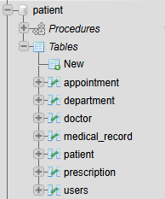
Users of the System
User Group | Role
Doctors | View and update patient records
Nurses | Assist in updating patient data
Receptionists | Register patients and schedule appointments
Administrators | Manage system and generate reports

Business Case

Application Domain
The Patient Database System supports the digitization and management of patient health information within a hospital setting. It replaces paper-based records with a centralized, structured database that supports the following tasks and operations:
- Patient registration and demographic management
- Recording diagnoses, treatments, and clinical notes
- Scheduling and tracking patient appointments
- Managing prescriptions and medication history
- Ordering and retrieving laboratory test results
- Managing ward admissions and patient discharges

The system serves the following user groups:

User Group | Role in the System
Doctors | Record diagnoses, prescribe medication, order lab tests
Receptionists | Register patients, schedule appointments
Administrators | Generate reports, monitor hospital performance

Analysis of Benefits
Tangible Benefits
- Elimination of paper record costs including printing, storage, and retrieval
- Faster patient processing resulting in reduced wait times at registration and consultation
- Reduced medication errors through digitized prescription tracking
- Faster billing and insurance claim processing
- Reduced duplicate lab tests due to accessible shared patient records
Intangible Benefits
- Improved quality of care: doctors can access complete patient history instantly
- Better coordination between departments such as lab, pharmacy, and wards
- Enhanced patient privacy and data security compared to physical files
- Improved regulatory compliance with health data standards
- Greater patient trust and overall satisfaction with hospital services

Analysis of Costs
Cost Item | Estimated Cost (USD)
Database server hardware | $3,000 – $8,000
Software licenses (MySQL, OS) | $500 – $2,000/year
System development & setup | $5,000 – $15,000
Staff training | $1,000 – $3,000
Network infrastructure | $2,000 – $5,000
Total Estimated Cost | $11,500 – $33,000

Intangible Costs
- Resistance to change from staff accustomed to paper-based workflows
- Temporary productivity loss during system transition and training period
- Risk of workflow disruption during data migration from paper to digital records

Cost/Benefit Verdict: The system becomes economically feasible within 12 to 18 months, as reduced paper costs, improved efficiency, and fewer medical errors generate savings that outweigh the initial investment.

User Issues
Skills Required
- Basic computer literacy required for all users
- SQL and database knowledge required for IT and administrative staff only
- Familiarity with medical coding standards (e.g., ICD-10) required for clinical staff
Adoption Effort
- Clinical staff (doctors and nurses) require 1 to 2 weeks of hands-on training
- Reception and administrative staff require 3 to 5 days of training
- A phased rollout department by department is recommended to minimize disruption
- A dedicated IT support desk should be available during the first 3 months post-launch

Risk Assessment
Risk | Type | Likelihood | Impact | Mitigation
Unauthorized access to patient records | Security | Medium | High | Role-based access control, password policies
System downtime during emergencies | Technical | Low | High | Backup servers, offline contingency records
Data loss or corruption | Technical | Low | High | Regular automated backups
Staff resistance / low adoption | Organizational | Medium | Medium | Training and change management program
Incomplete migration from paper records | Organizational | High | Medium | Supervised data entry team during transition
Regulatory non-compliance | Legal | Low | High | Align system with HIPAA and local health data laws

System Limitations
- No real-time medical device integration: the system does not directly pull data from diagnostic equipment; values must be entered manually.
- Single-hospital scope: the system is designed for one hospital and does not support inter-hospital record sharing.
- No clinical decision support: the system stores and retrieves records but does not provide AI-based diagnostic suggestions or drug interaction alerts.
- Internet dependency: the system requires network connectivity; full offline access is not supported.
- No mobile application: access is limited to desktop terminals within the hospital.
- Language support: the system is designed for English only; multilingual support is not included in this version.

Entities and Attributes
Entity | Attributes
Patient | patient_id (PK), first_name, last_name, Date_of_birth, gender, phone, address
Doctor | doctor_id (PK), first_name, last_name, specialization, department, phone
Appointment | appointment_id (PK), patient_id (FK), doctor_id (FK), appointment_date, reason
medical_record | record_id (PK), patient_id (FK), doctor_id (FK), diagnosis, treatment, record_date
Prescription | prescription_id (PK), record_id (FK), patient_id (FK), medication
Department | Deptment_id(PK), name,
Users | User_id(PK),username,user_email,phone,first_name,last_name,password

Entity Relationships with Multiplicities
Relationship | Entities | Multiplicity | Description
has | Patient — Appointment | 1 to Many | One patient can have many appointments
conducts | Doctor — Appointment | 1 to Many | One doctor handles many appointments
generates | Appointment — Medical Record | 1 to 1 | Each appointment produces one medical record
creates | Doctor — Medical Record | 1 to Many | A doctor can create many medical records
contains | Medical Record — Prescription | 1 to Many | One record can have multiple prescriptions

Entity Relationship Diagram(ERD)
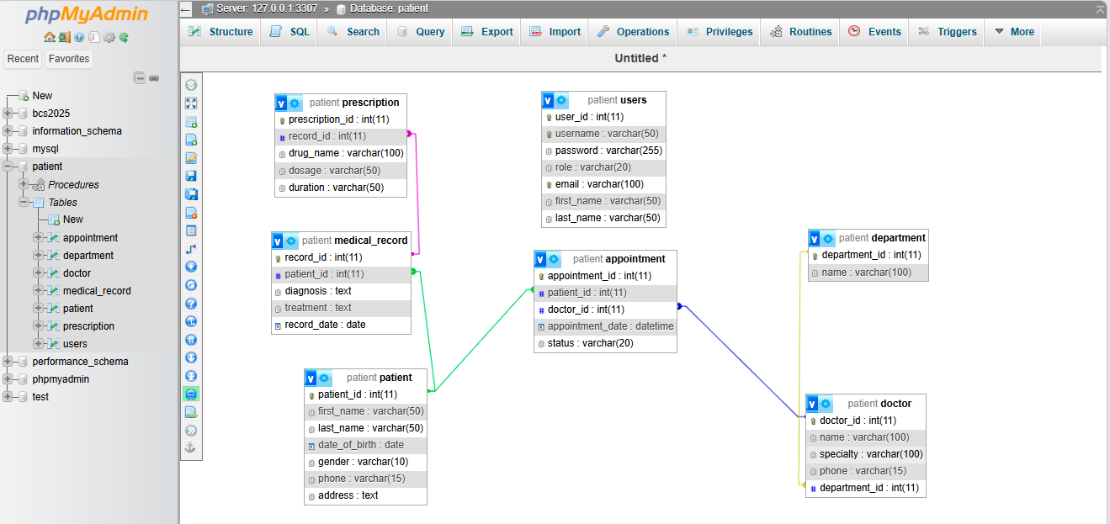

Physical Design — Database Schema
The physical schema consists of nine tables with primary and foreign key relationships enforced at the database level. The schema was implemented in MySQL as described in Section 4.

Table | Primary Key | Foreign Keys | Linked To
patients | patient_id | — | —
doctors | doctor_id | — | —
appointments | appointment_id | patient_id, doctor_id | patients, doctors
medical_records | record_id | patient_id, doctor_id | patients, doctors
prescription | prescription_id | record_id, patient_id | medical_records, patients
Sample
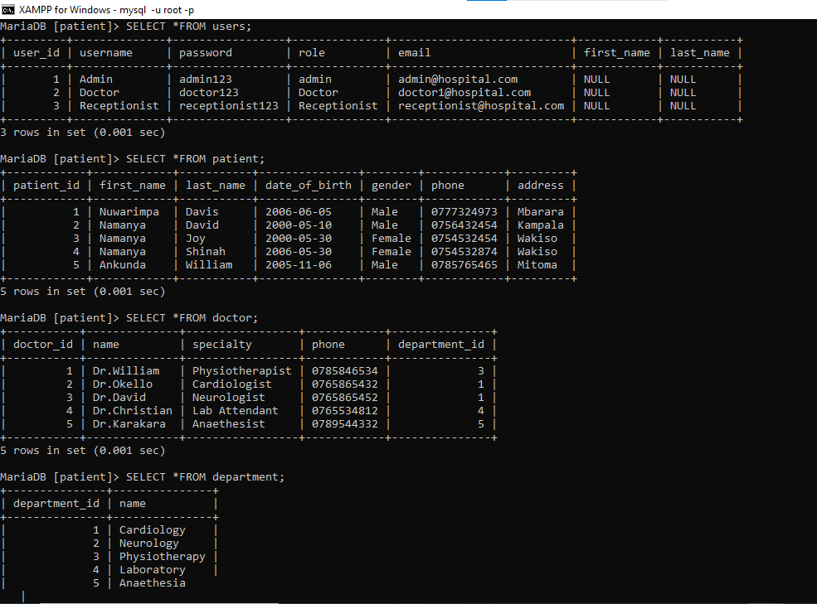

. Sample Queries and Results
The following ten queries demonstrate the operational capabilities of the EMR system. Each query addresses a real-world information need identified in the business case.

Query 1: List All Patients
Purpose: Basic retrieval of all registered patients for administrative reference.
SELECT patient_id, CONCAT(first_name, ' ', last_name) AS full_name,
dob, gender,phone
FROM patients
ORDER BY last_name ASC;

patient_id | full_name | dob | gender
5 | Nuwarimpa Davis | 2006-06-05 | Male
1 | Namanya David | 2000-05-10 | Male
2 | Namanya Joy | 2000-05-30 | Female
4 | Namanya Shinah | 2006-05-30 | Female
3 | Ankunda William | 2005-11-06 | Male

Query 2: Appointments for a Specific Doctor
Purpose: Helps a doctor review their scheduled and completed appointments.
SELECT a.appointment_id,
CONCAT(p.first_name, ' ', p.last_name) AS patient_name,
a.appointment_date, a.reason
FROM appointments a
JOIN patients p ON a.patient_id = p.patient_id
JOIN doctors d ON a.doctor_id = d.doctor_id
WHERE d.last_name = 'Shinah'
ORDER BY a.appointment_date DESC;

Query 3: Patient Load per Doctor
Purpose: Hospital management monitors doctor workload for staffing decisions.
SELECT CONCAT(d.first_name, ' ', d.last_name) AS doctor_name,
d.specialization,
COUNT(DISTINCT a.patient_id) AS total_patients
FROM doctors d
JOIN appointments a ON d.doctor_id = a.doctor_id
GROUP BY d.doctor_id
ORDER BY total_patients DESC;

doctor_name | specialization | total_patients
Okello | Cardiology | 3
David | Neurology | 3
William | Physiotherapy | 2
Christian | Laboratory | 1
Karakara | Anesthesia | 1

CONCLUSION
The Patient Database System improves healthcare data management by providing a structured and efficient way to store and retrieve patient information. It enhances hospital performance and patient care.
Future improvements include:
- Mobile system access
- Integration with other hospital systems
- Advanced reporting

