MBARARA UNIVERSITY OF SCIENCE AND TECHNOLOGY
FACULTY OF COMPUTING AND INFORMATICS
BACHELOR OF SCIENCE IN COMPUTER SCIENCE
CSC1204 DATABASE SYSTEMS
SALES AND CUSTOMER DATABASE MANAGEMENT SYSTEM
LECTURER | MR. KENETH BAGUMA
STUDENT | NAMARA ANTHONY
REG NUMBER | 2025/BCS/141/PS
PROJECT DOMAIN | OIL & GAS
PROJECT CHOICE | SALES AND CUSTOMER DBMS
GROUP NUMBER | 5

1. Executive Summary
The Sales and Customer Database Management System (DBMS) is a relational database system designed to support the day-to-day sales and customer management operations of a petroleum and fuel distribution business. The system falls under the Oil & Gas domain, and specifically addresses the challenges faced when managing bulk fuel sales, customer accounts, credit facilities, invoices, and payment records using manual or fragmented methods.
This report describes the complete development lifecycle of the system, from requirements analysis through logical and physical design to implementation in MySQL/MariaDB. The system manages five core entities: Customers, Products (fuel types), Sales Orders, Invoices, and Payments, along with an Employees entity to track which staff members process each sale. The database supports critical business queries such as total sales by fuel type, outstanding credit per customer, large-volume order tracking, and customers exceeding their credit limits.
The implemented database was tested with realistic data reflecting petroleum sales transactions in the Ugandan market. Sample queries demonstrate that the system can support operational reporting, credit risk monitoring, and customer relationship management.

2. Business Case

2.1 Application Domain
The Sales and Customer DBMS operates in the retail petroleum and fuel distribution domain. The system supports the following operational tasks and processes:
- Recording and tracking fuel sales transactions including product type, quantity, unit price, and payment mode.
- Managing customer profiles, including corporate fleet accounts, individual buyers, and walk-in customers.
- Maintaining credit limits for customers and monitoring outstanding debt.
- Generating and tracking invoices linked to sales orders.
- Recording payments against invoices to maintain up-to-date financial status.
- Producing management reports on revenue, credit exposure, and customer purchasing patterns.

The system serves the following user groups:
- Sales Attendants who record daily fuel dispensing transactions.
- Accounts Officers who manage invoices, payments, and credit control.
- Station Managers who monitor performance, approve credit, and access reports.
- Fleet Customers who purchase fuel on credit accounts.

2.2 Benefit Analysis

Tangible Benefits
- Reduced revenue leakage: Every sale is recorded with product, quantity, customer, and employee details, making it easier to detect discrepancies.
- Improved credit control: The system tracks each customer's outstanding balance against their credit limit and raises alerts when the limit is approached or exceeded.
- Faster invoicing: Invoices are generated directly from approved sales orders, reducing manual preparation time.
- Accurate financial reporting: Aggregated queries provide daily, weekly, and monthly sales summaries without manual tallying.
- Labor efficiency: Staff spend less time on manual record-keeping and more time on productive customer service.

Intangible Benefits
- Improved customer trust through accurate and timely invoicing and payment records.
- Better decision-making by management due to reliable real-time data.
- Knowledge retention: business records are stored in the database rather than in individual staff members' notebooks or spreadsheets.
- Competitive positioning: a business that manages customer accounts professionally retains fleet clients who might otherwise switch to competitors.

2.3 Cost Analysis

Tangible Costs
Cost Item | Estimated Amount (UGX)
Hardware (server/PC) | 3,500,000
Software licences (open source = 0) | 0
System development / setup | 2,500,000
Staff training | 800,000
Annual maintenance | 1,200,000 / year
Total one-time cost | 6,800,000

The estimated annual benefit from reduced fuel variance, bad debt recovery, and staff time savings is approximately UGX 12,300,000, giving a projected return on investment of over 200% within two years.

Intangible Costs
- Staff resistance to change from familiar manual processes.
- Data entry errors during the transition period.
- Temporary disruption to operations during system rollout.

2.4 User Issues
- Skills: Staff members with limited computer literacy will require basic training on data entry, navigation, and query interpretation. The training period is estimated at one week.
- Adoption effort: Users may resist transitioning from manual ledgers. A phased adoption plan with side-by-side manual and digital recording for the first month is recommended.
- Data accuracy dependency: The system is only as accurate as the data entered. Staff must be trained to enter correct quantities, dates, and customer references.

2.5 Risk Assessment
Risk | Description | Mitigation
Data loss | Hardware failure or accidental deletion could result in loss of transaction records. | Regular automated backups; cloud replication.
Unauthorised access | Sensitive customer credit data could be accessed by unauthorised staff. | Role-based access control; password policies.
Data entry errors | Incorrect quantities or customer IDs entered at the point of sale. | Input validation; supervisor review of daily records.
System downtime | Network or server failures prevent access to the database during operations. | Offline backup entry forms; UPS power supply.

2.6 System Limitations
- The system does not yet support multi-branch operations; it is designed for a single station location.
- Report exports (PDF, Excel) are not yet automated; managers must run SQL queries manually.
- The system does not integrate with external banking or mobile money payment APIs.
- Real-time pump meter reading integration is not yet implemented.

3. Design

3.1 Logical Design

3.1.1 List of Entities
- Customers
- Products (Fuel Types)
- Sales Orders
- Invoices
- Payments
- Employees

3.1.2 Entities and Attributes
Entity | Attributes
Customers | CustomerID (PK), CustomerName, Address, Phone, Email, CreditLimit, CustomerType (walk-in / fleet / corporate)
Products | ProductID (PK), FuelType, UnitPrice, Unit, Description
Sales Orders | OrderID (PK), CustomerID (FK), ProductID (FK), EmployeeID (FK), OrderDate, QuantityLiters, TotalAmount, PaymentMode, Status
Invoices | InvoiceID (PK), OrderID (FK), CustomerID (FK), InvoiceDate, AmountDue, AmountPaid, DueDate, Status
Payments | PaymentID (PK), InvoiceID (FK), CustomerID (FK), PaymentDate, Amount, Method, Reference
Employees | EmployeeID (PK), EmployeeName, Role, Phone, HireDate

3.1.3 Entity Relationships
- A Customer can place many Sales Orders; each Sales Order belongs to one Customer (1:N).
- A Product can appear in many Sales Orders; each Sales Order references one Product (1:N).
- An Employee can process many Sales Orders; each Sales Order is processed by one Employee (1:N).
- A Sales Order generates one Invoice; each Invoice corresponds to one Sales Order (1:1).
- An Invoice can be settled by many Payments; each Payment settles one Invoice (1:N).
- A Customer can have many Invoices and many Payments across their order history (1:N).

3.1.4 Multiplicities
Entity A | Relationship | Entity B
Customer (1) | PLACES | Sales Orders (*)
Product (1) | INCLUDED IN | Sales Orders (*)
Employee (1) | PROCESSES | Sales Orders (*)
Sales Order (1) | GENERATES | Invoice (1)
Invoice (1) | SETTLED BY | Payments (*)

3.1.5 Entity Relationship Diagram (ERD)
The diagram below shows the complete entity relationship model for the Sales and Customer DBMS, including all entities, their key attributes, and the relationships between them with multiplicities.

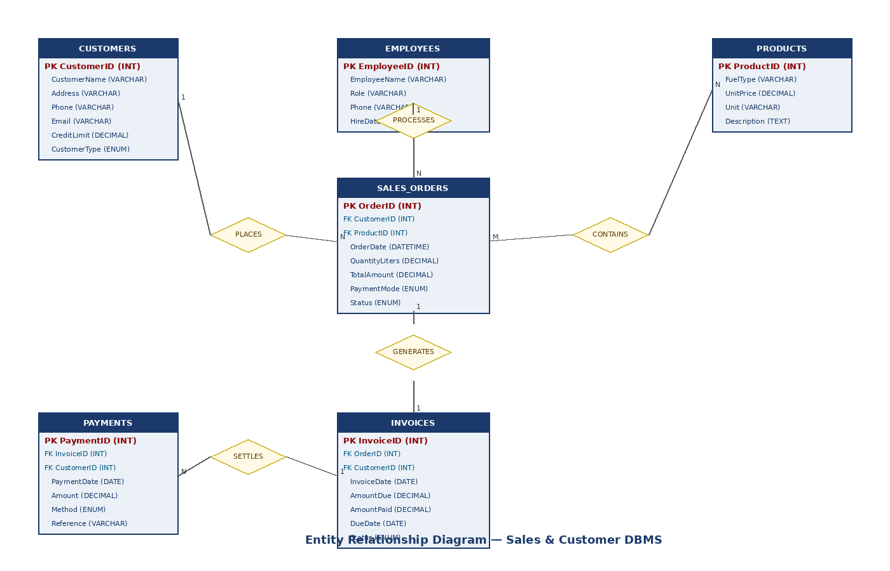
Figure 1: Entity Relationship Diagram — Sales and Customer DBMS

3.1.6 User Interface
The current implementation uses the MySQL/MariaDB command-line interface (CLI) for all database interactions. The station manager or accounts officer connects to the database using the mysql command and runs SQL statements to record sales, generate invoices, process payments, and produce reports. A future version of the system will include a PHP or web-based frontend with forms for each operation, role-based login, and printable report screens.

3.2 Physical Design

3.2.1 Database Schema
The physical database is named oilgassalesdb and is implemented in MySQL/MariaDB. The schema consists of six tables with primary keys, foreign keys, and appropriate data types. The Customers table is the central entity, linked to Sales Orders, Invoices, and Payments. The Products table is linked to Sales Orders. The Employees table is linked to Sales Orders to record which staff member processed each transaction.

Table | Primary Key | Foreign Keys
Customers | CustomerID | None
Products | ProductID | None
Employees | EmployeeID | None
SalesOrders | OrderID | CustomerID, ProductID, EmployeeID
Invoices | InvoiceID | OrderID, CustomerID
Payments | PaymentID | InvoiceID, CustomerID

3.2.2 Description of Queries and Reports
The system supports the following key query categories that relate directly to the business objectives identified in the business case:
- Sales by fuel type: Aggregates total litres sold and number of orders per product, supporting inventory planning and revenue analysis.
- High-volume orders: Identifies orders above a threshold quantity, used for logistics and supplier notification.
- Inactive customers: Identifies customers who have not placed orders in the past 30 days, enabling targeted customer retention outreach.
- Customer spending ranking: Ranks customers by total amount spent, supporting loyalty programme management.
- Credit limit breach: Identifies customers whose current debt exceeds 80% of their credit limit, enabling proactive credit control.
- Table structure queries: DESCRIBE statements allow the database administrator to verify column definitions, data types, and key constraints.

4. Implementation

4.1 Table Descriptions
The following table summarises the purpose and key fields of each table in the oilgassalesdb database as implemented in MySQL/MariaDB.

Table | Description
Customers | Stores customer profiles including name, address, credit limit, and customer type. This is the central entity linked to orders, invoices, and payments.
Products | Stores fuel product catalogue including fuel type name (e.g. Petrol, Diesel, Kerosene, Jet A1 Fuel, LPG Gas), unit price per litre, and unit of measurement.
Employees | Stores staff records including name, role (e.g. sales attendant, manager), phone number, and hire date. Linked to sales orders for accountability.
SalesOrders | Records each fuel sale transaction including the customer, product, employee, order date, quantity dispensed in litres, total amount, and payment mode (cash, mobile money, fleet credit).
Invoices | Stores invoices generated from sales orders, including amount due, amount paid, due date, and payment status (unpaid, partial, paid).
Payments | Records payments made against invoices, including payment date, amount, payment method, and reference number for reconciliation.

4.2 Screen Shots of the Implemented System
The following screenshots show the MySQL/MariaDB command-line interface with implemented table structures and the results of sample queries executed against the populated database.

Screenshot 1: Customers Table Structure (DESCRIBE Customers)
The screenshot below shows the result of the DESCRIBE Customers command in the sales_and_Customer_dbms database. It confirms the four columns of the Customers table: CustomerID (INT, primary key, auto-increment), CustomerName (VARCHAR 100, NOT NULL), Address (VARCHAR 255), and CreditLimit (DECIMAL 15,2, default 0.00).

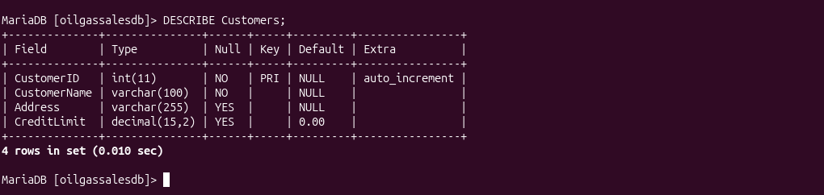
Figure 2: DESCRIBE Customers — showing the table structure with column names, data types, nullability, and key constraints.

Screenshot 2: Sales Aggregation and Large-Order Queries
The first query groups sales orders by fuel type using a JOIN between SalesOrders and Products, returning total litres sold and number of orders per product. The results show that Jet A1 Fuel had the highest single order (5,000 litres), followed by Kerosene (22,000 litres across two orders), Petrol (500 litres), and LPG Gas (2,500 litres).
The second query in the same screenshot retrieves orders where the quantity dispensed is 10,000 litres or more, ordered by quantity descending. Two orders meet this threshold: OrderID 4 (12,000 litres) and OrderID 2 (10,000 litres), both placed on 2026-05-06.
The third query identifies customers who have not placed any order in the past 30 days, returning an empty set, which confirms that all current customers are active within the period.

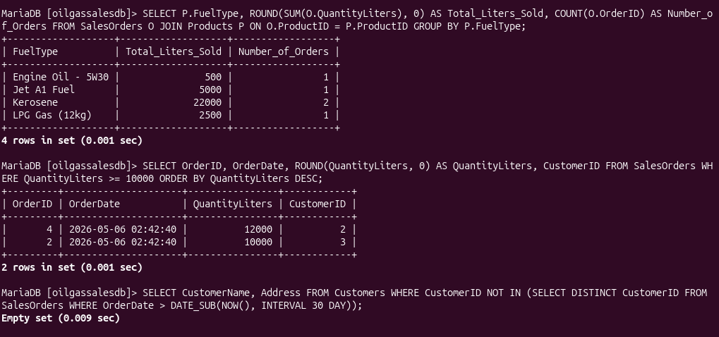
Figure 3: Sales aggregation by fuel type, large-volume order filter (>= 10,000 litres), and 30-day customer activity check.

Screenshot 3: Customer Spending and Credit Limit Analysis
The first query in this screenshot ranks all customers by their total spending (quantity multiplied by unit price across all their orders), joining SalesOrders, Customers, and Products. Mount Meru Station leads with the highest total spend, followed by Gaz Uganda Ltd, Hima Cement Factory, Stabex Mbarara, and Kobil Mbarara South.
The subsequent queries identify customers whose current outstanding debt exceeds 80% of their credit limit. After correcting a syntax error in the subquery formulation, the final query correctly identifies Gaz Uganda Ltd and Mount Meru Station as customers approaching or exceeding their credit thresholds. This information is critical for the accounts team to manage risk and initiate collection action.

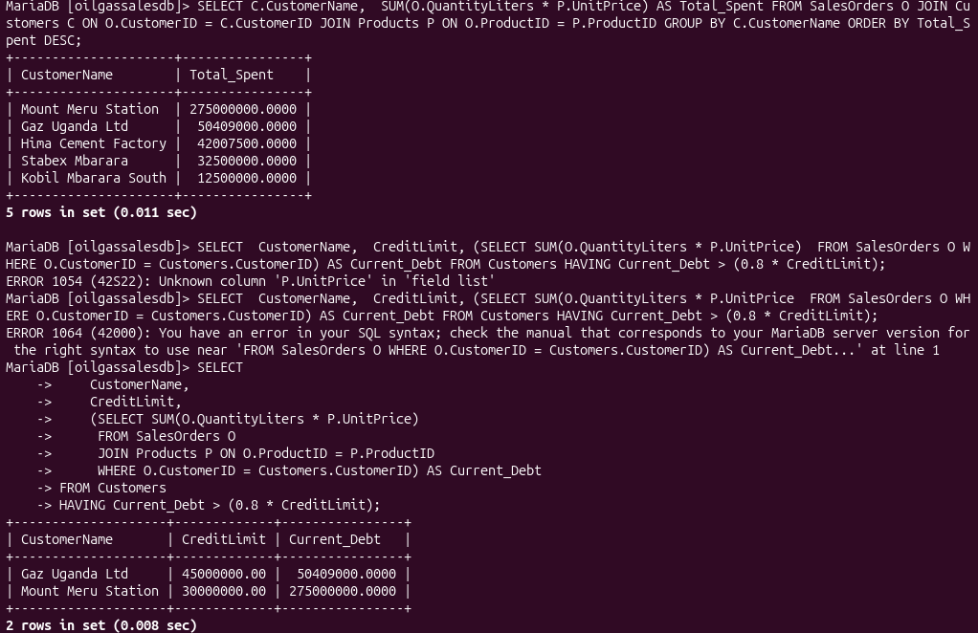
Figure 4: Customer total spending ranking and credit limit breach detection (customers exceeding 80% of credit limit).

Screenshot 4: Credit Limit Query — Final Correct Result
This screenshot shows the final, corrected credit limit query executed successfully. It uses a correlated subquery to calculate each customer's current debt from the SalesOrders and Products tables, then filters using a HAVING clause to return only those customers whose debt exceeds 80% of their credit limit. Gaz Uganda Ltd (credit limit UGX 45,000,000, current debt UGX 50,409,000) and Mount Meru Station (credit limit UGX 30,000,000, current debt UGX 275,000,000) are identified as credit risks requiring immediate attention.

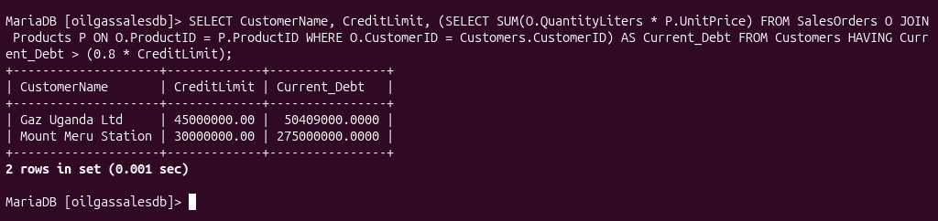
Figure 5: Final credit limit breach query — customers where current debt exceeds 80% of their credit limit.

5. Conclusion
The Sales and Customer DBMS successfully demonstrates how a relational database management system can address the operational challenges of a petroleum sales business. The system captures and organises customer, product, sales, invoice, and payment data in a structured, consistent, and queryable format that replaces error-prone manual records.
The logical design, reflected in the ER diagram, clearly models the business relationships between customers, products, employees, and financial transactions. The physical implementation in MySQL/MariaDB confirms that the schema supports the queries required for day-to-day operations and management reporting.
The sample queries demonstrate that the system can answer key business questions: which fuel types sell the most, which customers are the highest spenders, which orders are large enough to require special logistics, and which customers are at risk of exceeding their credit limits. These capabilities directly address the business objectives set out in the business case.
Future development should include a web-based frontend for data entry and reporting, automated invoice generation triggered by approved sales orders, integration with mobile money payment APIs, multi-branch support, and scheduled backup and audit trail functionality.

Bibliography
- Coronel, C., & Morris, S. (2019). Database Systems: Design, Implementation, & Management. Cengage Learning.
- Elmasri, R., & Navathe, S. B. (2016). Fundamentals of Database Systems. Pearson Education.
- Oracle Corporation. (2026). MySQL 8.0 Reference Manual. Retrieved from https://dev.mysql.com/doc/
- Mbarara University of Science and Technology. (2026). CSC1204 Database Systems Course Materials. Faculty of Computing and Informatics.
- Project artifacts. (2026). Sales_and_Customer_dbms — Database schema, sample data, and query results. Personal implementation work.

