DMML Tooling Integration
Data Profiling and Drift Detection with
Evidently AI on the Heart Disease MLOps Pipeline

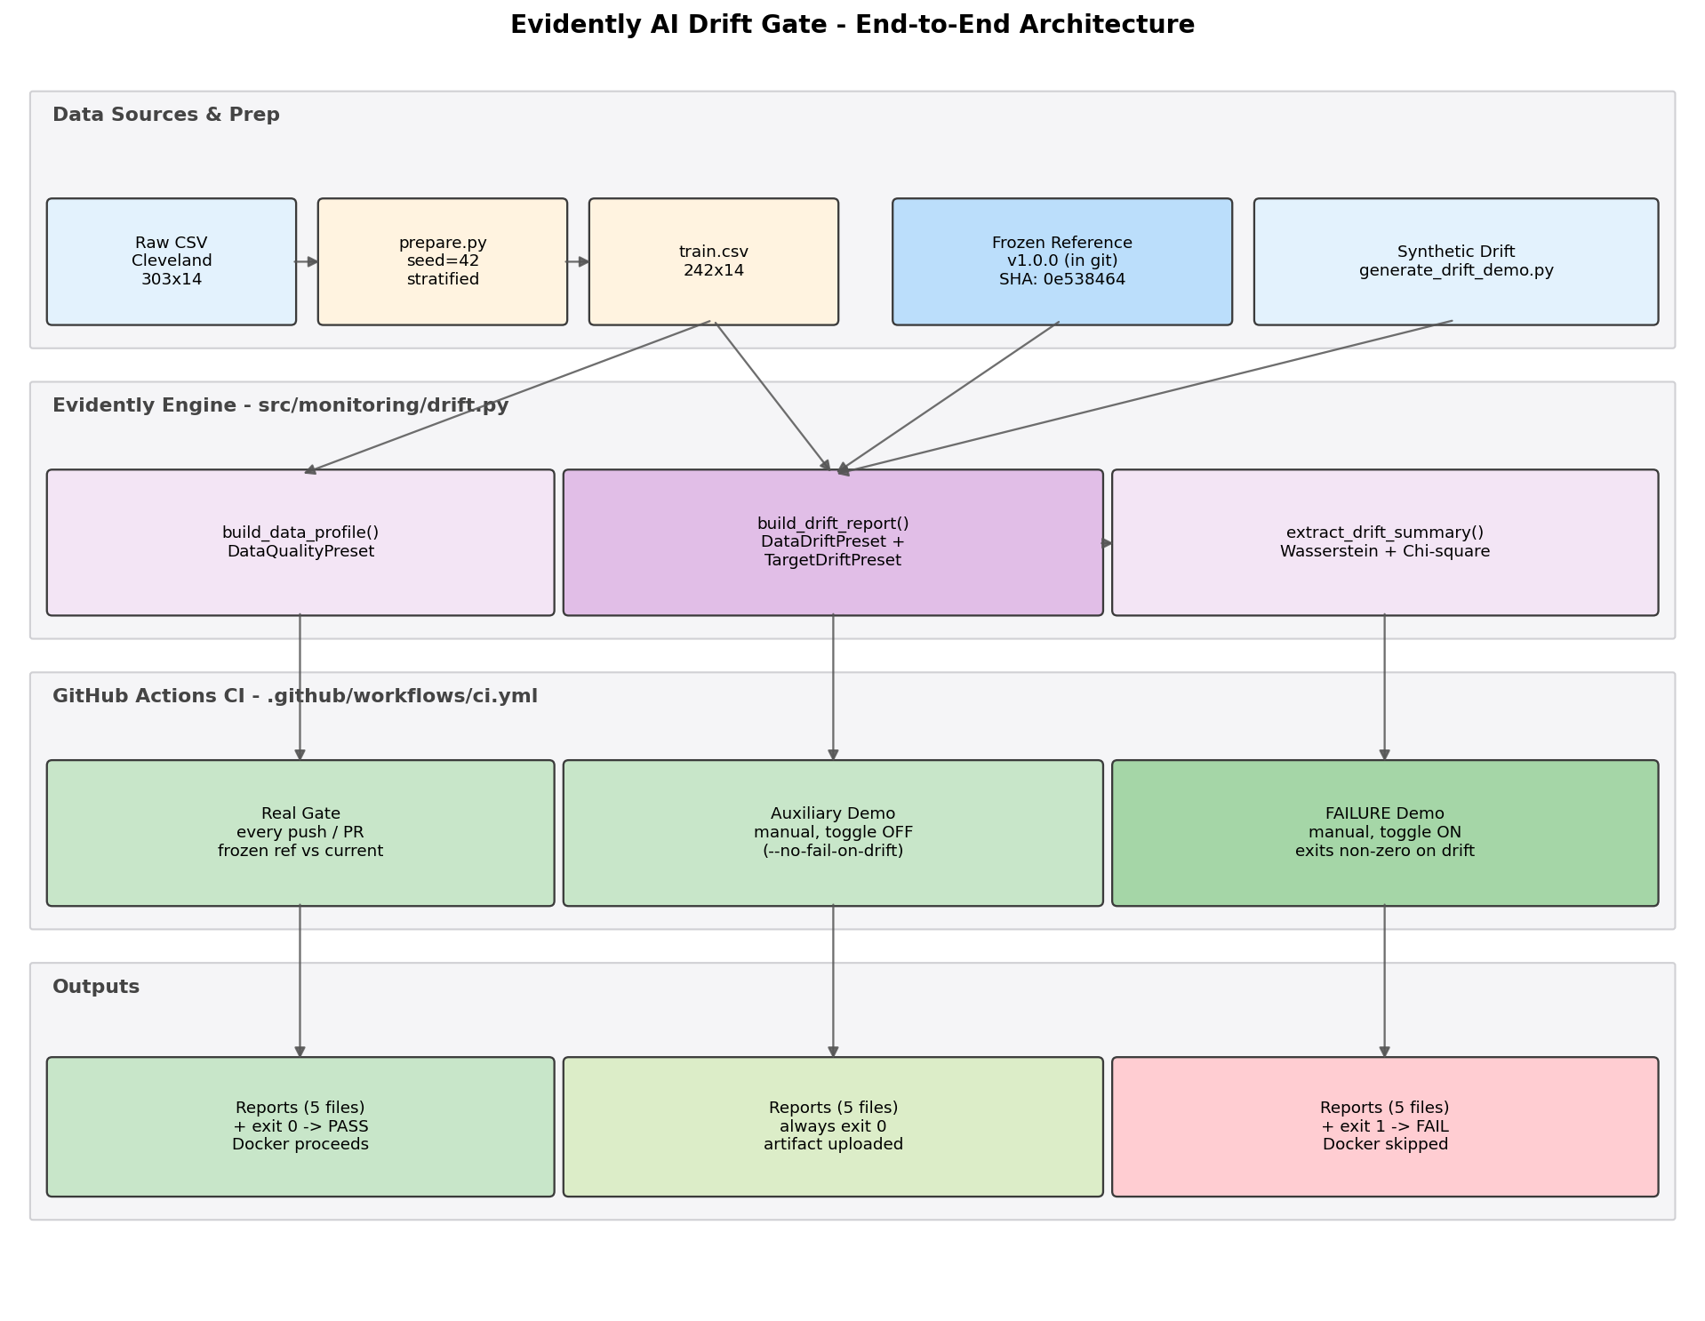
Figure 1. End-to-end Evidently AI drift gate architecture - data sources, engine, CI gating and outputs.

Group Members Name with Student ID
Student Name | BITS ID
Bhaskar Borah | 2025CS05039
Ramya K S | 2025CS05055
Nikhil Rahul Ekka | 2025CS05012
Nagendren K | 2025CS05011

Programme: M.Tech Software Engineering, BITS Pilani WILP
Repository: github.com/2025cs05011-nagenkri-bits/dmml-heart-disease-monitoring

1. Environment and Project Recap
This activity extends the existing Heart Disease UCI MLOps pipeline (Assignment 1) with a Data Mining and Machine Learning (DMML) tool, Evidently AI, focused on data profiling and drift detection. The base pipeline already covers data preparation (src/data/prepare.py), training with cross-validation and MLflow tracking (src/training/train.py), a Flask serving layer with Prometheus metrics, a Helm-deployed Kubernetes target and a GitHub Actions CI workflow. No changes were required to the model, container or deployment surface; the integration is additive and isolated to a new monitoring sub-package, two helper scripts and three additional CI steps.
Tooling stack used in this activity:
- Evidently AI 0.4.40 - the DMML library providing DataDriftPreset, TargetDriftPreset and DataQualityPreset.
- Python 3.9 in a project-local venv (ML_Ops_assignment/venv); scikit-learn 1.6.1 and pandas 2.3.3 are inherited from the production runtime image and pinned via requirements.txt.
- GitHub Actions for continuous integration, with the workflow file at .github/workflows/ci.yml driving lint, unit tests, training reproduction and the new drift gate.
- Git as the canonical store of the immutable reference snapshot (data/reference/) used for every drift comparison.
All work is contained in the ML_Ops_assignment/ subproject of the DMML_Project workspace. Reproducing this report end-to-end from a clean checkout requires only `pip install -r requirements.txt -r requirements-dev.txt` followed by `python scripts/run_evidently.py` and `python -m scripts.generate_dmml_report`.

2. Why Drift Detection
A model trained on a historical snapshot of the input distribution will silently lose accuracy when the production data distribution diverges from that snapshot. The divergence may originate upstream (a sensor recalibration, a label-mapping change, a new data provider), or it may be introduced by an engineering accident (a developer modifies the data preparation script, replaces the raw file or bumps the random seed). In either case, the deployed model's predictions become increasingly unreliable while the test suite continues to pass, because unit tests verify code behaviour, not data behaviour.
The standard mitigation is to treat data as a first-class build input: capture the distribution the production model was trained on as an immutable artefact, then on every change recompute the distribution and compare. If the comparison flags a statistically significant divergence, fail the build before the bad model can be packaged and deployed. This activity implements exactly that pattern, with Evidently AI providing the statistical machinery and the existing GitHub Actions workflow providing the gate.

2.1 What Evidently AI provides
Evidently AI is an open-source Python library for ML observability. The features used in this activity are:
- DataDriftPreset - per-column statistical tests (Wasserstein distance for numerics, Chi-square for categoricals) plus a dataset-level verdict computed as a configurable share of drifted columns.
- TargetDriftPreset - the same machinery applied specifically to the target column, useful for detecting label-prevalence shifts.
- DataQualityPreset - per-column descriptive statistics (mean, std, missing fraction, distinct values) used to profile the reference set in absolute terms.
- Reports rendered as both HTML (for human inspection) and JSON (for machine consumption by the CI gate).

3. Architecture and Evidently Engine
Figure 1 on the cover page summarises the end-to-end flow. The system is organised into four horizontal bands. The top band covers data sources and preparation. The middle band is the Evidently engine, encapsulated in src/monitoring/drift.py and exposing three pure functions: build_data_profile, build_drift_report and extract_drift_summary. The third band is the CI workflow; three drift-related steps share the same engine but differ in their inputs and exit-code semantics. The bottom band lists the deterministic outputs: five stable files in reports/evidently/, a GitHub Actions artifact and the binary PASS / FAIL verdict that gates the downstream Docker job.

3.1 Engine module - src/monitoring/drift.py
The engine is intentionally thin. build_data_profile takes a single DataFrame and returns an Evidently Report containing a DataQualityPreset evaluation. build_drift_report takes a reference and a current DataFrame and returns a Report combining DataDriftPreset with TargetDriftPreset (the latter is added only when the target column is present in both inputs). save_report writes any Report to disk under stable filenames (profile.html / drift.html and matching .json files), overwriting the previous run so the directory contains exactly five files at any time. extract_drift_summary parses the JSON form of a drift report and returns the four headline figures the CI gate uses for its pass/fail decision.
Column types are declared explicitly via Evidently's ColumnMapping, sourced from the same constants used by src/data/preprocess.py. This guarantees that the drift detector and the production preprocessing pipeline always agree on which features are numeric, categorical and binary, eliminating a common source of false-positive drift caused by misclassified columns.
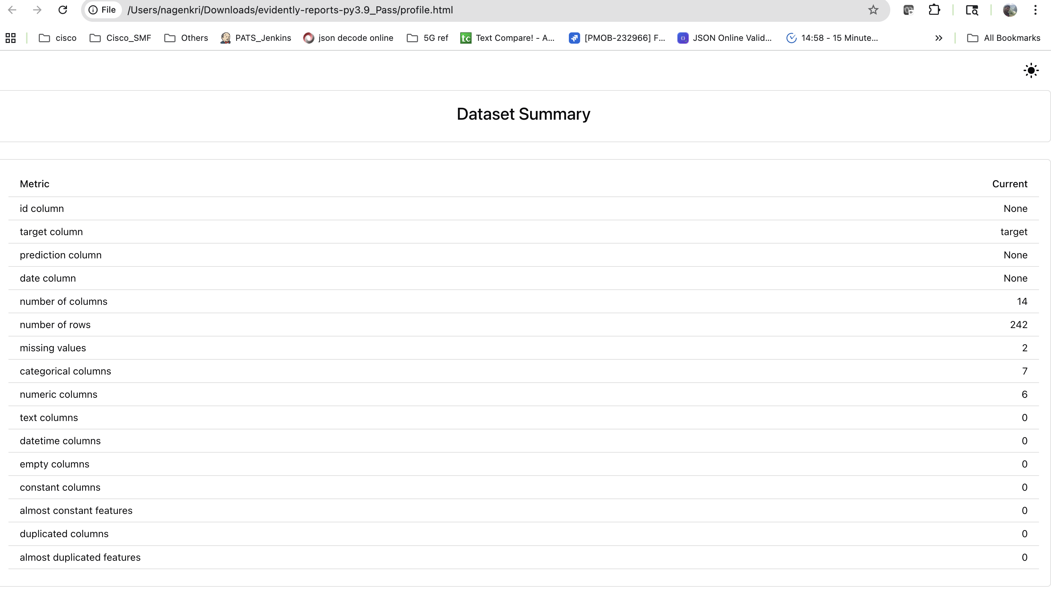
Figure 2. DataQualityPreset profile HTML - per-column statistics, missing values and distribution summaries on the reference set.
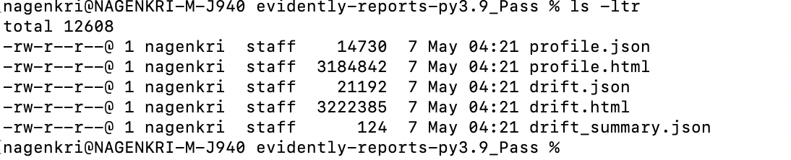
Figure 3. reports/evidently/ directory after a run - exactly five stable files (profile + drift HTML/JSON pairs and the summary), overwritten in place each invocation.

4. The Frozen Reference Pattern
A drift comparison is only meaningful relative to a stable baseline. The pattern adopted here is the frozen reference: at the moment the production model is shipped, the exact training set used to fit it is copied to data/reference/reference_train_<version>.csv and committed to git alongside a JSON metadata sidecar. From that point onwards, every CI run compares today's regenerated training data against the same committed snapshot. The snapshot is treated as immutable; changes are made by freezing a new version, never by editing in place.
The metadata sidecar (reference_train_<version>.metadata.json) captures full provenance: semantic version, source path, SHA-256 of the snapshot, git commit at freeze time, row and column counts, the inferred per-column schema, the target column name and the target prevalence. SHA-256 is the audit anchor - any future divergence from the snapshot can be traced back to a specific git commit and a specific data hash.
The freeze is automated by scripts/freeze_reference.py:
- Input: any training CSV (defaults to data/processed/train.csv).
- Output: snapshot CSV, metadata JSON, both committed to git.
- Refuses to overwrite an existing version unless --force is passed, preventing accidental baseline corruption.
- Captures the current git HEAD so the snapshot is traceable to the model code version that produced it.
The current baseline used by the CI gate is v1.0.0, with 242 rows, 14 columns, target prevalence 0.4587 and SHA-256 prefix 0e538464. Bumping the baseline is a one-line change in the CI workflow once a new version has been frozen and committed.
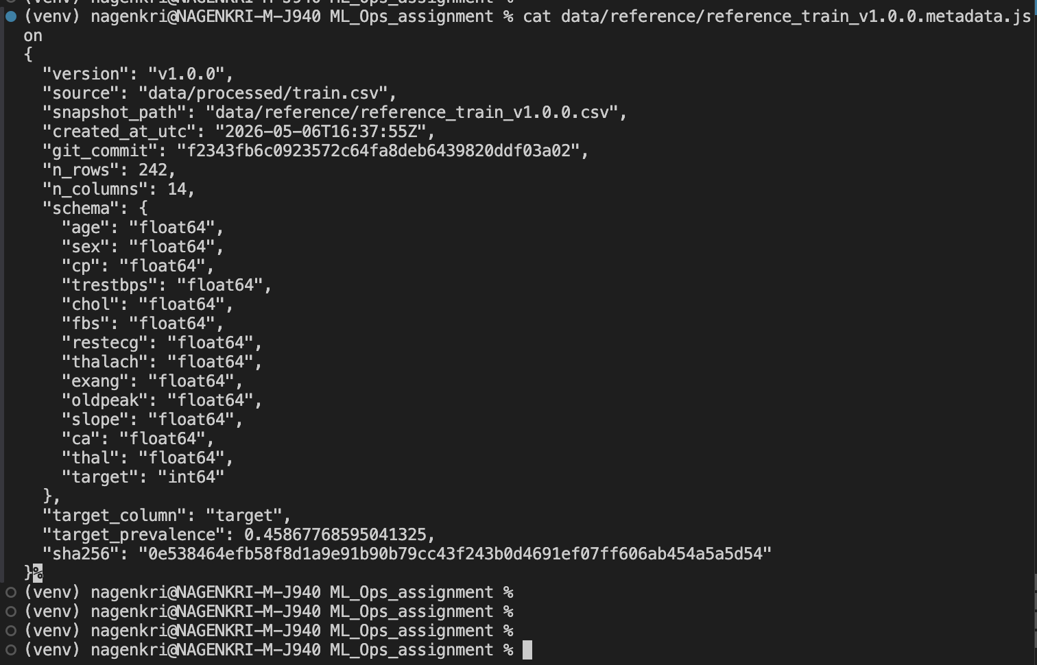
Figure 4. Frozen reference metadata file - schema, SHA-256, target prevalence and git provenance committed alongside the snapshot.

5. CI Gating - Three Trigger Modes
.github/workflows/ci.yml hosts three drift-related steps that share the same Evidently engine but differ in their inputs and in whether they are allowed to fail the build. The matrix below summarises which steps run for each trigger.
- Push or pull request - only the real gate runs. Reference is v1.0.0 frozen snapshot; current is the freshly regenerated train.csv. On a healthy main branch this step always reports zero drift and exits zero, keeping CI green.
- Manual workflow_dispatch with demo_fail_on_drift = false - the real gate plus an auxiliary demo step that runs Evidently against synthetically drifted data with --no-fail-on-drift. The auxiliary step proves the report works against a known-drifted input but does not block the build.
- Manual workflow_dispatch with demo_fail_on_drift = true - the real gate plus the failure demo step. The failure demo runs the same drift check WITHOUT --no-fail-on-drift, so a positive verdict propagates through sys.exit and CI turns red. This is used to demonstrate the gate's rejection behaviour.
Two implementation details warrant note. First, the conditional for the failure step uses truthy evaluation of the input rather than a literal == true comparison; boolean workflow_dispatch inputs are sometimes stringified by GitHub, which causes the literal comparison to silently mis-evaluate. Second, the Evidently report upload step runs unconditionally (if: always), so the HTML reports remain downloadable from the run page even when the build fails. Engineers can therefore inspect what drifted without having to re-run anything locally.
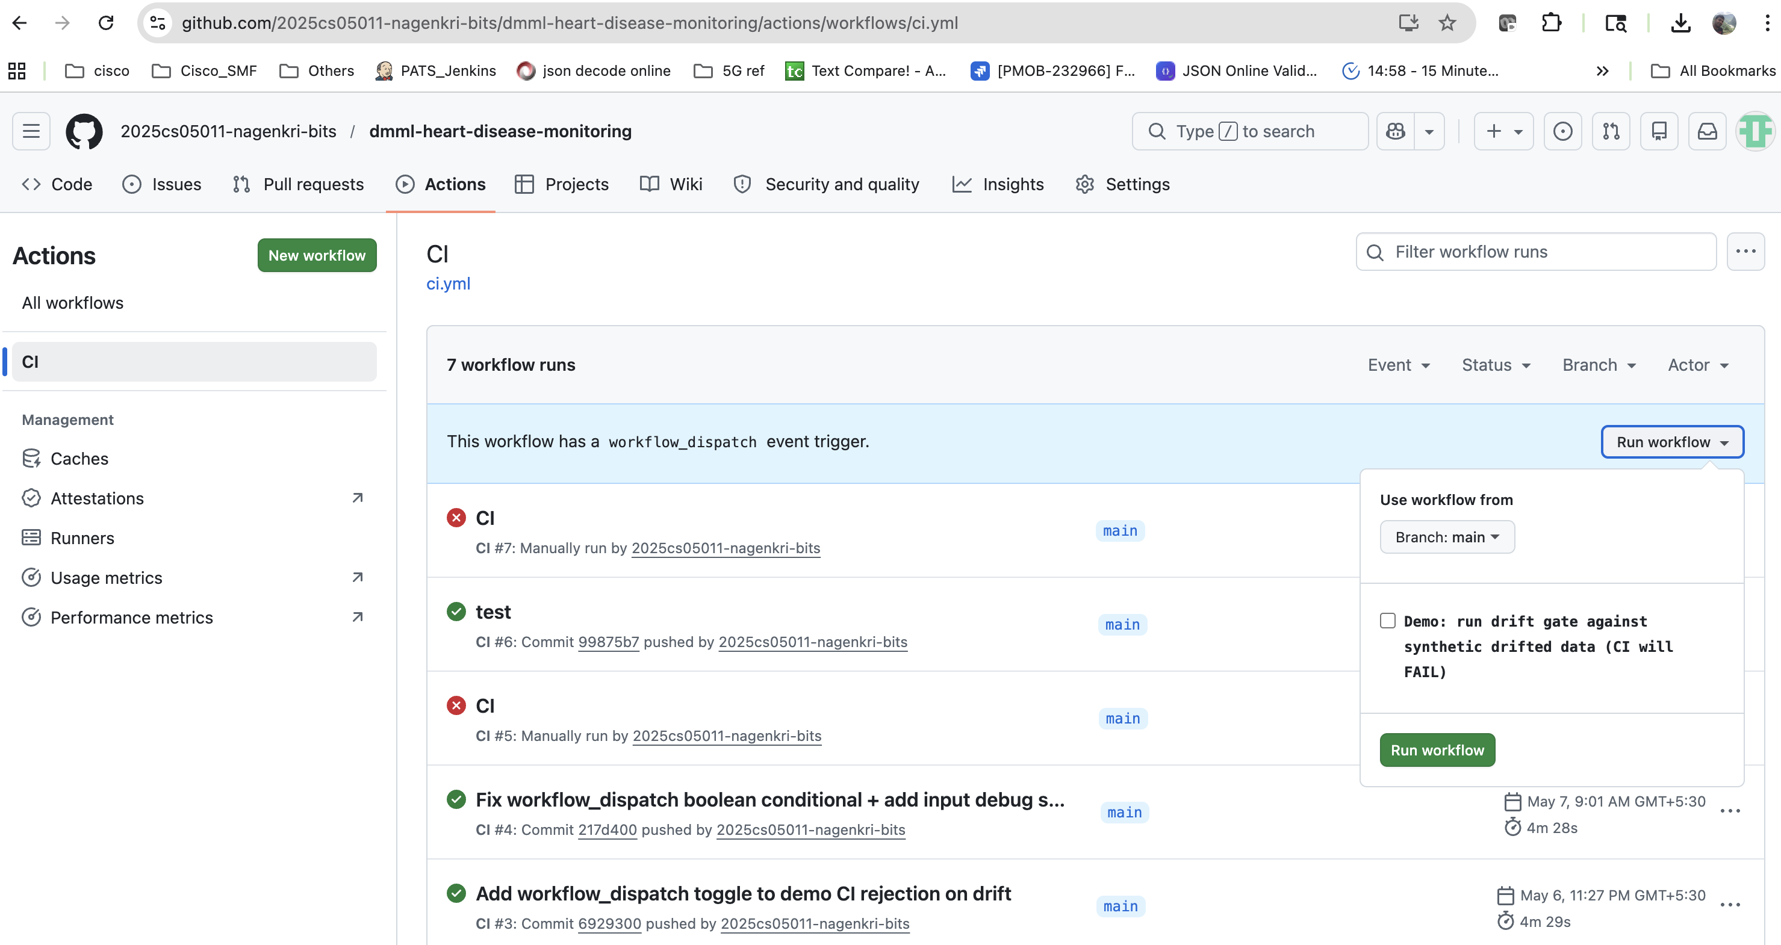
Figure 5. GitHub Actions workflow_dispatch panel - the 'demo_fail_on_drift' checkbox toggles between the healthy and failure scenarios.
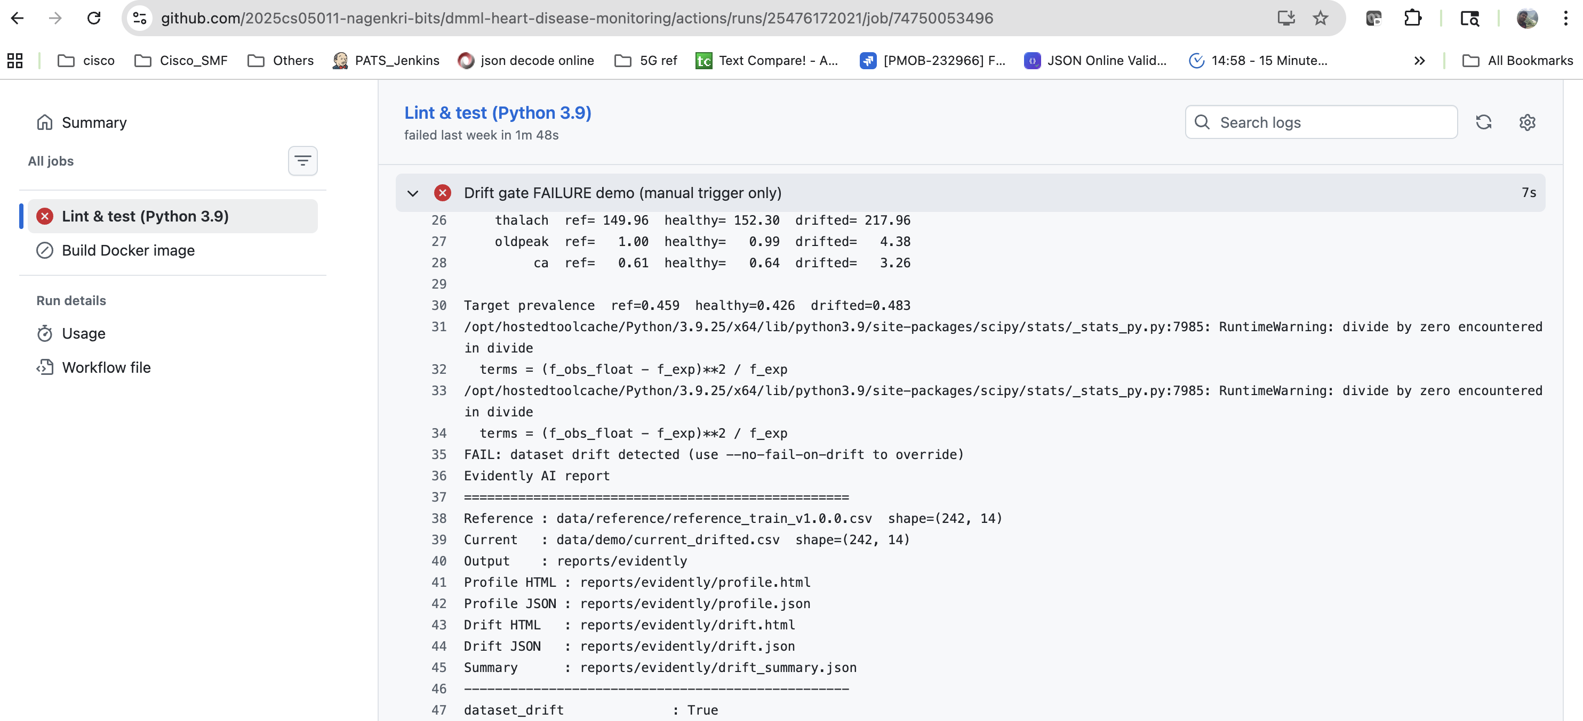
Figure 6. Debug step output confirming the workflow_dispatch input value that the conditional 'if' clauses gate on.

6. Demonstration and Results

6.1 Healthy path - zero drift
Running the gate against the frozen reference and the freshly regenerated train.csv produces dataset_drift = False and share_of_drifted_columns = 0.0000 in 14 of 14 columns. Files are byte-identical at SHA-256 0e538464 and the script exits zero, letting CI proceed to the Docker build job. The same outcome holds locally and in CI because requirements.txt pins all scientific-Python dependencies, making the prepare.py output deterministic across platforms.
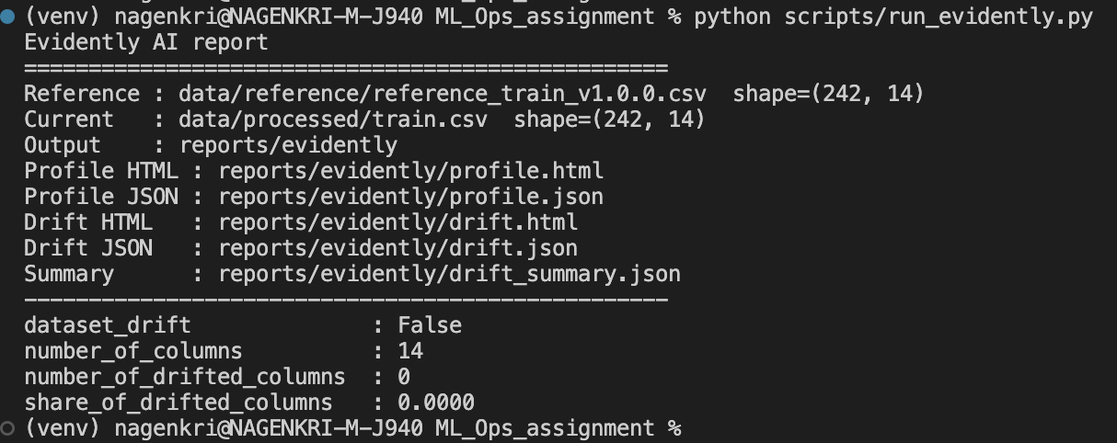
Figure 7. Local invocation of run_evidently.py against the frozen reference - dataset_drift=False, share_of_drifted_columns=0.0000, exit code 0.
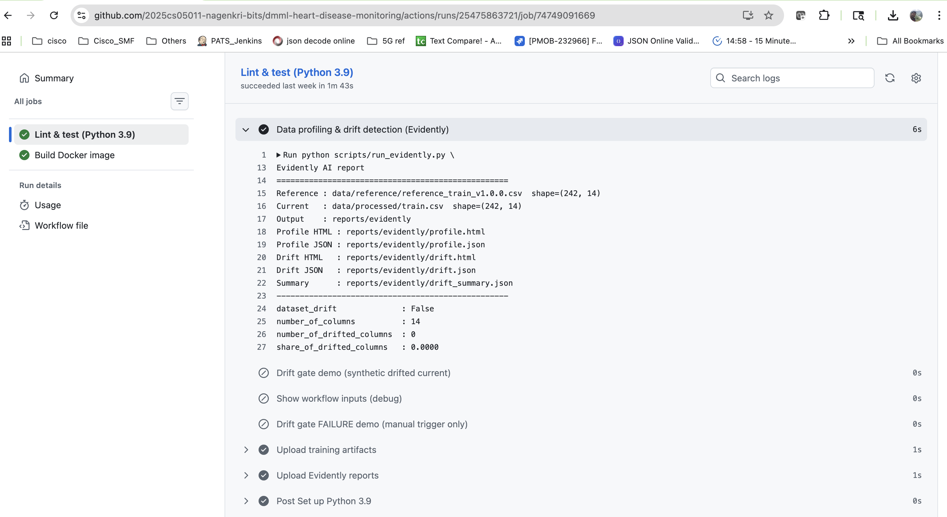
Figure 8. Successful CI run - the real drift gate step executes against the frozen reference and reports zero drift.
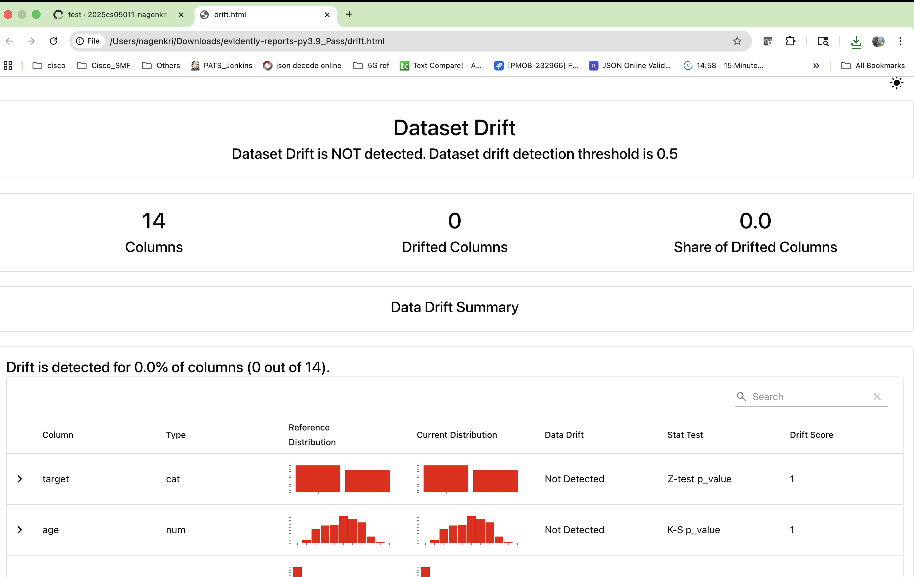
Figure 9. drift.html for the healthy path - dataset-level verdict reads 'no drift' with zero drifted columns when current data matches the frozen reference.

6.2 Drifted path - gate rejects the build
scripts/generate_drift_demo.py fabricates a current dataset designed to trigger every detector: numeric features are shifted by 1.5 standard deviations, ~30 percent of categorical entries are flipped to a different valid level, and the target prevalence is skewed downward. Running run_evidently.py against this dataset yields dataset_drift = True with share_of_drifted_columns = 0.7143 (10 of 14 columns flagged). The script exits with code 1, GitHub marks the step failed, and the dependent Docker build job is skipped. Despite the failure, the artifact upload step still runs and the HTML reports remain attached to the run page.
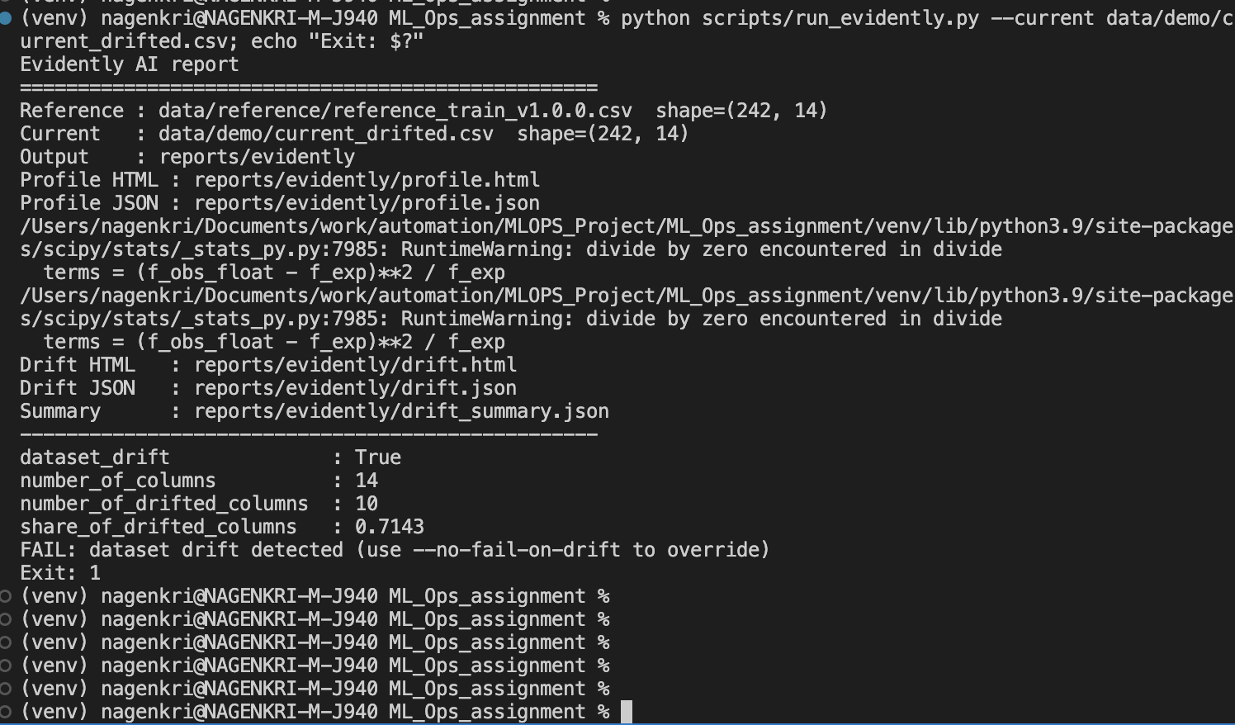
Figure 10. Local invocation against the synthetic drifted current dataset - dataset_drift=True, exit code 1; identical behaviour to the CI gate.
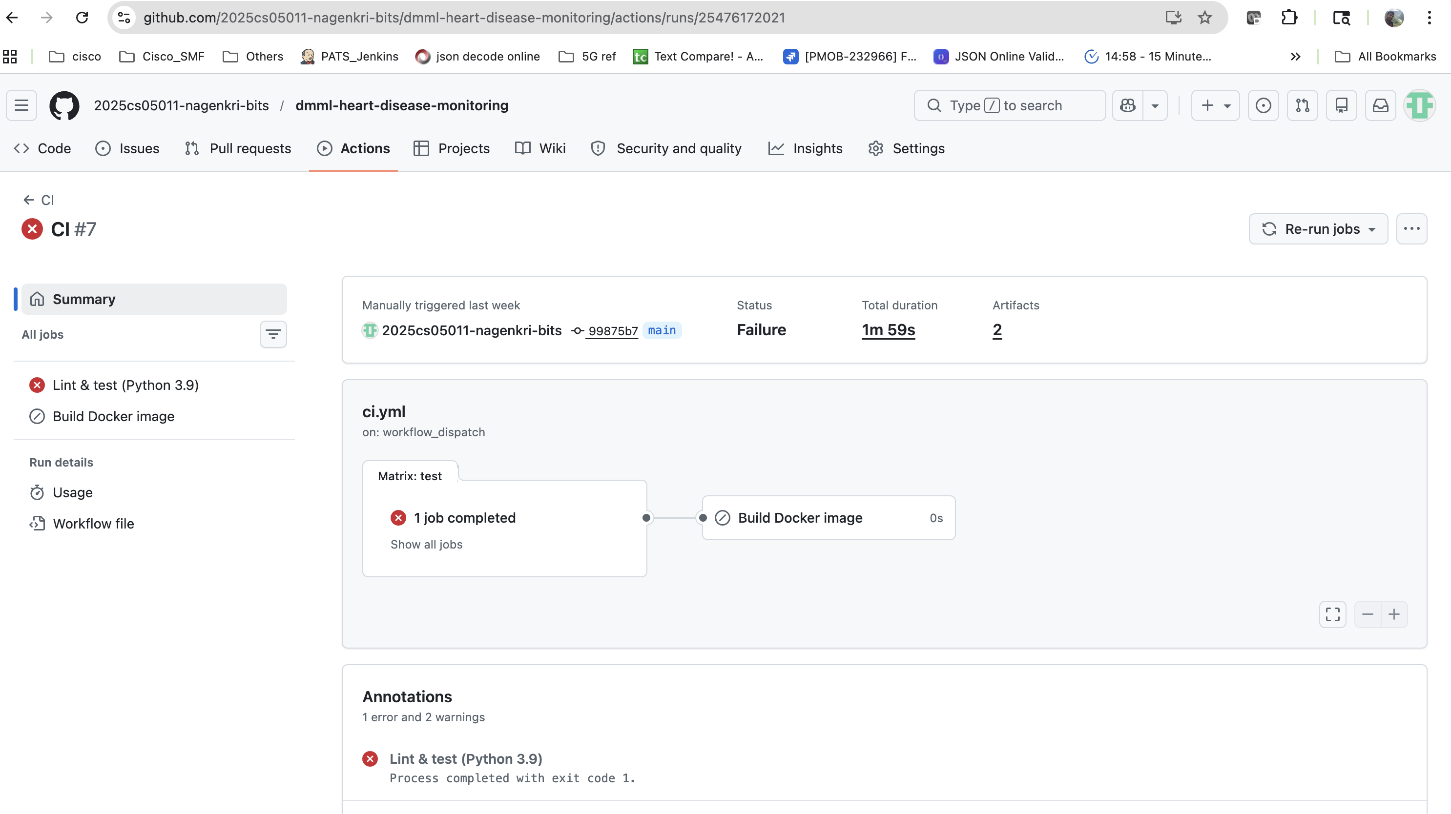
Figure 11. Failed CI run summary triggered via workflow_dispatch with the demo_fail_on_drift toggle on.
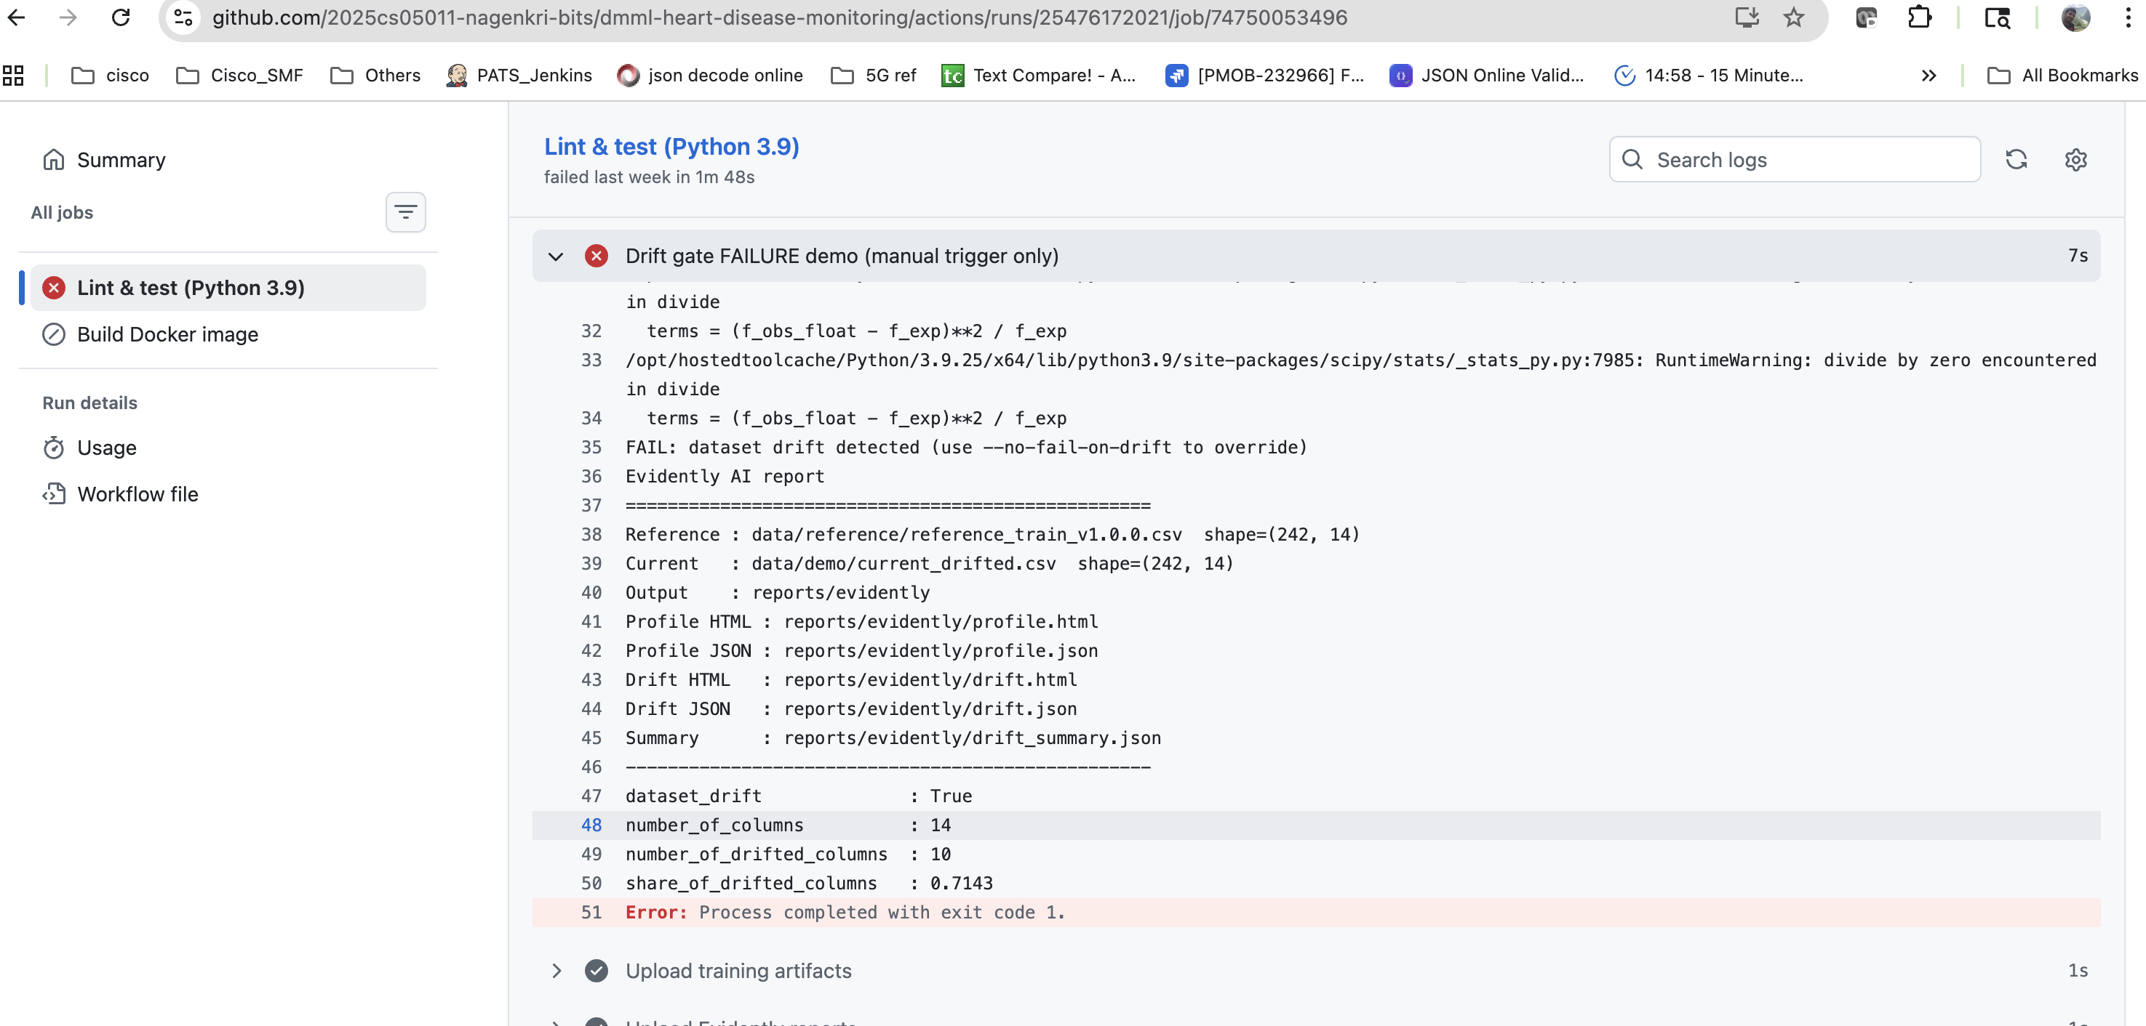
Figure 12. Expanded 'Drift gate FAILURE demo' step log - dataset_drift=True, share=0.7143, FAIL message and non-zero exit code.

6.3 Side-by-side outcomes and visual reports
The most informative artefact for a stakeholder review is the pair of CI runs on the same commit - one green from the push trigger, one red from the manual trigger - with the drift HTML report attached to the failed run. The HTML walks the reader from the dataset-level verdict at the top, through a per-column table with the chosen statistical test and its p-value, down to individual reference-versus-current distribution overlays. This is the same evidence path a downstream MLOps engineer would follow when investigating a real drift incident in production.
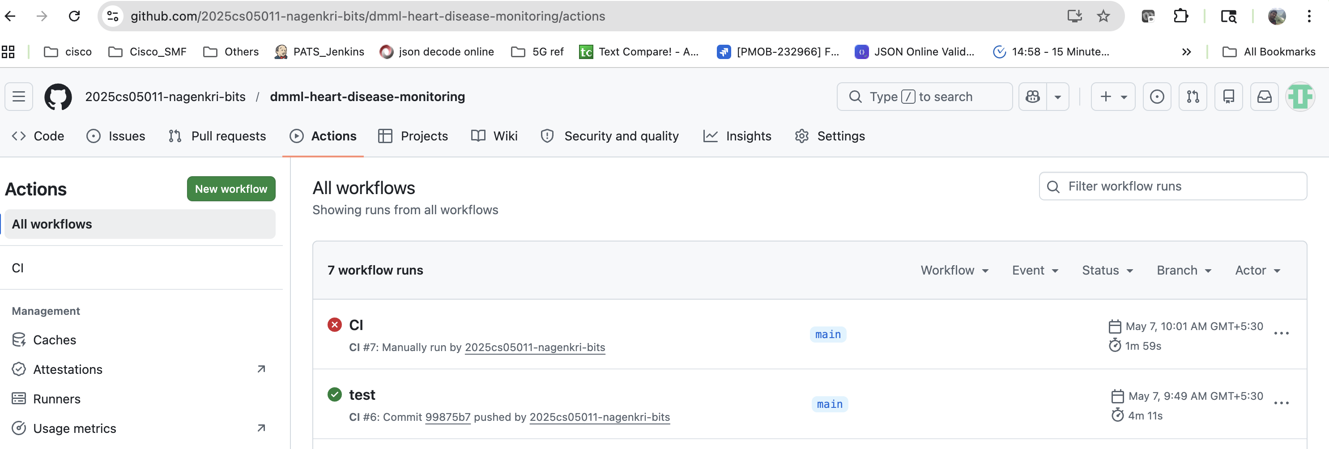
Figure 13. Workflow runs list - green push run and red workflow_dispatch run on the same commit, illustrating the gate's binary verdict.
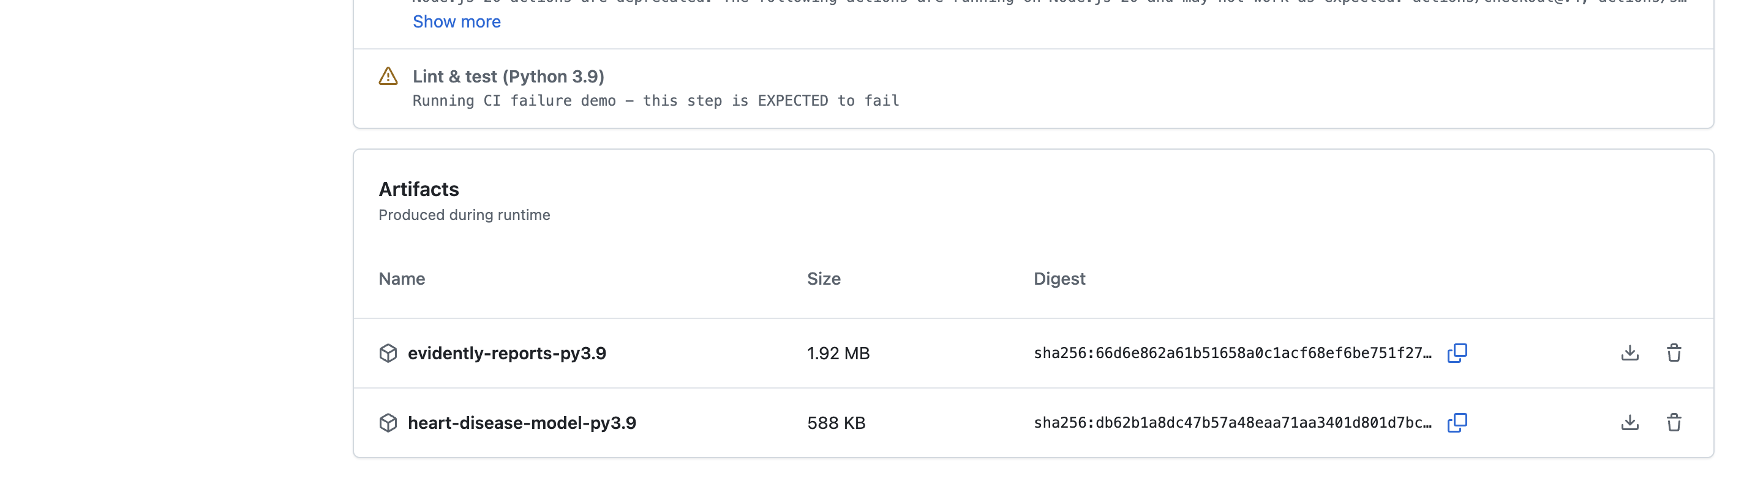
Figure 14. Artifacts panel of the failed run - the Evidently report bundle is still uploaded thanks to 'if: always()' on the upload step.
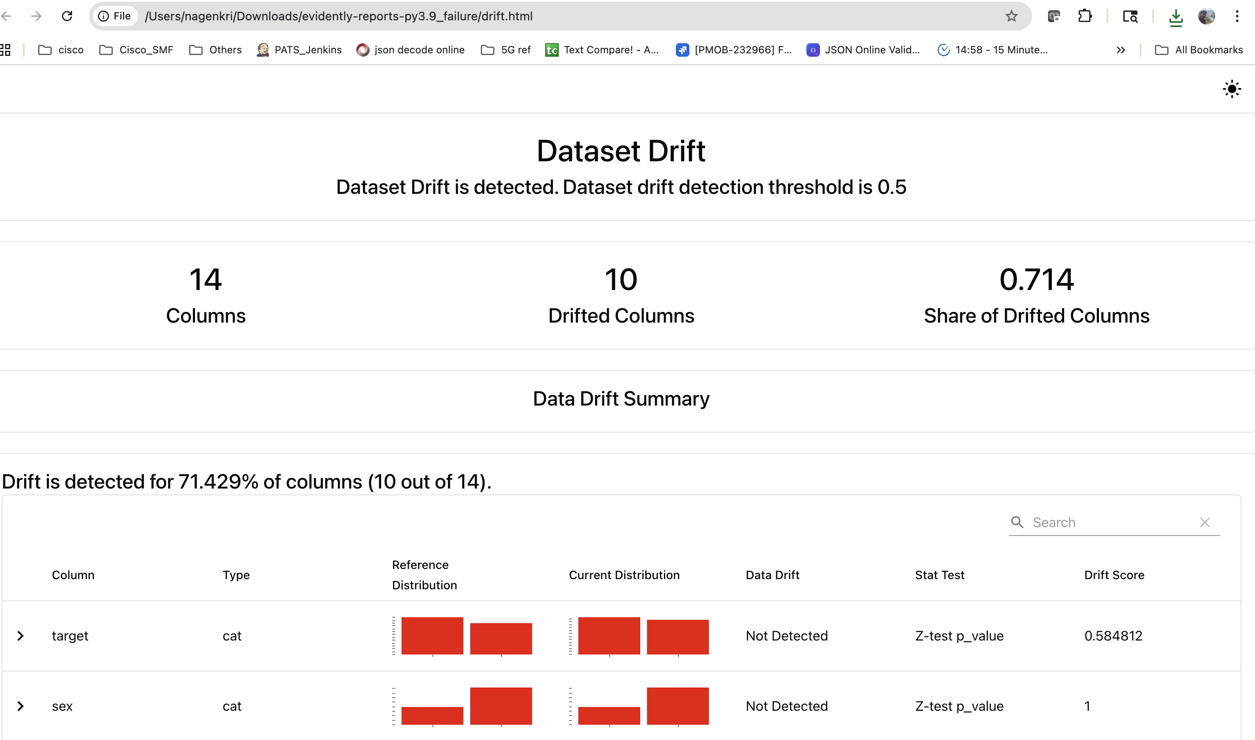
Figure 15. drift.html overview - dataset-level verdict, drifted column count and share-of-drifted-columns at the top of the report.
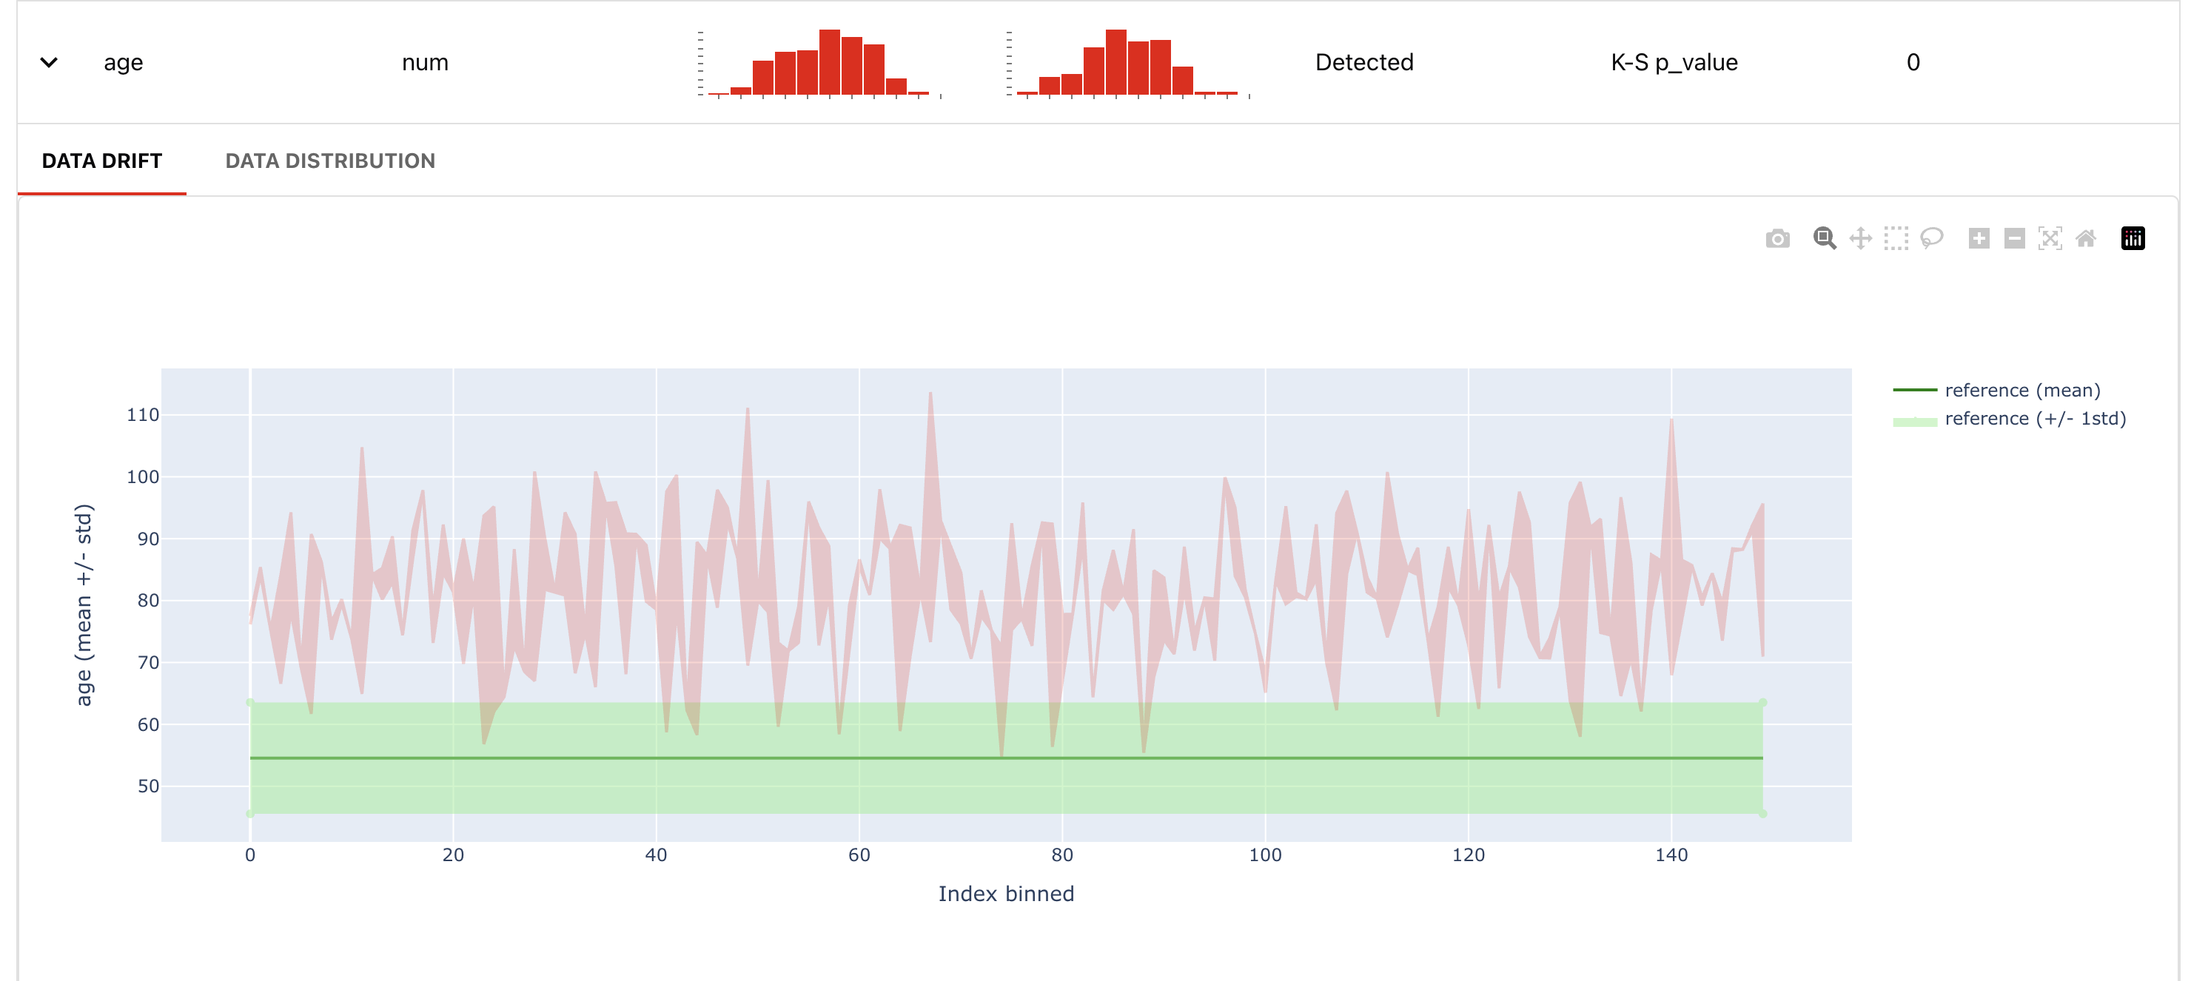
Figure 16. drift.html per-column section - reference vs current distribution overlay for a drifted feature with the statistical test result.

7. Conclusion and Future Work
Evidently AI has been integrated into the Heart Disease MLOps pipeline as a CI-gated data-quality and drift detector. The integration is small (one engine module, three scripts, three CI steps, seven new pytest cases) and additive (no changes to the model, container or deployment surface). The frozen reference pattern gives the gate something stable to compare against; the workflow_dispatch toggle gives stakeholders a one-click way to demonstrate both healthy and rejection paths on the same commit; and the unconditional artifact upload preserves the evidence trail even on failure.
Three extensions are earmarked for the next iteration:
- Live drift endpoint - expose /drift on the Flask app that compares a rolling window of /predict inputs against the frozen reference, surfacing share_of_drifted_columns as a Prometheus gauge and as a Grafana panel.
- Scheduled drift check - a separate workflow on a nightly cron that pulls a real production sample and runs the same gate, decoupling drift detection from code pushes.
- Second DMML tool - layer Great Expectations or Pandera on top of the same reference snapshot to add schema and value-range assertions that complement Evidently's distributional checks.

