Tool 2: Evidently AI

Overview
Once a machine-learning model is shipped, the world keeps moving - sensors get recalibrated, customer behaviour shifts, upstream pipelines change - and the production input distribution slowly drifts away from the one the model was trained on. Without an automated guard, accuracy degrades silently while the unit-test suite continues to pass, because tests verify code behaviour, not data behaviour. This is where data drift detection plays an important role.
Evidently AI is an open-source Python library for ML observability that has become popular for catching distribution shifts before they reach production.
Its Python-based framework is designed to help data teams monitor the health of their data and models. Users describe a reference dataset (the distribution the model was trained on) and a current dataset (today's inputs); Evidently then runs a battery of statistical tests, produces an HTML report for humans and a JSON summary for machines, and reports a single dataset-level drift verdict that a CI gate can act on.
Some benefits of Evidently AI include:
- Pre-built drift presets - DataDriftPreset (per-column distribution tests), TargetDriftPreset (label-prevalence shifts) and DataQualityPreset (descriptive profiling) work out of the box without writing custom test logic.
- Per-column statistical tests - Wasserstein distance for numeric features, Chi-square for categoricals, with configurable thresholds and a dataset-level share-of-drifted-columns verdict.
- Dual-format output - Reports as HTML for human inspection and JSON for CI gates, both written from the same Report object.
- Pipeline integration - Pure-Python API with no external services; trivial to wire into pytest, GitHub Actions, Airflow or any CI runner.
- Frozen-reference pattern - Designed around comparing a current dataset to a stable reference, which maps cleanly onto a version-controlled training-snapshot workflow.
- Open source and self-hosted - Apache 2.0, no vendor lock-in, runs entirely inside the project's existing Python environment.
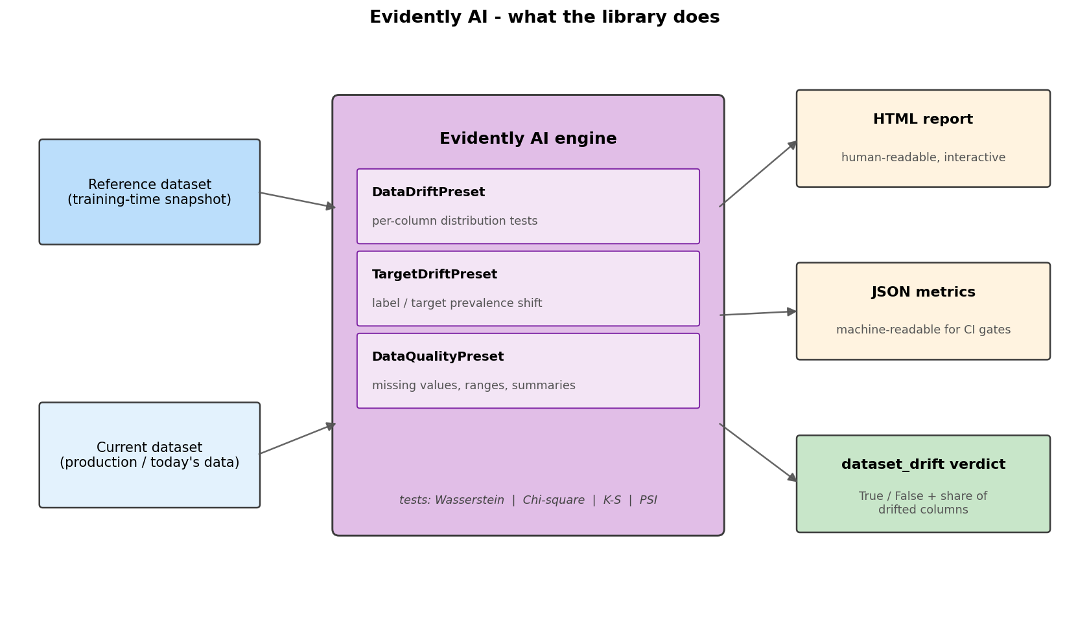
Figure - At a glance: Evidently compares a reference and a current dataset using its built-in presets and statistical tests, then emits an HTML report, a JSON metrics file and a single dataset_drift verdict that downstream pipelines can act on.
More details on the Evidently tool: https://docs.evidentlyai.com/
******************************
Now, let's look at an end-to-end drift detection on the Heart Disease UCI dataset using the Evidently AI tool!
Source: scripts/run_evidently.py and src/monitoring/drift.py in the ML_Ops_assignment repository.

1. Introduction
This report summarises the Evidently AI integration into the Heart Disease UCI MLOps pipeline, a hands-on walkthrough of data profiling and drift detection wired into a real CI workflow. The integration extends an existing pipeline (scikit-learn training with MLflow tracking, Flask serving, Helm-deployed Kubernetes target, GitHub Actions CI) with a new drift gate that compares every CI run's training data against a frozen reference snapshot. If the comparison flags a statistically significant divergence, the build fails before a stale model can be packaged or deployed.
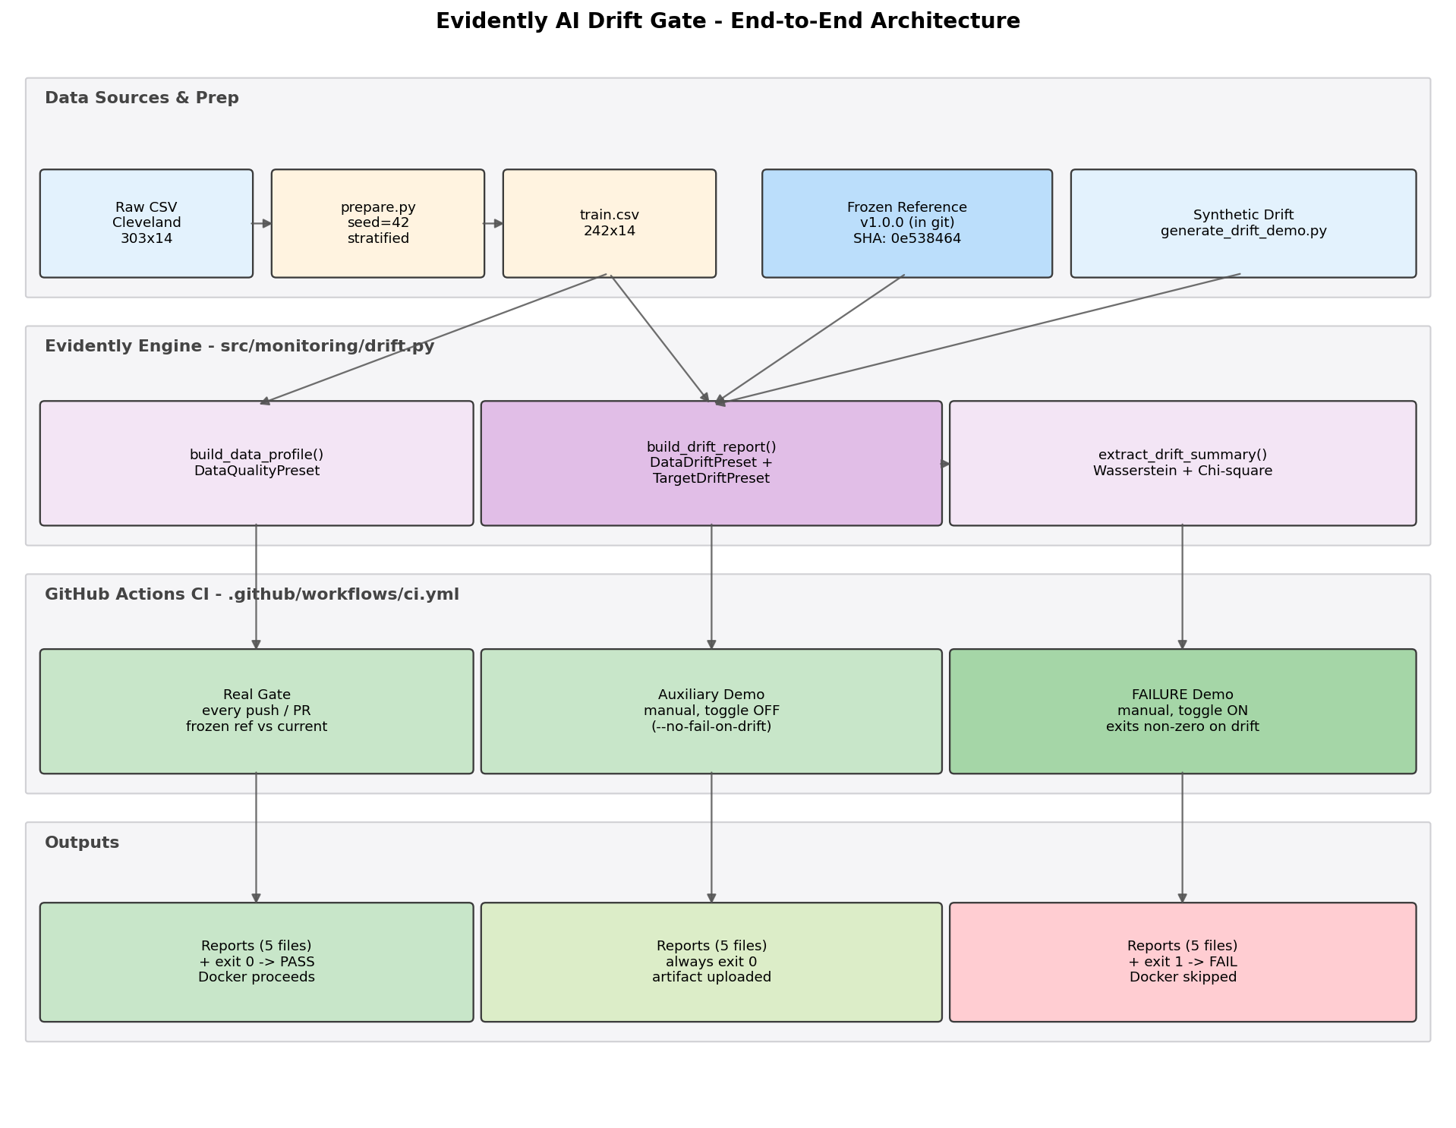
Figure 1 - End-to-end Evidently AI drift gate architecture: data sources, engine, CI gating and outputs.

2. Environment Setup and Reference Snapshot (Steps 1-3)
The integration begins by adding evidently to requirements.txt and creating a frozen baseline. The dataset is loaded with pandas; column types are declared explicitly via Evidently's ColumnMapping, sourced from the same constants used by the production preprocessing pipeline (src/data/preprocess.py). This guarantees that the drift detector and the production preprocessor always agree on which features are numeric, categorical and binary, eliminating a common source of false-positive drift caused by misclassified columns.
Step | Operation | Purpose
Installation | pip install evidently==0.4.40 | Installs the drift-detection library
Import library | from evidently.report import Report | Loads the Report API and the drift / quality presets
Load reference | pd.read_csv('data/reference/reference_train_v1.0.0.csv') | Loads the frozen training snapshot from git
Freeze snapshot | python scripts/freeze_reference.py --version v1.0.0 | Pins train.csv plus SHA-256 metadata to git as the immutable baseline

3. Core Workflow (Steps 4-10)
The drift module (src/monitoring/drift.py) exposes three pure functions that wrap Evidently presets: build_data_profile, build_drift_report and extract_drift_summary. Reports are written to stable filenames (profile.html / profile.json and drift.html / drift.json) and overwritten each run, so reports/evidently/ always contains exactly five files. scripts/run_evidently.py is the CLI entry point that invokes the engine, prints the headline verdict and exits with code 1 when drift is detected (unless --no-fail-on-drift is set).
Step | Check | Key API
4 | Build per-column profile of reference | DataQualityPreset()
5 | Compare current vs reference distributions | DataDriftPreset()
6 | Detect target prevalence shift | TargetDriftPreset()
7 | Persist HTML and JSON reports | report.save_html(...) / save_json(...)
8 | Parse JSON for the CI verdict | extract_drift_summary(json_path)
9 | Pipeline gate (fail-fast on drift) | sys.exit(1) if dataset_drift else sys.exit(0)
10 | Visual report attached to CI artifact | actions/upload-artifact, if: always()
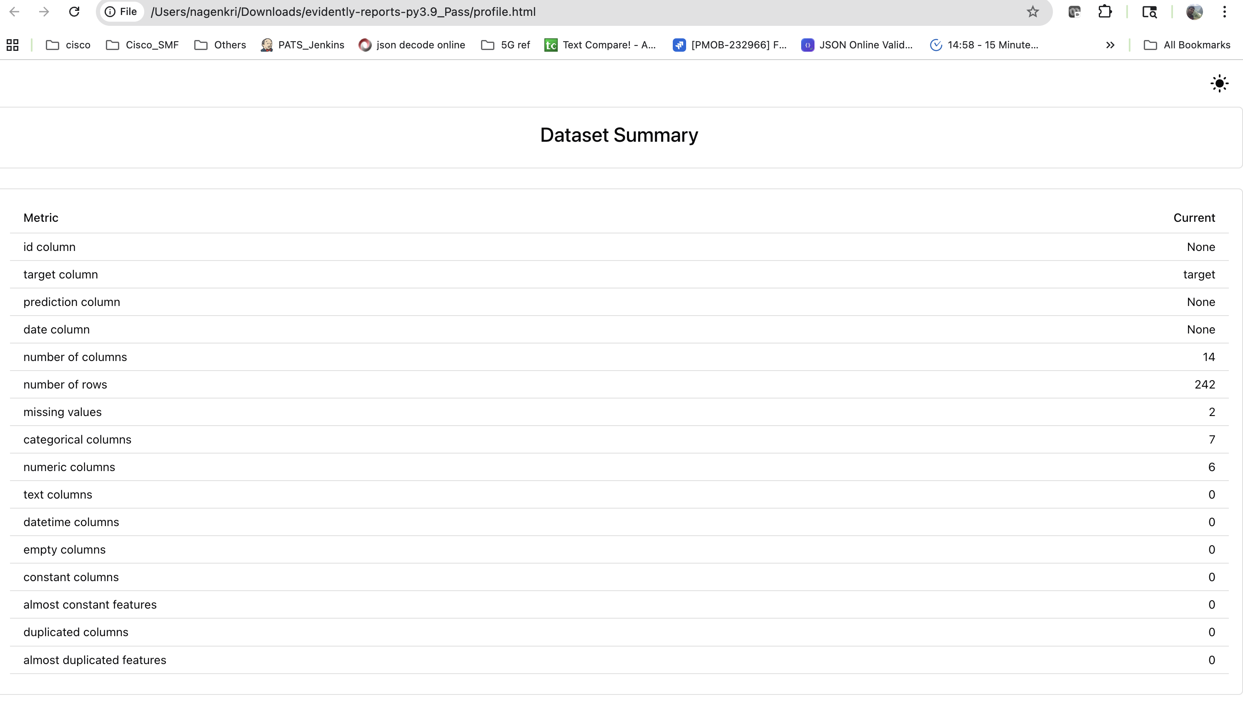
Figure 2 - DataQualityPreset profile.html: per-column statistics, missing values and distribution summaries for the reference set (Step 4).

4. Drift Demonstration and CI Failure Injection
To prove the gate actually rejects bad data, scripts/generate_drift_demo.py fabricates a current dataset with deliberately injected drift. Numeric features are shifted by 1.5 standard deviations, around 30 percent of categorical entries are flipped to other valid levels, and the target prevalence is skewed downward. The CI workflow exposes a manual workflow_dispatch toggle that runs the gate against this dirty data on demand.
Running run_evidently.py against the synthetic input yields dataset_drift = True with share_of_drifted_columns = 0.7143 (10 of 14 columns flagged). The script exits with code 1, GitHub marks the step failed, and the dependent Docker build job is skipped. Despite the failure, the artifact upload step still runs (if: always()) so the HTML reports remain downloadable from the failed run page.
Step 12 - injected drift and the detectors that trip:
# | Injected drift | Detector that trips
1 | Numeric features shifted by +1.5 sigma (age, chol, thalach, trestbps, oldpeak) | DataDriftPreset (Wasserstein distance)
2 | ~30% categorical flips on cp, restecg, slope, thal | DataDriftPreset (Chi-square test)
3 | Target prevalence skewed by ~10 pp | TargetDriftPreset
4 | Combined effect across 14 columns | dataset_drift = True, share = 0.7143
5 | Exit code 1 propagates through CI | Docker build job is skipped
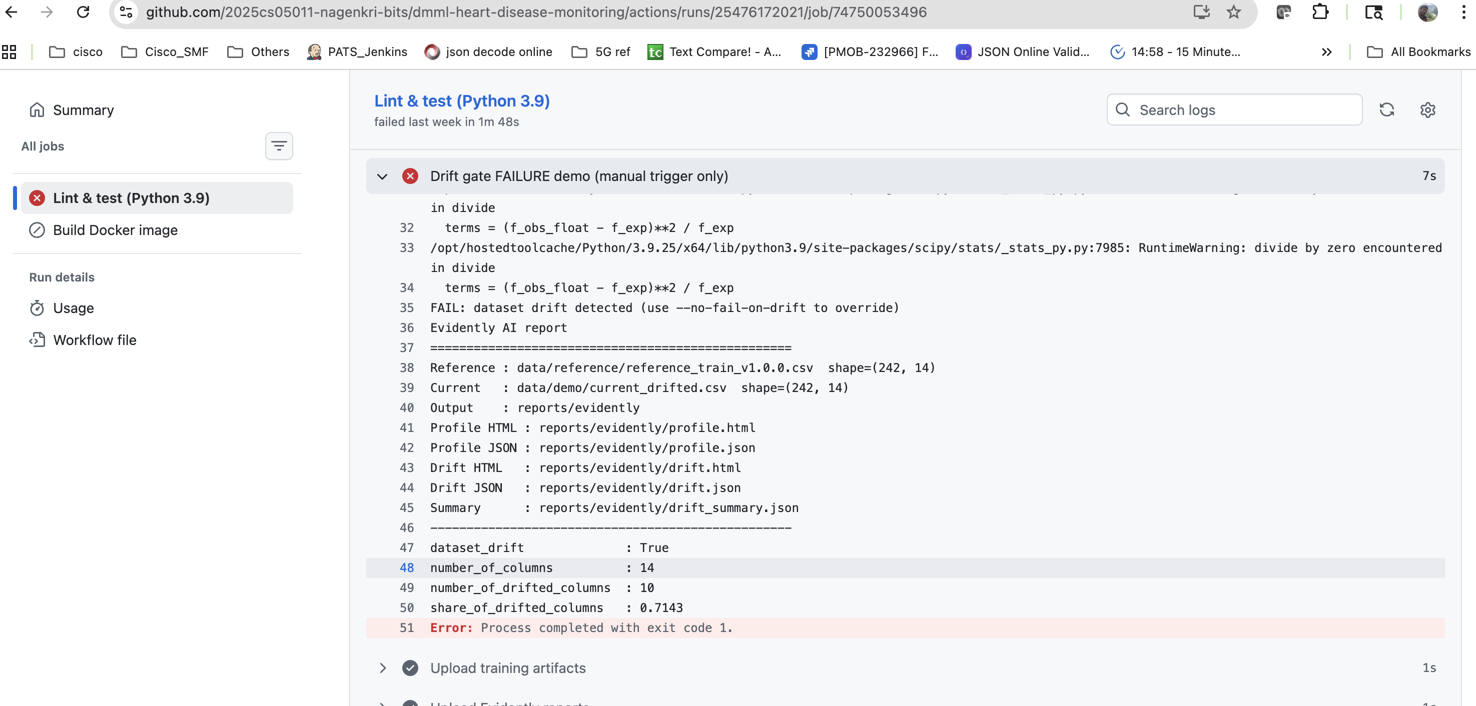
Figure 3 - Failed CI run on the synthetic drifted input: dataset_drift = True, share = 0.7143, exit code 1, build marked red.

5. Advanced Features (Steps 13-17)
The second half of the integration demonstrates the patterns that distinguish a production-ready drift gate from a one-off script: a versioned reference snapshot, a three-mode CI gating strategy, unconditional artifact upload, per-column drill-down and stable filenames.
Step | Capability | Implementation
13 | Frozen reference with SHA-256 metadata | scripts/freeze_reference.py + reference_train_<version>.metadata.json
14 | Three-mode CI gate (real / aux demo / failure demo) | workflow_dispatch input with truthy if: condition
15 | Unconditional artifact upload (works on red builds) | if: always() on actions/upload-artifact@v4
16 | Per-column distribution overlays | drift.html per-column drill-down section
17 | Stable filenames overwritten each run | save_report() with fixed paths under reports/evidently/
Step 13 highlight - frozen reference. Each baseline is committed as reference_train_<version>.csv plus a JSON sidecar capturing version, sha256, n_rows, target_prevalence, full schema and the git HEAD at freeze time. The current baseline v1.0.0 covers 242 rows x 14 columns at SHA-256 prefix 0e538464. Bumping the baseline is one freeze command plus one CI line change, and the metadata file becomes the audit trail of why.
Selected Step 14 finding:
- workflow_dispatch boolean inputs are sometimes stringified by GitHub, so the conditional uses a truthy check rather than a literal == true comparison; otherwise the failure-demo step silently skips even when the toggle is on.
- All three CI modes share the same Evidently engine; only the input dataset and the --no-fail-on-drift flag differ. The real gate runs on every push, the auxiliary demo never blocks, and the failure demo blocks only when the manual toggle is on.
Step 15 - artifact upload. Even when the drift gate fails the build, actions/upload-artifact@v4 still executes because of if: always(). Engineers can download evidently-reports-py3.9 from the red run page and inspect drift.html without re-running anything locally.
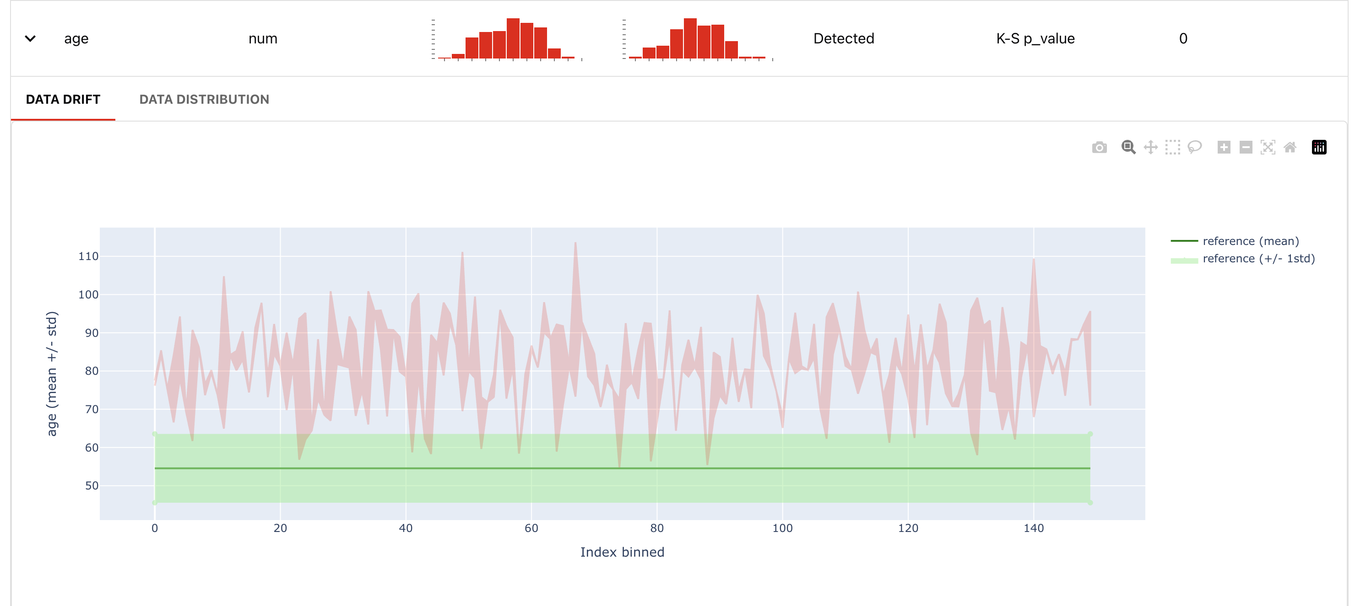
Figure 4 - drift.html per-column drill-down: reference vs current distribution overlay for a drifted feature, with the Wasserstein test result and verdict.
Deliverables produced by the integration:
- src/monitoring/drift.py - engine module wrapping the three Evidently presets behind pure functions.
- scripts/run_evidently.py - CLI entry point with --no-fail-on-drift flag for non-blocking runs.
- scripts/freeze_reference.py - versions a training snapshot to git with SHA-256 audit metadata.
- data/reference/reference_train_v1.0.0.csv plus .metadata.json - the frozen baseline used by every CI gate.
- reports/evidently/{profile,drift}.{html,json} plus summary.json - five stable files overwritten on each run.

6. Conclusion
The Evidently AI integration provides a complete walkthrough of automated data-drift detection wired into a real CI pipeline. It demonstrates how a frozen training snapshot, a small Python engine and three GitHub Actions steps are enough to turn drift detection from an offline analytics task into a build-time gate that physically prevents a stale model from shipping. The same engine powers a one-click stakeholder demo of both the healthy path and the rejection path on the same commit, and the Evidently HTML reports remain inspectable on every run regardless of pass or fail.
Overall, the implementation shows how Evidently AI can detect distributional drift before a stale model is deployed, give engineers a downloadable HTML report on every run regardless of build outcome, and complement code-level tests with a data-level test that catches the failure modes unit tests cannot see.

