DMML Assignment Report
Group ID: 3
Group Members Name with Student ID:

1. Bhaskar Borah | 2025CS05039
2. Ramya K S | 2025CS05055
3. Nikhil Rahul Ekka | 2025CS05012
4. Nagendren K | 2025CS05011

Tool 1: Great Expectations
Overview
Data quality and consistency are like the foundation of a house—without a solid base, everything built on top risks collapsing. This is where data validation plays an important role. Data validation helps you make sure that your data is accurate, consistent, and reliable.
Great Expectations (GX) is an open-source framework that has become popular for managing and automating data validation in modern data pipelines.

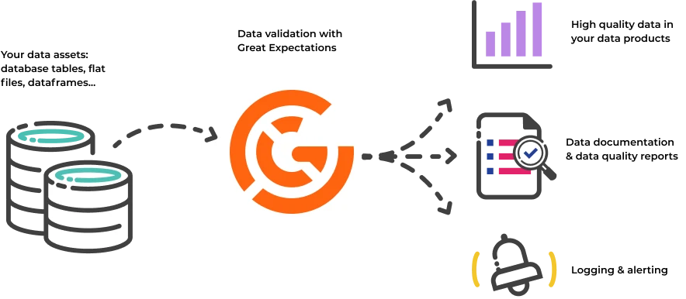
Its Python-based framework is designed to help data teams guarantee the quality and consistency of their data. Users can define "expectations"—rules or tests that describe what valid data should look like—that automatically validate whether the data meets these standards.
Some benefits of Great Expectations include:
- Data Profiling – With its profiling functionalities, it allows us to understand the data better by giving detailed insights into things like how columns are distributed, what unique values exist, and various statistical measures.
- Automated data validation – Great Expectations automates the process of validating data, reducing manual effort and minimizing the risk of errors. It ensures that data consistently meets predefined standards.
- Integration with data pipelines – It easily integrates with various data sources and platforms, including SQL databases, cloud storage, and ETL tools, allowing for data validation across different stages of your pipeline.
- Clear, actionable validation results – The tool provides transparent validation results, making it easy to spot data quality issues and address them quickly.
- Data documentation – Great Expectations can generate detailed, accessible documentation of your data validation processes, helping teams align on quality standards and providing a reference for future use.
- Custom expectations – Custom expectations allow data engineers and analysts to define their own rules for what their data should look like and to validate their data against their specific requirements
- Scalability and flexibility – As an open-source tool, Great Expectations is highly customizable and can scale with your data validation needs, offering flexibility to adjust to various use cases without high costs.
More details on the GX tool: https://docs.greatexpectations.io/docs/core/introduction/
******************************
Now, let’s look at an End-to-end data-quality testing on the Sales dataset (data.xlsx) using Great Expectations tool !
Link for ipynb notebook:

1. Introduction
This report summarises the Great_Expectations_Demo.ipynb notebook, a hands-on walkthrough of the Great Expectations (GE) framework for data-quality testing. The notebook is executed against a real Sales dataset (data.xlsx) and is split into a Core Workflow (Steps 1–12) and an Advanced Features tour (Steps 13–17). All examples use the GE 0.15.41 PandasDataset API.
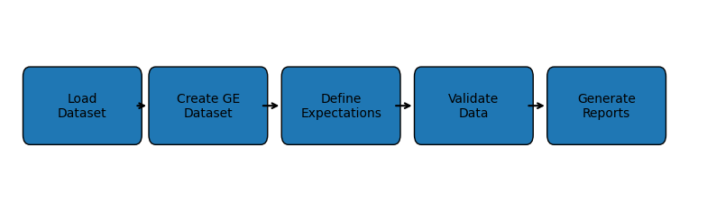
Figure 1 — Overall workflow followed in the notebook.

2. Environment Setup and Data Loading (Steps 1–3)
The notebook begins by installing the required libraries. The dataset is loaded using pandas and converted into a Great Expectations dataset object using ge.from_pandas(). This conversion enables the use of validation expectations directly on the DataFrame.
Step | Operation | Purpose
Installation | pip install great_expectations pandas openpyxl | Installs required libraries
Import Libraries | import great_expectations as ge | Loads GE framework into notebook
Load Dataset | pd.read_excel('data.xlsx') | Reads Excel dataset into pandas DataFrame
Inspect Schema | df.dtypes / df.head() | Checks columns and datatypes

3. Core Workflow (Steps 4–11)
The expectations form the foundation of automated data quality testing. The notebook validates business rules such as valid product categories, positive order quantities, valid latitude and longitude values, and acceptable pricing ranges.
After defining expectations, the validate() function is executed. This compares the dataset against all saved rules and produces a detailed JSON result containing pass/fail statistics.
The notebook also generates Data Docs, which are HTML reports provided by Great Expectations. These reports visually display successful checks, failed checks, unexpected values, and summary statistics.
A pipeline gating mechanism is demonstrated using an if-condition. If all expectations pass, the pipeline continues; otherwise, failed checks are reported. This approach is commonly used in real-world ETL and ML pipelines.
Step | Check | Key API
4 | Row count in range | expect_table_row_count_to_be_between
5 | Column exists / not null / type | expect_column_to_exist, _values_to_not_be_null, _in_type_list
6 | Allowed categorical values | expect_column_values_to_be_in_set
7 | Numeric ranges & mean | expect_column_values_to_be_between, _mean_to_be_between
8 | Persist suite to JSON | save_expectation_suite(...)
9 | Re-validate new data | df.validate(expectation_suite=...)
10 | Pipeline gate (fail-fast) | branch on results['success']
11 | Visual report (Data Docs) | BaseDataContext + SimpleCheckpoint + build_data_docs()

4. Stress Testing and Failure Injection
To demonstrate the effectiveness of the framework, the notebook intentionally injects data quality issues such as null values, invalid categories, negative quantities, and out-of-range geographic coordinates. The same expectation suite is then re-executed against the corrupted dataset.
Great Expectations successfully identifies each anomaly independently. This section is important because it proves that the framework can detect real-world data issues before the data reaches downstream analytics or machine learning systems.
Step 12 — injected faults and the rules they trip:
# | Injected fault | Rule it trips
1 | 3 product rows -> NaN | expect_column_values_to_not_be_null('product')
2 | 2 productcategory rows -> 'Toys' | expect_column_values_to_be_in_set('productcategory', ...)
3 | OrderQuantity set to 0 and 5000 | expect_column_values_to_be_between('OrderQuantity', 1, 1000)
4 | Discount set to -25 | expect_column_values_to_be_between('Discount', 0, 10000)
5 | latitude set to 99.9 | expect_column_values_to_be_between('latitude', -90, 90)
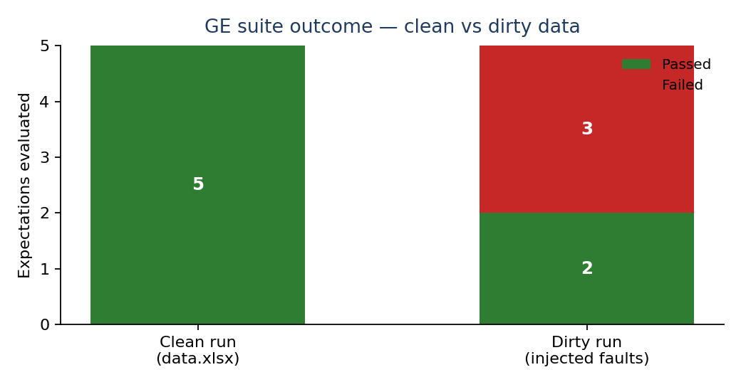
Figure 2 — Suite pass/fail counts on the clean dataset vs. the stress-test dirty copy.

5. Advanced Features (Steps 13–17)
The second half of the notebook demonstrates the capabilities that distinguish GE from a hand-rolled assert script: auto-profiled suites, statistical drift detection, cross-column integrity rules, format/regex checks and custom domain-specific expectations.
Step | Capability | Key API
13 | Automatic profiling using UserConfigurableProfiler | UserConfigurableProfiler(...).build_suite()
14 | Drift detection using KL divergence | expect_column_kl_divergence_to_be_less_than
15 | Cross-column integrity checks | expect_column_pair_values_A_to_be_greater_than_B, expect_compound_columns_to_be_unique, expect_column_values_to_be_increasing
16 | String / format / regex validation | expect_column_values_to_match_regex, _value_lengths_to_equal, _match_strftime_format
17 | Custom domain expectation creation using subclassing | subclass PandasDataset + @MetaPandasDataset.multicolumn_map_expectation
Step 14 highlight — KL-divergence drift on UnitPrice. The reference distribution is built from the full historical data; the current batch is then re-priced by +10% to simulate an across-the-board price hike. The KL score jumps roughly 10x and trips the threshold of 0.5, while the unshifted batch passes cleanly.
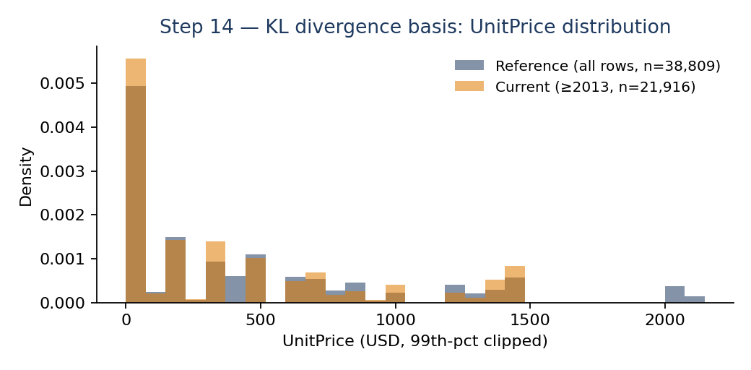
Figure 3 — UnitPrice distribution: reference vs. current vs. +10% drifted batch (Step 14).
Selected Step 16 finding:
- ZIP regex ^\d{5}$ surfaces a real ingestion bug — Massachusetts ZIPs like 02134 became 2134 when stored as int.
- StateCD length == 2 passes; OrderDateStr matches %Y-%m-%d until 4 malformed values are injected, all of which are caught.
Step 17 — custom expectation:
A SalesDataset subclass adds expect_sales_to_equal_unitprice_times_quantity, a revenue-audit rule that no built-in expectation provides. On the clean non-discounted slice it reports zero violations; after three rows are tampered with, GE flags exactly those rows and the custom rule serialises into the saved suite alongside built-ins.
Deliverables produced by the notebook:
- sales.data.expectations.json — hand-built suite of ~10 expectations.
- sales.auto.expectations.json — auto-profiled starter suite.
- sales.audit.expectations.json — suite containing a custom domain expectation.
- Data Docs HTML report (gx/uncommitted/data_docs/local_site/) plus data_docs.zip.

6. Conclusion
The Great Expectations demo notebook provides a complete walkthrough of automated data quality validation. It demonstrates how expectations can be created, executed, saved, and reused in production pipelines. The notebook also highlights advanced features such as drift detection and custom expectations, making it suitable for modern data engineering and MLOps workflows.
Overall, the implementation shows how Great Expectations can improve data reliability, reduce manual validation effort, and prevent poor-quality data from affecting downstream systems.

