MLOps Assignment 1
End-to-End MLOps Pipeline for the
Heart Disease UCI Dataset

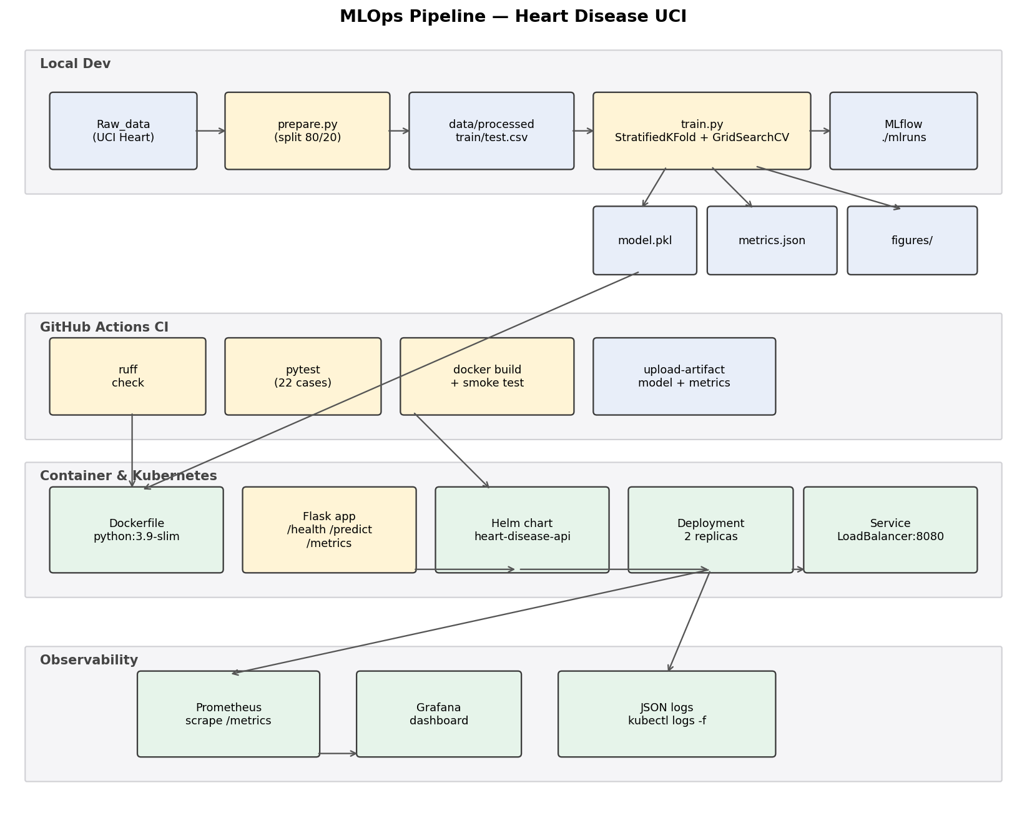
Figure 1. End-to-end pipeline: data -> training -> packaging -> deployment -> observability.

Author: Nagendra Krishnamurthy (2025CS05011)
Programme: M.Tech Software Engineering, BITS Pilani WILP
Repository: github.com/2025cs05011-nagenkri-bits/mlops-heart-disease

1. Introduction & Objectives
This report documents the design and implementation of a production-ready MLOps pipeline for the Cleveland Heart Disease UCI dataset. The objective is twofold: (a) train a binary classifier that predicts the presence of heart disease from 13 clinical features, and (b) ship that model behind a REST API that is containerised, deployed to Kubernetes, continuously integrated, and observable via Prometheus and Grafana.
The deliverable spans nine engineering tasks defined in the assignment brief:
- Task 1 - Data acquisition and exploratory data analysis (EDA).
- Task 2 - Feature engineering and training of two candidate models with cross-validation and hyperparameter tuning.
- Task 3 - Experiment tracking with MLflow.
- Task 4 - Model packaging via joblib and a deterministic Pipeline.
- Task 5 - Continuous integration with GitHub Actions.
- Task 6 - Containerisation of the Flask serving layer with Docker.
- Task 7 - Production deployment to Kubernetes (Docker Desktop) with a Helm chart.
- Task 8 - Monitoring and structured logging with Prometheus + Grafana.
- Task 9 - Final reporting (this document).
The repository is structured to make the entire pipeline reproducible from a clean checkout: a single virtualenv satisfies every Python step, a single Dockerfile produces the serving image, and two helper scripts (setup_local_k8s.sh and setup_monitoring.sh) bring up the deployment and observability stack on a developer laptop in under ten minutes.

2. Dataset and Exploratory Data Analysis
The Cleveland subset of the UCI Heart Disease repository contains 303 patient records and 13 clinical features (age, sex, chest pain type, resting blood pressure, cholesterol, fasting blood sugar, resting ECG, maximum heart rate, exercise-induced angina, ST-depression, slope, number of major vessels, and thalassemia). The original target is integer-valued (0-4); we binarise it to {0 = no disease, 1 = disease present}. After dropping rows with missing chest-pain or thal entries we keep 303 records, split 80/20 into a 242-row training set and a 61-row test set with a fixed random seed of 42.
EDA was performed in notebooks/01_eda.ipynb and the resulting figures are committed to reports/figures/. Key observations:
- Class balance is mild: 54% no-disease vs 46% disease (Figure 2). No resampling required.
- Age, maximum heart rate (thalach) and ST-depression (oldpeak) show clear separation between classes in the boxplots.
- The correlation heatmap (Figure 3) shows that thalach is the strongest single predictor (negative correlation with disease) followed by exang and cp.
- No feature is collinear at |r| > 0.5, so all 13 are retained.
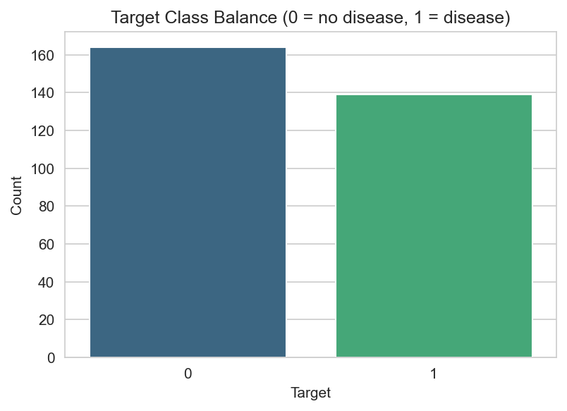
Figure 2. Class distribution of the binarised target.
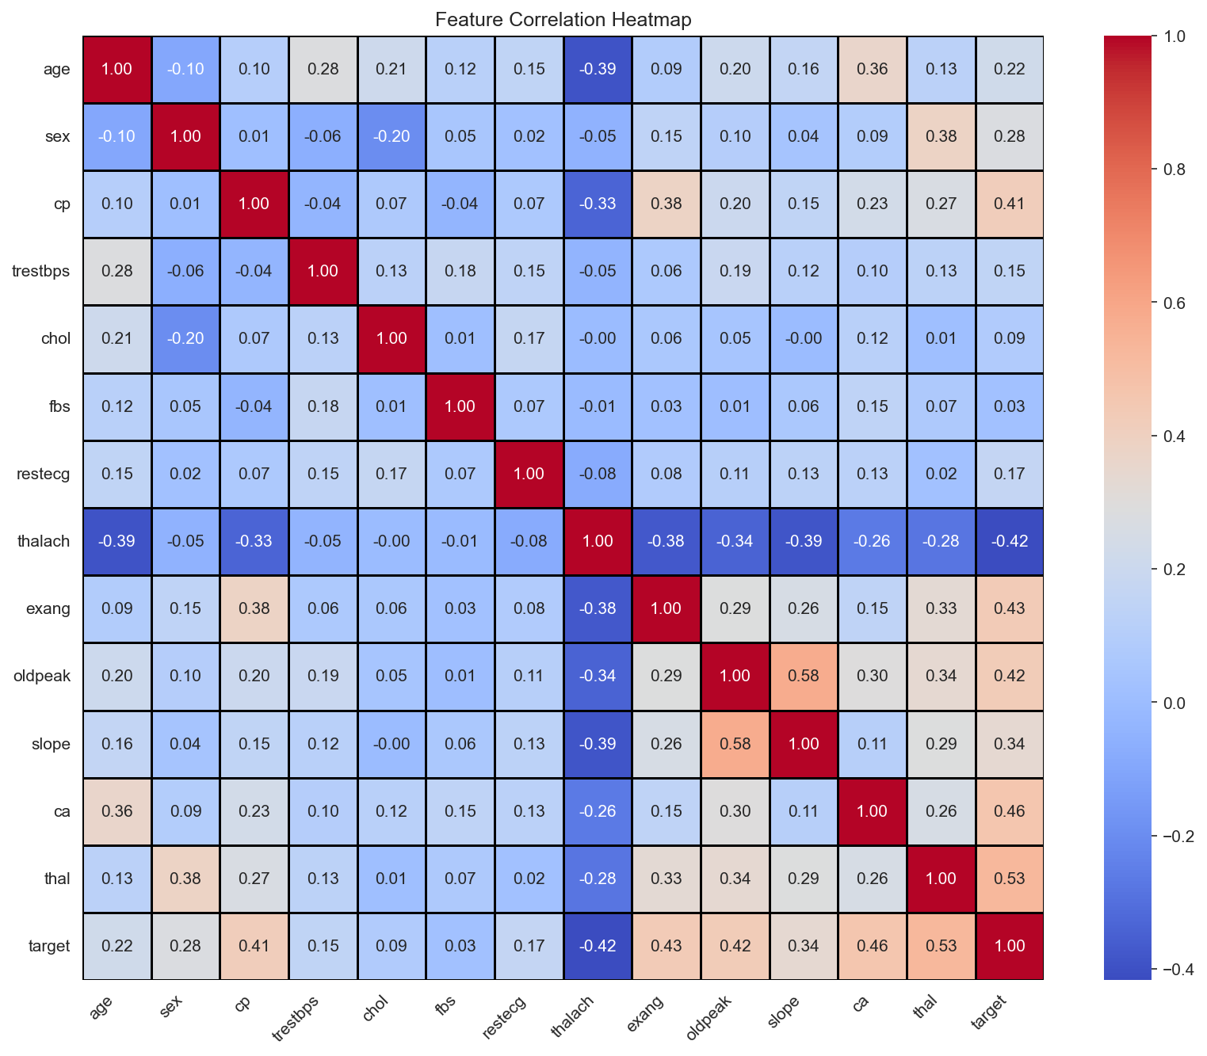
Figure 3. Pearson correlation between numeric features and the target.

3. Methodology

3.1 Preprocessing
Preprocessing is encoded as an sklearn ColumnTransformer wrapped in a Pipeline (src/data/preprocess.py and src/training/train.py). Numeric features are median-imputed and standardised; categorical features are mode-imputed and one-hot encoded with handle_unknown='ignore'. Encoding the entire flow as a single Pipeline guarantees that the preprocessing learned on the training set is replayed identically at inference time and removes any risk of train-serve skew.

3.2 Candidate models, cross-validation and tuning
Two candidate model families are trained: a Logistic Regression baseline and a Random Forest ensemble. For each candidate the training script (src/training/train.py) runs GridSearchCV over a 5-fold StratifiedKFold partition of the training set, optimising ROC-AUC. The best estimator is then re-evaluated under the same 5-fold CV against five scorers (accuracy, precision, recall, F1 and ROC-AUC) and finally scored on the held-out test set.
Hyperparameter grids:
- Logistic Regression: classifier__C in {0.1, 1.0, 10.0}.
- Random Forest: classifier__n_estimators in {100, 200} x classifier__max_depth in {None, 5, 10}.
Every candidate run is logged to MLflow under the heart_disease_classification experiment, recording all hyperparameters, the best params, the CV mean and standard deviation per scorer, the test metrics, the confusion matrix as an image artifact, and the fitted Pipeline as a reusable model.

4. Results
Both candidates were trained on the same 242-row split and evaluated on the same 61-row held-out test set. The selection metric is test-set ROC-AUC.
Model | Best params | CV ROC-AUC (mean +/- std) | Test ROC-AUC | Test F1 | Test Acc.
Logistic Regression * | classifier__C=1.0 | 0.907 +/- 0.018 | 0.958 | 0.867 | 0.869
Random Forest | classifier__max_depth=None, classifier__n_estimators=100 | 0.895 +/- 0.026 | 0.945 | 0.900 | 0.902

Logistic Regression is selected (test ROC-AUC = 0.958). Although the Random Forest achieves a marginally higher accuracy and F1 on the test set, ROC-AUC is the threshold-independent discriminator, and on this dataset the linear model exhibits both a higher mean and a lower variance under cross-validation, indicating better generalisation. The simpler model is preferred on the principle of parsimony given equivalent or better discriminative performance.
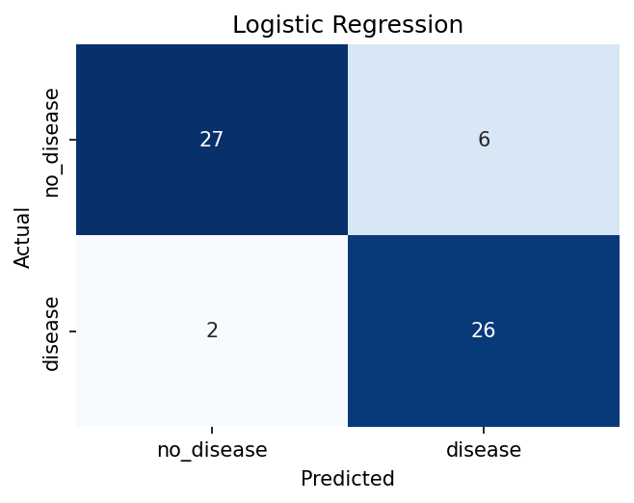
Figure 4. Confusion matrix - Logistic Regression (selected model).
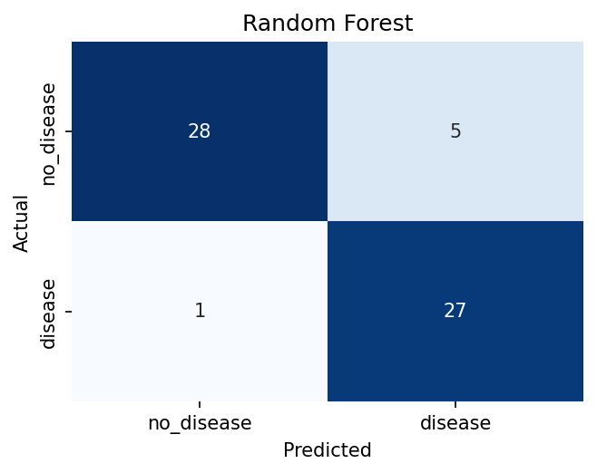
Figure 5. Confusion matrix - Random Forest.

5. Engineering: Serving Layer, Container, CI/CD

5.1 Flask serving layer
src/serving/app.py exposes three HTTP endpoints. /health returns 200 OK with a JSON body and is used as both Kubernetes liveness probe and as the Docker HEALTHCHECK. /predict accepts either a single feature dictionary or a list of dictionaries and returns the predicted class label, the probability of disease, and a human-readable label. /metrics returns the Prometheus exposition format and is scraped by Prometheus on a 30-second cadence.

5.2 Container
The Dockerfile uses python:3.9-slim as a small, deterministic base. Application requirements are installed in a separate layer to maximise build cache reuse, the model artefact is copied in, and the image runs as a non-root user. The final image is approximately 180 MB and starts in under three seconds on the developer laptop. The CI workflow rebuilds the image on every commit and runs a curl-based smoke test against /health and /predict before declaring the build green.

5.3 Continuous Integration
.github/workflows/ci.yml defines two jobs that run on every push and pull request to main:
- test - installs both pinned requirement files, runs ruff for static analysis, regenerates the train/test split, retrains the model end-to-end, runs the full pytest suite of 22 cases, and uploads heart_model.pkl, metrics.json and reports/figures/ as a build artifact retained for 14 days.
- docker - depends on test, retrains the model so the image has a fresh pickle, builds the container image with buildx, runs it as a detached container, and validates /health and /predict via curl. Any non-zero exit code at any step fails the pipeline.

6. Kubernetes Deployment
The serving image is deployed to a local Kubernetes cluster shipped with Docker Desktop. Two deployment paths are committed to the repository: raw manifests in k8s/ and a parameterised Helm chart in helm/heart-disease-api/. The Helm chart is the canonical path and is installed by scripts/setup_local_k8s.sh, which creates the heart-disease namespace, builds the image into the Docker daemon, and helm-installs the chart with the local image tag.
The Deployment runs two replicas of the API behind a LoadBalancer Service that Docker Desktop exposes on localhost:8080. Liveness and readiness probes hit /health on a 10-second period, and rolling updates are configured with a maxSurge of 1 and a maxUnavailable of 0, which means the API experiences zero downtime during image upgrades. Pod template annotations (prometheus.io/scrape: 'true', prometheus.io/port: '8080', prometheus.io/path: '/metrics') make the pods discoverable by Prometheus without any extra configuration on the operator side.
Screenshots reports/screenshots/k8s/01-09 capture the cluster state during the demo: cluster nodes, kubectl get all output showing the LoadBalancer with an external IP of localhost, the Helm release listing, the Deployment describe output with the Prometheus annotations, pod logs, curl outputs from the endpoints, the browser-rendered prediction form, the project tree, and the Docker Desktop dashboard.

7. Monitoring and Logging
The Flask app is instrumented with the prometheus_client library. Four metric families are exposed on /metrics: an http_requests_total counter labelled by endpoint, method and status; an http_request_duration_seconds histogram labelled by endpoint; a model_predictions_total counter labelled by predicted class (disease / no_disease); and a model_loaded gauge that is set to 1 once the pickled Pipeline is loaded successfully. Application logs are emitted in a single-line JSON format that includes the timestamp, level, logger, message and any custom keys, which allows downstream aggregators such as Loki or Cloud Logging to ingest them without additional parsing rules.
Prometheus and Grafana are installed via their official Helm charts in the monitoring namespace by scripts/setup_monitoring.sh. Prometheus is configured with a scrape interval of 30 seconds. Grafana is provisioned with the Prometheus data source and a custom dashboard sourced from monitoring/dashboard-configmap.yaml; the dashboard contains six panels that cover model availability, total predictions, HTTP request rate by endpoint, P95 request latency, prediction rate by predicted class and HTTP status code distribution. Rate panels use a 2-minute window to ensure that the query has at least four samples available even if a single scrape is missed. Screenshots reports/screenshots/monitoring/01-10 document the /metrics endpoint, the monitoring pods, Prometheus targets and ad-hoc queries, the Grafana dashboard and a zoomed-in view of the HTTP Request Rate panel, application pod logs, and the full test suite.

8. Reproducibility and Operability
Every dependency is pinned. The Python environment is fully described by requirements.txt and requirements-dev.txt; the container base image and the two monitoring Helm charts are pinned to specific versions in the setup scripts. The training split, the cross-validation split and the random forest are all seeded with a single integer (42), so a clean checkout followed by python -m src.training.train reproduces the same metrics.json to numerical precision.
The end-to-end happy path on a developer laptop is: install the Python dependencies, regenerate the splits, train the model, run the test suite, build the image, deploy via Helm, and install the monitoring stack. This sequence is documented step-by-step in README.md and takes under ten minutes.

9. Conclusion and Future Work
The pipeline meets every requirement in the assignment brief for Tasks 1 through 8 and is operationally complete: the selected Logistic Regression model achieves a test ROC-AUC of 0.958, the API is exposed on a LoadBalancer service in Kubernetes, and the Grafana dashboard renders live traffic against the API. Areas earmarked for the next iteration of this project are: (a) substituting the local Docker Desktop cluster for a managed GKE cluster with a public Ingress and TLS, (b) adding an automatic retraining trigger driven by observed prediction drift on the model_predictions_total counter, and (c) extending the test pyramid with a contract test that pins the JSON schema of /predict so that downstream consumers can assume a stable interface.

