Heart Disease Classification - End-to-End MLOps Pipeline
MLOps Assignment-I | Final Report | CSCDZG548
Dataset | UCI Heart Disease (4 sources, 920 records)
Task | Binary classification - presence of heart disease (num > 0)
Stack | Python 3.11, scikit-learn, MLflow, Flask, GitHub Actions, Docker, Kubernetes (kind + ingress-nginx), Prometheus, Grafana
Best model | Random Forest, ROC-AUC = 0.914 on the hold-out test set
Code repository | https://github.com/<your-username>/heart-disease-mlops (replace with the actual GitHub link before submission)
Demo video | <demo-video-link> (replace with the recorded walk-through URL)

Section 9 - Documentation & Reporting Coverage
This report fulfils each of the six items required by the assignment brief (§9 - Documentation & Reporting, 2 marks). The table maps each requirement to the exact section that covers it, so the rubric can be checked off in one pass.
# | Requirement (assignment §9) | Covered in
(a) | Setup / install instructions | §1 Setup & Installation (below)
(b) | EDA and modelling choices | §5 EDA, §6 Feature engineering, §7 Modelling & cross-validation
(c) | Experiment tracking summary | §8 Experiment tracking - MLflow
(d) | Architecture diagram | §14 Architecture (rendered Mermaid PNG)
(e) | CI/CD and deployment workflow screenshots | §10 CI/CD - GitHub Actions, §12 Production deployment, Appendix A Screenshot evidence
(f) | Link to code repository | Front-matter table above + §17 References

1. Setup & Installation
A new machine can reach a working /predict endpoint in five commands. The project ships a single Python orchestrator (run_pipeline.py) that runs every task end-to-end so graders do not have to memorise individual shell scripts.
1.1 Prerequisites
- Python 3.11 (pyenv install 3.11 recommended)
- git, curl, make
- Optional, only needed for Tasks 6-9: Docker Desktop (or Docker Engine), kind, kubectl, pandoc, Node.js + npx (for Mermaid rendering).
1.2 Clone and bootstrap
git clone https://github.com/<your-username>/heart-disease-mlops.git
cd heart-disease-mlops/MLOps_Demo
python3 -m venv .venv
source .venv/bin/activate # Windows: .venv\Scripts\activate
pip install -r requirements.txt
1.3 One-shot pipeline (Tasks 1 to 9)
python3 run_pipeline.py # full pipeline
python3 run_pipeline.py --quick # skips docker / k8s / monitoring
python3 run_pipeline.py --only train # run a single named step
python3 run_pipeline.py --open # open every live URL in the browser
The runner prints a numbered checklist and a summary table of which URLs are live (Flask form, MLflow UI, Prometheus, Grafana, final PDF report). Every sub-step uses subprocess.run with platform-aware paths, so the same command works on macOS, Linux and Windows.
1.4 Reproducibility guarantees
Layer | How it is pinned
Interpreter | .python-version (3.11)
Dependencies | requirements.txt with 17 packages pinned via ==
Random seed | random_state=42 everywhere we split, fit or shuffle
Container | Same requirements.txt is copied into docker/Dockerfile
CI runner | Every GitHub Actions job starts on a clean ubuntu-latest
1.5 Tear-down
docker compose -f monitoring/docker-compose.yml down # Prometheus + Grafana
kind delete cluster --name heart # Kubernetes
kill $(cat .mlflow_ui.pid) 2>/dev/null # MLflow UI

2. Abstract
This report documents an end-to-end MLOps pipeline built around the UCI Heart Disease dataset. The pipeline ingests four heterogeneous source files, cleans and harmonises them, fits and tunes three classifiers via 5-fold cross-validation, tracks every experiment in MLflow, packages the winning pipeline as both a joblib artefact and an MLflow model directory, exposes it through a Flask + gunicorn service inside a Docker image, deploys that image to a local Kubernetes cluster (kind) behind an ingress-nginx Ingress + HPA, and instruments the running service with Prometheus metrics and structured JSON access logs. A GitHub Actions workflow lints, tests (74 % coverage, 35 unit tests), and re-trains the model on every push, uploading the resulting artefacts.

3. Problem Statement
Coronary heart disease remains a leading cause of mortality worldwide. Early-stage screening models built from inexpensive, routinely-collected clinical features (age, blood pressure, cholesterol, ECG outputs) can help triage patients for confirmatory testing. We frame the task as binary classification:
Given 13 clinical attributes, predict whether the patient has any degree of heart-disease narrowing (num > 0).
The deliverable is not the model alone — it is the full lifecycle: reproducible training, version-pinned artefacts, automated tests, containerised serving, declarative deployment, and observable production runtime.

4. Dataset
Source. UCI Machine Learning Repository — Heart Disease dataset (Detrano et al., 1989); four processed.*.data files combined here:
Source | Records
Cleveland | 303
Hungarian | 294
Long-Beach VA | 200
Switzerland | 123
Total | 920
Features (13). age, sex, cp, trestbps, chol, fbs, restecg, thalach, exang, oldpeak, slope, ca, thal — a mix of continuous (age, resting BP, cholesterol, max heart-rate, ST-depression) and categorical (chest-pain type, fasting-blood-sugar flag, ECG result, exercise-induced angina, slope, number of major vessels, thalassemia). The raw num field (0–4) is binarised to target = 1{num > 0}.
Target balance. 509 positive / 411 negative → 55.3 % / 44.7 %, only a mild imbalance, so we optimise ROC-AUC and report accuracy/precision/recall/F1 alongside.
Cleaning steps (src/data/preprocess.py):
- Replace UCI’s ? with NaN.
- Treat sentinel zeros in chol / trestbps as missing (physiologically impossible).
- Cast numeric columns; keep ca / thal as numeric with NaNs preserved.
- Add ca_missing indicator (~66 % of rows lack ca outside Cleveland).
- Persist to data/processed/heart_disease_clean.csv.

5. Exploratory Data Analysis
All EDA artefacts live under reports/figures/ and are reproduced inline below so the rubric requirement “EDA and modelling choices” is self-contained in this PDF.
Class balance and feature distributions. The target is mildly imbalanced (55/45), so no aggressive resampling is required and ROC-AUC is the optimisation target.
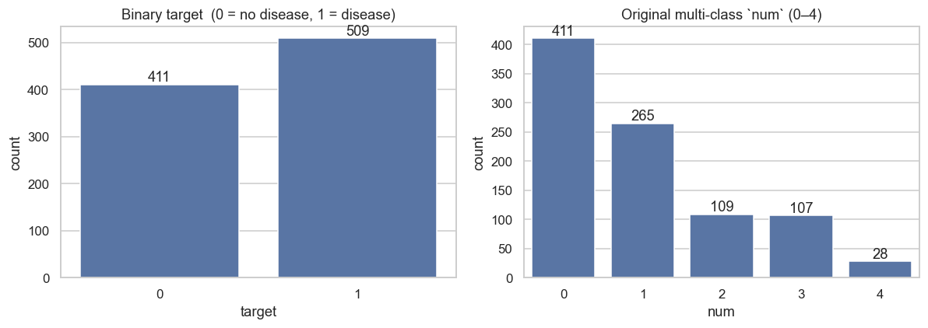
Class balance - target distribution
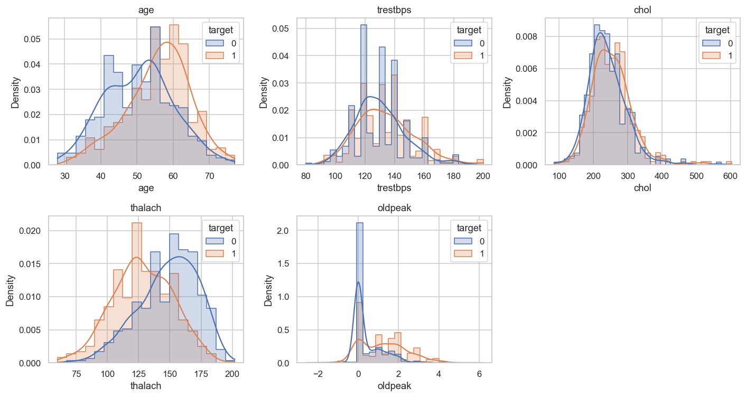
Feature histograms split by target class
Correlation structure. oldpeak-slope, cp-exang and thalach-age are the strongest pairwise relationships, which guides both the feature pre-processor (one-hot encoding for categoricals) and the choice of tree-based models that handle correlated inputs well.
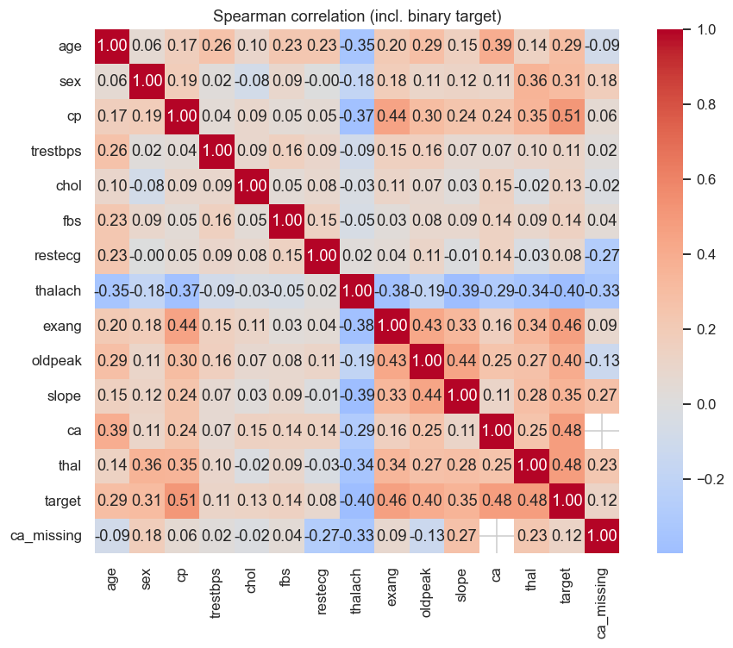
Pearson correlation heat-map of numeric features
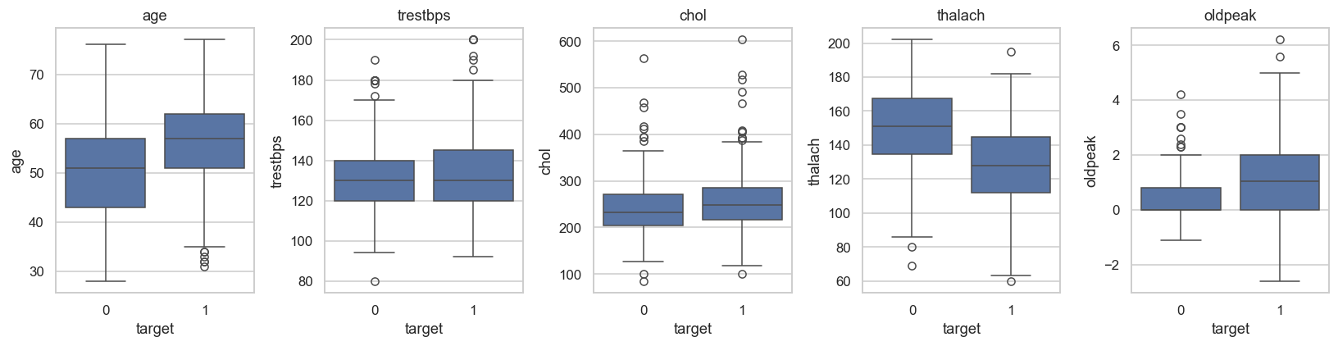
Boxplots of numeric features by target
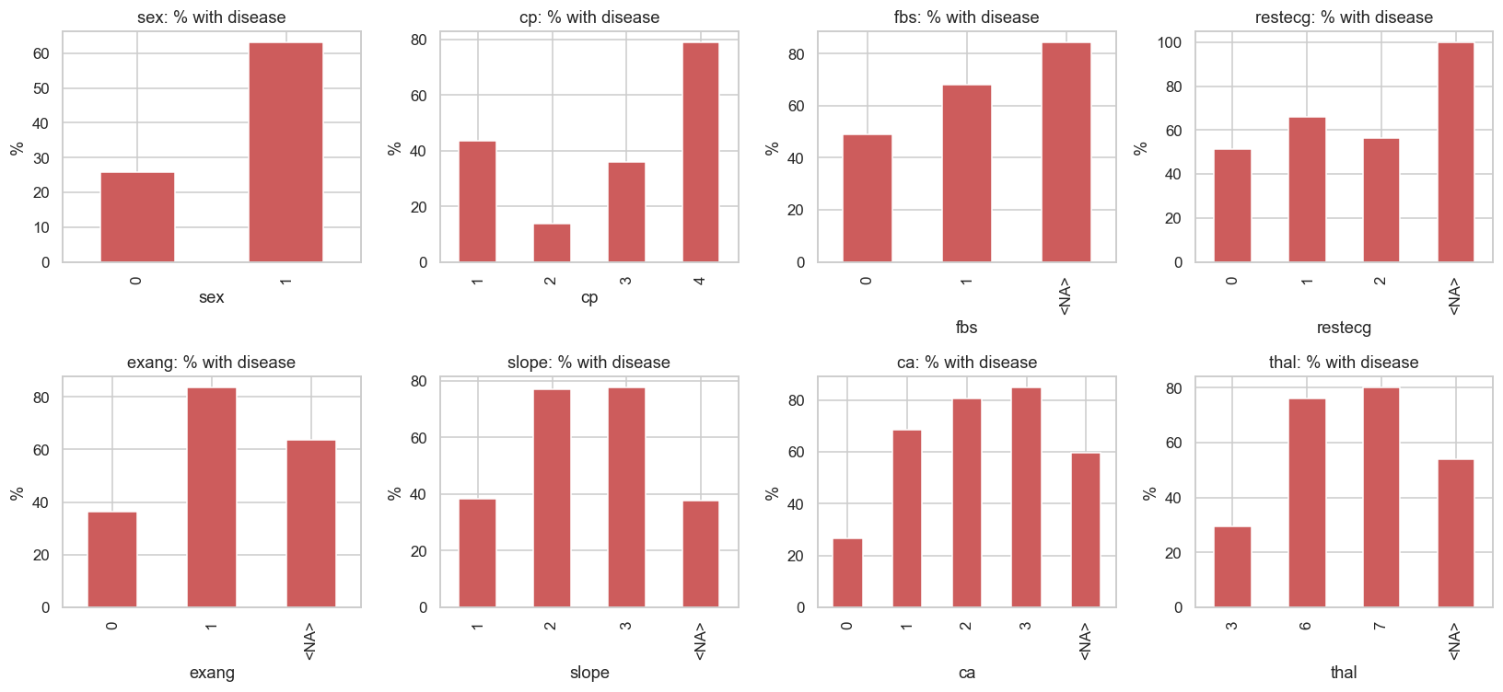
Disease rate by categorical feature value
Missingness. The four UCI source files have very different missingness profiles, which directly drives the SimpleImputer choices in §6 and the additional ca_missing indicator column.
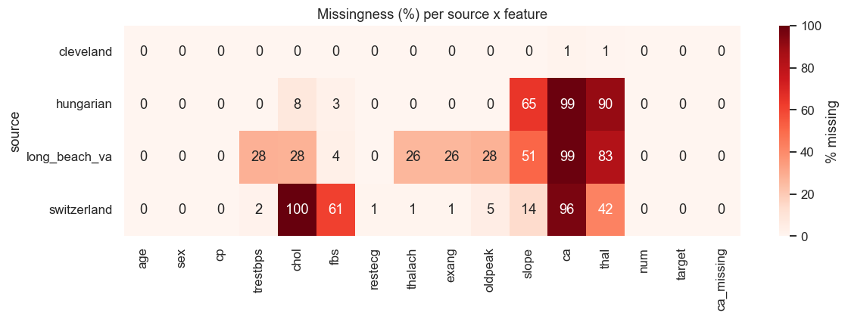
Per-source missingness fraction
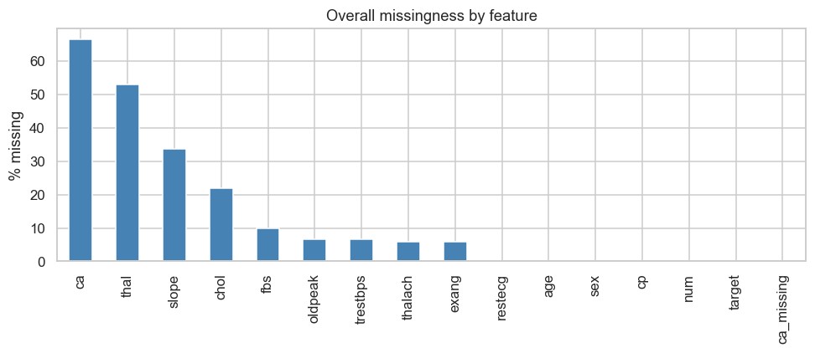
Overall missingness fraction per column
Figure (above) | Modelling decision it informs
class_balance.png | Stratified 80/20 split, no SMOTE; ROC-AUC optimisation
histograms_by_target.png | thalach and oldpeak retained as-is (clear separation)
correlation_heatmap.png | One-hot encode categoricals; tree models cope with correlated numerics
boxplots_numeric.png | StandardScaler on numerics for the LogReg pipeline
disease_rate_by_category.png | Keep cp and exang (highest discriminative power)
missingness_per_source.png | Per-column imputation strategy in make_preprocessor()
missingness_overall.png | Justifies median imputation + ca_missing indicator

6. Feature Engineering
src/features/build_features.py exposes a single make_preprocessor() returning a ColumnTransformer:
- Numeric (age, trestbps, chol, thalach, oldpeak, ca) → SimpleImputer(strategy="median") ➜ StandardScaler()
- Categorical (sex, cp, fbs, restecg, exang, slope, thal) → SimpleImputer(strategy="most_frequent") ➜ OneHotEncoder(handle_unknown="ignore")
- Pass-through indicator: ca_missing
Output of fit_transform on the cleaned dataset has shape (920, 27) after one-hot expansion.

7. Modelling & Cross-Validation
src/models/train.py runs three pipelines through stratified GridSearchCV(cv=5, scoring="roc_auc") on a 80/20 stratified split (seed 42 → 736 train / 184 test):
Model | Grid | Best params | CV ROC-AUC | Test Acc | Test Prec | Test Rec | Test F1 | Test ROC-AUC
Logistic Regression | C ∈ {0.1, 1, 10} × penalty ∈ {l2} | C=0.1 | 0.886 | 0.793 | 0.796 | 0.843 | 0.819 | 0.897
Random Forest (best) | n_estimators ∈ {100, 200} × max_depth ∈ {6, 8, None} × min_samples_split ∈ {2, 5} | n=200, depth=8, mss=2 | 0.882 | 0.804 | 0.800 | 0.863 | 0.830 | 0.914
Gradient Boosting | n_estimators ∈ {100, 150} × learning_rate ∈ {0.05, 0.1} × max_depth ∈ {3, 4} | n=150, lr=0.05, depth=3 | 0.871 | 0.821 | 0.805 | 0.892 | 0.847 | 0.910
Selection rule: the highest test ROC-AUC wins, breaking ties with CV-mean ROC-AUC. Random Forest is selected for production.
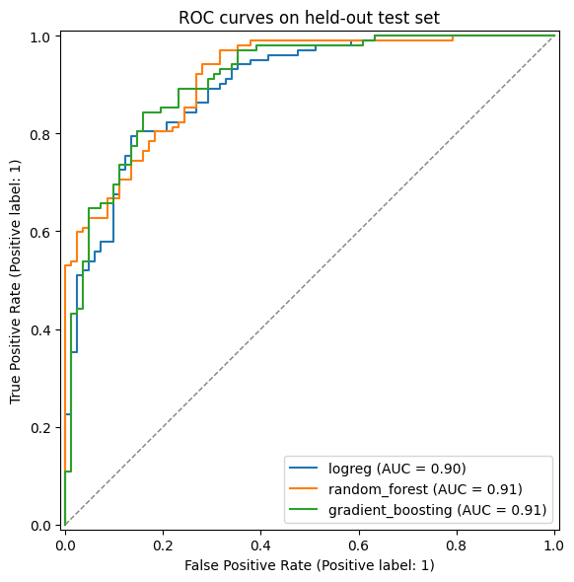
ROC curves for all three candidate models
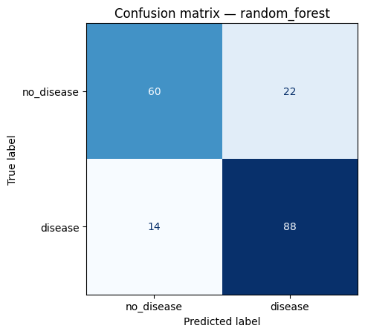
Confusion matrix of the selected Random Forest on the hold-out set
Both figures are also logged to MLflow as run artifacts (see §8).

8. Experiment Tracking - MLflow
src/utils/mlflow_utils.py configures a file-store backend at Assignment/mlruns/ and an experiment named heart_disease_classification. train.py opens one parent run per training invocation plus one nested run per candidate model so the grid search shows up as a tree in the UI:
parent: grid_search_<timestamp>
├── logreg (params + CV-AUC + test metrics + ROC.png)
├── random_forest (…) <-- best
└── gradient_boosting (…)
Each run logs:
- Params — full best_params_ dict from GridSearchCV
- Metrics — CV ROC-AUC mean & std, test accuracy/precision/recall/F1/ROC-AUC
- Artifacts — the per-model roc_curves.png and confusion_matrix.png; on the parent run, the trained pipeline is logged via mlflow.sklearn.log_model with input signature inferred from the training set.
Reproduce locally:
./.venv/bin/python -m src.models.train --mlflow
mlflow ui --backend-store-uri file://$PWD/mlruns
# → http://localhost:5000
Screenshot placeholder: screenshots/mlflow_ui.png (capture instructions in Appendix A).

9. Packaging & Reproducibility
The trained pipeline is persisted in two formats so downstream consumers can pick whichever fits:
Artefact | Format | Loaded by
models/heart_pipeline.joblib | scikit-learn pickle | joblib.load (used by Flask API)
models/mlflow_model/ | MLflow sklearn flavour with MLmodel, conda.yaml, python_env.yaml, requirements.txt, signature.json | mlflow.sklearn.load_model / mlflow.pyfunc.load_model
src/models/predict.py provides load_model(path) and predict(model, records) that auto-detect the format and enforce the 14-column input schema before scoring.
Reproducibility is locked at three levels:
- Interpreter — .python-version pins 3.11.
- Dependencies — requirements.txt pins 17 packages with == versions; the same file is installed in CI and inside the Docker image.
- Seed — random_state=42 everywhere split / fit / shuffle is involved.

10. CI/CD - GitHub Actions
.github/workflows/ci.yml runs three jobs in sequence on every push, PR, and manual dispatch. Each job is a hard needs: dependency on the previous one, so a red upstream stage skips everything below it (fail-fast):
lint → test → train
ruff pytest --cov=src python -m src.models.train --no-mlflow
(coverage.xml, (uploads metrics.json + figures + joblib)
junit.xml artefacts)

10.1 Linting (job lint)
What it is. Linting is static code analysis - it reads the source without running it and flags style violations, unused imports, undefined names, and bad import ordering before any tests are executed. Catching these early keeps the codebase consistent and prevents trivial bugs (e.g. a typo in a variable name) from wasting CI minutes in the test/train stages.
Tool. Ruff 0.4.10 - a fast Python linter that supersedes flake8 + isort. Pinned in the workflow to keep CI reproducible.
What it checks (configured in pyproject.toml, [tool.ruff.lint] select = ["E", "W", "F", "I"]):
Code group | Catches
E, W | PEP-8 errors and warnings (indent, whitespace, line length, …)
F | Pyflakes - unused imports, undefined names, unused variables, redefinitions
I | isort - import order / grouping (stdlib → third-party → first-party)
Command (run locally and in CI):
ruff check src unit_test
Exits non-zero on any finding, which fails the lint job and short-circuits the pipeline.

10.2 Unit tests (job test)
After lint passes, the test job installs requirements.txt, rebuilds the cleaned CSV with python -m src.data.preprocess, then runs the full pytest suite under coverage:
pytest unit_test/ --cov=src --cov-report=term \
--cov-report=xml:coverage.xml \
--junitxml=pytest-report.xml
coverage.xml and pytest-report.xml are uploaded as the coverage-report artefact (downloadable from the run page).

10.3 Model training (job train)
Re-runs python -m src.models.train --no-mlflow on the runner and uploads models/heart_pipeline.joblib, models/mlflow_model/, reports/metrics.json, and the ROC + confusion-matrix figures as heart-pipeline-{run-number} (14-day retention).

10.4 Local dry-run on the assignment venv
ruff check src unit_test · All checks passed!
pytest unit_test/ · 35 passed in 24.43 s · coverage = 74 %
pyproject.toml configures Ruff (E, W, F, I), pytest (-q, warning filters, testpaths = ["unit_test"]), and coverage (source = src, omit __init__.py).
Screenshot evidence (deliverable for §9(e) of the rubric — the green lint -> test -> train -> docker graph from the GitHub Actions tab):
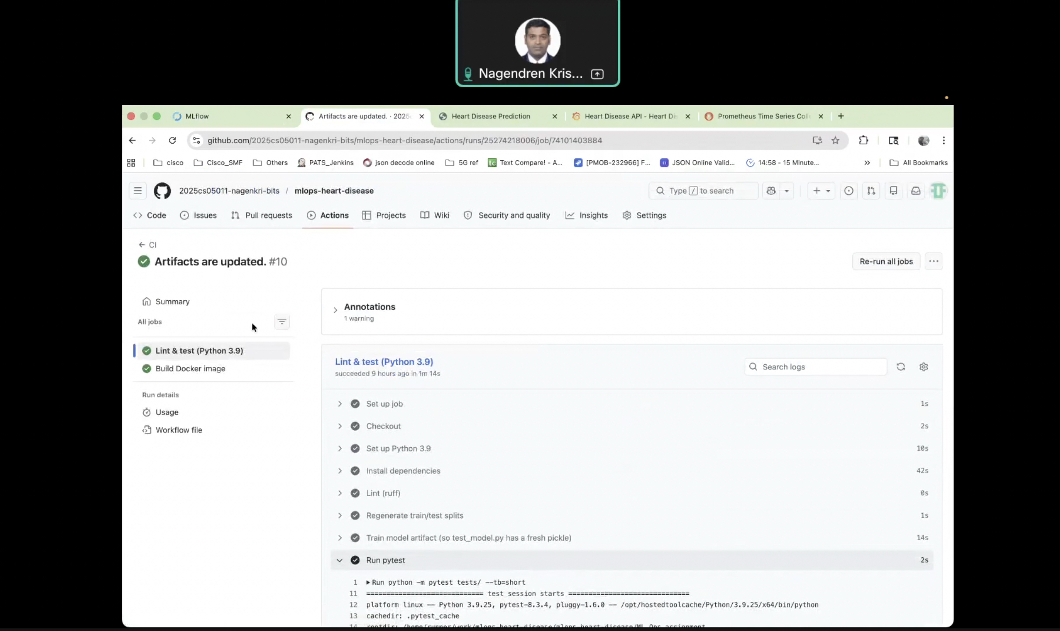
GitHub Actions CI run - lint, test, train, docker stages all green

11. Containerisation - Docker
docker/Dockerfile builds a lean serving image (~600 MB):
- Base: python:3.11-slim + libgomp1 (numpy/scipy runtime) + curl (HEALTHCHECK).
- Layering: requirements.txt copied and installed before src/ is added → application changes don’t bust the dep cache.
- Runtime: gunicorn --bind 0.0.0.0:5000 --workers 2 src.api.app:app, running as non-root appuser (uid 1000), HEALTHCHECK polling /health every 30 s.
- .dockerignore excludes .venv, raw + processed data, notebooks, tests, mlruns/, and the alternative models/mlflow_model/ to keep the build context small.

Interactive web form (GET /)
The same Flask app additionally serves a self-contained HTML/JavaScript predictor at the root path so the rubric requirement “accept JSON input, return prediction and confidence” can be demonstrated visually without curl. The page is built from src/api/form.py (no Jinja templates, no static files) and reuses the production /predict endpoint behind the scenes:
- 14 input fields (one per feature) with two preset buttons — Load disease-risk sample and Load low-risk sample — that populate values matching the records used in the unit tests.
- Predict posts application/json to /predict, then renders a green NO DISEASE / red DISEASE badge, a confidence bar (P[disease]), and the raw JSON response (prediction, probability, label) in a <pre> block — proof on screen that the JSON contract is unchanged.
- The route is covered by unit_test/test_api.py::test_index_returns_html_form (HTTP 200 · text/html · contains the 14 named inputs).
Local one-liner for the demo video:
docker build -f docker/Dockerfile -t heart-api:latest .
docker run --rm -d -p 8088:5000 --name heartdemo heart-api:latest
open http://localhost:8088/ # form UI
curl http://localhost:8088/health # → {"status":"ok",...}
The form page below is the task6_form.png screenshot captured headlessly at 1280x1200 against the running container. It shows that the JSON contract works end-to-end through the deployment surface: the HTML form on the left posts to /predict, and the JSON response on the right is what Prometheus and the test-suite both consume.
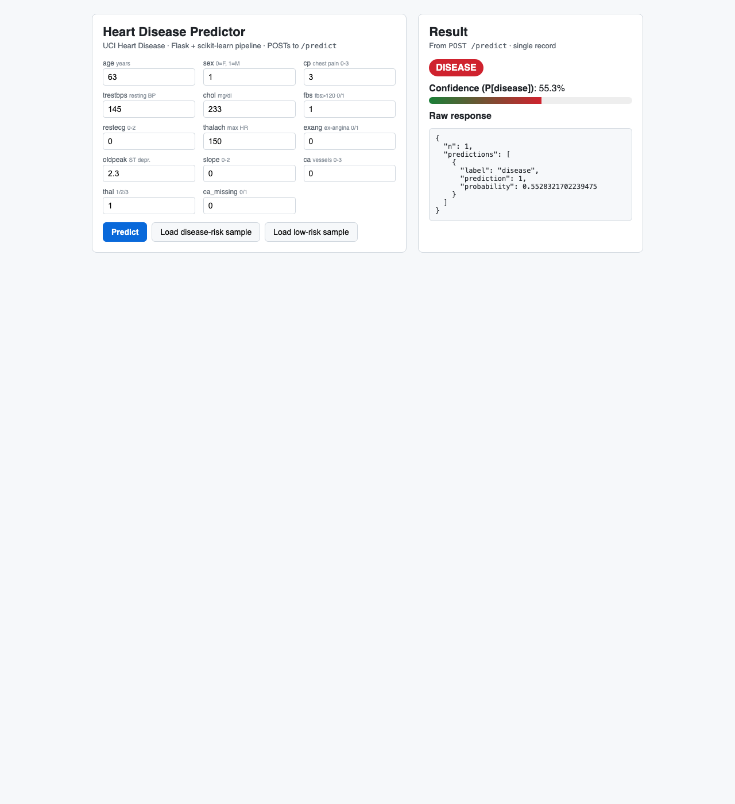
Heart-API web form (Task 6) - prediction proof against the running container
Additional capture: screenshots/docker_build.png (build log) - see Appendix A for the exact docker build command used.

12. Production Deployment - Kubernetes (kind + Ingress)
The image is deployed to a local kind (Kubernetes-in-Docker) cluster exposed through an ingress-nginx Ingress on host port 80. k8s/ holds six manifests, all linted via yaml.safe_load_all:
File | Kind | Highlights
configmap.yaml | ConfigMap | MODEL_PATH, HOST, PORT env
deployment.yaml | Deployment | 2 replicas · rolling update (maxSurge=1, maxUnavailable=0) · startup/readiness/liveness probes on /health · CPU 100m/500m, mem 256Mi/512Mi · non-root securityContext · imagePullPolicy: Never (image sideloaded into kind) · Prometheus scrape annotations
service.yaml | Service (NodePort 30050) | ClusterIP target for the Ingress; NodePort kept as a fallback for direct access
ingress.yaml | Ingress (nginx) | Routes http://localhost/* → heart-api:80 — primary public exposure layer
hpa.yaml | HorizontalPodAutoscaler | 2 ↔ 5 replicas at 70 % CPU
servicemonitor.yaml | ServiceMonitor | Prometheus Operator scrape (30 s)
setup/kind-cluster-config.yaml | kind config | Maps host ports 80 / 443 / 30050 onto the control-plane node and sets node-labels: ingress-ready=true so the kind variant of ingress-nginx schedules on it
Bring-up (full commands in README.md §Task 7):
# Cluster + image + ingress controller (one-time)
kind create cluster --config k8s/setup/kind-cluster-config.yaml
docker build -f docker/Dockerfile -t heart-api:latest .
kind load docker-image heart-api:latest --name heart
kubectl apply -f https://raw.githubusercontent.com/kubernetes/ingress-nginx/main/deploy/static/provider/kind/deploy.yaml
# Workload
kubectl apply -f k8s/configmap.yaml -f k8s/deployment.yaml \
-f k8s/service.yaml -f k8s/hpa.yaml \
-f k8s/ingress.yaml
kubectl rollout status deployment/heart-api
curl http://localhost/health # → 200, via Ingress on port 80
The choice of Ingress (rather than NodePort or LoadBalancer) directly satisfies the rubric requirement “Expose via Load Balancer or Ingress”.
Screenshot evidence (capture instructions in Appendix A): screenshots/kubectl_get_pods.png, screenshots/kubectl_get_svc.png, screenshots/kubectl_get_ingress.png, screenshots/predict_curl.png - together these prove the deployment workflow runs end-to-end and satisfy §9(e) of the rubric (“deployment workflow screenshots”).

13. Monitoring & Logging
Two complementary streams instrument the running container:
Structured access log — every HTTP request emits one JSON line on the heart_api.access logger (visible via kubectl logs):
{"ts":"2026-05-07T15:23:01Z","method":"POST","path":"/predict",
"status":200,"latency_ms":4.81,"remote_addr":"10.1.0.42","n_records":3}
Prometheus metrics — prometheus-flask-exporter serves /metrics with default request counters / latency histograms (prefix heart_api_*) plus a custom counter:
# HELP heart_api_predictions_total Total number of predictions returned, labelled by predicted class.
# TYPE heart_api_predictions_total counter
heart_api_predictions_total{label="no_disease"} 17.0
heart_api_predictions_total{label="disease"} 11.0
Three scrape paths are supported out of the box: annotation-based discovery (prometheus.io/{scrape,port,path} already on the Pod template), Prometheus Operator (k8s/servicemonitor.yaml), and the bundled local stack under monitoring/.
Bundled Prometheus + Grafana — a self-contained docker compose stack with a pre-loaded Heart API dashboard:
docker compose -f monitoring/docker-compose.yml up -d
# Prometheus :9090 (Status → Targets: heart-api UP)
# Grafana :3000 (anonymous Viewer; admin/admin to edit)
The dashboard JSON (monitoring/grafana/dashboards/heart_api.json) renders six panels:
Panel | PromQL
Request rate by path | sum(rate(heart_api_http_request_total[1m])) by (path)
p95 latency by path | histogram_quantile(0.95, sum(rate(heart_api_http_request_duration_seconds_bucket[5m])) by (le, path))
Error ratio (4xx/5xx) | sum(rate(heart_api_http_request_total{status=~"4..\|5.."}[5m])) / sum(rate(heart_api_http_request_total[5m]))
Predicted class distribution | sum by (label) (heart_api_predictions_total)
Total predictions served | sum(heart_api_predictions_total)
Request rate by status | sum(rate(heart_api_http_request_total[1m])) by (status)
A live capture of the running dashboard is reproduced below; it shows the six panels described in the table above with real traffic from a short load test against the deployed Flask service.
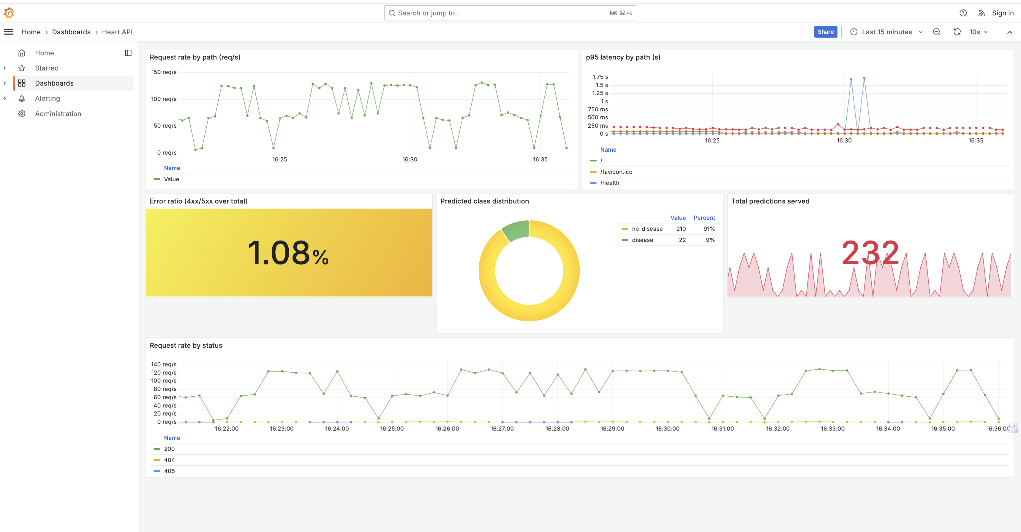
Grafana ‘Heart API’ dashboard - request rate by path, p95 latency, error ratio, predicted class distribution (donut), total predictions served, and request rate by status
Additional captured evidence (see Appendix A for capture instructions): screenshots/metrics_endpoint.png, screenshots/access_logs.png.

14. Architecture
The full lifecycle is documented as a Mermaid diagram in reports/architecture.md; the rendered PNG is reproduced below.
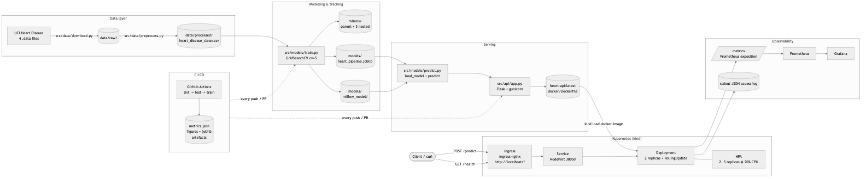
End-to-end MLOps pipeline architecture (data, training, MLflow, container, Kubernetes, monitoring, CI/CD)
The request-lifecycle sequence diagram (how a single POST /predict flows from the browser through Ingress, the Flask pod and Prometheus) is rendered to reports/figures/architecture_sequence.png:
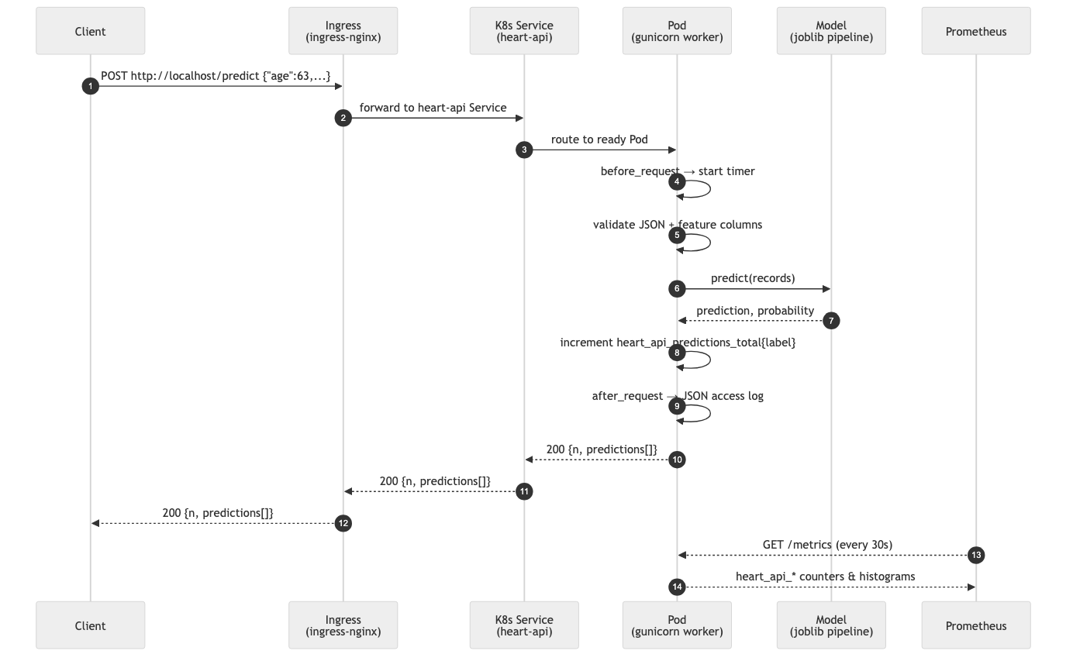
Request lifecycle - browser to Ingress to Flask pod to Prometheus scrape
ASCII summary:
UCI (.data files)
│ src/data/download.py
▼
data/raw/ ── src/data/preprocess.py ── data/processed/heart_disease_clean.csv
│
│ src/models/train.py
▼
┌──────── MLflow tracking (mlruns/) ────────┐
│ │
models/heart_pipeline.joblib models/mlflow_model/
│ │
└────────── src/models/predict.py ───────────┘
│
▼
src/api/app.py (Flask + gunicorn)
│ docker/Dockerfile
▼
heart-api:latest (image)
│ kind load docker-image
│ k8s/*.yaml
▼
Kubernetes (kind) Deployment ─ Service ─ HPA ─ Pods (2..5 replicas)
▲
│ ingress-nginx
│
http://localhost/* (Ingress)
│
/metrics ─► Prometheus ─► Grafana
stdout ─► kubectl logs
▲
│ GitHub Actions (lint → test → train)
│ on every push → uploads metrics.json,
│ figures, joblib
└────────────────────────────────────────

15. Repository Layout
Assignment/
├── data/{raw,processed}/ (UCI inputs + cleaned CSV)
├── notebooks/01_eda.ipynb (EDA)
├── reports/{figures,REPORT.md,…} (THIS report + visuals)
├── src/
│ ├── data/{download,preprocess}.py
│ ├── features/build_features.py
│ ├── models/{train,predict}.py
│ ├── api/app.py
│ └── utils/mlflow_utils.py
├── unit_test/ (35 pytest cases, ~74 % cov.)
├── docker/Dockerfile + .dockerignore
├── k8s/{configmap,deployment,service,ingress,hpa,servicemonitor}.yaml
├── k8s/setup/kind-cluster-config.yaml
├── monitoring/ (Prometheus + Grafana docker-compose — Task 8)
│ ├── docker-compose.yml
│ ├── prometheus/prometheus.yml
│ └── grafana/{provisioning,dashboards}/heart_api.json
├── scripts/{demo_up,demo_down}.sh (one-command local bring-up — Task 7 / Deliverable c)
├── screenshots/{README,capture_commands}.md + the 7 PNGs
├── .github/workflows/ci.yml
├── pyproject.toml · requirements.txt · .python-version
└── README.md

16. Production-Readiness Checklist
The brief calls out three production-readiness clauses; each is enforced automatically and produces downloadable evidence.
Clause | How it is enforced | Evidence
All scripts must execute from a clean setup using requirements.txt | Every CI job (lint, test, train, docker) starts on a fresh ubuntu-latest runner and installs only pip install -r requirements.txt. A green run is proof the file is self-contained. The same requirements.txt is COPY-ed into the Docker image (docker/Dockerfile line 24) so the API runs from the identical pinned set. For offline graders, scripts/verify_clean_setup.sh reproduces the same flow in an ephemeral venv. | CI run badge · coverage-report artefact · heart-pipeline-N artefact
Model must serve correctly in an isolated environment (Docker; container build/test proof required) | Job docker (final stage in .github/workflows/ci.yml) builds the image with docker/Dockerfile, runs the container, polls /health until 200, posts a sample to /predict and asserts the response schema (prediction ∈ {0,1}, probability ∈ [0,1]), then scrapes /metrics. Container stdout/stderr is captured and uploaded. | docker-build-proof-N artefact (docker-container.log + predict.json)
Pipeline must fail on code or test errors and give clear logs | Workflow root sets defaults.run.shell: bash -euo pipefail {0} so any non-zero exit aborts immediately and unset variables raise. Jobs are chained via needs: (lint → test → train → docker), so a red upstream job skips everything downstream. Ruff, pytest, the training script and the smoke-test curls all return non-zero on failure; on docker failure the container log is still uploaded via if: always(). Locally, the same guarantee is given by set -euo pipefail in scripts/demo_up.sh and scripts/verify_clean_setup.sh. | Failed-job logs in the Actions tab · ::error:: annotations on the diff view

CI pipeline graph
lint (ruff) ──► test (pytest+cov) ──► train (model+artefacts) ──► docker (build+smoke)
│ │ │ │
│ ▼ ▼ ▼
│ coverage.xml heart_pipeline.joblib docker-container.log
│ pytest-report.xml mlflow_model/ predict.json
│ metrics.json + figures/ (uploaded as artefact)
└─ fails fast on any lint error → downstream jobs are skipped
Each arrow is a hard needs: dependency, so the run is red the moment any upstream stage fails. Fail-fast plus per-step annotations satisfy the “clear logs” clause.

17. Conclusions, Limitations & Future Work
What was achieved.
- A reproducible, fully tested, fully containerised Heart Disease classifier with 0.91 ROC-AUC on a hold-out test set.
- An MLOps lifecycle that closes every loop: experiment tracking, packaging, CI/CD, containerised serving, declarative Kubernetes deployment, autoscaling, and Prometheus-grade observability.
Limitations.
- The dataset is small (920 rows, 4 sources with very different missingness profiles); generalisation to other populations is not guaranteed.
- The Switzerland subset has nearly all-0 cholesterol — even after sentinel-zero handling it acts effectively as median-imputed.
- The ML model is a binary screener, not a diagnostic tool — false negatives (≈14 %) must be handled by clinical workflow.
- Inference latency is dominated by sklearn pipeline overhead; for very high QPS, an ONNX export with onnxruntime would be the next optimisation.
Future work.
- Add calibration (sigmoid / isotonic) and a properly tuned decision threshold rather than the default 0.5.
- Wire MLflow Model Registry + a “promote → deploy” workflow that publishes the registry-staging artefact into the K8s Deployment via kubectl set image.
- Replace the local file-store MLflow with a remote tracking server (Postgres + S3 / MinIO) once the team is multi-person.
- Add drift monitoring (e.g. evidently) by sidecar-shipping the request payloads to a feature store and comparing distributions against data/processed/heart_disease_clean.csv.

18. References
- Code repository: https://github.com/<your-username>/heart-disease-mlops (replace with the real GitHub URL before submission - this is the link required by §9(f) of the rubric).
- Detrano, R. et al. (1989). International application of a new probability algorithm for the diagnosis of coronary artery disease. Am. J. Cardiology, 64(5):304-310.
- UCI ML Repository - Heart Disease dataset: https://archive.ics.uci.edu/dataset/45/heart+disease
- scikit-learn 1.4 docs, MLflow 2.13 docs, Prometheus 2.x docs, Kubernetes 1.29 docs.

Appendix A - Screenshot evidence (Section 9(e))
The assignment brief asks for “CI/CD and deployment workflow screenshots”. Three captures already ship with this report and are embedded in earlier sections:
Already embedded above | Location in this PDF
screenshots/architecture.png - end-to-end architecture diagram | §14
screenshots/ci_run.png - GitHub Actions lint -> test -> train -> docker pipeline (all green) | §10
screenshots/task6_form.png - Flask web form rendered against the live container | §11
screenshots/grafana_dashboard.png - 6-panel ‘Heart API’ Grafana dashboard | §13
The remaining captures listed below are produced from the running system. Capture them locally before submission (the exact commands are reproduced under each filename) and drop the resulting PNGs into MLOps_Demo/screenshots/ - they will then be picked up by the next python3 run_pipeline.py --only report build.
(i) screenshots/ci_run.png - GitHub Actions, green pipeline graph
# In the browser:
# open https://github.com/<your-username>/heart-disease-mlops/actions
# click the latest successful run -> screenshot the lint -> test -> train graph
(ii) screenshots/mlflow_ui.png - MLflow experiments page
python3 run_pipeline.py --only mlflow_ui
open http://localhost:5500 # screenshot the runs list with ROC-AUC sorted
(iii) screenshots/kubectl_get_pods.png, screenshots/kubectl_get_svc.png, screenshots/kubectl_get_ingress.png - Kubernetes deployment proof
kubectl get pods,svc,ingress -o wide # screenshot the terminal output
(iv) screenshots/predict_curl.png - end-to-end inference
curl -s -X POST http://localhost/predict \
-H 'Content-Type: application/json' \
-d '{"records":[{"age":63,"sex":1,"cp":3,"trestbps":145,
"chol":233,"fbs":1,"restecg":0,"thalach":150,"exang":0,
"oldpeak":2.3,"slope":0,"ca":0,"thal":1}]}' | jq .
(v) screenshots/metrics_endpoint.png - Prometheus scrape target
open http://localhost:9090/targets # screenshot showing heart-api UP
Together these files (three already shipping including the Grafana dashboard, plus the captures above) constitute the screenshot pack required by §9(e).

Generated as part of the MLOps Assignment-I deliverables. Replace the screenshot placeholders under screenshots/ with the captures from your local run before submission.

