MLOps Pipeline — Heart Disease Prediction
SANDIP BHATTACHARYYA (2025cs05025) · 6th May 2026
https://github.com/2025cs05025/ml_learning.git

Table of Contents

1. Introduction, repository & deliverables

2. Setup & Installation Instructions

3. Data Acquisition & Exploratory Data Analysis

4. Feature Engineering & Model Development

5. Experiment Tracking with MLflow

6. Model Packaging & Reproducibility

7. CI/CD Pipeline & Automated Testing

8. Model Containerization

9. Production Deployment

10. Monitoring & Logging

11. Architecture (diagram)

12. Evidence reference

1. Introduction

1.1 Problem & dataset
Heart disease is one of the leading causes of death globally. Early detection and risk assessment from routine clinical measurements can improve outcomes and prioritisation. This project builds an end-to-end Machine Learning Operations (MLOps) pipeline to predict heart-disease risk from the UCI Heart Disease dataset, covering the full lifecycle: data acquisition, exploratory analysis, model development, experiment tracking with MLflow, automated unit tests, continuous integration and delivery, containerisation, optional Kubernetes deployment, and production-style monitoring with Prometheus and Grafana—aligned with common industry MLOps practice.
The UCI Heart Disease dataset is used (see data/). After preprocessing, records include 13 numeric input features and a binary target (0 = no disease, 1 = disease). Feature groups include demographics (age, sex), clinical measures (cp, trestbps, chol, fbs, restecg), exercise-related variables (thalach, exang, oldpeak, slope), and angiographic indicators (ca, thal).
Data source: UCI Machine Learning Repository (Heart Disease).

1.2 Technology stack
Component | Technology
Programming language | Python 3.9+ (CI / Docker image: 3.11)
ML framework | scikit-learn (pinned in requirements.txt)
API | FastAPI + Uvicorn (Flask in requirements is optional; main API is FastAPI)
Experiment tracking | MLflow (local ./mlruns)
Testing | pytest (tests/test_pipeline.py)
CI/CD | GitHub Actions (.github/workflows/ci.yml)
Containerisation | Docker + Docker Compose
Orchestration | Kubernetes manifests under k8s/ (e.g. Minikube)
Monitoring | Prometheus + Grafana (monitoring/)

1.3 Official repository
Item | Value
URL | https://github.com/2025cs05025/ml_learning.git
Clone | git clone https://github.com/2025cs05025/ml_learning.git
Root folder | ml_learning
Author / ID | SANDIP BHATTACHARYYA — 2025cs05025
Work dir | Repo root so data/, src/, models/ match README

1.4 Deliverables map (repo paths)
Required element | Location in this repository
Application & library code | src/ (api/, config/, data_preprocessing/, eda/, model_training/, …)
Dockerfile(s) & Compose | Dockerfile at repo root; docker-compose.yml for API + Prometheus + Grafana
Python dependencies | requirements.txt (pinned scikit-learn for pickle compatibility)
Conda environment file | Not in repo. Use conda + pip install -r requirements.txt, or add env.yml if required
Raw & cleaned datasets | data/heart_disease_UCI_dataset.csv (bundled raw); data/heart_disease_processed_dataset.csv (generated by EDA preprocess)
Dataset download / provenance | README has the UCI link. Raw CSV is already in data/ (no download script)
EDA, training, inference | Python modules: src/eda/eda.py, src/model_training/train.py, src/model_training/inference.py (no .ipynb in-tree; notebooks optional)
Unit / integration tests | tests/ (pytest; pytest.ini sets testpaths=tests, pythonpath=src)
CI/CD workflow | .github/workflows/ci.yml (GitHub Actions; no Jenkinsfile)
Deployment manifests | k8s/ (Kustomize YAML). No Helm chart; you can add one if the course asks
Reporting screenshots | screenshots/*.png (embedded in §12.1 when this report is regenerated)
Monitoring config | monitoring/prometheus.yml; monitoring/grafana/ (dashboard JSON + provisioning)
Generated model artifacts (local/CI) | models/best_model.pkl, models/feature_names.pkl, models/training_metadata.json (recreated by train.py)
Experiment tracking store (local) | ./mlruns/ for MLflow (often gitignored; CI can upload a zip artifact)

2. Setup & Installation Instructions
This section gives a complete installation narrative: what must exist on the machine before you start, how to create an isolated Python environment, how dependencies are pinned for reproducible unpickling of the model, and which optional tools unlock Docker Compose and Kubernetes demos. For edge cases (port conflicts, Minikube drivers, Apple Silicon), the README troubleshooting section is the authoritative extension of these steps.

2.1 Prerequisites
- Python 3.9 or newer on the host (3.11 is used in CI and in the API Docker image). Verify with: python3 --version.
- Git, to clone and push the repository.
- A C compiler toolchain may be required on some platforms when pip builds binary wheels (gcc is also installed in the Dockerfile).
- Docker Desktop or an equivalent OCI runtime (optional) for docker build, docker compose, and image load into Minikube.
- kubectl and Minikube (optional) only if you demonstrate the k8s/ manifests.

2.2 Local setup
Create a dedicated virtual environment so that scikit-learn, MLflow, FastAPI, and pytest versions match those used during training and in CI. The project pins scikit-learn==1.6.1 because joblib pickles are not guaranteed compatible across arbitrary sklearn major/minor versions. After activation, upgrade pip, then install from requirements.txt. Full detail (ports, troubleshooting, K8s): README.md in the repository.
Step | Command / action | Notes
1 | git clone https://github.com/2025cs05025/ml_learning.git | Then: cd ml_learning
2 | python3 -m venv .venv | Activate: source .venv/bin/activate (Windows: .venv\Scripts\activate)
3 | pip install -r requirements.txt | Pins scikit-learn for pickle compatibility
4 | python3 src/eda/eda.py all | Writes cleaned CSV + screenshots/
5 | python3 src/model_training/train.py | GridSearch + MLflow; writes models/ and mlruns/
6 | python3 -m pytest tests/ -v | Unit tests
7 | python3 src/api/api.py | Or: uvicorn api.api:app --app-dir src --host 0.0.0.0 --port 8000
8 | python3 -m mlflow ui --backend-store-uri ./mlruns --host 127.0.0.1 -p 5050 | Experiment UI

Shell sequence (repository root):
git clone https://github.com/2025cs05025/ml_learning.git
cd ml_learning
python3 -m venv .venv
python3 -m pip install --upgrade pip
pip install -r requirements.txt
python3 src/eda/eda.py all
python3 src/model_training/train.py
python3 -m pytest tests/ -v
python3 src/api/api.py
# Swagger UI: http://127.0.0.1:8000/docs

Verification | Expected
After pytest | Imports and paths OK
After train | models/best_model.pkl + mlruns/

3. Data Acquisition & Exploratory Data Analysis
Step | What we did | Output / path
Source | UCI Heart Disease CSV in repo | data/heart_disease_UCI_dataset.csv
Clean | pre_processing_data.py (missing tokens, types, binary target) | In-memory matrix; same code in train/API
EDA CLI | src/eda/eda.py preprocess | eda | all | data/heart_disease_processed_dataset.csv
Plots | Histograms, correlation, class balance, age×target | screenshots/*.png (default names)
Re-run | Single command for full EDA + preprocess | python3 src/eda/eda.py all

3.1 Exploratory Data Analysis
EDA — Key Insights:
· Age distribution: ranges from 29 to 77 years with a mean of ~54 years; slightly right-skewed.
· Gender: majority male (~68.3% male, ~31.7% female).
· Chest pain: type 0 is the most common (~47.2% of cases).
· Blood pressure: mostly between 120–140 mmHg.
· Fasting blood sugar: most patients below 120 mg/dl (85.1%).
· Heart disease prevalence: slightly more than half have heart disease (~54.5%).
· Correlations: age, exercise-induced angina, ST depression (oldpeak), and maximum heart rate show strong associations with the target.

4. Feature Engineering & Model Development
Model | Pipeline (sklearn)
Logistic regression | SimpleImputer(median) → StandardScaler → LogisticRegression(liblinear, class_weight=balanced, max_iter=2000)
Random forest | SimpleImputer(median) → RandomForestClassifier(class_weight=balanced); no scaler

4.1 Data splits
Stage / split | Approx. fraction | Rows used for | Implementation notes
Full cleaned dataset | 100% | EDA plots, optional exploration | heart_disease_processed_dataset.csv
Training split | ~80% | GridSearchCV, refit, CV metrics, MLflow train metrics | stratify=y, random_state=42
Hold-out test | ~20% | Final metrics, ROC/CM plots, model selection vs other family | Never inside CV folds
CV folds (×5) | Training only | Hyperparameter scoring (ROC-AUC) | StratifiedKFold, shuffle, random_state=42
Inference / API | N/A | New patients or batch CSV | No split; apply fitted Pipeline from best_model.pkl

4.2 Hyperparameter search & evaluation
Setting | Value
Tuning | GridSearchCV + StratifiedKFold(5), shuffle, random_state=42
Scoring | roc_auc; refit on full train split
Winner | Highest hold-out test ROC-AUC → models/best_model.pkl

Parameter | Grid
lr__C | 0.01, 0.1, 1.0, 10.0
rf__n_estimators | 100, 200
rf__max_depth | None, 6, 12
rf__min_samples_leaf | 1, 2

Model | Test metrics
Logistic Regression | roc_auc=0.9015, accuracy=0.8525, f1=0.8302
Random Forest | roc_auc=0.8755, accuracy=0.8033, f1=0.7778

Training metadata | Value
Best model (metadata) | Logistic Regression
saved_at_utc (metadata) | 2026-05-06T15:05:15.015361+00:00
CV / random_state | cv_splits=5, random_state=42
sklearn (metadata) | 1.6.1

Plot artifact | Path
CM — logistic regression | screenshots/cm_logistic_regression.png
CM — random forest | screenshots/cm_random_forest.png
ROC — logistic regression | screenshots/roc_logistic_regression.png
ROC — random forest | screenshots/roc_random_forest.png

5. MLflow
Topic | Detail | Notes
Code | src/model_training/train.py | Logs each family after GridSearchCV
Store | ./mlruns | ./mlruns (local file store)
Experiment | heart_disease_prediction | UI lists runs
Logged | params, CV + test metrics, plot files | Optional sklearn model log
JSON summary | models/training_metadata.json | Best model + metrics
UI tabs | Parameters / Metrics / Artifacts | Test ROC-AUC picks winner in code

MLflow UI command:
python3 -m mlflow ui --backend-store-uri ./mlruns --host 127.0.0.1 -p 5050

6. Artifacts & Batch Scoring
File | Role | Used by
models/best_model.pkl | Fitted Pipeline | inference.py, api.py
models/feature_names.pkl | Column order | api.py
models/training_metadata.json | Metrics / versions | Report, audit

Reproducibility | How
Versions | requirements.txt sklearn pin
Splits | random_state=42 in train & CV
Cleaning | Shared pre_processing_data.py

Batch inference command:
python3 src/model_training/inference.py --output data/batch_predictions.csv

7. CI/CD Pipeline & Automated Testing

7.1 Automated tests
pytest configuration:
pytest.ini sets pythonpath=src and testpaths=tests. Tests under tests/ in tests/test_pipeline.py (data load/clean, split checks, both sklearn pipelines, predict_proba, PatientData schema).
Code block — run tests locally:
python3 -m pytest tests/ -v --tb=short

CI job | Purpose
flake8 | Lint src/, tests/
pytest | JUnit + log artifacts
train | EDA + train.py → artifact zip
docker smoke | Build image; /health, /predict

ci.yml excerpt:
# .github/workflows/ci.yml — CI/CD for MLOps assignment (course S2-25_AMLCSZG523).
# Author: SANDIP BHATTACHARYYA — BITS Pilani ID 2025cs05025
#
# ── When does this run? ───────────────────────────────────────────────────────
# • push / merge to branches: main, master only (other branches: open a PR)
# • pull_request targeting main or master
# • workflow_dispatch (Actions tab → CI/CD Pipeline → Run workflow)
#
# ── Four jobs (sequential) ───────────────────────────────────────────────────
# 1. lint — flake8
# 2. testing — pytest + upload test-results (pytest-results.xml)
# 3. training-model — preprocess → train.py → upload ml-training (models/ + mlruns/)
# 4. docker-build-smoke — needs training-model; docker build + /health + /predict smoke
#
# Later jobs show "Queued" until the previous job finishes. That is normal.
#
# ── How long? (ballpark) ─────────────────────────────────────────────────────
# Often ~15–35 minutes total. Slow parts: pip install (per job), GridSearchCV,
# Docker build. training-model: 45m; lint/testing: 15m each.
#
name: CI/CD Pipeline
on:
push:
branches: [main, master]
pull_request:
branches: [main, master]
workflow_dispatch:

Screenshot (save to screenshots/) | Shows
Actions list | Green workflow run
Job graph | lint → test → train → docker
Logs | pytest tail, train upload, docker curl
Artifacts | XML, training zip, smoke logs
Compose / k8s | Services or pods up

8. Container (API)
Image | Detail
Base | python:3.11-slim
App | PYTHONPATH=/app/src; Uvicorn api.api:app
Health | GET /health

Dockerfile:
# Dockerfile — production-style image for the FastAPI inference API (assignment Task 6).
# Author: SANDIP BHATTACHARYYA — BITS Pilani ID 2025cs05025
#
# Expects trained artifacts under models/ at build time (best_model.pkl, feature_names.pkl).
# Build: docker build -t heart-disease-api:latest .
# Run: docker run --rm -p 8000:8000 heart-disease-api:latest
# Stack: prefer docker-compose.yml for API + Prometheus + Grafana.
#
# ── Stage 1: base image ───────────────────────────────────────────────────────
FROM python:3.11-slim
WORKDIR /app
# PYTHONPATH so ``api.api`` resolves to ``src/api/api.py``
ENV PYTHONDONTWRITEBYTECODE=1 \
PYTHONUNBUFFERED=1 \
PYTHONPATH=/app/src \
MODEL_PATH=/app/models/best_model.pkl \
FEATURE_PATH=/app/models/feature_names.pkl \
API_LOG_PATH=/app/logs/api_requests.log \
PIP_ROOT_USER_ACTION=ignore
RUN apt-get update && apt-get install -y --no-install-recommends \
gcc \
curl \
&& rm -rf /var/lib/apt/lists/* \
&& mkdir -p /app/logs
COPY requirements.txt .
RUN pip install --no-cache-dir --upgrade pip \
&& pip install --no-cache-dir -r requirements.txt
COPY src/ ./src/
COPY models/ ./models/
EXPOSE 8000
HEALTHCHECK --interval=30s --timeout=10s --start-period=20s --retries=3 \
CMD curl -fsS http://127.0.0.1:8000/health >/dev/null || exit 1
Build & run (host shell):
docker build -t heart-disease-api:latest .
docker run --rm -p 8000:8000 heart-disease-api:latest

8.1 API surface (FastAPI)
Endpoint | Method | Description
/health | GET | Liveness; pipeline loaded
/predict | POST | JSON body → prediction, label, confidence, risk_level
/metrics | GET | Prometheus text format
/docs | GET | Swagger UI

Smoke checks (API on port 8000):
curl -sS http://127.0.0.1:8000/health
curl -sS -X POST http://127.0.0.1:8000/predict \
-H "Content-Type: application/json" \
-d '{"age":55,"sex":1,"cp":2,"trestbps":130,"chol":250,"fbs":0,"restecg":0,"thalach":150,"exang":0,"oldpeak":1.0,"slope":1,"ca":0,"thal":2}'

9. Deployment
Compose service | URL | Role
API | http://127.0.0.1:8000 | FastAPI
Prometheus | http://127.0.0.1:9090 | Scrapes /metrics
Grafana | http://127.0.0.1:3000 | Dashboards (README: creds)

Command / path | Purpose
docker compose up -d --build | Stack: API + Prometheus + Grafana
kubectl apply -k k8s/ | Optional K8s (Kustomize); README: Minikube load

10. Monitoring
Piece | Location | Role
Logs | src/api/api.py; API_LOG_PATH → logs/ | Structured request log
Metrics | GET /metrics on API | Counters, latency, predictions (prometheus_client)
Dashboard | monitoring/grafana/heart_disease_api.json | Grafana panels
Scrape config | monitoring/prometheus.yml | Compose scrape target

prometheus.yml excerpt:
# Prometheus scrape config for Docker Compose (service name heart-disease-api).
# Mounted into the prometheus container via docker-compose.yml.
# Author: SANDIP BHATTACHARYYA — BITS Pilani ID 2025cs05025
global:
scrape_interval: 15s
evaluation_interval: 15s
scrape_configs:
# Faster scrape during local Compose tests so counters appear in TSDB quickly after /predict.
- job_name: heart-disease-api
scrape_interval: 5s
# Prometheus requires scrape_timeout <= scrape_interval.
scrape_timeout: 4s
metrics_path: /metrics
static_configs:
- targets:
- heart-disease-api:8000

11. Architecture
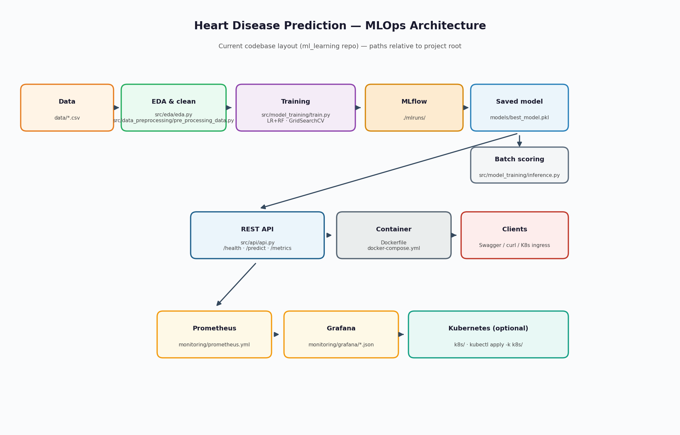

12. Evidence reference

Please refer:
- Screenshots present in https://github.com/2025cs05025/ml_learning/tree/main/screenshots
- https://github.com/2025cs05025/ml_learning/blob/main/reports/Heart_Disease_MLOps_Evidence_Sandip_Bhattacharyya_2025cs05025.pdf

