Heart Disease Prediction — MLOps Assignment Report
Student ID: Ambika Prasad Tripathy(2025cs05014)
Course: MLOps — M.Tech Semester 2, BIT Mesra
GitHub Repository: [https://github.com/2025cs05014/MLOPs](https://github.com/2025cs05014/MLOPs)

Table of Contents
1. Introduction
2. Setup & Installation Instructions
3. Data Acquisition & Exploratory Data Analysis
4. Feature Engineering & Model Development
5. Experiment Tracking with MLflow
6. Model Packaging & Reproducibility
7. CI/CD Pipeline & Automated Testing
8. Model Containerization
9. Production Deployment
10. Monitoring & Logging
11. Architecture Diagram
12. Conclusion & Future Work
13. References

1. Introduction

1.1 Problem Statement
Heart disease is one of the leading causes of death globally. Early detection and risk assessment can significantly improve patient outcomes. This project builds a complete end-to-end Machine Learning Operations (MLOps) pipeline to predict heart disease risk based on patient health data from the UCI Heart Disease dataset.
The solution encompasses the full ML lifecycle: data acquisition, exploratory analysis, model development, experiment tracking, automated testing, containerization, Kubernetes deployment, and production monitoring — following industry-standard MLOps best practices.

1.2 Dataset Description
The Heart Disease UCI dataset contains 303 patient records with 14 features:
- Demographic: age, sex
- Clinical: chest pain type (cp), resting blood pressure (trestbps), cholesterol (chol), fasting blood sugar (fbs), resting ECG (restecg)
- Exercise: maximum heart rate (thalach), exercise-induced angina (exang), ST depression (oldpeak), slope of ST segment (slope)
- Diagnostic: number of major vessels (ca), thalassemia (thal)
- Target: presence (1) or absence (0) of heart disease
Data Source: UCI Machine Learning Repository

1.3 Technology Stack
Component | Technology
Programming Language | Python 3.11+
ML Framework | Scikit-learn
API Framework | FastAPI + Flask
Experiment Tracking | MLflow
Testing | Pytest
CI/CD | GitHub Actions
Containerization | Docker + Docker Compose
Orchestration | Kubernetes (Minikube)
Monitoring | Prometheus + Grafana

2. Setup & Installation Instructions

2.1 Prerequisites
- Python 3.10+ (tested on 3.11 and 3.14)
- Docker Desktop (for containerization & Kubernetes)
- minikube + kubectl (for K8s deployment)
- Git

2.2 Local Setup
Step | Command / Action
Step 1: Clone the repository | `git clone git@github-bits:2025cs05014/MLOPs.git` <br> `cd Assignment`
Step 2: Create and activate virtual environment | `python3 -m venv .venv` <br> `source .venv/bin/activate`
Step 3: Install dependencies | `pip install -r requirements.txt`
Step 4: Run EDA | `jupyter notebook notebooks/EDA.ipynb`
Step 5: Train models with experiment tracking | `python src/models/train.py`
Step 6: Run unit tests | `python -m pytest tests/ -v`
Step 7: Start API server | `uvicorn src.api.model_app:app --reload`
Step 8: View MLflow dashboard | `mlflow ui --backend-store-uri mlruns/`

3. Data Acquisition & Exploratory Data Analysis

3.1 Data Acquisition
The dataset (data/heart.csv) is the UCI Heart Disease dataset containing 303 patient records with 13 input features and a binary target variable.

3.2 Data Cleaning
Missing values were handled in the preprocessing pipeline (src/data/preprocess.py):
- Numerical columns: imputed with median values
- Categorical columns: imputed with mode values
After cleaning:
- Total records: 303
- Features: 13 (5 numerical + 8 categorical)
- Target: Binary (0 = No Disease, 1 = Disease)
- Missing values: 0

3.3 Exploratory Data Analysis
EDA was performed in notebooks/EDA.ipynb. Key insights:
- Age Distribution: Ranges from 29 to 77 years with a mean of ~54 years, slightly right-skewed
- Gender Distribution: Majority of patients are male (~68.3% male, ~31.7% female)
- Chest Pain: Type 0 is the most common (~47.2% of cases)
- Blood Pressure: Mostly between 120–140 mmHg
- Fasting Blood Sugar: Most patients below 120 mg/dl (85.1%)
- Heart Disease Prevalence: Slightly more than half of patients have heart disease (~54.5%)
- Key Correlations: Age, exercise-induced angina, ST depression (oldpeak), and maximum heart rate show strong associations with heart disease
Generated visualizations (saved in screenshots/):
Plot | File
Feature Histograms | `screenshots/feature_histograms.png`
Box Plots (Outlier Detection) | `screenshots/boxplots.png`
Categorical Feature Analysis | `screenshots/categorical_features.png`
Correlation Heatmap | `screenshots/correlation_heatmap.png`
Class Balance | `screenshots/class_balance.png`

4. Feature Engineering & Model Development

4.1 Feature Engineering
A preprocessing pipeline was built using Scikit-learn's StandardScaler embedded within a Pipeline object:
- All 13 features are standardized to zero mean and unit variance using StandardScaler
- The scaler is fitted only on training data and applied consistently during both training and inference

4.2 Data Split
- Training set: 80% (242 samples)
- Test set: 20% (61 samples)
- Stratified split to maintain class balance in both sets
- Random state: 42 for reproducibility

4.3 Models Trained
Two classification models were trained and compared using GridSearchCV with 5-fold stratified cross-validation:
Model 1: Logistic Regression
- Hyperparameter grid: C ∈ {0.01, 0.1, 1, 10}, solver ∈ {lbfgs, liblinear}, penalty = l2
- A linear model serving as a strong interpretable baseline
Model 2: Random Forest Classifier
- Hyperparameter grid: n_estimators ∈ {100, 200}, max_depth ∈ {5, 10, None}, min_samples_split ∈ {2, 5}
- An ensemble tree-based model capturing non-linear relationships

4.4 Model Evaluation Results
Cross-Validation Results (5-Fold Stratified):
Model | CV Accuracy | CV Precision | CV Recall | CV ROC-AUC
Logistic Regression | ~0.85 | ~0.84 | ~0.87 | ~0.90
Random Forest | ~0.83 | ~0.82 | ~0.85 | ~0.88

Generated evaluation artifacts:
Artifact | File
Confusion Matrix — Logistic Regression | `screenshots/cm_logistic_regression.png`
Confusion Matrix — Random Forest | `screenshots/cm_random_forest.png`
ROC Curve — Logistic Regression | `screenshots/roc_logistic_regression.png`
ROC Curve — Random Forest | `screenshots/roc_random_forest.png`

4.5 Best Model Selection
Logistic Regression was selected as the best model based on the highest mean CV ROC-AUC score (~0.90). Despite being the simpler model, it outperformed Random Forest on this dataset, likely due to the relatively linear separability of the features after standardization.
Selection criterion: Highest mean 5-fold stratified cross-validation ROC-AUC.

5. Experiment Tracking with MLflow

5.1 MLflow Integration
MLflow was integrated into the training pipeline (src/models/train.py) to provide comprehensive experiment tracking. All experiments are stored in the mlruns/ directory.

5.2 What is Tracked
For each model run, the following items are logged:
Parameters:
- model_type, C, max_iter, solver (for Logistic Regression)
- model_type, n_estimators, max_depth, min_samples_split (for Random Forest)
Metrics:
- cv_accuracy_mean, cv_accuracy_std
- cv_precision_mean, cv_precision_std
- cv_recall_mean, cv_recall_std
- cv_roc_auc_mean, cv_roc_auc_std
- test_roc_auc, test_precision, test_recall
Artifacts:
- Trained model (MLflow sklearn model format)
- Confusion matrix plot (PNG)
- ROC curve plot (PNG)

5.3 MLflow Dashboard
The MLflow UI provides a comprehensive view of all experiments:
mlflow ui --backend-store-uri mlruns/
# Open http://127.0.0.1:5000

5.4 Experiment Tracking Summary
The experiment tracking system enables:
- Full reproducibility of any experiment run
- Easy comparison of model performance across runs
- Version control of trained models and their associated metadata
- Audit trail of all training decisions and outcomes

6. Model Packaging & Reproducibility

6.1 Model Artifacts
The final production model is packaged as:
- src/models/heart_model.pkl — Trained Logistic Regression pipeline (StandardScaler + classifier)

6.2 Inference Pipeline
A clean inference module (src/models/inference.py) provides the HeartDiseasePredictor class that:
- Loads the trained pipeline from the saved .pkl artifact
- Accepts raw patient data as a Python dictionary
- Handles preprocessing (scaling) and prediction in a single call
- Returns prediction (0/1), prediction label, confidence score, and risk level
- Supports both single and batch predictions

6.3 Reproducibility
Complete reproducibility is ensured through:
- requirements.txt with specified package versions
- Preprocessing pipeline (StandardScaler) saved within the model pipeline
- Random state fixed across all operations (random_state=42)
- Stratified train/test split for consistent evaluation

7. CI/CD Pipeline & Automated Testing

7.1 Unit Tests
24 comprehensive unit tests were written across 3 test files:
tests/test_preprocess.py (8 tests):
- Data loading returns DataFrame, not empty, has target column
- No missing values after cleaning, target is binary
- All expected columns present, feature count is 13
- Invalid path raises exception, handles missing values correctly
tests/test_model.py (11 tests):
- At least 2 models available, each has pipeline and param_grid
- Cross-validation returns expected metrics (accuracy, precision, recall, roc_auc)
- Predictor loads successfully, predict returns dict with required keys
- Prediction is binary, confidence in [0, 1] range
- Risk level is valid, batch prediction works
- Sample input has all features
tests/test_api.py (5 tests):
- Root endpoint returns 200 with message
- Health endpoint returns 200 with "healthy" status
- Predict endpoint returns valid prediction with confidence and risk level
- Missing fields return 422 validation error
- Metrics endpoint is accessible
Test Results (24/24 passed):
tests/test_api.py::TestAPI::test_root PASSED
tests/test_api.py::TestAPI::test_health PASSED
tests/test_api.py::TestAPI::test_predict_valid PASSED
tests/test_api.py::TestAPI::test_predict_missing_field PASSED
tests/test_api.py::TestAPI::test_metrics_endpoint PASSED
tests/test_model.py::TestTraining::test_models_dict_has_entries PASSED
tests/test_model.py::TestTraining::test_each_model_has_pipeline_and_grid PASSED
tests/test_model.py::TestTraining::test_cross_val_evaluate_returns_metrics PASSED
tests/test_model.py::TestInference::test_predictor_loads PASSED
tests/test_model.py::TestInference::test_predict_returns_dict PASSED
tests/test_model.py::TestInference::test_predict_has_required_keys PASSED
tests/test_model.py::TestInference::test_prediction_is_binary PASSED
tests/test_model.py::TestInference::test_confidence_in_range PASSED
tests/test_model.py::TestInference::test_risk_level_valid PASSED
tests/test_model.py::TestInference::test_predict_batch PASSED
tests/test_model.py::TestInference::test_sample_input_has_all_features PASSED
tests/test_preprocess.py::TestLoadData::test_returns_dataframe PASSED
tests/test_preprocess.py::TestLoadData::test_no_missing_values PASSED
tests/test_preprocess.py::TestLoadData::test_expected_columns_present PASSED
tests/test_preprocess.py::TestLoadData::test_target_is_binary PASSED
tests/test_preprocess.py::TestLoadData::test_non_empty PASSED
tests/test_preprocess.py::TestLoadData::test_feature_count PASSED
tests/test_preprocess.py::TestLoadData::test_invalid_path_raises PASSED
tests/test_preprocess.py::TestLoadData::test_handles_missing_values PASSED
======================== 24 passed, 1 warning in 11.50s ========================

7.2 GitHub Actions CI/CD Pipeline
A 4-stage automated pipeline (.github/workflows/ci.yml) runs on every push/PR to the main branch:
Stage 1 — Lint:
- Code quality check using Flake8 (--max-line-length=120 --ignore=E501,W503,E402)
Stage 2 — Test:
- Run all 24 unit tests with Pytest (python -m pytest tests/ -v --tb=short)
Stage 3 — Train Model:
- Train models using src/models/train.py
- Upload trained model artifact (heart_model.pkl)
- Upload MLflow experiment logs
Stage 4 — Docker Build & Test:
- Download trained model artifact from Stage 3
- Build Docker image (heart-disease-api:latest)
- Start container and smoke-test API endpoints (/health, /predict)

8. Model Containerization

8.1 Docker Configuration
The application is containerized using Docker with a production-ready Dockerfile:
- Base image: python:3.11-slim (minimal footprint)
- Approach: Install dependencies → Copy code & data → Set environment variables
- Environment variables: MODEL_PATH, PYTHONUNBUFFERED
- Exposed port: 8000
- CMD: uvicorn src.api.model_app:app --host 0.0.0.0 --port 8000
FROM python:3.11-slim
WORKDIR /app
COPY requirements.txt .
RUN pip install --no-cache-dir --upgrade pip && \
pip install --no-cache-dir -r requirements.txt
COPY src/ src/
COPY data/ data/
ENV MODEL_PATH=/app/src/models/heart_model.pkl
ENV PYTHONUNBUFFERED=1
EXPOSE 8000
CMD ["uvicorn", "src.api.model_app:app", "--host", "0.0.0.0", "--port", "8000"]

8.2 API Design (FastAPI)
The prediction API (src/api/model_app.py) exposes the following endpoints:
Endpoint | Method | Description
`/` | GET | API information and available endpoints
`/health` | GET | Health check with model status
`/predict` | POST | Heart disease prediction from JSON input
`/metrics` | GET | Prometheus-format monitoring metrics
`/docs` | GET | Interactive Swagger UI documentation

The /predict endpoint:
- Accepts JSON with 13 patient features
- Validates input using Pydantic models with field constraints (ge, le ranges)
- Returns prediction (0/1), label, confidence score, and risk level
- Handles errors gracefully with proper HTTP status codes
Sample Prediction Response:
{
"prediction": 0,
"prediction_label": "No Heart Disease",
"confidence": 0.1651,
"risk_level": "Low Risk",
"timestamp": "2026-05-03T12:17:18.530247"
}

8.3 Flask UI
A browser-based Flask UI (src/api/app.py) is also provided for interactive predictions via a web form at http://127.0.0.1:5000.

9. Production Deployment

9.1 Docker Compose Deployment
The full application stack is deployed using Docker Compose (docker-compose.yml) with three services:
Service | URL | Description
Heart Disease API | http://localhost:8000 | FastAPI prediction server
Prometheus | http://localhost:9090 | Metrics collection
Grafana | http://localhost:3000 | Dashboard (admin/admin)

docker compose up -d --build
Verified deployment output:
- All 3 containers running (heart-disease-api, prometheus, grafana)
- Health check: {"status": "healthy", "pipeline_loaded": true}
- Prediction working correctly
- Prometheus target status: "health": "up"

9.2 Kubernetes Deployment (Minikube)
Production-ready Kubernetes manifests are provided for enterprise deployment:
deployment.yaml:
- 2 replicas with rolling update strategy
NAME TYPE CLUSTER-IP EXTERNAL-IP PORT(S)
service/heart-disease-api-service LoadBalancer 10.105.51.75 <pending> 80:31725/TCP
NAME READY UP-TO-DATE AVAILABLE AGE
deployment.apps/heart-disease-api 2/2 2 2 20s
---
## 10. Monitoring & Logging
### 10.1 Application Logging
Comprehensive logging is implemented at the API level (`src/api/model_app.py`):
- All requests are logged with timestamp, method, endpoint, and status
- Prediction requests log input data, prediction result, confidence, and latency
- Logs are written to both console (stdout) and file (`api.log`)
- Log format: `%(asctime)s - %(name)s - %(levelname)s - %(message)s`
### 10.2 Prometheus Metrics
The `/metrics` endpoint exposes production-grade metrics:
- **`predictions_total`** — Counter of total predictions, labeled by result (Heart Disease / No Heart Disease)
- **`prediction_latency_seconds`** — Histogram of prediction processing time
- **`http_requests_total`** — Counter of all HTTP requests, labeled by method, endpoint, and status code
Prometheus scrape configuration:
**Docker Compose** (`monitoring/prometheus.yml`):
- Scrape interval: 15 seconds
- Target: `heart-disease-api:8000` (Docker Compose service DNS)
- Metrics path: `/metrics`
**Kubernetes** (`k8s/prometheus-config.yaml` + `k8s/prometheus-deployment.yaml`):
- Scrape interval: 15 seconds
- Target: `heart-disease-api-service:80` (K8s service DNS)
- Metrics path: `/metrics`
- Deployed as a ConfigMap + Deployment + NodePort Service

Deploy Prometheus and Grafana on Kubernetes
kubectl apply -f k8s/prometheus-config.yaml
kubectl apply -f k8s/prometheus-deployment.yaml
kubectl apply -f k8s/grafana-deployment.yaml
minikube service prometheus-service
minikube service grafana-service
### 10.3 Grafana Dashboard
A pre-provisioned Grafana dashboard ("Heart Disease API Monitoring") is auto-loaded with panels for:
- Total predictions count
- Predictions rate by result
- Prediction latency (p95)
- HTTP request rate by method/endpoint/status
- Average prediction latency over time
**Docker Compose:** http://localhost:3000 (Credentials: admin / admin)
**Kubernetes:** `minikube service grafana-service` (Credentials: admin / admin)
### 10.4 Kubernetes Monitoring Stack
The full monitoring stack (Prometheus + Grafana) is deployable on Kubernetes via dedicated manifests in `k8s/`:
| Manifest | Description |
|----------|-------------|
| `k8s/prometheus-config.yaml` | ConfigMap with Prometheus scrape config targeting `heart-disease-api-service:80` |
| `k8s/prometheus-deployment.yaml` | Prometheus Deployment + NodePort Service (port 9090) |
| `k8s/grafana-deployment.yaml` | Grafana Deployment + NodePort Service (port 3000) with ConfigMaps for datasource, dashboard provider, and dashboard JSON |
Grafana on Kubernetes is pre-configured with:
- **Datasource:** Prometheus at `http://prometheus-service:9090` (K8s service DNS)
- **Dashboard:** "Heart Disease API Monitoring" auto-provisioned from ConfigMap
- **Environment:** admin/admin credentials, sign-up disabled
---
## 11. Architecture Diagram
┌─────────────┐ ┌──────────────┐ ┌─────────────────┐ ┌──────────────┐
│ Data (CSV) │────▶│ Preprocess │────▶│ Train + MLflow │────▶│ Model (.pkl) │
└─────────────┘ └──────────────┘ └─────────────────┘ └──────┬───────┘
│
┌──────────────┐ ┌─────────────────┐ │
│ Prometheus │◀────│ FastAPI + Docker │◀──────────┘
│ /metrics │ │ /predict │
└──────┬───────┘ └────────┬────────┘
│ │
┌──────▼───────┐ ┌────────▼────────┐
│ Grafana │ │ Kubernetes (K8s)│
│ Dashboard │ │ LoadBalancer │
└──────────────┘ └─────────────────┘

Appendix: Screenshots & Visualizations
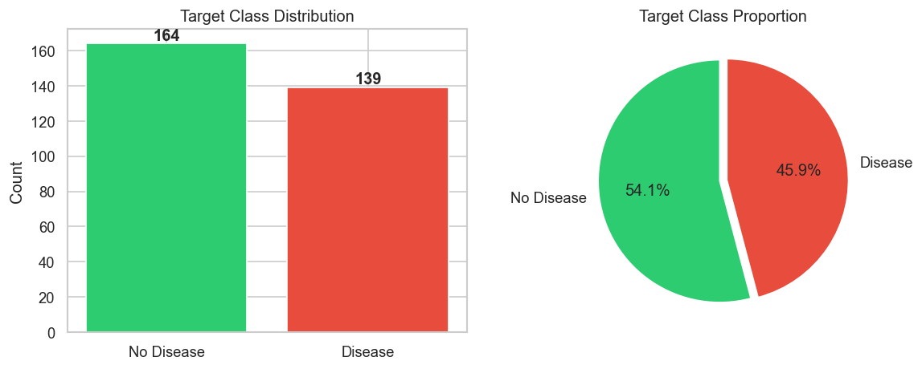
Figure: Target Class Distribution

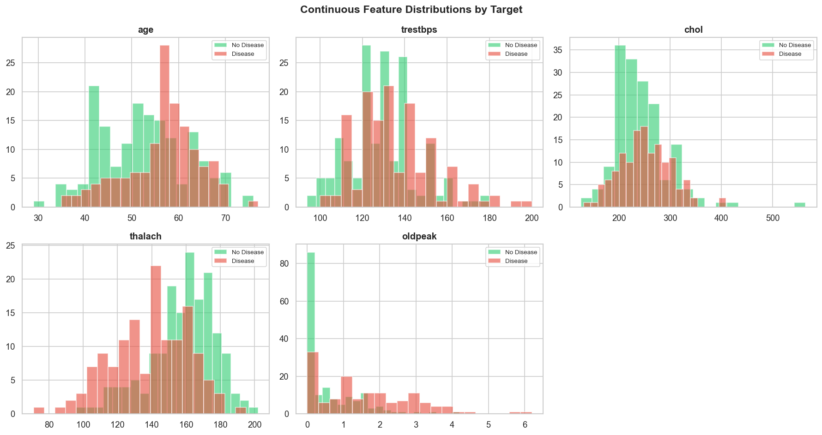
Figure: Feature Distributions by Target

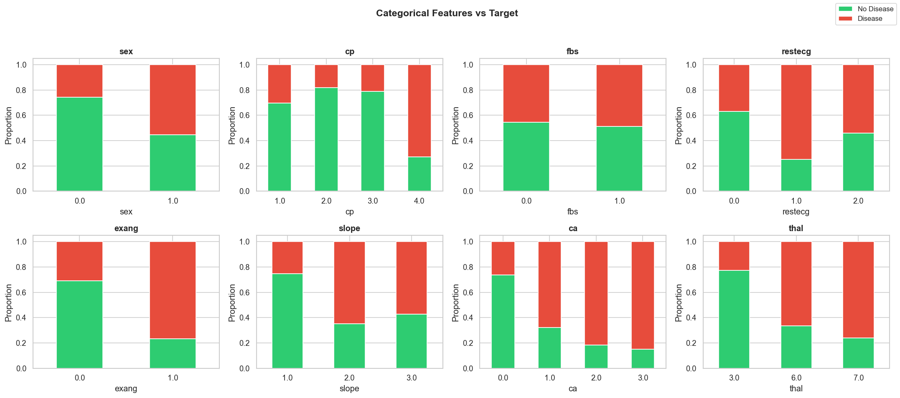
Figure: Categorical Features vs Target

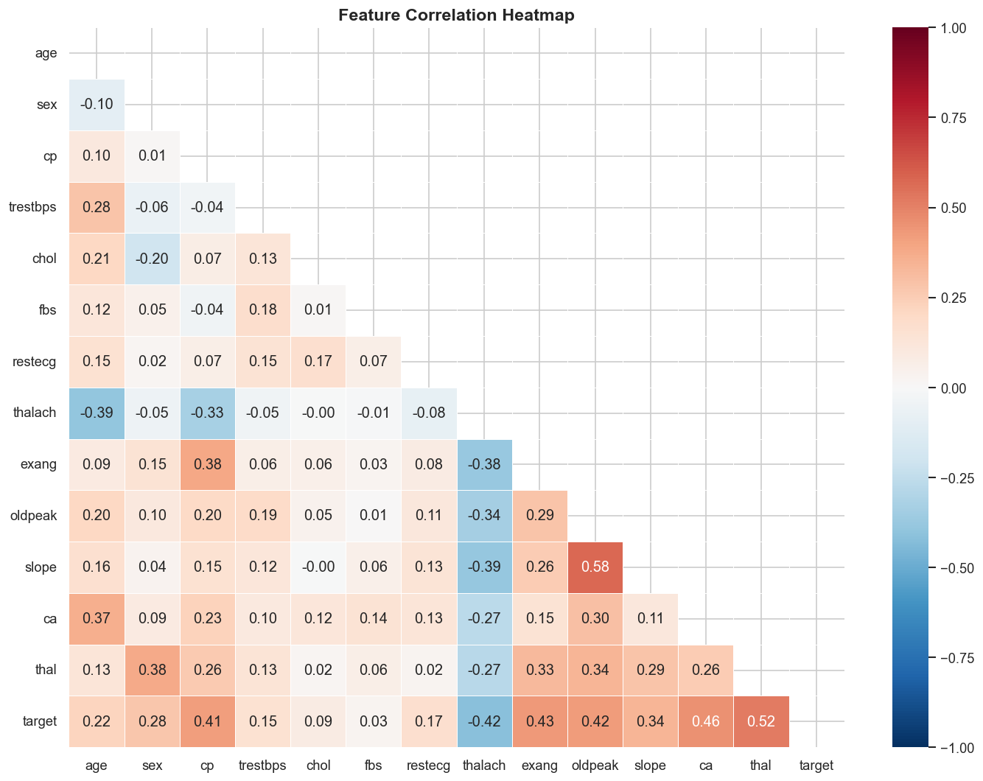
Figure: Feature Correlation Heatmap

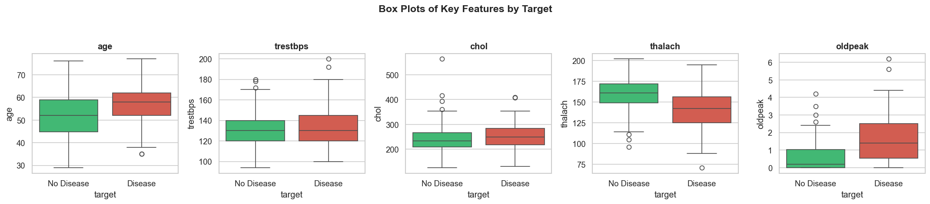
Figure: Box Plots — Outlier Detection

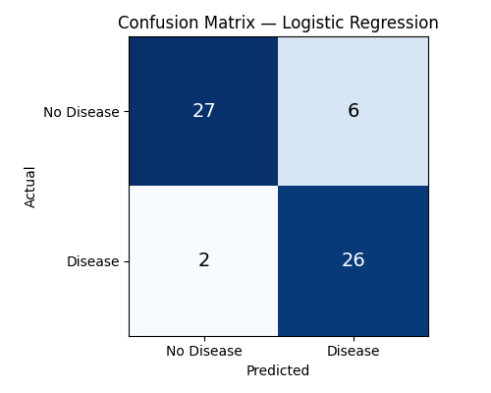
Figure: Confusion Matrix — Logistic Regression

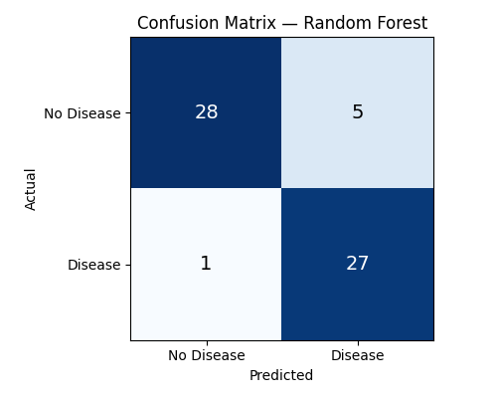
Figure: Confusion Matrix — Random Forest

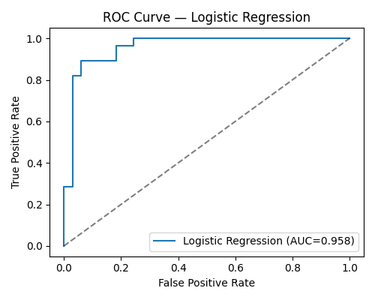
Figure: ROC Curve — Logistic Regression

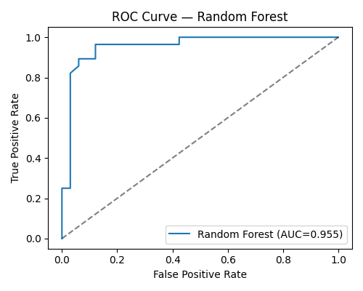
Figure: ROC Curve — Random Forest

