Heart Disease Classification with MLOps
  - Machine Learning Operations AIMLCZG523
  - Assignment 01 2026
Name Lokesh Verma
Student ID 2025ct05026@wilp.bits-pilani.ac.in
Date 19 October 2026

Project overview
HeartCare predicts the presence or absence of heart disease using the UCI Cleveland dataset. The project connects data preparation, two classifier families, experiment tracking and a validated API. Container, CI and local Kubernetes configurations support repeatable delivery.
The selected candidate is logistic_2. It achieved a mean five-fold development ROC AUC of 0.902 and a separate holdout ROC AUC of 0.966. These are educational dataset results and do not establish clinical suitability.
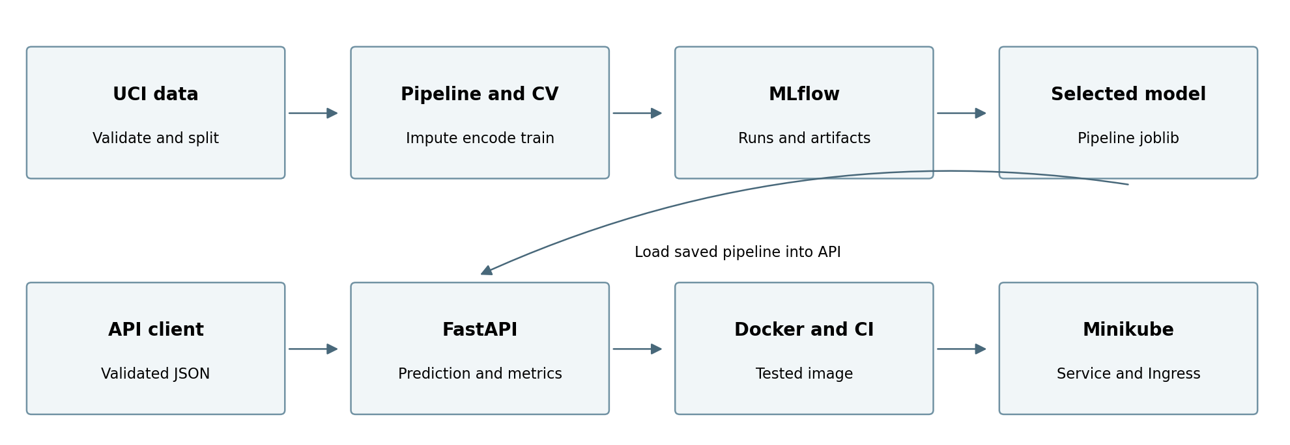
Figure 1 Data and model flow with delivery and monitoring components

Implementation scope
Local training, tracking, model reload, automated tests and HTTP serving have been executed. The repository contains a Dockerfile, GitHub Actions workflow, Minikube manifests and a monitoring stack. CI, container and cluster evidence must be added after executing them in the submission environment.
Code repository https://github.com/2025ct05026/heartcare-mlops

1 Data acquisition and exploration
The data comes from the original processed Cleveland file in UCI dataset 45 [1]. It contains 303 patients, 13 predictors and one diagnosis column. The 14-column schema includes the target. The download script uses the official UCI archive and records its SHA256 checksum.
Cleaning converts the question mark marker to missing values and maps diagnosis num = 0 to target 0, with num = 1 to 4 mapped to target 1. It validates column order and target codes and removes exact duplicates. No rows were removed in this dataset. Missing predictors remain null until pipeline fitting, preventing imputation from using validation or holdout data.
Measure | Observed value
Total patients | 303
Disease absent and present | 164 and 139
Missing values | ca 4 thal 2
Development and holdout patients | 242 and 61

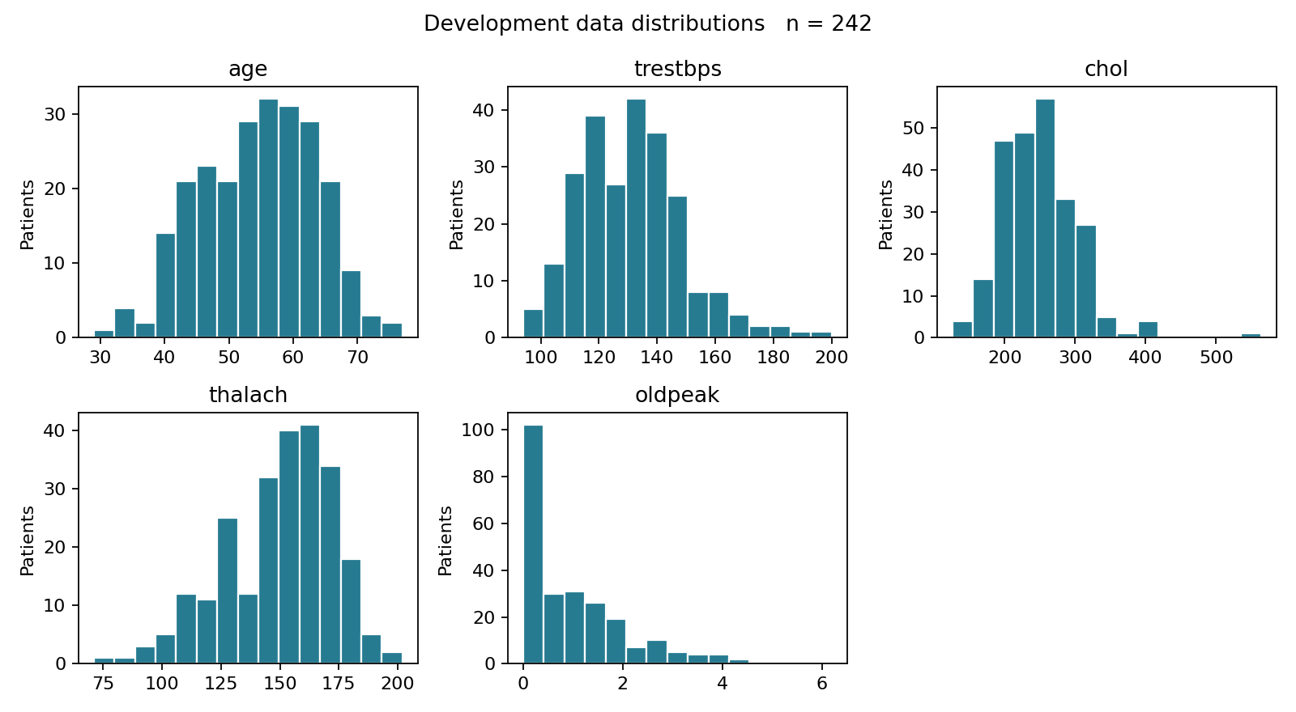
Figure 2 Continuous feature distributions on the 242 development patients
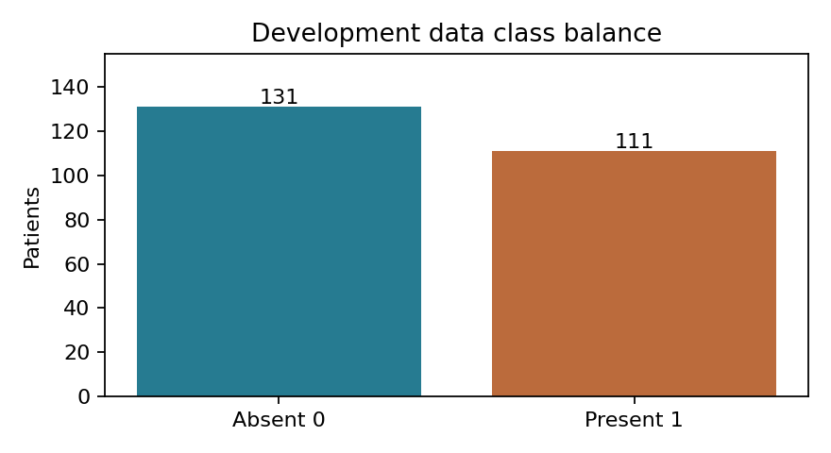
Figure 3 Development class counts after stratified splitting
The development classes are reasonably balanced, so no resampling is used. The cohort is small and historical; performance may not generalize to new populations. EDA excludes the holdout.

2 Feature engineering and preprocessing
Continuous predictors use median imputation followed by standardization. Categorical predictors use most frequent imputation and one hot encoding. OneHotEncoder ignores unseen categories as a defensive pipeline behavior; the API still rejects category codes outside the UCI schema.
Features | Meaning | Treatment
age trestbps chol | Age resting BP cholesterol | Median and scaling
thalach oldpeak | Maximum HR and ST depression | Median and scaling
sex fbs exang | Binary categories | Mode and one hot
cp restecg slope | Chest pain ECG and ST slope | Mode and one hot
ca thal | Vessel count and thal code | Mode and one hot

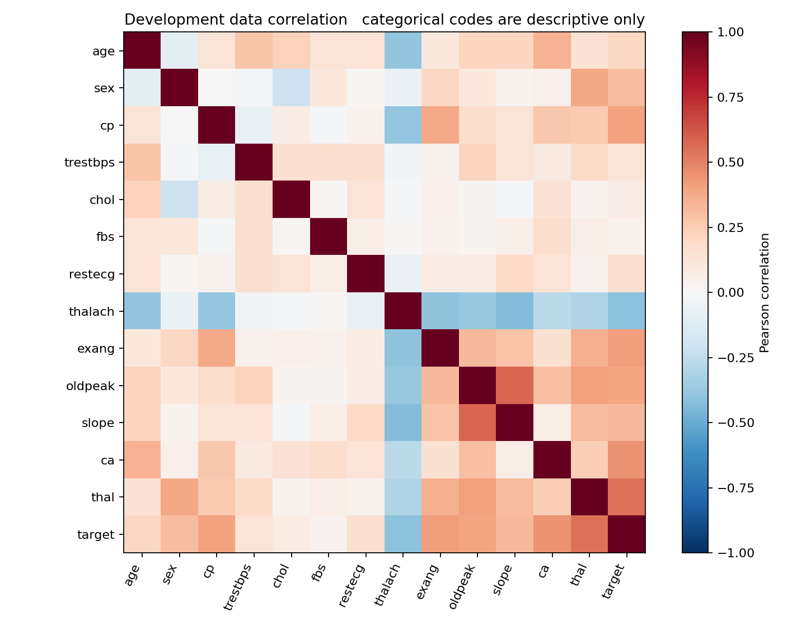
Figure 4 Development correlations describe associations and do not establish causation
Pearson correlation of categorical codes is exploratory only. The model does not assume their numeric distances are meaningful. All 13 original predictors are retained for a transparent baseline. The target is excluded from the input feature list. No global imputation, scaling or data-driven feature selection occurs before cross-validation.

3 Model development and selection
A stratified 80 to 20 split with seed 42 creates 242 development rows and 61 untouched holdout rows. Five shuffled stratified folds within the development set compare two model families. Each fold fits its own preprocessing pipeline. All candidates use the same fold allocation for comparability.
Logistic Regression is a simple linear baseline; its regularization strength C takes values 0.1, 1 and 10. Random Forest uses 200 trees, minimum leaf size 2 and maximum depths 3, 5 and unlimited. The small six-candidate search keeps the workflow understandable and inexpensive.
Candidate | Accuracy | Precision | Recall | ROC AUC
logistic_1 | 0.839 | 0.868 | 0.774 | 0.90246
logistic_2 | 0.847 | 0.877 | 0.783 | 0.90249
logistic_3 | 0.855 | 0.878 | 0.802 | 0.89947
forest_4 | 0.814 | 0.824 | 0.764 | 0.89679
forest_5 | 0.806 | 0.807 | 0.764 | 0.89540
forest_6 | 0.814 | 0.809 | 0.783 | 0.89473

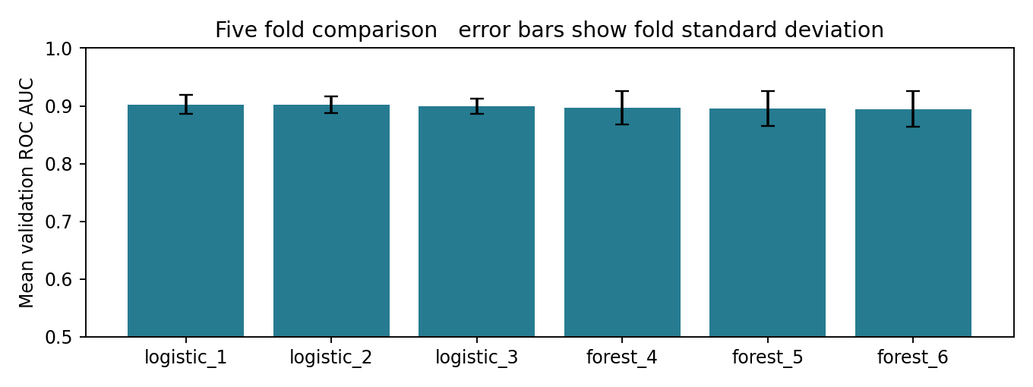
Figure 5 Mean five-fold ROC AUC with fold standard deviation
The highest mean validation ROC AUC selects logistic_2, with parameters {'C': 1.0}. Its ROC AUC is 0.90249 with fold standard deviation 0.014. A score tie keeps the earlier candidate. The holdout is not used to choose the candidate, hyperparameters or decision threshold. The strongest two Logistic Regression settings are practically tied; selection uses unrounded scores.
ROC AUC compares ranking across thresholds. Accuracy measures overall correctness; precision measures how many predicted positives are positive, and recall measures how many actual positives are detected. Positive class 1 means disease presence in the source diagnosis.

4 Final evaluation and model limitations
After model selection, the winning pipeline is fitted on the 242 development rows and evaluated once on the 61 holdout rows. The deployment artifact is that same fitted pipeline; it is not refitted on the holdout data. Predictions use the fixed probability threshold 0.50.
Holdout metric | Measured value
Accuracy | 0.8852
Precision | 0.8387
Recall | 0.9286
Roc Auc | 0.9665

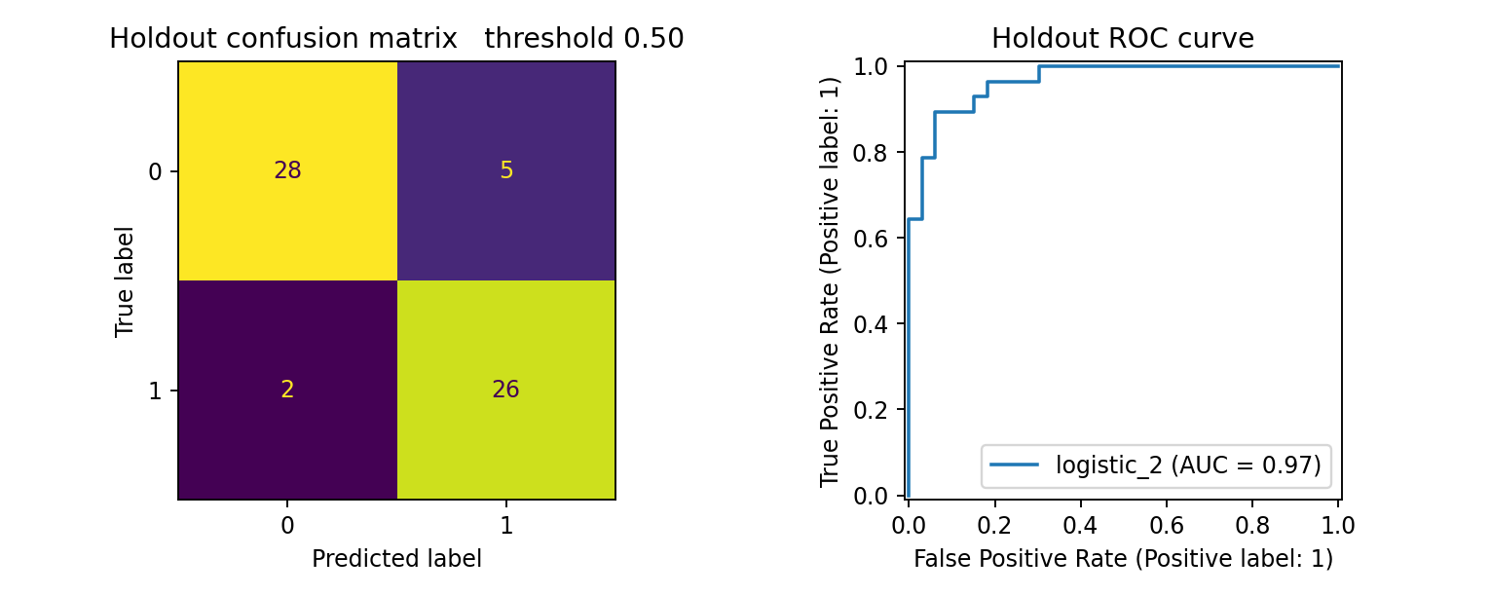
Figure 6 Observed holdout confusion matrix and ROC curve

Interpretation
The confusion matrix separates false negatives from false positives. A false negative is an actual positive patient predicted as class 0. A false positive is an actual negative patient predicted as class 1. These errors have different practical implications; the assignment uses a conventional threshold rather than claiming a clinically optimized decision rule.
The holdout has only 61 observations, so the measured performance is sensitive to the split. Selecting the best candidate can make its CV estimate optimistic. The separate holdout provides a further check, but external validation is still needed. Repeated tuning against this holdout would invalidate that interpretation.

Responsible scope
This model estimates dataset class membership. Its probability is not a validated future disease risk or a clinical diagnosis. Calibration, subgroup fairness, broader validation and expert review are outside this baseline. The historical cohort limits claims about current populations.

5 Experiment tracking and traceability
MLflow groups the six candidate runs in the heartcare-cleveland experiment [2]. A local SQLite backend stores run metadata. A local artifact directory stores complete fitted candidate pipelines, plots and fold results. Training does not require a separately running tracking server.
Logged item | Purpose
Parameters | Model type hyperparameters seed folds and split size
Metrics | CV means and standard deviations for four metrics
Artifacts | Pipeline joblib EDA plots and fold scores
Selected run | Holdout metrics evaluation plot and metadata
Tags | Dataset hash Python sklearn and selection metric

The tracking UI can be opened after training with the command below. The database and artifact paths are local; rerun training after relocating the project to regenerate valid local artifact paths.
python -m mlflow ui --backend-store-uri sqlite:///mlflow.db
Open http://127.0.0.1:5000 and select heartcare-cleveland
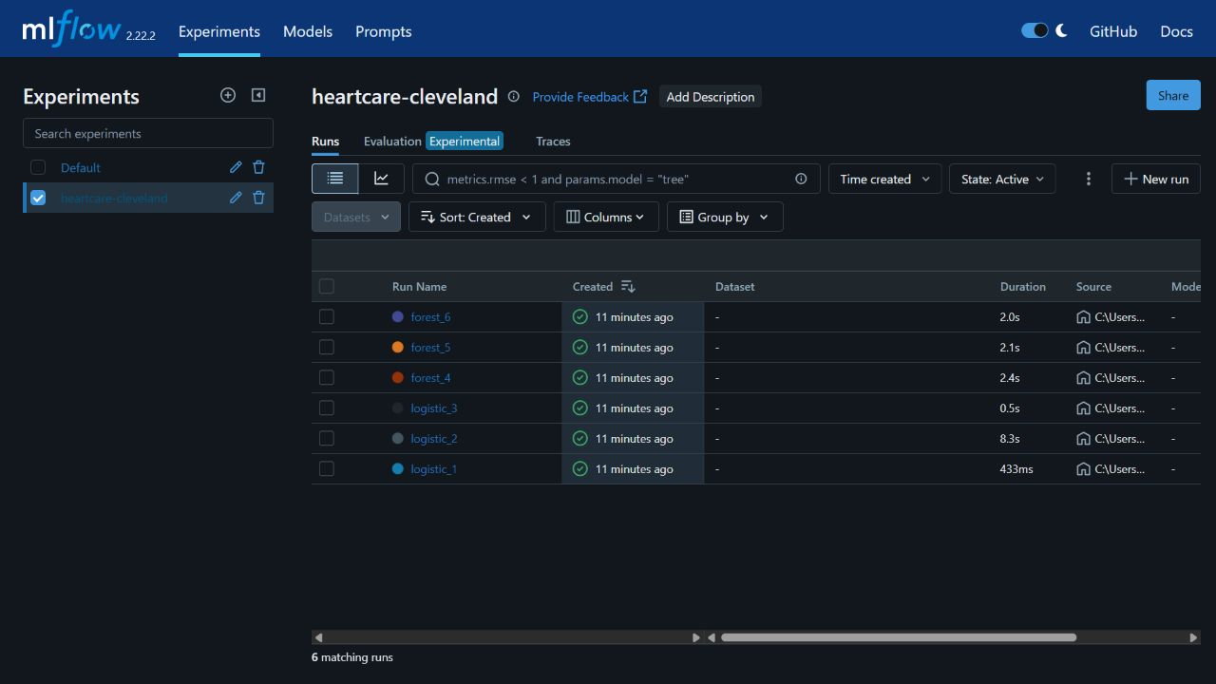
Figure 7 Actual local MLflow experiment view
Selected run ID a33b47e0c853415db61b139c973cea1f
The portable experiment summary is reports/experiments.csv. Evidence exports preserve the actual run parameters and metrics without requiring the original machine path. Model metadata records feature order, software versions, seed, split sizes and dataset and artifact hashes.

6 Reproducibility and the prediction API
Use Python 3.12 for the documented clean environment; the verification environment used Python 3.12.14. Direct requirements are pinned. The full preprocessing pipeline is saved with joblib, so inference loads the same imputer, scaler, encoder and classifier. Only trusted model files should be loaded because joblib uses executable serialization.
py -3.12 -m venv .venv
.\.venv\Scripts\Activate.ps1
python -m pip install -r requirements.txt
python -m heartcare.data
python -m heartcare.eda
python -m heartcare.train
python -m uvicorn heartcare.api:app --port 8000
FastAPI exposes GET /health, POST /predict, GET /metrics and interactive documentation at /docs [3]. All 13 keys are required. Explicit null values are imputed; invalid codes, numeric bounds and extra fields return HTTP 422. The service loads the model at startup and fails clearly if it is missing.

Sample request body
{
"age": 63, "sex": 1, "cp": 1, "trestbps": 145,
"chol": 233, "fbs": 1, "restecg": 2, "thalach": 150,
"exang": 0, "oldpeak": 2.3, "slope": 3, "ca": 0, "thal": 6
}

Observed HTTP response
A real local POST request returned HTTP 200 with the following JSON response.
{
"prediction": 0,
"probability": 0.16553481726241553,
"confidence": 0.8344651827375844,
"model_version": "81f450abefeb"
}
The response includes prediction, probability of class 1, confidence of the predicted class and a model hash prefix. Confidence equals p for a predicted positive or 1 minus p for a predicted negative. The sample input is examples/patient.json. Run python -m scripts.smoke against the running service to verify health, prediction, rejection and metrics.

7 Automated testing and container delivery
GitHub Actions triggers on pushes and pull requests. It installs pinned dependencies, lints the Python code, prepares data and EDA, trains all candidates, runs Pytest, builds the image and exercises a real container over HTTP. Nonzero lint, training, test or smoke exits fail the job. Logs and experiment artifacts are uploaded even if an earlier step fails [4].
Verification | Local outcome
Lint | Passed
Pytest | 19 passed
Training and MLflow | Six runs completed
Real HTTP smoke | Passed over localhost HTTP
Docker and GitHub Actions | Execution evidence to be added

Tests cover target mapping, missing label rejection, duplicates, schema, both model families, serialization consistency, training-only imputation, invalid API inputs, missing model failure and metrics. They check behavior rather than only mirroring code.

Container execution
docker build -t heartcare:1.0 .
docker run -d --name heartcare -p 8000:8000 heartcare:1.0
python -m scripts.smoke
docker inspect --format="{{.State.Health.Status}}" heartcare
The image uses Python 3.12 slim, runs as a nonroot user and contains the saved pipeline. A Docker health check calls /health. Training happens before image construction, making the served artifact explicit. CI exports the tested image as an artifact for local deployment.

Evidence required before submission
Replace this paragraph with your successful GitHub Actions workflow screenshot and Docker build plus healthy container screenshot. Save the originals as screenshots/github-actions.png and screenshots/docker-proof.png. These executions have not been verified in the current environment because Docker is unavailable and GitHub workflow execution is not yet verified.
Delivery ends with a tested image artifact. Deployment to the laptop cluster is a documented manual step; a hosted GitHub runner cannot directly access the local Minikube cluster.

8 Local deployment and service monitoring
The deployment route uses Minikube with the Docker driver. The Kubernetes manifest defines two API replicas, a ClusterIP service and an NGINX Ingress. Requests reach the Ingress, then the service and a ready replica. Health probes remove unready containers from routing and restart unhealthy ones. CPU and memory requests and limits bound resource use [5].
minikube start --driver=docker
minikube addons enable ingress
minikube image load heartcare:1.0
kubectl apply -f k8s/api.yaml
kubectl rollout status deployment/heartcare --timeout=180s
kubectl get pods,svc,ingress
Keep minikube tunnel running in an administrator terminal on Windows. For the Docker driver, set API_URL to http://127.0.0.1 and run the smoke script through ingress. A service port forward is useful for debugging, but ingress must also be verified. The README contains access and rollback instructions.

Request logging and monitoring
The API logs route, method, HTTP status and duration as JSON without patient fields. Prometheus collects request counts, latency histograms and prediction counters. A separate Compose stack provisions Prometheus and a Grafana dashboard for a simple one-container monitoring demonstration. It does not claim to monitor accuracy or drift [6].
$env:GRAFANA_PASSWORD = "choose-your-own-local-password"
docker compose -f monitoring/compose.yaml up --build -d
Open Grafana at http://127.0.0.1:3000 and generate API traffic
Dashboard panels show request rate, mean latency, invalid requests and prediction counts. The local /metrics endpoint has been exercised. Prometheus scraping and Grafana visualization still require Docker execution. With two Kubernetes replicas, counters belong to each process; the supplied Compose dashboard intentionally demonstrates one API process.

Evidence required before submission
Replace this paragraph with two ready Kubernetes pods, the Ingress resource and a successful prediction through ingress. Add a Grafana screenshot after traffic and a Prometheus target UP capture. No cluster rollout or Grafana session is claimed until these commands have run.

9 Review and references

Outcome and next improvements
The project provides reproducible data processing, six tracked experiments, a reusable pipeline, tested API behavior and configurations for automated delivery and local deployment. The chosen logistic_2 has holdout accuracy 0.885 and ROC AUC 0.966. All numerical results in this report come from the saved local experiment outputs.
Before broader use, improvements would include independent validation, probability calibration, subgroup evaluation, authenticated serving, TLS, locked image digests, multi-replica monitoring and drift alerts. A small historical dataset and a local demonstration cannot establish production clinical readiness.

Submission completion checks
The project repository URL is listed on page 1. Run CI, Docker, Minikube and the monitoring stack, then replace the evidence instructions on pages 8 and 9 with actual screenshots. Verify the report remains ten pages. Read the accompanying learning guide and follow course requirements for originality and disclosure of assistance.

References
[1] Janosi A Steinbrunn W Pfisterer M and Detrano R. Heart Disease. UCI Machine Learning Repository 1989. DOI 10.24432/C52P4X. CC BY 4.0. https://archive.ics.uci.edu/dataset/45/heart+disease
[2] MLflow. ML Experiment Tracking. https://mlflow.org/docs/latest/ml/tracking/
[3] FastAPI. Request Body. https://fastapi.tiangolo.com/tutorial/body/
[4] GitHub. GitHub Actions documentation. https://docs.github.com/en/actions
[5] Kubernetes. Set up Ingress on Minikube. https://kubernetes.io/docs/tasks/access-application-cluster/ingress-minikube/
[6] Prometheus Python client. https://prometheus.github.io/client_python/
[7] scikit learn. Pipelines and composite estimators. https://scikit-learn.org/stable/modules/compose.html
Project files README.md gives runnable commands. LEARN_THE_PROJECT.md explains the concepts. SUBMISSION_CHECKLIST.md lists the remaining submission steps. Evidence and results are stored under evidence and reports respectively.

