Technical Report – ML Ops Assignment 1
ID: 2025CT05039
Name: Hemant Kaktwan
Git repository: 2025ct05039/MLOps_heart_disease

Executive Summary:
This report documents the implementation of an end to end ML Ops pipeline for Hear disease prediction using machine learning best practices.
Data analysis and EDA:
Source UCI Heart disease dataset
Records: 303 records, 14 columns (13 input and 1 target)
Target – Binary classification of heart disease (Present /Absent)
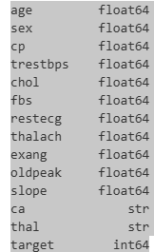
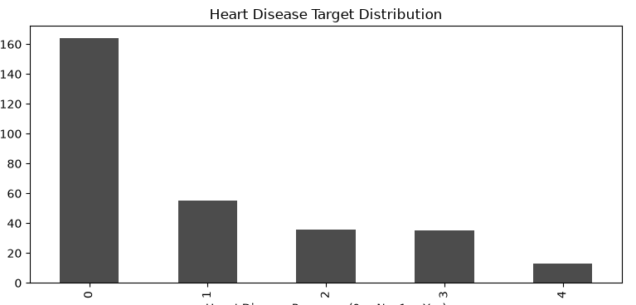
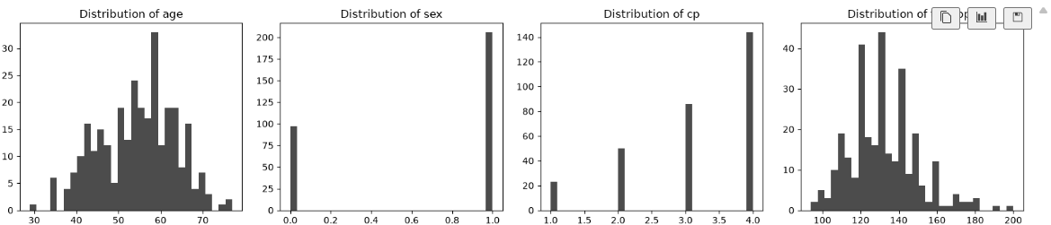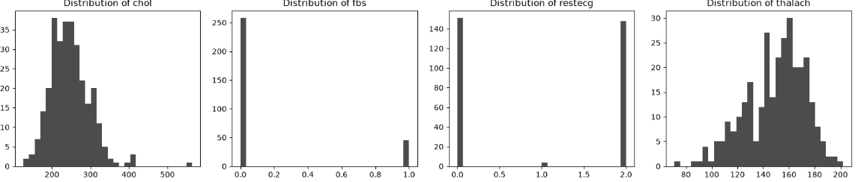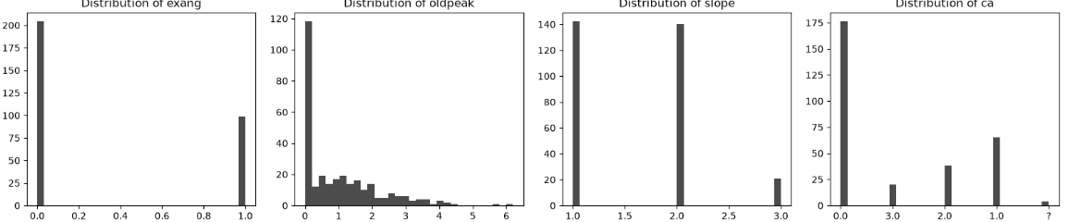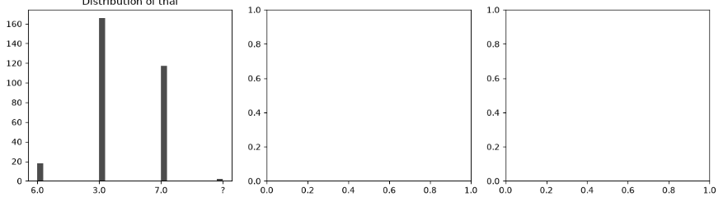
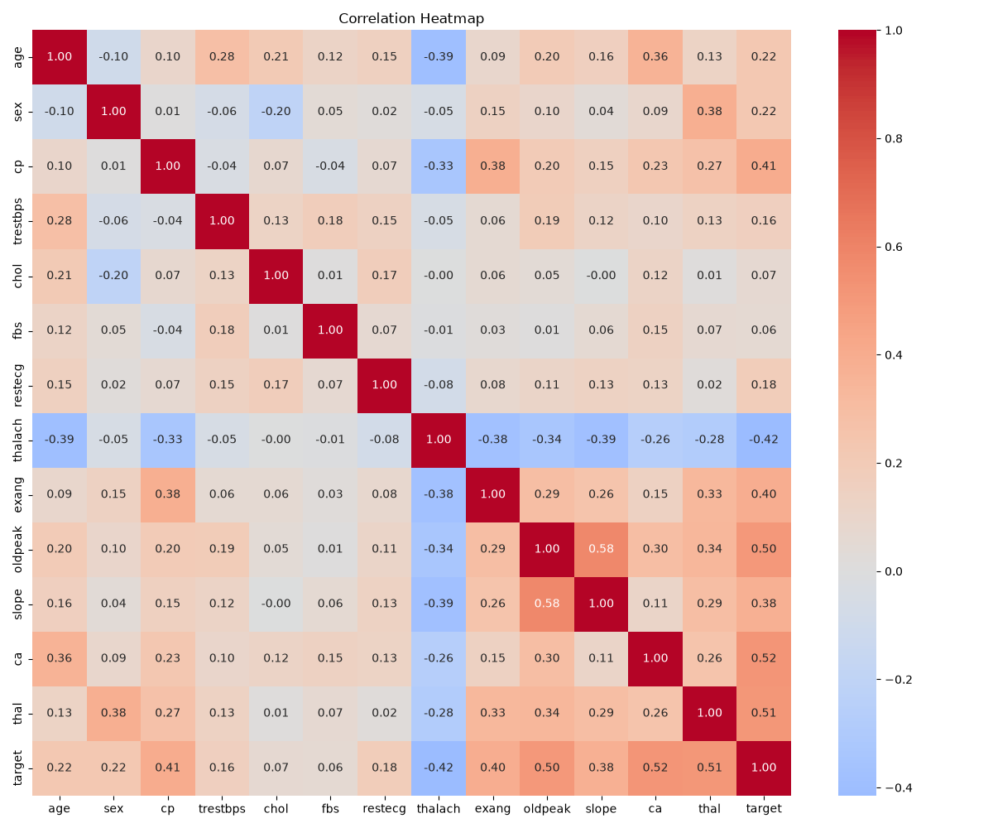
160 of the records have target variable 0 (which is roughly 53% of the input data.
We don’t have any null values in the dataset but we have ‘?’ in thal and ca inputs. In data preprocessing stage , we replace these with mean.
- Age follows almost a normal distribution with tails on either side (low and high ages) and peak in the middle
- Sex has only two values 1 = male and 0 = female. Males form 67% of the population
- cp: chest pain type has four values
  - -- Value 1: typical angina (6.6%)
  - -- Value 2: atypical angina (~15%)
  - -- Value 3: non-anginal pain (~27%)
  - -- Value 4: asymptomatic (~50%)
- Resting blook pressure is skewed to the left with very few records exceeding 180
- Cholestrol level is also normally distributed with few outliers towards the higher range
- Fasting blood sugar – 15% of records show high sugar level
- ECG is equally distributed between normal and “probable or definite left ventricular hypertrophy”. There are very few cases (less than 5) having ST-T wave abnormality
- Max hear rate achieved is normally distributed with a skew to the right
- exercise induced angina is yes for 33% of the data
- oldpeak which is ST depression induced by exercise relative to rest is 0 for ~38% of the population and then distributed with peaks at 0.5, 1,1.2,1.6 and 2
- Slope of the peak exercise ST segment is equally distributed between 1 and 2 with 6.6% having value of 3
- number of major vessels (0-3) colored by flourosopy is 0 for 58%, 23% for 1, 14% for 2 and 5% for 3
- thal - 3 = normal; 6 = fixed defect; 7 = reversable defect is distributed 56% for 3, 38% for 7 and 6% for 6

Correlation for target is strongest with the input variables – thal, ca and oldpeak. Thalach has a negative correlation with the target.

Feature engineering:
Missing values in thal and ca fields are replaced with mean
Scalar transformation is performed on the dataset
There is no categorical encoding . All features are treated as numeric.
All 13 features are used in the final model

Model development:
Models trained:

LOGISTIC_REGRESSION:
train_accuracy: 0.8430
test_accuracy: 0.8525
train_precision: 0.8544
test_precision: 0.7879
train_recall: 0.7928
test_recall: 0.9286
train_f1: 0.8224
test_f1: 0.8525
train_roc_auc: 0.9199
test_roc_auc: 0.9491

RANDOM_FOREST:
train_accuracy: 0.9835
test_accuracy: 0.8689
train_precision: 0.9908
test_precision: 0.8125
train_recall: 0.9730
test_recall: 0.9286
train_f1: 0.9818
test_f1: 0.8667
train_roc_auc: 0.9996
test_roc_auc: 0.9470

Random forest chosen as final model based on F1 score and robustness

Experiment tracking:
All experiment logged in MLFlow with :
- Parameters
- Metrics
- Artifacts
- Training logs

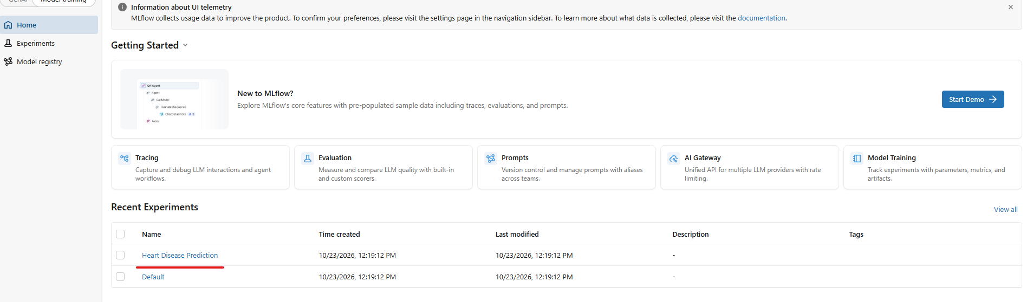

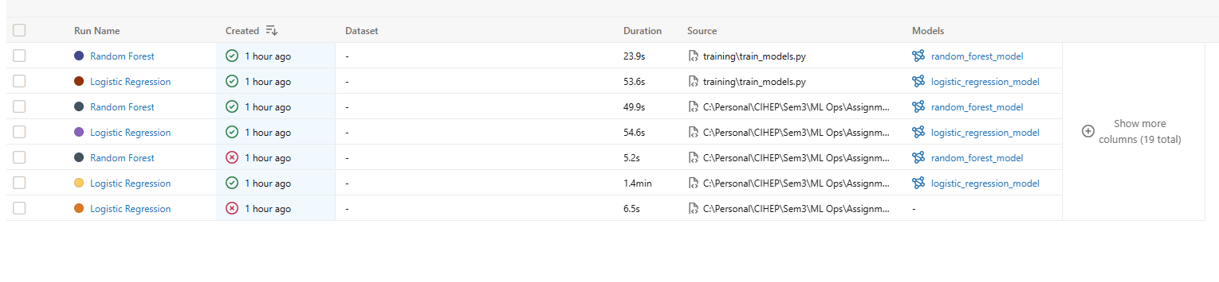

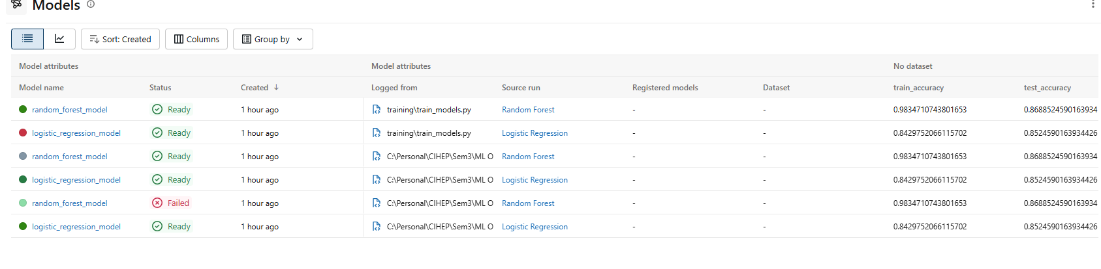

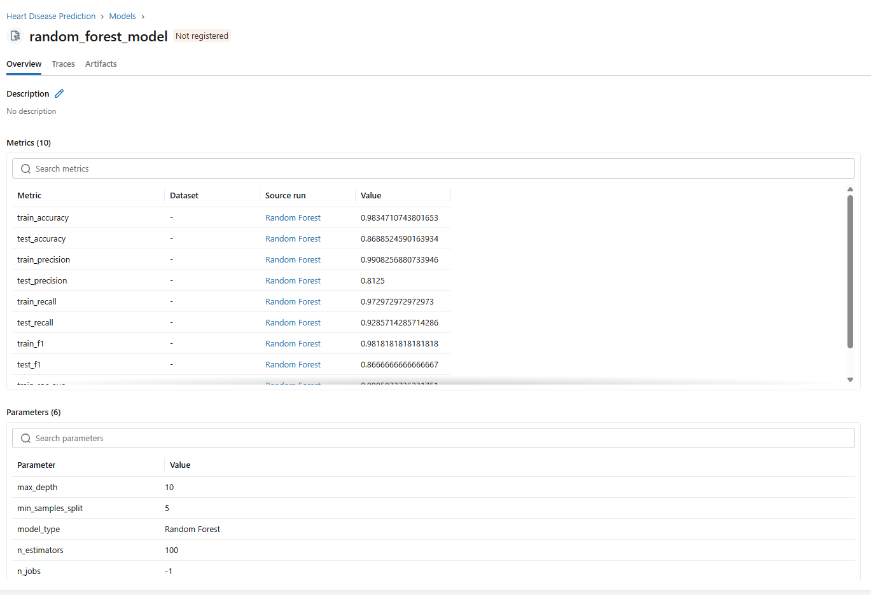
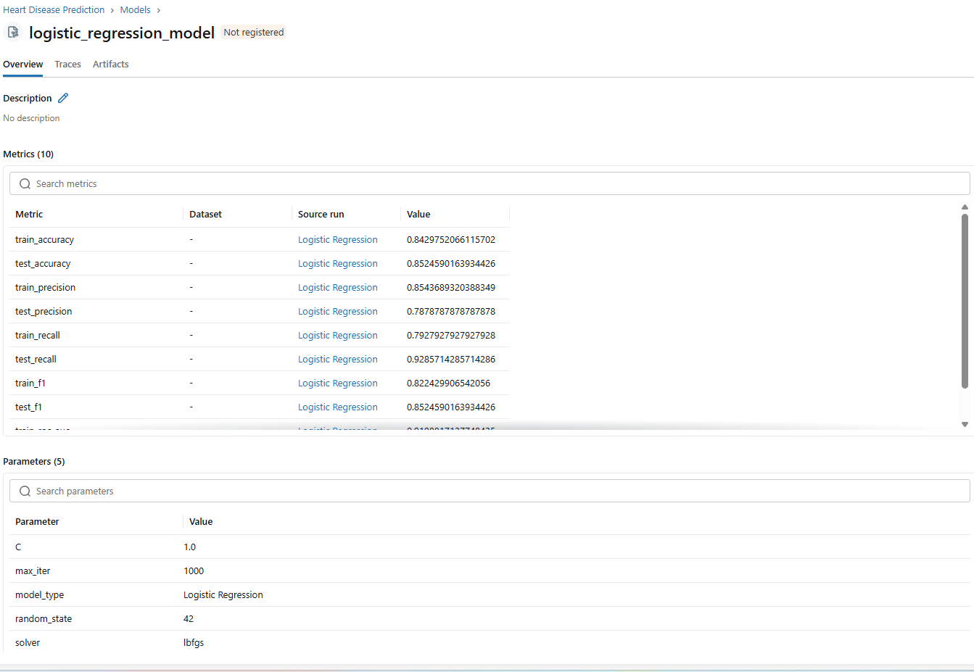

API and containerization:
Flask API is used with:
- Health check endpoint
- Prediction endpoint with confidence scores
- Metrics endpoint (Prometheus)
For containerization, we use Docker.
Image size: 494.25 MB. Duration: ~4 minutes

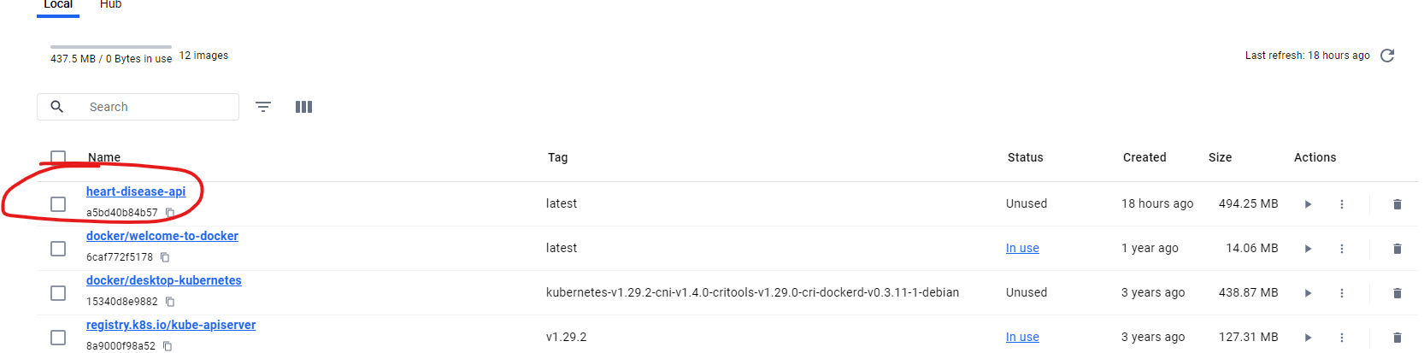

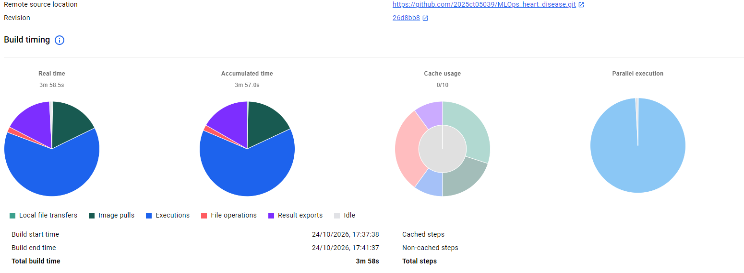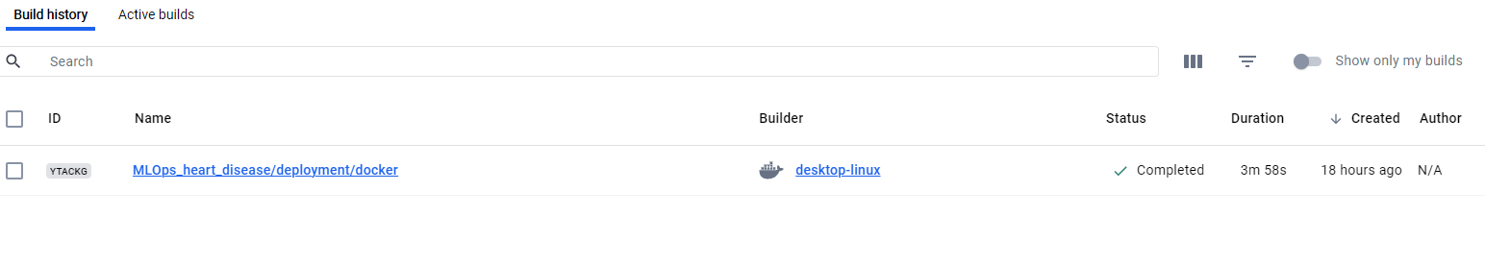
Kubernetes Deployment:
Configuration:
- 3 replicas for high availability
- LoadBalancer service for external access
- Health probes for reliability
- Resource limits for efficiency
NAME READY STATUS RESTARTS AGE
pod/heart-disease-api-5f8b6cf885-dm8xw 1/1 Running 0 6m44s
pod/heart-disease-api-5f8b6cf885-t2rb4 1/1 Running 0 6m44s
pod/heart-disease-api-5f8b6cf885-wkvlq 1/1 Running 0 6m44s

NAME TYPE CLUSTER-IP EXTERNAL-IP PORT(S) AGE
service/heart-disease-api-service LoadBalancer 10.104.126.172 <pending> 80:30715/TCP 6m44s
service/kubernetes ClusterIP 10.96.0.1 <none> 443/TCP 30m

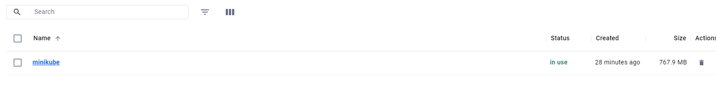
CI / CD pipeline:
Github Actions worokflow
- **Lint** - Code quality checks
- **Tests** - Unit tests with coverage
- **Train** - Model training
- **Upload** - Artifacts to MLflow

Monitoring:
Metrics tracked:
- Total API requests
- Request latency
- Model predictions distribution
- Prediction confidence distribution
Logging
- Structured loggings to file and console
- Log rotation (max 10MB per file)
- All predictions logged with metadata

Reproducibility:
Requirements
- Requirements.txt with pinned versions
- Preprocessing pipeline saved and versioned
- Model saved in MLflow format
- Seed fixed for reproducibility
Deployment
- Single command deployment: `docker run …`
- Environment variables for configuration
- Health checks for verification

