MACHINE LEARNING OPERATIONS | ASSIGNMENT 01 | OCTOBER 2026

Heart Disease Classification
An end-to-end MLOps workflow for the UCI Cleveland dataset
Course | Dataset | Records | Target
MLOps AIMLCZG523 | UCI Heart Disease | 303 | Diagnosis > 0

Executive summary
This project builds a repeatable path from the supplied clinical data to a model-backed API. The source diagnosis is recoded as absence (0) versus presence (1). A single sklearn pipeline owns missing-value handling, feature scaling, categorical encoding, and classification so training and inference share the same transformations. Logistic Regression and Random Forest are tuned with stratified cross-validation; mean cross-validation ROC-AUC selects the model. The trained artifact is served by FastAPI, while MLflow records experiments and Prometheus metrics feed a provisioned Grafana dashboard.
This report records measured model results and local runtime checks. Docker Compose served health and prediction requests, Prometheus reported the API target as UP, and Grafana received metrics. Docker Desktop Kind ran two API replicas, with health, prediction, and metrics verified through kubectl port-forward. No public cloud endpoint is used.
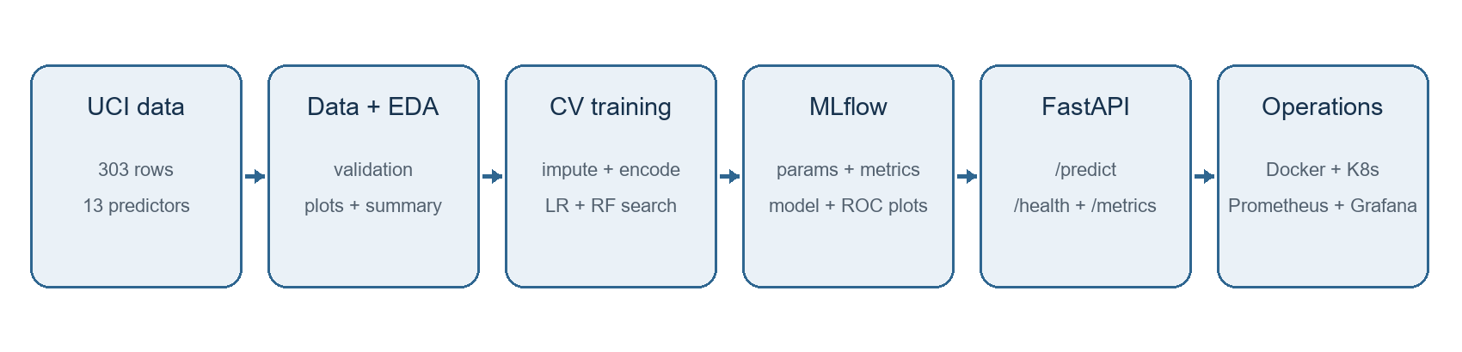
Figure 1. Data, training, serving, and monitoring architecture.

01 | DATA ACQUISITION

Dataset and data contract
The project uses the processed Cleveland subset in the UCI Heart Disease archive. The legacy file has 14 comma-separated fields without a header: 13 predictors and one diagnosis value. The supplied archive is retained at the workspace root; data/raw/processed.cleveland.data is the focused input used by the scripts. The download helper fetches the UCI ZIP and extracts only this named member, printing SHA-256 hashes for provenance.
Acquisition was run from the UCI endpoint. The downloaded archive SHA-256 matched the supplied archive (b17cd273da9ce1caa4710fce80227ea454d4dbf9fcbc8e6a9121672751563adc); the extracted Cleveland file hash is a74b7efa387bc9d108d7d0115d831fe9b414b29ae7124f331b622b4efa0427c8.
Data check | Observed | Handling
Records | 303 | Keep usable diagnosis rows
Predictors | 13 clinical fields | Preserve source order and names
Unknown values | 6 | Keep missing until model fit
Diagnosis | Ordinal values 0-4 | Binary label: 0 vs 1-4
Duplicates | 0 | Remove exact duplicate rows

Target definition
The binary label follows the assignment framing and UCI's documented convention: diagnosis 0 is absence, while diagnoses 1, 2, 3, or 4 represent presence. This transformation is explicit in src/data.py and tested. It avoids treating the original ordinal values as four separate classes when the project objective is binary classification.
Predictors are age, sex, chest-pain type (cp), resting blood pressure, serum cholesterol, fasting blood sugar flag, resting ECG category, maximum heart rate, exercise angina, ST depression, slope, major vessels (ca), and thalassemia category (thal).

Data quality and limits
Missingness is sparse in this subset (ca: 4, thal: 2). The analysis keeps these cells as nulls; it does not delete patient rows or fill them before data splitting. The preprocessing pipeline fits the imputers only on each training fold. This preserves the holdout and validation boundaries.
The subset is small and historical. It is appropriate for an educational workflow demonstration, not for clinical use or for claims about present-day populations.

02 | EXPLORATORY ANALYSIS

Feature distributions and class balance
The first EDA view summarizes all 13 predictors after the target mapping. Continuous features show broad patient variability, while coded fields such as chest-pain type and thalassemia type are discrete categories even though they are stored as numbers. That distinction informs the model pipeline: numerical measurements are scaled; encoded clinical codes are one-hot encoded.
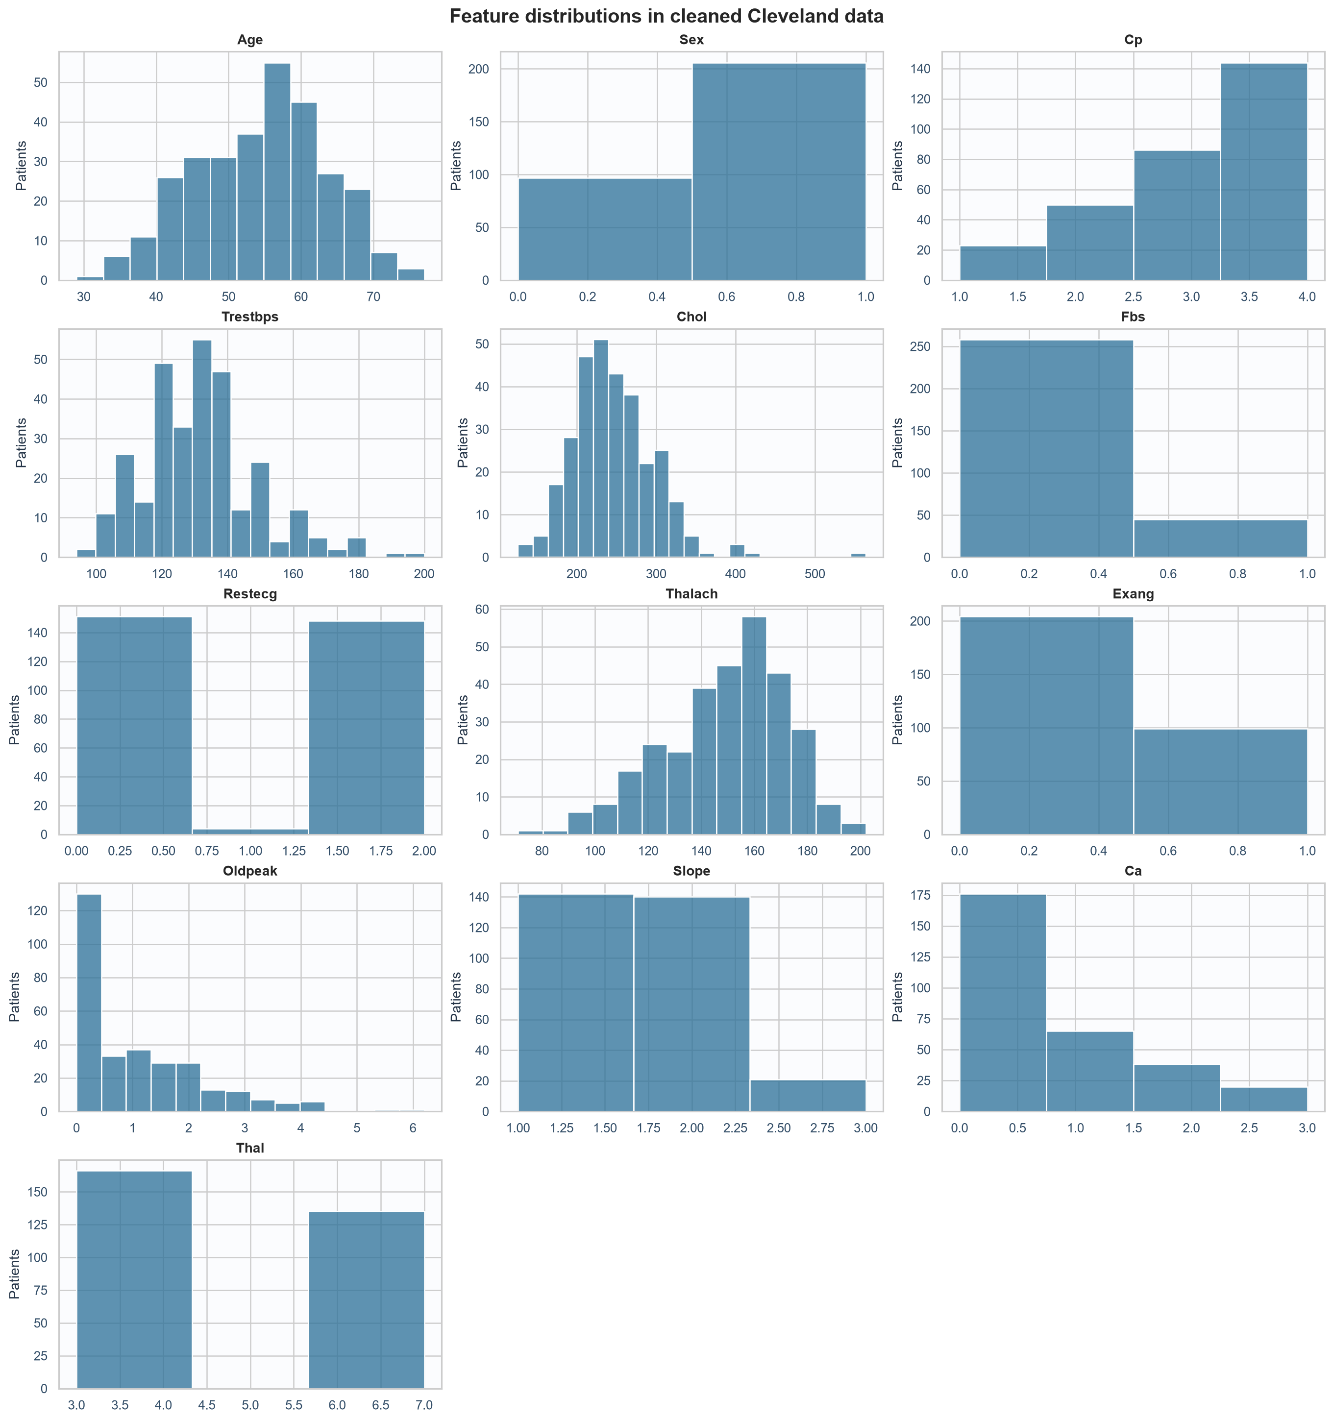
Figure 2. Histograms for Cleveland clinical features.
Target | Meaning | Patients | Share
0 | No diagnosis | 164 | 54.1%
1 | Diagnosis present | 139 | 45.9%
The target is moderately imbalanced, so accuracy alone would be incomplete. Precision and recall are reported alongside ROC-AUC, and the candidate classifiers use class weighting to reduce the impact of unequal class frequencies.

02 | EXPLORATORY ANALYSIS

Associations and missing source values
The correlation heatmap is descriptive: it shows linear associations among numeric encodings and the binary target. Ordinal category codes can create correlations that do not represent a true distance between categories, so the figure is used to orient feature review rather than as a feature-selection rule.
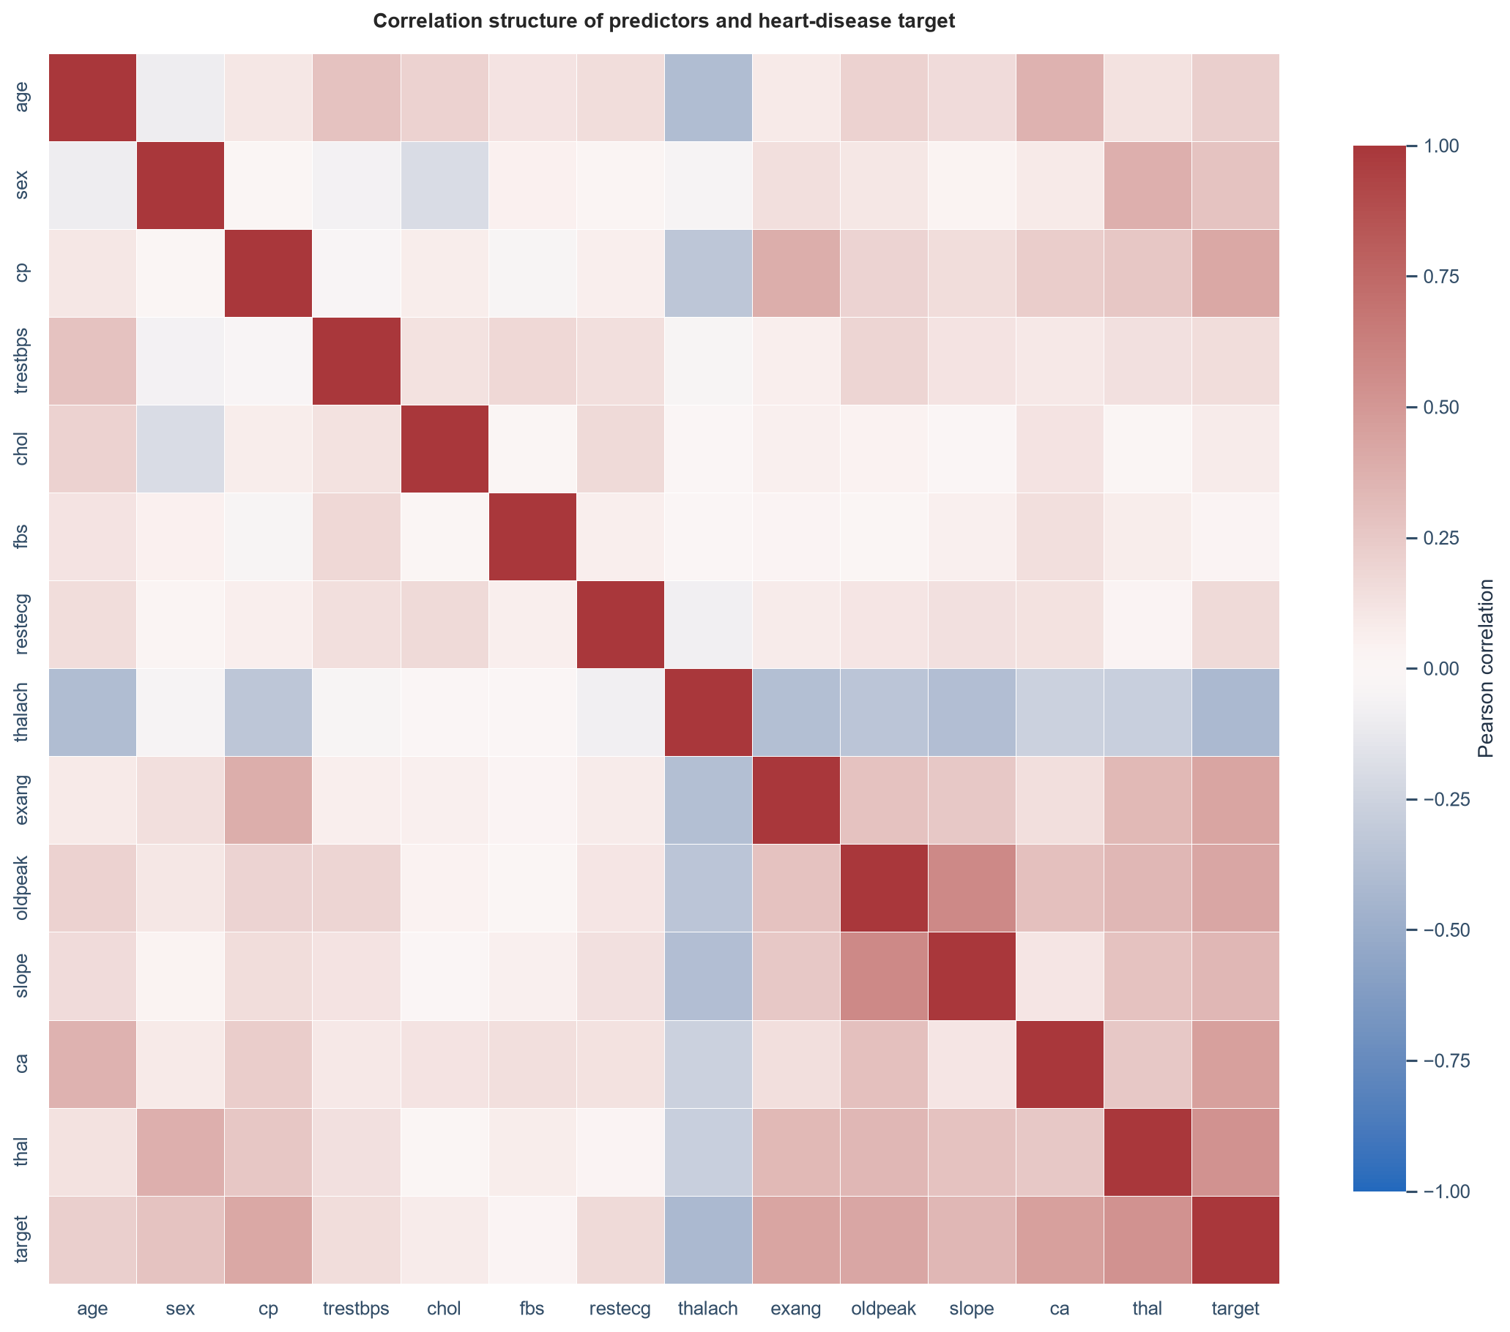
Figure 3. Pearson correlation matrix, including the binary target.
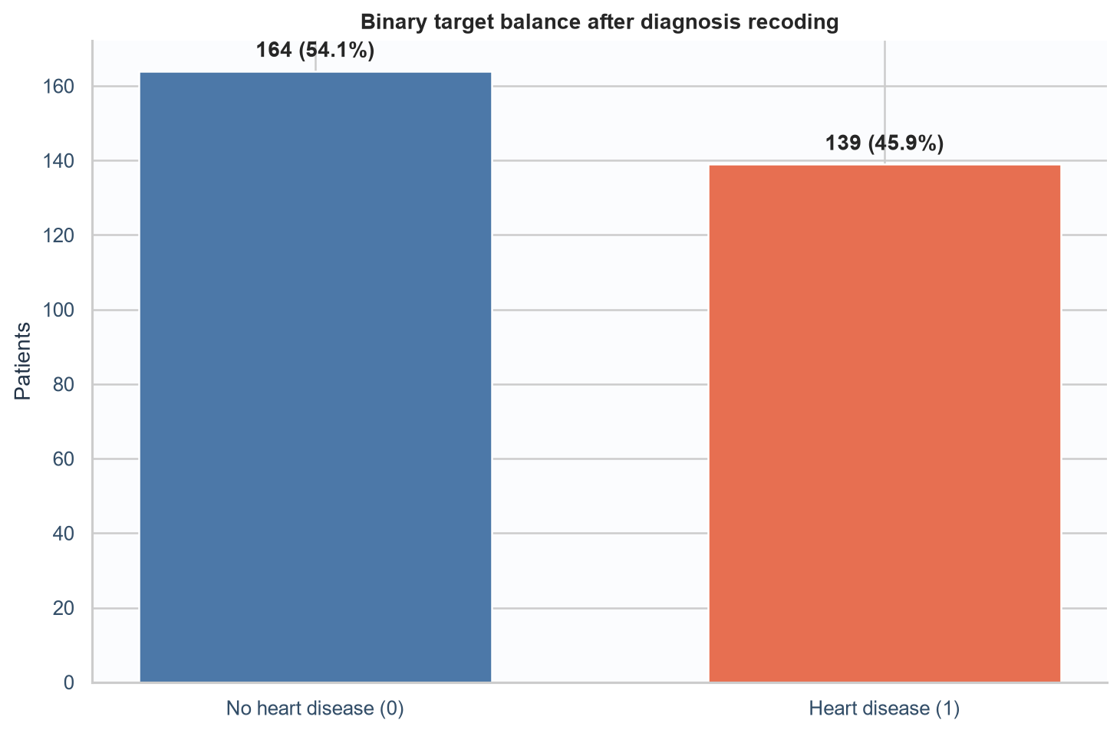 | 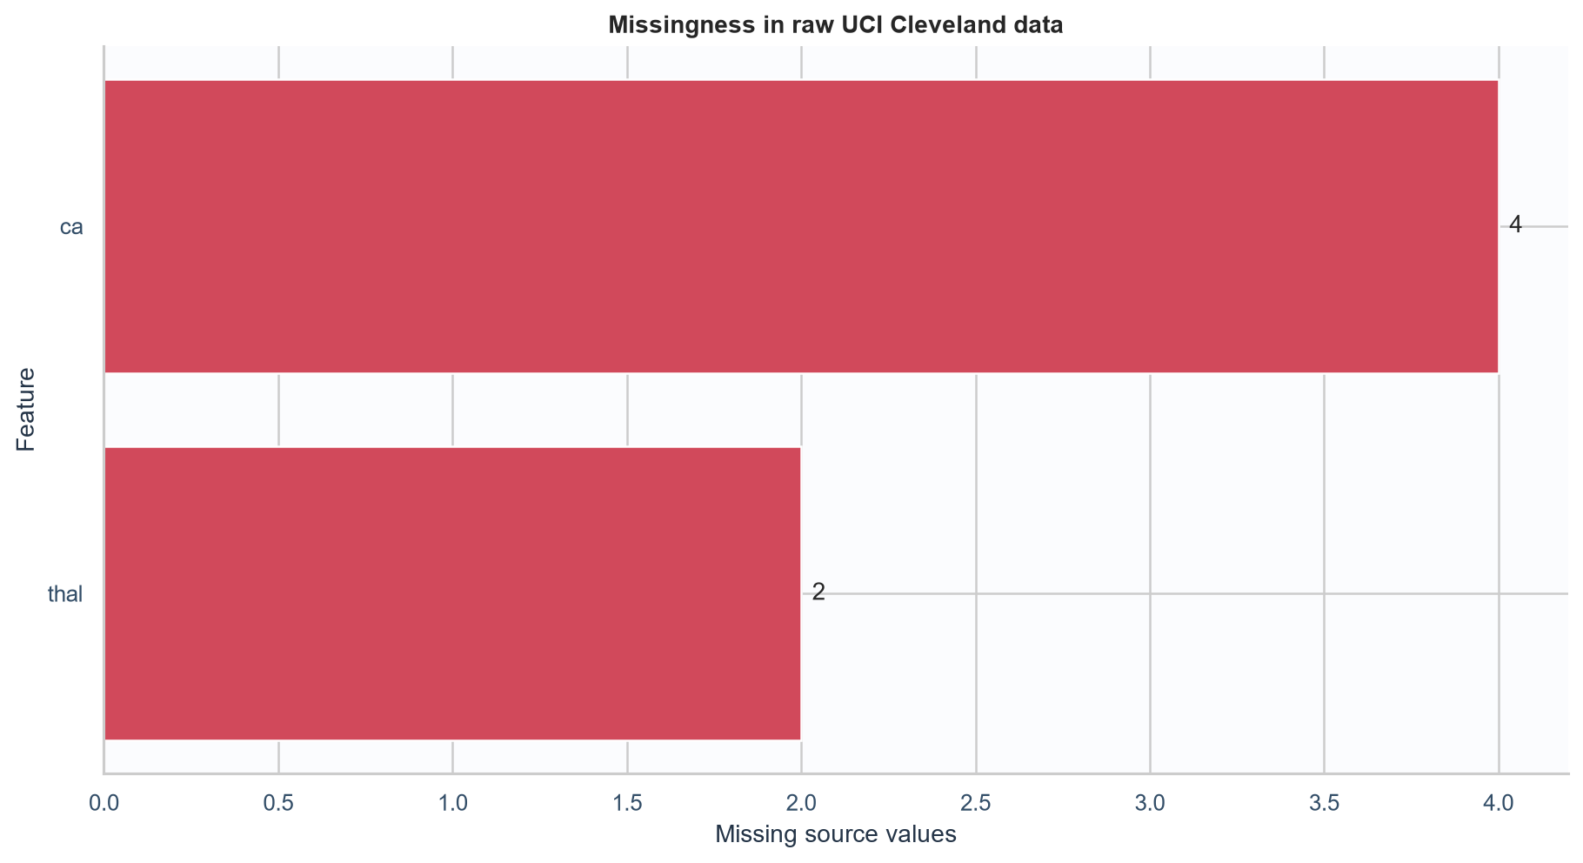
Figure 4. Class balance (left) and missingness before imputation (right).
The raw file contains six missing feature values. Their source-level visibility is retained in the summary JSON and figure. All plots and counts are generated by scripts/eda.py rather than manually edited, so a new run recreates the report inputs.

03 | FEATURE ENGINEERING

Leakage-safe preprocessing and model selection
A ColumnTransformer routes five measurements (age, resting blood pressure, serum cholesterol, maximum heart rate, and ST depression) through median imputation and StandardScaler. Eight coded fields are treated as categorical and pass through most-frequent imputation followed by one-hot encoding. Unknown categories at inference are ignored safely. These transformations are placed inside the classifier pipeline, so each cross-validation fold learns its own imputation and scaling statistics.
Candidate | Role | Search dimensions
Logistic Regression | Interpretable linear baseline | C; class_weight balanced
Random Forest | Nonlinear tree ensemble | tree count, depth, leaf size; balanced subsampling

Evaluation protocol
A stratified 80/20 split is created with a fixed random seed. GridSearchCV tunes each candidate on the training portion using five stratified folds (three in the CI smoke run). The refit metric is ROC-AUC. Accuracy, precision, recall, and ROC-AUC means and standard deviations are retained for the best setting. The untouched holdout reports all four metrics once after tuning. The final serialized pipeline is then refit on all 303 rows for API use.
The holdout score is a single estimate from a small dataset and should not be interpreted as a stable clinical performance guarantee. Cross-validation variability is therefore shown next to each mean.

04 | MODEL RESULTS

Cross-validation and holdout performance
Table 1 reports training-set cross-validation scores for each selected parameter setting. The mean and standard deviation summarize fold-to-fold variation.
Model | Accuracy | Precision | Recall | ROC-AUC
Logistic Regression | 0.835 ± 0.043 | 0.831 ± 0.016 | 0.802 ± 0.104 | 0.899 ± 0.033
Random Forest | 0.814 ± 0.050 | 0.805 ± 0.046 | 0.785 ± 0.085 | 0.898 ± 0.046
Table 2 reports the held-out 20% test results.
Model | Accuracy | Precision | Recall | ROC-AUC
Logistic Regression | 0.918 | 0.960 | 0.857 | 0.974
Random Forest | 0.902 | 0.958 | 0.821 | 0.965

Selection
Logistic Regression is selected because it achieved the highest mean cross-validation ROC-AUC (0.899). Its margin over the other candidate is very small relative to fold-to-fold variation, so this run does not show a decisive model separation. The ranking rule is fixed before the holdout comparison; the holdout is not used to select hyperparameters. The selected parameters are recorded in metrics.json and the MLflow run.
These values are experimental estimates on a small historical sample. They are not medical thresholds, and the API output must not guide patient care.

05 | EXPERIMENT TRACKING

MLflow and reproducible artifacts
Each candidate run records the model name, chosen hyperparameters, cross-validation metrics, holdout metrics, fitted pipeline, and holdout ROC curve. The default tracking URI is a local file store under mlruns/. Run the UI from the repository root with mlflow ui to inspect the experiment. A separate metrics.json and model_comparison.csv make the result readable without opening the tracking interface. Model signatures use numeric input fields with a type that can represent missing values, matching the preprocessing contract.
Artifact | Contents | Use
heart_disease_model.joblib | Preprocessor plus selected estimator | API inference
model_metadata.json | Model family, parameters, features, time | Model identity
metrics.json | Data snapshot, selection, CV and holdout results | Reporting and audit
model_comparison.csv | One row per candidate | Quick comparison
*_roc.png | Holdout ROC curve per model | Visual assessment
MLflow runs | Parameters, metrics, model and plots | Experiment history

Reproduction controls
- The raw source file is headerless and parsed through a shared schema.
- A fixed random seed controls data splitting, folds, and estimators.
- Preprocessing is fitted within cross-validation and serialized with the model.
- requirements.txt and the CI workflow define the execution environment.
MLflow organizes runs, records parameters and metrics, and stores output artifacts as documented in the official tracking API reference. The current setup is local; a shared server and object store would be needed for team-wide or cloud tracking.

06 | MODEL SERVING

FastAPI request and response contract
The API loads the packaged sklearn pipeline from MODEL_PATH and accepts one JSON object containing the 13 named predictors. Pydantic validates required fields and plausible input ranges before inference. Optional ca and thal values may be null; the trained pipeline handles them. The response returns a 0/1 prediction, a readable class label, and the model's estimated positive-class probability as confidence. This probability has not been calibrated or validated for clinical use.

Example request
{
"age": 63, "sex": 1, "cp": 1, "trestbps": 145,
"chol": 233, "fbs": 1, "restecg": 2, "thalach": 150,
"exang": 0, "oldpeak": 2.3, "slope": 3, "ca": 0, "thal": 6
}
POST /predict | GET /health | GET /metrics
Endpoint | Purpose | Expected behavior
/predict | One prediction | 200 with prediction, label, confidence, version
/health | Readiness | Model load state; 503 when artifact unavailable
/metrics | Monitoring | Prometheus request, latency, and class counters

Privacy and logging
Request logs capture the method, route, HTTP status, and elapsed time. They omit the request body so patient-feature values are not written to application logs. This reduces one operational exposure but does not replace access control, transport security, retention rules, or a privacy review for real health data.
The local Python process and Docker Compose smoke checks returned /health status ok and valid /predict responses for samples/predict.json. The Docker container also returned HTTP 200 from /metrics. Kubernetes health, prediction, and metrics endpoints were verified separately through kubectl port-forward.

07 | CI AND QUALITY

Automated checks and local verification
The GitHub Actions workflow installs the requirements file, runs Ruff linting, executes pytest, trains the models in a smaller CI search mode, and uploads the model, metrics, plots, and local MLflow store as a workflow artifact. Each command is a required step, so a lint, test, or training failure marks the run as failed.
Check | Coverage | Local status
Ruff | Imports, style, common correctness errors | Passed (ruff check src app scripts tests)
Pytest | Data contract, recoding, pipeline, API schema | Passed (7 tests)
Training smoke run | Search, metrics, plots, serialized model | Passed (full 5-fold comparison; Logistic Regression selected)
Workflow artifact | Retain training outputs per CI run | Passed (recorded GitHub Actions run #4 on commit e808c1d; workflow concluded successfully)

Reproduction commands
ruff check src app scripts tests
pytest
python scripts/train.py --fast
Current GitHub Actions status: Passed (recorded GitHub Actions run #4 on commit e808c1d; workflow concluded successfully). The recorded passing workflow run is documented in docs/screenshots/github-actions-ci-passed.png.

08 | DEPLOYMENT AND OPERATIONS

Container, Kubernetes, and monitoring
The Docker image packages the API and serialized model. Docker Compose starts the API with Prometheus and Grafana; the API exports request totals, latency histograms, and prediction counts. A provisioned dashboard shows request rate, p95 latency, class counts, and 5xx ratio. The Kubernetes Deployment specifies two replicas, readiness and liveness probes, resource bounds, and scrape annotations; a LoadBalancer Service exposes port 80.
Evidence item | What is prepared | What remains
API container | Dockerfile; health, prediction, and metrics requests | Passed locally
Observability | Prometheus target UP; Grafana dashboard | Passed locally
Kubernetes | Two ready replicas; endpoints via port-forward | Passed locally
Public deployment | No cloud-specific resource is assumed | Not performed; no public URL
Video and screenshots | Four evidence screenshots in docs/screenshots | Short demo video remains

Conclusion and limitations
Docker Compose and the local Docker Desktop Kind cluster have both been exercised. The Kubernetes Deployment reached two ready replicas, and /health, /predict, and /metrics were verified through port-forwarding. Prometheus, Grafana, Kubernetes, and GitHub Actions screenshots are included. The current GitHub Actions result is Passed (recorded GitHub Actions run #4 on commit e808c1d; workflow concluded successfully). No public cloud endpoint is claimed; a short demo video and the course submission remain for the student. The dataset has only 303 historical records, so model metrics should not be used for diagnosis or health decisions.

References
UCI Machine Learning Repository. Heart Disease dataset, DOI 10.24432/C52P4X. https://archive.ics.uci.edu/dataset/45/heart+disease
MLflow. Tracking API documentation. https://mlflow.org/docs/latest/tracking/tracking-api/
scikit-learn. ColumnTransformer and model evaluation documentation. https://scikit-learn.org/stable/modules/generated/sklearn.compose.ColumnTransformer.html

