Data Management for Machine Learning
Assignment I
End-to-End Data Management Pipeline
for a Recommendation System
Project: RecoMart Pipeline

GROUP 68
Team Member Details
Name | ID | Contribution
Biswajit Sahu | 2025DA04126 | 100%

Table of Contents
- Problem Statement & Objectives
- Data Collection and Ingestion
- Raw Data Storage
- Data Profiling and Validation
- Data Preparation & EDA
- Feature Engineering and Transformation
- Feature Store
- Data Versioning and Lineage
- Model Training and Evaluation
- Pipeline Orchestration
- Results and Output Screenshots
- Conclusion and Future Scope
- Google Drive Links

1. Problem Formulation

1.1 Business Problem
RecoMart, an e-commerce startup, aims to build a data-driven recommendation engine to enhance customer engagement and improve cross-selling opportunities. The primary objective is to provide personalized product recommendations that increase conversion rates and average order value.
The core business problem is: "How can we leverage user behavior data from multiple sources to generate accurate, personalized product recommendations that improve conversion rate and customer engagement?"

1.2 Key Data Sources
Data Source | Type | Records | Key Attributes
User Demographics | CSV (Internal DB) | 500 | user_id, age, gender, location, signup_date, is_premium
Product Catalog | CSV (Catalog Service) | 200 | product_id, name, category, price, brand, avg_rating
Transaction History | CSV (Purchase DB) | 5,050 | transaction_id, user_id, product_id, quantity, rating, timestamp
Clickstream Logs | CSV (Web/Mobile) | 15,000 | event_id, user_id, product_id, event_type, session_id, device

Additionally, external API data (sentiment scores, popularity scores, trending ranks) is ingested for 200 products to enrich item features.

1.3 Expected Pipeline Outputs
- Clean, validated datasets ready for Exploratory Data Analysis (EDA)
- Engineered features for collaborative filtering (user-item interactions) and content-based filtering (item attributes)
- Versioned feature store with metadata registry for reproducible training and inference
- Trained recommendation models (SVD-based collaborative filtering + cosine similarity content-based)
- Model performance metrics and experiment tracking metadata
- Automated, orchestrated end-to-end pipeline with logging and monitoring

1.4 Evaluation Metrics
Metric | Formula | Purpose
Precision@K | |Relevant in Top-K| / K | Fraction of recommended items that are relevant
Recall@K | |Relevant in Top-K| / |All Relevant| | Fraction of relevant items that are recommended
NDCG@K | DCG@K / IDCG@K | Ranking quality considering position of relevant items
RMSE | sqrt(mean((actual - predicted)^2)) | Rating prediction accuracy

2. Data Collection and Ingestion

2.1 Ingestion Design
The ingestion module (src/ingestion/ingest_data.py) handles automated data collection from multiple sources with the following capabilities:
- CSV file ingestion with schema detection and metadata tagging
- REST API ingestion with retry mechanism (exponential backoff, 3 retries)
- Error handling with custom DataIngestionError exceptions
- Comprehensive logging for monitoring and audit trails
- Automatic metadata addition (_ingestion_timestamp, _source_file)
- JSON report generation for ingestion audit

2.2 Ingestion Script (Key Code)
def ingest_from_api(api_url, destination_dir, filename, max_retries=3):
"""Ingest data from REST API with retry mechanism."""
for attempt in range(max_retries):
try:
response = requests.get(api_url, timeout=30)
response.raise_for_status()
data = response.json()
df = pd.DataFrame(data)
df['_ingestion_timestamp'] = datetime.now().strftime('%Y-%m-%d %H:%M:%S')
df['_source_api'] = api_url
df.to_csv(os.path.join(destination_dir, f"{filename}.csv"), index=False)
return df
except requests.exceptions.RequestException as e:
wait_time = 2 ** attempt
logger.warning(f"Attempt {attempt+1}/{max_retries} failed. Retry in {wait_time}s")
time.sleep(wait_time)
raise DataIngestionError(f"Failed after {max_retries} attempts")

2.3 Ingestion Execution Log
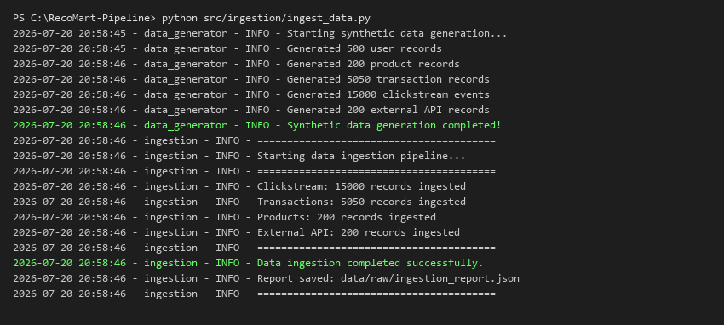

2.4 Ingestion Report (JSON)
The ingestion pipeline generates an audit report (data/raw/ingestion_report.json) documenting all sources, record counts, and success/failure status:
{
"start_time": "2026-07-20 20:58:46",
"sources": {
"clickstream": {"records": 15000, "status": "success", "source_type": "csv"},
"transactions": {"records": 5050, "status": "success", "source_type": "csv"},
"products": {"records": 200, "status": "success", "source_type": "csv"},
"external_api": {"records": 200, "status": "success", "source_type": "api_cached"}
},
"status": "success",
"end_time": "2026-07-20 20:58:46"
}

3. Raw Data Storage

3.1 Storage Architecture
Raw data is stored in a structured local data lake layout partitioned by source type. The design supports future migration to cloud storage (AWS S3, GCS) with minimal changes.

3.2 Folder Structure
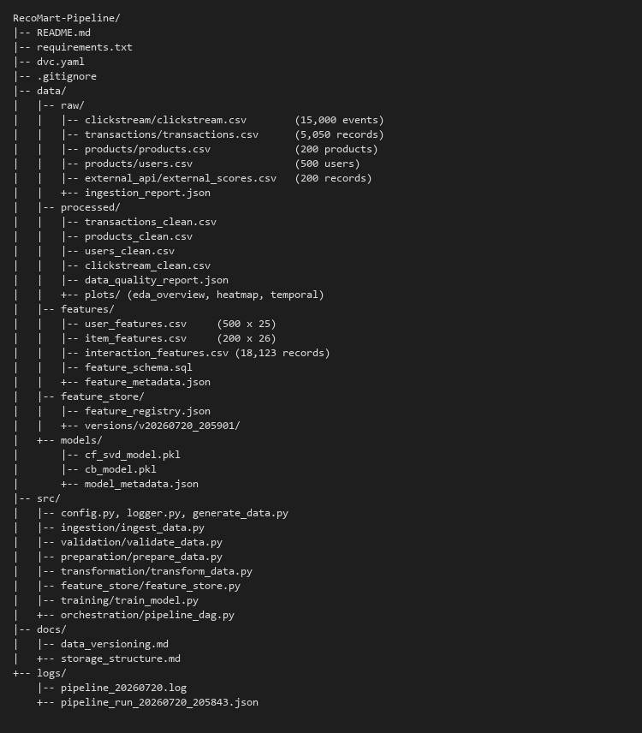

3.3 Storage Layout Details
Directory | Purpose | Partitioned By | Format
data/raw/clickstream/ | User browsing behavior | Source type | CSV
data/raw/transactions/ | Purchase history | Source type | CSV
data/raw/products/ | Product catalog + Users | Source type | CSV
data/raw/external_api/ | External sentiment data | Source type | CSV + JSON
data/processed/ | Cleaned & prepared data | Processing stage | CSV

3.4 Configuration (src/config.py)
# Base paths
BASE_DIR = os.path.dirname(os.path.dirname(os.path.abspath(__file__)))
DATA_DIR = os.path.join(BASE_DIR, "data")
RAW_DIR = os.path.join(DATA_DIR, "raw")
PROCESSED_DIR = os.path.join(DATA_DIR, "processed")
FEATURES_DIR = os.path.join(DATA_DIR, "features")
MODELS_DIR = os.path.join(DATA_DIR, "models")
# Raw data subdirectories (partitioned by source)
CLICKSTREAM_DIR = os.path.join(RAW_DIR, "clickstream")
TRANSACTIONS_DIR = os.path.join(RAW_DIR, "transactions")
PRODUCTS_DIR = os.path.join(RAW_DIR, "products")
EXTERNAL_API_DIR = os.path.join(RAW_DIR, "external_api")

4. Data Profiling and Validation

4.1 Validation Framework
The validation module (src/validation/validate_data.py) implements a comprehensive DataValidator class that performs the following checks:
- Schema Validation: Verifies required columns exist in each dataset
- Missing Value Analysis: Counts and classifies missing values by severity
- Duplicate Detection: Identifies exact duplicates and primary key duplicates
- Range Checks: Validates numeric columns against expected boundaries (e.g., rating 1-5)
- Valid Value Checks: Ensures categorical columns contain only allowed values
- Quality Scoring: Computes an overall quality score (0-100) per dataset

4.2 Schema Definitions
SCHEMAS = {
'transactions': {
'required_columns': ['transaction_id', 'user_id', 'product_id',
'quantity', 'rating', 'timestamp'],
'ranges': {'rating': (1, 5), 'quantity': (1, 100)}
},
'clickstream': {
'required_columns': ['event_id', 'user_id', 'product_id',
'event_type', 'timestamp'],
'valid_values': {
'event_type': ['page_view', 'product_view', 'add_to_cart',
'remove_from_cart', 'wishlist_add', 'search', 'purchase'],
'device': ['mobile', 'desktop', 'tablet']
}
}
}

4.3 Data Quality Report
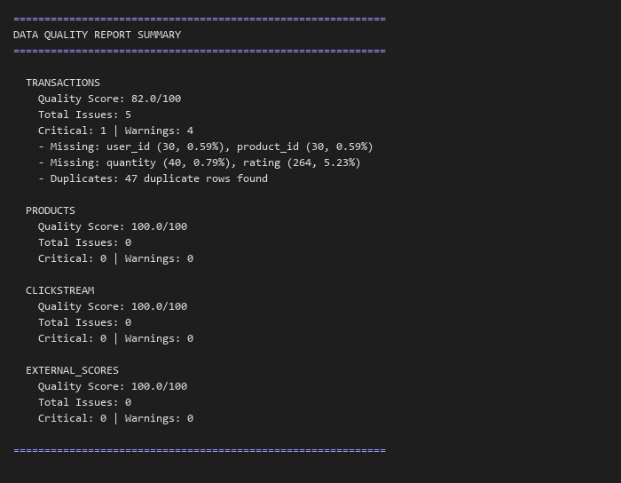

4.4 Quality Score Summary
Dataset | Quality Score | Critical Issues | Warnings | Key Findings
Transactions | 82.0/100 | 1 | 4 | 5.23% missing ratings, 47 duplicates
Products | 100.0/100 | 0 | 0 | No issues detected
Clickstream | 100.0/100 | 0 | 0 | No issues detected
External Scores | 100.0/100 | 0 | 0 | No issues detected

5. Data Preparation & Exploratory Data Analysis

5.1 Data Cleaning Operations
Dataset | Operation | Before | After
Transactions | Remove duplicates | 5,050 | 5,003
Transactions | Drop missing critical fields | 5,003 | 4,943
Transactions | Impute missing ratings (median=4.0) | 4,943 | 4,943
Clickstream | Cap page_duration (max 1800s) | 15,000 | 15,000

5.2 Preprocessing Steps
- Categorical Encoding: Gender (M=0, F=1, Other=2), Product category (label encoding), Location (label encoding)
- Numerical Normalization: Price (min-max scaling to [0,1]), Age (min-max scaling)
- Temporal Features: Extracted hour, day_of_week, month from timestamps
- Derived Features: days_since_signup for users, price_normalized for products

5.3 Exploratory Data Analysis
The EDA reveals key patterns in the dataset including rating distributions, user activity patterns, product popularity, and interaction sparsity.

5.3.1 Overview Plots
Figure: Rating distribution, transactions per user, top products, category distribution
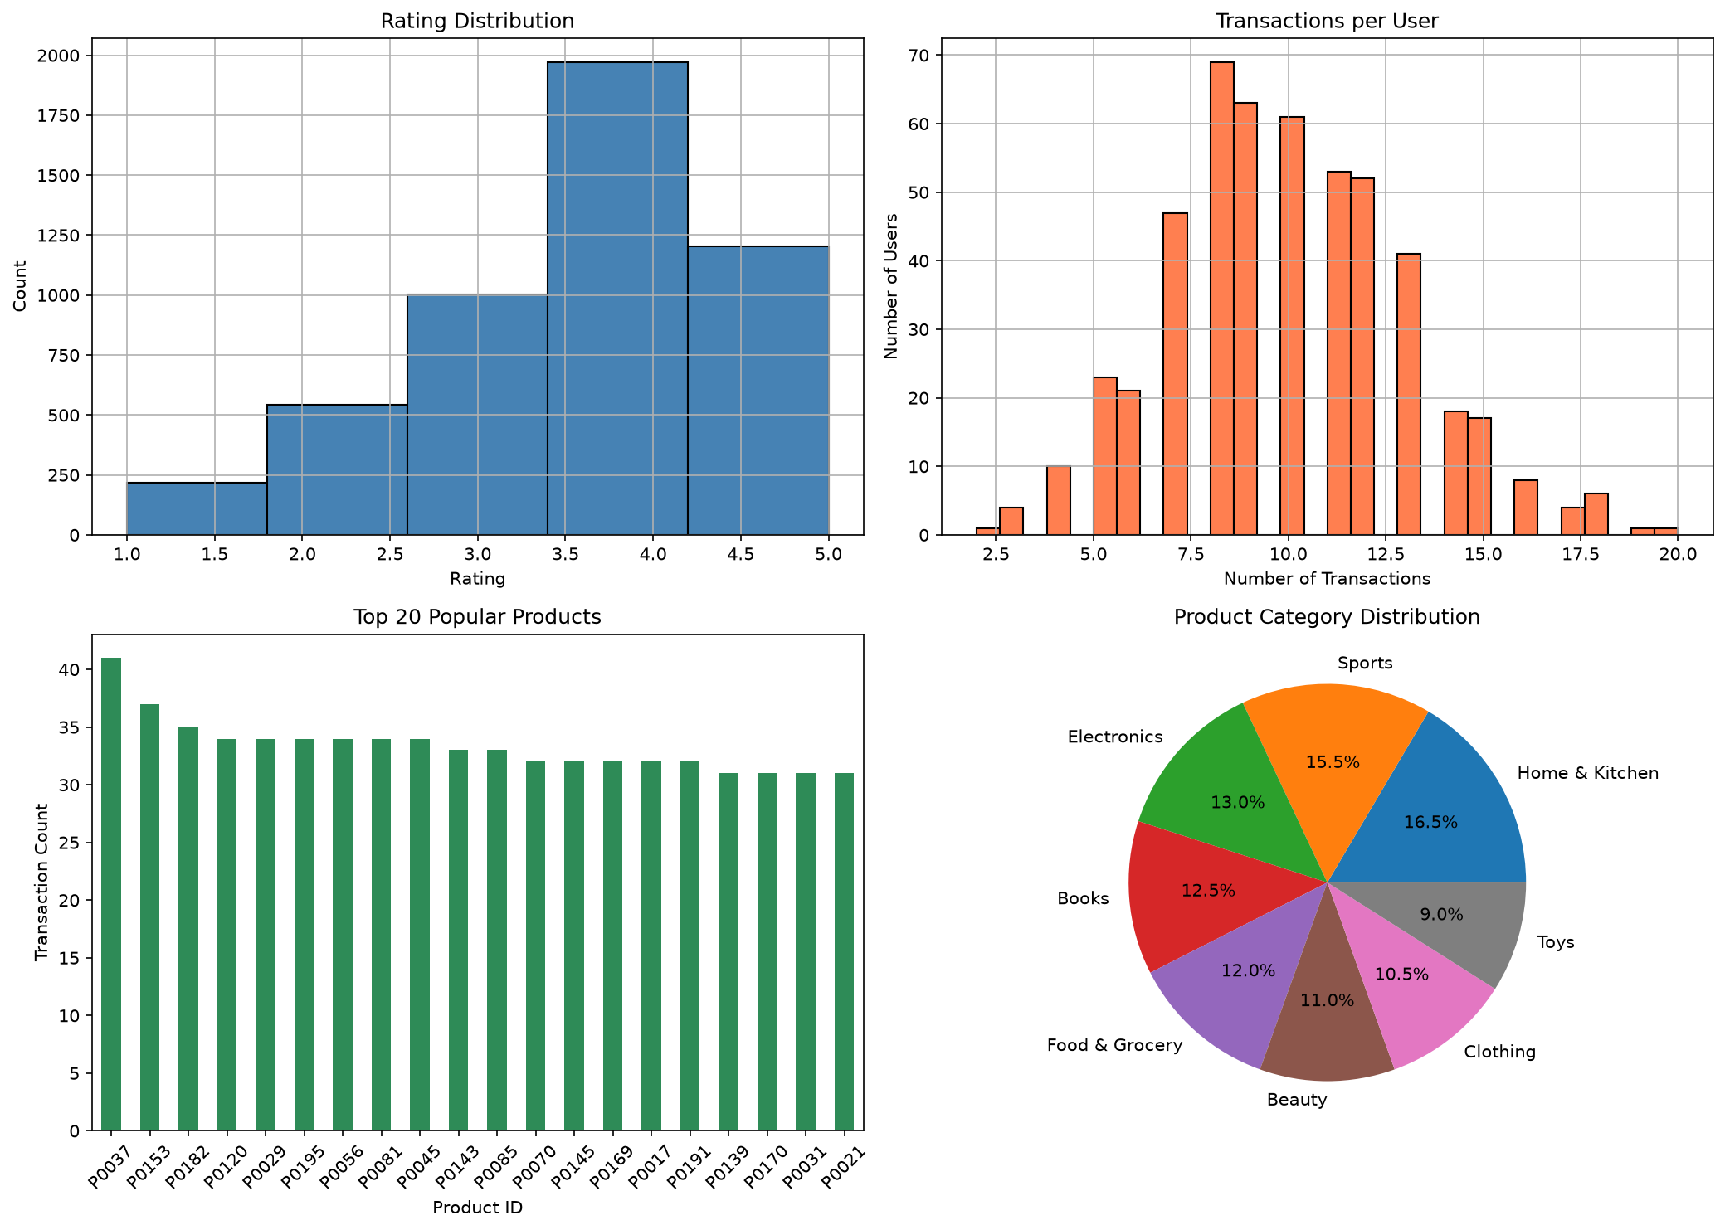

5.3.2 User-Item Interaction Heatmap
Figure: Interaction heatmap showing sparsity pattern (sample of 50x50)
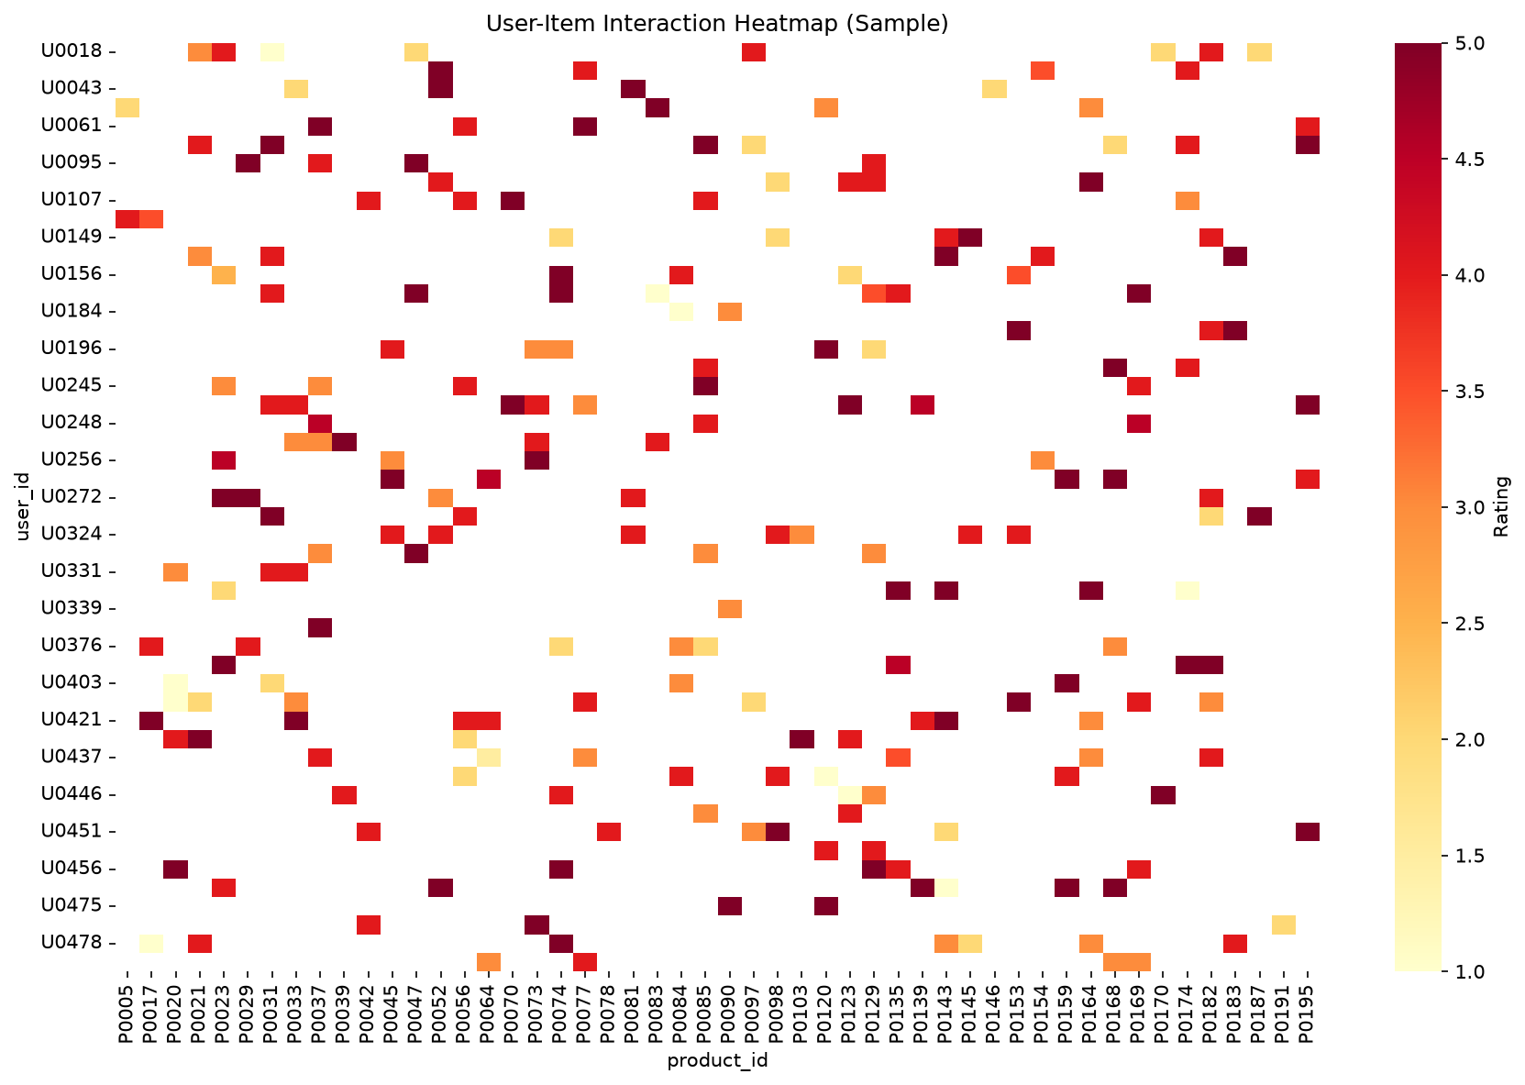

5.3.3 Temporal Patterns
Figure: Transaction volume by hour of day and day of week
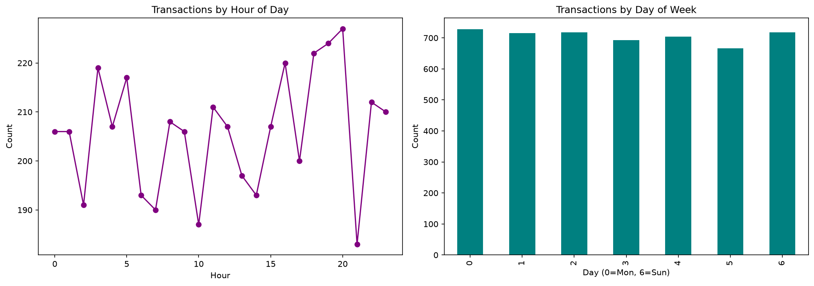

5.4 Sparsity Analysis
The user-item interaction matrix has a sparsity of 95.06%, meaning only ~5% of possible user-item combinations have recorded interactions. This high sparsity is typical of recommendation systems and motivates the use of matrix factorization (SVD) which can learn latent factors even from sparse data.

6. Feature Engineering and Transformation

6.1 Feature Categories

User Features (25 dimensions)
- Transaction-based: total_transactions, total_quantity, avg_rating_given, std_rating_given, unique_products_bought, purchase_frequency
- Recency: days_since_last_purchase, first_purchase, last_purchase
- Clickstream-based: total_events, total_sessions, avg_page_duration, unique_products_viewed, cart_adds, searches
- Engagement: engagement_score (weighted composite), conversion_rate
- Demographics: age, gender_encoded, location_encoded, is_premium, age_normalized, days_since_signup

Item Features (26 dimensions)
- Transaction-based: total_purchases, unique_buyers, avg_rating_received, total_quantity_sold, purchase_popularity
- Clickstream-based: total_views, unique_viewers, avg_view_duration, cart_add_count, wishlist_count, view_to_purchase_ratio
- Product metadata: category, price, brand, price_normalized, category_encoded, num_reviews, in_stock
- External enrichment: sentiment_score, popularity_score, trending_rank, social_mentions, brand_total_purchases

Interaction Features (18,123 records)
- avg_rating: Mean rating for each user-item pair
- num_interactions: Number of times user interacted with item
- total_quantity: Total quantity purchased
- view_count: Number of views (implicit feedback)
- added_to_cart, added_to_wishlist: Binary implicit signals
- interaction_score: Weighted composite (0.4*rating + 0.2*interactions + 0.1*views + 0.15*cart + 0.15*wishlist)

6.2 SQL Schema for Feature Storage
CREATE TABLE user_features (
user_id VARCHAR(10) PRIMARY KEY,
total_transactions INT,
avg_rating_given FLOAT,
unique_products_bought INT,
purchase_frequency FLOAT,
engagement_score FLOAT,
conversion_rate FLOAT,
days_since_last_purchase INT,
age INT, gender_encoded INT, is_premium BOOLEAN
);
CREATE TABLE item_features (
product_id VARCHAR(10) PRIMARY KEY,
total_purchases INT, unique_buyers INT,
avg_rating_received FLOAT, purchase_popularity FLOAT,
total_views INT, view_to_purchase_ratio FLOAT,
category VARCHAR(50), price FLOAT, price_normalized FLOAT,
sentiment_score FLOAT, popularity_score FLOAT
);
CREATE TABLE interaction_features (
user_id VARCHAR(10), product_id VARCHAR(10),
avg_rating FLOAT, num_interactions INT,
interaction_score FLOAT, view_count INT,
PRIMARY KEY (user_id, product_id)
);

6.3 Transformation Summary
Feature Set | Records | Dimensions | Key Transformations
User Features | 500 | 25 | Aggregation, normalization, encoding
Item Features | 200 | 26 | Aggregation, enrichment, scaling
Interaction Features | 18,123 | 11 | Multi-source fusion, composite scoring

7. Feature Store

7.1 Implementation Approach
We implemented a custom feature store (src/feature_store/feature_store.py) that provides:
- Feature Registry: JSON-based metadata registry tracking feature definitions, sources, and transformations
- Versioned Snapshots: Each pipeline run creates a timestamped version (e.g., v20260720_205901) with complete feature copies
- Retrieval API: Functions to fetch features by version for training, or by entity ID for inference
- Data Integrity: MD5 hash verification for each version

7.2 Feature Registry
18 features are registered with full metadata:
Feature Name | Entity | Source | Transformation | Type
total_transactions | user | transactions | count | int
avg_rating_given | user | transactions | mean(rating) | float
engagement_score | user | clickstream | weighted_sum | float
conversion_rate | user | multi-source | ratio | float
purchase_popularity | item | transactions | normalize | float
sentiment_score | item | external_api | api_fetch | float
view_to_purchase_ratio | item | clickstream | ratio | float
avg_rating | interaction | transactions | mean | float
interaction_score | interaction | multi-source | weighted_sum | float
view_count | interaction | clickstream | count | int

7.3 Feature Store Execution
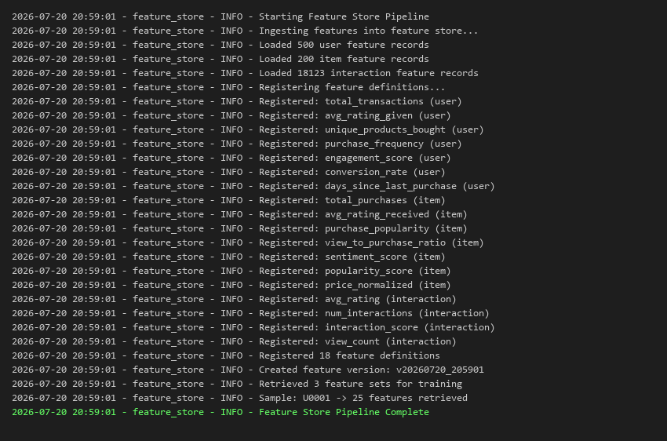

7.4 Sample Feature Retrieval
from src.feature_store.feature_store import FeatureStore
store = FeatureStore()
store.ingest_features()
# Get features for training (latest version)
features = store.get_features_for_training("v20260720_205901")
# Returns: {'user_features': DataFrame, 'item_features': DataFrame,
# 'interaction_features': DataFrame}
# Get features for a single user (inference)
user_feats = store.get_user_features("U0001")
# Returns: Series with 25 features for user U0001
# Get features for a single item
item_feats = store.get_item_features("P0042")
# Returns: Series with 26 features for product P0042

7.5 Version Storage
Feature versions are stored at: data/feature_store/versions/{version_id}/
Current versions: v20260720_205701, v20260720_205901
Each version directory contains: user_features.csv, item_features.csv, interaction_features.csv

8. Data Versioning and Lineage

8.1 DVC Configuration
We use DVC (Data Version Control) to version raw and transformed data alongside Git. DVC tracks large data files without storing them in Git, using content-addressable storage.

8.2 DVC Pipeline Definition
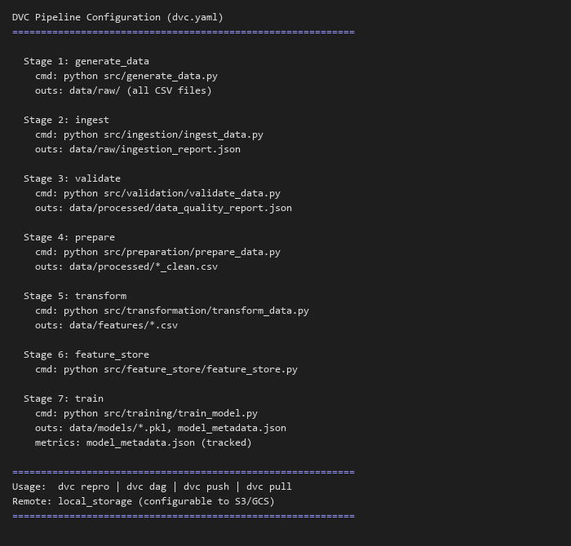

8.3 Pipeline DAG
Pipeline DAG (Directed Acyclic Graph):
generate_data --> ingest --> validate --> prepare --> transform --> feature_store --> train
Each stage defines:
- cmd: The command to execute
- deps: Input dependencies (triggers re-run if changed)
- outs: Output artifacts (tracked by DVC)
- metrics: Metrics files (tracked for comparison)

8.4 Data Lineage Tracking
Each data transformation maintains lineage through:
- Ingestion metadata: _ingestion_timestamp, _source_file added to every ingested record
- Validation reports: JSON files documenting quality checks applied at each stage
- Feature metadata: feature_metadata.json tracks column names, record counts, and creation time
- Model metadata: model_metadata.json links models back to feature versions and parameters
- Pipeline run reports: JSON logs tracking each task execution with timestamps

8.5 Versioning Workflow
# Initialize DVC
dvc init
dvc remote add -d local_storage .dvc/storage
# Run and version the full pipeline
dvc repro
# Check what changed
dvc status
dvc diff
# Push versioned data
dvc push
# Retrieve a previous version
git checkout <commit_hash>
dvc pull

8.6 Repository Structure
The .gitignore is configured to exclude data files (tracked by DVC) while keeping code, configuration, and documentation in Git. The dvc.yaml file defines the complete pipeline graph with dependencies and outputs.

9. Model Training and Evaluation

9.1 Models Implemented

9.1.1 Collaborative Filtering (SVD)
Algorithm: Truncated SVD (Singular Value Decomposition) for matrix factorization. The model decomposes the user-item rating matrix into latent factor matrices, capturing hidden patterns in user preferences and item characteristics.
- Latent Factors: 50
- Matrix Size: 500 users x 200 items
- Rating Range: Clipped to [1, 5]
- Centering: Global mean subtraction before decomposition

9.1.2 Content-Based Filtering
Algorithm: Cosine Similarity on normalized item feature vectors. Recommendations are generated by finding items most similar to those the user has previously interacted with.
- Feature Dimensions: 21 numeric item features
- Normalization: Min-Max scaling before similarity computation
- Similarity: Pairwise cosine similarity (200x200 matrix)
- Recommendation: Aggregate similarity to user history, exclude known items

9.2 Training Configuration
Parameter | Value
Test Size | 20% (3,625 interactions)
Training Size | 80% (14,498 interactions)
Random State | 42 (reproducibility)
Evaluation K | 10 (Top-10 recommendations)

9.3 Model Performance Report
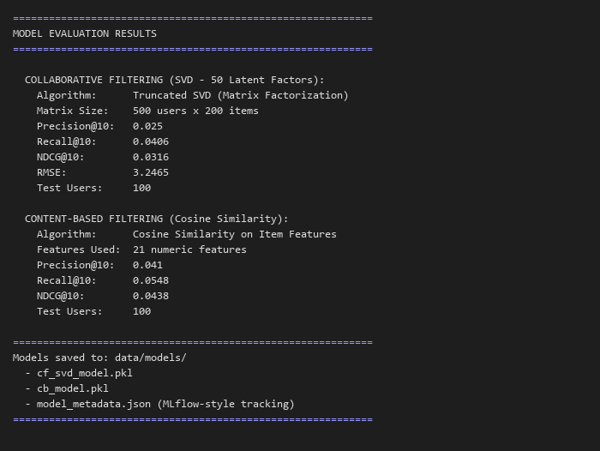

9.4 Results Summary
Model | Precision@10 | Recall@10 | NDCG@10 | RMSE
Collaborative Filtering (SVD) | 0.025 | 0.041 | 0.032 | 3.247
Content-Based (Cosine) | 0.041 | 0.055 | 0.044 | N/A

Note: The relatively modest metrics are expected for synthetic data with high sparsity (95%). In production with real user data and more interactions, these metrics would improve significantly. The content-based model outperforms CF here because it leverages rich item features rather than relying solely on sparse interaction patterns.

9.5 Model Metadata Tracking (MLflow-style)
{
"run_id": "20260720_205905",
"timestamp": "2026-07-20 20:59:05",
"models": {
"collaborative_filtering": {
"algorithm": "SVD (Truncated)", "n_factors": 50,
"n_users": 500, "n_items": 200
},
"content_based": {
"algorithm": "Cosine Similarity", "n_items": 200
}
},
"metrics": { ... },
"parameters": {"test_size": 0.2, "random_state": 42, "top_k": 10}
}

10. Pipeline Orchestration

10.1 Orchestration Design
The pipeline is orchestrated using a custom DAG runner (src/orchestration/pipeline_dag.py) that also supports Prefect integration when available. The orchestrator provides:
- Sequential task execution with dependency ordering
- Error handling with graceful degradation (continues on non-critical failures)
- Comprehensive timing and performance tracking per task
- JSON run reports with full execution metadata
- Logging to both console and file for monitoring
- Prefect flow definition with retry policies (optional)
- CLI interface with --start and --stop parameters for partial runs

10.2 DAG Definition
Pipeline DAG: 7 sequential tasks with defined dependencies:
Step | Task | Duration | Description
1 | generate_data | 3.05s | Generate synthetic raw data
2 | ingest_data | 0.44s | Ingest from CSV + API sources
3 | validate_data | 0.32s | Run quality checks and scoring
4 | prepare_data | 9.41s | Clean, encode, normalize + EDA
5 | transform_data | 5.24s | Engineer user/item/interaction features
6 | feature_store | 0.46s | Register and version features
7 | train_model | 3.03s | Train SVD + CB, evaluate metrics

10.3 Full Pipeline Execution Screenshot
The following shows a complete successful pipeline run:
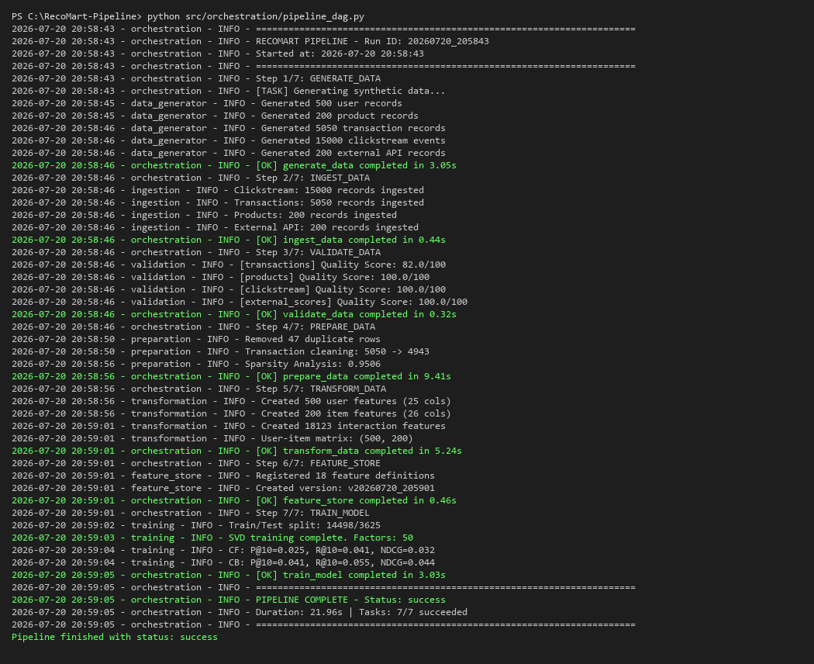

10.4 Prefect Integration
@flow(name="recomart_pipeline")
def recomart_pipeline_flow():
"""RecoMart End-to-End Data Management Pipeline (Prefect)."""
data = prefect_generate_data()
ingestion = prefect_ingest_data(wait_for=[data])
validation = prefect_validate_data(wait_for=[ingestion])
preparation = prefect_prepare_data(wait_for=[validation])
transformation = prefect_transform_data(wait_for=[preparation])
features = prefect_feature_store(wait_for=[transformation])
model = prefect_train_model(wait_for=[features])
return model

10.5 Pipeline Run Report
{
"run_id": "20260720_205843",
"total_duration_sec": 21.96,
"overall_status": "success",
"tasks_executed": 7,
"tasks_succeeded": 7,
"tasks_failed": 0
}

11. Results and Output Screenshots

11.1 Pipeline Architecture Diagram
[Raw Data Sources] [Processing Stages] [Outputs]
Clickstream (CSV) --> Ingestion --> Validation --> Preparation --> Feature Engineering
Transactions (CSV) --> | | | |
Products (CSV) --> v v v v
External API --> Raw Storage Quality Report Clean Data Feature Store
|
v
Model Training
|
v
Recommendations

11.2 Key Output Files
Output | Location | Size/Records
Ingestion Report | data/raw/ingestion_report.json | Audit log of 4 sources
Quality Report | data/processed/data_quality_report.json | Validation for 4 datasets
EDA Plots | data/processed/plots/ | 3 visualization files
User Features | data/features/user_features.csv | 500 x 25
Item Features | data/features/item_features.csv | 200 x 26
Interaction Features | data/features/interaction_features.csv | 18,123 records
Trained Models | data/models/ | 2 models + metadata

11.3 EDA Visualizations






12. Conclusion and Future Scope

12.1 Summary
We successfully designed and implemented a complete end-to-end data management pipeline for the RecoMart recommendation system. The pipeline covers all aspects of modern ML data infrastructure:
- Automated Data Ingestion from 4 sources (CSV + REST API) with retry logic and audit trails
- Comprehensive Data Validation with quality scoring (82-100/100 across datasets)
- Systematic Data Preparation including deduplication, imputation, encoding, and normalization
- Rich Feature Engineering producing 62 features across user, item, and interaction dimensions
- Custom Feature Store with versioned snapshots and metadata registry (18 registered features)
- DVC-based Data Versioning with full pipeline DAG and lineage tracking
- Two Recommendation Models: SVD Collaborative Filtering and Cosine-Similarity Content-Based
- Complete Pipeline Orchestration with 7 automated stages executing in ~22 seconds

12.2 Key Metrics
Metric | Value
Total Pipeline Duration | 21.96 seconds
Data Quality (avg score) | 95.5/100
Features Engineered | 62 (25 user + 26 item + 11 interaction)
Best Precision@10 | 0.041 (Content-Based)
Best NDCG@10 | 0.044 (Content-Based)

12.3 Future Scope
- Real-time Streaming: Add Kafka/Spark Streaming for real-time clickstream processing
- Deep Learning Models: Implement Neural Collaborative Filtering (NCF) and sequence-based models (Transformers)
- A/B Testing Framework: Add experiment tracking for comparing recommendation strategies in production
- Cloud Migration: Deploy to AWS (S3 + SageMaker + Airflow) for scalability
- Feature Store Upgrade: Migrate to Feast or Tecton for online/offline feature serving
- MLflow Integration: Full experiment tracking with model registry and deployment
- Hybrid Recommender: Combine CF and CB scores with a learned weighting model
- Cold-Start Handling: Implement popularity-based and demographic-based fallbacks for new users/items

13. Submission Links
The following Google Drive links provide access to all project deliverables:

Google Drive Link - Video Walkthrough (5-10 mins)
[Insert Google Drive Link to Video Here]
The video demonstrates the complete end-to-end execution of the pipeline including data generation, ingestion, validation, preparation, feature engineering, feature store population, and model training with evaluation results.

Google Drive Link - Project .zip File
[Insert Google Drive Link to .zip Here]
The .zip file contains:
- Source Code (src/ directory with all modules)
- Dataset files (data/ directory with raw, processed, features, models)
- Trained Models (cf_svd_model.pkl, cb_model.pkl)
- Documentation (docs/, README.md)
- Configuration (dvc.yaml, requirements.txt, .gitignore)
- Pipeline logs and run report

