Input and Output Samples of the Model

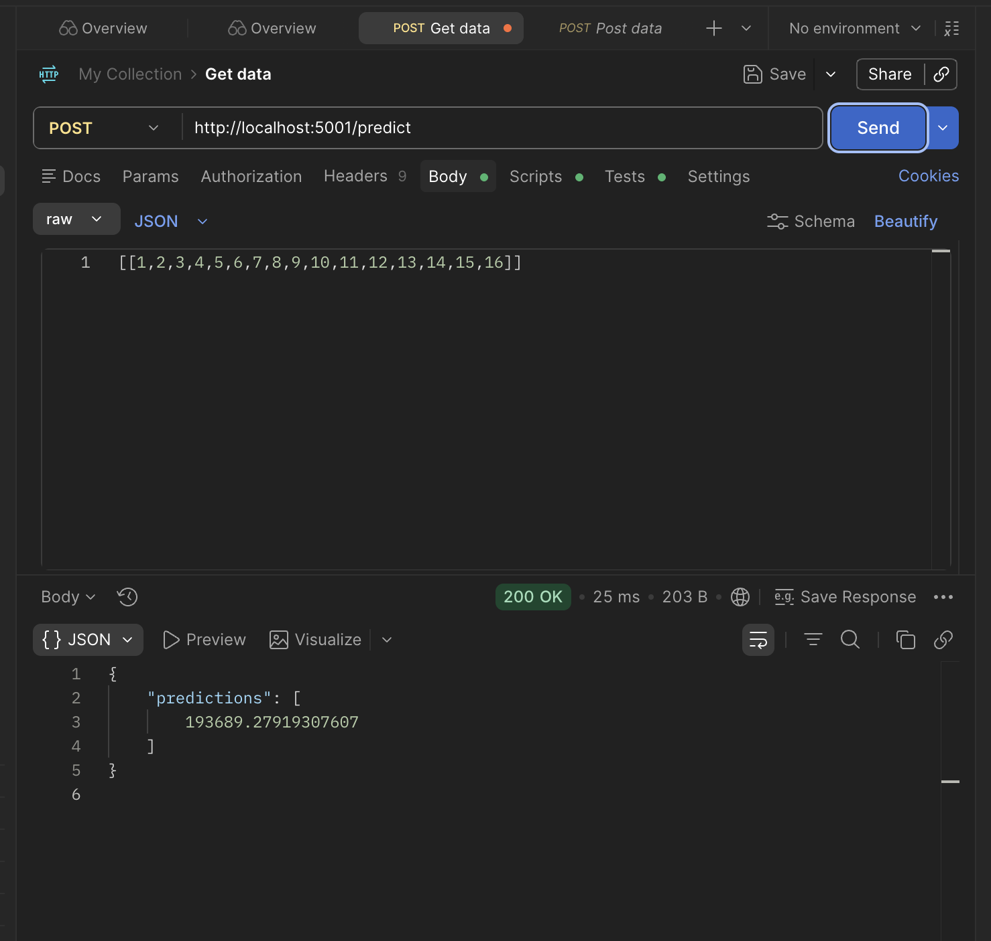
Sample 1:
The model predicts time taken as 193689.27919307607 based on the input.

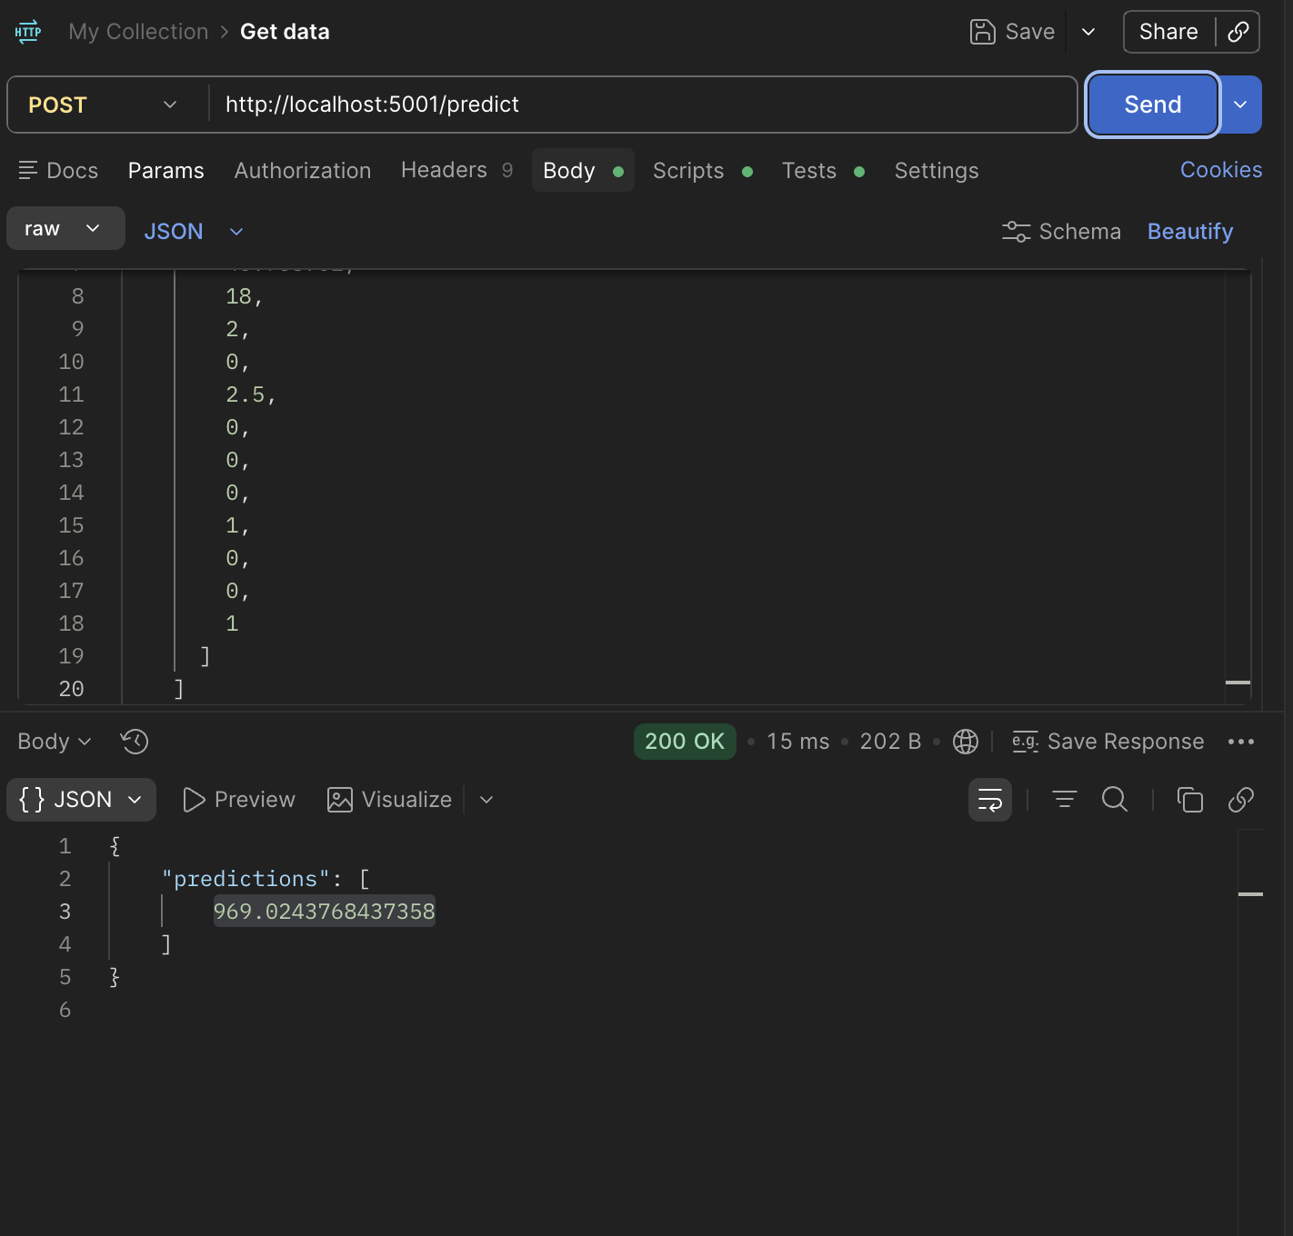
Sample 2:
The model predicts time taken as 969.024 seconds

Sample 3:

