AI/ML CERTIFICATION
Technical Architecture Document
Customer Sentiment Analysis
End-to-End NLP Classification, REST API and Containerized Deployment

1. Purpose and Scope
This document describes the technical architecture of the Customer Sentiment Analysis project submitted for the AI/ML certification. It focuses on the implemented data-processing, feature-engineering, model-training, model-persistence, REST-serving and Docker-deployment components, and separately identifies monitoring and retraining elements that are architectural design considerations rather than fully implemented runtime capabilities in the supplied code.
Architecture principle
The solution separates offline machine-learning development from online inference. Training produces serialized model artifacts; the FastAPI layer consumes those artifacts to serve predictions without retraining.

2. Architecture at a Glance
The architecture follows a staged ML lifecycle. Raw customer sentiment data is transformed into normalized text, converted into engineered linguistic features, used to train and evaluate five classifiers, and persisted as model artifacts. The serving layer loads these artifacts and exposes prediction endpoints through FastAPI. Docker provides a portable execution environment.
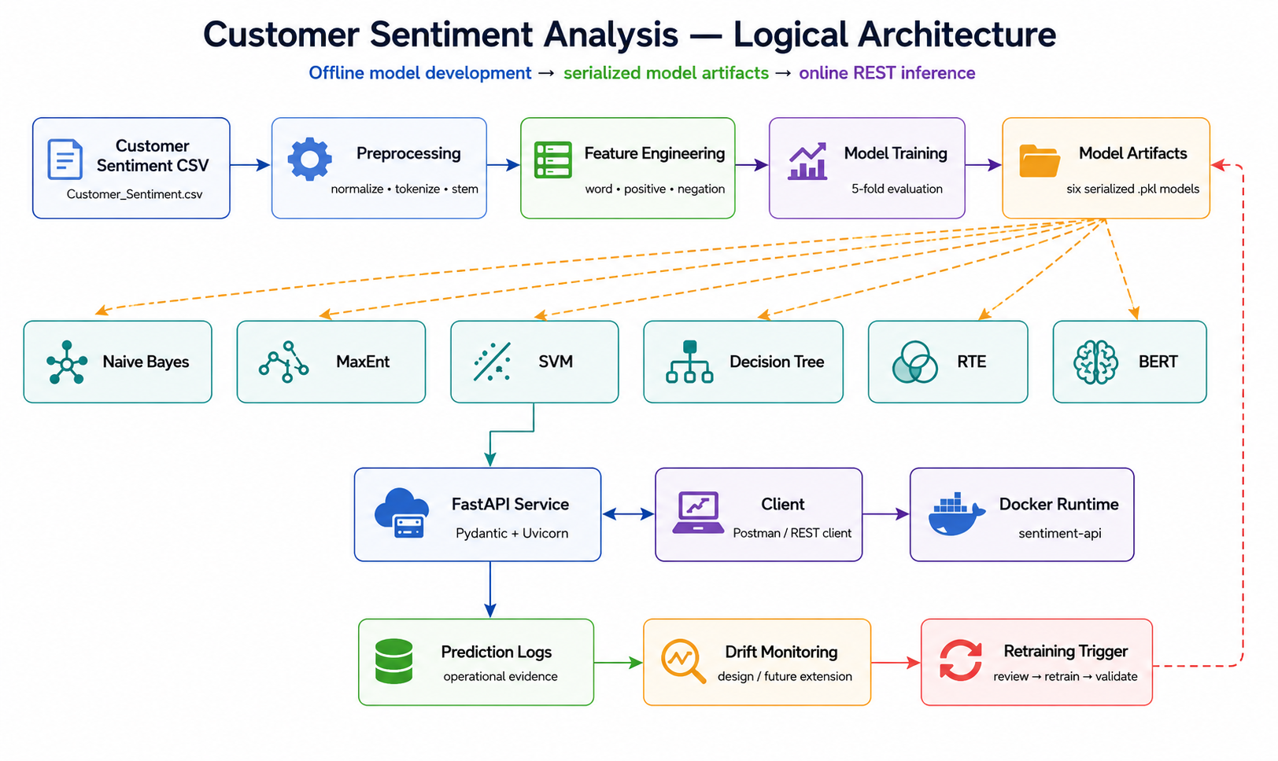
Architectural Layer | Primary Components | Responsibility
Data | Customer_Sentiment.csv | Source customer/review records.
Preprocessing | preprocess.ipynb | Text normalization and processed/shuffled datasets.
Features | NLTK/Python feature functions | Word presence, positive lexical signals and negation context.
Training | preprocess_and_train.ipynb | Five classifiers with five-fold evaluation.
Persistence | models/*.pkl | Serialized classifiers used for inference.
Experiment evidence | logs/*.txt | Fold accuracy, average accuracy, feature information and confusion matrices.
Serving | api.py / FastAPI | REST interface and prediction execution.
Runtime packaging | Dockerfile | Container image and runtime configuration.
Monitoring design | Logging / drift / retraining design | Operational lifecycle extension; automation is not fully present in supplied code.

3. Component Architecture

3.1 Data and preprocessing components
Component | Input | Output | Key responsibility
Raw dataset | Customer_Sentiment.csv | In-memory dataframe | Load source records.
Preprocessor | review_text | Normalized text | Handles URLs, handles, hashtags, emoticons, punctuation and repeated characters.
Processed dataset writer | Processed records | preprocessed_reviews.csv | Persist cleaned review text and sentiment.
Shuffle stage | Processed CSV lines | preprocessed_reviews_shuffled.csv | Randomize record ordering for downstream training.

3.2 Feature-engineering component
The feature representation is dictionary-based and NLTK-compatible. It is not a TF-IDF implementation in the current supplied notebooks. The feature extractor stems tokens, removes English stopwords, identifies positive lexical terms, and produces left/right negation features.
Feature | Example form | Purpose
Word presence | has(<stem>) = 1 | Represents occurrence of a token/stem.
Positive term | pos(<stem>) = 1 | Adds explicit positive lexical evidence.
Left negation | neg_l(<stem>) | Captures nearby negation context.
Right negation | neg_r(<stem>) | Captures nearby negation context.
Bert Model | all-MiniLM-L6-v2 | Bert mini word features model

4. Model Training Architecture
The training architecture is implemented in preprocess_and_train.ipynb. The notebook loads the shuffled processed dataset, creates the feature dictionaries, evaluates five classifiers using five folds, logs the results, and serializes the final classifier instance for each algorithm.
Classifier | Implementation in supplied code | Artifact
Naive Bayes | nltk.classify.NaiveBayesClassifier | NaiveBayesClassifier_pkl_model.pkl
MaxEnt | nltk.classify.MaxentClassifier (GIS) | MaxentClassifier_pkl_model.pkl
SVM | NLTK SklearnClassifier wrapping sklearn.svm.SVC | SvmClassifier_pkl_model.pkl
Decision Tree | nltk.classify.DecisionTreeClassifier | DecisiontreeClassifier_pkl_model.pkl
RTE | NLTK RTE classifier / IIS training | RTEClassifier_pkl_model.pkl
BERT | Sentence transformer | BertClassifier_pkl_model.pkl

4.1 Five-fold evaluation
The Classifier implementation uses FOLDS=5. For each fold, records whose index modulo five differs from the fold identifier are used for training, while records matching that identifier are used for testing. Accuracy is captured for every fold and averaged.

4.2 Experiment evidence
The supplied training workflow redirects classifier output to timestamped files under logs/. The observed training output reports near-perfect fold accuracy for all five classifiers. These results are documented as observed output rather than interpreted as proof of production generalization.
Model | Reported average accuracy | Observation
Naive Bayes | ~0.99992 | Very high; verify with clean holdout.
MaxEnt | 1.00000 | Perfect in supplied five-fold output.
SVM | ~0.99992 | Very high; verify with clean holdout.
Decision Tree | ~0.99992 | Very high; verify with clean holdout.
RTE | 1.00000 | Perfect in supplied five-fold output.
Evaluation caution
The current ingestion code reads the CSV with an explicit names list without removing the existing header row. The reported metrics are therefore best treated as development evidence. A final production benchmark should remove the header row, use a clean stratified split and evaluate against an untouched holdout dataset.

5. Model Artifact and Serving Architecture
Model training and inference are intentionally separated. After training, each classifier is serialized using dill. The API does not need to execute the training notebook for normal inference. Instead, it loads an existing model artifact from the configured model directory.
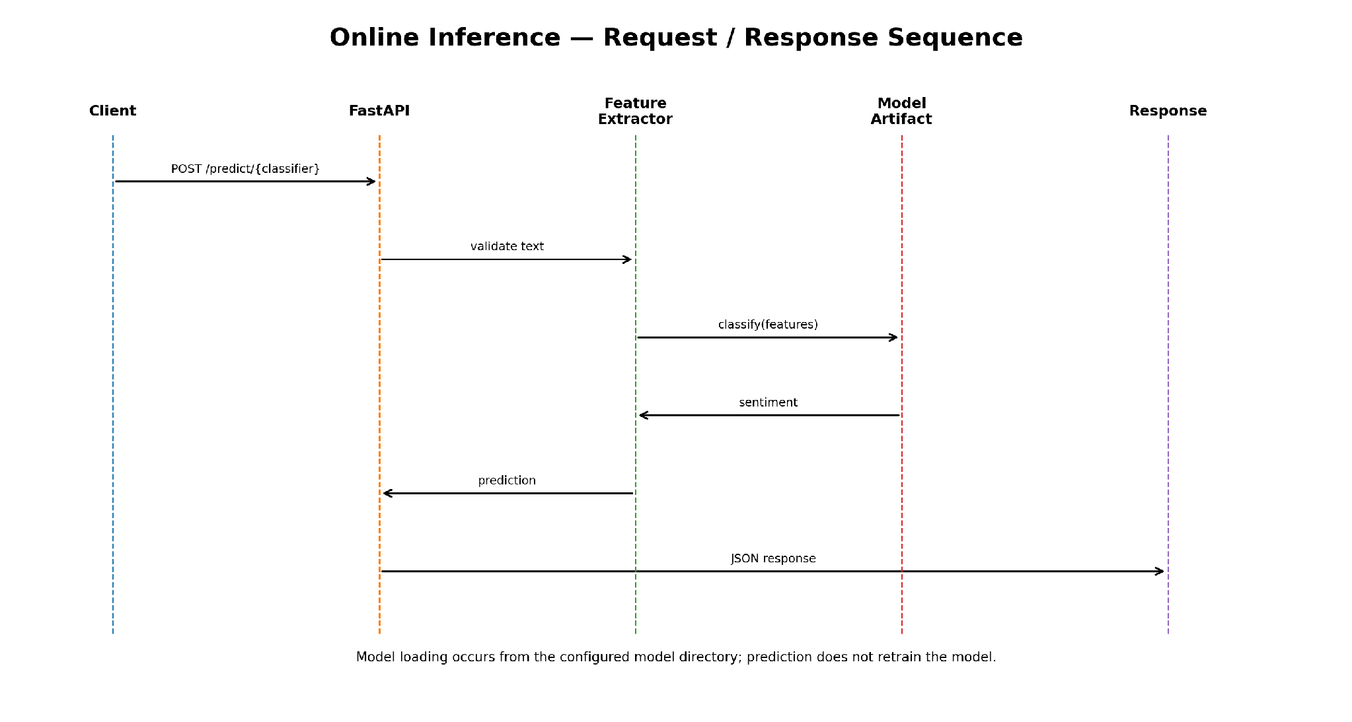

6. REST API Architecture
api.py implements a FastAPI service. The API defines a Pydantic TextRequest model containing the incoming text, maps classifier-specific routes to model artifacts, applies the feature-extraction logic, and returns a JSON response.
Endpoint | Method | Purpose
/ | GET | Health/status response and list of available endpoints.
/predict/naivebayes | POST | Sentiment prediction using Naive Bayes.
/predict/maxent | POST | Sentiment prediction using MaxEnt.
/predict/svm | POST | Sentiment prediction using SVM.
/predict/decisiontree | POST | Sentiment prediction using Decision Tree.
/predict/rte | POST | Sentiment prediction using RTE.

6.1 Request and response contract
POST http://localhost:8000/predict/naivebayes
Content-Type: application/json
{
"text": "great value for the money"
}
{
"classifier": "NaiveBayesClassifier",
"text": "great value for the money",
"sentiment": "positive"
}

6.2 Error handling and validation
- Pydantic validates the request body structure.
- The model loader checks whether the model directory exists.
- The loader searches for the requested .pkl artifact and reports a server error when the artifact is missing or cannot be loaded.
- Production hardening should additionally reject empty/whitespace-only text and enforce a maximum payload length.

7. Deployment Architecture
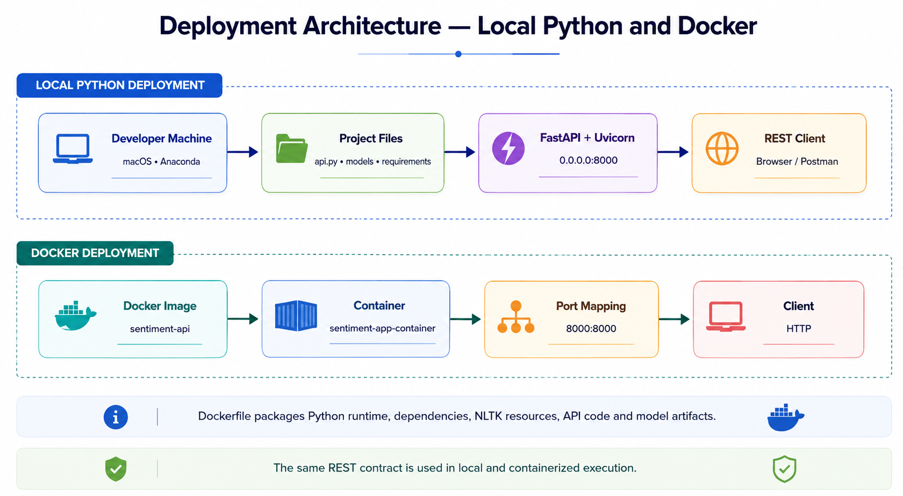

7.1 Local deployment
pip install -r requirements.txt
python api.py
http://localhost:8000/
The application starts Uvicorn on 0.0.0.0:8000, making the service accessible through the local machine's port 8000.

7.2 Container deployment
docker build -t sentiment-api .
docker run -d -p 8000:8000 --name sentiment-app-container sentiment-api
The supplied Dockerfile uses python:3.10-slim, installs system build tools and Python dependencies, downloads required NLTK resources during image construction, copies model artifacts and api.py into the image, exposes port 8000, and starts the API.

8. Operational and Non-Functional Architecture
Concern | Current design | Recommended hardening
Configuration | Model directory is configured in api.py. | Move paths/ports to environment variables.
Model loading | Artifact is loaded from configured model directory. | Load once at startup and cache in memory.
Input validation | Pydantic request model. | Reject empty text; enforce max length.
Dependency management | requirements.txt supplied. | Pin exact versions for reproducibility.
Logging | Training logs are timestamped. | Add structured API request, latency and error logs.
Health | GET / reports service status. | Add readiness check that verifies model availability.
Container | Dockerfile provided. | Use non-root user and image vulnerability scanning.
Monitoring | Conceptual design. | Implement measurable drift metrics and alert thresholds.

9. Monitoring, Concept Drift and Retraining Architecture
The supplied architecture anticipates an M5 lifecycle in which prediction activity is logged and changes in incoming language are monitored. The supplied code does not constitute a complete automated drift-monitoring service, so this section distinguishes the intended operating architecture from currently implemented functionality.
Stage | Signal | Action
Input monitoring | Vocabulary, unseen terms, slang/topic frequency | Compare against training baseline.
Prediction monitoring | Positive/negative/neutral distribution | Detect sustained distribution shift.
Feature monitoring | Frequency/distribution of engineered features | Measure population shift.
Performance monitoring | Accuracy/F1 when labels become available | Trigger model review if below threshold.
Operational monitoring | API error rate and latency | Investigate service degradation.

9.1 Proposed retraining flow
- Detect sustained drift or performance degradation.
- Create a new labeled dataset containing representative recent customer text.
- Run the same preprocessing and feature-engineering pipeline.
- Retrain and compare all candidate classifiers.
- Validate against an untouched holdout set.
- Promote the new artifact only when acceptance criteria are met.
- Retain the previous artifact and experiment logs for rollback and traceability.

10. End-to-End Data Flow
Step | Input | Processing | Output
1 | Raw CSV | Load customer records | Dataframe
2 | Review text | Normalize URLs, handles, hashtags, emoticons and punctuation | Clean text
3 | Clean text | Stem and remove stopwords | Tokens/stems
4 | Tokens/stems | Create word, positive and negation features | Feature dictionary
5 | Feature dictionaries + labels | Five-fold training/evaluation | Accuracy, confusion matrices, logs
6 | Trained classifier | Serialize with dill | models/*.pkl
7 | REST request | Validate and transform incoming text | Prediction features
8 | Features + selected artifact | Classifier inference | Sentiment JSON response
9 | Prediction evidence | Monitor distribution/performance | Retraining decision

11. Repository / Deployment Structure
CustSentiAnalysis/
├── data/
│ ├── Customer_Sentiment.csv
│ ├── preprocessed_reviews.csv
│ └── preprocessed_reviews_shuffled.csv
├── models/
│ ├── NaiveBayesClassifier_pkl_model.pkl
│ ├── MaxentClassifier_pkl_model.pkl
│ ├── SvmClassifier_pkl_model.pkl
│ ├── DecisiontreeClassifier_pkl_model.pkl
│ └── RTEClassifier_pkl_model.pkl
│ └── BertClassifier_pkl_model.pkl
├── logs/
├── preprocess.ipynb
├── preprocess_and_train.ipynb
├── load_model_and_test.ipynb
├── api.py
├── Dockerfile
├── requirements.txt
└── GitCommands_customer_senti.txt

12. Key Architecture Decisions and Rationale
Decision | Rationale
Separate training from serving | Prevents inference from depending on expensive training execution and allows existing artifacts to be reused.
Multiple classifiers | Provides a comparative basis for model selection instead of assuming a single algorithm is optimal.
Five-fold evaluation | Provides repeated validation across folds rather than relying on one evaluation partition.
Feature-based NLP | Produces interpretable lexical and negation features and aligns with the current NLTK implementation.
Serialized model artifacts | Allows the API to load trained models without retraining.
FastAPI | Provides a lightweight REST interface with typed request validation through Pydantic.
Docker | Packages runtime dependencies, application code and model artifacts for consistent deployment.

13. Architecture-to-Code Traceability
Architecture element | Source artifact | Evidence / responsibility
Preprocessing | preprocess.ipynb | Reads raw CSV, normalizes review text, writes processed/shuffled datasets.
Feature engineering | preprocess.ipynb + preprocess_and_train.ipynb | Tokenization/stemming, word/positive/negation feature construction.
Training | preprocess_and_train.ipynb | Five classifier training and five-fold evaluation.
Experiment logging | preprocess_and_train.ipynb | Timestamped stdout capture into logs.
Model persistence | preprocess_and_train.ipynb | dill serialization to models/.
Inference | api.py | Request model, feature extraction, classifier loading and prediction endpoints.
Containerization | Dockerfile | Runtime image and startup command.
Dependencies | requirements.txt | Python packages required by the implementation.

14. Architecture Risks and Mitigations
Risk | Impact | Mitigation
Header row retained during CSV ingestion | Can contaminate training/evaluation. | Use header=0 or explicitly remove header before modeling.
Near-perfect validation results | May indicate leakage, overly strong lexical cues or non-representative validation. | Add untouched holdout and review feature/label construction.
Training/inference code duplication | Feature transformations could diverge. | Move shared preprocessing/feature logic into a reusable module.
Per-request model loading | Can increase latency and I/O. | Cache artifacts at application startup.
Unpinned dependencies | Reproducibility risk. | Pin versions and capture environment.
Monitoring not fully automated | Drift may be detected late. | Implement prediction logging, baseline comparison and alerting.

15. Recommended Technical Demonstration
- Show the architecture diagram and explain the offline-to-online separation.
- Open preprocess.ipynb and demonstrate raw data → processed/shuffled data.
- Open preprocess_and_train.ipynb and show the five classifiers and five-fold results.
- Show the generated .pkl model artifacts and timestamped experiment logs.
- Start the service with python api.py and open http://localhost:8000/.
- Send a POST request through Postman using a customer review and show the JSON sentiment response.
- Build and run the Docker image, then repeat the same health check and prediction request.
- Close with the monitoring/drift/retraining lifecycle and clearly distinguish implemented versus proposed M5 capabilities.

16. Conclusion
The solution provides a clear end-to-end architecture for customer sentiment classification: raw data is prepared and transformed into engineered NLP features; multiple classifiers are trained and evaluated; trained models are persisted as reusable artifacts; and a FastAPI service exposes those artifacts through REST endpoints. Docker adds a portable deployment boundary.
For a production-grade evolution, the highest-value improvements are clean dataset ingestion, an untouched holdout evaluation, shared preprocessing code, startup model caching, pinned dependencies, structured inference logging, and executable drift monitoring with explicit retraining thresholds.

Appendix A — API Test Examples
# Health check
GET http://localhost:8000/
# Naive Bayes
POST http://localhost:8000/predict/naivebayes
{
"text": "great value for the money"
}
# SVM
POST http://localhost:8000/predict/svm
{
"text": "This product was excellent"
}

Appendix B — Deployment Commands
# Local
pip install -r requirements.txt
python api.py
# Docker
docker build -t sentiment-api .
docker run -d -p 8000:8000 --name sentiment-app-container sentiment-api

Appendix C — Source Basis
This architecture document was prepared from the supplied project artifacts: preprocess.ipynb, preprocess_and_train.ipynb, load_model_and_test.ipynb, api.py, Dockerfile, requirements.txt, the data directory, models directory, logs directory and project structure. Statements about missing or future capabilities are explicitly labeled as recommendations or design considerations.
End of Technical Architecture Document

