

Secure File Quarantine and Release System
  - Design and technical report | Scalable Services SEZG583 | Assignment 1

Contributors | Amrutha Ramachandra (2025TM93006)  Gilbile Rohan Ulhas (2025TM93127)  Himanshu Jain (2025TM93556)  Yadiki Akhil Kumar Reddy (2025MT13083)
Git hub link | https://github.com/2025tm93006/scalable-services-assignment.git
Video link

Problem and scope
The application models accepting file metadata, quarantining a file, obtaining a simulated scan verdict and recording a release decision.
The application comprises of four independently runnable services: Intake service, Quarantine service, Scanner service and Release service demonstrating concurrent resource contention, repeated requests and downstream failure handling.
The implementation uses Java with a release target of 17, Spring Boot 3.3.5, Maven and Spring Data JPA. All the services make use of persistent file-based H2 databases. The application accepts file metadata and does not store or inspect real files.

Scope and assumptions
- The Client supplies a file metadata along with an Idempotency-Key.
- Enforce the Quarantine state rules and bound scanner admission using database slot records.
- Invoke an independently runnable mock Scanner through REST and handle delayed or unavailable responses.
- Verify release evidence through Quarantine, record releases and expose repeatable scripts and database-backed evidence summaries.
The client script coordinates Intake, Quarantine and Release. Quarantine calls Scanner to obtain the scan result, and Release calls Quarantine to verify the state before a new release. Cross-service references are UUID values; services do not read other services’ databases.

Out of scope
Login, a web UI, real payment processing, emails or SMS, real antivirus integration, file-content storage and event-broker deployment are outside this implementation.

Considered assignment challenges
Along with Challenges 1 and 2, the current implementation demonstrates challenge 3A Resilience

Service decomposition and architecture
Service | Business responsibility | Port | Owned records
Intake | Accept and validate metadata. Replay duplicate submissions | 8081 | FILE_RECORD: metadata, key, fingerprint and JSON response
Quarantine | Own lifecycle and scanner admission | 8082 | QUARANTINE_RECORD and SCAN_SLOT
Scanner | Return deterministic mock scan results | 8083 | SCAN_ATTEMPT
Release | Verify release evidence with Quarantine and retain the decision | 8084 | RELEASE_RECORD

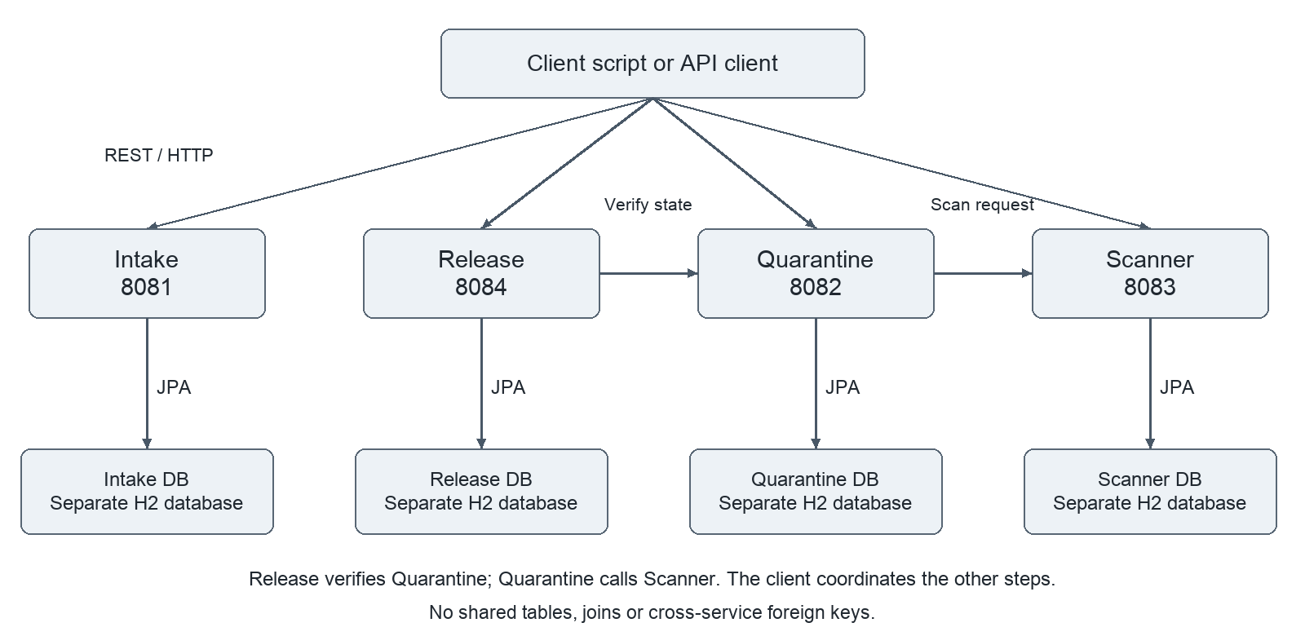
Figure 1 Client-orchestrated component relationships. Quarantine calls Scanner and Release calls Quarantine over REST. Database arrows are service-local JPA.

Why these boundaries
Acceptance, quarantine policy, scan execution and release recording have different responsibilities and owned state. The scanner can fail independently without taking the API processes down. A shared database was rejected because it would couple schemas and allow business rules to be bypassed through table access.
Client orchestration keeps the flow visible but leaves the client responsible for partial progress and does not create an atomic distributed transaction. A single-service implementation would be operationally simpler but would not demonstrate these assignment boundaries.

Main transaction and state model
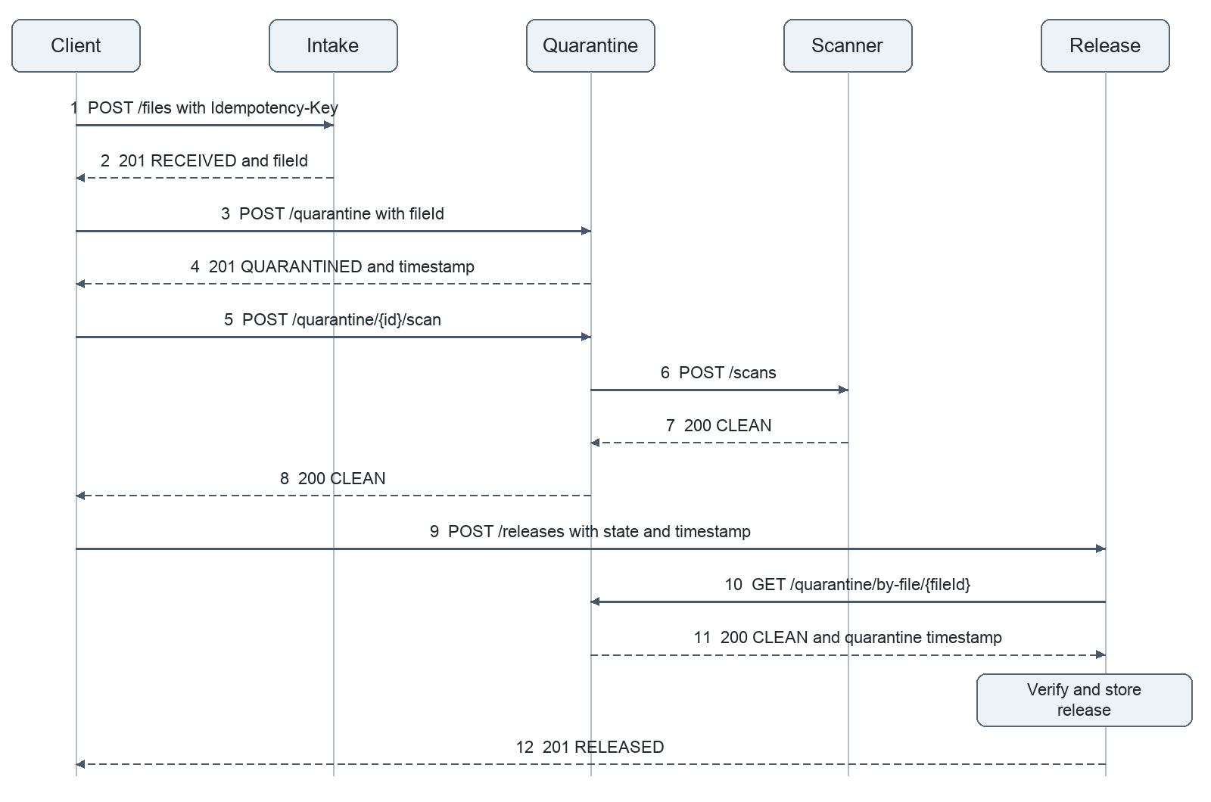
Figure 2 Successful transaction. Release verifies the Quarantine state and timestamp before storing a new release. All messages are HTTP requests or responses. Dashed arrows indicate responses. Endpoint prefixes are /api/v1.

Lifecycle across service boundaries
The lifecycle states are logically spread across the different services.
Service | Lifecycle State | Description
Intake | RECEIVED | Stores accepted metadata and fileId; matching key and payload replay the original response.
Quarantine | QUARANTINED → SCANNING → CLEAN | INFECTED | FAILED | Owns scan state and rejects repeat scans. No capacity leaves the file QUARANTINED.
Scanner | IN_PROGRESS (derived) → CLEAN | INFECTED | FAILED | A null result means in progress; completion stores the verdict for retry-safe replay.
Release | RELEASED | Stores release after Quarantine confirms CLEAN and the supplied quarantine timestamp matches its record.

Intake stores RECEIVED. Quarantine owns QUARANTINED → SCANNING → CLEAN, INFECTED or FAILED. Release stores RELEASED separately. This is a logical lifecycle across databases, not one shared state column.
QuarantineService checks the current state before starting a scan. A repeated scan returns 409 if the record is already SCANNING or has reached CLEAN, INFECTED or FAILED. For a new release, Release independently fetches the Quarantine record and checks that it is CLEAN and that the supplied timestamp matches to millisecond precision. Existing releases replay the stored response.

Failure path and data design
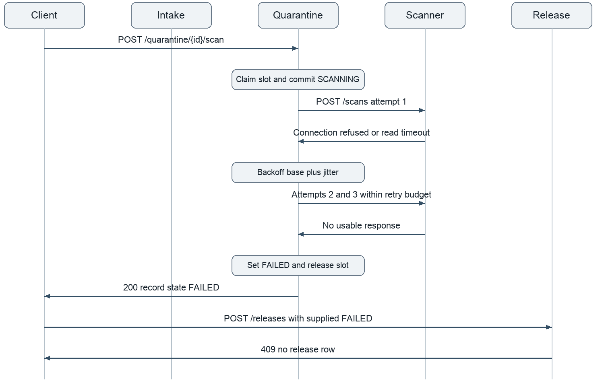
Figure 3 Scanner outage. Failed calls consume a bounded retry budget; Quarantine settles FAILED and returns capacity. Release rejects the submitted FAILED state.

Database Design and Service Ownership

Database ownership and references
Each service owns its datasource, schema and credentials. Each service uses persistent file-based H2 databases preserving records and history across restarts.
Service | Owned Database | Cross service reference
Intake | data/intake.mv.db | file_record.id becomes fileId. Store key, fingerprint and response snapshot together.
Quarantine | data/quarantine.mv.db | quarantine_records.file_id refers logically to Intake; scan_slots.file_id identifies its current holder.
Scanner | data/scanner.mv.db | scan_attempt.file_id is a logical file reference and a unique operation identity.
Release | data/release.mv.db | release_record.file_id is its primary key. The submitted quarantine timestamp is checked against Quarantine before it is stored.

There are no cross-database joins or foreign keys. The Quarantine API currently accepts a UUID without checking its existence in Intake. Release verifies the state and timestamp through the Quarantine API. Checking that a fileId originated in Intake remains a further improvement.

Entities
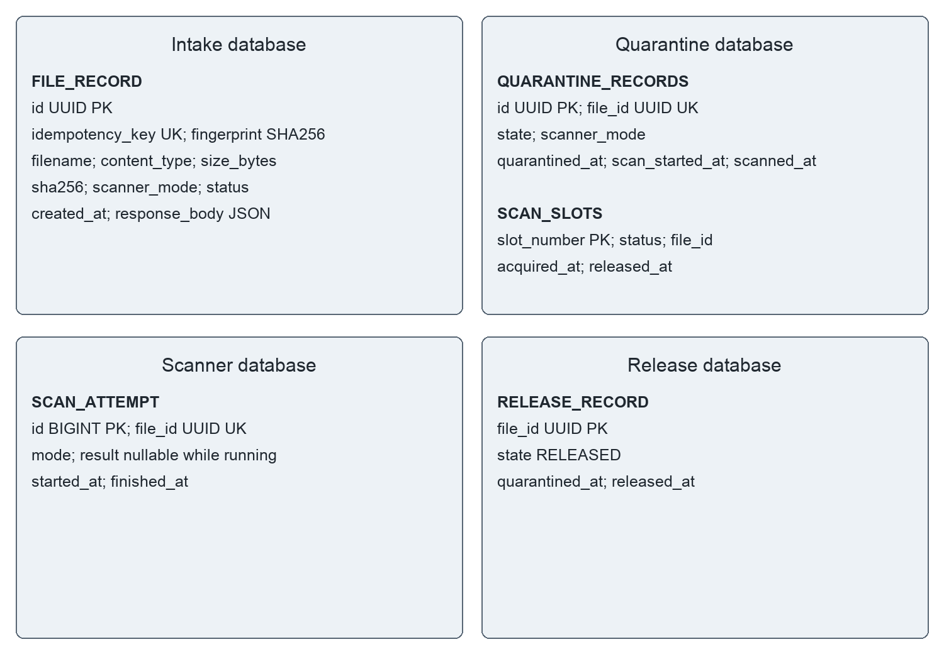
Figure 4 Entity diagrams per service. PK - primary key and UK - unique key. Quarantine’s two tables have a logical holder relationship through file_id, without a cross service foreign key.

API design and operability
Service | Method and path below /api/v1 | Result
Intake | POST /files | 201 accepted/replayed; 400 input; 409 key conflict
Intake | GET /files/{id} | 200 original response; 400 invalid UUID; 404 absent
Quarantine | POST /quarantine | 201 created; 409 already quarantined
Quarantine | POST /quarantine/{id}/scan | 200 completed scan; 409 capacity or repeat scan; 404 absent
Quarantine | GET /quarantine/{id}  GET /quarantine/by-file/{fileId} | 200 state; 404 absent
Scanner | POST /scans  GET /scans/{fileId} | 200 verdict or replay; missing GET 404
Release | POST /releases  GET /releases/{fileId} | POST: 201 release or replay; 409 evidence rejected; 503 Quarantine unavailable  GET: 200 release; 404 absent

Validation and error model
Intake requires all five metadata fields, a nonblank key of at most 255 characters, nonblank filename/content type of at most 255 characters, nonnegative integer size, 64 hexadecimal SHA-256 characters and an allowed mode. Its HTTP tests cover malformed JSON, invalid UUIDs and consistent 400/404/405/409/415 errors. OpenAPI contracts for all four services are available in docs/openapi/.
{"status":409,"error":"Conflict",
"message":"Idempotency-Key was used with a different payload",
"timestamp":"<ISO instant>","path":"/api/v1/files",
"correlationId":"<request ID>","fieldErrors":{}}

Configuration and correlation
SERVER_PORT, DB_URL, DB_USERNAME, DB_PASSWORD, DB_DRIVER and DDL_AUTO control the runtime. Scanner and Quarantine URLs, capacity, timeouts, delays, retry settings, circuit breaker and reclaim settings are environment driven. X-Correlation-Id is carried in responses, MDC-backed logs, the Quarantine-to-Scanner call and the Release-to-Quarantine call. Logs use a consistent timestamp/level/correlation pattern and key-value event messages.

Business rules and traceability
Rule | Implemented behaviour
BR1 | The same Intake key and typed payload return the original response with no second row
BR2 | The same Intake key with a different typed payload returns 409 and preserves the original.
BR3 | Quarantine creates one record per file and follows QUARANTINED to SCANNING to CLEAN, INFECTED or FAILED  using Scanner’s verdict
BR4 | For a new release, Quarantine must confirm CLEAN and the supplied quarantine timestamp must match its record. Invalid evidence returns 409; inability to verify returns 503.

Sample requests and responses
POST /api/v1/files requires Content-Type: application/json and a caller-generated Idempotency-Key. Intake generates fileId and stores a JSON response snapshot. Same key and typed payload replay the original response body, including receivedAt, with HTTP 201; a new key represents a new operation.
{"filename":"demo.txt","contentType":"text/plain",
"sizeBytes":4,
"sha256":"0123456789012345678901234567890123456789012345678901234567890123",
"scannerMode":"CLEAN"}
201 {"fileId":"<UUID>","status":"RECEIVED",
"filename":"demo.txt","scannerMode":"CLEAN",
"receivedAt":"<ISO instant>"}
POST /api/v1/releases accepts fileId, quarantineState and quarantinedAt. The client supplies the state and timestamp returned by Quarantine. Before creating a new release, Release reads GET /api/v1/quarantine/by-file/{fileId}, verifies CLEAN and compares timestamps to millisecond precision. A missing record or mismatched evidence returns 409. If Quarantine cannot be reached after retries, Release returns 503 and does not store a release.

Mandatory engineering challenges

Challenge 1 Concurrency control
Problem: Parallel requests must not allocate more than N scanner slots.
The scanner pool has capacity MAX_CONCURRENT_SCANS, normally two. Quarantine creates one database row for each capacity slot at startup. Before scanning, it claims a FREE slot using an atomic conditional update to HELD. If no slot can be claimed, the request receives HTTP 409. The handled success or downstream-outage path returns the slot to FREE.
A plain check-then-update would allow two callers to observe the same free capacity before either updates it. Here, the database update succeeds only if the slot is still FREE, so only one caller can claim a given slot. The slot rows enforce admission and show the current allocation. This is demonstrated locally; shared database operation across replicas has not been demonstrated with embedded H2.
python3 scripts/concurrency.py
Captured output on 2026-10-30 UTC
CAPACITY 2; PARALLEL SCAN REQUESTS 20
BURST ACCEPTED 2; REJECTED 18
AFTER BURST {CLEAN: 2, QUARANTINED: 19}
AFTER BURST SLOTS {FREE: 2, HELD: 0}
AFTER RETRIES {CLEAN: 20, QUARANTINED: 1}
Evidence: evidence/challenge-1-concurrency/run.txt includes the results and relevant application logs. The script first proves one quarantine record for eight simultaneous creates, then runs 20 parallel SLOW scans. The extra QUARANTINED record comes from the create test. Rejected scans are retried after capacity is available. scripts/reclaim.py and evidence/challenge-1-concurrency/reclaim-run.txt also show recovery after Quarantine is killed during a scan. These are local process tests.

Challenge 2 Idempotency
Problem: Repeating intake must not create duplicate identities.
If client retries the same request with the same key, Intake service handles this by producing the same result, without creating another record. The intake service handles the scenario like below:
- Intake service accepts the Idempotency key and calculates a SHA-256 fingerprint from the parsed request fields, so JSON whitespace or field order does not affect the comparison.
- It then looks for an existing key.
  - Same key + same payload → return the original stored response, including the original file ID and timestamp.
  - Same key + different payload → return 409 Conflict.
- If the key is new, it saves everything together: file metadata, idempotency key, fingerprint, and response body, in one transaction.
However, if 2 requests occur simultaneously, just a query wouldn’t suffice as there won’t be any database entry. So, the initial lookup alone cannot prevent duplicates. In this case,
- Both attempt to insert.
- The database’s uk_file_idempotency_key constraint allows only one to succeed. The losing request’s transaction rolls back.
- The service then reads the winning record and performs the same payload comparison: replay the response if it matches, or return 409 if it differs.
Evidence: evidence/challenge-2-idempotency/run.txt and intake-service-log.txt. The script verifies complete response equality, including timestamp, and one row for eight simultaneous requests.

Challenge 3A Resilience
Problem: Scanner may answer after Quarantine’s read timeout or may be stopped.
ScannerClient configures a connect timeout and read timeout, makes at most maxAttempts total attempts and waits between attempts using exponential backoff with jitter. Exhaustion becomes ScannerUnavailableException; Quarantine records FAILED and returns its slot.
delay(failedAttempt) = base * 2^(min(failedAttempt - 1, 20))
+ random integer from 0 through jitter
Setting | Default | Script demonstration
Connect timeout | 300 ms | 300 ms
Read timeout | 5000 ms | 500 ms
Maximum attempts | 3 total attempts | 3 total attempts
Backoff base and jitter | 100 ms and 0 to 100 ms | 200 ms and 0 to 150 ms
SLOW mode delay | 2000 ms | 1500 ms

The shipped SLOW delay is below the default read timeout; selecting SLOW alone does not demonstrate a timeout. scripts/resilience.py intentionally overrides the budget. Part A shows timeout logs, jittered retries, eventual CLEAN and exactly one stored Scanner attempt. Part B stops Scanner and checks exactly three calls, FAILED and FREE slots. Part C restarts Scanner and confirms a new file succeeds while the old FAILED file remains terminal. Part D repeats the Scanner request and compares the stored result and attempt count. Part E enables the circuit breaker, shows that an open circuit makes no HTTP attempt, and confirms that a successful probe closes it after the cooldown.
Scanner makes retries safe by claiming a unique fileId before running the mock scan. A repeated request waits for a running attempt and replays its completed result; a changed mode conflicts. This domain identity complements Intake’s header key idempotency. It does not mean Scanner implements the same header contract.
Timeout without retry would reject transient outages. Unbounded retry risks a hanging client and sustained overload. A circuit breaker is implemented and disabled by default. When enabled, it counts calls that exhaust their retry budget, opens after the configured threshold and allows one probe after the cooldown. Backoff sleeps on request threads, and Scanner REST failures are retried, including permanent 4xx responses. Production policy should classify transient failures and enforce a total deadline.
Evidence: scripts/resilience.py; evidence/challenge-3a-resilience/README.md and run.txt. Unit coverage includes ScannerClientTest and ScannerCircuitBreakerTest. Socket based integration coverage includes QuarantineScanResilienceTest and QuarantineCircuitBreakerTest.

Testing strategy and observed results
Service | Unit and client tests | HTTP and database tests | Total
Intake | 13 | 23 | 36
Quarantine | 37 | 10 | 47
Scanner | 14 | 20 | 34
Release | 34 | 27 | 61
Total | 98 | 80 | 178

Process level validation
The stored process runs cover /health on all services, clean and infected end to end flows, simultaneous Intake idempotency, the 20 request capacity challenge, slow and stopped Scanner resilience, circuit breaker recovery, and all four process restart scripts. Additional runs cover release verification and recovery after Quarantine is killed during a scan. Captures are stored in the repository’s evidence/ folders, and docs/demo-runbook.md explains how to reproduce the demonstrations.
The per-suite test captures in evidence/tests/ report 178 tests in total with no failures, errors or skipped tests. The current build compiles for Java 17. evidence/tests/fresh-clone-run.txt records a successful earlier clean-clone build with 171 tests, followed by health, end to end, challenge and persistence checks. This earlier capture does not establish that the latest 178-test suite was run from a clean clone.
Scope: persistence scripts prove completed records survive a graceful restart. The separate reclaim script demonstrates recovery of Quarantine slots and SCANNING records after a forced process termination. These local runs do not prove recovery of unfinished Scanner attempts, multi replica execution or production database behaviour. The release verification script also checks false CLEAN claims, incorrect timestamps and a Quarantine outage. The team still needs to complete the video and remaining individual reflections before submission.

Decisions limitations and future work
Decision | Alternative | Reason and consequence
Client coordinated workflow | Long synchronous chain or saga | Keeps client orchestration and two internal REST edges. Earlier steps remain if a later step fails; no compensation.
Synchronous Scanner call | Queue and background worker | Makes timeouts and retry effects visible. Holds request threads and increases latency during outages.
Database slot ledger | JVM semaphore | Atomic database updates enforce capacity. A scheduled sweep recovers stale slots and abandoned SCANNING records.
Database key and stored response | In memory key map | Preserves replay after restart and arbitrates insert races. Adds storage and retention responsibility.
Separate embedded H2 files | External PostgreSQL per service | Easy local execution and separate ownership. One JVM per file; replica deployment needs database servers.
Quarantine API verification before release | Trust caller evidence or use signed attestation | Checks the state held by Quarantine before a new release. Adds a downstream dependency; unavailable verification returns 503.

Integrity boundaries
Release verifies a new release against Quarantine rather than accepting the caller’s claim alone. It rejects an absent record, a state other than CLEAN or a timestamp mismatch. Existing release records are replayed before new evidence is checked, so a completed release can still be replayed during a Quarantine outage. scripts/verification.py demonstrates these cases. Authentication and access control remain outside this assignment, and Quarantine still does not verify that the fileId originated in Intake.
Quarantine does not verify that fileId came from Intake. Its state read and SCANNING write are not an atomic compare and set. Two requests for the same record can both read QUARANTINED and claim different slots; Scanner’s unique fileId prevents duplicate stored attempts, but this does not prove one slot or one transition per file. Add a conditional state transition or optimistic version and a same record parallel HTTP test.

Recovery and concurrency
Slots and SCANNING are persisted in separate commits. A crash or a save failure after slot acquisition can leave a held slot or an in flight record; slot acquisition and the first save also precede the try finally block. ScanReclaimJob frees stale held slots and settles stale SCANNING records as FAILED when no slot remains held for the file. The reclaim script demonstrates this after a forced termination. The stale age must allow for the full scan and retry budget, so an active scan is not reclaimed. Scanner can still retain an unfinished attempt after a crash; recovery of those attempts remains further work.
Lowering capacity does not delete higher numbered slot rows. Claims iterate only up to the configured capacity, but summary FREE counts can include old rows. Use a new presentation database when changing capacity, or implement deliberate capacity migration. Shared database replica behaviour has not been demonstrated with embedded H2.

Operational improvements
Replace automatic schema updates with versioned migrations, isolate sensitive diagnostics, define retention for idempotency keys and scan history, and add metrics and machine readable JSON logs if needed. Validate Scanner response identity and terminal verdicts, retry only transient failures and avoid sleeping request threads at production scale.
A production file security product needs actual file storage, content verification, malware scanning, authentication and access control. Those are product extensions outside the assignment’s API demonstration.

Submission links and completion status
Claim or material | Repository location
Architecture and data | docs/architecture.md and docs/business-rules.md.
Business-rule mapping | docs/business-rules.md and the service README files
API contracts | docs/openapi/*.yaml
Main flow | scripts/e2e.sh;
Concurrency | scripts/concurrency.py; scripts/reclaim.py; evidence/challenge-1-concurrency/
Idempotency | scripts/idempotency.sh; evidence/challenge-2-idempotency/
Resilience | scripts/resilience.py and challenge-3a evidence
Restart persistence | scripts/persistence.py, scripts/quarantine-persistence.py, scripts/scanner-persistence.py and scripts/release-persistence.py
Release verification | scripts/verification.py; evidence/tests/verification-run.txt
Clean clone check | evidence/tests/fresh-clone-run.txt (earlier 171-test build)

Contribution record
The contribution entries below are based on the repository history. Each student should confirm their owned work and reviews before submission.
Student | Owned work and review | Commit or PR evidence
2025tm93006 | Intake service, idempotency, validation, tests , final documentation | b88153e - Intake service changes
2025tm93127 rohanbits | Quarantine setup and updates | 9a6e585 - Quarantine API setup  18d98c1 - Quarantine updates
himanshu bitswilp 2025tm93556 | Scanner implementation | dc833a4 – Scanner Implementation  b7bc523 - Tests
Akhil Kumar Reddy 2025mt13083 | Release service, REST integration, challenge scripts, resilience and documentation | 8efc71f - REST integration  a877490 - Concurrency script  9588871 - Resilience script  9bb93c0 - Release verification  c901859 - Scan recovery  ac0c0b1 - Circuit breaker

Contribution Record and Individual reflections
Amrutha Ramachandra (2025TM93006)
I primarily worked on the Intake service of this application. Through this assignment, I gained an understanding of how responsibilities are divided in microservices architecture and how independent services work together.
In Intake service, important concern was to maintain Idempotency. As the requests are triggered by an external entity, the service must handle repeated requests, including retries caused by network failures. If left unaddressed, it could create duplicate entries in Database tables.
Implementing this behavior helped me understand how idempotency keys, request fingerprints, stored responses, and database unique constraints work together. I also learned why checking for an existing record alone is insufficient when requests arrive simultaneously.
Overall, this assignment provided practical experience with microservices, concurrency, and reliable request handling.
AI Usage: For this assignment, I have made use of ChatGPT Codex for the following
- Generating test scripts and collecting test evidence.
- Reviewing and validating my implementation.
- Updating README documents and this report.
- Clarifying concepts and checking my understanding.

Gilbile Rohan Ulhas (2025TM93127)

Himanshu Jain (2025TM93556)
Yadiki Akhil Kumar Reddy (2025MT13083)

