Work Integrated Learning Programmes
M. Tech Software Engineering



Introduction to DevOps
Assignment 1

Submitted By:
Gyanendra Sinha
2025tm93008
2025tm93008@wilp.bits-pilani.ac.in

Phase 1: Linux Setup & Application Modularization

- Installing pre-requisites like Python, Visual Code for assignment.
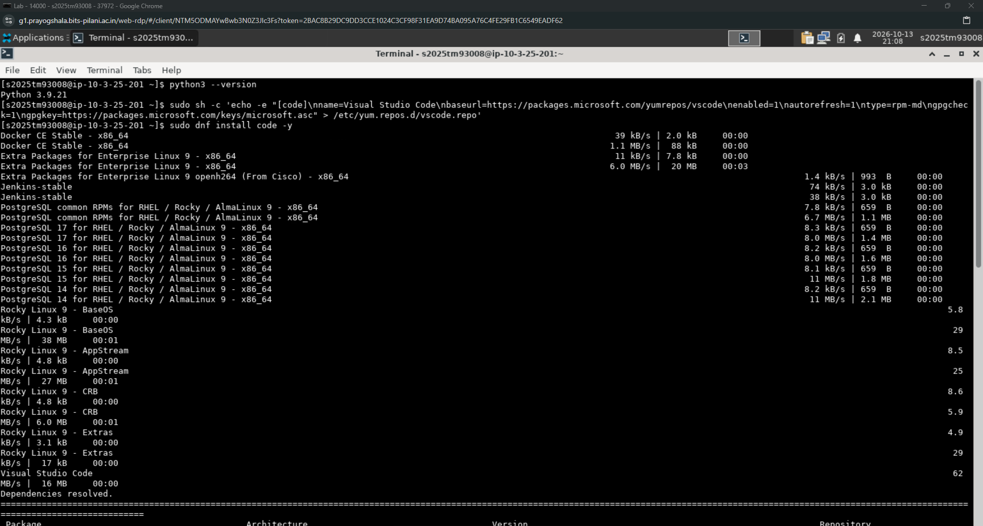

- Visual code and Python are installed successfully.
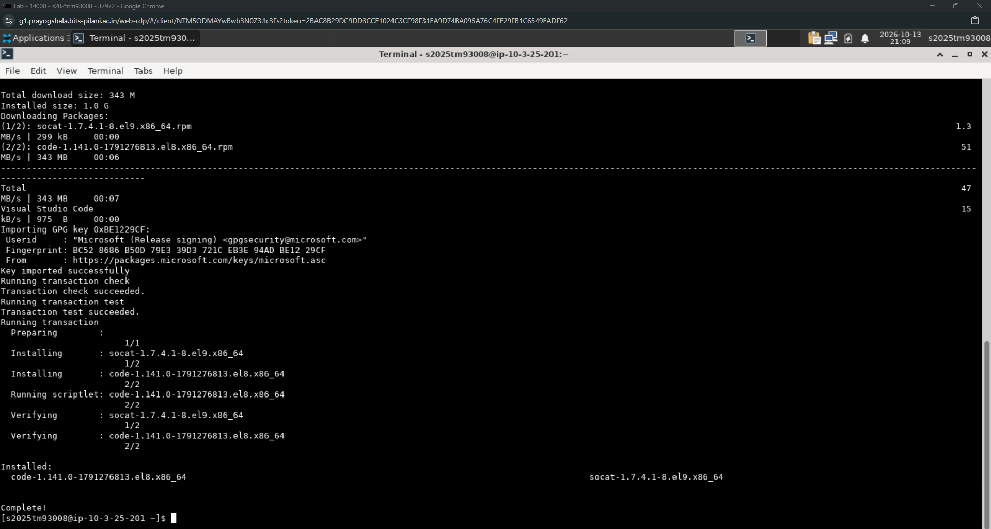

- Creating root assignment directory and required subfolders to keep the flask application organized.
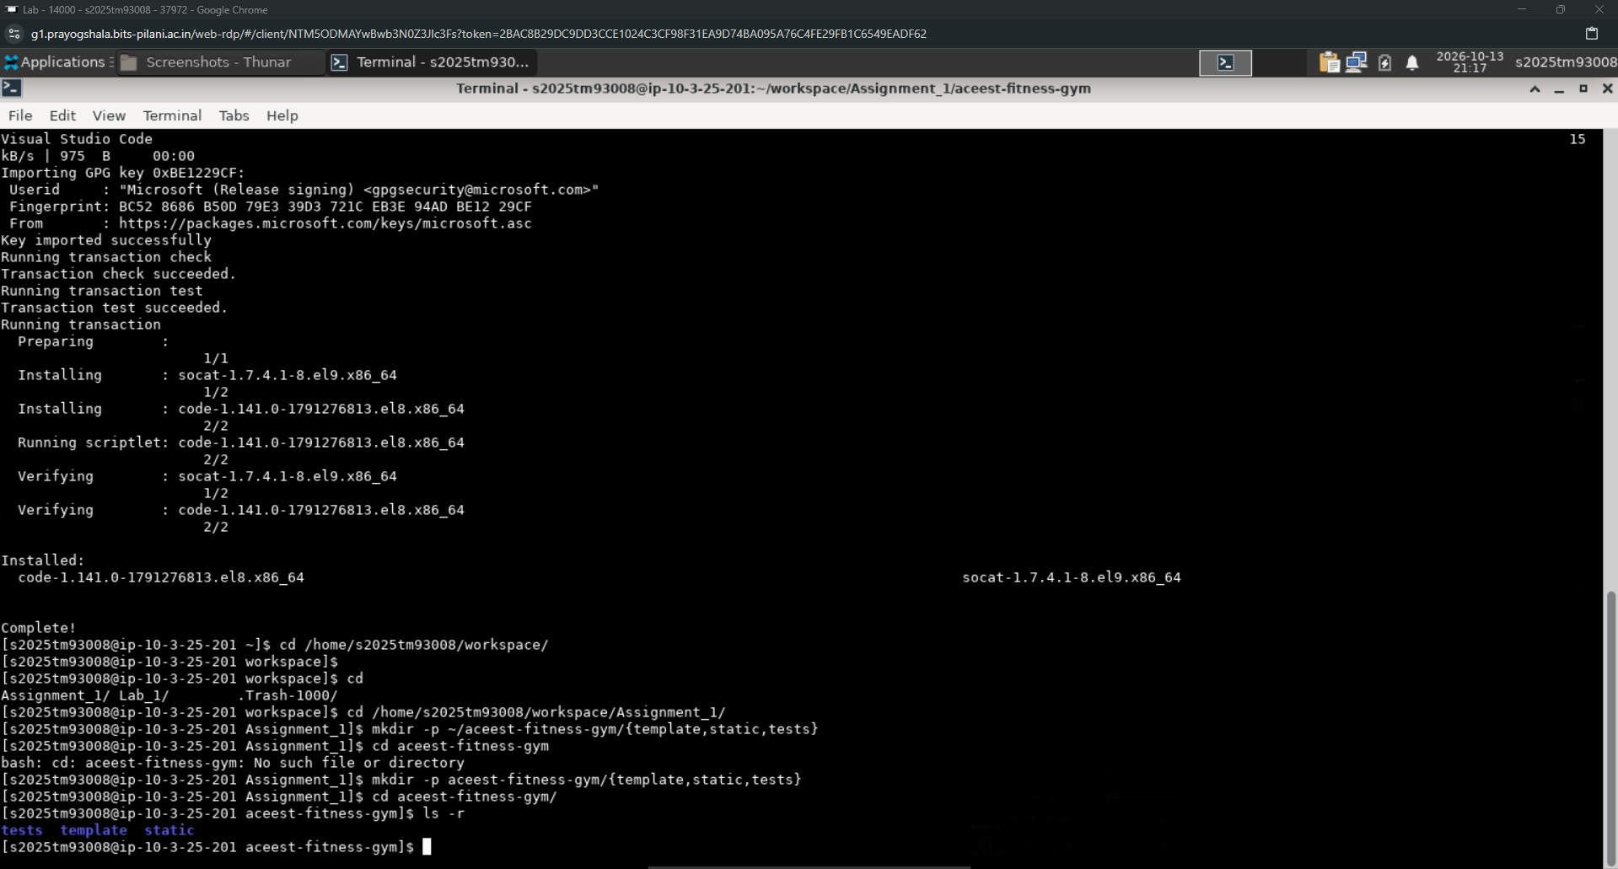

- Opening the directory in Visual Code for further steps for assignment.
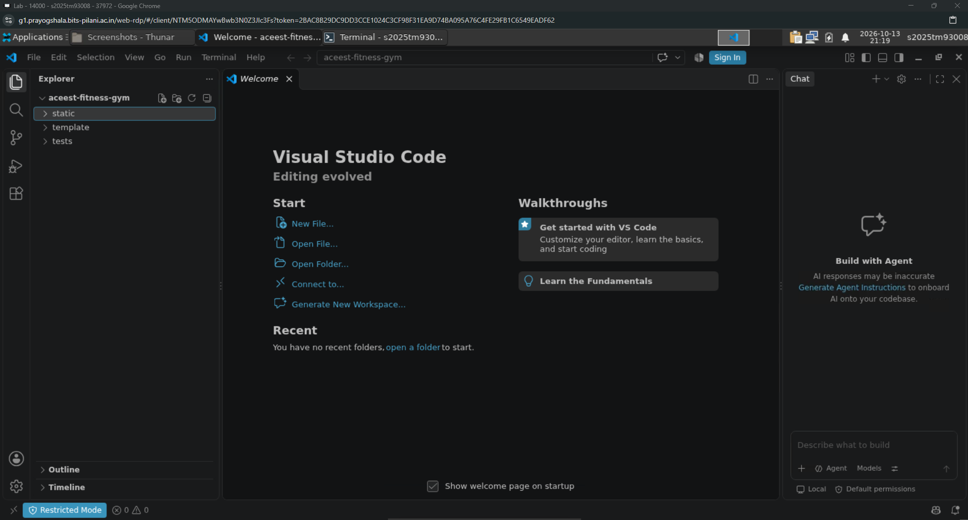

- Starting the virtual environment for running our flask application. (Same steps are done in Visual Code terminal also)
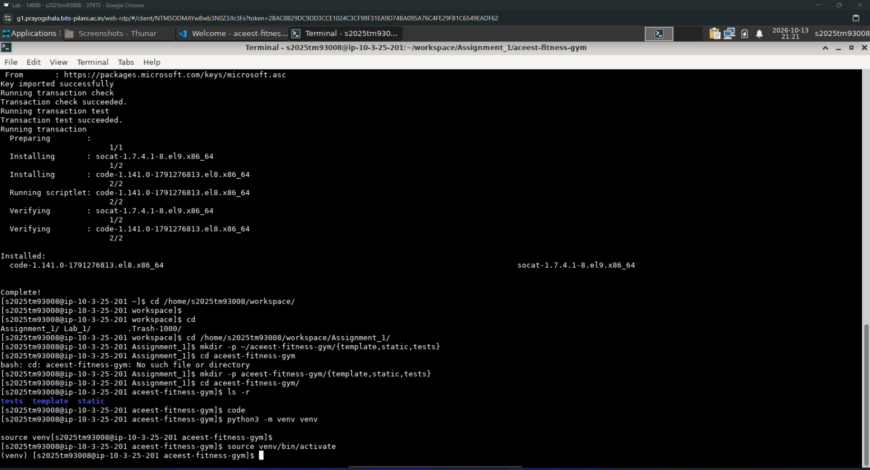

- Upgrading the pip installs in the virtual environment. Then, downloading the dependencies for the application. (Same steps are done in Visual Code terminal also)
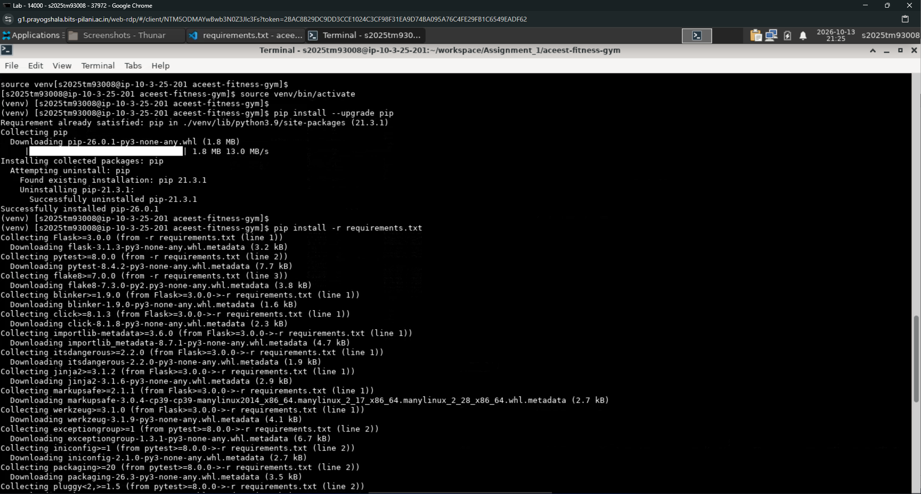

- Dependencies like “Flask”, “pytest” and “flask8” are successfully downloaded in the virtual environment. (Same steps are done in Visual Code terminal also)
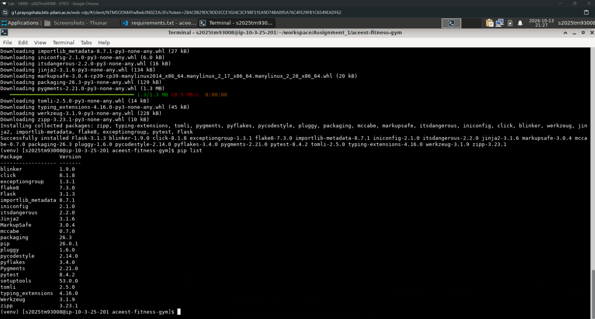

- The “requirements.txt” file contains all the dependencies and their versions for the proper building and running of our flask application.
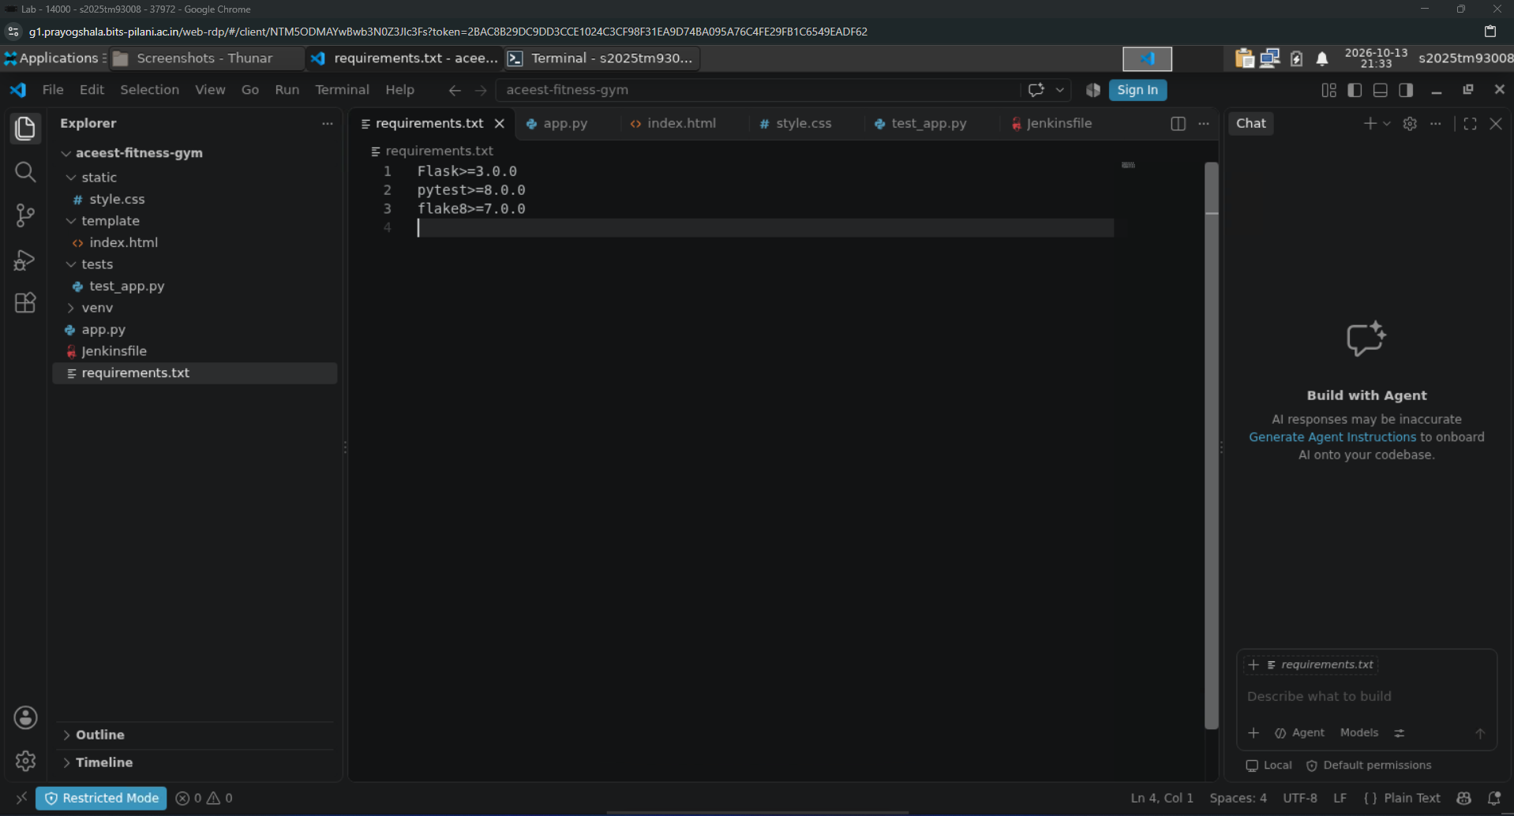

- Now, testing the code for syntax errors in all the files created for my flask application.
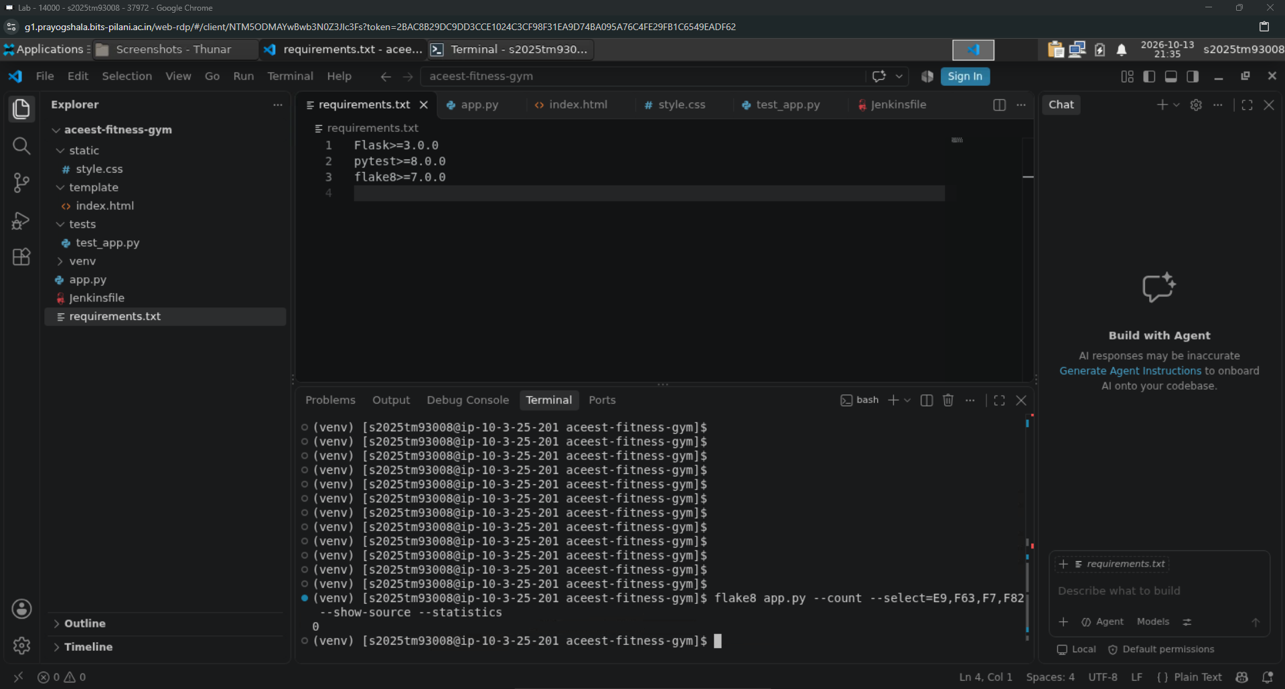

- Now, testing my test cases that are created for my flask application.
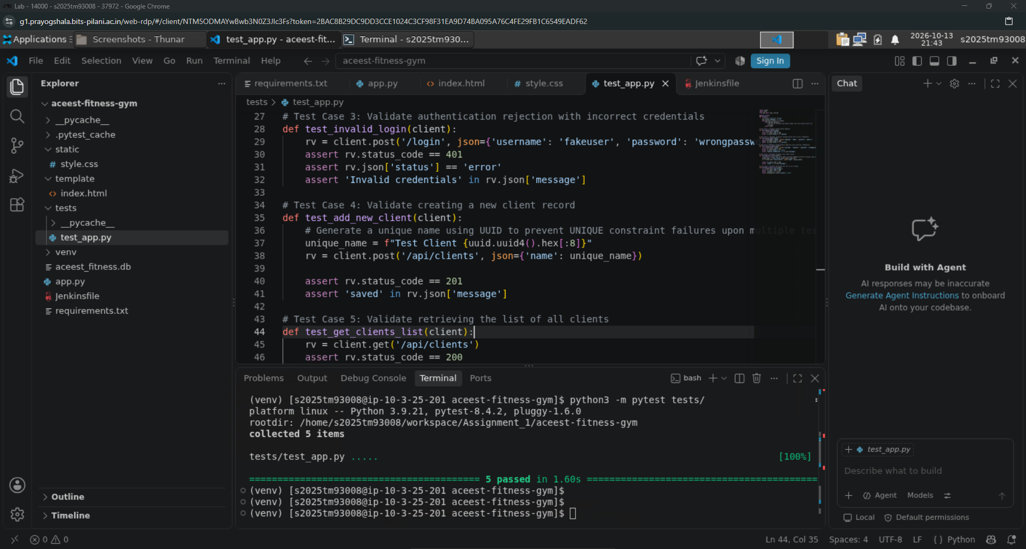

- Now, running the flask application for ensuring that the database initializes and the web interface loads.
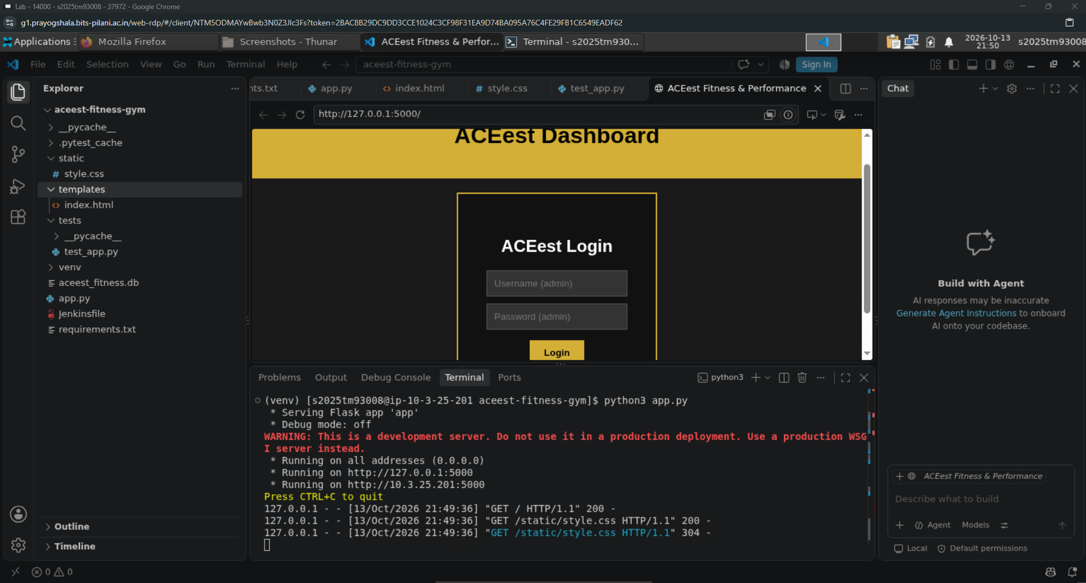

Phsae2: Establishing a VCS strategy using Git and GitHub

- Configuring the Git credentials for the further steps.
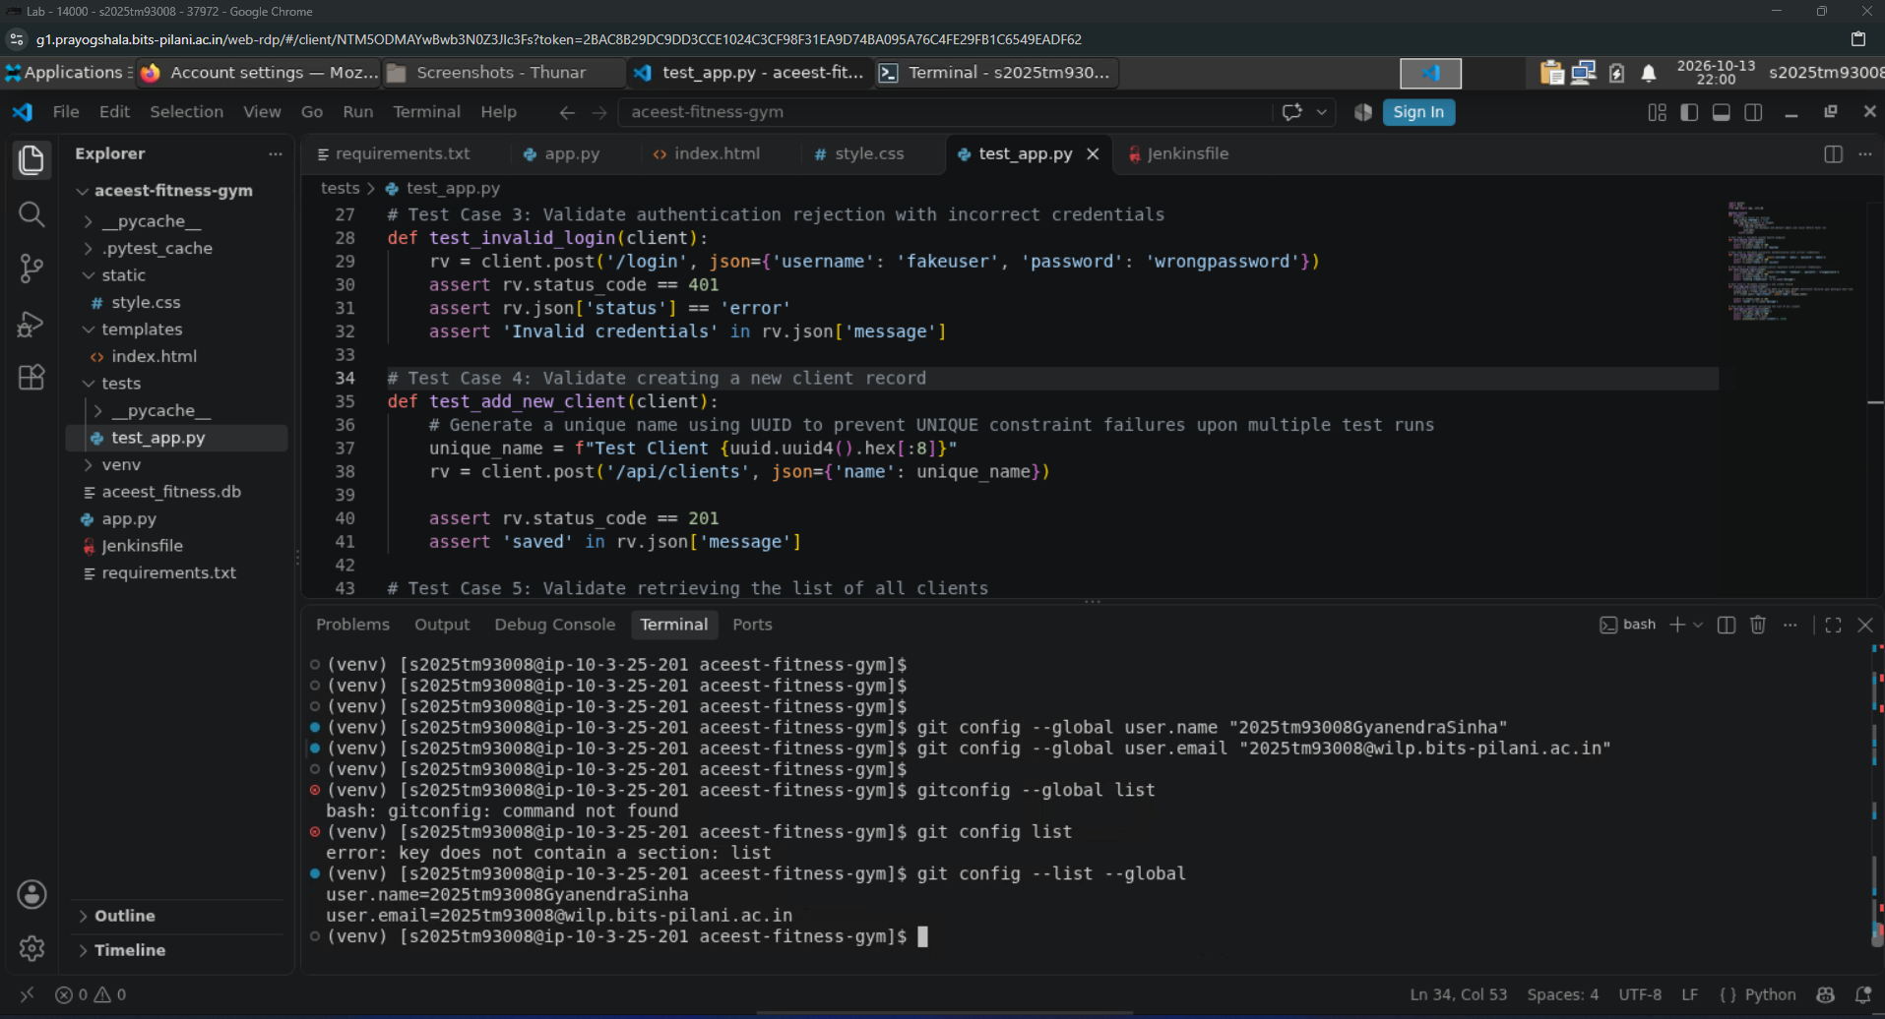

- Initializing the Git for tracking all the changes and changing the branch to “main”.
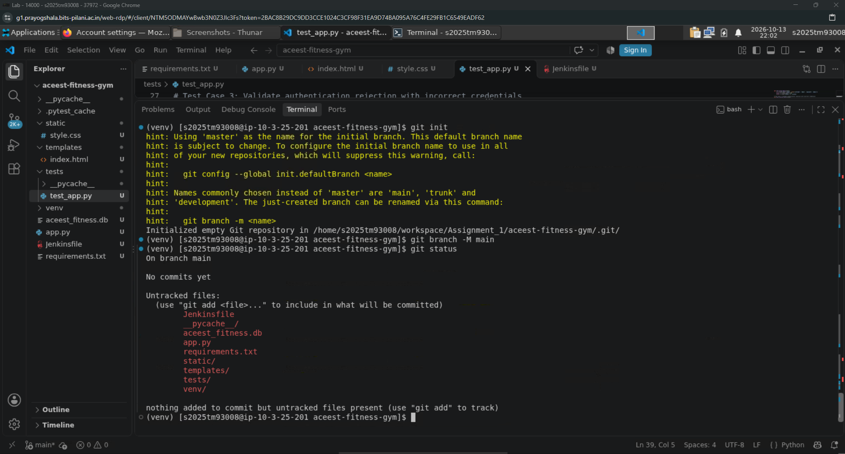

- Creating “.gitignore” file for preventing Git from tracking large, unnecessary and sensitive files in the repository.
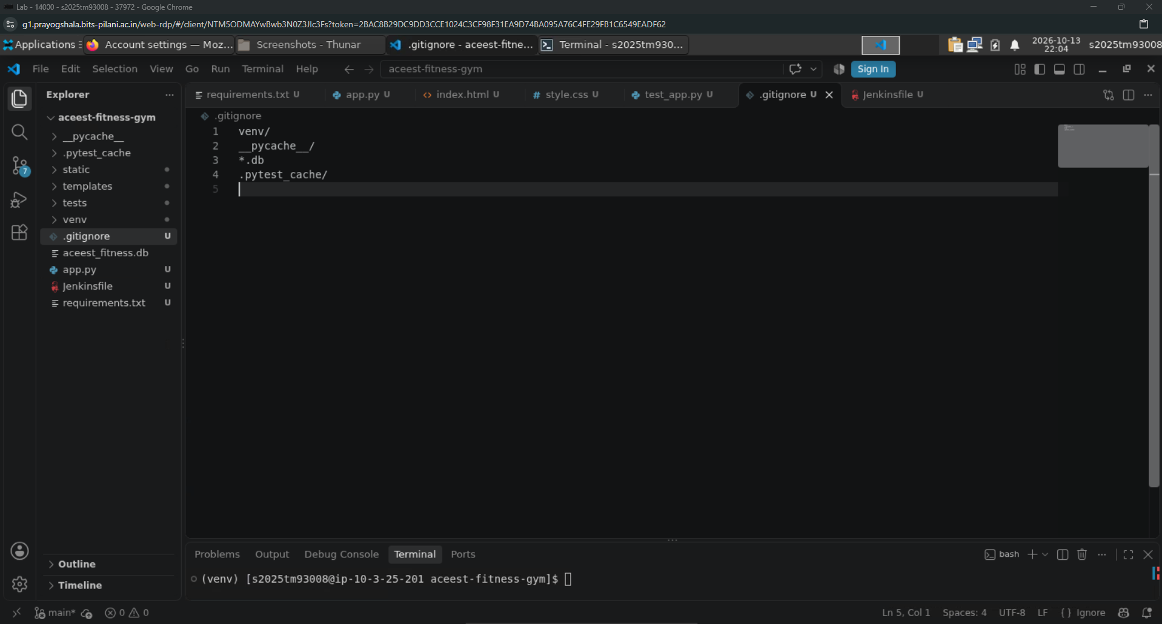

- Now, committing the local changes using a descriptive and industry-standard commit message.
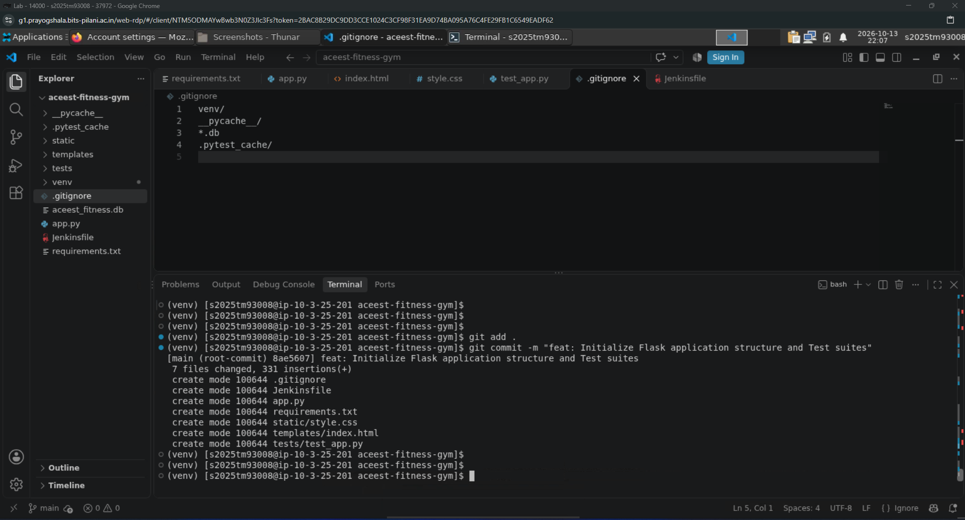

- Now, creating a dedicated “feature” branch for tracking features or infra updates.
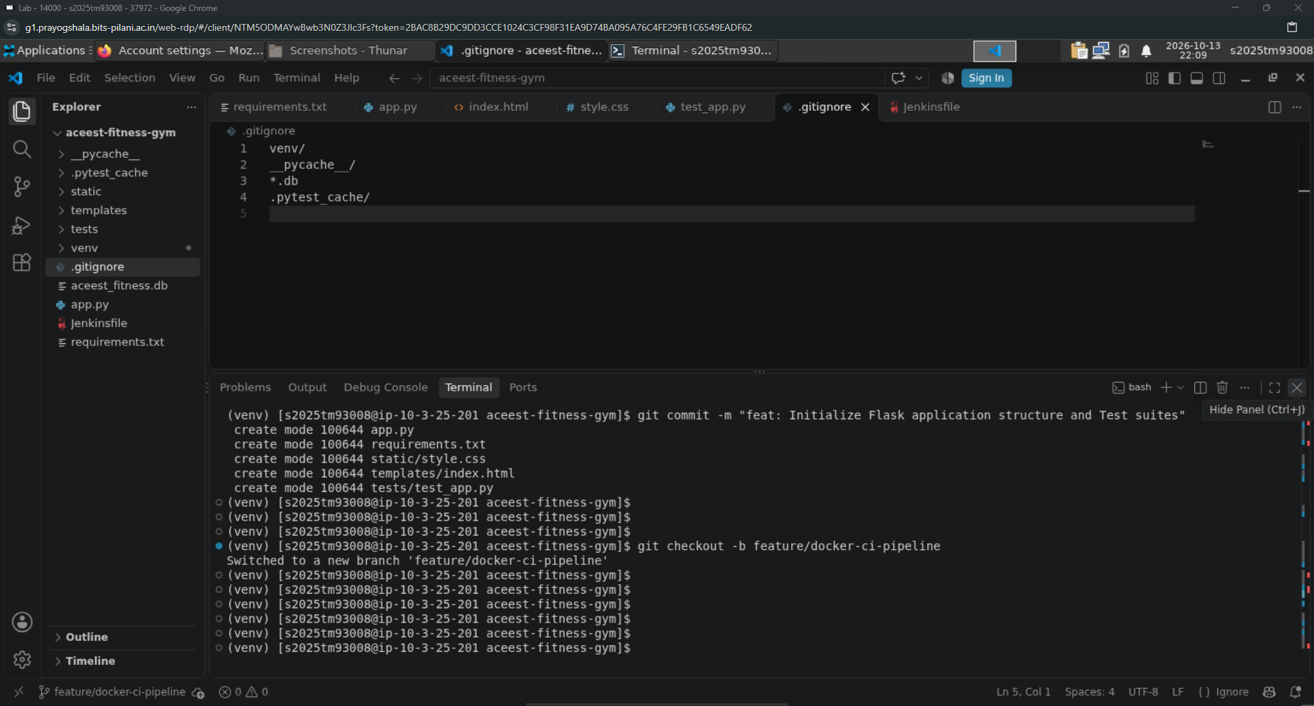

- Now, the “main” branch is pushed using the git commands provided in the GitHub repository on the repository webpage. (In background, a GitHub repository is created for hosting the assignment)
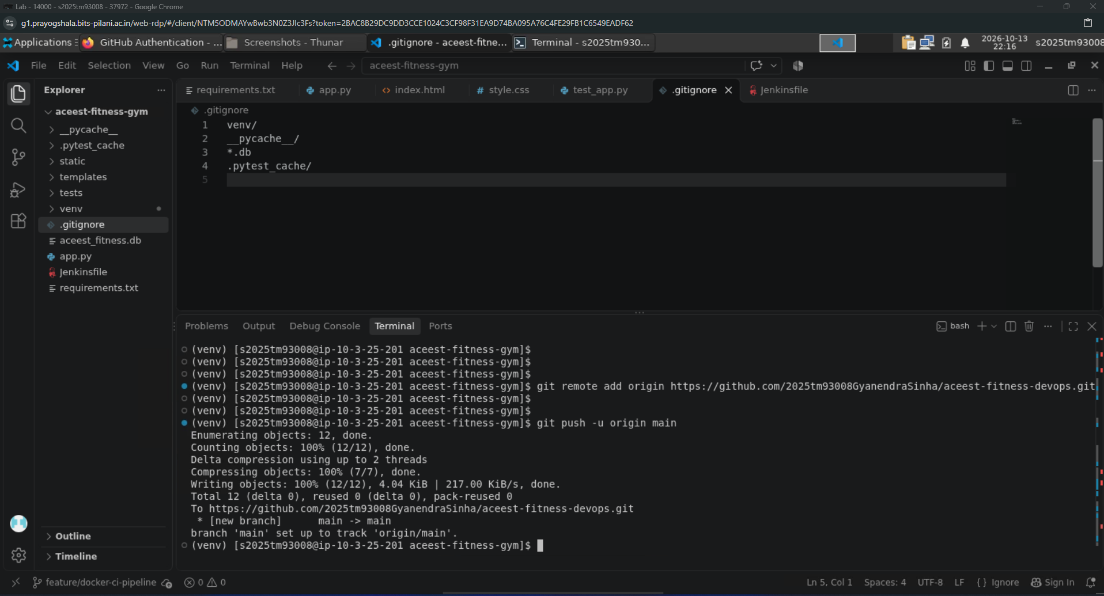

- Now, the “feature” branch is also pushed to GitHub.
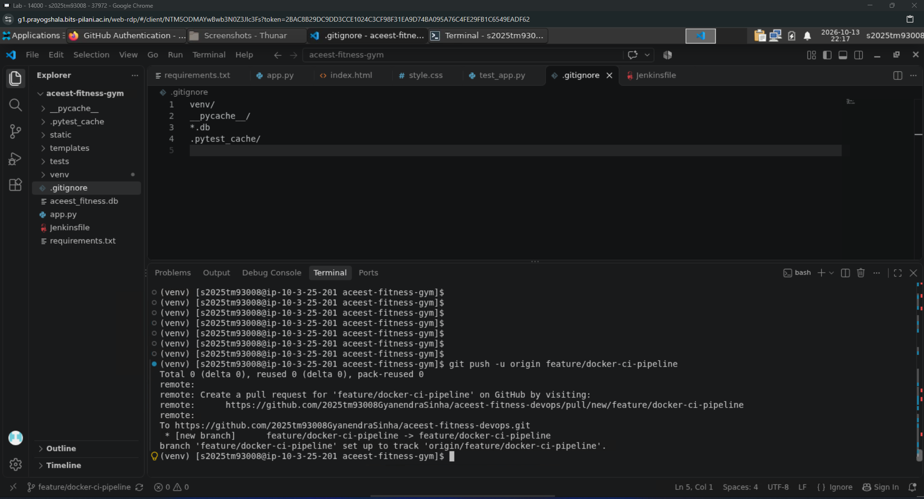

- Refreshing the webpage on GitHub to confirm that all the required files are present in repository.
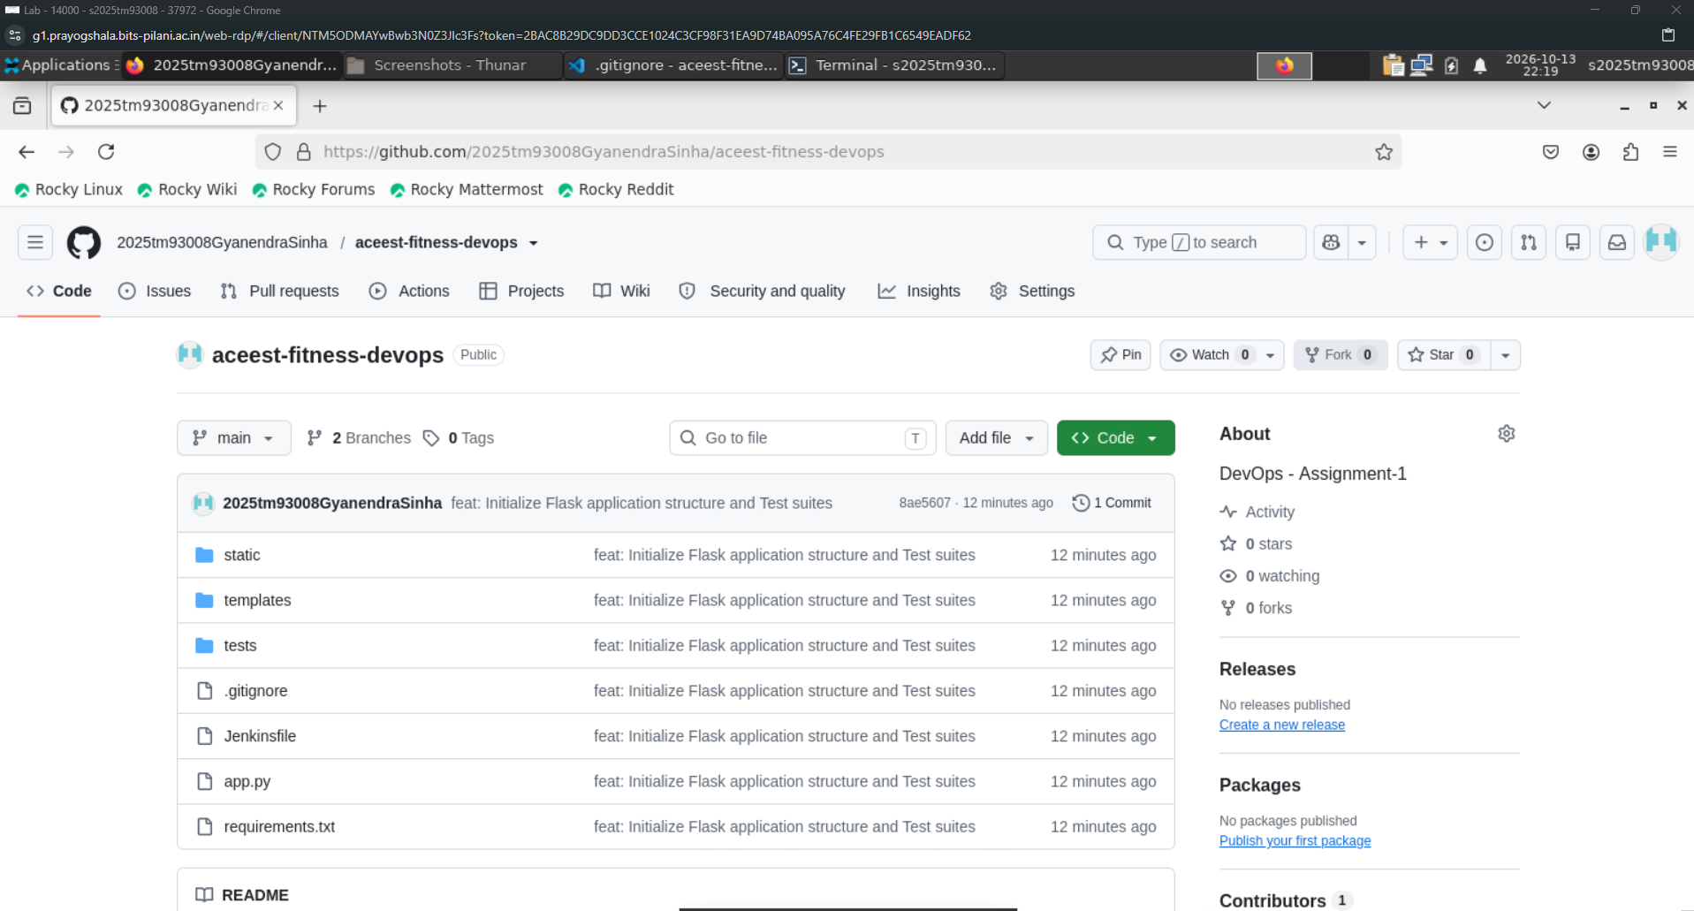

- Also, confirming that both the branches are pushed correctly to the GitHub repository.
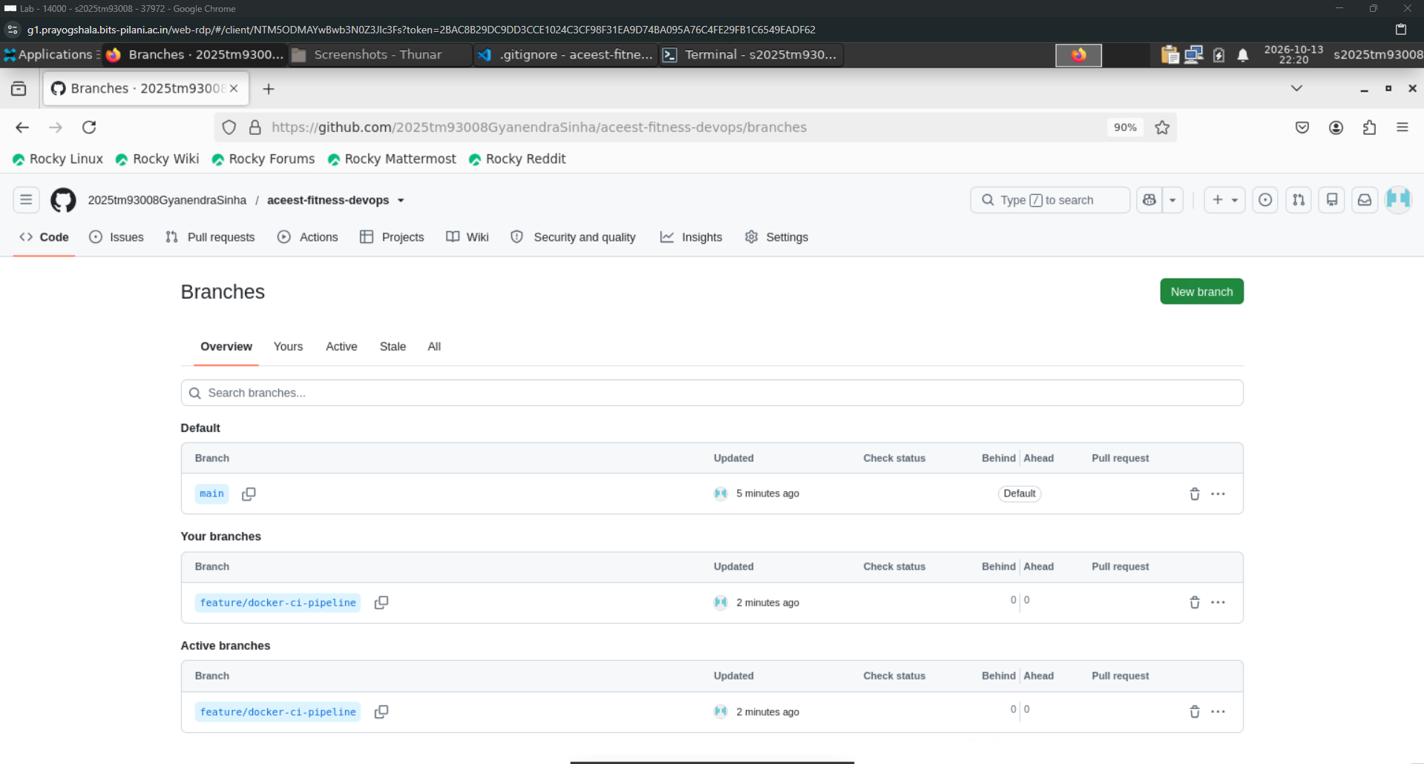

Phase 3: Unit Testing & Validation Framework

- Installing “pytest-cov” to measure the lines of code that are executed during the test suites.
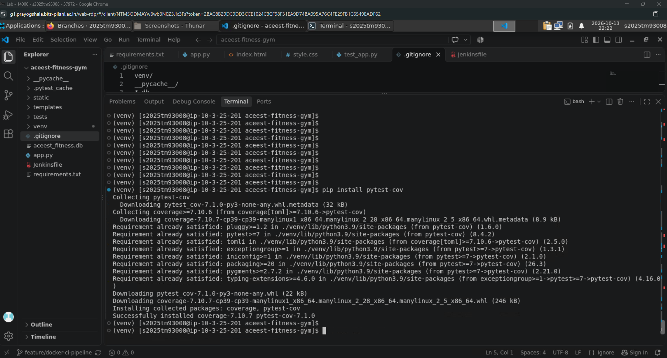

- Updating the “requirements.txt” file for the new dependency for the CI/CD pipeline.
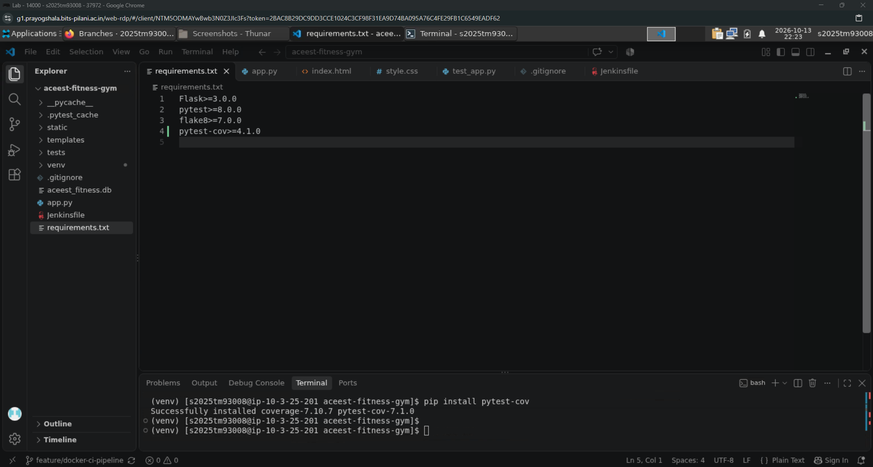

- Now, running the tests with coverage flag “-cov=app” to generate the coverage report.
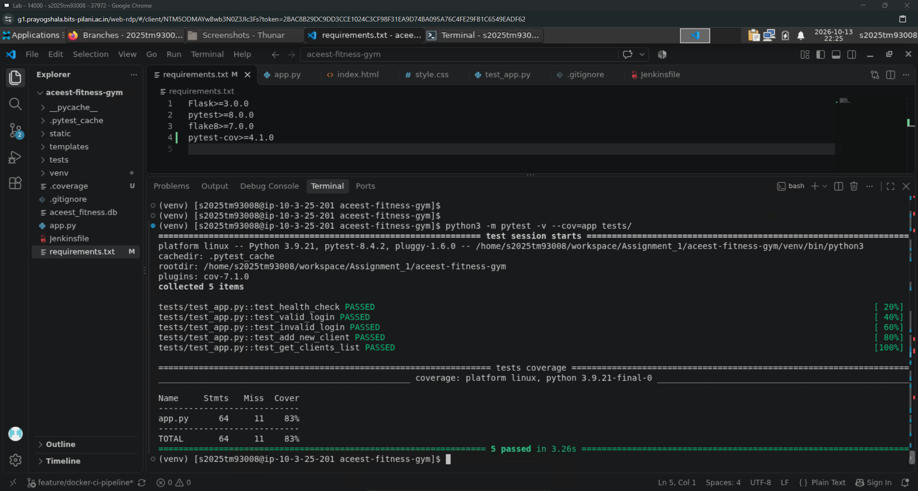

- Now, committing these new changes to GitHub repository with appropriate comments.
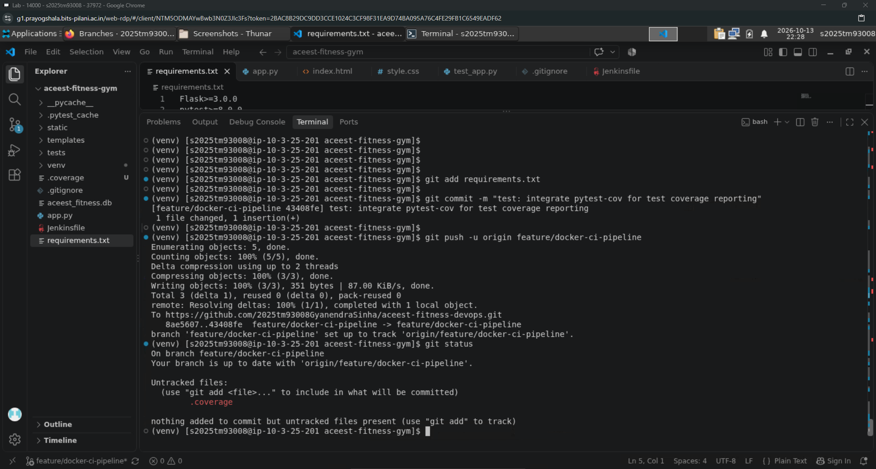

Phase 4: Containerization with Docker

- Create a new file “.dockerignore” to prevent copying unnecessary or sensitive local files into the container.
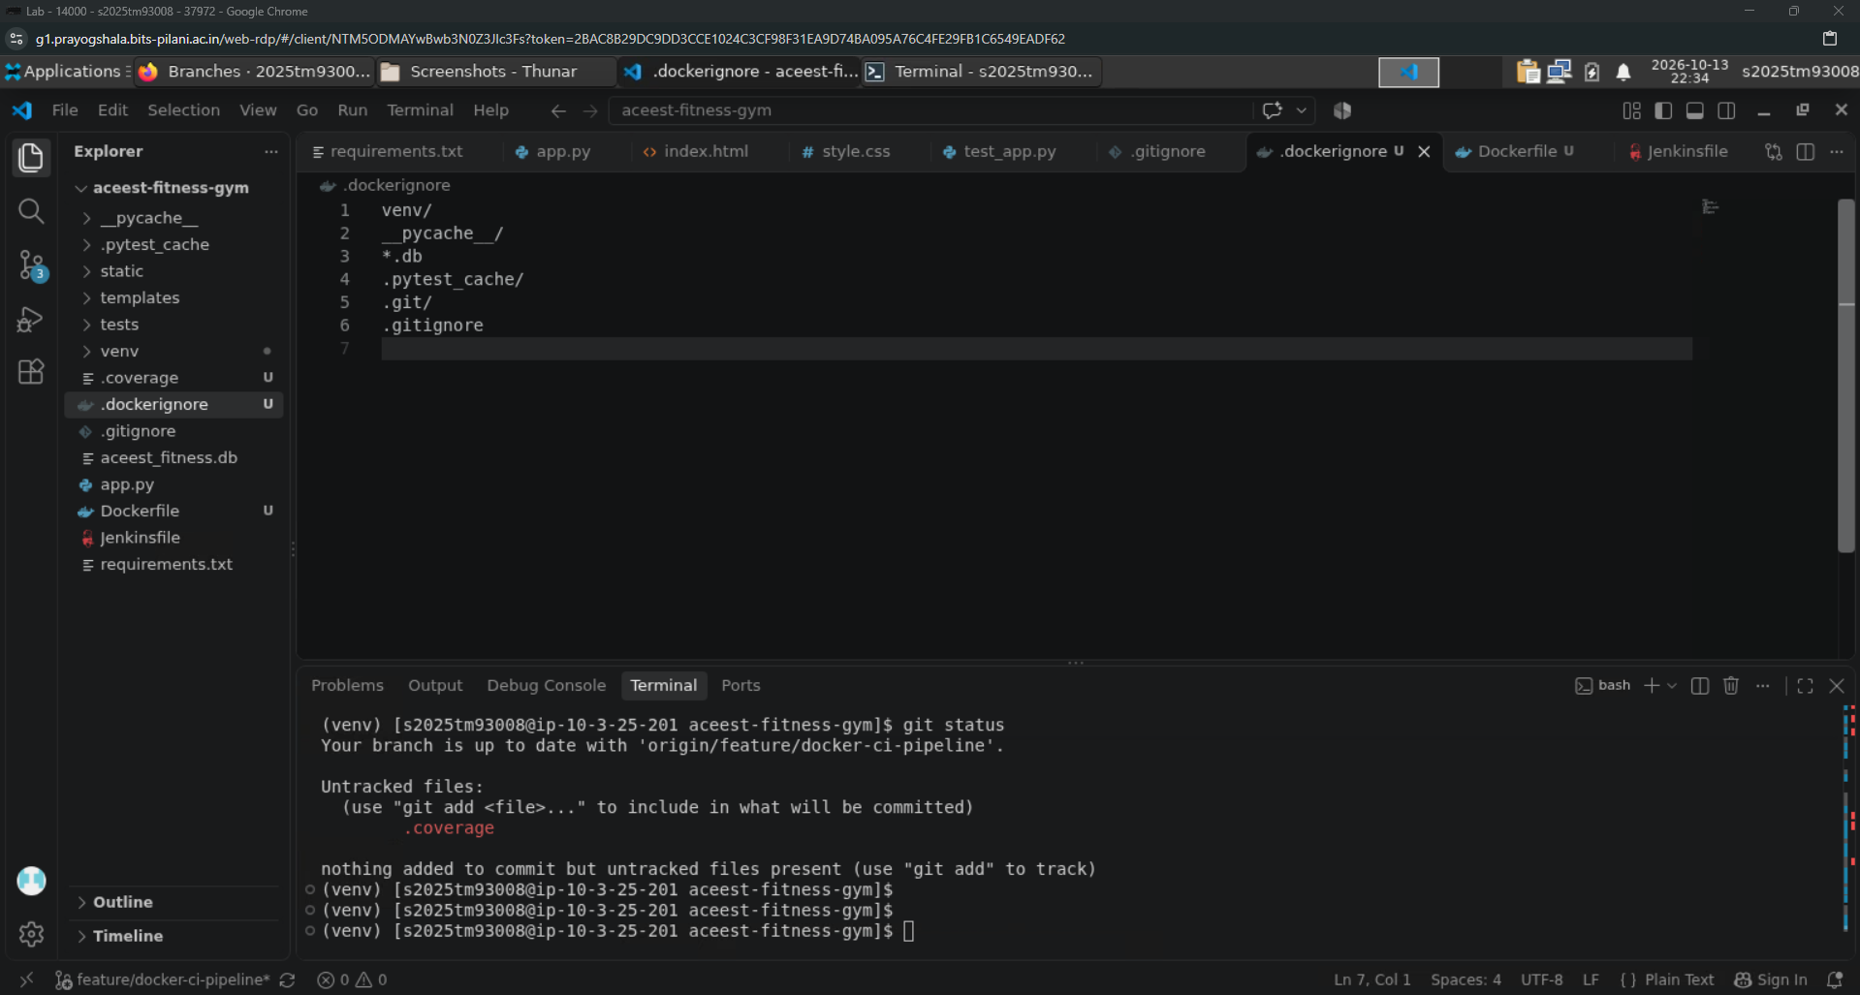

- Now, create a new file named “Dockerfile” containing all the required steps for containerization.
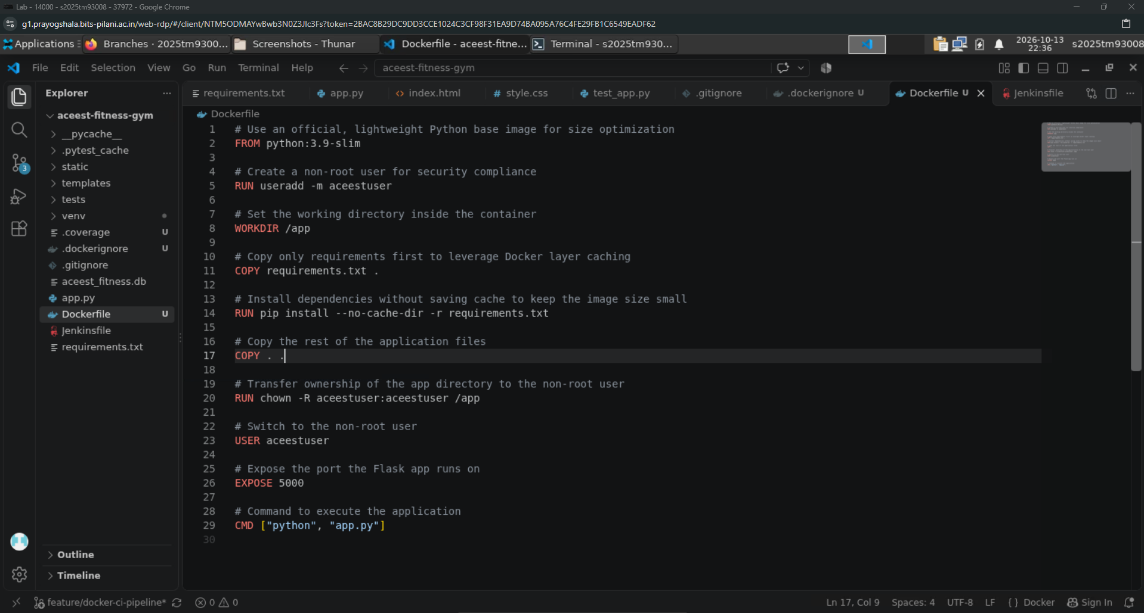

- Now, checking the docker version to check the compatibility. Also, build the whole container to check for any issues.
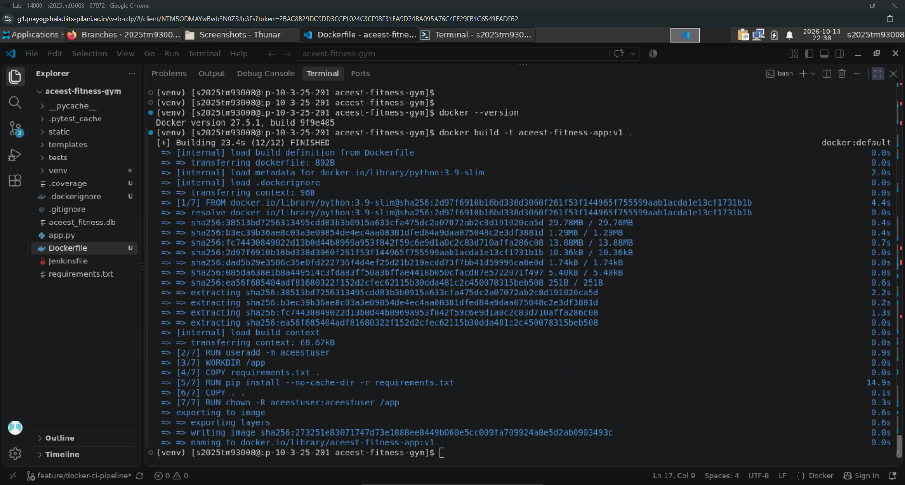

- Now, launching the Flask application in an isolated Docker container and then checking the ports that are up and running on docker. Also, running the curl command to check the status and health of the application.
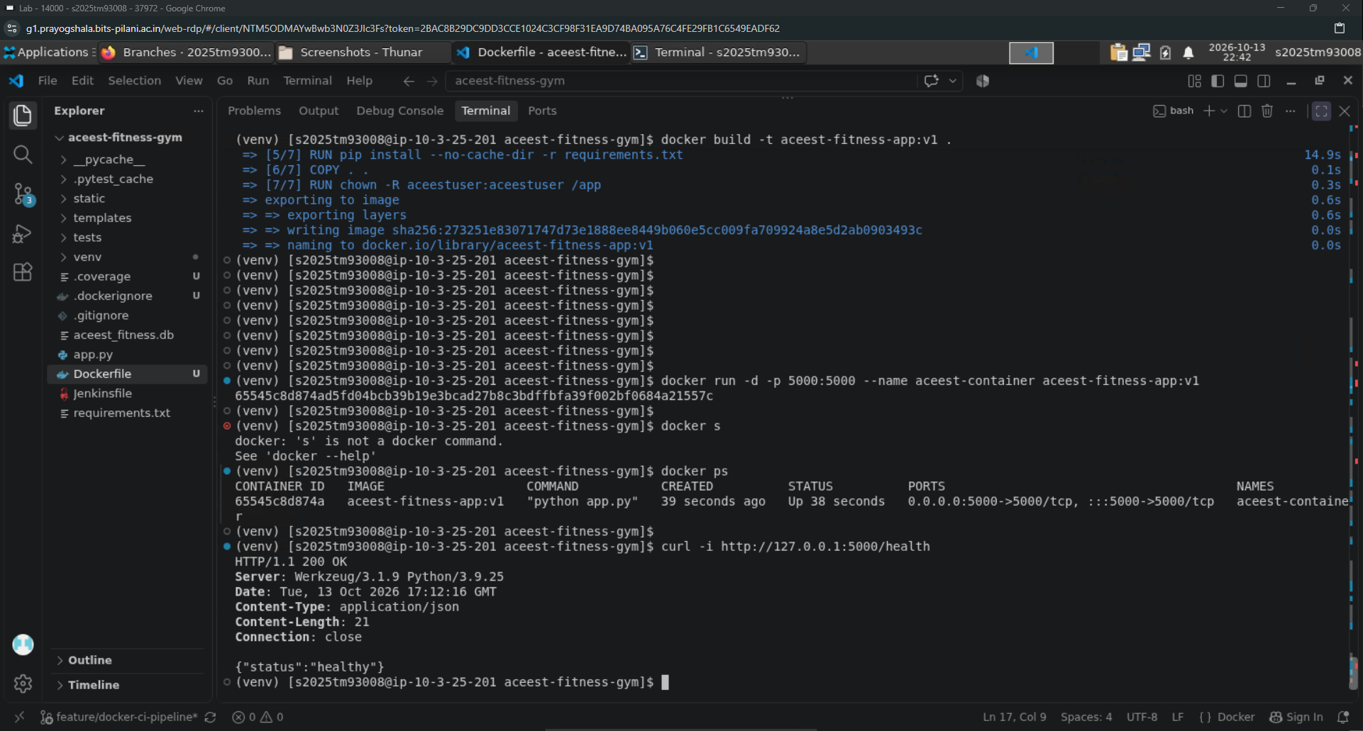

- Now, stopping the ports running on the container and removing the container too.
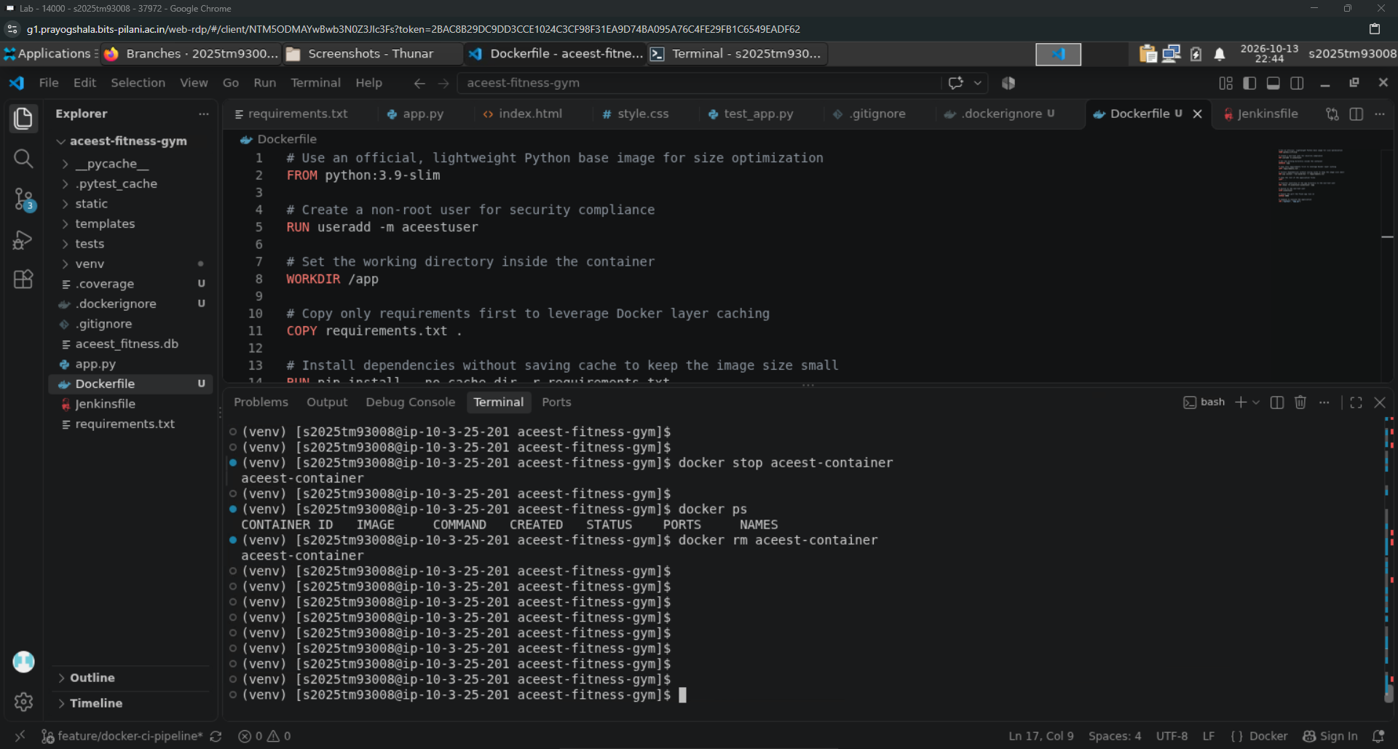

- Finally, committing these new changes to GitHub repository with appropriate comments.
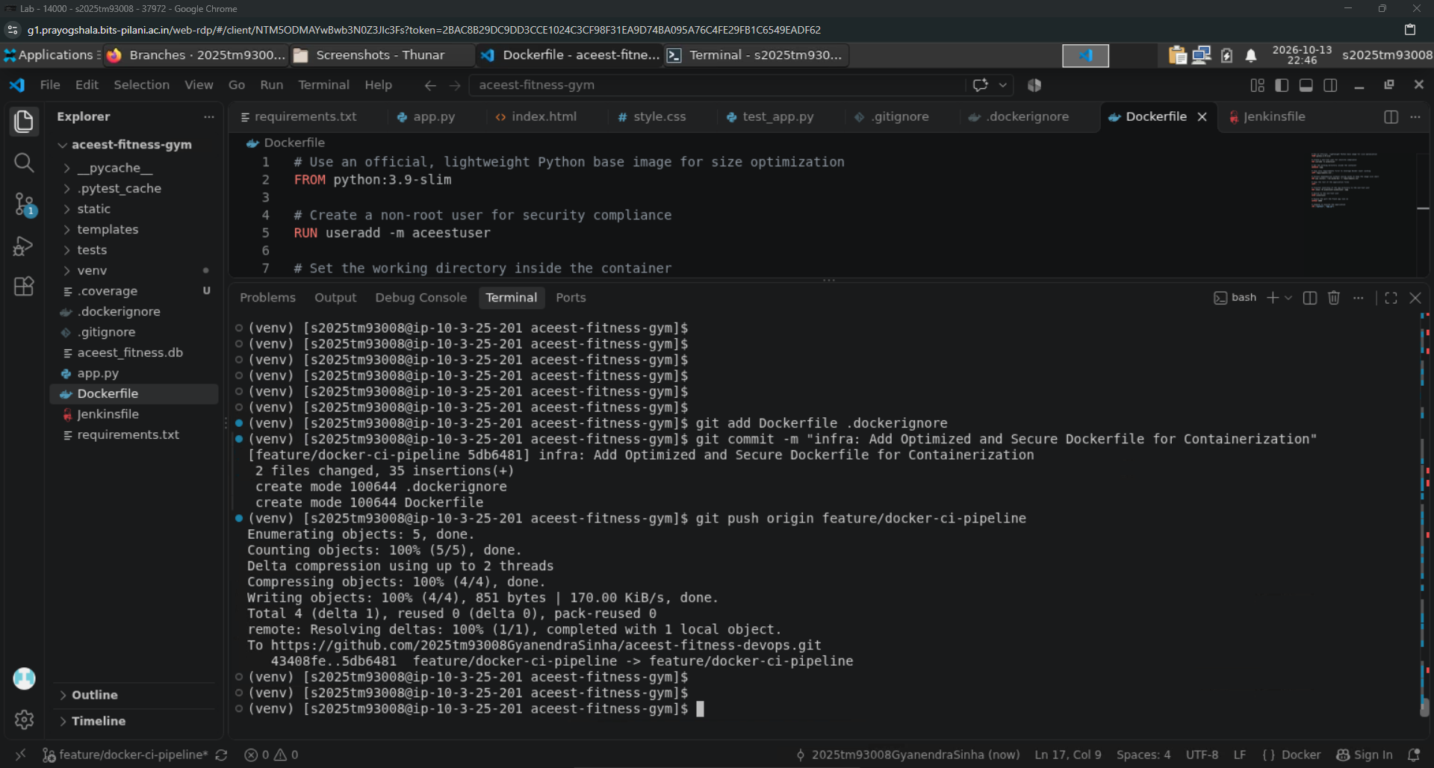

Phase 5: Jenkins Automation & Quality Gate

- Opening the “Jenkins” dashboard in Mozilla Firefox.
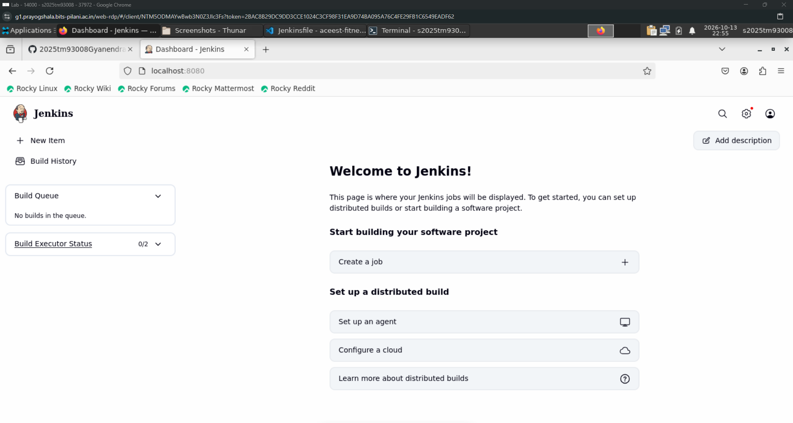

- Updating the “Jenkinsfile” file for the requirements for building and running the test cases.
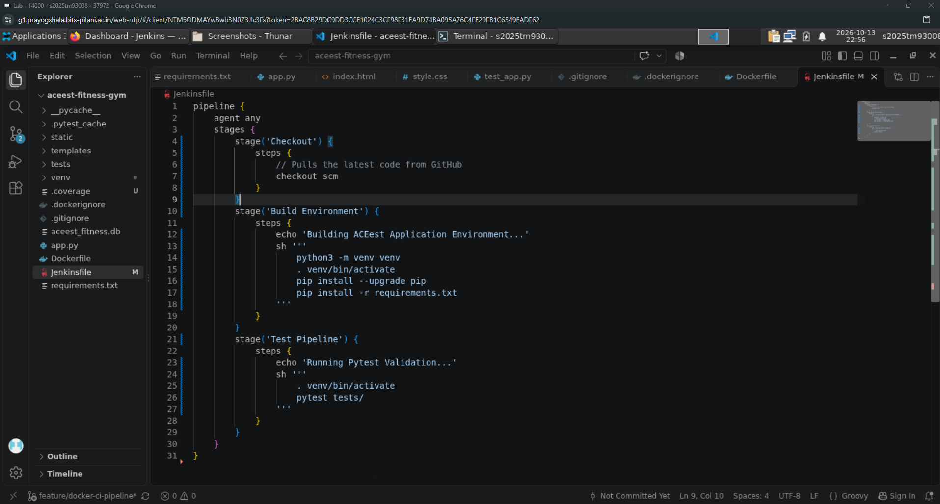

- Now, committing and pushing the updated file for further Jenkins configuration steps.
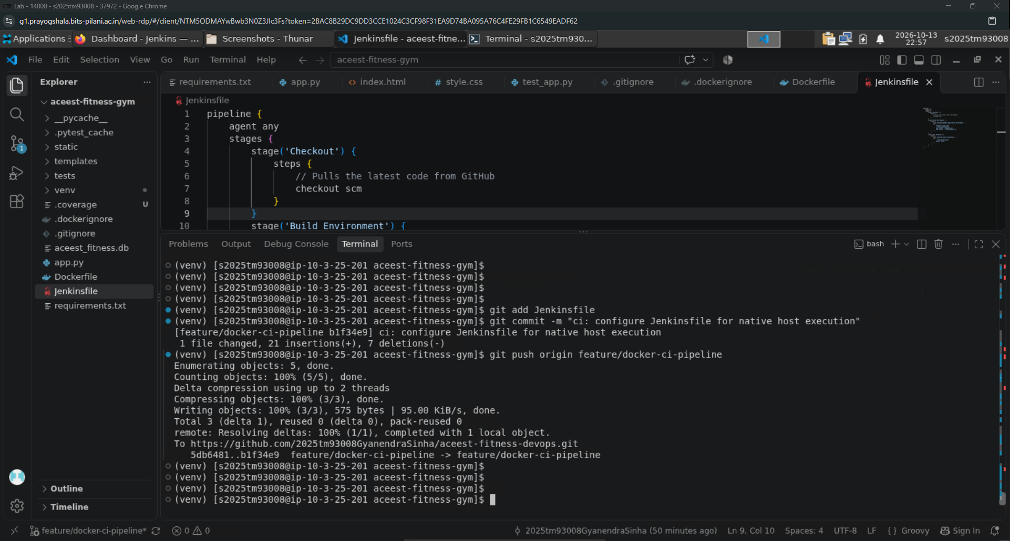

- Now, in Jenkins webpage, creating a new “Pipeline” with the required details of the GitHub repo and the configuration for pipeline.
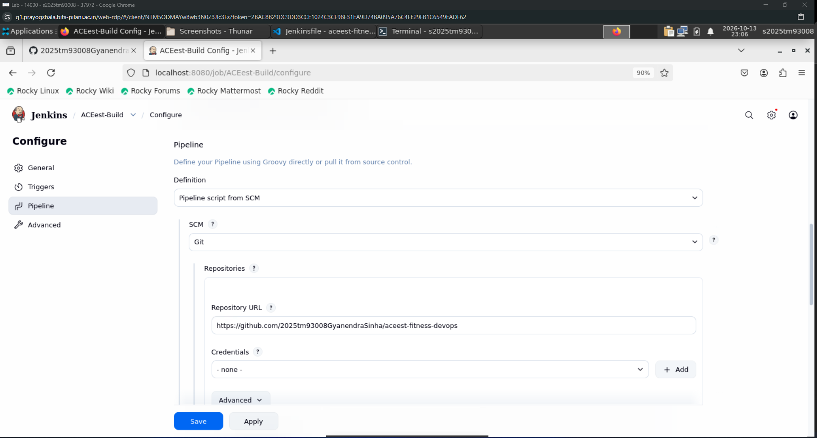

- Also, specifying which specific branch to build and the file name “Jenkinsfile” for the steps to be followed in pipeline.
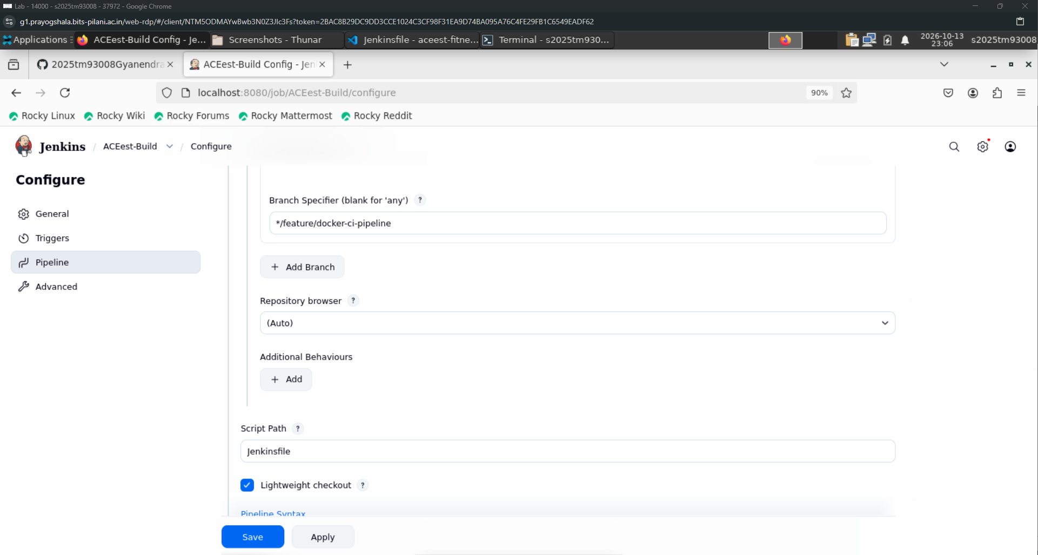

- Below is the result of the 1st build that was triggered using the “Build” button on webpage.
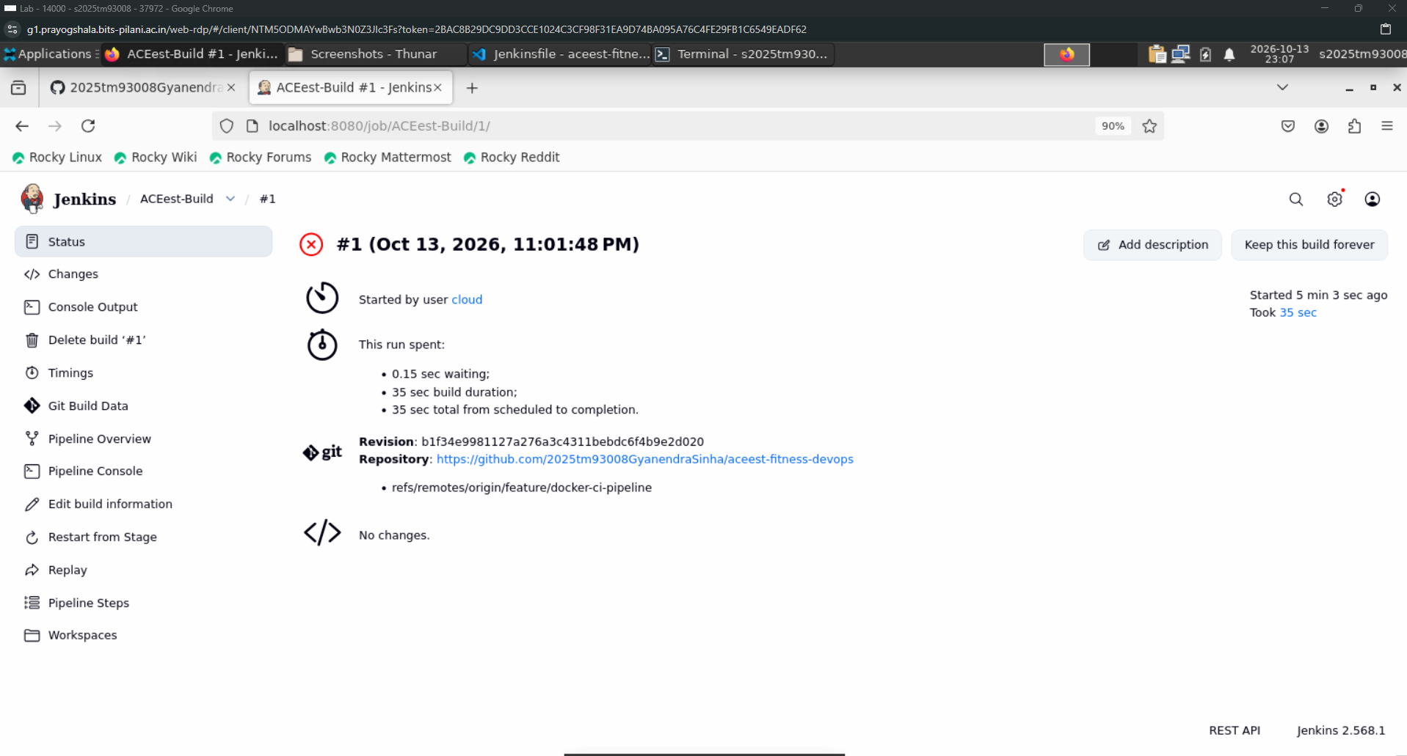

- Now, updating the Jenkins file for the correction of the issue faced in previous step and pushing the changes to GitHub repo.
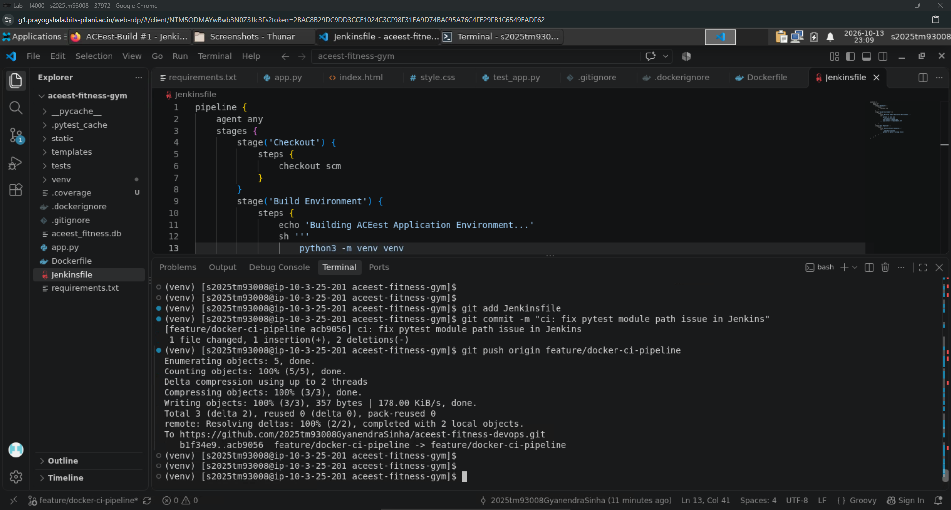

- This is the 2nd Build result after the correction of the Jenkins file for CI/CD pipeline.
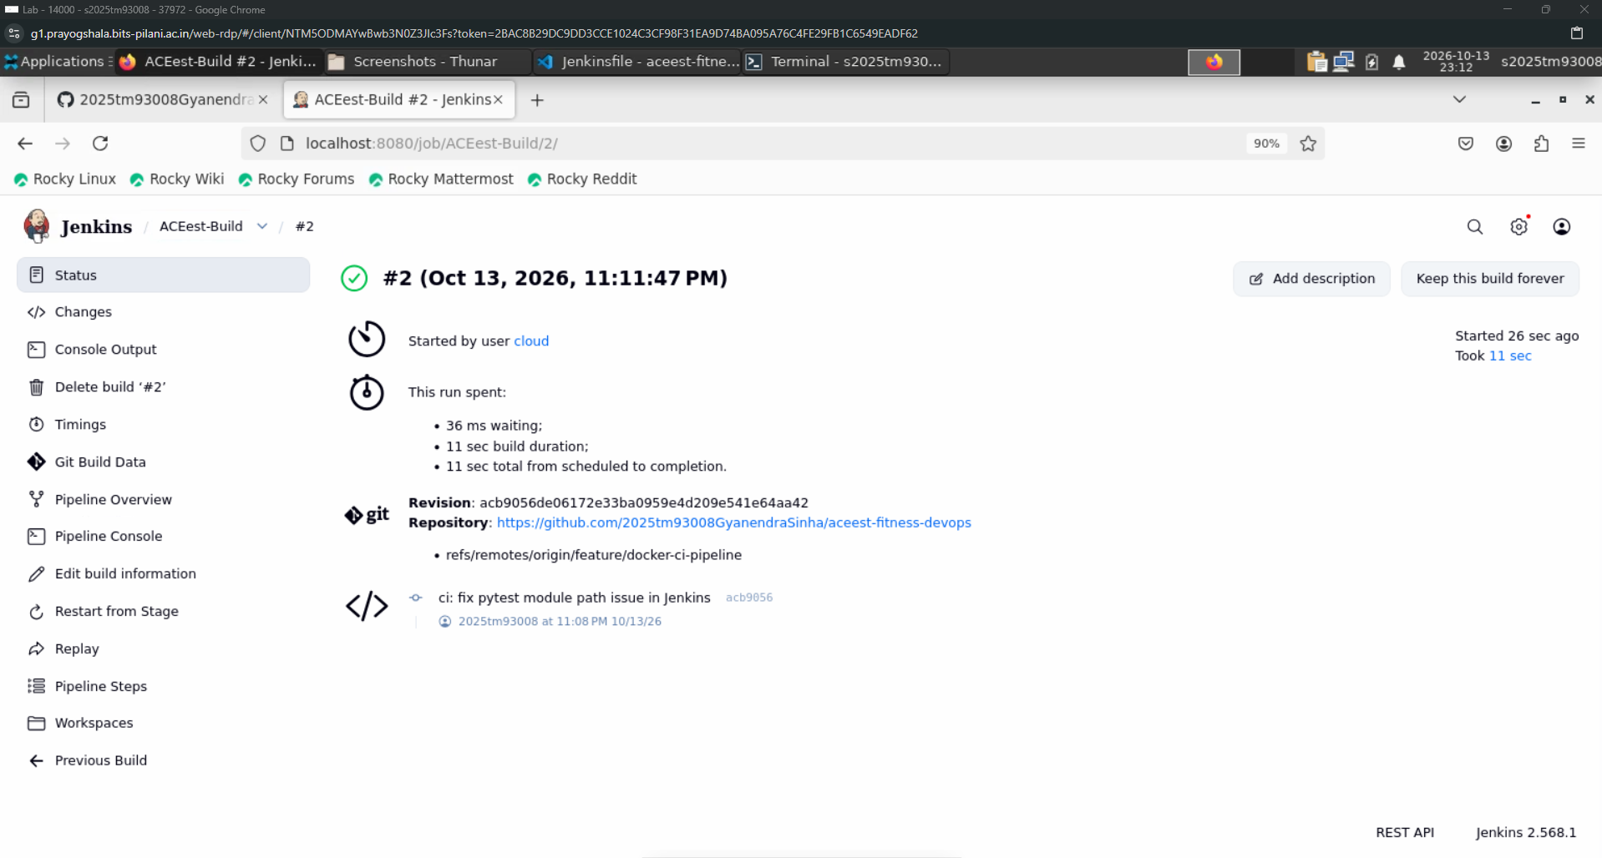

- This is the final test results (console logs) after running of the 2nd build.
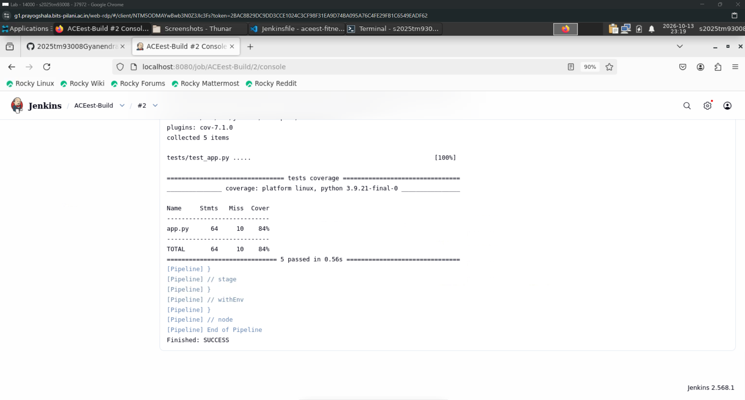

- Now, creating a scheduled “Poll SCM” for periodic builds & test of the GitHub repo without any human intervention.
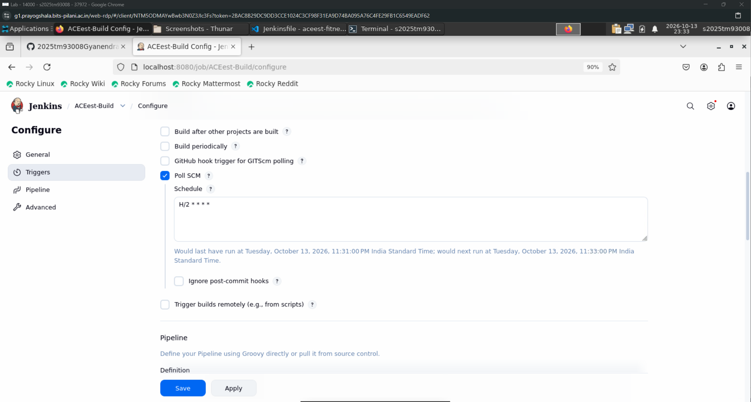

- For testing purpose, a dummy commit is done to the GitHub repo for triggering the automatic build process.
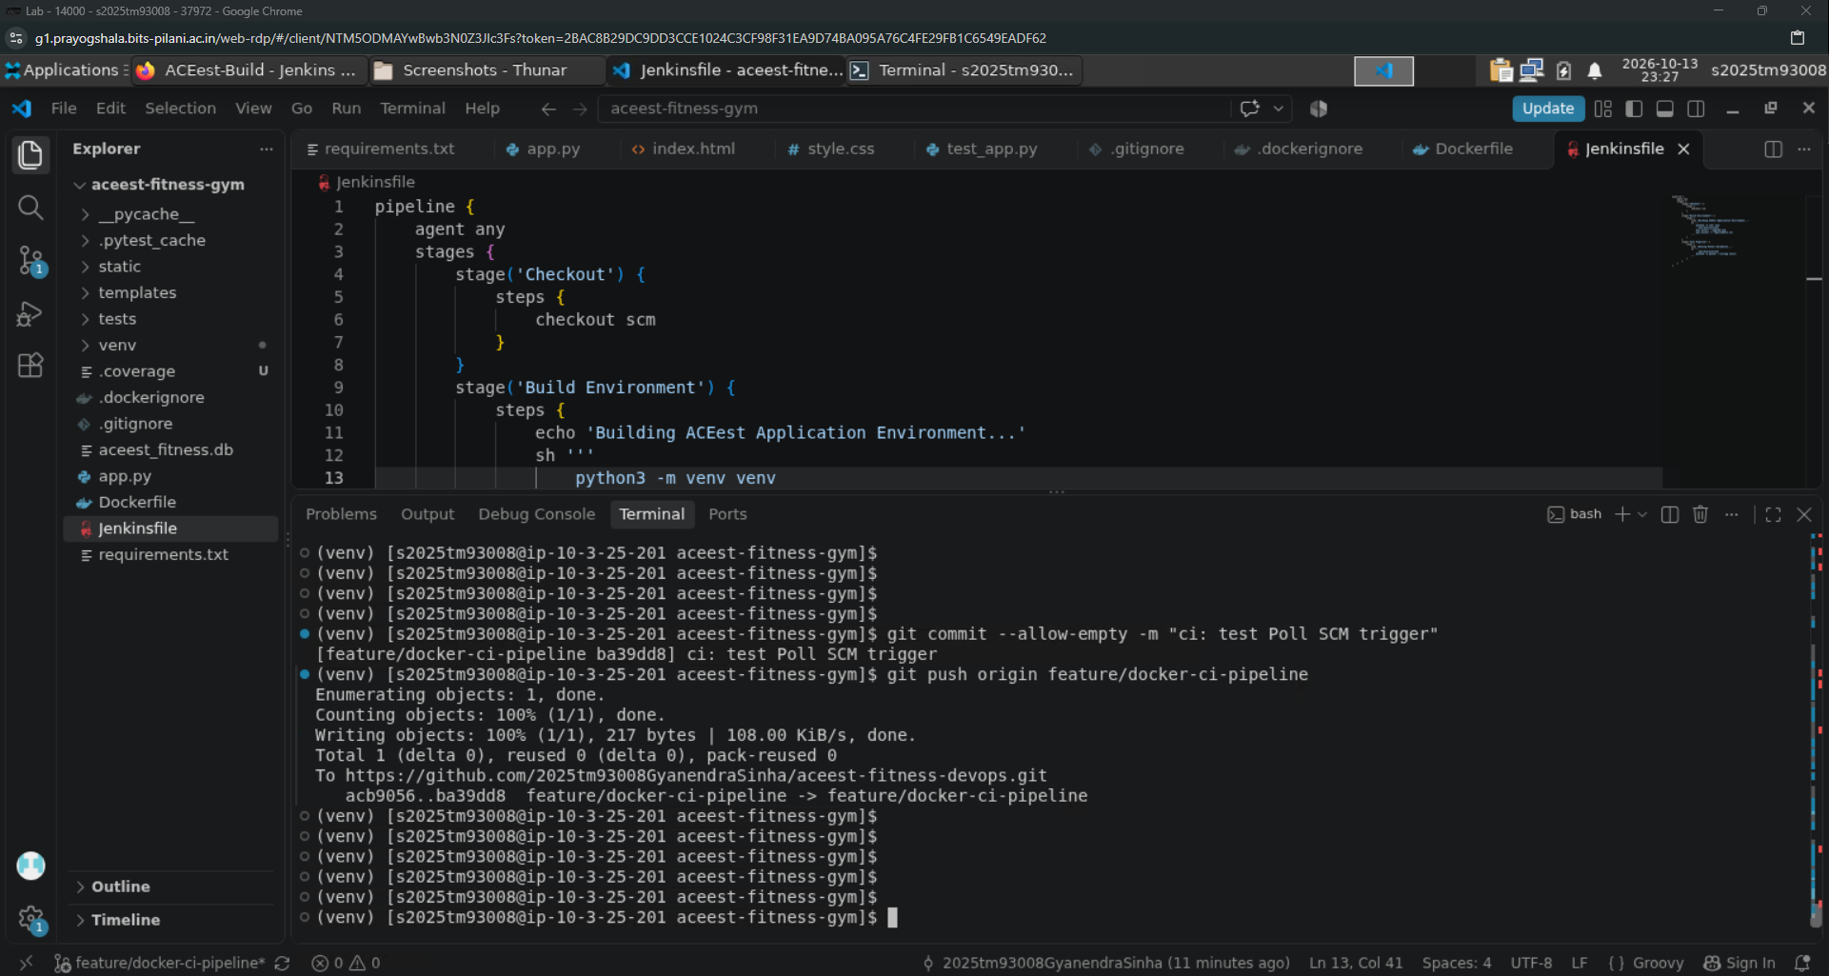

- This is the result for the automatic build process done by “Poll SCM”.
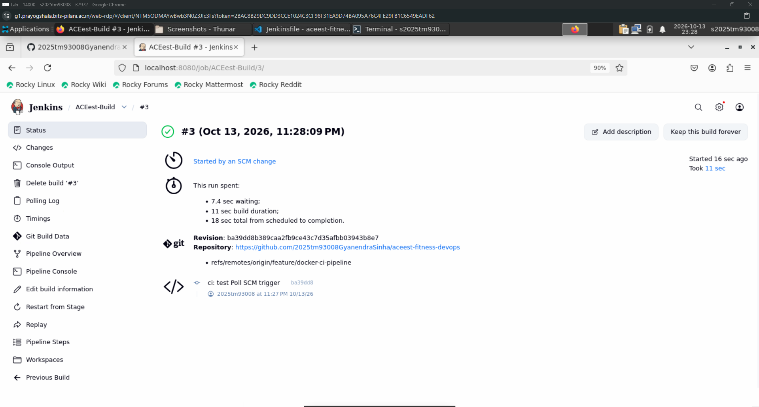

Phase 6: Automated CI/CD Pipeline via GitHub Actions

- GitHub Actions looks for specific hidden directory structure to identify the pipeline configuration. So, creating a file specific for this process.
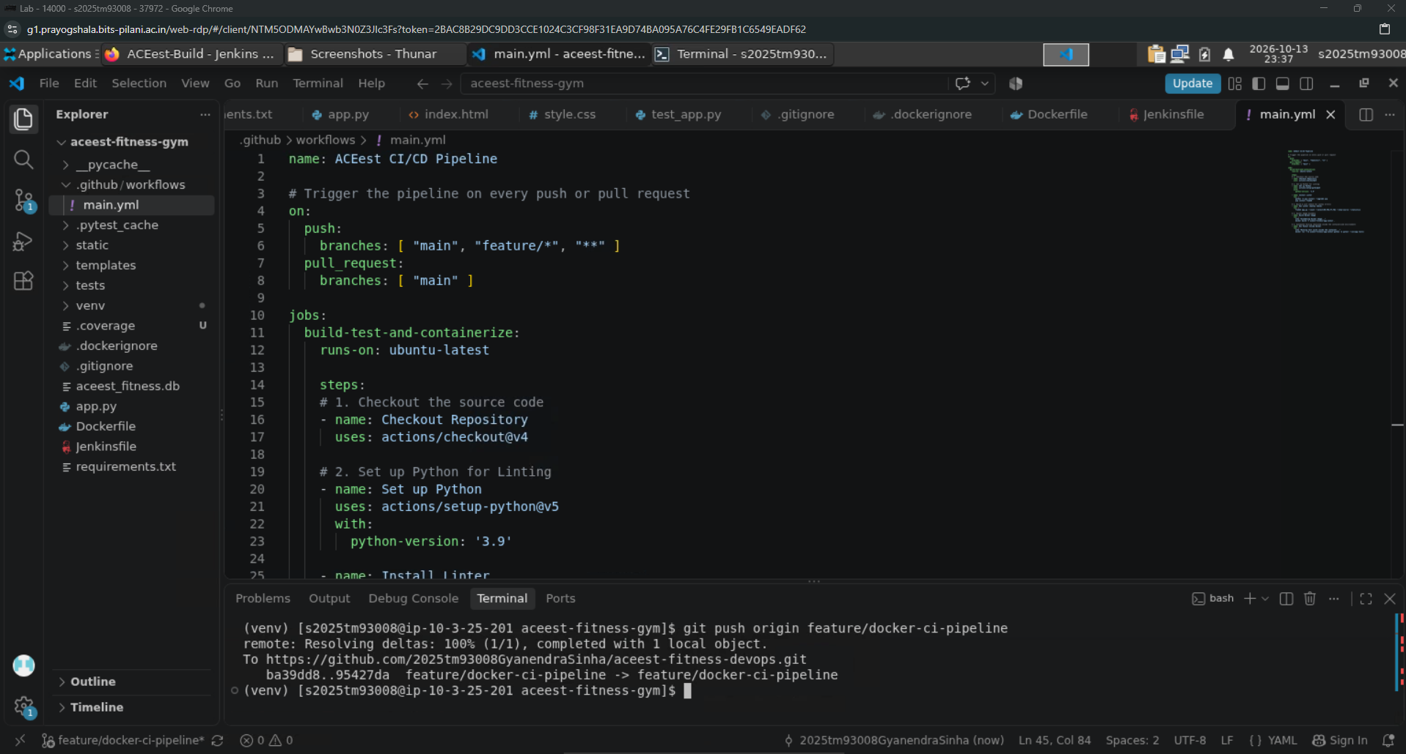

- Now, committing and pushing the changes to GitHub repo.
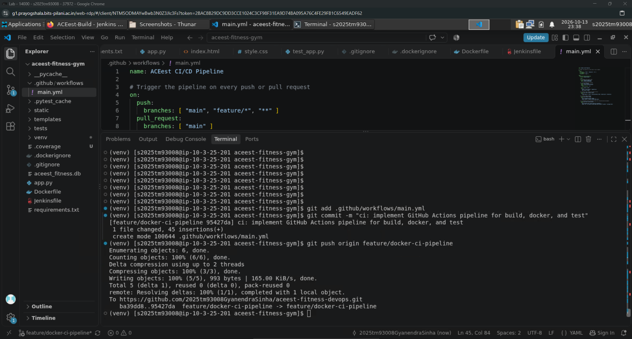

- Finally, checking of the GitHub Actions and the results of the automated process.
