DESIGN AND DEVELOPMENT OF A
MICROSERVICES APPLICATION
Bus Seat Booking System
Assignment Report
Team Members
Sona Jacob
Karri Parasuramu
Course: Scalable Services

1. Problem Statement, Scope and Business Rules

1.1 Problem Statement
A bus booking system must coordinate seat availability, booking creation, payment processing and customer notifications. This project implements these responsibilities as four independently runnable microservices that communicate through REST APIs. Each service owns its data and database, while the Booking Service coordinates the booking workflow.

1.2 Scope
- Booking Service: coordinates the booking workflow and stores booking and idempotency records.
- Seat Service: manages trips, seat capacity, availability and reservations.
- Payment Service: records simulated payment transactions.
- Notification Service: records simulated booking-confirmation notifications.
The implementation uses Python, FastAPI, Uvicorn, SQLAlchemy, PostgreSQL, HTTPX and Pytest. Payment and notification behavior is simulated rather than connected to external providers.

1.3 Business Rules
- A trip must have a non-empty name and positive seat capacity.
- A reservation must refer to an existing trip and use a valid seat number.
- Reserved seats must not exceed a trip's configured capacity.
- A trip must not have duplicate reservations for the same seat number.
- Booking requests must contain valid trip, amount and recipient data.
- A payment for the same booking must not be created with a conflicting amount.
- Repeating a booking request with the same idempotency key and payload returns the saved result.
- Reusing an idempotency key with a different payload is rejected.
- The Booking Service handles an unavailable Seat Service with a controlled failure response.

1.4 Out of Scope
Real payment gateway integration, actual email/SMS delivery, user authentication, a customer-facing frontend and production deployment are outside the current implementation scope.

2. Service Decomposition and Data Ownership
The system is split into four independently runnable services. Each service has its own PostgreSQL database and credentials. Inter-service operations use REST APIs; services do not directly query another service's database.
Service | Port | Database | Responsibility
Booking | 8001 | bus_booking_db | Booking workflow and idempotency
Seat | 8002 | bus_seat_db | Trips, capacity and reservations
Payment | 8003 | bus_payment_db | Mock payment records
Notification | 8004 | bus_notification_db | Mock notification records

2.1 Design Alternatives
A monolithic application could simplify initial deployment but would couple the four responsibilities. A shared database could simplify cross-entity queries but weaken data ownership. The selected design keeps services and databases separate, at the cost of additional network calls, configuration and distributed-failure handling.

3. Architecture and Workflow

3.1 Component Diagram
Figure 1. Logical component architecture and database ownership.
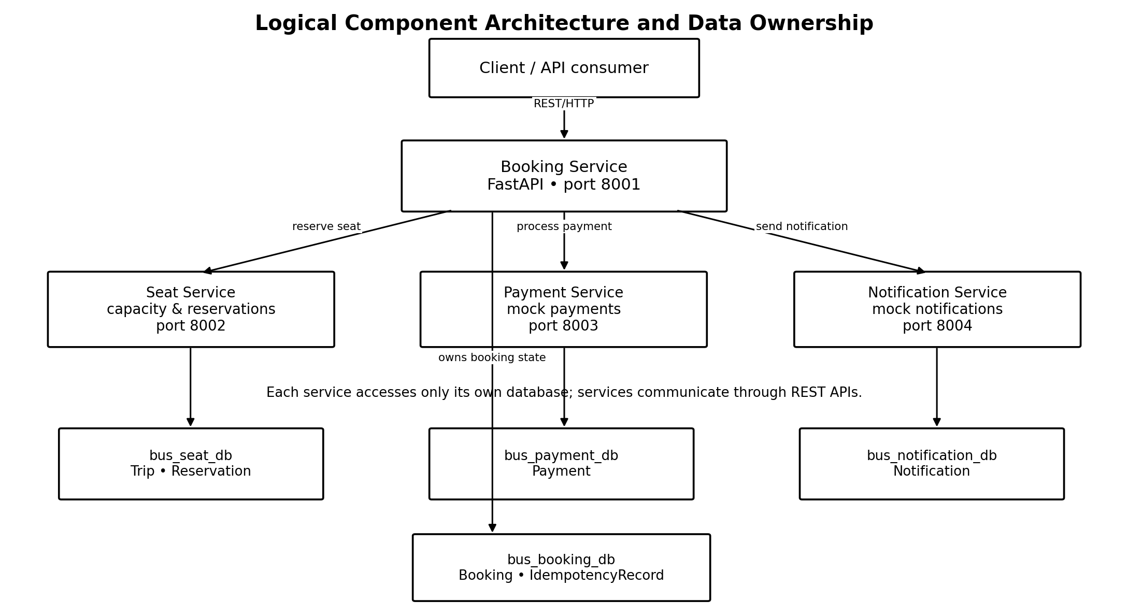
Figure 1. Logical service communication and database ownership

3.2 Successful Booking Sequence
- The client submits a booking request with an Idempotency-Key.
- The Booking Service validates the request and records the idempotency key and request fingerprint.
- The Booking Service asks the Seat Service to reserve a seat.
- The Seat Service checks capacity and persists the reservation.
- The Booking Service creates a booking record and calls the Payment Service.
- After the simulated payment succeeds, the booking is marked CONFIRMED.
- The Booking Service calls the Notification Service to record a confirmation notification.
- The completed idempotency response is saved and returned to the client.
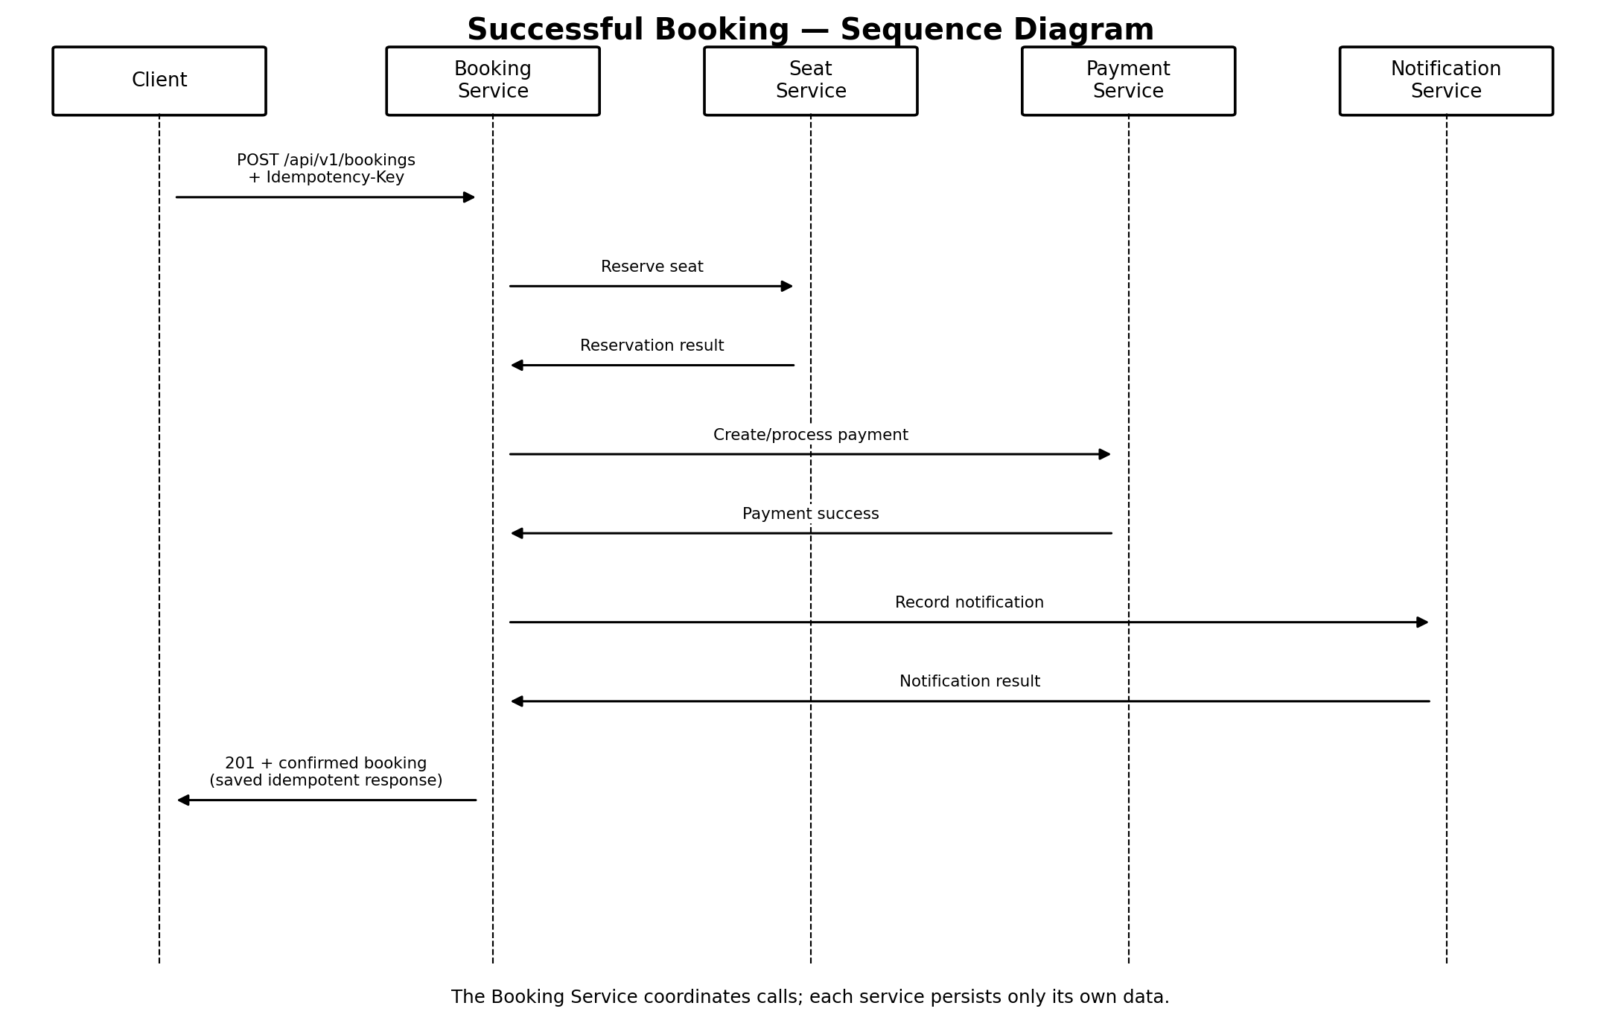
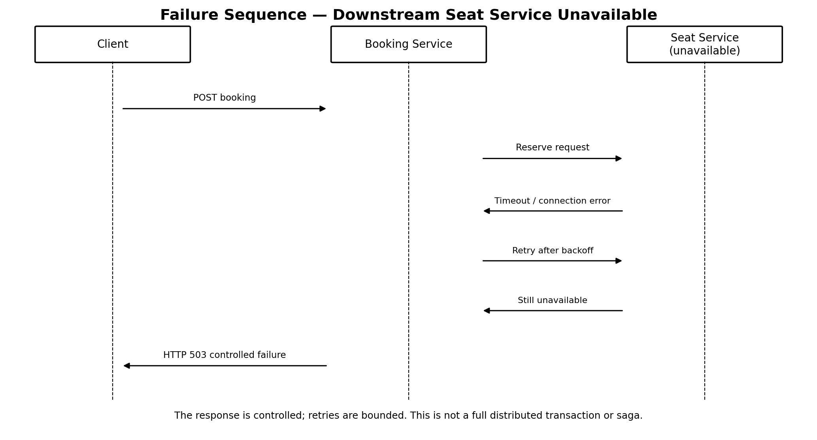
Figure 3. Failure sequence when the Seat Service is unavailable.

3.3 Failure Sequence
When the Seat Service is unavailable, the Booking Service applies configured timeout and retry behavior. If the downstream call ultimately fails, the Booking Service returns HTTP 503. The resilience evidence was produced by temporarily configuring an unavailable Seat Service URL and then restoring the correct URL.

3.4 Transaction Boundaries
The workflow spans independent databases and is not one distributed ACID transaction. Each service persists its own state, while the Booking Service coordinates API calls. A failure after a downstream operation succeeds can therefore leave partial state; compensation and stronger recovery mechanisms remain potential future improvements.

4. Database Design and Entity Relationships

4.1 Booking Database
Booking stores the booking ID, trip ID, seat reservation ID, payment ID, status and creation time. IdempotencyRecord stores a unique idempotency key, request fingerprint, saved response and processing status. Trip, reservation and payment identifiers are references to data owned by other services; they are not cross-database foreign keys.

4.2 Seat Database
Trip stores trip details and total capacity. Reservation stores the trip ID, seat number and reservation status. A reservation references a Trip within the Seat database. Constraints protect positive capacity and seat numbers and uniqueness of the trip-and-seat combination. The reservation operation locks the trip row while allocating a seat.

4.3 Payment Database
Payment stores a payment ID, booking ID, amount and status. The booking ID is owned by Booking Service. The service checks for an existing payment and rejects a conflicting amount.

4.4 Notification Database
Notification stores a notification ID, booking ID, recipient, message, status and creation time.

4.5 ER Summary
Database / Entity | Fields and relationships
Booking | id (PK), trip_id, seat_reservation_id, payment_id, status, created_at
IdempotencyRecord | id (PK), idempotency_key (UNIQUE), request_fingerprint, response_json, status
Trip | id (PK), name, total_seats
Reservation | id (PK), trip_id (FK to Trip.id), seat_number, status; UNIQUE(trip_id, seat_number)
Payment | id (PK), booking_id (unique), amount, status
Notification | id (PK), booking_id, recipient, message, status, created_at

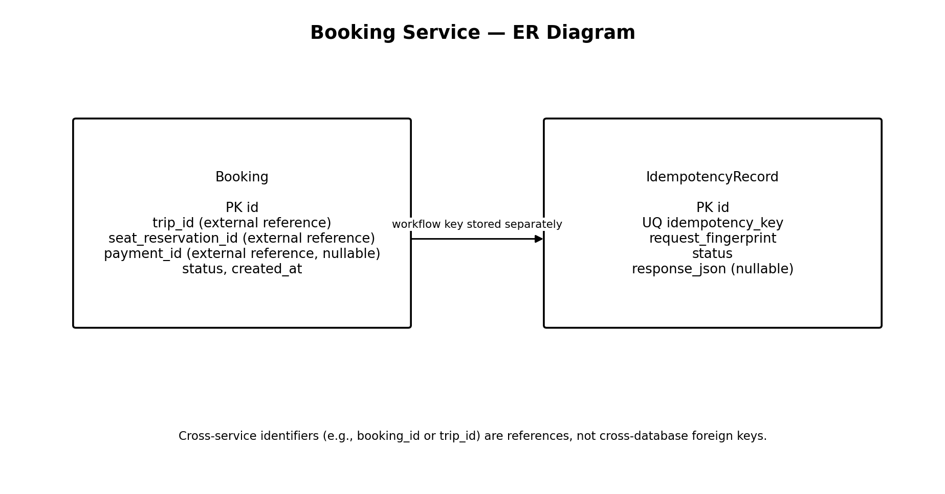
Figure 4. Booking Service data model.
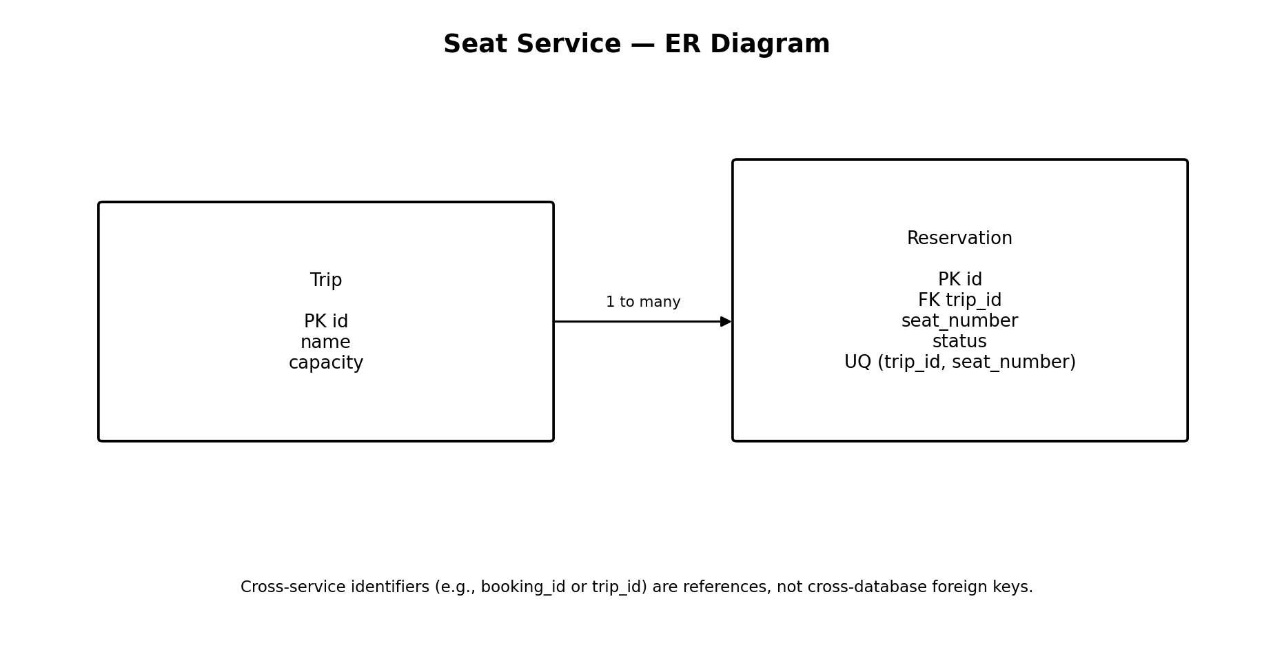
Figure 5. Seat Service data model.
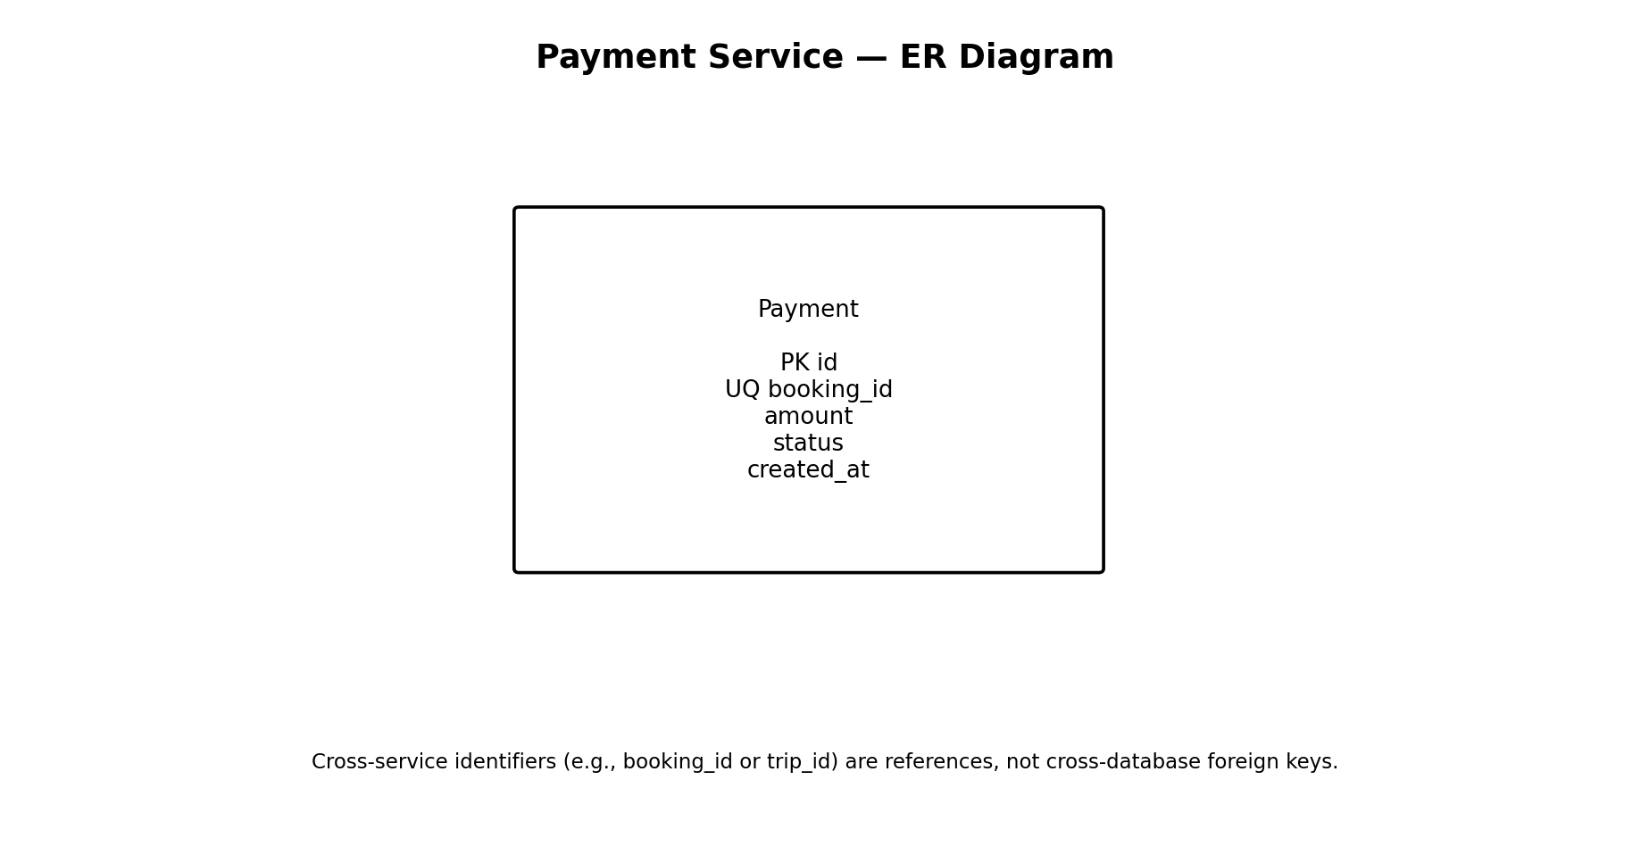
Figure 6. Payment Service data model.
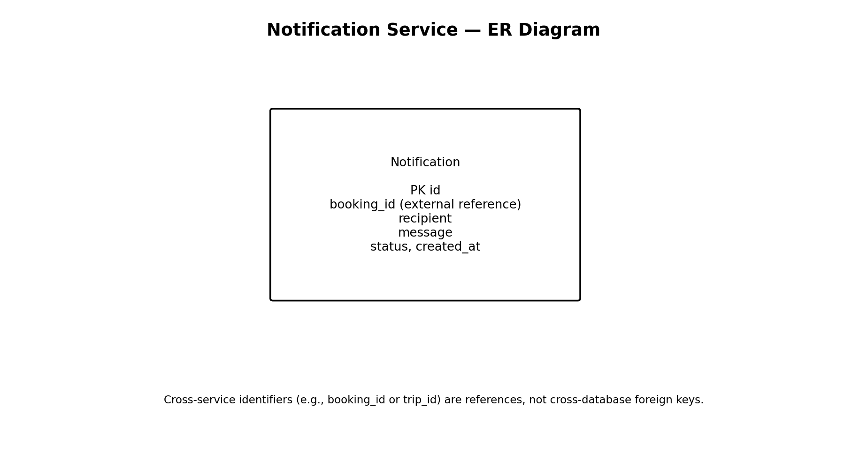
Figure 7. Notification Service data model.

5. API Design and Error Handling
Each service exposes a health endpoint and versioned REST paths under /api/v1/. FastAPI provides interactive OpenAPI documentation through Swagger UI.
Service | Endpoint | Purpose
Booking | GET /health | Health check
Booking | POST /api/v1/bookings | Create booking
Seat | GET /health | Health check
Seat | POST /api/v1/trips | Create trip
Seat | GET /api/v1/trips | List trips
Seat | GET /api/v1/trips/{trip_id}/availability | Check availability
Seat | POST /api/v1/trips/{trip_id}/reservations | Reserve seat
Seat | GET /api/v1/reservations | List reservations
Payment | GET /health | Health check
Payment | POST /api/v1/payments | Record mock payment
Notification | GET /health | Health check
Notification | POST /api/v1/notifications | Record mock notification

5.1 Validation and Error Responses
Pydantic schemas validate request fields. The services were updated to return a common error envelope for validation errors, HTTP exceptions and unexpected errors. Validation errors return HTTP 422, conflicts can return HTTP 409, and an unavailable downstream service returns HTTP 503.
{
"error": {
"code": "VALIDATION_ERROR",
"message": "Request validation failed"
}
}

5.2 Request IDs and OpenAPI
Request-ID middleware accepts or generates an X-Request-ID and returns it in the response header. The Booking Service propagates the request ID to downstream calls. Swagger UI is available at http://127.0.0.1:8001/docs, :8002/docs, :8003/docs and :8004/docs respectively when the services are running.

6. Engineering Challenges

6.1 Challenge 1: Concurrent Seat Reservations
Problem: concurrent clients could attempt to reserve the final available seats.
Implementation: the Seat Service locks the trip row during allocation and relies on database constraints to prevent duplicate seat numbers.
Test: twenty concurrent requests were sent to Trip ID 5, configured with capacity five.
Observed result: five successes, fifteen HTTP 409 capacity rejections and no unexpected responses. The database evidence showed five reservations.
Evidence folder: evidence/challenge-1-concurrency/

6.2 Challenge 2: Idempotent Booking Requests
Problem: retries or simultaneous submissions could create duplicate bookings.
Implementation: the Booking Service persists the idempotency key, request fingerprint, status and saved response. Reuse of a key with a different payload returns HTTP 409. A concurrent identical request waits for the original operation to finish and replays its saved response.
Test result: both simultaneous requests returned HTTP 201 with booking ID 5, seat reservation ID 15 and payment ID 5; the idempotency record was COMPLETED.
Evidence folder: evidence/challenge-2-idempotency/

6.3 Challenge 3A: Downstream Resilience
Problem: the Booking Service depends on Seat Service availability.
Implementation: the HTTP client uses a configurable timeout, retries and exponential backoff with jitter; if the downstream call ultimately fails, the Booking Service returns HTTP 503.
Test: the Seat Service URL was temporarily changed to an unavailable local port. The 503 response was captured, and the correct URL was restored.
Evidence folder: evidence/challenge-3a-resilience/

7. Testing and Results
Test | Expected / observed result
Booking validation | 4 tests passed
Seat validation | 4 tests passed
Payment validation | 4 tests passed
Notification validation | 4 tests passed
Seat capacity | 20 requests: 5 successes, 15 HTTP 409, no unexpected responses
Sequential idempotency | Same key and payload returns saved result
Changed idempotency payload | HTTP 409
Concurrent idempotency | Two HTTP 201 responses with the same booking ID
Downstream failure | HTTP 503 when Seat Service is unavailable
Health checks | All four services reported healthy after changes

The validation suites were run separately because the services have similarly named Python packages. Supporting screenshots are stored under evidence/.

8. Architectural Trade-offs

8.1 Independent Services vs. Simplicity
Independent services allow separate development and data ownership but require more configuration, deployment and testing effort.

8.2 REST Communication vs. Network Overhead
REST interfaces are explicit and easy to inspect with Swagger, but each network call adds latency and can fail independently.

8.3 Row Locks and Constraints vs. Throughput
Locks and unique constraints protect capacity and seat uniqueness, but concurrent requests for the same trip may wait for the row lock.

8.4 Idempotency Storage vs. Complexity
Persistent idempotency records support safe replay, but require fingerprints, processing states, stored responses and failure handling.

9. Limitations and Future Work
- Payments and notifications are simulated.
- The system does not implement user authentication or role-based authorization.
- The cross-service workflow is not a distributed ACID transaction and has no full saga compensation mechanism.
- Retry safety for every non-idempotent downstream operation should be strengthened and tested.
- Further end-to-end, failure-injection and recovery tests could be implemented.
- Production deployment, centralized monitoring, and a customer-facing frontend remain future work.

10. Conclusion
The project demonstrates a bus booking workflow decomposed into four independently runnable microservices with separate PostgreSQL databases and REST communication. The implementation includes request validation, OpenAPI documentation, database constraints, concurrent seat allocation protection, idempotency and graceful handling of a downstream service failure. The documented tests and evidence show these mechanisms working in the scenarios exercised.

11. Team Contributions

Team member | Proposed contributions
Sona Jacob | Booking Service and Seat Service implementation; booking workflow integration; idempotency and concurrent seat reservation tests; resilience test; related evidence capture and organization.
Karri Parasuramu | Payment Service and Notification Service implementation; database setup and ownership for those services; API validation and unit tests; report diagrams, documentation review.

11.1 Individual Reflection — Sona Jacob
Reflection — Sona Jacob: I worked on the Booking Service and Seat Service, focusing on the booking workflow, seat-capacity rules, request validation and database consistency. One important challenge was handling concurrent attempts to reserve seats without allowing the trip capacity to be exceeded. The work helped me understand why database transactions, row locking and constraints matter in a microservices system. I also learned that a service should own its data and expose operations through an API instead of allowing other services to access its database directly.

11.2 Individual Reflection — Karri Parasuramu
Reflection — Karri Parasuramu: I worked on the Payment Service and Notification Service, which keep simulated payment and notification records separate from booking and seat data. This helped me understand how small services can have clear responsibilities and communicate through REST APIs rather than sharing a database. A key lesson was that a successful booking involves several independent steps, so the system must handle downstream failures and avoid creating duplicate payment effects when requests are repeated.

12. AI-Use Declaration
AI tools were used to assist with technical explanations, debugging guidance, test planning and report drafting.

13. Demonstration Video
Video link: ______________________________________________________________

