CONTAINERIZATION AND DEPLOYMENT
OF A MICROSERVICES APPLICATION
Bus Seat Booking System
Assignment 2 Report

Team Members
Karri Parasuramu
Sona Jacob
Course: Scalable Services

1. Objective, Scope and Containerization Approach

1.1 Objective
The objective of Assignment 2 is to containerize the Bus Seat Booking microservices application developed in Assignment 1 and deploy the complete system using Docker Compose. The deployment packages each service separately, runs its database in a dedicated container, supplies configuration through environment variables and validates the end-to-end booking workflow.

1.2 Application Scope
The application retains the four-service design from Assignment 1. Booking Service coordinates the booking workflow and stores booking and idempotency records. Seat Service manages trips, seat capacity and reservations. Payment Service records simulated payment transactions, and Notification Service records simulated booking-confirmation notifications. Each service has its own PostgreSQL database.
Service | Container port | Database
Booking Service | 8001 | bus_booking_db
Seat Service | 8002 | bus_seat_db
Payment Service | 8003 | bus_payment_db
Notification Service | 8004 | bus_notification_db

1.3 Containerization Approach
A separate Dockerfile was created for each microservice. Each Dockerfile uses python:3.13-slim, sets /app as the working directory, installs the packages in requirements.txt, copies the service application code, exposes the relevant port and starts the FastAPI application using Uvicorn. Four separate images were built: booking-service:1.0, seat-service:1.0, payment-service:1.0 and notification-service:1.0.

2. Deployment Architecture
Docker Compose defines eight containers: four application services and four PostgreSQL databases. All containers communicate over the Compose network. The Booking Service uses the internal service URLs for Seat, Payment and Notification. Database URLs and service URLs are provided through environment variables rather than hardcoded into application code.
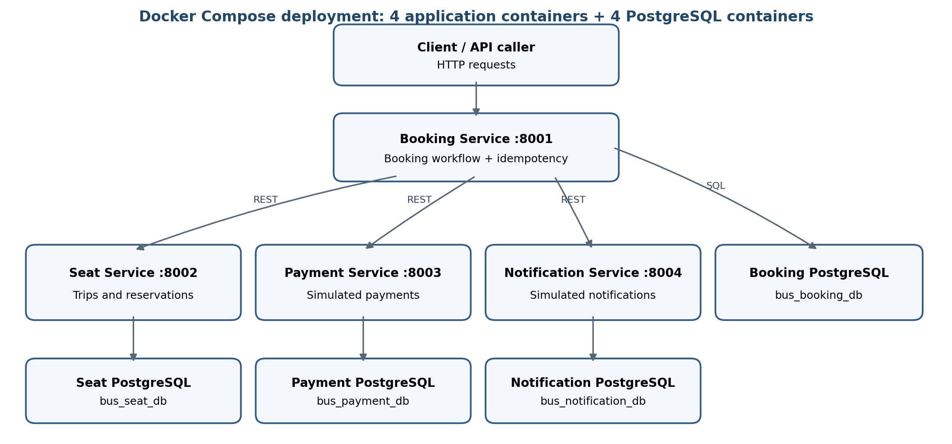
Figure 1. Docker Compose deployment architecture and database ownership.

3. Docker Compose Configuration and Deployment

3.1 Compose Configuration
The docker-compose.yml file defines the four application services and their four PostgreSQL 16 database containers. It configures host port mappings, environment variables, database health checks, application health checks, service dependencies and named volumes for persistent database storage.
The database configuration is kept in a local .env file. The .env file is excluded from Git through .gitignore. A .env.example file is included in the project with placeholder values only; real passwords are not placed in the Docker images or committed to the repository.

3.2 Deployment Command
docker compose up --build -d
The command builds the application images where required and starts the complete deployment in detached mode. The deployment was checked using docker compose ps. The output showed all eight containers running with healthy status. The four application health endpoints at ports 8001, 8002, 8003 and 8004 each returned a healthy response.

3.3 Full Stop and Restart Validation
The complete application was stopped using docker compose down and then started again using docker compose up --build -d. After restart, docker compose ps again showed the four application containers and four database containers as Up (healthy). The four /health endpoints were checked again and returned healthy. The named database volumes were retained because the deployment was stopped without deleting volumes.

4. End-to-End Booking Workflow
A demo trip named “Assignment 2 Demo Trip” was created through the Seat Service with a capacity of 10 seats. A booking request was then submitted to the Booking Service with trip_id 1, amount 1500 and a demo recipient. The request included the required Idempotency-Key header.
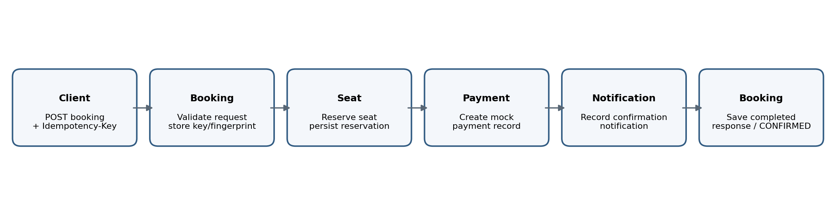
Figure 2. Main booking workflow executed across the microservices.
The first successful request created booking ID 1, seat reservation ID 1 and payment ID 1, with booking status CONFIRMED. After the Seat Service recovery test, a second request using a fresh idempotency key created booking ID 2, seat reservation ID 2 and payment ID 2, also with status CONFIRMED. Booking logs showed successful HTTP 201 responses from the downstream Seat, Payment and Notification services. Database queries verified the booking and payment records.

5. Deployment Troubleshooting

5.1 Problem and Symptom
A controlled service-availability failure was introduced for the deployment troubleshooting demonstration. The Seat Service container was stopped using docker compose stop seat-service while the other application containers and databases remained running. A new booking request was submitted to Booking Service and returned HTTP 503 with the message “Seat Service is currently unavailable”.

5.2 Diagnosis
The container status was inspected using docker compose ps. The output showed that seat-service was stopped while the other services and databases remained available. The Booking Service depends on Seat Service to reserve a seat before it can complete the booking workflow. The downstream HTTP client uses bounded retries; after the attempts fail, Booking Service returns a controlled HTTP 503 response.

5.3 Solution and Validation
The Seat Service was restarted using docker compose start seat-service. Its health endpoint returned healthy and docker compose ps showed the container as Up (healthy). A new booking request with a fresh Idempotency-Key was submitted. It completed successfully and returned a CONFIRMED booking. The team also performed a complete Compose stop and restart, and verified that all eight containers and all four health endpoints were healthy.

5.4 Learning and Reflection
The exercise demonstrated that a workflow can fail even when its coordinating service is running, because it depends on other services. Container status, health checks and service logs are useful for locating the unavailable dependency. Retries can handle temporary failures, but they do not replace recovery of the dependency. The application must be validated again with a fresh end-to-end request after recovery.

6. Testing and Results
Validation activity | Observed result
Individual service health checks | All four /health endpoints returned healthy.
Compose deployment | All eight containers showed Up (healthy).
Trip creation | Demo trip created with ID 1 and capacity 10.
Successful booking workflow | Booking ID 1; seat reservation ID 1; payment ID 1; CONFIRMED.
Workflow after recovery | Booking ID 2; seat reservation ID 2; payment ID 2; CONFIRMED.
Seat Service stopped | Booking request returned HTTP 503.
Seat Service restarted | Health check passed and a new booking succeeded.
Full deployment restart | All eight containers and four health endpoints healthy.

7. Deployment Design Decisions and Trade-offs

7.1 Separate Service Images
Building one image per microservice preserves the independent deployment approach established in Assignment 1. It allows each service to be built and run separately, although it requires maintaining multiple Dockerfiles and image builds.

7.2 Docker Compose and Service Networking
Docker Compose provides a reproducible way to start the application and its databases together. The Compose network allows services to communicate using service names, avoiding the need to use host addresses for container-to-container calls. The trade-off is that the Compose configuration must correctly define dependencies, health checks and environment variables.

7.3 Environment Variables and Persistent Volumes
Environment variables keep deployment-specific URLs and credentials outside the source code. The local .env file is excluded from Git, while .env.example documents the required variable names with placeholders. Named volumes keep PostgreSQL data outside the lifecycle of individual database containers.

8. Limitations and Future Work
- The Payment Service and Notification Service continue to simulate external payment and notification behavior.
- The deployment is demonstrated using Docker Compose; Kubernetes and other optional advanced deployment tasks were not included in this core deployment.
- Further automated end-to-end tests and failure-injection scenarios could strengthen deployment validation.
- Centralized monitoring, distributed tracing and production-grade secret management remain potential future improvements.

9. Conclusion
Assignment 2 containerized the four-service Bus Seat Booking application and deployed it with Docker Compose. Four independent application images and four PostgreSQL containers were configured with environment variables, health checks, service dependencies and persistent volumes. The team validated the main booking workflow, demonstrated a controlled Seat Service availability failure, restored the service and confirmed successful booking after recovery. A full deployment restart also verified that the application could be recreated with all services healthy.

10. Team Contributions
Team member | Assignment 2 contribution summary
Karri Parasuramu | Payment Service and Notification Service ownership carried forward from Assignment 1; participation in integration, Compose deployment validation, workflow testing, troubleshooting and evidence collection as performed by the team.
Sona Jacob | Booking Service and Seat Service ownership carried forward from Assignment 1; participation in integration, Compose deployment validation, workflow testing, troubleshooting and evidence collection as performed by the team.

The service ownership allocation is based on the Assignment 1 report. The shared Assignment 2 contribution wording should be reviewed by both team members and adjusted if the actual work was divided differently.

11. AI-Use Declaration
AI tools were used to assist with technical explanations, Docker and Docker Compose troubleshooting guidance, interpretation of command outputs and report drafting. The team executed the deployment commands, inspected service and database results, performed the workflow and recovery tests, and collected the supporting evidence. The team reviewed the generated material and remains responsible for the accuracy of this report.

12. Demonstration Video
Video link: ______________________________________________________________

Appendix A. Supporting Evidence
The supporting screenshots are organised in the project repository under evidence/assignment-2/. The folders cover the following evidence categories:
Evidence folder | Expected supporting evidence
01-dockerfiles | Dockerfiles for Booking, Seat, Payment and Notification services.
02-image-build | Successful build output for the four service images.
03-compose-deployment | Compose configuration, environment-file setup, all containers running and service health checks.
04-database | Database tables and records for Booking, Seat, Payment and Notification.
05-workflow-testing | Trip creation, successful booking response and Booking Service logs.
06-deployment-issue | Seat Service stopped, booking HTTP 503, failure logs, service recovery and successful booking after recovery.

Before submission, verify that each screenshot named in the report exists in the repository and that the screenshots clearly show the relevant command or result. The report describes the controlled Seat Service stop as a deliberate failure simulation.

Appendix B. Deployment Commands Used
- docker compose config --quiet
- docker compose up --build -d
- docker compose ps
- docker compose down
- docker compose start seat-service
- docker compose stop seat-service
The service health endpoints were checked at http://localhost:8001/health, http://localhost:8002/health, http://localhost:8003/health and http://localhost:8004/health.

