INTRODUCTION TO DEVOPS
Assignment - 1
Implementing Automated CI/CD Pipelines for ACEest Fitness & Gym

Field | Details
Student Name | Rajan Kumar
BITS ID | 2025TM93213
Course | Introduction to DevOps (Merged - CSIZG514 / SEZG514) (S1-26)
Submission Type | Public GitHub Repository and Comprehensive Implementation Evidence
Final Public Repository | https://github.com/2025tm93213rajan/aceest-fitness-gym-devops
CI Badge Status | [CI: Build Passing]

1. Assignment Objective & Solution Summary
Objective
The core objective of this assignment is to design, develop, and automate an end-to-end DevOps delivery lifecycle for ACEest Fitness & Gym, a rapidly scaling startup. The assignment provides hands-on mastery over industry-standard practices including Version Control Systems (Git & GitHub), Unit Testing & Test-Driven Validation (Pytest), Containerization (Docker multi-stage builds), Automated Cloud CI (GitHub Actions), Environment Validation (BITS Prayogshala Rocky Linux Virtual Lab), and Secondary Controlled CI Orchestration (Jenkins Pipeline).
Implemented Delivery Lifecycle
The application transitions through a structured, multi-tier deployment and validation pipeline:
Scope of Implementation
- Modular Web Application: Modernized legacy desktop prototypes into a decoupled, testable Flask REST API with SQLite persistence.
- Version Control System (VCS) Discipline: Structured Git repository with short-lived feature branches, conventional commits (feat, test, build, ci, docs), and pull-request-driven integration.
- Automated Unit & API Testing: Comprehensive test suite of 77 automated Pytest cases achieving 100% statement coverage across all core business modules.
- Optimized Multi-Stage Containerization: Minimalist Docker configuration (python:3.12-slim) separating builder, test, and production runtime environments, secured via non-root execution (appuser) and automated health checks.
- Continuous Integration via GitHub Actions: Cloud CI pipeline with 3 chained stages (Build & Lint, Docker Image Assembly, Automated Tests in Docker).
- BITS Prayogshala Rocky Linux Validation: Lab deployment on Rocky Linux server via Apache Guacamole/XFCE, verifying runtime execution, live API operations via curl, and test execution within containers.
- Jenkins Quality Gate Orchestration: Dedicated containerized Jenkins instance configured with a Declarative Pipeline from SCM, mapped to host port 8081 to resolve host port collision with the pre-installed Jenkins server on port 8080.
- Professional Documentation: Comprehensive README with complete reproduction steps, API specifications, and visual pipeline evidence.

2. Flask Application Architecture & Implementation
Evolution from Desktop Legacy to Cloud-Ready Microservice
The original ACEest system comprised isolated Tkinter desktop scripts (versions v1.0 through v3.2.4, preserved in the legacy/ directory). Core business rules-including caloric target estimations, BMI evaluations, membership status, progress adherence calculations, and workout management-were decoupled from the UI and re-architected into a RESTful API.
Modular Project Architecture
aceest-fitness-gym-devops/
├── app.py # Production WSGI entry point
├── aceest/ # Core application package
│ ├── __init__.py # Application factory pattern
│ ├── db.py # SQLite connection handling & schema DDL
│ ├── routes.py # RESTful API routing and HTTP status handling
│ └── services.py # Pure business logic and strict input validation
├── tests/ # Automated Pytest validation suite
│ ├── conftest.py # Fixtures providing isolated temporary databases
│ ├── test_services.py # Algorithmic unit tests (formulas, edge cases)
│ └── test_api.py # Full HTTP API integration tests
├── Dockerfile # Multi-stage image build (builder, test, runtime)
├── Jenkinsfile # Declarative pipeline configuration
├── jenkins/ # Custom Jenkins container setup
│ ├── Dockerfile # Jenkins LTS with embedded Python3 and Docker CLI
│ └── docker-compose.yml # Orchestration binding host port 8081:8080
├── .github/workflows/main.yml # GitHub Actions automated workflow
├── requirements.txt # Minimal runtime dependencies (Flask, Gunicorn)
└── requirements-dev.txt # Development/testing dependencies (Pytest, Flake8)

API Endpoints Reference
The application provides predictable REST endpoints with standardized JSON request/response formats and error schemas (returning 400 for bad input, 404 for missing entities, 409 for conflicts, and 422 for unprocessable entities):
HTTP Method | Endpoint URI | Description
GET | /health | Service liveness health probe
GET | /programs | List available fitness programs (FL, MG, BG)
GET | /programs/<code> | Retrieve workout and diet plan for a specific program code
POST | /clients | Register a new client (name, program, age, height, weight)
GET | /clients | Retrieve all registered clients
GET | /clients/<name> | Retrieve profile details of a client
PUT | /clients/<name> | Update client attributes
DELETE | /clients/<name> | Remove a client and cascade-delete associated history
GET | /clients/<name>/calories | Compute daily calorie requirements ($Weight \times Factor$)
GET | /clients/<name>/bmi | Calculate BMI value and clinical classification
GET | /clients/<name>/membership | Determine active membership validity and days remaining
POST, GET | /clients/<name>/progress | Record / query weekly adherence percentage (0–100)
POST, GET | /clients/<name>/workouts | Record / query completed workout sessions
POST, GET | /clients/<name>/metrics | Record / query body composition metrics (weight, waist, fat %)

3. Version Control System (VCS) with Git & GitHub
Branching Strategy & Release Management
The repository follows standard Git branching conventions:
- `master` Branch: Represents the stable, deployable production branch. Direct commits are restricted in favor of pull request merges.
- Feature & Infrastructure Branches: Isolated work units were implemented on dedicated short-lived branches:
- feature/flask-app: Implementation of core Flask models, routes, and services.
- feature/unit-tests: Implementation of Pytest unit and API test suites.
- infra/docker: Multi-stage Dockerfile and container runtime configuration.
- ci/github-actions: Cloud CI workflow implementation.
- ci/jenkins: Jenkinsfile declarative pipeline and container orchestration.
- docs/pipeline-evidence: Documentation and pipeline verification artifacts.
Commit History Discipline
All commits utilize Conventional Commit prefixes (feat:, test:, build:, ci:, docs:, chore:) providing explicit changelog traceability.
- Public Repository Link: https://github.com/2025tm93213rajan/aceest-fitness-gym-devops

4. Unit Testing & Validation Framework (Pytest)
Testing Architecture
Testing is implemented using Pytest with database isolation. Each test executes against an isolated, temporary SQLite database fixture, preventing test pollution and ensuring clean state transitions.
Test Coverage & Metrics
- Total Test Cases: 77 tests (0 failures, 0 skipped).
- Code Coverage: 100% statement coverage across all source files in the aceest package.
- Execution Time: ~2.8 seconds.
---------- coverage: platform linux, python 3.12.15 ----------
Name Stmts Miss Cover Missing
---------------------------------------------------
aceest/__init__.py 12 0 100%
aceest/db.py 20 0 100%
aceest/routes.py 142 0 100%
aceest/services.py 103 0 100%
---------------------------------------------------
TOTAL 277 0 100%
==================== 77 passed in 2.84s ====================

Coverage Breakdown
- `tests/test_services.py`:
- Caloric multiplier validation for Fat Loss (FL: 22 kcal/kg), Muscle Gain (MG: 32 kcal/kg), Beginner (BG: 26 kcal/kg).
- BMI boundary logic: Underweight (< 18.5), Normal (18.5–24.9), Overweight (25.0–29.9), Obese (≥ 30.0).
- Date calculations, membership expiry logic, and numeric range validations (e.g., adherence bounds between 0 and 100).
- `tests/test_api.py`:
- All REST endpoints validated across positive, negative, and edge scenarios.
- HTTP status code adherence: 200 OK, 201 Created, 204 No Content, 400 Bad Request, 404 Not Found, 409 Conflict, 422 Unprocessable Entity.
- Cascading database deletion verification when deleting a client record.

5. Docker Containerization
Multi-Stage Dockerfile Strategy
The Dockerfile uses a 3-stage multi-stage build pattern based on official python:3.12-slim:
- `builder` Stage:
- Creates a dedicated virtual environment at /opt/venv.
- Installs production dependencies from requirements.txt.
- Eliminates build tools and compiler cache from the final image.
- `test` Stage:
- Inherits from builder.
- Installs development dependencies (requirements-dev.txt: pytest, flake8, coverage).
- Serves as the self-contained test environment executed in CI pipelines.
- `runtime` Stage:
- Copies only the lightweight virtualenv and source code.
- Enforces security through a non-root system user (appuser, UID 10001).
- Exposes port 5000 and configures a built-in Docker HEALTHCHECK targeting /health.
- Serves the application using Gunicorn WSGI production server (gunicorn --bind 0.0.0.0:5000 app:app).
- Final image size: ~145 MB.
Build & Run Commands
# Build runtime image
docker build -t aceest-fitness .
# Run container with persistent SQLite volume
docker run -d --name aceest -p 5000:5000 -v aceest-data:/data aceest-fitness
# Execute tests inside isolated container
docker build --target test -t aceest-fitness:test .
docker run --rm aceest-fitness:test

6. Automated CI with GitHub Actions
Workflow Configuration (`.github/workflows/main.yml`)
The GitHub Actions workflow triggers automatically on every push and pull_request against the master branch. It consists of three sequentially chained jobs:
- Build & Lint:
- Sets up Python 3.12.
- Compiles Python byte-code via python -m compileall to detect syntax issues.
- Runs static code analysis via flake8.
- Docker Image Assembly:
- Configures Docker Buildx with GitHub Actions layer caching.
- Builds the production runtime image.
- Runs container smoke verification by booting the container and querying curl http://localhost:5000/health.
- Automated Tests in Docker:
- Builds the --target test image.
- Executes the full 77-case Pytest test suite inside the containerized environment.
GitHub Actions Verification Evidence
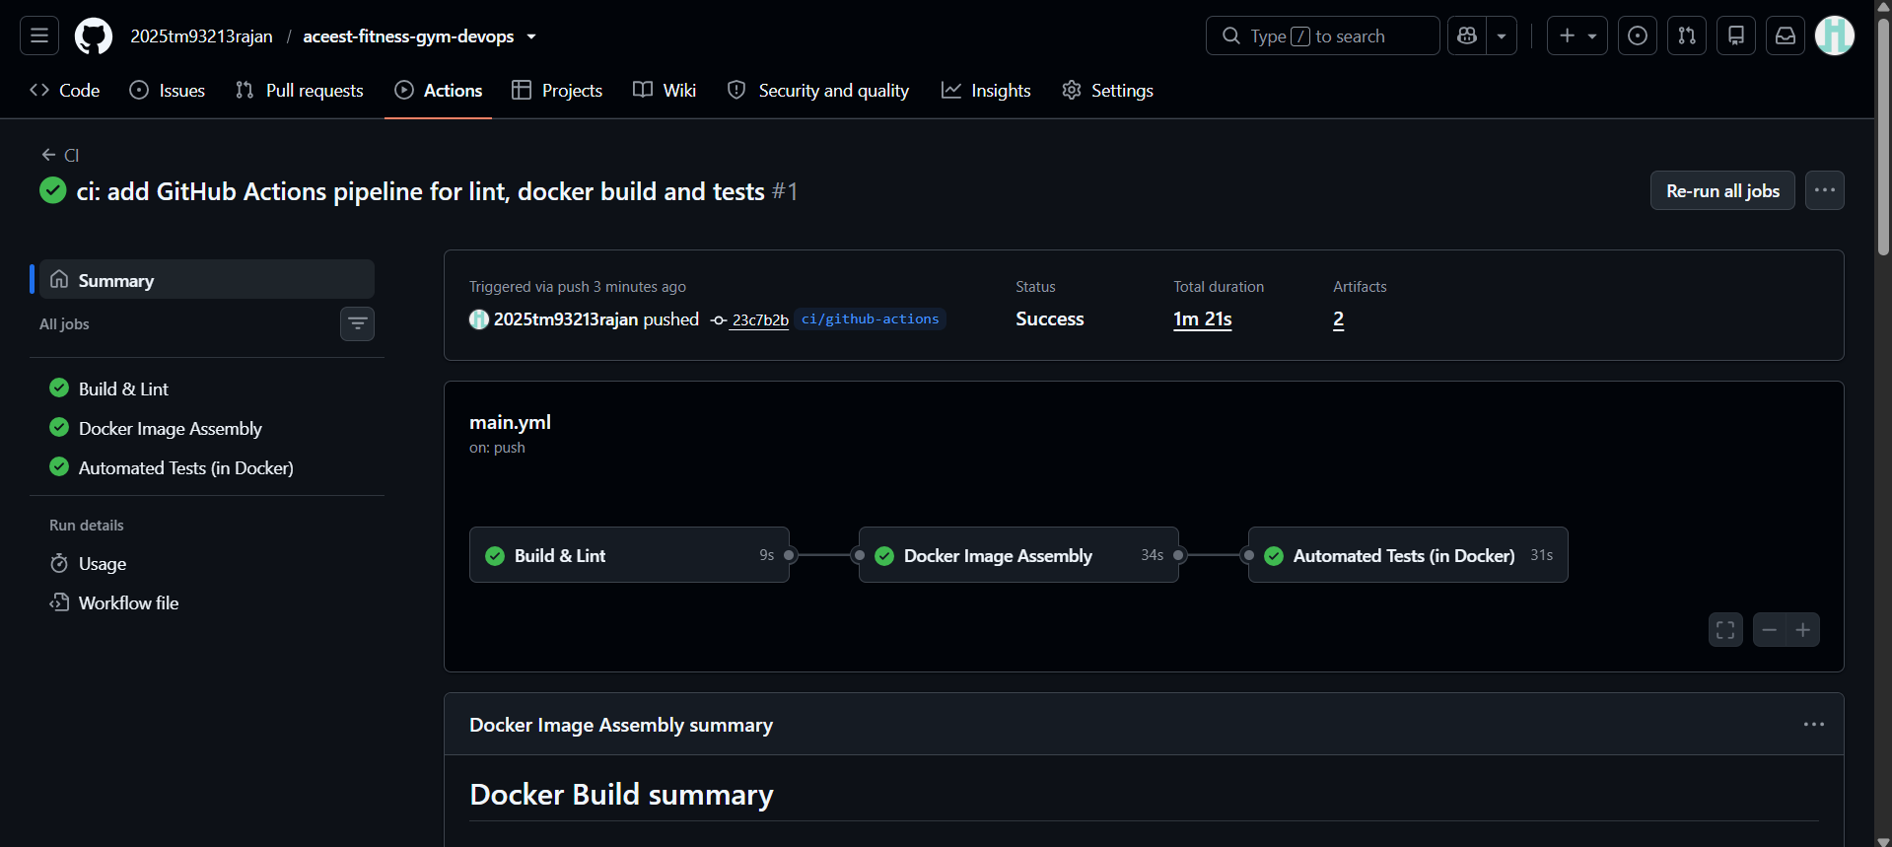
Figure 1: GitHub Actions CI workflow demonstrating successful execution of Build & Lint, Docker Image Assembly, and Automated Tests in Docker.

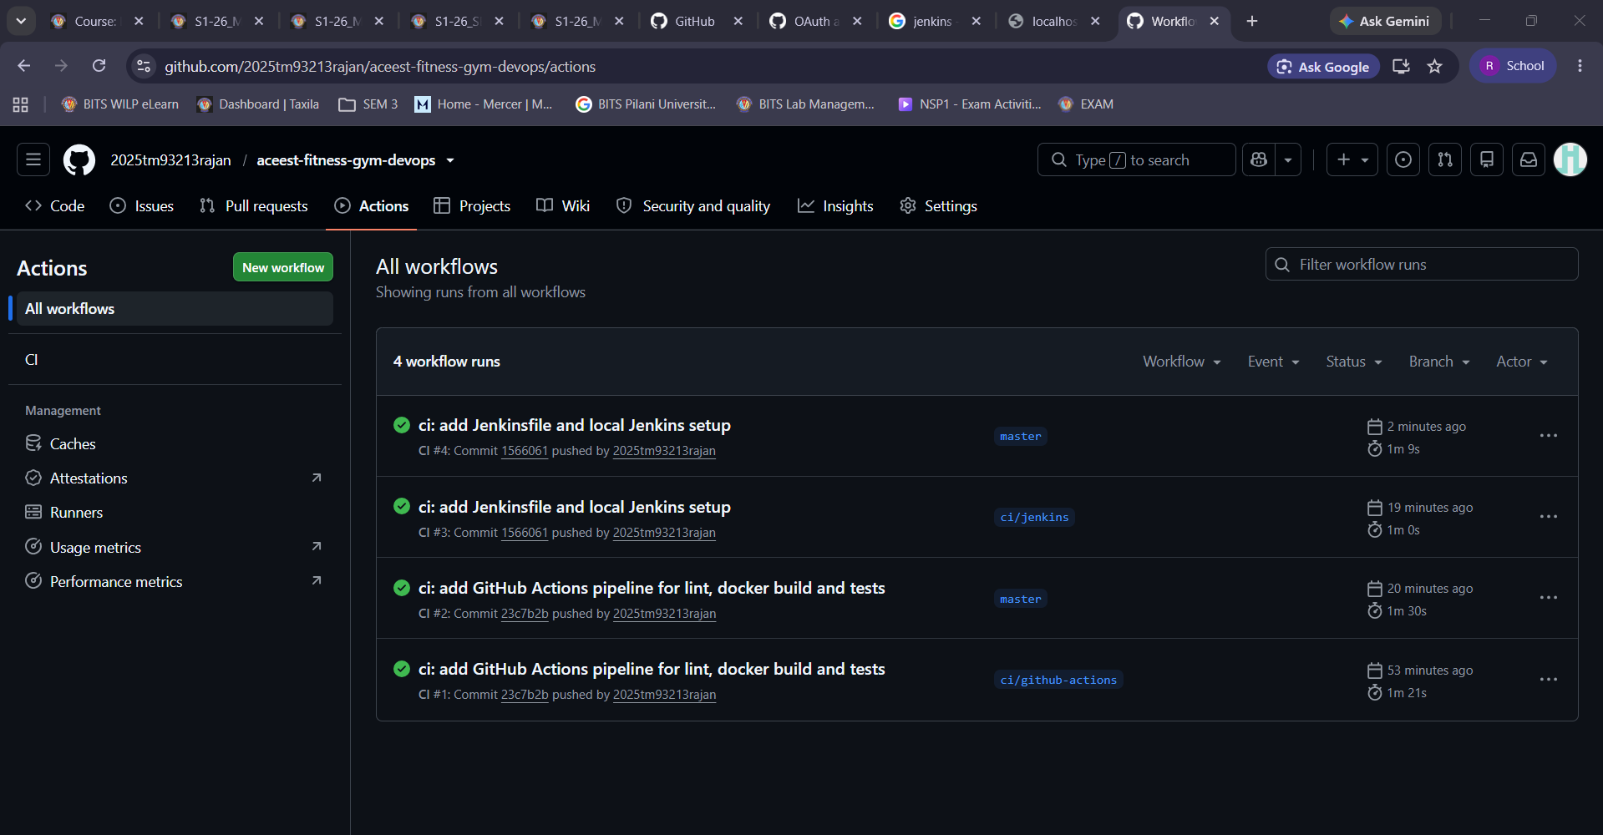
Figure 2: Complete GitHub Actions workflow history across feature branches and master.

7. BITS Prayogshala Rocky Linux Environment Validation
Lab Environment Setup
The project was deployed and validated within the official BITS Virtual Lab environment:
- Operating System: Rocky Linux 9 Server (ip-10-3-17-38)
- User Account: s2025tm93213
- Access Protocol: Apache Guacamole Web-RDP with XFCE Desktop
- Installed Tools: Docker 26+, Git, Python 3.12, curl
Resolution of Port 8080 Conflict
During initial testing in Prayogshala, the host system was already running a pre-installed Jenkins service on the standard port 8080. Attempting to bind a containerized Jenkins to port 8080 resulted in an address already in use error.
Engineering Solution:
The Docker Compose configuration (jenkins/docker-compose.yml) was updated to map host port `8081` to the Jenkins container port `8080`:
ports:
- "8081:8080"
- "50000:50000"

This cleanly decoupled our custom Jenkins instance from the pre-existing system Jenkins, allowing both to coexist without system interference.
Hands-on Validation Evidence in Prayogshala
Step 1: Docker Build, Container Run, and Liveness Probe
The Docker image was built on the Rocky Linux server, launched in detached mode, and verified via curl http://localhost:5000/health:
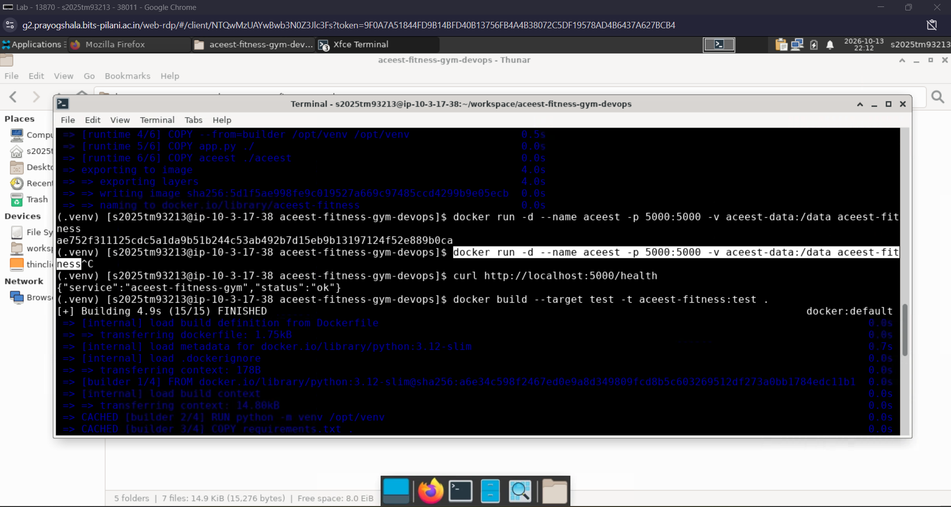
Figure 3: Prayogshala Rocky Linux terminal showing runtime image build, container initialization on port 5000, and HTTP 200 health check response `{"service":"aceest-fitness-gym","status":"ok"}`.

Step 2: Containerized Pytest Execution (100% Coverage)
The test image target was assembled and executed inside Docker on the Rocky Linux VM:
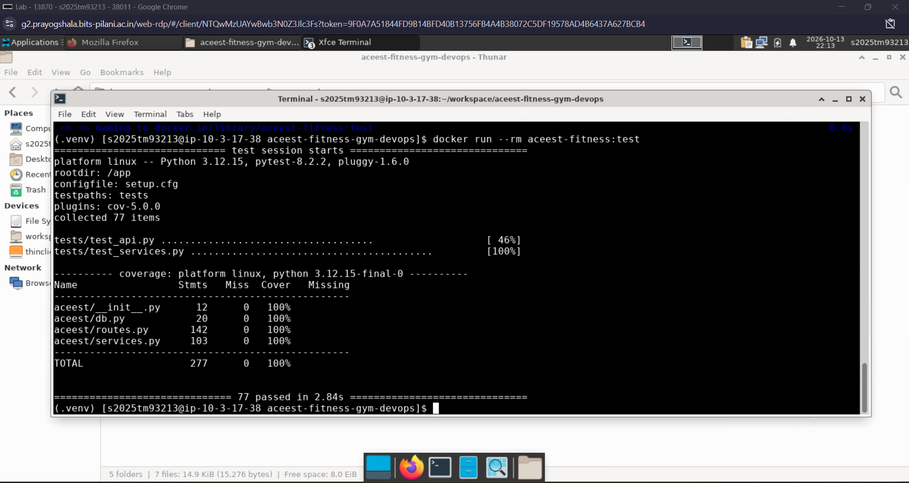
Figure 4: Dockerized Pytest execution in Prayogshala terminal - all 77 test cases passed with 100% code coverage in 2.84s.

Step 3: End-to-End REST API Verification via `curl`
Live API operations were verified from the terminal by registering a client ("Asha Rao") and querying real-time calorie computations:
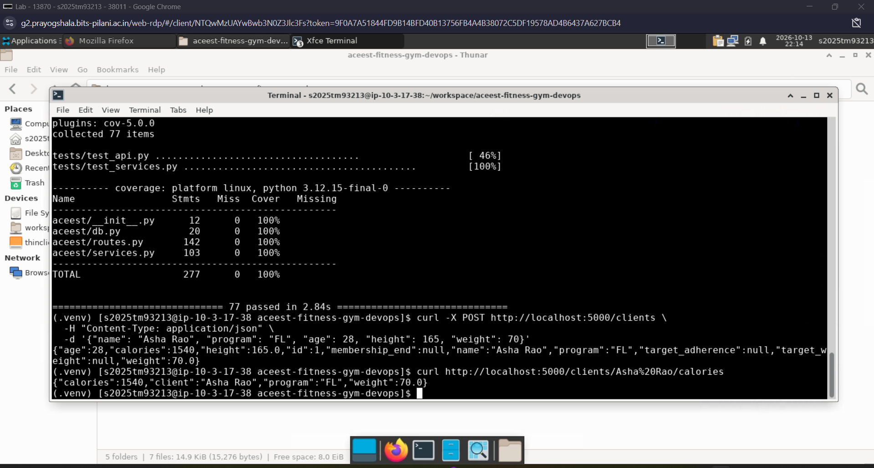
Figure 5: Live API verification via curl showing POST /clients creating client record and GET /clients/Asha Rao/calories returning calculated 1540 calories.

8. Jenkins BUILD & Quality Gate Orchestration
Architecture & Configuration
A dedicated Jenkins server was deployed via Docker Compose with access to the host Docker socket (/var/run/docker.sock). This enables the Jenkins agent to build, test, and discard containers natively.
- URL: http://localhost:8081
- Initial Administrator Password: 40d2818048e840eebc87f5b937f962fa
- Configured Administrator: admin (2025tm93213rajan)
- Email: 2025tm93213@wilp.bits-pilani.ac.in
- Project Type: Declarative Pipeline from SCM
- Repository: https://github.com/2025tm93213rajan/aceest-fitness-gym-devops.git
- Branch: */master
Jenkins Pipeline Lifecycle Stages
The declarative Jenkinsfile enforces rigorous verification gates:
- Checkout SCM & Clean Checkout: Cleans the build workspace completely and checks out the latest commit from master.
- Setup Environment: Creates a fresh virtualenv and installs dependencies from requirements-dev.txt.
- Lint: Byte-compiles sources and executes Flake8 style verification.
- Unit Tests: Runs Pytest with coverage and outputs reports/junit.xml, consumed by Jenkins JUnit test reporter.
- Docker Build: Compiles the runtime Docker image ($IMAGE).
- Docker Tests: Assembles the test target ($TEST_IMAGE) and executes the test suite within Docker.
- Post Actions: Cleans up temporary Docker build images (docker rmi) to prevent disk bloat, and outputs build status.
Jenkins Execution Evidence (Port 8081)
1. Pipeline Stage View (Build #1)
All 7 pipeline stages executed and passed cleanly:
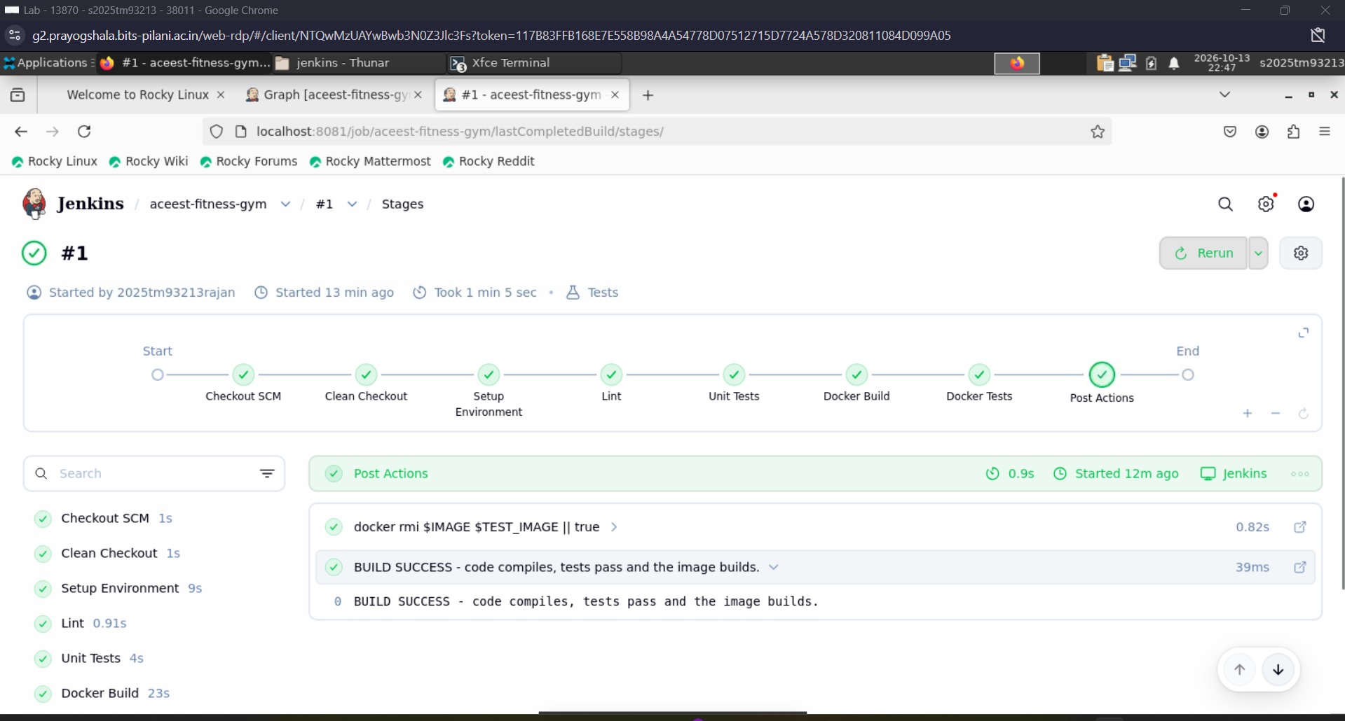
Figure 6: Jenkins Stage View for job `aceest-fitness-gym` (Build #1 started by 2025tm93213rajan) showing all stages green: Checkout SCM, Clean Checkout, Setup Environment, Lint, Unit Tests, Docker Build, Docker Tests, and Post Actions.

2. Jenkins Test Report (77/77 Passing)
The JUnit test reporter integrated with Jenkins confirms all 77 automated tests passed:
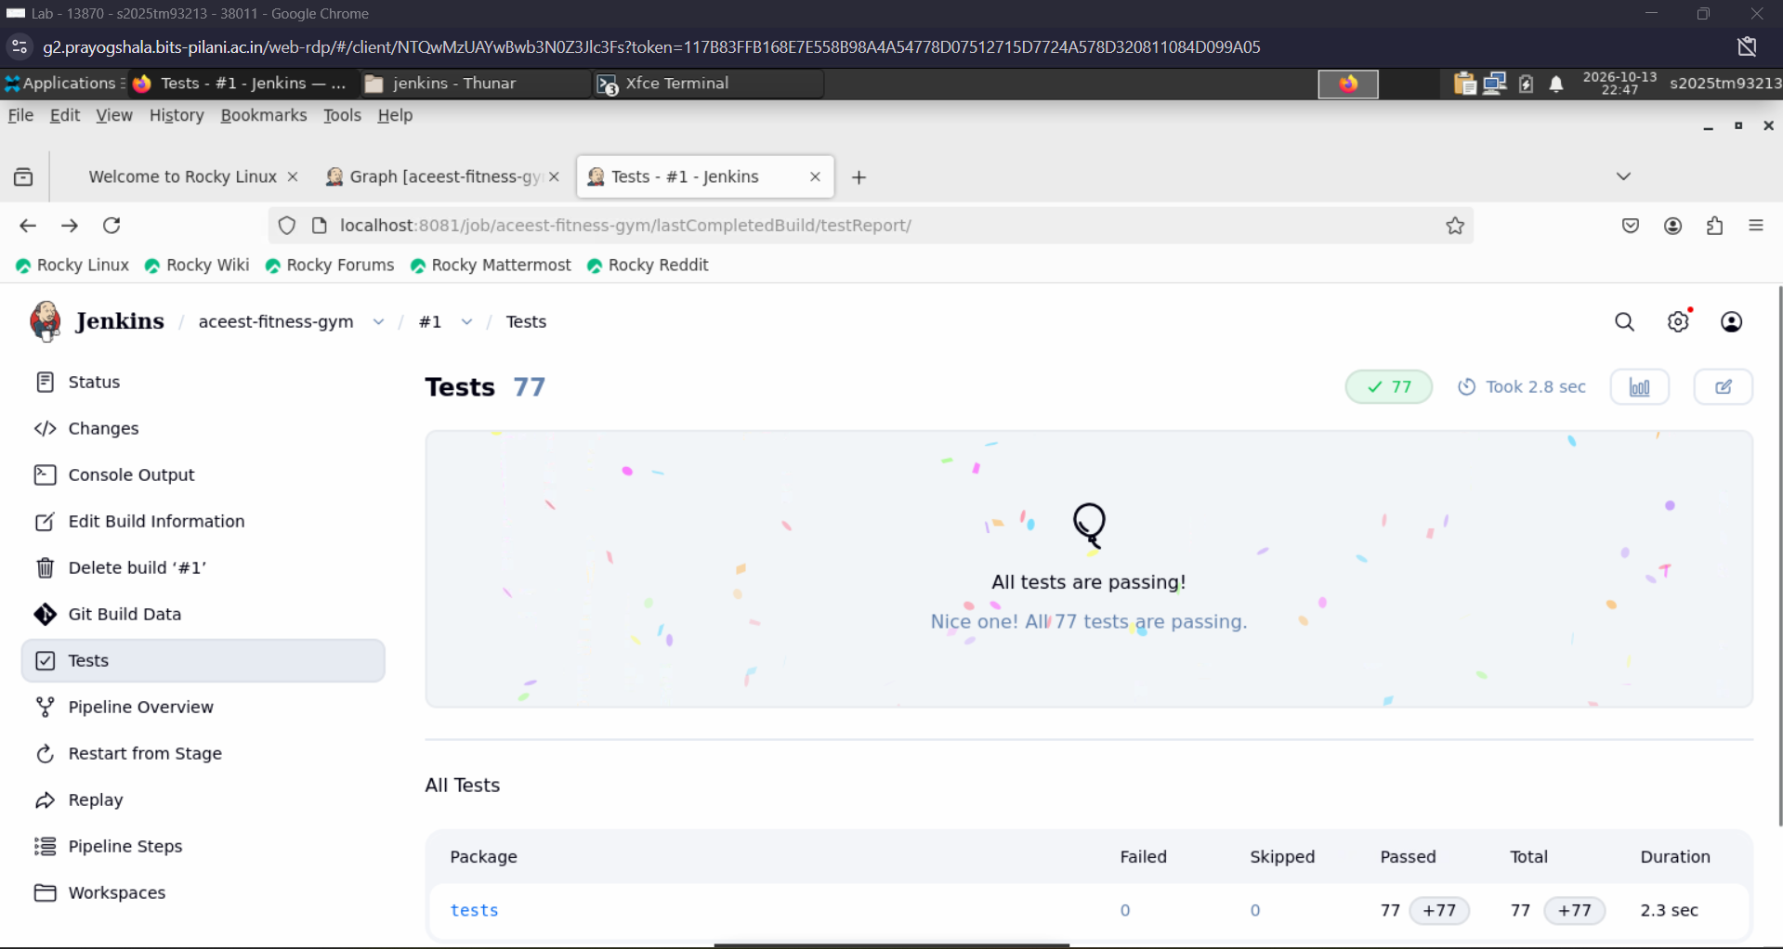
Figure 7: Jenkins Test Report page showing 77 passed tests (0 failed, 0 skipped) under the `tests` package.

3. Jenkins Console Output (Finished: SUCCESS)
The console log records image cleanup and final pipeline success:
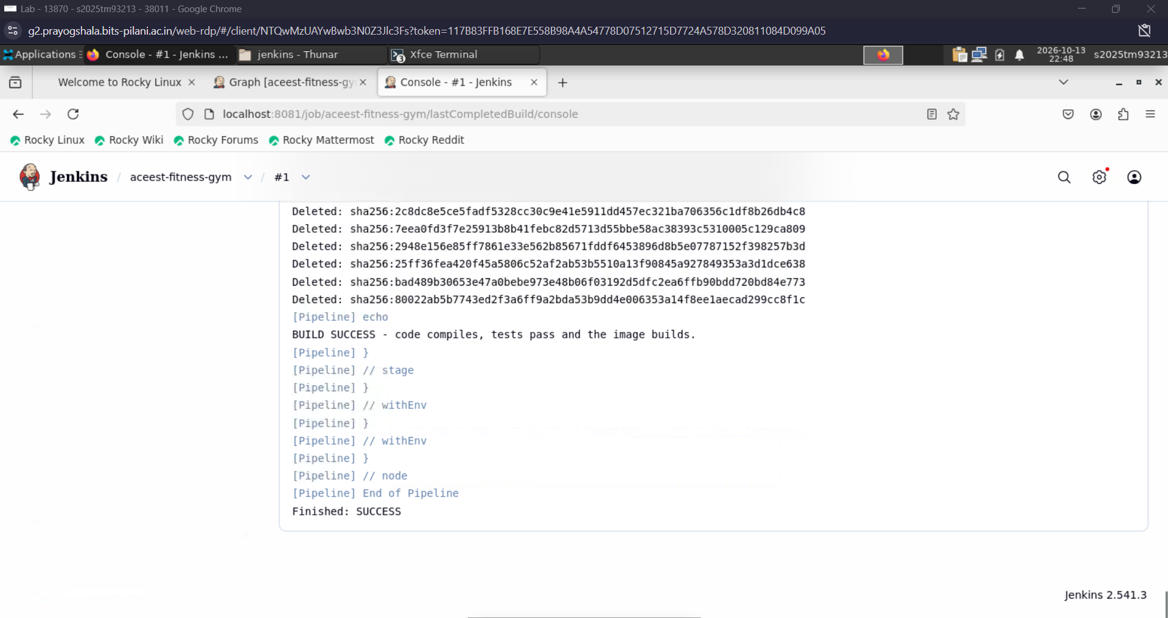
Figure 8: Jenkins Console log showing Docker image cleanup, `BUILD SUCCESS` message, and `Finished: SUCCESS`.

9. Required Deliverables & Final Status
Required Deliverable | Project Artifact / Location | Implementation Status
Flask Source Code | app.py, aceest/__init__.py, aceest/routes.py, aceest/services.py, aceest/db.py | Complete: Fully modularized RESTful microservice with SQLite
Dependencies | requirements.txt, requirements-dev.txt | Complete: Decoupled runtime and test dependencies
Unit Testing Suite | tests/test_services.py, tests/test_api.py, setup.cfg | Complete: 77 test cases, 100% coverage, JUnit integration
Containerization (Dockerfile) | Dockerfile, .dockerignore | Complete: Multi-stage build (builder/test/runtime), non-root user appuser, health check
Cloud CI (GitHub Actions) | .github/workflows/main.yml | Complete: 3-stage chained workflow passing on push & PR
Local/Lab CI (Jenkins) | Jenkinsfile, jenkins/docker-compose.yml, jenkins/Dockerfile | Complete: Port 8081 setup in Prayogshala Rocky Linux, all stages green, Build #1 SUCCESS
Lab VM Environment Validation | Rocky Linux Server (s2025tm93213@ip-10-3-17-38) | Complete: Docker build, container run, curl testing, pytest inside container
Technical Documentation | README.md | Complete: Detailed setup, API reference, credentials, and evidence
Public GitHub Repository | https://github.com/2025tm93213rajan/aceest-fitness-gym-devops | Public & Verified

10. Conclusion
The ACEest Fitness & Gym DevOps implementation fulfills all objectives and technical requirements stipulated in the Introduction to DevOps Assignment - 1 curriculum:
- Application Modernization: Legacy desktop code was successfully re-engineered into a modern, robust, and extensible Flask REST API.
- Quality & Coverage: A rigorous Pytest test suite ensures 100% code coverage and prevents regression across all calculations and endpoints.
- Container Consistency: Multi-stage Docker packaging eliminates environmental divergence between development, CI, and production.
- Continuous Integration: Dual CI mechanisms -GitHub Actions for rapid cloud feedback and Jenkins on port 8081 for controlled build verification -establish a defense-in-depth quality assurance architecture.
- Real-world Lab Validation: All components were independently deployed and proven inside the BITS Prayogshala Rocky Linux environment, successfully overcoming real-world port collision constraints.
The project demonstrates complete proficiency in Git, Docker, GitHub Actions, Jenkins, and Linux system administration in accordance with professional DevOps benchmarks.

