Birla Institute of Technology & Science, Pilani
Work Integrated Learning Programmes Division
SE*ZG504 — API-based Products
Assignment (EC-1)
Third Semester 2026
Student Name: Sheetal Prasad Sahu
Roll Number: 2025TM93239
Submission Date: Oct 27, 2026

Table of Contents
Table of Contents 1
1. Overview 1
2. Question 1 — gRPC Task Manager 3
3. Question 2 — Order API, MCP, and Kong 10
4. Question 3 — Token Bucket and Leaky Bucket 14

1. Overview
Three separate solutions were implemented in C# (.NET), This report summarizes implementation, provides compile/run instructions, includes selected code snippets, and reserves space for repository links, screenshots, and short demonstrations.
SN | Project Name | Git repo link
Question 1 | TaskManager | https://github.com/2025tm93239/TaskManager
Question 2 | Order Management | https://github.com/2025tm93239/OrderManagement
Question 3 | RateLimitingAlgorithms | https://github.com/2025tm93239/RateLimitingAlgorithms

2. Question 1 — gRPC Task Manager
Build a gRPC Task Manager with CreateTask, GetTask, ListTasks (server streaming), UpdateTask, and StreamTaskUpdates (bidirectional streaming).

2.1 Git repo Link

https://github.com/2025tm93239/TaskManager

Short demo: https://github.com/2025tm93239/TaskManager/blob/main/Screenshots%20and%20Demo%20video/Question%201%20Short%20Demos%20Recording.mp4

How to compile and run
- First cloned the above repo
- Build entire solution:
cd D:\Bits-pilani\API\TaskManager\TaskManager
dotnet build TaskManager.slnx
- Terminal 1 — start server (default profile):
cd D:\Bits-pilani\API\TaskManager\TaskManager
dotnet run --project TaskManager.Service
Server listens on http://localhost:5081
- Terminal 2 — run client (creates tasks, list stream, bidirectional updates, error cases):
dotnet run --project TaskManager.Client
- Deadline timeout demo:
dotnet run --project TaskManager.Service --launch-profile http-deadline-demo
# In second terminal:
dotnet run --project TaskManager.Client
Expected: GetTask step shows DEADLINE_EXCEEDED when server delays 2 seconds and client deadline is 1 second.

2.3 Code snippet — task.proto (service definition)
syntax = "proto3";

option csharp_namespace = "TaskManager.Grpc";

package taskmanager;

message Task
{
int32 id = 1;
string title = 2;
string status = 3;
}

message CreateTaskRequest
{
string title = 1;
}

message GetTaskRequest
{
int32 id = 1;
}

message UpdateTaskRequest {
int32 id = 1;
string status = 2;
}

message ListTasksRequest {}

message TaskUpdateRequest {
int32 id = 1;
string status = 2;
}

message TaskUpdateReply
{
Task task = 1;
string message = 2;
}

service TaskService {
rpc CreateTask(CreateTaskRequest) returns (Task);
rpc GetTask(GetTaskRequest) returns (Task);
rpc ListTasks(ListTasksRequest) returns (stream Task);
rpc UpdateTask(UpdateTaskRequest) returns (Task);
rpc StreamTaskUpdates(stream TaskUpdateRequest) returns (stream TaskUpdateReply);
}

Short demo

https://github.com/2025tm93239/TaskManager/blob/main/Screenshots%20and%20Demo%20video/Question%201%20Short%20Demos%20Recording.mp4

2.5 Screenshots

- Service is listening on: http://localhost:5081
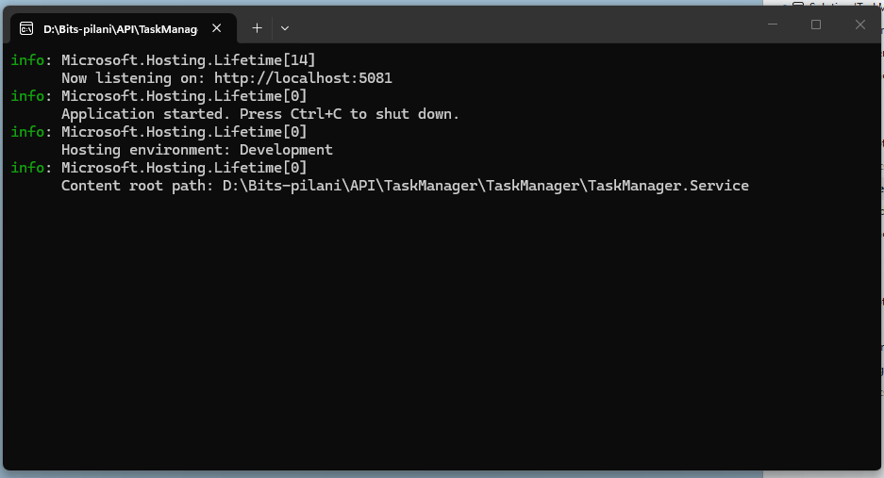
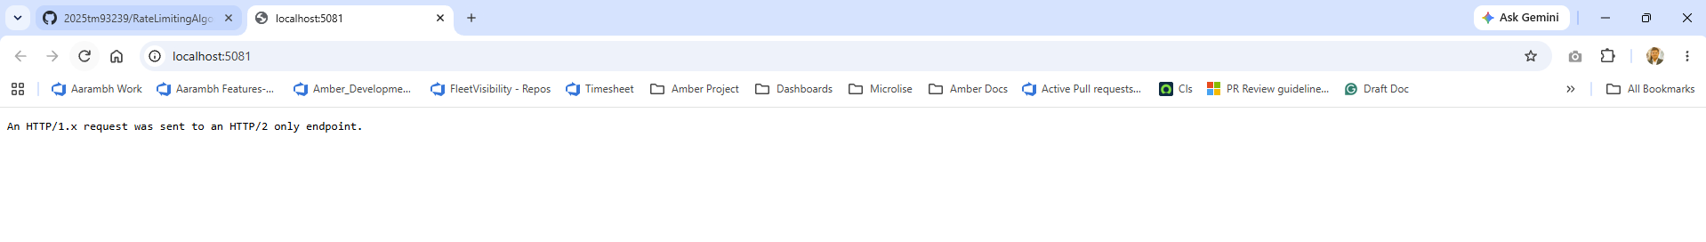

- Client output — create three tasks, fetch task #2, ListTasks streaming.

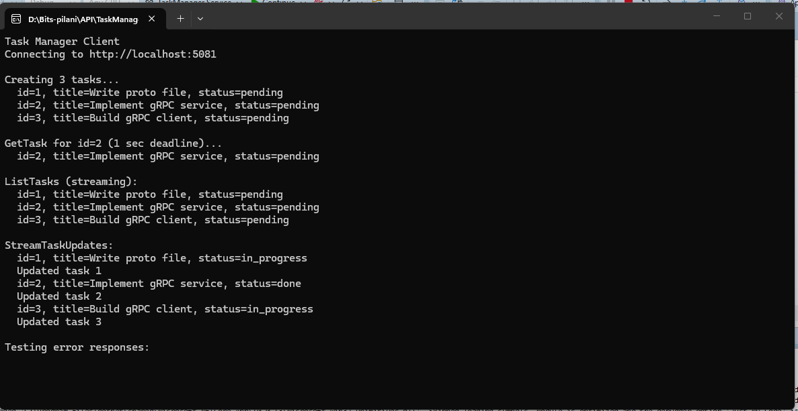

- Service Debug output
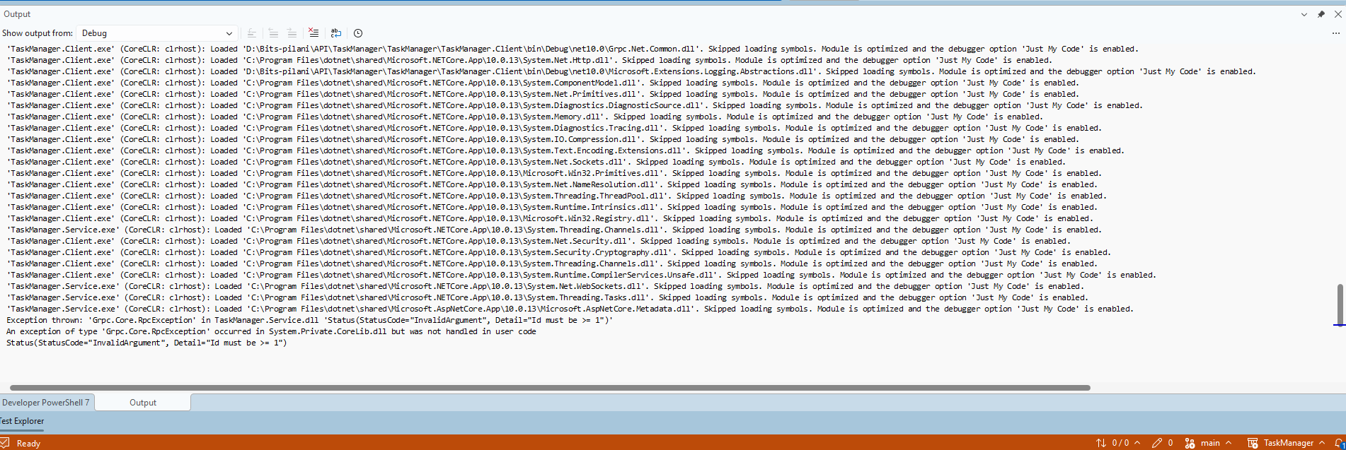

- Client Output with testing error responses

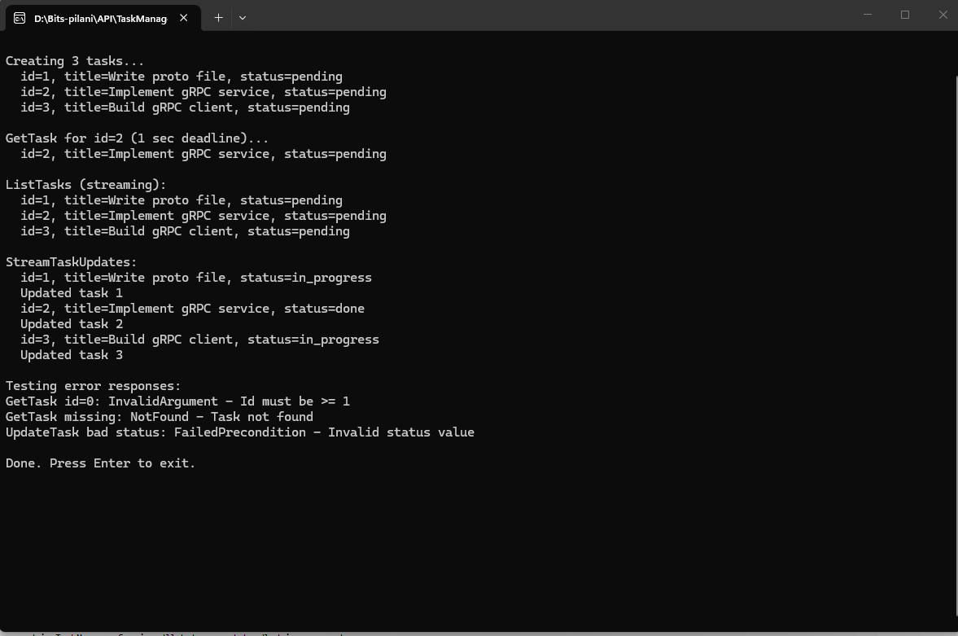

- Debug console output
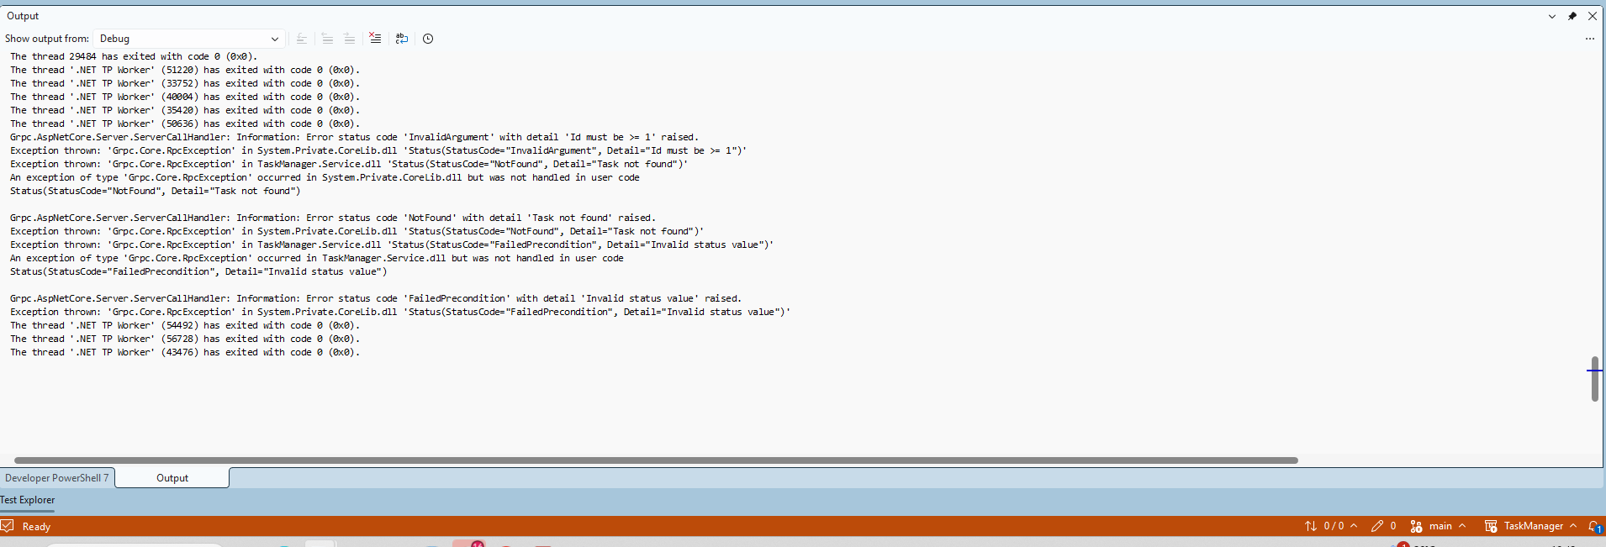
- Service output
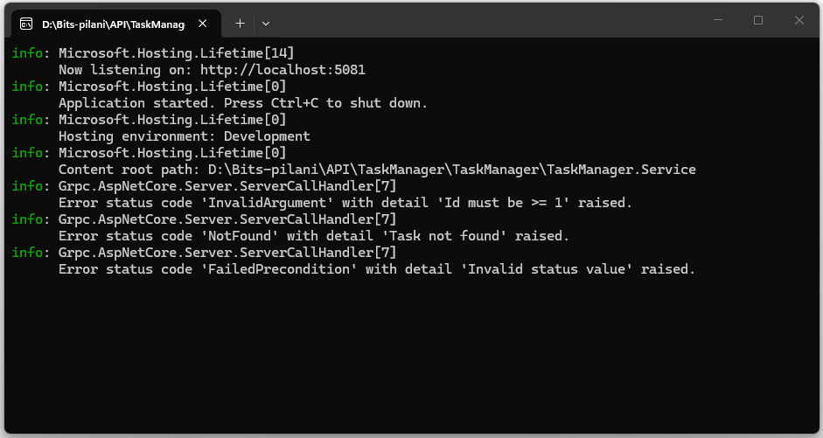
- Project structure:
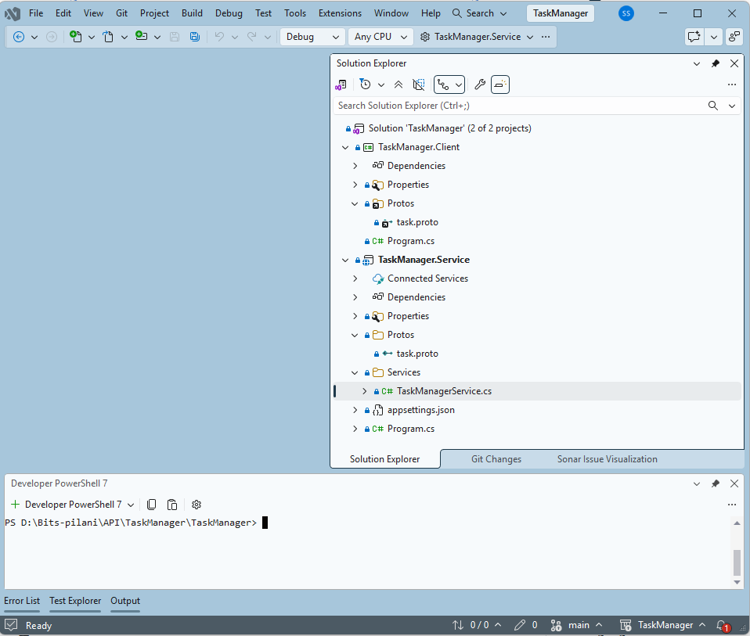
- Task.proto file
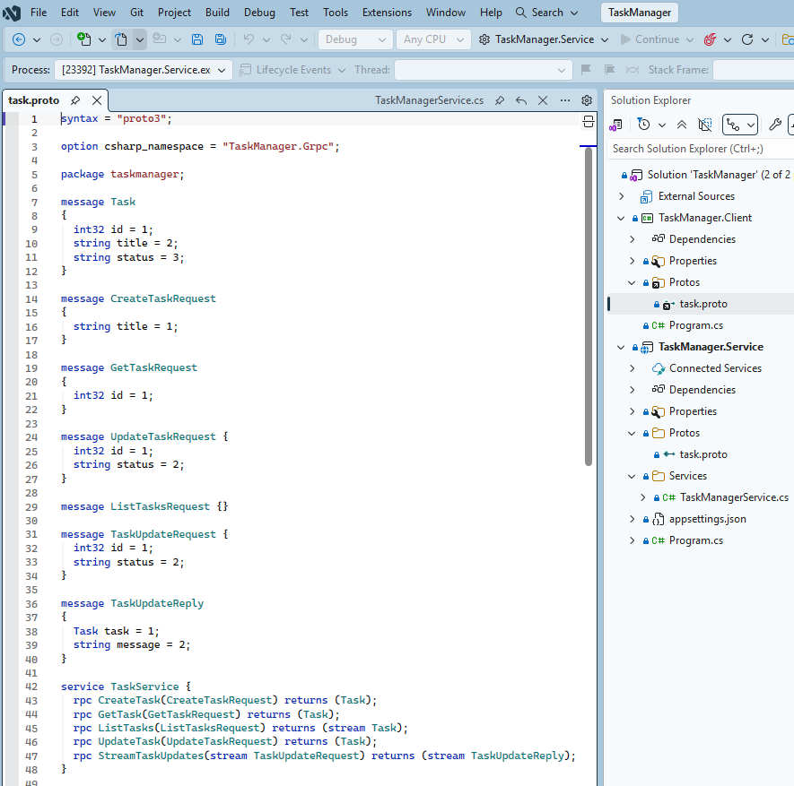

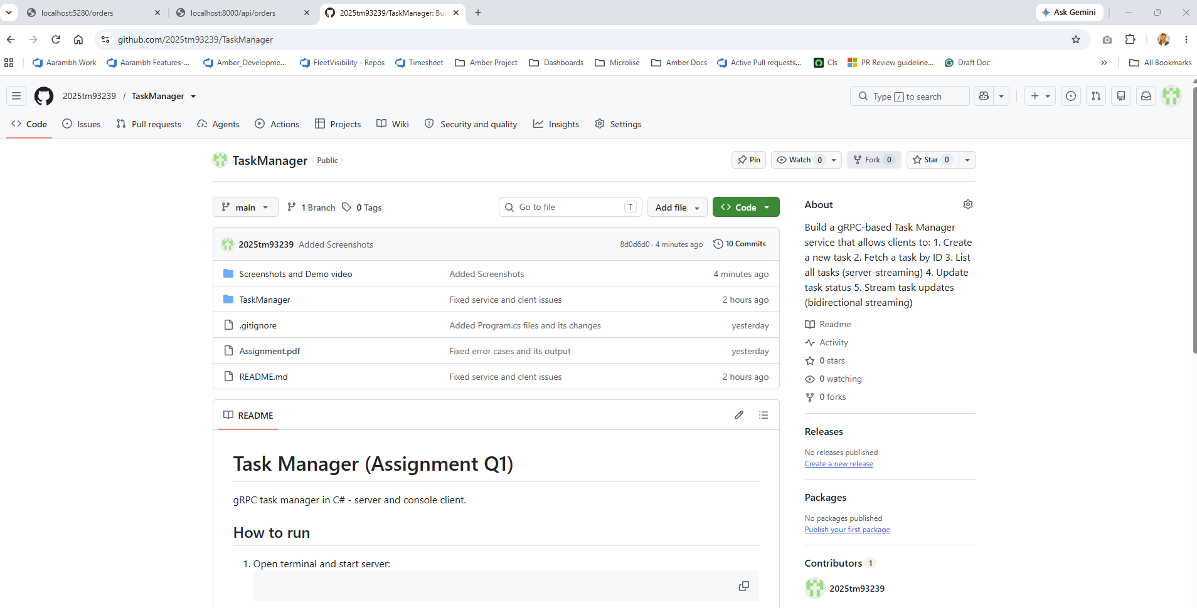3. Question 2 — Order API, MCP, and Kong
REST Order API with in-memory orders with MCP server exposing the order_api tool and Kong gateway with route /api/orders and rate limiting at 5 requests per minute.
Flow: LLM → MCP client → MCP server → Kong → Order API backend.

3.1 Git Repo Link
https://github.com/2025tm93239/OrderManagement
Short Demo: https://github.com/2025tm93239/OrderManagement/blob/main/Screenshots%20and%20Demo%20video/Question%202%20Short%20Demos%20Recording.mp4

3.2 Components
Component | Purpose
OrderApi | REST API — POST/GET /orders, JSON, in-memory store
OrderMcpServer | MCP stdio server — tool order_api (create_order, get_order, list_orders)
kong/kong.yml | Declarative Kong — service, route /api/orders, rate-limiting 5/min

3.3 How to compile and run
Prerequisites: .NET SDK, Docker Desktop (Kong).
- Build:
cd D:\Bits-pilani\API\OrderManagement
dotnet build OrderManagement.slnx
- Step 1 — Order API backend:
cd D:\Bits-pilani\API\OrderManagement\OrderApi
dotnet run --launch-profile http
API: http://localhost:5280
- Quick test:
curl -X POST http://localhost:5280/orders -H "Content-Type: application/json" -d "{\"item\":\"Pen\",\"quantity\":3}"
curl http://localhost:5280/orders
- Step 2 — Kong (rate limit 5 req/min):
cd D:\Bits-pilani\API\OrderManagement\kong
docker compose up -d
curl http://localhost:8000/api/orders
- Step 3 — Demonstrate rate limiting:
cd D:\Bits-pilani\API\OrderManagement\scripts
.\demo-rate-limit.ps1
Capture HTTP 429 on requests 6–8.
- Step 4 — MCP server (calls API via Kong):
cd D:\Bits-pilani\API\OrderManagement\OrderMcpServer
dotnet run
Register in MCP client (Cursor / Claude Desktop) using stdio; tool schema file: OrderManagement\schemas\order_api-tool-schema.json

3.4 Code snippet — Kong declarative config
_format_version: "3.0"
_transform: true

services:
- name: order-api-service
url: http://host.docker.internal:5280/orders
routes:
- name: order-api-route
paths:
- /api/orders
strip_path: true
plugins:
- name: rate-limiting
config:
minute: 5
policy: local
limit_by: ip
hide_client_headers: false

3.5 MCP tool schema
{
"name": "order_api",
"description": "Invokes the Order REST API (via Kong gateway) to create, fetch, or list orders.",
"inputSchema": {
"type": "object",
"properties": {
"action": {
"type": "string",
"enum": ["create_order", "get_order", "list_orders"],
"description": "Which API operation to perform."
},
"item": {
"type": "string",
"description": "Product name (required when action is create_order)."
},
"quantity": {
"type": "integer",
"minimum": 1,
"description": "Units ordered (required when action is create_order)."
},
"id": {
"type": "integer",
"minimum": 1,
"description": "Order id (required when action is get_order)."
}
},
"required": ["action"],
"additionalProperties": false
}
}

3.6 Short demo

https://github.com/2025tm93239/OrderManagement/blob/main/Screenshots%20and%20Demo%20video/Question%202%20Short%20Demos%20Recording.mp4

3.7 Screenshots

- Order.Api is listening on: http://localhost:5280

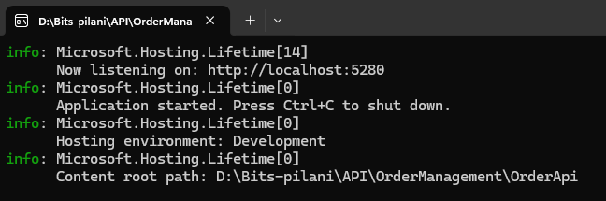

- Setup KONG AND DOCKER

cd "D:\Bits-pilani\API\OrderManagement\kong"
docker compose up -d
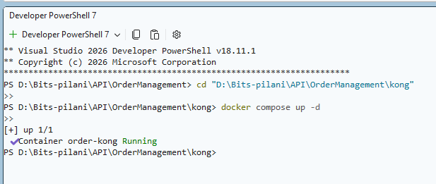

- Created a new order using Order API
Invoke-RestMethod -Uri "http://localhost:5280/orders" -Method Post -ContentType "application/json" -Body '{"item":"Pen","quantity":3}
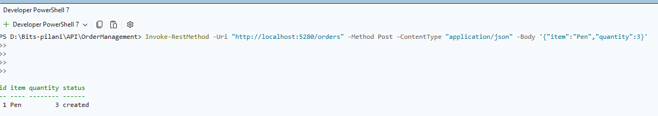

- Created another order
Invoke-RestMethod -Uri "http://localhost:5280/orders" -Method Post -ContentType "application/json" -Body '{"item":"Notebook","quantity":2}'

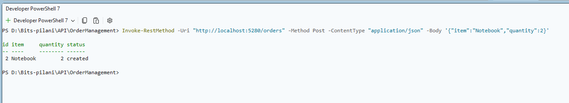

- Then called list out all orders API
Invoke-RestMethod -Uri "http://localhost:5280/orders" -Method Get

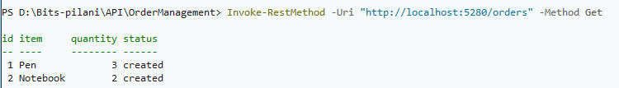

- Then tested Get Order by ID
Invoke-RestMethod -Uri "http://localhost:5280/orders" -Method Get

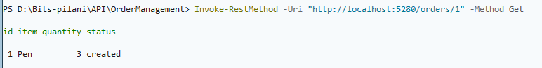

- Tested below URI and got 404 Error
try {
Invoke-RestMethod -Uri "http://localhost:5280/orders/9999" -Method Get
} catch {
$_.Exception.Response.StatusCode.value__
}
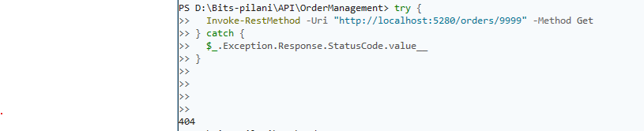

- Tried below URL and got 415 status code.
try {
Invoke-RestMethod -Uri "http://localhost:5280/orders" -Method Post
-ContentType "application/json"
-Body '{"item":"Bad","quantity":0}'
} catch {
$_.Exception.Response.StatusCode.value__
}

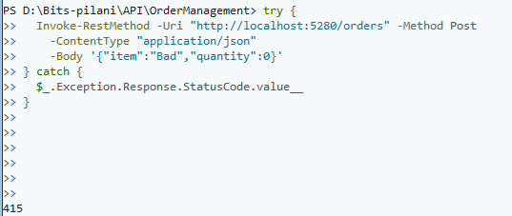

Testing using Kong

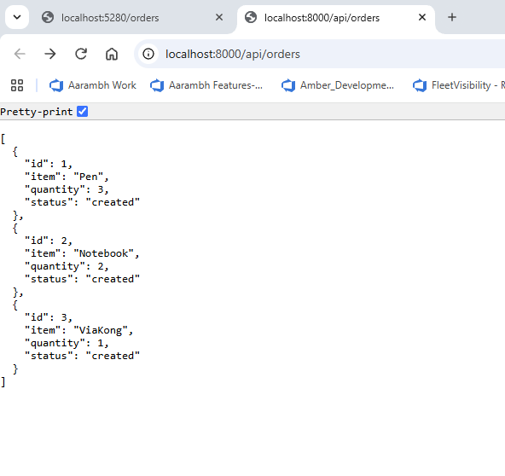

Testing using Order API
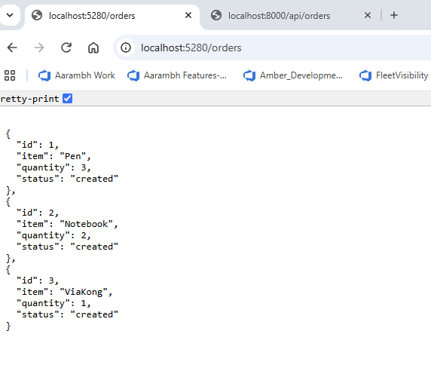

Also tested the service using KONG API
- List out all orders using Kong
Invoke-RestMethod -Uri "http://localhost:8000/api/orders" -Method Get
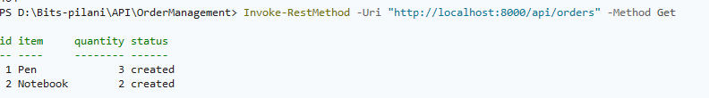

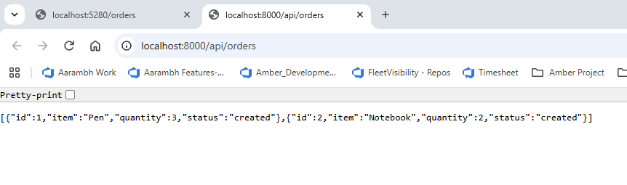
- Create a new order via KONG

Invoke-RestMethod -Uri "http://localhost:8000/api/orders" -Method Post -ContentType "application/json" -Body '{"item":"ViaKong","quantity":1}'

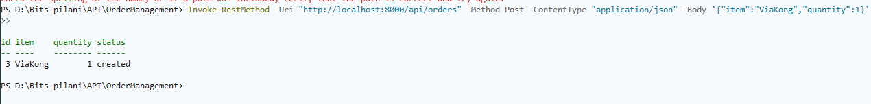

- Get a record by ID using KONG
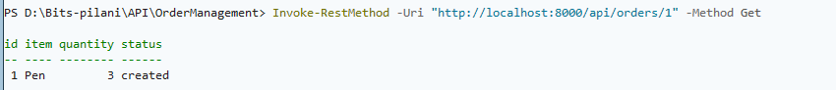

Rate limit demo (5 per minute — expect 200 then 429)
1..8 | ForEach-Object {
try {
$r = Invoke-WebRequest -Uri "http://localhost:8000/api/orders" -Method Get -UseBasicParsing
"Request $_ : $($r.StatusCode)"
} catch {
"Request $_ : $($_.Exception.Response.StatusCode.value__)"
}
Start-Sleep -Milliseconds 300
}

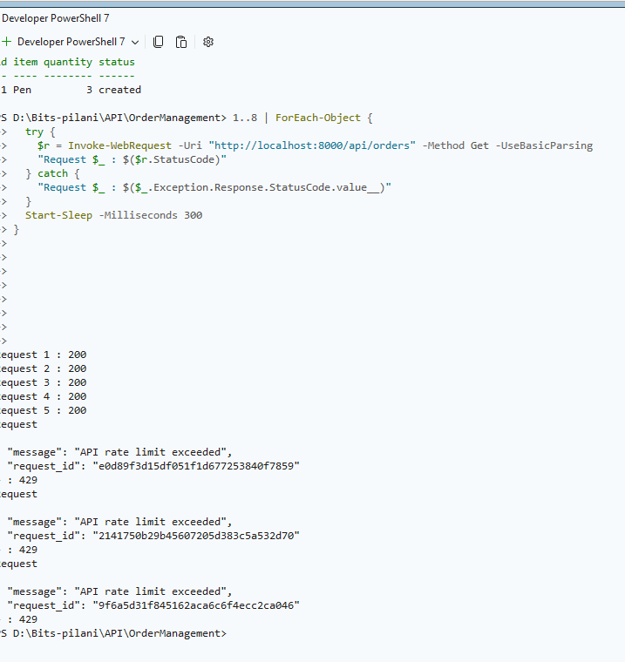

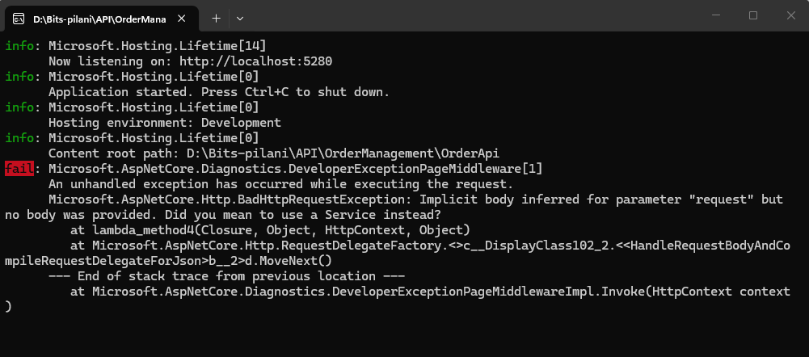

Solution structure:
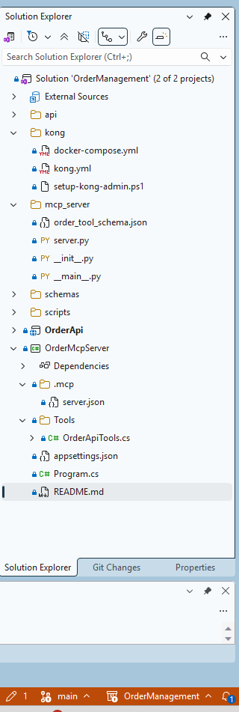

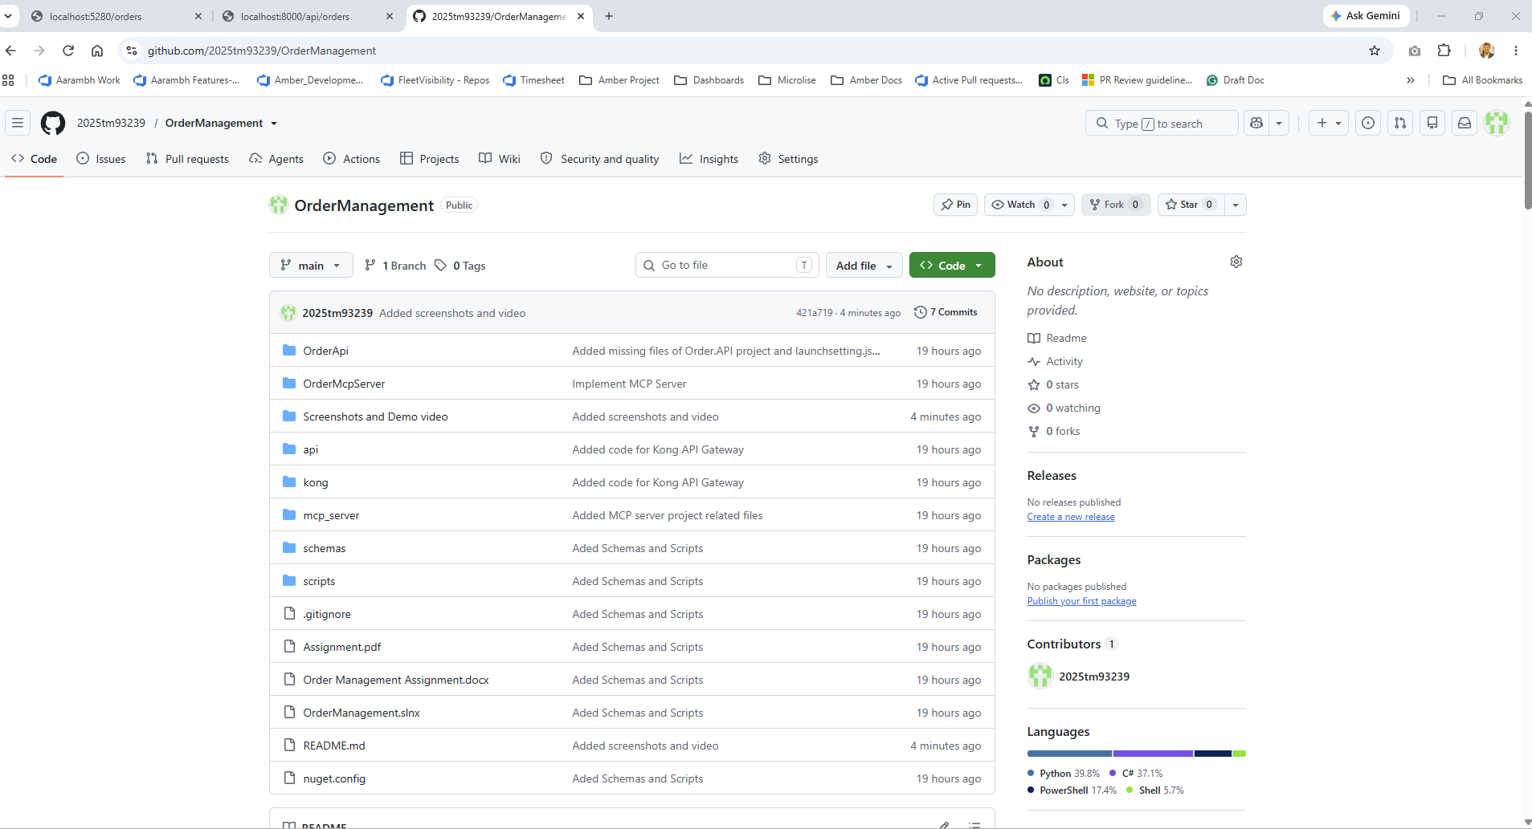

4. Question 3 — Token Bucket and Leaky Bucket
Implement Token Bucket and Leaky Bucket rate limiting algorithms in C#, with a console program demonstrating allowed vs blocked requests.

4.1 Git repo location
https://github.com/2025tm93239/RateLimitingAlgorithms
Short demo:
https://github.com/2025tm93239/RateLimitingAlgorithms/blob/main/Screenshots%20and%20Demo%20video/Question%203%20Short%20Demo%20Recording.mp4

4.2 How to compile and run
First clone the above repo
cd D:\Bits-pilani\API\RateLimitingAlgorithms
dotnet build
dotnet run --project RateLimitingAlgorithms.csproj

Or open RateLimitingAlgorithms.sln in Visual Studio and press F5.

4.3 Code snippet — demo driver (Program.cs excerpt)
using RateLimitingAlgorithms;

namespace RateLimitingAlgorithms
{
class Program
{
static void Main(string[] args)
{
Console.WriteLine("Implementedd TokenBucket and Leaky Bucket rate limiting algorithms in Java/Python/c#");

Console.WriteLine("Token Bucket and Leaky Bucket Rate Limiting");

Console.WriteLine("-------------------------------------------");

TestTokenBucket();
Console.WriteLine();
TestLeakyBucket();

Console.WriteLine();

Console.WriteLine("Press Enter to exit...");
Console.ReadLine();
}

static void TestTokenBucket()
{
Console.WriteLine("\n--- Token Bucket ---");

// bucket size 5, add 2 tokens every second
TokenBucketRateLimiter limiter = new TokenBucketRateLimiter(5, 2);

Console.WriteLine("Sending 8 requests at once:");
for (int i = 1; i <= 8; i++)
{
bool ok = limiter.AllowRequest();
if (ok)
Console.WriteLine("Request " + i + " : Allowed");
else
Console.WriteLine("Request " + i + " : Blocked");
}

Console.WriteLine("Waiting 1 second...");
Thread.Sleep(1000);

for (int i = 9; i <= 11; i++)
{
bool ok = limiter.AllowRequest();
if (ok)
Console.WriteLine("Request " + i + " : Allowed");
else
Console.WriteLine("Request " + i + " : Blocked");
}
}

static void TestLeakyBucket()
{
Console.WriteLine("\n--- Leaky Bucket ---");
// max 3 in bucket, leaks 1 per second
LeakyBucketRateLimiter limiter = new LeakyBucketRateLimiter(3, 1);

Console.WriteLine("Sending 5 requests at once:");
for (int i = 1; i <= 5; i++)
{
bool ok = limiter.AllowRequest();
if (ok)
Console.WriteLine("Request " + i + " : Allowe
// ...

4.6 Short demo Link
https://github.com/2025tm93239/RateLimitingAlgorithms/blob/main/Screenshots%20and%20Demo%20video/Question%203%20Short%20Demo%20Recording.mp4

4.7 Screenshots
Console — Token Bucket: 8 rapid requests (Allowed/Blocked) and after 1s wait.
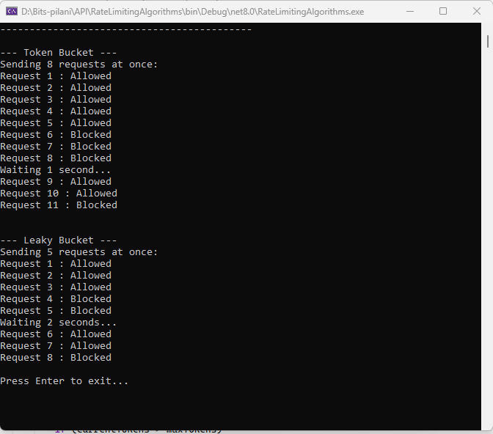
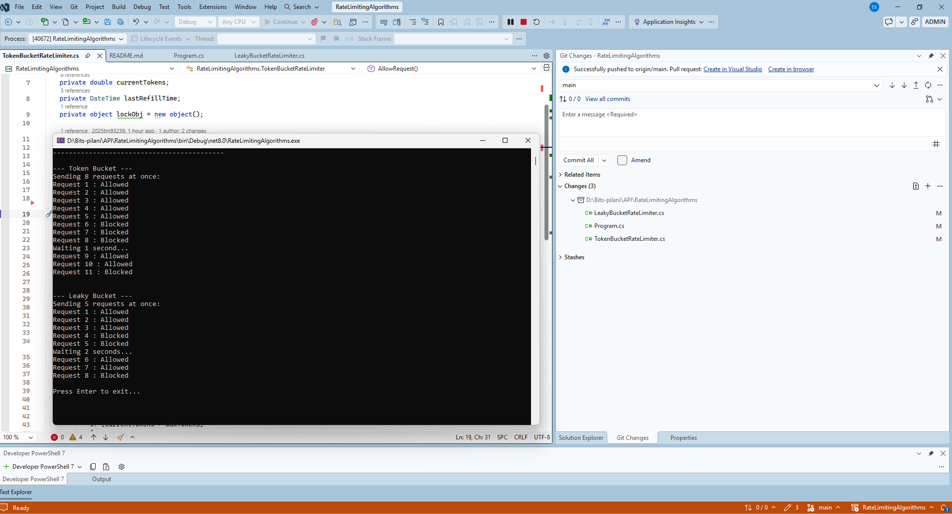

Token Bucket:
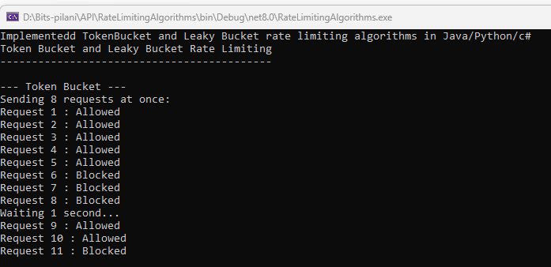

Console — Leaky Bucket: 5 requests, wait 2s, subsequent Allowed requests.
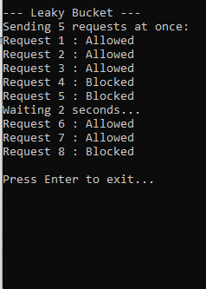
Debug console output
