Introduction to DevOps — Assignment 1
ACEest Fitness & Gym — Submission Document
Student ID: 2025TM93239
Student Name: Sheetal Prasad Sahu
Course: CSI ZG514 / SEZG514
Git Repository: https://github.com/2025tm93239/aceest-fitness

1. Purpose
This document summarizes the required deliverables for Assignment 1: Automated CI/CD for ACEest Fitness & Gym. All artefacts are in the public GitHub repository above.

2. GitHub Repository Link
Public URL: https://github.com/2025tm93239/aceest-fitness
Please note that in Virtual machine, I have added my application in “workspace/Assignment1/ aceest-fitness” folder.

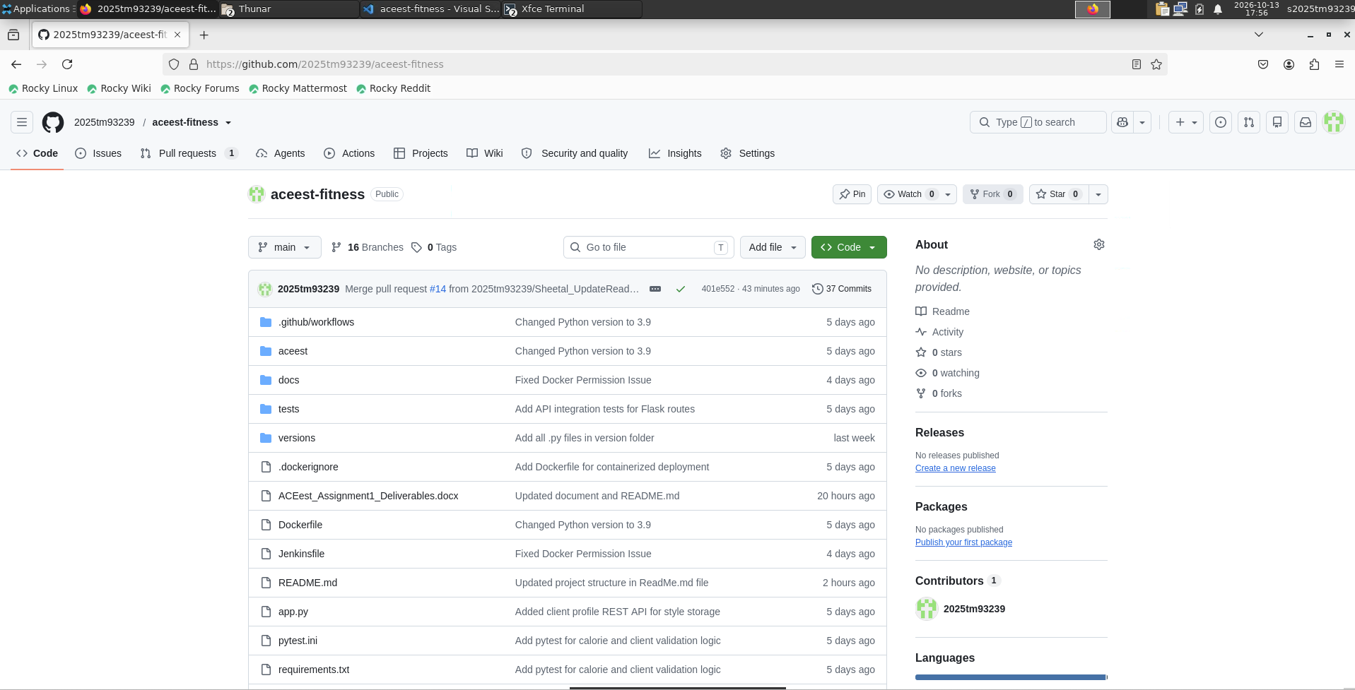

3. Source Code — Flask Application
Core application files in the repository:
- app.py — Flask REST API (health, metrics, programs, calories, clients).
https://github.com/2025tm93239/aceest-fitness/blob/main/app.py

- requirements.txt — Flask 3.0.3 and pytest 8.3.3.
https://github.com/2025tm93239/aceest-fitness/blob/main/requirements.txt

- aceest/programs.py — Program catalog and gym metrics.
https://github.com/2025tm93239/aceest-fitness/blob/main/aceest/programs.py

- aceest/services.py — Calorie estimation and validation logic.
https://github.com/2025tm93239/aceest-fitness/blob/main/aceest/services.py

- aceest/storage.py — In-memory client store.
https://github.com/2025tm93239/aceest-fitness/blob/main/aceest/storage.py

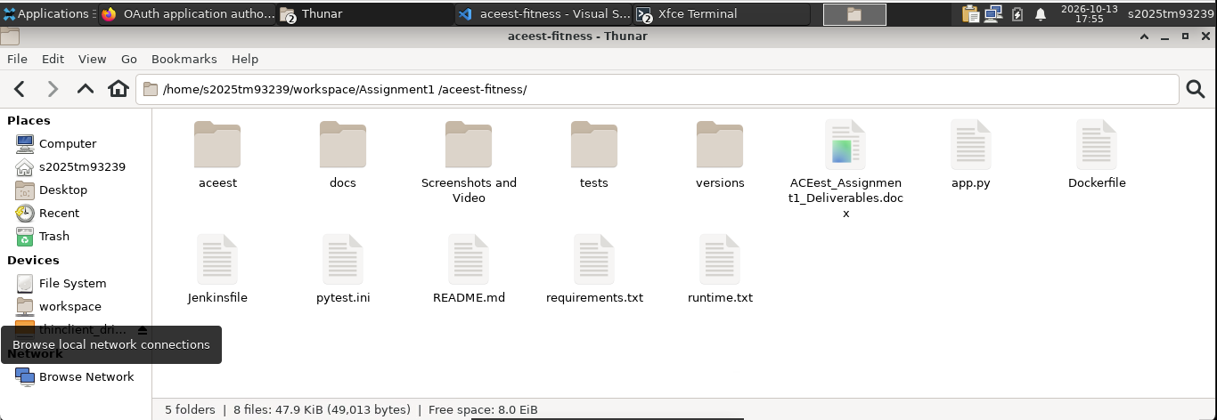

4. Application Run

A. First cloned the repository using the git command

git clone https://github.com/2025tm93239/aceest-fitness

B. Create a virtual environment and install dependencies
python3 -m venv .venv
source .venv/bin/activate
pip install -r requirements.txt
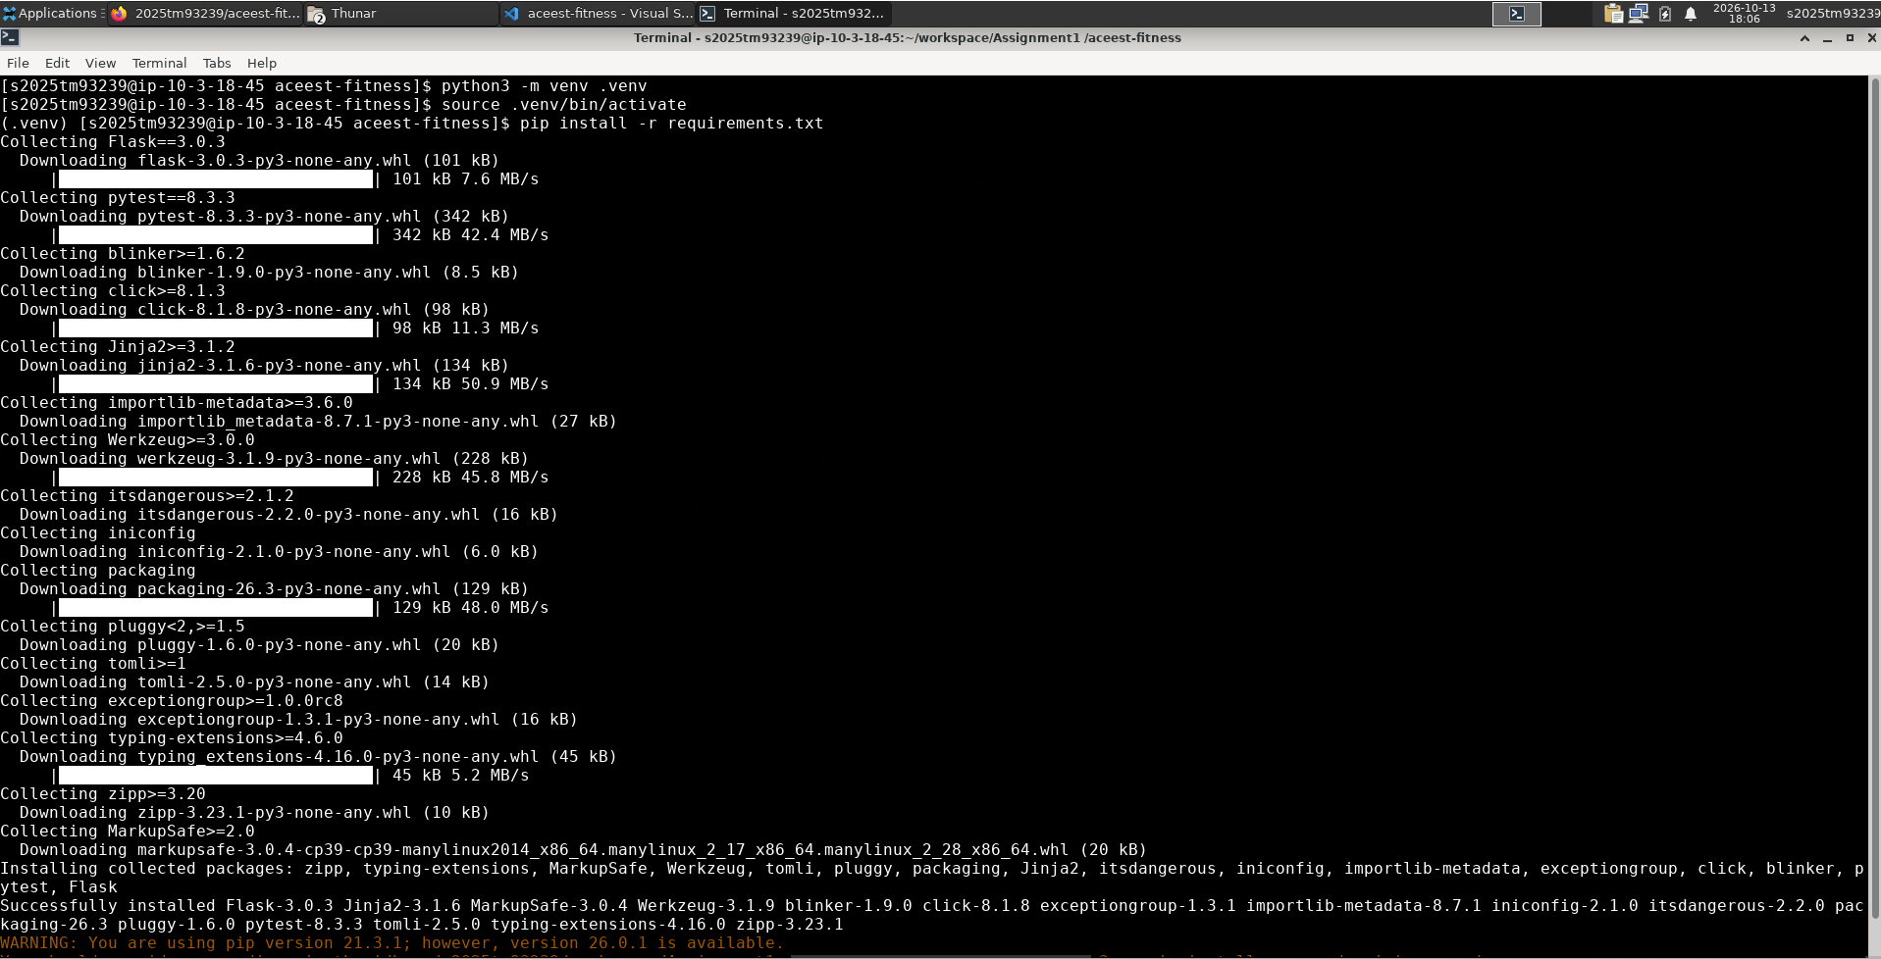

C. Now, ran the application server.
python app.py
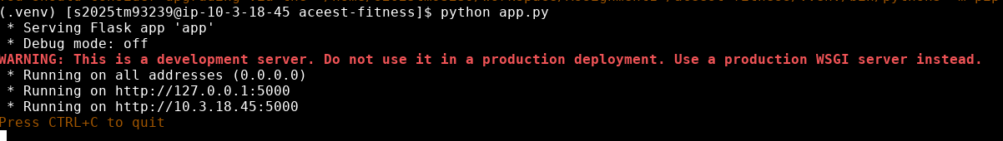

Our application is running on URLs below.

* Running on http://127.0.0.1:5000
* Running on http://10.3.18.45:5000

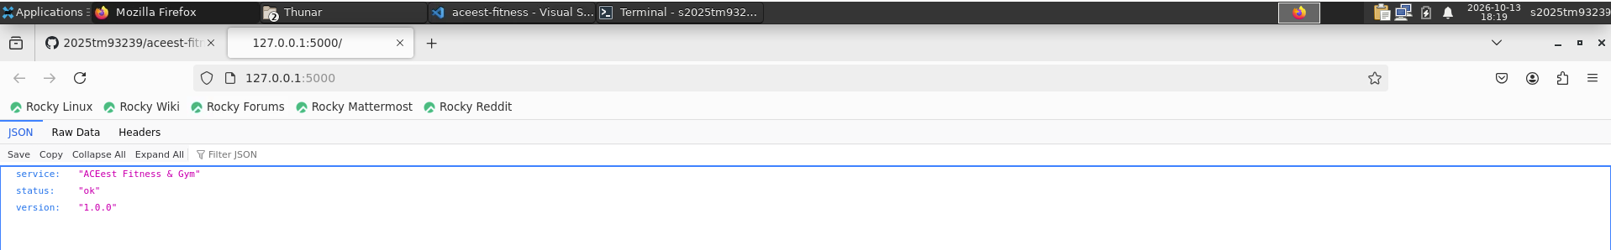

http://127.0.0.1:5000/metrics

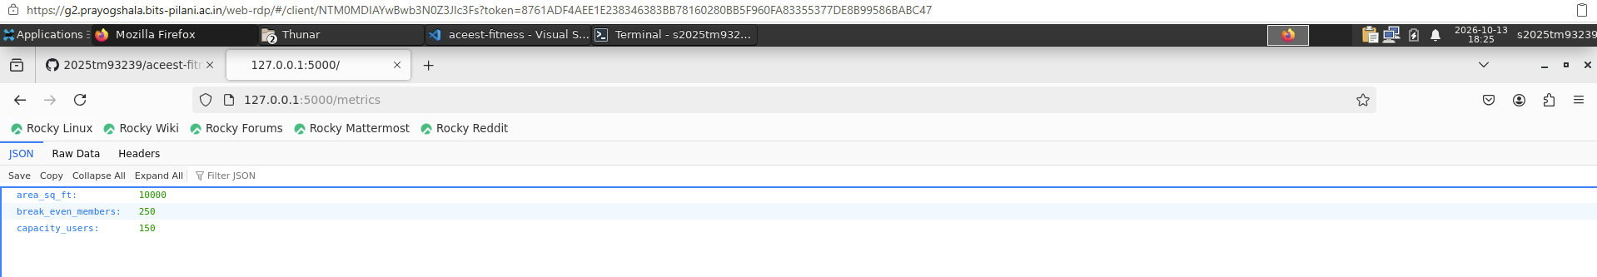

http://127.0.0.1:5000//programs

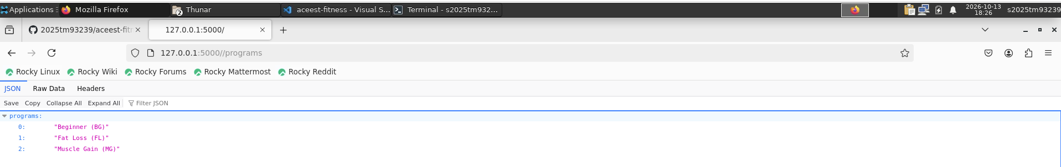

I have tested all Endpoints, and it is working as expected.

5. Test Suite — Pytest
- tests/conftest.py — Flask test client fixtures
https://github.com/2025tm93239/aceest-fitness/blob/main/tests/conftest.py

- tests/test_services.py — unit tests for services
https://github.com/2025tm93239/aceest-fitness/blob/main/tests/test_services.py

- tests/test_app.py — API integration tests
aceest-fitness/tests/test_app.py at main · 2025tm93239/aceest-fitness · GitHub

- pytest.ini — test configuration
aceest-fitness/pytest.ini at main · 2025tm93239/aceest-fitness · GitHub

- Eight tests total; run with: pytest -v

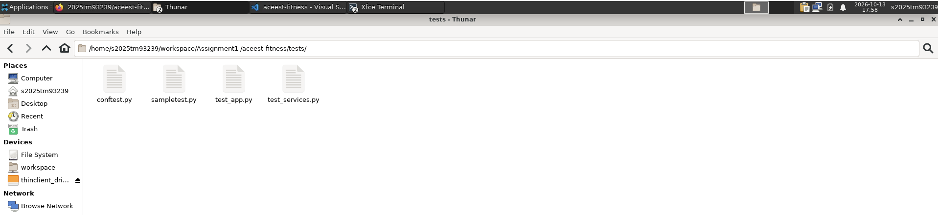

To run test cases, I have run below commands.

cd aceest-fitness
source .venv/bin/activate
python3 -m pip install -r requirements.txt
python3 -m pytest -v

After running above commands, got below result.

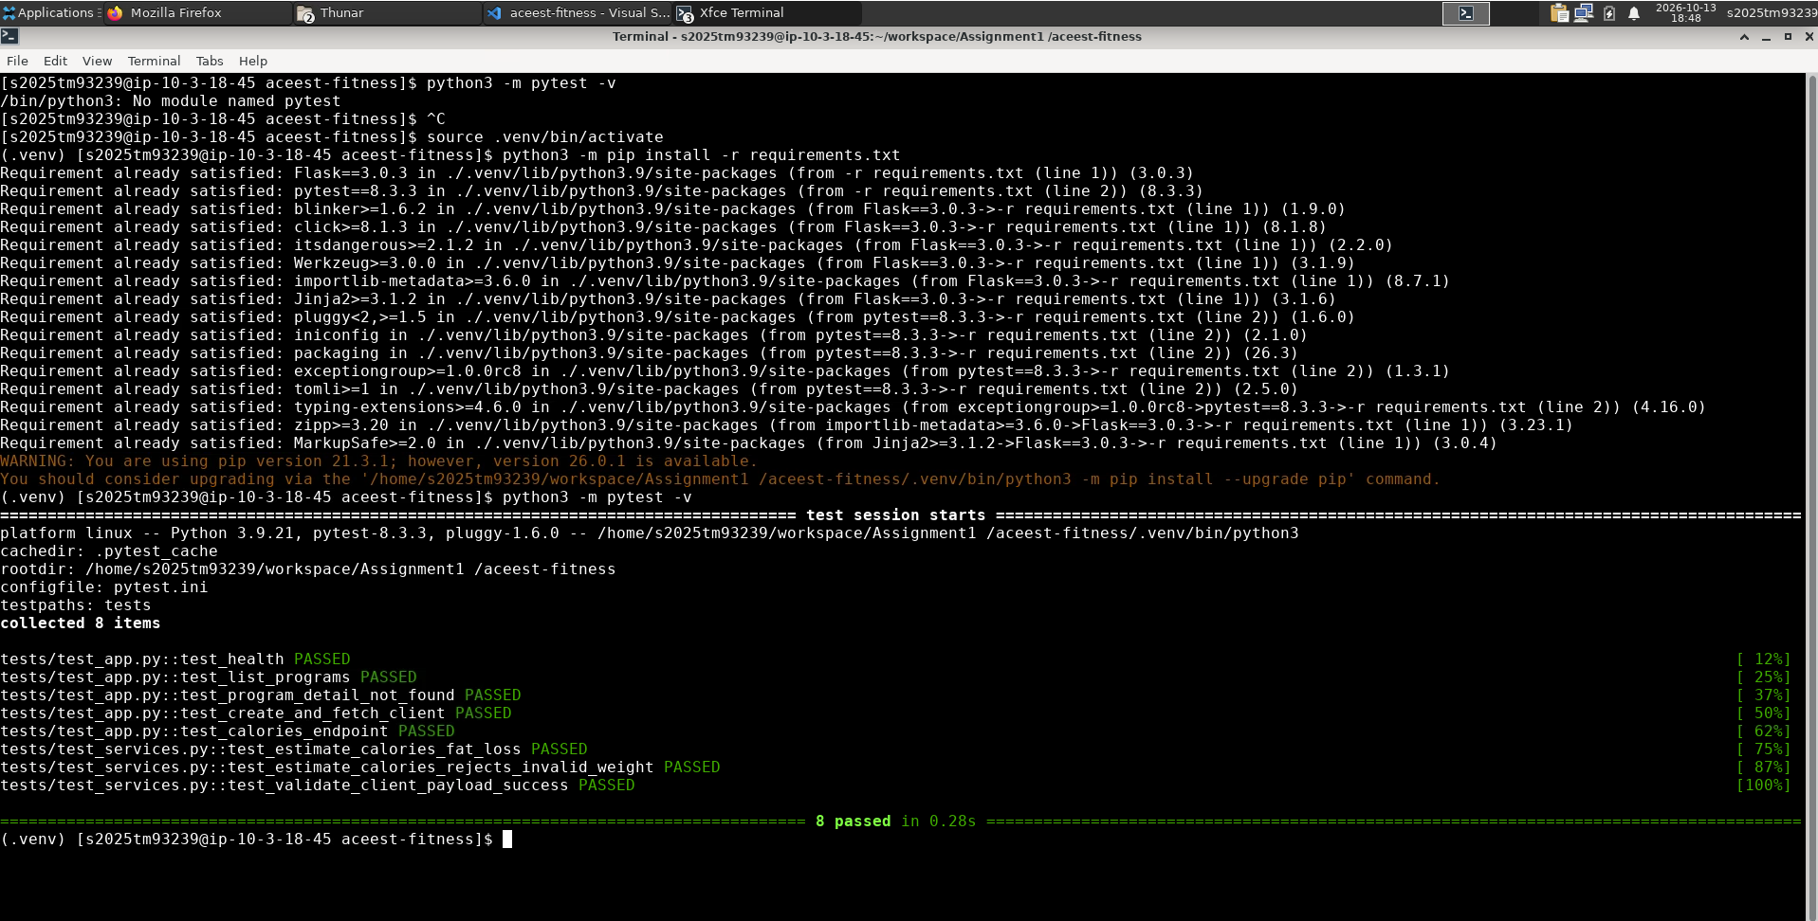

Please note that I have added 8 Test cases, which are passing.

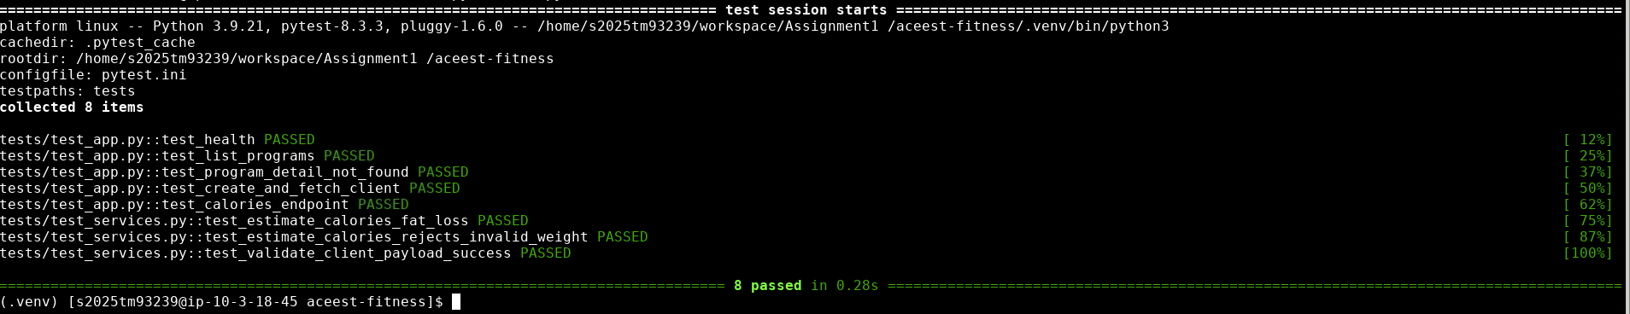

5. Infrastructure as Code

5.1 Dockerfile
python:3.9-slim base; installs requirements and Gunicorn; non-root user; exposes port 5000; includes tests for containerized pytest.
https://github.com/2025tm93239/aceest-fitness/blob/main/Dockerfile
- Build the image
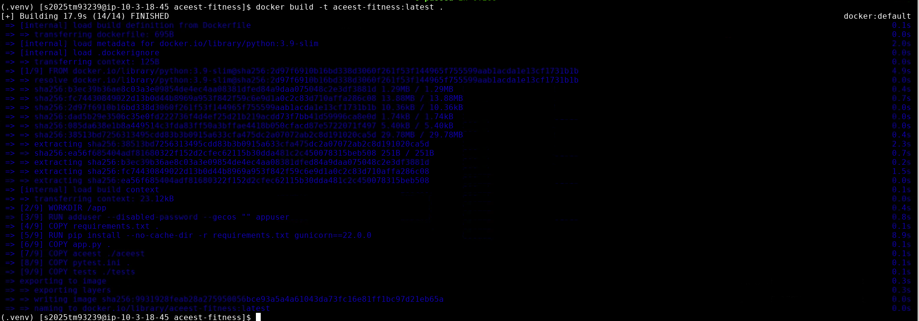
- Run the API container an verified
http://127.0.0.1:5000/

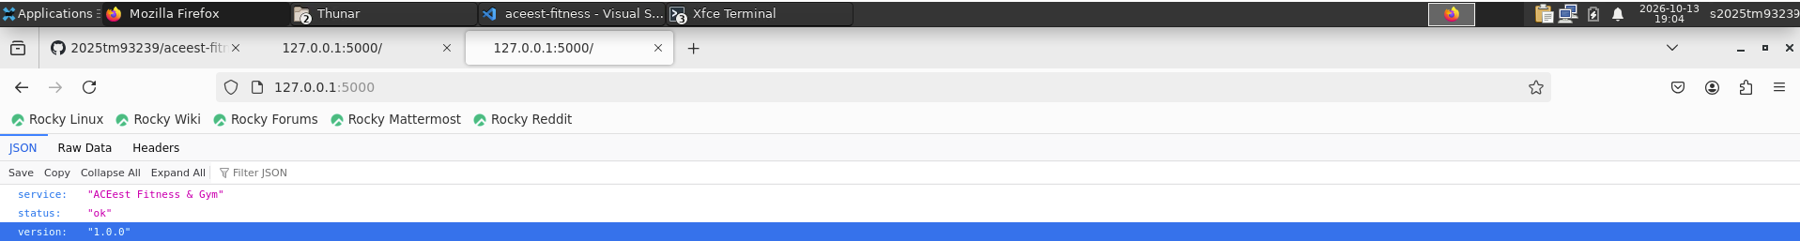
Running tests inside the Image
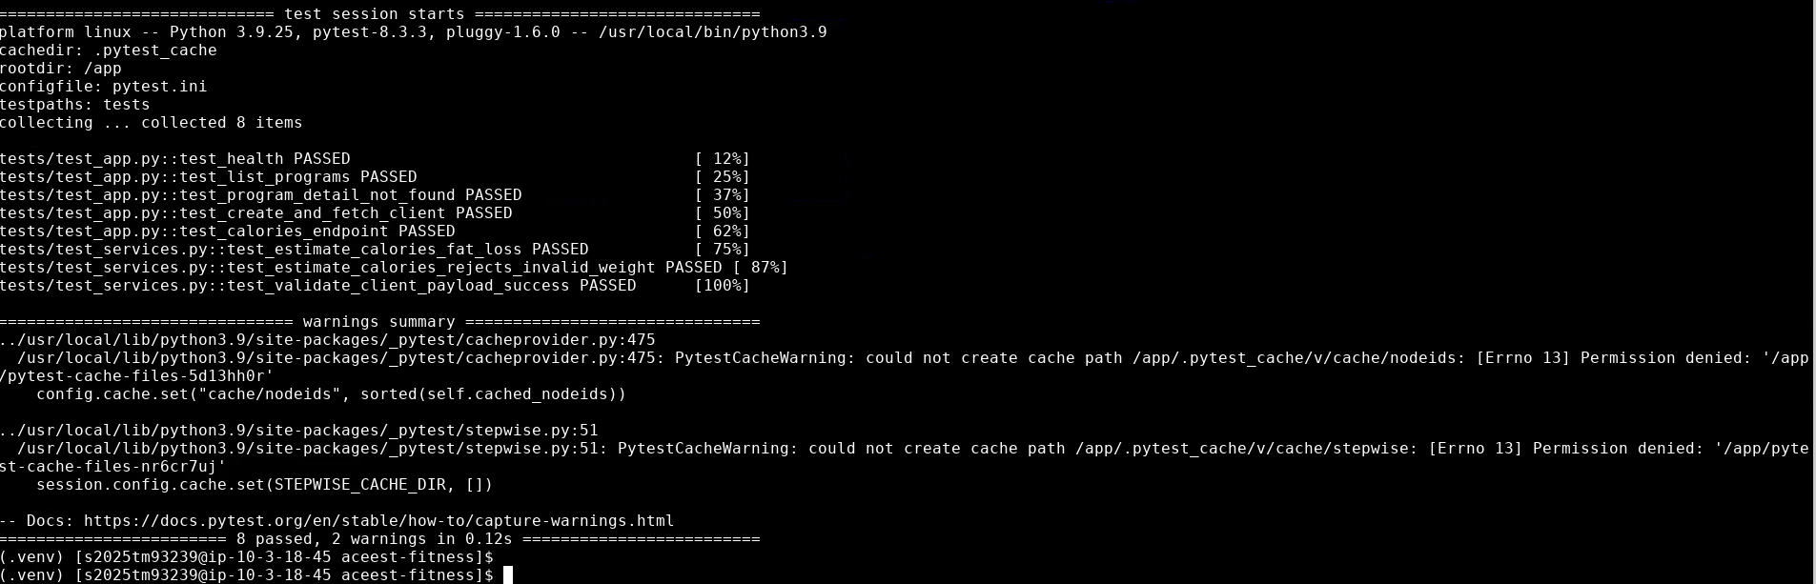

5.2 GitHub Actions
File: .github/workflows/main.yml
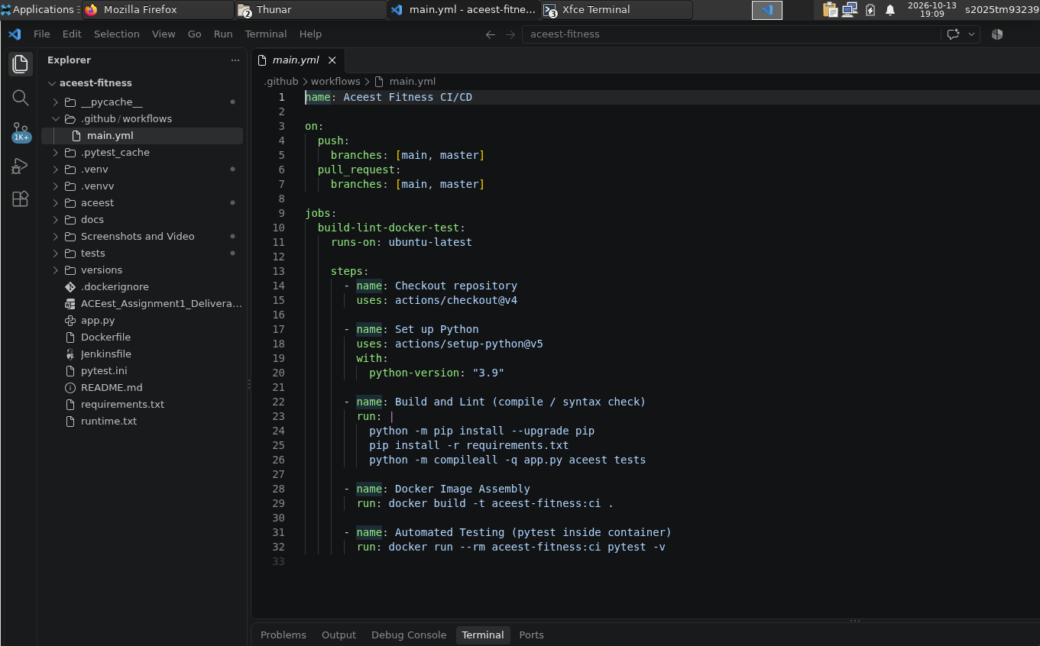

https://github.com/2025tm93239/aceest-fitness/blob/main/.github/workflows/main.yml

- Trigger: push and pull_request on main/master
- Build & lint: pip install + python -m compileall
- Docker image assembly: docker build
- Automated testing: pytest inside container

As we have configured using main.yml file, build is triggering on each commit.

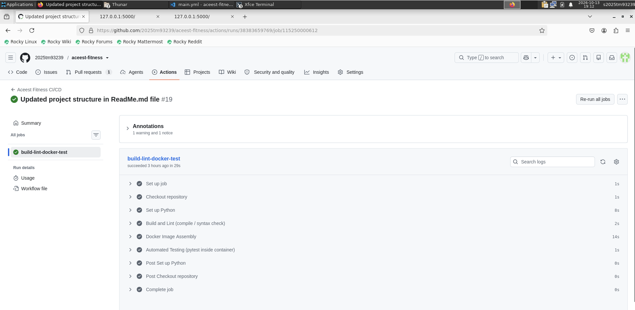

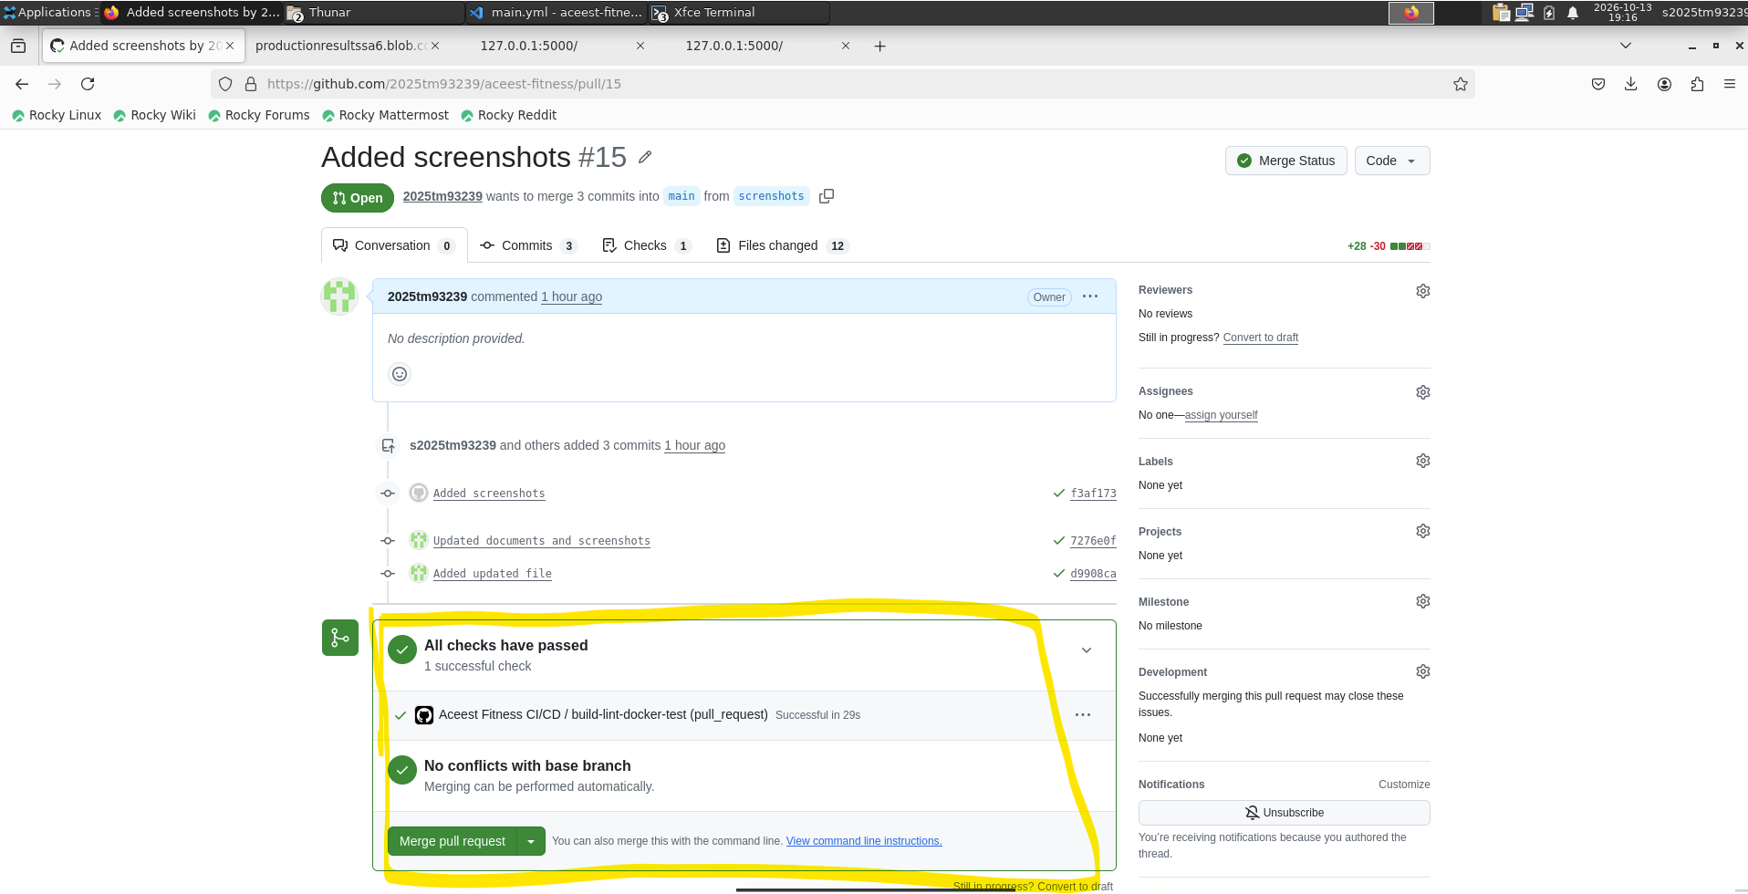

5.3 Jenkins
Jenkinsfile — Pipeline from SCM. Stages: checkout, install, compileall, pytest on agent, docker build, pytest in container.
- Logged-in Jenkins using default username and password
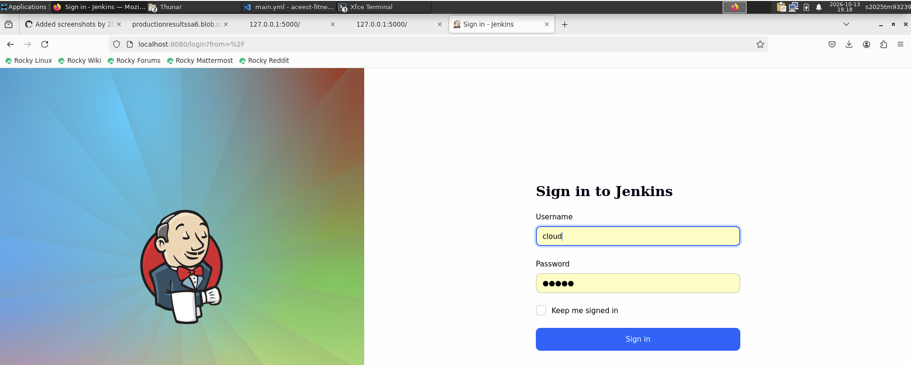
- Created a new pipeline
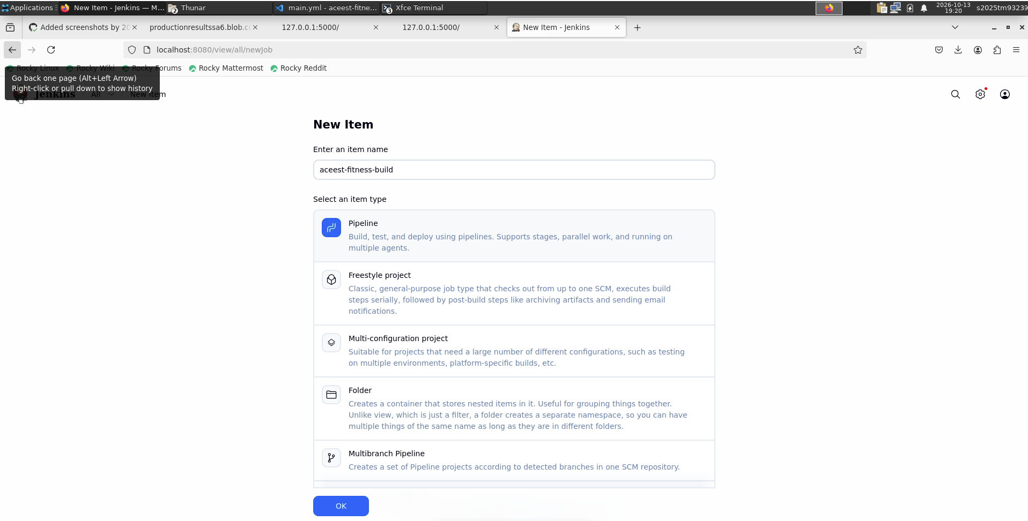

Completed Success Jenkin build and its build pipeline

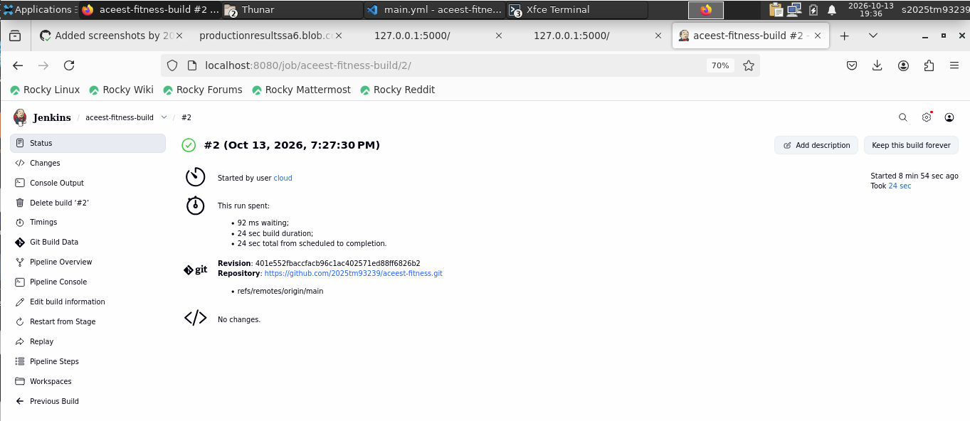

Pipeline Steps:
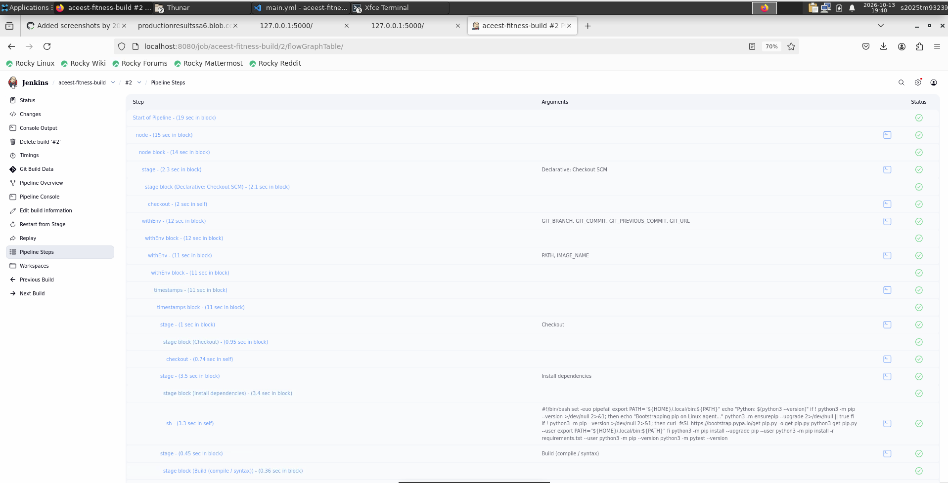

Pipeline Console Output:
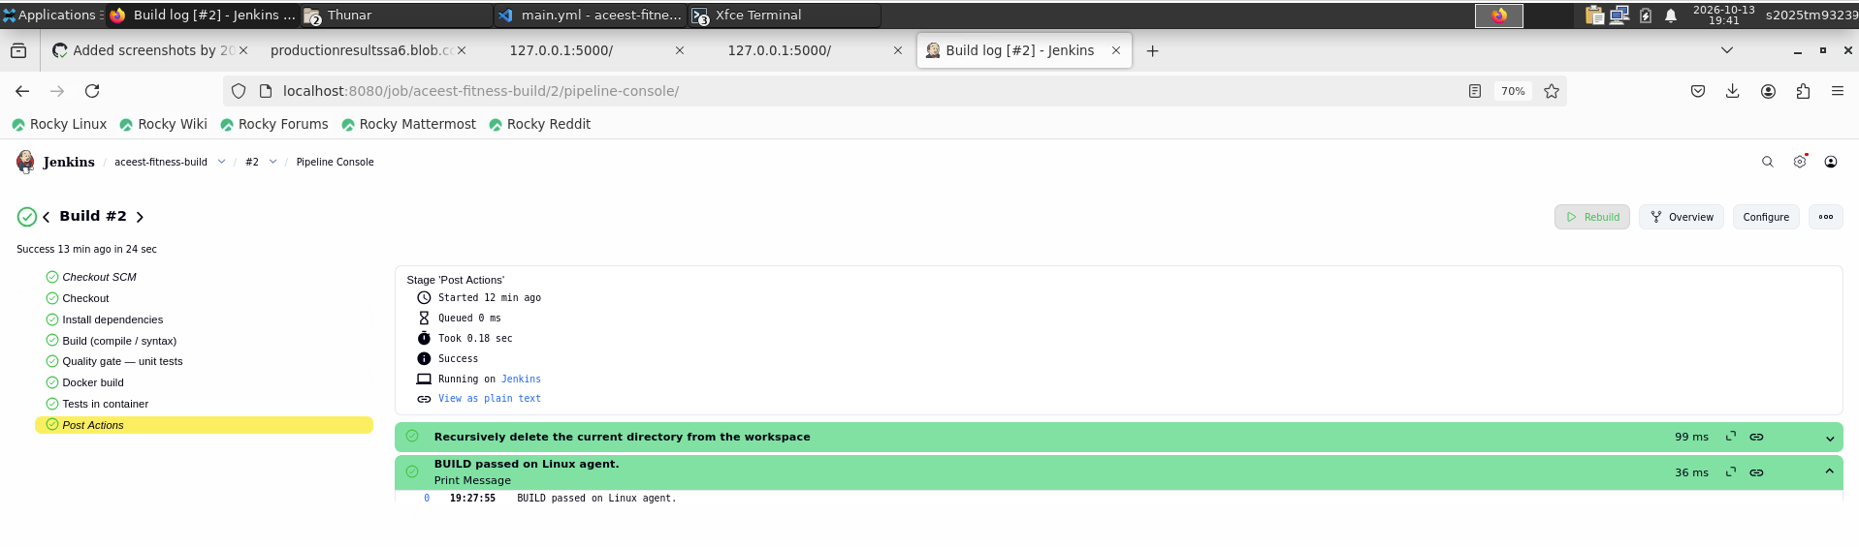
Pipeline Overview:
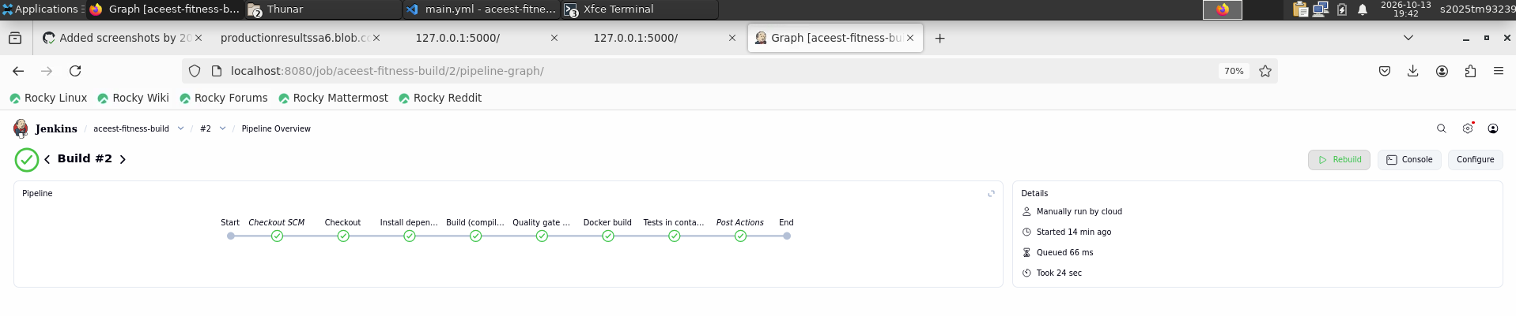

6. Documentation — README.md
https://github.com/2025tm93239/aceest-fitness/blob/main/README.md
https://github.com/2025tm93239/aceest-fitness/blob/main/docs/JENKINS-SETUP.md
https://github.com/2025tm93239/aceest-fitness/tree/main/Screenshots%20and%20Video

Local setup and execution

Run tests manually

Docker Setup steps

Jenkin Setup steps

Jenkins and GitHub Actions integration (overview)
GitHub Actions runs on every push/PR using GitHub-hosted runners. It checks out code, installs dependencies, runs compileall, builds the Docker image, and runs pytest inside the container. This gives immediate feedback on each change.
Jenkins runs on the course Linux VM as a BUILD quality gate. The Pipeline job clones the same repository, performs a clean install and compile, runs pytest on the agent, builds Docker, and runs pytest in the image. Jenkins validates the project in a controlled server environment; GitHub Actions validates on each commit in the cloud.

