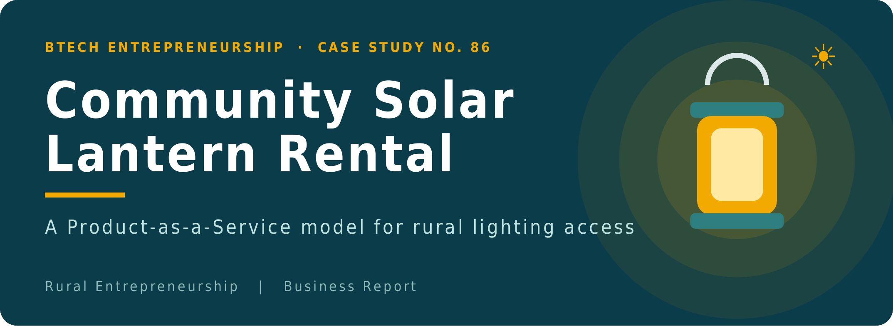

Name | Yatharth Dharmesh Mishra | Faculty Name | Mr. Sachin
Roll No. | 150096725055 | Course / Subject | Go-to-Market & Customer Operations
College | ITM Skills University | Academic Year | 2025-29
1. Executive Summary
Rural households and farm workers often need portable light only for short periods — during a power cut, a night of farm work, exam week or a village function. Buying and maintaining a rechargeable lantern (about ₹900) is not always sensible for such occasional needs. This report proposes a community kiosk that owns and manages a pool of 20 rechargeable/solar lanterns and rents them at ₹30 per lantern per day against a refundable ₹300 security deposit.
The kiosk handles charging, inspection, record-keeping and maintenance, so customers simply collect a ready-to-use lantern and return it. The pilot is planned at 10–15 rental days per lantern per month (roughly 33–50% utilisation), not full utilisation, and focuses on temporary, occasional and emergency users — not on households that need a lantern almost every day, who may do better to buy one.
20  lanterns in the pool | ₹18,000  initial lantern investment | ₹30  rent per lantern per day | ₹300  refundable deposit (not revenue)

We are not selling lanterns. We are providing temporary access to lighting through a community-based Product-as-a-Service model.
2. Problem & Opportunity
THE PROBLEM | THE OPPORTUNITY
- Lighting needs are often short-term or unpredictable: outages, harvest nights, exams, events.  - A lantern costs about ₹900 upfront — hard to justify for a household that needs it only a few days a month.  - Existing emergency lights fail or are left uncharged; candles, torches and phone flashlights give limited, short-lived light. | - Pay for use, not ownership: ₹30 per day instead of ₹900 upfront.  - The kiosk keeps lanterns charged and repaired, so every lantern issued is ready to use.  - One shared pool serves many households, so each lantern earns across many customers.

What is Product-as-a-Service (PaaS)? The provider keeps ownership of the product and customers pay for access or use. The provider’s income therefore depends on keeping every product available, working and well used — which is why charging, inspection and inventory discipline sit at the centre of this business.
3. Customer Segments & Profile
Segment | Typical temporary need | Why renting suits them
Households facing power outages | Light for a few hours or days during an unexpected outage | No need to buy a lantern for a rare event
Farmers with occasional night work | Night irrigation, harvest or livestock checks on specific days | Pay only for the nights worked
Students | Studying after dark during exams or short periods without power | Affordable, short-term access
Households whose emergency light failed | A gap while the old light is repaired or replaced | Bridge solution, no commitment
Village events / functions | Extra portable light for a festival, function or gathering | Several lanterns for a day or two
Other short-term / emergency users | Urgent repairs, visiting guests, sudden emergencies | Ready lantern, fast issue

Representative customer profile (illustrative)  - Small farming or rural household; income can be irregular  - Needs light on a few nights each month or in emergencies  - Prefers low upfront cost; trusts a known local kiosk  - Usually has a mobile phone (verified number where available) | Who we are NOT mainly targeting  - People who need a lantern almost every day — ownership is cheaper for them.  - Break-even: ₹900 ÷ ₹30 = 30 rental days. A customer renting for more than about 30 days in total is better off buying, and the kiosk should say so honestly.
4. Value Proposition
“Access to reliable portable lighting when you need it, without having to purchase and maintain a lantern.”

CUSTOMER PROFILE |  | VALUE MAP (what the kiosk offers)
Jobs to be done  - Get dependable light for a short period  - Keep work or study going during an outage | ↔ | Products & services  - Charged lantern rental by the day  - Registration, deposit and return service
Pains  - ₹900 upfront cost for occasional use  - Old light fails or is not charged  - Hassle of repair and upkeep | ↔ | Pain relievers  - ₹30 per day, refundable ₹300 deposit  - Kiosk tests charge before issue  - Kiosk handles all maintenance
Gains  - Light exactly when needed  - Low cost, no ownership burden  - A trusted, nearby source | ↔ | Gain creators  - Ready-to-use lantern, flexible duration  - Community-based location  - Loyalty and priority-access options

Option | Upfront cost | Maintenance | Best suited to
Rent from kiosk | ₹300 refundable deposit + ₹30/day | Handled by kiosk | Occasional and emergency needs
Buy a lantern | About ₹900 | Owner’s responsibility | Frequent, long-term daily use
Candles / torch / phone flashlight | Low | Replace candles or batteries; phone battery drain | Very short, low-light tasks
5. Customer Journey
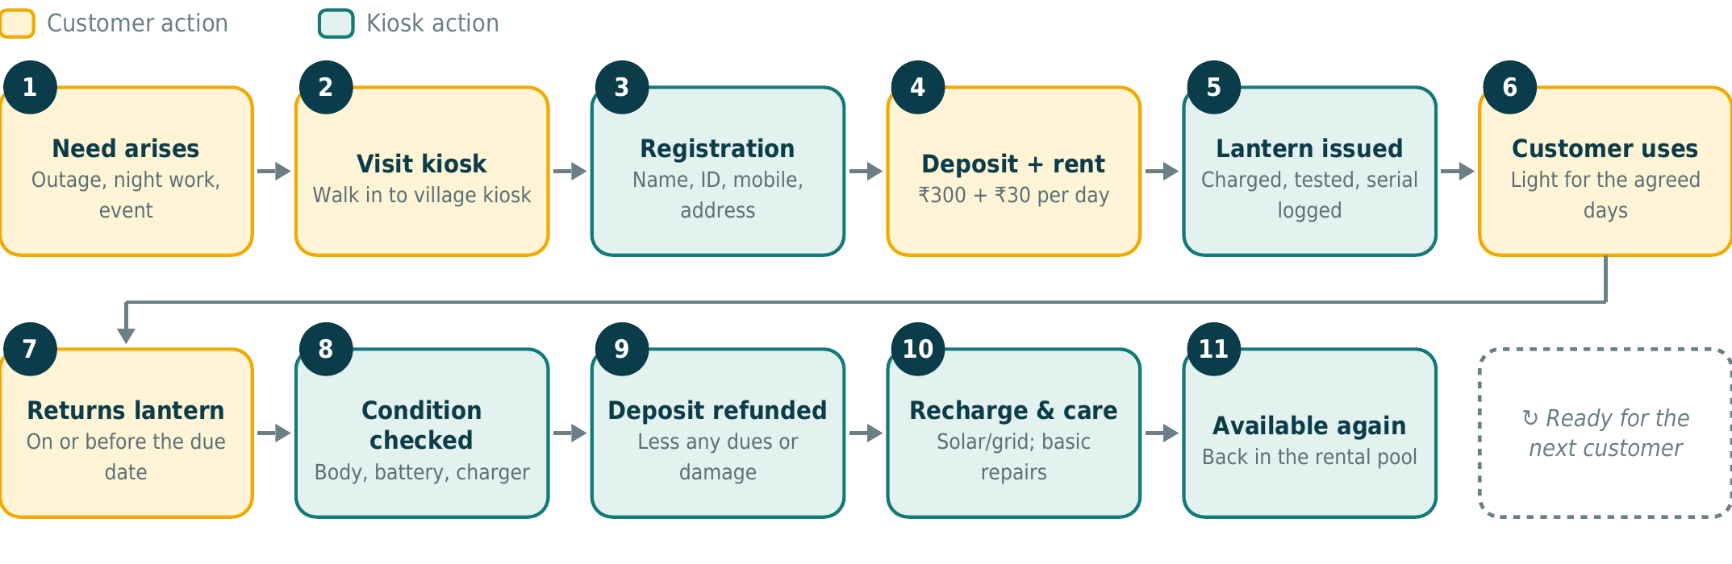
6. Operations, Charging & Security
KIOSK RESPONSIBILITIES | CHARGING SYSTEM (kept simple)
1. Receive lanterns from supplier  2. Maintain inventory  3. Charge lanterns  4. Check battery and operating condition  5. Rent lanterns  6. Record customer and rental information  7. Receive returned lanterns  8. Inspect for damage  9. Refund deposits  10. Recharge and return lanterns to inventory  11. Perform basic maintenance | - Solar charging preferred — daytime charging in the kiosk’s sunny area  - Grid electricity when available (cloudy days, evenings)  - Backup capacity where practical, e.g. a spare charged reserve  - Returned lanterns go on charge first so they are ready for the next day

Demand meets capacity. A lantern can only be rented if it is charged, inspected and in stock. During busy spells, charging throughput (lanterns recharged per day) — not just the 20 owned — limits how many rentals the kiosk can serve. Keeping a small reserve (e.g. 2–3 charged lanterns) for emergencies protects the service’s core promise.

THEFT & LOSS: A RISK-MANAGEMENT SYSTEM, NOT A GUARANTEE
- ₹300 refundable deposit per lantern  - Basic registration + identity verification  - Verified mobile number where available  - Local address / reference for unfamiliar customers | - Serial-numbered lanterns and a rental record (who holds which)  - Return-condition inspection; damage/loss policy  - Late-return charges  - Small allowance for occasional asset loss in the financial plan
No rental system can eliminate theft completely. These controls reduce its probability and financial impact: a lost lantern costs about ₹900 against a ₹300 deposit. Costly GPS/smart-tracking hardware is deliberately not used, to keep the service simple and affordable.
7. Supply Chain & Operating Flow
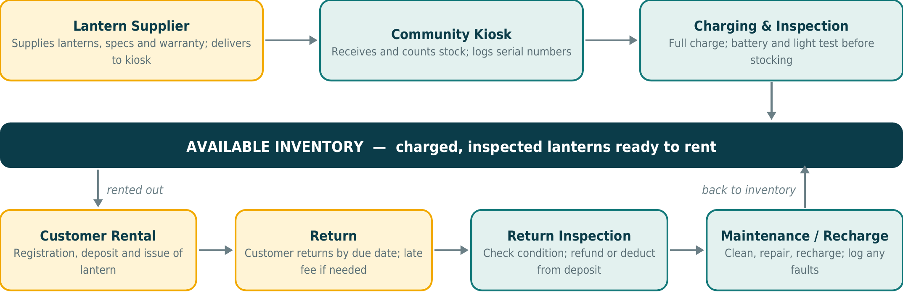
8. Business Model (Concise Canvas)
KEY PARTNERS  - Lantern supplier  - Village leaders for kiosk space and trust  - Local organisations / NGOs  - Local repair technician | KEY ACTIVITIES  - Charging and inspection  - Renting and record-keeping  - Return checks, deposit refunds  - Basic maintenance | VALUE PROPOSITION  - Access to reliable portable lighting without buying or maintaining a lantern  - Low upfront cost  - Charged, tested lanterns  - Refundable deposit | CUSTOMER RELATIONSHIPS  - Personal, local, trust-based  - Loyalty rewards  - Priority-access plan | CUSTOMER SEGMENTS  - Households facing outages  - Farmers with occasional night work  - Students  - Event organisers  - Other short-term / emergency users
 | KEY RESOURCES  - 20 lanterns  - Kiosk and charging area (solar + grid)  - Rental register  - Trained attendant |  | CHANNELS  - Community kiosk  - Word of mouth  - Local groups, notice boards
COST STRUCTURE  - Lantern purchase: ₹18,000 (one-time)  - Maintenance: ₹2,000 per year  - Charging power, attendant and kiosk setup  - Provision for loss or damage |  |  | REVENUE STREAMS  - Rental fees: ₹30 per lantern per day  - Late-return charges  - Deposits kept only to cover loss/damage (not routine income)  - Optional priority-plan fees
9. Financial Analysis
Item | Calculation | Amount |  | Deposits are not revenue. The ₹300 deposit is refundable and is never counted as business income. It is held as a security and returned unless a lantern is lost or damaged.  Utilisation = rental days ÷ 30 days in the month.
Initial lantern investment | 20 lanterns × ₹900 | ₹18,000
Annual maintenance | 20 lanterns × ₹100 | ₹2,000
Loss provision (planning assumption) | 1 lantern replaced per year × ₹900 | ₹900
Deposits held if all 20 are out | 20 × ₹300 — a liability | ₹6,000

Scenario (20 lanterns) | 10 days / month | 15 days / month | 20 days / month
Utilisation (pilot low / pilot high / upside) | 33% | 50% | 67%
Monthly rental revenue | 20 × 10 × ₹30 = ₹6,000 | 20 × 15 × ₹30 = ₹9,000 | 20 × 20 × ₹30 = ₹12,000
Annual rental revenue | ₹72,000 | ₹1,08,000 | ₹1,44,000
Less: maintenance + loss (₹2,900 ÷ 12) | − ₹242 | − ₹242 | − ₹242
Less: illustrative running costs (assumed) | − ₹3,000 | − ₹3,000 | − ₹3,000
Indicative monthly contribution | ₹2,758 | ₹5,758 | ₹8,758
Payback on ₹18,000 | ≈ 6.5 months | ≈ 3.1 months | ≈ 2.1 months

How to read this. The ₹3,000 running cost is only an assumption for sensitivity; electricity/charging, staffing, kiosk setup and other operating costs must be measured in a real implementation. On that assumption the kiosk covers its costs at about 108 rental days a month (≈ 5.4 days per lantern, 18% utilisation), and recovers ₹18,000 within 12 months at about 158 rental days a month (≈ 7.9 days per lantern, 26%). These are indicative figures, not guaranteed profit — poor utilisation would extend payback considerably.
10. SWOT Analysis
Strengths  - Low upfront cost for customers  - Affordable temporary access  - Community-based service  - Maintenance handled by provider  - Reusable inventory | Weaknesses  - Limited inventory  - Theft / damage risk  - Dependence on charging capacity  - Low revenue if utilisation is poor | Opportunities  - Expansion to nearby villages  - Partnerships with local organisations  - Seasonal / festival demand  - Monthly / loyalty programmes  - Additional rental equipment later | Threats  - Customers buying cheap lanterns  - Low demand  - Torches, candles, phone flashlights  - Theft  - Seasonal demand swings
11. Two Ways to Build Regular Usage
1 LOYALTY PROGRAMME | 2 COMMUNITY PRIORITY-ACCESS PLAN
- How: after a set number of rentals (e.g. 5), the customer earns a discounted or free rental day.  - Why: rewards repeat use and keeps customers returning to the kiosk instead of buying elsewhere.  - Cost: a free day forgoes only ₹30 of revenue; tracked on the existing rental record. | - How: households, farms or local groups pay a small monthly fee (to be tested in the pilot) for priority reservation of lanterns, especially at festival or peak times.  - Fit: remains for temporary use — it guarantees availability and does not push people into daily rental; frequent users are still advised to buy.
12. Risks & Mitigation
# | Risk | Practical mitigation | Priority
1 | Lantern theft | Deposit, registration and ID, verified mobile, local reference, serial numbers, rental record; loss allowance in budget. Reduced, not eliminated. | High
2 | Lantern damage | Condition check at issue and return; damage policy deducts repair cost from deposit; simple handling guidance. | Medium
3 | Late returns | Due date on the receipt, daily late-return charge, reminder call; repeat late customers noted in the record. | Medium
4 | Low utilisation | Target occasional and emergency users, use the two usage schemes, review demand weekly, add no lanterns until demand is proven. | High
5 | Charging / power problems | Solar first with grid backup, staggered charging, a charged reserve for cloudy days or outages. | Medium
6 | Battery failure | Test at issue, periodic battery checks, replacements from the ₹100/lantern maintenance budget, withdraw faulty units. | Medium
7 | Stock-out in emergencies | Reserve 2–3 charged lanterns, cap rental length at peak times, pre-booking for events, scale stock only on evidence. | Medium
8 | Cheaper alternatives | Compete on convenience, not price; advise frequent users to buy; focus on emergency demand and loyalty. | Medium
These mitigations lower each risk but do not remove it; the pilot is designed to measure how well they work.
13. 90-Day Pilot-to-Scale Plan
DAYS 1–30 · PILOT SETUP | DAYS 31–60 · TEST & IMPROVE | DAYS 61–90 · SCALE DECISION
- Acquire 20 lanterns  - Set up charging area  - Set up rental and deposit system  - Register initial customers  - Start tracking rentals and returns | - Measure utilisation  - Collect customer feedback  - Identify peak demand periods  - Improve charging and return process  - Monitor losses and damage | - Evaluate utilisation and revenue  - Decide if more lanterns are justified  - Expand awareness to nearby areas only if demand supports it

Pilot success criteria (targets to test, not guarantees)
60–70%+ average utilisation during active demand periods · Increasing repeat usage · Low loss/damage rate · Reliable return process · Positive operating contribution after major running costs · Evidence of sufficient demand before expanding inventory
14. Conclusion
Community Solar Lantern Rental addresses a real but occasional need: reliable portable light without the cost of owning a lantern. Its strength is a simple, low-cost Product-as-a-Service model; its weaknesses — theft, damage, charging limits and uncertain utilisation — are managed through deposits, records, inspection and a staged pilot rather than ignored. The concept is not suited to everyone, and it is only worth scaling if the pilot shows genuine demand. We are not selling lanterns; we are providing temporary access to lighting.

