5. Development & Implementation Summary
The MyDiet system is architected as a modular web application consisting of three distinct layers: a reactive Frontend Client, a central RESTful API Server, and a specialized AI Microservice. The Frontend Client handles all user interactions across the five core modules (Homepage, Plan, Identifier, Community, Profile). It communicates with the API Server via asynchronous HTTP requests to retrieve personalized meal plans and synchronize user data, such as daily caloric intake and social posts. A key architectural decision is the isolation of the ‘Identifier’ module: when a user uploads a meal photo, the main server acts as a proxy, forwarding the image data to the AI Microservice. This service processes the image and returns nutritional estimates back through the chain, ensuring the main application thread remains unblocked during heavy computational tasks.
To implement this design, we selected the PERN stack (PostgreSQL, Express, React, Node.js) supplemented by Python.
- Frontend: We chose React.js for its component-based architecture, which allows us to reuse UI elements like the 'nutrition progress bars' across different pages. We will use Recharts for the data visualization (e.g., the weight history graph in the Profile) because of its native React integration, and Framer Motion to deliver the "gamified" animations (like the streak flame) that are critical for user retention.
- Backend & Database: Node.js and Express were selected for their non-blocking I/O, which is ideal for handling real-time community interactions. For storage, we chose PostgreSQL over NoSQL alternatives. Since our "Plan" module relies on strict relationships between user biometrics, ingredients, and weekly schedules, a relational database ensures data integrity and complex querying capabilities.
- AI Service: The image recognition component will be built using Python. We chose Python here simply because it offers the most robust support for machine learning libraries (e.g., TensorFlow/PyTorch), allowing us to implement the food recognition feature more efficiently than if we attempted it in JavaScript.
Given the ten-week constraint, our development process prioritizes the data layer. We will use Git for version control, adopting a feature-branch workflow. The first week is dedicated to finalizing the PostgreSQL schema. Once the database is stable, the team will split: one sub-team will develop the API endpoints and the Python service concurrently with the frontend team building the React components. We will perform integration testing at the end of each sprint to ensure the separate modules (especially the AI link) function correctly before the final deployment.

10. UI / UX Mockup
The MyDiet Homepage features a clean layout with a top navigation bar for quick access to the Plan, Identifier, Community, and Profile sections.
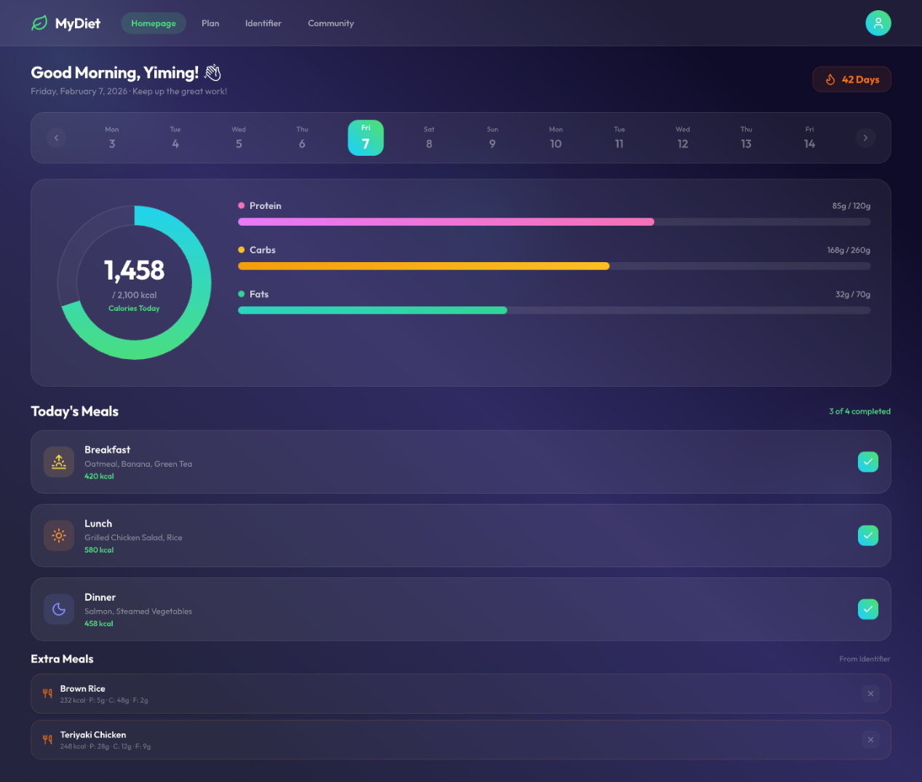
At the heart of the screen, a central ring tracks total calorie intake, complemented by dynamic progress bars that monitor daily protein, carbohydrate, and fat consumption. The "Today's Meal" section provides a detailed breakdown of these metrics for breakfast, lunch, and dinner. To make the experience more engaging, tapping the checkmark after a meal triggers a subtle confetti animation as the progress bars advance in real-time. If an intake limit is exceeded, the corresponding ring or bar will turn red as a visual warning. Additionally, any extra items captured and added via the camera scanner are automatically populated in the “Extra Meals” section.

