Wind Power Forecasting in Ireland’s Smart Grid: Apache Spark Data Processing and LSTM Deep Learning

Sebastián Alfonso Briones Astudillo
CCT College
Dublin, Ireland
2026004@student.cct.ie

Abstract
Ireland’s electricity grid faces growing pressure to integrate renewable energy sources. Wind power plays a central role in achieving the national renewable electricity target by 2030. However, the inherent variability of wind generation creates operational challenges for grid operators, including significant energy curtailment, 13.4% of available wind energy was dispatched down in 2025. This paper addresses the research questions: How does a LSTM model forecast wind power generation, and how does it perform in comparison with traditional machine learning algorithms using EirGrid data processed via Apache Spark? The rationale of this approach is twofold: deep learning models are better suited than traditional machine learning models for capturing non-linear temporal dependencies in wind data, and distributed processing frameworks are required to handle the scale and velocity of smart grid data. The methodology combines a PySpark pipeline on HDFS covering data ingestion, cleaning, feature engineering, and a Spark MLlib baseline model (linear regression). With a two-layer LSTM trained on over 90,000 hourly sequences. The LSTM model achieved RMSE = 131.50 MW and R² = 0.9851, outperforming the linear regression baseline (RMSE = 323.38 MW, R² = 0.9099) by 59.3%. These findings confirm the value of integrating big data infrastructure with deep learning for operational energy forecasting in Ireland’s renewable grid.
Keywords—Machine learning, Neural networks, Long short-term memory, Wind power forecast, Big data, Linear Regression.

Introduction
Ireland has set an ambitious target of generating 80% of its electricity from renewable sources by 2030 (EirGrid, 2025). Wind energy is the primary source of renewable generation on the island, however, its variability poses significant operational challenges for grid operators. In 2025, 13.4% of wind energy was dispatched down – meaning it was curtailed despite being available – primarily due to grid constraints and demand mismatches (EirGrid, 2025). Accurate short-term forecasting of wind power generation is therefore not merely an academic exercise but an economic and operational necessity: better forecasting directly reduces unnecessary curtailment, supports economic dispatch decisions, and contributes to grid stability.
Traditional machine learning (ML) models have long been applied to energy forecasting, however, these approaches assume linear relationships, limiting their effectiveness for the complex, non-linear characteristics of wind generation (Shahid et al., 2021). Furthermore, the emergence of smart metering infrastructure, producing continuous, high-volume readings across thousands of grid sensors, creates a scalability challenge that single-machine learning methods cannot adequately address (Kaur et al., 2022). This gap between the capabilities of traditional approaches and the demands of modern renewable energy forecasting represents the research niche this study addresses.

Deep learning (DL) methods, particularly Long Short-Term Memory (LSTM) networks, have demonstrated superior performance on large-scale non-linear time series datasets, While distributed processing frameworks such as Apache Spark have emerged as the preferred infrastructure for managing the volume and velocity of smart grid data (Shahid et al., 2021; Mostafa et al., 2022). Combining these two capabilities offers a practical pathway for addressing the forecasting challenge at scale. This study asks How does an LSTM model forecast wind power generation, and how does it perform in comparison with traditional machine learning algorithms using EirGrid data processed via Apache Spark?
To address these questions, the paper proceeds as follows, Section II reviews the relevant literature on wind power forecasting with DL, big data frameworks for energy systems, and normalisation in time series models. Section III describes the methodology, covering the Apache Spark pipeline, feature engineering, and LSTM architecture. Section IV presents the results and discussion, and a comparative performance between LSTM and linear regression. Section V concludes.

Literature Review

Wind Power Forecasting with Deep Learning
Shahid et al. (2021) proposed a hybrid Genetic-LSTM (GLSTM) model for wind forecasting, demonstrating that LSTM networks with optimised window sizes significantly outperform traditional regression and statistical models. Their work introduces the key formulation $W_{p}= W_{p}\left(t-1\right)+...+W_{p}(t-24)$, establishing 24 hour lag windows as a standard approach for capturing daily wind correlation (Shahid et al., 2021). Furthermore, Shahid et al. (2021) demonstrate that the choice of window size has a significant impact on the model performance, with windows that are too short failing to capture daily cycles and windows that are too long introducing noise from distant historical values.
Yamak et al. (2019) compared deep learning and traditional machine learning models for time series forecasting, finding that simpler models outperformed neural networks (NN) on small data sets, but the authors explicitly noted that “Recurrent Neural Networks (RNN) typically perform on more massive datasets, as previous research papers have shown” (Yamak et al., 2019). with more than 100,000 early records spanning over a decade, the EirGrid dataset employed in this study falls clearly within the category where LSTM is expected to excel over traditional ML alternatives.
Lalapura et al. (2021) survey the application of RNN’s across domains including energy systems, confirming that LSTM’s forget gate mechanism allows it to retain relevant long-term patterns, such as seasonal wind behaviour, while discarding irrelevant noise. This architectural advantage is particularly relevant for Irish wind data, where generation in January averages over twice that of July. Kaur et al. (2022), in a comprehensive review of energy forecasting methods for smart grid systems, confirm that LSTM achieves higher accuracies with least prediction errors among deterministic methods when dataset sizes are larger and involve non-linear patterns.

Big Data Frameworks
Inoubli et al. (2018) conducted an experimental survey comparing major big data processing frameworks, including Hadoop MapReduce, Spark, Storm, and Flink, across batch, stream, and iterative workloads. They found that Apache Spark consistently outperformed the others in iterative tasks due to its in-memory computational model, making it the preferred choice for ML pipelines. This finding directly supports the decision to implement the data pipeline in PySpark rather than alternative frameworks.
Ahmed et al. (2020) compare the performance of Hadoop and Spark on a real-world cluster handling 600 GB datasets, confirming Spark’s superior performance for data analytics workloads. Their results demonstrate that Spark achieves lower execution time than MapReduce across sorting, ML, and SQL query workloads. Lee et al. (2020) in Learning Spark, 2nd Edition establish the architectural foundations of Spark’s MLlib, including VectorAssembler and Pipeline API used in this study’s baseline model.
Mostafa et al. (2022) specifically address the intersection of big data and ML for smart grid management, arguing that the combination enables real-time monitoring, anomaly detection, and predictive modelling of renewable energy systems at scale. As illustrated in Figure 1, their framework validates the architectural approach taken in this paper, using a distributed processing layer (Spark) to prepare data before feeding it into a deep learning model.
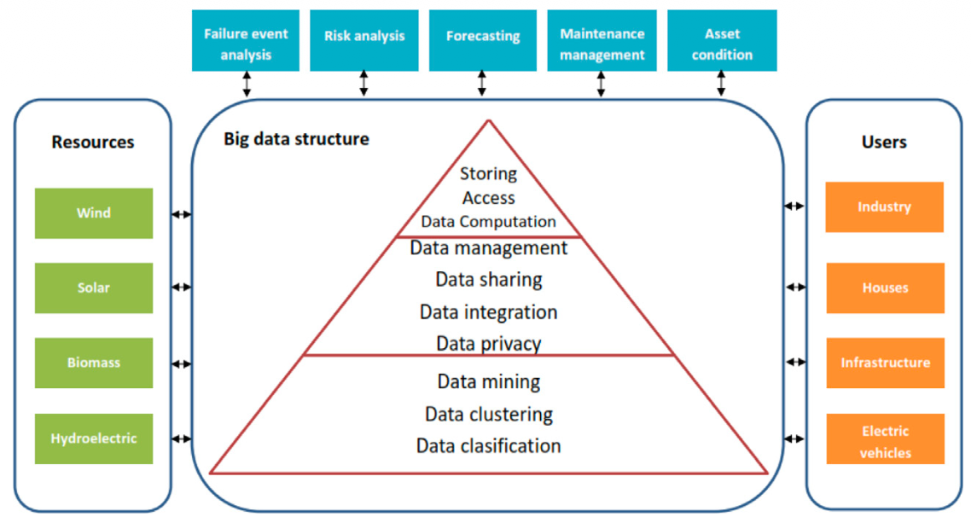
- Big data framework for renewable energy management (Source: Mostafa et al. 2022, Fig.1)

Normalisation in Time series Models
Feature scaling is a critical preprocessing step for NN training, as unscaled input variables can cause gradient instability and slow convergence. The choice of scaler depends on statistical properties of the data: MinMaxScaler transforms values to a fixed range [0,1] and is appropriate for skewed distributions, StandardScaler normalises to zero mean and unit variance and is suited for normally distributed features, RobustScaler uses median and interquartile range and is preferred when significant outliers are present (Chollet, 2021). As shown in Figure 2, the EirGrid wind generation data exhibits a right-skewed distribution. This skewness justifies the selection of MinMaxScaler in this study.
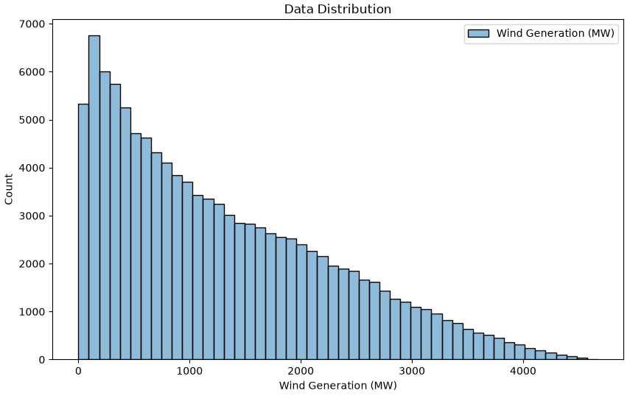
- Distribution of hourly wind generation (skewness = 0.764)

Methodology

Dataset
The dataset was obtained from EirGrid Smart Grid Dashboard open data portal, a publicly available resource providing electricity generation data for Ireland’s national grid. The dataset contains 446,193 records of 15-minute interval readings from January 2014 to October 2026. Variables include system demand, total generation export, actual wind generation, CO₂ intensity, CO₂ emissions, solar generation, and inter-connector flows.

Big Data Pipeline – Apache Spark
The raw CSV file was ingested from the Hadoop Distributed File System (HDFS), providing a distributed storage layer appropriate for production-scale grid data. All processing was performed using PySpark on an Ubuntu virtual machine, simulating a distributed computing environment.

Data Cleaning: Duplicate timestamps were removed, null values in critical columns were eliminated, and invalid negative wind readings (minimum observed: -59 MW, representing sensor errors) were filtered using a column condition.

Feature Engineering: Temporal features were added, such as, hour of day, month, and day of the week, to capture cyclical demand patterns across different timescales. A wind-demand ratio feature was computed as Wind Generation / System Demand to quantify wind’s contribution to total electricity output. Lag features were added using Window functions ordered by timestamp:
- wind_lag_96: wind generation 96 time-steps (24 hours).
- wind_lag_672: wind generation 672 time-steps (7 days).
These lag features are directly justified by Shahid et al. (2021) whose model formulation $W_{p}= W_{p}\left(t-1\right)+...+W_{p}(t-24)$ establishes that historical wind power values are the strongest predictors of future outputs.

Exploratory Data Analysis: Spark aggregations revealed important patterns in Ireland’s wind generation over the study period. Figure 3 shows the full time series of wind generation from 2014 to 2026, illustrating the overall upward trend in the installed capacity, As shown in Table I, average wind generation grew significantly from 718 MW in 2014 to 1,586 MW in 2026, reflecting the major expansion of wind farm infrastructure documented by EirGrid (2025). The wind share grew from 18.7% in 2014 to over 37% by 2020 and around 33% so far in 2026.
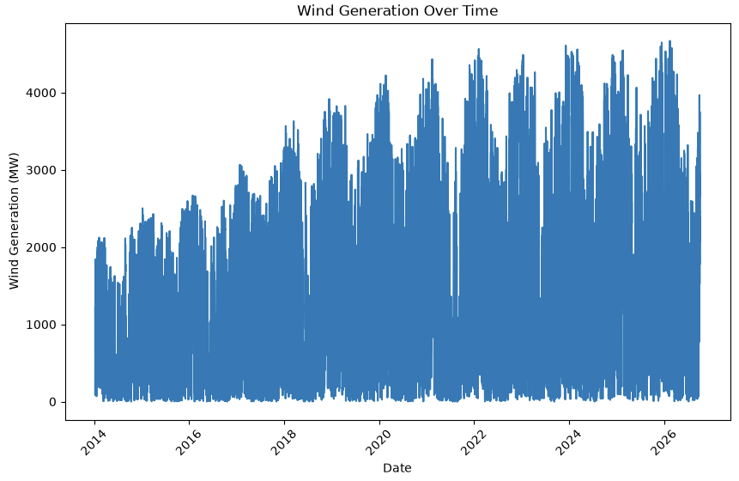
- Distribution of hourly wind generation (skewness = 0.764)
- Average wind generation (MW) and wind share of total demand by year (2014-2026)
Year | Average Wind (MW) | Average Wind Share
2014 | 718.23 | 0.1868
2015 | 939.78 | 0.2384
2016 | 862.91 | 0.2179
2017 | 1056.68 | 0.2643
2018 | 1261.28 | 0.3007
2019 | 1365.07 | 0.3293
2020 | 1560.52 | 0.3293
2021 | 1333.53 | 0.3061
2022 | 1559.95 | 0.3558
2023 | 1567.77 | 0.3481
2024 | 1510.3| | 0.3262
2025 | 1556.58 | 0.3303
2026 | 1585.83 | 0.3285

Baseline ML Model: A linear regression model was trained using Spark MLlib. Input features were assembled using VectorAssembler following the pattern established in Lee et al. (2020). Temporal split was applied, training on data before 2025, testing on 2025 onwards to preserve time series structure and avoid data leakage. The processed dataset was exported as a CSV file to be used in the LSTM notebook.

LSTM Neural Network

Preprocessing: The processed EirGrid dataset was resampled for 15-minute to hourly intervals, reducing the more than 400,000 records to just over 100,000 hourly observations. This resampling was necessary to manage computational requirements while preserving the dominant temporal patterns in the data. Wind generation exhibited a skewness of 0.764, justifying the application of MinMaxScaler to normalise values to [0,1] range. A date-based temporal split was applied, consistent with the Spark MLlib baseline (training before 2025, testing 2025 onwards). This approach ensures both models are evaluated in the same time period.

Sliding Window: Following Shahid et al. (2021), a sliding window of 24. For each hour t, the model receives the previous 24 hours of wind generation (t-24 to t-1) as input and predicts the value at time t. The first 24 rows of each split are consumed by window initialisation and do not produce sequences.

Model Architecture: The LSTM model consists of two stacked LSTM layers with Dropout regularisation, consistent with best practices for sequence modelling described by Chollet (2021).
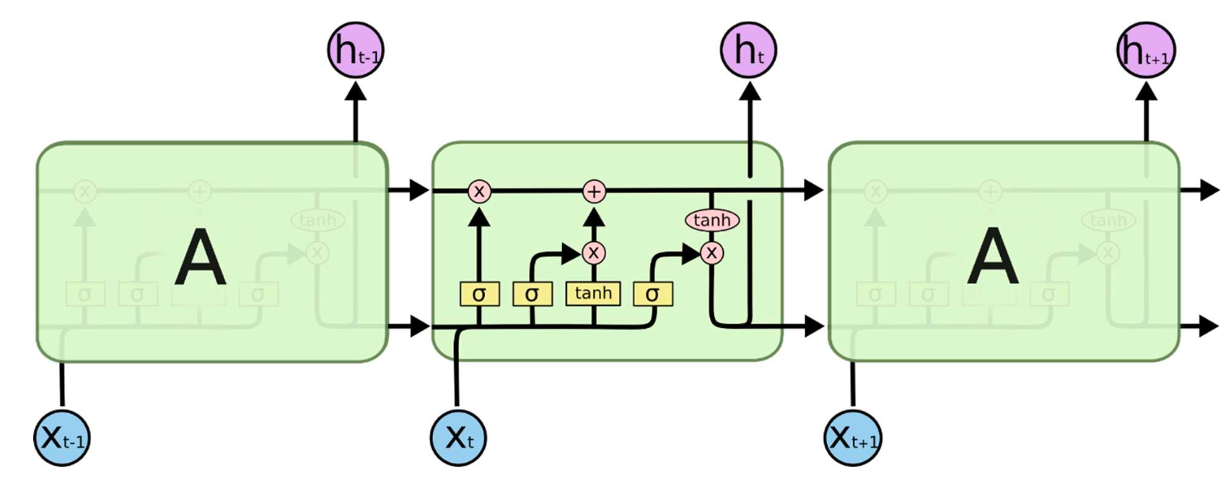
- LSTM cell architecture (source: course materials, Advanced Data Analytics, CCT Dublin, 2026)
As shown in Figure 4, the LSTM cell architecture uses a gating mechanism to selectively retain or discard information across time steps. Particularly, for this study the first LSTM layer passes the full sequence of hidden states to the second LSTM layer. Dropout of 20% was applied after each LSTM layer to prevent overfitting during training. The model was compiled with Adam optimiser and Mean Squared Error loss function, activation function by default (tanh), trained for 10 epochs with batch_size=32 and 20% validation split.

Training Convergence: Figure 5 shows how training loss decreases dramatically in epoch 1, with validation loss tracking closely, indicating no significant overfitting. Loss convergence was achieved by epoch 4, with marginal improvements afterwards.
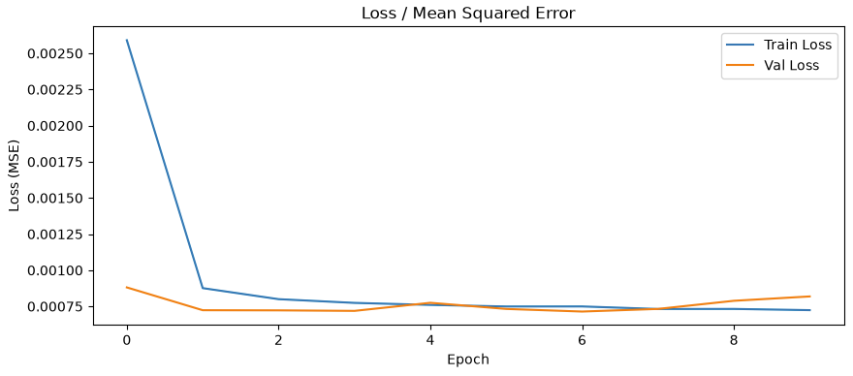
- LSTM training and validation loss (MSE)

Evaluation Metrics: Performance was assessed using Root Mean Squared Error (RMSE), Mean Absolute Error (MAE) and R², enabling comparison with the Spark MLlib baseline presented in Section IV.

Results and Discussion

Spark MLlib Baseline (Linear Regression)
The use of Apache Spark is justified not merely by the current dataset size but by architectural scalability. Inoubli et al. (2018) demonstrate that Spark outperforms MapReduce for iterative ML workloads, and Ahmed et al. (2020) confirm this advantage across large-scale benchmarks. The EirGrid dataset, represents a simulation of production conditions where smart grid data arrives continuously from thousands of sensors across the national grid. Mostafa et al. (2022) say that big data infrastructure is essential for real-time energy management, and the HDFS-based ingestion pipeline provides the architecture for such a system.
- MLlib Linear Regression Results
Metric | Value
Train set | 384,783 rows
Train test | 61,410 rows
RMSE | 323.38 MW
MAE | 222.33 MW
R² | 0.9099

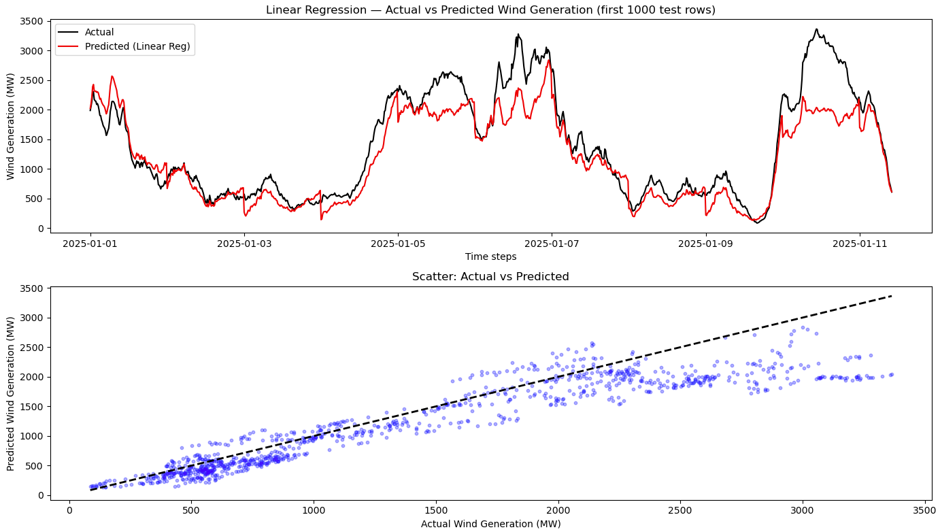
- Linear Regression – Actual vs Predicted Wind Generation
As shown in the scatter plot in the Figure 6, the model captures the dominant trend but shows dispersion at high wind values, reflecting a non-linear dynamics that a linear model cannot represent; this results in a prediction with R² = 0.9099 (Table II), meaning it explains around 91% of wind generation variance, and also confirms that the combination of lag features and the wind-demand ratio effectively explains the dominant patterns in the data.

LSTM
- LSTM Results
Metric | Value
Train set | 96,193 rows
Train test | 15,330 rows
RMSE | 131.50 MW
MAE | 95.67 MW
R² | 0.9851

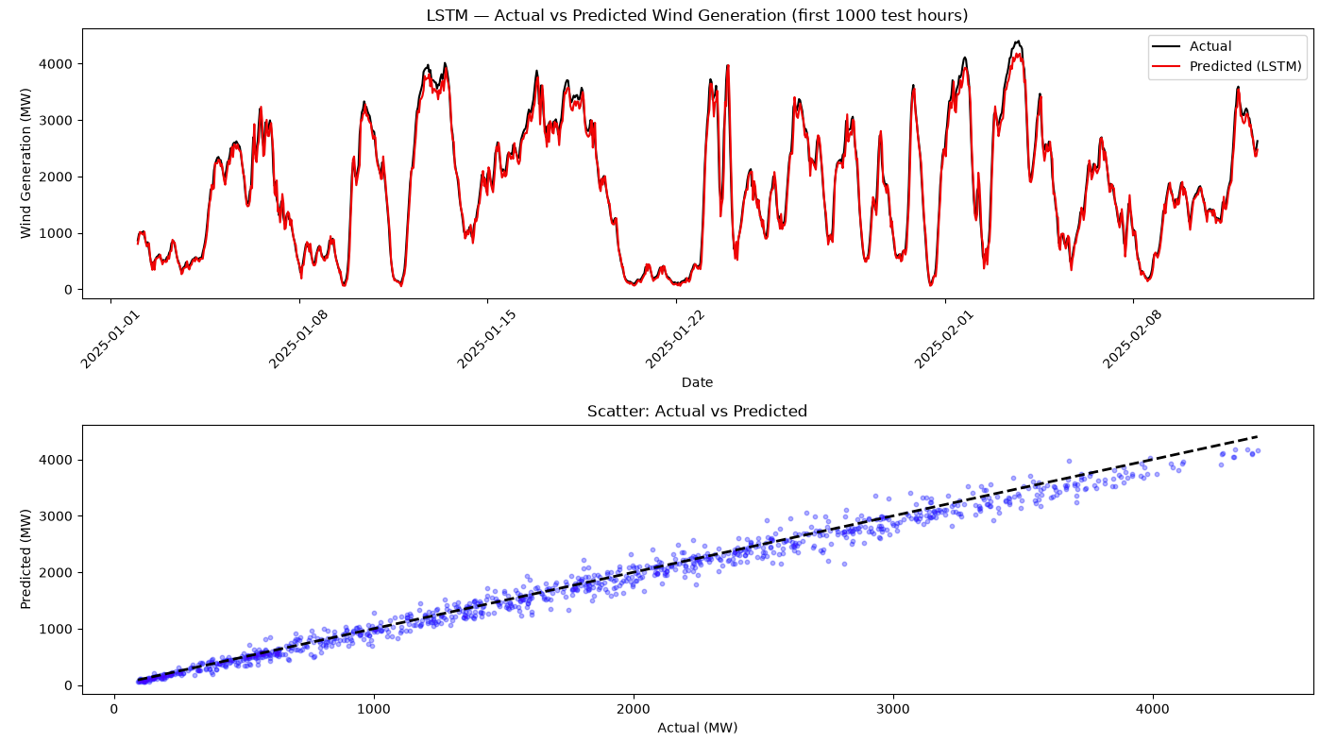
- LSTM – Actual vs Predicted Wind Generation
As illustrated in Figure 7, the LSTM predictions closely follow the actual wind generation pattern. The R² of 0.9851 (Table III) represents a strong result for a univariate (only wind power) forecasting model. LSTM lies precisely in its ability to improve by capturing non-linear patterns, seasonal transitions and ramp events that a linear model structurally cannot represent.
The visual comparison between actual and predicted wind generation in Figures 6 and 7 is consistent with Yamak et al. (2019) observation that RNN’s perform better on larger datasets.
Both models were evaluated on the same test period (2025 onwards). The LSTM reduced RMSE more than 50% (by 191.88 MW), equivalent to reducing the average forecast error from 25% to around 10% of mean wind generation (1,293 MW). Comparing the scatter plots (Figures 6, 7) we observe a clear difference in prediction quality, the linear regression shows significant dispersion at higher wind values, while LSTM demonstrates tight clustering around the perfect-fit diagonal across the full range.
As we said, the RMSE represents ~10.2% of mean generation, within the operational useful range cited by Shahid et al. (2021). EirGrid’s dispatch-down rate of 13.4% in 2025 (EirGrid, 2025) suggests that forecasting at this accuracy could inform curtailment reduction decisions.

Conclusion and Future Directions
This study developed and evaluated an end to end pipeline for wind power forecasting in Ireland, integrating Hadoop Apache Spark for distributed data processing with an LSTM neural network for temporal sequence prediction. The Apache Spark pipeline successfully processed over 440,00 EirGrid records stored in HDFS, performed comprehensive feature engineering using PySpark window functions and lag features, and established a reproducible ML (linear regression) baseline (RMSE = 323.38 MW, R² = 0.9099) using Spark MLlib. The LSTM model, trained on 96,193 rows (2014-2024) using a 24-hour sliding window and MinMaxScaler normalisation, achieved RMSE = 131.50 MW and R² = 0.9851, representing a 59.3% improvement in forecast error over the baseline, evaluated over the same 2025-2026 test period.
The results confirm that LSTM networks are significantly more effective than linear models for capturing non-linear temporal dynamics of wind generation, consistent with findings by Shahid et al. (2021) and the expected behaviour of deep learning models on large-scale datasets (Yamak et al., 2019). The LSTM’s RMSE of 131.50 MW represents approximately 10.2% of mean wind generation, a level of forecast accuracy within the operationally useful range of grid planning, with direct implication for reducing Ireland’s 13.4% wind curtailment rate (EirGrid, 2025).
Several directions for future work emerge from the limitations identified in this study. The use of a multivariate LSTM as demonstrated by Shahid et al. (2021), incorporating meteorological inputs like wind speed, direction, and atmospheric pressure from Met Éireann or Numerical Weather Prediction (NWP), this could address an accuracy improvement. Systematic hyper-parameter optimisation, using tools like Genetic Algorithm approach (Shahid et al., 2021). The pipeline architecture developed here, Spark on HDFS for data engineering, represents a scalable, reproducible template applicable to Ireland’s expanding renewable energy management challenge.

References
Ahmed, N., Barczak, A.L.C., Susnjak, T. and Rashid, M.A. (2020) 'A comprehensive performance analysis of Apache Hadoop and Apache Spark for large scale data sets using HiBench', Journal of Big Data, 7, p.110. doi: 10.1186/s40537-020-00388-5.
Chollet, F. (2021) Deep Learning with Python. 2nd edn. Shelter Island, NY: Manning Publications.
EirGrid (2026) Annual Renewable Energy Constraint and Curtailment Report 2025. Dublin: EirGrid Group.
Inoubli, W., Aridhi, S., Mezni, H., Maddouri, M. and Nguifo, E.M. (2018) 'An experimental survey on big data frameworks', Future Generation Computer Systems, 86, pp. 546–564. doi: 10.1016/j.future.2018.04.032.
Kaur, D., Islam, S.N., Mahmud, M.A., Haque, M.E. and Dong, Z.Y. (2022) 'Energy forecasting in smart grid systems: recent advancements in probabilistic deep learning', IET Generation, Transmission & Distribution, 16, pp. 4461–4479. doi: 10.1049/gtd2.12603.
Lalapura, V.S., Amudha, J. and Satheesh, H.S. (2021) 'Recurrent Neural Networks for Edge Intelligence: A Survey', ACM Computing Surveys, 54(4), Article 91. doi: 10.1145/3448974.
Lee, J., Chambers, B. and Zaharia, M. (2020) Learning Spark: Lightning-Fast Data Analytics. 2nd edn. Sebastopol, CA: O'Reilly Media.
Mostafa, N., Ramadan, H.S.M. and Elfarouk, O. (2022) 'Renewable energy management in smart grids by using big data analytics and machine learning', Machine Learning with Applications, 9, p.100363. doi: 10.1016/j.mlwa.2022.100363.
Shahid, F., Zameer, A. and Muneeb, M. (2021) 'A novel genetic LSTM model for wind power forecast', Energy, 223, p.120069. doi: 10.1016/j.energy.2021.120069.
Yamak, P.T., Yujian, L. and Gadosey, P.K. (2019) 'A comparison between ARIMA, LSTM, and GRU for time series forecasting', in Proceedings of the 2019 2nd International Conference on Algorithms, Computing and Artificial Intelligence (ACAI '19), Sanya, China, 20–22 December. New York: ACM. doi: 10.1145/3377713.3377722.

