Neural Networks on Apache Spark and a Parquet Data Lake: Storage, Model Design and Scalability
Odmaa Itgel
CCT College Dublin
2026129@student.cct.ie

Abstract—Organizations increasingly want to train and serve neural networks on the platforms that already store and process their big data, yet the practical costs of doing so on Apache Spark and open columnar data lakes are rarely quantified. This paper reviews the state of the art in distributed deep learning on Spark and lakehouse storage, then evaluates a documented end-to-end pipeline that classifies diamonds into four price bands with Spark MLlib’s multilayer perception over Parquet data. Across nine logged experiments, one-hot encoding of categorical attributes lifted validation accuracy from 79.8% to 93%, whereas larger networks added at most 0.2 percentage points at up to 13 times the training cost. The selected network reaches 93.8% test accuracy against 93.0% for logistic regression on identical features. Parquet was 2.5 times smaller than CSV and made a grouped query 9.1 times faster at 5.4 million rows. The study is limited to a single-core machine and one tabular data set, so its scalability findings concern cost growth, not parallel speed-up.
Keywords—Apache Spark, neural networks, data lake, Parquet, lakehouse, Structured Streaming, distributed machine learning

Introduction
Neural networks are data-hungry, and the data that feeds them increasingly lives in data lakes: large collections of files on open formats held on cheap storage. A common response is to export data from the lake to a separate training environment, which adds copies, delays and governance risk. (Armbrust, 2021)2021) argue that lakehouse, which puts warehouse-style management on open formats such as Parquet, exists partly because machine-learning code needs direct access to large data rather than access through SQL interfaces. Apache Spark is the most widely used engine for that kind of access, and it ships with a neural-network classifier, so it is natural to ask what it really costs and delivers to train a neural network where the data already sits.
The published literature describes systems (Dai et al., 2019; Sergeev and Del Balso, 2018) and measures configuration effects (Djebrouni et al., 2023), but it seldom documents the sequence of design decisions that a practitioner faces. Which matters more for accuracy: the storage format, the way attributes are prepared, or the size of network? Which of these choices is expensive to change? Answers to the questions are needed to justify architecture choices to stakeholders, which is the purpose of critical evaluation.
Legacy approaches each fall short in a different way. Disk-oriented batch engines such as MapReduce (Dean and Ghemawat, 2004) are poorly suited to iterative training. Row-oriented text format such as CSV force every query to read every column. Data warehouses offer strong management but, as Armsbrust et al.(2021) note, expose data to machine-learning code through interfaces that are inefficient for large scans. Stand-alone training environments avoid these problems but duplicate data and break lineage.
Evaluating these limitations against a concrete alternative is the basis for the critical stance taken in this paper.
Objective. The objective is to critically evaluate how neural networks can be integrated with Apache Spark and open columnar storage, and to quantify, through a reproducible and fully logged experiment, which design decisions most influence accuracy, cost and scalability.
Research question. To what extend to storage format, data preparation and network architecture affect the accuracy and computational cost of a neural-network classifier built on Spark over Parquet data, and what do published Spark-based deep-learning systems imply for scaling that design?

Literature Review and State of the Art

Spark as the processing substrate
Early large-scale analytics relied on MapReduce, which writes intermediate results to disk between stages (Dean and Ghemawat, 2004). That design is robust but expensive for iterative workloads such as neural-network training, where the same data set is scanned hundreds of times. Resilient distributed datasets (RDDs) address this by keeping working sets in memory and recovering lost partitions from their lineage rather than from replicas (Zaharia et al., 2012). Zaharia et al. (2016) later described Spark as a unified engine in which batch, SQL, streaming, machine learning and graph processing share one runtime, which is the property that makes it attractive as a host for end-to-end neural-network pipelines.
Three subsequent components share how a neural network can be embedded. Spark SQL added a DataFrame API that mixes relational and procedural code, with the Catalyst optimiser rewriting queries (Armbrust et al., 2015). Structured Streaming provides a declarative API that automatically incrementalises a static relational query, so that the same code serves batch and streaming (Armbrust et al., 2018); its authors report throughput advantages over Apache Flink and Kafka Streams and production deployments processing more than 1 PB per month, although these are vendor-side measurements. MLlib supplies pipeline abstractions and distributed learners (Meng et al., 2016), and Verbraeken et al. (2020) note in their survey that in inherits Spark’s scale-out and fault-tolerance behaviour. MLlib’s neural-network support is, however, limited to a feed-forward classifier, which frames the trade-offs explored later in this paper.

Neural networks with and on Spark
Two philosophies dominate the literature. The first executes training inside Spark’s own execution model. SparkNet embeds an existing deep-learning engine in Spark workers and periodically averages parameters (Moritz et al., 2015). BigDL goes further by implementing synchronous data-parallel training directly on Spark’s functional, coarse-grained compute model, so that deep learning runs on the Hadoop or Spark clusters where production data already sits (Dai et al., 2019). Its authors are candid that the paper also shares production experience, which is useful practical evidence but not a controlled comparison.
The second philosophy uses Spark for data preparation and delegates training to a specialised framework. Horovod applies ring all-reduce to make multi-GPU training efficient while requiring only a few lines of change to user code (Sergeev and Del Balso, 2018). Migliorini et al. (2020) combine both ideas in a high-energy-physics pipeline: Spark ingests and engineers features and stores results as Parquet, Keras models are trained with BigDL or TensorFlow, and hyper-parameters are tuned by grid search. Their ent-to-end structure closely resembles the pipeline evaluated here, but in a domain with far larger volumes.
Performance studies temper the enthusiasm. Dünner et al. (2016) start from the observation that Spark’s abstractions carry poorly understood communication and data-management overheads, and they separate framework overhead from computation by comparing Spark and MPI implementations of the same learner. Djebrouni et al. (2023) ran 13 learning methods on six real data sets across two clusters and analysed the interplay between data-science hyper-parameters and platform configuration, which highlights that model quality and system settings cannot be tuned independently.

Data lakes and lakehouse storage
Armbrust et al. (2021) argue that warehouses serve machine learning poorly because TensorFlow, PyTorch and XGBoost must process large data with non-SQL code, and reading through ODBC or JDBC is inefficient. They propose the lakehouse: open, directly accessible formats such as Parquet with warehouse-style management on top. Delta Lake realizes this by keeping a transaction log in the object store alongside Parquet data, giving ACID transactions, time travel and faster metadata operations (Armbrust et al., 2020). Jain et al. (2023) compare lakehouse storage systems empirically, and Harby and Zulkernine (2022) review the shift from warehouses to lakehouses. These studies concentrate on query workloads; effect of storage format on the machine-learning path is discussed mostly qualitatively.

Synthesis and research gap
Three gaps emerge. First, most system papers are written by platform builders and report favourable production evidence rather than independent, reproducible comparisons. Second, published work rarely documents the sequence of design decisions, so it is unclear how much accuracy comes from data preparation compared with network architecture. Third, storage-format studies and neural-network studies are conducted separately, leaving the joint cost unquantified. The quality of evidence also varies. Peer-reviewed system papers describe design and deployments, but few isolate the effect of an individual choice, and survey work such as Verbraeken et al. (2020) organizes approaches rather than testing them. Empirical studies are narrower, examining a specific workload or a specific storage format, and their findings do not automatically transfer to a different data type or scale. There is also a genuine disagreement: BigDL and SparkNet argue for co-locating training with the data, whereas Horovod and the physics pipeline favour handing data to specialised training engines. This paper does not settle that dispute, but provides a small, fully documented case that exposes what the co-located option costs and delivers.

Methodology

Environment and design
All experiments ran in a Jupyter notebook using PySpark 4.2.0 in local mode on a machine with 1 CPU core and 3 GB of memory, with a fixed random seed of 42. The local file system stands in for object storage. Delta Lake could not be installed because its packages could not be fetched in the restricted environment, so plain Parquet (Snappy-compressed) directories are used; Parquet is also the data format underneath Delta tables (Armbrust et al., 2020). The design follows the pipeline pattern of Migliorini et al. (2020): ingest, store as Parquet, engineer features, train, evaluate, and score a stream.

Data set and target
The diamonds data set (Wickham, 2016) has 53,940 rows and ten attributes: carat, cut, colour, clarity, depth, table, price and three dimensions. 23 rows with zero or implausible dimensions were removed, leaving 53,917. The target is a four-class price band whose edges ($945, $2,394 and $5,305) are the training-set quartiles, giving balanced classes. Price is used only to define the label and never as an input. The data are small by big-data standards, so larger volumes are synthesised only for storage and timing tests, by replicating rows with plus or minus 1% random jitter; no accuracy figure is computed on synthetic data.

Storage experiment
The data were written as CSV (with header and explicit schema) and as Parquet at 53,940, 1,078,800 and 5,394,000 rows. For each, on-disk size, write time and the median of three runs of a grouped-average query (average price by cut) were recorded.

Leakage control and splits
The cleaned data were split 80/20 into a training pool (43,060 rows) and a test set (10,857 rows) before the label was created, so price-band edges came from training data only. The pool was divided again into training (34,452) and validation (8,608) rows for model selection. The test set was used once, after the model had been fixed.

Iterative design protocol
Runs R1 to R9 (Table II) changed one factor at a time, and each decision was made from the previous validation results. The network is Spark's multilayer perceptron with sigmoid hidden units and a softmax output, trained by back-propagation (Rumelhart et al., 1986) using L-BFGS (Liu and Nocedal, 1989) unless stated. The sequence was: a majority-class floor (R0); a logistic-regression baseline (R1); a small network on raw features (R2); standardisation (R3); one-hot encoding of the three categorical attributes (R4); engineered features, namely log carat, log volume and the x/y aspect ratio (R5); wider and deeper networks (R6 to R8); and gradient descent as an alternative optimiser (R9). The selection rule was the highest validation accuracy, with ties broken by lower training time.

Metrics and reproducibility
Model quality is reported as accuracy, the share of rows assigned to the correct band, and as weighted F1, which averages per-class F1 weighted by class frequency and so guards against a model that neglects a minority band. Cost is reported as wall-clock training time measured around the fit call, excluding feature preparation, which is cached beforehand. Timings on shared hardware vary, so storage queries use the median of three runs; training runs were executed once, and single-run timings should be read as indicative. Every parameter, seed and intermediate result is written to an experiment log and a JSON results file by the notebook, so each figure and table in this paper can be regenerated by re-running it.

Comparison, scalability and streaming
The final pipeline was compared with logistic regression on identical features and with scikit-learn's multilayer perceptron of the same shape (Pedregosa et al., 2011). Because scikit-learn uses a different optimiser, only end-to-end accuracy and wall-clock time are compared. For scalability, training features were replicated up to ten times and Spark was given a fixed budget of 20 L-BFGS iterations; scikit-learn was given 20 epochs. Partition count was varied at fixed volume. Finally, the saved pipeline scored a file stream through Structured Streaming with one file per micro-batch (Armbrust et al., 2018).

Results

Storage
- STORAGE FORMAT COMPARISON
Rows | CSV MB | Parquet MB | Query CSV s | Query Parquet s
53,940 | 2.7 | 0.5 | 0.38 | 0.35
1,078,800 | 152.6 | 60.6 | 1.59 | 0.38
5,394,000 | 763.1 | 302.5 | 6.01 | 0.66

Parquet was 5.2, 2.5 and 2.5 times smaller than CSV at the three volumes (Table I and Fig. 1). The query benefit depended on scale: at 53,940 rows the two formats took 0.38 s and 0.35 s, so the difference was negligible, but at 5.4 million rows the Parquet query took 0.66 s against 6.01 s, a speed-up of 9.1. Columnar layout lets the engine read only the two columns the query needs, which CSV cannot do.
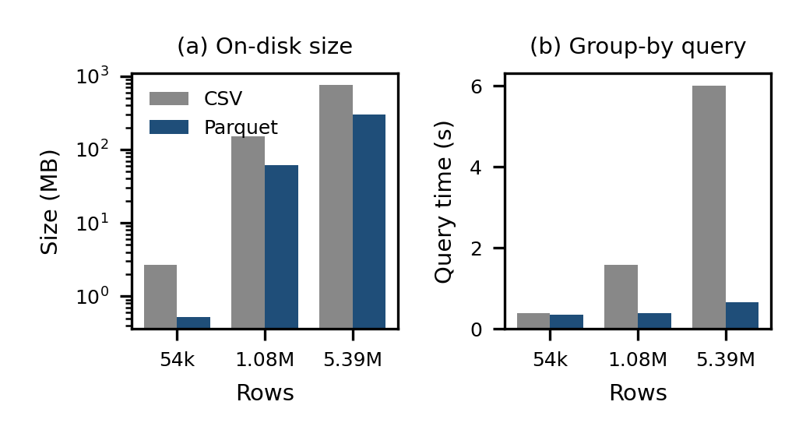
- On-disk size (log scale) and grouped-query time for CSV and Parquet.

Iterative neural-network design
- EXPERIMENT LOG (VALIDATION SET)
Run | Change | Layers | Acc. % | Fit (s)
R0 | Majority class | - | 24.0 | 0
R1 | Logistic regression | - | 79.2 | 7
R2 | MLP, unscaled | 6, 16, 4 | 78.5 | 8
R3 | + standardisation | 6, 16, 4 | 79.8 | 6
R4 | + one-hot cut/color/clarity | 26, 16, 4 | 93.0 | 7
R5 | + log/volume/aspect features | 29, 16, 4 | 93.2 | 7
R6 | wider | 29, 32, 4 | 93.1 | 9
R7 | deeper | 29, 64, 32, 4 | 93.3 | 27
R8 | deeper + wider | 29, 128, 64, 32, 4 | 93.4 | 87
R9 | Gradient descent | 29, 64, 32, 4 | 50.7 | 27

Table II and Fig. 2 give the log. The majority-class floor was 24.0%. Logistic regression on six raw numeric features reached 79.2%, and the same features in an unscaled network did slightly worse (78.5%), a reminder that a neural network gains nothing automatically. Standardisation gave 79.8%. The decisive step was one-hot encoding of cut, colour and clarity, which raised accuracy by 13.2 percentage points to 93.0%. Engineered features added 0.2 points. Widening and deepening the network then produced values between 93.1% and 93.4%, while training time rose from 7 s to 87 s. Gradient descent with an untuned step size reached only 50.7%.
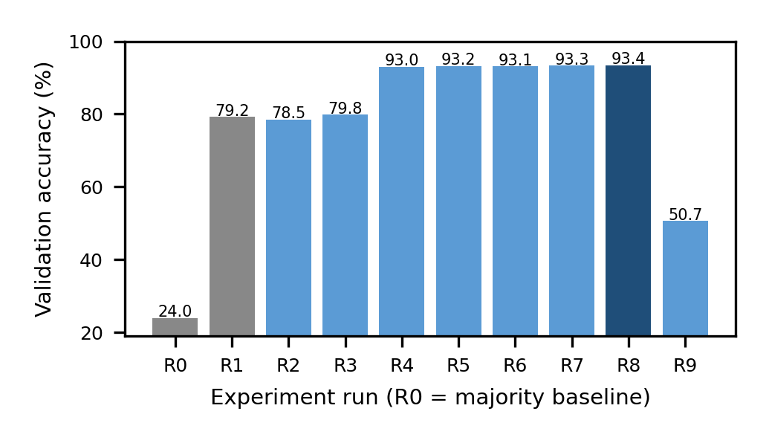
- Validation accuracy across experiment runs; the darkest bar is the selected model.

Final evaluation
The selection rule chose R8 (layers [29, 128, 64, 32, 4]). Retrained on the full training pool, it scored 93.80% accuracy and 93.81% weighted F1 on the test set. Logistic regression on the same features scored 92.96% and 92.97%, and scikit-learn's network scored 93.60%. Of 673 misclassified test rows, 1 (0.1%) were more than one price band from the truth, which is expected because the bands are adjacent quartiles of a continuous variable. Per-band recall was 96.0%, 92.4%, 92.8%, 94.0% from the cheapest to the most expensive band; the two middle bands are hardest because they have a neighbour on each side. Training took 113 s in Spark, 6 s for logistic regression and 5 s in scikit-learn.

Scalability, partitioning and streaming
- TRAINING TIME VERSUS DATA VOLUME (20 ITERATIONS OR EPOCHS)
Rows | Spark s | scikit-learn s | Ratio
43,060 | 27 | 4 | 6.7
215,300 | 119 | 20 | 5.9
430,600 | 244 | 47 | 5.2

Spark's training time grew roughly linearly with volume, from 27 s at 43,060 rows to 244 s at 430,600 rows; time per row changed by a factor of 0.90 (Table III and Fig. 3). Spark was between 5.2 and 6.7 times slower than scikit-learn wherever both were run, which is unsurprising on one core because Spark adds serialisation and scheduling overhead. Partition count also mattered on this machine: with 129,180 rows, training took 70 s with 1 partition and 77 s with 16 partitions, because extra partitions add task overhead without extra cores to absorb it.
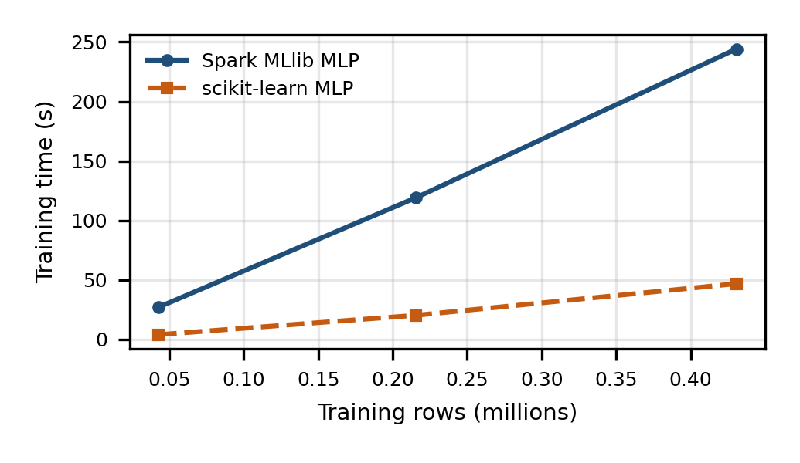
- Training time against training rows for Spark and scikit-learn on one core.
Structured Streaming scored 217,140 rows in 9.8 s across 20 micro-batches, a throughput of 22,227 rows per second including start-up, with 93.6% accuracy on the jittered stream. The same saved pipeline therefore served batch and streaming scoring without code changes, as Armbrust et al. (2018) describe.

Critical Evaluation

Implications
The central finding is that data preparation dominated. Encoding categorical attributes changed accuracy by 13.2 points, more than 67 times the largest gain from any architecture change (0.2 points). This aligns with the caution in Djebrouni et al. (2023) that data-science and platform choices interact, but it also suggests that the expensive infrastructure debate is often secondary to the cheap preparation step. For stakeholders it implies spending analyst time on feature preparation before buying larger clusters.
The likely reason is structural. Before encoding, the network could not see cut, colour or clarity at all, and these attributes carry independent information about price once carat is fixed: two stones of equal weight can differ by several bands because of clarity alone. Encoding them as indicator variables let the hidden layer learn interactions between weight and quality grades. By contrast, the physical dimensions x, y and z are almost collinear with carat, so the additional numeric detail offered by a larger network added little. The result is a reminder that representation, not capacity, was the bottleneck, and that a standardised numeric-only pipeline can look successful (79.8%) while missing most of the available signal.
The second finding concerns model selection. The validation standard error at about 93.2% accuracy on 8,608 rows is roughly 0.27 points, so the spread across runs R4 to R8 (0.35 points, about 1.3 standard errors) cannot be reliably separated from noise. The strict highest-accuracy rule therefore selected a network that is 13 times more expensive than R5 for a difference smaller than the noise. A parsimony rule, such as choosing the smallest model within one standard error of the best, would have been more defensible. That rule was not adopted in advance, and adopting it after seeing the results would be post-hoc, so it is offered here as a recommendation and not applied.
Third, the network's advantage over the linear baseline was modest. On identical features the network beat logistic regression by 0.8 points on the test set. Whether that margin justifies a neural network depends on cost of error; for an exercise whose target is a monotone band of physical attributes, a linear model captures most of the signal. This is consistent with the general point that neural networks earn their place on unstructured or highly non-linear data rather than on small, well-engineered tabular data.
Fourth, Parquet's value scaled with data volume: negligible at 53,940 rows and 9.1 times at 5.4 million. This supports the lakehouse argument of Armbrust et al. (2021) for open columnar formats, though the benefit measured here is for analytical reads and not for neural-network training itself.
Fifth, the streaming result deserves cautious reading. Scoring 22,227 rows per second on one core shows that the saved pipeline can be reused, but the test used file arrival with one file per micro-batch, measured throughput including start-up and did not measure end-to-end latency, state handling or failure recovery. Armbrust et al. (2018) report much stronger figures on production-scale clusters, and those cannot be compared with a single-core experiment. What this study does show is the value of the pipeline abstraction: the same fitted stages, including the indexers and scaler, were applied to batch and streaming data with no reimplementation, which removes a common source of training-serving skew.

Contradicting viewpoints
The literature disagrees on whether to train inside Spark. Dai et al. (2019) favour running deep learning on the cluster that holds the data, and the results here show that this is workable: a pipeline from Parquet to a saved model to a stream ran with no data export. Yet the same results show a cost. Spark was 5.2 to 6.7 times slower than scikit-learn on one node, and MLlib offers only a feed-forward classifier trained by L-BFGS or a plain gradient-descent optimiser, with no convolutional, recurrent or transformer layers and no GPU training. This supports the hand-off approach of Sergeev and Del Balso (2018) and Migliorini et al. (2020) for anything beyond small dense networks. The evidence here supports Spark as a strong data-preparation and scoring layer more clearly than as a training engine.

Limitations
Several limitations constrain the conclusions. The experiment ran on one CPU core, so it cannot show parallel speed-up, the very property that motivates Spark; the scalability results describe cost growth and overhead only. The data set is small, tabular and well behaved, and larger volumes were synthesised by replication, which is valid for timing and storage but says nothing about accuracy at scale. The local file system is not object storage, so network latency, small-file problems and transaction-log behaviour, which Armbrust et al. (2020) and Jain et al. (2023) study, were not tested; Delta Lake itself was not used. Validation used a single split, not cross-validation, and each configuration was run once with one seed, so no run-to-run variance is available. The gradient-descent run was not tuned, so its poor result reflects that configuration and not the optimiser in general. The scikit-learn comparison uses a different optimiser. Finally, the label is a discretisation of price, so the task is easier than direct price prediction.

Validity and practical recommendations
Internal validity is protected by splitting before the label is defined, by excluding price from the inputs, and by touching the test set once. Construct validity is weaker: price bands are a convenient proxy for a business decision and were chosen for class balance, not because any user needs them. External validity is the weakest point, since one small data set on one core cannot represent production workloads. The findings should therefore be read as a worked, transparent case that generates hypotheses for multi-node testing, not as benchmarks.
For practitioners, four recommendations follow. Begin with a linear baseline and a majority-class floor so that any neural network has to justify itself. Fix the data-preparation pipeline, particularly categorical encoding and scaling, before exploring architectures. Decide the model-selection rule, preferably one that penalises cost, before running experiments. Finally, choose the storage format for the read patterns that dominate: the columnar advantage is largest for selective analytical queries on large tables and smallest for small files that fit in memory.

Research gaps
Three gaps follow. First, multi-node experiments are needed to measure whether Spark's overhead amortises as executors are added, extending the workload characterisation of Djebrouni et al. (2023) to neural networks. Second, storage studies should measure the training read path directly, comparing Delta, Iceberg and Hudi (Jain et al., 2023) under repeated epoch scans. Third, a shared protocol for reporting design iterations, including negative results such as R2 and R9, would make future comparisons more reliable than the platform-authored evidence that currently dominates.

Conclusion
This study asked how storage format, data preparation and network architecture affect the accuracy and cost of a neural network on Spark and Parquet. The evidence answers the three parts differently. Data preparation had by far the largest effect on accuracy (79.8% to 93.0% from encoding alone). Network size produced gains inside the validation noise at up to 13 times the training cost. Parquet reduced storage by a factor of 2.5 and sped up analytical queries by 9.1 at 5.4 million rows.
The final network achieved 93.8% test accuracy, only 0.8 points above logistic regression, and Spark training was slower than a single-node library on this scale. Spark and a lakehouse are therefore best justified here by data management, batch and streaming reuse, and integration with the lake, not by training speed. Practitioners should prepare features first, adopt a parsimony rule for model selection, and treat Spark-native networks as suitable for modest tabular problems, handing larger architectures to specialised frameworks. Future work should repeat this protocol on a multi-node cluster with Delta Lake and a data set large enough that accuracy, and not only timing, is measured at scale.
Two claims in the wider literature are supported by this case and two are not. The claim that a lakehouse-style open format helps analytical access is supported, and so is the claim that one pipeline can serve batch and streaming. The claim that Spark is an efficient place to train neural networks is not supported at this scale, and neither is the claim that larger networks reliably justify their cost on tabular data. Stating these boundaries plainly is the main practical contribution of the work.

Data and Code Availability
The notebook, data set and screencast are available at: [https://drive.google.com/file/d/1rxB96Ozjf9ZgLd6RrHtn9Qz_dfPXj34-/view?usp=sharing].

References
Armbrust, M., Das, T., Sun, L., Yavuz, B., Zhu, S., Murthy, M., Torres, J., van Hovell, H., Ionescu, A., Łuszczak, A. et al. (2020) 'Delta Lake: high-performance ACID table storage over cloud object stores', Proceedings of the VLDB Endowment, 13(12), pp. 3411–3424. doi: 10.14778/3415478.3415560.
Armbrust, M., Das, T., Torres, J., Yavuz, B., Zhu, S., Xin, R., Ghodsi, A., Stoica, I. and Zaharia, M. (2018) 'Structured Streaming: a declarative API for real-time applications in Apache Spark', in Proceedings of the 2018 International Conference on Management of Data (SIGMOD '18). Houston, TX, 10–15 June. New York: ACM. doi: 10.1145/3183713.3190664.
Armbrust, M., Ghodsi, A., Xin, R. and Zaharia, M. (2021) 'Lakehouse: a new generation of open platforms that unify data warehousing and advanced analytics', in Proceedings of the 11th Conference on Innovative Data Systems Research (CIDR '21). Online, 11–15 January. Available at: https://www.cidrdb.org/cidr2021/papers/cidr2021_paper17.pdf (Accessed: 23 September 2026).
Armbrust, M., Xin, R.S., Lian, C., Huai, Y., Liu, D., Bradley, J.K., Meng, X., Kaftan, T., Franklin, M.J., Ghodsi, A. and Zaharia, M. (2015) 'Spark SQL: relational data processing in Spark', in Proceedings of the 2015 ACM SIGMOD International Conference on Management of Data (SIGMOD '15). Melbourne, 31 May–4 June. New York: ACM, pp. 1383–1394.
Dai, J.J., Wang, Y., Qiu, X., Ding, D., Zhang, Y., Wang, Y. et al. (2019) 'BigDL: a distributed deep learning framework for big data', in Proceedings of the ACM Symposium on Cloud Computing (SoCC '19). New York: ACM, pp. 50–60. doi: 10.1145/3357223.3362707.
Dean, J. and Ghemawat, S. (2004) 'MapReduce: simplified data processing on large clusters', in Proceedings of the 6th USENIX Symposium on Operating Systems Design and Implementation (OSDI '04). San Francisco, CA, pp. 137–150.
Djebrouni, Y., Rocha, I., Bouchenak, S., Chen, L.Y., Felber, P., Marangozova, V. and Schiavoni, V. (2023) 'Characterizing distributed machine learning workloads on Apache Spark', in Proceedings of the 24th International Middleware Conference (Middleware '23). Bologna, 11–15 December. New York: ACM, pp. 151–164. doi: 10.1145/3590140.3629112.
Dünner, C., Parnell, T., Atasu, K., Sifalakis, M. and Pozidis, H. (2016) 'Understanding and optimizing the performance of distributed machine learning applications on Apache Spark', arXiv preprint arXiv:1612.01437. Available at: https://arxiv.org/abs/1612.01437 (Accessed: 23 September 2026).
Harby, A.A. and Zulkernine, F. (2022) 'From data warehouse to lakehouse: a comparative review', in 2022 IEEE International Conference on Big Data (Big Data). IEEE, pp. 389–395.
Jain, P., Kraft, P., Power, C., Das, T., Stoica, I. and Zaharia, M. (2023) 'Analyzing and comparing lakehouse storage systems', in Proceedings of the 13th Conference on Innovative Data Systems Research (CIDR '23).
Liu, D.C. and Nocedal, J. (1989) 'On the limited memory BFGS method for large scale optimization', Mathematical Programming, 45(1–3), pp. 503–528.
Meng, X., Bradley, J., Yavuz, B., Sparks, E., Venkataraman, S., Liu, D. et al. (2016) 'MLlib: machine learning in Apache Spark', Journal of Machine Learning Research, 17(34), pp. 1–7. Available at: https://www.jmlr.org/papers/volume17/15-237/15-237.pdf (Accessed: 23 September 2026).
Migliorini, M., Castellotti, R., Canali, L. and Zanetti, M. (2020) 'Machine learning pipelines with modern big data tools for high energy physics', Computing and Software for Big Science, 4, article 8. Preprint: arXiv:1909.10389.
Moritz, P., Nishihara, R., Stoica, I. and Jordan, M.I. (2015) 'SparkNet: training deep networks in Spark', arXiv preprint arXiv:1511.06051. Available at: https://arxiv.org/abs/1511.06051 (Accessed: 23 September 2026).
Pedregosa, F., Varoquaux, G., Gramfort, A., Michel, V., Thirion, B., Grisel, O. et al. (2011) 'Scikit-learn: machine learning in Python', Journal of Machine Learning Research, 12, pp. 2825–2830.
Rumelhart, D.E., Hinton, G.E. and Williams, R.J. (1986) 'Learning representations by back-propagating errors', Nature, 323(6088), pp. 533–536.
Sergeev, A. and Del Balso, M. (2018) 'Horovod: fast and easy distributed deep learning in TensorFlow', arXiv preprint arXiv:1802.05799. Available at: https://arxiv.org/abs/1802.05799 (Accessed: 23 September 2026).
Verbraeken, J., Wolting, M., Katzy, J., Kloppenburg, J., Verbelen, T. and Rellermeyer, J.S. (2020) 'A survey on distributed machine learning', ACM Computing Surveys, 53(2), article 30. Preprint: arXiv:1912.09789.
Wickham, H. (2016) ggplot2: elegant graphics for data analysis. New York: Springer. (Source of the diamonds data set; CSV mirror: https://github.com/mwaskom/seaborn-data, accessed 23 September 2026.)
Zaharia, M., Chowdhury, M., Das, T., Dave, A., Ma, J., McCauley, M., Franklin, M.J., Shenker, S. and Stoica, I. (2012) 'Resilient distributed datasets: a fault-tolerant abstraction for in-memory cluster computing', in Proceedings of the 9th USENIX Symposium on Networked Systems Design and Implementation (NSDI '12). San Jose, CA, pp. 15–28.
Zaharia, M., Xin, R.S., Wendell, P., Das, T., Armbrust, M., Dave, A. et al. (2016) 'Apache Spark: a unified engine for big data processing', Communications of the ACM, 59(11), pp. 56–65.

IEEE conference templates contain guidance text for composing and formatting conference papers. Please ensure that all template text is removed from your conference paper prior to submission to the conference. Failure to remove template text from your paper may result in your paper not being published.

