Programming paradigms for Data Analytics
Michael Alexander Bramwell Layne
MSc in Data Analytics (FT)
CCT College Dublin (Computing, IT, Business)
Dublin, Ireland
2026215@student.cct.ie

Abstract: Selecting the right programming paradigm is essential for ensuring optimal performance when processing the continuous logging and analysis of data, in that way maximizing resource utilization. This work examines two primary paradigms that dictate the methodology used to develop specific software solutions. In the case of data analysis, a multi-paradigm approach was employed: functional (declarative) programming was used to retrieve records added over specific time intervals querying over a thousand records every 24 hours using parallel or distributed storage principles while the procedural paradigm was utilized to establish connections with the dynamic record data. Implementing multiple paradigms proved necessary to ensure whole integration with financial classification methods and the proper handling of the stored metadata.
Keywords: Bigdata, paradigms programming, data analysis, parallel distribution, imperative paradigm, declarative paradigm, convolutional neural network, TensorFlow.

Introduction
Today, the Internet acts as a constantly growing global source of information. According to IBM, 90% of the world digital data has been generated since 2010, this clearly shows the rapid increase of information in the modern digital age (Dobre and Xhafa, 2014), To extract useful information from this data, new systems have been developed in recent years, these architectures and programming models help structure digital information correctly, their main goal is to handle the high complexity of modern data efficiently; Additionally, they allow us to process large amounts of data generated at high speed (Belcastro, L et al.,2022, p. 2), However, Programming paradigms offer different methods to solve complex problems in software development, the help manage data distribution for efficient processing and guide code writing using declarative or imperative programming. Therefore, the main goal of this paper is to apply different parallel data distribution with Hadoop and deep learning models such as CNN (Convolutional neural network). Finally, we measure the performance of each approach to find the most suitable paradigm for each case.

Haddop is commonly used as the main software to store huge amounts of collected data. After the data is stored, it is processed by Apache Spark. Spark is widely valued by developers because its is very versatile. It allows high-speed processing of large datasets, and it also has good fault tolerance, which means the system can continue working even if an error occurs. However, managing this big infrastructure to support large volumes of data has changed how programming paradigms are used in data analysis, for instance, functional programming allows developers to create code that is more predictable and concise. On the other hand, imperative programming allows developers to write more detailed and explicit instructions for the computer.
Python has become the most popular programming language to interact with data processing in PySpark, this is mainly due to its flexibility in many programming applications, and it is easy to learn. Specialized libraries like pandas make the data analysis process. They help clean and organize the dataset, preparing it properly for next phase, which involves advanced deep learning models.
To train our models, we have confidence in the Tensorflow framework, TensorFlow is very useful because it simplifies the complex mathematics behind deep learning and efficiently manages the large datasets that were processed previously.
When we analyse visual data, such as digital images with low or high resolution, standard neural networks often have difficulty identifying spatial features. To solve this problem, we use convolutional neural networks (CNNs). These networks are specially designed to automatically identify patterns such as approaches, textures and shapes. Traditional models require us to select features manually, while CNNs use special layers called convolutional and pooling layers. These layers reduce the amount of computation needed while keeping visual details. This makes tasks such as recognising objects, classifying images and detecting scenes much faster and more accurate.

Related works

Paradigms Programming
Object-oriented programming (OOP) use encapsulation and message passing to make code modular and reusables. This helps different software parts communicate well and prevent systems conflicts like race conditions (Simarmata, S., 2026, p. 35), additionally, multi-paradirgm programming allows developers to mix different coding styles in one project. Systems built this way are generally faster, cheaper to create, and more reliable than single-style systems
(Samuel, M.S., 2017, p. 13): this style focuses on variables, memory, and simple controls like loops and IF confitions. It shows the computer step-by-step how to calculate an answer
Imperative Paradigm: this style focuses on variables, memory, and simple controls like loops and IF conditions. It shows the computer step-by-step how to calculate an answer (Vandeloise, 2025, p. 3) .

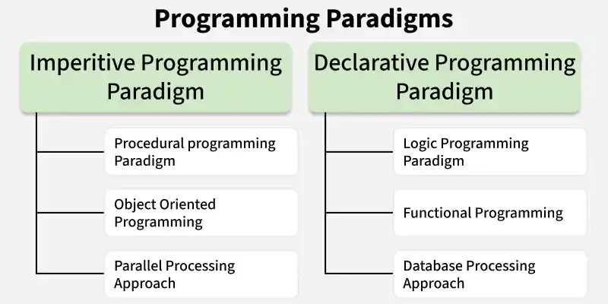
Fig. 1. Comparison of imperative and declarative programming paradigms.

Convulotional Neural Network (CNN)
Different CNN designs affect model speed and accuracy than regular CNNs, combining this with a Hybrid Dilated Convolution (HDC) model cuts training time by another 2.02% and improves accuracy by around 14% to 15%(Lei et al., 2019); However, live camera test give different results than static image test. In real-time testing, AlexNet achieved only 13% accuracy, RseNet50 reached 52.55%, and GoogLeNet scored highest with 68.95%. Live environments often confuse models; for example, ResNet50 frequently mistakes dogs and deer for horses, Overal, GoogLeNet performed best and gave the most accurate results (Sharma, N. et al, p. 382)

Big data storage distribution
Functional programming works well to stop data errors and speed up parallel computing(Corro et al., 2025,p.4), because it relies on immutable data and stateless tasks, it simplifies running multiple process loops across servers
(Simarmata, S., 2026, p. 35

This idea explains why modern platforms like Apache Spark are much faster than Hadoop-up to 100 times faster in memory and 19 times faster on disk. Spark reaches high speeds because it saves temporary dara directly in RAM instead of constantly reading and writing to disk (Sifat Ibtisum et al., 2023, p. 1094)

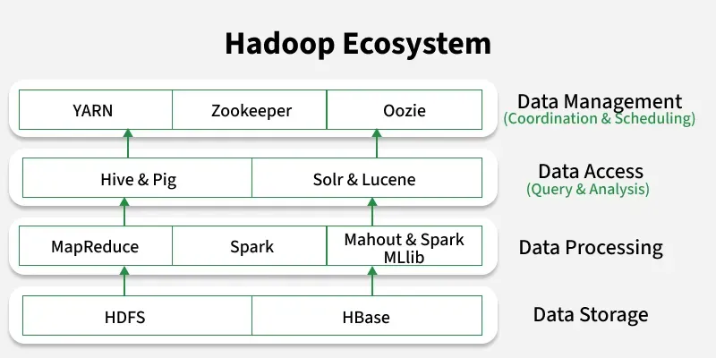
Fig. 2. Main components of the Hadoop ecosystem.

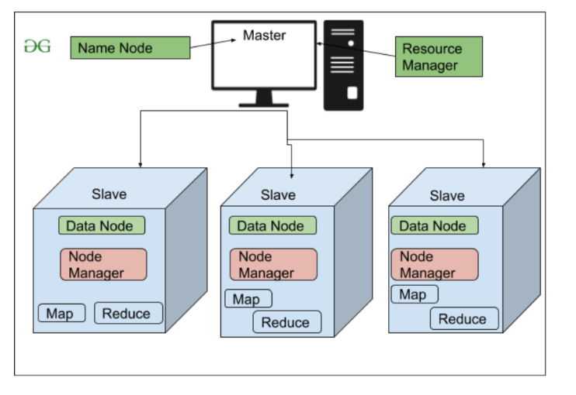
Fig. 3. Hadoop distributed architecture with worker nodes.

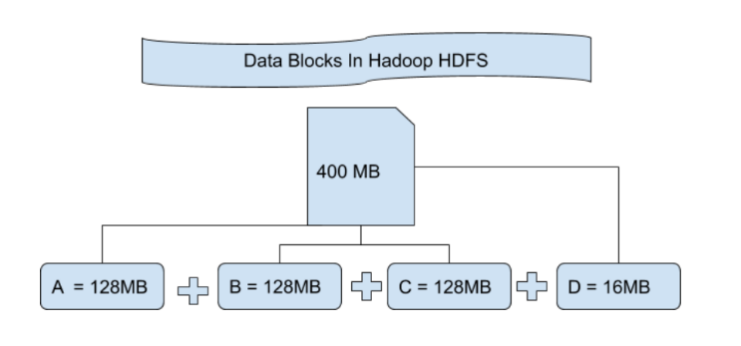
Fig. 4. Distribution of a 400 MB file into HDFS data blocks.

METHODOLOGY

Data architecture and distributed infrastructure

Large-scale storage: Apache Hadoop was used as an open-source framework to store data in the Hadoop Distributed File System (HDFS). Its main advantages are high fault tolerance and broad compatibility.

b) Processing engine: Apache Spark was used as the distributed processing system for loading large datasets. It keeps data in cache memory, which supports faster and more efficient execution. Spark was accessed through its Python API, PySpark, to run operations such as map and filter.

E. Image preprocessing

A total of 70,000 images were processed and used for training. They were divided into ten classes: aeroplane, automobile, bird, cat, deer, dog, frog, horse, ship and truck. The training set contained 60,000 images (85.70%), while the test set contained 10,000 images (14.30%). The images were loaded from the CIFAR-10 dataset through Keras. After loading, the image arrays were reshaped to 32 × 32 pixels to improve classification accuracy. Separate variables were created for training and testing, and ten classes were assigned to each set. The model was then trained through several sequential layers with specific filters and parameters. These settings were adjusted during processing to improve efficiency and reduce resource use.

Dataset preprocessing

Apache Hadoop was used as the storage environment in an Ubuntu virtual machine, so the data did not need to be stored locally. A total of 209,527 records were stored and then processed with Apache Spark. Python and Jupyter Notebook were used to analyse and evaluate the dataset. JSON was selected because it is easy to use with PySpark. The data types and attributes were reviewed, the “short description” field was filtered to show 20 records, the total number of records was counted, and duplicate records were removed.

Application of programming paradigms

Several programming paradigms were applied during image classification. Object-oriented programming was used through Keras for machine learning and TensorFlow for deep learning. A Sequential model was created, and components were added through method calls such as model.add. These components included Conv2D, MaxPool2D, Dropout and Dense classes, each with its own attributes and filters. Procedural programming, as part of the imperative paradigm, was used to load, manipulate and preprocess the training and test data. The image arrays were reshaped, converted to float32, normalised by dividing by 255, and transformed into categorical labels. Declarative programming was used in the compile method, where the categorical cross-entropy loss function, accuracy metric and Adam optimiser were defined.

H. Convolutional neural network architecture

The classification model used a sequential architecture with several convolutional layers. The first layer contained 50 filters to detect different visual features. Each filter examined a 3 × 3 pixel area with a stride of one pixel, used the ELU activation function, and applied padding to keep the image size at 32 × 32 pixels. The second layer received the output from the first layer and used 75 filters. MaxPool2D reduced the dimensions to 16 × 16 pixels, and Dropout randomly removed 25% of the neurons. The final convolutional layer used 125 filters and reduced the image dimensions to 8 × 8 pixels. After the three convolutional layers, Flatten converted the output into a one-dimensional vector of 8,000 elements. Hidden layers with about 250 to 500 neurons were then added, with dropout rates between 30% and 40%. The output layer contained ten neurons. Finally, the model was compiled with loss and accuracy measures and trained on X_train and Y_train for 15 epochs with 128 examples per batch. The final accuracy and predictions for three classes were then evaluated.

I. Performance evaluation metrics

In the following tests, the activation function was changed while the other main model settings were kept consistent.

Result 1:

Parameter/metric | Value obtained
Activation Type | ReLu
Loss – epoch 1 | 1.6221
Loss – epoch 15 | 0.3646
Validation loss – epoch 1 | 1.2576
Validation loss – epoch 15 | 0.6789
Accuracy – epoch 1 | 0.4030 ($40.30\%$)
Accuracy – epoch 15 | 0.8698 ($86.98\%$)
Validation accuracy – epoch 1 | 0.5541 ($55.41\%$)
Validation accuracy – epoch 15 | 0.7779 ($77.79\%$)
Training time | 74.57 minutes ($4,474\text{ s}$)
Final accuracy | 0.778 ($77.80\%$)

Category | Metric/parameter | Result
Training performance (epoch 1 vs. 15) | Training loss | 1.6221–0.3646 (77.52% decrease)
 | Training accuracy | 40.30%–86.98% (46.68% increase)
Validation performance (epoch 1 vs. 15) | Validation loss | 1.2576–0.6789 (minimum reached at epoch 9)
 | Validation accuracy | 55.41%–77.79% (maximum reached at epoch 14)
Test-set evaluation | Final test accuracy | 77.80% (0.778)
 | Direct inference example | Predicted class: 3 | Actual class: 3 (correct prediction)
Time and efficiency | Total training time | 74.57 minutes
 | Average time per step (ms/step) | $708.67\text{ ms/step}$ ($0.7087\text{ s/step}$

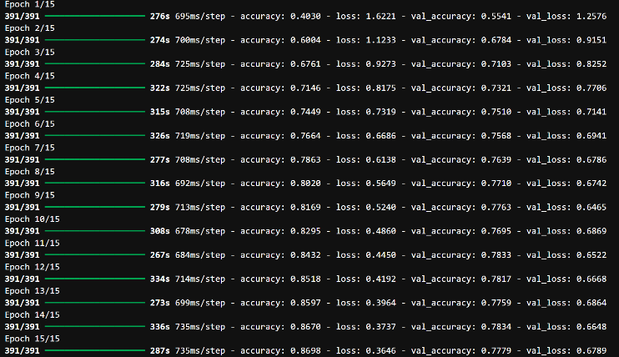
Fig. 5. CNN training output using the ReLU activation function.

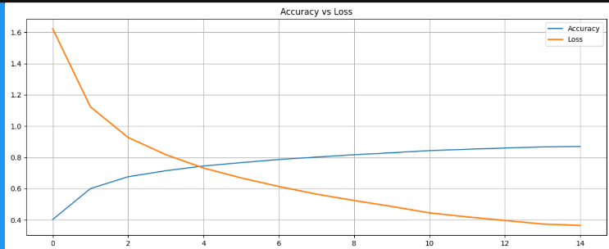
Fig. 6. Training and validation accuracy and loss with ReLU.

Parameter/metric | Value obtained
Activation Type | Sigmoid
Loss – epoch 1 | 2.3272
Loss – epoch 15 | 2.3027
Validation loss – epoch 1 | 2.3028
Validation loss – epoch 15 | 2.3026
Accuracy – epoch 1 | 0.1005 ($10.05\%$)
Accuracy – epoch 15 | 0.0990 ($9.90\%$)
Validation accuracy – epoch 1 | 0.1000 ($10.00\%$)
Validation accuracy – epoch 15 | 0.1000 ($10.00\%$)
Performance time | 346.02 minutes ($20,761\text{ s}$)
Final accuracy | 0.100 ($10.00\%$)

Category | Metric/parameter | Result
Training performance (epoch 1 vs. 13) | Training loss | 2.3272–2.3027 (stalled; no convergence)
 | Training accuracy | 10.05%–9.90% (random-guess level)
Validation performance (epoch 1 vs. 13) | Validation loss | 2.3028–2.3026 (no significant change)
 | Validation accuracy | 10.00%–10.00% (fixed at 10%)
Test-set evaluation | Final test accuracy | 10.00% (0.100)
 | Direct inference example | Predicted: 7 | Actual: 3 (incorrect prediction)
Time and efficiency | Total training time | 346.02 minutes (20,761.2 s)
 | Performance diagnosis | Failure to converge (vanishing gradient): with ten classes, an accuracy of about 10% means that the model is classifying at random.

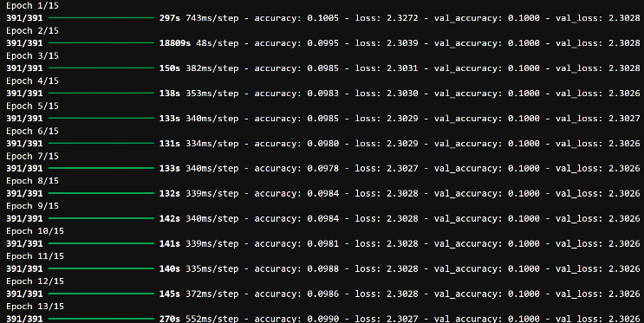
Fig. 7. CNN training output using the sigmoid activation function.

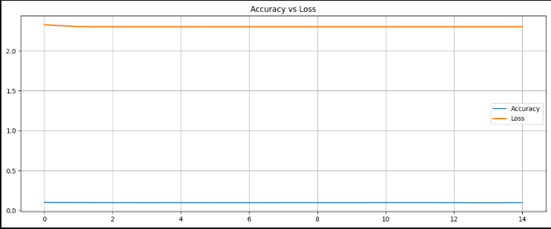
Fig. 8. Training and validation accuracy and loss with sigmoid.

Parameter/metric | Value obtained
Activation Type | tanh
Loss – epoch 1 | 1.4385
Loss – epoch 15 | 0.5329
Validation loss – epoch 1 | 1.2599
Validation loss – epoch 15 | 0.8425
Accuracy – epoch 1 | 0.4923 (49.23%)
Accuracy – epoch 15 | 0.8141 (81.41%)
Validation accuracy – epoch 1 | 0.5604 (56.04%)
Validation accuracy – epoch 15 | 0.7414 (74.14%)
Training time | 69.67 minutes (4,180 s)
Final accuracy | 0.741 (74.10%)

Category | Metric/parameter | Result
Training performance (epoch 1 vs. 15) | Training loss | 1.4385–0.5329 (62.95% decrease)
 | Training accuracy | 49.23%–81.41% (32.18% increase)
Validation performance (epoch 1 vs. 15) | Validation loss | 1.2599–0.8425 (minimum: 0.8226 at epoch 12)
 | Validation accuracy | 56.04%–74.14% (maximum: 74.14% at epoch 15)
Test-set evaluation | Final test accuracy | 74.10% (0.741)
 | Direct inference example | Predicted: 3 | Actual: 3 (correct prediction)
Time and efficiency | Total training time | 69.67 minutes (4,180 s)
 | Performance diagnosis | Successful convergence: stable behaviour and a final accuracy of 74.1%, slightly below ReLU (77.8%) but above sigmoid (10%).

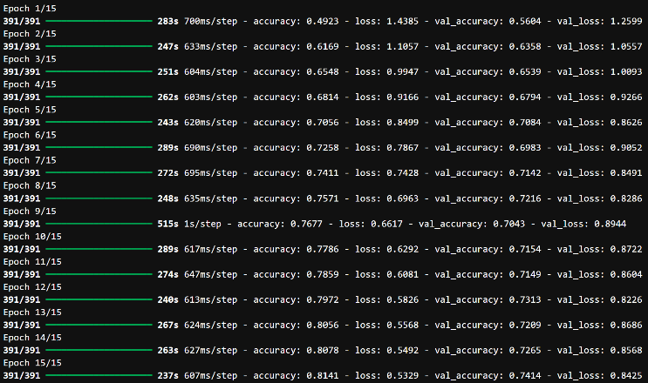
Fig. 9. CNN training output using the tanh activation function.

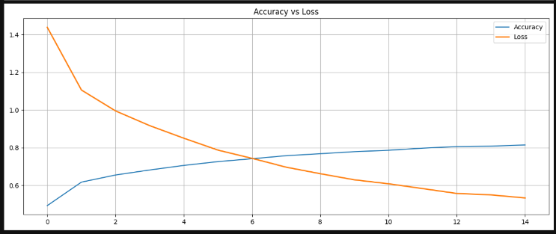
Fig. 10. Training and validation accuracy and loss with tanh.

Parameter/metric | Value obtained
Activation Type | Leaky_relu
Loss – epoch 1 | 1.3778
Loss – epoch 15 | 0.3249
Validation loss – epoch 1 | 0.9778
Validation loss – epoch 15 | 0.7070
Accuracy – epoch 1 | 0.5031 (50.31$\%$)
Accuracy – epoch 15 | 0.8854 (88.54$\%$)
Validation accuracy – epoch 1 | 0.6581 (65.81%)
Validation accuracy – epoch 15 | 0.7964 (79.64%)
Training time | 61.88 minutes (3,713 s)
Final accuracy | 0.796 (79.60)

Category | Metric/parameter | Result
Training performance (epoch 1 vs. 15) | Training loss | 1.3778–0.3249 (76.42% decrease)
 | Training accuracy | 50.31% - 88.54%  (38.23% increase)
Validation performance (epoch 1 vs. 15) | Validation loss | 0.9778–0.7070 (minimum: 0.6394 at epoch 7)
 | Validation accuracy | 65.81%–79.64% (maximum: 79.64% at epoch 14)
Test-set evaluation | Final test accuracy | 79.60% (0.796)
 | Direct inference example | Predicted: 3 | Actual: 3 (correct prediction)
Time and efficiency | Total training time | 61.88 minutes (3,713 s)
 | Performance diagnosis | Best result: higher than ReLU (77.8%), tanh (74.1%) and sigmoid (10%), with the highest test accuracy of 79.6%.

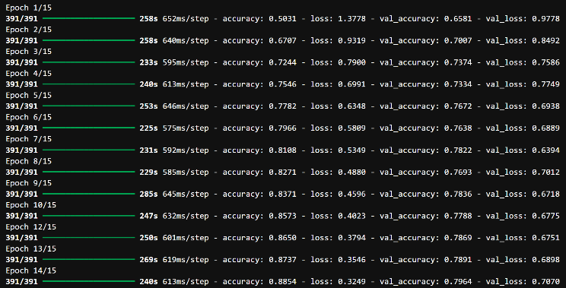
Fig. 11. CNN training output using the Leaky ReLU activation function.

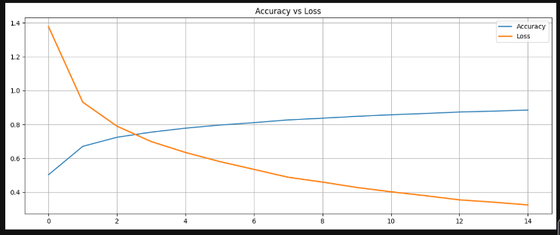
Fig. 12. Training and validation accuracy and loss with Leaky ReLU.

CRITICAL EVALUATION

A. Key findings

a) According to the results, Leaky ReLU produced the best performance. It achieved the highest test accuracy, at 79.60%, and the shortest training time, at 61.88 minutes. In contrast, sigmoid achieved an accuracy of only 10.00% and required the longest computing time, at 346.02 minutes. ReLU and tanh also produced suitable results, with test accuracies of 77.80% and 74.10%, respectively.
b) Apache Hadoop stored more than 200,000 records efficiently. When Apache Spark was used for distributed processing, no important delays were observed during data cleaning and filtering with PySpark.

B. Implications
a) The convolutional neural network architecture supported efficient image classification. The use of Leaky ReLU reduced the computing time and achieved higher accuracy when classifying and predicting the different image classes.
b) Hadoop HDFS provides fault-tolerant storage that can scale at a reasonable cost and reduces the need for local disk storage. Distributed processing with PySpark can reduce the execution time of data-preprocessing pipelines. Spark SQL queries use the declarative paradigm, while large-scale record operations such as map and filter use the functional paradigm.

C. Limitations

The tests used a low-resolution image dataset of 32 × 32 × 3 pixels. The results were acceptable, but higher-resolution images could produce different outcomes. To prioritise performance and processing time, training was limited to 15 epochs for the dataset of 60,000 images.

D. Point of contradiction

Different datasets were required for CNN image training and for data storage with Hadoop and Spark. Implementing image classification directly with PySpark was more difficult because of the complexity of the code and frequent errors in the Ubuntu virtual machine when Jupyter Notebook was running.

E. Research gap

a) Further research should examine the implementation of a convolutional neural network architecture in a virtual machine.
Programming-paradigm concepts should also be applied and evaluated with PySpark.

Future studies should monitor storage and memory distribution when both low- and high-resolution images are processed.

CONCLUSIONS

This study demonstrates that combining programming paradigms is effective for large-scale data processing and image classification. Hadoop HDFS and Apache Spark supported the storage and distributed processing of more than 200,000 records, while procedural, object-oriented, functional, and declarative techniques addressed different stages of data preparation, model construction, and querying. In the CNN experiments, Leaky ReLU achieved the best overall result, with a final test accuracy of 79.60% and the shortest training time of 61.88 minutes. ReLU and tanh also produced viable results, whereas sigmoid failed to converge and remained near random-guess accuracy. These findings indicate that paradigm selection and activation-function choice have a direct effect on scalability, execution time, and predictive performance. Future work should evaluate higher-resolution images, longer training schedules, additional model architectures, and a unified Spark-based pipeline for both distributed storage and model training.

F. REFERENCES

- Dobre, C. and Xhafa, F., 2014. Parallel programming paradigms and frameworks in big data era. International Journal of Parallel Programming, 42(5), pp.710-738.
- Belcastro, L., Cantini, R., Marozzo, F., Orsino, A., Talia, D. and Trunfio, P., 2022. Programming big data analysis: principles and solutions. Journal of Big Data, 9(1), p.2.
- Sánchez Corro, J. et al. (2025) ‘Systematic Review of functional programming for mutable states in the integration of Imperative Systems’, Proceedings of the 23rd LACCEI International Multi-Conference for Engineering, Education and Technology (LACCEI): ‘Engineering, Artificial Intelligence, and Sustainable Technologies in service of society’.
- Simarmata, S., 2026. Comparative Evaluation of Functional, Object Oriented, and Declarative Programming Paradigms for Scalability and Maintainability in Distributed Data Processing Applications. Programming and Algorithm Fundamentals, 1(1), pp.34-46.
- Ibtisum, S., Bazgir, E., Rahman, S.A. and Hossain, S.S., 2023. A comparative analysis of big data processing paradigms: Mapreduce vs. apache spark. World Journal of Advanced Research and Reviews, 20(1), pp.1089-1098.
- Lei, X., Pan, H. and Huang, X., 2019. A dilated CNN model for image classification. IEEE access, 7, pp.124087-124095.
- Samuel, M.S., 2017. An insight into programming paradigms and their programming languages. Journal of Applied Technology and Innovation, 1(1).
- Sharma, N., Jain, V. and Mishra, A., 2018. An analysis of convolutional neural networks for image classification. Procedia computer science, 132, pp.377-384.
- Vandeloise, M., 2025. Towards a unified framework for programming paradigms: A systematic review of classification formalisms and methodological foundations. arXiv preprint arXiv:2508.00534.
- Wegner, P., 1990. Concepts and paradigms of object-oriented programming. ACM Sigplan Oops Messenger, 1(1), pp.7-87.
- GeeksforGeeks (2026). Introduction of Programming Paradigms. 3 June. Available at: https://www.geeksforgeeks.org/system-design/introduction-of-programming-paradigms/ (Accessed: 12 October 2026).
- Keita, Z. (2026) What are convolutional neural networks? A complete CNN guide, datacamp. Available at: https://www.datacamp.com/tutorial/introduction-to-convolutional-neural-networks-cnns (Accessed: 12 October 2026).
- Mali, D. (2025) Hadoop - Architecture, geeksforgeeks. Available at: https://www.geeksforgeeks.org/big-data/hadoop-architecture/ (Accessed: 12 October 2026).
- Prasad, A. (2025) Hadoop ecosystem, geeksforgeeks. Available at: https://www.geeksforgeeks.org/profile/theprogrammedwords (Accessed: 13 October 2026).

