Forest Cover Type Classification Using Apache Spark and Neural Networks: A Comparative Study of Predictive Performance and Processing Efficiency

Rafsun Jani Sarker
ID:2026229
Master of Science in Data Analytics
CCT College Dublin
2026229@student.cct.ie

Dataset link: https://drive.google.com/file/d/1o2CRIGHum42QnJKj_93q4BmtAukbFSSU/view?usp=sharing

Screencast Presentation Link:
https://drive.google.com/file/d/1Ae8nF7KX05z5V75oLd-33oxM7L138ddl/view?usp=sharing

GitHub:
https://github.com/2026229-ops/2026_september_CA1_Big_data_storage_advanced_data_analytics

Abstract
The project looks at big data methods and machine learning for guessing forest cover types from the Cover type data set. It has more than half a million entries with details like elevation along with slope and soil information. Apache Spark was used to manage the size of it and run the different steps for preparation and modeling.

They started by loading everything then doing some preprocessing along with exploration checks to see how the features spread across the classes. Feature work came next with vector assembly and scaling to get ready for training. A couple of classifiers went in through Spark MLlib such as logistic regression and a multilayer perceptron network.

Model checks used the usual metrics, and it seems geographical plus soil traits gave solid signals for the cover categories. I think that shows how well Spark handles these large environmental sets while keeping the pipelines workable on a scale.

Practical sides include forest management and monitoring work plus conservation planning. The approach could speed up decisions without so much field surveying though some parts of the results still feel open to more testing.

Table of Contents

Table of Contents 1
List of Figures 1
1.1 Background and Problem Context 1
1.2 Research Problem and Motivation 1
1.3 Aim, Research Question and Objectives 1
1.4 Scope 1
2.1 Forest Cover Classification 1
2.2 Neural Networks for Tabular Classification 1
2.3 Big Data Storage and Processing 1
2.4 Critical Comparison of Studies 1
2.5 Research Gap and Project Positioning 1
3.1 Dataset Source and Characteristics 1
3.2 Data Quality and Class Distribution 1
3.3 Storage and Processing Architecture 1
3.4 Environment and Reproducibility 1
4.1 Data Preparation and Splitting 1
4.2 Models and Justification 1
4.3 Iterative Experiment Design 1
4.4 Local Spark Partition Processing Experiment 1
4.5 Evaluation Measure 1
5. Experimental Results and Critical Evaluation 1
5.1 Experimental Environment and Dataset Verification 1
5.2 Exploratory Data Analysis 1
5.3 Data Splitting and Feature Preparation 1
5.4 Baseline and Iterative Neural Network Experiments 1
5.4.1 Validation Performance 1
5.5 Final Model Performance 1
5.5.1 Class-Level Performance 1
5.6 Apache Spark Processing Benchmark 1
5.8 Critical Evaluation and Research Implications 1
6.1 Answer to the Research Question 1
6.2 Implications 1
6.3 Future Work 1
References 1

1.1 Background and Problem Context 2
1.2 Research Problem and Motivation 2
1.3 Aim, Research Question and Objectives 2
1.4 Scope 2
2.1 Forest Cover Classification 3
2.2 Neural Networks for Tabular Classification 3
2.3 Big Data Storage and Processing 3
2.4 Critical Comparison of Studies 4
2.5 Research Gap and Project Positioning 5
3.1 Dataset Source and Characteristics 6
3.2 Data Quality and Class Distribution 6
3.3 Storage and Processing Architecture 6
3.4 Environment and Reproducibility 7
4.1 Data Preparation and Splitting 10
4.2 Models and Justification 10
4.3 Iterative Experiment Design 11
4.4 Local Spark Partition Processing Experiment 11
4.5 Evaluation Measure 12
5.1 Experimental Environment and Dataset Verification 12
5.2 Exploratory Data Analysis 14
5.3 Data Splitting and Feature Preparation 16
5.4 Baseline and Iterative Neural Network Experiments 18
5.4.1 Validation Performance 19
5.5 Final Model Performance 20
5.5.1 Class-Level Performance 21
5.6 Apache Spark Processing Benchmark 23
5.8 Critical Evaluation and Research Implications 24
6.1 Answer to the Research Question 25
6.2 Implications 25
6.3 Future Work 25

List of Figures
Figure 1 Original proposed local Spark architecture (CSV/Parquet and Random Forest branches were not executed; see Sections 3.3 and 4). 9
Figure 2 Class Distribution
Figure 3 Apache Spark execution environment
Figure 4 Dataset loading, validation
Figure 5 Validation model comparison (original notebook screenshot) 14
Figure 6 Spark partition benchmark output (original notebook screenshot) 15
Figure 7 Model saving and reload verification (original notebook screenshot) 16
Figure 8 Test confusion matrix and classification report 17
Figure 9 Experiment summary output 18
Figure 10 NN_1, NN_2 and NN_3 output results
Figure 11 Validation performance and computational cost comparison.
Figure 12 Performance of the selected neural network on unseen test observations.
Figure 13 Confusion matrix of actual and predicted forest cover classes.
Figure 14 Class-specific precision, recall and F1 results 22
Figure 15 Spark aggregation runtime under alternative partition configurations.

1. Introduction

1.1 Background and Problem Context

Forest cover classification is a process of categorizing forests based on environmental features like elevation, slope, soil type and proximity to water. These attributes are used to describe conditions related to the distribution of various vegetation types. This task is based on the Cover type dataset, which contains 581,012 observations, 54 predictive features and seven forest cover classes, and is therefore a practical basis for investigating this task (Blackard, 1998). For effective classification, it is important to consider predictive performance and efficient data storage and processing. This study is thus a mix of neural network modelling and an Apache Spark pipeline.

1.2 Research Problem and Motivation

Neural network performance depends on feature preparation, architecture and optimization, while more complex models often require longer training. Spark provides a common framework for preparing Covertype data and training multilayer perceptron’s (Apache Software Foundation, n.d.). This study evaluates a training-fitted standardization pipeline, a multinomial logistic regression baseline and three MLP configurations. Processing efficiency is assessed through local Spark partition-count benchmarks; a direct CSV–Parquet storage comparison was not performed.

1.3 Aim, Research Question and Objectives

The aim is to evaluate classification quality and local processing efficiency in a reproducible Spark workflow. The research question is: How do neural network configurations compare with a multinomial logistic regression baseline for forest cover classification, and how does partition count affect local Spark aggregation time? Objectives are to review relevant research; validate and preprocess the dataset; train three MLP configurations and a logistic regression baseline on a consistent split; compare accuracy, weighted F1, per-class recall and training time; and benchmark aggregation across two, four and eight Spark partitions. Feature scaling was applied consistently, not experimentally compared with unscaled inputs; storage-format efficiency was outside the executed experiments.

1.4 Scope

Existing tabular Cover type data will be classified using supervised classification. PySpark will be used in local mode for experiments in a Jupyter notebook. Findings will be about performance in this environment, but not about scalability across multiple machines or generalization to other geographical regions.

2. Literature Review and State of the Art

2.1 Forest Cover Classification

Forest cover classification relates environmental measurements to vegetation categories. Blackard and Dean (1999) determined that a feedforward neural network was more accurate than Gaussian discriminant analysis in predicting forest cover in Colorado. This helps to model non-linear relationships, but the limited geographical scope and the fact that the comparator is an older alternative restricts conclusions about modern alternatives. Belgiu and Drăguţ (2016) reviewed the use of Random Forest in remote sensing, and it was considered as a baseline. However, imagery studies use spectral and spatial information, whereas Covertype uses cartographic attributes. The reported accuracies of these cannot be compared without considering differences in inputs, classes and evaluation procedures.

2.2 Neural Networks for Tabular Classification

An MLP learns nonlinear relationships by learning the weighted connections and activation functions. The size of the hidden layers affects representational capacity, and scaling and optimisation affect learning. Gorishniy et al. (2021) showed that there are good baseline models for residual networks and Transformer models, but there is no single best model. On medium-sized tabular datasets, Grinsztajn, Oyallon and Varoquaux (2022) found that tree ensembles performed better than other models on the datasets, as they were able to deal with irrelevant features and irregular relationships. Recently, Holzmüller, Grinsztajn and Steinwart (2024) showed competitive accuracy and runtime with carefully configured RealMLP models. These results put together indicate that preparation and tuning should be considered before making the network more complex. But the results of RealMLP cannot be taken for granted in Spark's regular MLP.

2.3 Big Data Storage and Processing

Process design can also influence actual performance. Zaharia et al. (2012) presented resilient distributed datasets, which enable in-memory computation and fault recovery for iterative workloads. Armbrust et al. (2015) extended Spark with structured DataFrames and Catalyst optimisation, bringing relational processing to analytics. These strategies tackle the problems of repeated computation and disk access costs in disk-heavy workflows.

Abadi, Boncz and Harizopoulos (2009) describe how columnar storage facilitates compression and selective column reads and introduce update and reconstruction costs. This gives you a reason to compare Parquet with CSV, not to take it for granted that it's faster. Local measurements should consider caching, workload characteristics and execution overhead. Furthermore, a CSV comparison is not a complete picture of the capabilities of a typical relational database.

2.4 Critical Comparison of Studies

The differences between neural-network and tree-based studies are partly due to the differences in the data sets, preprocessing and tuning budgets. In 176 datasets, McElfresh et al. (2023) discovered that a small amount of tuning might be more important than algorithm-family choice. Therefore, the splits and computational budgets must be consistent for meaningful comparisons.

There is another concern when it comes to evaluation design. Roberts et al. (2017) show that random validation of structured ecological data can lead to an underestimation of prediction error. Thus, a random Covertype split cannot provide transferability to new areas. This project will provide macro-F1 and class-specific recall in addition to accuracy to show imbalances. The results of the studies and their limitations are summarized in Table 1, where the limitations column indicates the relevance of the studies to the proposed experiment.

 | Table 1: Literature Comparison
 |  | Study |  | Dataset and task | Method | Processing approach | Key finding | Limitation and relevance
 |  | Blackard and Dean (1999) |  | Colorado forest classification | ANN versus discriminant analysis | GIS-derived tabular inputs | ANN performed better | Regional evidence; older baseline
 |  | Belgiu and Drăguţ (2016) |  | Remote-sensing applications | Random Forest review | Diverse imagery workflows | Broad classification applicability | Imagery differs from cartographic inputs
 |  | Gorishniy et al. (2021) |  | Tabular prediction benchmarks | ResNet and Transformer | Consistent tuning protocols | Strong neural baselines | No universal winner
 |  | Grinsztajn et al. (2022) |  | 45 tabular datasets | Trees versus networks | Budget-aware benchmarking | Tree ensembles remained strong | Dataset scale affects transferability
 |  | Holzmüller et al. (2024) |  | Tabular classification/regression | RealMLP and boosted trees | Meta-tuned configurations | Competitive accuracy–runtime balance | Different from Spark MLP
 |  | McElfresh et al. (2023) |  | 176 tabular datasets | 19 algorithms | Repeated benchmark evaluation | Tuning often matters more | No forest-specific guarantee
 |  | Zaharia et al. (2012) |  | Iterative computing workloads | RDD abstraction | Distributed in-memory execution | Efficient reusable computation | Cluster findings need local verification
 |  | Armbrust et al. (2015) |  | Structured analytical workloads | Spark SQL | DataFrames and Catalyst | Integrated optimised analytics | Not a classifier comparison
 |  | Abadi et al. (2009) |  | Analytical database workloads | Column-store tutorial | Compression and column scans | Workload-dependent storage benefits | Not a Parquet-specific experiment
 |  | Roberts et al. (2017) |  | Structured ecological prediction | Validation comparisons | Simulations and case studies | Blocking addresses dependence | Validation must match prediction goals

2.5 Research Gap and Project Positioning
The literature motivates evaluating whether greater MLP complexity improves classification enough to justify extra training time, and whether local Spark partition settings affect processing latency. This study compares a logistic regression baseline with three MLPs on the same validation partition, then examines per-class errors and timing. Although columnar formats and tree ensembles remain relevant alternatives in the literature, Random Forest and CSV-versus-Parquet tests were not implemented and cannot be treated as experimental findings.

3. Dataset and Big Data Architecture

3.1 Dataset Source and Characteristics
The project will be based on the original UCI Cover type dataset donated in 1998, which consists of 581,012 observations, 54 predictors and seven forest classes (Blackard, 1998). The observations are from 4 wilderness areas in the Roosevelt National Forest in northern Colorado, each of which is a 30 x 30 meter land cell. Predictors include ten numerical measurements of the terrain, four binary wilderness indicators and forty binary soil indicators. Cover Type is the target, which can be Spruce/Fir, Lodgepole Pine, Ponderosa Pine, Cottonwood/Willow, Aspen, Douglas-fir or Krummholz. It has limited conclusions regarding current forests because of its historical and geographically limited coverage.

3.2 Data Quality and Class Distribution

The covtype.data.gz file was downloaded and inspected, and it was found that there were no missing values, duplicate records, or duplicate combinations of predictors, and that there were 55 integer variables, including the target. Only one wilderness and soil category were active at each observation, and indicator values were only 0 or 1. The range of target values was from 1 to 7. The observations were highly imbalanced, with Lodgepole Pine accounting for 48.76% of the observations, while Cottonwood/Willow accounted for only 0.47%. All observations are available and no imputation or duplicate removal was needed. During assessment, accuracy will be complemented with class-specific recall and macro-F1.

3.3 Storage and Processing Architecture

The executed workflow reads the headerless Covertype file into a Spark DataFrame, assigns 55 column names, casts input fields, checks nulls and duplicates, and retains 581,012 valid observations. Rather than creating separate CSV and Parquet copies, processing benchmarks apply the same group-by aggregation to the cleaned DataFrame at partition counts of two, four and eight. Each setting is timed three times and the mean and standard deviation are reported; storage size and read-format performance were not measured.

The cleaned dataset was split using Spark randomSplit with seed 42 into approximately 70% training, 15% validation and 15% test partitions. A VectorAssembler creates a 54-feature vector, and a StandardScaler with standard-deviation scaling and no mean-centering is fitted only to training data and reused on validation and testing data. All 54 predictors, including binary indicators, enter this scaled vector. Logistic regression and three MLP configurations use these prepared features, with validation weighted F1 determining the selected network.

Spark schedules work over local partitions on one Colab machine, rather than across physical cluster nodes. The notebook records Spark 4.0.4, Python 3.13.16, local [*], a 4 GB driver setting, eight shuffle partitions and a default parallelism of two. Figure 1 illustrates the originally proposed architecture, which included CSV/Parquet and Random Forest branches; those branches were not executed and are superseded by the actual workflow described here.

3.4 Environment and Reproducibility

The executed environment used Google Colab, Python 3.13.16, Apache Spark 4.0.4 and a fixed random seed of 42. The notebook records data counts, model parameters, validation metrics, test metrics, partition benchmark results and saved model reload verification. No source-file SHA-256 measurement, stratified partition membership or isolated warm-up protocol was reported, so these should not be claimed as completed reproducibility controls.

Table 2: Dataset and Feature Summary

Component | Count | Description
Observations | 581,012 | Complete original dataset; no rows removed
Numerical predictors | 10 | Elevation, aspect, slope, hydrology distances, roadway distance, three hillshade measurements and fire-point distance
Wilderness indicators | 4 | Binary indicators for Rawah, Neota, Comanche Peak and Cache la Poudre
Soil indicators | 40 | Binary indicators for soil categories
Total predictors | 54 | Ten numerical and 44 binary features
Target | 1 | Cover_Type, with original labels 1–7
Missing values | 0 | Verified across all 55 columns
Exact duplicate records | 0 | Verified using all columns
Duplicate predictor combinations | 0 | Verified using the 54 predictors

Source: UCI documentation and direct inspection of the downloaded dataset.

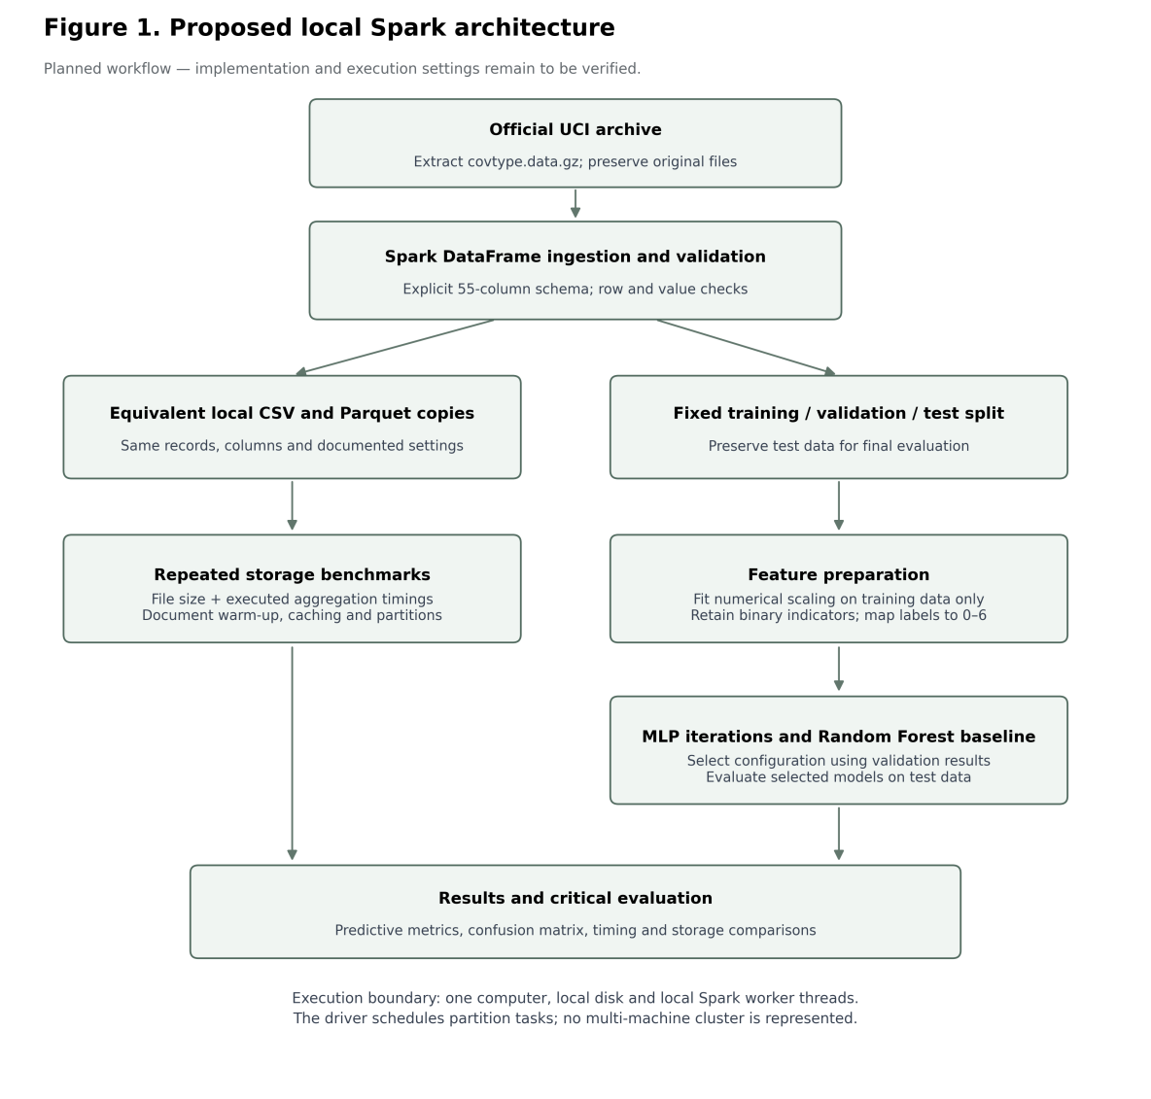
Figure 1 Original proposed local Spark architecture (CSV/Parquet and Random Forest branches were not executed; see Sections 3.3 and 4).

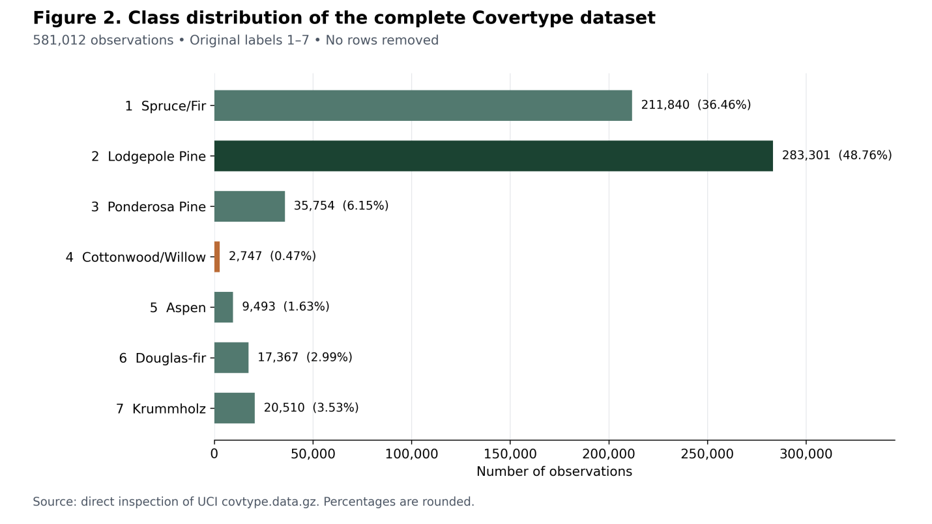
Figure 1 Class Distribution

4. Methodology and Experimental Design

4.1 Data Preparation and Splitting

Original class labels 1–7 were remapped to 0–6. After null and duplicate checks, 581,012 rows remained. Spark randomSplit (seed 42) produced training (406,923), validation (86,973) and testing (87,116) subsets; this was not a stratified split. VectorAssembler joined the 54 predictors and StandardScaler was fitted on training data only, with withStd=True and withMean=False. Binary indicators were included in scaling. The held-out test partition was reserved for the selected network's final evaluation.

4.2 Models and Justification

The primary models were Spark multilayer perceptron classifiers using 54 input units and seven outputs, with progressively larger hidden layers and revised optimisation settings. These networks can learn nonlinear feature interactions, but increasing model size also increases training cost. The three implemented architectures were 54–32–7, 54–64–32–7 and 54–128–64–7 (Apache Software Foundation, n.d.).

The executed baseline was multinomial logistic regression with a maximum of 50 iterations and regularisation parameter 0.01, trained on the same scaled training features. It provides a relatively simple linear comparator to the nonlinear MLPs. A Random Forest was discussed in the literature and original proposal but was not fitted or evaluated in the notebook; conclusions are restricted to logistic regression and the three implemented MLPs.

4.3 Iterative Experiment Design

Four validation experiments were completed using seed 42 where applicable: the logistic regression baseline and three MLP configurations shown in Table 3. The MLP settings changed hidden-layer widths/depth, iteration limits, block sizes and learning rates. Therefore, the sequence demonstrates iterative refinement but does not isolate the causal effect of scaling, width or depth one factor at a time. Validation weighted F1 was used for MLP selection; model-fitting durations were recorded.
Table 3: Controlled Experimental Sequence
Experiment | Configuration | Purpose
B0 | Multinomial logistic regression; scaled inputs | Linear baseline; 50 iterations
N1 | MLP: 54 → 32 → 7; scaled; 50 iterations | Initial neural network
N2 | MLP: 54 → 64 → 32 → 7; scaled; 100 iterations | Architecture and training changes
N3 | MLP: 54 → 128 → 64 → 7; scaled; 150 iterations | Larger model and revised optimisation
Note | All MLPs use the same training-fitted scaler | No unscaled or isolated scaling experiment

The same training and validation feature datasets were reused across model experiments. Timing was recorded around fitting, with Spark actions used to materialise prediction outputs. The single seed, random split and local runtime limit repeatability and generalisability; results are descriptive rather than a controlled causal assessment of each individual hyperparameter.

4.4 Local Spark Partition Processing Experiment

Processing was compared by repartitioning the cleaned Spark DataFrame into two, four and eight partitions. For each setting, a grouped aggregation computed record counts and average elevation by cover type and triggered execution with collect (). Three elapsed-time trials were recorded; means and sample standard deviations were compared. The observed averages were 2.925, 0.876 and 1.538 seconds respectively. These measurements do not quantify storage efficiency, CSV-versus-Parquet performance or genuine multi-node scaling.

4.5 Evaluation Measure

Model evaluation used validation accuracy, weighted precision, weighted recall, weighted F1 and measured training time. NN_3 was selected using the highest validation weighted F1, and its accuracy and weighted scores were then assessed once on the held-out test split. A confusion matrix, class-specific precision/recall/F1 and macro-average recall were inspected because weighted scores can hide poor performance on minority forest types. The logistic regression baseline was compared on validation results; the notebook did not report its final test performance.

5. Experimental Results and Critical Evaluation

5.1 Experimental Environment and Dataset Verification

Experiments were performed with Apache Spark 4.0.4 and Python 3.13.16 . Spark was set up in local mode with local [*], 4 GB of driver memory and 8 SQL shuffle partitions. The default parallelism reported by the environment is 2.

The UCI Covertype dataset was imported into Spark for forest cover classification with multiple classes. The number of observations in the dataset was validated as 581,012, and the number of input features was validated as 54, and the number of target classes was validated as 7. No missing values or duplicate records were found in the data quality checks and all observations were retained. The time recorded for the cleaning operation was 49.36 seconds.

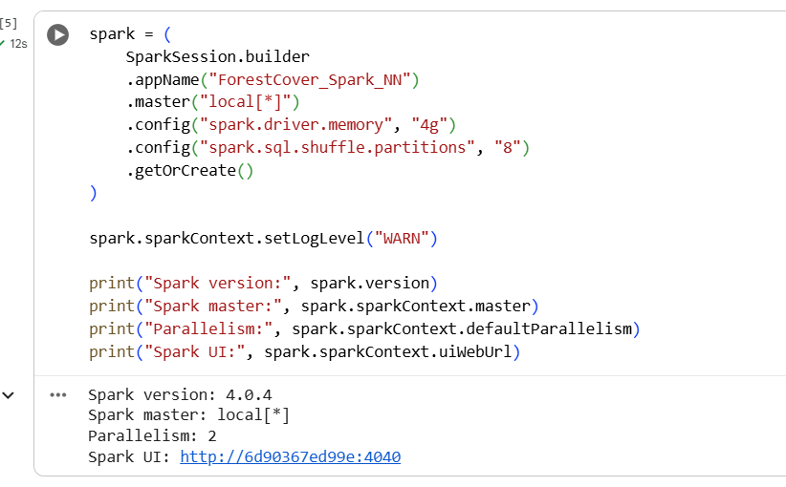
Figure 2 Apache Spark execution environment

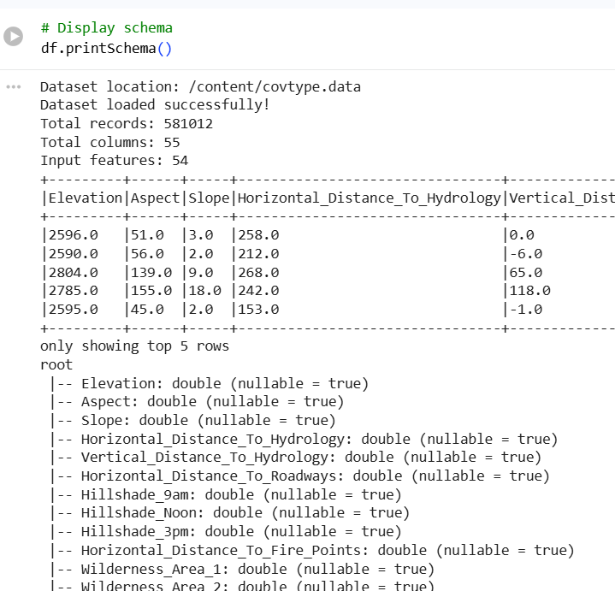
Figure 3 Dataset loading, validation

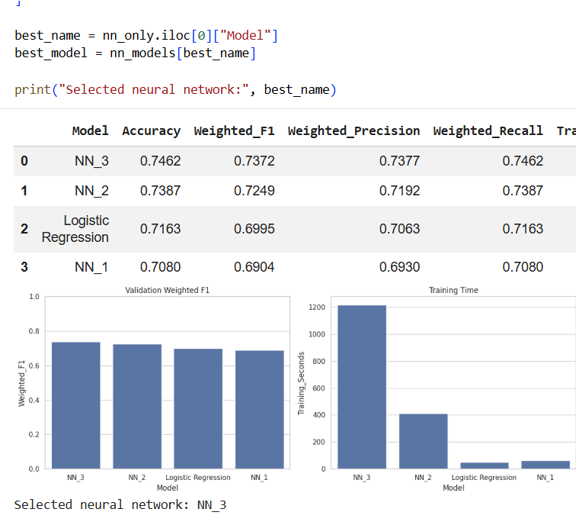
Figure 5 Validation model comparison (original notebook screenshot)

5.2 Exploratory Data Analysis
The dataset exhibited substantial class imbalance.
Cover type | Records | Percentage
1 | 211,840 | 36.46%
2 | 283,301 | 48.76%
3 | 35,754 | 6.15%
4 | 2,747 | 0.47%
5 | 9,493 | 1.63%
6 | 17,367 | 2.99%
7 | 20,510 | 3.53%
Cover Types 1 and 2 accounted for approximately 85.22% of the dataset. Cover Type 4 represented less than half of one percent, making it the least represented class.

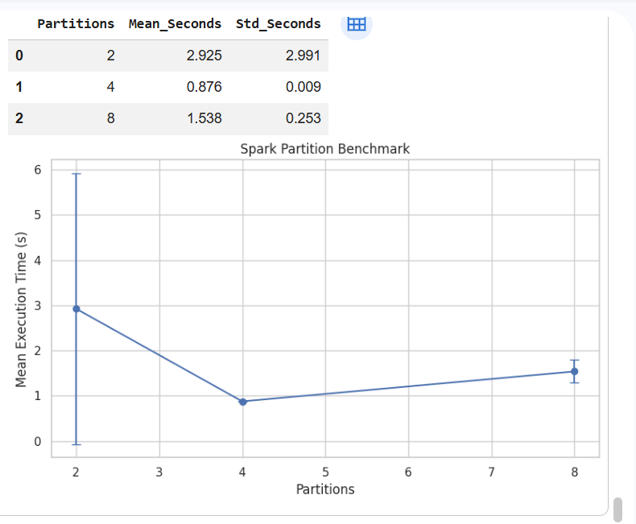
Figure 6 Spark partition benchmark output (original notebook screenshot)

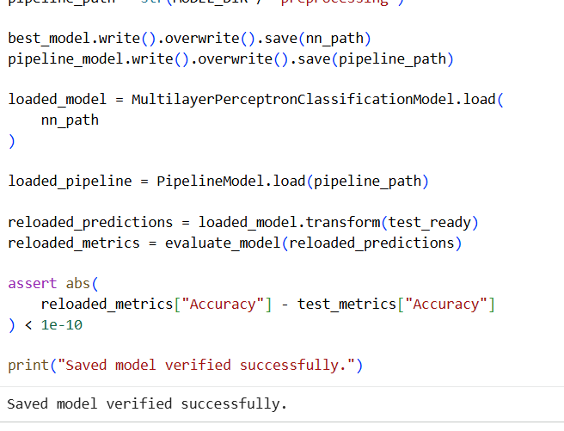
Figure 7 Model saving and reload verification (original notebook screenshot)

The data is imbalanced, so accuracy is not enough since Cover Types 1 and 2 make up 85.22% of the data, and Cover Type 4 only 0.47%. A model can have high overall accuracy but low accuracy for minority classes. Thus, precision, recall and F1-score are also required for balanced evaluation. The correlations between the terrain features, such as elevation, slope, hillshade and distance measurements, are explored in Figure 7. If there are strong correlations between predictors, this may reflect redundant information and can make the model more complex but not necessarily improve the classification. Correlation analysis is thus used to determine the relationships that are important for feature selection and performance of neural networks.

5.3 Data Splitting and Feature Preparation
The cleaned dataset was divided into training, validation and testing subsets using a random seed of 42.
Dataset | Records | Percentage
Training | 406,923 | 70.04%
Validation | 86,973 | 14.97%
Testing | 87,116 | 14.99%

The 54 predictors were combined into a feature vector using Spark's VectorAssembler. StandardScaler then scaled the features to the standard scale based on the training set. The same fitted preprocessing model was used for the validation and testing subsets, without using the information from the validation or test set to influence the scaler.

The recorded fit time for the preprocessing was 8.145 seconds. This timing refers to the preprocessing operation that is fitted in the notebook, not to the full cost of materializing all the transformed datasets.

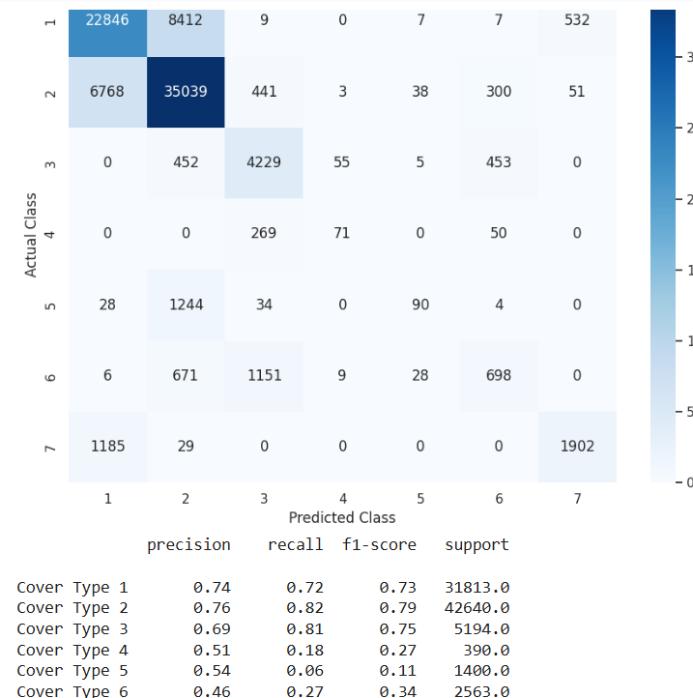
Figure 8 Test confusion matrix and classification report

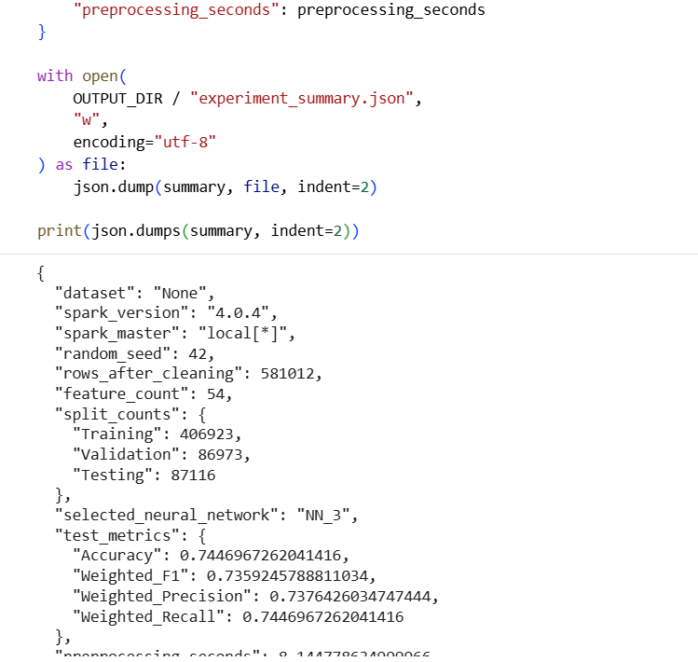
Figure 9 Experiment summary output

5.4 Baseline and Iterative Neural Network Experiments
Four models were evaluated on the same validation partition: a multinomial logistic regression baseline and three multilayer perceptron configurations.
Model | Architecture | Iterations | Block size | Step size
Logistic regression | Linear classifier | 50 | — | —
NN_1 | 54–32–7 | 50 | 128 | 0.03
NN_2 | 54–64–32–7 | 100 | 128 | 0.03
NN_3 | 54–128–64–7 | 150 | 256 | 0.02
The experiments progressively changed network architecture and optimization settings. They provide evidence of iterative model development, although the simultaneous changes mean that any performance improvement cannot be attributed to a single hyperparameter.

5.4.1 Validation Performance
Model | Accuracy | Weighted F1 | Training time
Logistic regression | 71.63% | 0.6995 | 50.30 s
NN_1 | 70.80% | 0.6904 | 61.83 s
NN_2 | 73.87% | 0.7249 | 411.69 s
NN_3 | 74.62% | 0.7372 | 1,218.09 s

NN_1 performed below the logistic regression baseline. NN_2 improved validation accuracy to 73.87%, while NN_3 achieved the highest validation accuracy of 74.62%.

NN_3 outperformed the logistic regression baseline by around 3.00 percentage points and required around 24 times as much time to measure the training time. NN_3 achieved about 0.75 percentage point better validation accuracy than NN_2, but required nearly three times as much training time.

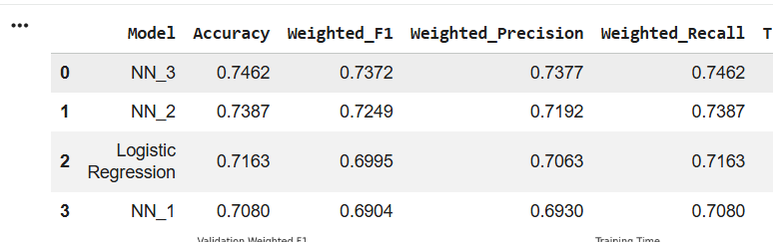
Figure 4 NN_1, NN_2 and NN_3 output results
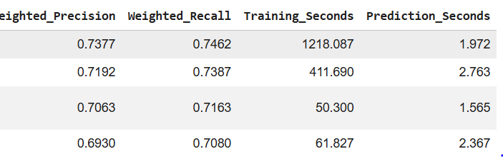

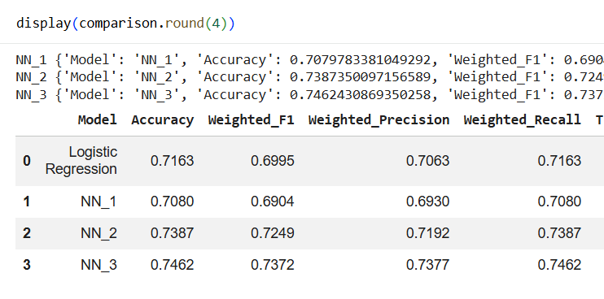
Figure 5 Validation performance and computational cost comparison.

5.5 Final Model Performance
NN_3 was selected using validation weighted F1 and subsequently evaluated on the held-out testing partition of 87,116 observations.
Test metric | NN_3 result
Accuracy | 74.47%
Weighted precision | 0.7376
Weighted recall | 0.7447
Weighted F1 | 0.7359
Test accuracy was approximately 0.15 percentage points below validation accuracy. The small difference is encouraging, but one random split cannot establish model stability across different sampling conditions.
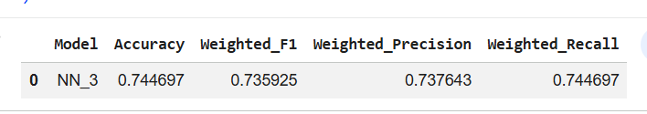
Final NN_3 test metrics

Figure 6 Performance of the selected neural network on unseen test observations.

5.5.1 Class-Level Performance
Cover type | Precision | Recall | F1-score
1 | 0.74 | 0.72 | 0.73
2 | 0.76 | 0.82 | 0.79
3 | 0.69 | 0.81 | 0.75
4 | 0.51 | 0.18 | 0.27
5 | 0.54 | 0.06 | 0.11
6 | 0.46 | 0.27 | 0.34
7 | 0.77 | 0.61 | 0.68

Cover Types 2 and 3 had the highest recall rates (82.17% and 81.42%, respectively). Recall for Cover Type 4 was only 18.21% and for Cover Type 5 was 6.43%, however.

The classification report also included a macro-average recall of around 0.50, which was significantly lower than the overall accuracy of 0.7447. This shows the disparity in classification in the seven categories.

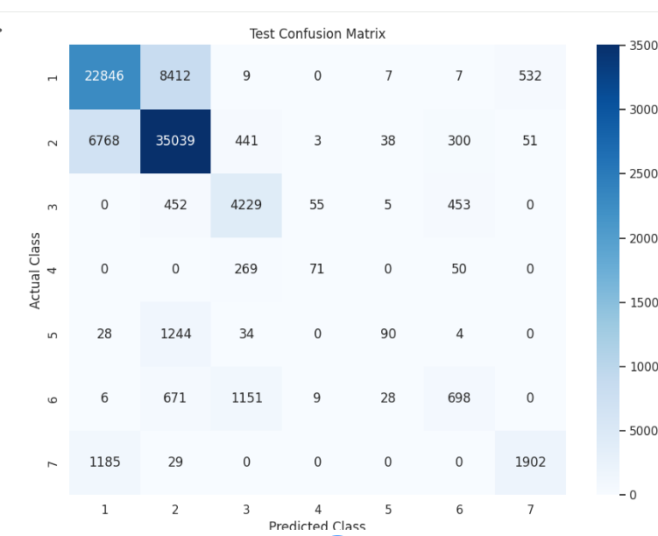
Figure 7 Confusion matrix of actual and predicted forest cover classes.

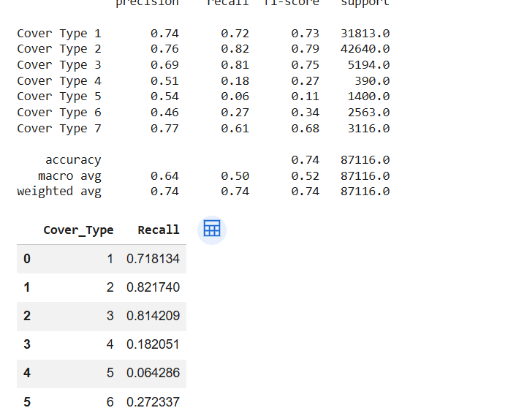
Figure 14 Class-specific precision, recall and F1 results

The confusion matrix indicates that the highest misclassifications are for Cover Types 4, 5 and 6, especially Cover Type 5 with only 6.43% recall. Class imbalance, terrain characteristics and limitations in the neural network architecture can cause errors. The prevalence of Cover Types 1 and 2 could lead to over-representation of majority classes. These are reasonable explanations, but not necessarily proven causes because no attempt was made to test class balancing or alternative feature selection methods.

5.6 Apache Spark Processing Benchmark
The notebook compared three Spark partition settings. Each configuration was timed across three aggregation trials.
Partitions | Mean runtime | Standard deviation
2 | 2.925 s | 2.991 s
4 | 0.876 s | 0.009 s
8 | 1.538 s | 0.253 s

The four-partition configuration had the shortest mean processing time for the aggregation tested. The two-partition setting, however, had a particularly high variance and the measurements were taken in a local Spark environment with two reported units of default parallelism.

These results, therefore, reflect local partition sensitivity and do not necessarily indicate distributed cluster scalability. Further controlled repetitions and multi-node experiments would be required for more general performance claims.

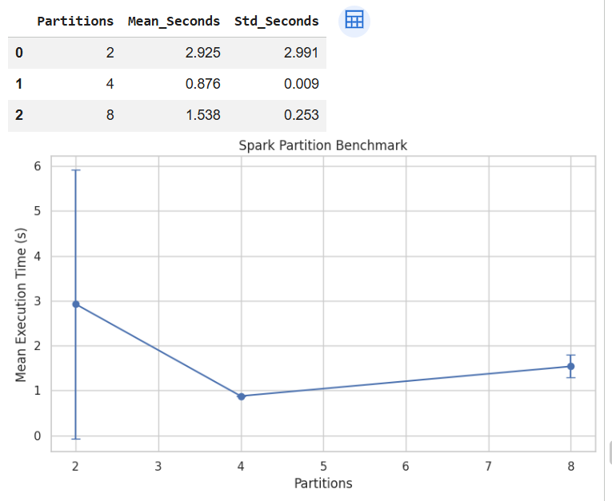
Figure 8 Spark aggregation runtime under alternative partition configurations.

The experiments have several methodological limitations that require consideration:
- Spark was run in the local mode, so the results cannot demonstrate the performance of the software on a real distributed cluster.
- The neural network experiments involved changing multiple parameters at once, which undermines the causal understanding of why performance improvements or degradations occur.
- The data set has a severe class imbalance problem, and the recall of several minor classes is low.
- Only one train-validation-test split was made, and only one process of benchmarking was done, which involved using a small range of partitions and three repetitions.
- The experiments did not use any class weighting, resampling, cross-validation, or other feature selection experiments.

5.8 Critical Evaluation and Research Implications

Critical evaluation should consider that NN_3 improved validation accuracy by approximately 0.75 percentage points over NN_2 while requiring nearly three times the training time. Its weighted F1 improved, but Cover Types 4 and 5 had low recall; therefore, average performance masks material errors affecting less frequent classes. The single random split and simultaneous alteration of several model settings prevent attribution of the performance change to an individual design choice. This supports the importance of tuning and appropriate evaluation highlighted by McElfresh et al. (2023), Grinsztajn et al. (2022) and Roberts et al. (2017), although those studies involve different modelling tasks and validation conditions. Spark partition benchmarking also demonstrated workload-dependent timing rather than multi-node scalability (Zaharia et al., 2012; Armbrust et al., 2015).

6. Conclusions and future work

6.1 Answer to the Research Question

In this study, the authors tested Apache Spark and neural networks for forest cover classification, using 581,012 records. The experiments showed that the architecture of the neural network and the optimization parameters had an impact on the classification results. The best model, NN_3, obtained **74.47% test accuracy and 0.7359 weighted F1-score** which is better than the logistic regression baseline with 71.63% validation accuracy. But as the models became more complex, the training time also increased. While Spark was able to provide data processing support, there was no distributed scalability or storage efficiency achieved locally.

6.2 Implications

The findings suggest that Spark-based preprocessing and feature scaling were a practical approach for dealing with the data. The fastest average aggregation time under the tested conditions was for four Spark partitions, which was **0.876 seconds**. The NN_3 model performed best, but was the slowest to train, making it less efficient. In addition, low recall for minority forest cover classes indicated that overall accuracy was not equally representative of the performance across all classes.

6.3 Future Work

Class balancing, feature selection and wider hyperparameter optimization are areas that could be explored in future work to enhance the prediction of minority classes. Model reliability and generalization could be evaluated using cross validation and geographically independent testing. Running on a real multi-node Spark cluster would allow for testing of distributed scalability, storage formats, memory usage and processing power. Further comparisons of other neural network architectures and distributed training techniques may also help determine if there is a benefit in terms of prediction accuracy for the extra computational expense.

References
Abadi, D.J., Boncz, P.A. and Harizopoulos, S. (2009) ‘Column-oriented database systems’, Proceedings of the VLDB Endowment, 2(2), pp. 1664–1665. https://www.vldb.org/pvldb/vol2/vldb09-tutorial6.pdf
Apache Software Foundation (n.d.) MultilayerPerceptronClassifier’, PySpark API documentation. Available at: https://spark.apache.org/docs/latest/api/python/reference/api/pyspark.ml.classification.MultilayerPerceptronClassifier.html (Accessed: 10 October 2026)
Armbrust, M. et al. (2015) ‘Spark SQL: Relational data processing in Spark’, Proceedings of the 2015 ACM SIGMOD International Conference on Management of Data, pp. 1383–1394. https://amplab.cs.berkeley.edu/wp-content/uploads/2015/03/SparkSQLSigmod2015.pdf
Belgiu, M. and Drăguţ, L. (2016) ‘Random Forest in remote sensing: A review of applications and future directions’, ISPRS Journal of Photogrammetry and Remote Sensing, 114, pp. 24–31. https://doi.org/10.1016/j.isprsjprs.2016.01.011
Blackard, J.A. (1998) Covertype [Dataset]. UCI Machine Learning Repository. https://doi.org/10.24432/C50K5N
Blackard, J.A. and Dean, D.J. (1999) ‘Comparative accuracies of artificial neural networks and discriminant analysis in predicting forest cover types from cartographic variables’, Computers and Electronics in Agriculture, 24(3), pp. 131–151. https://doi.org/10.1016/S0168-1699(99)00046-0
Gorishniy, Y., Rubachev, I., Khrulkov, V. and Babenko, A. (2021) ‘Revisiting deep learning models for tabular data’, Advances in Neural Information Processing Systems, 34, pp. 18932–18943. Available at: https://arxiv.org/abs/2106.11959
Grinsztajn, L., Oyallon, E. and Varoquaux, G. (2022) ‘Why do tree-based models still outperform deep learning on tabular data?’, Advances in Neural Information Processing Systems, 35, pp. 507–520. Available at: https://arxiv.org/abs/2207.08815
Holzmüller, D., Grinsztajn, L. and Steinwart, I. (2024) ‘Better by default: Strong pre-tuned MLPs and boosted trees on tabular data’, Advances in Neural Information Processing Systems, 37. Available at: https://arxiv.org/abs/2407.04491
McElfresh, D.C. et al. (2023) When do neural nets outperform boosted trees on tabular data?’, Advances in Neural Information Processing Systems, 36. Available at: https://arxiv.org/abs/2305.02997
Roberts, D.R. et al. (2017) ‘Cross-validation strategies for data with temporal, spatial, hierarchical, or phylogenetic structure’, Ecography, 40(8), pp. 913–929. https://doi.org/10.1111/ecog.02881
Zaharia, M. et al. (2012) ‘Resilient distributed datasets: A fault-tolerant abstraction for in-memory cluster computing’, Proceedings of the 9th USENIX Symposium on Networked Systems Design and Implementation, pp. 15–28. Available at: https://www.usenix.org/conference/nsdi12/technical-sessions/presentation/zaharia

